Supplementary Table1. The primer sequences for qRT-PCR in this study.
Target | Sequence (5’-3’)
SHMT1 | Forward: AGGAAAGGAGTGAAAAGTGTGGAT
SHMT1 | Reverse: GACACCAGTGTCGCTCTGGATCTG
SHMT2 | Forward: CCCTTCTGCAACCTCACGAC
SHMT2 | Reverse: TGAGCTTATAGGGCATAGACTCG
β-actin | Forward: AGTTGCGTTACACCCTTTC
β-actin | Reverse: CCTTCACCGTTCCAGTTT

Supplementary Tables
Supplementary Table2. The sequences of shRNAs used in this study.
Definition | Sequence (5’-3’)
shNC | Sense: TTCTCCGAACGTGTCACGT
 | Antisense: ACGTGACACGTTCGGAGAA
sh SHMT1 | Sense: TAGGCTCTTGCTTAAATAATT
 | Antisense: AAGCTATGACTCTGGAATTTT
sh SHMT2 | Sense: CCGGAGAGTTGTGTGGACTTTAT
 | Antisense: ACAAGTACTCGGAGGGTTATC

Supplementary Table3. The drugs and kit used in the study.
Drug | Manufacture | Catalog number
5-Fu | TargetMol | CAS 51-21-8
Epirubicin | TargetMol | CAS 56420-45-2
Oxaliplatin | TargetMol | CAS 61825-94-3
Paclitaxel | TargetMol | CAS 33069-62-4
Irinotecan | Selleck | CAS 97682-44-5
Gemcitabine | TargetMol | CAS 95058-81-4
SHIN1 | Macklin | S880436
SA-β-gal | Beyotime | C0602
SHIN2 | TargetMol | CAS 2204289-53-0
AGF347 | Sigma-Aldrich | CAS 2294820-23-6
PFT-α | MCE | CAS 63208-82-2

Supplementary Table4. The antibodies used in the study.
Antibody | Manufacture | Catalog number
SHMT1 | Abcam | ab186130
SHMT2 | Abcam | ab224427
P21 | Proteintech | 10355-1-AP
GADD45A | Invitrogen | PA5-88248
CDK4 | Immunoway | YT5198
CDK6 | Immunoway | YT5884
GAPDH | Immunoway | YM3029
α-tubulin | Immunoway | YM3035
γ-H2AX | Immunoway | YM1429
P53 | Abcam | 3

Supplementary Figures
Supplementary Figure 1
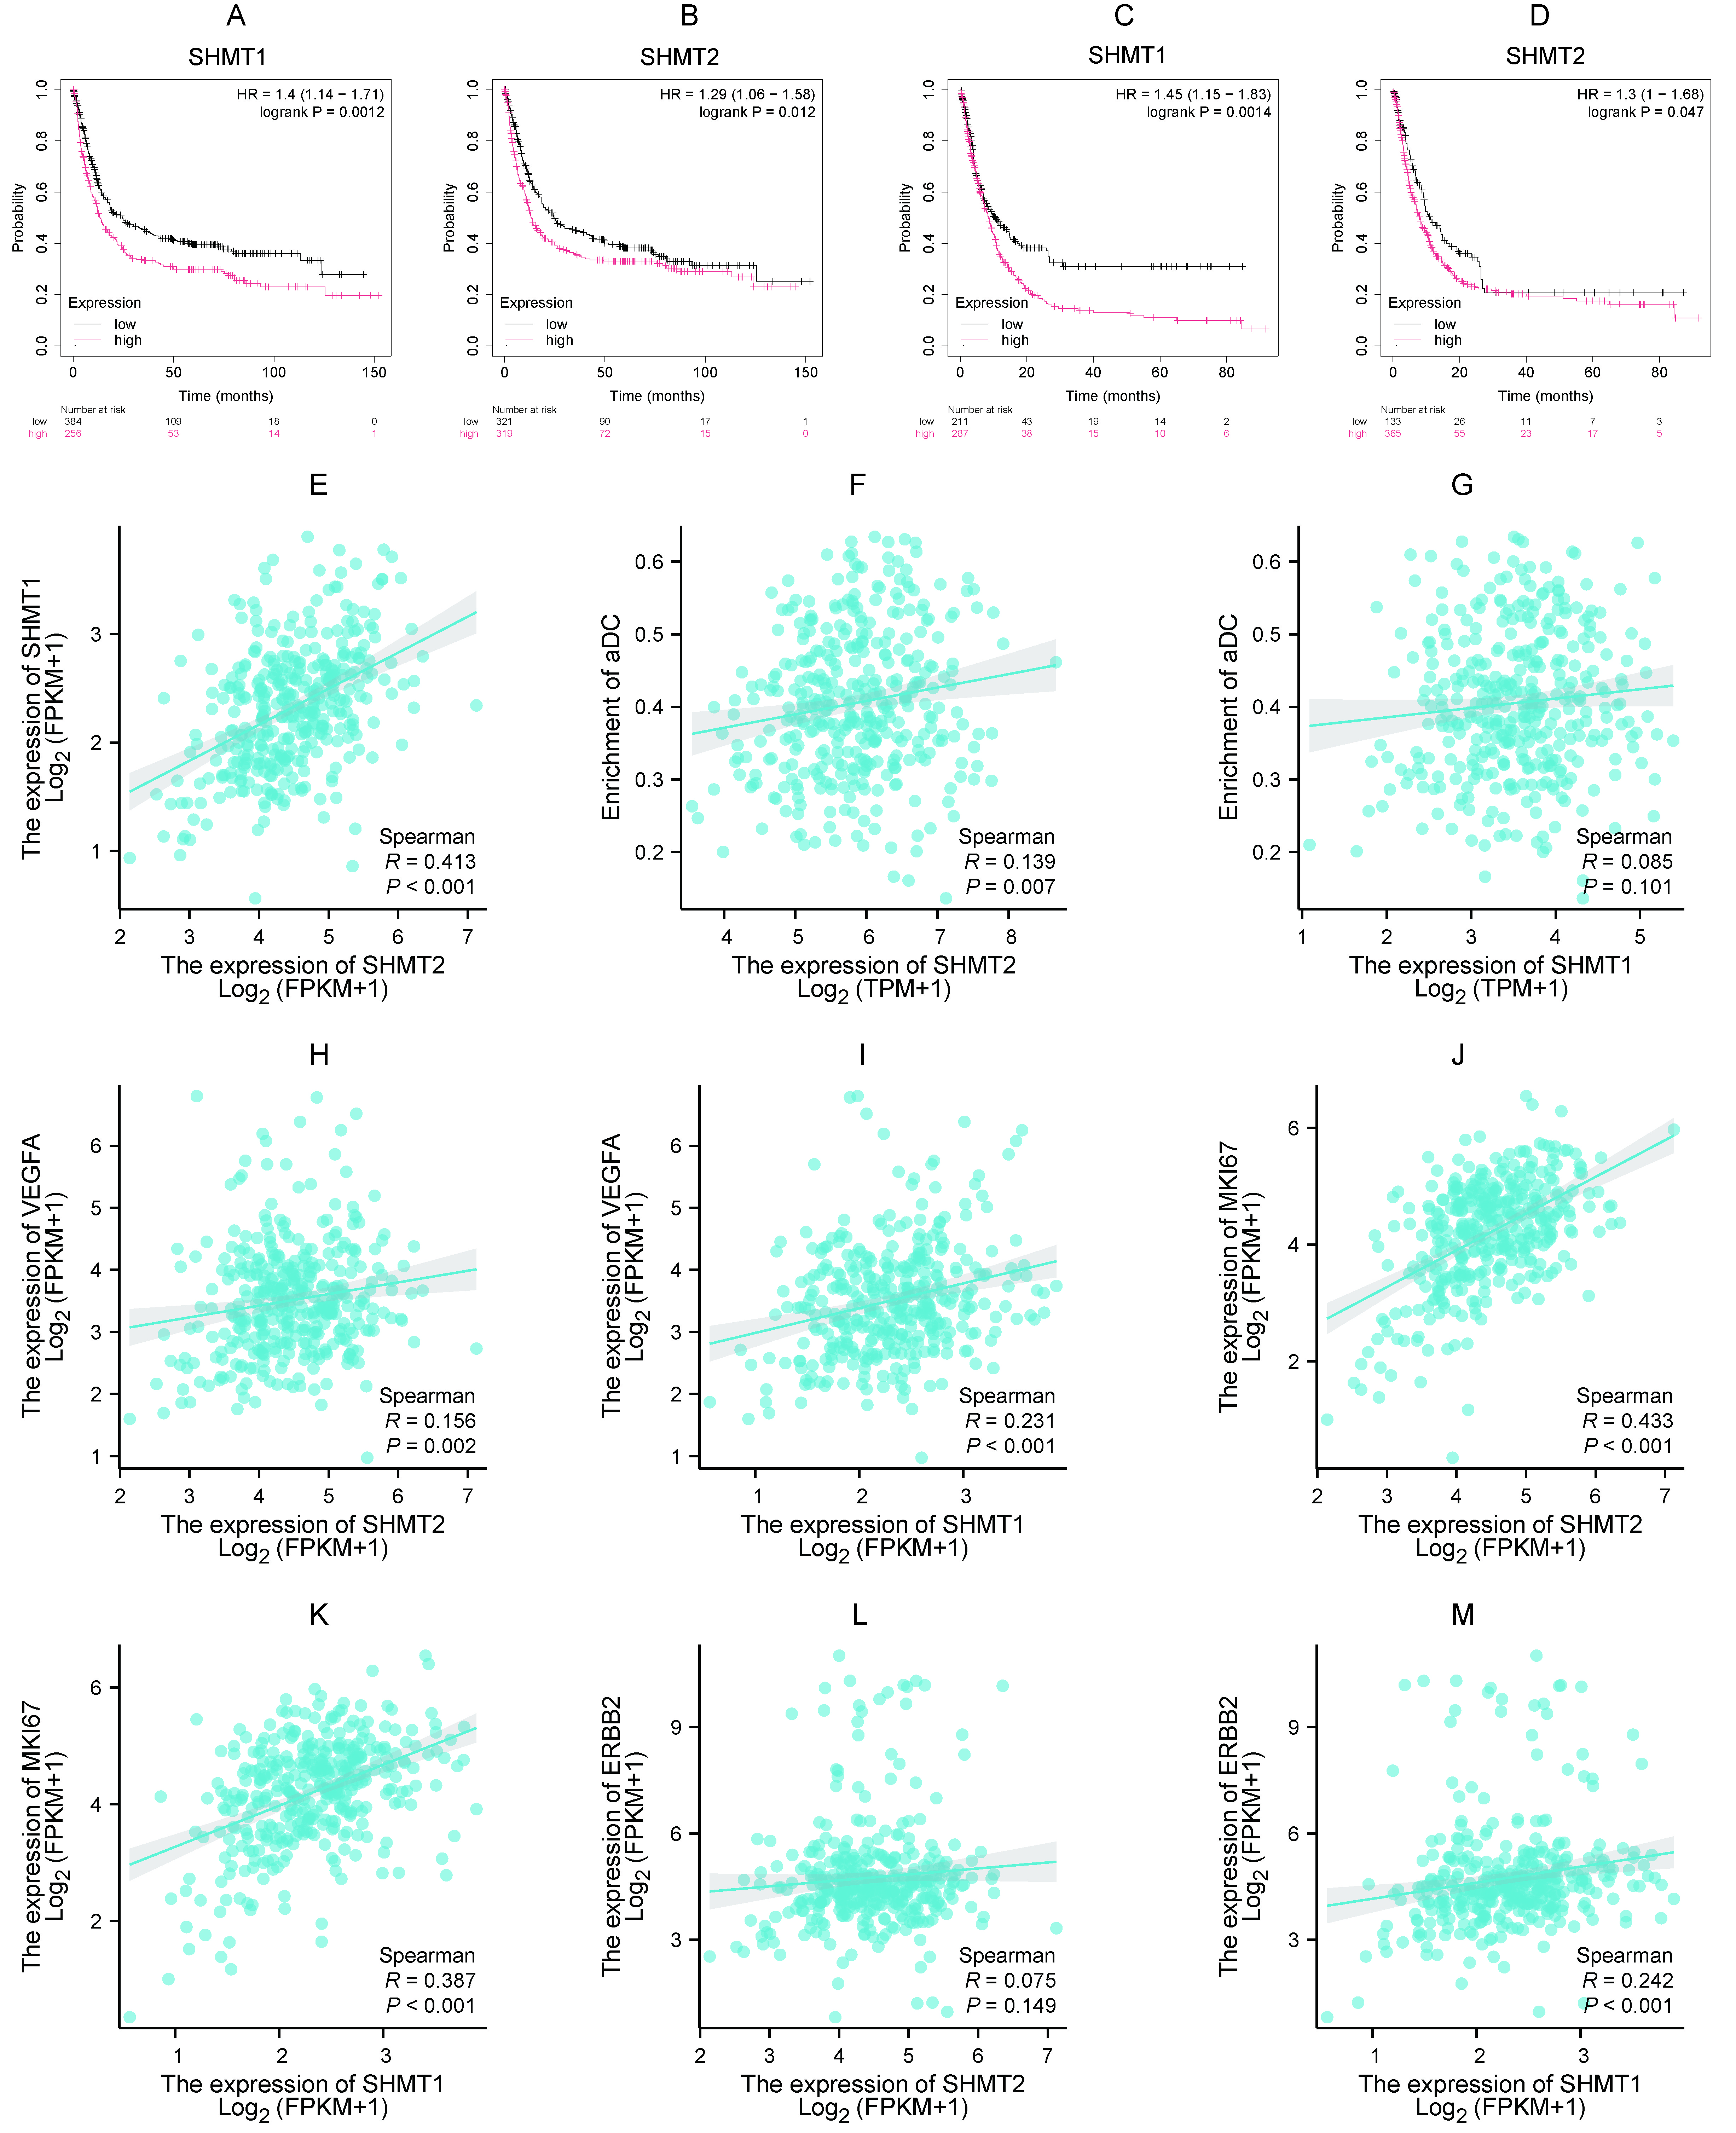
Supplementary Figure 1. Survival analysis and gene expression correlation associated with SHMT1 and SHMT2 in GC patients. (A) Disease-free survival (DFS) stratified by SHMT1 expression. (B) DFS stratified by SHMT2 expression. (C) Progression-free survival (PFS) stratified by SHMT1 expression. (D) PFS stratified by SHMT2 expression. (E) Correlation between SHMT1 and SHMT2 expression. (F) Correlation between SHMT2 expression and score of immune infiltration. (G) Correlation between SHMT1 expression and score of immune infiltration. (H) Correlation between VEGFA and SHMT2 expression. (I) Correlation between VEGFA and SHMT1 expression. (J) Correlation between Ki67 and SHMT1 expression. (K) Correlation between MKi67 and SHMT2 expression. (L) Correlation between ERBB2 (HER-2) and SHMT1 expression. (M) Correlation between ERBB2 (HER-2) and SHMT2 expression. Survival data derived from Kaplan-Meier Plotter database; gene expression correlations analyzed using TCGA database.

Supplementary Figure 2
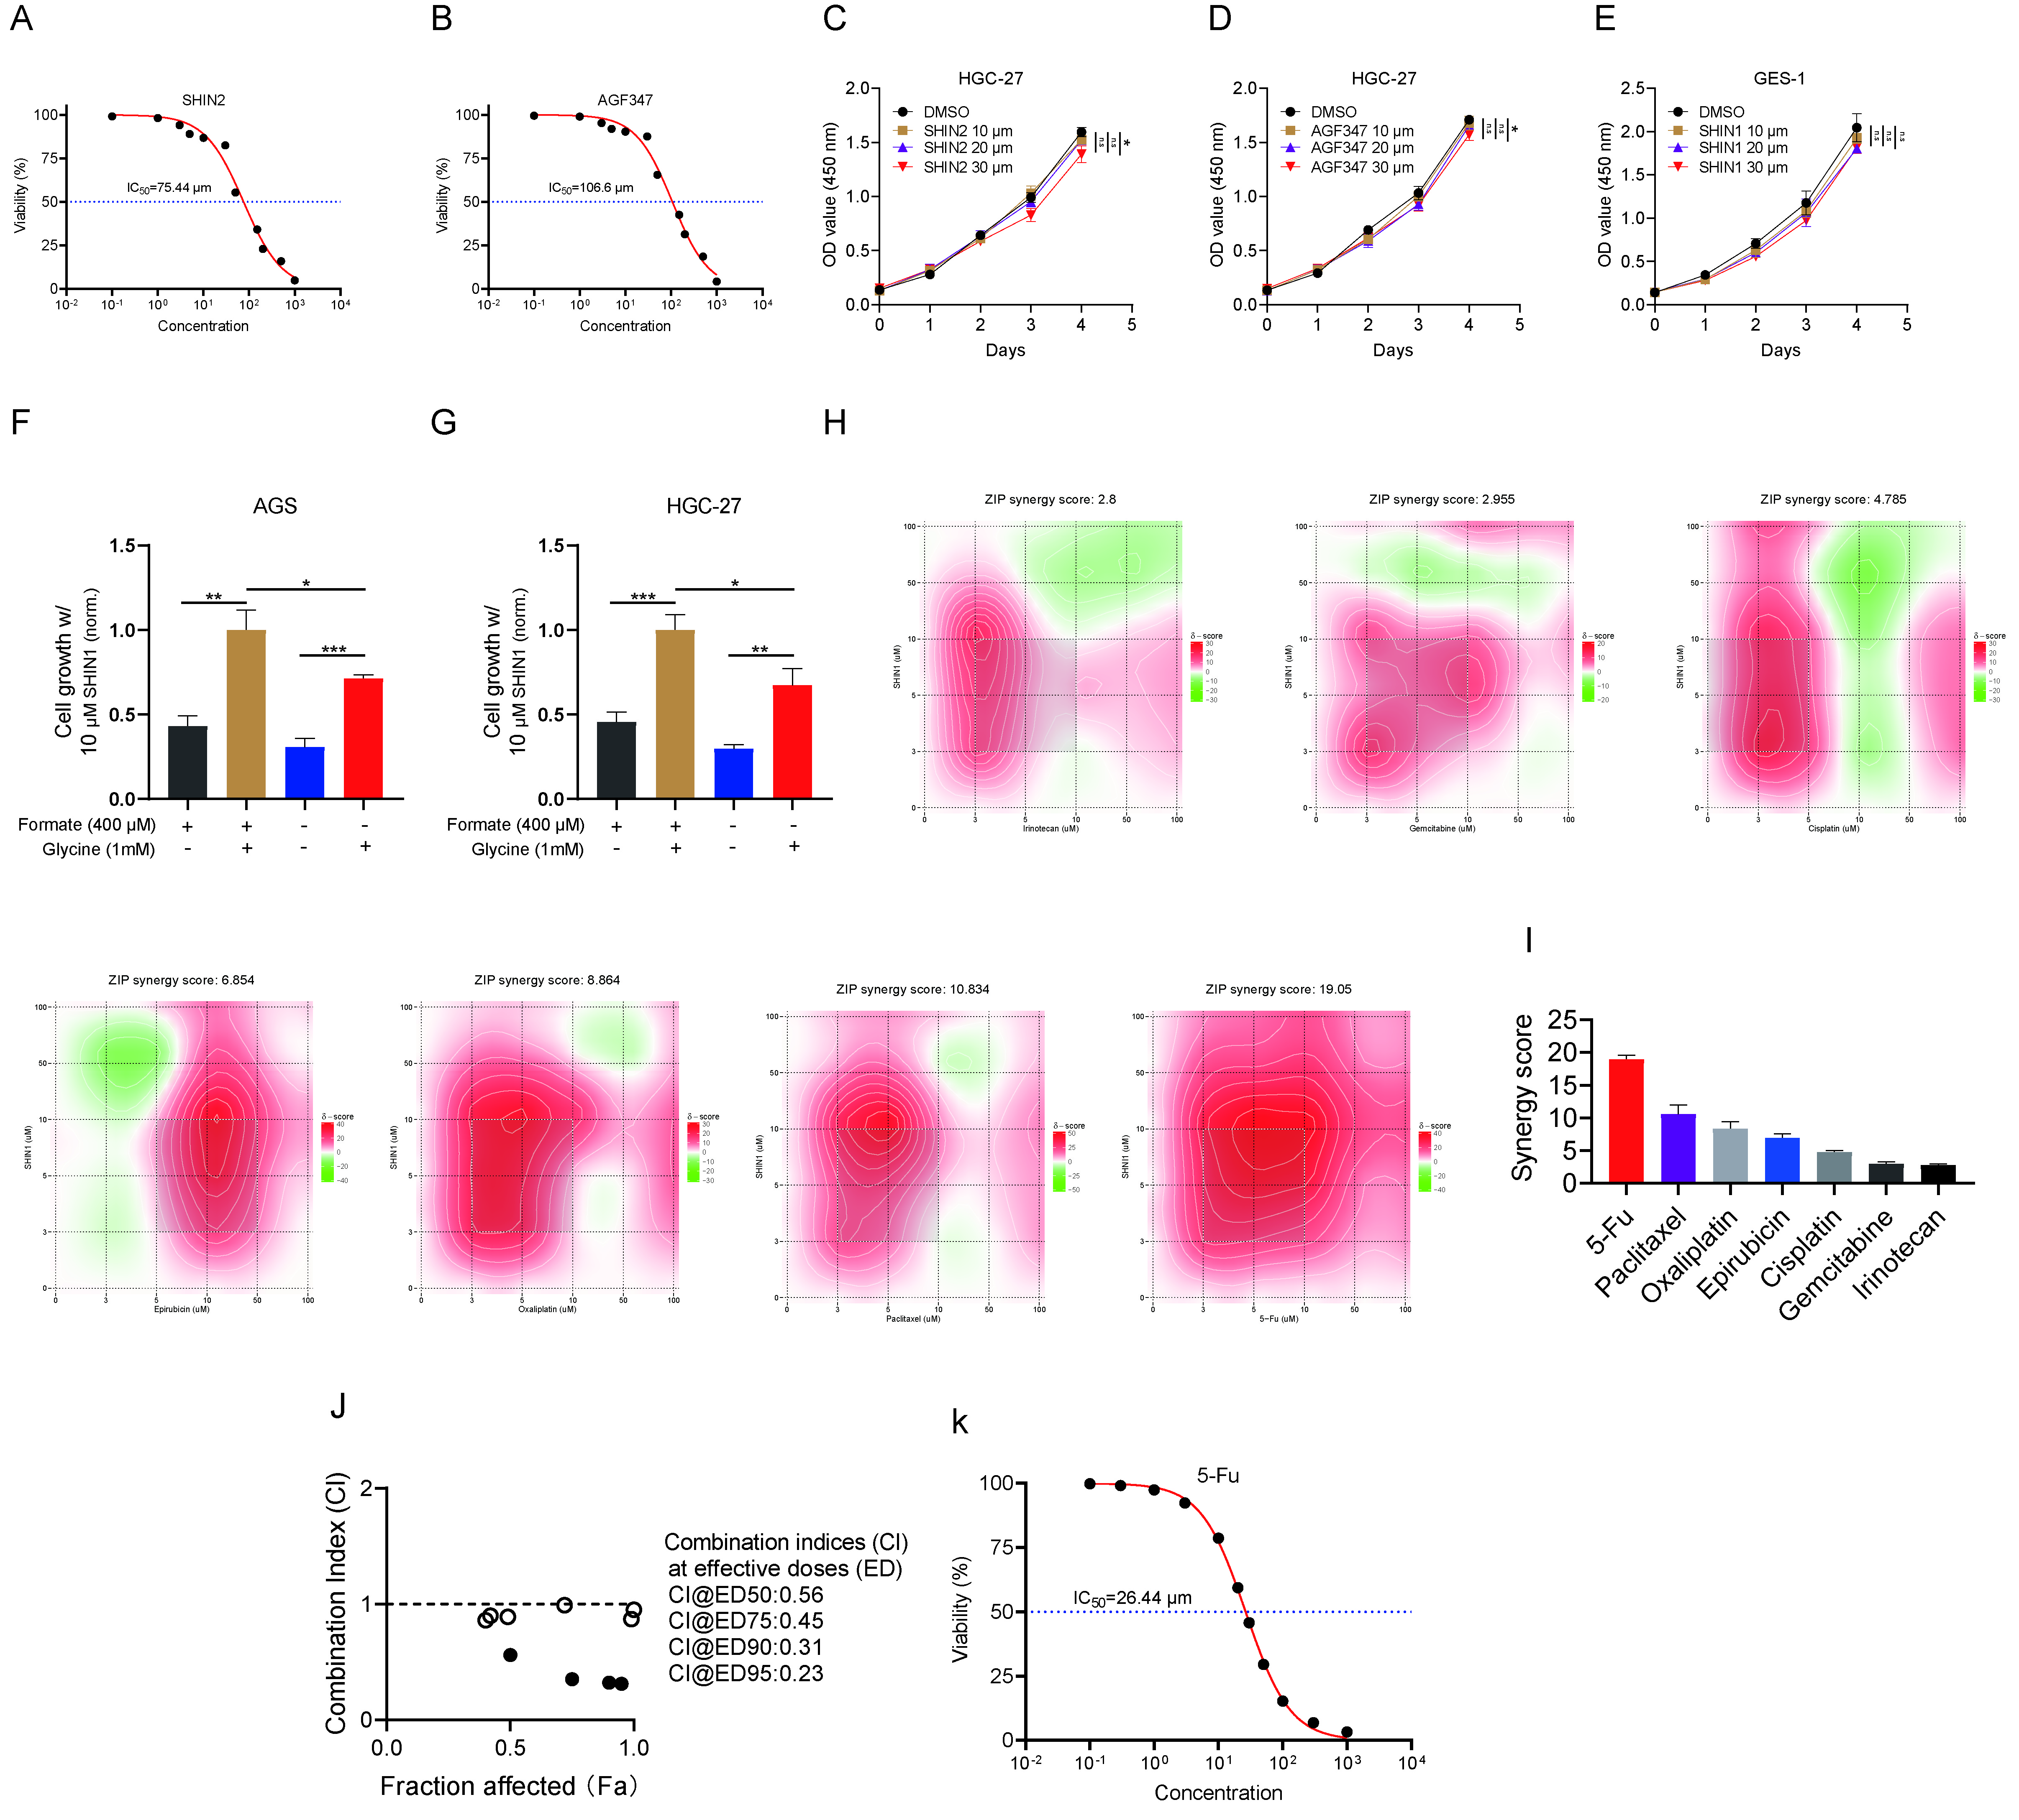
Supplementary Figure 2. Drug screening and synergistic analysis in the cell lines. (A-C) The IC₅₀ values generated from dose‒response assays for 5-Fu, SHIN2 and AGF247 in HGC-27 cells. (D) CCK-8 assays were used to detect the inhibitory effects of different doses of SHIN2 on the growth of HGC-27 cells. (E) CCK-8 assays were used to detect the inhibitory effects of different doses of AGF347 on the growth of HGC-27 cells. (F) CCK-8 assay was used to detect the inhibitory effects of different doses of SHIN1 on the growth of GES-1 cells. (G) Growth inhibition of AGS cells treated with 10 μM SHIN1 ± 400 μM Formate/1 mM Glycine (normalized to SHIN1 alone). (H) Growth inhibition of AGS cells treated with 10 μM SHIN1 ± 400 μM Formate/1 mM Glycine (normalized to SHIN1 alone). (I) A drug screening assays were used to determine the synergistic effect of SHIN1 with common chemotherapy drugs for GC in AGS cells.The SynergyFinder platform with the ZIP model was used to compute synergistic ZIP scores. (J) The histogram showing the synergistic scores in (I). (K) The compusyn analysis to show the synergistic effect of SHIN1 with 5-Fu. n.s: non-significant. *P<0.05, **P<0.01, ***P<0.001.
Supplementary Figure 3.
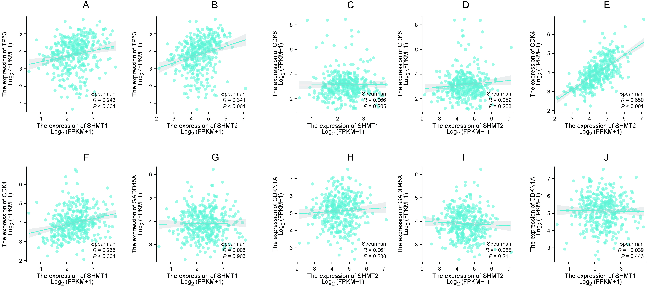
Supplementary Figure 3. Gene expression correlations associated with SHMT1/SHMT2 in GC patients. (A) Correlation between SHMT1 and TP53 expression. (B) Correlation between SHMT2 and TP53 expression. (C) Correlation between SHMT1 and CDK6 expression. (D) Correlation between SHMT2 and CDK6 expression. (E) Correlation between SHMT2 and CDK4 expression. (F) Correlation between SHMT1 and CDK4 expression. (G) Correlation between SHMT1 and GADD45A expression. (H) Correlation between SHMT2 and CDKN1A expression. (I) Correlation between SHMT2 and GADD45A (P21) expression. (J) Correlation between SHMT1 and CDKN1A (P21) expression. Gene expression correlations analyzed using TCGA database.

Supplementary Figure 4
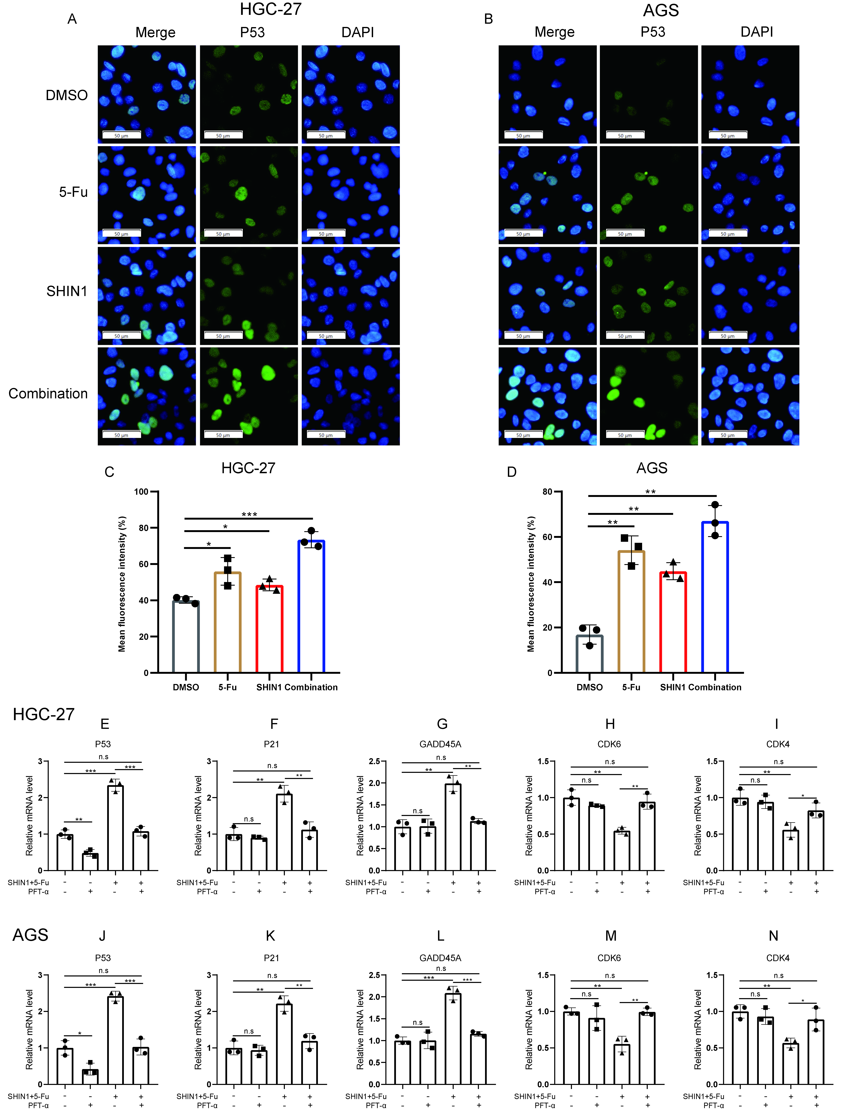
Supplementary Figure 4. P53 signaling pathway was activated in the combinative therapy groups. (A) Immunofluorescence staining for P53 protein in HGC-27 cells. (B) Immunofluorescence staining for P53 protein in AGS cells. (C and D) The histogram showing the mean mean fluorescence intensity in (A and B). (E) The relative P53 expression level of mRNA after adding P53 inhibitors (PFT-α) in various HGC-27 experimental groups. (F) The relative P21 expression level of mRNA after adding P53 inhibitors (PFT-α) in various HGC-27 experimental groups. (G) The relative GADD45A expression level of mRNA after adding P53 inhibitors (PFT-α) in various HGC-27 experimental groups. (H) The relative CDK6 expression level of mRNA after adding P53 inhibitors (PFT-α) in various HGC-27 experimental groups. (I) The relative CDK4 expression level of mRNA after adding P53 inhibitors (PFT-α) in various HGC-27 experimental groups. (J) The relative P53 expression level of mRNA after adding P53 inhibitors (PFT-α) in various AGS experimental groups. (K) The relative P21 expression level of mRNA after adding P53 inhibitors (PFT-α) in various AGS experimental groups. (L) The relative GADD45A expression level of mRNA after adding P53 inhibitors (PFT-α) in various AGS experimental groups. (M) The relative CDK6 expression level of mRNA after adding P53 inhibitors (PFT-α) in various AGS experimental groups. (N) The relative CDK4 expression level of mRNA after adding P53 inhibitors (PFT-α) in various AGS experimental groups. n.s: non-significant; *P<0.05, **P<0.01, ***P<0.001.

