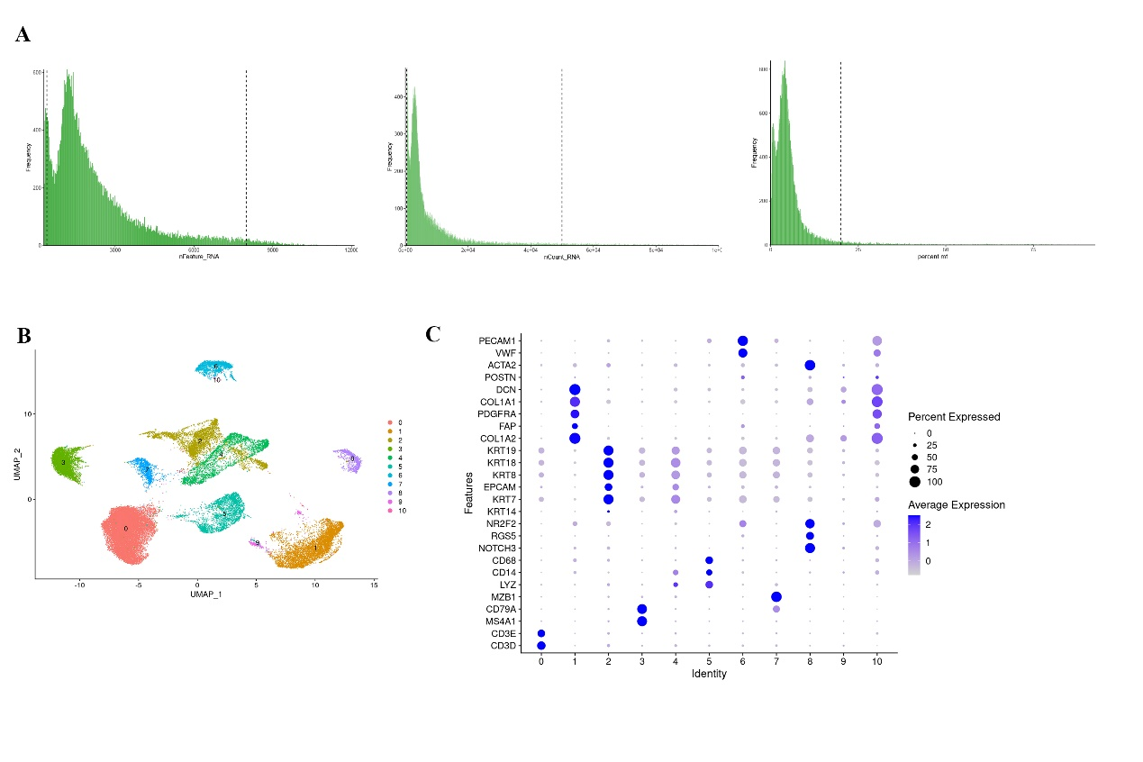
Fig.S1 The quality control and cell type of all samples. A. Quality control of all samples.
B. The UMAP distribution of 41145 cells labelled by cell clusters. C. Dot plot showing the normalized expression levels of representative canonical marker genes across the 11 clusters.

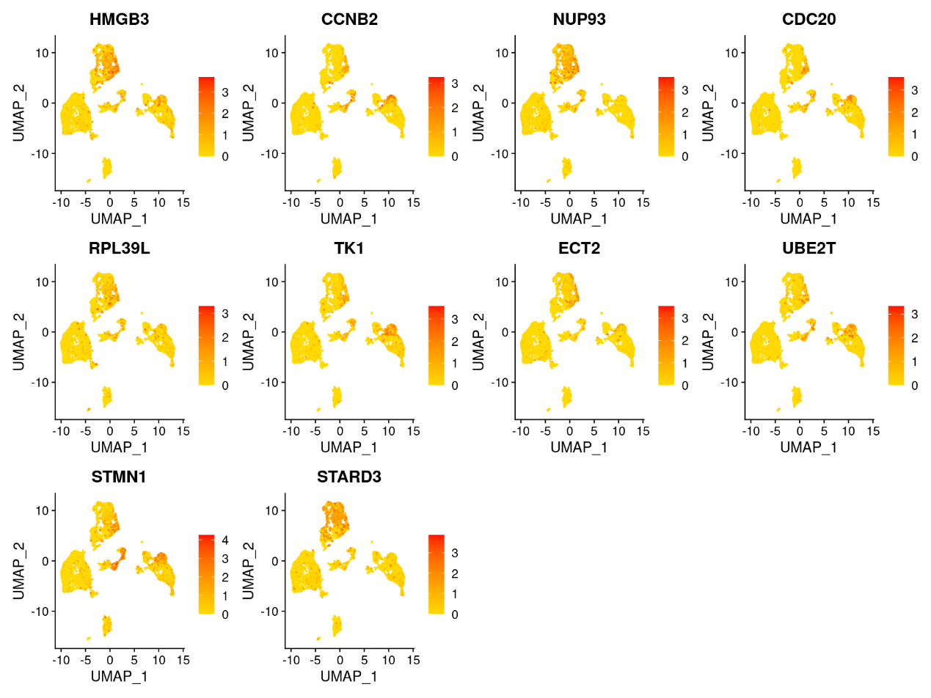
Fig.S2 UMAP plots showing the expression and distribution of marker genes in CC1 cells.

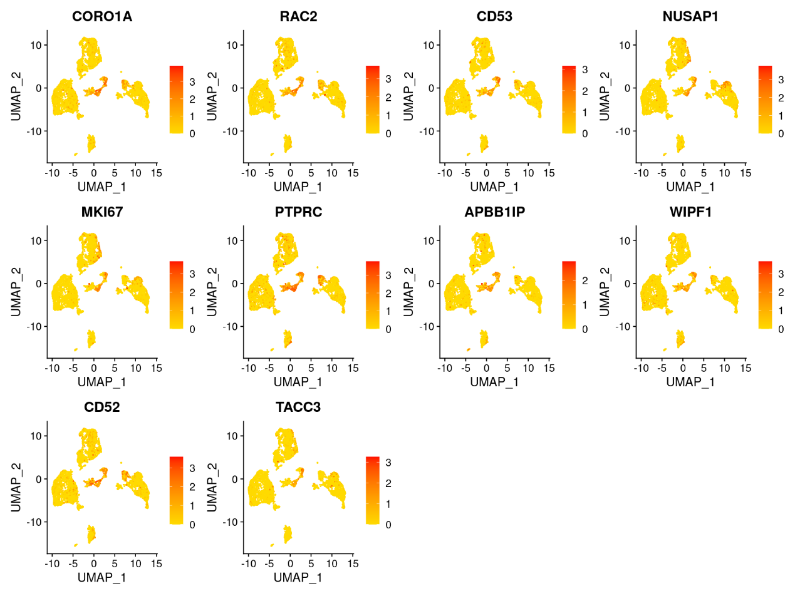
Fig.S3 UMAP plots showing the expression and distribution of marker genes in CC2 cells.

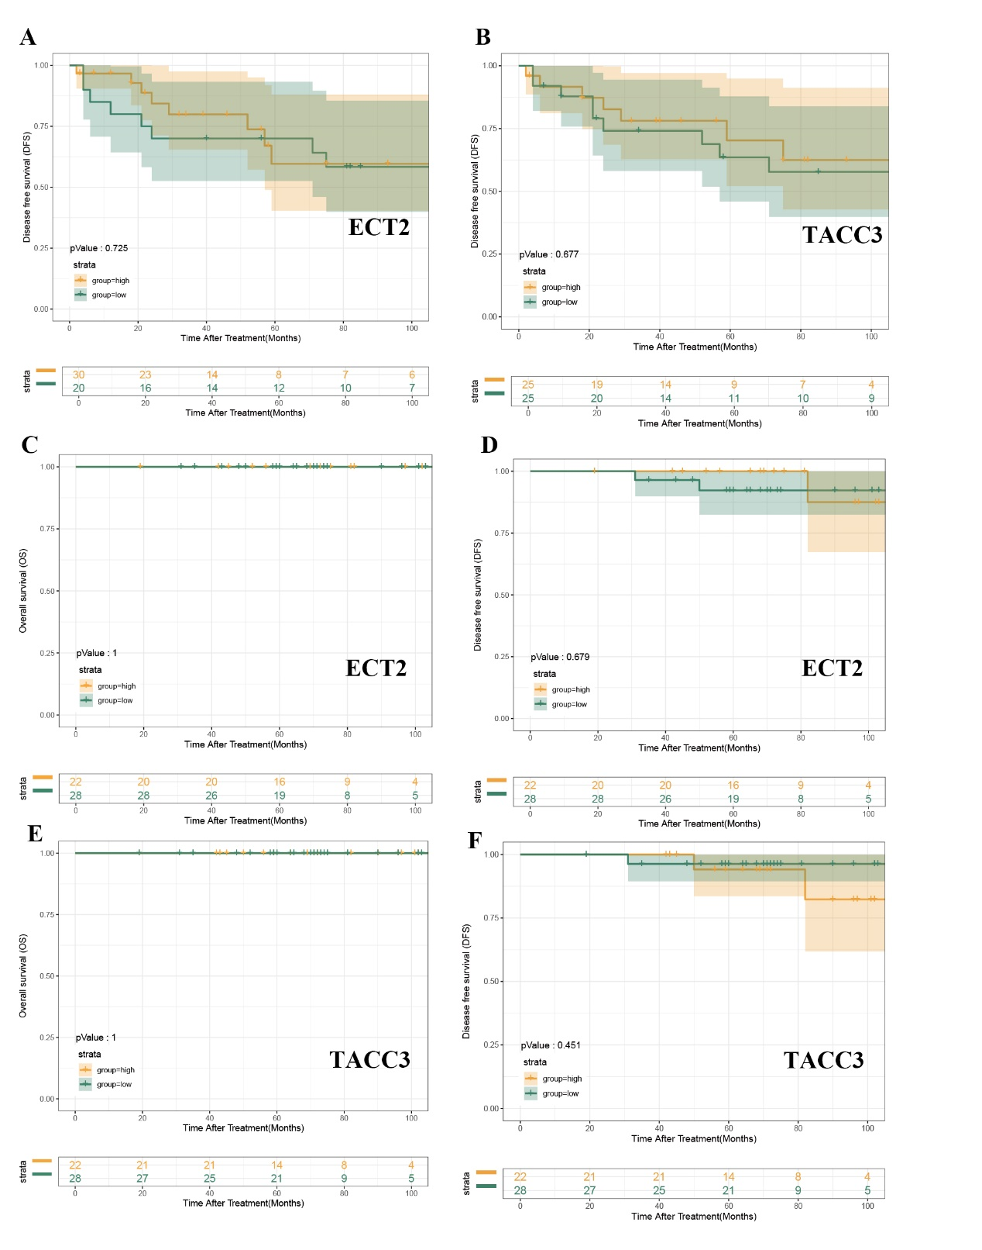
Fig.S4 A. Kaplan-Meier curves for DFS according to the expression levels of ECT2 (log-rank test, p >0.05) in WICXPA. B. Kaplan-Meier curves for DFS according to the expression levels of TACC3 (log-rank test, p >0.05) in WICXPA. C. Kaplan-Meier curves for OS according to the expression levels of ECT2 (log-rank test, p >0.05) in ICCXPA and MICXPA. D. Kaplan-Meier curves for DFS according to the expression levels of ECT2 (log-rank test, p >0.05) in ICCXPA and MICXPA. E. Kaplan-Meier curves for DFS according to the expression levels of TACC3 (log-rank test, p >0.05) in ICCXPA and MICXPA. F. Kaplan-Meier curves for DFS according to the expression levels of TACC3 (log-rank test, p >0.05) in ICCXPA and MICXPA.

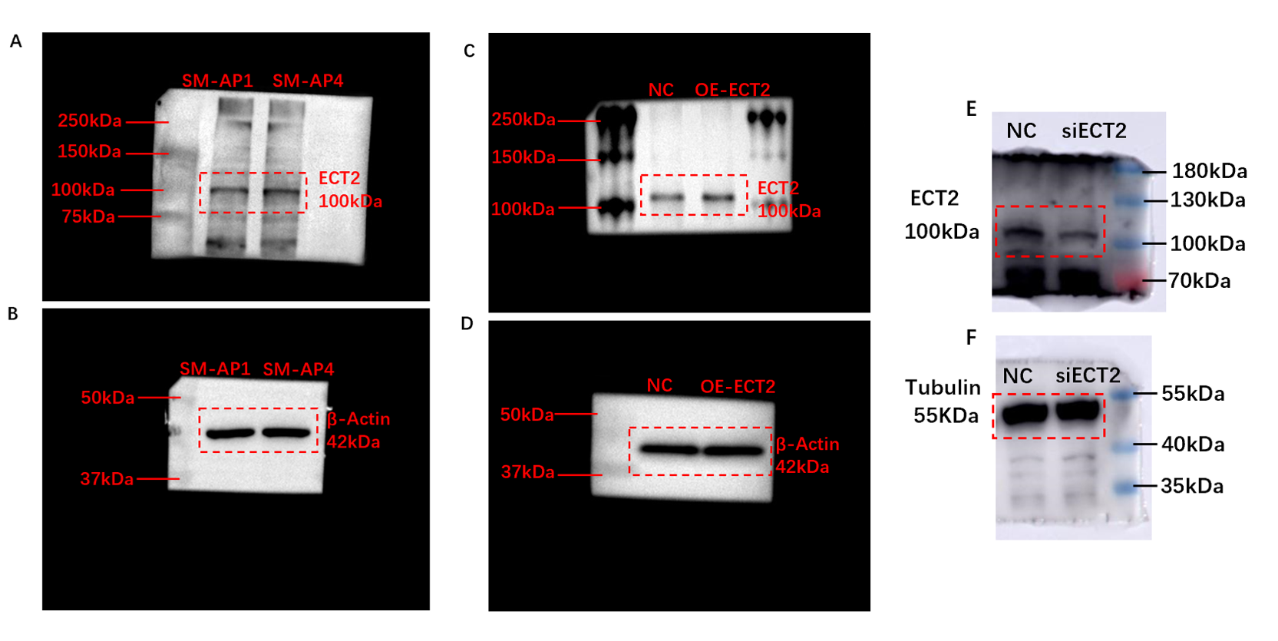
Fig.S5 Unprocessed scans of Western blots for Figure 6. A. Western blot analyses detected ECT2 expression in SM-AP1 and SM-AP4 cells. B. β-Actin expression in SM-AP1 and SM-AP4 cells. C. Western blot analyses detected the overexpression efficiency of ECT2 in SM-AP1 cells. D. β-Actin expression in SM-AP1 and OE-ECT2 SM-AP1 cells. E. Western blot analysis detected the knockdown efficiency of ECT2 in SM-AP4 cells. F. Tubulin expression in siECT2 SM-AP4 and SM-AP4 cells.

Supplementary Data 1 Clusters of co-expressed genes in each sample.

Supplementary Data 2 Stemness-related genes.

