Supplementary Table 1. Clinical stage information for each cancer type.
Age | Stage | Bile Duct | Breast | Cervical | Colorectum | Endometrial | Gallbladder | Head & Neck | Liver | Lung | Lymphoma | Oesophagus | Ovary | Pancreas | Prostate | Stomach
Age ≥ 55 | I | 0 | 25 | 0 | 75 | 1 | 0 | 0 | 39 | 86 | 13 | 9 | 7 | 7 | 0 | 27
Age ≥ 55 | II | 1 | 77 | 0 | 167 | 0 | 0 | 1 | 25 | 34 | 21 | 24 | 5 | 74 | 0 | 34
Age ≥ 55 | III | 2 | 37 | 1 | 103 | 2 | 1 | 1 | 36 | 67 | 16 | 16 | 35 | 10 | 0 | 39
Age ≥ 55 | IV | 8 | 3 | 0 | 42 | 1 | 11 | 4 | 17 | 158 | 56 | 14 | 6 | 10 | 2 | 36
Age ≥ 55 | LS |  |  |  |  |  |  |  |  | 7
Age ≥ 55 | ES |  |  |  |  |  |  |  |  | 42
Age ≥ 55 | Unknown | 2 | 8 | 0 | 61 | 0 | 7 | 10 | 65 | 200 | 22 | 43 | 9 | 24 | 3 | 45
Age < 55 | I | 0 | 24 | 1 | 12 | 0 | 0 | 0 | 25 | 30 | 15 | 1 | 4 | 1 | 0 | 10
Age < 55 | II | 0 | 76 | 1 | 54 | 0 | 0 | 0 | 23 | 2 | 15 | 12 | 2 | 12 | 0 | 15
Age < 55 | III | 3 | 40 | 0 | 45 | 0 | 0 | 2 | 28 | 15 | 12 | 4 | 13 | 0 | 0 | 11
Age < 55 | IV | 1 | 8 | 3 | 26 | 0 | 1 | 1 | 20 | 52 | 50 | 3 | 4 | 6 | 1 | 24
Age < 55 | LS |  |  |  |  |  |  |  |  | 1
Age < 55 | ES |  |  |  |  |  |  |  |  | 12
Age < 55 | Unknown | 1 | 13 | 2 | 19 | 1 | 2 | 3 | 36 | 64 | 13 | 11 | 21 | 9 | 0 | 18
Total |  | 18 | 311 | 8 | 604 | 5 | 22 | 22 | 314 | 770 | 233 | 137 | 106 | 153 | 6 | 259

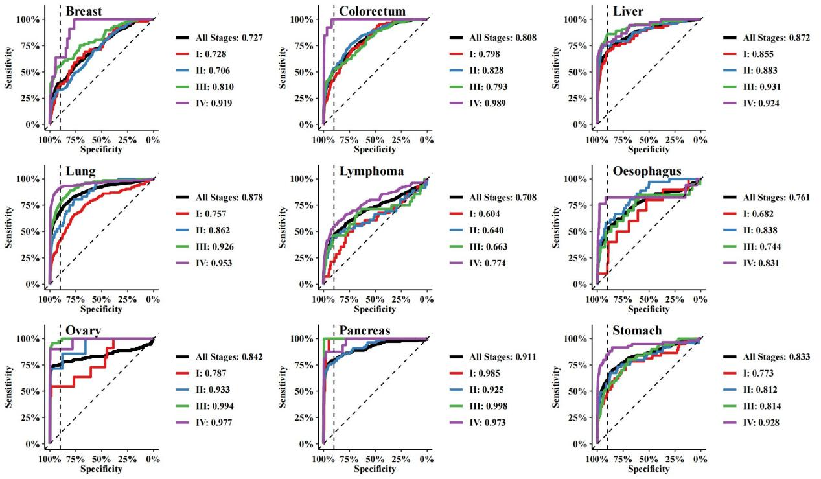
Supplementary Figure 1. Receiver operating characteristic (ROC) curve by stage in the nine pre-specified cancers. The corresponding area under the curve (AUC) values for the four stages were illustrated in the figure. The dotted vertical lines on the ROC curves indicate the threshold for 90.0% specificity.

Supplementary Table 2. Stage-standardized estimates of sensitivity and specificity for four cancer types in three cohorts.

 | Cancer Type | SeekIn | JHUSM | HNCH | P value
Specificity, % |  | 90 | 88.9 | 90.6
Sensitivity, % (number) | Colorectum | 60.6 (44) | 44.1 (388) | 49.2 (24) | 0.8741
Sensitivity, % (number) | Liver | 72.9 (114) | 79.6 (44) | 73.8 (13) | 0.8741
Sensitivity, % (number) | Lung | 72.2 (28) | 56.9 (104) | 47.1 (57) | 0.8741
Sensitivity, % (number) | Stomach | 44.0 (45) | 52.5 (68) | 45.5 (22) | 0.8741
The numbers in brackets indicate the case number for each cancer type.

