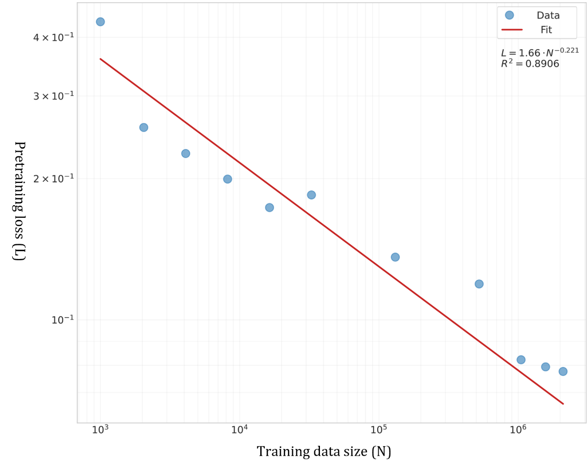
Supplementary Figure 1. Data scaling laws demonstrating the relationship between training dataset size and pretraining loss. The x-axis shows the number of training samples ranging from 1K to 2.1M on a logarithmic scale, while the y-axis represents the pretraining loss. The red line indicates the power-law fit (L = 1.66N^-0.221) with R² = 0.8906, suggesting that the model's performance consistently improves with increased training data, though with diminishing returns at larger scales.

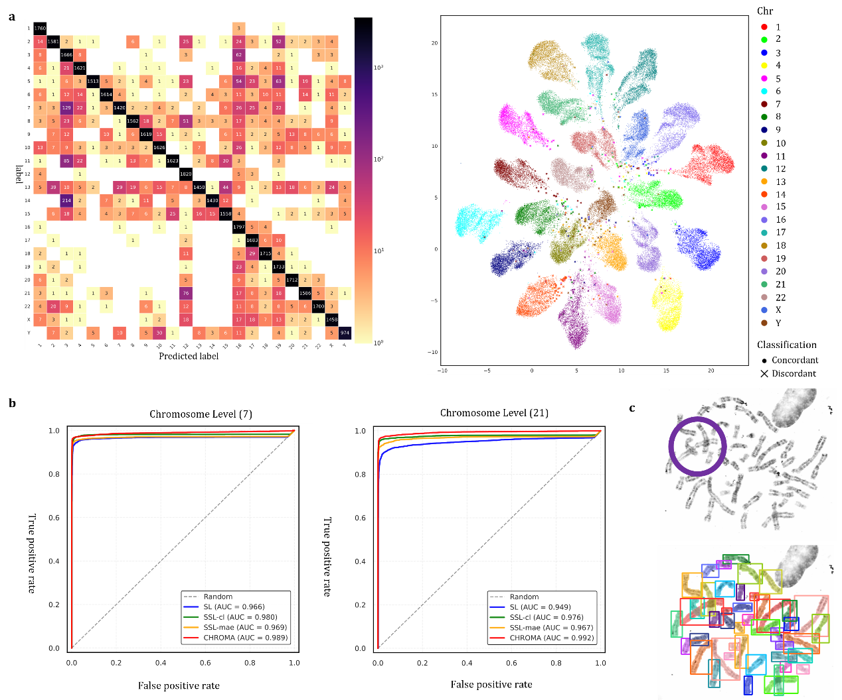 Supplementary Figure 2. Extended analysis on chromosome identification and numerical abnormalities. (a) Confusion matrix and visualization of the most competitive baseline model for chromosome classification. (b) ROC curves for chromosomes 7 and 21 at the chromosome level. The high AUC values indicate that CHROMA provides exceptional sensitivity and specificity for distinguishing these chromosomes, outperforming other methods consistently. (c) In the highlighted regions, chromosomes 1, 5, and 10 intersect, suggesting potential regions of shared or overlapping genetic content.

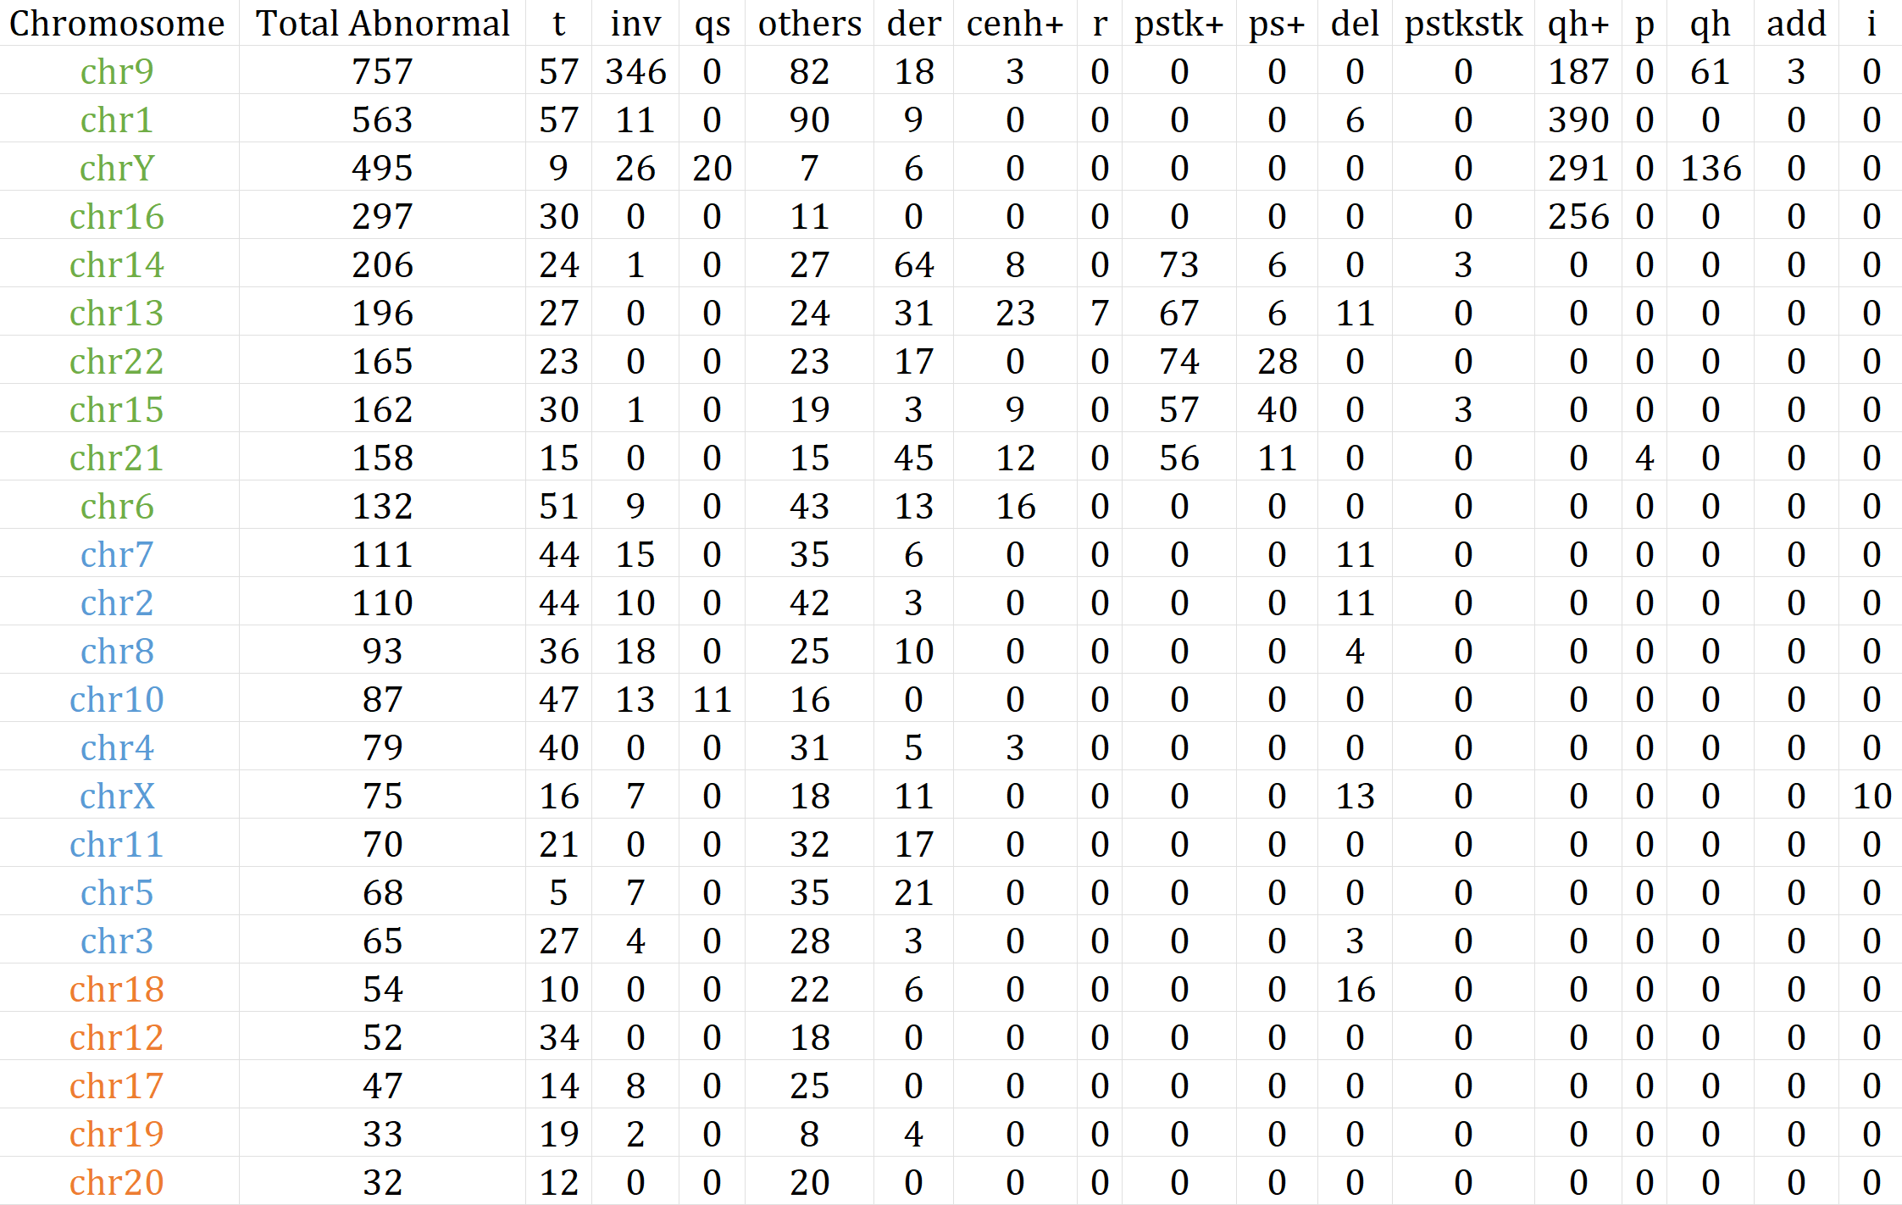
Supplementary Table 1. The data on chromosomal stability abnormalities and corresponding subtype abnormalities.

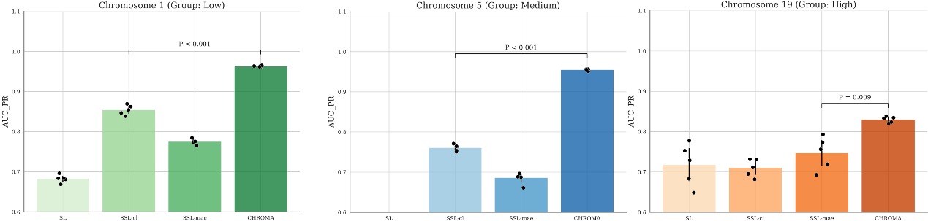
Supplementary Figure 3. Extended analysis on chromosome stable structural abnormalities. The bar plots show the AUC-PR (Area Under the Precision-Recall Curve) achieved by CHROMA and baseline methods (SL, SSL-cl, SSL-mae). For each chromosome, CHROMA consistently outperforms competing methods, with statistically significant improvements indicated by adjusted P < 0.001. Black dots represent results from individual seeds, highlighting the robustness and stability of CHROMA’s performance across random initializations. These results further validate CHROMA’s adaptability and resilience in handling imbalanced datasets with limited abnormal samples.

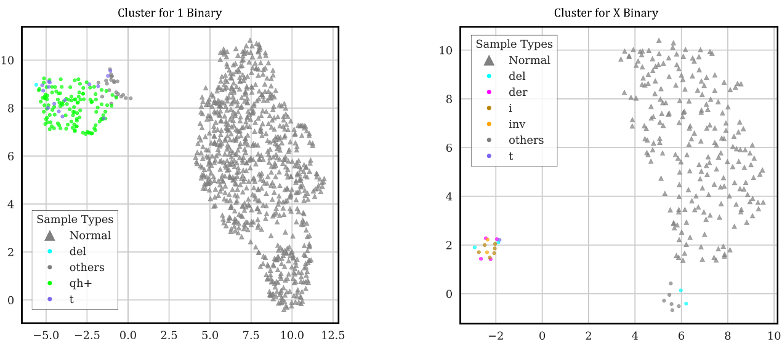
Supplementary Figure 4. UMAP visualizations of CHROMA’s learned embedding space for two additional cases under a binary classification setting (normal vs. abnormal). Each point represents a sample, colored by its subtype, with normal samples shown as gray triangles. Despite being trained on a binary objective, CHROMA’s embeddings naturally cluster abnormal subtypes into distinct groups. The left plot achieves a k-means clustering purity of 81.18%, while the right plot achieves a purity of 60.87%, further demonstrating CHROMA’s capacity to encode fine-grained structural differences.

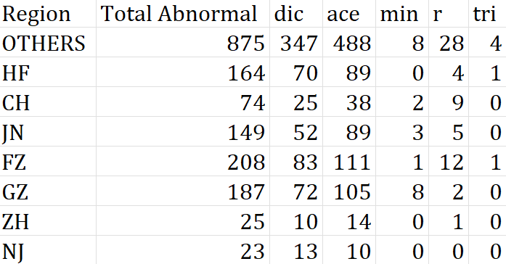
Supplementary Table 2. The data on chromosomal instability abnormalities and corresponding subtype abnormalities across different regions.

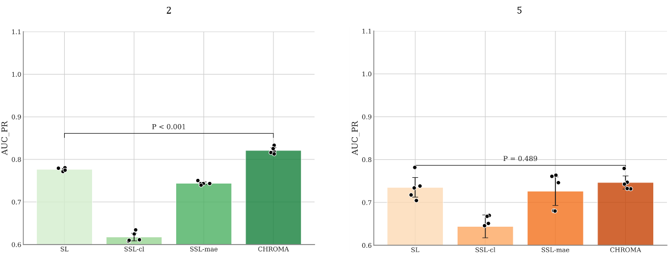
Supplementary Figure 5. Extended analysis on chromosome unstable structural abnormalities. The bar plots show the AUC-PR (Area Under the Precision-Recall Curve) achieved by CHROMA and baseline methods (SL, SSL-cl, SSL-mae) for the binary classification of normal vs abnormal (left), as well as for the five-class classification of abnormal types (ace, dic, min, r, tri) (right).

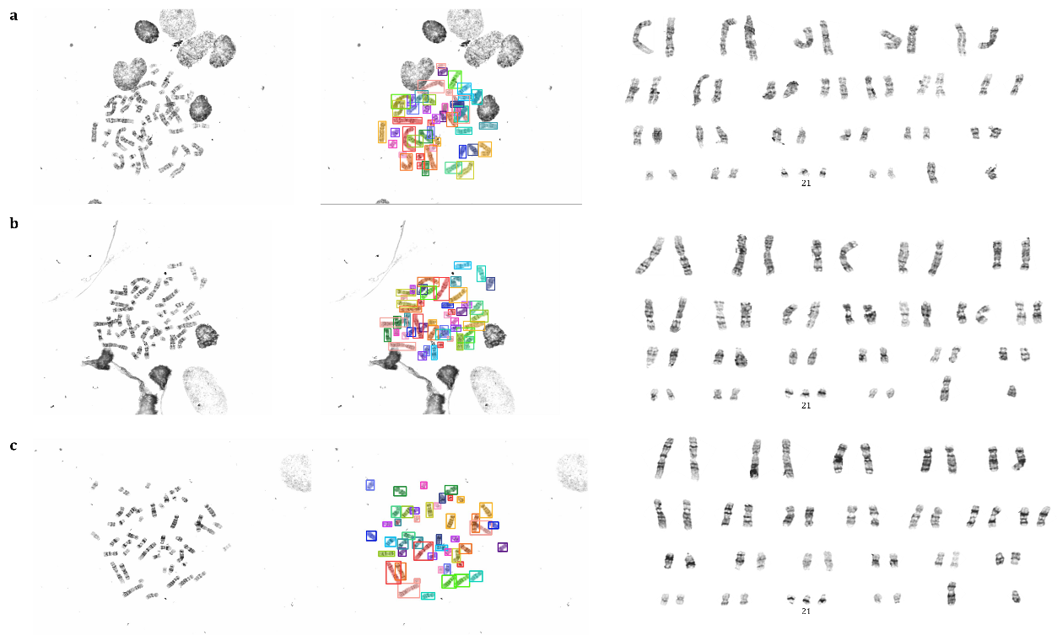
Supplementary Figure 6. Visualization of CHROMA’s performance on a Trisomy 21 case across multiple metaphases. Three representative metaphases from a single patient are shown. Left: Raw metaphase images. Middle: YOLOv8 segmentation results. Right: Karyograms based on CHROMA’s identification results. The chromosomes were manually arranged to highlight the consistent detection of three copies of chromosome 21 (Trisomy 21) across different cells.

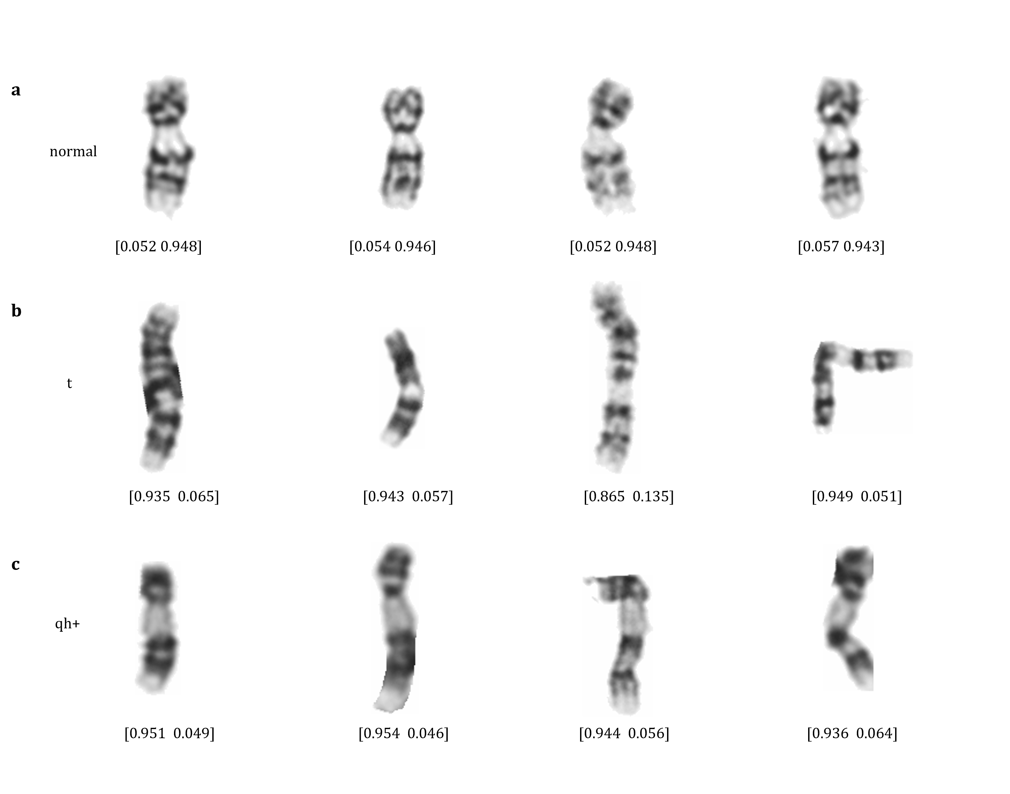
Supplementary Figure 7. Model sensitivity to structural abnormalities and variants at the single-chromosome level. A gallery of Chromosome 9 examples demonstrating CHROMA's classification performance on specific morphological patterns. The numerical values below each image represent the output probability vector formatted as [P_abnormal, P_normal]. a, Representative images of normal Chromosome 9. The model correctly assigns a low probability to the abnormal class (e.g., 0.052). b, Representative images of Chromosome 9 with a translocation (t). The distinct morphological alteration results in a high prediction score for abnormality (e.g., >0.93). c, Representative images of Chromosome 9 with increased heterochromatin (qh+). The model identifies this variant as distinct from the standard normal morphology with high confidence.

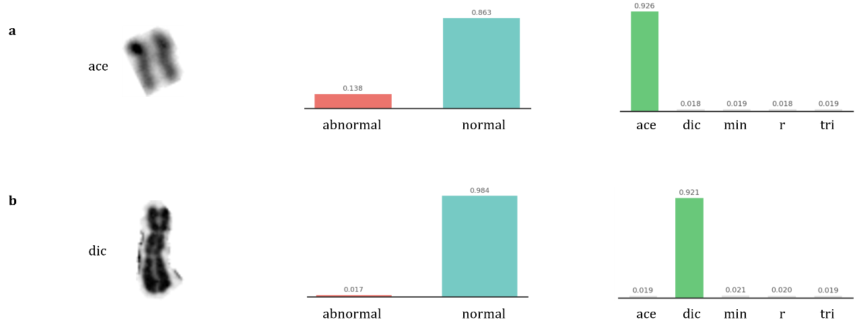
Supplementary Figure 8. Visualization of CHROMA flagging atypical chromosomes in real-world scenarios. The figure displays two challenging cases: an Acentric fragment (Top, ACE) and a Dicentric chromosome (Bottom, DIC). Left: The original input images showing subtle morphological abnormalities. Middle (Stage 1): The binary classifier incorrectly predicts both samples as "Normal" with high confidence (Prob=0.863 and 0.984, respectively), failing to detect the anomalies. Right (Stage 2): CHROMA's fine-grained classifier successfully flags these cases by detecting specific class features with high confidence (>0.92) and low uncertainty (Entropy < 0.4), effectively correcting the false negatives from the binary stage.

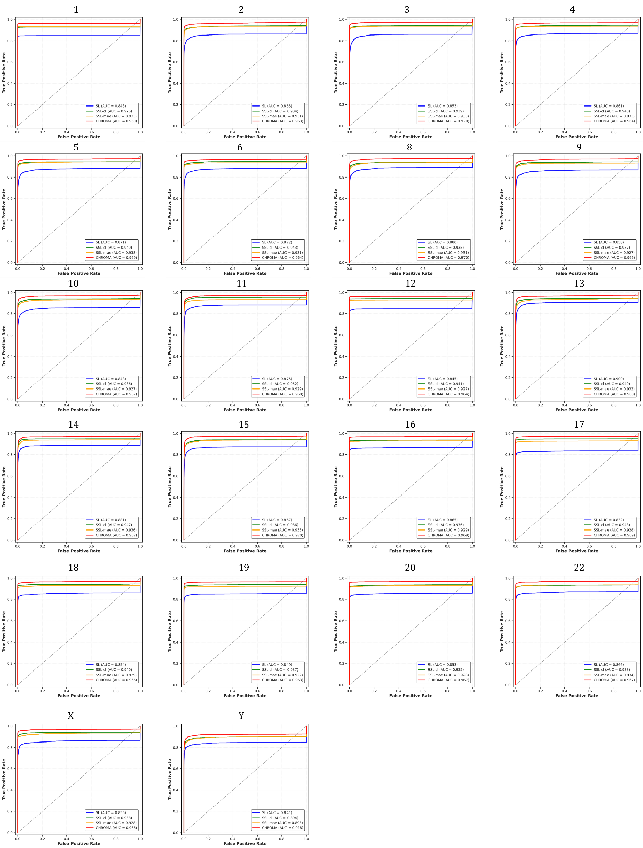
Supplementary Figure 9. ROC curves evaluating classification performance across all other 22 human chromosomes at the cell level.

Panel A: Identification and numerical abnormalities classification performance (Figure 2c)
Metric |  | Method |  | Mean Value |  | 95% CI
Accuracy |  | SL |  | 0.868 |  | [0.842, 0.890]
 |  | SSL-cl |  | 0.941 |  | [0.925, 0.959]
 |  | SSL-mae |  | 0.933 |  | [0.916, 0.954]
 |  | CHROMA |  | 0.953 |  | [0.941, 0.971]
Sensitivity |  | SL |  | 0.863 |  | [0.838, 0.892]
 |  | SSL-cl |  | 0.932 |  | [0.910, 0.952]
 |  | SSL-mae |  | 0.935 |  | [0.913, 0.955]
 |  | CHROMA |  | 0.947 |  | [0.936, 0.962]
Specificity |  | SL |  | 0.994 |  | [0.981, 0.998]
 |  | SSL-cl |  | 0.997 |  | [0.991, 1.000]
 |  | SSL-mae |  | 0.997 |  | [0.988, 1.000]
 |  | CHROMA |  | 0.998 |  | [0.992, 1.000]
G-Mean |  | SL |  | 0.923 |  | [0.904, 0.948]
 |  | SSL-cl |  | 0.969 |  | [0.952, 0.984]
 |  | SSL-mae |  | 0.964 |  | [0.948, 0.982]
 |  | CHROMA |  | 0.973 |  | [0.959, 0.987]
AUC-ROC |  | SL |  | 0.994 |  | [0.976, 0.998]
 |  | SSL-cl |  | 0.995 |  | [0.984, 0.999]
 |  | SSL-mae |  | 0.996 |  | [0.986, 1.000]
 |  | CHROMA |  | 0.996 |  | [0.989, 1.000]
F1-Score |  | SL |  | 0.863 |  | [0.839, 0.893]
 |  | SSL-cl |  | 0.942 |  | [0.922, 0.960]
 |  | SSL-mae |  | 0.933 |  | [0.914, 0.954]
 |  | CHROMA |  | 0.951 |  | [0.933, 0.977]
MCC |  | SL |  | 0.865 |  | [0.836, 0.892]
 |  | SSL-cl |  | 0.937 |  | [0.919, 0.959]
 |  | SSL-mae |  | 0.932 |  | [0.911, 0.953]
 |  | CHROMA |  | 0.944 |  | [0.930, 0.966]
Panel B: Chromosome-wise AUC of CHROMA with 95% CI (Figure 2e)
Chromosomes |  | AUC |  | Chromosomes |  | AUC
7 |  | 0.959 [0.941, 0.977] |  | 21 |  | 0.966 [0.950, 0.982]
1 |  | 0.960 [0.942, 0.978] |  | 2 |  | 0.963 [0.946, 0.980]
3 |  | 0.970 [0.955, 0.985] |  | 4 |  | 0.964 [0.947, 0.981]
5 |  | 0.969 [0.954, 0.984] |  | 6 |  | 0.964 [0.947, 0.981]
8 |  | 0.970 [0.956, 0.984] |  | 9 |  | 0.966 [0.950, 0.982]
10 |  | 0.967 [0.951, 0.983] |  | 11 |  | 0.968 [0.952, 0.984]
12 |  | 0.964 [0.948, 0.980] |  | 13 |  | 0.968 [0.953, 0.983]
14 |  | 0.967 [0.952, 0.982] |  | 15 |  | 0.970 [0.956, 0.984]
16 |  | 0.969 [0.954, 0.984] |  | 17 |  | 0.969 [0.954, 0.984]
18 |  | 0.966 [0.951, 0.981] |  | 19 |  | 0.963 [0.947, 0.979]
20 |  | 0.967 [0.951, 0.983] |  | 22 |  | 0.967 [0.952, 0.982]
X |  | 0.966 [0.950, 0.982] |  | Y |  | 0.918 [0.892, 0.944]
Panel C: Performance metrics of stable abnormalities across low, medium, and high groups (Figure 3a)
Group Low
Method | Metric |  | Value |  | Metric |  | Value
SL | Accuracy |  | 0.884 [0.852, 0.918] |  | Sensitivity |  | 0.699 [0.654, 0.748]
SSL-cl |  |  | 0.816 [0.778, 0.852] |  |  |  | 0.725 [0.679, 0.769]
SSL-mae |  |  | 0.879 [0.845, 0.911] |  |  |  | 0.777 [0.736, 0.820]
CHROMA |  |  | 0.888 [0.855, 0.919] |  |  |  | 0.894 [0.866, 0.922]
SL | Specificity |  | 0.702 [0.654, 0.748] |  | G-Mean |  | 0.634 [0.589, 0.679]
SSL-cl |  |  | 0.724 [0.683, 0.765] |  |  |  | 0.669 [0.618, 0.718]
SSL-mae |  |  | 0.778 [0.741, 0.815] |  |  |  | 0.732 [0.689, 0.777]
CHROMA |  |  | 0.893 [0.863, 0.925] |  |  |  | 0.884 [0.847, 0.919]
SL | AUC-ROC |  | 0.834 [0.801, 0.867] |  | AUC-PR |  | 0.754 [0.718, 0.790]
SSL-cl |  |  | 0.811 [0.785, 0.834] |  |  |  | 0.741 [0.704, 0.778]
SSL-mae |  |  | 0.888 [0.860, 0.916] |  |  |  | 0.825 [0.801, 0.850]
CHROMA |  |  | 0.964 [0.954, 0.978] |  |  |  | 0.934 [0.918, 0.947]
SL | F1-score |  | 0.701 [0.665, 0.734] |  | MCC |  | 0.427 [0.385, 0.470]
SSL-cl |  |  | 0.664 [0.631, 0.698] |  |  |  | 0.405 [0.360, 0.444]
SSL-mae |  |  | 0.734 [0.708, 0.769] |  |  |  | 0.524 [0.486, 0.561]
CHROMA |  |  | 0.812 [0.786, 0.837] |  |  |  | 0.686 [0.652, 0.715]
Group Medium
Method | Metric |  | Value |  | Metric |  | Value
SL | Accuracy |  | 0.819 [0.779, 0.857] |  | Sensitivity |  | 0.558 [0.508, 0.608]
SSL-cl |  |  | 0.902 [0.871, 0.933] |  |  |  | 0.633 [0.589, 0.681]
SSL-mae |  |  | 0.849 [0.814, 0.884] |  |  |  | 0.744 [0.703, 0.785]
CHROMA |  |  | 0.895 [0.867, 0.923] |  |  |  | 0.905 [0.861, 0.935]
SL | Specificity |  | 0.549 [0.496, 0.592] |  | G-Mean |  | 0.316 [0.245, 0.347]
SSL-cl |  |  | 0.625 [0.591, 0.672] |  |  |  | 0.353 [0.273, 0.379]
SSL-mae |  |  | 0.742 [0.695, 0.776] |  |  |  | 0.594 [0.548, 0.640]
CHROMA |  |  | 0.908 [0.873, 0.937] |  |  |  | 0.881 [0.846, 0.916]
SL | AUC-ROC |  | 0.735 [0.694, 0.776] |  | AUC-PR |  | 0.636 [0.596, 0.676]
SSL-cl |  |  | 0.721 [0.681, 0.761] |  |  |  | 0.694 [0.655, 0.733]
SSL-mae |  |  | 0.860 [0.830, 0.890] |  |  |  | 0.809 [0.775, 0.843]
CHROMA |  |  | 0.972 [0.957, 0.987] |  |  |  | 0.958 [0.940, 0.976]
SL | F1-score |  | 0.520 [0.471, 0.569] |  | MCC |  | 0.148 [0.091, 0.205]
SSL-cl |  |  | 0.581 [0.534, 0.628] |  |  |  | 0.221 [0.165, 0.277]
SSL-mae |  |  | 0.644 [0.600, 0.688] |  |  |  | 0.384 [0.336, 0.432]
CHROMA |  |  | 0.773 [0.739, 0.807] |  |  |  | 0.612 [0.573, 0.651]
Group High
Method | Metric |  | Value |  | Metric |  | Value
SL | Accuracy |  | 0.918 [0.885, 0.951] |  | Sensitivity |  | 0.557 [0.513, 0.613]
SSL-cl |  |  | 0.898 [0.864, 0.932] |  |  |  | 0.572 [0.528, 0.628]
SSL-mae |  |  | 0.895 [0.862, 0.928] |  |  |  | 0.638 [0.598, 0.688]
CHROMA |  |  | 0.867 [0.834, 0.900] |  |  |  | 0.794 [0.755, 0.833]
SL | Specificity |  | 0.551 [0.515, 0.607] |  | G-Mean |  | 0.238 [0.183, 0.293]
SSL-cl |  |  | 0.561 [0.532, 0.619] |  |  |  | 0.205 [0.152, 0.258]
SSL-mae |  |  | 0.643 [0.584, 0.675] |  |  |  | 0.427 [0.379, 0.475]
CHROMA |  |  | 0.794 [0.755, 0.833] |  |  |  | 0.747 [0.702, 0.792]
SL | AUC-ROC |  | 0.802 [0.769, 0.835] |  | AUC-PR |  | 0.725 [0.686, 0.764]
SSL-cl |  |  | 0.606 [0.560, 0.652] |  |  |  | 0.611 [0.569, 0.653]
SSL-mae |  |  | 0.847 [0.816, 0.878] |  |  |  | 0.776 [0.740, 0.812]
CHROMA |  |  | 0.922 [0.897, 0.947] |  |  |  | 0.861 [0.831, 0.891]
SL | F1-score |  | 0.571 [0.522, 0.620] |  | MCC |  | 0.208 [0.149, 0.267]
SSL-cl |  |  | 0.539 [0.490, 0.588] |  |  |  | 0.127 [0.075, 0.179]
SSL-mae |  |  | 0.618 [0.573, 0.663] |  |  |  | 0.305 [0.257, 0.353]
CHROMA |  |  | 0.706 [0.667, 0.745] |  |  |  | 0.473 [0.430, 0.516]
Panel D: Binary classification and five-class classification of unstable abnormalities (Figure 4a)
normal vs. abnormal
Method | Metric |  | Value |  | Metric |  | Value
SL | Accuracy |  | 0.950 [0.932, 0.968] |  | Sensitivity |  | 0.784 [0.746, 0.822]
SSL-cl |  |  | 0.862 [0.832, 0.892] |  |  |  | 0.725 [0.685, 0.765]
SSL-mae |  |  | 0.903 [0.876, 0.930] |  |  |  | 0.810 [0.776, 0.844]
CHROMA |  |  | 0.931 [0.910, 0.952] |  |  |  | 0.857 [0.831, 0.883]
SL | Specificity |  | 0.794 [0.762, 0.841] |  | G-Mean |  | 0.761 [0.723, 0.799]
SSL-cl |  |  | 0.726 [0.673, 0.769] |  |  |  | 0.710 [0.672, 0.748]
SSL-mae |  |  | 0.801 [0.784, 0.831] |  |  |  | 0.804 [0.768, 0.840]
CHROMA |  |  | 0.855 [0.828, 0.885] |  |  |  | 0.853 [0.824, 0.882]
SL | AUC-ROC |  | 0.916 [0.898, 0.934] |  | AUC-PR |  | 0.777 [0.742, 0.812]
SSL-cl |  |  | 0.796 [0.768, 0.824] |  |  |  | 0.618 [0.582, 0.654]
SSL-mae |  |  | 0.904 [0.887, 0.921] |  |  |  | 0.744 [0.712, 0.776]
CHROMA |  |  | 0.941 [0.929, 0.953] |  |  |  | 0.821 [0.798, 0.844]
SL | F1-score |  | 0.745 [0.709, 0.781] |  | MCC |  | 0.499 [0.459, 0.539]
SSL-cl |  |  | 0.596 [0.559, 0.633] |  |  |  | 0.263 [0.218, 0.308]
SSL-mae |  |  | 0.671 [0.634, 0.708] |  |  |  | 0.401 [0.361, 0.441]
CHROMA |  |  | 0.729 [0.696, 0.762] |  |  |  | 0.503 [0.465, 0.541]
ace, dic, min, r, tri
Method | Metric |  | Value |  | Metric |  | Value
SL | Accuracy |  | 0.899 [0.867, 0.931] |  | Sensitivity |  | 0.501 [0.446, 0.556]
SSL-cl |  |  | 0.872 [0.839, 0.905] |  |  |  | 0.509 [0.457, 0.561]
SSL-mae |  |  | 0.840 [0.806, 0.874] |  |  |  | 0.642 [0.598, 0.686]
CHROMA |  |  | 0.925 [0.901, 0.949] |  |  |  | 0.670 [0.627, 0.713]
SL | Specificity |  | 0.958 [0.937, 0.979] |  | G-Mean |  | 0.573 [0.525, 0.621]
SSL-cl |  |  | 0.953 [0.931, 0.975] |  |  |  | 0.577 [0.529, 0.625]
SSL-mae |  |  | 0.953 [0.932, 0.974] |  |  |  | 0.676 [0.633, 0.719]
CHROMA |  |  | 0.976 [0.960, 0.992] |  |  |  | 0.715 [0.678, 0.752]
SL | AUC-ROC |  | 0.941 [0.921, 0.961] |  | AUC-PR |  | 0.735 [0.698, 0.772]
SSL-cl |  |  | 0.832 [0.801, 0.863] |  |  |  | 0.644 [0.605, 0.683]
SSL-mae |  |  | 0.945 [0.930, 0.960] |  |  |  | 0.726 [0.696, 0.756]
CHROMA |  |  | 0.968 [0.953, 0.983] |  |  |  | 0.747 [0.715, 0.779]
SL | F1-score |  | 0.547 [0.506, 0.588] |  | MCC |  | 0.546 [0.507, 0.585]
SSL-cl |  |  | 0.537 [0.497, 0.577] |  |  |  | 0.519 [0.481, 0.557]
SSL-mae |  |  | 0.589 [0.551, 0.627] |  |  |  | 0.556 [0.518, 0.594]
CHROMA |  |  | 0.660 [0.622, 0.698] |  |  |  | 0.644 [0.605, 0.683]
Supplementary Table 3. Detailed performance metrics of CHROMA with 95% CI.

SampleID | Chroma_errors | Ikaros_errors | SampleID | Chroma_errors | Ikaros_errors | SampleID | Chroma_errors | Ikaros_errors
1 | 0 | 29 | 101 | 0 | 12 | 201 | 2 | 10
2 | 0 | 12 | 102 | 0 | 32 | 202 | 0 | 19
3 | 0 | 14 | 103 | 0 | 33 | 203 | 0 | 13
4 | 0 | 9 | 104 | 0 | 33 | 204 | 4 | 33
5 | 1 | 33 | 105 | 0 | 33 | 205 | 0 | 15
6 | 0 | 27 | 106 | 0 | 6 | 206 | 0 | 3
7 | 0 | 2 | 107 | 0 | 33 | 207 | 0 | 5
8 | 0 | 28 | 108 | 0 | 19 | 208 | 1 | 33
9 | 0 | 6 | 109 | 3 | 15 | 209 | 0 | 26
10 | 0 | 28 | 110 | 2 | 33 | 210 | 0 | 33
11 | 1 | 33 | 111 | 0 | 17 | 211 | 0 | 33
12 | 0 | 32 | 112 | 0 | 5 | 212 | 0 | 29
13 | 0 | 31 | 113 | 0 | 25 | 213 | 1 | 19
14 | 0 | 33 | 114 | 0 | 16 | 214 | 0 | 33
15 | 0 | 17 | 115 | 0 | 32 | 215 | 0 | 6
16 | 0 | 4 | 116 | 0 | 33 | 216 | 0 | 30
17 | 0 | 19 | 117 | 2 | 33 | 217 | 0 | 33
18 | 0 | 3 | 118 | 0 | 7 | 218 | 0 | 33
19 | 4 | 7 | 119 | 0 | 9 | 219 | 0 | 23
20 | 0 | 8 | 120 | 0 | 21 | 220 | 0 | 14
21 | 1 | 28 | 121 | 0 | 22 | 221 | 0 | 31
22 | 0 | 33 | 122 | 2 | 17 | 222 | 0 | 31
23 | 0 | 22 | 123 | 0 | 32 | 223 | 0 | 28
24 | 0 | 33 | 124 | 1 | 31 | 224 | 0 | 22
25 | 0 | 19 | 125 | 0 | 19 | 225 | 1 | 10
26 | 0 | 13 | 126 | 0 | 25 | 226 | 0 | 24
27 | 2 | 3 | 127 | 0 | 28 | 227 | 0 | 30
28 | 0 | 33 | 128 | 0 | 21 | 228 | 0 | 27
29 | 0 | 17 | 129 | 0 | 33 | 229 | 0 | 9
30 | 0 | 25 | 130 | 0 | 9 | 230 | 0 | 24
31 | 1 | 24 | 131 | 1 | 33 | 231 | 0 | 33
32 | 0 | 32 | 132 | 0 | 15 | 232 | 1 | 5
33 | 0 | 24 | 133 | 0 | 28 | 233 | 0 | 4
34 | 0 | 26 | 134 | 0 | 7 | 234 | 0 | 33
35 | 1 | 28 | 135 | 3 | 18 | 235 | 1 | 30
36 | 0 | 8 | 136 | 0 | 33 | 236 | 0 | 5
37 | 0 | 30 | 137 | 0 | 15 | 237 | 2 | 26
38 | 2 | 33 | 138 | 2 | 32 | 238 | 0 | 13
39 | 1 | 33 | 139 | 0 | 16 | 239 | 0 | 7
40 | 1 | 28 | 140 | 0 | 9 | 240 | 1 | 33
41 | 2 | 15 | 141 | 0 | 11 | 241 | 2 | 22
42 | 0 | 13 | 142 | 0 | 29 | 242 | 0 | 16
43 | 0 | 5 | 143 | 0 | 4 | 243 | 0 | 18
44 | 1 | 8 | 144 | 1 | 26 | 244 | 0 | 17
45 | 0 | 14 | 145 | 2 | 33 | 245 | 1 | 33
46 | 1 | 33 | 146 | 0 | 6 | 246 | 0 | 28
47 | 3 | 20 | 147 | 0 | 6 | 247 | 0 | 11
48 | 0 | 4 | 148 | 0 | 15 | 248 | 0 | 30
49 | 0 | 26 | 149 | 0 | 4 | 249 | 0 | 9
50 | 0 | 3 | 150 | 0 | 4 | 250 | 0 | 12
51 | 0 | 13 | 151 | 0 | 24 | 251 | 0 | 17
52 | 0 | 20 | 152 | 0 | 16 | 252 | 0 | 8
53 | 2 | 31 | 153 | 0 | 20 | 253 | 1 | 17
54 | 0 | 13 | 154 | 0 | 10 | 254 | 0 | 33
55 | 0 | 10 | 155 | 0 | 24 | 255 | 0 | 1
56 | 2 | 19 | 156 | 0 | 17 | 256 | 0 | 7
57 | 0 | 26 | 157 | 0 | 13 | 257 | 0 | 33
58 | 1 | 33 | 158 | 0 | 33 | 258 | 0 | 33
59 | 0 | 27 | 159 | 1 | 33 | 259 | 0 | 33
60 | 1 | 33 | 160 | 3 | 16 | 260 | 0 | 11
61 | 0 | 5 | 161 | 1 | 24 | 261 | 0 | 18
62 | 0 | 11 | 162 | 0 | 9 | 262 | 0 | 20
63 | 0 | 18 | 163 | 0 | 20 | 263 | 0 | 22
64 | 0 | 16 | 164 | 2 | 31 | 264 | 0 | 29
65 | 1 | 9 | 165 | 1 | 15 | 265 | 0 | 33
66 | 2 | 33 | 166 | 2 | 20 | 266 | 0 | 25
67 | 0 | 33 | 167 | 0 | 23 | 267 | 2 | 27
68 | 0 | 4 | 168 | 1 | 15 | 268 | 2 | 9
69 | 0 | 16 | 169 | 0 | 7 | 269 | 0 | 30
70 | 0 | 9 | 170 | 1 | 25 | 270 | 0 | 29
71 | 0 | 31 | 171 | 1 | 22 | 271 | 2 | 19
72 | 0 | 11 | 172 | 0 | 31 | 272 | 0 | 10
73 | 0 | 10 | 173 | 1 | 20 | 273 | 2 | 25
74 | 0 | 12 | 174 | 0 | 29 | 274 | 1 | 8
75 | 0 | 23 | 175 | 3 | 3 | 275 | 0 | 15
76 | 0 | 22 | 176 | 0 | 30 | 276 | 2 | 33
77 | 0 | 6 | 177 | 1 | 33 | 277 | 1 | 27
78 | 0 | 11 | 178 | 1 | 13 | 278 | 2 | 33
79 | 0 | 15 | 179 | 0 | 8 | 279 | 0 | 12
80 | 0 | 33 | 180 | 1 | 33 | 280 | 0 | 31
81 | 0 | 7 | 181 | 0 | 33 | 281 | 0 | 23
82 | 0 | 18 | 182 | 0 | 6 | 282 | 0 | 12
83 | 0 | 33 | 183 | 0 | 12 | 283 | 2 | 13
84 | 1 | 25 | 184 | 0 | 15 | 284 | 0 | 32
85 | 0 | 27 | 185 | 0 | 30 | 285 | 0 | 11
86 | 0 | 23 | 186 | 0 | 6 | 286 | 0 | 22
87 | 0 | 27 | 187 | 0 | 33 | 287 | 1 | 30
88 | 0 | 22 | 188 | 0 | 25 | 288 | 0 | 12
89 | 0 | 3 | 189 | 0 | 33 | 289 | 0 | 24
90 | 0 | 21 | 190 | 0 | 6 | 290 | 2 | 20
91 | 0 | 14 | 191 | 0 | 33 | 291 | 0 | 20
92 | 2 | 20 | 192 | 0 | 15 | 292 | 2 | 14
93 | 2 | 17 | 193 | 0 | 14 | 293 | 0 | 19
94 | 0 | 33 | 194 | 0 | 10 | 294 | 2 | 5
95 | 1 | 28 | 195 | 0 | 14 | 295 | 0 | 18
96 | 0 | 14 | 196 | 0 | 27 | 296 | 1 | 33
97 | 0 | 25 | 197 | 0 | 7 | 297 | 0 | 23
98 | 0 | 20 | 198 | 0 | 14 | 298 | 0 | 33
99 | 1 | 4 | 199 | 0 | 6 | 299 | 4 | 20
100 | 0 | 24 | 200 | 3 | 28 | 300 | 0 | 4
Supplementary Table 4. The raw data about performance comparison between CHROMA and MetaSystems Ikaros on 300 Clinical Metaphase Spreads.

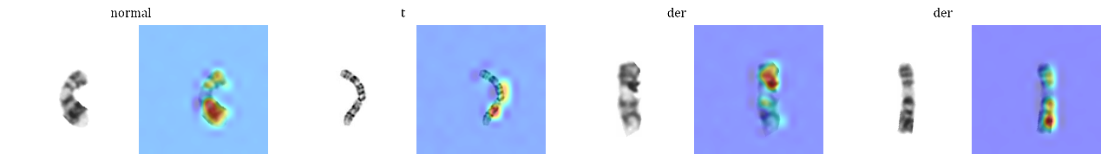
Supplementary Figure 10. Attention visualization of CHROMA. In normal chromosomes, attention is broadly distributed along the global banding patterns. In structurally abnormal chromosomes, attention is concentrated in locally distorted banding regions. Attention maps indicate regions contributing to the model’s decision and are not intended to represent precise cytogenetic breakpoint localization.

