Integrative immune subtyping of HNSCC reveals clinically relevant phenotypes and treatment-associated transitions
Indu Khatri^{1*}, Terezinha de Souza¹⁺, Saskia D. van Asten¹⁺, Merzu Belete², Felipe Vieira Braga³, Merel Jongmans¹, Sriram Sridhar², Brandon W. Higgs², Iris CRM Kolder^{1 *}
¹Translational Data Science, Genmab B.V., Utrecht, The Netherlands
² Translational Data Science, Genmab Inc., Princeton, USA
³Discovery Data Science, Genmab B.V., Utrecht, The Netherlands

⁺ These authors contributed equally
*Correspondence to:
Indu Khatri (inkh@genmab.com) and Iris Kolder (iko@genmab.com)
Genmab B.V., Uppsalalaan 15, 3584 CT,
Utrecht, The Netherlands

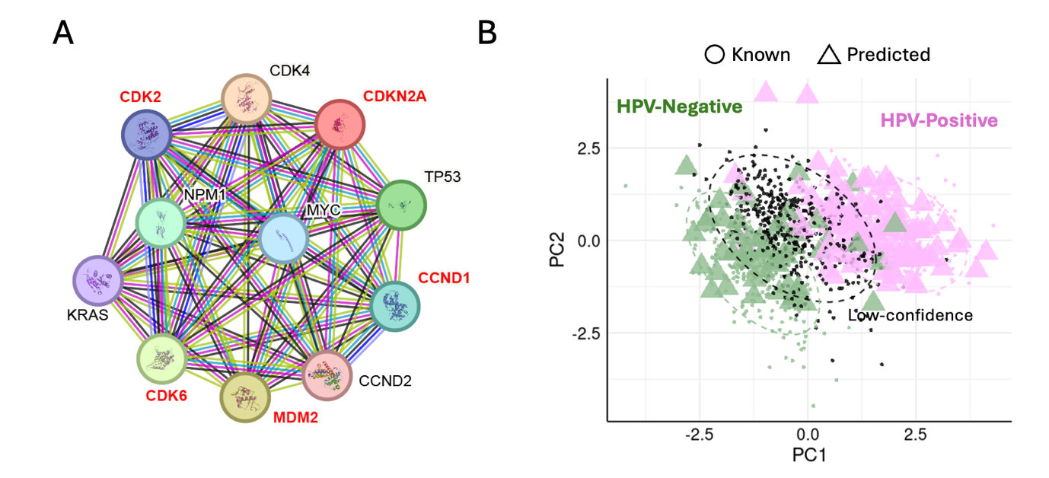
Supplementary Figure S1: Co-expression network of genes associated with p16 (CDKN2A) and HPV status prediction for unknown samples.
(A) Protein–protein interaction network of genes co-expressed with CDKN2A (p16), generated using the STRING database. Nodes represent proteins, and edges represent evidence-based associations including co-expression, experimental data, and curated databases. Genes labeled in red (e.g., CDK2, CDK6, CCND1, MDM2) were ranked higher in feature importance using a Random Forest model.
(B) Principal component analysis (PCA) of transcriptomic data used to visualize HPV status predictions from an SVM model, based on the five red-labeled genes in panel A. Known HPV-positive (purple) and HPV-negative (green) samples were used to train the model. Triangles indicate predicted HPV status for previously unclassified samples. Samples within the dashed circle were considered low-confidence predictions and were not assigned an HPV status.

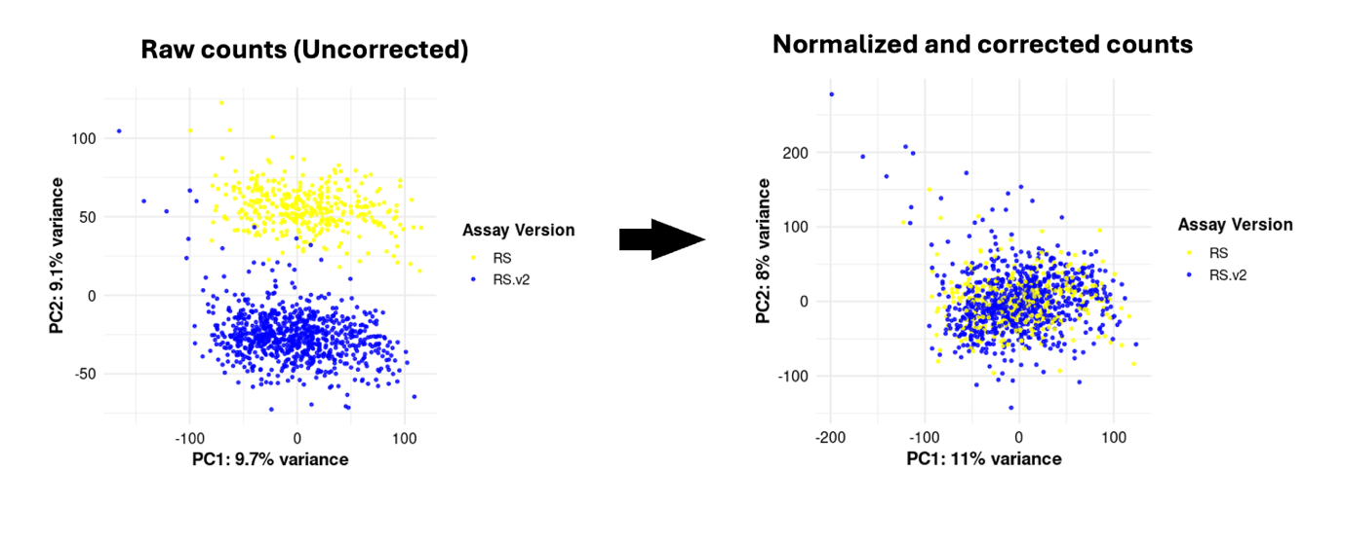
Supplementary Figure S2: Batch correction across assay versions. Principal component analysis (PCA) of gene expression data before and after normalization and batch correction. (Left) Raw (uncorrected) counts show clear separation by assay version: RS (yellow) and RS.v2 (blue). (Right) After normalization and batch correction, samples from both assay versions are mixed, indicating successful mitigation of batch effects.

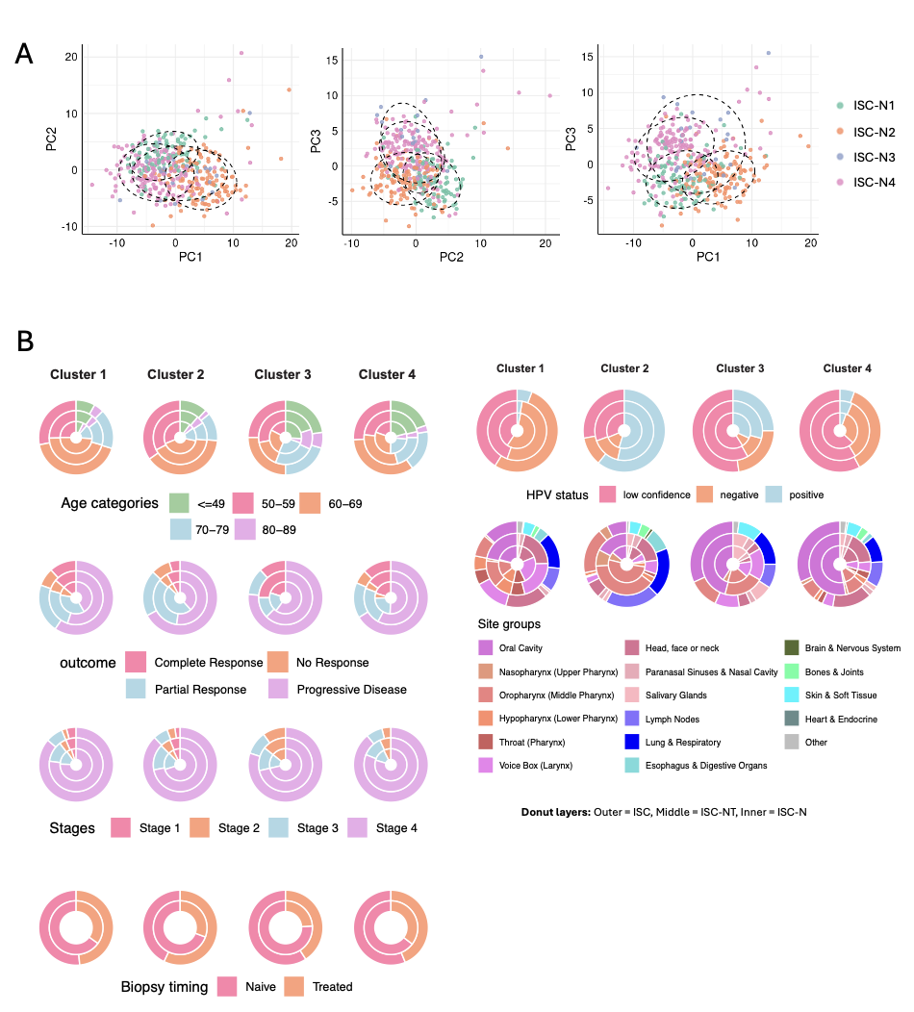
Supplementary Figure S3: Patient stratification and clinical characteristics across immune subtype clusters. (A) PCA plots showing separation of immune subtype clusters (ISC-N1 to ISC-N4) in three PC combinations (PC1 vs PC2, PC2 vs PC3, and PC1 vs PC3). The dashed ellipses mark the dense core of each cluster.
(B) Donut plots summarizing clinical and demographic characteristics across clusters. Each cluster (immune subtype group) is represented by a column of donut charts. The layers represent different data levels: outer (ISC), middle (ISC-NT), and inner (ISC-N).

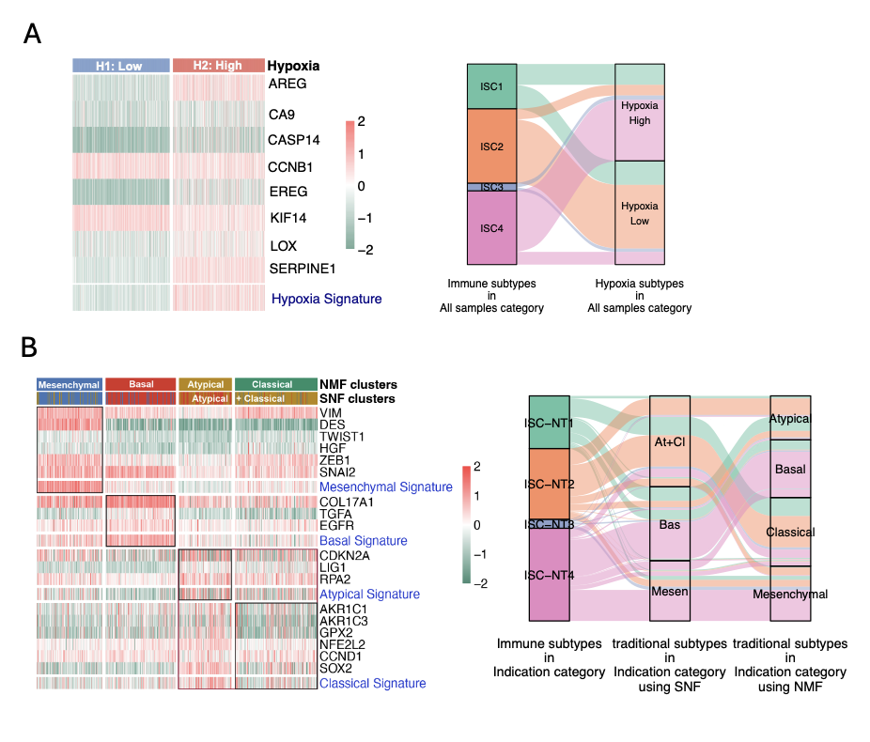
Supplementary Figure S4: Relationship of immune subtypes with hypoxia states and traditional HNSCC subtypes. (A) Hypoxia subtyping: Heatmap (left) shows expression of hypoxia signature genes across samples stratified into low (H1) and high (H2) hypoxia groups. Sankey plot (right) illustrates the distribution of immune subtypes (ISC1–ISC4) across hypoxia subtypes. (B) Traditional HNSCC subtypes: Heatmap (left) shows expression of gene signatures corresponding to four known HNSCC subtypes (Mesenchymal, Basal, Atypical, and Classical) as defined by NMF and SNF clustering. Sankey plot (right) shows the mapping of immune subtypes (ISC-NT1 to ISC-NT4) to traditional subtypes derived using SNF and NMF methods.

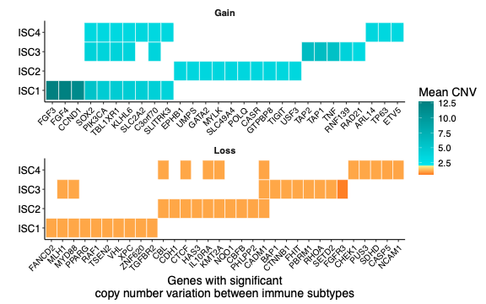
Supplementary Figure S5: Copy number alterations in genes with significant variation across immune subtypes (ISC1–ISC4). The tile plot displays mean copy number values for genes with statistically significant CNV differences between subtypes. The top panel shows copy number gains (mean CNV > 2), and the bottom panel shows losses (mean CNV < 2). Tile color indicates the mean CNV value, transitioning from orange (loss) to teal (gain).

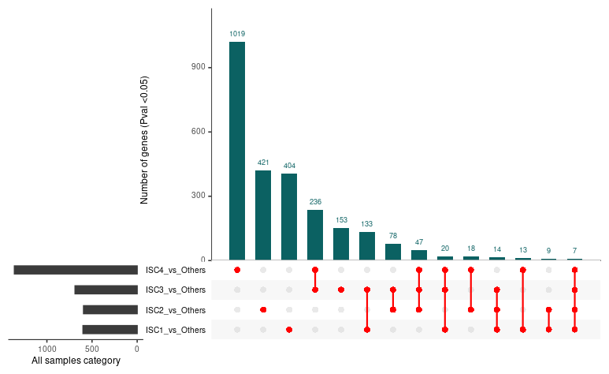
Supplementary Figure S6: Differentially expressed (DE) genes across immune subtype clusters. Bar plot and UpSet plot showing the number of differentially expressed genes (Pvalue < 0.05) for each immune subtype cluster (ISC) compared to the rest of the cohort. The UpSet plot below illustrates the intersections of DE genes among the comparisons, indicating the degree of shared and unique transcriptional changes across the ISC clusters.

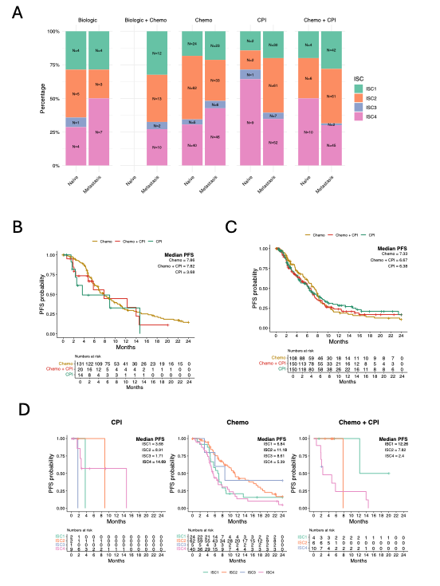
Supplementary Figure S7: Treatment-specific progression-free survival (PFS) patterns in each subtype across clinical settings. (A) Distribution of treatments across ISC subtypes in both 1L (naive) and M1L (metastatic/recurrent) settings. (B) PFS curves for patients in the 1L setting receiving Chemo, CPI, or Chemo + CPI. (C) PFS curves for patients in the M1L setting receiving Chemo, CPI, or Chemo + CPI. (D) Treatment-specific PFS curves stratified by ISC subtype in the 1L setting. Median PFS and number at risk are indicated for all KM plots.

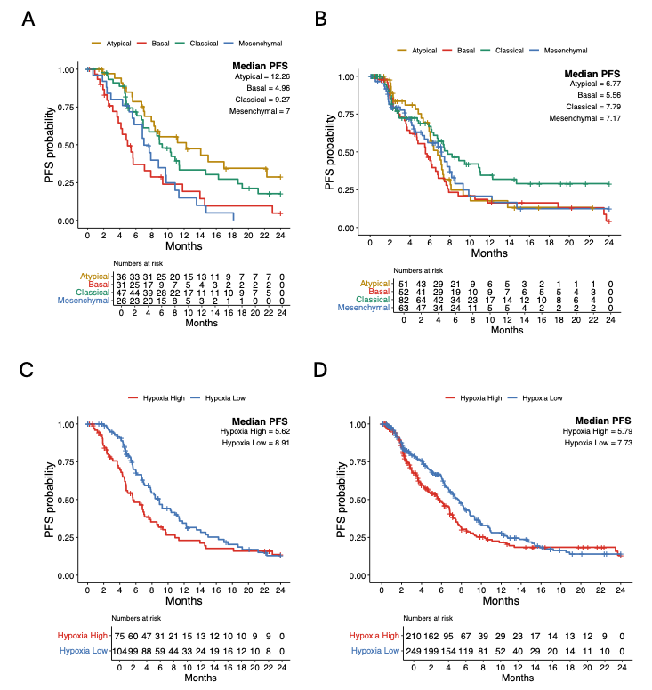
Supplementary Figure S8: Treatment-specific progression-free survival (PFS) patterns in traditional and hypoxia subtypes across clinical settings. PFS curves for patients grouped by traditional subtypes in the (A) 1L setting and (B) M1L setting. PFS curves for patients grouped by hypoxia subtypes in the (A) 1L setting and (B) M1L setting.
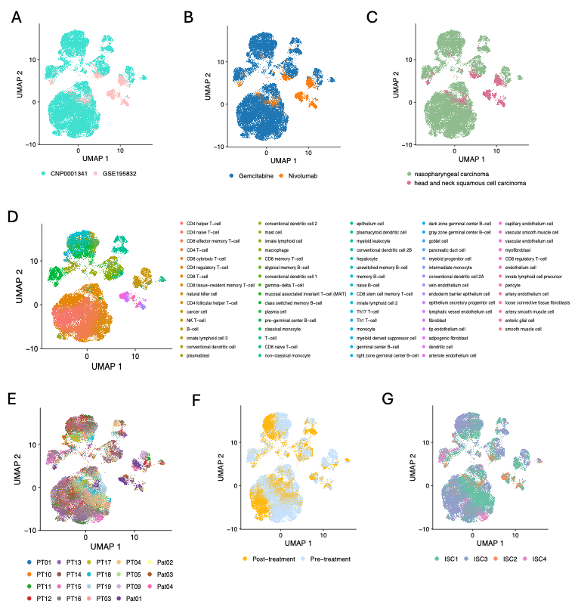
Supplementary Figure S9. Single-cell landscape of two studies featuring pre- and post-treatment samples from HNSCC patients treated with Chemo and CPI. (A) UMAP plot showing integrated single-cell RNA-seq data from two publicly available datasets (CNP0001341 and GSE195832), demonstrating successful cross-study integration. (B) Cells colored by treatment regimen, distinguishing patients treated with Gemcitabine (Chemo) versus Nivolumab (CPI). (C) Cells grouped by cancer type. (D) Cell type annotations based on Nebion reference. (E) UMAP colored by individual patient IDs. (F) Treatment status–specific distribution of cells. (G) Immune subtype classification (ISC1–ISC4) mapped onto the integrated single-cell space.

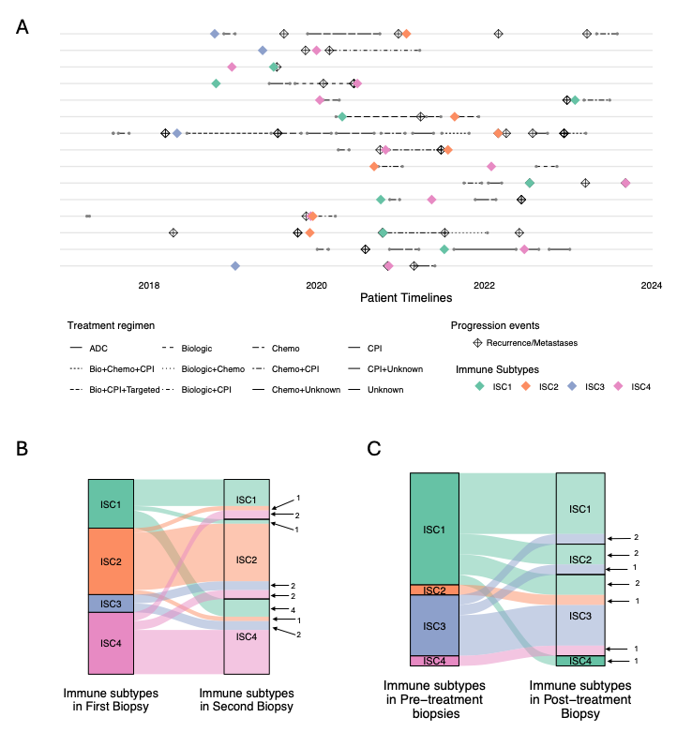
Supplementary Figure S10: Immune Subtype Dynamics Across Timepoints and Modalities (A) Patient-level timelines showing treatment history, recurrence/metastasis events, and immune subtypes at biopsy timepoints. Each row represent a single patient, with lines indicating treatment regimens (line types) over time. (B) Sankey diagram illustrating changes in immune subtypes between the first and second biopsies in the real-world evidence (RWE) cohort. (C) Sankey diagram showing immune subtype transitions between pre-treatment and post-treatment biopsies in the single-cell cohort. Frequencies of transitions are shown.

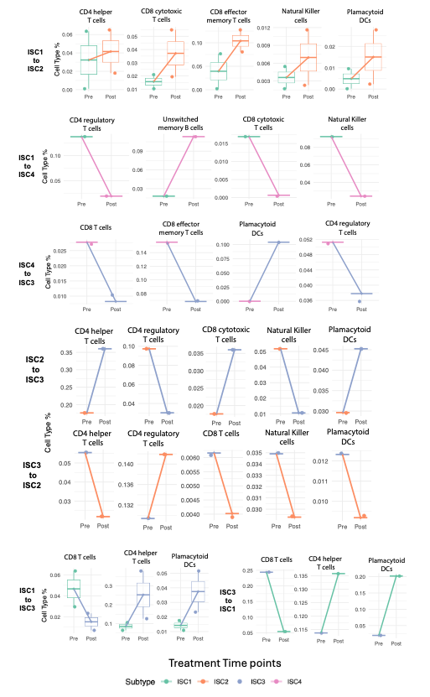
Supplementary Figure S11: Immune cell-type remodeling across treatment-associated subtype transitions in HNSCC. Boxplots and paired lines represent changes in the relative abundance of selected immune cell types between pre- and post-treatment biopsies, stratified by immune subtype transition. Each facet corresponds to a unique subtype–cell type pair (e.g., ISC1→ISC2: CD8 effector memory T cells). Lines connect pre- and post-treatment samples per patient, colored by final (post-treatment) subtype. Cell-type frequencies were calculated as a percentage of total cells per patient and treatment time point using single-cell data from HNSCC tumors. Subtype transitions were inferred by comparing subtype labels between pre- and post-treatment samples for each patient. Cell types shown were selected based on the largest absolute changes in relative abundance (|mean change| > 0.05) across transition groups. Only transitions and cell types meeting this threshold were retained for visualization.

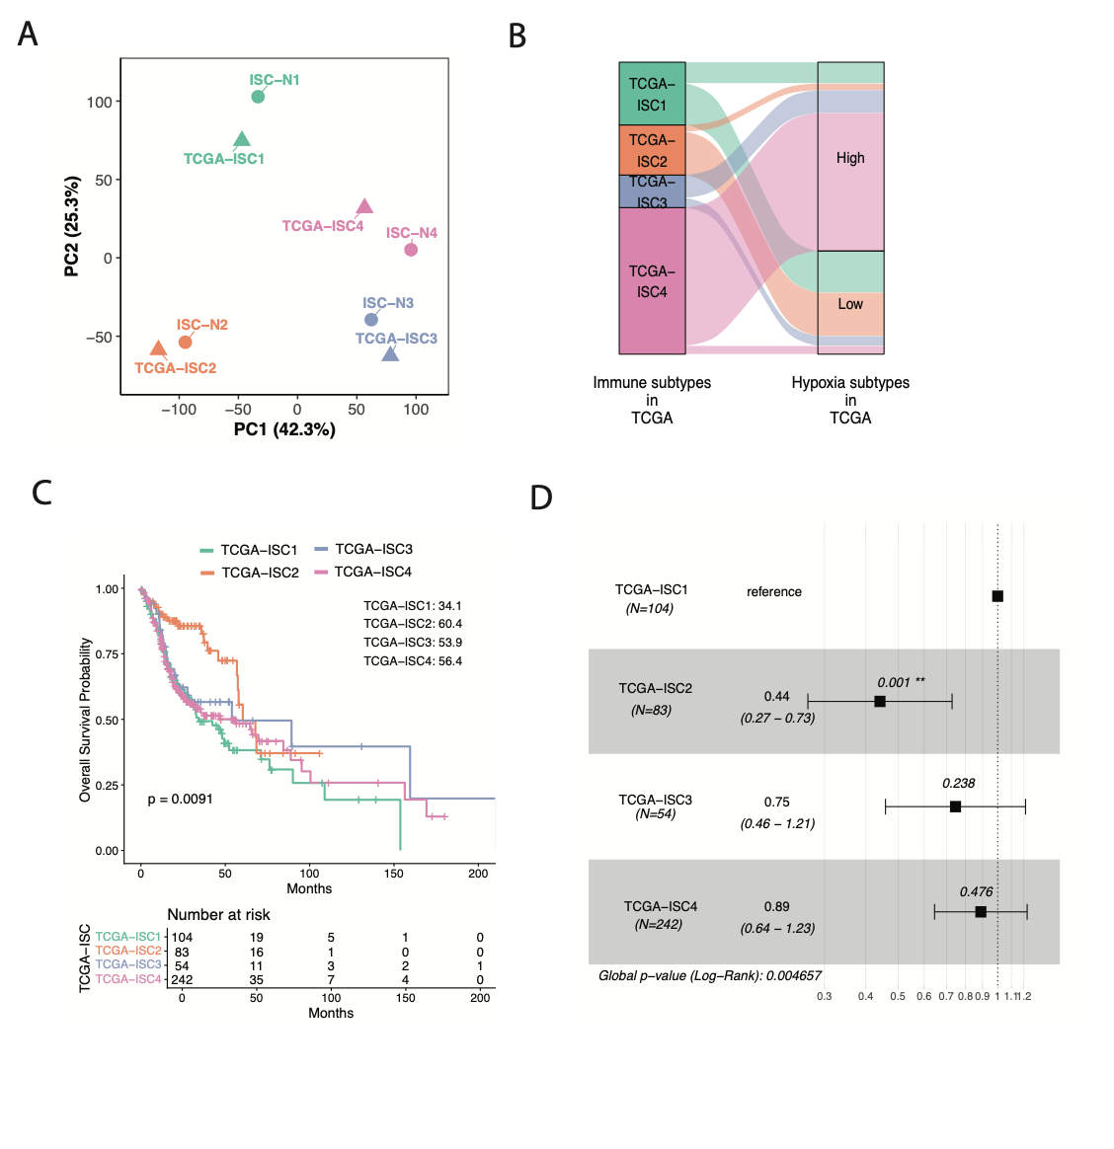
Supplementary Figure S12: External validation of immune subtypes in TCGA-HNSC. (A) PCA of centroid vectors from treatment-naïve RW immune subtypes (ISC-N1–ISC-N4) and TCGA immune subtypes (TCGA-ISC1–TCGA-ISC4). Centroids derived from the same gene set cluster together, indicating preservation of subtype structure across cohorts.
(B) Sankey diagram showing the relationship between TCGA immune subtypes and TCGA hypoxia subtypes. (C) Kaplan–Meier overall survival curves for TCGA-HNSC stratified by TCGA-ISC1–TCGA-ISC4. Median OS values (months). (D) Univariate Cox proportional hazards model comparing survival across TCGA immune subtypes, using TCGA-ISC1 as the reference.

Supplementary Data
Supplementary Data S1: Statistical associations between clinical features and sample categories (all samples, indication, and naïve categories) were assessed using Fisher’s exact test. Reported p-values indicate the significance of categorical associations. “NS” denotes non-significant comparisons (p > 0.05), while “NA” indicates variables not applicable in the specific category. Significance thresholds are reported as follows: p < 0.001, < 0.01. The accompanying tables on the right show the distribution (%) of samples across categories for each clinical variable.
Supplementary Data S2: Mutations significantly enriched in each immune subtype, identified using Fisher’s exact test. Only mutations with statistically significant associations (p < 0.05) are reported per subtype.
Supplementary Data S3: Copy number variations enriched in each cluster , identified using Fisher’s exact test. Only CNVs with statistically significant associations (p < 0.05) are reported per subtype.
Supplementary Data S4: Copy number variation related pathways enriched in each cluster. GSEA was performed on log₂ fold-change ranked genes using 1,000 gene-set permutations, a weighted scoring scheme, and gene sets sized 5–500. Significance was defined at FDR < 0.05.
Supplementary Data S5: DE genes enriched in each cluster. The table shows genes significantly enriched in each cluster based on p-values.
Supplementary Data S6: Regulons enriched in each cluster. The table shows regulons significantly enriched in each cluster based on p-values.
Supplementary Data S7: GSEA Hallmarks enriched in each cluster. GSEA was performed on log₂ fold-change ranked genes using 1,000 gene-set permutations, a weighted scoring scheme, and gene sets sized 5–500. Significance was defined at FDR < 0.05.
Supplementary Data S8: Immune cell composition enriched in each cluster. The table reports the median xCell enrichment score for each cell type within each cluster.
Supplementary Data S9: GSEA ImmuneSigDB profiles enriched in each cluster. GSEA was performed on log₂ fold-change ranked genes using 1,000 gene-set permutations, a weighted scoring scheme, and gene sets sized 5–500. Significance was defined at FDR < 0.05.
Supplementary Table S10: GSEA ImmuneSigDB and HALLMARK profiles enriched in each TCGA cluster. GSEA was performed on log₂ fold-change ranked genes using 1,000 gene-set permutations, a weighted scoring scheme, and gene sets sized 5–500. Significance was defined at FDR < 0.05.

