Supplementary information for Immunopeptidomics-guided identification of functional neoantigens in non-small cell lung cancer

Figure S1: ALYREF immunopeptide protein coverage from LUAD patient #0147

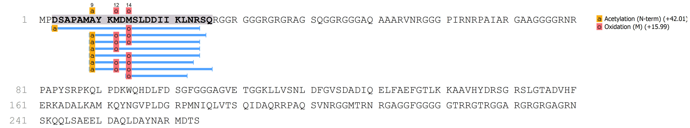

ALYREF protein coverage table, including additional 7 amino acid upstream sequence for the non-canonical length protein (Uniprot E9PB61) (indicated by bracket). The canonical length protein start position (Uniprot Q86V81) after N-terminal methionine removal is indicated by a black arrow. Seven nested observed peptides spanning the Asp→Tyr mutation (red box) are shown mapped in blue. One 22-mer peptide spans the isoform variant N terminus (mutational position: Asp10Tyr). 4 unique peptides spanning the canonical protein sequence only, and including the mutation, ranging from 15-18 amino acids in length were observed (mutational position Asp2Tyr). Three methionine oxidation state variants for the 16-mer were observed. One observed 9-mer peptide from this protein does not span the mutated region.
Figure 2: MS/MS spectra of observed neoantigen immunopeptides from the ALYREF protein including an Asp→Tyr mutation

- 15-mer, sequence AYKMDMSLDDIIKLN
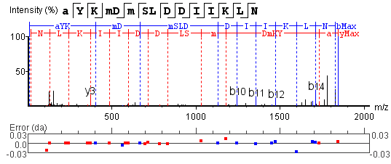
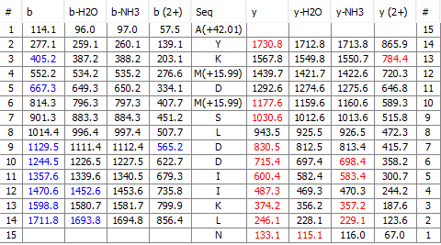
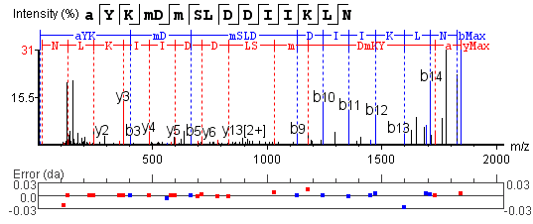
i) Raw spectrum
ii) Zoomed spectrum
iii) Ion table

Figure S2: MS/MS spectra of observed neoantigen immunopeptides from the ALYREF protein including an Asp→Tyr mutation
- 16-mer oxidation variant 1 Sequence: AYKMDMSLDDIIKLMNR
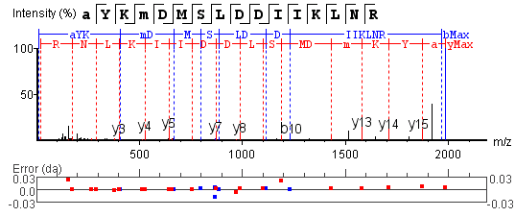
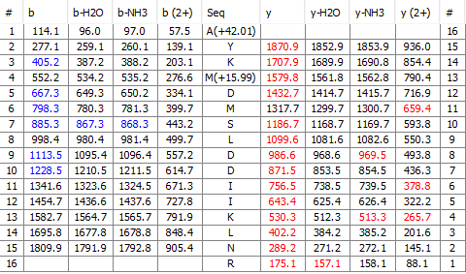
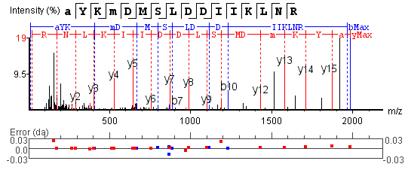
i)
i) Raw spectrum
ii) Zoomed spectrum
iii) Ion table

Figure S2: S2: MS/MS spectra of observed neoantigen immunopeptides from the ALYREF protein including an Asp→Tyr mutation

- 16-mer oxidation variant 2 Sequence: AYKMDMSLDDIIKLMNR
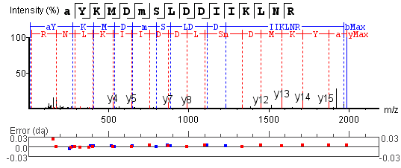
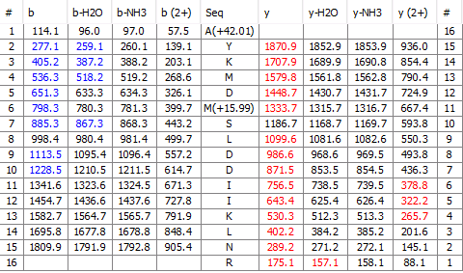
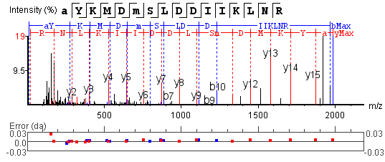
i) Raw spectrum
ii) Zoomed spectrum
iii) Ion table

Figure S2: S2: MS/MS spectra of observed neoantigen immunopeptides from the ALYREF protein including an Asp→Tyr mutation
D) 16-mer oxidation variant 3 Sequence: AYKMDMSLDDIIKLMNR

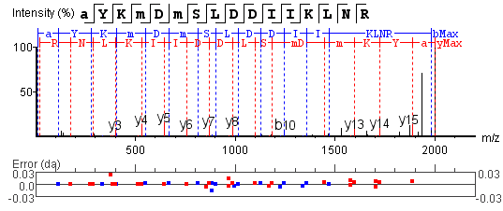
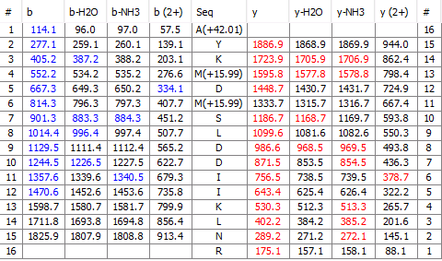
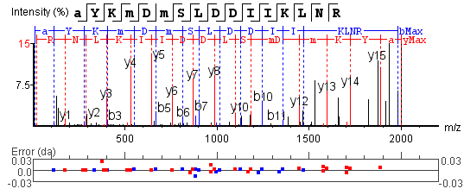
i) Raw spectrum
ii) Zoomed spectrum
iii) Ion table

Figure S2: S2: MS/MS spectra of observed neoantigen immunopeptides from the ALYREF protein including an Asp→Tyr mutation
- 17-mer Sequence: AYKMDMSLDDIIKLMNRS
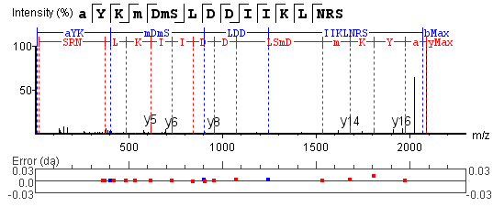
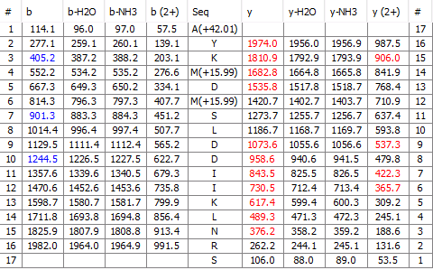
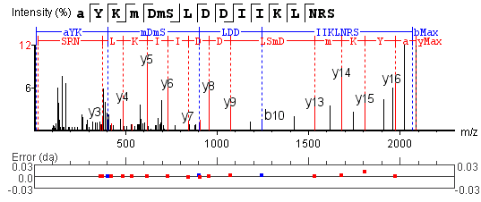
i) Raw spectrum
ii) Zoomed spectrum
iii) Ion table

Figure S2: S2: MS/MS spectra of observed neoantigen immunopeptides from the ALYREF protein including an Asp→Tyr mutation
- 18-mer Sequence: AYKMDMSLDDIIKLMNRSQ

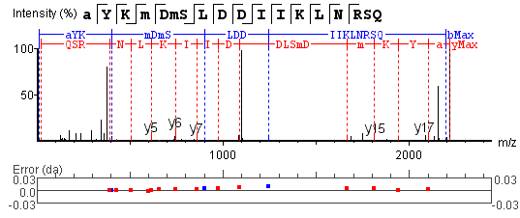
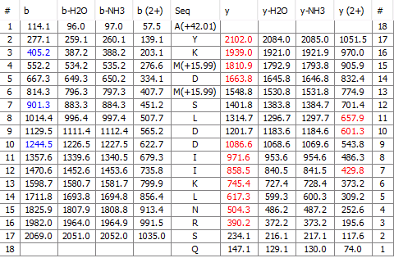
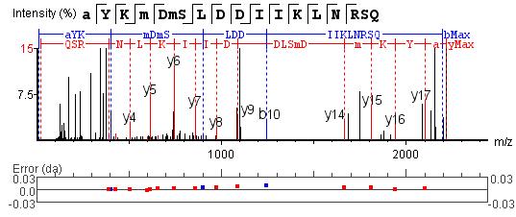
i) Raw spectrum
ii) Zoomed spectrum
iii) Ion table

Figure S2: S2: MS/MS spectra of observed neoantigen immunopeptides from the ALYREF protein including an Asp→Tyr mutation
- 22-mer isoform Sequence: DSAPAMAYKMDMSLDDIIKLNR
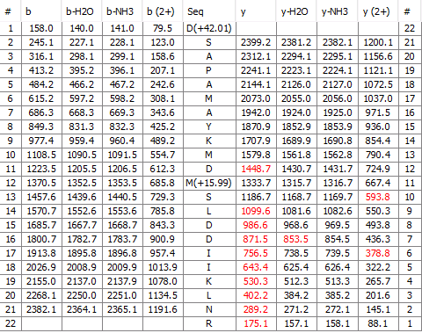
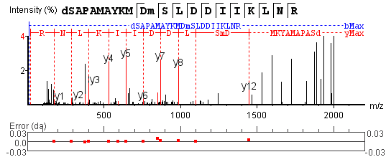
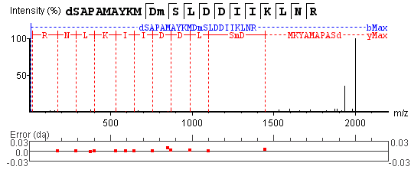
i) Raw spectrum
ii) Zoomed spectrum
iii) Ion table
Figure S3: MS/M spectrum of synthetic 15-mer neoantigen ALYREF peptide

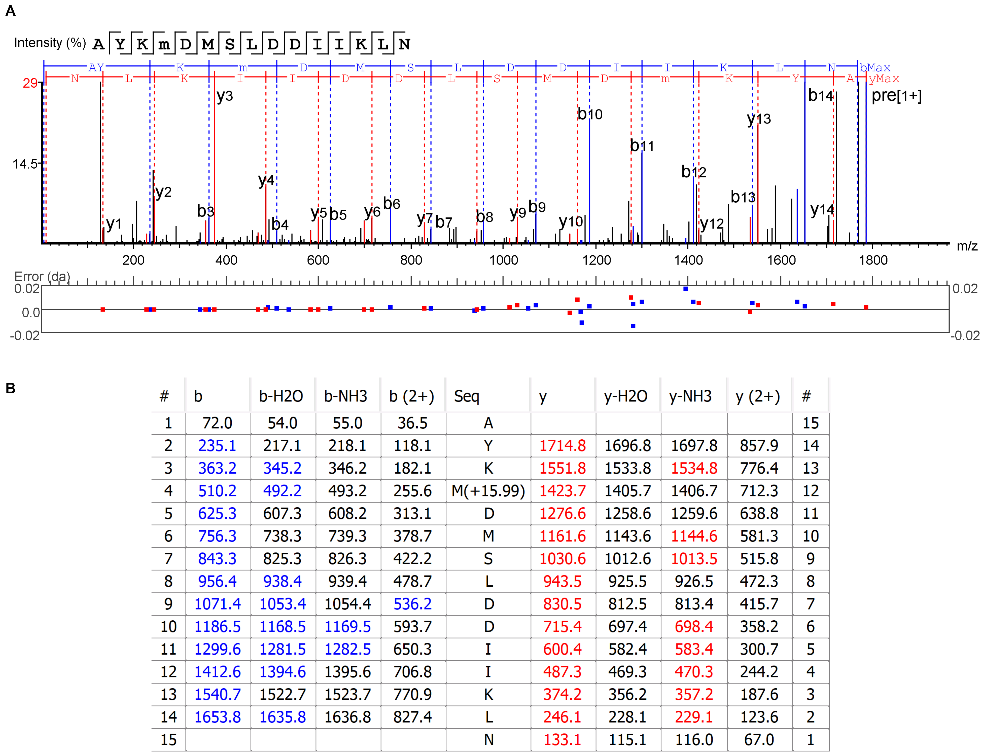

(A) MS/MS spectrum of synthetic peptide arising from ALYREF. (B) Ion table.

Figure S4: LUAD HLA-I model trace plot
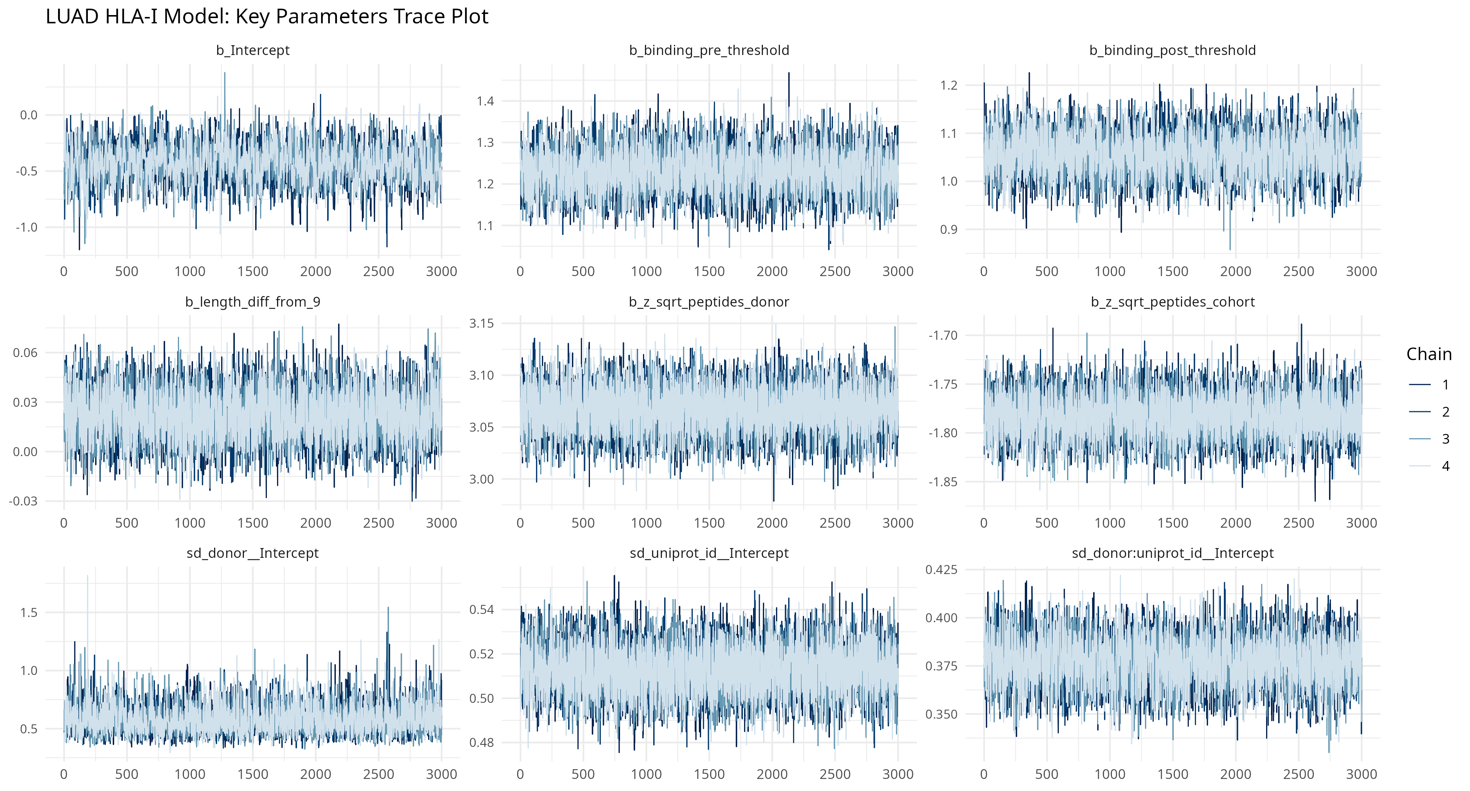
Trace plot of MCMC draws for key parameters.

Figure S5: LUAD HLA-II model trace plot
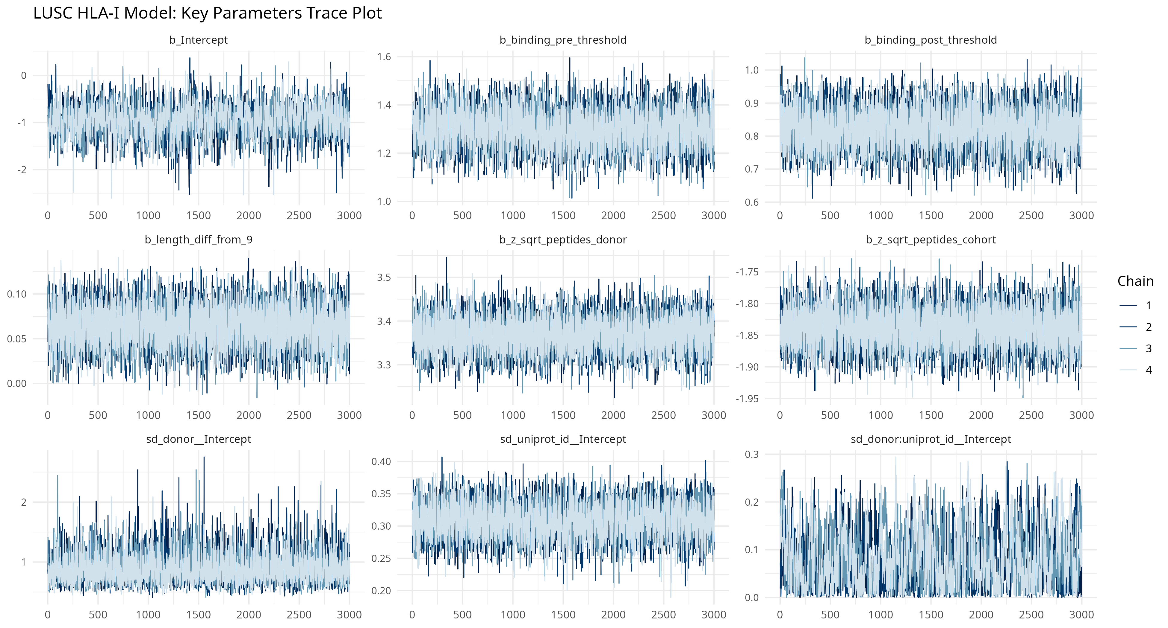
Trace plot of MCMC draws for key parameters.

Figure S6: LUSC HLA-I model trace plot
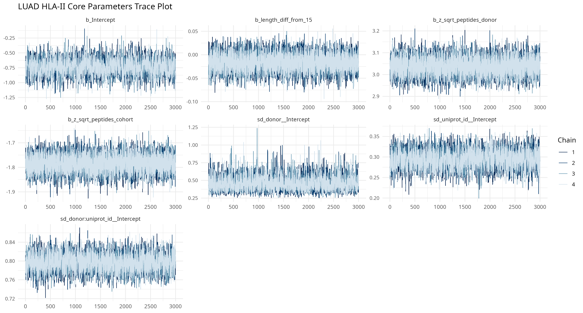
Trace plot of MCMC draws for key parameters.

Figure S7: LUSC HLA-II model trace plot
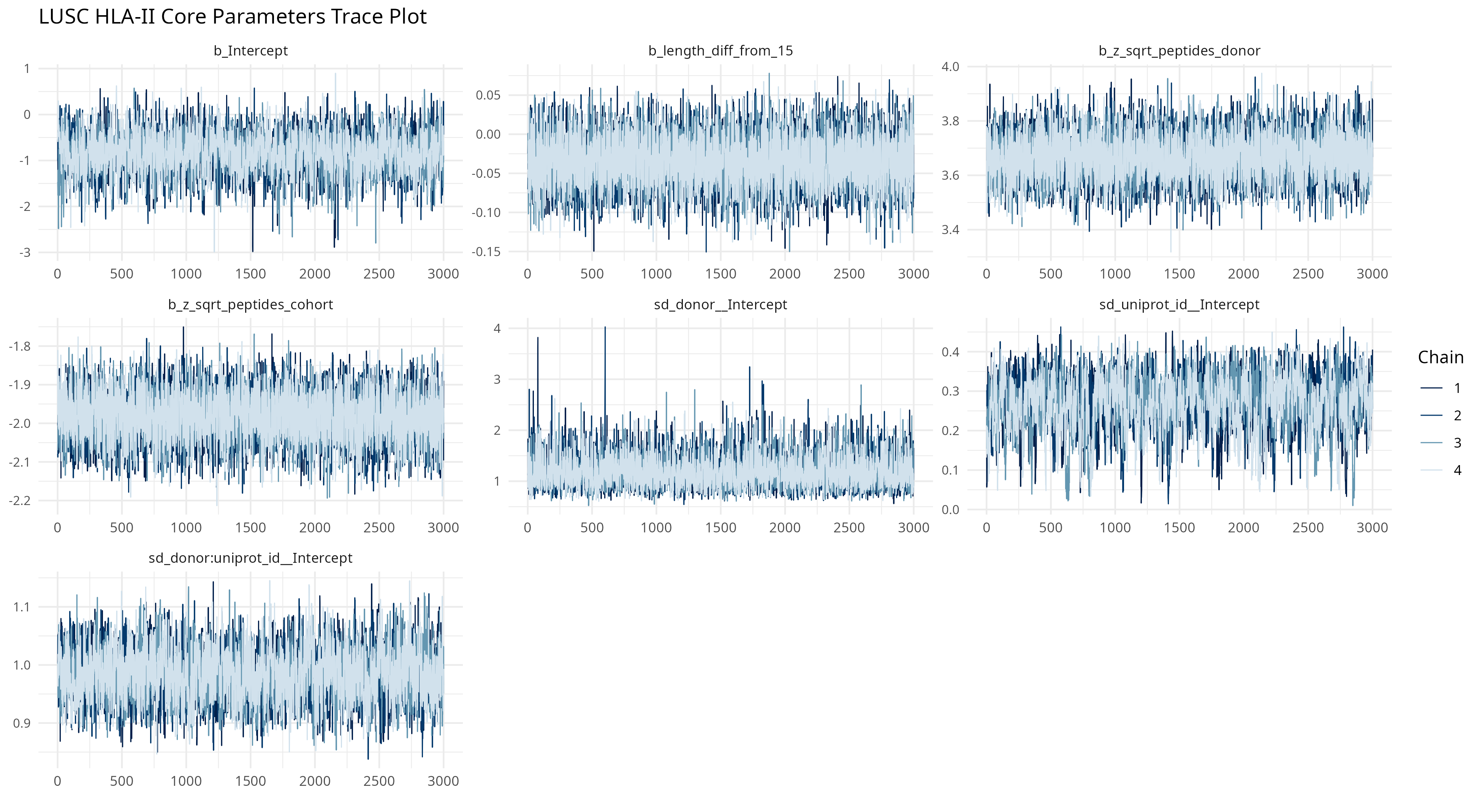
Trace plot of MCMC draws for key parameters.

Figure S8: LUAD HLA-I caterpillar plot
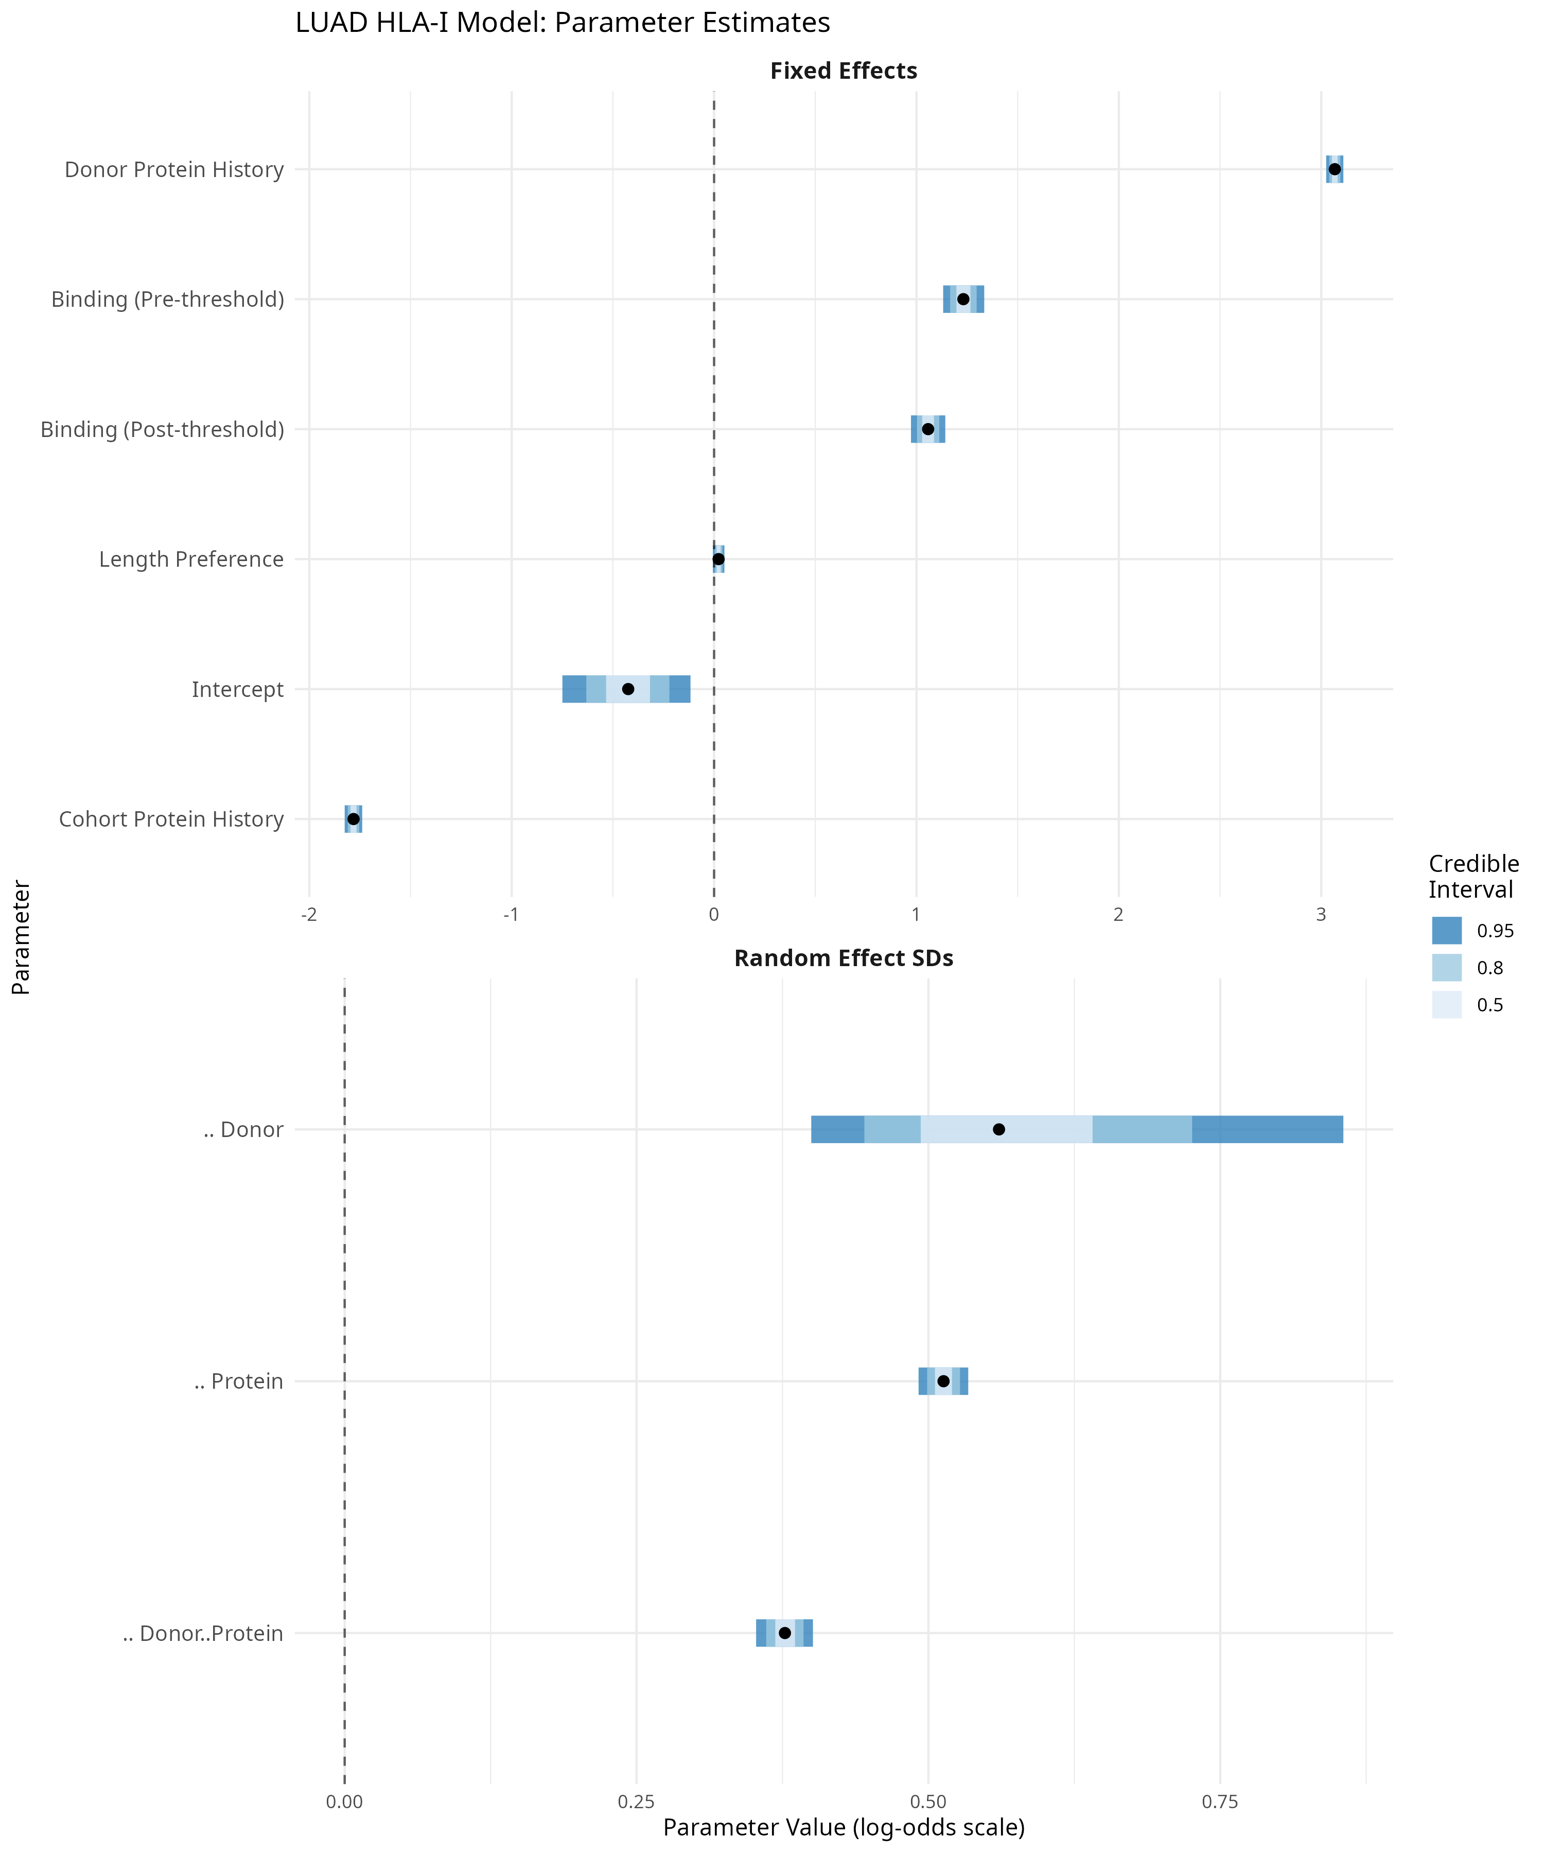
Caterpillar plot of uncertainty for key model parameters.

Figure S9: LUAD HLA-II caterpillar plot
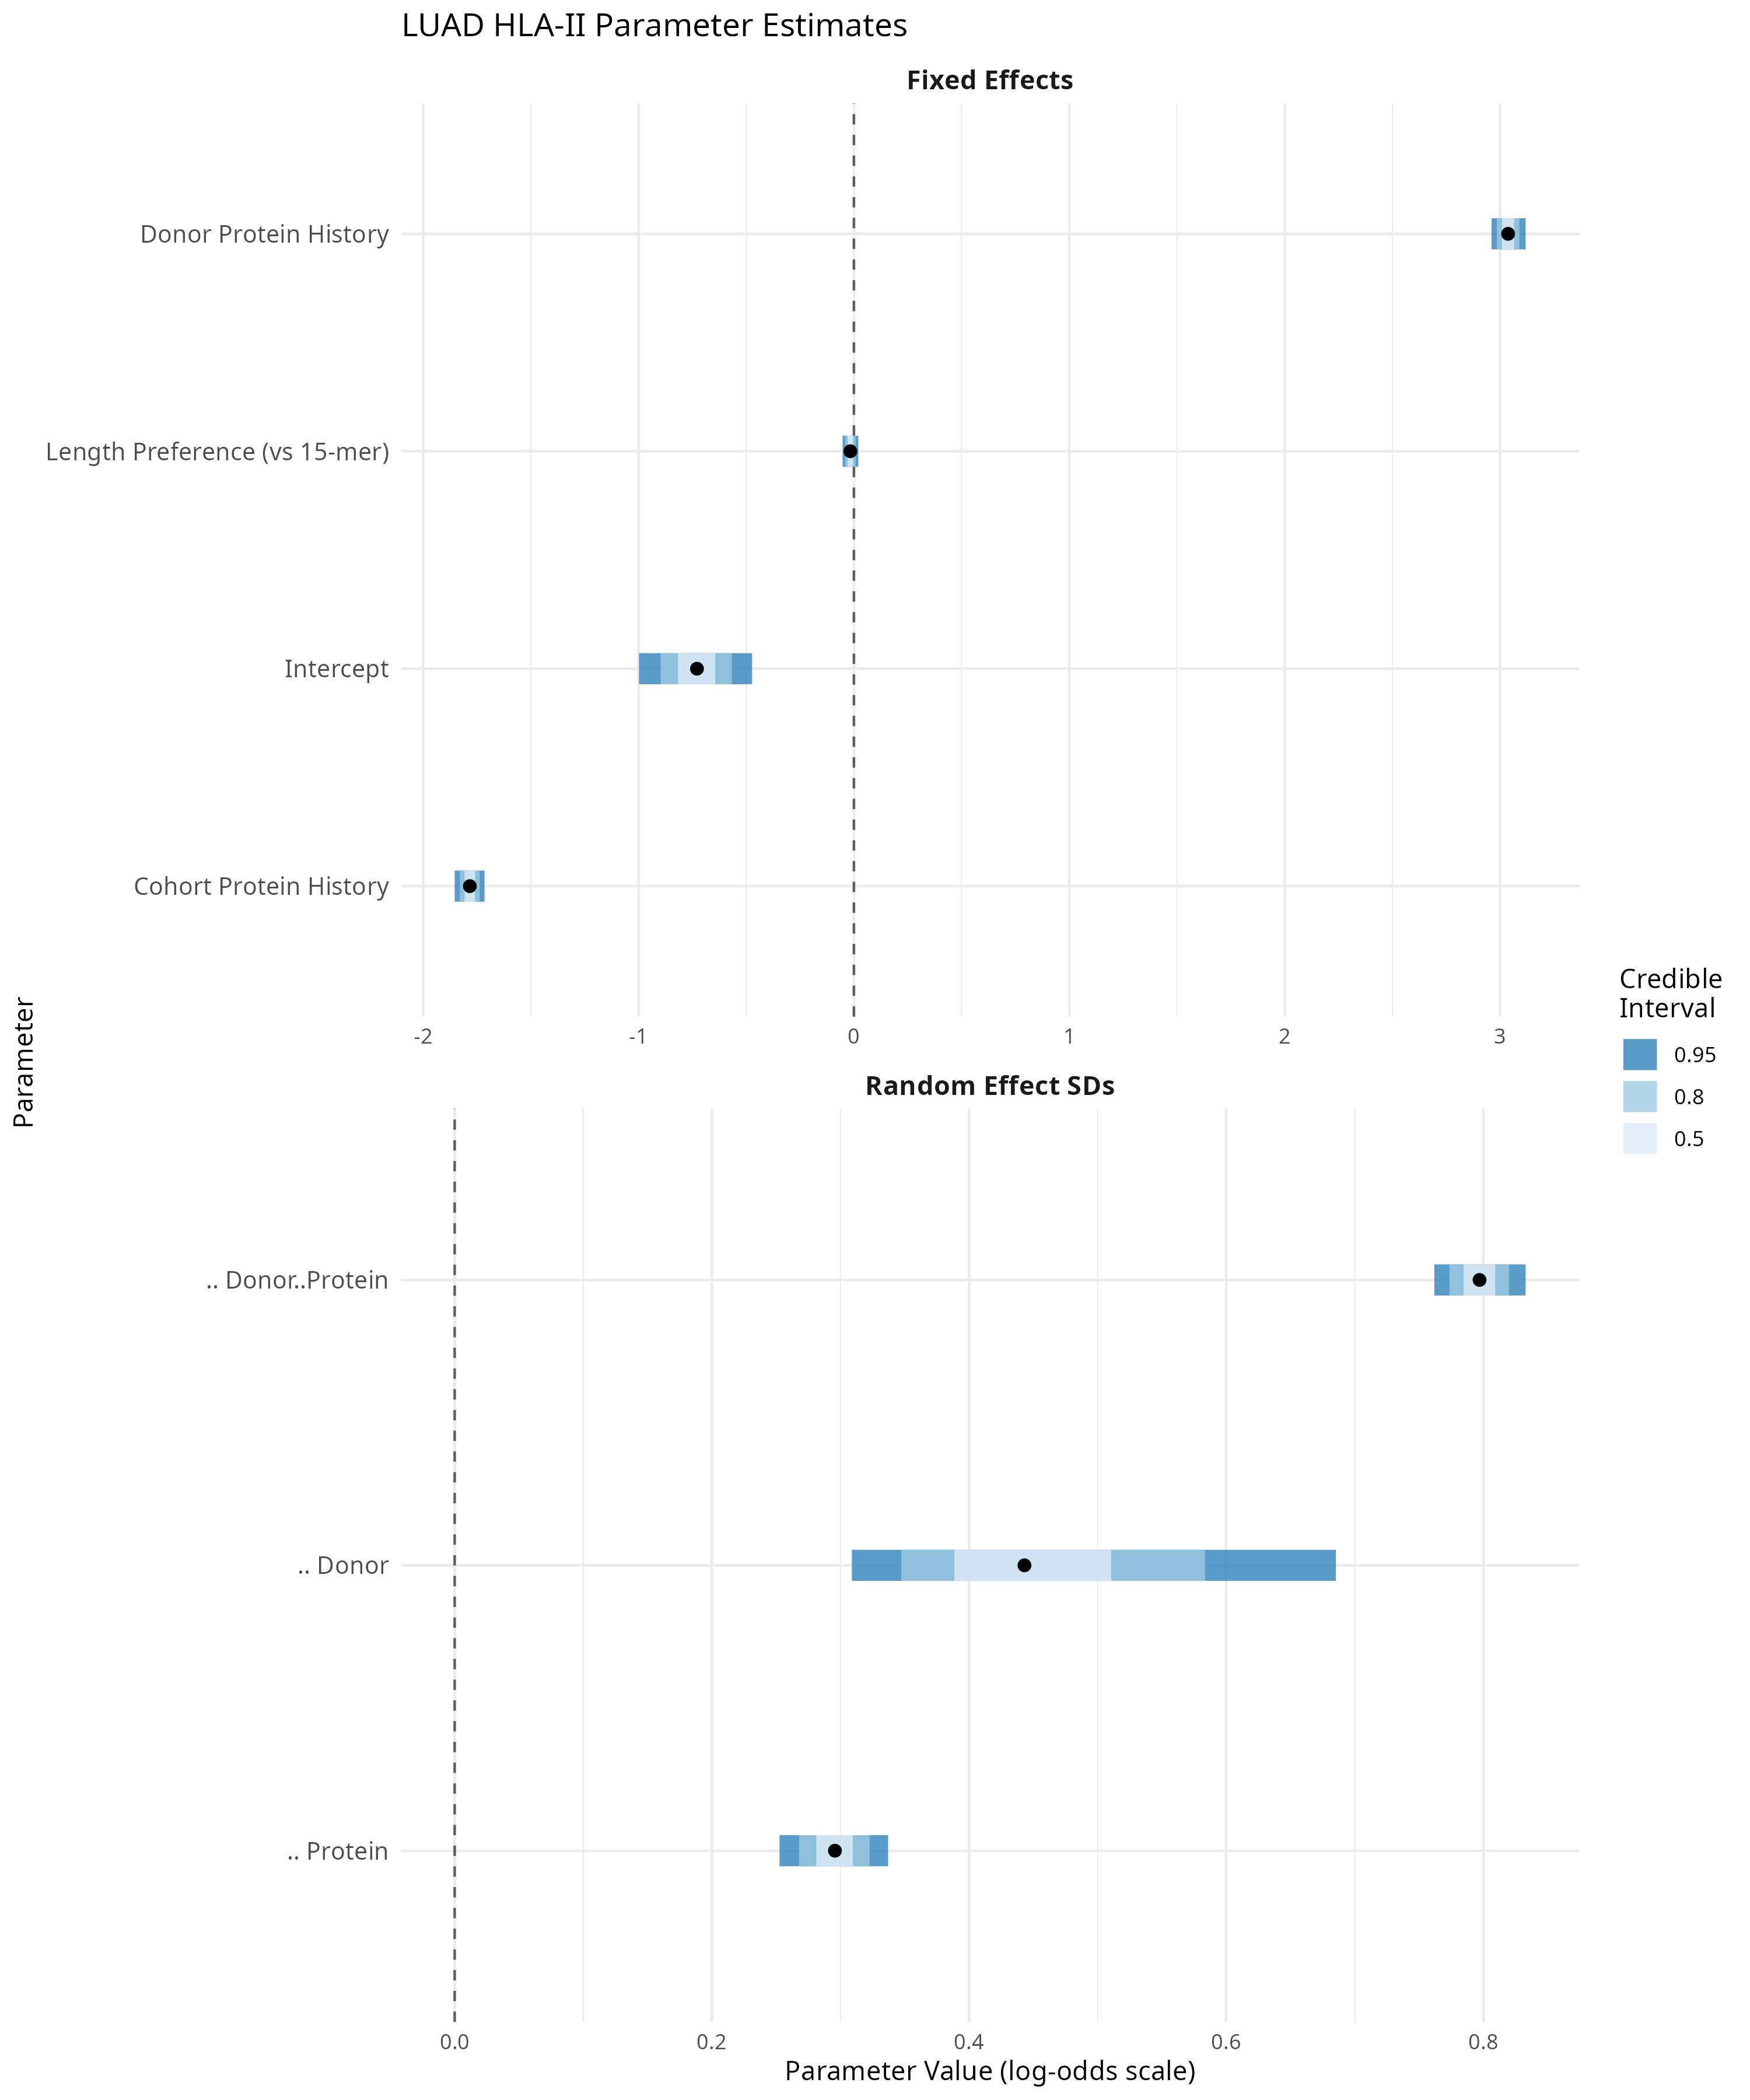
Caterpillar plot of uncertainty for key model parameters.

Figure S10: LUSC HLA-I caterpillar plot
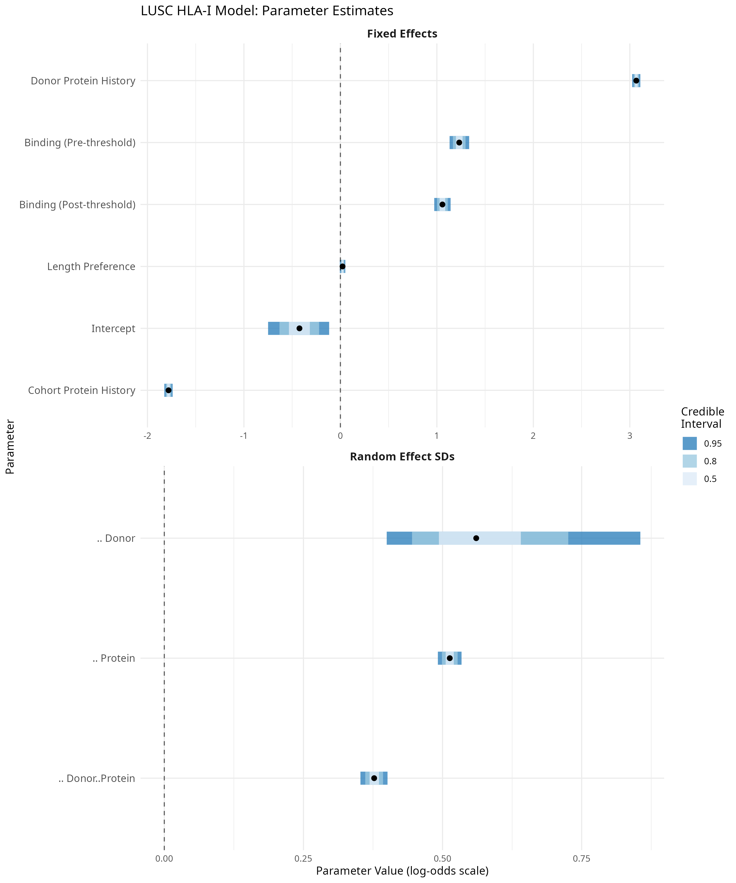
Caterpillar plot of uncertainty for key model parameters.

Figure S11: LUSC HLA-II caterpillar plot
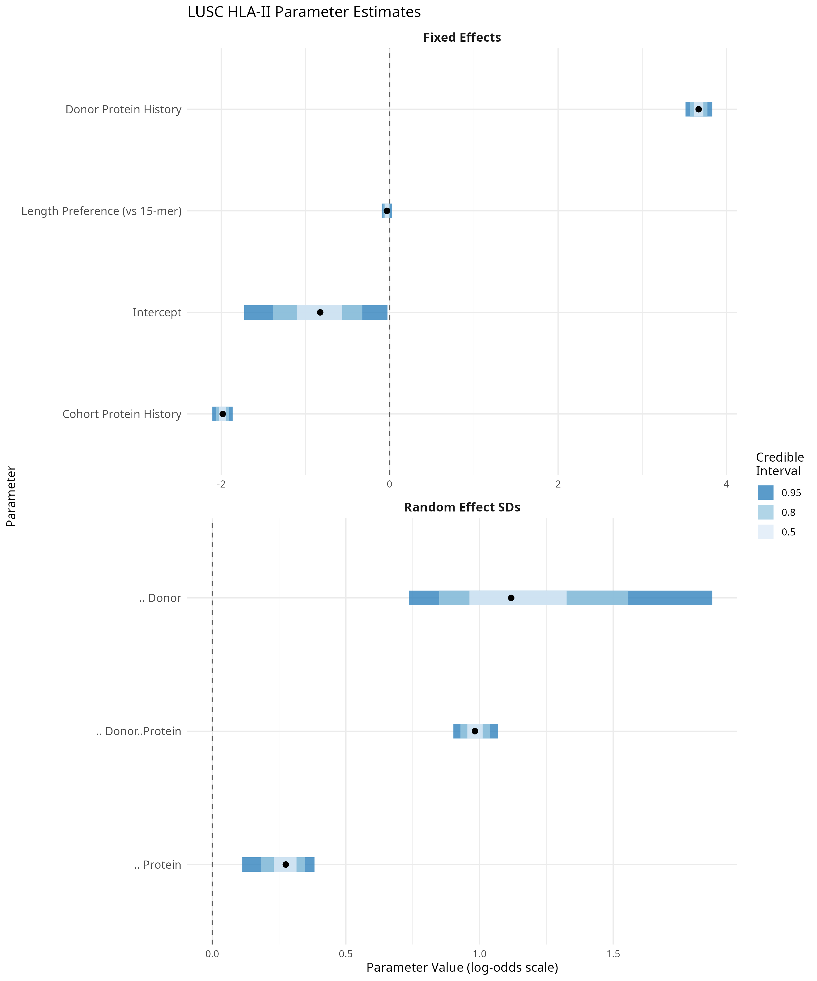
Caterpillar plot of uncertainty for key model parameters.

Table S1: Bayesian Model Precision Summary
Posterior distributions of key model parameters showing mean, median, standard deviation (sd), 95% credible intervals (ci_lower, ci_upper), probability of direction (pd), proportion of posterior outside ROPE (outside_rope), and signal-to-noise ratio (snr). High SNR values (>10) indicate well-estimated parameters. All parameters show pd = 1, indicating clear directional effects.
Table S1: Model precision summary
model | parameter | mean | median | sd | ci_lower | ci_upper | ci_width | pd | outside_rope | snr
LUAD HLA-I | z_sqrt_peptides_donor | 3.07 | 3.07 | 0.02 | 3.02 | 3.11 | 0.08 | 1.00 | 1.00 | 143.05
LUAD HLA-I | z_sqrt_peptides_cohort | -1.78 | -1.78 | 0.02 | -1.83 | -1.74 | 0.09 | 1.00 | 1.00 | 80.87
LUAD HLA-I | binding_pre_threshold | 1.23 | 1.23 | 0.05 | 1.13 | 1.33 | 0.20 | 1.00 | 1.00 | 23.92
LUAD HLA-I | binding_post_threshold | 1.06 | 1.06 | 0.04 | 0.97 | 1.14 | 0.17 | 1.00 | 1.00 | 24.52
LUAD HLA-I | length_diff_from_9 | 0.02 | 0.02 | 0.01 | -0.01 | 0.05 | 0.06 | 0.94 | 0.00 | 1.53
LUSC HLA-I | z_sqrt_peptides_donor | 3.37 | 3.37 | 0.04 | 3.30 | 3.44 | 0.15 | 1.00 | 1.00 | 88.42
LUSC HLA-I | z_sqrt_peptides_cohort | -1.84 | -1.84 | 0.03 | -1.90 | -1.78 | 0.12 | 1.00 | 1.00 | 60.92
LUSC HLA-I | binding_pre_threshold | 1.30 | 1.30 | 0.08 | 1.16 | 1.45 | 0.30 | 1.00 | 1.00 | 17.09
LUSC HLA-I | binding_post_threshold | 0.82 | 0.82 | 0.06 | 0.71 | 0.94 | 0.23 | 1.00 | 1.00 | 14.13
LUSC HLA-I | length_diff_from_9 | 0.06 | 0.06 | 0.02 | 0.02 | 0.11 | 0.09 | 1.00 | 0.00 | 2.91
LUAD HLA-II | z_sqrt_peptides_donor | 3.04 | 3.04 | 0.04 | 2.96 | 3.12 | 0.16 | 1.00 | 1.00 | 74.58
LUAD HLA-II | z_sqrt_peptides_cohort | -1.78 | -1.78 | 0.04 | -1.85 | -1.71 | 0.14 | 1.00 | 1.00 | 49.81
LUSC HLA-II | z_sqrt_peptides_donor | 3.67 | 3.67 | 0.08 | 3.51 | 3.83 | 0.32 | 1.00 | 1.00 | 45.12
LUSC HLA-II | z_sqrt_peptides_cohort | -1.98 | -1.98 | 0.06 | -2.11 | -1.86 | 0.24 | 1.00 | 1.00 | 32.18

Table S2: Bayesian Effective Sample Size Summary
Variance components and effective sample sizes for the hierarchical Bayesian models. Columns: n_don (number of donors), n_prot (number of proteins), n_obs (total observations), avg_don (average observations per donor), avg_prot (average observations per protein), var_don (donor variance component), var_prot (protein variance component), var_don_prot (donor-protein interaction variance), var_res (residual variance), icc_don (intraclass correlation for donors), icc_prot (intraclass correlation for proteins), icc_don_prot (intraclass correlation for donor-protein interaction), de_don (design effect for donors), de_prot (design effect for proteins), n_eff_don (effective sample size for donors), n_eff_prot (effective sample size for proteins).
Table S2: Effective sample size summary
model | n_don | n_prot | n_obs | avg_don | avg_prot | var_don | var_prot | var_don_prot | var_res | icc_don | icc_prot | icc_don_prot | de_don | de_prot | n_eff_don | n_eff_prot
LUAD HLA-I | 14 | 9,335 | 164,586 | 11,756 | 18 | 0.33 | 0.26 | 0.14 | 3.29 | 0.08 | 0.07 | 0.04 | 971.74 | 2.09 | 169 | 78,881
LUSC HLA-I | 8 | 7,421 | 50,746 | 6,343 | 7 | 0.80 | 0.10 | 0.01 | 3.29 | 0.19 | 0.02 | 0.00 | 1,206.63 | 1.13 | 42 | 44,798
LUAD HLA-II | 14 | 2,909 | 84,562 | 6,040 | 29 | 0.21 | 0.09 | 0.64 | 3.29 | 0.05 | 0.02 | 0.15 | 299.71 | 1.58 | 282 | 53,508
LUSC HLA-II | 8 | 1,969 | 26,332 | 3,291 | 13 | 1.37 | 0.07 | 0.97 | 3.29 | 0.24 | 0.01 | 0.17 | 791.78 | 1.16 | 33 | 22,767

Metadata for Supplementary Data S1: NSCLC Patient Information
Supplementary Data S1, a csv file containing patient information with 24 rows and 21 column variables. Each row in Supplementary Data S1 represents observations for a single patient. Table 1 provides descriptions of the values contained in each column of Supplementary Data S1.
Table 1: Patient information Supplementary Data S1 variables
Column Variable | Description
accel_id | CRUK Accelerator patient identifier
target_lung_id | Targeted Lung Health Check patient identifier
tissue | NSCLC type: Adenocarcinoma or Squamous cell carcinoma
n_somatic_variants | Total number of somatic variants identified by whole exome sequencing
mut_burden_per_mb | Mutational burden: mutations per million bases of DNA. Exome target size was 35.7 Mb
obs_class_I | Number of observed HLA I peptides by mass spec. immunopeptidomics
obs_class_II | Number of observed HLA II peptides by mass spec. immunopeptidomics
HLA | Class I and II HLA allotypes identified by genomic sequencing
wet_weight | Wet weight of tumour tissue
tumour_purity | Tumour purity as calculated from WES by ASCAT
tumour_ploidy | Tumour ploidy as calculated from WES by ASCAT
til_status | Tumour infiltrating T-cell status by immunohistochemistry: Low, Moderate, High or NA
weeks_post_surgery | Number of weeks since surgery
status_as_of_2021_01_19 | Status since 2021-01-19: Alive, Deceased or NA
date_of_diagnosis | Date of diagnosis
smoking_status | Smoking status
notes_2 | Notes about smoking history

Metadata for Supplementary Data S2: NSCLC Protein-Affecting Variants
Table 2: NSCLC Protein-Affecting Variants Supplementary Data S2 variables
Column Variable | Description
accel_id | CRUK Accelerator patient identifier
vid | Unique variant identifier
chrom | Chromosome
pos | Genomic coordinate
ref | Reference base
alt | Variant base
type | Variant type: snv, ins, del or complex. Single nucleotide variant, insertion, deletion and complex variant respectively
gene_name | HGNC gene name
ensg | Ensembl gene identifier
ensp | Ensembl protein identifier
consequence | Variant consequence annotation
biotype | Gene biotype filter: protein_coding
canonical | Canonical transcript flag
vaf | Variant allele frequency
depth | Sequencing depth
filter | Variant filter status
info | Information field from VCF file
format | Format of VCF variable columns
sample_1 | Reference sample VCF variable values corresponding with format
sample_2 | Tumour sample VCF variable values corresponding with format
tissue | Lung tumour tissue type: Squamous or Adenocarcinoma

Metadata for Supplementary Data S3: NSCLC Missense Variants
Table 3: NSCLC Missense Variants Supplementary Data S3 variables
Column Variable | Description
accel_id | CRUK Accelerator patient identifier
vid | Unique variant identifier
chrom | Chromosome
pos | Genomic coordinate
ref | Reference base
alt | Variant base
type | Variant type: snv, ins, del or complex. Single nucleotide variant, insertion, deletion and complex variant respectively
gene_name | HGNC gene name
ensg | Ensembl gene identifier
ensp | Ensembl protein identifier
vaf | Variant allele frequency
depth | Sequencing depth
filter | Variant filter status
info | Information field from VCF file
format | Format of VCF variable columns
sample_1 | Reference sample VCF variable values corresponding with format
sample_2 | Tumour sample VCF variable values corresponding with format
tissue | Lung tumour tissue type: Squamous or Adenocarcinoma

Metadata for Supplementary Data S4: NSCLC HLA Loss of Heterozygosity
Table 4: NSCLC HLA Loss of Heterozygosity Supplementary Data S4 variables
Column Variable | Description
accel_id | CRUK Accelerator patient identifier
message | HLA LOH detection message
HLA_A_type1 | HLA allele type 1: A, B or C
HLA_A_type2 | HLA allele type 2: A, B or C
LossAllele | HLA allele that was lost
KeptAllele | HLA allele that was retained

Metadata for Supplementary Data S5: NSCLC Shared Protein Lists
Table 5: NSCLC Shared Protein Lists Supplementary Data S5 variables
Column Variable | Description
hla_class | HLA class (I or II)
intersection | Set intersection identifier
n_proteins | Number of patients observations of protein in set intersection
uniprot_id | UniProt protein identifier
gene_name | HGNC gene name

Metadata for Supplementary Data S6: NSCLC pVACseq Class I Predictions
Table 6: NSCLC pVACseq Class I Predictions Supplementary Data S6 variables
Column Variable | Description
sample | CRUK Accelerator patient identifier
chromosome | The chromosome of this variant
start | The start position of this variant in the zero-based, half-open coordinate system
stop | The stop position of this variant in the zero-based, half-open coordinate system
reference | The reference allele
variant | The alt allele
transcript | The Ensembl ID of the affected transcript
transcript_support_level | The transcript support level (TSL) of the affected transcript. NA if the VCF entry doesn’t contain TSL information
ensembl_gene_id | The Ensembl ID of the affected gene
variant_type | The type of variant. missense for missense mutations, inframe_ins for inframe insertions, inframe_del for inframe deletions, and FS for frameshift variants
mutation | The amino acid change of this mutation
protein_position | The protein position of the mutation
gene_name | The Ensembl gene name of the affected gene
hgv_sc | The HGVS coding sequence variant name
hgv_sp | The HGVS protein sequence variant name
hla_allele | The HLA allele for this prediction
peptide_length | The peptide length of the epitope
sub_peptide_position | The one-based position of the epitope within the protein sequence used to make the prediction
mutation_position | The one-based position of the start of the mutation within the epitope sequence. 0 if the start of the mutation is before the epitope
mt_epitope_seq | The mutant epitope sequence
wt_epitope_seq | The wildtype (reference) epitope sequence at the same position in the full protein sequence. NA if there is no wildtype sequence at this position or if more than half of the amino acids of the mutant epitope are mutated
best_mt_score_method | Prediction algorithm with the lowest mutant ic50 binding affinity for this epitope
best_mt_score | Lowest ic50 binding affinity of all prediction algorithms used
corresponding_wt_score | ic50 binding affinity of the wildtype epitope. NA if there is no WT Epitope Seq
corresponding_fold_change | Corresponding WT Score / Best MT Score. NA if there is no WT Epitope Seq
tumor_dna_depth | Tumor DNA depth at this position. NA if VCF entry does not contain tumor DNA readcount annotation
tumor_dna_vaf | Tumor DNA variant allele frequency (VAF) at this position. NA if VCF entry does not contain tumor DNA readcount annotation
tumor_rna_depth | Tumor RNA depth at this position. NA if VCF entry does not contain tumor RNA readcount annotation
tumor_rna_vaf | Tumor RNA variant allele frequency (VAF) at this position. NA if VCF entry does not contain tumor RNA readcount annotation
normal_depth | Normal DNA depth at this position. NA if VCF entry does not contain normal DNA readcount annotation
normal_vaf | Normal DNA variant allele frequency (VAF) at this position. NA if VCF entry does not contain normal DNA readcount annotation
gene_expression | Gene expression value for the annotated gene containing the variant. NA if VCF entry does not contain gene expression annotation
transcript_expression | Transcript expression value for the annotated transcript containing the variant. NA if VCF entry does not contain transcript expression annotation
median_mt_score | Median ic50 binding affinity of the mutant epitope across all prediction algorithms used
median_wt_score | Median ic50 binding affinity of the wildtype epitope across all prediction algorithms used. NA if there is no WT Epitope Seq
median_fold_change | Median WT Score / Median MT Score. NA if there is no WT Epitope Seq
mh_cflurry_wt_score | MHCflurry ic50 binding affinity for the wildtype epitope
mh_cflurry_mt_score | MHCflurry ic50 binding affinity for the mutant epitope
mh_cnuggets_i_wt_score | MHCnuggets-I ic50 binding affinity for the wildtype epitope
mh_cnuggets_i_mt_score | MHCnuggets-I ic50 binding affinity for the mutant epitope
net_mhc_wt_score | NetMHC ic50 binding affinity for the wildtype epitope
net_mhc_mt_score | NetMHC ic50 binding affinity for the mutant epitope
pick_pocket_wt_score | PickPocket ic50 binding affinity for the wildtype epitope
pick_pocket_mt_score | PickPocket ic50 binding affinity for the mutant epitope
cterm_7mer_gravy_score | Mean hydropathy of last 7 residues on the C-terminus of the peptide
max_7mer_gravy_score | Max GRAVY score of any kmer in the amino acid sequence. Used to determine if there are any extremely hydrophobic regions within a longer amino acid sequence
difficult_n_terminal_residue | Is N-terminal amino acid a Glutamine, Glutamic acid, or Cysteine? (T/F)
c_terminal_cysteine | Is the C-terminal amino acid a Cysteine? (T/F)
c_terminal_proline | Is the C-terminal amino acid a Proline? (T/F)
cysteine_count | Number of Cysteines in the amino acid sequence. Problematic because they can form disulfide bonds across distant parts of the peptide
n_terminal_asparagine | Is the N-terminal amino acid an Asparagine? (T/F)
asparagine_proline_bond_count | Number of Asparagine-Proline bonds. Problematic because they can spontaneously cleave the peptide
b_rank | Rank of binding score: 1/median neoantigen binding affinity. Lower is better
f_rank | Rank of fold change: the difference in median binding affinity between neoantigen and wildtype peptide (agretopicity). Higher is better
m_rank | Ranks of mutant allele expression: the product of gene_expression and tumor_rna_vaf. Higher is better
d_rank | Rank of the tumor_dna_vaf. Higher is better
score | A score is calculated from the above ranks with the following formula: b_rank + f_rank + (m_rank * 2) + (d_rank/2). Higher is better
rank_score | The score converted to a rank, with the best being 1, splitting ties by first. Lower is better
rank_percent | The percentage rank score. Lower is better

Metadata for Supplementary Data S7: NSCLC pVACseq Class II Predictions
Table 7: NSCLC pVACseq Class II Predictions Supplementary Data S7 variables
Column Variable | Description
sample | CRUK Accelerator patient identifier
chromosome | The chromosome of this variant
start | The start position of this variant in the zero-based, half-open coordinate system
stop | The stop position of this variant in the zero-based, half-open coordinate system
reference | The reference allele
variant | The alt allele
transcript | The Ensembl ID of the affected transcript
transcript_support_level | The transcript support level (TSL) of the affected transcript. NA if the VCF entry doesn’t contain TSL information
ensembl_gene_id | The Ensembl ID of the affected gene
variant_type | The type of variant. missense for missense mutations, inframe_ins for inframe insertions, inframe_del for inframe deletions, and FS for frameshift variants
mutation | The amino acid change of this mutation
protein_position | The protein position of the mutation
gene_name | The Ensembl gene name of the affected gene
hgv_sc | The HGVS coding sequence variant name
hgv_sp | The HGVS protein sequence variant name
hla_allele | The HLA allele for this prediction
peptide_length | The peptide length of the epitope
sub_peptide_position | The one-based position of the epitope within the protein sequence used to make the prediction
mutation_position | The one-based position of the start of the mutation within the epitope sequence. 0 if the start of the mutation is before the epitope
mt_epitope_seq | The mutant epitope sequence
wt_epitope_seq | The wildtype (reference) epitope sequence at the same position in the full protein sequence. NA if there is no wildtype sequence at this position or if more than half of the amino acids of the mutant epitope are mutated
best_mt_score_method | Prediction algorithm with the lowest mutant ic50 binding affinity for this epitope
best_mt_score | Lowest ic50 binding affinity of all prediction algorithms used
corresponding_wt_score | ic50 binding affinity of the wildtype epitope. NA if there is no WT Epitope Seq
corresponding_fold_change | Corresponding WT Score / Best MT Score. NA if there is no WT Epitope Seq
tumor_dna_depth | Tumor DNA depth at this position. NA if VCF entry does not contain tumor DNA readcount annotation
tumor_dna_vaf | Tumor DNA variant allele frequency (VAF) at this position. NA if VCF entry does not contain tumor DNA readcount annotation
tumor_rna_depth | Tumor RNA depth at this position. NA if VCF entry does not contain tumor RNA readcount annotation
tumor_rna_vaf | Tumor RNA variant allele frequency (VAF) at this position. NA if VCF entry does not contain tumor RNA readcount annotation
normal_depth | Normal DNA depth at this position. NA if VCF entry does not contain normal DNA readcount annotation
normal_vaf | Normal DNA variant allele frequency (VAF) at this position. NA if VCF entry does not contain normal DNA readcount annotation
gene_expression | Gene expression value for the annotated gene containing the variant. NA if VCF entry does not contain gene expression annotation
transcript_expression | Transcript expression value for the annotated transcript containing the variant. NA if VCF entry does not contain transcript expression annotation
median_mt_score | Median ic50 binding affinity of the mutant epitope across all prediction algorithms used
median_wt_score | Median ic50 binding affinity of the wildtype epitope across all prediction algorithms used. NA if there is no WT Epitope Seq
median_fold_change | Median WT Score / Median MT Score. NA if there is no WT Epitope Seq
mh_cnuggets_ii_wt_score | MHCnuggets-II ic50 binding affinity for the wildtype epitope
mh_cnuggets_ii_mt_score | MHCnuggets-II ic50 binding affinity for the mutant epitope
cterm_7mer_gravy_score | Mean hydropathy of last 7 residues on the C-terminus of the peptide
max_7mer_gravy_score | Max GRAVY score of any kmer in the amino acid sequence. Used to determine if there are any extremely hydrophobic regions within a longer amino acid sequence
difficult_n_terminal_residue | Is N-terminal amino acid a Glutamine, Glutamic acid, or Cysteine? (T/F)
c_terminal_cysteine | Is the C-terminal amino acid a Cysteine? (T/F)
c_terminal_proline | Is the C-terminal amino acid a Proline? (T/F)
cysteine_count | Number of Cysteines in the amino acid sequence. Problematic because they can form disulfide bonds across distant parts of the peptide
n_terminal_asparagine | Is the N-terminal amino acid an Asparagine? (T/F)
asparagine_proline_bond_count | Number of Asparagine-Proline bonds. Problematic because they can spontaneously cleave the peptide
net_mhci_ipan_wt_score | NetMHCIIpan ic50 binding affinity for the wildtype epitope
net_mhci_ipan_mt_score | NetMHCIIpan ic50 binding affinity for the mutant epitope
n_nalign_wt_score | NNalign ic50 binding affinity for the wildtype epitope
n_nalign_mt_score | NNalign ic50 binding affinity for the mutant epitope
sm_malign_wt_score | SMMalign ic50 binding affinity for the wildtype epitope
sm_malign_mt_score | SMMalign ic50 binding affinity for the mutant epitope
b_rank | Rank of binding score: 1/median neoantigen binding affinity. Lower is better
f_rank | Rank of fold change: the difference in median binding affinity between neoantigen and wildtype peptide (agretopicity). Higher is better
m_rank | Ranks of mutant allele expression: the product of gene_expression and tumor_rna_vaf. Higher is better
d_rank | Rank of the tumor_dna_vaf. Higher is better
score | A score is calculated from the above ranks with the following formula: b_rank + f_rank + (m_rank * 2) + (d_rank/2). Higher is better
rank_score | The score converted to a rank, with the best being 1, splitting ties by first. Lower is better
rank_percent | The percentage rank score. Lower is better

Metadata for Supplementary Data S8: NSCLC pVACseq Peptidome Combined Predictions
Table 8: NSCLC pVACseq Peptidome Combined Predictions Supplementary Data S8 variables
Column Variable | Description
sample_id | CRUK Accelerator patient identifier
hla_class | HLA class (I or II)
table_name | Identifier in the form accel_id/predicted_hla_allotype/peptide_length
length | Peptide length
hla_length_pref1 | HLA allotype preferred peptide length 1
hla_length_pref2 | HLA allotype preferred peptide length 2
gene_name | HGNC gene name
mt_epitope_seq | The mutant epitope sequence
median_mt_score | Median ic50 binding affinity of the mutant epitope across all prediction algorithms used
corresponding_fold_change | Corresponding WT Score / Best MT Score. NA if there is no WT Epitope Seq
gene_expression | Gene expression value for the annotated gene containing the variant
tumor_rna_vaf | Tumor RNA variant allele frequency (VAF) at this position
tumor_dna_vaf | Tumor DNA variant allele frequency (VAF) at this position
rank_percent | The percentage rank score. Lower is better
rank_score | The score converted to a rank, with the best being 1, splitting ties by first. Lower is better
Obs_I | The number of peptides from the source protein observed by mass spectrometry in HLA-I immunopeptidome
Obs_II | The number of peptides from the source protein observed by mass spectrometry in HLA-II immunopeptidome

Metadata for Supplementary Data S9: NSCLC Tested Neoantigens
Table 9: NSCLC Tested Neoantigens Supplementary Data S9 variables
Column Variable | Description
accel_id | CRUK Accelerator patient identifier
gene_name | Gene
mt_epitope_seq | Mutated (neoantigen) peptide sequence
wt_epitope_seq | Wildtype peptide sequence
peptide_length | Peptide length
table_name | Identifier in the form accel_id/predicted_hla_allotype/peptide_length e.g. A119/DRB1*04:04/15
mutation | The mutation From/To
protein_position | Location of the mutation in the source protein, UNIPROT sequence number
Obs_I | The number of peptides from the source protein observed by mass spectrometry in HLA-I immunopeptidome
Obs_II | The number of peptides from the source protein observed by mass spectrometry in HLA-II immunopeptidome
median_mt_score | The median pVACseq predicted binding affinity of the neoantigen peptide
median_wt_score | The median pVACseq predicted binding affinity of the wildtype peptide
median_fold_change | The ratio between the median neoantigen affinity and wildtype peptide affinity
rank_percent | The overall rank percentage for the neoantigen from pVACseq for the peptide of that length and HLA allotype
mean_sfc_mt | Mean IFN-γ ELISPOT spot forming cells per million cells for the neoantigen peptide
mean_sfc_wt | Mean IFN-γ ELISPOT spot forming cells per million cells for the wildtype peptide
elispot_response | ELISPOT response category: Strong, Weak or None

