Supplementary Materials

Supplementary Table S1. Post-hoc sensitivity analysis for identification of patients in “recommend gem/nab-p” cohort with superior outcomes on gem/nab-p
Cutoff | Score ≥ | N | FOL/  gem/nab-p | % Testing cohort | TTNT HR (95% CI) | TTNT  p-value | OS HR (95% CI) | OS  p-value
Top 10% | -0.013 | 38 | 21/17 | 5.7% | 0.63 (0.30-1.34) | 0.2292 | 0.56 (0.25-1.23) | 0.1469
Top 15% | -0.033 | 54 | 29/25 | 8.2% | 0.51 (0.27-0.96) | 0.0362 | 0.42 (0.21-0.84) | 0.0138
Top 20% | -0.070 | 70 | 35/35 | 10.6% | 0.67 (0.39-1.15) | 0.1444 | 0.56 (0.31-1.01) | 0.0544
Top 25% | -0.090 | 88 | 44/44 | 13.3% | 0.63 (0.39-1.02) | 0.0587 | 0.57 (0.34-0.95) | 0.0315
Top 30% | -0.110 | 104 | 54/50 | 15.7% | 0.66 (0.42-1.01) | 0.0576 | 0.58 (0.36-0.93) | 0.0229
Top 33% | -0.127 | 115 | 61/54 | 17.4% | 0.66 (0.44-1.01) | 0.0531 | 0.57 (0.37-0.90) | 0.0161
Top 40% | -0.163 | 139 | 77/62 | 21.0% | 0.74 (0.51-1.09) | 0.1283 | 0.74 (0.49-1.11) | 0.1503
Top 50% | -0.217 | 173 | 97/76 | 26.2% | 0.77 (0.54-1.08) | 0.1319 | 0.77 (0.53-1.11) | 0.1566
Tertile cutoff used in outcomes analysis and p-values <0.05 are italicized and bolded.

Supplementary Table S2. Median TTNT and OS for gem/nab-p-treated and FOLFIRINOX-treated patients in the “recommend gem/nab-p” group according to tertile ensemble voting scores.
REC_GEM Tertile | FOL TTNT (mo.) | gem/nab-p TTNT (mo.) | FOL OS (mo.) | gem/nab-p OS (mo.)
Tertile 1 | 4.9 | 5.5 | 8.3 | 6.6
Tertile 2 | 7.1 | 6.7 | 12.0 | 10.7
Tertile 3 | 6.1 | 8.3 | 8.3 | 13.3

Supplementary Table S3. Primary tumor sites
Regimen | Tumor Site | Total, No. (%) | Training, No. (%) | Testing, No. (%)
FOLFIRINOX | Ampulla of Vater | 1 (0.08) | 1 | 0
FOLFIRINOX | Body of pancreas | 155 (11.6) | 105 | 50
FOLFIRINOX | Head of pancreas | 408 (30.6) | 291 | 117
FOLFIRINOX | Neck of pancreas | 12 (0.9) | 10 | 2
FOLFIRINOX | Other specified parts of pancreas | 4 (0.3) | 4 | 0
FOLFIRINOX | Overlapping lesion of pancreas | 26 (2.0) | 15 | 11
FOLFIRINOX | Pancreas, NOS | 542 (40.7) | 380 | 162
FOLFIRINOX | Pancreatic duct | 14 (1.1) | 12 | 2
FOLFIRINOX | Tail of pancreas | 170 (12.8) | 114 | 56
 | All sites | 1,332 (100) | 932 | 400
Gemcitabine/  nab-paclitaxel | Body of pancreas | 105 (12.1) | 74 | 31
Gemcitabine/  nab-paclitaxel | Head of pancreas | 244 (28.0) | 177 | 67
Gemcitabine/  nab-paclitaxel | Neck of pancreas | 7 (0.8) | 2 | 5
Gemcitabine/  nab-paclitaxel | Other specified parts of pancreas | 3 (0.3) | 2 | 1
Gemcitabine/  nab-paclitaxel | Overlapping lesion of pancreas | 19 (2.2) | 14 | 5
Gemcitabine/  nab-paclitaxel | Pancreas, NOS | 364 (41.8) | 249 | 115
Gemcitabine/  nab-paclitaxel | Pancreatic duct | 12 (1.4) | 8 | 4
Gemcitabine/  nab-paclitaxel | Tail of pancreas | 116 (13.3) | 83 | 33
 | All sites | 870 (100) | 609 | 261

Supplementary Table S4. Pathways and drugs represented in hypothesis-driven feature sets
Pathways | Drugs
ABC Transport | Gemcitabine
Cell Cycle Checkpoint | Gemcitabine, 5-FU
Phase II Metabolism (GSTs) | Oxaliplatin
Unfolded Protein Response (UPR) | 5-FU
Signal Transduction / Growth (RTK) | Gemcitabine
Drug Target | Irinotecan
Epigenetics | 5-FU
Homologous Recombination | Gemcitabine
Transport | Oxaliplatin
Folate | 5-FU
N/A | Irinotecan
N/A | Leucovorin
KRAS, BRCA2, BRAF mutations and PurIST | N/A
N/A, not applicable

Supplementary Data S1. Hypothesis-free pathways and drugs evaluated during model development (see Excel file).

Supplementary Data S2. Hypothesis-driven features used with corresponding model type (see Excel file).

Supplementary Data S3. Description of log-risk calibrations conducted during model development (see Excel file).

Supplementary Data S4. Final hypothesis-free models and features used for model training (see Excel file).

Supplementary Figure S1. Clinical outcomes in total, training, and testing cohort. Kaplan-Meier curves illustrate TTNT (A, C, E) and OS (B, D, F) for FOLFIRINOX-treated patients and gem/nab-p-treated patients in the total cohort (A-B), the training cohort (C-D), and the testing cohort (E-F).
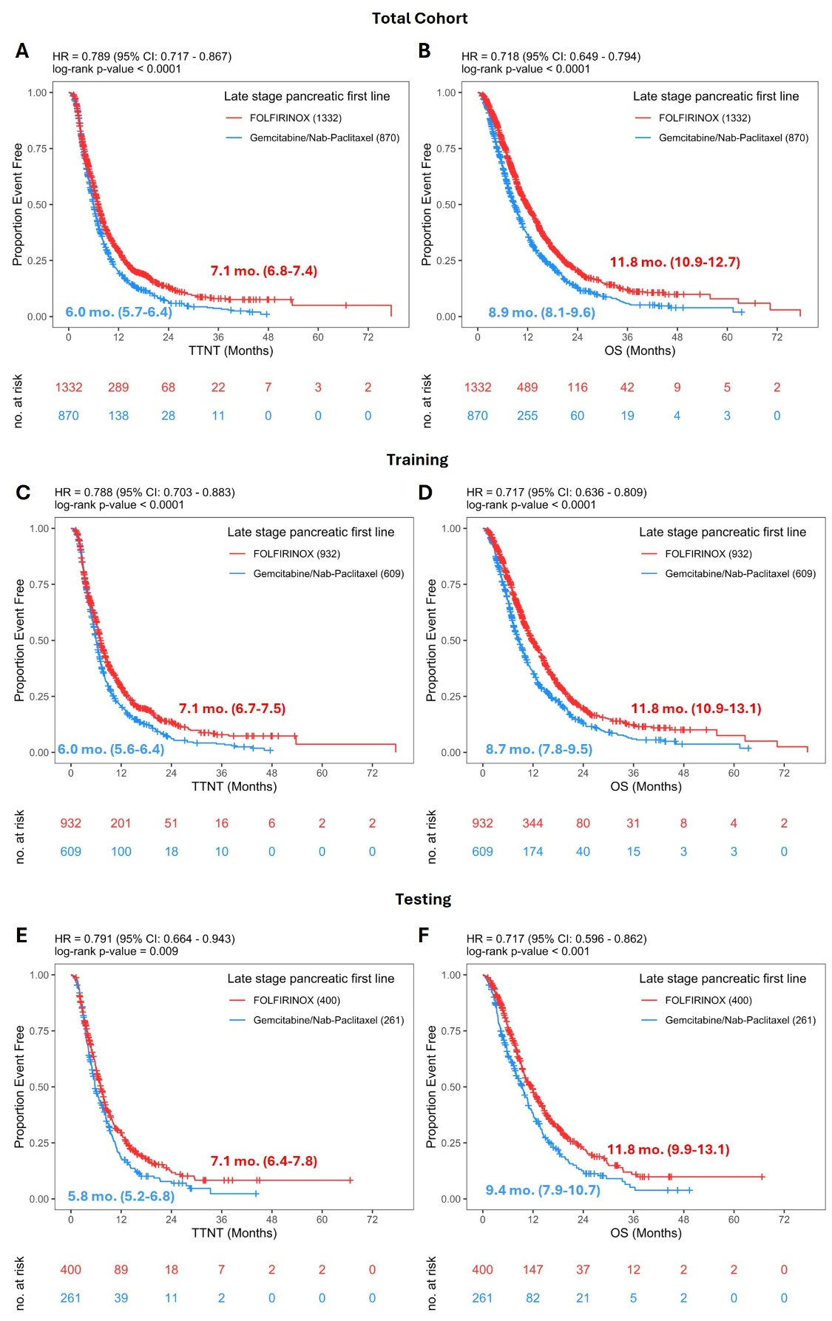
Supplementary Figure S2. Propensity score matching. (A-C) Propensity score versus frailty (A) and age (years) (B-C) are plotted. Shading in (C) indicates activation year, which is the year the case was activated at Caris and represents the number of years (0-5) from the year 2020. (D) Purple bars represent cases with matched propensity scores from the FOLFIRINOX-treated (red bars) and gem/nab-p-treated (blue bars) groups. (E) Propensity logit scores of side-by-side matched controls are shown. (F) Standardized mean differences in effect sizes of activation year, frailty score, age, and sex (male) are shown before (red bars) and after (blue bars) propensity score matching.

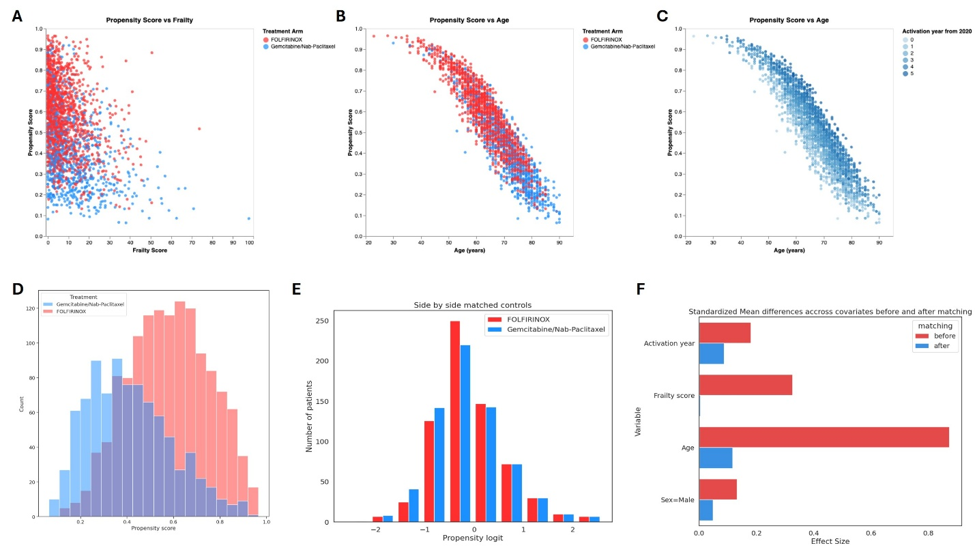

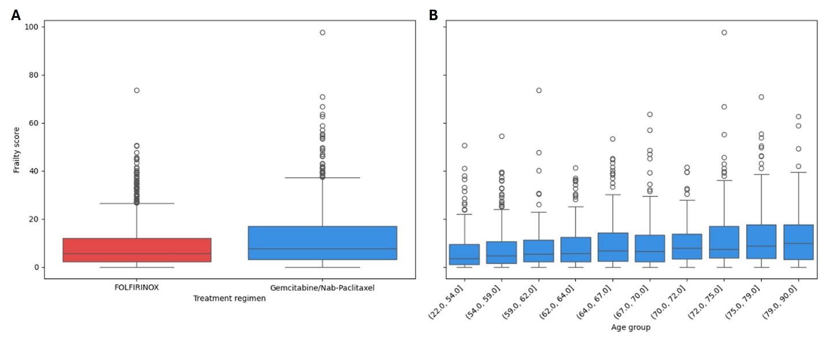
Supplementary Figure S3. Association of frailty with age and treatment regimen. (A) Frailty score in FOLFIRINOX and gem-nab-p treated groups. (B) Frailty score according to age groups. Midline represents median.

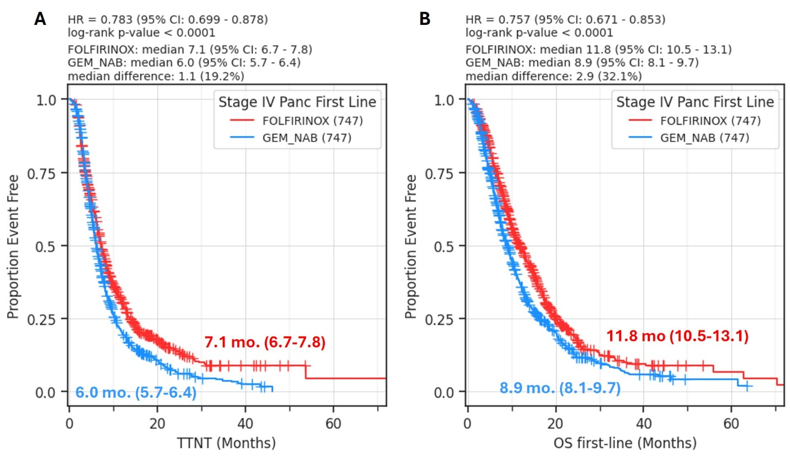
Supplementary Figure S4. Time-to-next-treatment (TTNT) and overall survival (OS) for FOLFIRINOX-treated and gem/nab-p-treated patients with propensity score matching (PSM). Kaplan-Meier curves show TTNT (A) and OS (B) for all PSM patients.

Supplementary Figure S5. Training cohort and total cohort predictions for first-line FOLFIRINOX recommendation group. Kaplan-Meier curves illustrate TTNT and OS for FOLFIRINOX-treated versus gem/nab-p-treated patients in standard-risk and high-risk “recommend first-line FOLFIRINOX” groups in the training cohort (n = 1,541) (A) and total cohort (n = 2,202) (B).
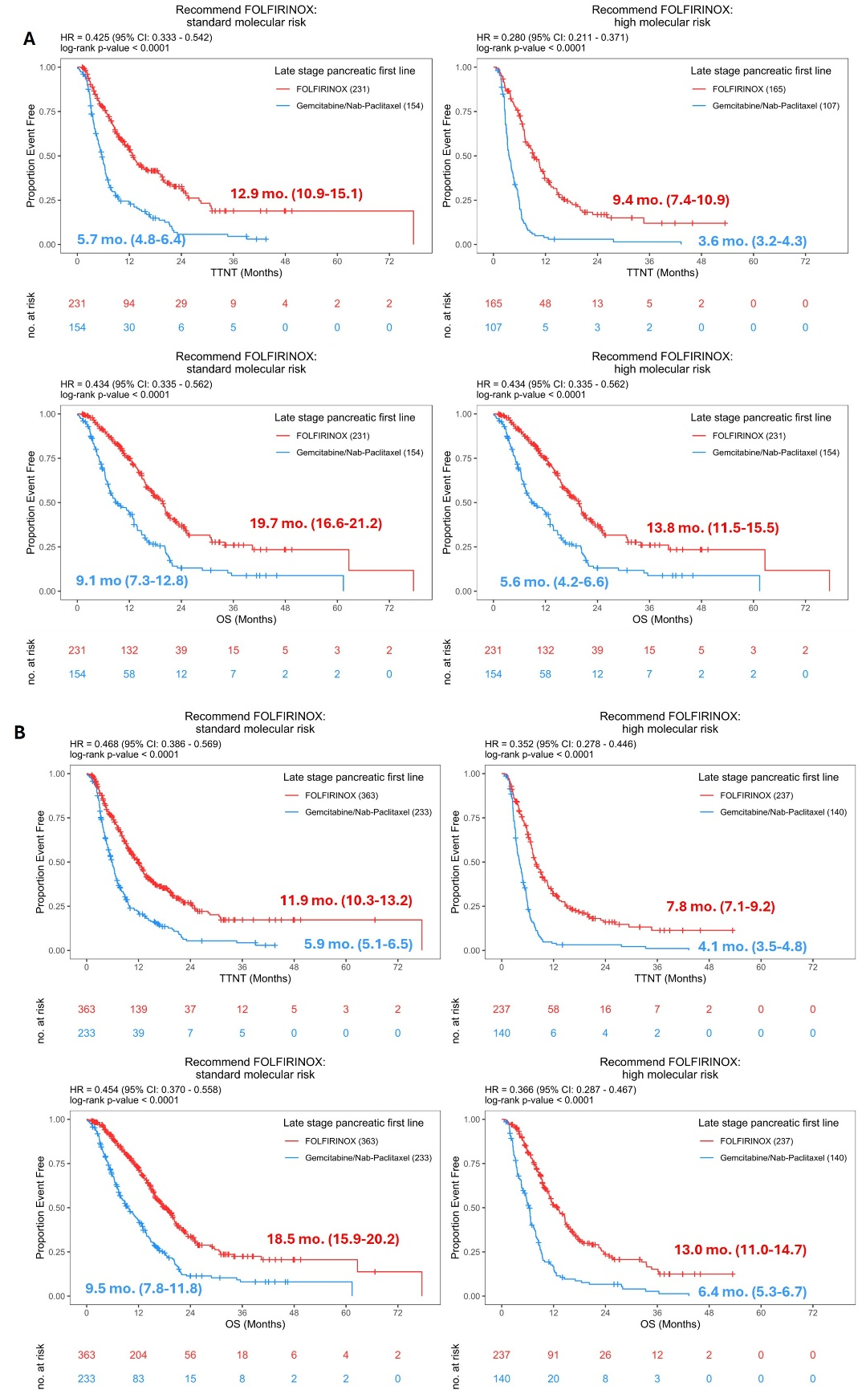

Supplementary Figure S6. Training cohort and total cohort predictions for first-line gem/nab-p recommendation group. Kaplan-Meier curves illustrate TTNT and OS for FOLFIRINOX-treated versus gem/nab-p-treated patients in standard-risk and high-risk “recommend first-line gem/nab-p” groups in the training cohort (n = 1,541) (A) and total cohort (n = 2,202) (B).
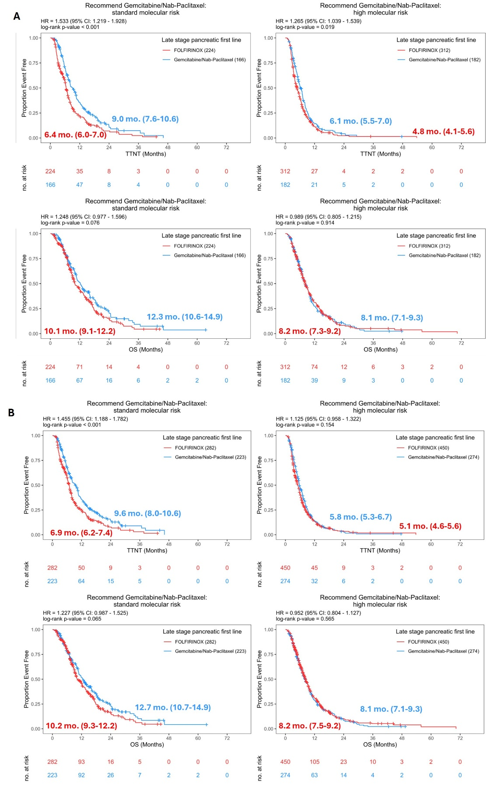

Supplementary Figure S7. Association of KRAS status with treatment recommendations and actual treatments received. (A) Percentage of patients with KRAS-mutated (mut) tumors (white bars), KRAS-wildtype (WT) tumors (gray bars), and all tumors (black bars) who were recommended for FOLFIRINOX but received gem/nab-p (solid bars) and who could have received gem/nab-p with equivalent outcomes but actually received FOLFIRINOX (patterned bars). (B) Overall rates of recommended versus actual treatments in KRAS-mut (n = 2,008) and KRAS-WT (n = 194) subgroups. (C-D) Forest plot summary of time-to-next-treatment (TTNT, C) and overall survival (OS, D) according to KRAS mutation status and modeling results. Kaplan-Meier curves are shown in Supplementary Figs. S9-10.
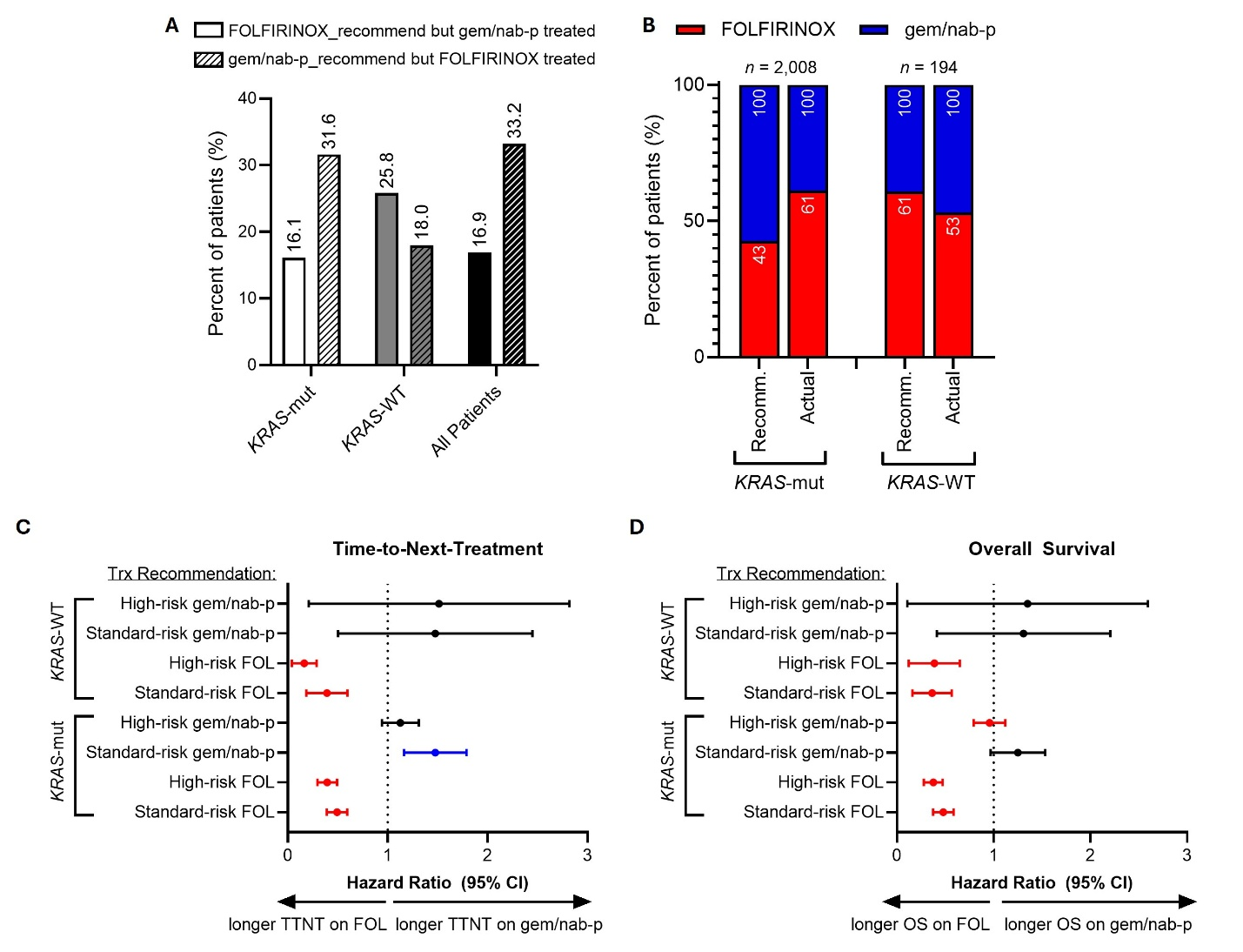

Supplementary Figure S8. FOLFIRINOX and gem/nab-p time-to-next-treatment (TTNT) and overall survival (OS) by KRAS mutation status. Kaplan-Meier curves illustrate TTNT (A-B) and OS (C-D) for FOLFIRINOX-treated patients and gem/nab-p-treated patients in KRAS-mutated (A, C) and KRAS-wildtype (B, D) groups.
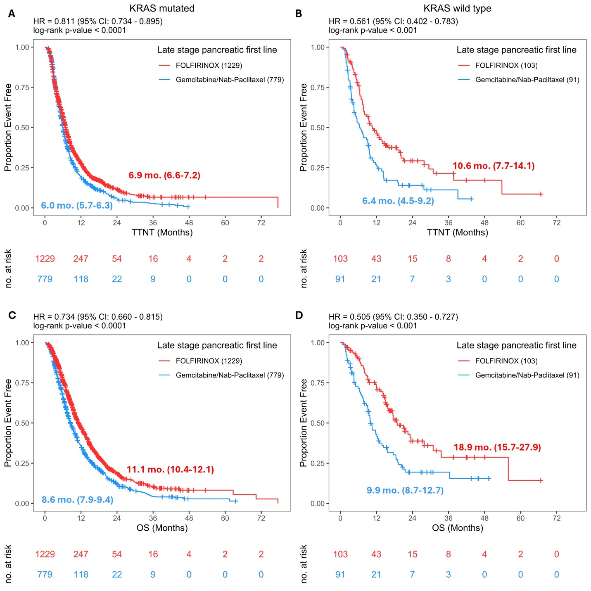

Supplementary Figure S9. FOLFIRINOX and gem/nab-p time-to-next-treatment (TTNT) and overall survival (OS) in patients with KRAS-mutated tumors, according to modeling groups. Kaplan-Meier curves illustrate TTNT and OS for FOLFIRINOX-treated patients and gem/nab-p-treated patients with KRAS-mutated tumors in “recommend FOLFIRINOX” standard- and high-risk groups (A) and “recommend gem/nab-p” standard- and high-risk groups (B).
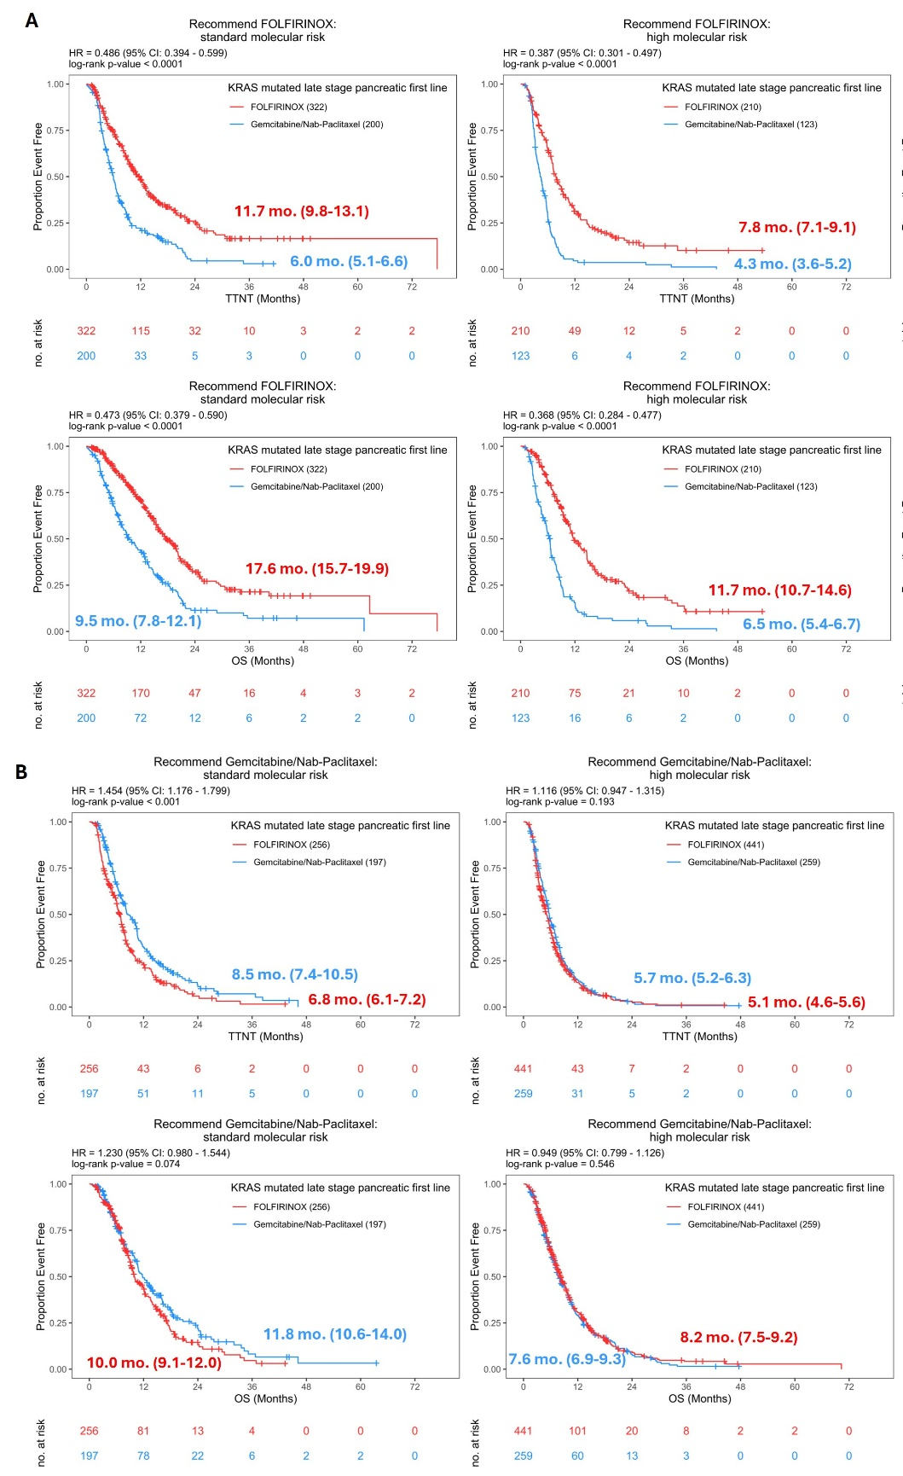

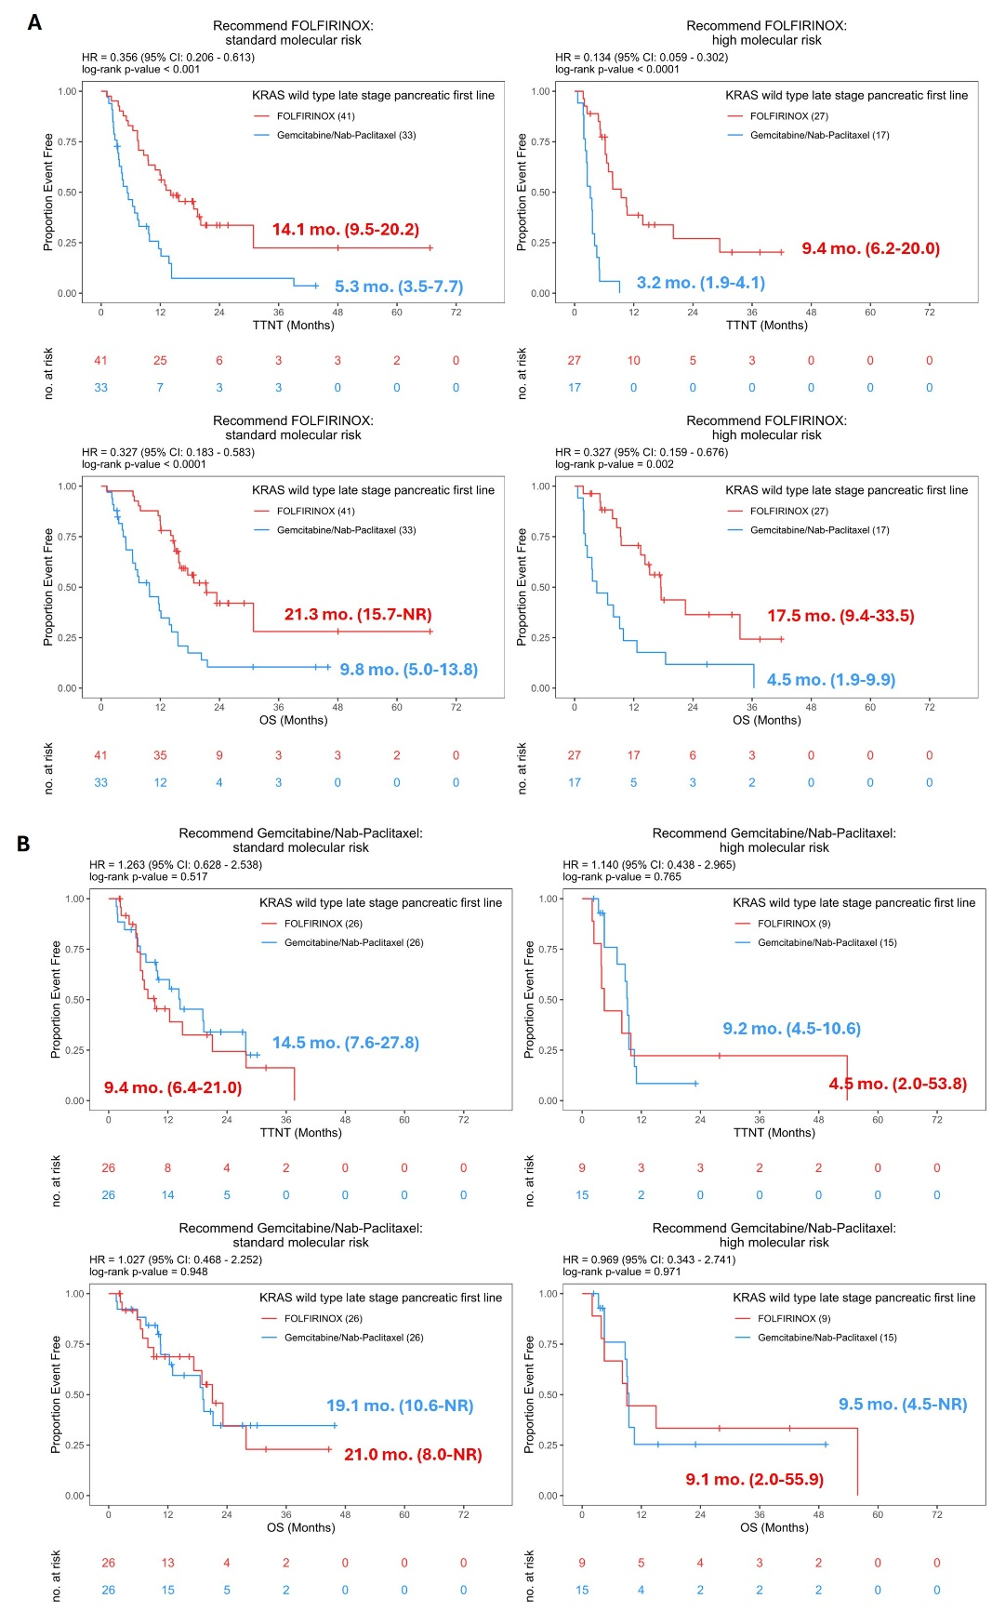
Supplementary Figure S10. FOLFIRINOX and gem/nab-p time-to-next-treatment (TTNT) and overall survival (OS) in patients with KRAS-wildtype tumors, according to modeling groups. Kaplan-Meier curves illustrate TTNT and OS for FOLFIRINOX-treated patients and gem/nab-p-treated patients with KRAS-wildtype tumors in “recommend FOLFIRINOX” standard- and high-risk groups (A) and “recommend gem/nab-p” standard- and high-risk groups (B).

