Glucocorticoid and mitophagy signaling–based molecular subtyping reveals HMGA1 as a prognostic and immunotherapy biomarker in lung adenocarcinoma
Junjie Yu^{1#}, Yantao Jiang^{1#}, Qingqing Xiong^{1#}, Yongmeng Wu², Wei Luo¹, Luyao Tong¹, Yi Lu¹, Lianmin Zhang¹*, Peng Chen ¹*, Tingting Qin¹*.

Supplementary Figures
Supplementary Figure 1. Consensus clustering, survival validation, prognostic model evaluation, and single-cell annotation validation based on the 127-gene signature. (A, B) Consensus matrix and CDF curves supporting two stable molecular subtypes based on the 127-gene signature. (C–E) Kaplan–Meier and PCA analyses in GSE31210 and GSE50081 showing prognostic differences and subtype separation between C1 and C2. (F, G) Consensus clustering and CDF curves in GSE50081 confirming the reproducibility of the two-subtype classification. (H) Kaplan–Meier survival analysis in GSE50081 showing distinct overall survival between C1 and C2. (I) C-index comparison of the StepCox[forward] + Ridge model across TCGA, GSE31210, and GSE50081 cohorts. (J–L) DCA curves comparing stage alone with the stage plus RS-based nomogram for 1-, 3-, and 5-year OS prediction. (M) Dot plot showing canonical marker gene expression across major cell types in the GSE131907 single-cell reference, supporting the cell-type annotations used for RCTD-based spatial projection.
Supplementary Figure 2. HMGA1 knockout suppresses proliferation, colony formation, migration, and invasion of lung cancer cells, which is partially rescued by HMGA1 re-expression. (A, B) RT-qPCR analysis of HMGA1 expression in PC9 and NCI-H1299 cells after HMGA1 knockout and rescue. (C, D) CCK-8 assays showing cell proliferation. (E, F) Western blot validation of HMGA1 protein expression. (G–I) Colony formation assays and quantification. (J–L) Transwell migration and invasion assays and quantification.(M–P) Wound healing assays and quantification. Data are shown as mean ± SD from three independent experiments (n = 3). p < 0.05, p < 0.01, p < 0.001, p < 0.0001; ns, not significant.
Supplementary Figure 3
Uncropped images of the WB
Figure 7E
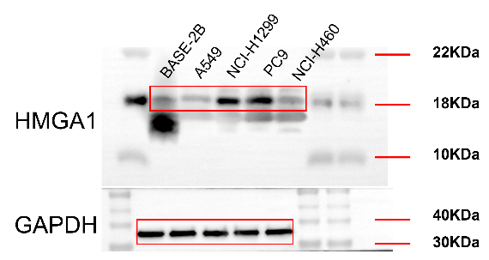
Figure 7F
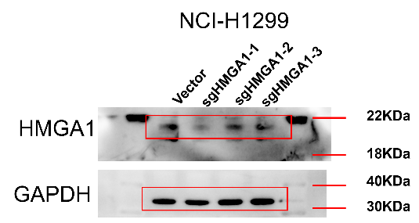
Figure 7G
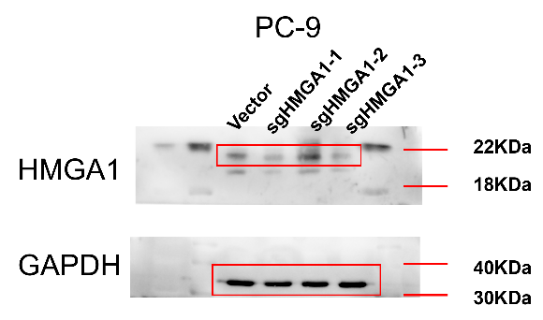
Figure 7H
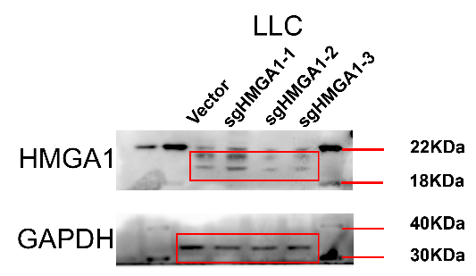

Supplementary Tables
Supplementary Data 1 DEGs Tumor vs Normal
Supplementary Data 2 GC Mitophagy genes
Supplementary Data 3 DEGs BothHigh vs BothLow
Supplementary Data 4 Core 127 genes
Supplementary Data 5 Cindex all models
Supplementary Data 6 17 gene signature coeff
Supplementary Data 7 pubilc signatures
Supplementary Data 8 Degree Analysis miRNA TF PPI Networks
Supplementary Data9 ImmuneCheckpoint pvalue FDR
Supplementary Data10 HMGA1 Checkpoint Adjusted limma PC
Supplementary Data 11 Tumor Immune Dysfunction and Exclusion
Supplementary Data12 consistency summary allMethods
Supplementary Data 13 primer information
Supplementary Data 14 Primary Antibodies Used

