From Predictive Model to Clinical Application: Interpretable Prediction of Metachronous Liver Metastasis in Colorectal Cancer

Liuyang Yang^{1,2*}, Liyu Shan^{3,4*}, Peiyi Xie^{5,6*}, Tong Tong^{7,8*}, Changlong Yang³, Lizhu Liu¹, Rongxiang Fang¹, Mingxiong Zhang³, Zhihui Shi¹, Yibo Gong⁴, Youguo Dai³, Xiaoyan Zhang^{9#}, Zhenhui Li^{1#}, Wenliang Li^{3,4#}

¹Department of Radiology, The Third Affiliated Hospital of Kunming Medical University, Yunnan Cancer Hospital, Peking University Cancer Hospital Yunnan, Yunnan, China
²The first people’s hospital of Yunnan Province, Yunnan, China
³Department of Gastrointestinal Surgery, The Third Affiliated Hospital of Kunming Medical University, Yunnan Cancer Hospital, Peking University Cancer Hospital Yunnan, Yunnan, China
⁴The Second Affiliated Hospital of Kunming Medical University, Yunnan, China
⁵Department of Radiology, Guangdong Provincial Key Laboratory of Colorectal and Pelvic Floor Diseases, The Sixth Affiliated Hospital, Sun Yat-sen University, Guangdong, China
⁶Biomedical Innovation Center, The Sixth Affiliated Hospital, Sun Yat-sen University, Guangzhou, Guangdong, 510655, China
⁷Department of Radiology, Fudan University Shanghai Cancer Center, Shanghai, China
⁸Department of Oncology, Shanghai Medical College, Fudan University, Shanghai, China
⁹Key laboratory of Carcinogenesis and Translational Research (Ministry of Education/Beijing), Department of Radiology, Peking University Cancer Hospital & Institute, Beijing, China

*These authors contributed equally.
#Corresponding author

Supplementary
Supplementary Figures
Fig. S1 Comparation of Dice index between MA-YOLO segmentation model and senior radiologists.
Fig. S2. Radar plot-based performance comparison of models across validation cohorts.
Supplementary Tables
Table S1. Baseline patient characteristics by data source
Table S2. Baseline patient characteristics by data source
Table S3. Performance of the three prediction model in the internal and external validation cohorts.
Table S4. Timepoint-specific comparison of postoperative pathology-only and integrated preoperative–postoperative models
Table S5. Performance of conventional numerical-feature-based models for identifying MLM

Supplementary Figures

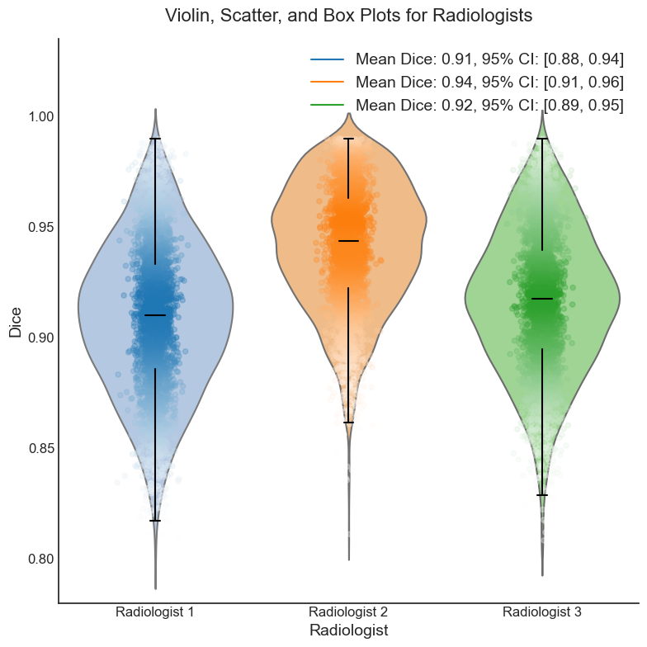
Fig. S1. Comparation of Dice index between MA-YOLO segmentation model and senior radiologists.

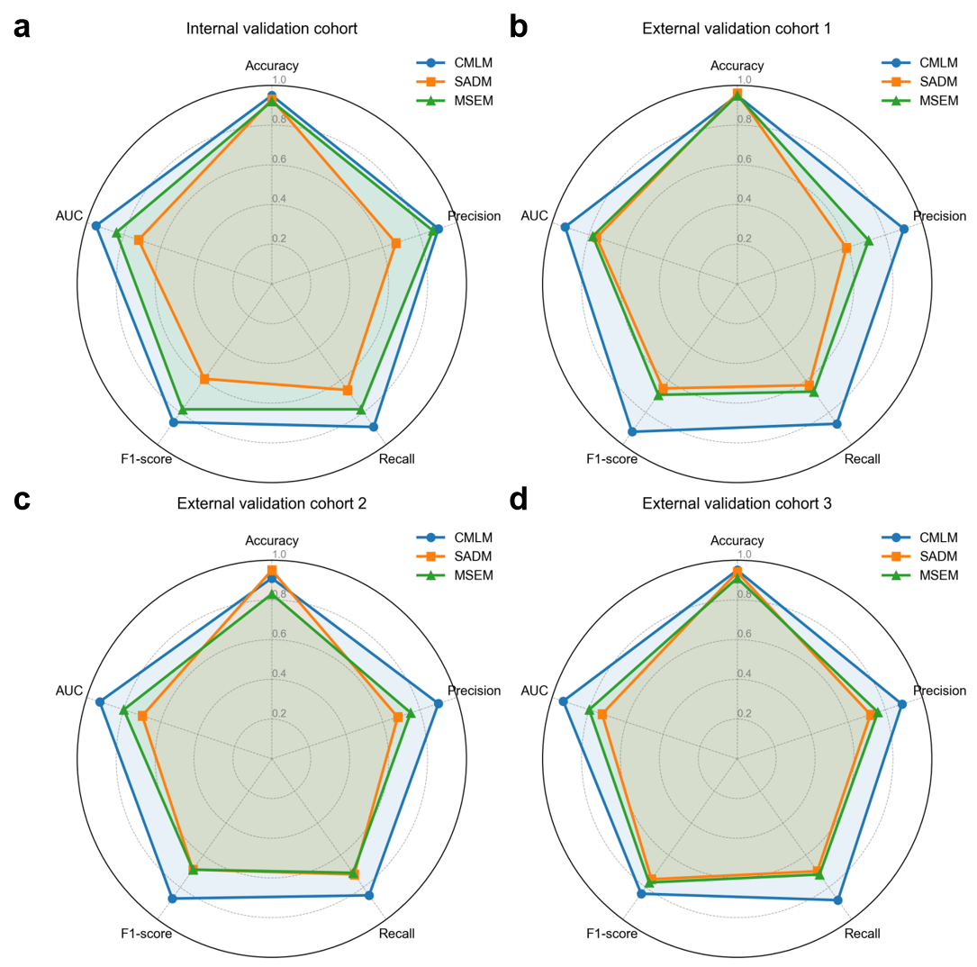
Fig. S2. Radar plot-based performance comparison of models across validation cohorts. The plots illustrate the performance of CMLM (blue), SADM (orange), and MSEM (green) on five metrics: accuracy, AUROC, precision, recall, and F1-score. Values are scaled from 0 to 1. (a) Internal validation cohort. (b) External validation cohort 1. (c) External validation cohort 2. (d) External validation cohort 3.

Supplementary Tables
Table S1. Baseline patient characteristics by data source
Variables | Training and internal validation cohort (n=2145) | External validation cohort 1 (n=311) | External validation cohort 2 (n=333) | External validation cohort 3 (n=194) | P value
Marital status |  |  |  |  | ＜0.01
Unmarried | 39 (1.8%) | 16(5.1%) | 48(14.4%) | 24(12.4%)
Married | 2071 (96.6%) | 257(82.6%) | 244(73.3%) | 158(81.4%)
Widowed | 26 (1.2%) | 0(0%) | 26(7.8%) | 3(1.5%)
Divorced | 9 (0.4%) | 38(12.2%) | 15(4.5%) | 9(4.6%)
Smoking history |  |  |  |  | 0.049
Yes | 554(25.8%) | 74(23.8%) | 95(28.5%) | 35(18%)
No | 1591(74.2%) | 237(76.2%) | 238(71.5%) | 159(82.0%)
Alcohol consumption history  historyCause of injury, n (%) |  |  |  |  | 0.513
Yes | 481(22.4%) | 61(19.6%) | 68(20.4%) | 47(24.2%)
No | 1664(77.6%) | 250(80.4%) | 265(79.6%) | 147(75.8%)
Hypertension history |  |  |  |  | 0.292
Yes | 504(23.5%) | 65(20.9%) | 86(25.8%) | 38(19.6%)
No | 1641(76.5%) | 246(79.1%) | 247(74.2%) | 156(80.4%)
Diabetes history |  |  |  |  | 0.114
Yes | 175(8.2%) | 26(8.4%) | 36(10.8%) | 24(12.4%)
No | 1970(91.8%) | 285(91.6%) | 297(89.2%) | 170(87.6%)
Coronary artery disease |  |  |  |  | 0.682
Yes | 59(2.8%) | 12(3.9%) | 8(2.4%) | 6(3.1%)
No | 2086(97.2%) | 299(96.1%) | 325(97.6%) | 188(96.9%)
Chronic obstructive pulmonary disease |  |  |  |  | ＜0.01
Yes | 19(0.9%) | 11(3.5%) | 4(1.2%) | 2(1.0%)
No | 2126(99.1%) | 300(96.5%) | 329(98.8%) | 192(99.0%)
CCI |  |  |  |  | 0.051
≤2 | 1653(77.1%) | 242(77.8%) | 245(73.6%) | 160(82.5%)
3-4 | 467(21.8%) | 64(20.6%) | 88(26.4%) | 31(16.0%)
≥5 | 25(1.2%) | 5(1.6%) | 0(0%) | 3(1.5%)
ASA classification |  |  |  |  | 0.192
Ⅰ-Ⅱ | 2052(95.7%) | 303(97.4%) | 325(97.6%) | 185(95.4%)
Ⅲ-Ⅳ | 93(4.3%) | 8(2.6%) | 8(2.4%) | 9(4.6%)
Data are presented as n (%).
CCI, Charlson Comorbidity Index; ASA, American Society of Anesthesiologists.
P-values were calculated using the Chi-square test for categorical variables across the four cohorts, with Fisher’s exact test applied when expected cell counts were less than 5. A P-value < 0.05 was considered statistically significant.

Table S2. Continuous baseline characteristics across data sources
Variables | Training and internal validation cohort (n=2145) | External validation cohort 1 (n=311) | External validation cohort 2 (n=333) | External validation cohort 3 (n=194) | P value
preCEA (ng/ml) | 3.70 [2.74-8.49] | 3.32 [2.72-7.24] | 2.99 [2.61-7.65] | 3.38 [1.73-7.21] | 0.012
preAFP (ng/ml) | 2.85 [2.03-3.85] | 2.81 [2.00-3.91] | 2.75 [1.92-3.82] | 2.65 [1.80-3.85] | 0.299
preCA125 (U/ml) | 13.99 [8.83-21.96] | 12.10 [7.90-19.10] | 12.80 [7.90-20.10] | 11.70 [7.70-18.20] | 0.024
preCA153 (U/ml) | 11.22 [7.57-15.75] | 11.07 [7.80-14.88] | 11.08 [7.80-15.00] | 11.28 [8.90-15.47] | 0.427
preCA199 (U/ml) | 14.49 [7.55-29.40] | 13.40 [7.10-26.23] | 13.80 [7.40-25.50] | 9.38 [3.49-23.51] | 0.233
preCA242 (U/ml) | 7.61 [4.30-16.22] | 7.50 [4.29-16.46] | 7.52 [4.34-15.16] | 5.94 [2.80-9.75] | 0.163
preCA724 (U/ml) | 3.15 [1.44-7.39] | 3.13 [1.45-7.36] | 3.13 [1.45-7.37] | 3.20 [1.91-7.02] | 0.030
preWBC (*10⁹/L) | 5.83 [4.73-7.46] | 5.96 [4.80-7.61] | 5.53 [4.38-7.18] | 5.29 [4.28-7.03] | 0.140
preLYM# (*10⁹/L) | 1.70 [1.20-2.30] | 1.76 [1.27-2.37] | 1.64 [1.18-2.21] | 1.87 [1.32-2.49] | 0.118
preMON# (*10⁹/L) | 0.36 [0.27-0.46] | 0.35 [0.26-0.46] | 0.35 [0.26-0.45] | 0.36 [0.28-0.45] | 0.331
preNEU#(*10⁹/L) | 3.67 [2.75-4.92] | 3.51 [2.57-4.80] | 3.38 [2.53-4.60] | 3.31 [2.22-4.74] | 0.119
preRBC (*10¹²/L） | 4.76 [4.31-5.12] | 4.70 [4.28-5.06] | 4.62 [4.20-4.97] | 4.74 [4.27-5.13] | 0.425
preHGB (g/L) | 141.00 [124.00-158.00] | 142.1 [126.1-158.7] | 140.5 [123.7-157.3] | 139.4 [123.9-154.6] | 0.400
prePLT (*10⁹/L) | 227.00 [181.00-293.00] | 225.5 [178.3-292.0] | 234.2 [186.4-301.2] | 230.3 [181.0-299.6] | 0.574
preALB (g/L) | 42.20 [39.30-44.70] | 41.2 [38.4-43.6] | 41.8 [38.7-44.5] | 43.1 [40.2-45.3] | 0.487
preTBIL (μmol/L) | 10.80 [7.00-15.30] | 11.2 [7.4-15.9] | 10.5 [6.7-15.0] | 10.9 [7.1-15.6] | 0.347
preAST (U/L) | 19.00 [15.00-26.00] | 18.5 [14.3-25.5] | 19.4 [15.3-26.8] | 19.2 [15.0-26.5] | 0.301
preALT (U/L) | 17.00 [12.00-24.00] | 17.5 [12.5-24.3] | 16.8 [11.6-23.6] | 17.2 [12.0-24.5] | 0.408
preLDH (U/L) | 159.00 [138.00-192.00] | 165.4 [144.6-198.6] | 158.1 [138.6-190.1] | 174.2 [153.1-211.4] | 0.065
preCRE (μmol/L) | 74.00 [64.00-87.00] | 77.9 [68.2-92.9] | 71.1 [61.3-83.9] | 75.5 [65.2-89.6] | 0.176
preCHOL (mmol/L) | 4.83 [4.15-5.67] | 4.96 [4.26-5.82] | 4.82 [4.12-5.69] | 5.10 [4.42-5.96] | 0.103
preHDL-C (mmol/L) | 1.11 [0.93-1.33] | 1.12 [0.93-1.34] | 1.19 [1.02-1.41] | 1.04 [0.85-1.26] | 0.122
preLDL-C (mmol/L) | 2.97 [2.35-3.60] | 3.11 [2.47-3.69] | 3.05 [2.40-3.75] | 2.96 [2.32-3.61] | 0.126
Number of positive lymph nodes | 0.00 [0.00-2.00] | 0.00 [0.00-1.00] | 0.00 [0.00-2.00] | 0.00 [0.00-3.00] | 0.072
ELN | 15.00 [13.00-19.00] | 17.00 [14.00-21.00] | 17.00 [14.00-23.00] | 19.00 [15.00-26.00] | 0.052
LNR | 0.00 [0.00-0.17] | 0.00 [0.00-0.11] | 0.00 [0.00-0.18] | 0.00 [0.00-0.14] | 0.058
TDs | 0.00 [0.00-0.00] | 0.00 [0.00-1.00] | 0.00 [0.00-0.00] | 0.00 [0.00-1.00] | 0.083
postCEA(ng/ml) | 1.93 [1.06-3.54] | 1.54 [0.98-2.38] | 1.57 [1.01-2.59] | 1.87 [1.23-3.18] | 0.153
postCA199(U/ml) | 10.77 [6.29-20.94] | 10.28 [5.81-16.93] | 10.12 [7.12-14.57] | 8.47 [5.63-12.32] | 0.365
postCA242(U/ml) | 6.32 [2.74-11.93] | 5.36 [2.84-9.12] | 5.40 [3.37-8.70] | 4.39 [2.28-7.20] | 0.288
postCA724 (U/ml) | 2.26 [1.18-4.67] | 2.97[1.78-5.04] | 2.88[1.66-5.54] | 3.06[1.58-4.93] | 0.721
Intraoperative blood loss (ml) | 150.00 [100.00-250.00] | 180.00 [132.00-280.00] | 170.00 [130.00-290.00] | 165.00 [126.00-220.00] | 0.067
Total anesthesia duration(min) | 195.00 [165.00-245.00] | 226.00 [204.00-252.00] | 232.00 [207.00-256.00] | 221.00 [198.00-248.00] | 0.011
postNa(mmol/L) | 142.00 [139.00-144.62] | 142.40 [140.86-145.67] | 139.30 [137.82-143.65] | 141.50 [140.10-143.84] | 0.066
Data are presented as median (interquartile range). The prefixes "pre" and "post" refer to preoperative and postoperative measurements, respectively.
CEA, carcinoembryonic antigen; AFP, alpha-fetoprotein; CA125, cancer antigen 125; CA153, cancer antigen 15-3; CA199, cancer antigen 19-9; CA242, cancer antigen 242; CA724, cancer antigen 724; WBC, white blood cell count; LYM#, lymphocyte count; NEU#, neutrophil count; MON#, monocyte count; RBC, red blood cell count; HGB, hemoglobin; PLT, platelet count; ALB, albumin; TBIL, total bilirubin; AST, aspartate aminotransferase; ALT, alanine aminotransferase; LDH, lactate dehydrogenase; CRE, creatinine; CHOL, cholesterol; HDL-C, high-density lipoprotein cholesterol; LDL-C, low-density lipoprotein cholesterol; ELN, number of examined lymph nodes; LNR, lymph node ratio; TDs, tumor deposits; Na, sodium.
P-values were calculated using the Kruskal-Wallis test for continuous variables across the four cohorts. A P-value < 0.05 was considered statistically significant.

Table S3. Performance of the three prediction model in the internal and external validation cohorts.
Cohort | Model | Accuracy | Specificity | Recall | F1-score | AUROC | AUPRC | PPV | NPV | Prevalence  (Random guess baseline)
Internal validation cohort | CMLM | 0.98  (0.97 - 0.99) | 0.99  (0.98 - 1.00) | 0.71  (0.61 - 0.82) | 0.72  (0.62 - 0.81) | 0.95  (0.94 - 0.96) | 0.81  (0.70 - 0.91) | 0.71  (0.60 - 0.83) | 0.99  (0.98 - 1.00) | 0.05
External validation cohort 1 | CMLM | 0.97  (0.95 - 0.99) | 0.99  (0.98 -1.00) | 0.54  (0.44 - 0.65) | 0.64  (0.54 - 0.64) | 0.93  (0.89 - 0.96) | 0.70  (0.61 - 0.80) | 0.78  (0.62 - 0.90) | 0.98  (0.96 - 0.99) | 0.07
External validation cohort 2 | CMLM | 0.90  (0.87 - 0.93) | 0.91  (0.87 -0.94) | 0.81  (0.69 - 0.94) | 0.44  (0.38 - 0.50) | 0.93  (0.91 - 0.95) | 0.54  (0.45 - 0.67) | 0.30  (0.26 - 0.36) | 0.99  (0.98 - 1.00) | 0.07
External validation cohort 3 | CMLM | 0.97  (0.95 - 0.99) | 0.98  (0.97 - 0.99) | 0.82  (0.73 - 0.91) | 0.78  (0.70 - 0.87) | 0.94  (0.91 - 0.97) | 0.78  (0.68 - 0.91) | 0.75  (0.64 - 0.89) | 0.99  (0.97 - 1.00) | 0.04
CMLM, Colorectal Cancer Metachronous Liver Metastasis Prediction Model based on multimodal data;

SADM, Self-Attention Dense ResNet Model based solely on numerical data; MSEM, Multi-scale Feature Extraction Model based on imaging data;

AUC, area under the receiver operating characteristic curve.

Table S4. Timepoint-specific comparison of postoperative pathology-only and integrated preoperative–postoperative models
Cohort | Model | Features | Accuracy | Specificity | Recall | F1-score | AUROC | AUPRC | PPV | NPV | Prevalence  Random guess baseline
Internal validation cohort | C  M  L  M | Pathology-only | 0.93  (0.92 - 0.94) | 0.95  (0.93 -0.97) | 0.38  (0.34 - 0.43) | 0.22  (0.18 - 0.26) | 0.74  (0.65 - 0.83) | 0.24  (0.20 - 0.28) | 0.15  (0.12 - 0.18) | 0.97  (0.95 - 0.98) | 0.05
Internal validation cohort | C  M  L  M | Integrated preoperative–postoperative | 0.94  (0.93 - 0.94) | 0.96  (0.94 -0.98) | 0.44  (0.40 - 0.47) | 0.33  (0.28 - 0.42) | 0.78  (0.74 - 0.82) | 0.35  (0.28 - 0.42) | 0.26  (0.22 - 0.30) | 0.98  (0.97 - 0.99) | 0.05

Table S5. Performance of conventional numerical-feature-based models for identifying MLM
Cohort | Model | Features | Accuracy | Specificity | Recall | F1-score | AUROC | AUPRC | PPV | NPV | Prevalence  (Random guess baseline)
Internal validation cohort | LR | Selected value-based variables | 0.97  (0.97 - 0.99) | 1.00  (1.00 - 1.00) | 0.00  (0.00 - 0.00) | 0.00  (0.00 - 0.00) | 0.69  (0.52 - 0.84) | 0.08  (0.04 - 0.15) | 0.00  (0.00 - 0.00) | 0.97  (0.95 - 0.98) | 0.05
Internal validation cohort | XGB | Selected value-based variables | 0.96  (0.94 - 0.99) | 0.99  (0.98 -1.00) | 0.00  (0.00 - 0.00) | 0.00  (0.00 - 0.00) | 0.58  (0.43 - 0.70) | 0.06  (0.03 - 0.12) | 0.00  (0.00 - 0.00) | 0.97  (0.95 - 0.98) | 0.05
LR: Logistic regression
XGB: XGBoost

