Supplementary Figures

Figure S1. cfDNA features in healthy participants and cancer patients
(A-C) Principal component analysis (PCA) plots showing the separation of healthy and cancer groups based on fragment size profile (FSP) (A), focal copy number variation (CNV) (B), and genome-wide methylation (GWM) (C) features.

Figure S2. Feature performance and the stacked model using the training data
(A) Receiver operating characteristics (ROC) curves and area under the curve (AUC) values for the stacked model and models based on single cfDNA features in the training dataset, including fragment size profile (FSP), focal copy number variation (CNV), and genome-wide methylation (GWM). (B) Cancer prediction scores for healthy and cancer participants in the training dataset, with the cutoff threshold for 95% specificity indicated by the dotted line. (C) Model performance at the predefined cancer prediction cutoff in the training dataset.

Figure S3. ROC curves for serum biomarkers in comparison to the stacked model using the internal validation set

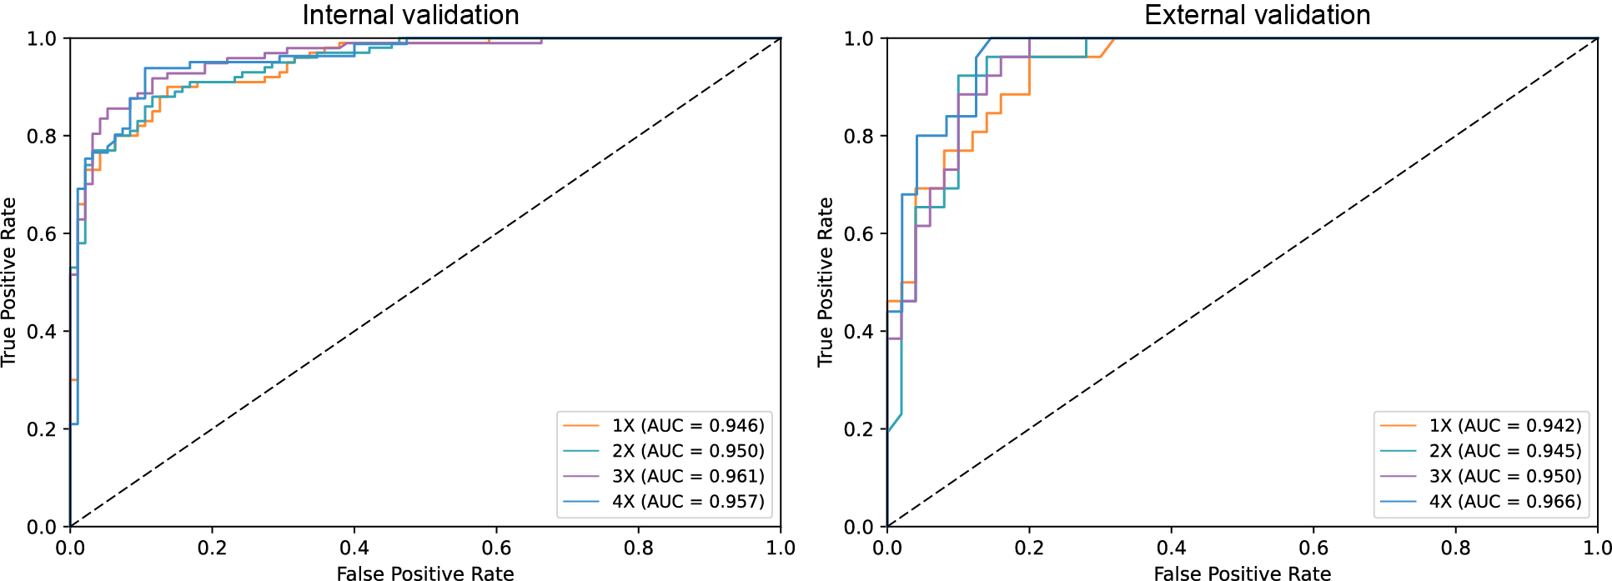

Figure S4. Model performance at lower sequencing depths
ROC curves showing the discriminative power of the stacked ensemble model after downsampling to sequencing depths of 4x, 3x, 2x, and 1x in the internal (left) and external (right) validation sets.

Figure S5. Subgroup analysis using the training set
Cancer prediction scores stratified by clinical stage (A), anatomical site (B), and tumor differentiation status (C) using the training data.

Figure S6. ROC curves for subgroup analysis
Comparison of receiver operating characteristics (ROC) curves and area under the curve (AUC) values for subgroup patients stratified by TNM stage, anatomical sites, and extent of differentiation in the training cohort (A), internal validation cohort (B), and external validation cohort (C).

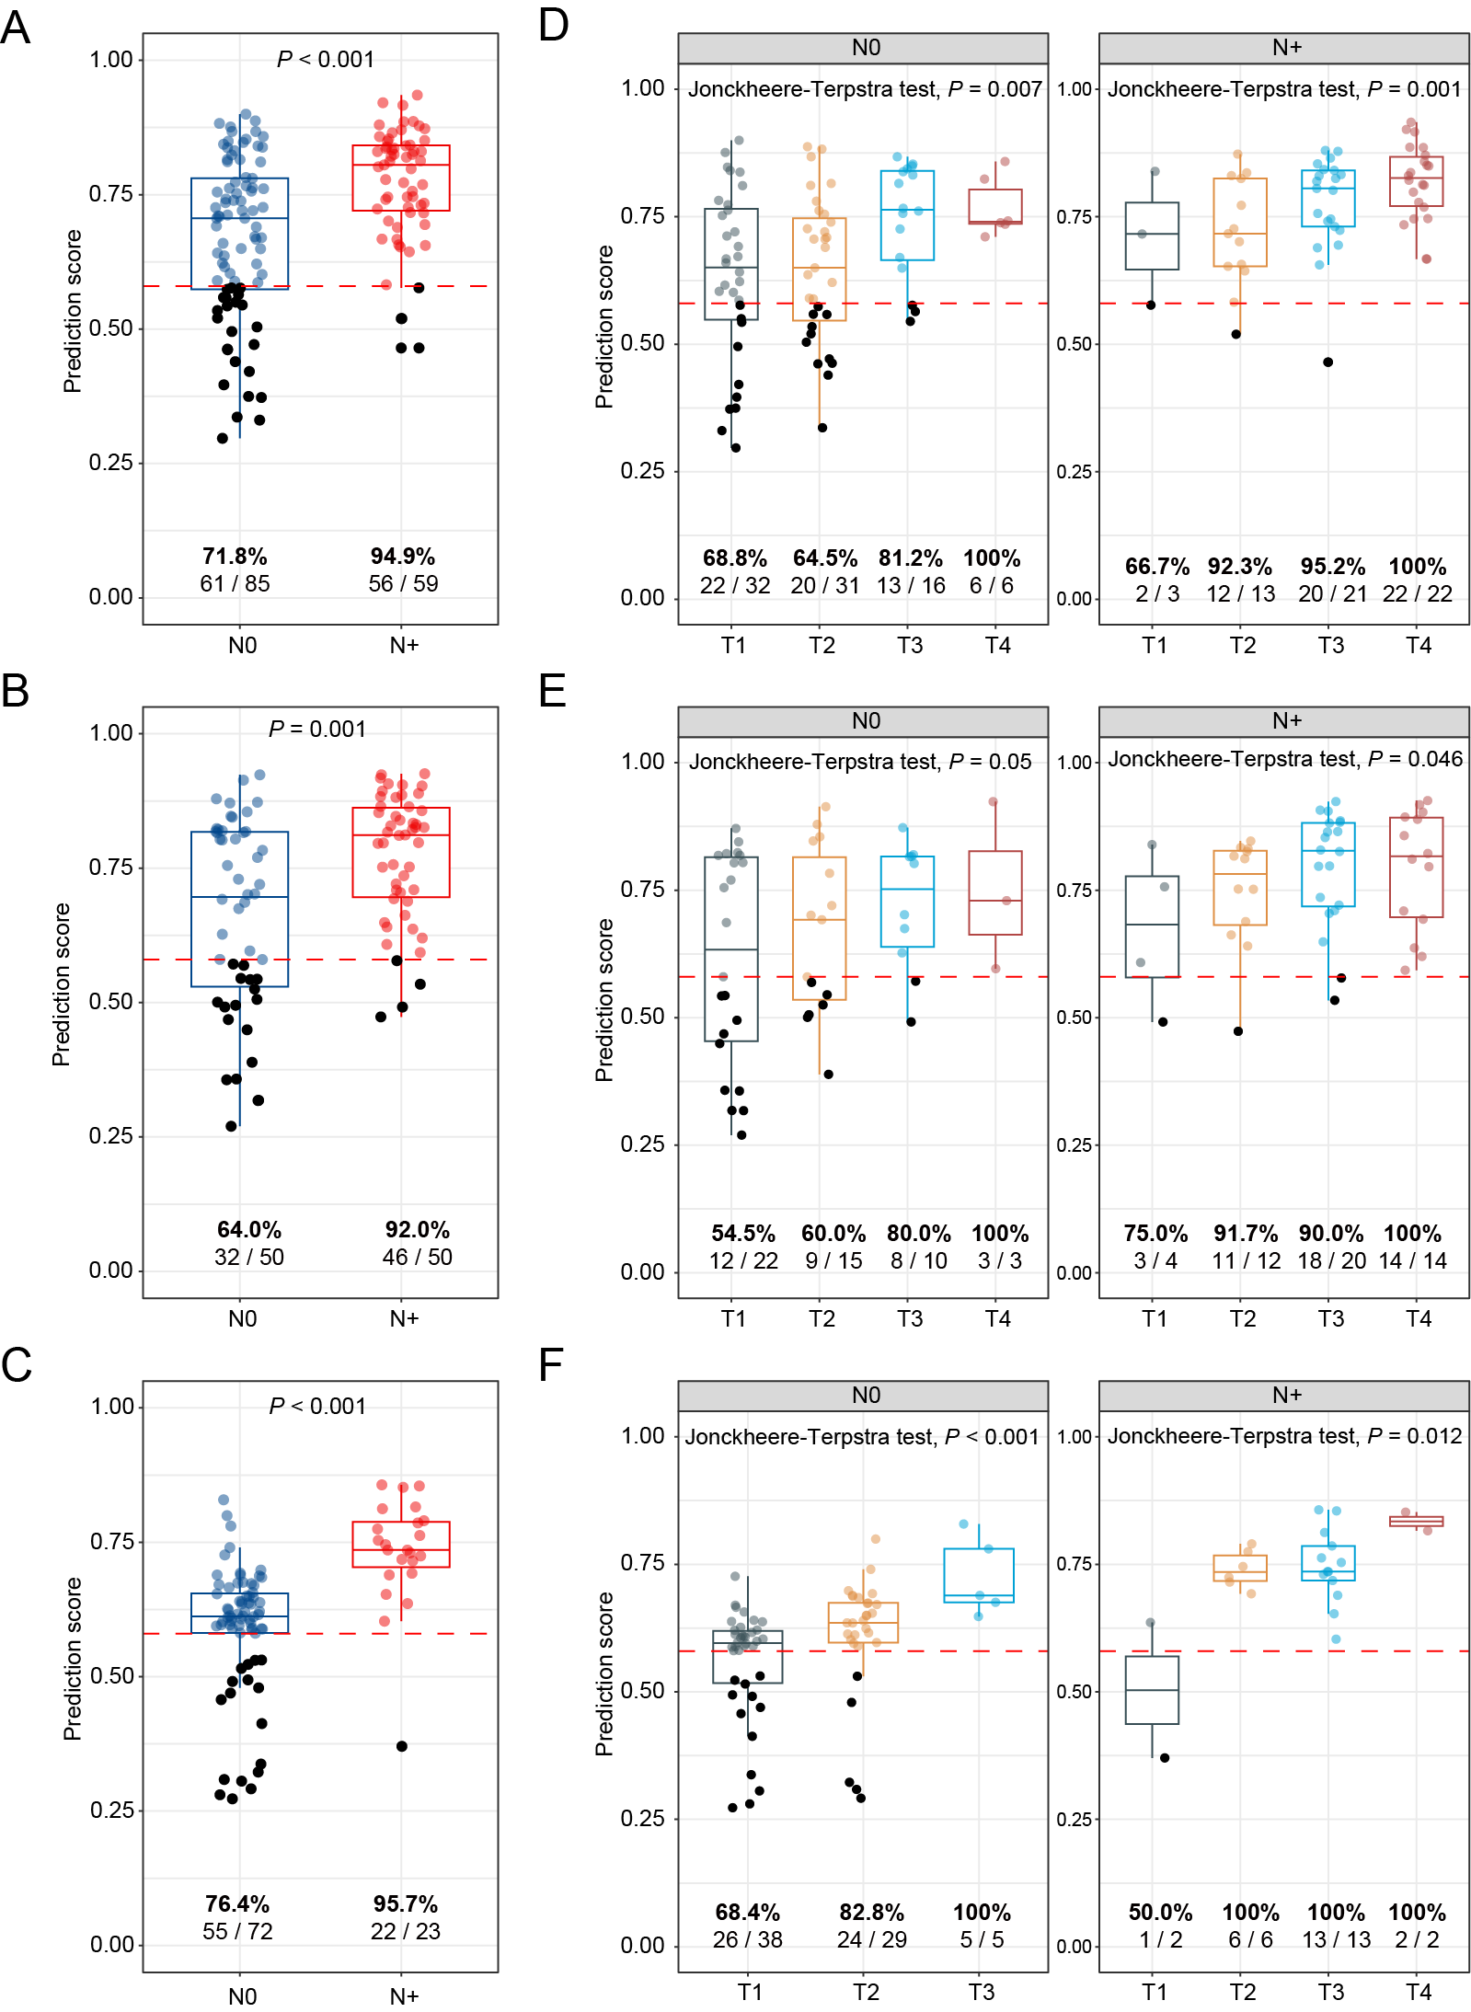

Figure S7. Prediction score in patients with or without lymph node metastasis
(A-C) Cancer prediction scores in patients with (N+) or without (N0) nodal involvement in the training (A), internal validation (B), and external validation (C) datasets. The predefined prediction score cutoff is indicated by the red dotted line. Each point represents an individual patient. Black dots indicate false negatives (patients with cancer whose prediction score falls below the cutoff), and colored dots indicate true positives. Sensitivity at the predefined cutoff is shown below each group as both percentage and raw numbers. (D-F) Cancer prediction scores exhibited a stepwise increase across tumor stage subgroups, independent of lymph node status in the training (D), internal validation (E), and external validation (F) datasets. Black dots indicate false negatives as defined above. P-values were reported using the one-sided (increasing) Jonckheere-Terpstra test.

Figure S8. Subgroup analysis of patient survival based on cancer prediction score
(A-C) Overall survival of patients stratified by a prediction score cutoff of 0.58 across clinical stage I (A), stage II (B), and stage III (C). (D) Overall survival of stage IV patients stratified by quartile values of the prediction score. (E, F) Overall survival of N0 (E) and N+ (F) patients stratified by a prediction score cutoff of 0.58.

Figure S9. Proposed clinical workflow for early detection of HNSCC using cfDNA-based fragmentomic profiling
Schematic illustration of a tiered screening strategy using the cfDNA-based model for early HNSCC detection in high-risk individuals. Positive cases undergo further diagnostic evaluation (e.g., endoscopy, imaging, viral tests), while negative cases may enter periodic surveillance.

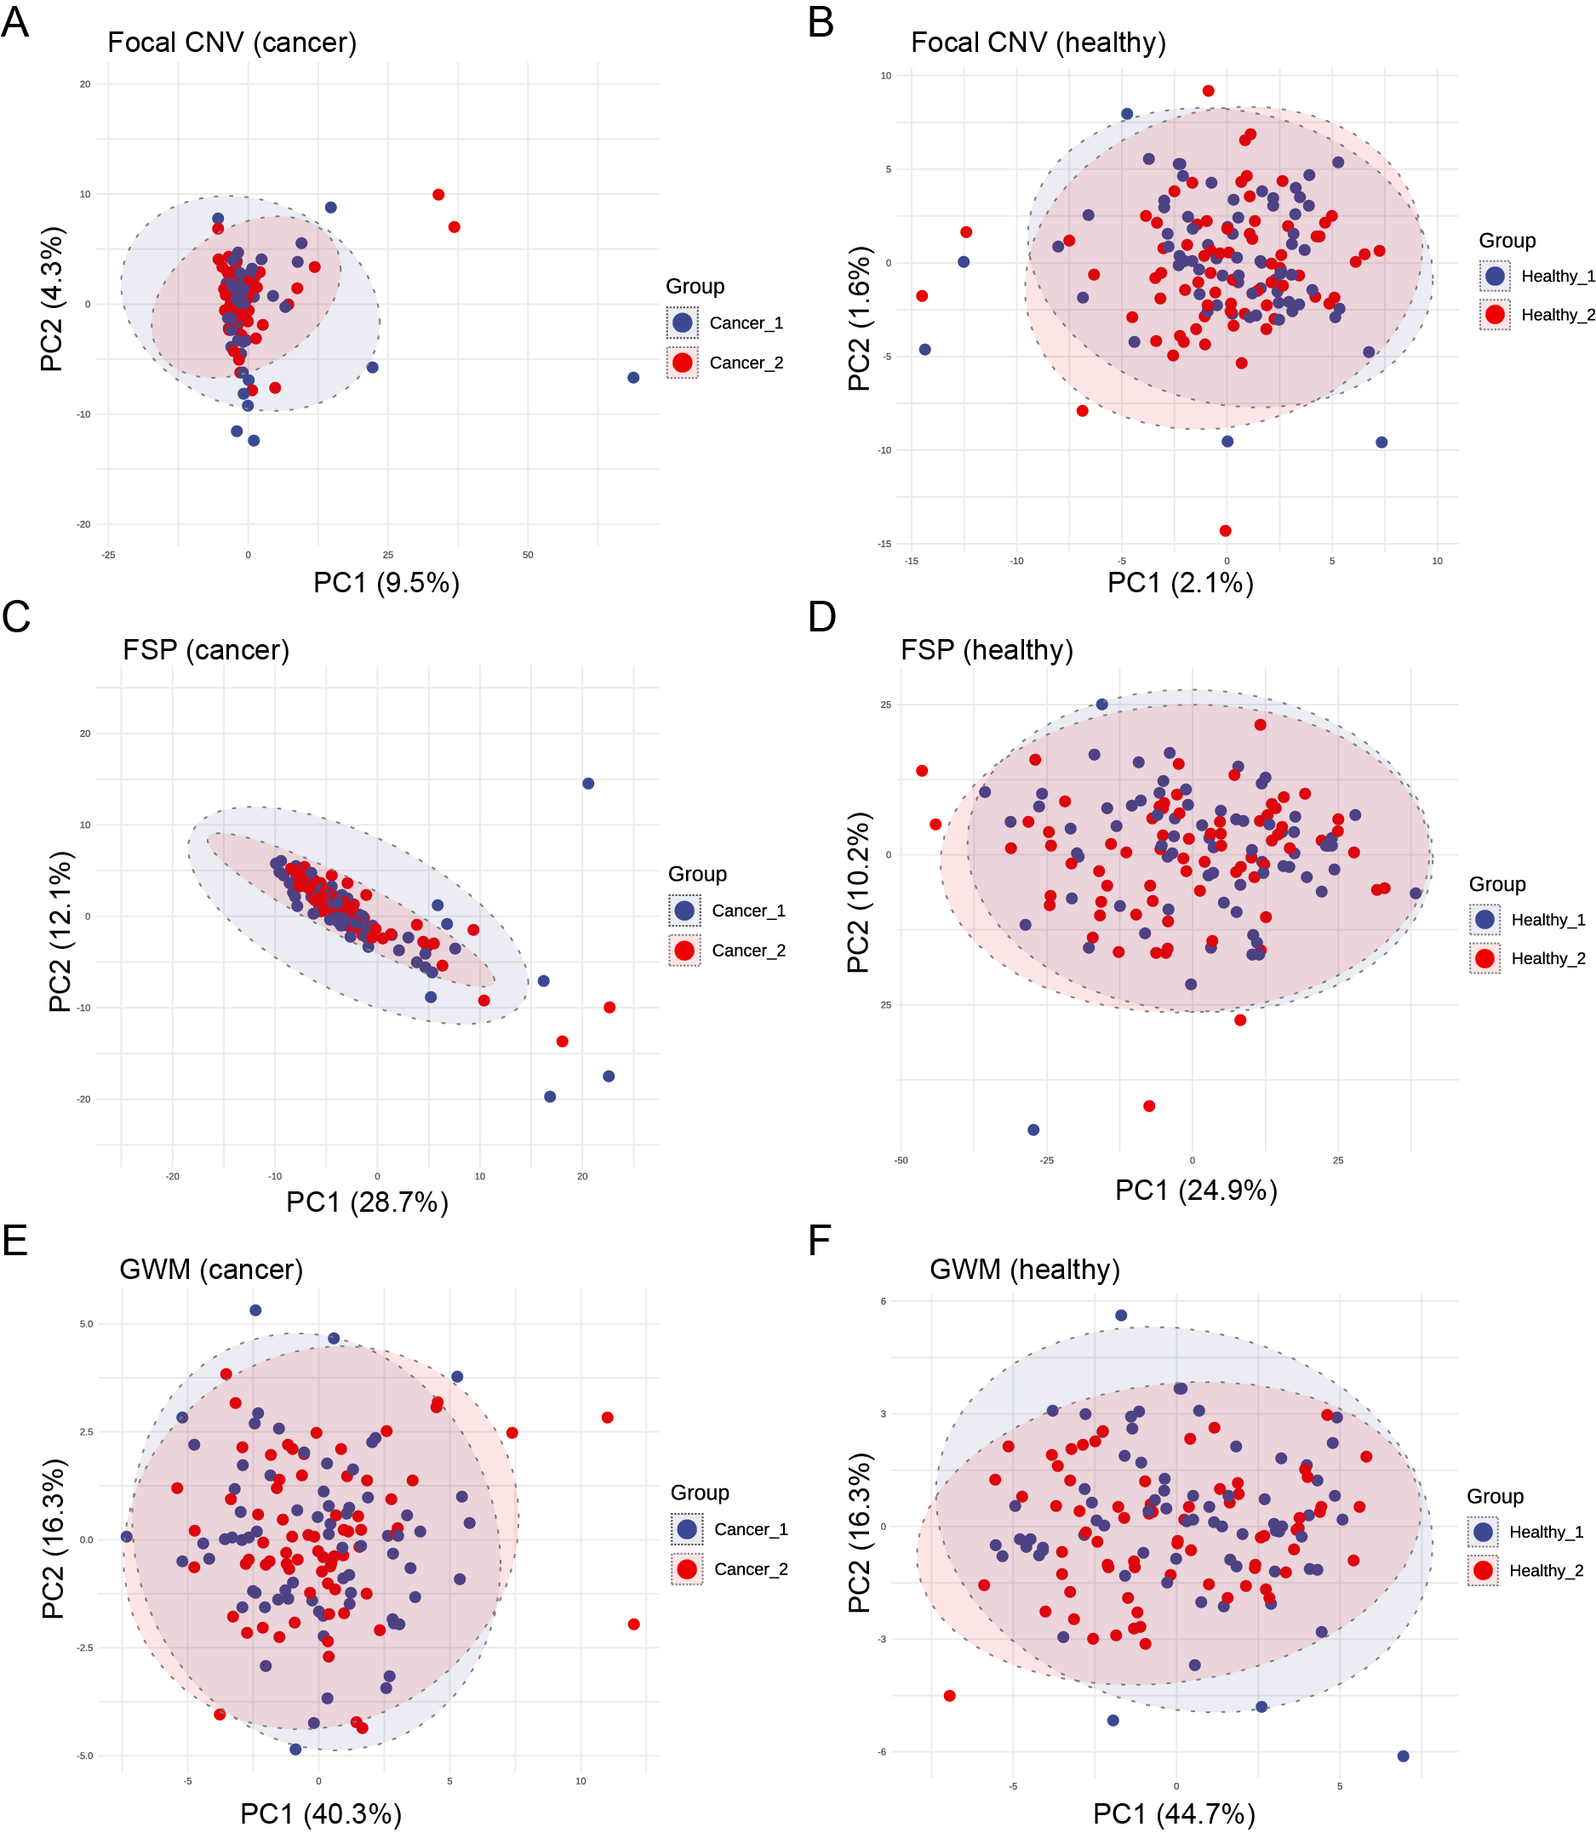

Figure S10. Principal component analysis of cfDNA sequencing batches
Training cohort samples were randomly divided and sequenced across two batches, with each batch containing both cancer and healthy samples. Principal component analysis (PCA) was performed on normalized cfDNA sequencing features. Samples from each batch are color-coded according to batch assignment. CNV, copy number variation; FSP, fragment size profile; GWM, genome-wide methylation.

Supplementary Tables

Table S1. Comparison of baseline characteristics among cohorts
 | Training vs. Internal |  | Training vs. External |  | Internal vs. External
 | Healthy | HNSCC | Healthy | HNSCC | Healthy | HNSCC
Age | 0.27 | 0.82 | 0.54 | 0.13 | 0.62 | 0.11
Sex | >0.99 | 0.88 | >0.99 | 0.75 | >0.99 | 0.56
Clinical stage | ~ | 0.33 | ~ | <0.001 | ~ | <0.001
Nodal involvement | ~ | 0.21 | ~ | 0.01 | ~ | <0.001
Distant metastasis | ~ | 0.15 | ~ | 0.15 | ~ | >0.99
Anatomical site | ~ | 0.41 | ~ | 0.01 | ~ | 0.06
Differentiation | ~ | 0.24 | ~ | 0.21 | ~ | 0.09

Table S2. Relative contribution of individual cfDNA features to the ensemble model
Feature | Ensemble stacked AUC | Permuted AUC (mean) | ΔAUC | Permuted AUC (95% CI) | Relative  Contribution
Internal validation
Focal CNV | 96.2 | 90.69 | 5.51 | 90.64 - 90.74 | 34.28%
GWM | 96.2 | 92.32 | 3.88 | 92.27 - 92.37 | 24.14%
FSP | 96.2 | 89.52 | 6.68 | 89.45 - 89.59 | 41.58%
External validation
Focal CNV | 96.6 | 89.03 | 7.57 | 88.97 - 89.09 | 42.97%
GWM | 96.6 | 93.39 | 3.21 | 93.34 - 93.43 | 18.24%
FSP | 96.6 | 89.77 | 6.83 | 89.71 - 89.83 | 38.79%
Abbreviations: AUC, area under the curve; CNV, copy number variation; GWM, genome-wide methylation; FSP, fragment size profile

Table S3. Evaluation of performance metrics for the stacked model
Dataset | Accuracy  (95% CI) | Precision  (95% CI) | Recall  (95% CI) | Specificity  (95% CI) | F1-score  (95% CI) | PPV  (95% CI) | NPV  (95% CI)
Training | 0.884  (0.846-0.918) | 0.944  (0.901-0.982) | 0.812  (0.752-0.874) | 0.953  (0.915-0.985) | 0.873  (0.829-0.912) | 0.944  (0.901-0.982) | 0.839  (0.780-0.891)
Internal validation | 0.867  (0.816-0.913) | 0.951  (0.900-0.989) | 0.780  (0.694-0.856) | 0.958  (0.915-0.991) | 0.857  (0.798-0.906) | 0.951  (0.900-0.989) | 0.807  (0.732-0.875)
External validation | 0.891  (0.845-0.933) | 0.963  (0.915-1.000) | 0.811  (0.731-0.882) | 0.969  (0.928-1.000) | 0.880  (0.824-0.923) | 0.963  (0.915-1.000) | 0.841  (0.768-0.904)
Abbreviations: PPV, positive predictive value; NPV, negative predictive value; CI, confidence interval

Table S4. Univariate Cox regression analysis for overall survival in HNSCC patients (N=212)
Features | HR (95% CI) | P-value
Age (≥ 60 years vs < 60 years) | 1.05 (0.57-1.93) | 0.877
Sex (Male vs Female) | 1.69 (0.52-5.47) | 0.380
Differentiation (Poor vs Well/Moderate) | 1.26 (0.66-2.41) | 0.484
Subsite (Laryngeal vs Hypopharynx) | 0.26 (0.13-0.51) | <0.001***
Subsite (Nasopharynx vs Hypopharynx) | 0.36 (0.13-0.95) | 0.040*
Subsite (Oropharynx vs Hypopharynx) | 0.85 (0.32-2.27) | 0.747
Clinical stage (III/IV vs I/II) | 3.72 (1.81-7.61) | <0.001***
Prediction score (≥ 0.58 vs < 0.58) | 6.16 (1.49-25.46) | 0.012*
Prediction score (continuous) | 401.15 (21.89-7350.88) | <0.001***

Table S5. Parameters for selected base models
Algorithm | Feature | Model lD | Parameter
DRF | CNV | Focal_cnv--DRF_1_AutoML_1_20240515_182539 | ntrees=47; max_depth=20; sample_rate=0.632
GBM | CNV | Focal_cnvGBM_grid_1_AutoML_1_20240515_182539_model_6 | ntrees=74; max_depth=11; learn_rate=0.1; col_sample_rate=0.4
GLM | CNV | Focal_cnvGLM_1_AutoML_1_20240515_182539 | family=binomial; alpha=0.0,0.2,0.4,0.6,0.8,1.0; lambda sequence
XGBoost | CNV | Focal_cnv--XGBoost_grid_1_AutoML_1_20240515_182539_model_8 | ntrees=82; max_depth=3; learn_rate=0.3; colsample_bytree=0.9; reg_alpha=0.1
XRT | CNV | Focal_cnv--XRT_1_AutoML_1_20240515_182539 | ntrees=50; max_depth=20; sample_rate=0.632; histogram_type=Random
Deep Learning | CNV | Focal_cnv--DeepLearning_grid_1_AutoML_1_20240515_182539_model_8 | hidden=[50]; activation=RectifierWithDropout; epochs=601.35；rate=0.005；input_dropout_ratio=0.15
DRF | FSP | fragment2023--DRF_1_AutoML_1_20240515_182510 | ntrees=46; max_depth=20; sample_rate=0.632
GBM | FSP | fragment2023GBM_grid_1_AutoML_1_20240515_182510_model_14 | ntrees=77; max_depth=8; learn_rate=0.1; sample_rate=0.5
GLM | FSP | fragment2023GLM_1_AutoML_1_20240515_182510 | family=binomial; alpha=0.0,0.2,0.4,0.6,0.8,1.0; lambda sequence
XGBoost | FSP | ragment2023--XGBoost_2_AutoML_1_20240515_182510 | ntrees=50；max_depth=10；learn_rate=0.3；subsample=0.6；colsample_bytree=0.8
XRT | FSP | fragment2023--XRT_1_AutoML_1_20240515_182510 | ntrees=42；max_depth=20；sample_rate=0.632
Deep Learning | FSP | fragment2023--DeepLearning_grid_3_AutoML_1_20240515_182510_model_2 | hidden=[50,50,50]；activation=RectifierWithDropout；epochs=223.97；rate=0.005
DRF | GWM | FragMa--DRF_1_AutoML_1_20240515_182536 | ntrees=36; max_depth=20; sample_rate=0.632
GBM | GWM | FragMaGBM_grid_1_AutoML_1_20240515_182536_model_3 | ntrees=55; max_depth=8; learn_rate=0.1; sample_rate=0.7
GLM | GWM | FragMaGLM_1_AutoML_1_20240515_182536 | family=binomial; alpha=0.0,0.2,0.4,0.6,0.8,1.0; lambda sequence; solver=COORDINATE_DESCENT
XGBoost | GWM | FragMa--XGBoost_grid_1_AutoML_1_20240515_182536_model_17 | booster=dart；ntrees=46；max_depth=9；reg_alpha=0.001；reg_lambda=0.001
XRT | GWM | FragMa--XRT_1_AutoML_1_20240515_182536 | ntrees=50；max_depth=20；sample_rate=0.632
Deep Learning | GWM | FragMa--DeepLearning_grid_1_AutoML_1_20240515_182536_model_5 | hidden=[100]；activation=RectifierWithDropout；epochs=7193.71；rate=0.005；input_dropout_ratio=0.2

