Supplementary Information
Embedded Gate CVD MoS₂ Microwave FETs
Atresh Sanne^{1,}*, Saungeun Park^{1,}*, Rudresh Ghosh¹, Maruthi Nagavalli Yogeesh¹, Chison Liu¹, Leo Mathew², Rajesh Rao², Deji Akinwande¹, and Sanjay Kumar Banerjee¹
¹Microelectronics Research Center, The University of Texas at Austin, Austin, TX 78758, USA ²Applied Novel Devices Inc., Austin, TX, USA
Address correspondence to atresh.sanne@utexas.edu; deji@ece.utexas.edu

- Material Growth
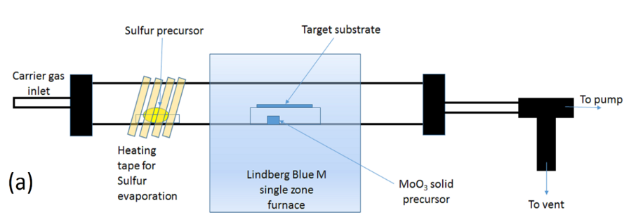

Figure S1. Schematic of the MoS₂ growth setup starting from MoO₃ and S.
The MoS₂ atomic layer films were grown by a standard vapor transfer growth process (schematic of growth setup shown in Figure S1) within a quartz tube with an inner diameter of 22 mm and a Lindberg/Blue M furnace. The starting materials were MoO₃ (15 mg) and sulfur (1 g) powder that were loaded in separate alumina crucibles and placed inside the tube, with the sulfur crucible outside the actual furnace and heated independently using a heating tape. The substrates used for this work were surface cleaned 285 nm SiO₂ on highly resistive Si (> 5000 Ω∙cm).
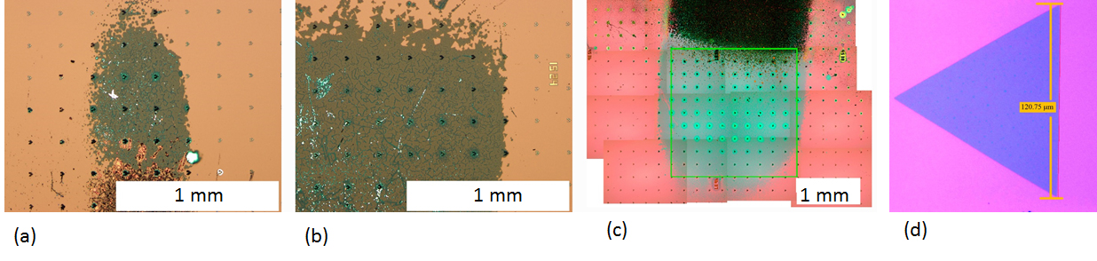
(f)
(e)
(g)

Figure S2. (a,b,c) Controlled large-area growth of continuous monolayer MoS₂ in the mm² scale. (d) Individual isolated domains with edge lengths > 100 µm. (e) SEM scan of triangular domains which merge to form pseudo continuous films. (f) SEM scan of mm-scale CVD MoS₂. (g) AFM image of a triangular MoS2 domain showing a flake height of about 0.8 nm, confirming a monolayer.
Controlled large area growth was accomplished by using masking and target substrates. Both the masking and target substrates used were from the same wafer. The polished side of the substrates faced the MoO₃ precursor. By controlling the distance between individual masking substrates we could control the area of the continuous monolayer region. The procedure for the growth consisted of loading the starting materials and substrates, followed by pumping down the tube to base pressure (< 10 mTorr). This was followed by purging the tube and the gas lines by flowing in UHP N₂ gas at 200 sccm. After 4 purging cycles the tube was filled with N₂ to 1 atm pressure. Then temperature of the furnace was raised to 850 °C at a rate of 50 °C/min. When the temperature of the tube furnace was at 650 °C, the sulfur was heated to 150 °C (+/- 5 °C) and held there at that temperature. The growth continued for 5 min at 850 °C. After the 5 minutes at 850 °C the heater in the furnace was turned off for cooling without any feedback. Heating of the sulfur was cut off once the furnace cooled down to 650 °C. Figure S2(a,b,c) show optical images of resulting large area growths. Figure S2(d) shows an individual triangular domain typical to those used for device fabrication. Figure S2(e,f) show scanning electron microscope (SEM) images of large area MoS₂. From the SEM scans the triangular domains merge to form pseudo continuous films. With the correct growth conditions we can obtain mm-scale MoS₂.

- Gummel’s Method
Figure S3. The Gummel plot confirms the 20 GHz f_{T} given by the inverse of the slope.

An alternative way to extract the f_{T} of a transistor is using Gummel’s method. The imaginary part of the short circuit current gain |h₂₁| is plotted versus frequency. The inverse of the slope is the extract f_{T}. As shown in Figure S3, we use this method to corroborate the f_{T} of 20 GHz for an embedded gate CVD MoS₂ FET at L_{g} of 150 nm.

- Unilateral Gain
Figure S4. Mason’s unilateral gain vs. frequency. We measure a cutoff frequency of 10.3 GHz.

Mason’s unilateral gain, U, is a common way of measuring and comparing the f_{max} between transistors. In the 2-port network, assuming lossless S₁₂ feedback, the maximum unilateral gain assumes matched input and outputs. Using this method we measure an intrinsic f_{max} of 10.3 GHz (Figure S4), which agrees well with the maximum available gain f_{max}.

- De-embedding Structures
10 µm
(b)
(a)
10 µm
Figure S5. (a) Optical image of the OPEN structure. (d) Optical image of the SHORT structure.
We used OPEN and SHORT structures fabricated on the same device-under-test (DUT) as measured for high frequency parameters. Figure S5(a) shows the zoomed in optical image of the OPEN DUT. An electron beam lithography (EBL) step exposing the channel region followed by a MoS₂ etch creates an electrical open in the device. Figure S5(b) shows the SHORT DUT. An EBL step across the channel and pad region followed by a thick metal deposition creates an electrical short in the device. De-embedding on the same DUT provides an accurate removal of parasitic capacitances and resistances characteristic to the measured DUT. As such, each measured device requires the same de-embedding procedure to be applied to each device. The intrinsic performance is obtained by the following two-step de-embedding process. We first obtain Y-parameters from the measurement data, and then using the Agilent ADS simulation tool, the parasitics are de-embedded with Equation 3.

- Equations
$f_{T}=\frac{g_{m}}{2π\left(C_{gs}+C_{p,gs}+C_{p,gd}\right)\left(\left(R_{p,s}+R_{p,d}\right)g_{d}+1\right)+C_{p,gd}g_{m}(R_{p,s}+R_{p,d})}$ (1)
Where g_{m} is the transconductance, C_{gs} is the gate-to-source capacitance, C_{p,xy} are the various parasitic capacitances, g_{d} is the drain conductance, R_{p,d} and R_{p,s} are the drain and source resistances respectively.
$f_{max}= \frac{f_{T}}{\sqrt{2g_{d}\left(R_{p,s}+ R_{gate}\right)+2πf_{T}C_{p,gd}R_{gate}}}$ (2)
Where f_{T} is the transit frequency, g_{d} is the drain conductance, R_{p,s} and R_{gate} are the drain and gate resistances respectively, and C_{p,gd} is the parasitic gate-to-drain capacitance.
$Y_{FET}={({\left(Y_{DUT}- Y_{OPEN}\right)}^{-1}- {\left(Y_{SHORT}- Y_{OPEN}\right)}^{-1})}^{-1}$ (3)
Where Y_{DUT}, Y_{OPEN}, and Y_{SHORT} are the device, open, and short Y-parameters, respectively.

- XPS of Alumina
The elemental composition and chemical stoichiometry were investigated by X-ray photoelectron spectroscopy (XPS). All XPS spectra were acquired at room temperature using an Omicron Multiprobe system and monochromatic Al–Kα (hν = 1486.7 eV) x-ray radiation source.¹ The background pressure during measurements was kept below 3 × 10⁻¹⁰ mbar. The chemical composition of the Al₂O_{x} was quantified using the Casa XPS software, in which x was found to be about 3.1. Below is the spectral intensity of the various elemental compositions.

Figure S6. XPS spectral intensity of the various elemental compositions in ALD-grown alumina on a bare Si substrate.

- Device Statistics
Below is additional device data to give some insight into the reproducibility and scalability of CVD MoS₂ for RF devices. The devices were patterned on a single wafer and additional measures were taken to maintain uniformity among devices. Below is the acquired data from the set. We note that our fabrication process begins with 49 initial gate patterns on the bare SiO₂ substrate. After ALD and CVD MoS₂ film transfer, we identify which gate patterns are suitable for device completion, which came to a total of 15 potential devices. The count of device data seen below is the acquired functional data of the 15 attempted devices. We again want to highlight that the non-functioning devices are not necessarily due to poor CVD MoS₂ sites, but were also caused by fabrication failures and electrical failures during biasing. An example of a fabrication failure is poor lift-off of the metal while an example of an electrical failure is gate breakdown during DC biasing.
Device Count | Maximum Current (uA/um) | g_{m} (uS/um) | u (cm^2/Vs) | I_{ON}/I_{OFF} | Extrinsic f_{T}
1 | 44.8 | 58.8 | 25.9 | 3.00E+08 | 3.25
2 | 22.4 | 43.1 | 21.36 | 3.00E+08 | 2.38
3 | 1.63 | 3.45 | 1.6 | 1.00E+03 | 0.19
4 | 0.67 | 1.32 | 0.49 | 7.00E+03 | 0.07
5 | 15.5 | 28.6 | 12.8 | 8.00E+06 | 1.58
6 | 3.62 | 8.68 | 3.2 | 4.00E+07 | 0.48
7 | 9.52 | 16.15 | 6.5 | 5.00E+08 | 0.89
8 | 0.07 | 0.13 | 0.05 | 1.00E+02 | 0.01
9 | 35.6 | 44.2 | 21.4 | 1.00E+08 | 2.44
Table S1. Device data of fabricated CVD MoS₂ RF devices.
The maximum current was measured at a V_{d} of 1 V and a V_{gs} of 2 V. The g_{m} is taken from a V_{d} of 1 V. The mobility is the raw field-effect mobility taken at a V_{d} of 100 mV. The I_{ON}/I_{OFF} ratio is for a V_{d} of 100 mV.
References
[1] Roy, A. et al. Two-dimensional weak anti-localization in Bi2Te3 thin film grown on Si(111) (7 × 7) surface by molecular beam epitaxy. (2017).

