Fast and accurate view classification of echocardiograms using deep learning

Ali Madani MS, Ramy Arnaout MD DPhil, Mohammad Mofrad PhD, Rima Arnaout MD

SUPPLEMENTARY INFORMATION

Supplementary Figure 1. Confidence for first and second guesses on image classification. Box plot summarizing probabilities assigned to correct and incorrect images in the test set using the single highest probability to classify the test image. Confidence for correct answers was higher than for incorrect answers. Median, interquartile range for correct (0.999, 0.970-1.00) and incorrect (0.682, 0.525-0.867) answers.

Supplementary Figure 2. Example native-resolution and downsampled images. (a) Native echocardiographic images ranged from 300x400 to 768x1024 pixels in resolution, and many contained color, either as color Doppler or as different chroma maps to aid in visualization. (b) The same sample image as in (a), downsampled to the 60-by-80-pixel resolution used as input to the deep learning model.

Supplementary Figure 1. Confidence for first and second guesses on image classification.

Supplementary Figure 2. Example native-resolution and downsampled images.
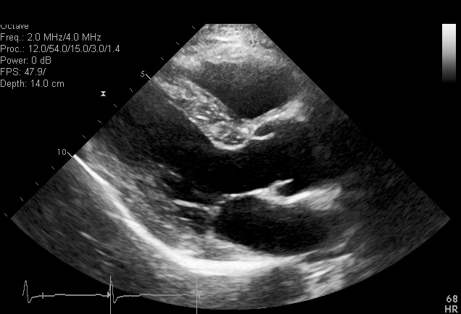
a

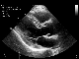
b

