Supplementary information

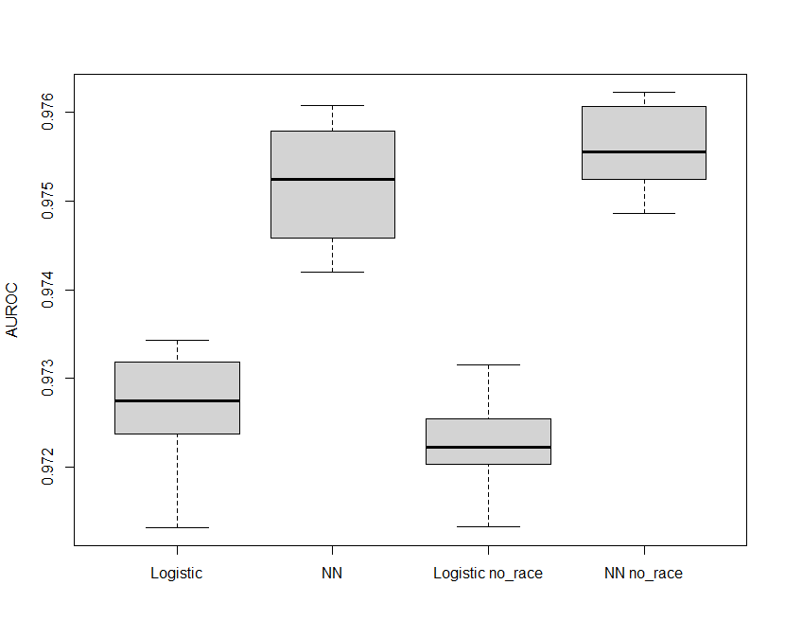
Supplementary Figure 1. Exclusion of race and race proxy features do not cause statistically significant reduction in the model performance measured by AUROC. P-values for both logistic regression and neural network (NN) are > 0.05.

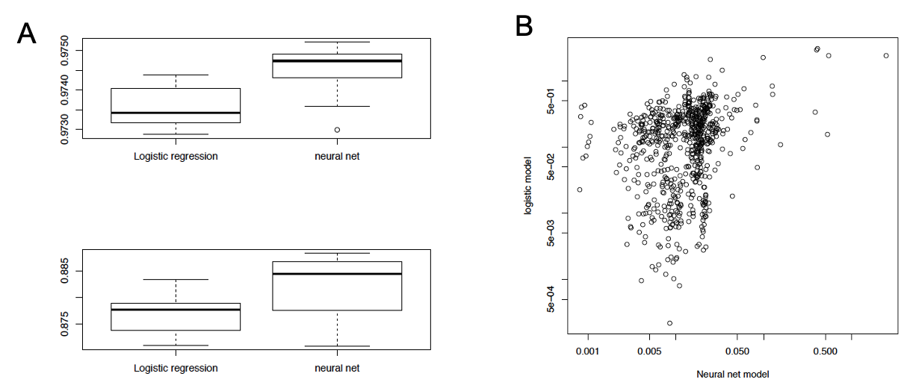
Supplementary Figure 2. (A) Logistic regression versus neural network models with data missing type plus weather information. Upper and lower panels are AUROC and AUPRC, respectively. (B) Importance (weights) of different features in predicting no-show. Y axis: logistic regression model. X axis: neural network model. Correlation=0.46. P<0.001

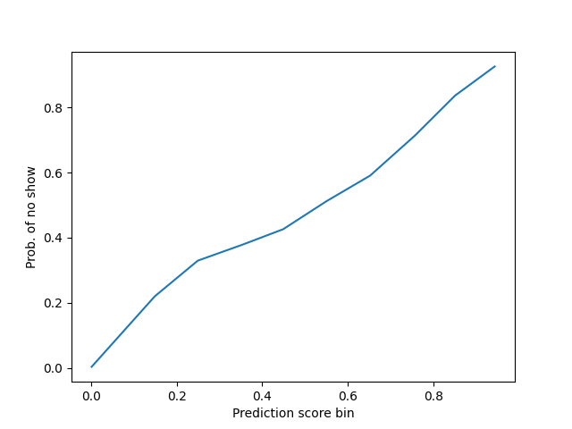
Supplementary figure 3. Calibration curve of the neural network model when the number of bins is 10.

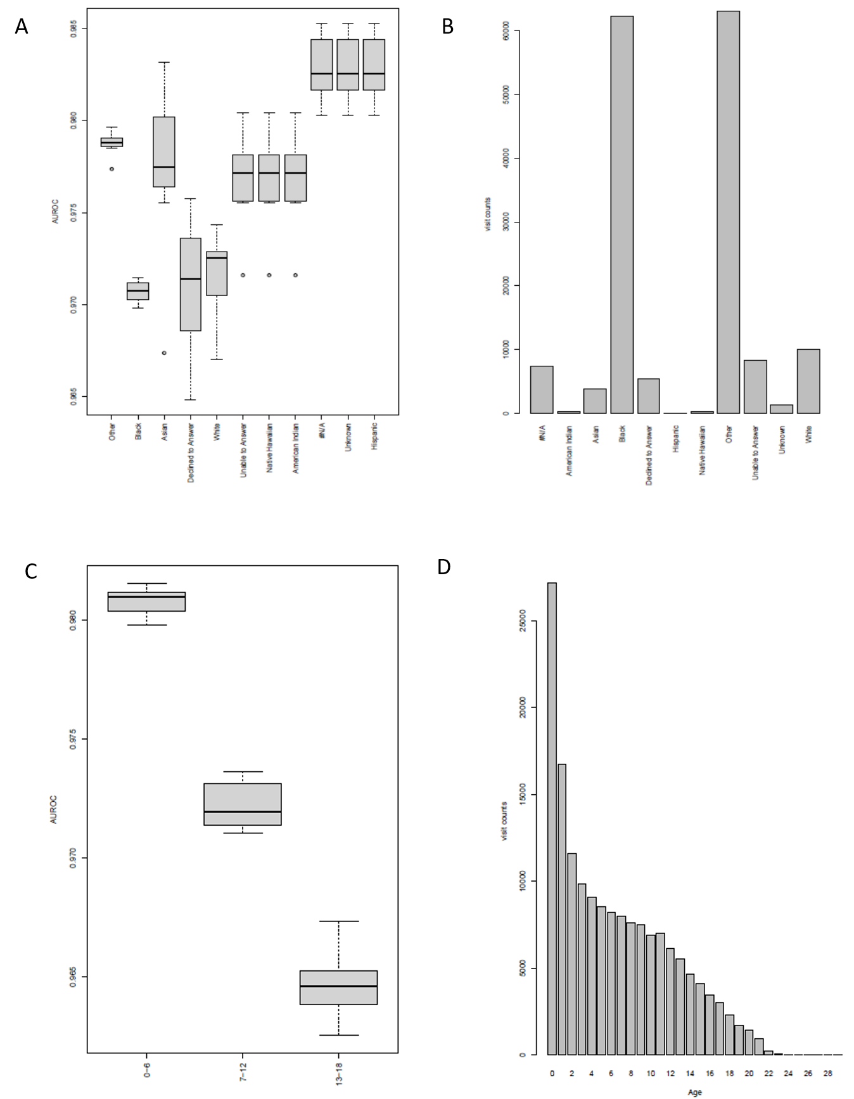
Supplementary figure 4. No show (NN) prediction model performance and number of visits in the data set by race (A, B) and age (B,D) groups. Y axis is AUROC in A and C. Some race groups have a very small number of patients, therefore the range of AUROC looks uniform.

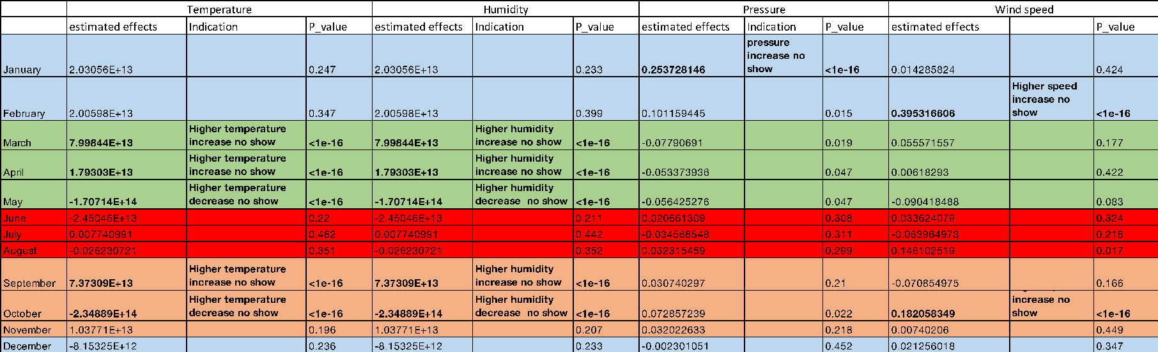
Supplementary figure 5. Estimated causal effects of weather-related features on no-shows in different months of the year, where different colors represent different seasons

Supplementary table 1. Precision, recall, and F1 score of baseline methods and our approach
 | Baseline (persistence) | Logistic regression (history only) | Logistic regression (with imputation/indicator and include local weather information) | Neural  network-based method (with missing information imputation/indicator include local weather information)
Precision | 0.64 | 0.80 | 0.81 | 0.83
Recall | 0.98 | 0.81 | 0.82 | 0.83
F1 | 0.78 | 0.80 | 0.81 | 0.83

Supplementary table 2. top 20 most important features in predicting no-shows in our neural network model

Feature | Mean score
Previous_vist_1_Completed | 2.44390
Previous_vist_1_No Show | 0.54366
Days.Between.Scheduled.and.Appointment | 0.52584
Ratio.of.No.Shows.to.No.Shows...Completed | 0.40645
Previous_vist_1_NA | 0.39766
pressure | 0.38228
Language_English | 0.15424
Visit.Type_URGENT PEDS | 0.12553
Visit.Type_RETURN CHPCC | 0.12444
Previous_vist_1_Canceled | 0.09797
wind_speed | 0.08404
temperature | 0.08348
Humidity | 0.08341
weather_description_mist | 0.08051
Public.Or.Private_Public | 0.07073
Race_Other | 0.06116
Appointment.Date.Time..Month.of.Year._April | 0.05953
Race_Black or African American | 0.05747
weather_description_light rain | 0.05368
weather_description_few clouds | 0.05063

Supplementary table 3. top 20 most important features in predicting no-shows in our logistic regression model

Feature | Importance score
Previous_vist_1_Completed | 2.42568513
Previous_vist_1_No Show | 2.42684533
Days.Between.Scheduled.and.Appointment | 0.153721411
Ratio.of.No.Shows.to.No.Shows...Completed | 3.08709121
Previous_vist_1_NA | 2.95971436
pressure | 0.335858268
Language_English | 0.108464511
Visit.Type_URGENT PEDS | 0.63015907
Visit.Type_RETURN CHPCC | 0.835925781
Previous_vist_1_Canceled | 2.27176397
wind_speed | 0.049340496
temperature | 0.257498967
Humidity | 0.243839736
weather_description_mist | 0.424207526
Public.Or.Private_Public | 0.165831679
Race_Other | 0.129652853
Appointment.Date.Time..Month.of.Year._April | 0.757974815
Race_Black or African American | 0.095366389
weather_description_light rain | 0.367293397
weather_description_few clouds | 0.63036262

Our predictive models achieved a high level of accuracy and perform better than the persistence baseline and logistic regression method. To illustrate the full spectrum of the data, three-class classification results are shown in supplementary table 3, 4, and 5, where our neural network model still shows improvement compared with logistic regression and NaÏve Bayes baseline models.

Supplementary table 4. Performance of the NaÏve Bayes model in three-class classification

 | precision | recall | f1-score
show | 0.95 [0.95,0.95] | 0.92 [0.92,0.92] | 0.93 [0.93,0.93]
cancelled | 0.27 [0.26,0.29] | 0.11 [0.11,0.12] | 0.16 [0.15,0.17]
no show | 0.70 [0.70,0.70] | 0.87 [0.86,0.87] | 0.77 [0.77,0.78]

Supplementary table 4. Performance of the baseline method in three-class classification

 | precision | recall | f1-score
show | 1.00 [1.00,1.00] | 0.85 [0.85,0.85] | 0.92 [0.92,0.92]
cancelled | 0.25 [0.25,0.25] | 0.28 [0.27,0.28] | 0.26 [0.26,0.26]
no show | 0.64 [0.64,0.64] | 0.98 [0.98,0.99] | 0.78 [0.78,0.78]

Supplementary table 4. Performance of the neural network model in three-class classification

 | precision | recall | f1-score
show | 1.00 [1.00,1.00] | 0.89 [0.88,0.89] | 0.94 [0.94,0.94]
cancelled | 0.33 [0.33,0.34] | 0.30 [0.28,0.31] | 0.31 [0.31,0.32]
no show | 0.69 [0.69,0.70] | 0.99 [0.98,0.99] | 0.81 [0.81,0.82]

Supplementary List 1. Full list of features available in a patient’s record for this study

