Supplementary Information

Table of Contents
Supplementary Information 1
A. AI-CAC correlations with Agatston CAC Score 7
B. Kaplan Meier Cumulative Incidence 9
C. Cox Proportional Hazards Models 16
D. 1-, 5-, 10-, and 15-year prediction of All CVD events on top of risk factors 20
E. Heart Failure Prediction with Clinical Risk Factors 25
F. Atrial Fibrillation Prediction with Clinical Risk Factors. 29
G. AI-CAC Plaque Characterization 31
H. HFrEF vs. HFpEF Detection 34
I. Cardiac Chambers measurement by Scanner 36

Supplementary Information Figure Legends:

Supplementary Figure 1a. Correlation between AI-enabled automated cardiac chambers volumetry to CAC scans (AI-CAC) Left Atrial (LA) volume vs. Agatston Coronary Artery Calcium (CAC) Score.
Scatterplot of AI-CAC LA volume vs. Agatston CAC Score shows low correlation (R=0.20).
Supplementary Figure 1b. Correlation between AI-enabled automated cardiac chambers volumetry to CAC scans (AI-CAC) Left Atrial (LA) volume vs. Log-transformed Agatston Coronary Artery Calcium (CAC) Score.
Scatterplot of AI-CAC LA volume vs. Log-transformed Agatston CAC Score shows low correlation (R=0.26).

Supplementary Figure 2a. Correlation between AI-enabled automated cardiac chambers volumetry to CAC scans (AI-CAC) Left Ventricle (LV) volume vs. Agatston Coronary Artery Calcium (CAC) Score.
Scatterplot of AI-CAC LV volume vs. Agatston CAC Score shows little to no correlation (R=0.10)
Supplementary Figure 2b. Correlation between AI-enabled automated cardiac chambers volumetry to CAC scans (AI-CAC) Left Ventricle (LV) volume vs. Log-transformed Agatston Coronary Artery Calcium (CAC) Score.
Scatterplot of AI-CAC LV volume vs. Log-transformed Agatston CAC Score shows little to no correlation (R=0.08).

Supplementary Figure 3a. Cumulative Incidence of All Cardiovascular (CVD) Events over 15 years by AI-enabled automated cardiac chambers volumetry to CAC scans (AI-CAC) Left Atrial (LA) volume.
Cumulative incidence of all CVD events by LA volume quartiles. The cumulative incidence of CVD increases with larger left atrial volumes, with the highest incidence observed in the 1st quartile (>70.6 cc) (p<0.0001).

Supplementary Figure 3b. Cumulative Incidence of All Cardiovascular (CVD) Events over 15 years by AI-enabled automated cardiac chambers volumetry to CAC scans (AI-CAC) Left Ventricular volume.

Cumulative incidence of all CVD events by LV volume quartiles. The cumulative incidence of CVD events increases with larger LV volumes, with the highest incidence observed in the 1st quartile (>117.3 cc) (p<0.0001).

Supplementary Figure 3c. Cumulative Incidence of All Cardiovascular (CVD) Events over 15 years by AI-enabled automated cardiac chambers volumetry to CAC scans (AI-CAC) Left Ventricular wall mass.
Cumulative incidence of all CVD events by LV wall mass quartiles. The cumulative incidence of CVD events increases with larger LV mass, with the highest incidence observed in the 1st quartile (>120.9 cc) (p<0.0001).

Supplementary Figure 4a. Cumulative Incidence of Heart Failure (HF) Events over 15 years by AI-enabled automated cardiac chambers volumetry to CAC scans (AI-CAC) Left ventricular (LV) volume.
This figure shows the cumulative incidence of HF events over a follow-up period of 15 years, stratified by quartiles of LV volume as measured by AI-CAC. The quartiles are defined as follows: LV 4th Quartile (<84.5 cc) in blue, LV 3rd Quartile (84.5-99.4 cc) in orange, LV 2nd Quartile (99.5-117.3 cc) in green, and LV 1st Quartile (>117.3 cc) in red. The cumulative incidence of CVD events increases with larger left ventricular volumes, with the highest incidence observed in the 1st quartile (>117.3 cc).
Supplementary Figure 4b. Cumulative Incidence of Heart Failure (HF) Events over 15 years by AI-enabled automated cardiac chambers volumetry to CAC scans (AI-CAC) Left ventricular (LV) wall mass.
This figure shows the cumulative incidence of HF events over a follow-up period of up to 15 years, stratified by quartiles of LV mass as measured by AI-CAC. The quartiles are defined as follows: LV Mass 4th Quartile (<86.1 cc) in blue, LV Mass 3rd Quartile (86.1-102.4 cc) in orange, LV Mass 2nd Quartile (102.5-120.9 cc) in green, and LV Mass 1st Quartile (>120.9 cc) in red. The cumulative incidence of CVD events increases with larger left ventricular mass, with the highest incidence observed in the 1st quartile (>120.9 cc).

Supplementary Figure 5. Cumulative Incidence of Atrial Fibrillation Events over 15 years by AI-enabled automated cardiac chambers volumetry to CAC scans (AI-CAC) Left Atrial (LA) Volume Quartiles.
The quartiles are defined as follows: LA 4th Quartile (<49.8 cc) in blue, LA 3rd Quartile (49.8-59.5 cc) in orange, LA 2nd Quartile (59.6-70.6 cc) in green, and LA 1st Quartile (>70.6 cc) in red. The cumulative incidence of AF increases with larger left atrial volumes, with the highest incidence observed in the 1st quartile (>70.6 cc) (p<0.0001).

Supplementary Figure 6a. 1-year prediction of All CVD events of AI-enabled automated cardiac chambers volumetry to CAC scans (AI-CAC) on top of CVD risk factors.
AI-CAC measurements demonstrated significant incremental value when added to CVD risk factors for 1-year CVD prediction (0.803 vs. 0.749).
Supplementary Figure 6b. 5-year prediction of All CVD events of AI-enabled automated cardiac chambers volumetry to CAC scans (AI-CAC) on top of CVD risk factors.
AI-CAC measurements demonstrated significant incremental value when added to CVD risk factors for 5-year CVD prediction (0.786 vs. 0.752).
Supplementary Figure 6c. 10-year prediction of All CVD events of AI-enabled automated cardiac chambers volumetry to CAC scans (AI-CAC) on top of CVD risk factors.
AI-CAC measurements demonstrated significant incremental value when added to CVD risk factors for 10-year CVD prediction (0.801 vs. 0.774).
Supplementary Figure 6d. 15-year prediction of All CVD events of AI-enabled automated cardiac chambers volumetry to CAC scans (AI-CAC) on top of CVD risk factors.
AI-CAC measurements demonstrated significant incremental value when added to CVD risk factors for 15-year CVD prediction (0.823 vs. 0.816).
CVD risk factors included age, gender, LDL, HDL, systolic blood pressure, diastolic blood pressure, smoking status, diabetes, and hypertension medication usage. The composite model included these risk factors along with AI-CAC measurements: LA volume index, RV volume index, LV volume index, LV mass index, and Agatston CAC score.

Supplementary Figure 7a. 5-year Heart Failure (HF) Prediction of AI-enabled automated cardiac chambers volumetry to CAC scans (AI-CAC) on top of Clinical Risk Factors.
AI-CAC measurements demonstrated significant incremental value when added to CVD risk factors for 5-year HF prediction (0.862 vs. 0.796). CVD risk factors included age, gender, LDL, HDL, systolic blood pressure, diastolic blood pressure, smoking status, diabetes, and hypertension medication usage. The composite model included these risk factors along with AI-CAC measurements: RV volume index, LV volume index, LV mass index, and Agatston CAC score.
Supplementary Figure 7b. 10-year Heart Failure (HF) Prediction of AI-enabled automated cardiac chambers volumetry to CAC scans (AI-CAC) on top of Clinical Risk Factors.
AI-CAC measurements demonstrated significant incremental value when added to CVD risk factors for 10-year HF prediction (0.847 vs. 0.790). CVD risk factors included age, gender, LDL, HDL, systolic blood pressure, diastolic blood pressure, smoking status, diabetes, and hypertension medication usage. The composite model included these risk factors along with AI-CAC measurements: RV volume index, LV volume index, LV mass index, and Agatston CAC score.
Supplementary Figure 7c. 15-year Heart Failure (HF) Prediction of AI-enabled automated cardiac chambers volumetry to CAC scans (AI-CAC) on top of Clinical Risk Factors.
AI-CAC measurements demonstrated significant incremental value when added to CVD risk factors for 15-year HF prediction (0.886 vs. 0.870). CVD risk factors included age, gender, LDL, HDL, systolic blood pressure, diastolic blood pressure, smoking status, diabetes, and hypertension medication usage. The composite model included these risk factors along with AI-CAC measurements: RV volume index, LV volume index, LV mass index, and Agatston CAC score.

Supplementary Figure 8a. 5-year coronary heart disease (CHD) prediction in the CAC 1 to 100 cohort by AI-enabled automated cardiac chambers volumetry to CAC scans (AI-CAC) and Agatston CAC Score.
Over 5-years follow-up, the time-dependent AUC for the AI-CAC composite model vs. Agatston CAC Score was 0.654 vs. 0.557 (p<0.0001), respectively. AI-CAC plaque characteristics included number of plaques, location, density, plus number of vessels affected. The AI-CAC composite model included LA volume, RV volume, LV volume, LV mass, AI-CAC derived plaque characteristics, and Agatston CAC Score

Supplementary Figure 8b. 10-year coronary heart disease (CHD) prediction in the CAC 1 to 100 cohort by AI-enabled automated cardiac chambers volumetry to CAC scans (AI-CAC) and Agatston CAC Score.
Over 10-years follow-up, the time-dependent AUC for the AI-CAC composite model vs. Agatston CAC Score was 0.688 vs. 0.556 (p<0.0001), respectively. AI-CAC plaque characteristics included number of plaques, location, density, plus number of vessels affected. The AI-CAC composite model included LA volume, RV volume, LV volume, LV mass, AI-CAC derived plaque characteristics, and Agatston CAC Score

Supplementary Figure 9. Density plots for Heart Failure with reduced ejection fraction (HFrEF) vs. Heart Failure with preserved ejection fraction HFpEF detection by AI-enabled automated cardiac chambers volumetry to CAC scans (AI-CAC) and Echocardiography.
AI-CAC LV volume index (LVVI) defined as LV volume divided by body surface area was able to distinguish HFrEF vs. HFpEF (58.4±16.2 vs. 85.6±27, p=0.0005) comparably to echocardiography LVVI (50.7±14.9 vs. 85.7±27.3, p<0.0001).

AI-CAC correlations with Agatston CAC Score

In our study, we have found correlations between Agatston CAC score and LA and LV volumes to be low (R=0.20 and R=0.10 respectively), hence a substantial portion of the population with enlarged LA and LV chambers are found in low-risk CAC categories.

Supplementary Figure 1a. Correlation between AI-enabled automated cardiac chambers volumetry to CAC scans (AI-CAC) Left Atrial (LA) volume vs. Agatston Coronary Artery Calcium (CAC) Score.
Scatterplot of AI-CAC LA volume vs. Agatston CAC Score shows low correlation (R=0.20).

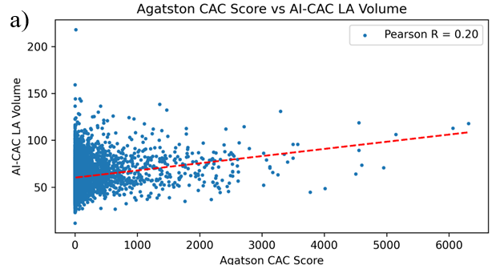

Supplementary Figure 1b. Correlation between AI-enabled automated cardiac chambers volumetry to CAC scans (AI-CAC) Left Atrial (LA) volume vs. Log-transformed Agatston Coronary Artery Calcium (CAC) Score.
Scatterplot of AI-CAC LA volume vs. Log-transformed Agatston CAC Score shows low correlation (R=0.26).

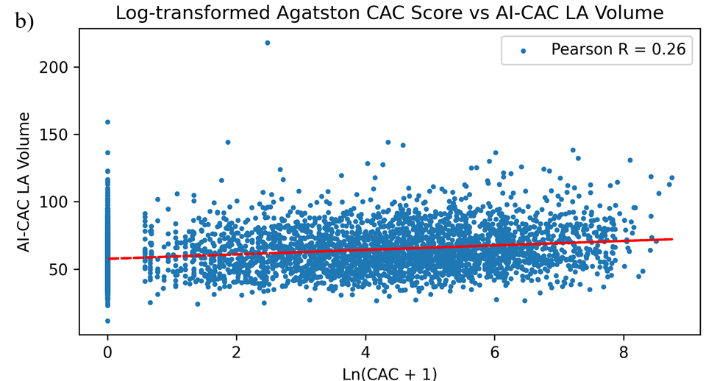

Supplementary Figure 2a. Correlation between AI-enabled automated cardiac chambers volumetry to CAC scans (AI-CAC) Left Ventricle (LV) volume vs. Agatston Coronary Artery Calcium (CAC) Score.
Scatterplot of AI-CAC LV volume vs. Agatston CAC Score shows little to no correlation (R=0.10)

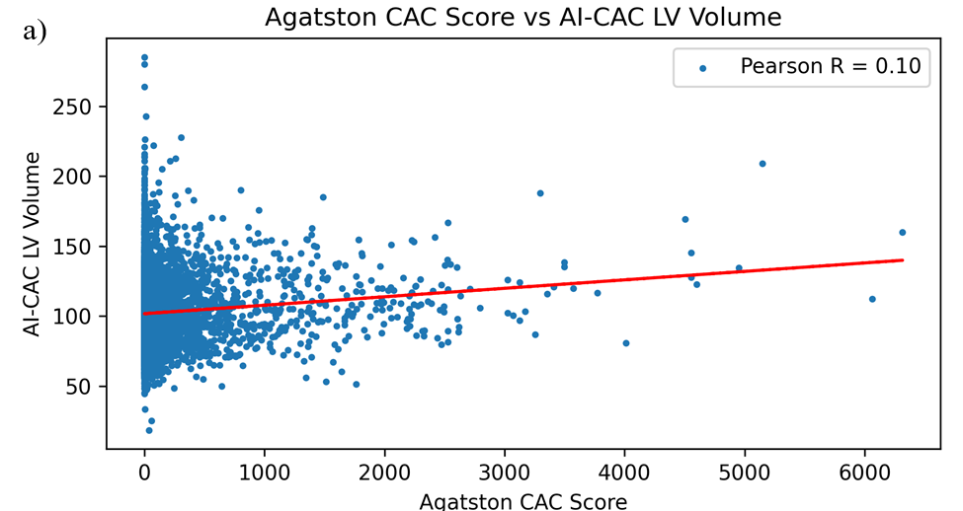

Supplementary Figure 2b. Correlation between AI-enabled automated cardiac chambers volumetry to CAC scans (AI-CAC) Left Ventricle (LV) volume vs. Log-transformed Agatston Coronary Artery Calcium (CAC) Score.
Scatterplot of AI-CAC LV volume vs. Log-transformed Agatston CAC Score shows little to no correlation (R=0.08).
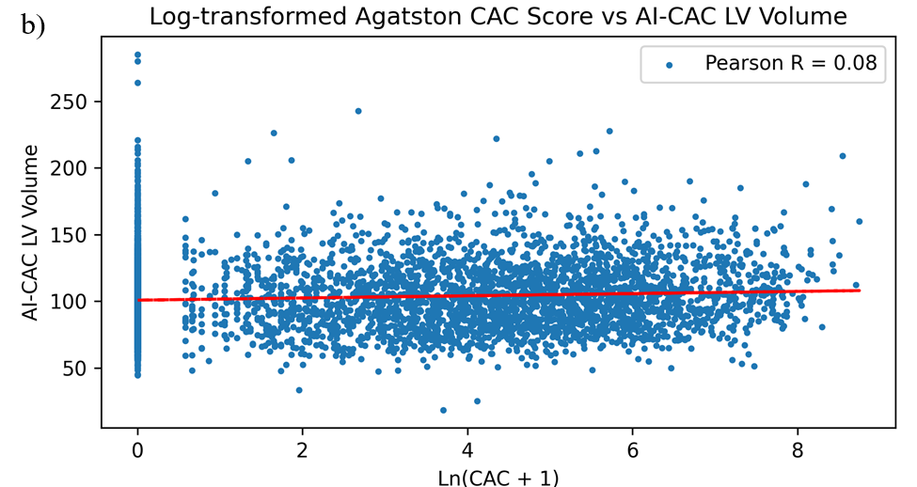

Kaplan Meier Cumulative Incidence

The cumulative incidence of cardiovascular disease (CVD), atrial fibrillation (AF), and heart failure (HF) events is significantly higher in the top quartile of left atrial (LA) and left ventricular (LV) volume over 15 years.

Supplementary Figure 3a. Cumulative Incidence of All Cardiovascular (CVD) Events over 15 years by AI-enabled automated cardiac chambers volumetry to CAC scans (AI-CAC) Left Atrial (LA) volume.
Cumulative incidence of all CVD events by LA volume quartiles. The cumulative incidence of CVD increases with larger left atrial volumes, with the highest incidence observed in the 1st quartile (>70.6 cc) (p<0.0001).

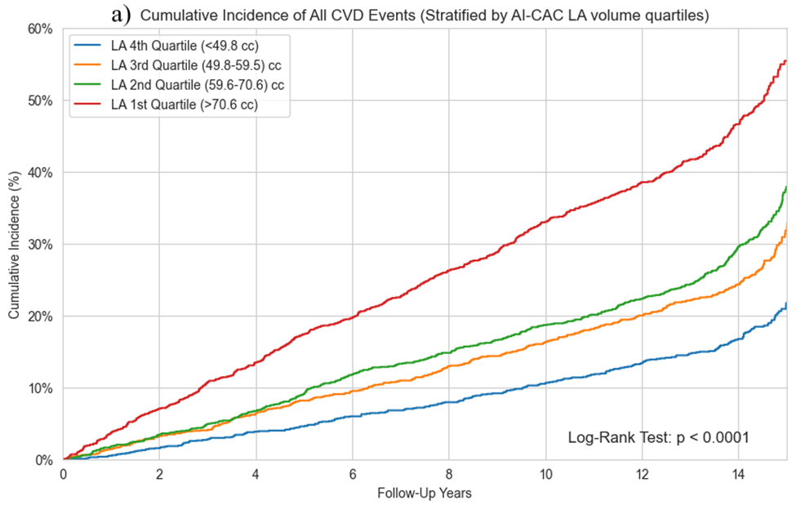

Supplementary Figure 3b. Cumulative Incidence of All Cardiovascular (CVD) Events over 15 years by AI-enabled automated cardiac chambers volumetry to CAC scans (AI-CAC) Left Ventricular volume.

Cumulative incidence of all CVD events by LV volume quartiles. The cumulative incidence of CVD events increases with larger LV volumes, with the highest incidence observed in the 1st quartile (>117.3 cc) (p<0.0001).

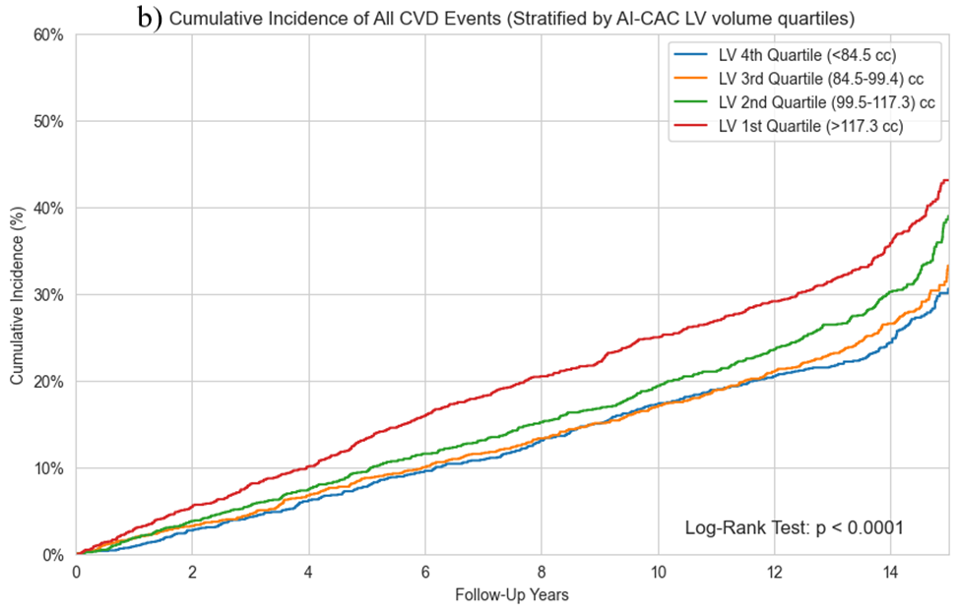

Supplementary Figure 3c. Cumulative Incidence of All Cardiovascular (CVD) Events over 15 years by AI-enabled automated cardiac chambers volumetry to CAC scans (AI-CAC) Left Ventricular wall mass.
Cumulative incidence of all CVD events by LV wall mass quartiles. The cumulative incidence of CVD events increases with larger LV mass, with the highest incidence observed in the 1st quartile (>120.9 cc) (p<0.0001).
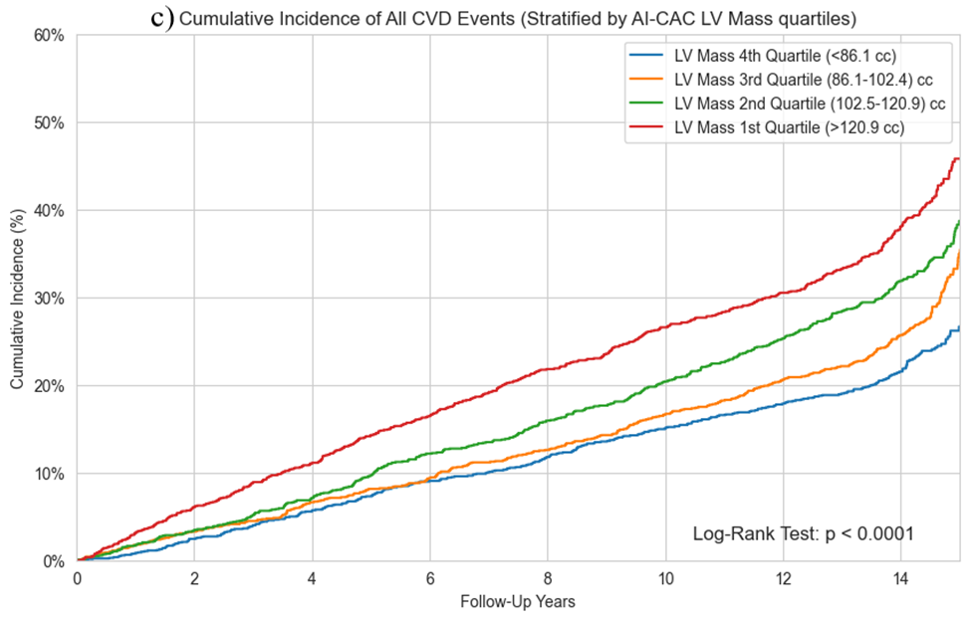

Heart Failure:

Supplementary Figure 4a. Cumulative Incidence of Heart Failure (HF) Events over 15 years by AI-enabled automated cardiac chambers volumetry to CAC scans (AI-CAC) Left ventricular (LV) volume.
This figure shows the cumulative incidence of HF events over a follow-up period of 15 years, stratified by quartiles of LV volume as measured by AI-CAC. The quartiles are defined as follows: LV 4th Quartile (<84.5 cc) in blue, LV 3rd Quartile (84.5-99.4 cc) in orange, LV 2nd Quartile (99.5-117.3 cc) in green, and LV 1st Quartile (>117.3 cc) in red. The cumulative incidence of CVD events increases with larger left ventricular volumes, with the highest incidence observed in the 1st quartile (>117.3 cc).

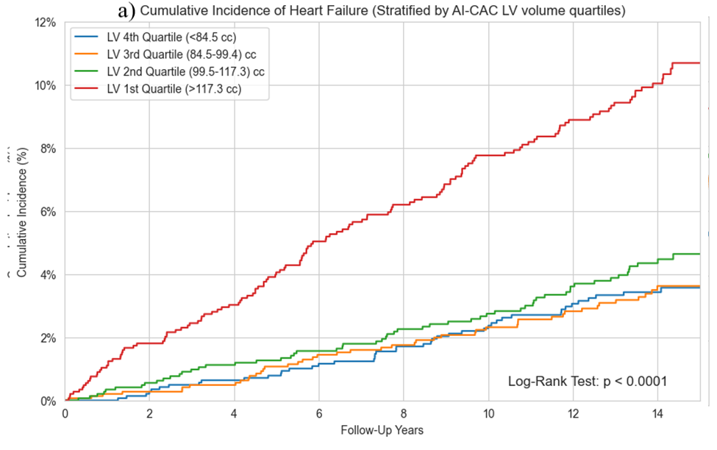

Supplementary Figure 4b. Cumulative Incidence of Heart Failure (HF) Events over 15 years by AI-enabled automated cardiac chambers volumetry to CAC scans (AI-CAC) Left ventricular (LV) wall mass.
This figure shows the cumulative incidence of HF events over a follow-up period of up to 15 years, stratified by quartiles of LV mass as measured by AI-CAC. The quartiles are defined as follows: LV Mass 4th Quartile (<86.1 cc) in blue, LV Mass 3rd Quartile (86.1-102.4 cc) in orange, LV Mass 2nd Quartile (102.5-120.9 cc) in green, and LV Mass 1st Quartile (>120.9 cc) in red. The cumulative incidence of CVD events increases with larger left ventricular mass, with the highest incidence observed in the 1st quartile (>120.9 cc).

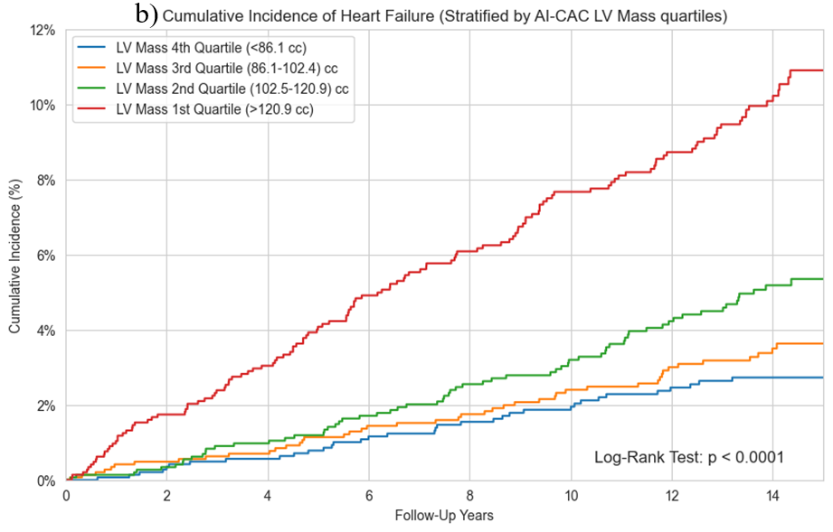

Atrial Fibrillation:

Supplementary Figure 5. Cumulative Incidence of Atrial Fibrillation Events over 15 years by AI-enabled automated cardiac chambers volumetry to CAC scans (AI-CAC) Left Atrial (LA) Volume Quartiles.
The quartiles are defined as follows: LA 4th Quartile (<49.8 cc) in blue, LA 3rd Quartile (49.8-59.5 cc) in orange, LA 2nd Quartile (59.6-70.6 cc) in green, and LA 1st Quartile (>70.6 cc) in red. The cumulative incidence of AF increases with larger left atrial volumes, with the highest incidence observed in the 1st quartile (>70.6 cc) (p<0.0001).

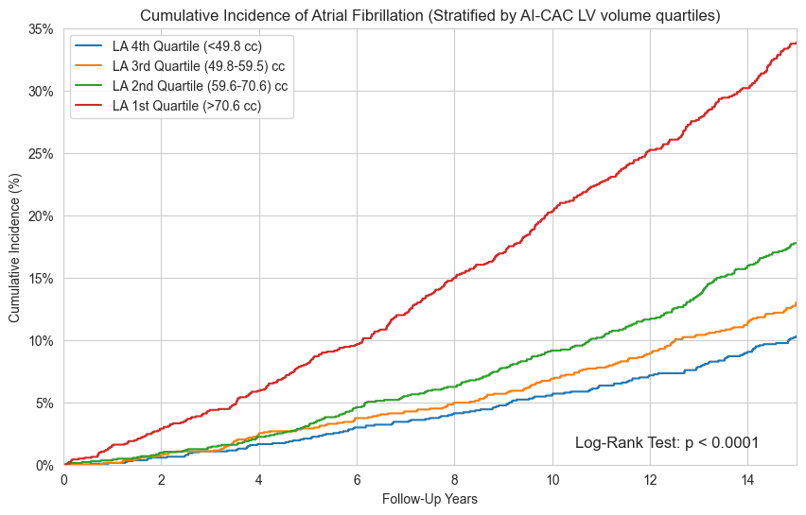

Cox Proportional Hazards Models

A risk factors-based model was developed based on previous literature to demonstrate the incremental value of AI-CAC measurements on top of known risk factors for CVD prediction. CVD risk factors included age, gender, LDL, HDL, systolic blood pressure, diastolic blood pressure, smoking status, diabetes, and hypertension medication usage. The composite model included these risk factors along with LA volume index, RV volume index, LV volume index, LV mass index, and Agatston CAC score. Gender, smoking, diabetes, and hypertension medication usage were binarized as yes/no. All remaining predictors were modeled continuously.
We have provided the Cox Proportional Hazards Models (CoxPH) used for outcome prediction in this manuscript along with coefficients and hazard ratios (Supplementary Table 1). The table below is the full non-sparse model with risk factors. We have also included AI-CAC biomarker-based CoxPH models for all CVD (Supplementary Table 2), AF (Supplementary Table 3), and HF prediction (Supplementary Table 4). Hazard ratios are presented per standard deviation (SD) increase for continuous variables. Note, in multivariate analyses we have consistently observed lower RV volume associated with slightly higher risk.

Supplementary Table 1. Composite Risk Factor Model for All CVD events
 | Coefficient | Chi-Square | P-value | Hazard  Ratio
Left atrial volume indexed by BSA per SD | 0.0246 | 38.859 | <.0001 | 1.202
Right ventricular volume indexed by BSA per SD | -0.013 | 16.220 | <.0001 | 0.821
Left ventricular volume + mass indexed by BSA per SD | 0.0118 | 26.022 | <.0001 | 1.273
Log (CAC+1) per SD | 0.1246 | 131.401 | <.0001 | 1.371
Age per 10 years | 0.0489 | 197.760 | <.0001 | 1.631
Gender (0: Female, 1: Male) | 0.2378 | 12.616 | 0.0004 | 1.271
LDL per SD | 0.0001 | 0.035 | 0.8514 | 1.005
HDL per SD | -0.0015 | 0.712 | 0.3985 | 0.977
Systolic Blood Pressure per SD | 0.0030 | 3.248 | 0.0715 | 1.068
Diastolic Blood Pressure per SD | 0.0028 | 0.657 | 0.4176 | 1.029
Smoking status (current/other) | 0.3233 | 17.707 | <.0001 | 1.382
Diabetes (yes/no) | 0.3521 | 28.166 | <.0001 | 1.420
Hypertension Medication (yes/no) | 0.1429 | 7.187 | 0.0073 | 1.154

C-index: 0.773 (95% CI: 0.726, 0.819)

Supplementary Table 2. AI-CAC based Biomarker model for All CVD events
 | Coefficient | Chi-Square | P-value | Hazard  Ratio
Left atrial volume indexed by BSA per SD | 0.04344 | 147.1701 | <.0001 | 1.381
Right ventricular volume indexed by BSA per SD | -0.02349 | 62.4271 | <.0001 | 0.715
Left ventricular volume + mass indexed by BSA per SD | 0.01503 | 50.2421 | <.0001 | 1.353
Log (CAC+1) per SD | 0.21408 | 480.3121 | <.0001 | 1.715

C-index: 0.742 (95% CI: 0.723, 0.761)

Supplementary Table 3. AI-CAC based Biomarker Model for AF prediction.
 | Coefficient | Chi-Square | P-value | Hazard  Ratio
Left atrial volume indexed by BSA per SD | 0.0697 | 291.920 | <.0001 | 1.682
Right ventricular volume indexed by BSA per SD | -0.0162 | 20.317 | <.0001 | 0.793
Left ventricular volume + mass indexed by BSA per SD | 0.0049 | 3.548 | 0.0596 | 1.106
Log (CAC+1) per SD | 0.1767 | 227.371 | <.0001 | 1.564

C-index: 0.708 (95% CI: 0.696, 0.719)

Supplementary Table 4. AI-CAC based Biomarker Model for HF prediction.
 | Coefficient | Chi-Square | P-value | Hazard  Ratio
Left atrial volume indexed by BSA per SD | 0.0376 | 32.627 | <.0001 | 1.325
Right ventricular volume indexed by BSA per SD | -0.0533 | 69.173 | <.0001 | 0.467
Left ventricular volume + mass indexed by BSA per SD | 0.0421 | 161.052 | <.0001 | 2.366
Log (CAC+1) per SD | 0.2446 | 109.431 | <.0001 | 1.857

C-index: 0.768 (95% CI: 0.738, 0.799)

Supplementary Table 5. AI-CAC vs. Simple Risk Factor based models for All CVD events
Model | Uno's Concordance (95% CI) | P-value compared to previous model
Age + Gender | 0.745 (0.655-0.836) | -
Age + sex + Hypertension + Diabetes + BMI | 0.757 (0.670-0.842) | 0.0006
Age + sex + Hypertension + Diabetes + BMI + AI-CAC measurements | 0.774 (0.693-0.852) | 0.0177

1-, 5-, 10-, and 15-year prediction of All CVD events on top of risk factors
In addition to the CoxPH models and C-index we have provided time-dependent area under the curve (AUC) for 1-, 5-, 10-, and 15-year all CVD event prediction of AI-CAC measurements on top of CVD risk factors (Supplementary Figures 6a-d). CVD risk factors included age, gender, LDL, HDL, systolic blood pressure, diastolic blood pressure, smoking status, diabetes, and hypertension medication usage. The composite model included these risk factors along with AI-CAC measurements: LA volume index, RV volume index, LV volume index, LV mass index, and Agatston CAC score.

Supplementary Figure 6a. 1-year prediction of All CVD events of AI-enabled automated cardiac chambers volumetry to CAC scans (AI-CAC) on top of CVD risk factors.
AI-CAC measurements demonstrated significant incremental value when added to CVD risk factors for 1-year CVD prediction (0.803 vs. 0.749).

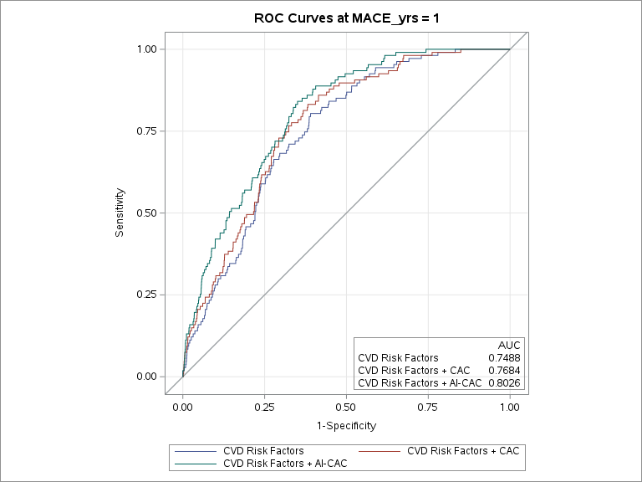
- 1-year Prediction of All-CVD
Supplementary Figure 6b. 5-year prediction of All CVD events of AI-enabled automated cardiac chambers volumetry to CAC scans (AI-CAC) on top of CVD risk factors.
AI-CAC measurements demonstrated significant incremental value when added to CVD risk factors for 5-year CVD prediction (0.786 vs. 0.752).

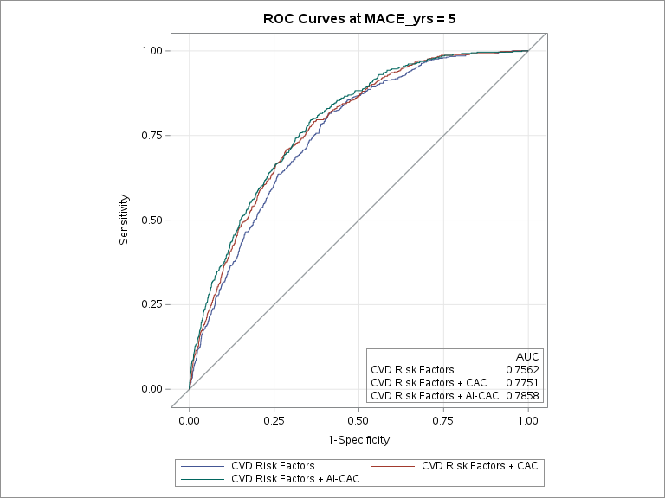
b) 5-year Prediction of All-CVD
Supplementary Figure 6c. 10-year prediction of All CVD events of AI-enabled automated cardiac chambers volumetry to CAC scans (AI-CAC) on top of CVD risk factors.
AI-CAC measurements demonstrated significant incremental value when added to CVD risk factors for 10-year CVD prediction (0.801 vs. 0.774).

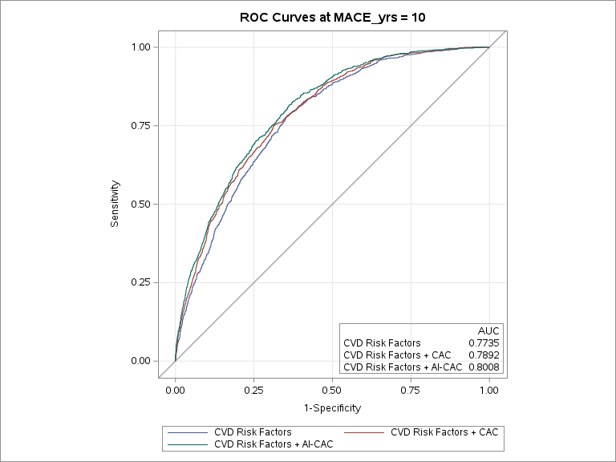
c) 10-year Prediction of All-CVD

Supplementary Figure 6d. 15-year prediction of All CVD events of AI-enabled automated cardiac chambers volumetry to CAC scans (AI-CAC) on top of CVD risk factors.
AI-CAC measurements demonstrated significant incremental value when added to CVD risk factors for 15-year CVD prediction (0.823 vs. 0.816).
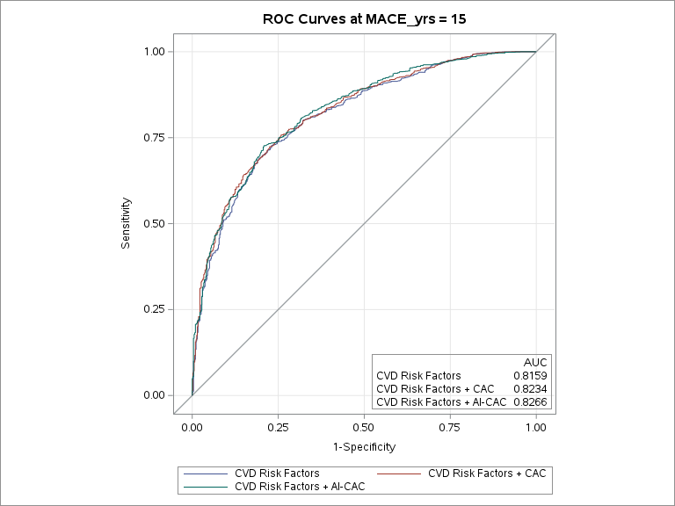
d) 15-year Prediction of All-CVD

Heart Failure Prediction with Clinical Risk Factors

The AI-CAC model as presented in this manuscript uses exclusively coronary artery calcium (CAC) score and cardiac chambers volumetry obtained from CT scans and does not include risk factors or arrythmia. We have added analysis from previous publications on adding known risk factors and Agatston CAC Score to AI-CAC cardiac chambers volumetry for HF prediction over 5-, 10-, and 15- year follow-up (Supplementary Figures 7a-c.). A significant increase in discrimination using the time-dependent area under the curve (AUC) was observed over all periods of follow-up when comparing the composite model to a risk factor model alone.
The composite model presented below contains age, gender, diabetes, current smoking, hypertension medication, systolic blood pressure, diastolic blood pressure, LDL cholesterol, HDL cholesterol, Agatston CAC Score, LA volume, LV volume, RV volume, and LV wall mass indexed by body surface area.

Supplementary Figure 7a. 5-year Heart Failure (HF) Prediction of AI-enabled automated cardiac chambers volumetry to CAC scans (AI-CAC) on top of Clinical Risk Factors.
AI-CAC measurements demonstrated significant incremental value when added to CVD risk factors for 5-year HF prediction (0.862 vs. 0.796).

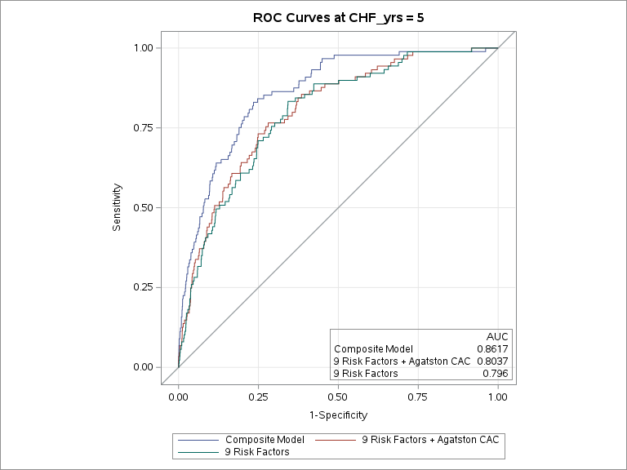
a) 5-year Follow-Up Prediction of HF in MESA
Supplementary Figure 7b. 10-year Heart Failure (HF) Prediction of AI-enabled automated cardiac chambers volumetry to CAC scans (AI-CAC) on top of Clinical Risk Factors.
AI-CAC measurements demonstrated significant incremental value when added to CVD risk factors for 10-year HF prediction (0.847vs. 0.790).
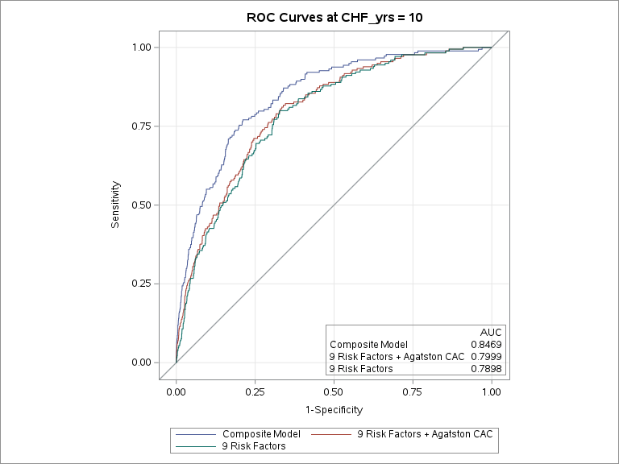
b) 10-year Follow-Up Prediction of HF in MESA

Supplementary Figure 7c. 15-year Heart Failure (HF) Prediction of AI-enabled automated cardiac chambers volumetry to CAC scans (AI-CAC) on top of Clinical Risk Factors.
AI-CAC measurements demonstrated significant incremental value when added to CVD risk factors for 15-year HF prediction (0.886 vs. 0.870). scans (AI-CAC) on top of CVD risk factors.
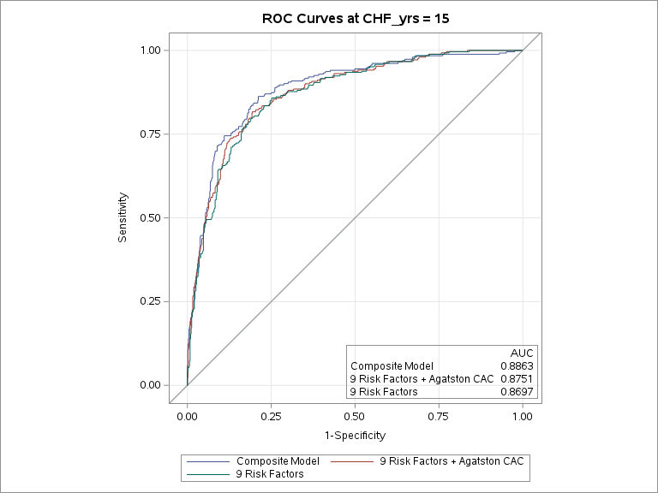
c) 15-year Follow-Up Prediction of HF in MESA

Atrial Fibrillation Prediction with Clinical Risk Factors.

Based on previous literature, we hypothesized that AI-powered cardiac chambers volumetry in CAC scans (AI-CAC) would be a significant predictor for incident AF in asymptomatic individuals. We have compared AI-CAC LA volume with amino terminal Pro-B-type natriuretic peptide (NT-proBNP) and CHARGE-AF for incident AF prediction across 1 to 5 years using the time-dependent AUC. The CHARGE-AF Risk Score is a widely recognized risk model used to predict the 5-year risk of AF in asymptomatic populations. CHARGE-AF is an epidemiological risk calculator created based on both asymptomatic people and patients with cardiovascular disease (CVD) from Atherosclerosis Risk in Communities (ARIC) and Framingham Heart Study (FHS) cohorts. NT-proBNP is a blood protein that is associated with enlarged cardiac chambers and correlates with LA volume. Recent studies have linked NT-proBNP to the incidence of AF and reported incremental predictive value when NT-proBNP is added to the CHARGE-AF Risk Score.

The table below presents time-dependent AUC for incident AF prediction over 5 years. At 1,2,3,4, and 5 years follow-up 36, 77, 123, 182, and 236 cases of AF were identified, respectively. The AUC for AI-CAC LA volume was significantly higher than CHARGE-AF for Years 1, 2, and 3 (0.83 vs. 0.74, 0.84 vs. 0.80, and 0.81 vs. 0.78, respectively, all p<0.05), but similar for Years 4 and 5, and significantly higher than NT-proBNP at Years 1-5 (all p<0.01).

Supplementary Table 6. 1-to-5-year Prediction of Atrial Fibrillation (AF) by AI-CAC Left Atrial (LA) volume, CHARGE-AF Risk Score, and NT-proBNP.
 | 1 Year |  | 2 Years |  | 3 Years |  |  | 4 Years |  | 5 Years
AF Events | 36 |  | 77 |  | 123 |  |  | 182 |  | 236
Predictors | AUC  (95% CI) | P value | AUC  (95% CI) | P value | AUC  (95% CI) | P value | AUC  (95% CI) |  | P value | AUC  (95% CI) | P value
AI-CAC LA Volume | 0.83 (0.74, 0.90) | - | 0.84 (0.79, 0.89) | - | 0.81 (0.77, 0.85) | - | 0.78 (0.75, 0.81) |  | - | 0.77 (0.75, 0.81) | -
CHARGE-AF | 0.74 (0.66, 0.81) | 0.010 | 0.80 (0.76, 0.85) | 0.003 | 0.78 (0.75, 0.82) | 0.022 | 0.76 (0.74, 0.80) |  | 0.110 | 0.76 (0.74, 0.79) | 0.080
NT-proBNP | 0.74 (0.66, 0.82) | 0.003 | 0.77 (0.71, 0.83) | 0.005 | 0.75 (0.69, 0.79) | 0.001 | 0.73 (0.68, 0.76) |  | 0.001 | 0.73 (0.70, 0.77) | 0.001
CHARGE-AF + AI-CAC LA Volume | 0.80 (0.72, 0.89) | 0.076 | 0.82 (0.75, 0.87) | 0.020 | 0.79 (0.73, 0.86) | 0.059 | 0.77 (0.72, 0.84) |  | 0.309 | 0.77 (0.74, 0.82) | 0.513
Category-Free NRI adding AI-CAC LA Volume | NRI  (95% CI) | NRI P value | NRI  (95% CI) | NRI P value | NRI  (95% CI) | NRI P value | NRI  (95% CI) |  | NRI P value | NRI  (95% CI) | NRI P value
To Base Model CHARGE-AF | 0.60  (0.27,0.94) | <.0001 | 0.38 (0.15,0.60) | <.0001 | 0.33 (0.17, 0.54) | <.0001 | 0.19 (0.02, 0.35) |  | 0.0233 | 0.23 (0.10, 0.36) | 0.0006
To Base Model NT-proBNP | 0.68 (0.25, 0.97) | <.0001 | 0.44 (0.19, 0.67) | <.0001 | 0.42 (0.21, 0.58) | <.0001 | 0.20 (0.04, 0.35) |  | 0.0128 | 0.37 (0.18, 0.45) | <.0001
To Base Model Agatston CAC Score  *P-values are provided in comparison to the AI-CAC LA Volume model. | 0.73 (0.38, 1.05) | <.0001 | 0.49 (0.20, 0.66) | <.0001 | 0.53 (0.37, 0.64) | <.0001 | 0.31 (0.16, 0.46) |  | <.0001 | 0.44 (0.26, 0.54) | <.0001

AI-CAC Plaque Characterization

AI-CAC plaque characterization significantly improved CHD prediction in the CAC 1-100 cohort (Appendix E). The addition of AI-CAC RV volume, LV volume, and LV mass further improvement discrimination for CHD in this cohort. The AI-CAC composite model included LA volume, RV volume, LV volume, LV mass, AI-CAC derived plaque characterization, and Agatston CAC Score. Over 5- and 10- year follow-up, the time-dependent AUC for the AI-CAC composite model vs. Agatston CAC Score was 0.654 vs. 0.557 (p<0.0001) and 0.688 vs. 0.556 (p<0.0001), respectively (Supplementary Figures 8a-b).

The net reclassification index of adding AI-CAC volumetry and plaque characterization to Agatston CAC score for 5-, 10-, and 15-year CHD prediction was 0.46, 0.34, and 0.19 (p<0.0001).

Supplementary Figure 8a. 5-year coronary heart disease (CHD) prediction in the CAC 1 to 100 cohort by AI-enabled automated cardiac chambers volumetry to CAC scans (AI-CAC) and Agatston CAC Score.
Over 5-years follow-up, the time-dependent AUC for the AI-CAC composite model vs. Agatston CAC Score was 0.654 vs. 0.557 (p<0.0001), respectively.
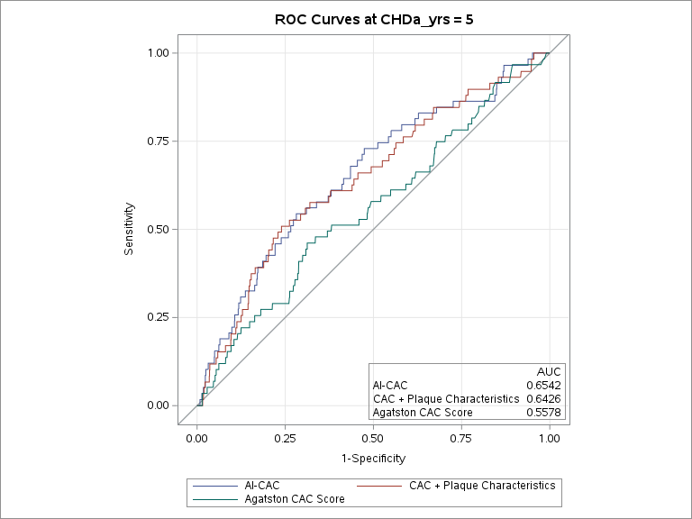
- 5-year Follow-Up Prediction of CHD in MESA
Supplementary Figure 8b. 10-year coronary heart disease (CHD) prediction in the CAC 1 to 100 cohort by AI-enabled automated cardiac chambers volumetry to CAC scans (AI-CAC) and Agatston CAC Score.
Over 10-years follow-up, the time-dependent AUC for the AI-CAC composite model vs. Agatston CAC Score was 0.688 vs. 0.556 (p<0.0001), respectively.
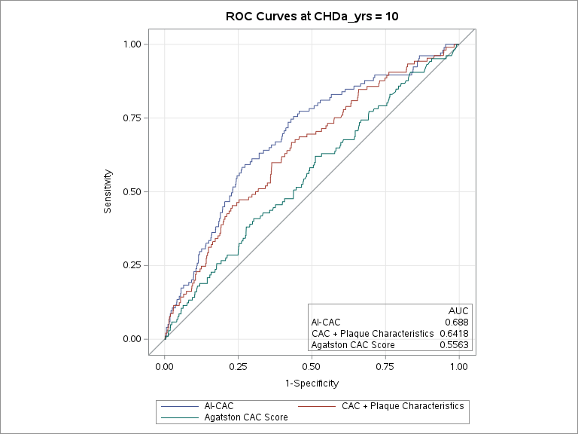
b) 10-year Follow-Up Prediction of CHD in MESA

HFrEF vs. HFpEF Detection

In our analyses we combined LV volume and mass into a composite variable to reduce collinearity in our models. Separating these measurements could provide insight into other HF subtypes that were not present in MESA.
In a preliminary study we analyzed AI-CAC data from 75 patients who underwent both a cardiac CT scan and echocardiography at Harbor UCLA medical center. AutoChamber took on average 21 seconds per scan to estimate cardiac chambers volumetry. Estimated volume for LV volume was indexed by BSA (LVVI) to allow a more accurate assessment of the size of the left ventricle relative to the size of the individual. HFrEF and HFpEF were defined as EF<40% and EF>50% respectively.
AI-CAC LV volume index (LVVI) defined as LV volume divided by BSA was able to distinguish HFrEF vs. HFpEF (58.4±16.2 vs. 85.6±27, p=0.0005) comparably to echocardiography LVVI (50.7±14.9 vs. 85.7±27.3, p<0.0001). Density plots show a clear distinction between HFpEF and HFrEF using AI measured LVVI and comparable results (Supplementary Figure 9).

Supplementary Figure 9. Density plots for Heart Failure with reduced ejection fraction (HFrEF) vs. Heart Failure with preserved ejection fraction HFpEF detection by AI-enabled automated cardiac chambers volumetry to CAC scans (AI-CAC) and Echocardiography.
AI-CAC LV volume index (LVVI) defined as LV volume divided by body surface area was able to distinguish HFrEF vs. HFpEF (58.4±16.2 vs. 85.6±27, p=0.0005) .

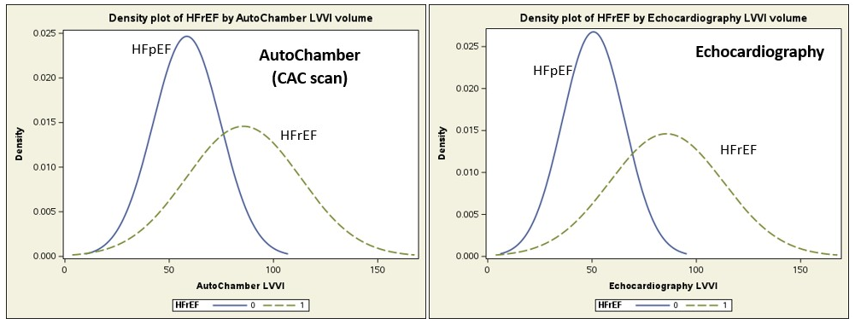

Cardiac Chambers Measurements by Scanner

The potential impact of different ECG gating methods (RR-interval) used in MESA for multidetector CT (50%) and EBCT (80%) cannot be understated. This discrepancy resulted in significant differences in LA volume between participants scanned with EBCT vs. MDCT (57.4 cc vs. 65.4 cc, respectively, p<0.0001). Similarly, for RA volume these differences were significant between EBCT vs. MDCT (66.9 cc vs 75.0 cc, respectively, p<0.0001). However, LV volume, LV mass, and RV volume measurements were less affected by scanner type. Although interaction terms between LA volume and scanner type were tested and found to be non-significant for outcome prediction, questions remain on the extent of the impact of scanner type on our finding.

Cumulative incidence of AF by LA measured by EBCT and MDCT showed the top quartile of EBCT measured LA had slightly higher incidence of AF compared to MDCT. However, it is important to note the EBCT group experienced 6% more AF events over 15 years compared to the MDCT group. Time-dependent AUC curves showed similar discrimination for AF between LA volume measured with EBCT vs. MDCT across 5-year follow-up (0.773 vs 0.785, respectively, p=0.24).and 10-year follow up. (0.802 vs 0.803, respectively, p=0.74).

Supplementary Table 7. AI-CAC measurements by Scanner Type
 | EBCT  (80% R-R) | MDCT  (50% R-R) | P-value
LA (cc) | 57.4 | 65.4 | <0.0001
LV (cc) | 102.0 | 103.1 | 0.11
RA (cc) | 66.9 | 75.0 | <0.0001
RV (cc) | 135.2 | 133.3 | 0.03
LV Mass (g) | 105.2 | 105.7 | 0.53

Supplementary Figure 10. Cumulative Incidence of Atrial Fibrillation Events over 15 years by AI-enabled automated cardiac chambers volumetry to CAC scans (AI-CAC) Left Atrial (LA) Volume Quartiles in EBCT Scanners.
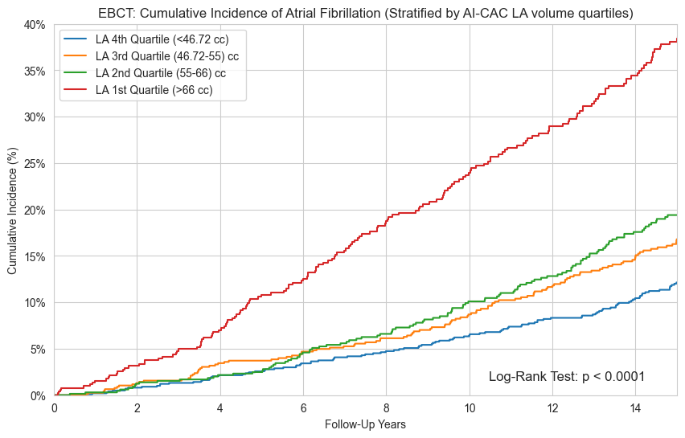
Supplementary Figure 11. Cumulative Incidence of Atrial Fibrillation Events over 15 years by AI-enabled automated cardiac chambers volumetry to CAC scans (AI-CAC) Left Atrial (LA) Volume Quartiles in MDCT Scanners.

