Supplemental Figures
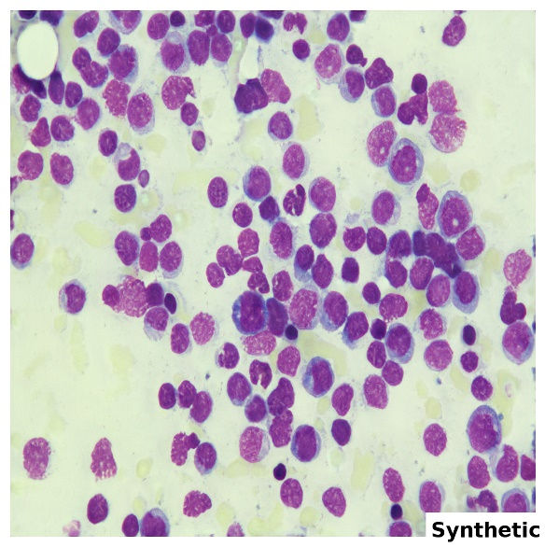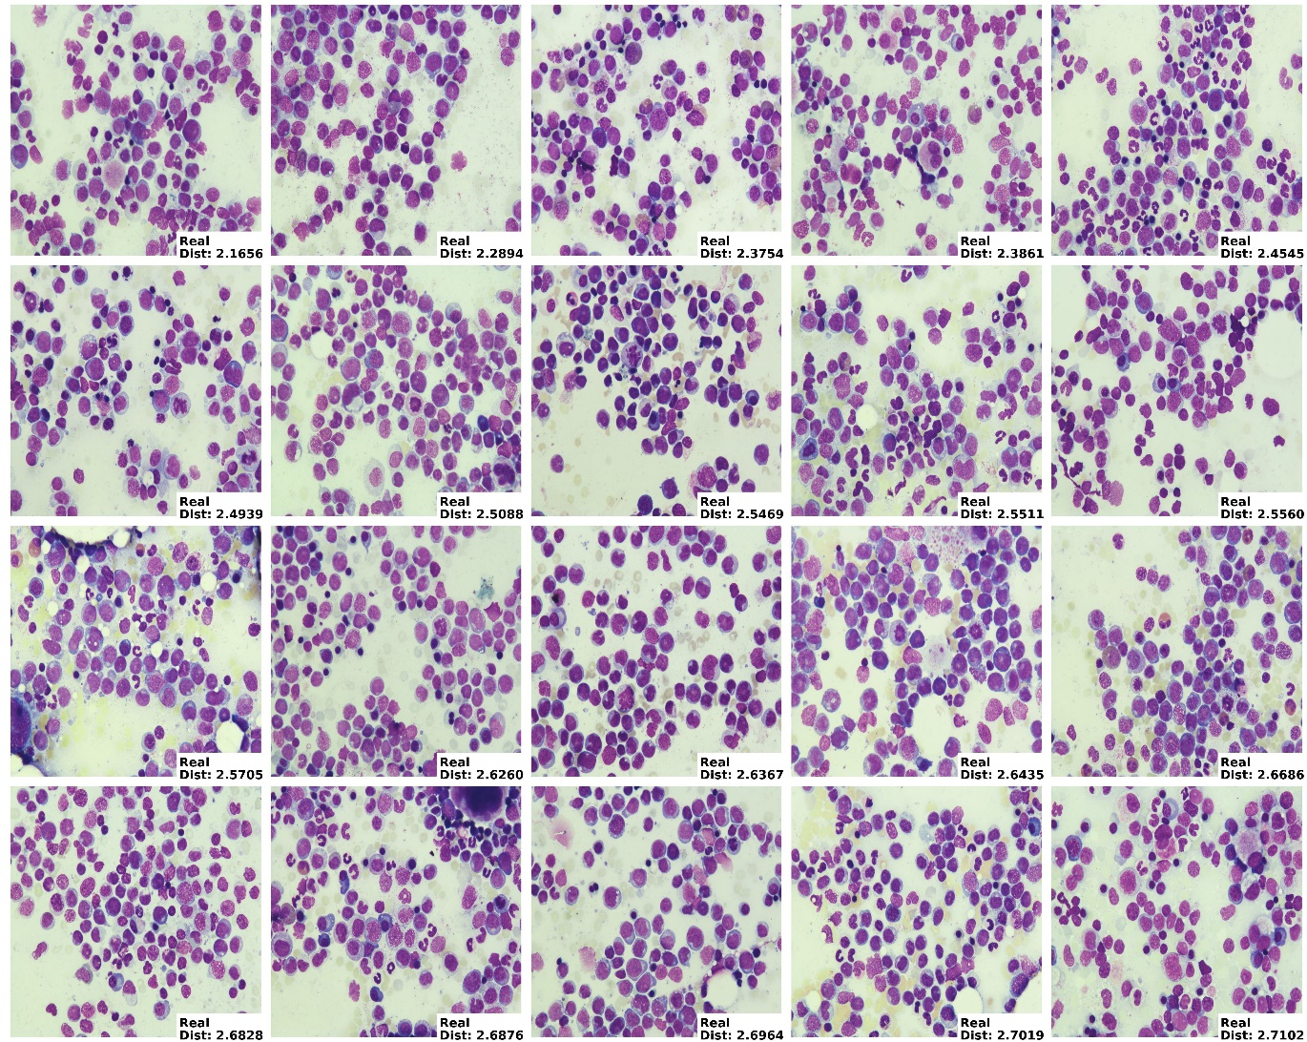
Supplemental Figure 1. Euclidean distance similarity scores for synthetic-real AML image pairs. Synthetic AML image compared to the 20 paired real AML images that had the lowest Euclidean distance similarity scores, indicating sufficient similarities between real-synthetic image pairs while avoiding direct replication. Numerical score values are given per sample in the lower right corner of each panel.
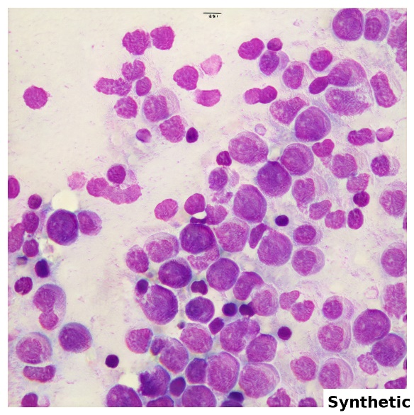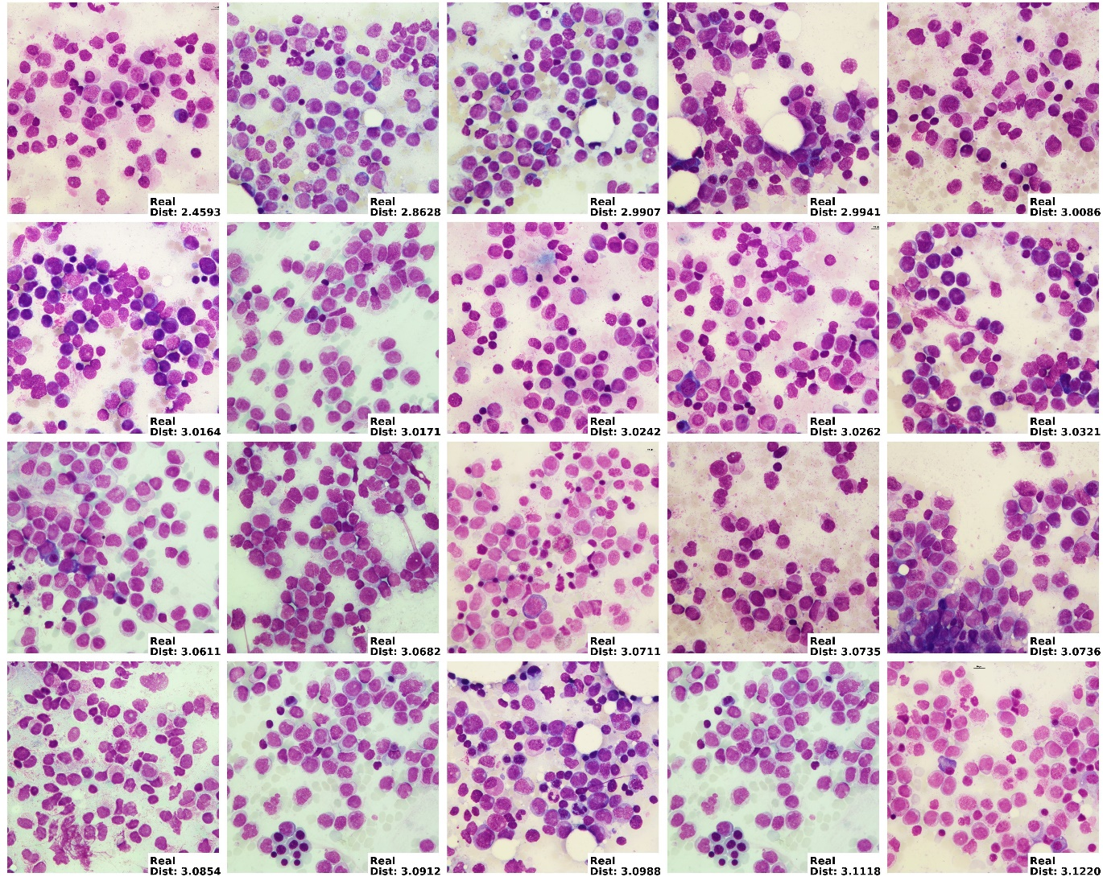
Supplemental Figure 2. Euclidean distance similarity scores for synthetic-real APL image pairs. Synthetic APL image compared to the 20 paired real APL images that had the lowest Euclidean distance similarity scores, indicating sufficient similarities between real-synthetic image pairs while avoiding direct replication. Numerical score values are given per sample in the lower right corner of each panel.
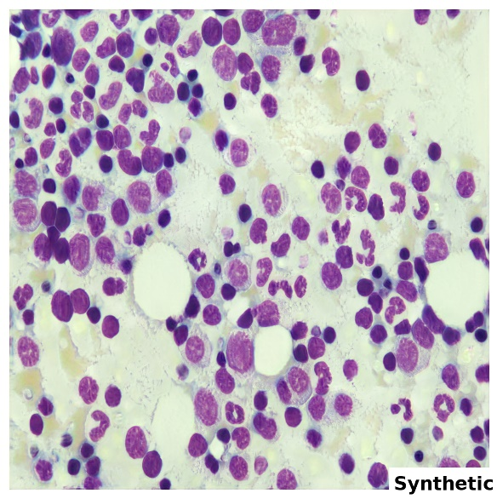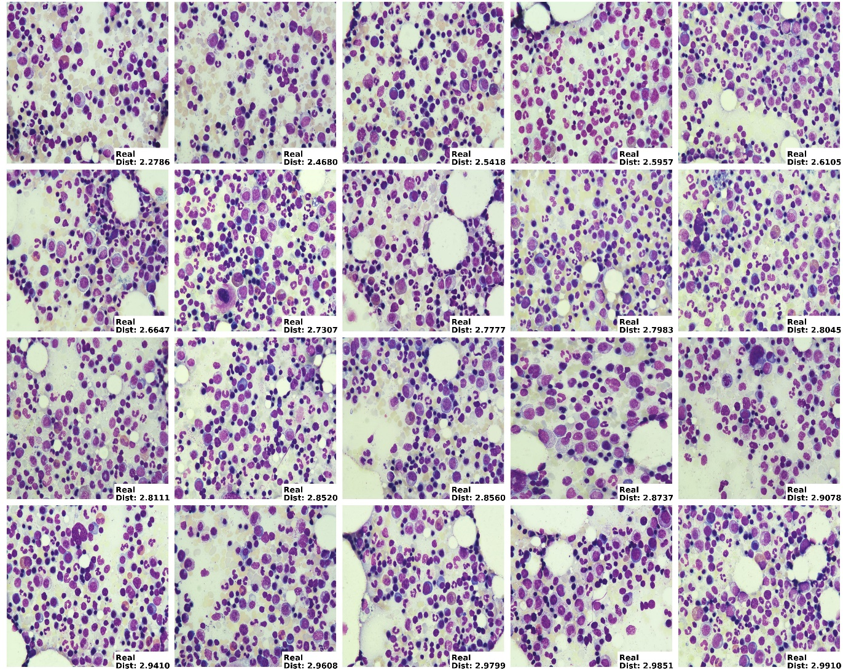
Supplemental Figure 3. Euclidean distance similarity scores for synthetic-real donor image pairs. Synthetic donor image compared to the 20 paired real donor images that had the lowest Euclidean distance similarity scores, indicating sufficient similarities between real-synthetic image pairs while avoiding direct replication. Numerical score values are given per sample in the lower right corner of each panel.
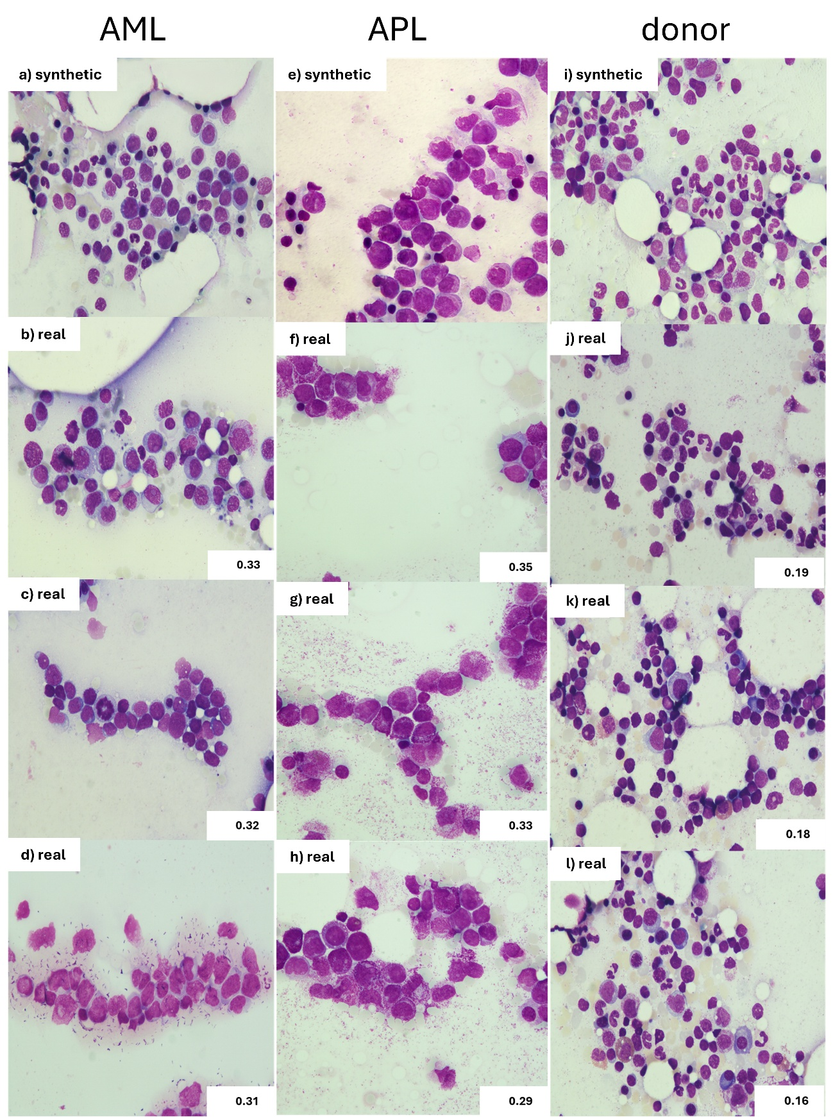
Supplemental Figure 4. Structural Similarity Index Measure scores. The top row (a, e, i) show examples of synthetic images for AML (a), APL (e), and donor (i) samples. Below are paired real images with the top three highest corresponding structural similarity index measure scores for the respective synthetic sample for AML (b, c, d), APL (f, g, h), and donors (j, k, i). Numerical score values are given per sample in the lower right corner of each panel. These indicate low structural similarity highlighting adequate abstraction in the image generation process.
Supplemental Tables
Supplemental Table 1. Classification performance for training on 100% real data and testing on synthetic data
 |  | Accuracy [in %]  (95%-CI) | AUROC (95%-CI) | Precision | Recall
AML vs. donors |  | 97.15 (95.179, 98.932) | 0.9949 (0.9890, 0.9979) | 0.9894 | 0.9451
APL vs. donors |  | 94.22 (92.418, 97.487) | 0.9903 (0.9839, 0.9953) | 0.9647 | 0.9559
AML vs. APL |  | 95.44 (92.260, 97.881) | 0.9803 (0.9680, 0.9942) | 0.98199 | 0.9836

