Supplementary Check List

Index | Name
Supplementary File 1 | Proposed drug-target prediction model  - Supplementary Figure 1  - Supplementary Figure 2  - Supplementary Figure 3
Supplementary File 2 | Emulation process  - Supplementary Table 1
Supplementary Figure 4 | Overall performance of the proposed drug-target prediction model
Supplementary Figure 5 | Results of Test 0.
Supplementary Figure 6 | Results of Test 1.
Supplementary Figure 7 | Results of Test 2 by Category.
Supplementary Figure 8. | Results of Test 2 by Type.
Supplementary Figure 9. | Results of Test 3 by Category.
Supplementary Figure 10. | Results of Test 3 by Type.
Supplementary Figure 11. | Results of Test 4 by Drug.
Supplementary Figure 12. | Results of Test 4 by Target.
Supplementary Figure 13. | Results of Test 5 by Disease.
Supplementary Figure 14. | Results of Test 5 by Type.
Supplementary Figure 15. | Results of Test 6 by Disease.
Supplementary Figure 16. | Results of Test 6 by Type.
Supplementary Figure 17. | AUCROC and PRAUC of EHR-based emulation using four HF cohorts for 10 prognostic outcome markers.
Supplementary Figure 18. | AUCROC and PRAUC of emulation integrated with drug-target prediction using four HF cohorts for 10 prognostic outcome markers.
Supplementary Figure 19. | AUCROC and PRAUC of EHR-based emulation using 11 prognostic outcome measurements based on three HF cohorts, ALLL, HFpEF, and HFrEF.
Supplementary Figure 20. | AUCROC and PRAUC of emulation integrated with drug-target prediction using 11 prognostic outcome measurements based on three HF cohorts, ALLL, HFpEF, and HFrEF.
Supplementary Figure 21. | Direct comparison of PRAUC between the EHR-based emulation and the emulation integrated with drug-target Prediction.
Supplementary Figure 22. | Results (PRAUC) of incorporating interactions between HF drugs and gender in the proposed method (ET integrated with Drug-Target Prediction) for the top four prognostic markers that yielded the highest number of improved predictions.
Supplementary Figure 23. | Improved prediction for other 7 prognostic markers across four cohorts by incorporating interactions between HF drugs and gender in the emulation integrated with drug-target Prediction, with the corresponding AUCROC and PRAUC.
Supplementary Figure 24. | Supplementary Figure 24. Agreement Analysis of Prediction Results Between PP and ITT.
Supplementary Figure 25. | Comparison of AUC-ROC and PR-AUC between the proposed method that incorporates logistic regression coefficients based on statistical significance and the method that ignores p-values (referred to as "Ignore P").
Supplementary Table 2. | Drug information.
Supplementary Table 3. | Gene information.
Supplementary Table 4. | ICD code for HF.
Supplementary Table 5. | Baseline HF drugs.
Supplementary Table 6. | Followup time for 17 HF drugs.
Supplementary Table 7. | Category for 11 prognostic markers.
Supplementary Table 8. | Confidence interval of logistic regression models for BASELINE cohort across 11 prognostic outcome measures.
Supplementary Table 9. | Confidence interval of logistic regression models for BNP across 4 cohots generated from subtypes.

Supplementary Note 1

Proposed drug-target prediction model
Given a set of bipartite networks $\{g\}$, the proposed model aims to learn a $F(D,T, \{g\})$ to predict the novel drug-target predictions, where $D$ and $T$ represent drugs and targets respectively. In our proposed neural network, we mainly use two encoding layers to process the drug chemical structure and gene sequence, and the topological structure of the bipartite network respectively which refer to N-network and D-network in Supplementary Figure 1.
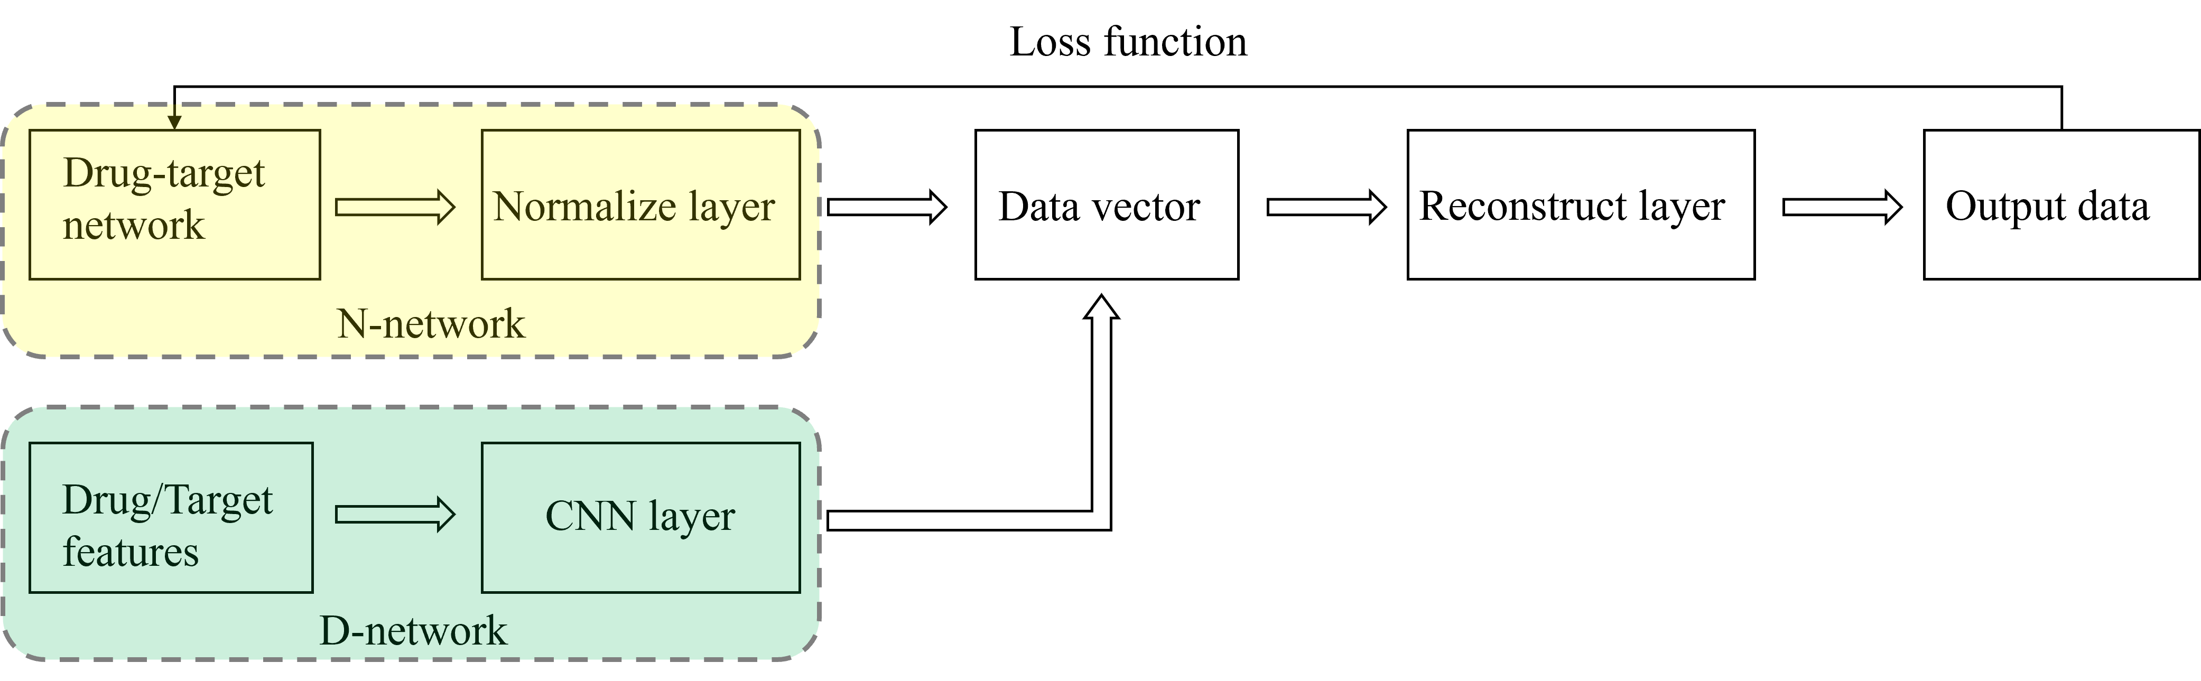
Supplementary Figure 1. The pipeline of the model. This figure illustrates the relationships between all the components proposed for drug-target prediction.
The proposed model for drug-target prediction consists of a series of four interconnected steps that are designed to integrate biological and topological information from various input sources. In the first step, the D-network is used to obtain biological information about drugs, such as their chemical structure and gene sequence. In the second step, the N-network is employed to aggregate neighborhood information for each node in the network. These two steps are then followed by the third step, in which each node generates a new feature representation by integrating both its own features and the neighborhood information obtained in the previous step. The updated node embedding is then used in the fourth step to enforce the preservation of topological and biological information through feature-preserving learning. Overall, this workflow enables the extraction of all features of individual nodes for accurate target prediction. A simple workflow diagram is presented in Supplementary Figure 2 to illustrate the process of learning drug information from various input sources.
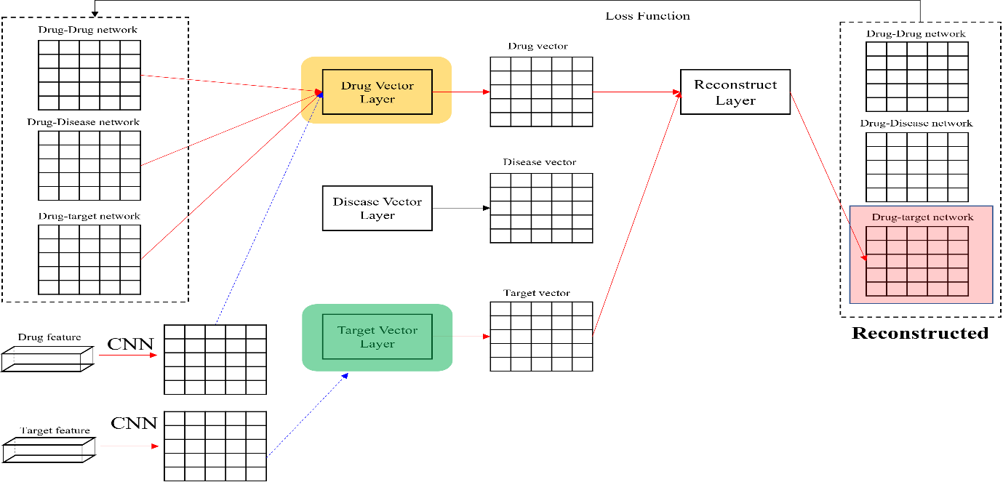
Supplementary Figure 2. The workflow of the drug. This figure illustrates the flow of tensors related to drugs.
Step 1 (biological information aggregation from D-network): D-network is a model that takes a simplified molecular-input line-entry system (SMILES) string and protein amino acid sequence pair as input, representing a drug compound and a target protein. To encode these inputs, two deep transformation functions, $R_{drug}: D→R$ and $R_{target}: T→R$, are specified for the compounds ${str}_{d}$ and protein ${seq}_{t}$, respectively. These functions learn representations $R_{drug}$ and $R_{target}$ using molecular encoders, which are obtained from DeepPurpose¹. The molecular encoders include Morgan Fingerprint, Pubchem, Daylight, RDKit-2D, CNN, CNN+RNN, Transformer, and MPNN for drugs, and AAC, CNN, CNN+RNN, and Transformer for targets. In practical applications, molecular encoders are used to transform the input data into a numerical representation that can be processed by machine learning algorithms. This allows the D-network to learn meaningful representations of drugs and targets, which can be used to predict drug-target interactions and optimize drug discovery. By using a variety of molecular encoders, D-network can capture different aspects of the chemical and biological properties of drugs and targets, providing a comprehensive view of drug-target interactions.
Step 2 (neighborhood information aggregation from N-network). In the context of a heterogeneous network graph, neighborhood information aggregation for a given node $ν∈V$ involves combining the embeddings of its neighboring nodes using an edge weight mapping function $s:E→R$ that assigns a weight $s(e)$ to each edge $e∈E$. This process enables the creation of an updated embedding for the node, capturing the influence of its neighbors on its properties and characteristics. To begin, an initial node embedding function $f^{0}:V→R_{d}$ is defined, which maps each node $ν∈V$ to a d-dimensional vector representation $f^{0}(ν)$. Then, for each edge $e=(v,v^{'})∈E$ adjacent to $v$. The contributions of all neighboring nodes are aggregated using a weighted sum, resulting in a new embedding $f^{1}(ν)$ for $v:f^{1}(ν)=\sum_{\begin{aligned} \\ e\left(v,v^{'}\right)∈E\end{aligned}}{f^{0}(v^{'})}$.This process can be iterated to update the embeddings of all nodes in the graph, incorporating information from multiple layers of neighborhood connections. By combining node embeddings with edge weights, heterogeneous network graphs can capture complex relationships between nodes and enable effective analysis and prediction of network properties. In practice, we adopted NeoDTI² for the calculation of $f^{t}\left(v\right)$.
Step 3 (updating the node embedding). Updating the node embeddings graph involves using the aggregated neighbor information a_v's for all nodes $v^{'}$s in the network and the feature embeddings $R$ to generate an updated embedding $f^{1}(ν)$ for each node $v$ as $f^{2}\left(ν\right) ←{Concat(f}^{1}\left(ν\right),R)$, where $R$ is an embedding learned from D-network. Specifically, ${R=R}_{drug}$ when $ν$ is a drug and ${R=R}_{target}$ when $ν$ is a target. Note that a similar reconstruction strategy has also been used ^{3, 4} to solve the link prediction problems. This process is crucial for capturing the influence of neighboring nodes on the properties and characteristics of the node, enabling effective analysis and prediction in heterogeneous networks. Noted that in principle, we repeat the previous two steps alternately several times to produce more embeddings of nodes (e.g., $f^{1}(∙)$, $f^{2}(∙)$, $f^{3}(∙)$,...).
Step 4 (feature-preserving learning of the node embedding). Feature-preserving learning of node embeddings involves updating the embeddings $f^{t}(∙)$ of all nodes in a graph while preserving their original feature representations. This process is important for ensuring that the updated embeddings retain the informative features of the original embeddings while incorporating new information from the graph. To achieve feature-preserving learning, we use a regularization term that encourages the updated embeddings to remain close to the original embeddings in the embedding space based on the proximity penalty as ${\left\|s\left(e\right)-f(u)QN^{T}f(v)\right\|}^{2}$, where $s\left(e\right)$ is the original edge weight $s(e_{u,v})$ and $f(u)QN^{T}f(v)$ is the re-constructed edge weight. Therefore, we define a loss function as the sum of the edge weights between all the edges and the re-constructed edges:
$min\sum_{e(u,v)∈E}{{\left\|s\left(e\right)-f(u)QN^{T}f(v)\right\|}^{2}}$ (1)
, where $Q$ and $N$ are a projection matrix for the bipartite network. The above equation states that, after edge-specific projections of $f(u)$ and $f(v)$ by $Q$ and $N$, respectively, the inner product of the two projected vectors should reconstruct the original edge weight $s(e)$ as much as possible.
The predicted interaction confidence score between drug node $u$ and protein node $v$ can be obtained by
$f(u)QN^{T}f(v),$ $subject to ∅\left(u\right)=drug, ∅\left(v\right)=protein$ (2)
where $∅\left(u\right)$ and $∅\left(v\right)$ stand for the node types of $u$ and $v$ in the predicted drug-target network.
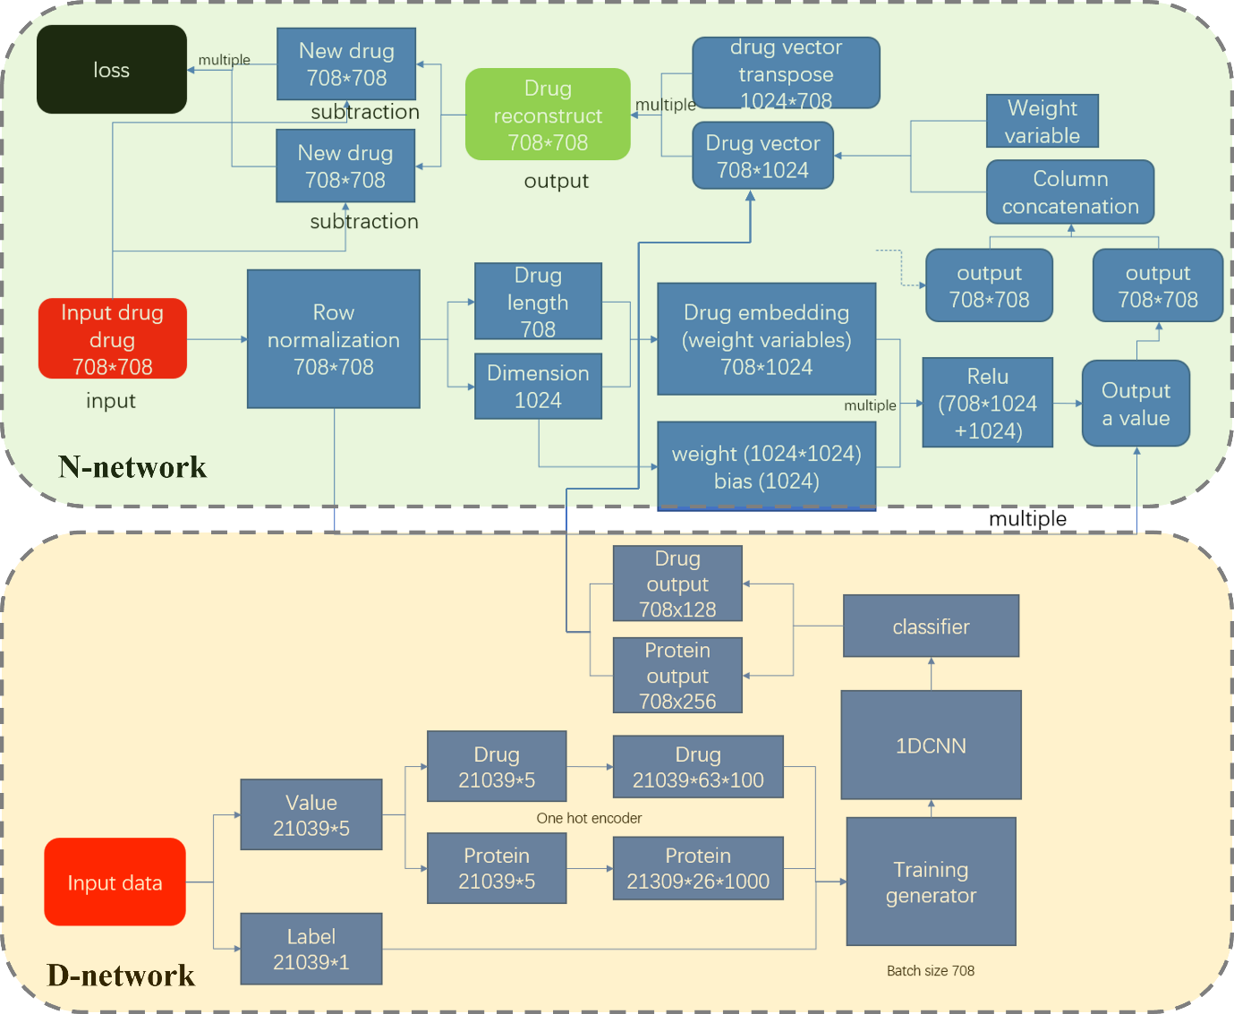
Supplementary Figure 3. The aggregation of the data stream of the D-network and N-network. This figure illustrates how the tensors are combined from both networks.
Our drug-target prediction task can be viewed as a matrix factorization or completion problem, similar to conventional approaches ^{4, 5, 6, 7}. However, we take a different approach by incorporating a deeper learning model to construct the feature matrices $f_{d}$ and $f_{t}$ explicitly. We achieve this by defining the construction processes of $f_{d}$ and $f_{t}$ through Steps (1) to (3). By doing so, we leverage prior knowledge of network topology and use it to guide the optimization process downstream. This approach has several benefits, such as preventing the drug-target-interaction network and other networks from being factorized arbitrarily in Step (4). In turn, this serves as a useful regularization strategy that can improve the performance of drug-target-interaction prediction. Overall, our method is unique in how it integrates deep learning and prior knowledge to optimize matrix factorization, leading to enhanced accuracy in drug-target prediction.

Supplementary References
1. Huang K, Fu T, Glass LM, Zitnik M, Xiao C, Sun J. DeepPurpose: a deep learning library for drug–target interaction prediction. Bioinformatics, (2020).

2. Wan F, Hong L, Xiao A, Jiang T, Zeng J. NeoDTI: neural integration of neighbor information from a heterogeneous network for discovering new drug–target interactions. Bioinformatics 35, 104-111 (2019).

3. Luo Y, et al. A network integration approach for drug-target interaction prediction and computational drug repositioning from heterogeneous information. Nature communications 8, 573 (2017).

4. Natarajan N, Dhillon IS. Inductive matrix completion for predicting gene–disease associations. Bioinformatics 30, i60-i68 (2014).

5. Gönen M. Predicting drug–target interactions from chemical and genomic kernels using Bayesian matrix factorization. Bioinformatics 28, 2304-2310 (2012).

6. Güvenç Paltun B, Mamitsuka H, Kaski S. Improving drug response prediction by integrating multiple data sources: matrix factorization, kernel and network-based approaches. Briefings in bioinformatics 22, 346-359 (2021).

7. Zheng X, Ding H, Mamitsuka H, Zhu S. Collaborative matrix factorization with multiple similarities for predicting drug-target interactions. In: Proceedings of the 19th ACM SIGKDD international conference on Knowledge discovery and data mining) (2013).

Supplementary Note 2
Emulation process
Our aim is to evaluate the improvement in outcomes for patients receiving additional targeted repurposed drugs alongside standard HF care, compared to those receiving only standard care, focusing on 11 key prognostic markers (NT-proBNP, BNP, TnT, TnI, Creatinine, BUN, eGFR, Hemoglobin, Renin, Aldosterone, CRP). Specifically, we aim to estimate the causal effect of taking a repurposed drug on the likelihood of achieving normal prognostic marker levels during follow-up. This is assessed using logistic regression, where the odds ratios derived from the model capture the extent to which repurposed drugs influence the probability of achieving normal outcomes. Please note that while our emulation derives the odds ratio to capture both the magnitude and direction of the association, our primary objective is to estimate the likelihood of a drug exhibiting beneficial efficacy compared to the standard of care. To achieve this, after completing the emulation process, we transform the odds ratio and integrate it with drug-target predictions to generate a normalized probability-like score.
Emulation Protocol: Our emulation follows a general framework designed to evaluate any targeted drug and disease. In this study, the specific repurposed drugs are considered hyperparameters. Patients who meet the eligibility criteria are enrolled in the emulated trial and assigned to one of two arms at baseline (i.e., time zero) based on their healthcare conditions, as determined by their healthcare providers. These patients are given therapy during the follow-up period, with outcomes measured at the completion of follow-up. Our emulation protocol includes eight components: Aim, Eligibility Criteria, Treatment Strategies, Treatment Assignment, Follow-up Period, Confounders, Outcomes, Causal Contrast, and Statistical Analysis (see Supplementary Table 1).
- Treatment Strategy and Assignment: The protocol compares the efficacy of targeted repurposed drugs with the current standard of care for HF. Two types of drugs are included: existing HF drugs (ACRI, BB, ARB, and LD) and a targeted repurposed drug. Patients are assigned to one of two arms: 1) Arm 1 (Exposed Group) - Standard HF drugs + Targeted Repurposed Drug; 2) Arm 2 (Unexposed Group) - Standard HF drugs only. Since this is a retrospective study, patients in the exposed and unexposed groups are determined by their eligibility criteria before treatment assignment and the initiation of the emulation at time zero.
- Follow-up Period: time zero is defined as the moment when a patient meets the eligibility criteria and is assigned a treatment, which is the repurposed drug for Aim 1 and standard HF medication for Aim 2. The follow-up period is completed based on a defined minimum follow-up time, as specified in Supplementary Table 6.
- Eligibility Criteria and Confounders: The cohort is selected based on specific eligibility criteria, including patients who meet the follow-up requirements, are at least 18 years old, and have given consent to share their data for research. Patients who do not meet these criteria are excluded. We account for various confounders to reduce selection bias, such as baseline comorbidities and additional factors like the "Frequency of medication orders." These confounders are adjusted for in the later stages of analysis.
- Outcome Measures: The 11 prognostic markers are used to assess outcomes. Each marker is categorized as "Normal" or "Abnormal" based on reference ranges used in clinical practice at MC (see Supplementary Table 7). Additionally, two prognostic-related measures are treated as confounders to further reduce bias: the value at time zero (baseline) and the length of elapsed time for biomarker measurement.
- Causal contrast: This protocol evaluates the observational analogs of the Per-Protocol (PP) and Intention-To-Treat (ITT) effects to assess the impact of treatment adherence and initiation on patient outcomes.
Data Processing and Analysis:
- Data Extraction: For extracting data (e.g., biomarker values or events) at time zero or the completion of follow-up, we use the closest available time point, as exact values at the extraction time as in an RCT are not possible. We extract the closest measurements for both biomarker values and relevant events.
- Handling Missing Data, Confounder Balancing, Adherence Weighting: For missing values, we imputed numeric variables using the mean and categorical variables using the mode. This approach was selected over the carry-forward method because the missing data resulted from a lack of clinical records when baseline and follow-up values were extracted from the nearest visits. To address confounding and ensure exchangeability between exposed and unexposed groups in this observational study, we applied propensity score (PS) matching. Baseline confounders from the emulation covariates were included in a logistic regression model to estimate the PS, which represents each individual’s likelihood of being exposed. Exposed and unexposed individuals were matched using nearest-neighbor matching within predefined caliper bounds to enhance comparability. Additionally, to mitigate adherence-related biases, we employed inverse probability weighting (IPW) to weight patients based on their adherence levels, categorized as either completing or not completing follow-ups. The IPW implementation relied on baseline covariates to ensure robustness in the analysis.
- Analysis: The matched and weighted population was analyzed using a logistic regression model to estimate odds ratios, which quantify the causal effect of treatment with the repurposed drug on the likelihood of achieving normal prognostic outcomes. Confounders that were balanced through PS matching were excluded from the final model, while the remaining confounders were included as main effects. Additionally, heart failure medication and sex were modeled as interaction terms to further adjust the analysis.

Supplementary Table 1. Emulation protocol
Protocol component | Description
Aim | To evaluate the improvement in outcomes for HF patients receiving additional targeted repurposed drugs alongside standard heart failure care, compared to those receiving standard care alone, we assessed the causal effect on 11 key prognostic markers by estimating the odds of achieving normal outcomes. Please note the distinction between the purpose of emulation and our study objective. While the odds ratio captures both the magnitude and direction of the association between taking a repurposed drug and the likelihood of achieving a normal prognostic marker, it is later transformed and integrated with drug-target predictions to estimate the probability of the drug demonstrating beneficial efficacy compared to the standard of care (i.e., efficacy direction).
Eligibility criteria | - The HF patient has received standard-of-care treatment with HF medications, including ACE inhibitors (ACEI), beta-blockers (BB), angiotensin receptor blockers (ARB), and loop diuretics (LD)  - The HF patient has not received any targeted repurposed drugs before Time Zero.  - The HF patient has completed all follow-up visits (refer to Supplementary Table 6 for the detailed follow-up schedule for each drug).  - The HF patient is over 18 years old  - The HF patient has consented to provide their EHR for research purposes.
Treatment strategies | Arm 1 (Treatment Group):  - Continuous therapy with any HF medications (e.g., ACEI, BB, ARB, LD).  - Continuous therapy with the targeted repurposed drugs.  Arm 2 (Standard-of-Care Group):  - Continuous therapy with any HF medications (e.g., ACEI, BB, ARB, LD).  - No administration of the targeted repurposed drugs.
Treatment Assignment | The treatment arms are determined on a case-by-case basis in clinical practice based on the specific condition of the patients and the clinical judgment of healthcare providers.
Follow-up | The follow-up begins at time zero, defined as the point when the eligibility criteria are met and treatment is assigned by healthcare providers. For Arm 2, the treatment at time zero specifically refers to any of the HF drugs (e.g., ACEI, BB, ARB, LD), and for Arm 1, the treatment refers to a targeted repurposed drug at time zero.  The follow-up ends after a pre-defined period for each targeted repurposed drug (see Supplementary Table 6 for details).
Confounders | Baseline Confounder:  Arrhythmias, cardiac arrest, myocardial infarction, hypertension, pulmonary hypertension, ischemic heart disease, hypertensive heart and renal disease, medications affecting heart health, congestive heart failure, renal failure, and diabetes mellitus.  Others:  - Prognostic markers at time zero and the corresponding elapsed time, defined as the baseline biomarker values measured at time zero and the interval from time zero until the end of the follow-up period.  - HF subtypes (Baseline, All, HFpEF, HFrEF), HF medication types (ACEI, BB, ARB, LD), sex, age, and ethnicity.  - Length of HF medication consumption, defined as the total duration of HF drug usage through the end of follow-up.  - Frequency of medication orders, defined as the count of HF- and repurposed-drug orders from time zero until the end of the follow-up period, based on treatments administered during follow-up visits.
Outcome | 11 prognostic outcome measures (NT-proBNP, BNP, TnT, TnI, Creatinine, BUN, eGFR, Hemoglobin, Renin, Aldosterone, CRP)
Causal Contrast | Observational analog of PP and ITT effect.
Statistical Analysis | A logistic regression model was applied after balancing confounders using propensity scores and inverse probability weighting, with further adjustment for confounders included as covariates.

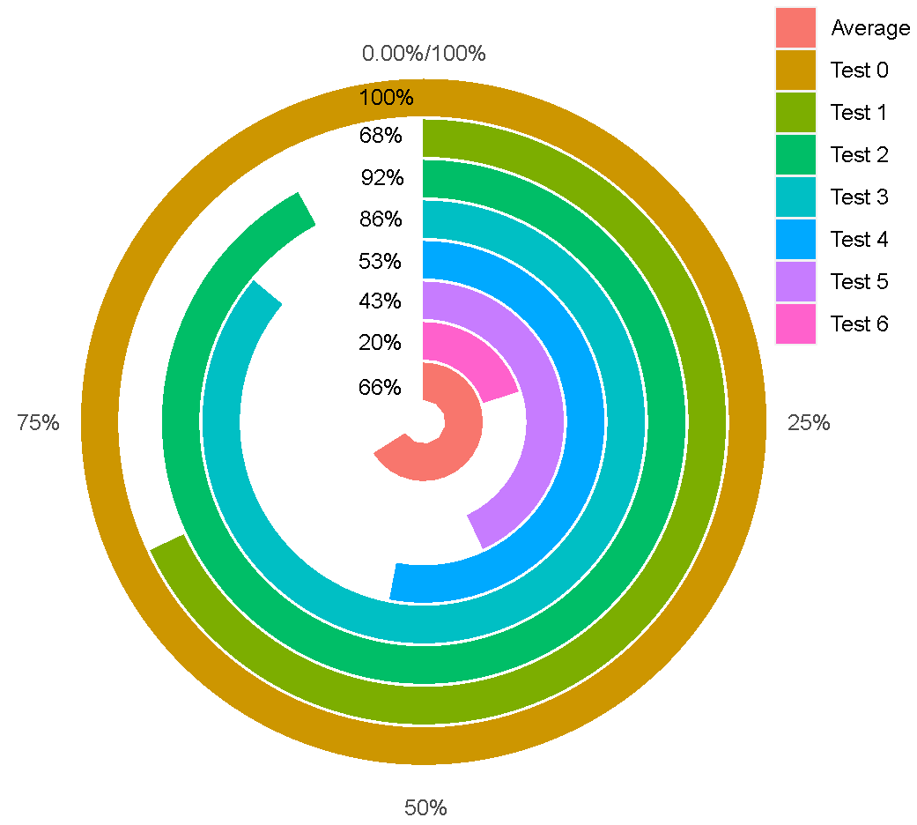
Supplementary Figure 4. Overall performance of the proposed drug-target prediction model across 7 tests, measured by the percentage of top performance in all tasks. For example, in Test 0, the proposed method ranks first in all 10 tasks, achieving a 100% top-performance rate. The average percentage of top performance across all Tests is 66%.

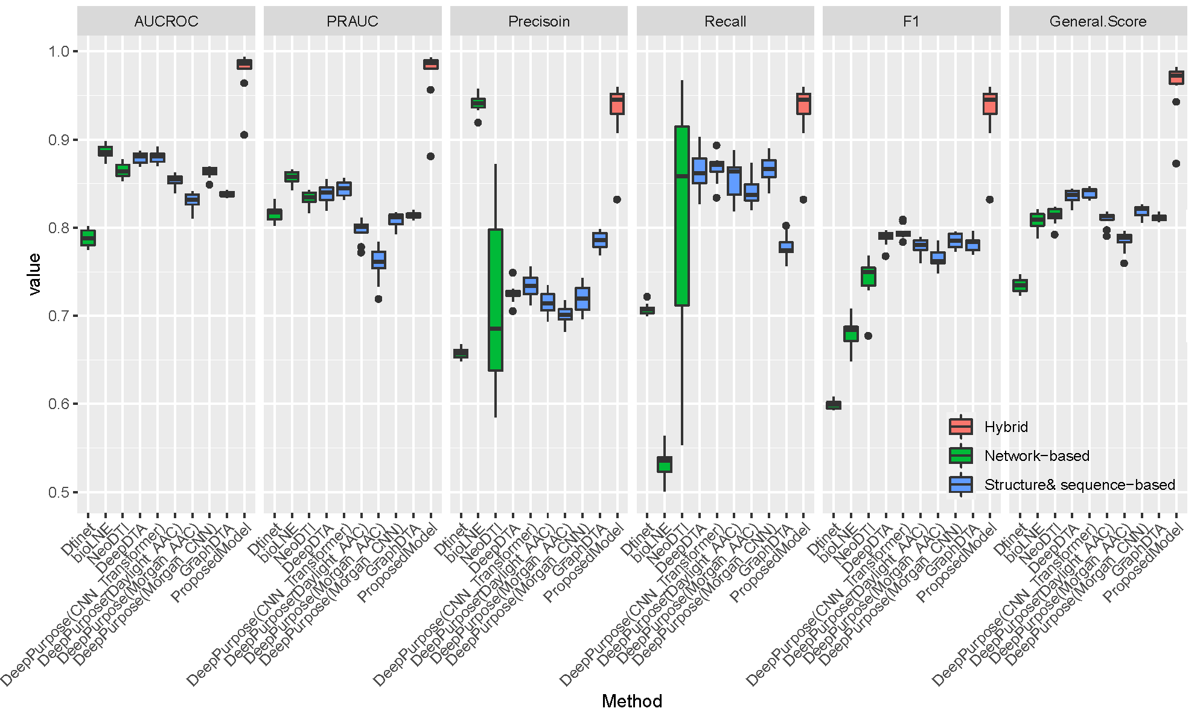
Supplementary Figure 5. Results of Test 0. This figure illustrates that the proposed model, referred to as "Hybrid," outperformed all baseline methods in Test 0.

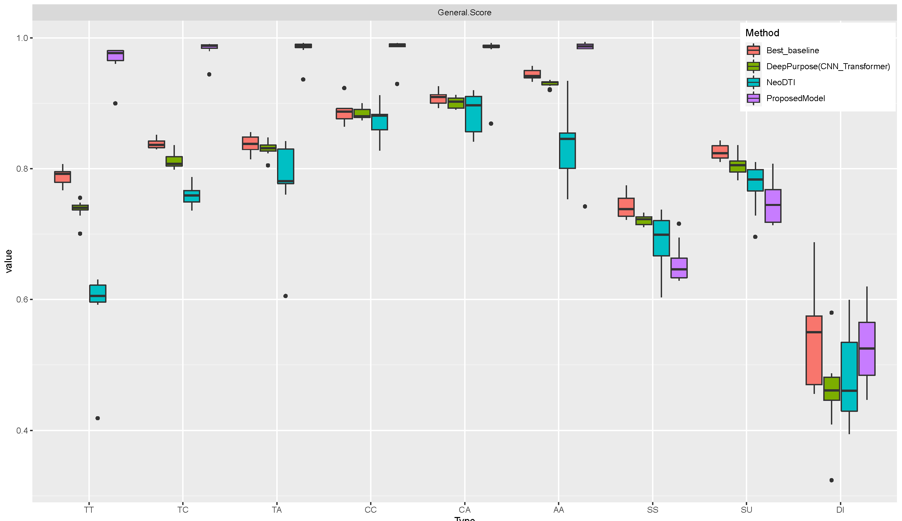
Supplementary Figure 6. Results of Test 1. This figure demonstrates that the proposed model outperformed all baseline methods in the majority of tasks in Test 1.

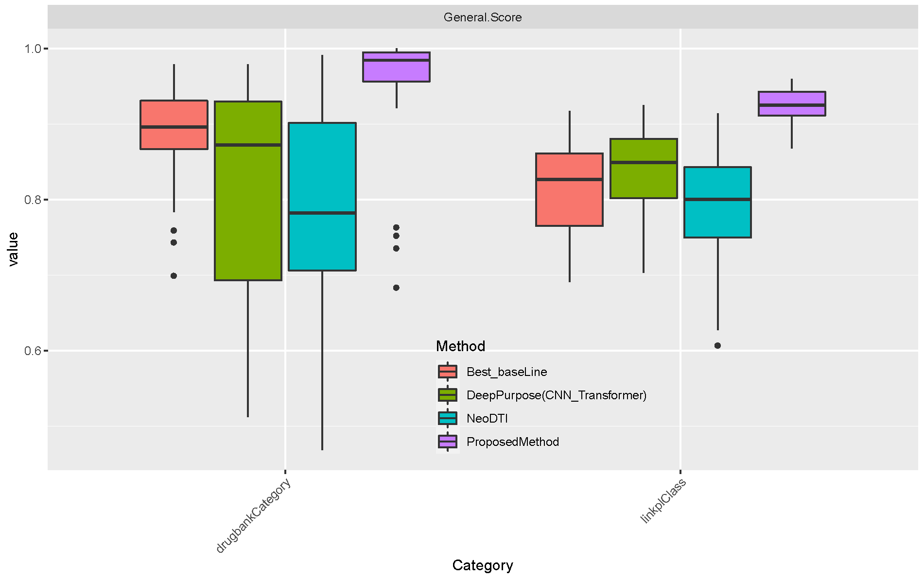
Supplementary Figure 7. Results of Test 2 by category. This figure demonstrates that the proposed model outperformed all baseline methods in Test 2 tasks by category.
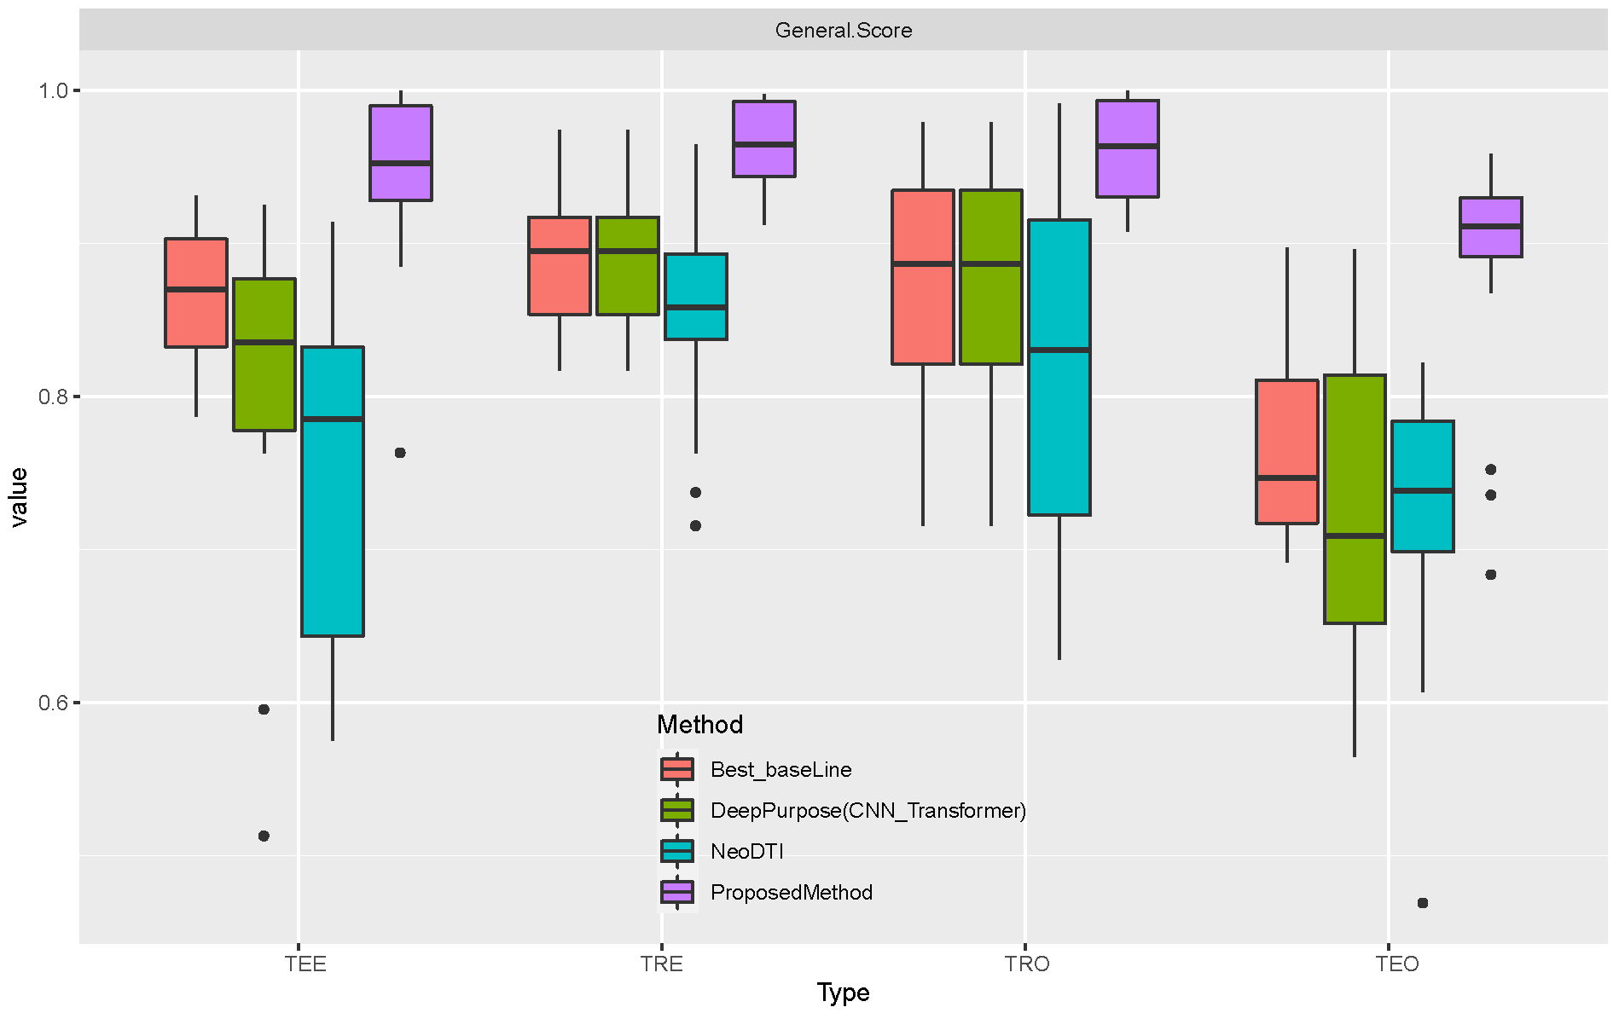
Supplementary Figure 8. Results of Test 2 by type. This figure demonstrates that the proposed model outperformed all baseline methods in Test 2 tasks by type.

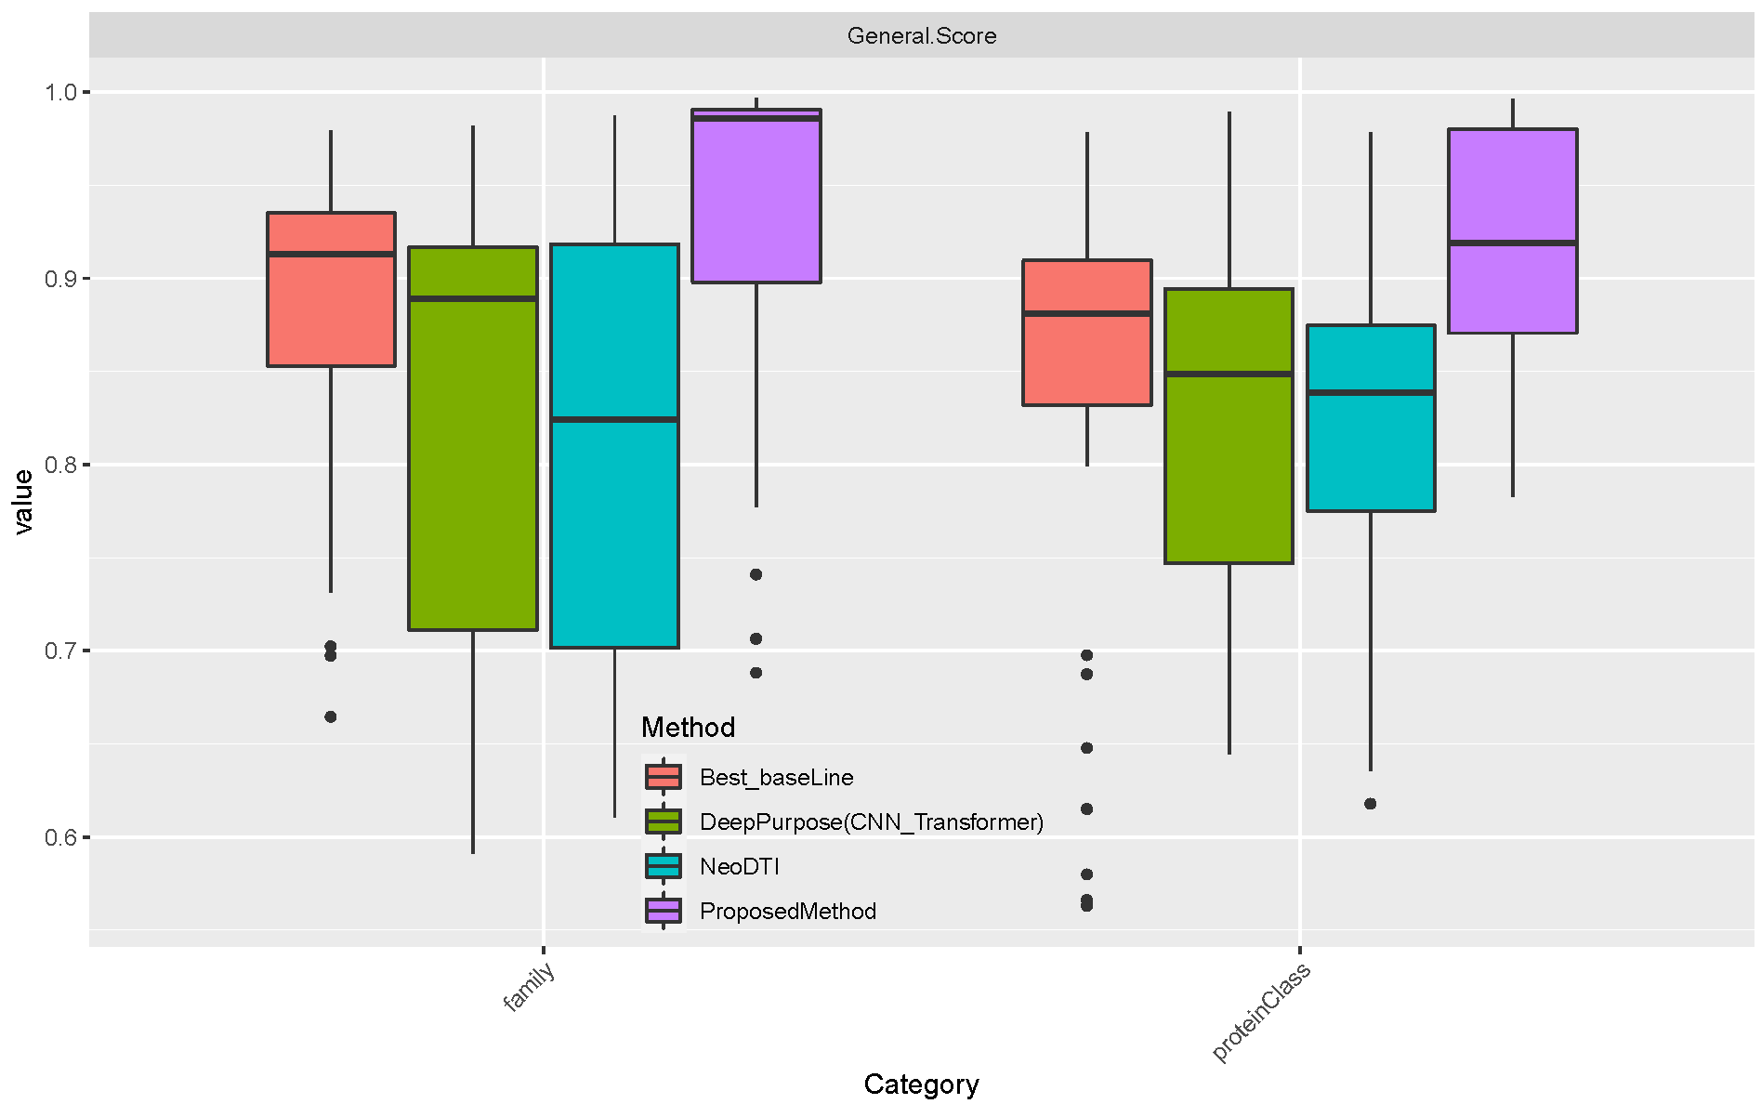
Supplementary Figure 9. Results of Test 3 by category. This figure demonstrates that the proposed model outperformed all baseline methods in Test 3 tasks by category.

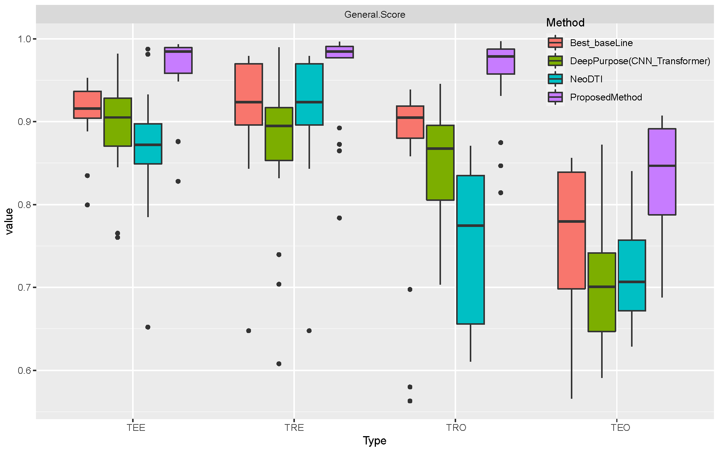
Supplementary Figure 10. Results of Test 3 by type. This figure demonstrates that the proposed model outperformed all baseline methods in Test 3 tasks by type.

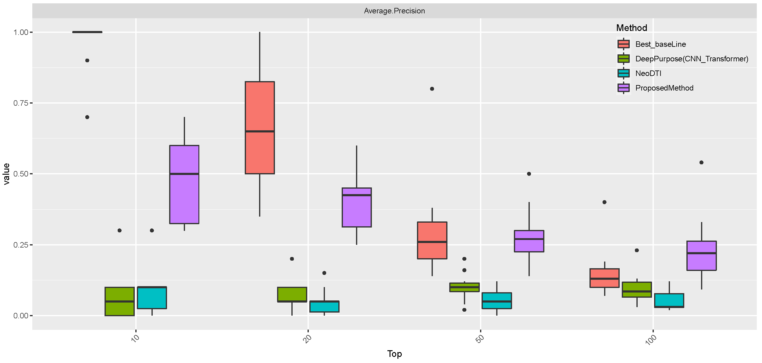
Supplementary Figure 11. Results of Test 4 by drug. This figure demonstrates that the proposed model outperformed all baseline methods in half of Test 4 tasks by drug.

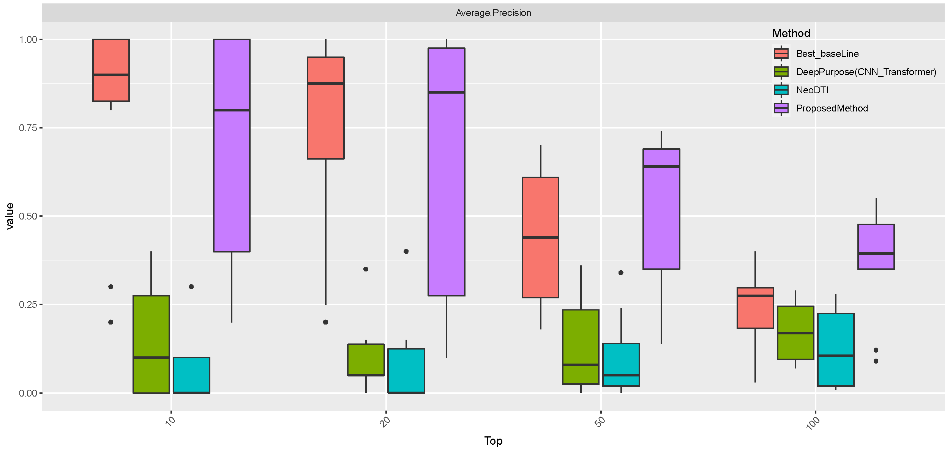
Supplementary Figure 12. Results of Test 4 by target. This figure demonstrates that the proposed model outperformed all baseline methods in half of Test 4 tasks by targets.

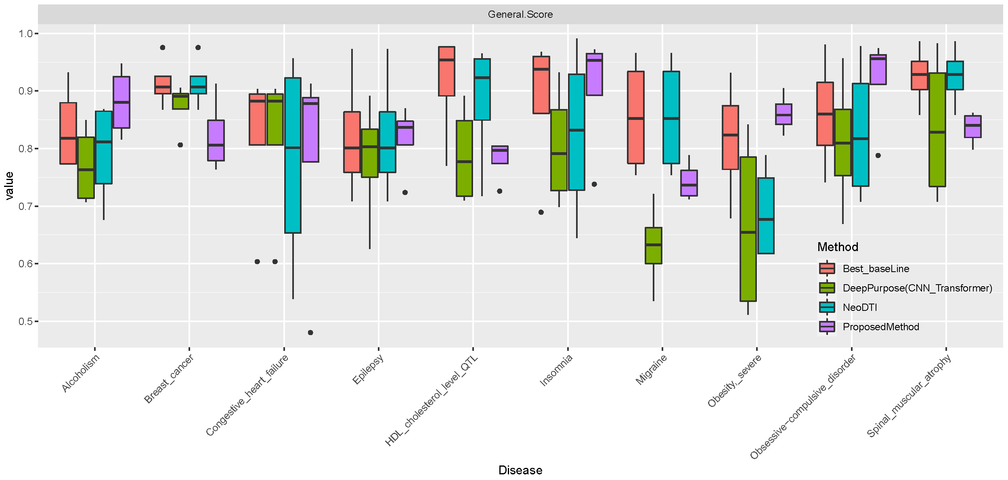
Supplementary Figure 13. Results of Test 5 by disease. This figure demonstrates that the proposed model outperformed all baseline methods in half of Test 5 tasks by disease.

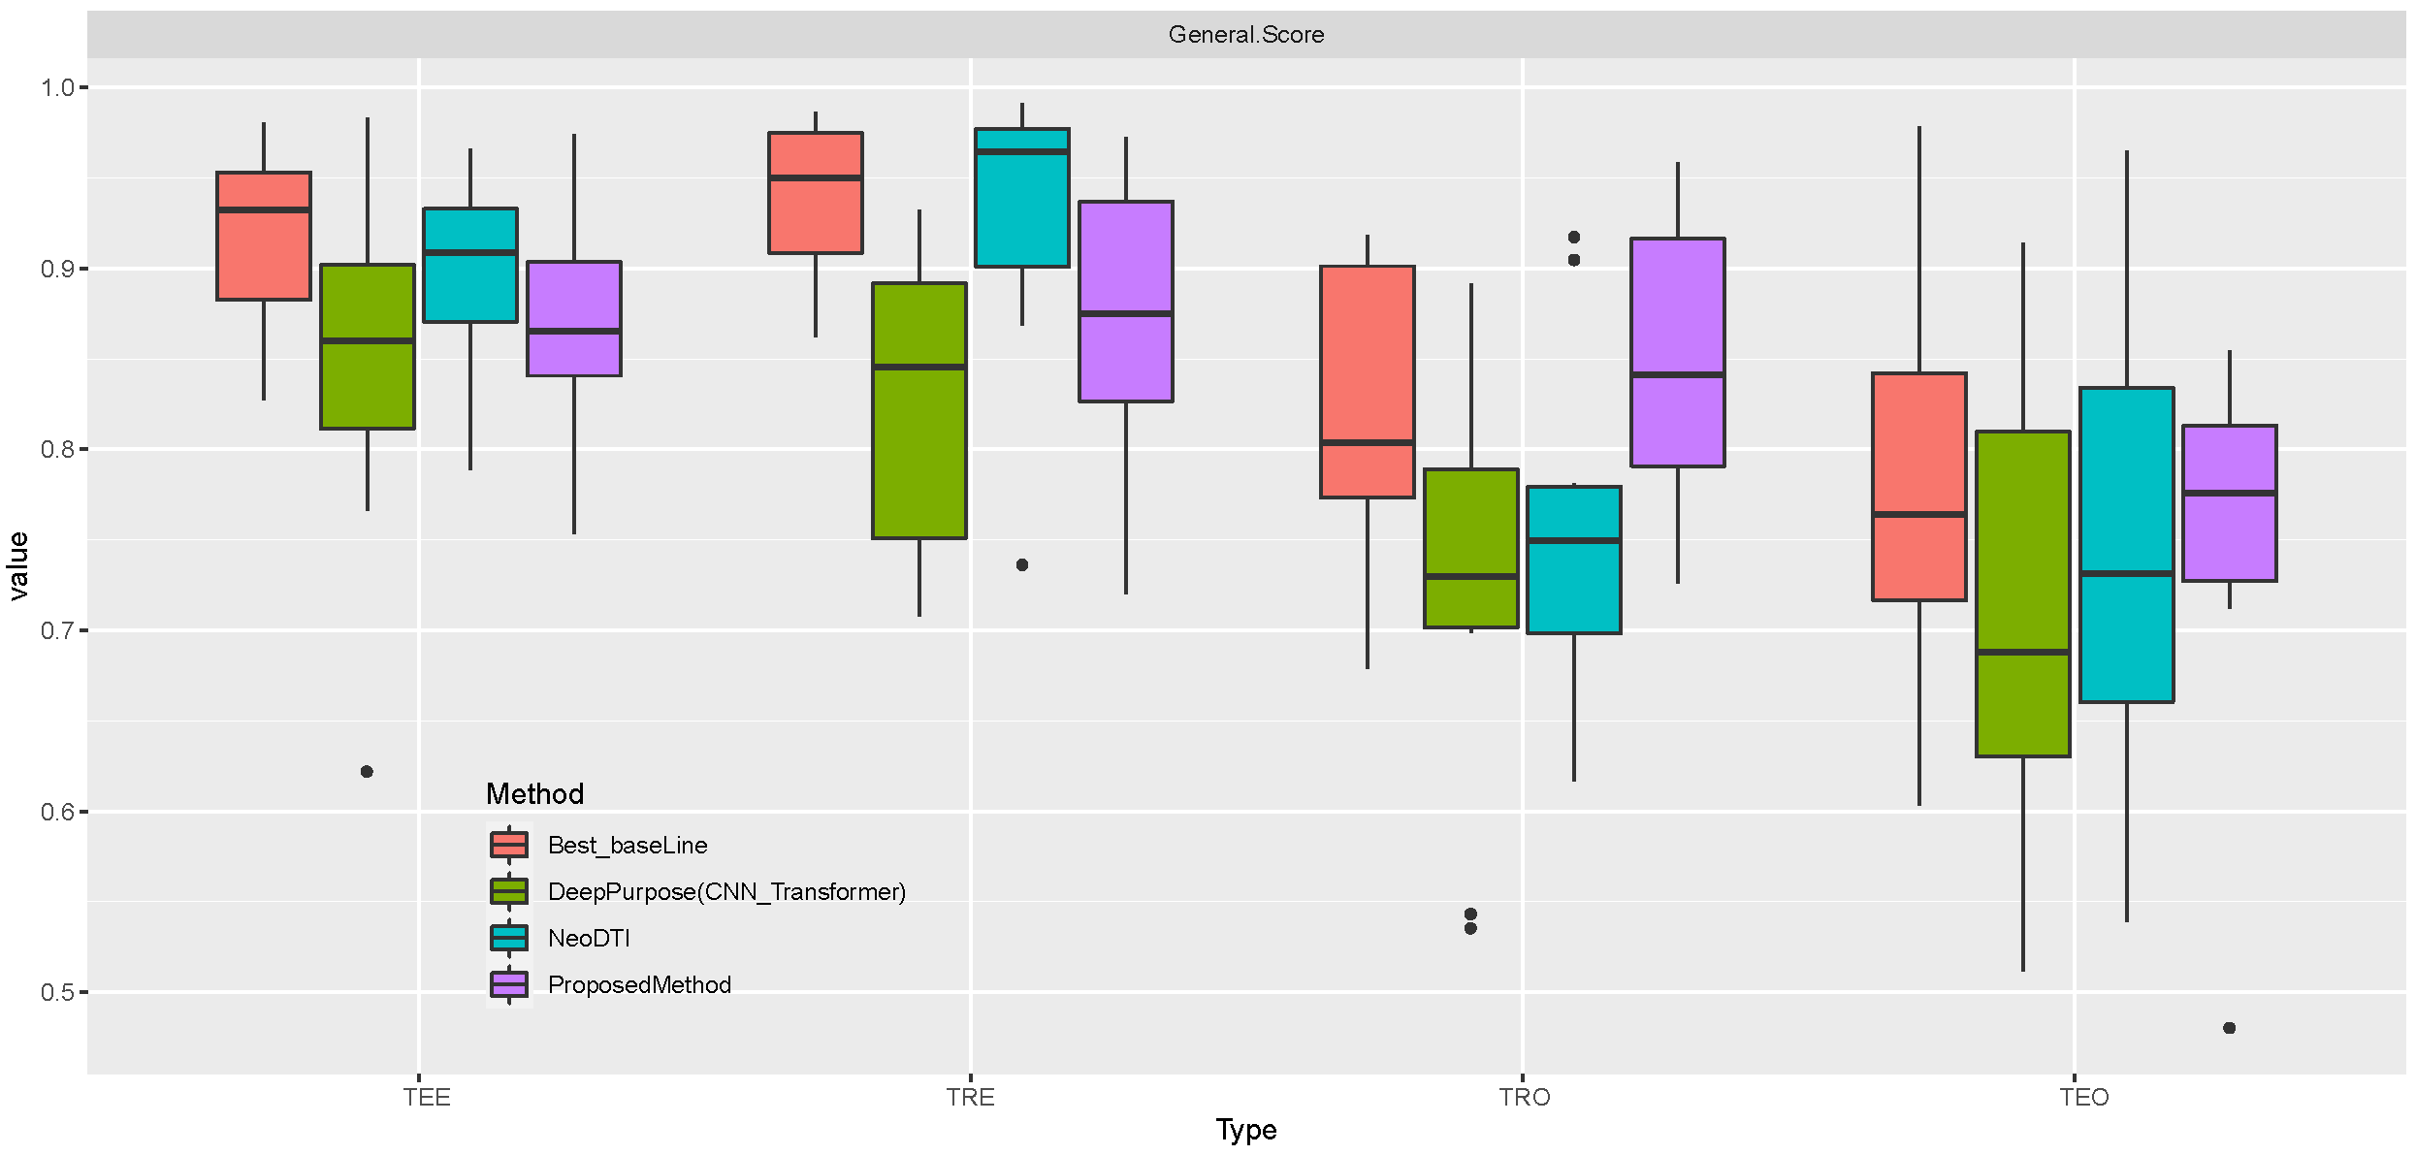
Supplementary Figure 14. Results of Test 5 by type. This figure demonstrates that the proposed model outperformed all baseline methods in half of Test 5 tasks by type.

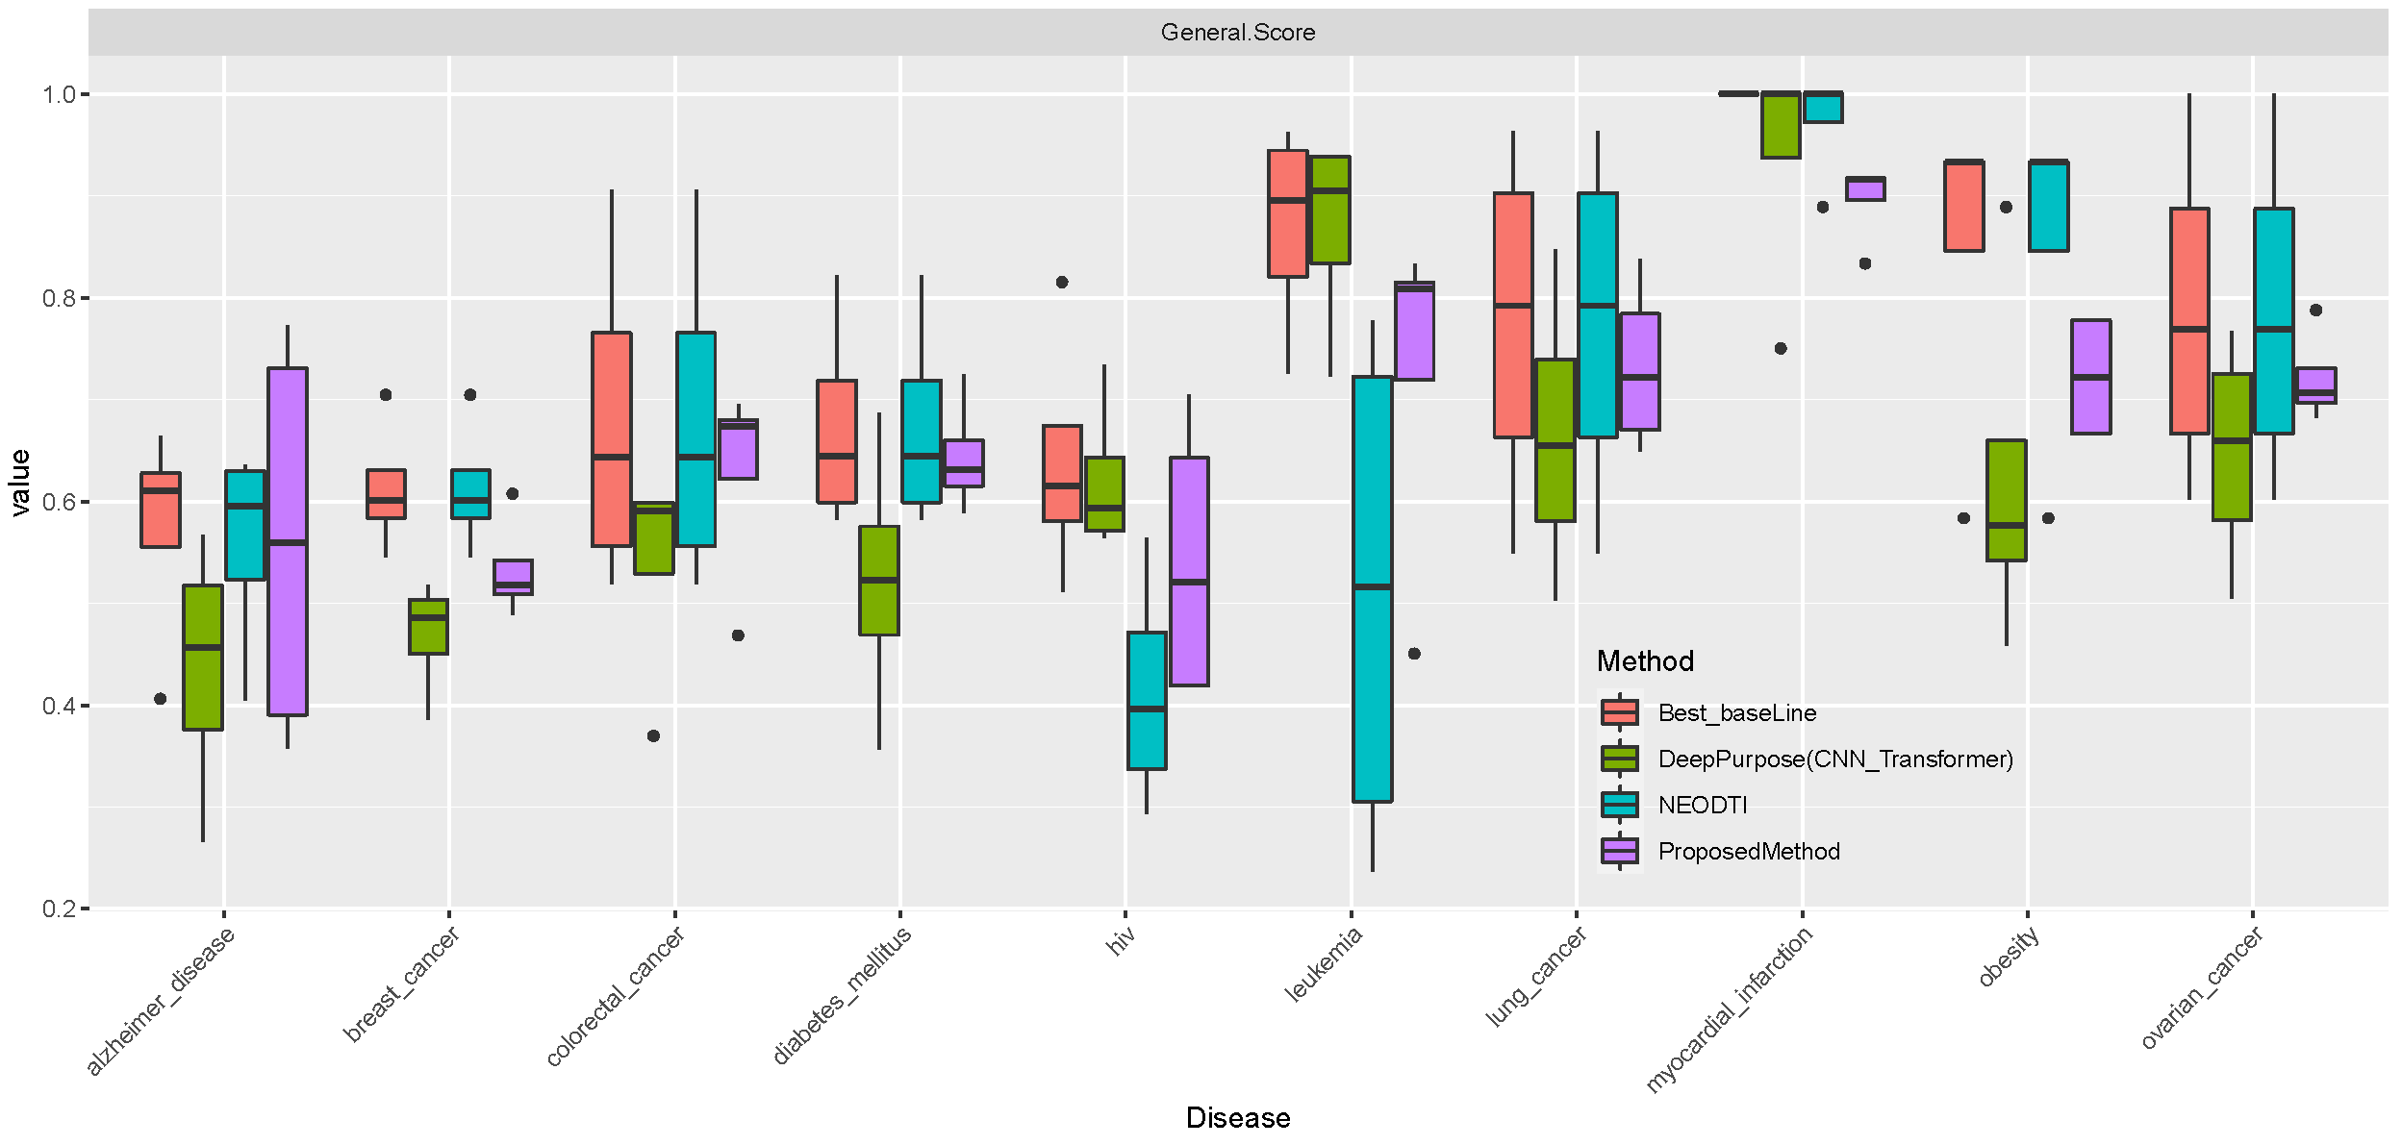
Supplementary Figure 15. Results of Test 6 by disease. This figure demonstrates that the proposed model outperformed some baseline methods in Test 6 tasks by disease.

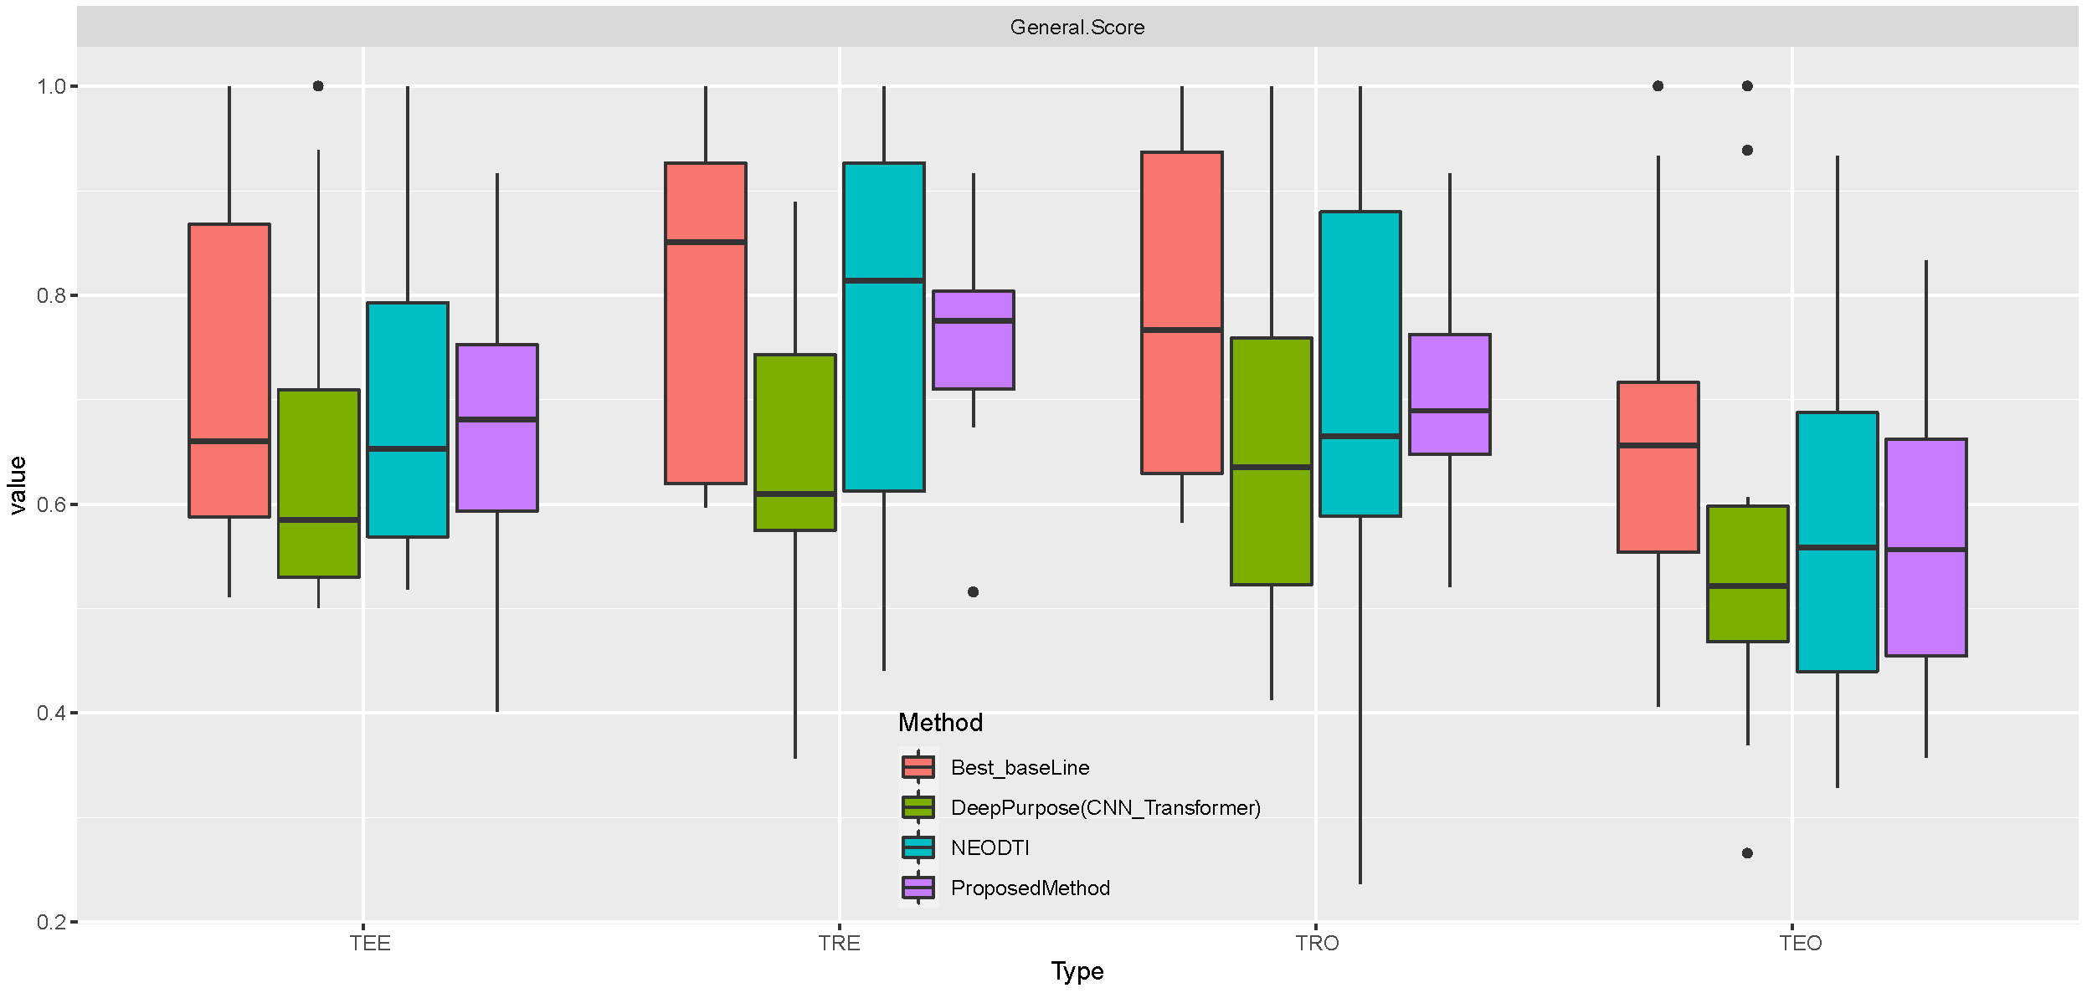
Supplementary Figure 16. Results of Test 6 by type. This figure demonstrates that the proposed model outperformed some baseline methods in Test 6 tasks by type.
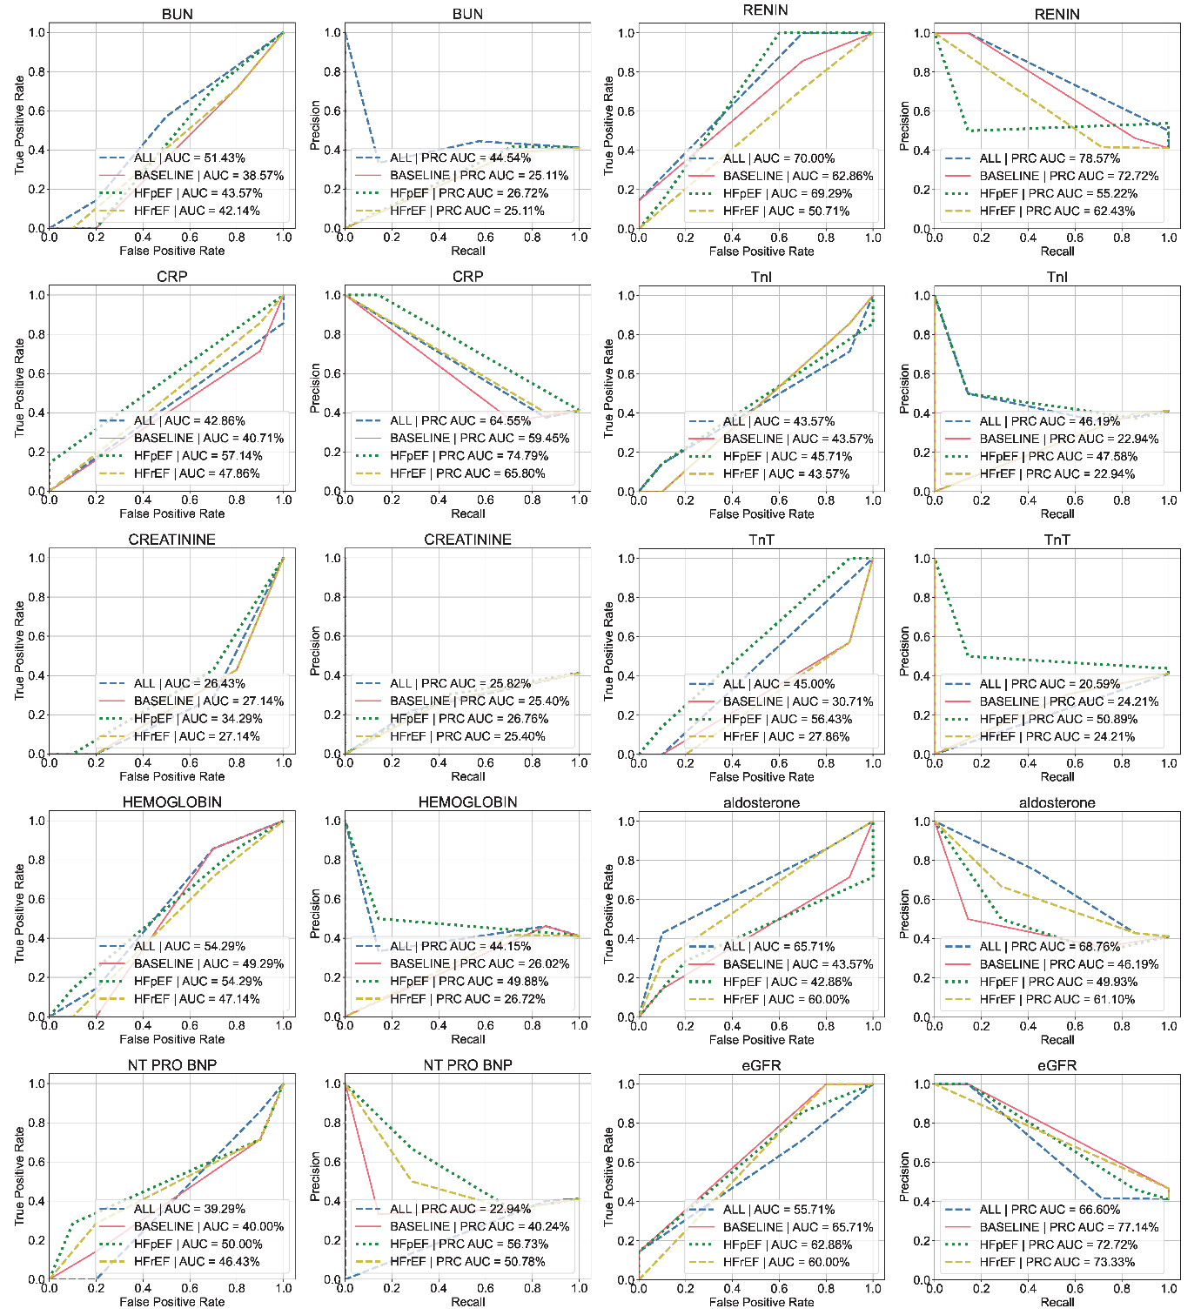
Supplementary Figure 17. AUCROC and PRAUC of EHR-based emulation using four HF cohorts for 10 prognostic outcome markers. This figure shows the AUCROC and PRAUC scores of EHR-based emulation across 10 prognostic markers, highlighting baseline performance in emulation.

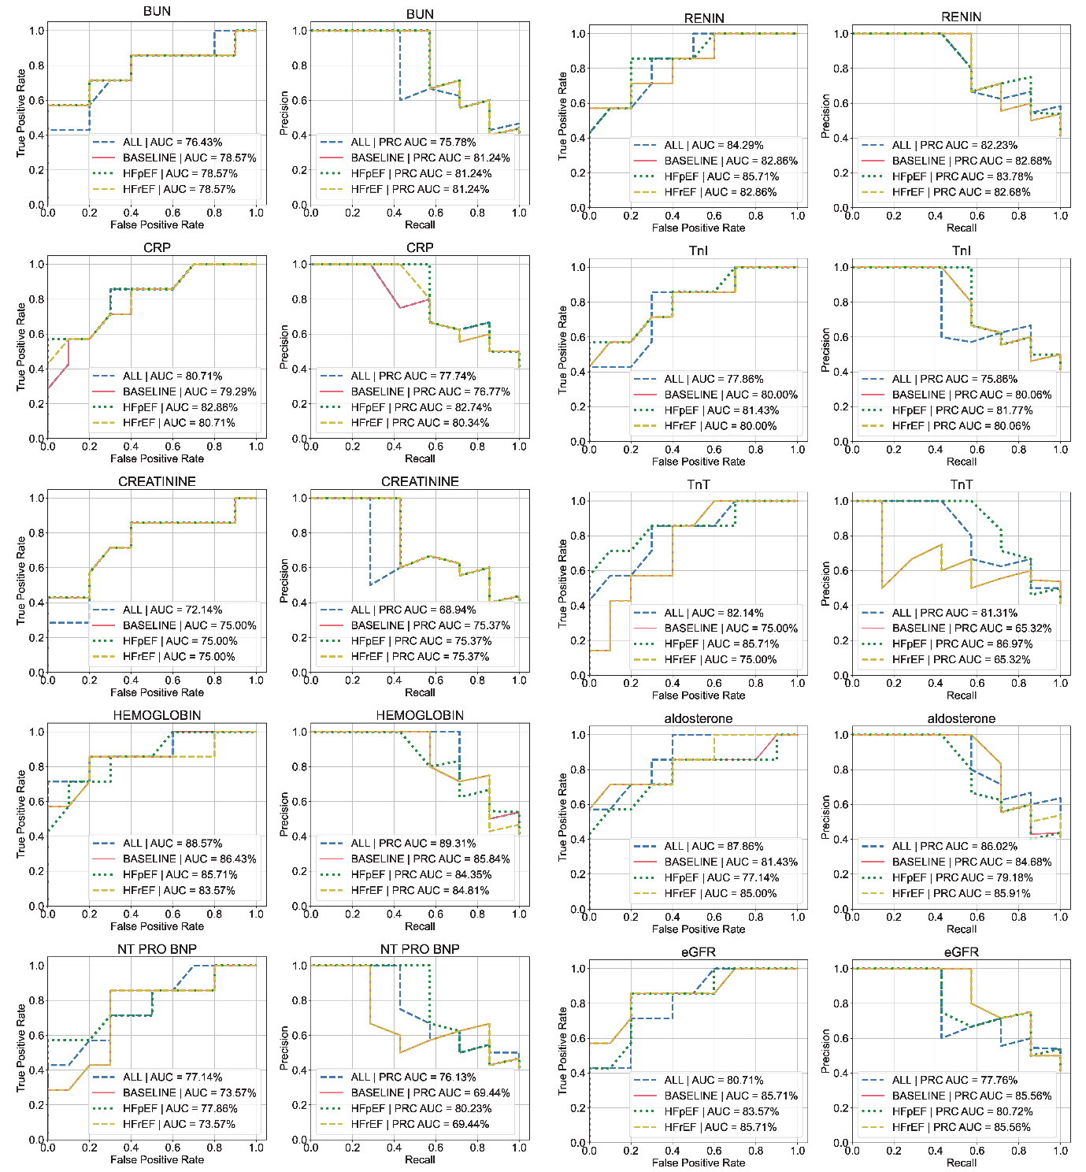
Supplementary Figure 18. AUCROC and PRAUC of emulation integrated with drug-target prediction using four HF cohorts for 10 prognostic outcome markers. This figure shows the AUCROC and PRAUC scores across 10 prognostic markers, highlighting the performance based on the integration of EHR-based emulation and drug-target prediction for heart failure prognostics.

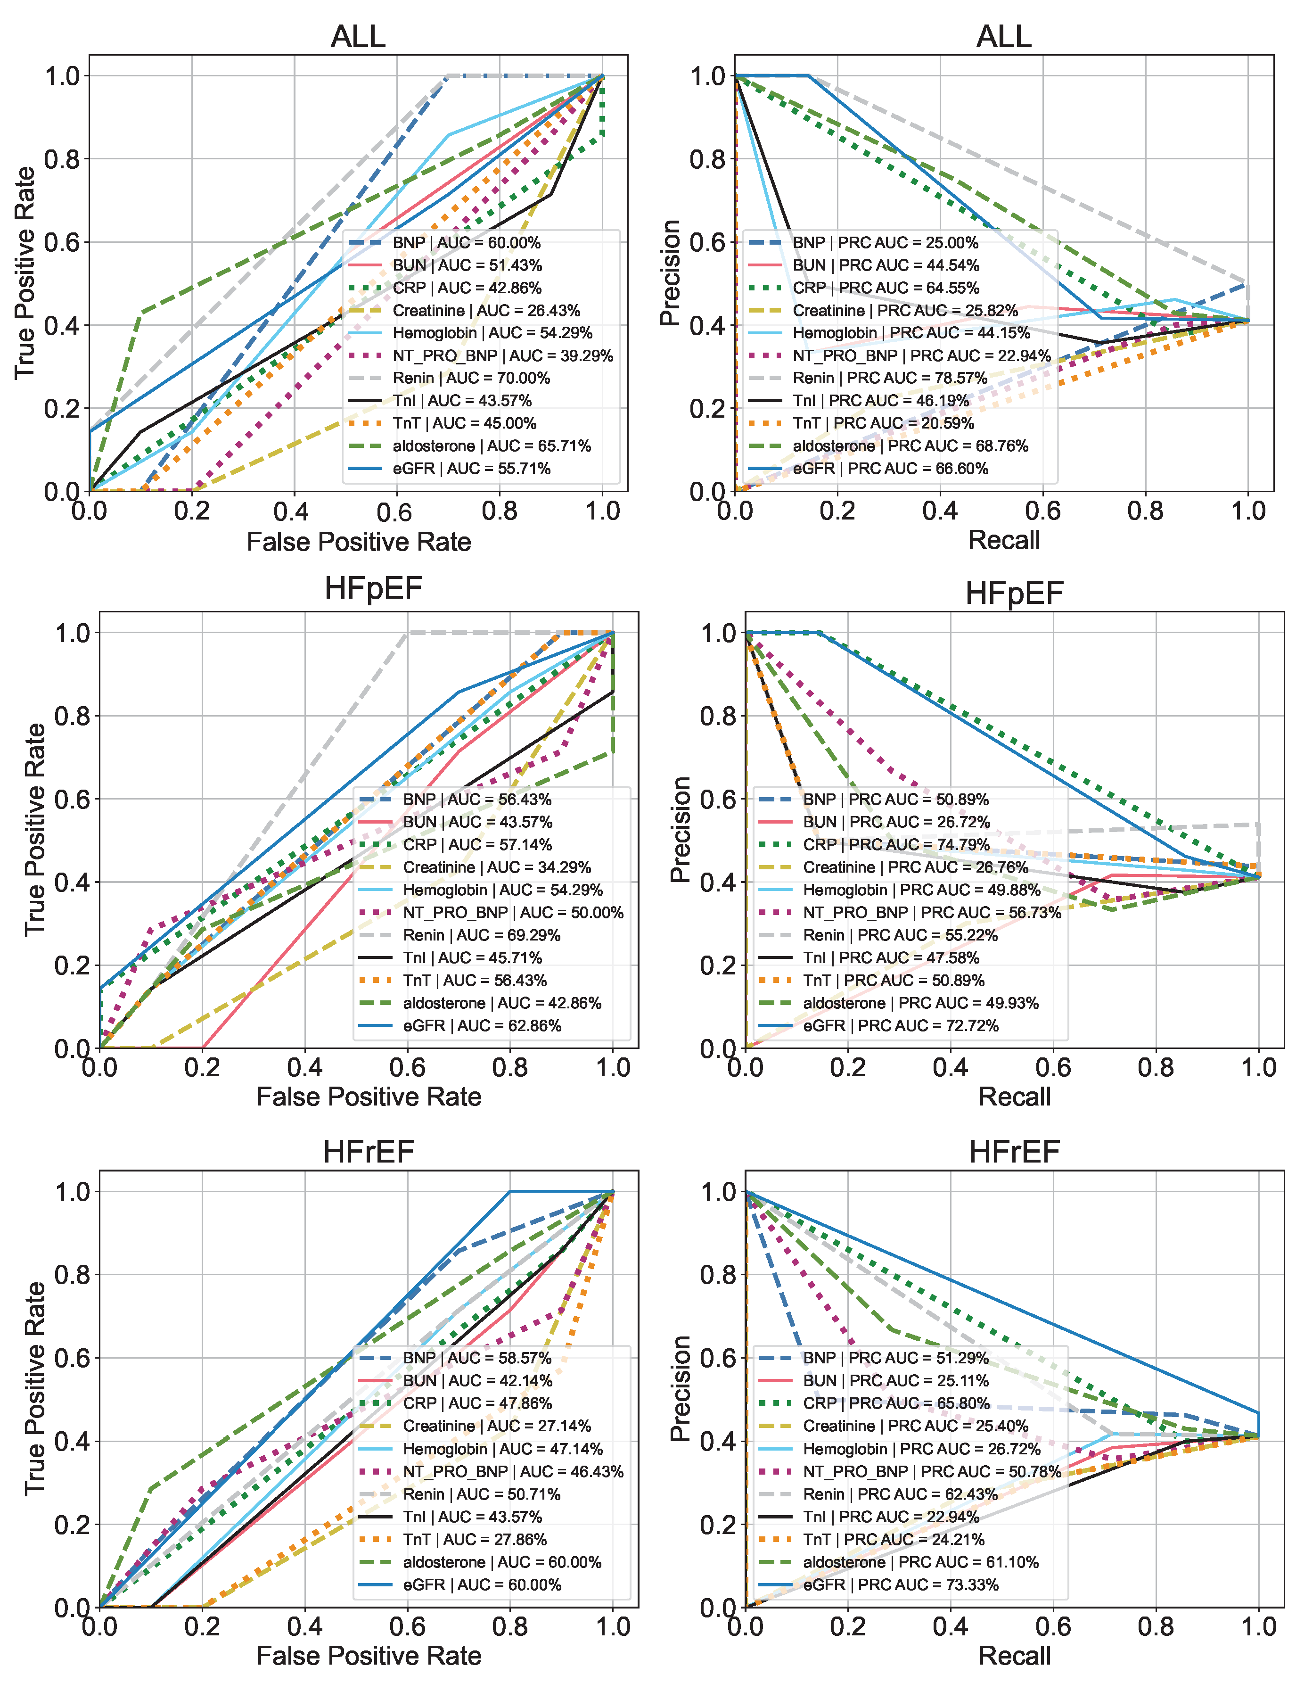

Supplementary Figure 19. AUCROC and PRAUC of EHR-based emulation using 11 prognostic outcome measurements based on three HF cohorts, ALLL, HFpEF, and HFrEF. This figure shows the AUCROC and PRAUC scores of EHR-based emulation across three HF cohorts, highlighting baseline performance in emulation.

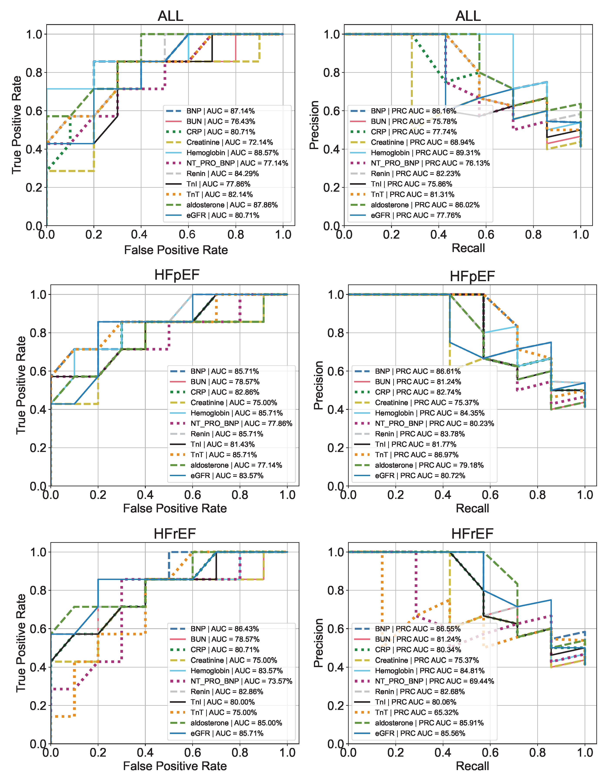
Supplementary Figure 20. AUCROC and PRAUC of emulation integrated with drug-target prediction using 11 prognostic outcome measurements based on three HF cohorts, ALLL, HFpEF, and HFrEF. This figure shows the AUCROC and PRAUC scores across three cohorts, highlighting the performance based on the integration of EHR-based emulation and drug-target prediction for heart failure prognostics.
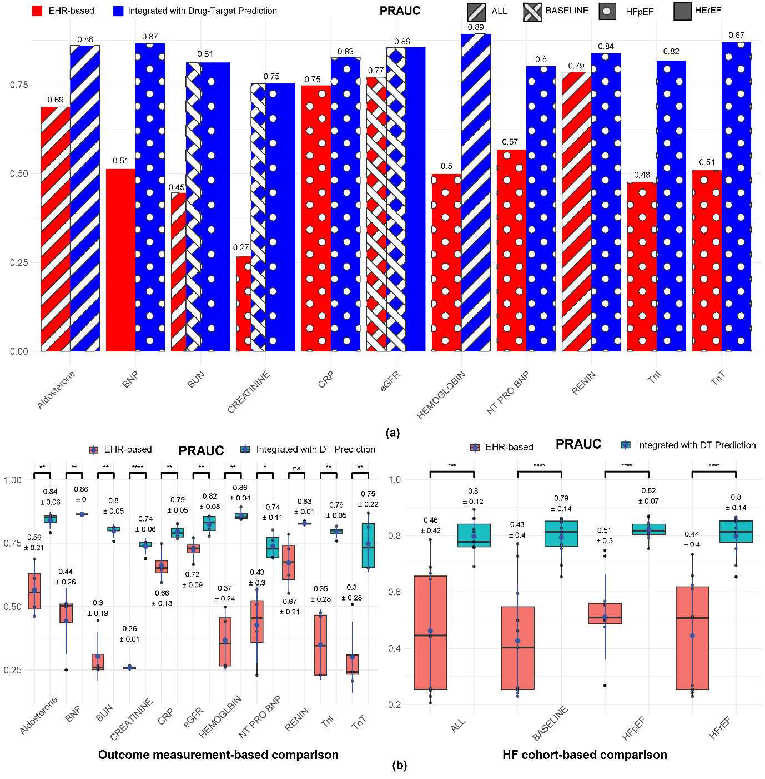
Supplementary Figure 21. Direct comparison of PRAUC between the EHR-based emulation and the emulation integrated with drug-target prediction. (a) presents the comparison for each prognostic outcome measure, focusing on the best-performing HF cohort, where the EHR-based emulation is highlighted in red, and the emulation integrated with Drug-Target Prediction is highlighted in blue. (b) illustrates the comparison based on both outcome measures and HF cohorts, respectively.
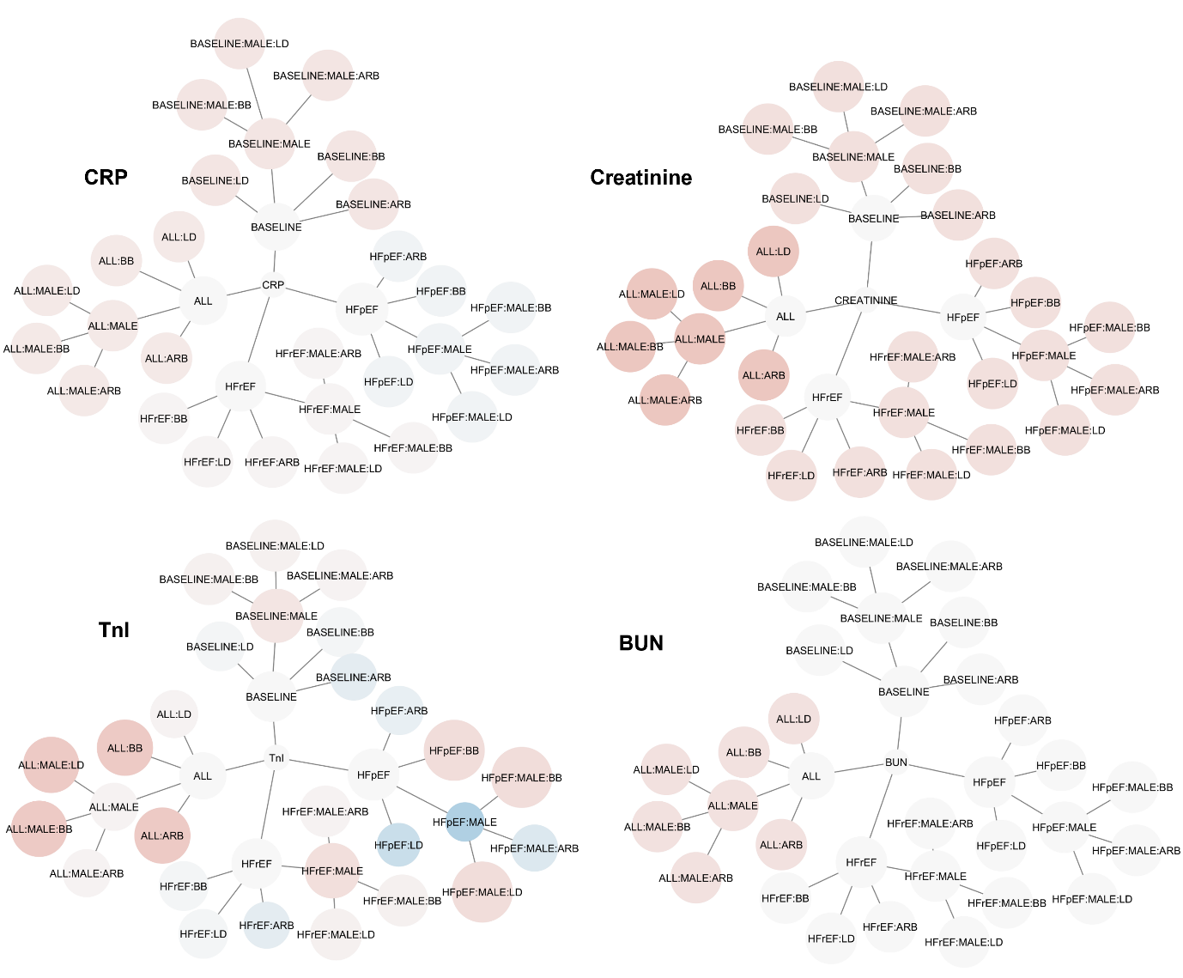
Supplementary Figure 22. Results (PRAUC) of incorporating interactions between HF drugs and gender in the proposed method (ET integrated with Drug-Target Prediction) for the top four prognostic markers that yielded the highest number of improved predictions. The top four prognostic markers are: 1) CRP, 2) Creatinine, 3) TnI, and 4) BUN. Red nodes indicate an improvement in PRAUC, while blue nodes represent a decrease in PRAUC performance. The size of each node corresponds to the PRAUC score.

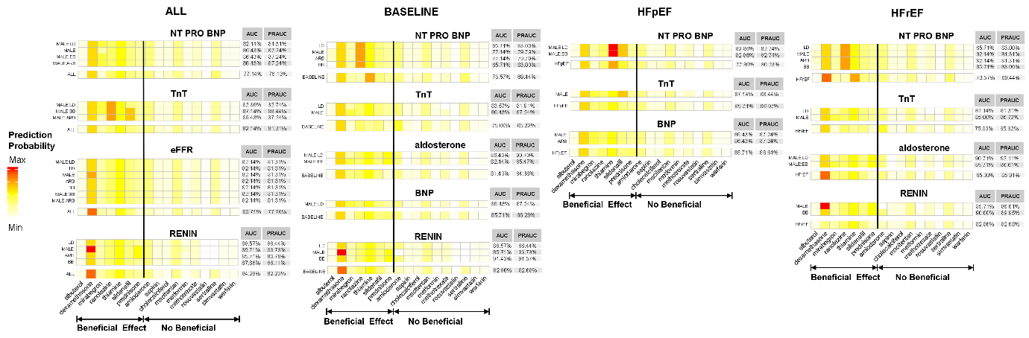
Supplementary Figure 23. Improved prediction for other 7 prognostic markers. This figure presents the AUCROC and PRAUC scores, providing detailed predictions for each drug using a method that integrates interactions between HF drugs and gender within the emulation, combined with Drug-Target Prediction across four cohorts.

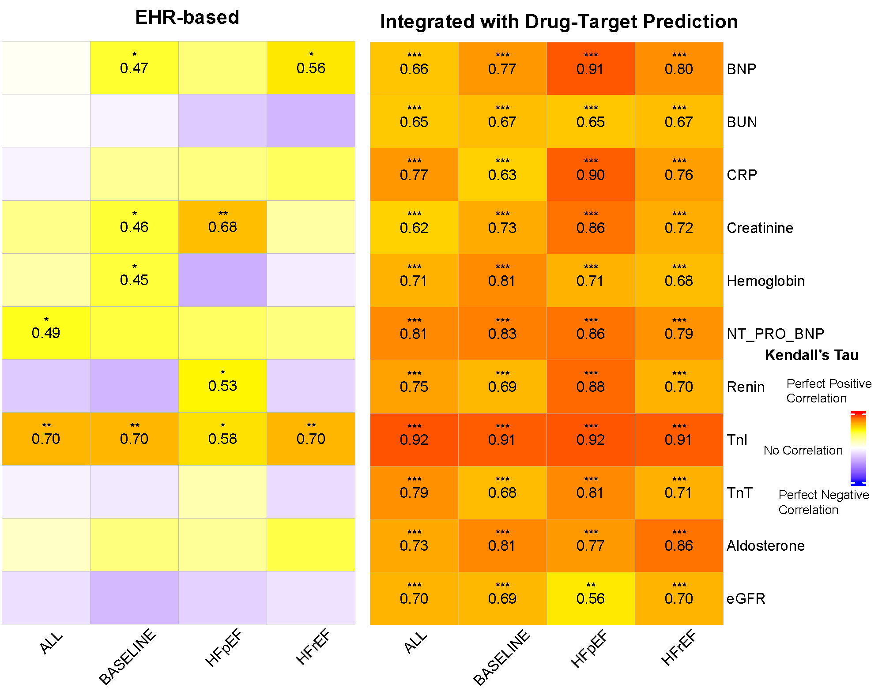
Supplementary Figure 24. Agreement Analysis of Prediction Results Between PP and ITT. This figure presents an agreement analysis of efficacy direction predictions between PP and ITT using Kendall's Tau. Two prediction approaches—EHR-based emulation and emulation integrated with Drug-Target Prediction—were compared. The results show a moderate level of consistency in predictions between PP and ITT using EHR-based emulation, and a significant level of agreement when incorporating Drug-Target Prediction into the emulation.

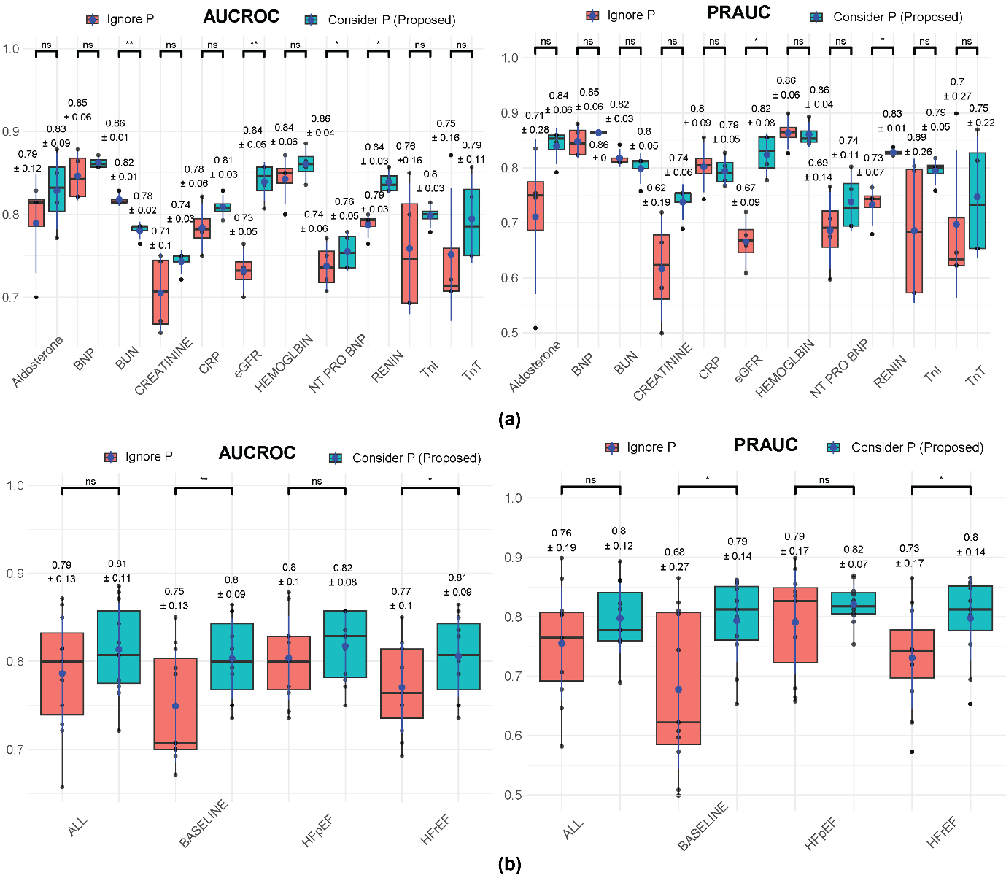
Supplementary Figure 25. Comparison of AUC-ROC and PR-AUC between the proposed method that incorporates logistic regression coefficients based on statistical significance and the method that ignores p-values (referred to as "Ignore P").
(a) shows the comparison across outcome measurements (i.e., 11 prognostic markers).
(b) presents the comparison across different heart failure (HF) cohorts.

Supplementary Table 2. Drug information
Drug Name | Drugbank ID | BASELINE Cohort | RCTs
Albuterol | DB01001 | HFpEF | NCT02885636
Amiodarone | DB01118 | HFrEF | NCT00000609
Aspirin | DB00945 | HFrEF | NCT00041938
Cholecalciferol | DB00169 | HFrEF | NCT01292720
Dexamethasone | DB01234 | ALL | NCT00953303
Macitentan | DB08932 | ALL | NCT03775421
Metformin | DB00331 | HFrEF | NCT01690091;NCT01217307
Methotrexate | DB00563 | HFrEF | NCT00759811
Mirabegron | DB08893 | HFrEF | NCT03926754
Prednisone | DB00635 | HFrEF | NCT02129764;NCT01559727,NCT00953303
Ranolazine | DB00243 | HFrEF | NCT01215253
Rosuvastatin | DB01098 | ALL | NCT00240292;NCT00206310;NCT00228514;NCT00505154
Sertraline | DB01104 | HFrEF | NCT00078286
Sildenafil | DB00203 | ALL | NCT00763867;NCT00309790;NCT00309816;NCT00975494;NCT01156636;NCT01936350;NCT01726049;NCT00407446
Simvastatin | DB00641 | HFrEF | NCT01160978
Thiamine (B1) | DB00152 | HFrEF | NCT01115504
Warfarin | DB00682 | ALL | NCT00041938

Supplementary Table 3. Gene information
Gene | Gene_Full_Name | Protein_Class | N_diseases | Score_gda | N_PMIDs | Last_Ref
MSTN | myostatin | Signaling | 159 | 0.54 | 5 | 2019
REN | renin | Enzyme | 721 | 0.4 | 147 | 2020
AGT | angiotensinogen | Enzyme modulator | 765 | 0.6 | 90 | 2020
PTH | parathyroid hormone |  | 528 | 0.4 | 12 | 2020
TNF | tumor necrosis factor | Signaling | 2724 | 0.6 | 57 | 2019
IL1B | interleukin 1 beta |  | 1801 | 0.4 | 27 | 2019
CRP | C-reactive protein |  | 1483 | 0.4 | 38 | 2019
IL6 | interleukin 6 |  | 2367 | 0.6 | 40 | 2019
EDN1 | endothelin 1 | Signaling | 679 | 0.6 | 34 | 2020
NR3C2 | nuclear receptor subfamily 3 group C member 2 | Nuclear receptor | 287 | 0.4 | 93 | 2020
ADRB1 | adrenoceptor beta 1 | G-protein coupled receptor | 130 | 0.6 | 45 | 2019
HMOX1 | heme oxygenase 1 |  | 666 | 0.55 | 7 | 2019
ACE | angiotensin I converting enzyme | Enzyme | 1082 | 0.6 | 211 | 2020
CCL2 | C-C motif chemokine ligand 2 | Signaling | 1157 | 0.56 | 8 | 2019
ADRB3 | adrenoceptor beta 3 | G-protein coupled receptor | 142 | 0.52 | 5 | 2017
VEGFA | vascular endothelial growth factor A | Signaling | 1899 | 0.4 | 15 | 2020
NPPB | natriuretic peptide B |  | 193 | 0.6 | 68 | 2020
GRK2 | G protein-coupled receptor kinase 2 | Kinase | 159 | 0.6 | 49 | 2020
EDNRA | endothelin receptor type A | G-protein coupled receptor | 427 | 0.4 | 17 | 2019
NOS3 | nitric oxide synthase 3 |  | 706 | 0.6 | 20 | 2018
AGTR1 | angiotensin II receptor type 1 | G-protein coupled receptor | 440 | 0.6 | 27 | 2019
HTR2B | 5-hydroxytryptamine receptor 2B | G-protein coupled receptor | 61 | 0.5 | 2 | 2009
PIK3CG | phosphatidylinositol-4,5-bisphosphate 3-kinase catalytic subunit gamma | Kinase | 1101 | 0.4 | 11 | 2019
RAC1 | Rac family small GTPase 1 | Enzyme modulator | 415 | 0.5 | 2 | 2005
HIF1A | hypoxia inducible factor 1 subunit alpha | Transcription factor | 1044 | 0.6 | 12 | 2019

Supplementary Table 4. ICD code for HF
 | ICD Codes
ICD-9 | 398.91, 402.01, 402.11, 402.91, 404.01, 404.03, 404.11, 404.13, 404.91, 404.93, 428.0, 428.1, 428.20, 428.21, 428.22, 428.23, 428.30, 428.31, 428.32, 428.33, 428.40, 428.41, 428.42, 428.43, 428.9
ICD-10 | I09.81, I11.0, I13.0, I13.2, I50.1, I50.20, I50.21, I50.22, I50.23, I50.30, I50.31, I50.32, I50.33, I50.40, I50.41, I50.42, I50.43, I50.810, I50.811, I50.812, I50.813, I50.814, I50.82, I50.83, I50.84, I50.89, I50.9

Supplementary Table 5. Baseline HF drugs
Baseline HF drugs by Category | Name
ACEI | Benazepril, Lotensin, Captopril, Enalapril, Vasotec, Fosinopril, Lisinopril, Prinivil, Zestril, Moexipril, Perindopril, Quinapril, Accupril, Ramipril, Altace, Trandolapril
Beta Blocker | Acebutolol, Atenolol, Tenormin, Bisoprolol, Zebeta, Metoprolol, Lopressor, Toprol XL, Nadolol, Corgard, Nebivolol, Bystolic, Propranolol, Inderal, InnoPran XL
ARB | Azilsartan, Edarbi, Candesartan, Atacand, Eprosartan, Irbesartan, Avapro, Losartan, Cozaar, Olmesartan, Benicar, Telmisartan, Micardis, Valsartan, Diovan
Loop Diuretic | Chlorothiazide, Chlorthalidone, Hydrochlorothiazide, Indapamide, Metolazone, Bumetanide, Bumex, Ethacrynic acid, Edecrin, Furosemide, Lasix, Torsemide, Soaanz, Amiloride, Midamor, Eplerenone, Inspra, Spironolactone, Aldactone, Carospir, Triamterene, Dyrenium

Supplementary Table 6. Followup time for 17 HF drugs
Drug Name | Drugbank ID | Emulation Followup (1month=30 days)
Albuterol | DB01001 | 0.25 month (1 week)
Amiodarone | DB01118 | 12 month
Aspirin | DB00945 | 12 month
Cholecalciferol | DB00682 | 12 month
Dexamethasone | DB01234 | 1 month
Macitentan | DB08932 | 12 month
Metformin | DB00331 | 6 month
Methotrexate | DB00563 | 3 month
Mirabegron | DB08893 | 3 month
Prednisone | DB00635 | 1 month
Ranolazine | DB00243 | 12 month
Rosuvastatin | DB01098 | 6 month
Sertraline | DB01104 | 3 month
Sildenafil | DB00203 | 6 month
Simvastatin | DB00641 | 0.25 month (1 week)
Thiamine (B1) | DB00152 | 1 month
Warfarin | DB00682 | 12 month

Supplementary Table 7. Category for 11 prognostic markers
Prognostic Marker | Category | Range (Normal)
NT-proBNP | Myocardial Stress/Injury | <900 pg/mL
BNP | Myocardial Stress/Injury | < 100 pg/mL
TnT | Myocardial Stress/Injury | <0.03ng/ml
TnI | Myocardial Stress/Injury | <0.058ng/ml
Creatinine | Comorbidities | Male: 0.7 -1.3 mg/dL  Female: 0.6-1.1 mg/dL
BUN | Comorbidities | 6 - 20 mg/dL
eGFR | Comorbidities | >90 mL
Hemoglobin | Comorbidities | Male: 13.8-17.2 g/dL  Female: 12.1-15.1/dL
Renin | Neurohormonal Activation | 0.7-3.3ng/mL/h
Aldosterone | Neurohormonal Activation | 7-30 ng/dl
CRP | Inflammation | <8.0mg/L

Supplementary Table 8. Confidence interval of logistic regression models for BASELINE cohort across 11 prognostic outcome measures. The values are reported in the format odds ratio (95% confidence interval: lower, upper). Note, ⁕ indicates that the corresponding logistic regression model encountered convergence issues (i.e., extremely large or near-zero estimated values), resulting in confidence intervals not being accurately estimated, thus not reported. ※ Not significant after P-value adjustment (P > 0.05).
Prognostic markers | Albuterol | Dexamethasone | Mirabegron | Ranolazine | Thiamine | Sildenafil | Prednisone
NT PRO BNP | NA⁕ | 0.98  (0.43, 2.27) | 2.23  (0.74, 6.70) | NA⁕ | NA⁕ | 0.93  (0.53, 1.62) | 0.66  (0.22, 1.93)
BNP | 0.91  (0.57, 1.44) | 0.76  (0.56, 1.02) | NA⁕ | 0.70  (0.32, 1.54) | 1.24  (0.30, 5.16) | 1.02  (0.38, 2.72) | 2.13  (1.44, 3.15)
TnT | 0.81  (0.49, 1.33) | 0.91  (0.66, 1.26) | NA⁕ | 4.50  (0.92, 21.96) | 0.24  (0.11, 0.50) | 0.44  (0.12, 1.60) | 0.45  (0.29, 0.71)
TnI | 1.11  (0.48, 2.54) | 1.38  (1.09, 1.75) | NA⁕ | 0.08  (0.01, 0.94) | 0.20  (0.05, 0.90)※ | 0.38  (0.08, 1.68) | 0.98  (0.53, 1.82)
Creatinine | 0.85  (0.79, 0.91) | 0.82  (0.77, 0.87) | 1.28  (0.46, 3.56) | 0.54  (0.33, 0.88)※ | 0.78  (0.61, 1.00) | 0.35  (0.22, 0.57) | 0.66  (0.59, 0.73)
BUN | 0.73  (0.68, 0.78) | 0.94  (0.89, 1.00)※ | 2.14  (0.88, 5.17) | 0.68  (0.40, 1.18) | 1.04  (0.82, 1.32) | 0.69  (0.45, 1.06) | 0.65  (0.59, 0.72)
eGFR | 0.98  (0.89, 1.09) | 1.19  (1.08, 1.30) | 3.24  (1.28, 8.20)※ | 0.61  (0.37, 1.02) | 0.92  (0.66, 1.30) | 0.51  (0.28, 0.93)※ | 0.95  (0.83, 1.09)
Hemoglobin | 0.90  (0.82, 0.99)※ | 0.87  (0.81, 0.93) | 1.43  (0.71, 2.88) | 1.89  (1.19, 3.00)※ | 0.74  (0.57, 0.95)※ | 0.95  (0.62, 1.45) | 1.12  (1.00, 1.26)※
Renin | 0.98  (0.86, 1.11) | 16.21  (2.57, 102.19) | NA⁕ | 1.54  (0.68, 3.49) | 0.83  (0.62, 1.12) | 0.42  (0.14, 1.25) | NA⁕
Aldosterone | 0.00  (0.00, 0.17) | 0.72  (0.24, 2.15) | NA⁕ | 0.75  (0.34, 1.64) | 0.76  (0.55, 1.06) | 0.48  (0.14, 1.70) | NA⁕
CRP | 0.99  (0.62, 1.57) | 0.69  (0.55, 0.88) | 0.17  (0.05, 0.59) | 1.73  (0.67, 4.42) | 1.40  (0.65, 3.03) | 0.74  (0.25, 2.13) | 1.14  (0.85, 1.52)

Supplementary Table 9. Confidence interval of logistic regression models for BNP across 4 cohots generated from subtypes. The values are reported in the format odds ratio (95% confidence interval: lower, upper). Note, ⁕ indicates that the corresponding logistic regression model encountered convergence issues (i.e., extremely large or near-zero estimated values), resulting in confidence intervals not being accurately estimated, thus not reported. ※ Not significant after P-value adjustment (P > 0.05).
HF Cohort (Subtypes) | Albuterol | Dexamethasone | Mirabegron | Ranolazine | Thiamine | Sildenafil | Prednisone
BASELINE | 0.91  (0.57, 1.44) | 0.76  (0.56, 1.02) | NA⁕ | 0.70  (0.32, 1.54) | 1.24  (0.30, 5.16) | 1.02  (0.38, 2.72) | 2.13  (1.44, 3.15)
ALL | 0.82  (0.56, 1.19) | 0.76  (0.56, 1.02) | 1.19  (0.22, 6.43) | 0.56  (0.36, 0.87) ※ | 0.48  (0.26, 0.87)※ | 1.27  (0.70, 2.30) | 1.38  (1.05, 1.80)※
HFrEF | 0.66  (0.35, 1.26) | 0.65  (0.41, 1.02) | NA⁕ | 0.70  (0.32, 1.54) | 1.24  (0.30, 5.16) | 1.02  (0.38, 2.72) | 2.13  (1.44, 3.15)
HFpEF | 0.91  (0.57, 1.44) | 0.89  (0.59, 1.34) | 1.24  (0.22, 7.01) | 0.53  (0.25, 1.11) | 0.48  (0.18, 1.30) | 1.50  (0.74, 3.02) | 1.62  (1.20, 2.19)

