The authors provide the supplementary materials for the following manuscript:

“Personalized and Real-Time Hemodynamic Management in Critical Care Using Dynamic Cohort Ensemble Learning (DynaCEL)”

Authors:
Lingzhong Meng, Jiangqiong Li, Xiang Liu, Yanhua Sun, Zuotian Li, Jinjin Cai, Ameya D. Parab, George Lu, Aishwarya S. Budhkar, Saravanan Kanakasabai, David Adams, Ziyue Liu, Xuhong Zhang, Jing Su

Content:
- Supplementary Table 1: Propensity score-matched analysis of subgroups with actual HR/SBP within or beyond ±20% of personalized targets
- Supplementary Table 2: Propensity score-matched analysis of subgroups with actual HR/SBP within or beyond ±20% of population targets
- Supplementary Table 3: Propensity score-matched analysis of subgroups with actual HR/SBP within ±20% of personalized vs. population targets
- Supplementary Table 4: Characteristics of the three datasets used in this study
- Supplementary Table 5: Input and outcome variables used in model development
- Supplementary Table 6: Imputation methods and data missingness
- Supplementary Table 7: Missing rate of hourly heart rate or systolic blood pressure for the entire dataset
- Supplementary Table 8: Complete missing rate of heart rate or systolic blood pressure during the prediction window for the 18-hour MOP cohorts
- Supplementary Table 9: Characteristics of the 18-hour MOP cohorts for the three datasets used in this study
- Supplementary Table 10: Performance of models trained on expanded versus unexpanded cohorts
- Supplementary Table 11: Performance of different base models
- Supplementary Table 12: Performance comparison between random forest and XGBoost base models
- Supplementary Table 13: Performance of the DynaCEL models versus the single model
- Supplementary Table 14: Comparison of the use of vasoactive drugs and antibiotics between propensity score-matched subgroups
- Supplementary Table 15: Subpopulation characteristics
- Supplementary Table 16: Model performance in subpopulations
- Supplementary Table 17: Feature importance ranks according to Gini impurity reduction and SHAP
- Supplementary Table 18: Case studies based on chart review and comparisons between actual HR/SBP levels and DynaCEL predicted targets
- Supplementary Figure 1: Dynamic cohorts by time following ICU admission
- Supplementary Figure 2: HR-BP-mortality contour maps for individual patients with different demographic and baseline conditions (case studies)
- Supplementary Figure 3: HR-BP-mortality contour maps for individual patients with different acute illnesses (case studies)
- Supplementary Figure 4: Boxplots of inferred hemodynamic management targets for the two cases presented in Figures 2b and 2c
- Supplementary Figure 5: Data preprocessing
- Supplementary Figure 6: Data processing
- Supplementary Figure 7: Data split and model development
- Supplementary Figure 8: Hemodynamic target inference with XGBoost-based DynaCEL at 18-hour MOP in a random patient
- Supplementary Figure 9: Relationship between sample size and model performance
- Supplementary Figure 10: Distribution of heart rate and systolic blood pressure values
- Supplementary Figure 11: The SHAP and Gini importance ranking of 44 features including heart rate and systolic blood pressure
- Supplementary Figure 12: Sensitivity analysis using an encoder-decoder model

Supplementary Table 1: Propensity score-matched analysis of subgroups with actual HR/SBP within or beyond ±20% of personalized targets*

Different comparisons | Comparison (1) |  | Comparison (2)
Relationship to targets | Close to targets | Away from targets | Close to targets | Away from targets
Subgroups | Actual HR and SBP within ±20% of targets | Actual HR or SBP beyond ±20% of targets | Actual HR and SBP within ±20% of targets | Actual HR and SBP beyond ±20% of targets
Before matching
ICU stays, n | 40,243 | 23,067 | 40,243 | 3,272
Mortality rate, n (%) | 17 (0.04) | 961 (4.2) | 17 (0.04) | 722 (22.1)
After matching
ICU stays, n | 23,067 | 23,067 | 22,904 | 3,272
Mortality rate, n (%) | 7 (0.03) | 961 (4.2) | 11 (0.05) | 722 (22.1)
Post-match odds ratio | 143.3 (95% CI 69.2 to 358.2) |  | 587.0 (95% CI 327.0 to 1239.4)

ICU, intensive care unit; MOP, moment of prediction; HR, heart rate; SBP, systolic blood pressure

* The 18-hour MOP cohort from the MIMIC-IV dataset was analyzed, dividing it into subgroups based on whether HR and SBP levels were within or beyond ±20% of the DynaCEL-predicted personalized targets. Two comparisons were conducted for cases exceeding ±20% of the targets: (1) subgroups where either HR or SBP was beyond ±20% of the targets, and (2) subgroups where both HR and SBP were beyond ±20% of the targets. See Figure 3 for further details.

Note: The figure below shows the absolute mean differences between subgroups in comparison 1 (within ±20% of targets vs. either HR or SBP beyond ±20% of targets) before and after propensity score matching. Red dots represent pre-match differences, while blue dots represent post-match differences. (COPD, chronic obstructive pulmonary disease; MSLD, moderate or severe liver disease; HIV/AIDS, human immunodeficiency virus/acquired immunodeficiency syndrome; SOFA, Sequential Organ Failure Assessment; MV, mechanical ventilation)
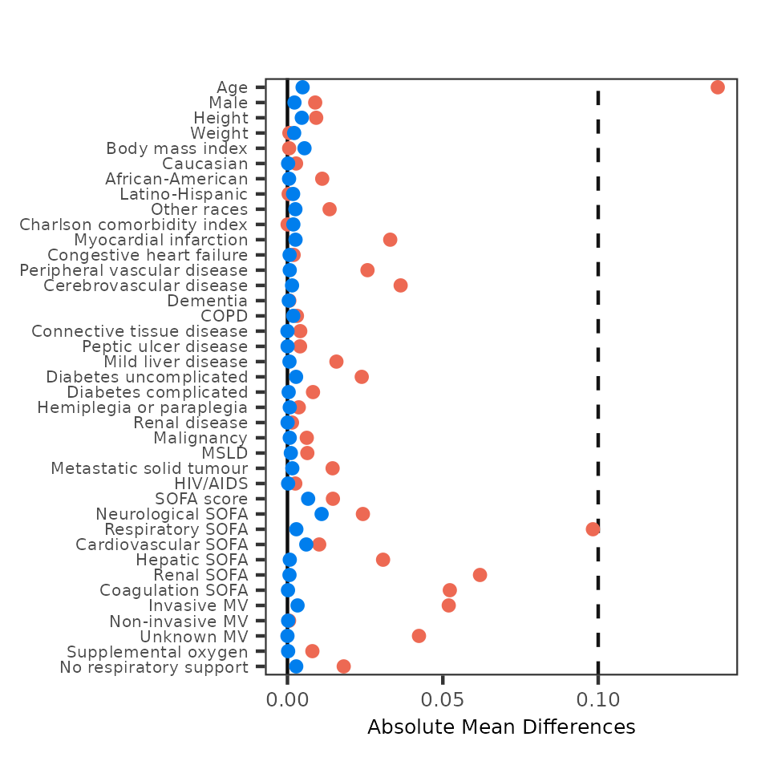

Note: The figure below shows the absolute mean differences between subgroups in comparison 2 (within ±20% of targets vs. both HR and SBP beyond ±20% of targets) before and after propensity score matching. Red dots represent pre-match differences, while blue dots represent post-match differences. (COPD, chronic obstructive pulmonary disease; MSLD, moderate or severe liver disease; HIV/AIDS, human immunodeficiency virus/acquired immunodeficiency syndrome; SOFA, Sequential Organ Failure Assessment; MV, mechanical ventilation)

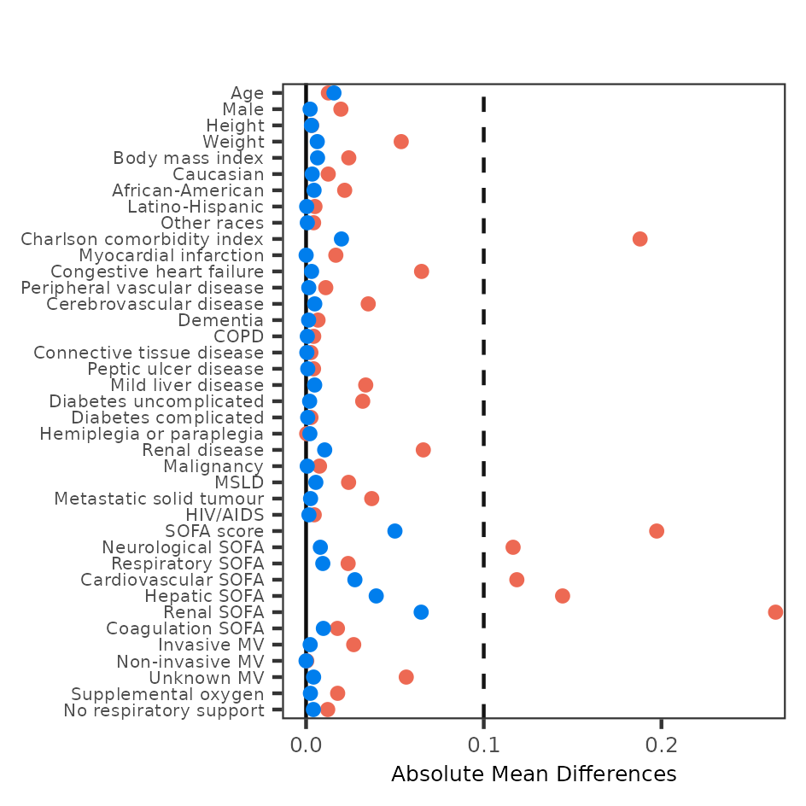

Supplementary Table 2: Propensity score-matched analysis of subgroups with actual HR/SBP within or beyond ±20% of population targets*

Different comparisons | Comparison (1) |  | Comparison (2)
Relationship to targets | Close to targets | Away from targets | Close to targets | Away from targets
Subgroups | Actual HR and SBP within ±20% of targets | Actual HR or SBP beyond ±20% of targets | Actual HR and SBP within ±20% of targets | Actual HR and SBP beyond ±20% of targets
Before matching
ICU stays, n | 36,479 | 26,831 | 36,479 | 3,531
Mortality rate, n (%) | 309 (0.8) | 669 (2.5) | 309 (0.8) | 187 (5.3)
After matching
ICU stays, n | 26,831 | 26,831 | 21,186 | 3,531
Mortality rate, n (%) | 238 (0.9) | 669 (2.5) | 222 (1.0) | 187 (5.3)
Post-match odds ratio | 2.9 (95% CI 2.5 to 3.3) |  | 5.3 (95% CI 4.3 to 6.5)

ICU, intensive care unit; MOP, moment of prediction; HR, heart rate; SBP, systolic blood pressure

* The 18-hour MOP cohort from the MIMIC-IV dataset was analyzed, dividing it into subgroups based on whether HR and SBP levels were within or beyond ±20% of the population-based fixed targets (i.e., HR = 80 bpm; SBP = 120 mmHg). Two comparisons were conducted for cases exceeding ±20% of the targets: (1) subgroups where either HR or SBP was beyond ±20% of the targets, and (2) subgroups where both HR and SBP were beyond ±20% of the targets. See Figure 3 for further details.

Note: The figure below shows the absolute mean differences between subgroups in comparison 1 (within ±20% of targets vs. either HR or SBP beyond ±20% of targets) before and after propensity score matching. Red dots represent pre-match differences, while blue dots represent post-match differences. (COPD, chronic obstructive pulmonary disease; MSLD, moderate or severe liver disease; HIV/AIDS, human immunodeficiency virus/acquired immunodeficiency syndrome; SOFA, Sequential Organ Failure Assessment; MV, mechanical ventilation)
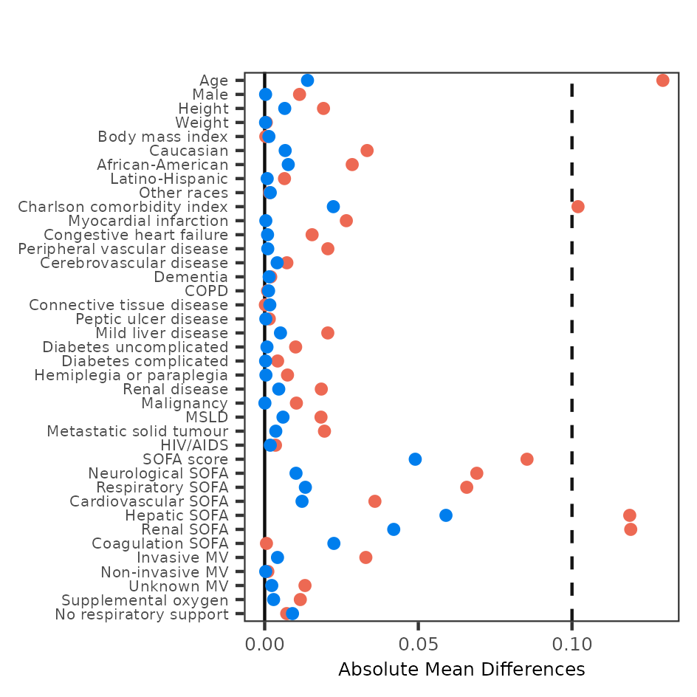

Note: The figure below shows the absolute mean differences between subgroups in comparison 2 (within ±20% of targets vs. both HR and SBP beyond ±20% of targets) before and after propensity score matching. Red dots represent pre-match differences, while blue dots represent post-match differences. (COPD, chronic obstructive pulmonary disease; MSLD, moderate or severe liver disease; HIV/AIDS, human immunodeficiency virus/acquired immunodeficiency syndrome; SOFA, Sequential Organ Failure Assessment; MV, mechanical ventilation)
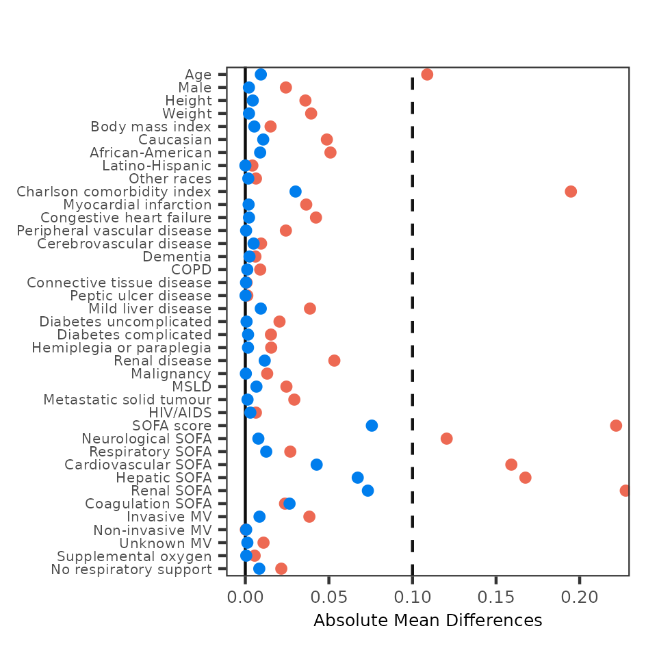

Supplementary Table 3: Propensity score-matched analysis of subgroups with actual HR/SBP within ±20% of personalized vs. population targets*

Subgroups | Actual HR and SBP within ±20% of personalized targets | Actual HR and SBP within ±20% of population targets
Before matching
ICU stays, n | 40,243 | 36,479
Mortality rate, n (%) | 17 (0.04) | 309 (0.84)
After matching
ICU stays, n | 36,479 | 36,479
Mortality rate, n (%) | 13 (0.04) | 309 (0.85)
Post-match odds ratio | 24.0 (95% CI 13.8 to 45.5)

HR, heart rate; SBP, systolic blood pressure; ICU, intensive care unit; MOP, moment of prediction; DynaCEL, dynamic cohort ensemble learning

* This analysis, based on the 18-hour MOP cohort from the MIMIC-IV dataset, compares two target sets: DynaCEL-predicted personalized targets and population-based fixed targets (i.e., HR of 80 bpm and SBP of 120 mmHg for all patients). We evaluated two subgroups: one with actual HR and SBP levels within ±20% of personalized targets and another with levels within ±20% of population targets. The overlapping cases between these subgroups were excluded from the propensity score matching but were included in the mortality analysis. Refer to Figure 5 for additional details.

Supplementary Table 4: Characteristics of the three datasets used in this study*

Dataset characteristic | eICU dataset | MIMIC IV dataset | IUH dataset
Patients, n | 148,618 | 50,920 | 3,959
Patients with multiple ICU stays, n (%) | 23,379 (15.7%) | 12,448 (24.4%) | 274 (6.9%)
ICU stays, n† | 177,187 | 73,181 | 4,179
ICU mortality, n (%)‡ | 7,975 (5.4%) | 5,319 (10.4%) | 1,126 (28.4%)
ICU stay in hours, median (IQR)§ | 40.7 (22.0 – 73.9) | 45.3 (25.9 – 85.5) | 91.6 (39.9 – 187.4)
Age in years, median (IQR)§ | 64 (52 – 75) | 67 (54 – 78) | 67 (49 – 77)
Male, n (%) | 80,803 (54.4%) | 284,40 (55.9%) | 1,772 (44.8%)
Height in cm, median (IQR)§ | 170.1 (162.6 – 177.8) | 170 (170.0 – 170.0) | 167.6 (160.0 – 177.0)
Weight in kg, median (IQR)§ | 80.7 (67.5 – 97.0) | 80.0 (67.6 – 95.1) | 81.7 (67.3 – 99.0)
BMI in kg/m², median (IQR)§ | 27.9 (23.7 – 33.0) | 27.7 (23.7 – 32.6) | 29.0 (24.1 – 34.4)
Caucasians, n (%) | 114,615 (77.1%) | 34,564 (67.9%) | 3,344 (84.5%)
African-Americans, n (%) | 164,89 (11.1%) | 4,657 (9.1%) | 378 (9.5%)
Latino/Hispanic, n (%) | 5,619 (3.8%) | 1,784 (3.5%) | 152 (3.8%)
Other races, n (%) | 11,895 (8.0%) | 9,910 (19.5%) | 85 (2.1%)
CCI score, median (IQR)§ | 0 (0 – 1) | 2 (1 – 4) | 5 (2 – 8)
Worst SOFA score, median (IQR)‡¶ | 5 (4 – 7) | 3 (2 – 6) | 4 (1 – 5)

IUH, Indiana University Health; ICU, intensive care unit; IQR, interquartile range; BMI, body mass index; CCI, Charlson Comorbidity Index; SOFA, Sequential Organ Failure Assessment

* ICU stays were excluded from the datasets if they had unknown survival status, missing HR or BP data, age below 18 years, or unspecified sex (see Supplementary Figure 1). The IUH dataset includes ICU stays with admission dates from 1 January 2022 onward.
† ICU stays refer to all ICU admissions recorded in the dataset, each with a unique admission and discharge/mortality date. A single patient may have multiple ICU stays.
‡ ICU mortality refers to death occurring during an ICU stay. For patients with multiple stays, only the last stay was counted.
§ If a patient had multiple ICU stays, calculations were based on data from the last stay.
¶ Worst SOFA score is the highest score within the first 24 hours after ICU admission.

Supplementary Table 5: Input and outcome variables used in model development

Variable | Type | Data frequency | Description
Demographics, height, and weight
Age | Numerical | Baseline, fixed | In years
Sex | Binary | Baseline, fixed | Male vs. female
Height | Numerical | Baseline, fixed | Centimeter
Weight | Numerical | Baseline, fixed | Kilogram
Body mass index | Numerical | Baseline, fixed | In kilogram over meter squared
Race/ethnicity | Categorical | Baseline, fixed | Caucasians, African-Americans, Latino-Hispanics, others
Baseline comorbidities (version Quan 2011)¹⁻³*
CCI score | Numerical | Baseline, fixed | The sum of the score for each condition
Myocardial infarction | Binary | Baseline, fixed | 1 if present for CCI calculation
Congestive heart failure | Binary | Baseline, fixed | 1 if present for CCI calculation
Peripheral vascular disease | Binary | Baseline, fixed | 1 if present for CCI calculation
Cerebrovascular disease | Binary | Baseline, fixed | 1 if present for CCI calculation
Dementia | Binary | Baseline, fixed | 1 if present for CCI calculation
COPD | Binary | Baseline, fixed | 1 if present for CCI calculation
Connective tissue disease | Binary | Baseline, fixed | 1 if present for CCI calculation
Peptic ulcer disease | Binary | Baseline, fixed | 1 if present for CCI calculation
Mild liver disease | Binary | Baseline, fixed | 1 if present for CCI calculation
Diabetes (uncomplicated) | Binary | Baseline, fixed | 1 if present for CCI calculation
Diabetes (complicated) | Binary | Baseline, fixed | 2 if present for CCI calculation
Hemiplegia or paraplegia | Binary | Baseline, fixed | 2 if present for CCI calculation
Renal disease | Binary | Baseline, fixed | 2 if present for CCI calculation
Malignancy† | Binary | Baseline, fixed | 2 if present for CCI calculation
Moderate or severe liver disease | Binary | Baseline, fixed | 3 if present for CCI calculation
Metastatic solid tumor | Binary | Baseline, fixed | 6 if present for CCI calculation
HIV/AIDS | Binary | Baseline, fixed | 6 if present for CCI calculation
SOFA score and the score of each SOFA component‡
SOFA score (overall) | Numerical | Dynamic | 0 to 24, the score closest to the MOP within the PW
Neurological function (component) | Numerical | Dynamic | 0 to 4, the score closest to the MOP within the PW
Respiratory function (component) | Numerical | Dynamic | 0 to 4, the score closest to the MOP within the PW
Cardiovascular function (component) | Numerical | Dynamic | 0 to 4, the score closest to the MOP within the PW
Hepatic function (component) | Numerical | Dynamic | 0 to 4, the score closest to the MOP within the PW
Renal function (component) | Numerical | Dynamic | 0 to 4, the score closest to the MOP within the PW
Coagulation (component) | Numerical | Dynamic | 0 to 4, the score closest to the MOP within the PW
Haemodynamics, respiratory support, and mortality
Heart rate | Numerical | Dynamic | The median of medians for each hour within the PW
Systolic blood pressure | Numerical | Dynamic | The median of medians for each hour within the PW
Respiratory support§ | Categorical | Dynamic | Invasive vs. non-invasive vs. oxygen vs. none
Mortality | Binary | Not applicable | Death within the outcome window

CCI, Charlson Comorbidity Index; COPD, chronic obstructive pulmonary disease; HIV/AIDS, human immunodeficiency virus/acquired immunodeficiency syndrome; SOFA, Sequential Organ Failure Assessment; MOP, moment of prediction; PW, prediction window

* The Charlson Comorbidity Index was calculated based on the following conditions: myocardial infarction (1 point), congestive heart failure (1 point), peripheral vascular disease (1 point), cerebrovascular disease (1 point), dementia (1 point), chronic pulmonary disease (1 point), rheumatic disease (1 point), peptic ulcer disease (1 point), mild liver disease (1 point), diabetes without chronic complications (1 point), diabetes with chronic complications (2 points), hemiplegia or paraplegia (2 points), renal disease (2 points), any malignancy (including leukemia and lymphoma, 2 points), moderate or severe liver disease (3 points), metastatic solid tumor (6 points), and HIV/AIDS (6 points). The model incorporated both the presence of each comorbidity (binary) and the total score (numerical).
† Refers to localized solid tumors, leukemia, and lymphoma.
‡ The models included both the overall SOFA score and individual scores for six organ systems: respiratory, cardiovascular, hepatic, coagulation, renal, and neurological. Each organ system was scored from 0 (normal function) to 4 (severe dysfunction or failure). The score closest to the MOP within the predictor window (PW) was included in the model.
§ Invasive support included mechanical ventilation via tracheostomy or endotracheal tube. Noninvasive support comprised Continuous Positive Airway Pressure (CPAP) and Bilevel Positive Airway Pressure (BiPAP). Oxygen therapy included high-flow nasal cannula, regular nasal cannula, simple face masks, or non-rebreather masks. The most intense support within the PW was included in the model.

Supplementary Table 6: Imputation methods and data missingness

Variable | Imputation
Demographics, height, and weight
Age | No imputation
Sex | No imputation
Height | The median values
Weight | The median values
Body mass index | The median values
Race | No imputation
Baseline comorbidities
CCI score | No imputation
Myocardial infarction | No imputation
Congestive heart failure | No imputation
Peripheral vascular disease | No imputation
Cerebrovascular disease | No imputation
Dementia | No imputation
Chronic obstructive pulmonary disease | No imputation
Connective tissue disease | No imputation
Peptic ulcer disease | No imputation
Mild liver disease | No imputation
Diabetes (uncomplicated) | No imputation
Diabetes (complicated) | No imputation
Hemiplegia or paraplegia | No imputation
Renal disease | No imputation
Malignancy* | No imputation
Moderate or severe liver disease | No imputation
Metastatic solid tumor | No imputation
HIV/AIDS | No imputation
SOFA score and the score of each SOFA component
SOFA score | Nearest score in the past
Neurological function | Nearest score in the past
Respiratory function | Nearest score in the past
Cardiovascular function | Nearest score in the past
Hepatic function | Nearest score in the past
Renal function | Nearest score in the past
Coagulation | Nearest score in the past
Haemodynamics and respiratory support
Heart rate | No imputation
Systolic blood pressure | No imputation
Respiratory support | None if no data

CCI, Charlson Comorbidity Index; COPD, chronic obstructive pulmonary disease; HIV/AIDS, human immunodeficiency virus/acquired immunodeficiency syndrome; SOFA, Sequential Organ Failure Assessment; MOP, moment of prediction; HR, heart rate; SBP, systolic blood pressure; ICU, intensive care unit

* Refers to localized solid tumors, leukemia, and lymphoma.

Supplementary Table 7: Missing rate of hourly heart rate or systolic blood pressure for the entire dataset

Variables & counting methods | eICU dataset | MIMIC-IV dataset | IUH dataset*
Missing hourly heart rate | 8.85% | 5.36% | 50.56%
Missing hourly systolic blood pressure | 11.36% | 9.46% | 54.9%

IUH, Indiana University Health

* The 50–55% missingness rate for HR and SBP in the Indiana ICU dataset reflects, in part, the clinical use of certain IUH hospital locations for both ICU patients and individuals requiring high-acuity care not formally designated as ICU-level. As a result, some patients experienced less frequent vital sign monitoring compared to conventional ICU settings. Due to overlap in patient populations and limitations in the available data, it was not feasible to reliably distinguish between ICU and step-down care cases.

Supplementary Table 8: Complete missing rate of heart rate or systolic blood pressure during the prediction window for the 18-hour MOP cohorts

Variables & counting methods | eICU dataset | MIMIC-IV dataset | IUH dataset
Completely missing HR or SBP in the prediction window | 0.036% | 0.005% | 0.086%
Number of ICU stays excluded due to complete missingness | 48 out of 134,261 | 3 out of 63,310 | 3 out of 3,481

MOP, moment of prediction; HR, heart rate; SBP, systolic blood pressure; ICU, intensive care unit

Supplementary Table 9: Characteristics of the 18-hour MOP cohorts for the three datasets used in this study*

Cohort characteristic | Cohort from eICU dataset | Cohort from MIMIC-IV dataset | Cohort from IUH dataset
ICU stays, n† | 134,261 | 63,310 | 3,481
24-hour mortality n (%)‡ | 2,103 (1.6%) | 978 (1.5%) | 179 (5.4%)
Age in years, median (IQR) | 65 (53 – 75) | 66 (55 – 77) | 65 (45 – 76)
Height in cm, median (IQR) | 170.1 (162.6 – 177.8) | 170 (170.0 – 170.0) | 167.6 (160.0 – 177.0)
Weight in kg, median (IQR) | 80.7 (68.0 – 97.0) | 78.2 (65.7 – 93.3) | 82.0 (67.5 – 99.4)
BMI in kg/m², median (IQR) | 27.8 (23.9 – 32.8) | 28.5 (27.6 – 28.5) | 29.0 (24.2 – 34.6)
CCI score, median (IQR) | 1 (0 – 3) | 2 (1 – 4) | 5 (2 – 8)
Worst SOFA score, median (IQR)§ | 4 (3 – 5) | 2 (1 – 4) | 3 (0 – 4)

MOP, moment of prediction; IUH, Indiana University Health; ICU, intensive care unit; IQR, interquartile range; BMI, body mass index; CCI, Charlson comorbidity index; SOFA, Sequential Organ Failure Assessment

* The cohort includes all ICU stays where patients were alive and remained in the ICU at a specific MOP. Cohorts differ across MOPs due to patient discharge or death. This table illustrates the cohorts at the 18-hour MOP for the three datasets used in this study.
† ICU stays refer to all stays during which patients were alive and remained in the ICU at a specific MOP in a given dataset. Each stay has a unique admission and discharge/mortality date, and one patient may have multiple ICU stays.
‡ 24-hour mortality refers to death occurring within 24 hours following the MOP of interest. For example, if MOP = 18 hours, 24-hour mortality includes deaths occurring from 18 to 42 hours after ICU admission.
§ Worst SOFA score represents the highest SOFA score recorded during the first 24 hours following ICU admission.

Supplementary Table 10: Performance of models trained on expanded versus unexpanded cohorts*

Dataset | MOP (h) | AUC, median (IQR)
Dataset | MOP (h) | Expanded cohorts | Unexpanded cohorts
eICU dataset (test set) | 12 | 0.898 (0.890, 0.902) | 0.879 (0.864, 0.885)
eICU dataset (test set) | 18 | 0.912 (0.908, 0.916) | 0.893 (0.890, 0.894)
eICU dataset (test set) | 24 | 0.897 (0.883, 0.905) | 0.878 (0.868, 0.888)
eICU dataset (test set) | 30 | 0.851 (0.850, 0.857) | 0.849 (0.847, 0.853)
eICU dataset (test set) | 36 | 0.852 (0.849, 0.860) | 0.846 (0.840, 0.849)
eICU dataset (test set) | 42 | 0.841 (0.838, 0.861) | 0.826 (0.834, 0.849)

MOP, moment of prediction; AUC, area under the curve; IQR, interquartile range

* The unexpanded cohort includes ICU stays where patients were alive and remained in the ICU at the specified MOP. In contrast, the expanded cohort comprises the unexpanded cohort plus ICU stays where patients either died or were discharged during the prediction window (i.e., the time period immediately preceding the MOP). The models compared here were based on a random forest model using a 12-hour prediction window and a 24-hour outcome window and were trained on either expanded or unexpanded cohorts as described. AUCs are presented for different cohorts (defined by MOPs) from the eICU test set.

Supplementary Table 11: Performance of different base models*

MOP (h) | AUC, median (IQR) |  |  |  | n† | 24-hour mortality
MOP (h) | Random forest | MLP | SVM | Logistic regression | n† | 24-hour mortality
12 | 0.898 (0.890, 0.902) | 0.793 (0.761, 0.796) | 0.753 (0.746, 0.759) | 0.802 (0.791, 0.803) | 150,239 | 1.39%
18 | 0.912 (0.908, 0.916) | 0.788 (0.787, 0.792) | 0.763 (0.751, 0.770) | 0.796 (0.792, 0.803) | 134,261 | 1.54%
24 | 0.897 (0.883, 0.905) | 0.790 (0.788, 0.793) | 0.764 (0.763, 0.771) | 0.795 (0.790, 0.795) | 113,798 | 1.36%
30 | 0.851 (0.850, 0.857) | 0.755 (0.751, 0.773) | 0.697 (0.683, 0.707) | 0.768 (0.768, 0.784) | 97,964 | 1.33%
36 | 0.852 (0.849, 0.860) | 0.755 (0.730, 0.757) | 0.730 (0.715, 0.739) | 0.768 (0.755, 0.768) | 88,511 | 1.31%
42 | 0.841 (0.838, 0.861) | 0.737 (0.732, 0.750) | 0.738 (0.721, 0.740) | 0.768 (0.738, 0.768) | 77,948 | 1.33%

MOP, moment of prediction; AUC, area under the curve; IQR, interquartile range; MLP, multilayer perceptron; SVM, support vector machine

* The table presents the performance of various base models (random forest, MLP, SVM, and logistic regression) using a 12-hour PW and 24-hour OW in training. The AUCs are based on different cohorts (defined by MOPs) from the eICU test set.
† “n” is the eICU dataset’s total ICU stays used in this study.

Supplementary Table 12: Performance comparison between random forest and XGBoost base models
MOP (h) | AUC, median (IQR)
MOP (h) | Random forest | XGBoost
12 | 0.898 (0.890, 0.902) | 0.890 (0.887, 0.894)
18 | 0.912 (0.908, 0.916) | 0. 905 (0.902, 0.916)
24 | 0.897 (0.883, 0.905) | 0.907 (0.898, 0.912)
30 | 0.851 (0.850, 0.857) | 0.870 (0.878, 0.880)
36 | 0.852 (0.849, 0.860) | 0.872 (0.872, 0.881)
42 | 0.841 (0.838, 0.861) | 0.855 (0.854, 0.867)

MOP, moment of prediction; AUC, area under the curve; IQR, interquartile range

Supplementary Table 13: Performance of the DynaCEL models versus the single model*

Dataset | MOP (h) | AUC, median (IQR)
Dataset | MOP (h) | DynaCEL models | Single model
eICU dataset (test set) | 12 | 0.898 (0.890, 0.902) | 0.797 (0.787, 0.799)
MIMIC IV dataset | 12 | 0.858 (0.846, 0.862) | 0.761 (0.760, 0.766)
IUH dataset | 12 | 0.850 (0.850, 0.851) | 0.844 (0.834, 0.845)
eICU dataset (test set) | 18 | 0.912 (0.908, 0.916) | 0.795 (0.795, 0.799)
MIMIC IV dataset | 18 | 0.889 (0.879, 0.894) | 0.797 (0.795, 0.797)
IUH dataset | 18 | 0.868 (0.865, 0.871) | 0.861 (0.861, 0.866)
eICU dataset (test set) | 24 | 0.897 (0.883, 0.905) | 0.795 (0.788, 0.808)
MIMIC IV dataset | 24 | 0.886 (0.882, 0.890) | 0.805 (0.801, 0.806)
IUH dataset | 24 | 0.878 (0.878, 0.880) | 0.864 (0.864, 0.865)
eICU dataset (test set) | 30 | 0.851 (0.850, 0.857) | 0.769 (0.764, 0.793)
MIMIC IV dataset | 30 | 0.832 (0.826, 0.837) | 0.795 (0.795, 0.795)
IUH dataset | 30 | 0.883 (0.883, 0.884) | 0.870 (0.861, 0.874)
eICU dataset (test set) | 36 | 0.852 (0.849, 0.860) | 0.773 (0.768, 0.783)
MIMIC IV dataset | 36 | 0.825 (0.821, 0.828) | 0.796 (0.788, 0.796)
IUH dataset | 36 | 0.853 (0.838, 0.858) | 0.849 (0.847, 0.851)
eICU dataset (test set) | 42 | 0.841 (0.838, 0.861) | 0.761 (0.758, 0.777)
MIMIC IV dataset | 42 | 0.838 (0.811, 0.841) | 0.782 (0.776, 0.784)
IUH dataset | 42 | 0.865 (0.861, 0.866) | 0.832 (0.831, 0.840)

DynaCEL, Dynamic Cohort Ensemble Learning; MOP, moment of prediction; AUC, area under the curve; IQR, interquartile range; IUH, Indiana University Health

* The DynaCEL models were trained using the same methods but on distinct MOP-specific cohorts. This approach contrasts with the single model, which was trained on pooled cohorts with the MOP included as an input variable. Both DynaCEL and single models were based on a random forest model with a 12-hour prediction window and a 24-hour outcome window. The AUC values presented are based on cohorts corresponding to MOPs at 12, 18, 24, 30, 36, and 42 hours from different datasets.

Supplementary Table 14: Comparison of the use of vasoactive drugs and antibiotics between propensity score-matched subgroups*

Drugs, n (%) | HR and SBP within ±20% target (N = 23,067) | HR or SBP beyond ±20% target (N = 23,067) | Absolute Standardized Difference
Beta-Blockers | 3,500 (15%) | 4,462 (19%) | 0.111
Norepinephrine | 7,392 (32%) | 7,469 (32%) | 0.007
Epinephrine | 922 (4%) | 733 (3%) | 0.044
Dopamine | 491 (2%) | 701 (3%) | 0.057
Phenylephrine | 3,911 (17%) | 3,912 (17%) | <0.001
Milrinone | 367 (2%) | 383 (2%) | 0.005
Dobutamine | 240 (1%) | 466 (2%) | 0.080
Nicardipine | 1,238 (5%) | 898 (4%) | 0.070
ACE Inhibitors | 2,125 (9%) | 2,104 (9%) | 0.003
Diuretics | 7,718 (33%) | 7,232 (31%) | 0.045
Antibiotics | 15,118 (66%) | 15,403 (67%) | 0.025

HR, heart rate; SBP, systolic blood pressure; ACE, angiotensin-converting enzyme; MOP, moment of prediction

* Patients from the 18-hour MOP cohort from the MIMIC-IV dataset were categorized into two mutually exclusive subgroups: (1) heart rate and systolic blood pressure both within ±20% of the DynaCEL-predicted targets, and (2) either heart rate or systolic blood pressure beyond ±20%. Propensity score matching was used to balance baseline variables, and hemodynamically relevant medications not included in the matching model were compared between groups. Medication use was defined as any administration within the 12-hour prediction window immediately preceding MOP. All variables demonstrated an absolute standardized difference of less than 0.111, suggesting good balance.

Supplementary Table 15: Subpopulation characteristics*

Subpopulations | eICU dataset |  | MIMIC-IV dataset |  | IUH dataset
Subpopulations | ICU stays, n (%) | 24-hour Mortality (%)† | ICU stays, n (%) | 24-hour Mortality (%)† | ICU stays, n (%) | 24-hour Mortality (%)†
Age < 65 years | 60,530 (49.5%) | 1.1% | 28,670 (45.2%) | 1.1% | 1,704 (49.0%) | 3.2%
Age ≥ 65 years | 61,703 (50.5%) | 2.0% | 34,640 (54.7%) | 1.9% | 1,777 (51.0%) | 7.0%
Male | 66,958 (54.8%) | 1.6% | 35,515 (56.1%) | 1.4% | 1,506 (43.3%) | 6.2%
Female | 55,275 (45.2%) | 1.6% | 27,795 (43.9%) | 1.7% | 1,975 (56.7%) | 4.4%
BMI < 30 | 77,979 (63.8%) | 1.7% | 52,308 (82.6%) | 1.6% | 1,664 (47.8%) | 3.3%
BMI ≥ 30 | 44,254 (36.1%) | 1.4% | 11,002 (17.4%) | 1.2% | 1,368 (39.3%) | 2.2%
Caucasians | 94,734 (77.5%) | 1.6% | 43,325 (68.4%) | 1.4% | 2,933 (84.3%) | 5.4%
African-Americans | 13,305 (10.9%) | 1.5% | 6,738 (10.6%) | 1.3% | 330 (9.5%) | 4.8%
Latino/Hispanics | 4,740 (3.9%) | 1.5% | 2,398 (3.8%) | 1.2% | 144 (4.1%) | 2.1%
Other races | 8,184 (6.7%) | 1.6% | 10,829 (17.1%) | 2.6% | 74 (2.1%) | 2.7%
CCI score < 2 | 71,095 (58.2%) | 1.1% | 22,113 (34.9%) | 1.0% | 794 (22.8%) | 1.9%
CCI score ≥ 2 | 51,138 (41.8%) | 2.1% | 41,197 (65.1%) | 1.8% | 2,687 (77.2%) | 6.1%
Worst SOFA score < 5‡ | 76,256 (62.4%) | 0.9% | 51,404 (81.2%) | 1.0% | 2,777 (79.8%) | 4.2%
Worst SOFA score ≥ 5‡ | 45,977 (37.6%) | 2.7% | 11,906 (18.8%) | 4.1% | 704 (20.2%) | 8.9%

IUH, Indiana University Health; ICU, intensive care unit; BMI, body mass index; CCI, Charlson Comorbidity Index; SOFA, Sequential Organ Failure Assessment; MOP, moment of prediction

* Subpopulations are based on the 18-hour MOP cohorts from different datasets.
† 24-hour mortality refers to deaths occurring within the 24-hour outcome window starting from the specified MOP. For example, if MOP = 18 hours, the 24-hour mortality refers to deaths between 18 and 42 hours after ICU admission.
‡ Worst SOFA score indicates the highest SOFA score recorded during the first 24 hours following ICU admission.

Supplementary Table 16: Model performance in subpopulations*

Subpopulation | AUC, median (IQR)
Subpopulation | eICU dataset (test set) | MIMIC IV dataset | IUH dataset
Age < 65 years | 0.928 (0.926, 0.930) | 0.926 (0.914, 0.927) | 0.873 (0.873, 0.879)
Age ≥ 65 years | 0.905 (0.895, 0.906) | 0.864 (0.854, 0.872) | 0.861 (0.859, 0.863)
Male | 0.913 (0.907, 0.916) | 0.899 (0.891, 0.904) | 0.858 (0.855, 0.859)
Female | 0.909 (0.909, 0.912) | 0.877 (0.864, 0.882) | 0.879 (0.875, 0.880)
BMI < 30 | 0.909 (0.909, 0.923) | 0.890 (0.882, 0.895) | 0.859 (0.858, 0.864)
BMI ≥ 30 | 0.905 (0.903, 0.915) | 0.890 (0.863, 0.896) | 0.852 (0.846, 0.853)
Caucasians | 0.912 (0.907, 0.917) | 0.889 (0.873, 0.891) | 0.863 (0.858, 0.864)
African-Americans | 0.902 (0.888, 0.907) | 0.876 (0.872, 0.891) | 0.897 (0.894, 0.911)
Latino/Hispanic | 0.940 (0.893, 0.946) | 0.871 (0.858, 0.877) | 0.953 (0.949, 0.968)
Other races | 0.920 (0.893, 0.952) | 0.886 (0.885, 0.893) | 0.938 (0.937, 0.941)
CCI score < 2 | 0.918 (0.910, 0.920) | 0.927 (0.916, 0.931) | 0.879 (0.873, 0.887)
CCI score ≥ 2 | 0.908 (0.899, 0.909) | 0.866 (0.860, 0.876) | 0.861 (0.858, 0.863)
Worst SOFA score < 5† | 0.905 (0.888, 0.909) | 0.869 (0.854, 0.874) | 0.880 (0.876, 0.883)
Worst SOFA score ≥ 5† | 0.901 (0.898, 0.904) | 0.865 (0.851, 0.879) | 0.811 (0.811, 0.812)

AUC, area under the curve; IQR, interquartile range; IUH, Indiana University Health; BMI, body mass index; CCI, Charlson Comorbidity Index; SOFA, Sequential Organ Failure Assessment

* The DynaCEL model was trained using a random forest algorithm on the 18-hour MOP cohort from the eICU training set, with a 12-hour prediction window and a 24-hour outcome window. Subpopulations were derived from the 18-hour MOP cohort of the MIMIC-IV dataset.
† Based on information from the first 24 hours following intensive care unit admission.

Supplementary Table 17: Feature importance ranks according to Gini impurity reduction and SHAP
Features | Gini | SHAP
no respiratory support | 0.061 | 0.016
SOFA: cardiovascular | 0.131 | 0.015
Charlson Comorbidity Index | 0.063 | 0.013
oxygen therapy | 0.044 | 0.011
SOFA: respiration | 0.105 | 0.010
SOFA: total | 0.061 | 0.009
heart rate | 0.044 | 0.009
SOFA: renal | 0.048 | 0.007
systolic blood pressure | 0.047 | 0.006
age | 0.022 | 0.005
cancer | 0.031 | 0.005
race and ethnicity: white | 0.008 | 0.005
mechanical ventilation: unknown | 0.023 | 0.004
chronic pulmonary disease | 0.032 | 0.004
BMI | 0.016 | 0.004
weight: availability | 0.006 | 0.003
renal disease | 0.024 | 0.003
race and ethnicity: black | 0.008 | 0.003
diabetes without complications | 0.045 | 0.003
weight | 0.016 | 0.003
BMI: availability | 0.011 | 0.002
myocardial infarction | 0.015 | 0.002
hemiplegia or paraplegia | 0.013 | 0.002
race and ethnicity: others | 0.005 | 0.002
congestive heart failure | 0.027 | 0.002
height | 0.014 | 0.002
gender | 0.004 | 0.002
SOFA: coagulation | 0.019 | 0.001
dementia | 0.005 | 0.001
SOFA: liver | 0.013 | 0.001
metastatic cancer | 0.004 | 0.001
race and ethnicity: Latino | 0.003 | 0.001
peripheral vascular disease | 0.005 | 0.000
SOFA: central nervous system | 0.004 | 0.000
height: availability | 0.004 | 0.000
mild liver disease | 0.005 | 0.000
cerebrovascular disease | 0.005 | 0.000
moderate or severe renal disease | 0.003 | 0.000
rheumatologic disease | 0.002 | 0.000
peptic ulcer disease | 0.002 | 0.000
HIV/AIDS | 0.000 | 0.000
diabetes without complications | 0.000 | 0.000
mechanical ventilation: invasive | 0.004 | 0.000
mechanical ventilation: non-invasive | 0.000 | 0.000

BMI, body mass index; HR, heart rate; SBP, systolic blood pressure; SOFA, Sequential Organ Failure Assessment; SHAP, SHapley Additive exPlanations; Gini, Gini impurity reduction; HIV/AIDS, human immunodeficiency virus/acquired immunodeficiency syndrome

Supplementary Table 18: Case studies based on chart review and comparisons between actual HR/SBP levels and DynaCEL predicted targets*

ID and demographic information | ICU Issues and comorbidities | At 18 hours post-ICU admission |  | ICU expert comments
ID and demographic information | ICU Issues and comorbidities | SOFA scores and treatments† | HR & SBP, actual levels vs. model-predicted targets | ICU expert comments
33585643  Age = 91 years  Sex = Female | Unspecified septicemia, Acute respiratory failure, Septic shock, Acidosis, Acute kidney failure, unspecified, Urinary tract infection, site not specified, Severe sepsis, Myocardial infarction,  Coronary atherosclerosis of native coronary artery, Unspecified essential hypertension, Diabetes mellitus without mention of complication, type II or unspecified type, not stated as uncontrolled, Other persistent mental disorders due to conditions classified elsewhere, Old myocardial infarction, Osteoporosis, unspecified | Total SOFA = 4  CV SOFA = 1  Pulmonary SOFA = 0  CNS SOFA = 3  Renal SOFA = 0  Hepatic SOFA = 0  Coagulation SOFA = 0  Vasopressors = None  Respiratory support = None  Kidney support = None | HR = 90 bpm  SBP = 82 mmHg  Model-predicted targets as follows:  HR = 67 bpm  SBP = 135 mmHg | No safety concerns related to the proposed targets were identified. The systolic blood pressure of 82 mmHg is markedly low; a target of 135 mmHg is clinically appropriate and should be pursued, especially considering that no vasopressor was used.
38639922  Age = 68 years  Sex = Female | Other complications due to renal dialysis device, implant, and graft, End stage renal disease, Acute on chronic diastolic heart failure, Hypertensive chronic kidney disease, unspecified, with chronic kidney disease stage V or end stage renal disease, Diabetes with renal manifestations, type II or unspecified type, not stated as uncontrolled, Polyneuropathy in diabetes, Hyperpotassemia, Home accidents, Long-term (current) use of insulin, Obstructive sleep apnea (adult)(pediatric),Renal dialysis status, Polymyalgia rheumatica, Unspecified acquired hypothyroidism, Other and unspecified hyperlipidemia, Long-term (current) use of steroids, Esophageal reflux, Diabetes with ophthalmic manifestations, type II or unspecified type, not stated as uncontrolled, Background diabetic retinopathy, Depressive disorder, not elsewhere classified, Obesity, unspecified, Body Mass Index 36.0-36.9, adult, Anemia, unspecified, Diabetes with neurological manifestations, type II or unspecified type, not stated as uncontrolled, Congestive heart failure, unspecified, Surgical operation with anastomosis, bypass, or graft, with natural or artificial tissues used as implant causing abnormal patient reaction, or later complication, without mention of misadventure at time of operation | Total SOFA = 0  CV SOFA = 0  Pulmonary SOFA = 0  CNS SOFA = 0  Renal SOFA = 0  Hepatic SOFA = 0  Coagulation SOFA = 0  Vasopressors = None  Respiratory support = Supplemental Oxygen  Kidney support = None | HR = 74 bpm  SBP = 174 mmHg  Model-predicted targets as follows:  HR = 82 bpm  SBP = 137 mmHg | No safety concerns related to the proposed targets were identified. The SBP of 174 mmHg is significantly elevated, especially concerning in a patient with end-stage renal disease, diabetes with complications, and heart failure.  The target SBP of 137 mmHg is appropriate to reduce cardiovascular strain and lower the risk of further cardiac or renal deterioration.
35947837  Age = 57 years  Sex = Female | Acute alcoholic hepatitis, Acute and subacute necrosis of liver, Hepatic encephalopathy, Gastroesophageal laceration-hemorrhage syndrome, Toxic encephalopathy, Acute respiratory failure, Hepatorenal syndrome, Unspecified septicemia, Severe sepsis, Acute kidney failure with lesion of tubular necrosis, Septic shock, Chronic pancreatitis, Ventilator associated pneumonia, Acute posthemorrhagic anemia, Alkalosis, Alcohol withdrawal, Other ascites, Hyperosmolality and/or hypernatremia, Portal hypertension, Alcoholic cirrhosis of liver, Other and unspecified alcohol dependence, continuous, Allergic rhinitis, cause unspecified, Unspecified essential hypertension, Diarrhea, Irritable bowel syndrome, Chronic obstructive asthma, unspecified, Insomnia, unspecified, Tobacco use disorder, Other fluid overload, Other specified disorders of stomach and duodenum, Other convulsions, Leukocytosis, unspecified, Personal history of colonic polyps, Other specified procedures as the cause of abnormal reaction of patient, or of later complication, without mention of misadventure at time of procedure | Total SOFA = 6  CV SOFA = 1  Pulmonary SOFA = 0  CNS SOFA = 1  Renal SOFA = 0  Hepatic SOFA = 3  Coagulation SOFA = 1  Vasopressors = Yes  Respiratory support = Invasive Ventilation  Kidney support = None | HR = 122 bpm  SBP = 90 mmHg  Model-predicted targets as follows:  HR = 78 bpm  SBP = 119 mmHg | No safety concerns on targets were identified.
36603744  Age = 65 years  Sex = Male | Acute and subacute hepatic failure without coma, Acute kidney failure with tubular necrosis, Acute respiratory failure with hypoxia, Unspecified systolic (congestive) heart failure, Cardiomyopathy, unspecified, Acidosis, Encephalopathy, unspecified, Cardiogenic shock, Hypertensive heart disease with heart failure, Chronic atrial fibrillation, Chronic obstructive pulmonary disease, unspecified, Hypovolemia, Abnormal coagulation profile, Do not resuscitate, Encounter for palliative care, Anemia, unspecified, Memory deficit following unspecified cerebrovascular disease, Other sequelae following unspecified cerebrovascular disease, Other visual disturbances, Long term (current) use of anticoagulants, Hyperkalemia, Other disorders of phosphorus metabolism, Physical restraint status, Personal history of nicotine dependence, Encounter for adjustment and management of automatic implantable cardiac defibrillator, Hepatomegaly, not elsewhere classified | Total SOFA = 12  CV SOFA = 4  Pulmonary SOFA = 0  CNS SOFA = 1  Renal SOFA = 3  Hepatic SOFA = 3  Coagulation SOFA = 1  Vasopressors = Yes  Respiratory support = Invasive Ventilation  Kidney support = Yes | HR = 130 bpm  SBP = 82 mmHg  Model-predicted targets as follows:  HR = 71 bpm  SBP = 119 mmHg | No safety concerns related to the proposed targets were identified.
33403473  Age = 59 years  Sex = Male | Chronic or unspecified duodenal ulcer with hemorrhage, Other shock, Acute posthemorrhagic anemia, Hypotension, unspecified, Hyperkalemia, Gastric ulcer, unspecified as acute or chronic, without hemorrhage or perforation, Essential (primary) hypertension, Asymptomatic human immunodeficiency virus [HIV] infection status, Personal history of nicotine dependence, Encounter for examination for normal comparison and control in clinical research program | Total SOFA = 0  CV SOFA = 0  Pulmonary SOFA = 0  CNS SOFA = 0  Renal SOFA = 0  Hepatic SOFA = 0  Coagulation SOFA = 0  Vasopressors = None  Respiratory support = None  Kidney support = None | HR = 75 bpm  SBP = 94 mmHg  Model-predicted targets as follows:  HR = 72 bpm  SBP = 119 mmHg | No safety concerns related to the proposed targets were identified.
35321289  Age = 89 years  Sex = Female | Traumatic subarachnoid hemorrhage without loss of consciousness, initial encounter, Metabolic encephalopathy, Cerebral infarction due to unspecified occlusion or stenosis of left posterior cerebral artery, Delirium due to known physiological condition, Aphasia, Unspecified protein-calorie malnutrition, Hemiplegia, unspecified affecting right nondominant side, Unspecified place in single-family (private) house as the place of occurrence of the external cause, Essential (primary) hypertension, Personal history of transient ischemic attack (TIA), and cerebral infarction without residual deficits, Unspecified dementia, unspecified severity, without behavioral disturbance, psychotic disturbance, mood disturbance, and anxiety, Age-related osteoporosis without current pathological fracture, Presence of artificial hip joint, bilateral, Encounter for palliative care, Do not resuscitate, Spinal stenosis, site unspecified, Gastro-esophageal reflux disease without esophagitis, Diaphragmatic hernia without obstruction or gangrene, Spondylosis without myelopathy or radiculopathy, cervical region, Long term (current) use of opiate analgesic, Benign neoplasm of cerebral meninges, Lumbago with sciatica, unspecified side, Other chronic pain, Other chondrocalcinosis, right hand, Unspecified atrial fibrillation, Essential (hemorrhagic) thrombocythemia, Hypotension, unspecified, Retention of urine, unspecified, Presence of artificial knee joint, bilateral, Physical restraint status, Other nonrheumatic aortic valve disorders, Primary osteoarthritis, left shoulder, Body mass index [BMI] 24.0-24.9, adult, Other fall from one level to another, initial encounter, Anterior displaced fracture of sternal end of right clavicle, initial encounter for closed fracture, Dehydration, Hypovolemia, Dysphagia, oropharyngeal phase, Coma scale, eyes open, to pain, at arrival to emergency department | Total SOFA = 2  CV SOFA = 0  Pulmonary SOFA = 0  CNS SOFA = 2  Renal SOFA = 0  Hepatic SOFA = 0  Coagulation SOFA = 0  Vasopressors = None  Respiratory support = None  Kidney support = None | HR = 56 bpm  SBP = 93 mmHg  Model-predicted targets as follows:  HR = 59 bpm  SBP = 140 mmHg | No safety concerns related to the proposed targets were identified. The current HR of 56 bpm and SBP of 93 mmHg indicate bradycardia and hypotension, which are concerning in the setting of dementia, prior strokes, metabolic encephalopathy, and a high CNS SOFA score.  The target HR of 59 bpm is only slightly higher and remains within a safe range.  However, the target SBP of 140 mmHg is clinically justified and desirable to ensure adequate cerebral perfusion, particularly given the patient's extensive cerebrovascular disease and frailty.
37609236  Age = 54 years  Sex = Male | Acute kidney failure with lesion of tubular necrosis, Other encephalopathy, Severe sepsis, Septic shock, Unspecified septicemia, Hyposmolality and/or hyponatremia, Urinary tract infection, site not specified, Hyperpotassemia, Diabetes mellitus without mention of complication, type II or unspecified type, not stated as uncontrolled, Iron deficiency anemia, unspecified, Constipation, unspecified, Venous (peripheral) insufficiency, unspecified, Atrial fibrillation, Other and unspecified hyperlipidemia, Asthma, unspecified type, unspecified, Pressure ulcer, stage II, Edema, Hypertensive chronic kidney disease, unspecified, with chronic kidney disease stage I through stage IV, or unspecified, Obesity, unspecified, Abnormal coagulation profile, Chronic kidney disease, unspecified, Personal history of traumatic brain injury, Long-term (current) use of anticoagulants, Other orthopedic aftercare, Body Mass Index 39.0-39.9, adult, Other diuretics causing adverse effects in therapeutic use | Total SOFA = 5  CV SOFA = 0  Pulmonary SOFA = 2  CNS SOFA = 1  Renal SOFA = 2  Hepatic SOFA = 0  Coagulation SOFA = 0  Vasopressors = None  Respiratory support = None  Kidney support = None | HR = 124 bpm  SBP = 104 mmHg  Model-predicted targets as follows:  HR = 74 bpm  SBP = 130 mmHg | No safety concerns related to the proposed targets were identified. The current HR of 124 bpm is high and likely reflects a response to septic shock, fluid loss, or inflammation, possibly worsened by atrial fibrillation.  Targeting 74 bpm is reasonable to reduce heart strain and improve filling.
34885943  Age = 66 years  Sex = Male | Pneumonitis due to inhalation of food or vomitus, Chronic hepatitis C with hepatic coma, Acute kidney failure with lesion of tubular necrosis, Other ascites, Acidosis, Alcoholic cirrhosis of liver, Other emphysema, Tobacco use disorder, Hyperpotassemia, Other chronic pulmonary heart diseases, Anemia, unspecified, Umbilical hernia without mention of obstruction or gangrene | Total SOFA = 8  CV SOFA = 1  Pulmonary SOFA = 2  CNS SOFA = 0  Renal SOFA = 2  Hepatic SOFA = 1  Coagulation SOFA = 2  Vasopressors = None  Respiratory support = Invasive Ventilation  Kidney support = None | HR = 87 bpm  SBP = 87 mmHg  Model-predicted targets as follows:  HR = 81 bpm  SBP = 115 mmHg | No safety concerns related to the proposed targets were identified.
36110247  Age = 89 years  Sex = Male | Other specified complication of vascular prosthetic devices, implants and grafts, initial encounter, Essential (primary) hypertension, Postprocedural hematoma of a nervous system organ or structure following other procedure, Hyperlipidemia, unspecified, Personal history of other malignant neoplasm of large intestine, Personal history of other malignant neoplasm of skin, Personal history of nicotine dependence, Diarrhea, unspecified, Other reconstructive surgery as the cause of abnormal reaction of the patient, or of later complication, without mention of misadventure at the time of the procedure, Unspecified place in hospital as the place of occurrence of the external cause | Total SOFA = 0  CV SOFA = 0  Pulmonary SOFA = 0  CNS SOFA = 0  Renal SOFA = 0  Hepatic SOFA = 0  Coagulation SOFA = 0  Vasopressors = None  Respiratory support = Supplemental Oxygen  Kidney support = None | HR = 62 bpm  SBP = 105 mmHg  Model-predicted targets as follows:  HR = 64 bpm  SBP = 147 mmHg | No safety concerns related to the proposed targets were identified. The current SBP of 105 mmHg is relatively low for an 89-year-old male with a history of hypertension and vascular interventions.  A target SBP of 147 mmHg is appropriate to support perfusion, particularly cerebral and renal, and aligns with his baseline hypertensive status.
39081803  Age = 70 years  Sex = Male | Obstructive chronic bronchitis with (acute) exacerbation, Acute on chronic combined systolic and diastolic heart failure, Acute respiratory failure, Cardiogenic shock, Pneumonia, organism unspecified, Subendocardial infarction, initial episode of care, Chronic pulmonary embolism, Congestive heart failure, unspecified, Unspecified essential hypertension, Diabetes mellitus without mention of complication, type II or unspecified type, not stated as uncontrolled, Hyperpotassemia, Tobacco use disorder, Long-term (current) use of steroids, Other dependence on machines, supplemental oxygen | Total SOFA = 4  CV SOFA = 3  Pulmonary SOFA = 0  CNS SOFA = 0  Renal SOFA = 1  Hepatic SOFA = 0  Coagulation SOFA = 0  Vasopressors = None  Respiratory support = Invasive Ventilation  Kidney support = None | HR = 65 bpm  SBP = 92 mmHg  Model-predicted targets as follows:  HR = 76 bpm  SBP = 115 mmHg | No safety concerns related to the proposed targets were identified.
39369914  Age = 60 years  Sex = Male | Malignant neoplasm of other specified part of esophagus, Hematemesis, Acute kidney failure, unspecified, Malignant neoplasm of liver, secondary, Secondary malignant neoplasm of lung, Barrett's esophagus, Chronic systolic heart failure, Secondary malignant neoplasm of bone and bone marrow, Acute posthemorrhagic anemia, Opioid type dependence, continuous, Mechanical complication due to other implant and internal device, not elsewhere classified, Other and unspecified angina pectoris, Aortocoronary bypass status, Heart valve replaced by other means, Long-term (current) use of anticoagulants, Congestive heart failure, unspecified, Unspecified disorder of autonomic nervous system, Constipation, unspecified, Examination of participant in clinical trial, Family history of sudden cardiac death (SCD),Other dysphagia, Loss of weight, Hypertrophy of breast, Other specified procedures as the cause of abnormal reaction of patient, or of later complication, without mention of misadventure at time of procedure | Total SOFA = 3  CV SOFA = 1  Pulmonary SOFA = 0  CNS SOFA = 0  Renal SOFA = 1  Hepatic SOFA = 0  Coagulation SOFA = 1  Vasopressors = None  Respiratory support = None  Kidney support = None | HR = 68 bpm  SBP = 89 mmHg  Model-predicted targets as follows:  HR = 80 bpm  SBP = 120 mmHg | No safety concerns related to the proposed targets were identified.
38956694  Age = 52 years  Sex = Male | Subdural hemorrhage following injury without mention of open intracranial wound, unspecified state of consciousness, Hyposmolality and/or hyponatremia, Alcohol withdrawal delirium, Drug-induced delirium, Unspecified fall, Tobacco use disorder, Depressive disorder, not elsewhere classified, Other chronic pain, Lumbago, Benzodiazepine-based tranquilizers causing adverse effects in therapeutic use | Total SOFA = 5  CV SOFA = 0  Pulmonary SOFA = 4  CNS SOFA = 0  Renal SOFA = 0  Hepatic SOFA = 0  Coagulation SOFA = 1  Vasopressors = None  Respiratory support = None  Kidney support = None | HR = 107 bpm  SBP = 124 mmHg  Model-predicted targets as follows:  HR = 81 bpm  SBP = 103 mmHg | No safety concerns related to the proposed targets were identified.
32873451  Age = 72 years  Sex = Female | Infection and inflammatory reaction due to internal joint prosthesis, Pyogenic arthritis, lower leg, Other restorative surgery causing abnormal patient reaction, or later complication, without mention of misadventure at time of operation, Knee joint replacement, Other iatrogenic hypotension, Contact dermatitis and other eczema, unspecified cause, Cephalosporin group causing adverse effects in therapeutic use, Other and unspecified hyperlipidemia, Carrier or suspected carrier of Methicillin resistant Staphylococcus aureus, Urge incontinence, Hypertensive chronic kidney disease, unspecified, with chronic kidney disease stage I through stage IV, or unspecified, Chronic kidney disease, unspecified, Personal history of transient ischemic attack (TIA), and cerebral infarction without residual deficits, Esophageal reflux, Other chronic pain, Lumbago, Disorder of bone and cartilage, unspecified | Total SOFA = 2  CV SOFA = 1  Pulmonary SOFA = 0  CNS SOFA = 0  Renal SOFA = 1  Hepatic SOFA = 0  Coagulation SOFA = 0  Vasopressors = None  Respiratory support = None  Kidney support = None | HR = 66 bpm  SBP = 89 mmHg  Model-predicted targets as follows:  HR = 76 bpm  SBP = 120 mmHg | No safety concerns related to the proposed targets were identified.
35847260  Age = 89 years  Sex = Female | Nonrheumatic aortic (valve) stenosis, Chronic diastolic (congestive) heart failure, Paroxysmal atrial fibrillation, Hypertensive heart and chronic kidney disease with heart failure and stage 1 through stage 4 chronic kidney disease, or unspecified chronic kidney disease, Atherosclerotic heart disease of native coronary artery without angina pectoris, Coronary angioplasty status, Atrioventricular block, first degree, Gout, unspecified, Visuospatial deficit and spatial neglect following Sg unspecified cerebrovascular disease, Blindness, left eye, normal vision right eye, Long term (current) use of /antiplatelets, Presence of right artificial knee joint, Chronic kidney disease, stage 3 (moderate), Diarrhea, unspecified, Encounter for examination for normal comparison and control in clinical research program | Total SOFA = 1  CV SOFA = 0  Pulmonary SOFA = 0  CNS SOFA = 0  Renal SOFA = 1  Hepatic SOFA = 0  Coagulation SOFA = 0  Vasopressors = None  Respiratory support = None  Kidney support = None | HR = 67 bpm  SBP = 161 mmHg  Model-predicted targets as follows:  HR = 73 bpm  SBP = 133 mmHg | No safety concerns related to the proposed targets were identified. The current HR of 67 bpm and SBP of 161 mmHg suggest stable hemodynamics, but the SBP is elevated in the context of heart failure and chronic kidney disease.  The target HR of 73 bpm and SBP of 133 mmHg are reasonable, aiming to reduce afterload and cardiac workload while maintaining adequate perfusion.
35156239  Age = 58 years  Sex = Female | Unspecified fracture of lower end of right tibia, initial encounter for closed fracture, Toxic encephalopathy, Acute kidney failure, unspecified, Acidosis, Chronic diastolic (congestive) heart failure, Urinary tract infection, site not specified, Atelectasis, Fall on same level from slipping, tripping and stumbling without subsequent striking against object, initial encounter, Unspecified place in unspecified non-institutional (private) residence as the place of occurrence of the external cause, Hyperkalemia, Essential (primary) hypertension, Chronic viral hepatitis C, Unspecified urinary incontinence, Hyperlipidemia, unspecified, Post-traumatic stress disorder, unspecified, Fibromyalgia, Migraine, unspecified, not intractable, without status migrainosus, Obesity, unspecified, Gastro-esophageal reflux disease without esophagitis, Irritable bowel syndrome without diarrhea, Unspecified Escherichia coli [E. coli] as the cause of diseases classified elsewhere, Insomnia, unspecified, Long QT syndrome, Personal history of transient ischemic attack (TIA), and cerebral infarction without residual deficits | Total SOFA = 0  CV SOFA = 0  Pulmonary SOFA = 0  CNS SOFA = 0  Renal SOFA = 0  Hepatic SOFA = 0  Coagulation SOFA = 0  Vasopressors = None  Respiratory support = None  Kidney support = None | HR = 90 bpm  SBP = 102 mmHg  Model-predicted targets as follows:  HR = 82 bpm  SBP = 127 mmHg | No safety concerns related to the proposed targets were identified.
33920056  Age = 63 years  Sex = Male | Displaced intertrochanteric fracture of left femur, initial encounter for closed fracture, Traumatic subarachnoid hemorrhage with loss of consciousness of unspecified duration, initial encounter, Traumatic pneumothorax, initial encounter, Contusion of heart, unspecified with or without hemopericardium, initial encounter, Unspecified fracture of first lumbar vertebra, initial encounter for closed fracture, Traumatic subcutaneous emphysema, initial encounter, Unspecified fracture of second lumbar vertebra, initial encounter for closed fracture, Unspecified fracture of third lumbar vertebra, initial encounter for closed fracture, Multiple fractures of ribs, right side, initial encounter for closed fracture, Unspecified fracture of fourth lumbar vertebra, initial encounter for closed fracture, Unspecified hydronephrosis, Fracture of unspecified part of right clavicle, initial encounter for closed fracture, Fall from, out of or through roof, initial encounter, Garden or yard in single-family (private) house as the place of occurrence of the external cause, Essential (primary) hypertension, Hyperlipidemia, unspecified, Obstructive sleep apnea (adult) (pediatric),Nicotine dependence, cigarettes, uncomplicated, Coma scale, eyes open, spontaneous, at hospital admission, Coma scale, best verbal response, oriented, at hospital admission, Coma scale, best motor response, obeys commands, at hospital admission, Physical restraint status, Restlessness and agitation | Total SOFA = 1  CV SOFA = 0  Pulmonary SOFA = 0  CNS SOFA = 0  Renal SOFA = 0  Hepatic SOFA = 0  Coagulation SOFA = 1  Vasopressors = None  Respiratory support = Supplemental Oxygen  Kidney support = None | HR = 90 bpm  SBP = 148 mmHg  Model-predicted targets as follows:  HR = 72 bpm  SBP = 120 mmHg | No safety concerns related to the proposed targets were identified.
31206864  Age = 87 years  Sex = Male | Non-ST elevation (NSTEMI) myocardial infarction, Acute respiratory failure with hypoxia, Acute kidney failure, unspecified, Acute on chronic combined systolic (congestive) and diastolic (congestive) heart failure, Toxic encephalopathy, Unspecified bacterial pneumonia, Unspecified hydronephrosis, Malignant neoplasm of bladder, unspecified, Chronic kidney disease, stage 3 (moderate), Anemia in other chronic diseases classified elsewhere, Atherosclerotic heart disease of native coronary artery without angina pectoris, Nosocomial condition, Hypertensive chronic kidney disease with stage 1 through stage 4 chronic kidney disease, or unspecified chronic kidney disease, Nonrheumatic mitral (valve) insufficiency, Myelodysplastic syndrome, unspecified, Hyperlipidemia, unspecified, Presence of aortocoronary bypass graft, Personal history of nicotine dependence | Total SOFA = 3  CV SOFA = 1  Pulmonary SOFA = 0  CNS SOFA = 0  Renal SOFA = 2  Hepatic SOFA = 0  Coagulation SOFA = 0  Vasopressors = None  Respiratory support = Supplemental Oxygen  Kidney support = None | HR = 69 bpm  SBP = 103 mmHg  Model-predicted targets as follows:  HR = 78 bpm  SBP = 130 mmHg | No safety concerns related to the proposed targets were identified. The current heart rate (69 bpm) and systolic blood pressure (103 mmHg) are both below the target values (HR 78 bpm, SBP 130 mmHg). Given the patient's background of acute heart failure, renal disease, and recent NSTEMI, this may reflect a low-output state. Optimization toward the targets may improve perfusion but must be balanced against cardiac reserve and volume status.
30070238  Age = 91 years  Sex = Female | Other specified sepsis, Portal vein thrombosis, Severe sepsis with septic shock, Unspecified severe protein-calorie malnutrition, Acute diastolic (congestive) heart failure, Encephalopathy, unspecified, Acute pancreatitis, unspecified, Acute kidney failure, unspecified, Alkalosis, Cholangitis, Other specified types of non-Hodgkin lymphoma, unspecified site, Calculus of bile duct without cholangitis or cholecystitis with obstruction, Other pancytopenia, Coagulation defect, unspecified, Hypo-osmolality and hyponatremia, Other autoimmune hemolytic anemias, Acidosis, Nonrheumatic aortic (valve) stenosis, Nonrheumatic mitral (valve) insufficiency, Unspecified dementia, unspecified severity, without behavioral disturbance, psychotic disturbance, mood disturbance, and anxiety, Presence of cardiac pacemaker, Adult failure to thrive, Generalized skin eruption due to drugs and medicaments taken internally, Adverse effect of penicillin, initial encounter, Unspecified place in hospital as the place of occurrence of the external cause, Long term (current) use of anticoagulants, Do not resuscitate, Other disorders of phosphorus metabolism, Vitamin B12 deficiency anemia, unspecified, Abnormal findings on diagnostic imaging of other specified body structures, Unspecified atrial fibrillation, Chronic kidney disease, unspecified, Hypertensive chronic kidney disease with stage 1 through stage 4 chronic kidney disease, or unspecified chronic kidney disease, Major depressive disorder, single episode, unspecified, Gastritis, unspecified, without bleeding, Constipation, unspecified, Retention of urine, unspecified, Nausea with vomiting, unspecified, Body mass index [BMI] 20.0-20.9, adult | Total SOFA = 9  CV SOFA = 4  Pulmonary SOFA = 0  CNS SOFA = 0  Renal SOFA = 1  Hepatic SOFA = 2  Coagulation SOFA = 2  Vasopressors = Yes  Respiratory support = None  Kidney support = None | HR = 73 bpm  SBP = 95 mmHg  Model-predicted targets as follows:  HR = 72 bpm  SBP = 122 mmHg | No safety concerns related to the proposed targets were identified.
32626112  Age = 86 years  Sex = Male | Pneumonia, unspecified organism, Respiratory failure, unspecified with hypoxia, Acute diastolic (congestive) heart failure, Acute respiratory failure with hypoxia, Hairy cell leukemia, in relapse, Other pancytopenia, Hypo-osmolality and hyponatremia, Nonrheumatic aortic (valve) stenosis, Hypertensive heart disease with heart failure, Unspecified glaucoma, Anemia in neoplastic disease, Mixed hyperlipidemia, Hypercalciuria, Migraine, unspecified, not intractable, without status migrainosus, Personal history of other malignant neoplasm of stomach, Family history of ischemic heart disease and other diseases of the circulatory system, Atherosclerotic heart disease of native coronary artery with other forms of angina pectoris, Acquired absence of spleen, Hypotension, unspecified, Benign prostatic hyperplasia with lower urinary tract symptoms, Other retention of urine, Personal history of transient ischemic attack (TIA), and cerebral infarction without residual deficits, Long term (current) use of opiate analgesic | Total SOFA = 1  CV SOFA = 0  Pulmonary SOFA = 0  CNS SOFA = 0  Renal SOFA = 0  Hepatic SOFA = 0  Coagulation SOFA = 1  Vasopressors = None  Respiratory support = Supplemental Oxygen  Kidney support = None | HR = 77 bpm  SBP = 91 mmHg  Model-predicted targets as follows:  HR = 77 bpm  SBP = 122 mmHg | No safety concerns related to the proposed targets were identified.

ICU, intensive care unit; SOFA, Sequential Organ Failure Assessment; HR, heart rate; SBP, systolic blood pressure; BMI, body mass index; COPD, chronic obstructive pulmonary disease; CV, cardiovascular; CNS, central nervous system.

* Twenty patients were randomly selected from the MIMIC-IV dataset among those who were alive and remained in the ICU 18 hours after admission. To enrich clinical relevance, we further restricted the pool to cases in which the model-predicted HR or SBP target deviated by 20% or more from the observed values at that time point. Actual HR and SBP values reflect measurements taken at the 18th hour post-ICU admission, and DynaCEL predictions correspond to the same time point. Two ICU physicians independently reviewed each case and reached consensus.
† In the absence of explicit documentation, supportive interventions were presumed not to have been administered.

Supplementary Figure 1: Dynamic cohorts by time following ICU admission

The ICU course is divided into 6-hour intervals from ICU admission (time 0) up to 96 hours. The figures illustrate three categories for each 6-hour block: the number of patients who were alive and remained in the ICU at the start of each block (green bars), the number of patients discharged during each block (blue bars), and the number of patients who died during each block (pink bars).

ICU, intensive care unit; eICU, eICU dataset; MIMIC IV, MIMIC IV dataset; IUH, Indiana University Health

A: eICU dataset
B: MIMIC-IV dataset
C: IUH dataset

Supplementary Figure 2: HR-BP-mortality contour maps for individual patients with different demographic and baseline conditions (case studies)

These maps are based on a model with a 12-hour predictor window, a 24-hour outcome window, and a prediction moment at 18 hours following ICU admission. Comparisons are illustrated between female and male patients (A and B), young and elderly patients (C and D), patients with low and high BMI (E and F), and patients with low and high Charlson Comorbidity Index scores (G and H). Relevant variables were controlled in each comparison. The maps reveal distinct patterns, varying mortality risks for identical HR-BP combinations, differences in predicted optimal HR/SBP targets, and discrepancies between predicted and actual HR and SBP values. These findings highlight the importance of personalized hemodynamic management in ICU settings.

BMI, body mass index; CCI, Charlson Comorbidity Index; ICU, intensive care unit; SOFA, Sequential Organ Failure Assessment; RS, respiratory support; HR, heart rate; SBP, systolic blood pressure

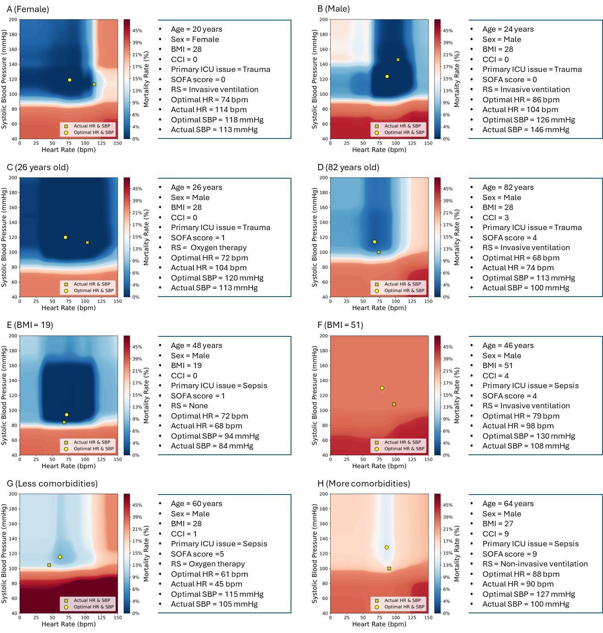

Supplementary Figure 3: HR-BP-mortality contour maps for individual patients with different acute illnesses (case studies)

These maps are based on a model with a 12-hour predictor window, a 24-hour outcome window, and a prediction moment at 18 hours following ICU admission. The maps depict distinct patterns, varying mortality risks for identical HR-BP combinations, differences in predicted optimal HR/SBP targets, and discrepancies between predicted and actual HR and SBP values. These variations underscore the importance of personalized hemodynamic management in ICU settings.

BMI, body mass index; CCI, Charlson Comorbidity Index; ICU, intensive care unit; SOFA, Sequential Organ Failure Assessment; RS, respiratory support; HR, heart rate; SBP, systolic blood pressure

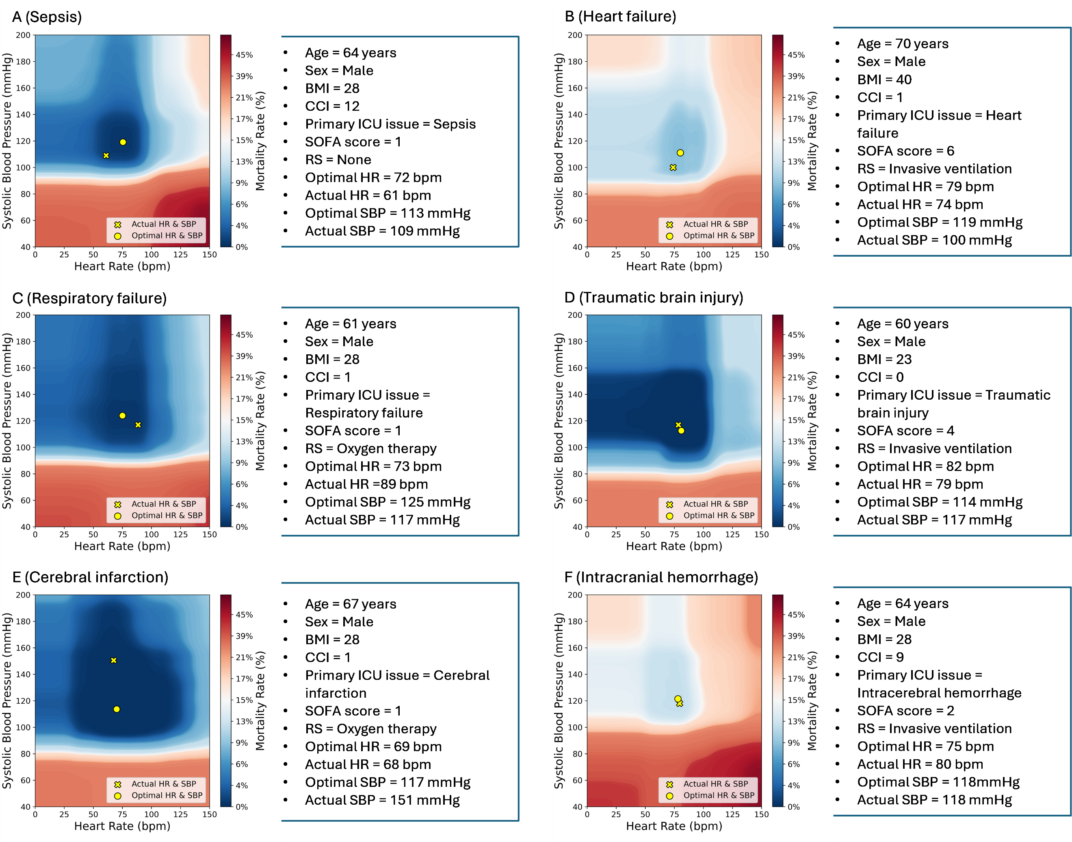

Supplementary Figure 4: Boxplots of inferred hemodynamic management targets for the two cases presented in Figures 2b and 2c

Boxplots display DynaCEL-inferred heart rate and systolic blood pressure targets at six time points (12–42 hours post-ICU admission) for the ICU cases in Figure 2b (left) and 2c (right). Targets represent the median and interquartile range of HR and SBP values associated with the lowest predicted 24-hour mortality based on five prediction models. The figure illustrates the inter-patient and temporal variation in optimal targets, highlighting DynaCEL’s capacity to generate individualized recommendations that adapt to evolving physiologic states.

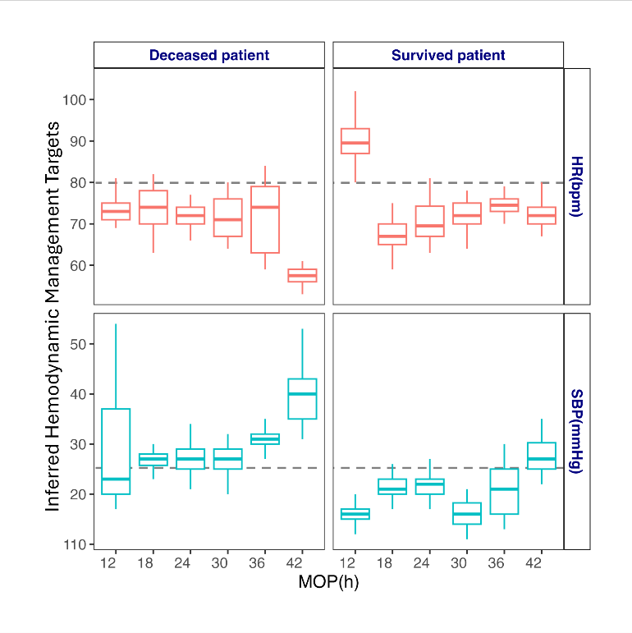

Supplementary Figure 5: Data preprocessing

ICU stays were excluded from the eICU dataset if they had unknown survival status, were missing HR or BP data, were under 18 years old, or had unspecified sex. These exclusion criteria were not applied to the MIMIC-IV and IUH datasets, as they contained all the necessary information for our study.

ICU, intensive care unit; eICU, eICU dataset; MIMIC IV, MIMIC IV dataset; IUH, Indiana University Health; HR, heart rate; BP, blood pressure

Supplementary Figure 6: Data processing

For all datasets, BMI was calculated for ICU stays with available height and weight values, and missing values were imputed using the median. Sex was binarised, ethnicity was one-hot encoded, comorbidities and hourly SOFA scores were linked, and missing SOFA scores were filled with the most recent prior score. Respiratory support data was also linked and one-hot encoded.

ICU, intensive care unit; BMI, body mass index; SOFA, sequential organ failure assessment

Supplementary Figure 7: Data split and model development

DynaCEL models were trained and evaluated using 5-fold cross-validation on the eICU dataset. The dataset was divided into five equal-sized folds. For each iteration, the model was trained on four folds and tested on the remaining fold. This process was repeated five times, with a different fold serving as the test set in each iteration while the remaining folds were used for training.

DynaCEL, Dynamic Cohort Ensemble Learning

Supplementary Figure 8: Hemodynamic target inference with XGBoost-based DynaCEL at 18-hour MOP in a random patient
This figure illustrates the HR–SBP–mortality contour map generated by a DynaCEL model using XGBoost as the base learner for a randomly selected ICU patient at 18 hours post-admission. The model infers a personalized heart rate and systolic blood pressure combination associated with the lowest predicted 24-hour mortality risk. The contour map visualizes the risk landscape across HR and SBP values, highlighting the optimal target region and the patient’s actual hemodynamic state. This figure is used to assess inference quality and identify potential artifacts compared with random forest–based models.
DynaCEL, dynamic cohort ensemble learning; MOP, moment of prediction

Supplementary Figure 9: Relationship between sample size and model performance

Models were trained on randomly selected proportions of the 18-hour MOP cohort from the eICU training set. For each proportion, five models were developed using a random forest algorithm with a 12-hour PW and a 24-hour OW. Performance was evaluated on the held-out eICU test sets and also validated on the MIMIC-IV and IUH datasets. Model performance (AUC) increased with larger training sample sizes and saturated at approximately 80% of the training data for the eICU and MIMIC-IV datasets, and around 30% for the IUH dataset.

eICU, eICU dataset; MIMIC IV, MIMIC-IV dataset; IUH, Indiana University Health; PW, prediction window; OW, outcome window

Supplementary Figure 10: Distribution of heart rate and systolic blood pressure values

This figure displays the distribution of heart rate and systolic blood pressure values at 18 hours after ICU admission (MOP = 18) in the MIMIC-IV cohort. Green dots represent patients who survived, and pink dots represent those who died. The plot highlights the substantial variability in these parameters across critically ill patients, underscoring the need for personalized hemodynamic targets.

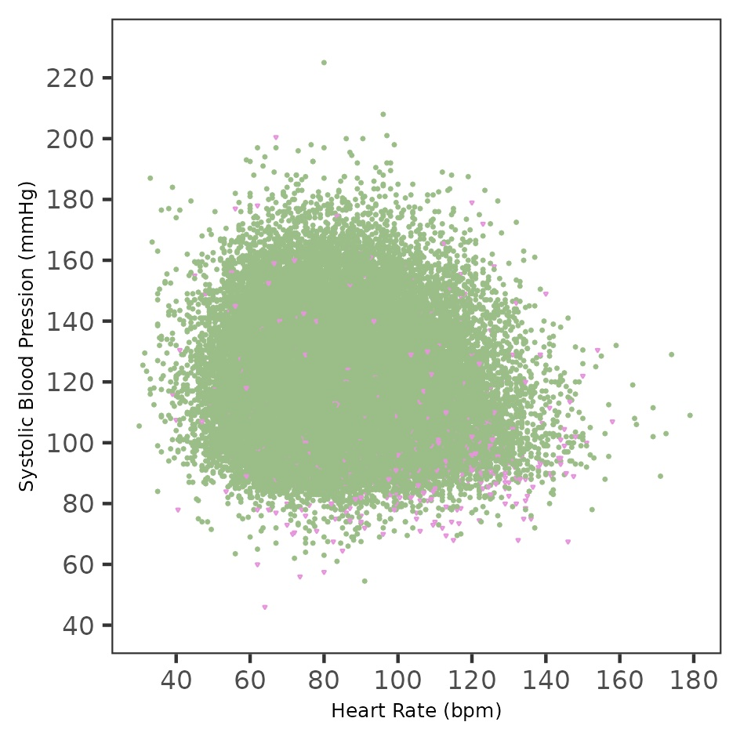
MOP, moment of prediction

Supplementary Figure 11: The SHAP and Gini importance ranking of 44 features including heart rate and systolic blood pressure
This figure presents the importance of 44 clinical features used in DynaCEL modeling, ranked by SHAP (Shapley Additive Explanations) values and Gini impurity reduction from the random forest algorithm. Heart rate and systolic blood pressure are highlighted among the top contributors in both ranking methods, confirming their central role in mortality risk prediction. SHAP values capture each feature’s marginal contribution to model output, while Gini importance reflects the total reduction in node impurity across decision trees. Consistent rankings across methods support the robustness of feature influence in the DynaCEL framework.
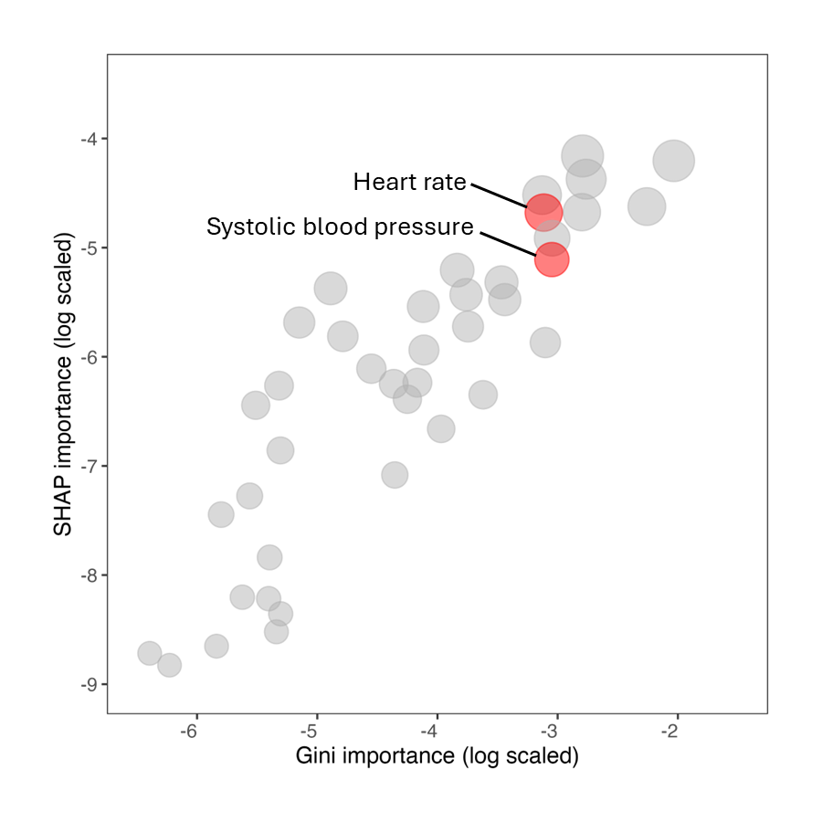

Supplementary Figure 12: Sensitivity analysis using an encoder-decoder model
Comparison of the inferred hemodynamic management targets for heart rate (A) and systolic blood pressure (B) derived from reconstructed inputs using an encoder–decoder model versus original unmasked inputs. The analysis was conducted using the DynaCEL framework on the 18-hour MOP cohort from the MIMIC-IV dataset with a prediction window of 12 hours and an outcome window of 24 hours. The results assess the model’s robustness to input reconstruction and feature dependencies.

References
1. Quan, H., et al. Updating and validating the Charlson comorbidity index and score for risk adjustment in hospital discharge abstracts using data from 6 countries. Am J Epidemiol 173, 676-682 (2011).
2. Charlson, M.E., Carrozzino, D., Guidi, J. & Patierno, C. Charlson Comorbidity Index: A Critical Review of Clinimetric Properties. Psychother Psychosom 91, 8-35 (2022).
3. Charlson, M.E., Pompei, P., Ales, K.L. & MacKenzie, C.R. A new method of classifying prognostic comorbidity in longitudinal studies: development and validation. J Chronic Dis 40, 373-383 (1987).

