Supplementary Materials for

Metagenomic Fingerprints in Bronchoalveolar Lavage Differentiate Pulmonary Diseases
Dongsheng Han et al.

This file includes:

Figs. S1 to S19
Tables S1 to S2

Other Supplementary Materials for this manuscript include the following:

Data S1 to S4

Figure S1. The steps of the model-building process. Step 1: We used the normalization method included with DESeq2 for batch effect correction and employed both DESeq2 and Lefse as differential analysis methods to identify distinct features in each data type. Step 2: After obtaining all candidate features, we calculated the frequency of features in the training set for each classifier capable of performing feature selection, across different data types. We conducted 1,000 iterations to tally the frequency of each feature's occurrence. Subsequently, we selected the optimal combination of features through sequential forward selection. Step 3: LASSO, SVM, XGBoost, and Random Forest—4 different classifiers and 54 ensemble models of each two classifiers—were used to construct models in the training set for six types of models. Statistical analysis was then performed to identify the optimal classifier/model. Step 4: Finally, we selected the optimal classifier and Model VI for combined rule-in and rule-out predictions, filtering for more accurate diagnostic outcomes.

Figure S2. Microorganisms found in NC samples and their relative abundance in mNGS DNA data. The boxplot displays the log10-transformed relative abundance of microorganisms. Red (where relative abundance is higher in background samples than in BALF and frequencies were higher than 50% and relative abundances in NCs were higher than 0.1%) and blue (only frequencies were higher than 50% and relative abundances in NCs were higher than 0.1%) labels indicate taxa considered possible contaminant. The differential microorganisms identified in Figure 2 do not correspond entirely to these microorganisms, indicating the reliability of the lung disease-specific microorganisms we have discovered.

Figure S3. Microorganisms found in NC samples and their relative abundance in mNGS DNA data. The boxplot displays the log10-transformed relative abundance of microorganisms. Red (where relative abundance is higher in background samples than in BALF and frequencies were higher than 50% and relative abundances in NCs were higher than 0.1%) and blue (only frequencies were higher than 50% and relative abundances in NCs were higher than 0.1%) labels indicate taxa considered possible contaminant.

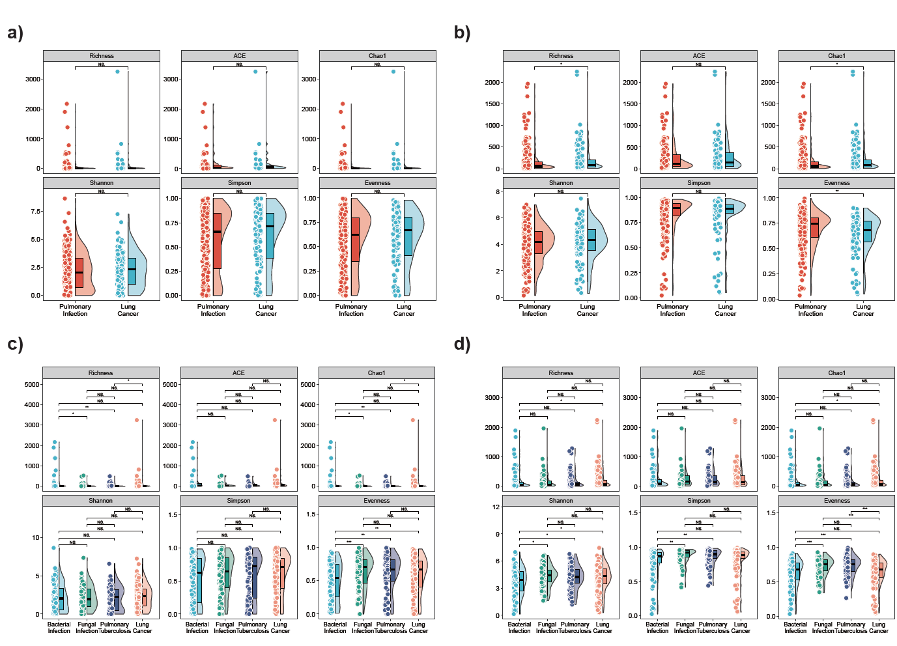
Figure S4. Microbial Alpha Diversity Profiles Differentiating Lung Cancer and Pulmonary Infections Based on mNGS DNA and RNA Data. (a–b) Alpha diversity indices derived from mNGS DNA data (a) and RNA data (b) in the training cohort, comparing individuals with pulmonary infection and lung cancer. (c–d) Alpha diversity indices based on mNGS DNA data (c) and RNA data (d), comparing bacterial infection, fungal infection, pulmonary tuberculosis, and lung cancer. Six commonly used metrics were calculated: Richness (Observed species), ACE, Chao1, Shannon index, Simpson index, and Evenness index. P-values were determined using the two-sided Wilcoxon rank-sum test. In the boxplots, the central line represents the median; boxes indicate the interquartile range (IQR); whiskers extend to 1.5 × IQR from the hinges. Asterisks denote statistical significance between two groups (*p < 0.05, **p < 0.01, ***p < 0.001), and “NS” indicates no significant difference.

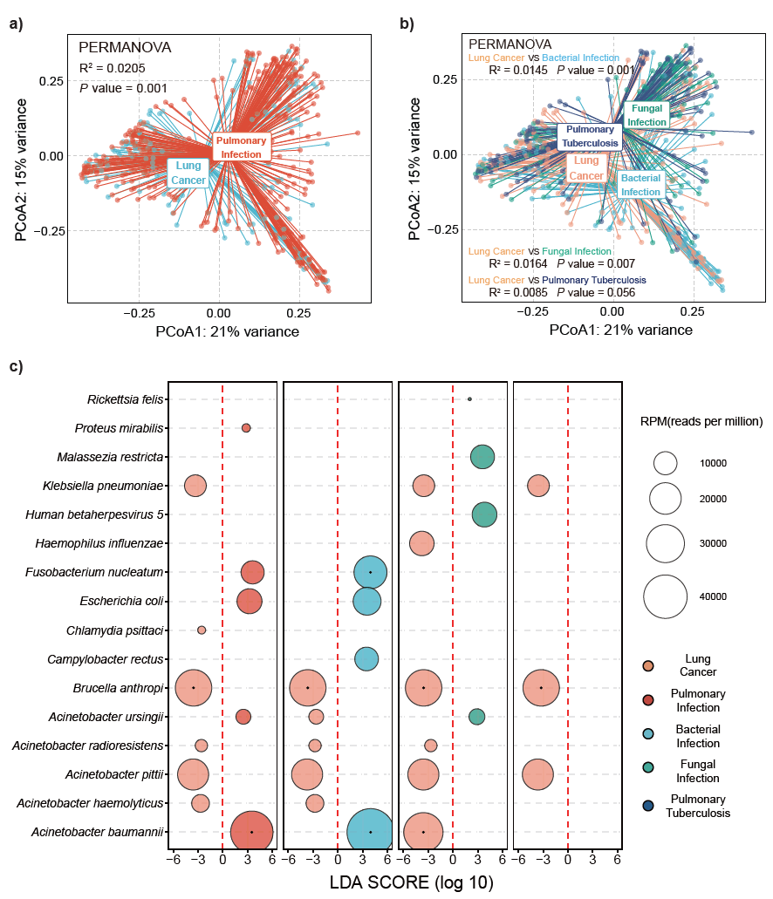
Figure S5. Microbial and bacteriophage composition analyses in BALF mNGS RNA data. a) PCoA based on Bray–Curtis dissimilarity index of microbial and bacteriophage composition in comparing lung cancer and pulmonary infection (single-variable PERMANOVA, P value). PCoA1, principal component 1; PCoA2, principal component 2. b) PCoA based on Bray–Curtis dissimilarity index of microbial and bacteriophage composition in comparing lung cancer and infection subgroups (single-variable PERMANOVA, P value). c) Bubble plot displaying Lefse analysis results and the relative abundance of microorganisms consistently differentially enriched across various pulmonary disease groups. The size of each bubble corresponds to the median relative abundance of statistically significant findings. A red dashed line delineates positive (on the right) and negative (on the left) fold changes. Bubbles indicate statistical significance (adjusted p-value < 0.05). Distinct bubble colors denote different pulmonary diseases, matching the labels atop the bubble graph, illustrating the enrichment of specific species within each pulmonary disease group. TB, tuberculosis.

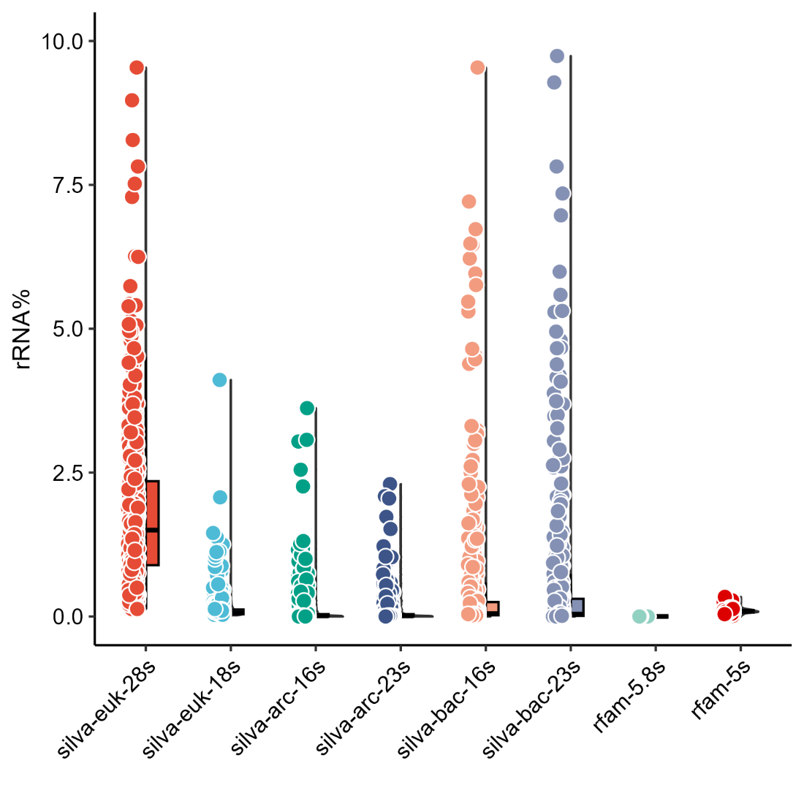
Figure S6. Ribosomal RNA rate of mNGS RNA data.
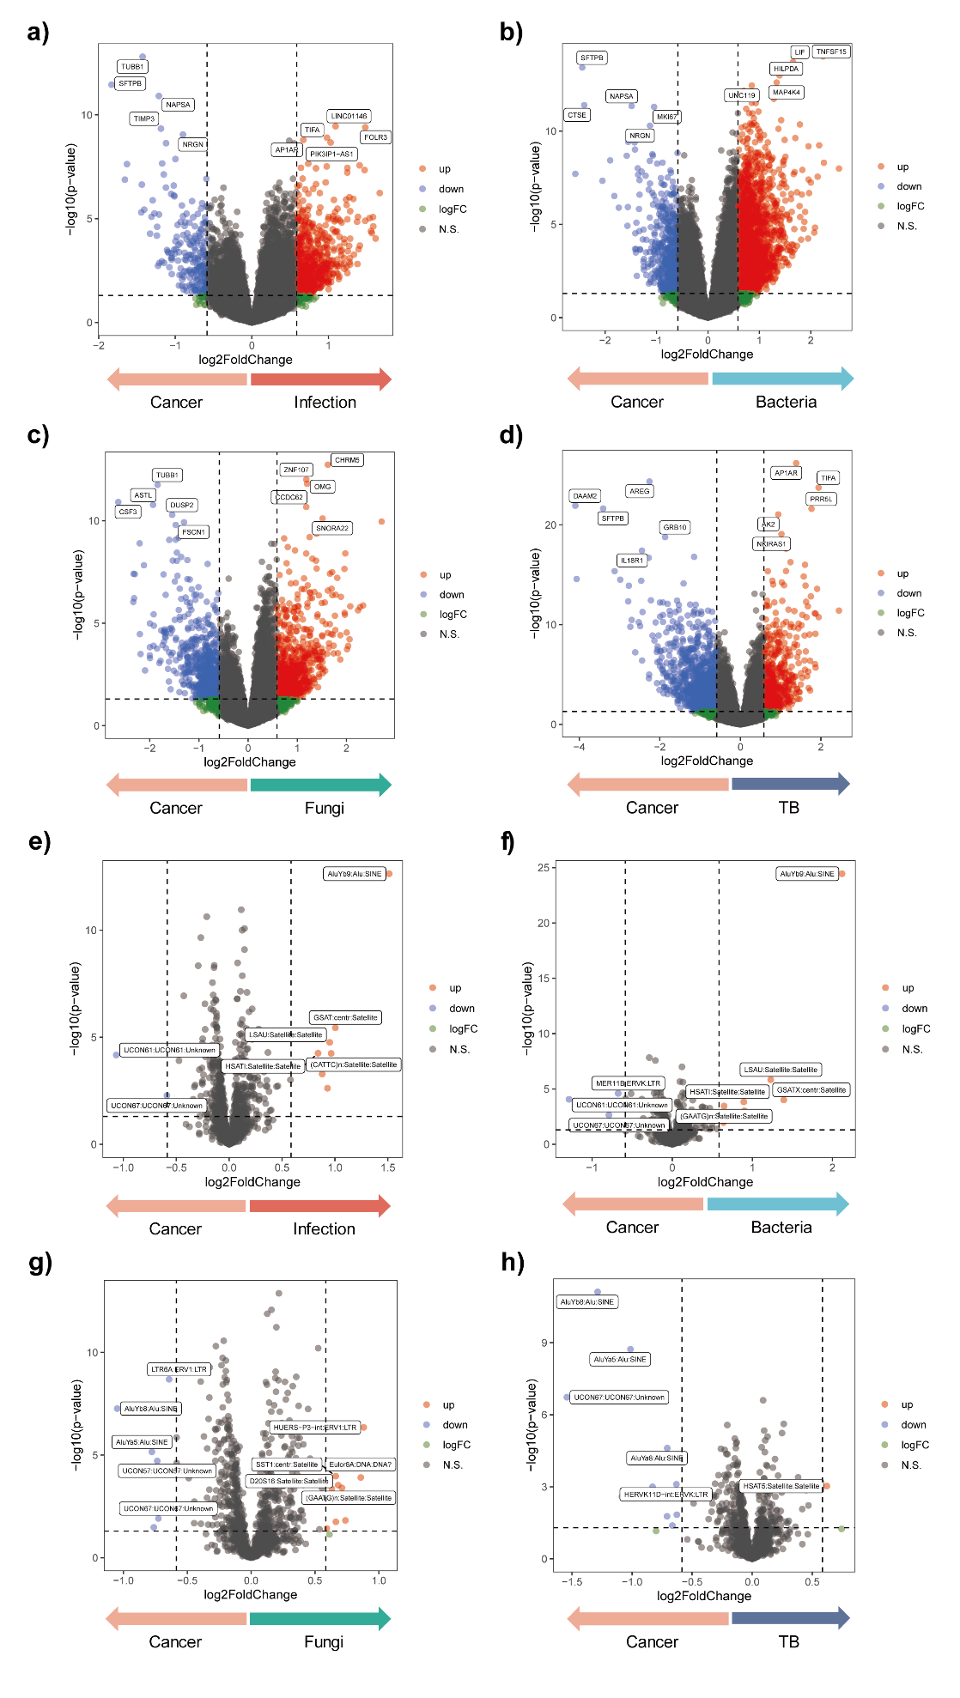
Figure S7. Host transcriptomic and transposable element responses in bronchoalveolar lavage fluid (BALF) of patients with lung cancer and pulmonary infections.
(a–d) Volcano plots showing differential host gene expression profiles between lung cancer and various pulmonary infections based on RNA-seq data. Comparisons include lung cancer vs. (a) pulmonary infection, (b) bacterial infection, (c) fungal infection, and (d) pulmonary tuberculosis. (e–h) Volcano plots illustrating differential expression of transposable elements across the same comparison groups: (e) pulmonary infection, (f) bacterial infection, (g) fungal infection, and (h) pulmonary tuberculosis. Each plot integrates log₂ fold change and −log₁₀(p-value). Blue dots indicate significantly upregulated genes or elements in the lung cancer group (p < 0.05, fold change ≥ 1.5), red dots represent those upregulated in infection groups, and green dots highlight genes with high fold change but not statistically significant. Grey dots denote non-significant genes or elements. Horizontal dashed lines indicate p = 0.05; vertical dashed lines indicate fold change thresholds (±1.5×). Key differentially expressed genes or elements are labelled. TB, tuberculosis.

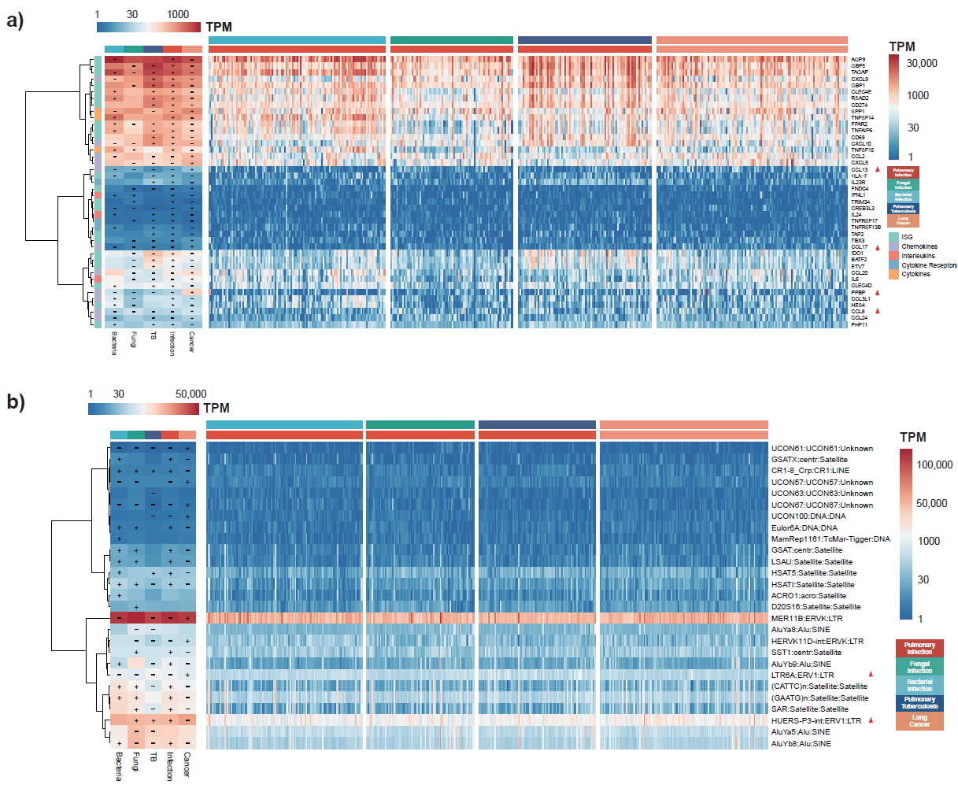
Figure S8. Heatmaps of Immune-Related Gene Expression and Consistent Transposable Element Signatures.​ 42 significantly differential expressed genes encoding cytokines, their receptors and interferon stimulated a) and 29 significantly differential expressed transposable elements (TE) b). (Left) Heatmap of DEGs encoding cytokines, their receptors and ISG or TE on average of each group. Plus (+) indicate significant DEGs up regulated in this group. Minus (-) indicate significant DEGs down regulated in this group (p-value < 0.05). (Right) Heatmap of DEGs encoding cytokines, their receptors and ISG or TE of each sample. Gene were classified by ISG, Chemokines, Interleukins, Cytokines and Cytokines receptors. Red triangle represents gene were regulated with same trend in each comparison of Lung Cancer with Pulmonary Infection, Bacterial Infection, Fungal Infection and Pulmonary Tuberculosis. TB, tuberculosis.

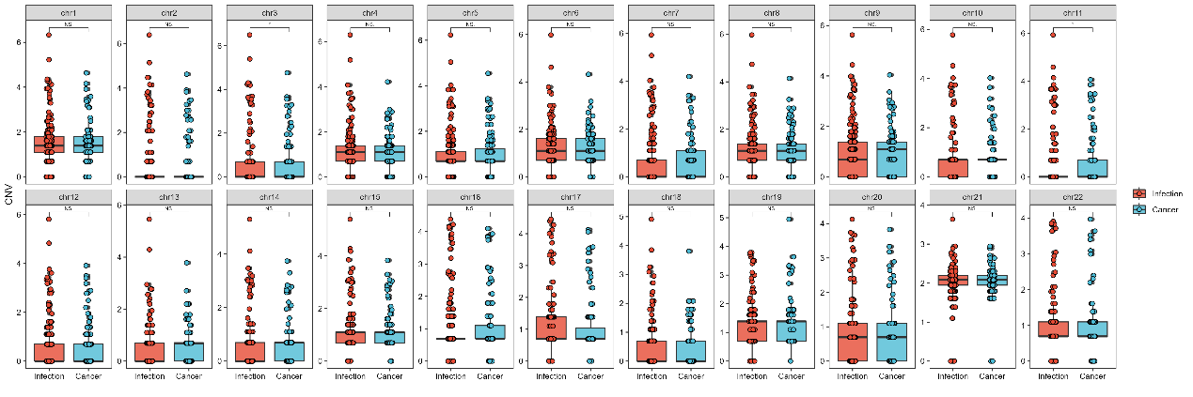
Figure S9. CNV numbers on each chromosome called by CNVkit between Lung cancer and Pulmonary infection group. Paired Wilcoxon rank sum test was used for continuous variables. *,**,*** represent significance between two groups (*: p < 0.05; **: p < 0.01; ***: p < 0.001) and N.S. represents no significance between two groups.

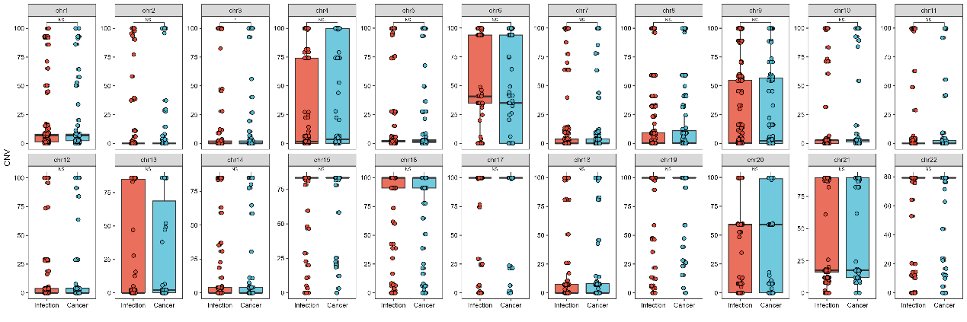
Figure S10. CNV percentage on each chromosome called by CNVkit between Lung Cancer and Pulmonary Infection group. Paired Wilcoxon rank sum test was used for continuous variables. *,**,*** represent significance between two groups (*: p < 0.05; **: p < 0.01; ***: p < 0.001) and N.S. represents no significance between two groups.

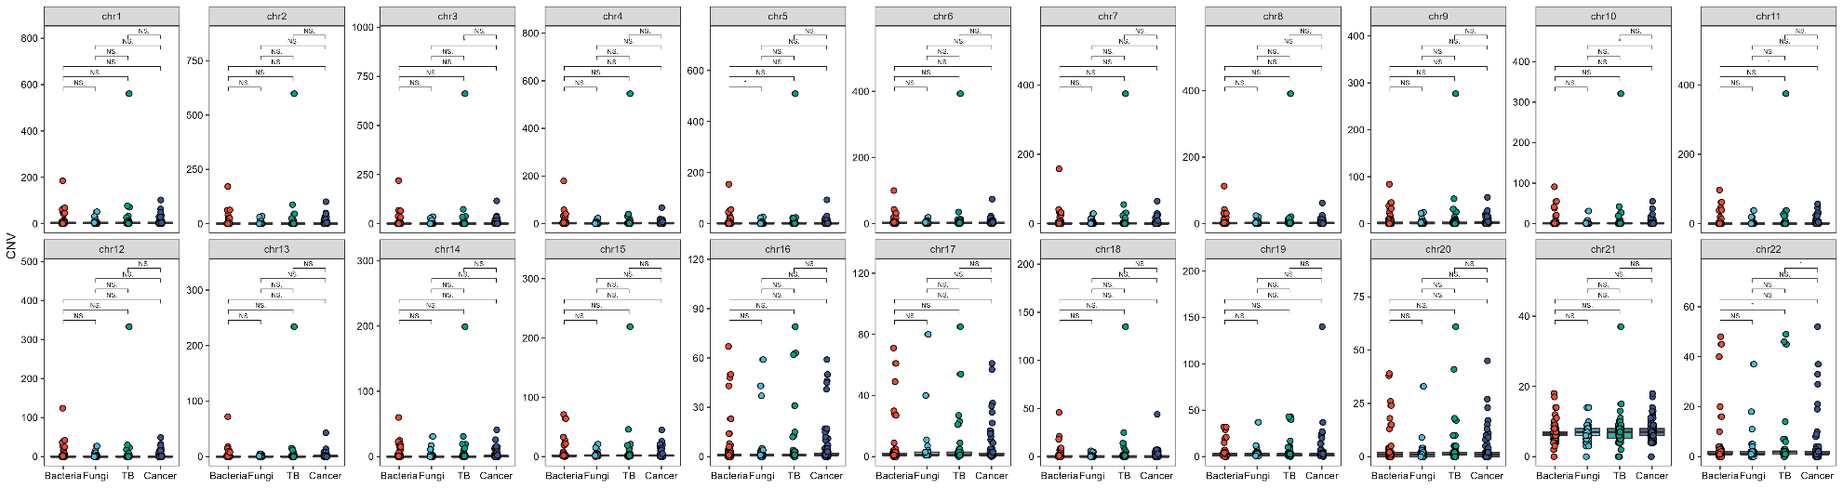
Figure S11. CNV numbers on each chromosome called by CNVkit among Lung Cancer, Bacterial Infection, Fungal Infection and Pulmonary Tuberculosis. Paired Wilcoxon rank sum test was used for continuous variables of each two-group comparison. *,**,*** represent significance between two groups (*: p < 0.05; **: p < 0.01; ***: p < 0.001) and N.S. represents no significance between two groups. TB, tuberculosis.

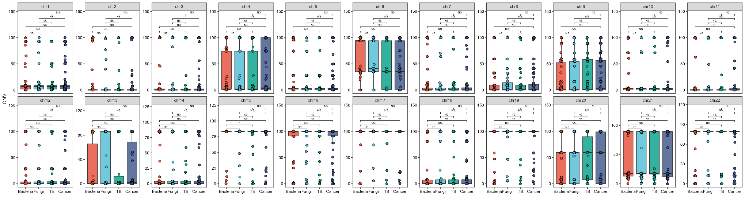
Figure S12. CNV percentage on each chromosome called by CNVkit among Lung Cancer, Bacterial Infection, Fungal Infection and Pulmonary Tuberculosis. Paired Wilcoxon rank sum test was used for continuous variables of each two-group comparison. *,**,*** represent significance between two groups (*: p < 0.05; **: p < 0.01; ***: p < 0.001) and N.S. represents no significance between two groups. TB, tuberculosis.

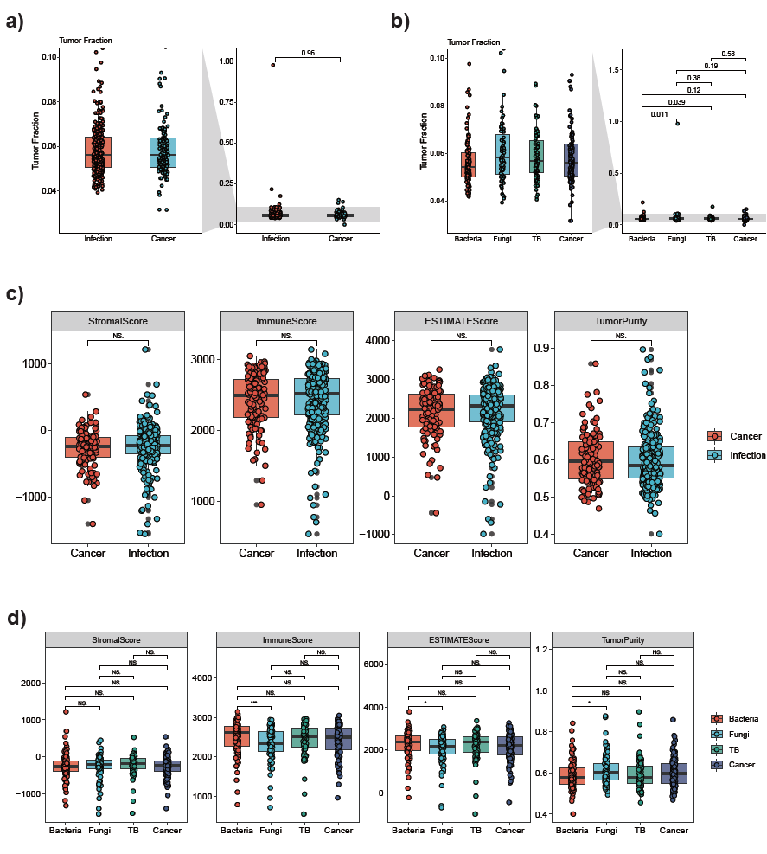
Figure S13. Comparative Cancer Burden Biomarkers: Tumor Fraction and ESTIMATE Microenvironment Scores in Lung Cancer vs. Pulmonary Infections. ​ a) The ichorCNA Tumor Fraction values between Lung Cancer and Pulmonary Infection group. Paired Wilcoxon rank sum test was used for continuous variables. b) The ichorCNA Tumor Fraction values among Lung Cancer, Bacterial Infection, Fungal Infection and Pulmonary Tuberculosis. Paired Wilcoxon rank sum test was used for continuous variables of each two-group comparison. c) The ESTIMATE values between Lung Cancer and Pulmonary Infection. Paired Wilcoxon rank sum test was used for continuous variables. Paired Wilcoxon rank sum test was used for continuous variables. *, **, *** represent significance between two groups and N.S. represents no significance between two groups. d) The ESTIMATE values among Lung Cancer, Bacterial Infection, Fungal Infection and Pulmonary Tuberculosis. Paired Wilcoxon rank sum test was used for continuous variables of each two-group comparison. *,**,*** represent significance between two groups (*: p < 0.05; **: p < 0.01; ***: p < 0.001) and N.S. represents no significance between two groups. TB, tuberculosis.

Figure S14. A total of 58 prediction models (4 individual machine learning models: LASSO, Random Forest, XGboost and Support Vector Machine and 54 ensemble models) via Model I further calculated AUC of each model across all comparisons in test datasets. Red label indicated the model with highest average AUC of all comparison. TB, tuberculosis.

Figure S15. A total of 58 prediction models (4 individual machine learning models: LASSO, Random Forest, XGboost and Support Vector Machine and 54 ensemble models) via Model II further calculated AUC of each model across all comparisons in test datasets. Red label indicated the model with highest average AUC of all comparison. TB, tuberculosis.

Figure S16. A total of 58 prediction models (4 individual machine learning models: LASSO, Random Forest, XGboost and Support Vector Machine and 54 ensemble models) via Model III further calculated AUC of each model across all comparisons in test datasets. Red label indicated the model with highest average AUC of all comparison. TB, tuberculosis.

Figure S17. A total of 58 prediction models (4 individual machine learning models: LASSO, Random Forest, XGboost and Support Vector Machine and 54 ensemble models) via Model IV further calculated AUC of each model across all comparisons in test datasets. Red label indicated the model with highest average AUC of all comparison. TB, tuberculosis.

Figure S18. A total of 58 prediction models (4 individual machine learning models: LASSO, Random Forest, XGboost and Support Vector Machine and 54 ensemble models) via Model V further calculated AUC of each model across all comparisons in test datasets. Red label indicated the model with highest average AUC of all comparison. TB, tuberculosis.

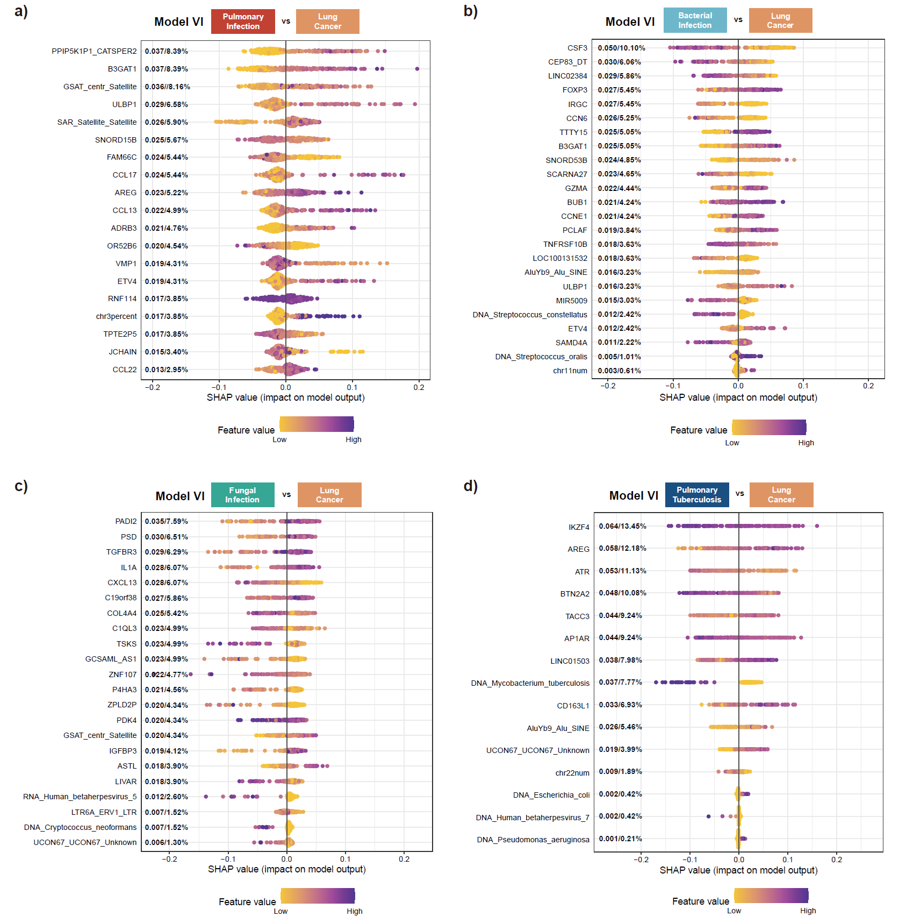
Figure S19. Feature Importance with SHAP value for differentiating Lung Cancer from Various Pulmonary Infections. SHAP (SHapley Additive exPlanations) summary plots showing the most influential features used by Model VI to distinguish between lung cancer and four types of pulmonary infections. Each dot represents a SHAP value for a feature in a specific sample, where color indicates the original feature value (purple = low, yellow = high). a) Lung cancer vs. Pulmonary infection; b) Lung cancer vs. Bacterial infection; c) Lung cancer vs. Fungal infection; d) Lung cancer vs. Pulmonary tuberculosis. Features include host genes, microbial taxa, and genomic elements. Features are ranked by their mean absolute SHAP values, indicating their overall impact on the model’s predictions.

Table S1. Ribosomal RNA rate (%) of different pulmonary disease groups
Group | Euk-28s | Euk-18s | Arc-16s | Arc-23s | Bac-16s | Bac-23s | rfam-5.8s | rfam-5s | Euk-ribosome | Total
Bacterial infection | 1.64[1.01, 2.92] | 0.08[0.05, 0.15] | 0.05[0, 0.17] | 0.03[0, 0.12] | 0.29[0.05, 1.24] | 0.32[0.03, 1.33] | 0[0, 0] | 0.1[0.08, 0.11] | 1.83[1.12, 3.01] | 3.21[1.92, 5.85]
Fungal infection | 1.32[0.58, 2.16] | 0.07[0.04, 0.14] | 0[0, 0.01] | 0[0, 0.01] | 0.03[0.02, 0.09] | 0.01[0, 0.08] | 0[0, 0] | 0.08[0.07, 0.11] | 1.48[0.75, 2.32] | 1.75[1.12, 2.73]
Lung cancer | 1.84[1.06, 2.6] | 0.06[0.04, 0.11] | 0.01[0, 0.03] | 0.01[0, 0.04] | 0.06[0.02, 0.25] | 0.05[0.01, 0.29] | 0[0, 0] | 0.09[0.07, 0.11] | 1.95[1.3, 2.66] | 2.65[1.72, 4.05]
Pulmonary tuberculosis | 1.29[1.06, 2.6] | 0.05[0.04, 0.11] | 0[0, 0.03] | 0[0, 0.03] | 0.03[0.02, 0.23] | 0.02[0.01, 0.26] | 0[0, 0] | 0.09[0.07, 0.11] | 1.37[1.3, 2.66] | 1.63[1.72, 4.05]
Total | 1.53[0.89, 2.45] | 0.06[0.04, 0.12] | 0.01[0, 0.04] | 0.01[0, 0.04] | 0.06[0.02, 0.27] | 0.04[0.01, 0.35] | 0[0, 0] | 0.09[0.07, 0.11] | 1.66[1.01, 2.62] | 2.3[1.38, 3.98]

Table S2. Host rate (%) and mapping reads of different pulmonary disease groups in mNGS DNA data
Group | Mapping reads (M reads) | Host rate (%)
Bacterial infection | 18.82[14.98, 22.48] | 98.1[96.94, 98.54]
Fungal infection | 20.34[16.71, 24.84] | 98.4[97.74, 98.74]
Lung cancer | 18.89[15.48, 23.77] | 98.22[96.67, 98.63]
Pulmonary tuberculosis | 19.36[16.73, 23.35] | 98.43[97.76, 98.74]
Total | 19.23[15.95, 23.66] | 98.22[97.46, 98.66]

Data S1. (separate file)
Microbiological results and malignancy diagnosis by cytology/flow cytometry/Pathological results of pulmonary disease patients.

Data S2. (separate file)
Microbiological results and diagnosis of Negative Control patients.

Data S3. (separate file)
Performance of different models to classify lung cancer and infection.

Data S4. (separate file)
Features of Model I-VI among all classifiers.

