Supplementary appendix

Supplementary Figure 1. Risk of bias summary 1
Supplementary Figure 2. Risk of bias graph 2
Supplementary Figure 3. Spatial distribution and functional significance of EEG electrode placement in wearable devices 4
Supplementary Figure 4. Distribution of mobility and system quality scores by channel configuration. 6
Supplementary Figure 5. Marginal effect analysis of diagnostic performance reveals an optimal EEG channel count for MCI detection. 6
Supplementary Figure 6. Distribution and reporting frequency of neurophysiological biomarker categories across the 21 included studies. 7
Supplementary Figure 7. Distribution and reporting frequency of performance evaluation metrics across the 21 included studies 8
Supplementary Figure 8. Comparative analysis of diagnostic performance stratified by neurophysiological feature category. 9
Supplementary Figure 9. Multimodal data fusion consistently enhances MCI classification accuracy compared to EEG-only approaches. 10
Supplementary Figure 10. Ensemble learning methods consistently improve classification accuracy over standard baseline models. 11
Supplementary Table 1. Searching strategies 12
Supplementary Table 2. Inclusion and exclusion criteria for studies on wearable EEG in mild cognitive impairment detection 19
Supplementary Table 3. Justification for inclusion of 15 wearable EEG devices 20
Supplementary Table 4. Technical specifications of wearable EEG devices and associated assessment protocols 22
Supplementary Table 5. The modified version of the Quality of Diagnostic Accuracy Studies 2 (QUADAS-2) 25
Supplementary Table 6. Fundamentals of wearable EEG devices 28
Supplementary Table 7. Electrode system of wearable EEG devices 29
Supplementary Table 8. Signal acquisition performance of wearable EEG devices 32
Supplementary Table 9. Additional sensors of wearable EEG devices 34
Supplementary Table 10. Data processing and transmission of wearable EEG devices 35
Supplementary Table 11. Physical characteristics and mobility assessment of wearable EEG devices 36
Supplementary Table 12. Distribution of cognitive domains across EEG study paradigms 37
Supplementary Table 13. Signal processing and feature extraction methods in EEG-Based cognitive assessment studies 38
Supplementary Table 14. Technical specifications across selected wireless EEG devices 40
Supplementary Table 15. Summary of EEG biomarkers for mild cognitive impairment detection and their neurophysiological correlates 44
Supplementary Table 16. Summary of EEG feature categories in MCI detection studies: slowing, complexity, and connectivity 47
Supplementary Table 17. Multivariate logistic regression analysis of EEG configuration factors associated with superior classification performance 49
Supplementary Table 18. PRISMA 2020 Checklist 50
Supplementary Table 19. CoME S (System Specifications) scoring criteria 53
Supplementary Table 20. CoME D (Device Mobility) scoring framework 54

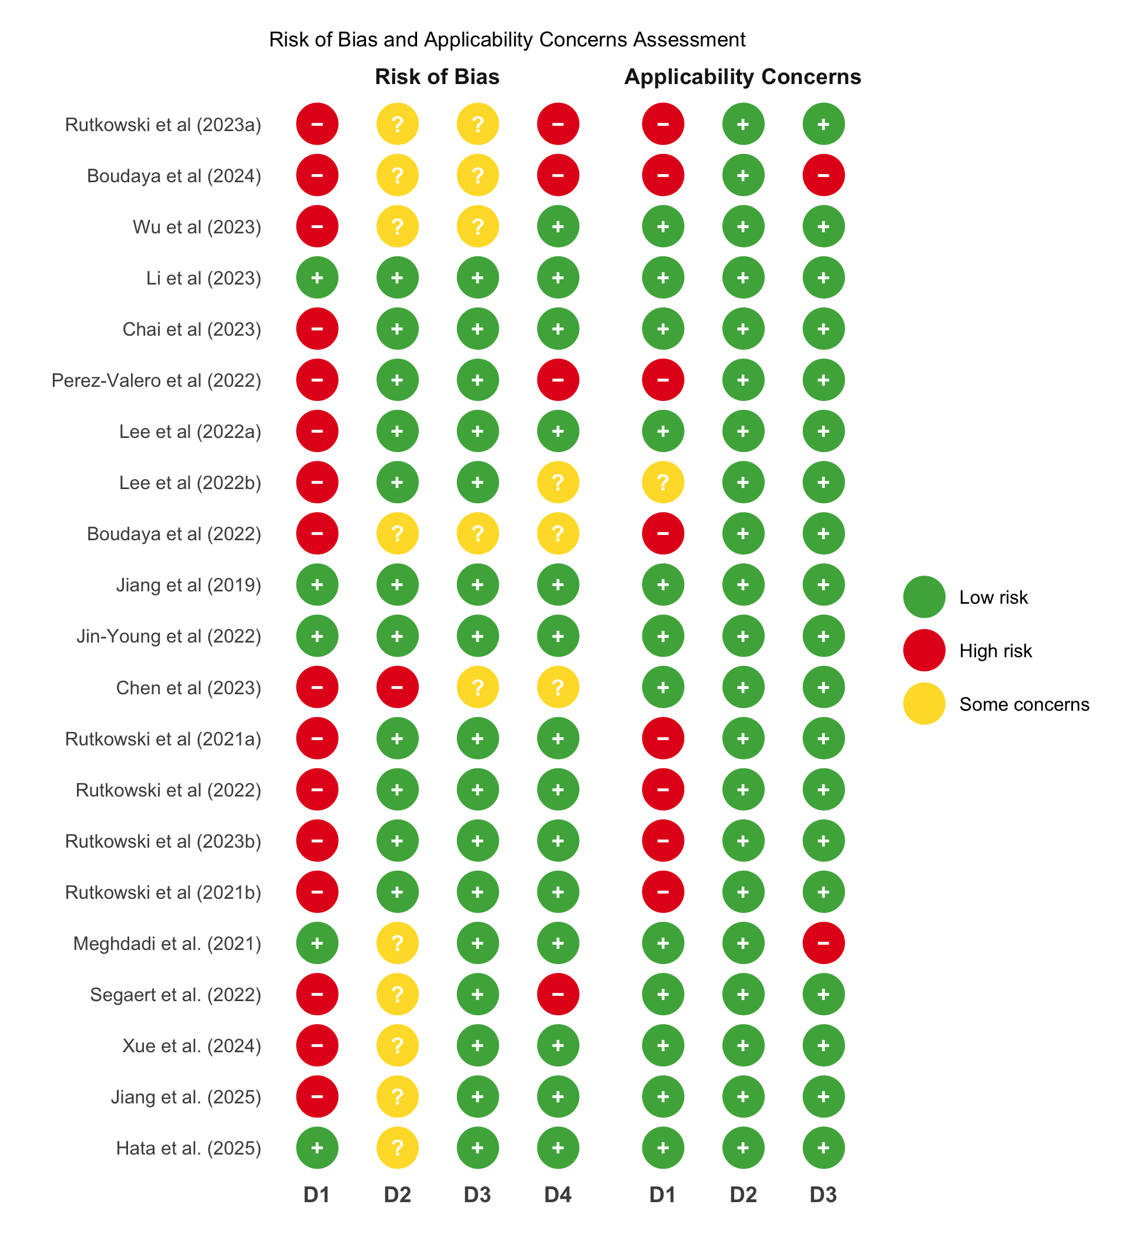
Note: D1: Participant; D2: Index test; D3: Reference Standard; D4: Analysis.

Supplementary Figure 1. Risk of bias summary
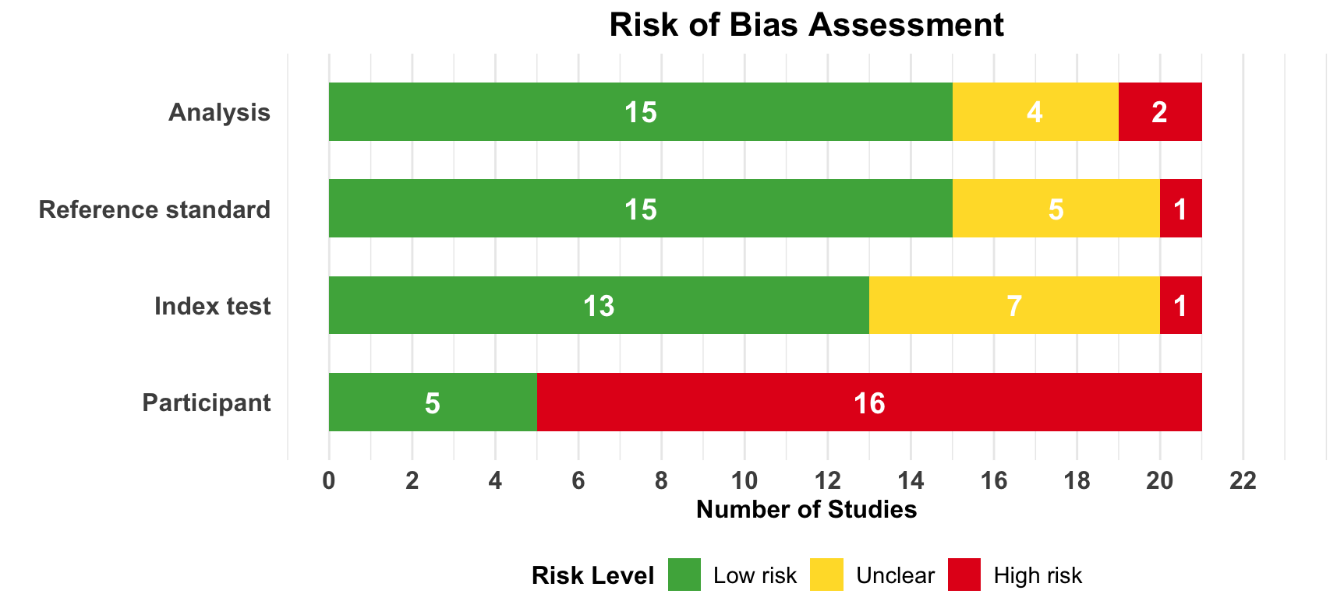
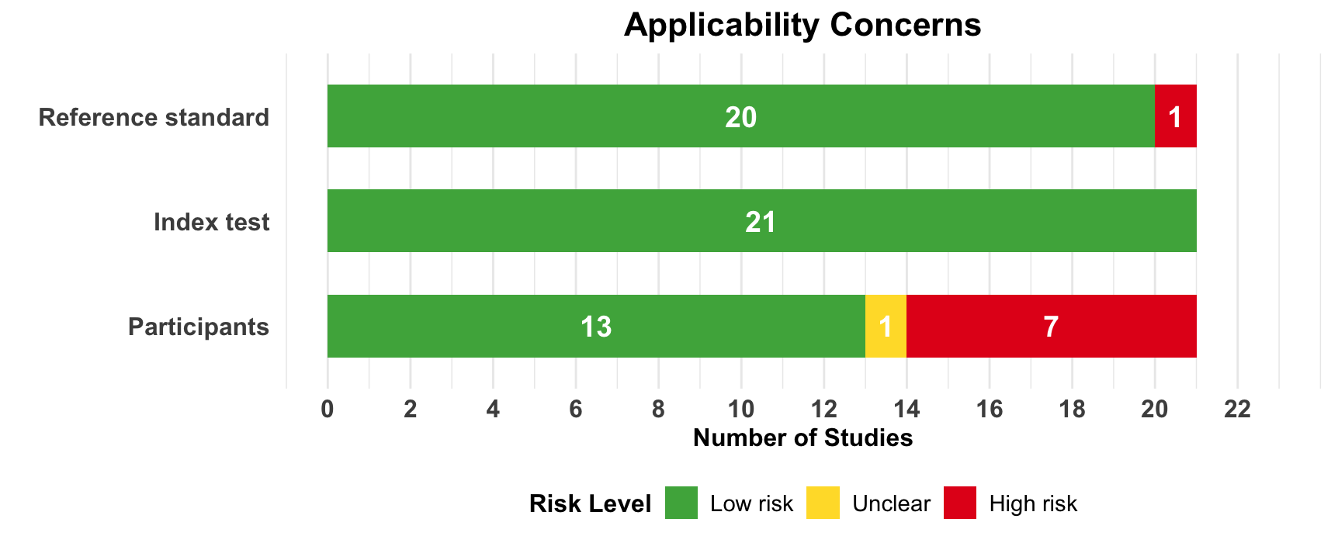

Supplementary Figure 2. Risk of bias graph

Almost all studies (16/21, 76%) did not provide sufficient information to verify if an appropriate consecutive or random sample of eligible patients was used. Most studies (13/21, 62%) avoided inappropriate exclusions. An adequate balance in the number of patients between the MCI and non-MCI subgroups was used in only 38% (8/21) of the studies. Researchers have used an insufficient sample size in 62% (13/21) of the included studies. Thus, the risk of bias owing to the "selection of participants" was rated as low in only 24% (5/21) of the studies.
Concerns regarding the matching between the spectrum of participants and the pre-stated requirements in the review question were rated as low in 62% (13/21) of the studies, while 33% (7/21) had high concerns and 5% (1/21) had unclear concerns.
The wearable EEG devices and associated models were described in detail in 86% (18/21) of the studies. The features (predictors) used in the models were clearly described in almost all studies (20/21, 95%) and were assessed in the same way for all participants in 95% (20/21) of the studies. Features were collected without the knowledge of outcome data in 62% (13/21) of the studies, while 33% (7/21) had unclear reporting on this aspect. Therefore, there was a low risk of bias because of the "index test" in 62% (13/21) of the studies.
All the included studies (21/21, 100%) were judged to have low concerns that the wearable EEG devices and data processing methods matched the review question.
Researchers in 95% (20/21) of the studies assessed the outcome of interest (i.e., mild cognitive impairment) using appropriate diagnostic tools. In 90% (19/21) of the studies, the outcome was defined in a similar way for all participants. However, only 62% (13/21) of studies clearly reported that MCI diagnosis was determined without knowledge of EEG results, and only 43% (9/21) of studies used an appropriate interval between the EEG recording and the MCI diagnosis. According to these judgments, the risk of bias because of the "reference standard" was low in 71% (15/21) of the studies.
All studies (21/21, 100%) except one (5%) were judged to have low concerns that the reference standard definition and determination matched the review question, with only one study (5%, Boudaya et al. 2024) having high concerns.
All participants enrolled in the study were included in the data analysis in 62% (13/21) of the studies. In 81% (17/21) of the studies, the data preprocessing was carried out appropriately, and in 76% (16/21) of the studies, the breakdown of the training, validation, and test sets was adequate. The performance of the EEG-based models was evaluated using suitable measures in 90% (19/21) of the studies. Accordingly, 71% (15/21) of the studies had a low risk of bias in the analysis domain, while 19% (4/21) had unclear risk and 10% (2/21) had high risk.
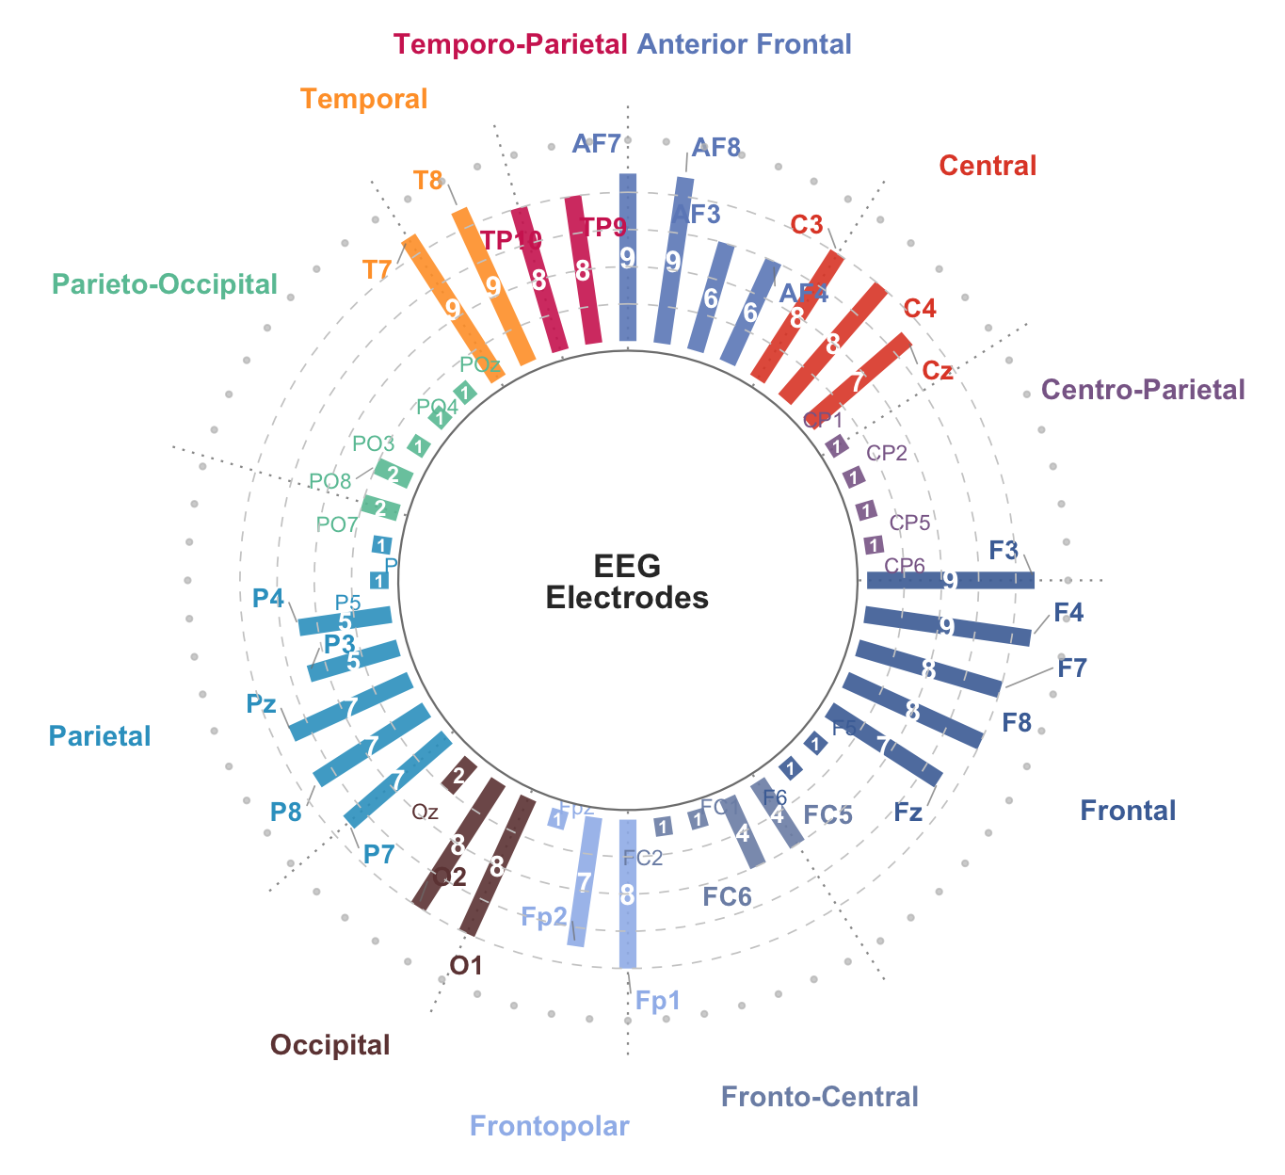

Supplementary Figure 3. Spatial distribution and functional significance of EEG electrode placement in wearable devices
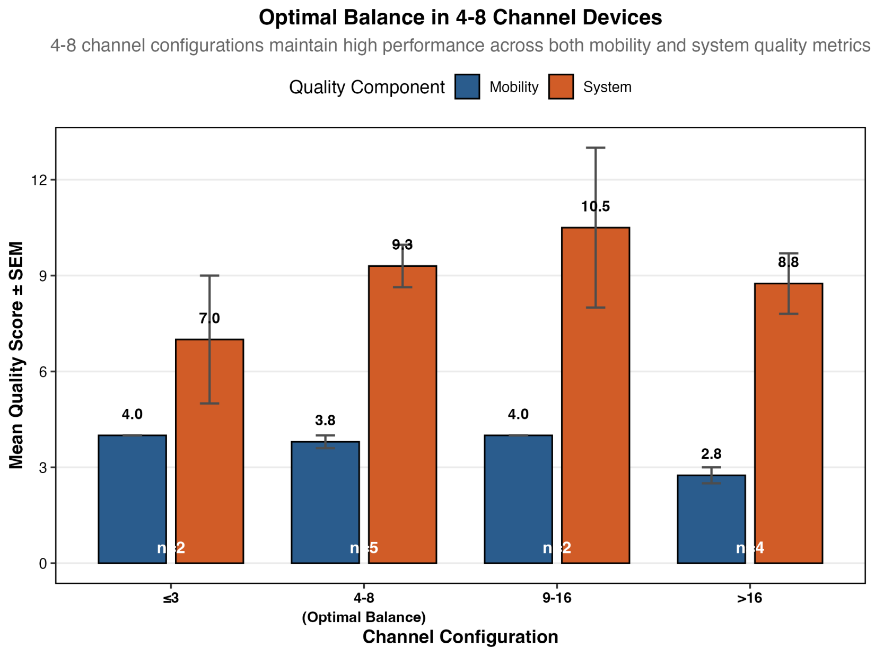
Supplementary Figure 4. Distribution of mobility and system quality scores by channel configuration.
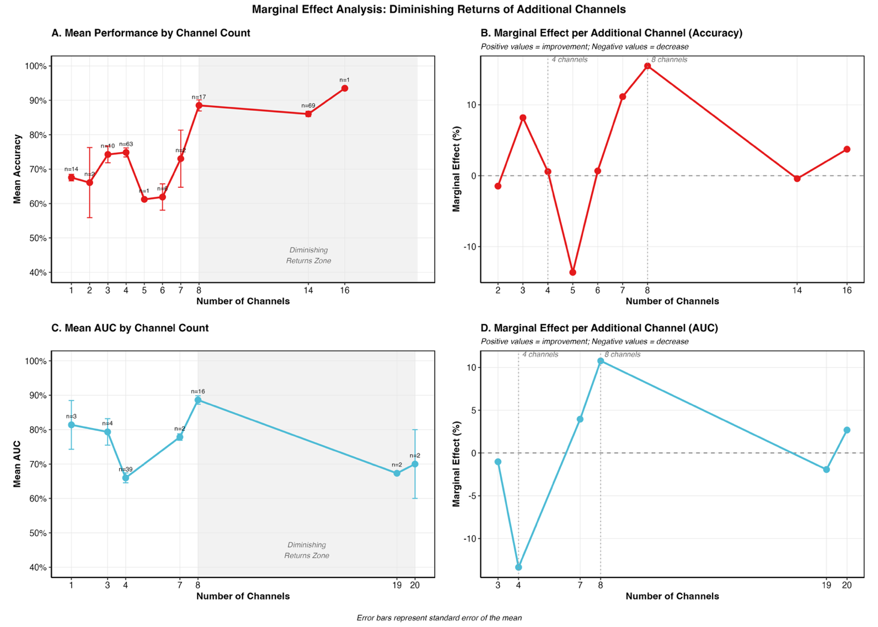

Supplementary Figure 5. Marginal effect analysis of diagnostic performance reveals an optimal EEG channel count for MCI detection.

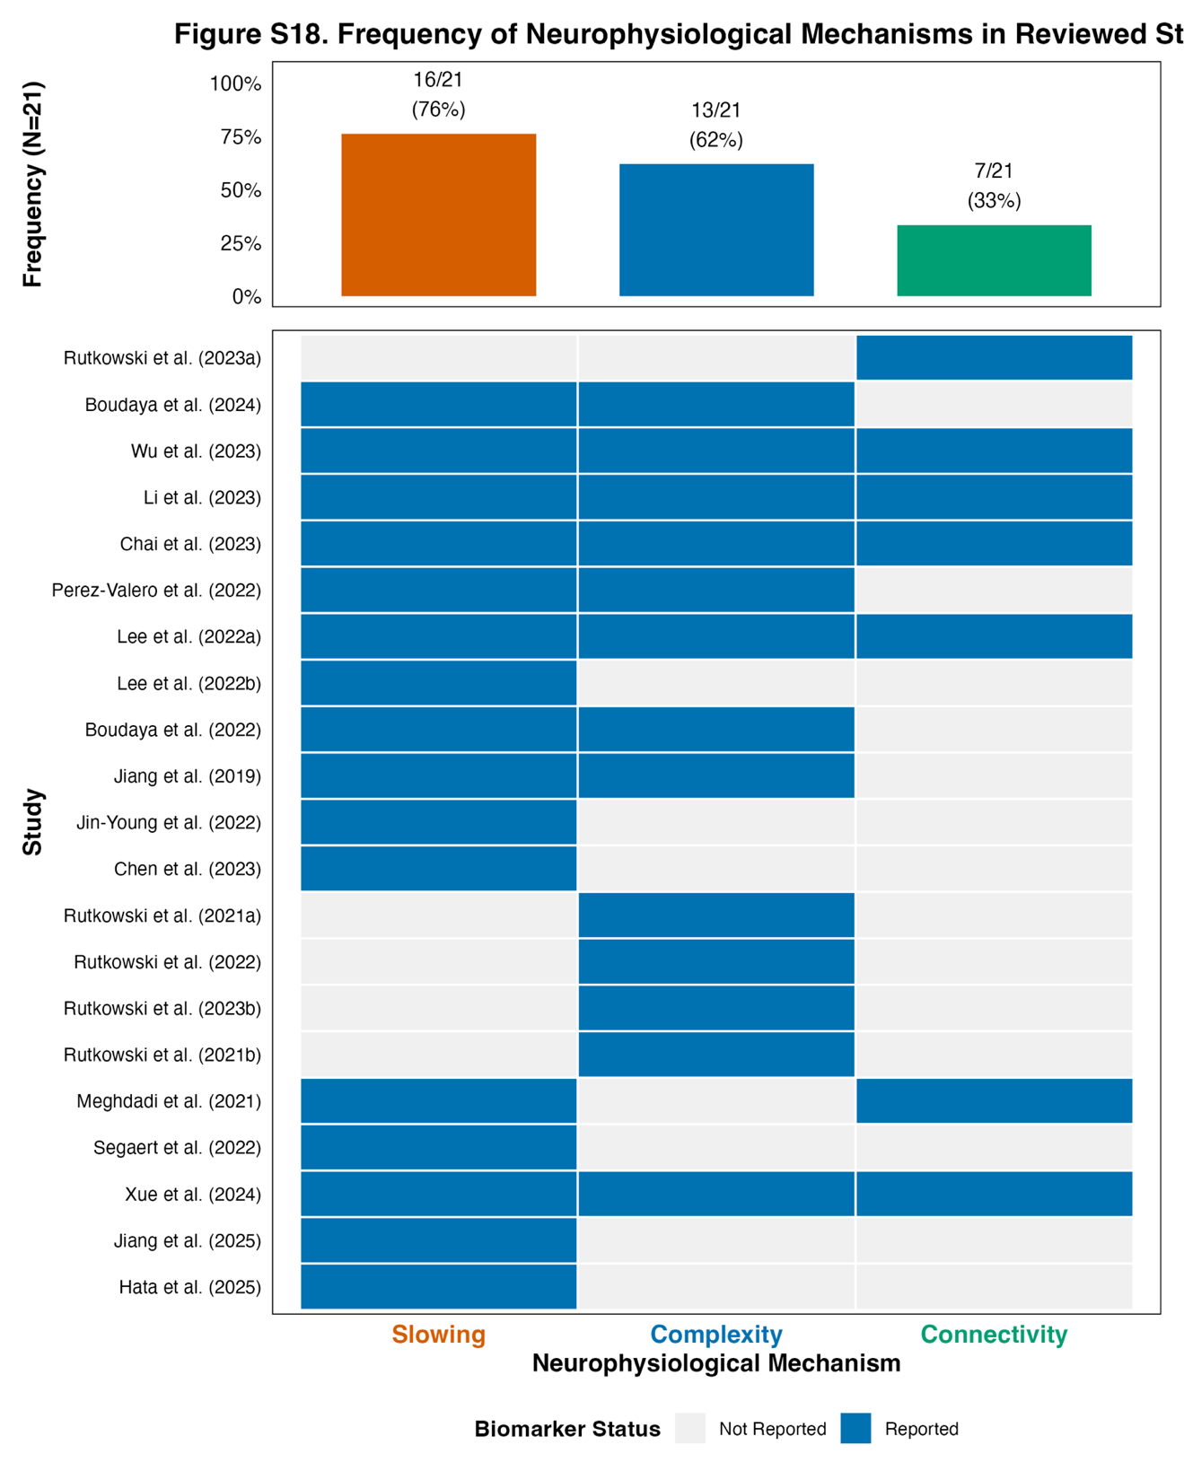

Supplementary Figure 6. Distribution and reporting frequency of neurophysiological biomarker categories across the 21 included studies.

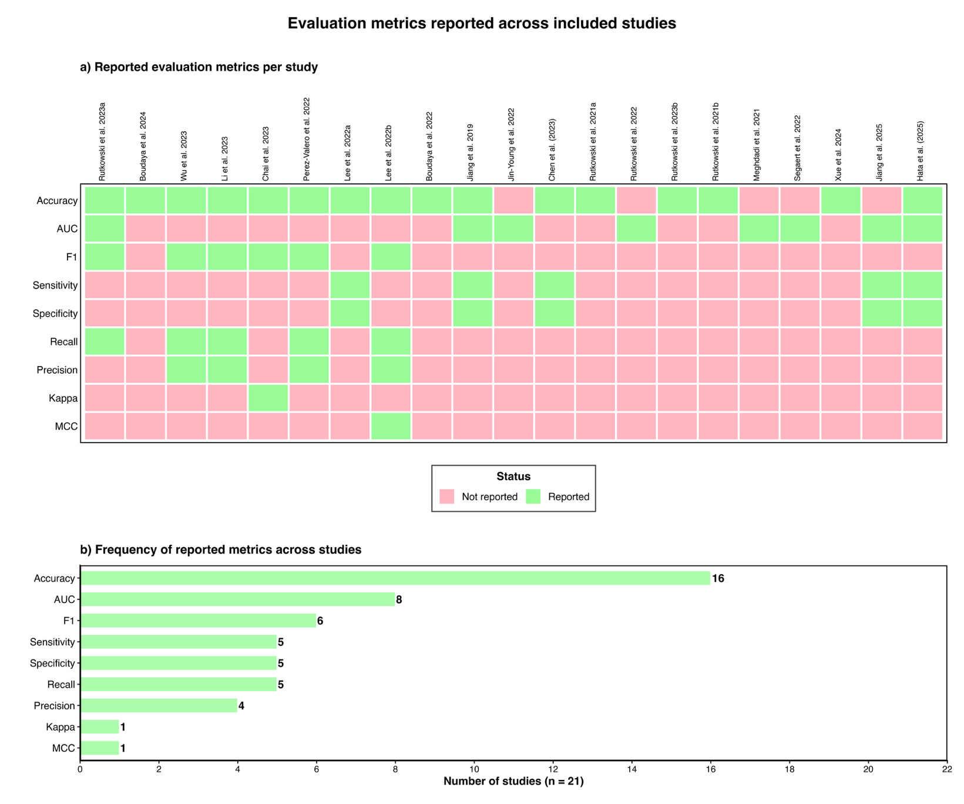

Supplementary Figure 7. Distribution and reporting frequency of performance evaluation metrics across the 21 included studies
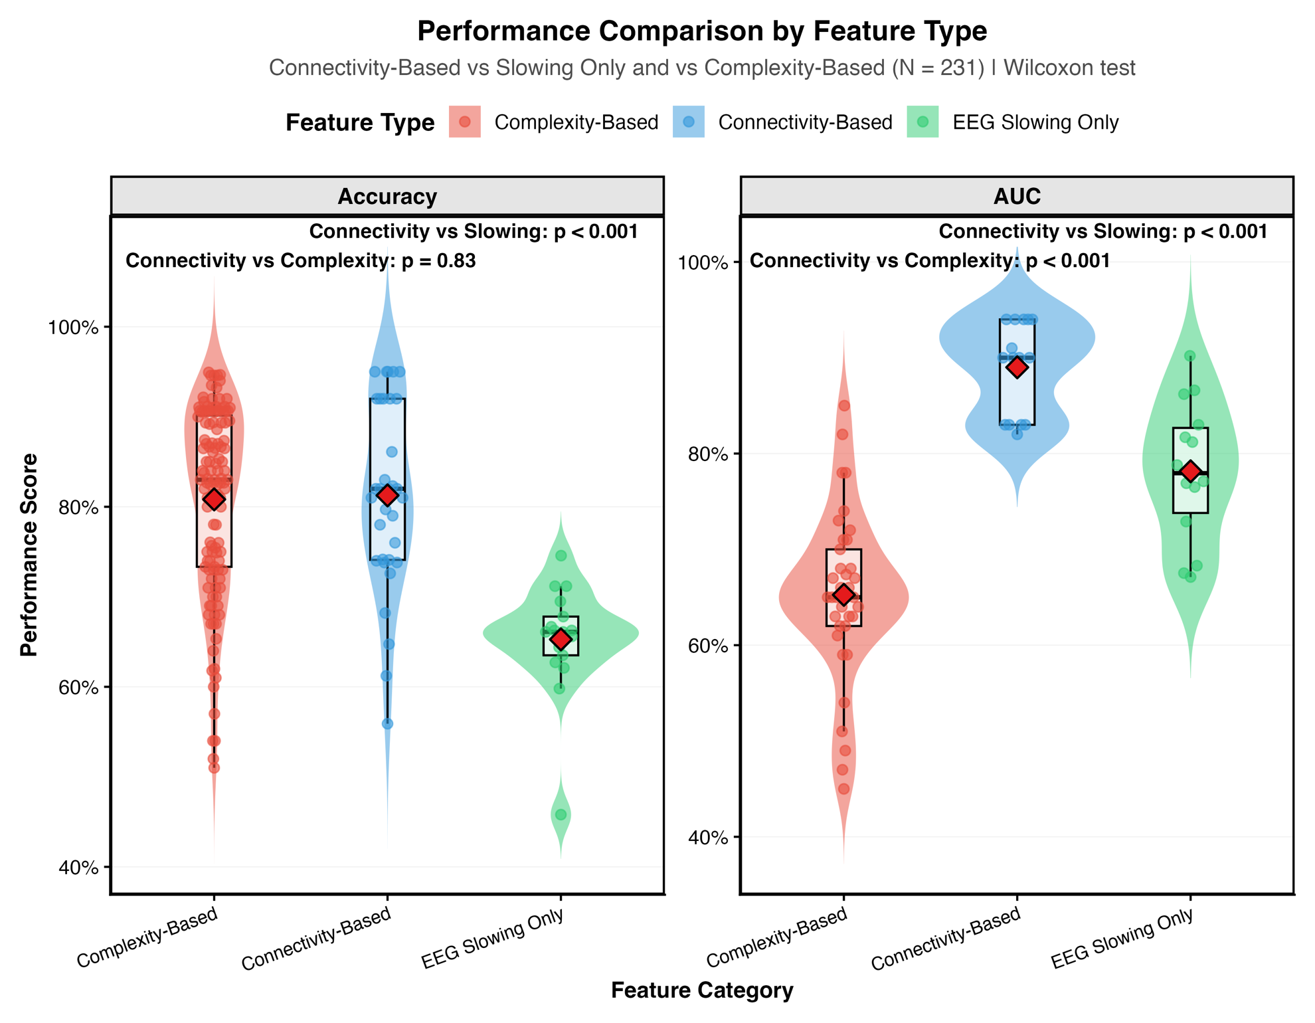

Supplementary Figure 8. Comparative analysis of diagnostic performance stratified by neurophysiological feature category.
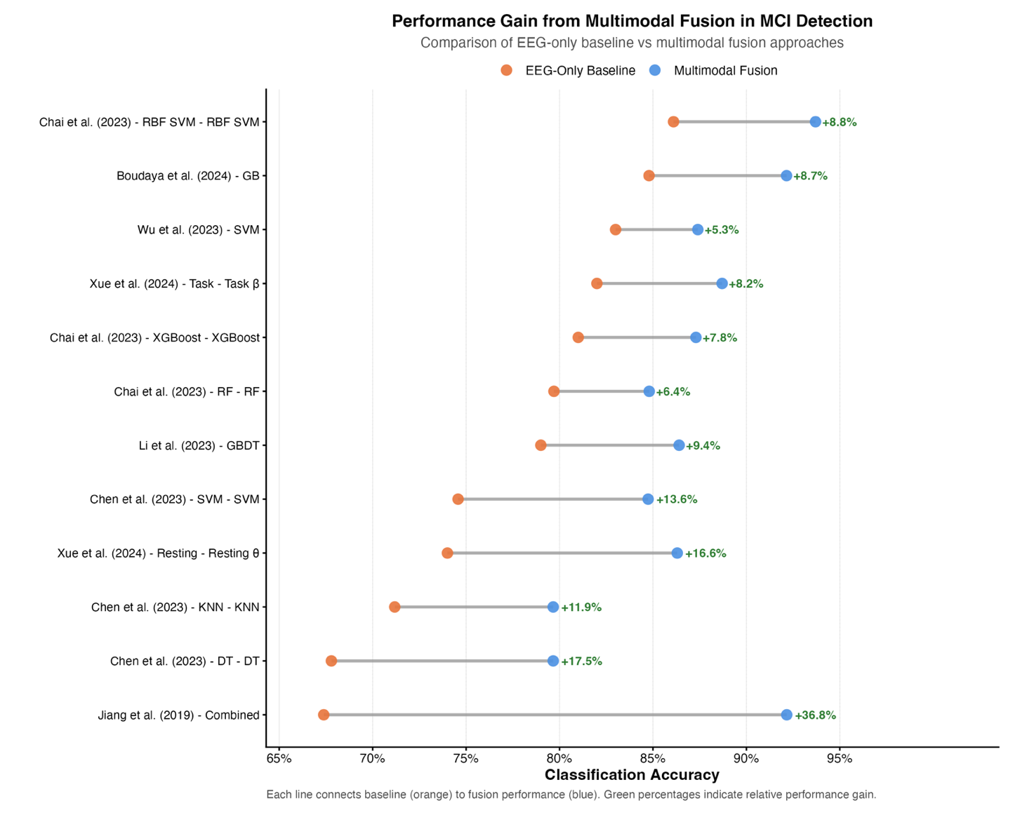

Supplementary Figure 9. Multimodal data fusion consistently enhances MCI classification accuracy compared to EEG-only approaches.

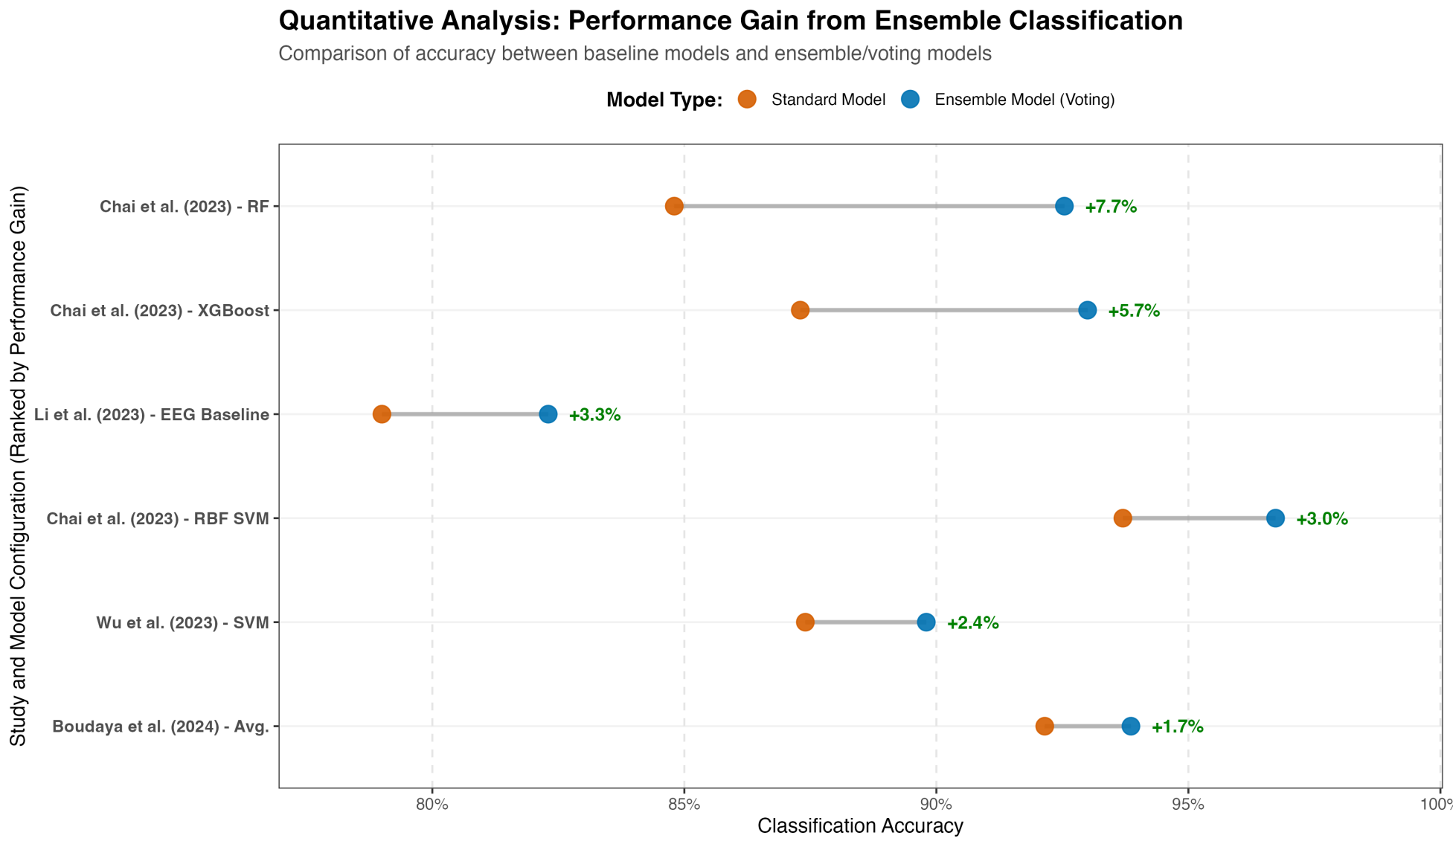

Supplementary Figure 10. Ensemble learning methods consistently improve classification accuracy over standard baseline models.

Supplementary Table 1. Searching strategies
Date: 01/01/2016-09/11/2024
Database: PubMed
Set # |  | Results
1 | Ear[Title/Abstract] OR wireless[Title/Abstract] OR Bluetooth[Title/Abstract] OR portable[Title/Abstract] OR mobile[Title/Abstract] OR wearable[Title/Abstract] OR smartphone[Title/Abstract] OR rapid response[Title/Abstract] OR activity-sensor[Title/Abstract] OR head-band[Title/Abstract] OR accelerometer[Title/Abstract] OR consumer[Title/Abstract] OR headset[Title/Abstract] OR smart-device[Title/Abstract] OR low-cost[Title/Abstract] OR user-friendly[Title/Abstract] OR home-based[Title/Abstract] OR non-invasive[Title/Abstract]
2 | ("Electroencephalography"[Mesh]) OR (((electroencephalograph[Title/Abstract]) OR (electroencephalogram[Title/Abstract])) OR (EEG[Title/Abstract]))
3 | (("Cognitive Dysfunction"[Mesh]) OR (Cognitive Dysfunctions[Title/Abstract])) OR (Cognitive Impairment[Title/Abstract])) OR (Cognitive Disorder[Title/Abstract])) OR (Mild Cognitive Impairment[Title/Abstract])) OR (mild cognitive[Title/Abstract])) OR (mild neurocognitive[Title/Abstract])) OR (Cognitive Decline[Title/Abstract])) OR (Mild Neurocognitive Disorder[Title/Abstract])
4 | (screen[Title/Abstract] OR detect[Title/Abstract] OR predict[Title/Abstract] OR evaluate[Title/Abstract] OR differentiate[Title/Abstract] OR diagnosis[Title/Abstract] OR measure[Title/Abstract] OR assess[Title/Abstract] OR characterize[Title/Abstract] OR distinguish[Title/Abstract] OR discriminate[Title/Abstract] OR classify[Title/Abstract] OR identify[Title/Abstract] OR monitor[Title/Abstract] OR early detection[Title/Abstract] OR sensitivity[Title/Abstract] OR specificity[Title/Abstract] OR accuracy[Title/Abstract] OR "screening test"[Title/Abstract] OR "diagnostic performance"[Title/Abstract] OR validation[Title/Abstract] OR biomarker[Title/Abstract] OR prognostic[Title/Abstract])
5 | NOT ((Editorial[Publication Type]) OR (Letter[Publication Type]) OR (Case Reports[Publication Type]) OR (Comment[Publication Type])) NOT (animals[MeSH Terms])
6 | #1 AND #2 AND #3 AND #4 AND #5 | 47

Database: IEEE
Set # |  | Results
1 | ("Document Title":Ear) OR ("Abstract":Ear) OR ("Document Title":wireless) OR ("Abstract":wireless) OR ("Document Title":Bluetooth) OR ("Abstract":Bluetooth) OR ("Document Title":portable) OR ("Abstract":portable) OR ("Document Title":mobile) OR ("Abstract":mobile) OR ("Document Title":wearable) OR ("Abstract":wearable) OR ("Document Title":smartphone) OR ("Abstract":smartphone) OR ("Document Title":"rapid response") OR ("Abstract":"rapid response") OR ("Document Title":"activity-sensor") OR ("Abstract":"activity-sensor") OR ("Document Title":"head-band") OR ("Abstract":"head-band") OR ("Document Title":accelerometer) OR ("Abstract":accelerometer) OR ("Document Title":consumer) OR ("Abstract":consumer) OR ("Document Title":headset) OR ("Abstract":headset) OR ("Document Title":"smart-device") OR ("Abstract":"smart-device") OR ("Document Title":"low-cost") OR ("Abstract":"low-cost") OR ("Document Title":"user-friendly") OR ("Abstract":"user-friendly") OR ("Document Title":"home-based") OR ("Abstract":"home-based") OR ("Document Title":"non-invasive") OR ("Abstract":"non-invasive")
2 | ("Document Title":"Electroencephalography") OR ("Abstract":"Electroencephalography") OR ("Document Title":electroencephalograph) OR ("Abstract":electroencephalograph) OR ("Document Title":electroencephalogram) OR ("Abstract":electroencephalogram) OR ("Document Title":EEG) OR ("Abstract":EEG)
3 | ("Document Title":"Cognitive Dysfunction") OR ("Abstract":"Cognitive Dysfunction") OR ("Document Title":"Cognitive Dysfunctions") OR ("Abstract":"Cognitive Dysfunctions") OR ("Document Title":"Cognitive Impairment") OR ("Abstract":"Cognitive Impairment") OR ("Document Title":"Cognitive Disorder") OR ("Abstract":"Cognitive Disorder") OR ("Document Title":"Mild Cognitive Impairment") OR ("Abstract":"Mild Cognitive Impairment") OR ("Document Title":"mild cognitive") OR ("Abstract":"mild cognitive") OR ("Document Title":"mild neurocognitive") OR ("Abstract":"mild neurocognitive") OR ("Document Title":"Cognitive Decline") OR ("Abstract":"Cognitive Decline") OR ("Document Title":"Mild Neurocognitive Disorder") OR ("Abstract":"Mild Neurocognitive Disorder")
4 | ("Document Title":screen) OR ("Abstract":screen) OR ("Document Title":detect) OR ("Abstract":detect) OR ("Document Title":predict) OR ("Abstract":predict) OR ("Document Title":evaluate) OR ("Abstract":evaluate) OR ("Document Title":differentiate) OR ("Abstract":differentiate) OR ("Document Title":diagnosis) OR ("Abstract":diagnosis) OR ("Document Title":measure) OR ("Abstract":measure) OR ("Document Title":assess) OR ("Abstract":assess) OR ("Document Title":characterize) OR ("Abstract":characterize) OR ("Document Title":distinguish) OR ("Abstract":distinguish) OR ("Document Title":discriminate) OR ("Abstract":discriminate) OR ("Document Title":classify) OR ("Abstract":classify) OR ("Document Title":identify) OR ("Abstract":identify) OR ("Document Title":monitor) OR ("Abstract":monitor) OR ("Document Title":"early detection") OR ("Abstract":"early detection") OR ("Document Title":sensitivity) OR ("Abstract":sensitivity) OR ("Document Title":specificity) OR ("Abstract":specificity) OR ("Document Title":accuracy) OR ("Abstract":accuracy) OR ("Document Title":"screening test") OR ("Abstract":"screening test") OR ("Document Title":"diagnostic performance") OR ("Abstract":"diagnostic performance") OR ("Document Title":validation) OR ("Abstract":validation) OR ("Document Title":biomarker) OR ("Abstract":biomarker) OR ("Document Title":prognostic) OR ("Abstract":prognostic)
5 | #1 AND #2 AND #3 AND #4 | 36

Database: Web of Science
Set # |  | Results
1 | (TI=(Ear) OR AB=(Ear) OR TI=(wireless) OR AB=(wireless) OR TI=(Bluetooth) OR AB=(Bluetooth) OR TI=(portable) OR AB=(portable) OR TI=(mobile) OR AB=(mobile) OR TI=(wearable) OR AB=(wearable) OR TI=(smartphone) OR AB=(smartphone) OR TI=("rapid response") OR AB=("rapid response") OR TI=("activity-sensor") OR AB=("activity-sensor") OR TI=("head-band") OR AB=("head-band") OR TI=(accelerometer) OR AB=(accelerometer) OR TI=(consumer) OR AB=(consumer) OR TI=(headset) OR AB=(headset) OR TI=("smart-device") OR AB=("smart-device") OR TI=("low-cost") OR AB=("low-cost") OR TI=("user-friendly") OR AB=("user-friendly") OR TI=("home-based") OR AB=("home-based") OR TI=("non-invasive") OR AB=("non-invasive"))
2 | (TS=("Electroencephalography") OR TI=(electroencephalograph) OR AB=(electroencephalograph) OR TI=(electroencephalogram) OR AB=(electroencephalogram) OR TI=(EEG) OR AB=(EEG))
3 | (TS=("Cognitive Dysfunction") OR TS=("Cognitive Dysfunctions") OR TI=("Cognitive Impairment") OR AB=("Cognitive Impairment") OR TI=("Cognitive Disorder") OR AB=("Cognitive Disorder") OR TI=("Mild Cognitive Impairment") OR AB=("Mild Cognitive Impairment") OR TI=("mild cognitive") OR AB=("mild cognitive") OR TI=("mild neurocognitive") OR AB=("mild neurocognitive") OR TI=("Cognitive Decline") OR AB=("Cognitive Decline") OR TI=("Mild Neurocognitive Disorder") OR AB=("Mild Neurocognitive Disorder"))
4 | (TI=(screen) OR AB=(screen) OR TI=(detect) OR AB=(detect) OR TI=(predict) OR AB=(predict) OR TI=(evaluate) OR AB=(evaluate) OR TI=(differentiate) OR AB=(differentiate) OR TI=(diagnosis) OR AB=(diagnosis) OR TI=(measure) OR AB=(measure) OR TI=(assess) OR AB=(assess) OR TI=(characterize) OR AB=(characterize) OR TI=(distinguish) OR AB=(distinguish) OR TI=(discriminate) OR AB=(discriminate) OR TI=(classify) OR AB=(classify) OR TI=(identify) OR AB=(identify) OR TI=(monitor) OR AB=(monitor) OR TI=("early detection") OR AB=("early detection") OR TI=(sensitivity) OR AB=(sensitivity) OR TI=(specificity) OR AB=(specificity) OR TI=(accuracy) OR AB=(accuracy) OR TI=("screening test") OR AB=("screening test") OR TI=("diagnostic performance") OR AB=("diagnostic performance") OR TI=(validation) OR AB=(validation) OR TI=(biomarker) OR AB=(biomarker) OR TI=(prognostic) OR AB=(prognostic))
5 | #1 AND #2 AND #3 AND #4 | 416

Database: Embase
Set # |  | Results
1 | ear:ab,ti OR wireless:ab,ti OR bluetooth:ab,ti OR portable:ab,ti OR mobile:ab,ti OR wearable:ab,ti OR smartphone:ab,ti OR 'rapid response':ab,ti OR 'activity-sensor':ab,ti OR 'head-band':ab,ti OR accelerometer:ab,ti OR consumer:ab,ti OR headset:ab,ti OR 'smart-device':ab,ti OR 'low-cost':ab,ti OR 'user-friendly':ab,ti OR 'home-based':ab,ti OR 'non-invasive':ab,ti
2 | 'electroencephalography'/exp OR electroencephalograph:ab,ti OR electroencephalogram:ab,ti OR eeg:ab,ti
3 | 'cognitive dysfunction'/exp OR 'cognitive dysfunctions':ab,ti OR 'cognitive impairment':ab,ti OR 'cognitive disorder':ab,ti OR 'mild cognitive impairment':ab,ti OR 'mild cognitive':ab,ti OR 'mild neurocognitive':ab,ti OR 'cognitive decline':ab,ti OR 'mild neurocognitive disorder':ab,ti
4 | screen:ab,ti OR detect:ab,ti OR predict:ab,ti OR evaluate:ab,ti OR differentiate:ab,ti OR diagnosis:ab,ti OR measure:ab,ti OR assess:ab,ti OR characterize:ab,ti OR distinguish:ab,ti OR discriminate:ab,ti OR classify:ab,ti OR identify:ab,ti OR monitor:ab,ti OR 'early detection':ab,ti OR sensitivity:ab,ti OR specificity:ab,ti OR accuracy:ab,ti OR 'screening test':ab,ti OR 'diagnostic performance':ab,ti OR validation:ab,ti OR biomarker:ab,ti OR prognostic:ab,ti
5 | [humans]/lim AND [english]/lim AND ([embase]/lim OR [medline]/lim)
6 | #1 AND #2 AND #3 AND #4 AND #5 | 453

Database: APA PsycInfo
Set # |  | Results
1 | TI Ear OR AB Ear OR TI wireless OR AB wireless OR TI Bluetooth OR AB Bluetooth OR TI portable OR AB portable OR TI mobile OR AB mobile OR TI wearable OR AB wearable OR TI smartphone OR AB smartphone OR TI "rapid response" OR AB "rapid response" OR TI "activity-sensor" OR AB "activity-sensor" OR TI "head-band" OR AB "head-band" OR TI accelerometer OR AB accelerometer OR TI consumer OR AB consumer OR TI headset OR AB headset OR TI "smart-device" OR AB "smart-device" OR TI "low-cost" OR AB "low-cost" OR TI "user-friendly" OR AB "user-friendly" OR TI "home-based" OR AB "home-based" OR TI "non-invasive" OR AB "non-invasive"
2 | MH "Electroencephalography" OR TI electroencephalograph OR AB electroencephalograph OR TI electroencephalogram OR AB electroencephalogram OR TI EEG OR AB EEG
3 | MH "Cognitive Dysfunction" OR TI "Cognitive Dysfunctions" OR AB "Cognitive Dysfunctions" OR TI "Cognitive Impairment" OR AB "Cognitive Impairment" OR TI "Cognitive Disorder" OR AB "Cognitive Disorder" OR TI "Mild Cognitive Impairment" OR AB "Mild Cognitive Impairment" OR TI "mild cognitive" OR AB "mild cognitive" OR TI "mild neurocognitive" OR AB "mild neurocognitive" OR TI "Cognitive Decline" OR AB "Cognitive Decline" OR TI "Mild Neurocognitive Disorder" OR AB "Mild Neurocognitive Disorder"
4 | TI screen OR AB screen OR TI detect OR AB detect OR TI predict OR AB predict OR TI evaluate OR AB evaluate OR TI differentiate OR AB differentiate OR TI diagnosis OR AB diagnosis OR TI measure OR AB measure OR TI assess OR AB assess OR TI characterize OR AB characterize OR TI distinguish OR AB distinguish OR TI discriminate OR AB discriminate OR TI classify OR AB classify OR TI identify OR AB identify OR TI monitor OR AB monitor OR TI "early detection" OR AB "early detection" OR TI sensitivity OR AB sensitivity OR TI specificity OR AB specificity OR TI accuracy OR AB accuracy OR TI "screening test" OR AB "screening test" OR TI "diagnostic performance" OR AB "diagnostic performance" OR TI validation OR AB validation OR TI biomarker OR AB biomarker OR TI prognostic OR AB prognostic
5 | #1 AND #2 AND #3 AND #4 | 50
*Limiters -Publication Date: 20160101-20241231; English language; Population Group: Human
Expanders -Apply equivalent subjects
Search modes -Proximity

Database: CINAHL
Set # |  | Results
1 | TI Ear OR AB Ear OR TI wireless OR AB wireless OR TI Bluetooth OR AB Bluetooth OR TI portable OR AB portable OR TI mobile OR AB mobile OR TI wearable OR AB wearable OR TI smartphone OR AB smartphone OR TI "rapid response" OR AB "rapid response" OR TI "activity-sensor" OR AB "activity-sensor" OR TI "head-band" OR AB "head-band" OR TI accelerometer OR AB accelerometer OR TI consumer OR AB consumer OR TI headset OR AB headset OR TI "smart-device" OR AB "smart-device" OR TI "low-cost" OR AB "low-cost" OR TI "user-friendly" OR AB "user-friendly" OR TI "home-based" OR AB "home-based" OR TI "non-invasive" OR AB "non-invasive"
2 | MH "Electroencephalography" OR TI electroencephalograph OR AB electroencephalograph OR TI electroencephalogram OR AB electroencephalogram OR TI EEG OR AB EEG
3 | MH "Cognitive Dysfunction" OR TI "Cognitive Dysfunctions" OR AB "Cognitive Dysfunctions" OR TI "Cognitive Impairment" OR AB "Cognitive Impairment" OR TI "Cognitive Disorder" OR AB "Cognitive Disorder" OR TI "Mild Cognitive Impairment" OR AB "Mild Cognitive Impairment" OR TI "mild cognitive" OR AB "mild cognitive" OR TI "mild neurocognitive" OR AB "mild neurocognitive" OR TI "Cognitive Decline" OR AB "Cognitive Decline" OR TI "Mild Neurocognitive Disorder" OR AB "Mild Neurocognitive Disorder"
4 | TI screen OR AB screen OR TI detect OR AB detect OR TI predict OR AB predict OR TI evaluate OR AB evaluate OR TI differentiate OR AB differentiate OR TI diagnosis OR AB diagnosis OR TI measure OR AB measure OR TI assess OR AB assess OR TI characterize OR AB characterize OR TI distinguish OR AB distinguish OR TI discriminate OR AB discriminate OR TI classify OR AB classify OR TI identify OR AB identify OR TI monitor OR AB monitor OR TI "early detection" OR AB "early detection" OR TI sensitivity OR AB sensitivity OR TI specificity OR AB specificity OR TI accuracy OR AB accuracy OR TI "screening test" OR AB "screening test" OR TI "diagnostic performance" OR AB "diagnostic performance" OR TI validation OR AB validation OR TI biomarker OR AB biomarker OR TI prognostic OR AB prognostic
5 | #1 AND #2 AND #3 AND #4 | 21
*Limiters -Publication Date: 20160101-20241231; English language
Expanders -Apply equivalent subjects
Search modes -Proximity

Database: Scopus
Set # |  | Results
1 | TITLE-ABS-KEY ( ear OR wireless OR bluetooth OR portable OR mobile OR wearable OR smartphone OR "rapid response" OR "activity-sensor" OR "head-band" OR accelerometer OR consumer OR headset OR "smart-device" OR "low-cost" OR "user-friendly" OR "home-based" OR "non-invasive"
2 | TITLE-ABS-KEY ( electroencephalogram OR EEG )
3 | TITLE-ABS-KEY ( "Cognitive Dysfunctions" OR "Cognitive Impairment" OR "Cognitive Disorder" OR "Mild Cognitive Impairment" OR "mild cognitive" OR "mild neurocognitive" OR "Cognitive Decline" OR "Mild Neurocognitive Disorder" )
4 | TITLE-ABS-KEY (screen OR detect OR predict OR evaluate OR differentiate OR diagnosis OR measure OR assess OR characterize OR distinguish OR discriminate OR classify OR identify OR monitor OR "early detection" OR sensitivity OR specificity OR accuracy OR "'screening test" OR "diagnostic performance" OR validation OR biomarker OR prognostic)
5 | #1 AND #2 AND #3 AND #4 | 0?

Supplementary Table 2. Inclusion and exclusion criteria for studies on wearable EEG in mild cognitive impairment detection
Category | Inclusion Criteria | Exclusion Criteria
Population | Studies enrolling participants with a clinical diagnosis of mild cognitive impairment (MCI) and age-matched healthy controls (HC). | Studies lacking either MCI or HC groups; animal or in vitro investigations.
Wearable EEG Device | Studies employing miniaturized, portable, wireless, and user-friendly head-mounted EEG systems capable of recording brain activity in naturalistic or daily-life environments. The definition prioritizes portability, untethered operation, and feasibility outside laboratory settings, without restrictions on electrode configuration or material. | Devices requiring wired connections to stationary amplifiers or recording consoles; invasive or semi-invasive EEG systems (e.g., intracranial, subdural, or electrocorticographic electrodes). Systems described by the manufacturer or study protocol as intended solely for experimental or hospital-based diagnostic use, rather than for portable or real-world applications. Studies were also excluded if the recording setup necessitated participant immobilization or continuous connection to fixed hardware (e.g., bedside amplifiers, rack-mounted consoles, or wired signal hubs).
Outcomes | Studies reporting EEG-derived metrics or classification performance for MCI detection, including at least one quantitative indicator (e.g., accuracy, sensitivity, specificity, F1-score, or AUC), with a binary classification design (MCI vs. HC). | Studies evaluating therapeutic or interventional effects, employing multi-class classification (e.g., MCI vs. AD vs. HC), or focusing on dementia subtypes without isolating MCI.
Study Design | Original, peer-reviewed research articles published in English. | Duplicate publications, reviews, preprints, conference abstracts, editorials, commentaries, or non-English articles.

Supplementary Table 3. Justification for inclusion of 15 wearable EEG devices
Author (Year) | Device |  | Rationale for inclusion
Rutkowski et al. (2023a) | Unicorn EEG headset | 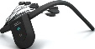 | A miniaturized, portable, wireless head-mounted EEG system with 8 channels, designed for user-friendly operation in naturalistic settings without requiring fixed hardware connections or extensive preparation.
Lee et al. (2022b) | Looxid Link | 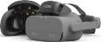 | A lightweight, portable, wireless head-mounted EEG accessory (6 channels) compatible with VR headsets, designed for mobile brain monitoring in naturalistic and real-world environments without tethered connections.
Perez-Valero et al. (2022) | Versatile | 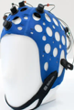 | A portable, wireless, head-mounted wearable EEG system designed specifically for mobile, real-world research applications, featuring user-friendly setup that eliminates the need for fixed recording equipment.
Lee et al. (2022a) | Focusband | 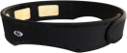 | A lightweight, miniaturized, wireless head-mounted neurofeedback EEG headband designed for portable use in daily-life settings with user-friendly operation via Bluetooth-connected mobile devices.
Lee et al. (2022a) | DSI-7 | 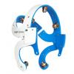 | A miniaturized, portable, wireless head-mounted EEG system (7 configurable channels plus 2 earclip sensors) designed for rapid, user-friendly deployment in naturalistic, non-laboratory settings.
Lee et al. (2022a) | Imec | 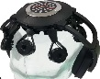 | A portable, wireless, miniaturized head-mounted brain monitoring system emphasizing user-friendly design, lightweight construction, and suitability for mobile applications outside laboratory settings.
Lee et al. (2022a) | Insight | 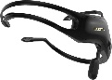 | A 4-channel miniaturized, portable, wireless head-mounted EEG headset designed for user-friendly field research and daily-life applications without requiring fixed recording equipment.
Lee et al. (2022a) | EPOC X | 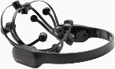 | A miniaturized, portable, wireless head-mounted EEG system designed for mobile brain research in naturalistic settings with user-friendly setup requiring no fixed amplifier connections.
Boudaya et al. (2024) | EPOC X
Boudaya et al. (2022) | EPOC X
Jiang et al. (2019) | MindWave MW001 | 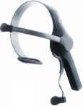 | A single-channel miniaturized, portable, wireless head-mounted EEG headset designed for user-friendly, unsupervised brain monitoring in naturalistic daily-life settings without requiring fixed recording hardware.
Jin-Young et al. (2022) | MINDD SCAN | 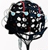 | A portable, wireless, miniaturized head-mounted EEG device (regulatory-approved) designed for rapid, user-friendly deployment in clinical and research applications outside traditional laboratory settings.
Chen et al. (2023) | DSI-24 | 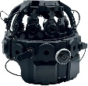 | A miniaturized, portable, wireless head-mounted research-grade EEG system (21 channels) designed for user-friendly naturalistic data collection in real-world environments including VR, sports, and field research.
Rutkowski et al. (2021a) | MUSE 2 | 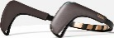 | A miniaturized, portable, wireless head-mounted consumer-grade EEG headband (7 sensors) designed for user-friendly at-home brain monitoring in naturalistic settings via smartphone/tablet applications.
Rutkowski et al. (2022) | MUSE 2
Rutkowski et al. (2023b) | MUSE 2
Rutkowski et al. (2021b) | MUSE 2
Wu et al. (2023) | MUSE 2
Li et al. (2023) | MUSE 2
Chai et al. (2023) | MUSE 2
Xue et al. (2024) | MUSE 2
Meghdadi et al. (2021) | STAT™ X24 | 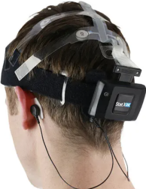 | A miniaturized, portable, wireless head-mounted clinical-grade EEG system (20 channels in 10-20 montage) designed for deployment in naturalistic settings outside traditional laboratory environments without requiring fixed recording equipment.
Segaert et al. (2022) | Open-cEEGrids Around-the-Ear EEG Bundle | 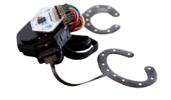 | A miniaturized, portable, flexible head-mounted EEG electrode system (c-shaped around-ear configuration) that becomes fully wireless when paired with portable amplifiers, designed for discrete long-term recording in naturalistic settings.
Jiang et al. (2025) | g.Nautilus | 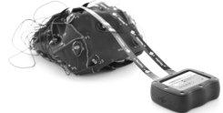 | A miniaturized, portable, wireless head-mounted EEG system (8/16/32/64 channels, CE/FDA-cleared) designed for user-friendly naturalistic data collection in motion-intensive real-world applications without fixed hardware requirements.
Hata et al. (2025) | HARU-1 | 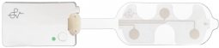 | A miniaturized, portable, wearable sheet-type frontal EEG device designed for user-friendly naturalistic sleep monitoring at home without requiring fixed recording equipment.

Supplementary Table 4. Technical specifications of wearable EEG devices and associated assessment protocols
Author (Year) | Device | Channels (n) | Key Electrode Positions | Brain Regions Covered | Sampling Rate (Hz) | Protocol | Duration (min) | Cognitive Domains Assessed
Rutkowski et al. (2023a) | Unicorn EEG headset | 8 | Fz, C3, Cz, C4, Pz, PO7, Oz, PO8 | Frontal, central, parietal, parieto-occipital, occipital | 250 | Facial video-based emotion assessment + Interior oddball working memory task | NR | Visual-spatial learning, working memory, short-term memory
Boudaya et al. (2024) | EPOC X | 14 | AF3, AF4, F3, F4, F7, F8, FC5, FC6, T7, T8, P7, P8, O1, O2 | Anterior frontal, frontal, fronto-central, temporal, parietal, occipital | 128 | CERAD test battery | 8 | Executive functions, visual perception, short/long-term memory, visual construction, verbal memory
Wu et al. (2023) | MUSE 2 | 4 | TP9, AF7, AF8, TP10 | Anterior frontal, temporo-parietal | 256 | Open eyes + Dual VR language cognition tasks | RS: 3; Tasks: NR | Visuospatial functions
Li et al. (2023) | MUSE 2 | 4 | AF7, AF8, TP9, TP10 | Anterior frontal, frontopolar, temporo-parietal | 256 | Closed eyes + Cognitive battery tests | RS: 5; Tasks: NR | Verbal fluency, memory, attention, auditory/visuospatial functions, executive functions
Chai et al. (2023) | MUSE 2 | 4 | AF7, AF8, TP9, TP10 | Anterior frontal, temporo-parietal | 256 | Closed eyes + Handwriting motor tasks | RS: 1; Tasks: NR | Motor control, visuospatial functions
Perez-Valero et al. (2022) | Versatile | 16 | Fp1, Fp2, F5, F6, Fz, C3, C4, Cz, T7, T8, P5, P6, Pz, O1, O2, Oz | Frontopolar, frontal, temporal, central, parietal, occipital | 256 | Open eyes | 6 | —
Lee et al. (2022a) | Focusband | 2 | Fp1, Fp2 | Frontopolar | 256 | Closed eyes | 4 | —
Lee et al. (2022a) | DSI-7 | 7 | F3, F4, C3, C4, P3, P4, Pz | Frontal, central, parietal | 300 | Closed eyes | 4 | —
Lee et al. (2022a) | Imec | 8 | F7, F3, Fz, F4, F8, C3, Cz, C4 | Frontal, central | 128 | Closed eyes | 4 | —
Lee et al. (2022a) | Insight | 4 | AF3, AF4, T7, T8 | Anterior frontal, temporal, parietal midline | 128 | Closed eyes | 4 | —
Lee et al. (2022a) | EPOC X | 14 | AF3, AF4, F7, F3, F4, F8, FC5, FC6, T7, T8, P7, P8, O1, O2 | Anterior frontal, frontal, fronto-central, temporal, parietal, occipital | 128 | Closed eyes | 4 | —
Lee et al. (2022b) | Looxid Link | 6 | AF3, AF4, AF7, AF8, Fp1, Fp2 | Anterior frontal, frontopolar | 500 | Closed eyes + VR tasks | NR | Focused attention, selective attention, working memory, depth perception
Boudaya et al. (2022) | EPOC X | 14 | AF3, AF4, F3, F4, F7, F8, FC5, FC6, T7, T8, P7, P8, O1, O2 | Anterior frontal, frontal, fronto-central, temporal, parietal, occipital | 128 | CERAD test battery | 8 | Executive functions, visual perception, short/long-term memory, visual construction, verbal memory
Jiang et al. (2019) | MindWave MW001 | 1 | Fp1 | Left frontopolar | 500 | Track calibration + Closed eyes + Visual tracking task | 7 | Attention
Jin-Young et al. (2022) | MINDD SCAN | 19 | Fp1, Fp2, F3, F4, F7, F8, Fz, C3, C4, Cz, T7, T8, P3, P4, P7, P8, Pz, O1, O2 | Frontopolar, frontal, temporal, central, parietal, occipital | 500 | Closed eyes | 5 | —
Chen et al. (2023) | DSI-24 | 19 | Fp1, Fp2, F3, F4, F7, F8, Fz, C3, C4, Cz, T7, T8, P3, P4, P7, P8, Pz, O1, O2 | Frontal, central, temporal, parietal, occipital | 300 | Delayed match-to-sample task | 11 | Short-term memory
Rutkowski et al. (2021a) | MUSE 2 | 4 | TP9, AF7, AF8, TP10 | Anterior frontal, temporo-parietal | 256 | Face identity and facial emotion oddball task | NR | Attention, working memory, visuospatial assessment
Rutkowski et al. (2022) | MUSE 2 | 4 | TP9, AF7, AF8, TP10 | Anterior frontal, temporo-parietal | 256 | Reminiscent interior image working memory paradigm | NR | Working memory
Rutkowski et al. (2023b) | MUSE 2 | 4 | TP9, AF7, AF8, TP10 | Anterior frontal, temporo-parietal | 256 | Facial emotion oddball paradigm | NR | Attention, working memory, visuospatial assessment
Rutkowski et al. (2021b) | MUSE 2 | 4 | TP9, AF7, AF8, TP10 | Anterior frontal, temporo-parietal | 256 | Facial emotion oddball paradigm | NR | Attention, working memory, visuospatial assessment
Meghdadi et al. (2021) | STAT™ X24 | 20 | Fp1, Fp2, F7, F3, Fz, F4, F8, T3, C3, Cz, C4, T4, T5, P3, Pz, P4, T6, O1, O2, POz | Frontal, central, parietal, occipital, temporal | 256 | Closed eyes +Open eyes | 10 | —
Segaert et al. (2022) | cEEGrid | 18 | L1–L10 (left), R1–R10 (right) | Temporal (inferior temporal cortex) | 500 | Two-word phrase language comprehension task | NR | Language comprehension, lexical retrieval, semantic binding
Xue et al. (2024) | MUSE 2 | 4 | TP9, AF7, AF8, TP10 | Anterior frontal, temporo-parietal | 256 | Resting-state + VR tasks | RS: 5; Tasks: ~17 | Attention, visuospatial working memory, executive functions
Jiang et al. (2025) | g.Nautilus | 32 | Fp1, Fp2, AF3, AF4, F3, F4, F7, F8, Fz, FC1, FC2, FC5, FC6, C3, C4, Cz, T7, T8, CP1, CP2, CP5, CP6, P3, P4, P7, P8, Pz, PO3, PO4, PO7, PO8, O1, O2 | Frontal, central, parietal, parieto-occipital, occipital | 250 | Delayed sample-matching | 5 | Working memory, visual recognition
Hata et al. (2025) | HARU-1 | 3 | ChZ, ChR, ChL | Frontal | 250 | Closed eyes | 2 | —
Abbreviations:
NR, not reported; RS, resting state; VR, virtual reality; CERAD, Consortium to Establish a Registry for Alzheimer's Disease; Hz, Hertz; min, minutes.
Note: Lee et al. (2022a): Compared Focusband™ (2ch), Insight™ (4ch), DSI-7™ (7ch), Imec™ (8ch), and EPOC™ (14ch).
Electrode positioning: All studies reported electrode positions according to the international 10-20 system or manufacturer specifications.

Supplementary Table 5. The modified version of the Quality of Diagnostic Accuracy Studies 2 (QUADAS-2)
 | Signaling questions | Explanation
Participants
 | 1.1 Was a consecutive or random sample of patients enrolled? | -Yes: If a consecutive or random sample of eligible patients was enrolled.  - No: If patients were selected by convenience;  - Unclear: If the study did not report the manner in which participants were enrolled.
 | 1.2 Did the study avoid inappropriate exclusions? | - Yes: If inclusion and exclusion of participants were appropriate, so participants correspond to unselected participants of interest.  - No: If participants are included who would already have been identified as having mild cognitive impairment and so are no longer participants at suspicion of disease (diagnostic studies),  or if specific subgroups are excluded that may have altered the performance of the prediction model for the intended target population.  - Unclear: When there is no information on whether inappropriate inclusions or exclusions took place.
 | 1.3 Was the sample size sufficient? | - Yes: For model validation studies, if the number of participants is ≥100.  - No: For model validation studies, if the number of participants with MCI is <100.  - Unclear: For model development studies, no information on the number of candidate predictor parameters or number of participants with MCI, such that the EPV cannot be calculated.  For model validation studies, no information on the number of participants with MCI.
 | 1.4 Was there a balance in the number of patients between the subgroups (MCI vs. normal cognition)? | - Yes: If the percentage of participants in any group is 66.7 or less of the sample (≤2/3).  - No: If the percentage of participants in any group is more than 66.7 of the sample (>2/3).  - Unclear: If no information was provided regarding the number of participants in the groups.
 | Risk of bias assessment: Could the selection of participants have introduced bias? | - Low risk of bias: If the answers to all signaling questions is ‘yes’ then risk of bias can be considered low. If the answer to one or more questions is ‘no,’ the judgment could still be ‘low risk of bias,’ but specific reasons should be given why the risk of bias can be considered low.  - High risk of bias: If the answer to any of the signaling questions is ‘no,’ there is a potential for bias, unless defined as low risk of bias as above.  - Unclear risk of bias: If relevant information is missing for all or some of the signaling questions, and none of the answers to the signaling questions were judged to put the domain at high risk of bias.
 | Applicability concerns: Are there concerns that the included participants and setting do not match the review question? | - Low applicability concerns: If the spectrum of participants (inclusion and exclusion criteria, setting, prior testing) matches the pre-specified requirements in the review question.  - High applicability concerns: If the spectrum of participants does not fully match the pre-specified requirements in the review question.  - Unclear applicability concerns: If insufficient information is available to make a judgment on applicability.
Index Test (Wearable EEG Device) | 2.1 Are the EEG device and algorithm described in detail? | - Yes: If device specifications (e.g., number of electrodes, sampling rate, bandwidth) and algorithm details such as signal processing methods, feature extraction techniques, classifier type and parameters are provided. Alternatively, if previously published methods are used, the paper must cite references meeting the aforementioned standards and fully describe any modifications made to the methods.  - No: If only the name of the device or algorithm is reported in the paper, or if the study reports some information but still lacks other important information.
 | 2.2 Are all EEG features used in the model clearly identified? | - Yes: If all EEG features used in each model are reported (e.g., frequency band power, waveform features, connectivity metrics, time-frequency analysis, etc.).  - No: If any features used in any model are not reported. Or if all features used in the paper are identified, but it is unclear which features were used in each model.
 | 2.3 Was the EEG data assessed in the same way for all participants? | - Yes: If the EEG recording method, recording conditions (e.g., resting state, specific tasks), and data processing methods were similar for all participants.  - No: If different EEG recording setups, conditions, or processing methods were used for different participants.  - Unclear: If there is no detailed information on how EEG data was collected or processed.
 | 2.4 Was the EEG data collected and analyzed without knowledge of cognitive status? | - Yes: If it is explicitly stated that cognitive status information was not used during EEG data collection and analysis, or if the persons performing data processing evidently did not (yet) have access to cognitive status information.  - No: If it is clearly indicated that cognitive status information was used when collecting or analyzing EEG data.  - Unclear: If there is no information about whether EEG data was collected and analyzed without knowledge of cognitive status information.
 | Risk of bias assessment: Could the conduct or interpretation of the index test have introduced bias? | - Low risk of bias: If the answers to all signaling questions is ‘yes’ then risk of bias can be considered low. If the answer to one or more questions is ‘no,’ the judgment could still be ‘low risk of bias,’ but specific reasons should be given why the risk of bias can be considered low, e.g., use of automated EEG analysis methods that do not require subjective interpretation.  - High risk of bias: If the answer to any of the signaling questions is ‘no,’ there is a potential for bias, unless defined as low risk of bias as above.  - Unclear risk of bias: If relevant information is missing for all or some of the signaling questions, and none of the answers to the signaling questions were judged to put the domain at high risk of bias.
 | Applicability concerns: Are there concerns that the EEG device configuration, data acquisition, or analysis methods do not match the review question? | - Low applicability concerns: The type of wearable EEG device, configuration, data acquisition, and analysis methods match the review question.  - High applicability concerns: The type of EEG device (e.g., non-portable), configuration, or analysis methods used differ from the wearable EEG devices of interest in the review question.  - Unclear applicability concerns: If relevant information about the EEG device and analysis methods is not reported.
Reference Standard (MCI Diagnosis) | 3.1 Is the reference standard likely to correctly classify MCI? Is the diagnostic tool used appropriate? | - Yes: If the study used internationally recognized MCI diagnostic criteria such as Petersen criteria, NIA-AA criteria, DSM-5 neurocognitive disorder criteria, or used comprehensive neuropsychological testing (e.g., MMSE, MoCA, ADAS-Cog, etc.) combined with clinical assessment. Or if clinical diagnosis was made by qualified specialists (e.g., neurologists, geriatricians, or neuropsychologists).  - No: If only a single brief cognitive screening (e.g., MMSE alone) was used without clinical assessment. Or if diagnosis was made by unqualified assessors.  - Unclear: If no information is provided about the method of MCI diagnosis.
 | 3.2 Was MCI defined and determined in a similar way for all participants? | - Yes: If MCI was defined and determined with similar criteria and methods for all participants.  - No: If it is clear that different diagnostic criteria or methods were used for different participants.  - Unclear: If there is no information about whether MCI was determined in a similar way for all participants.
 | 3.3 Was the MCI diagnosis determined without knowledge of the EEG results? | - Yes: If the MCI diagnosis was determined without knowledge of the EEG results, or if it is explicitly reported that MCI diagnosis was made without knowledge of EEG results.  - No: If it is clearly indicated that information from EEG results was used when determining the MCI diagnosis.  - Unclear: If there is no information about whether MCI diagnosis was determined without knowledge of EEG results.
 | 3.4 Was there an appropriate interval between EEG testing and cognitive assessment? | - Yes: If the time interval between EEG recording and cognitive assessment was reasonable (typically not exceeding 3 months), or if EEG recording and cognitive assessment were conducted during the same period.  - No: If the time interval between EEG recording and cognitive assessment was too long (exceeding 3 months), potentially leading to changes in cognitive status.  - Unclear: If no information is provided about the time interval between EEG recording and cognitive assessment.
 | Risk of bias assessment: Could the reference standard, its conduct, or its interpretation have introduced bias? | - Low risk of bias: If the answers to all signaling questions is ‘yes’ then risk of bias can be considered low. If the answer to one or more questions is ‘no,’ the judgment could still be ‘low risk of bias,’ but specific reasons should be given why the risk of bias can be considered low.  - High risk of bias: If the answer to any of the signaling questions is 'no,' there is a potential for bias, unless defined as low risk of bias as above.  - Unclear risk of bias: If relevant information is missing for all or some of the signaling questions, and none of the answers to the signaling questions were judged to put the domain at high risk of bias.
 | Applicability concerns: Are there concerns that the MCI definition, assessment methods, or diagnostic criteria do not match the review question? | - Low applicability concerns: The MCI definition, assessment methods, and diagnostic criteria match the type of mild cognitive impairment of interest in the review question.  - High applicability concerns: The MCI definition, assessment methods, or diagnostic criteria differ from the type of mild cognitive impairment of interest in the review question.  - Unclear applicability concerns: If relevant information about the MCI definition, assessment methods, and diagnostic criteria is not reported.
Analysis | 4.1 Were all participants included in the analysis? | - Yes: If all participants recruited in the study were included in the data analysis.  - No: If some or a subgroup of participants were inappropriately excluded from the analysis.  - Unclear: If there is no information about whether all recruited participants were included in the analysis.
 | 4.2 Was EEG data preprocessing conducted appropriately? | - Yes: If EEG data preprocessing methods (e.g., artifact removal, filtering, segmentation) were appropriate and clearly described, and the study explicitly reports how low-quality recordings or missing data were handled.  - No: If EEG preprocessing methods were inappropriate or insufficient, such as no basic artifact removal, or if participants with low-quality EEG recordings were simply excluded from the analysis rather than using appropriate data processing methods.  - Unclear: If there is insufficient information to determine whether EEG data preprocessing methods were appropriate.
 | 4.3 Was the division of training, validation, and test sets appropriate? | - Yes: If the study used appropriate validation methods such as cross-validation, independent test sets, or external validation.  - No: If the study did not appropriately separate training and testing data, potentially leading to over-fitting.  - Unclear: If no information is provided about validation methods.
 | 4.4 Was model performance appropriately evaluated? | - Yes: If confusion matrices were presented, or if multiple performance metrics (e.g., sensitivity, specificity, accuracy, AUC, etc.) were used, and the selected metrics are appropriate for the clinical needs of MCI detection.  - No: If no confusion matrices were presented and only a single performance metric (e.g., accuracy alone) was reported, or if the selected metrics do not adequately reflect MCI detection performance.  - Unclear: If no information is provided about performance evaluation metrics.
 | Risk of bias assessment: Could the analysis, its conduct, or its interpretation have introduced bias? | - Low risk of bias: If the answers to all signaling questions is ‘yes’ then risk of bias can be considered low. If the answer to one or more questions is ‘no,’ the judgment could still be 'low risk of bias,' but specific reasons should be given why the risk of bias can be considered low.  - High risk of bias: If the answer to any of the signaling questions is ‘no,’ there is a potential for bias, unless defined as low risk of bias as above.  - Unclear risk of bias: If relevant information is missing for all or some of the signaling questions, and none of the answers to the signaling questions were judged to put the analysis at high risk of bias.

Supplementary Table 6. Fundamentals of wearable EEG devices
Device | Device fundamentals
Device | Company | Manufacturer country | Releasing year | Medical certification | Safety Class | Price | Website
Unicorn EEG headset | g.tec medical engineering GmbH | Austria | 2019 | CE | IEC 60601-1 Ⅱ | 1712 EUR | https://www.gtec.at/product/unicorn-hybrid-black/
EPOC X | Emotiv | USA | 2020 | no | FCC 15 B, ICES-003 B, AS/NZ CISPR32:2015 B | 1999 USD | https://emotiv.gitbook.io/epoc-x-user-manual
MUSE 2 | Interaxon | Canada | 2016 | CE, FCC, UL | - | 199.99 USD | https://choosemuse.com/products/muse-2
Versatile | Bitbrain | Spain | 2017 | CE, CB | EN 60950, EN 55032, EN 55024 | - | https://www.bitbrain.com/
Focusband | T2 Green Pty Ltd. | Australia | 2016 | - | - | 500-599 USD | https://golfgym.com/focusband/
DSI-7 | Wearable Sensing | USA | 2013 | no | - |  | https://wearablesensing.com/dsi-7/
Imec | Imec | Belgium | 2018 | - | - | - | https://vandrico.com/wearables/device/imec-eeg-headset.html
Insight | Emotiv | USA | 2019 | no | IEC 60950-1 Ⅱ, ICES-003 B | 499 USD | https://emotiv.gitbook.io/insight-manual
Looxid Link | Looxid Labs | Korea | 2020 | no | FCC 15 B, ICES-003 B, AS/NZ CISPR32:2015 B | 299 USD | https://looxidlabs.com/
MindWave MW001 | Neurosky | USA | 2018 | - | - | - | http://www.neurosky.com.cn/products-markets/eeg-biosensors/hardware/
MINDD SCAN | Ybrain | Korea | 2021 | MFDS | - | - | https://www.ybrain.com/en/product/professional/
DSI-24 | Wearable Sensing | USA | 2009 | no | - | - | https://wearablesensing.com/dsi-24/
STAT™ X24 | Advanced Brain Monitoring | USA | - | FDA | - | - | https://www.advancedbrainmonitoring.com/products/stat-mobile-eeg
Open-cEEGrids Around-the-Ear EEG Bundle | OpenBCI | USA | 2015* | - | - | 3299.99 USD | https://docs.openbci.com/ThirdParty/cEEGrid_Kit/
g.Nautilus | g.tec medical engineering GmbH | Austria | 2014 | CE, FDA | IEC60601-1 3rd, IEC60601-1-2, IEC62304, IEC60601-2-26, ISO 14971 10993-1, 62366, | 5717 EUR | https://www.gtec.at/product/g-nautilus-research/
HARU-1 | PGV Inc. | Japan | 2020 | PMDA/RCB | ISO 10993 | - | https://www.pgv.co.jp/
*The original technology was developed by a team from the University of Oldenburg. It is reported in a journal article (doi: 10.1038/srep16743 (2015)).
Abbreviations: FCC, Federal Communications Commission; CE, Conformité Européenne (European Conformity); UL, Underwriters Laboratories; CB, Certification Bodies’ Scheme; MFDS, Ministry of Food and Drug Safety; FDA, Food and Drug Administration; PMDA, Pharmaceuticals and Medical Devices Agency; RCB, Registered Certification Body.

Supplementary Table 7. Electrode system of wearable EEG devices
Device | Electrode System
Device | Channels | Electrode type | Electrode placement | Reference location | Electrode preamplification† | Electrode shielding
Unicorn EEG headset | 8 | hybrid: gel, dry.  Dry recordings are fast to setup. For better performance, conductive gel can be applied. | flexible | M | active | unshielded
EPOC X | 14 | wet  Ensure wet felt pads to ensure mastoid referencing. | fixed | P3/P4 (default) or M1/M2 (optional) | passive | -
MUSE 2 | 4 | dry  Gold plated ( frontal electrodes). Conductive silicone-rubber (temporal electrodes). No need to use special conductive gels. | fixed | Fpz | passive | shielded
Versatile | 16 | wet  Works with absorbent materials moistened with tap water. | flexible | - | passive | shielded
Focusband | 2 | dry  Three silver oxide textile electrodes integrated on a neoprene band and designed to be used in the forehead region. | fixed | Fpz | active | -
DSI-7 | 7 | dry  The dry sensor interface (DSI). | fixed | Pz/E | active | shielded
Imec | 8 | dry  Use Softpulse dry electrodes from Datwyler in our headsets, which provide comfort and signal quality without the need of gel | fixed | - | active | shielded
Insight | 4 | dry  Prosumer EEG system using semi-dry polymer sensors. | fixed | M | passive | -
Looxid Link | 6 | dry  Monitored by dry electrodes on flexible PCB. | fixed | E | active | shielded
MindWave MW001 | 2 | dry  Consists of dry electrodes and a specially designed electronic circuit for the dry electrodes. | fixed | E | - | shielded
MINDD SCAN | 19 | wet  An absorbent pad touching the forehead that must be soaked in saline solution before use. | fixed | E | - | -
DSI-24 | 19 | dry  Active Dry Sensor Interface. | fixed | Pz/E | active | shielded
STAT™ X24 | 20 | wet  Passive Ag/AgCl electrodes printed on flexible polyester strips with conductive cream application | flexible | M | active | -
Open-cEEGrids Around-the-Ear EEG Bundle | 16 | wet  A flexible printed Ag/AgCl electrodes system. Collect brain signals with gelled around-the-ear EEG electrodes. | fixed | M | passive | shielded
g.Nautilus | 32 | hybrid: wet, dry  A hybrid (dry and wet) EEG electrode version and a gel EEG electrode version with 8/16/32/64 EEG channels are available for any kind of neurological and neuroscience research | flexible | Optional: E/M/Pz/Fpz | active | -
HARU-1 | 4 | wet  Conductive gel-based wet electrodes, which enhance adhesion and reduce contact impedance. | fixed | M (left) | passive | -
*E:Earlobe,M:Mastoid Process, P: Parietal Lobe, Fpz: Frontopolar Lobe.
† Active preamplification incorporates signal amplification circuitry at the electrode site to reduce noise and improve signal quality. Passive electrodes rely on remote amplification. Both technologies are compatible with wet and dry electrode types.
Electrode shielding reduces electromagnetic interference (EMI) and environmental noise by incorporating shielding layers around electrode cables or sensing elements. This technology can be implemented with various electrode types and is independent of whether electrodes are wet or dry.
Wet Electrodes: Require the application of a conductive medium (e.g., gel, saline solution, conductive cream, or tap water) to establish a low-impedance connection with the scalp.
Dry Electrodes: Designed for direct scalp contact without conductive gels or liquids, or utilize polymer-based semi-dry sensors, allowing for rapid setup and user comfort.
Hybrid Electrodes: Offer a versatile design that can function as either a wet (with gel application for higher performance) or dry system, or may use a mix of both.

Supplementary Table 8. Signal acquisition performance of wearable EEG devices
Device | Signal Acquisition Performance
Device | Input range (mVpp) | Input impedance (GΩ) | Input noise (uVrms) | CMRR (dB) | Continuous Impedance check | Bandwidth (Hz) | Sampling Rate (Hz) | Resolution (bits) | Least significant bit (uV/bit) | Sensitivity (mV)
Unicorn EEG headset | 375-4500 | >1 | 2 | 105 | no | 0-10230 | standard /fixed: 250 | 24 | 0.022-0.268 | ±750
EPOC X | 8.4 | - | 0.13/0.5 | - | yes | 0.2-45 | Bluetooth: 128  USB: 256 | 14/16 | 0.51 in 14-bit mode | -
MUSE 2 | 2 | - | - | - | no | - | standard /fixed: 256 | 12 | 0.488 | -
Versatile | ±100 mV (8/16), ±400 mV (32) | >50 | <1 (8/16), <4 (32) | >100 | yes | 40/70 | standard /fixed: 256 | 24 | 0.012 | -
Focusband | - | - | - | - | - | - | standard /fixed: 128 | - | - | -
DSI-7 | 20 | 47 | 1.06 | ＞120 | yes | 0.003-150 | Default: 300  Optional upgrade to 600 | 16 | 0.305 | -
Imec | - | - | - | - | - | - | standard /fixed: 250 | - | - | -
Insight | 8.4 | - | 0.5 | - | yes | 0.8-43 | standard /fixed: 128 | 14 | 0.122 | -
Looxid Link | - | - | - | - | - | - | standard /fixed: 500 | - | - | -
MindWave MW001 | - | - | - | - | - | - | standard /fixed: 512 | 16 | - | -
MINDD SCAN | - | - | - | - | - | - | standard /fixed: 500 | 24 | - | -
DSI-24 | 20 | 47 | 1.06 | 120 | yes | 0.003-150 | Default: 300  Paid upgrade to 600 | 16 | 0.305 | -
STAT™ X24 | 50 | 0.5 | 3.7 | 115 | yes | 0.1 Hz High Pass, firmware – 67 Hz Low Pass, hardware | standard /fixed: 256 | 16 | 0.03 | -
Open-cEEGrids Around-the-Ear EEG Bundle | ±24.4 mVpp | >10 | 1.2 µVrms | >110 | no | 0.16-47.6 | Bluetooth: 125  SD card: 250 | 24 | 0.298 | ±187.5 at gain 24; ±375 at gain 12
g.Nautilus | 375-4500 | >0.1 | <0.6 | - | yes | 0-250 | 500 (8/16/32)  250 (64) | 24 | 0.022 | Optional: ±2250, ±1125, ±750, ±562.5, ±375, ±187.5
HARU-1 | - | - | 1 | 110 | - | 0.5–95 | standard /fixed: 250 | 24 | 0.022 | -
*The original technology was developed by a team from the University of Oldenburg. It is reported in a journal article (doi: 10.1038/srep16743 (2015)).

Supplementary Table 9. Additional sensors of wearable EEG devices
Device | Additional Sensors
Device | Accelerometer | Gyroscope | Number of bipolar ExG | Auxiliary channels | Triggers ports
Unicorn EEG headset | 3-axis | 3-axis | 0 | 0 | no
EPOC X | 3-axis | - | - | - | -
MUSE 2 | 3-axis | 3-axis | 0 | 2 | no
Versatile | 9-axis | 9-axis | 0/0/2/4 | 1/1/1/2 | yes
Focusband | - | - | 2 | - | -
DSI-7 | 3-axis | 3-axis | 0 | 0 | yes
Imec | - | - | - | - | -
Insight | 3-axis | 3-axis | 0 | 0 | -
Looxid Link | - | - | - | - | -
MindWave MW001 | - | - | - | - | -
MINDD SCAN | - | - | - | - | -
DSI-24 | 3-axis | 3-axis | 3 | 0 | yes
STAT™ X24 | 3-axis | - | 2 | - | -
Open-cEEGrids Around-the-Ear EEG Bundle | 3-axis | 3-axis | 8 | 3 | yes
g.Nautilus | 3-axis | - | - | 4 | yes
HARU-1 | - | - | - | - | -

Supplementary Table 10. Data processing and transmission of wearable EEG devices
Device | Data Processing and Transmission
Device | Wireless protocol | Raw data access | Local storage /SD card | Output format | Aggregated measures | Smartphone EEG | Real-time streaming
Unicorn EEG headset | Bluetooth 2.1 | yes | no | csv, bdf | attention, concentration | yes | LSL, UDP
EPOC X | BLE 4.0, Proprietary USB receiver: 2.4GHz band | yes | no | csv, edf | attention, engagement, excitement, interest, relaxation, stress | yes | LSL, UDP, SDK, OSC
MUSE 2 | Bluetooth 4.2 | yes | no | csv, edf | attention, brain recovery score, cognition load, emotional regulation, meditation, stress, sleep | yes | LSL, SDK, OSC
Versatile | Bluetooth 2.1 | yes | yes | csv | cognition load, emotional regulation | in beta | LSL, SDK
Focusband | Bluetooth 2.4 | yes | - | csv, json | - | yes | yes
DSI-7 | Bluetooth | yes | yes | csv, edf | - | yes | LSL, TCP-IP, API
Imec | Bluetooth | - | - | - |  | yes | SDK, API
Insight | Bluetooth 2.4, BLE | - | no | csv, edf | - | yes | -
Looxid Link | Proprietary USB receiver: 2.4GHz band | yes | - | csv, edf, txt | attention, calmness, excitement, eye-tracking, fear, meditation, stress | - | SDK
MindWave MW001 | BLE, Bluetooth | yes | - | - | attention, meditation | yes | SDK, API
MINDD SCAN | - | - | - | - | - | - | -
DSI-24 | Bluetooth | yes | yes | csv, edf | - | yes | LSL, TCP-IP, API
STAT™ X24 | Bluetooth | yes | no | bdf, edf | - | - | LSL, SDK
Open-cEEGrids Around-the-Ear EEG Bundle | BLE, Proprietary USB receiver | yes | yes | csv, bdf, txt | - | yes | LSL, TCP-IP
g.Nautilus | 2.4GHz band | yes | no | hdf | - | yes | LSL, UDP, SDK, OSC, TCP-IP, API
HARU-1 | BLE 4.x | yes | yes | - | - | yes | -
Abbreviations: API, Application Programming Interface; BDF, BioSemi Data Format; BLE, Bluetooth Low Energy; CSV, Comma Separated Values; EDF, European Data Format; HDF, Hierarchical Data Format; JSON, JavaScript Object Notation; LSL, Lab Streaming Layer; OSC, Open Sound Control; SDK, Software Development Kit; TCP-IP, Transmission Control Protocol / Internet Protocol; TXT, Text File; UDP, User Datagram Protocol.

Supplementary Table 11. Physical characteristics and mobility assessment of wearable EEG devices
Device | Physical Characteristics & Mobility Assessment
Device | Size (mm) | Weight (g) | Battery life (h) | CoME D: Device Mobility | CoME S: System
Unicorn EEG headset | - | 56 | >3 | 4 | 11-12
EPOC X | 250 x 236 x 130 | 1000 | 9 | 4 | 7-9
MUSE 2 | 300-350, ear to ear | 38.5 | 10 | 4 | 8
Versatile | Small EEG cap (Yellow): 42-48 cm head circumference  Small/Medium EEG cap (Red/Yellow): 45-51 cm head circumference  Medium EEG cap (Red): 48-54 cm head circumference  Large/Medium EEG cap (Blue/Red): 51-57 cm head circumference  Large EEG cap (Blue): 54-60 cm head circumference  Extra Large cap (Green): 60-66 cm head circumference | 192/290 (8/16) | >8 (streaming), >10 (local SD storage) | 4 | 13
Focusband | - | - | - | 4 | 5
DSI-7 | 520-620 (adults), 480-540 (children) | 350 | ＞12 | 4 | 10
Imec | - | - | - | ？ | ？
Insight | 212 x 212 x 123 | 1000 | 8 | 4 | 8
Looxid Link | 255 x 155 x 92/165 | 90 | 8 | 3 | 9
MindWave MW001 | - | - | - | - | -
MINDD SCAN | - | 150 | - | - | -
DSI-24 | 255 x 155 x 92/165 | 90 | 8 | 3 | 9
STAT™ X24 | 68.58 (L) x 48.26 (W) x 20.32 (H) | 57 | >12 | 3 | 10
Open-cEEGrids Around-the-Ear EEG Bundle | octagonal, 25.4mm per side | - | - | 3 | 6
g.Nautilus | 78×60×26 (8/16/32)  78×60×36 (64) | 110 (8/16/32)  140 (64) | 6-10 | 2 | 10
HARU-1 | Sensor: 102.9×38.24×27.5  Sheet: 50.0×155.22×50 | 27-42 | 11 | 4 | 9

Supplementary Table 12. Distribution of cognitive domains across EEG study paradigms
Study | Working Memory | Short-term Memory | Long-term Memory | Visuospatial | Executive Function | Attention | Verbal / Language | Emotion Processing | Motor Control | Visual Perception | Depth Perception | Auditory Processing
Rutkowski et al. (2023a) | ✓ | ✓ |  | ✓ |  |  |  | ✓
Boudaya et al. (2024) |  | ✓ | ✓ | ✓ | ✓ |  | ✓ |  |  | ✓
Wu et al. (2023) |  |  |  | ✓ |  |  | ✓
Li et al. (2023) | ✓ | ✓ | ✓ | ✓ | ✓ | ✓ | ✓ |  |  | ✓ |  | ✓
Chai et al. (2023) |  |  |  | ✓ |  |  |  |  | ✓
Perez-Valero et al. (2022)
Lee et al. (2022a)
Lee et al. (2022b) | ✓ |  |  |  | ✓ |  |  |  |  |  | ✓
Boudaya et al. (2022) |  | ✓ | ✓ | ✓ | ✓ |  | ✓ |  |  | ✓
Jiang et al. (2019) |  |  |  |  |  | ✓
Jin-Young et al. (2022)
Chen et al. (2023) |  | ✓
Rutkowski et al. (2021a) | ✓ |  |  | ✓ |  | ✓ |  | ✓
Rutkowski et al. (2022) | ✓ |  |  | ✓ |  | ✓ |  | ✓
Rutkowski et al. (2023b) | ✓ |  |  | ✓ |  | ✓ |  | ✓
Rutkowski et al. (2021b) | ✓
Xue et al. (2024) | ✓ |  |  | ✓ | ✓ | ✓
Jiang et al. (2025) | ✓ |  |  |  |  |  |  |  |  | ✓
Segaert et al. (2022) |  |  |  |  | ✓ |  | ✓
Domain Total | 9 | 5 | 3 | 10 | 5 | 7 | 5 | 4 | 1 | 3 | 1 | 1
Note: Blank cells indicate domains not assessed in the corresponding study. Perez-Valero et al. (2022), Lee et al. (2022a), and Jin-Young et al. (2022) employed only resting-state EEG protocols without specific cognitive domain assessments.

Supplementary Table 13. Signal processing and feature extraction methods in EEG-Based cognitive assessment studies
Author (Year) | Feature Category | Segmentation (Epoch / Overlap) | Band-Pass Filter (Hz) | Artifact Removal | Extracted Features | Feature Preprocessing / Selection
Rutkowski et al. (2023a) | Connectivity | 5 s / 2 s | 1–40 | EMD | Ordinal partition network | UMAP
Boudaya et al. (2024) | EEG Slowing + Complexity | NR | NR | NR | Mean, variance, median, CV, Hjorth parameters, skewness, kurtosis, PSD | Z-score normalization
Wu et al. (2023) | All Three Features | NR | 0.1–45 | ICA + Manual | MP, SE, AI (DASM, RASM) | RFECV, BSA
Li et al. (2023) | All Three Features | NR | 1–45 | ICA + Manual | MP, Spectral SE, AI | RFECV
Chai et al. (2023) | All Three Features | NR | 1–45 | ICA + Manual | MP, SE, AI (DASM, RASM) | RFECV, BSA
Perez-Valero et al. (2022) | EEG Slowing + Complexity | 4 s | 1–45 | Autoreject + Auto ICA | RP, HC, SE | Chi-square; LOSO
Lee et al. (2022a) | All Three Features | 5 s | 0.5–50 | Manual | APSD/RPSD, PAC, DASM/RASM, SE, HP, LE, HE, KC | Fisher score
Lee et al. (2022b) | EEG Slowing | NR | 1–50 | NR | PSD | Wilcoxon rank-sum test
Boudaya et al. (2022) | EEG Slowing + Complexity | 3 s | NR | NR | Mean, variance, median, CV, Hjorth parameters, skewness, kurtosis, PSD | PCA
Jiang et al. (2019) | EEG Slowing + Complexity | 5 s | 0.5–30 | NR | Spectral, entropy, and complexity metrics | Stepwise regression; Z-score normalization
Jin-Young et al. (2022) | EEG Slowing | NR | 1–60 | ICA | PSD | Logistic regression models
Chen et al. (2023) | EEG Slowing | 2 s | 0.5–70 | ICA + Manual | PSD, PSDE, ERP | Chi-square
Rutkowski et al. (2021a) | Complexity | 8 s | 1–30 | NR | MFDFA | Z-score normalization
Rutkowski et al. (2022) | Complexity | 5 s | 1–30 | NR | MFDFA | NR
Rutkowski et al. (2023b) | Complexity | NS | 1–40 | EMD | TDA | NR
Rutkowski et al. (2021b) | Complexity | 3 s | 1–30 | NR | MSE | Z-score normalization
Meghdadi et al. (2021) | EEG Slowing + Connectivity | 20 s | 1–49 | ICA | PSD, PDDF | PCA
Segaert et al. (2022) | EEG Slowing | NR | NR | Auto ICA + Manual | PSD | PCA
Xue et al. (2024) | All Three Features | NR | 1–45 | ICA + Manual | MP, spectral entropy, AI | RFECV
Jiang et al. (2025) | EEG Slowing | 4 s | 1–30 | Auto ICA + Manual | PSD | NR
Hata et al. (2025) | EEG Slowing | 8 s | 0.5–95 | NR | STFT | NR
Abbreviations: AI, asymmetry index; APSD/RPSD, absolute/relative power spectral density; BSA, Bayesian search algorithm; CV, coefficient of variation; DASM/RASM, differential/relative asymmetry; EMD, empirical mode decomposition; ERP, event-related potential; HC, Hurst coefficient; HE, Higuchi entropy; HP, Hurst parameter; ICA, independent component analysis; KC, Katz complexity; LE, Lyapunov exponent; LOSO, leave-one-subject-out; MFDFA, multifractal detrended fluctuation analysis; MP, microstate parameters; MSE, multiscale entropy; NR, not reported; PAC, phase–amplitude coupling; PSD, power spectral density; PSDE, power spectral density entropy; RFECV, recursive feature elimination with cross-validation; RP, recurrence plot; SE, sample entropy; STFT, short-time Fourier transform; TDA, topological data analysis; UMAP, uniform manifold approximation and projection; PDDF, EEG power distribution difference function.

Supplementary Table 14. Technical specifications across selected wireless EEG devices
Device | 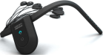 | 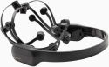 | 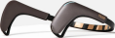 | 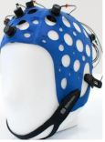 | 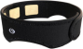 | 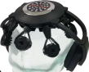 | 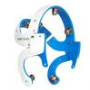 | 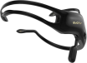 | 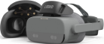 | 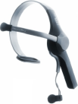 | 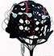 | 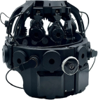 | 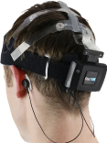 | 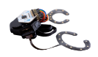 | 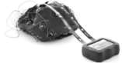
Device | Unicorn EEG headset | EPOC X | MUSE 2 | Versatile | Focusband | DSI-7 | Imec | Insight | Looxid Link | MindWave MW001 | MINDD SCAN | DSI-24 | STAT™ X24 | Open-cEEGrids Around-the-Ear EEG Bundle | g.Nautilus | HARU-1
Price range | 1712 EUR | 1999 USD | 1999.99 USD | - | 500-599 USD | - | - | 499 USD | 299 USD | - | - | - | - | 3299.99 USD | 5717 EUR | -
Medical certification | CE | no | CE, FCC, UL | CE, CB | - | no | - | no | no | - | MFDS | no | FDA | - | CE, FDA | PMDA/RCB
Safety Class | IEC 60601-1 Ⅱ | FCC 15 B, ICES-003 B, AS/NZ CISPR32:2015 B | - | EN 60950, EN 55032, EN 55024 | - | - | - | IEC 60950-1 Ⅱ, ICES-003 B | FCC 15 B, ICES-003 B, AS/NZ CISPR32:2015 B | - | - | - | - | - | IEC60601-1 3rd, IEC60601-1-2, IEC62304, IEC60601-2-26, ISO 14971 10993-1, 62366, | ISO 10993
Electrode type | hybrid: gel, dry. | Dry | wet | dry | wet | dry | dry | dry | dry | dry | dry | wet | wet | dry | wet | wet
Electrode placement | flexible | fixed | fixed | flexible | fixed | fixed | fixed | fixed | fixed | fixed | fixed | fixed | flexible | fixed | flexible | fixed
Reference location | M | P3/P4 (default) or M1/M2 (optional) | Fpz | - | Fpz | Pz/E | - | M | E | E | E | Pz/E | M | M | Optional: E/M/Pz/Fpz | M (left)
Electrode preamplification | active | passive | passive | passive | active | active | active | passive | active | - | - | active | active | passive | active | passive
Electrode shielding | unshielded | - | shielded | shielded | - | shielded | shielded | - | shielded | shielded | - | shielded | - | shielded | - | -
Impedance check | >1 | - | - | >50 | - | 47 | - | - | - | - | - | 47 | 0.5 | >10 | >0.1 | -
Accelerometer | 3-axis | 3-axis | 3-axis | 9-axis | - | 3-axis | - | 3-axis | - | - | - | 3-axis | 3-axis | 3-axis | 3-axis | -
Gyroscope | 3-axis | - | 3-axis | 9-axis | - | 3-axis | - | 3-axis | - | - | - | 3-axis | - | 3-axis | - | -
Number of bipolar ExG | 0 | - | 0 | 0/0/2/4 | 2 | 0 | - | 0 | - | - | - | 3 | 2 | 8 | - | -
Auxiliary channels | 0 | - | 2 | 1/1/1/2 | - | 0 | - | 0 | - | - | - | 0 | - | 3 | 4 | -
Triggers ports | no | - | no | yes | - | yes | - | - | - | - | - | yes | - | yes | yes | -
Wireless protocol | Bluetooth 2.1 | BLE 4.0, Proprietary USB receiver: 2.4GHz band | Bluetooth 4.2 | Bluetooth 2.1 | Bluetooth 2.4 | Bluetooth | Bluetooth | Bluetooth 2.4, BLE | Proprietary USB receiver: 2.4GHz band | BLE, Bluetooth | - | Bluetooth | Bluetooth | BLE, Proprietary USB receiver | 2.4GHz band | BLE 4.x
Raw data access | yes | yes | yes | yes | yes | yes | - | - | yes | yes | - | yes | yes | yes | yes | yes
Local storage/SD card | no | no | no | yes | - | yes | - | no | - | - | - | yes | no | yes | no | yes
Smartphone EEG | yes | yes | yes | in beta | yes | yes | yes | yes | - | yes | - | yes | - | yes | yes | yes
Output format | csv, bdf | csv, edf | csv, edf | csv | csv, json | csv, edf | - | csv, edf | csv, edf, txt | - | - | csv, edf | bdf, edf | csv, bdf, txt | hdf | -
Real-time streaming | LSL, UDP | LSL, UDP, SDK, OSC | LSL, SDK, OSC | LSL, SDK | yes | LSL, TCP-IP, API | SDK, API | - | SDK | SDK, API | - | LSL, TCP-IP, API | LSL, SDK | LSL, TCP-IP | LSL, UDP, SDK, OSC, TCP-IP, API | -
Size (mm) | - | 250 x 236 x 130 | 300-350, ear to ear | from small to extra large:  420-480 to 600-660 | - | 520-620 (adults), 480-540 (children) | - | 212 x 212 x 123 | 255 x 155 x 92/165 | - | - | 255 x 155 x 92/165 | 68.58 (L) x 48.26 (W) x 20.32 (H) | octagonal, 25.4mm per side | 78×60×26 (8/16/32), 78×60×36 (64) | Sensor: 102.9×38.24×27.5，Sheet: 50.0×155.22×50
Weight (g) | 56 | 1000 | 38.5 | 192/290 (8/16) | - | 350 | - | 1000 | 90 | - | 150 | 90 | 57 | 8 | 110 (8/16/32), 140 (64) | 27-42
Battery life (h) | >3 | 9 | 10 | >8 (streaming), >10 (local SD storage) | - | ＞12 | - | 8 | 8 | - | - | 8 | >12 | - | 6-10 | 11
CoME D:  Device Mobility | 4 | 4 | 4 | 4 | 4 | 4 | ？ | 4 | 3 | - | - | 3 | 3 | 3 | 2 | 4
CoME S:  System | 11-12 | 7-9 | 8 | 13 | 5 | 10 | ？ | 8 | 9 | - | - | 9 | 10 | 6 | 10 | 9

Supplementary Table 15. Summary of EEG biomarkers for mild cognitive impairment detection and their neurophysiological correlates
Author (Year) | EEG Biomarker(s)ᵃ | Key Findings in MCI vs. Healthy Controlsᵇ | Neurophysiological Correlationᶜ
Rutkowski et al. (2023a) | OPN | Significantly fewer nodes and edges; reduced microstate complexity and network integration | Reduced network complexity suggests synaptic loss and neuronal degradation, indicating early neuropathological disruption of key functional hubs
Boudaya et al. (2024) | Mean, variance, median, CV, Hjorth parameters, skewness, kurtosis, PSD (δ, θ, α, β), frequency ratios (δ/θ, δ/α, θ/α, [δ+θ]/α) | NR (no group comparison performed) | NR (no group comparison performed)
Wu et al. (2023) | MP (θ, δ), SE, AI (DASM, RASM) | Increased PSD in θ and δ bands during language tasks; greater interhemispheric asymmetry | Increased slow-wave activity reflects EEG slowing linked to cholinergic deficits and reduced cortical arousal, indicating inefficient information processing
Li et al. (2023) | MP (δ, θ, α, β), spectral SE, AI (RFECV-selected features) | Increased δ/θ PSD; altered α/β asymmetry; α/β features most discriminative by RFECV | EEG slowing and altered interhemispheric asymmetry reflect breakdown in functional communication, possibly due to asymmetric atrophy or amyloid pathology
Chai et al. (2023) | MP (α, θ), SE, AI (DASM, RASM) | Reduced complexity and synchrony in TP9/TP10 channels | Reduced functional connectivity in temporal lobes, a region critical for memory, likely due to early tau accumulation
Perez-Valero et al. (2022) | RP, HC, SE | NR (no group comparison performed) | NR (no group comparison performed)
Lee et al. (2022a) | APSD/RPSD, PAC, DASM/RASM, SE, HP, LE, HE, KC | Higher δ DASM (FC5-FC6) and HE (F3, C4); lower PAC θ-βH (P8) | Reduced cross-frequency PAC reflects impaired working memory and disrupted coordination between θ and β networks
Lee et al. (2022b) | PSD, DAR, TAR | Reduced α power; increased δ/β ratios and TAR during working memory retrieval | Decreased α power and increased TAR indicate impaired thalamocortical integrity and cholinergic deficits, reflecting cortical slowing
Boudaya et al. (2022) | Mean, variance, median, CV, Hjorth parameters, skewness, kurtosis, PSD | NR (no group comparison performed) | NR (no group comparison performed)
Jiang et al. (2019) | α/θ ratio, LZC, MSE | Increased α/θ ratio; decreased δ LZC; increased δ MSE | Altered complexity metrics suggest reduced adaptive variability, reflecting less efficient and flexible neuronal processing
Jin-Young et al. (2022) | PSD: High β and γ relative power | Reduced high-frequency (β/γ) power correlated with cognitive decline | Reduced β/γ oscillations indicate impaired local cortical processing and GABAergic interneuron dysfunction
Chen et al. (2023) | PSD, PSDE, ERP | Reduced ERP amplitudes; altered frontal PSD during cognitive tasks | Reduced ERP amplitudes (e.g., P300) indicate impaired cognitive resource allocation and synaptic dysfunction, especially in frontal networks
Rutkowski et al. (2021a) | MFDFA | Higher MFDFA scores in temporal and prefrontal lobes | Elevated fractal complexity reflects disorganized neural dynamics and loss of stable integrative patterns
Rutkowski et al. (2022) | MFDFA in θ band (4.0–7.5 Hz) | Elevated MFDFA values for inhibited oddball responses | Suggests failure of inhibitory control networks; increased pathological complexity reflects inefficient information suppression
Rutkowski et al. (2023b) | TDA: Persistent homology, number of cycles, NPE | Higher persistence and entropy; fewer cycles; distinguished MCI from HC | Simplified topological cycles indicate less intricate functional network architecture and reduced integration
Rutkowski et al. (2021b) | MSE | Bimodal response distributions; altered MSE patterns | Loss of adaptive variability across time scales reflects restricted dynamic range and less structured neural processing
Meghdadi et al. (2021) | Mean relative PSD | Increased low-frequency power; reduced coherence; largely preserved α | Reduced coherence reflects disrupted long-range connectivity; increased δ/θ indicates EEG slowing and network desynchronization
Segaert et al. (2022) | α/β modulation | Reduced α/β rebound; altered θ-α modulation | Reduced post-task rebound suggests failure of inhibitory control and less efficient working memory processing
Xue et al. (2024) | MP (β, α, δ, θ), spectral entropy, AI | Higher mean power across all bands; increased DASM/RASM; altered fuzzy entropy; β most discriminative | Increased power and asymmetry indicate inefficient cortical "idling," increased neural noise, and impaired network adaptability
Jiang et al. (2025) | PSD (θ, α bands) | Altered PSD mainly in prefrontal, parietal, and occipital electrodes; some strongly correlated with MoCA scores | Altered PSD in prefrontal-parietal-occipital regions implicates dysfunction in DMN and fronto-parietal attention networks
Hata et al. (2025) | STFT time-frequency features | NR (no group comparison performed) | NR (no group comparison performed)
Abbreviations:
AI, asymmetry index; APSD, absolute power spectral density; β, beta; CV, coefficient of variation; DAR, delta/alpha ratio; DASM, delta asymmetry; δ, delta; DMN, default mode network; EEG, electroencephalography; ERP, event-related potential; γ, gamma; HC, healthy controls; HE, Higuchi entropy; HP, Hjorth parameters; KC, Kolmogorov complexity; LE, Lyapunov exponent; LZC, Lempel-Ziv complexity; MCI, mild cognitive impairment; MFDFA, multifractal detrended fluctuation analysis; MoCA, Montreal Cognitive Assessment; MP, mean power; MSE, multiscale entropy; NPE, normalized persistence entropy; NR, not reported; OPN, ordinal partition network; PAC, phase-amplitude coupling; PSD, power spectral density; PSDE, power spectral density entropy; RASM, relative asymmetry; RFECV, recursive feature elimination with cross-validation; RP, recurrence plots; RPSD, relative power spectral density; SE, spectral entropy; STFT, short-time Fourier transform; TAR, theta/alpha ratio; TDA, topological data analysis; θ, theta; α, alpha.
Notes:
ᵃEEG biomarkers listed represent the primary features extracted and analyzed in each study. Studies utilizing multiple feature categories employed various combinations for classification or correlation analyses.
ᵇKey findings summarize the statistically significant differences between MCI patients and healthy controls as reported in the original studies. "NR" indicates studies where no direct group comparison was performed, typically indicating feature extraction studies without statistical group analysis.
ᶜNeurophysiological correlations represent the proposed underlying neural mechanisms associated with the observed EEG changes, linking electrophysiological alterations to known neuropathological processes in MCI and early Alzheimer's disease, including synaptic dysfunction, neurotransmitter deficits (particularly cholinergic), protein pathology (amyloid-β and tau), and network connectivity disruptions.

Supplementary Table 16. Summary of EEG feature categories in MCI detection studies: slowing, complexity, and connectivity
Author (Year) | EEG Slowing | Complexity | Connectivity
Rutkowski et al. (2023a) | — | — | ↓ Network nodes and edges (ordinal partition network)
Boudaya et al. (2024) | Time-domain and frequency-domain features (PSD)ᵃ | Time-domain features (Hjorth parameters, kurtosis)ᵃ | —
Wu et al. (2023) | ↑ PSD in δ and θ bands (mean power, signal energy) | Spectral entropy | Asymmetric features (DASM, RASM)
Li et al. (2023) | ↑ PSD in δ and θ bands (mean power) | Spectral entropy | Asymmetry index
Chai et al. (2023) | ↑ θ band activity (mean power) | ↓ Brain complexity (spectral entropy, fuzzy entropy) | ↓ Brain synchrony (DASM, RASM)
Perez-Valero et al. (2022) | Relative powerᵃ | Hjorth complexity, spectral entropyᵃ | —
Lee et al. (2022a) | Spectral features (9 frequency bands) | ↑ Hurst exponent, SE, Hjorth parameters, LE, KC | ↑ δ-DASM; ↓ PAC (θ-βH)
Lee et al. (2022b) | ↑ δ power; ↓ α power; ↑ DAR and TAR (PSD, band power ratios) | — | —
Boudaya et al. (2022) | Time-domain and frequency-domain features (PSD)ᵃ | Time-domain features (Hjorth parameters, kurtosis)ᵃ | —
Jiang et al. (2019) | ↑ α/θ ratio (power spectrum, spectral ratios) | ↓ Lempel-Ziv complexity (δ); ↑ MSE (δ) | —
Jin-Young et al. (2022) | ↓ High β and γ power | — | —
Chen et al. (2023) | ↑ α amplitude; ↓ β amplitude (PSD, PSDE, ERP) | — | —
Rutkowski et al. (2021a) | — | ↑ MFDFA scores | —
Rutkowski et al. (2022) | — | ↑ MFDFA scores in θ band (4.0–7.5 Hz) | —
Rutkowski et al. (2023b) | — | ↑ Persistent homology and normalized persistence entropy; ↓ number of cycles (TDA) | —
Rutkowski et al. (2021b) | — | Altered MSE patterns (bimodal distribution) | —
Meghdadi et al. (2021) | ↑ Relative δ and θ power; ↑ TAR (relative PSD) | — | ↓ Coherence in δ, θ, and α bands; ↑ θ coherence
Segaert et al. (2022) | ↓ α/β activity (time-frequency analysis) | — | —
Xue et al. (2024) | ↑ Mean power across all frequency bands | Resting: ↑ fuzzy entropy; Task: ↓ fuzzy entropy | ↑ Asymmetry indices (DASM, RASM)
Jiang et al. (2025) | PSD differences in θ and α bands | — | —
Hata et al. (2025) | Time-frequency features (STFT)ᵃ | — | —
Abbreviations:
α, alpha; β, beta; βH, high beta; γ, gamma; δ, delta; θ, theta; DAR, delta/alpha ratio; DASM, delta asymmetry; EEG, electroencephalography; ERP, event-related potential; KC, Kolmogorov complexity; LE, Lyapunov exponent; MCI, mild cognitive impairment; MFDFA, multifractal detrended fluctuation analysis; MSE, multiscale entropy; PAC, phase-amplitude coupling; PSD, power spectral density; PSDE, power spectral density entropy; RASM, relative asymmetry; SE, spectral entropy; STFT, short-time Fourier transform; TAR, theta/alpha ratio; TDA, topological data analysis.
Notes:
Symbols: ↑ indicates increased/elevated values in MCI compared to healthy controls; ↓ indicates decreased/reduced values in MCI compared to healthy controls; — indicates feature category not examined or not reported in the study.
ᵃNo direct group comparison was performed between MCI and healthy controls in these studies. Features were extracted for classification purposes but statistical comparisons were not reported.
Methods in parentheses indicate the primary analytical approach or feature extraction technique used in each study. EEG slowing typically involves power spectral analysis of low-frequency bands (delta and theta). Complexity measures assess signal irregularity, entropy, and fractal properties. Connectivity/asymmetry features evaluate functional coupling between brain regions and interhemispheric differences.

Supplementary Table 17. Multivariate logistic regression analysis of EEG configuration factors associated with superior classification performance
Variable | Reference Category | Odds Ratio | 95% CI | P-value
EEG Protocol: Multi-Domain | Single/Resting | 0.91 | 0.25-3.22 | 0.886
Multi-Domain Feature: Yes | No | 0.04 | 0.01-0.14 | <0.001
Channels: 1-3 | 4-8 channels | 0.12 | 0.03-0.44 | 0.002
Channels: 9-20 | 4-8 channels | 0.87 | 0.09-8.05 | 0.895
Electrode: Fronto-Parietal | Other | <0.01 | 0.00-0.02 | <0.001
Note: Odds ratios (OR) and 95% confidence intervals (CI) were estimated using binary logistic regression. Bold P-values indicate statistical significance (P < 0.05). Reference categories represent the baseline group for comparison. OR < 1 indicates lower odds of achieving high performance compared to the reference group.

Supplementary Table 18. PRISMA 2020 Checklist
Section and Topic | Item # | Checklist item | Location where item is reported
TITLE
Title | 1 | Identify the report as a systematic review. | Pg1
ABSTRACT
Abstract | 2 | See the PRISMA 2020 for Abstracts checklist. | Pg1
INTRODUCTION
Rationale | 3 | Describe the rationale for the review in the context of existing knowledge. | Pg2
Objectives | 4 | Provide an explicit statement of the objective(s) or question(s) the review addresses. | Pg2
METHODS
Eligibility criteria | 5 | Specify the inclusion and exclusion criteria for the review and how studies were grouped for the syntheses. | Pg19
Information sources | 6 | Specify all databases, registers, websites, organisations, reference lists and other sources searched or consulted to identify studies. Specify the date when each source was last searched or consulted. | P9
Search strategy | 7 | Present the full search strategies for all databases, registers and websites, including any filters and limits used. | Supplementary Table 1
Selection process | 8 | Specify the methods used to decide whether a study met the inclusion criteria of the review, including how many reviewers screened each record and each report retrieved, whether they worked independently, and if applicable, details of automation tools used in the process. | Pg9
Data collection process | 9 | Specify the methods used to collect data from reports, including how many reviewers collected data from each report, whether they worked independently, any processes for obtaining or confirming data from study investigators, and if applicable, details of automation tools used in the process. | Pg9
Data items | 10a | List and define all outcomes for which data were sought. Specify whether all results that were compatible with each outcome domain in each study were sought (e.g. for all measures, time points, analyses), and if not, the methods used to decide which results to collect. | Supplementary Table 4 & 6-13
Data items | 10b | List and define all other variables for which data were sought (e.g. participant and intervention characteristics, funding sources). Describe any assumptions made about any missing or unclear information. | Supplementary Table 4 & 6-13
Study risk of bias assessment | 11 | Specify the methods used to assess risk of bias in the included studies, including details of the tool(s) used, how many reviewers assessed each study and whether they worked independently, and if applicable, details of automation tools used in the process. | Pg20
Effect measures | 12 | Specify for each outcome the effect measure(s) (e.g. risk ratio, mean difference) used in the synthesis or presentation of results. | N/A
Synthesis methods | 13a | Describe the processes used to decide which studies were eligible for each synthesis (e.g. tabulating the study intervention characteristics and comparing against the planned groups for each synthesis (item #5)). | Pg19
Synthesis methods | 13b | Describe any methods required to prepare the data for presentation or synthesis, such as handling of missing summary statistics, or data conversions. | N/A
Synthesis methods | 13c | Describe any methods used to tabulate or visually display results of individual studies and syntheses. | Pg20
Synthesis methods | 13d | Describe any methods used to synthesize results and provide a rationale for the choice(s). If meta-analysis was performed, describe the model(s), method(s) to identify the presence and extent of statistical heterogeneity, and software package(s) used. | Pg20
Synthesis methods | 13e | Describe any methods used to explore possible causes of heterogeneity among study results (e.g. subgroup analysis, meta-regression). | N/A
Synthesis methods | 13f | Describe any sensitivity analyses conducted to assess robustness of the synthesized results. | N/A
Reporting bias assessment | 14 | Describe any methods used to assess risk of bias due to missing results in a synthesis (arising from reporting biases). | N/A
Certainty assessment | 15 | Describe any methods used to assess certainty (or confidence) in the body of evidence for an outcome. | N/A
RESULTS
Study selection | 16a | Describe the results of the search and selection process, from the number of records identified in the search to the number of studies included in the review, ideally using a flow diagram. | Pgs2
Study selection | 16b | Cite studies that might appear to meet the inclusion criteria, but which were excluded, and explain why they were excluded. | Pgs2
Study characteristics | 17 | Cite each included study and present its characteristics. | Pg2 & 4
Risk of bias in studies | 18 | Present assessments of risk of bias for each included study. | Pg11 & Supplementary Table 5
Results of individual studies | 19 | For all outcomes, present, for each study: (a) summary statistics for each group (where appropriate) and (b) an effect estimate and its precision (e.g. confidence/credible interval), ideally using structured tables or plots. | N/A
Results of syntheses | 20a | For each synthesis, briefly summarise the characteristics and risk of bias among contributing studies. | N/A
Results of syntheses | 20b | Present results of all statistical syntheses conducted. If meta-analysis was done, present for each the summary estimate and its precision (e.g. confidence/credible interval) and measures of statistical heterogeneity. If comparing groups, describe the direction of the effect. | N/A
Results of syntheses | 20c | Present results of all investigations of possible causes of heterogeneity among study results. | N/A
Results of syntheses | 20d | Present results of all sensitivity analyses conducted to assess the robustness of the synthesized results. | N/A
Reporting biases | 21 | Present assessments of risk of bias due to missing results (arising from reporting biases) for each synthesis assessed. | N/A
Certainty of evidence | 22 | Present assessments of certainty (or confidence) in the body of evidence for each outcome assessed. | N/A
DISCUSSION
Discussion | 23a | Provide a general interpretation of the results in the context of other evidence. | Pg14-17
Discussion | 23b | Discuss any limitations of the evidence included in the review. | Pg19
Discussion | 23c | Discuss any limitations of the review processes used. | Pg19
Discussion | 23d | Discuss implications of the results for practice, policy, and future research. | Pgs17-19
OTHER INFORMATION
Registration and protocol | 24a | Provide registration information for the review, including register name and registration number, or state that the review was not registered. | Pg19
Registration and protocol | 24b | Indicate where the review protocol can be accessed, or state that a protocol was not prepared. | Pgs19
Registration and protocol | 24c | Describe and explain any amendments to information provided at registration or in the protocol. | N/A
Support | 25 | Describe sources of financial or non-financial support for the review, and the role of the funders or sponsors in the review. | Pg23
Competing interests | 26 | Declare any competing interests of review authors. | Pg23
Availability of data, code and other materials | 27 | Report which of the following are publicly available and where they can be found: template data collection forms; data extracted from included studies; data used for all analyses; analytic code; any other materials used in the review. | Pg20 & 23

From: Page MJ, McKenzie JE, Bossuyt PM, Boutron I, Hoffmann TC, Mulrow CD, et al. The PRISMA 2020 statement: an updated guideline for reporting systematic reviews. BMJ 2021;372:n71. doi: 10.1136/bmj.n71. This work is licensed under CC BY 4.0. To view a copy of this license, visit https://creativecommons.org/licenses/by/4.0/

Supplementary Table 19. CoME S (System Specifications) scoring criteria
Domain | Scoring Range (1–5) | High-Score Criterion (Example) | Interpretation
Bit Resolution | 1 – 5 | ≥ 24-bit resolution | Higher precision in EEG signal digitization
Sampling Rate | 1 – 5 | ≥ 1000 Hz | Enables capture of high-frequency EEG activity
Battery Life | 1 – 5 | Long operational duration (> 8 h) | Suitable for extended recording sessions
Electrode Type | 1 – 5 | Active/shielded dry or hybrid electrodes | Better signal quality and user comfort
Total CoME S Score: 4 – 20 (sum of four domains). Higher scores indicate superior technical performance.

Supplementary Table 20. CoME D (Device Mobility) scoring framework
Score | Device Configuration | Description
0D | Off-body tethered | Conventional lab-based wired EEG system
1D | Waist/back-mounted (with external accessories) | Portable but dependent on external modules
2D | Fully waist-mounted | Compact belt-worn system
3D | Head-mounted + backpack | Head-worn sensors with additional backpack or controller unit
4D | Head-mounted (limited wireless) | Partially wireless, moderate freedom of movement
5D | Fully integrated head-mounted | Complete on-head integration, full mobility

