Supplementary Material

Contents
Supplementary Note I. Search strategy. 2
Supplementary Figure S1. Adapted PRISMA diagram. 4
Supplementary Figure S2. Updated meta-analyses 5
Supplementary Figure S3. Updated meta-analyses – total HF hospitalizations 6
Supplementary Figure S4. Updated meta-analyses – first HF hospitalization 7
Supplementary Figure S5. Updated meta-analyses – all-cause mortality 9
Supplementary Figure S6. Funnel plot updated meta-analysis – Total HF hospitalizations 11
Supplementary Figure S7. Funnel plot updated meta-analysis – First HF hospitalization 11
Supplementary Figure S8. Funnel plot updated meta-analysis – All-cause mortality 12
Supplementary Figure S9. Risk of bias (RoB 2) analysis 13
Supplementary Figure S10. Risk of bias (RoB 2) analysis – Summary table 14
Supplementary Figure S11. Funnel plot network meta-analysis – Total HF hospitalizations 14
Supplementary Figure S12. Funnel plot network meta-analysis – First HF hospitalization 15
Supplementary Figure S13. Funnel plot network meta-analysis – All-cause mortality 15
Supplementary Figure S14. Sensitivity analysis updated meta-analysis – excluding high risk of bias studies 16
Supplementary Figure S15. Sensitivity analysis network meta-analysis – excluding high risk of bias studies 17
Supplementary Table S1. Inclusion and exclusion criteria 18
Supplementary Table S2. Definitions of different remote monitoring modalities 18
Supplementary Table S3. Patient and trial characteristics of non-invasive RM studies 19
Supplementary Table S4. Patient and trial characteristics of invasive RM studies 21
Supplementary Table S5. Remote monitoring solutions and study endpoints of non-invasive RM studies 22
Supplementary Table S6. Remote monitoring solutions and study endpoints of invasive RM studies 25
Supplementary Table S7. Background medical therapy of non-invasive RM studies 26
Supplementary Table S8. Background medical therapy invasive RM studies 27
Supplementary Table S9. League table 28
Supplementary Table S10. Certainty of evidence (CINeMA) – Total HF hospitalizations 29
Supplementary Table S11. Certainty of evidence (CINeMA) – First HF hospitalizations 29
Supplementary Table S12. Certainty of evidence (CINeMA) – All-cause mortality 29

Supplementary Note I. Search strategy.

Embase
('heart failure'/exp OR 'heart left ventricle function'/de OR 'heart right ventricle function'/de OR 'heart function'/de OR ('implantable cardioverter defibrillator'/de NOT 'atrial fibrillation'/exp) OR (((diastol* OR systol* OR ventric* OR cardiac OR heart OR cardio* OR cordis* OR myocardial) NEAR/6 (dysfunction* OR function* OR failure* OR decompensat* OR insufficien*)) OR (((implant* NEAR/3 defibrillat*) OR icd) NOT (atri* NEXT/1 fibrillat*))):ab,ti,kw) AND ('remote sensing'/de OR telemonitoring/de OR 'cardiovascular monitoring device'/de OR 'implantable cardiac monitor'/de OR 'implantable hemodynamic monitor'/de OR 'home monitoring'/de OR 'ambulatory monitoring'/de OR telemetry/de OR (('patient monitoring'/de) AND (outpatient/de OR home/de OR 'ambulatory care'/de OR 'home care'/de OR implantation/de)) OR telehealth/de OR telemedicine/de OR telephone/de OR (((remote OR Wireless OR wearable* OR ambulator* OR telemedicine OR telehealth OR implant* OR self) NEAR/6 (sensing OR monitor*)) OR telemonitor* OR tele-monitoring* OR telemetr* OR biotelemetr* OR ((home OR outpatient* OR remote*) NEAR/3 monitor*) OR (monitor* NEAR/3 (device* OR technique*)) OR Cardiomems OR telehealth* OR tele-health* OR telecare* OR tele-care* OR telehomecare* OR tele-guidance* OR teleguidance* OR tele-homecare* OR tele-home-care* OR e-health* OR ehealth* OR m-health* OR mobile-health* OR mhealth* OR telemedic* OR tele-medic* OR (home NEAR/3 (intervention* OR management*)) OR (telephone* NEAR/3 (support OR counsel* OR consult* OR intervention* OR management OR follow-up*)) OR ((electronic* OR daily) NEAR/3 (transmi* OR upload*))):ab,ti,kw OR (telephone*):ti,kw) AND ('clinical trial'/exp OR 'Crossover procedure'/de OR 'Double-blind procedure'/de OR 'Single-blind procedure'/de OR 'prospective study'/de OR 'cohort analysis'/de OR 'longitudinal study'/de OR 'usual care'/de OR (random* OR factorial* OR crossover* OR (cross NEXT/1 over*) OR placebo* OR ((doubl* OR singl*) NEXT/1 blind*) OR RCT* OR Usual-Care* OR assign* OR allocat* OR volunteer* OR trial OR groups OR prospective* OR cohort* OR longitudinal*):ab,ti,kw) NOT ('case report'/de OR case-report*:ti) NOT [conference abstract]/lim NOT ([animals]/lim NOT [humans]/lim) AND [english]/lim
Medline ALL Ovid
(exp Heart Failure/ OR Heart Function Tests/ OR (Defibrillators, Implantable/ NOT exp Atrial Fibrillation/) OR (((diastol* OR systol* OR ventric* OR cardiac OR heart OR cardio* OR cordis* OR myocardial) ADJ6 (dysfunction* OR function* OR failure* OR decompensat* OR insufficien*)) OR (((implant* ADJ3 defibrillat*) OR icd) NOT (atri* ADJ fibrillat*))).ab,ti,kf.) AND (Remote Sensing Technology/ OR Monitoring, Ambulatory/ OR Telemetry/ OR ((Monitoring, Physiologic/) AND (Ambulatory Care/ OR Home Care Services/)) OR ((Telemedicine/) AND (Monitoring, Physiologic/)) OR *Telemedicine/ OR (((remote OR Wireless OR wearable* OR ambulator* OR telemedicine OR telehealth OR implant* OR self) ADJ6 (sensing OR monitor*)) OR telemonitor* OR tele-monitoring* OR telemetr* OR biotelemetr* OR ((home OR outpatient* OR remote*) ADJ3 monitor*) OR (monitor* ADJ3 (device* OR technique*)) OR Cardiomems OR ((telehealth* OR tele-health* OR telecare* OR tele-care* OR telehomecare* OR tele-homecare* OR tele-home-care* OR e-health* OR ehealth* OR m-health* OR mobile-health* OR mhealth* OR telemedic* OR tele-medic*) AND (monitor*))).ab,ti,kf.) AND (Exp Clinical Trial/ OR "Double-Blind Method"/ OR "Single-Blind Method"/ OR "Random Allocation"/ OR prospective study/ OR cohort analysis/ OR longitudinal study/ OR (random* OR factorial* OR crossover* OR (cross ADJ over*) OR placebo* OR ((doubl* OR singl*) ADJ blind*) OR RCT OR usual-care* OR assign* OR allocat* OR volunteer* OR trial OR groups OR prospective* OR cohort* OR longitudinal*).ab,ti,kf.) NOT (case reports/ OR case-report*.ti.) NOT (exp animals/ NOT humans/) AND english.la.
Web of Science Core Collection
TS=(((((diastol* OR systol* OR ventric* OR cardiac OR heart OR cardio* OR cordis* OR myocardial) NEAR/5 (dysfunction* OR function* OR failure* OR decompensat* OR insufficien*)) OR (((implant* NEAR/2 defibrillat*) OR icd) NOT (atri* NEAR/1 fibrillat*)))) AND ((((remote OR Wireless OR wearable* OR ambulator* OR telemedicine OR telehealth OR implant* OR self) NEAR/5 (sensing OR monitor*)) OR telemonitor* OR tele-monitoring* OR telemetr* OR biotelemetr* OR ((home OR outpatient* OR remote*) NEAR/2 monitor*) OR (monitor* NEAR/2 (device* OR technique*)) OR Cardiomems OR ((telehealth* OR tele-health* OR telecare* OR tele-care* OR telehomecare* OR tele-homecare* OR tele-home-care* OR e-health* OR ehealth* OR m-health* OR mobile-health* OR mhealth* OR telemedic* OR tele-medic*) AND (monitor*)))) AND ((random* OR factorial* OR crossover* OR (cross NEAR/1 over*) OR placebo* OR ((doubl* OR singl*) NEAR/1 blind*) OR RCT OR usual-care* OR assign* OR allocat* OR volunteer* OR trial OR groups OR prospective* OR cohort* OR longitudinal*))) NOT TI=(case-report*) AND DT=(Article OR Review OR Letter OR Early Acces) AND LA=(english)
Cochrane CENTRAL register of Trials
((((diastol* OR systol* OR ventric* OR cardiac OR heart OR cardio* OR cordis* OR myocardial) NEAR/6 (dysfunction* OR function* OR failure* OR decompensat* OR insufficien*)) OR (((implant* NEAR/3 defibrillat*) OR icd) NOT (atri* NEXT/1 fibrillat*))):Ab,ti,kw) AND ((((remote OR Wireless OR wearable* OR ambulator* OR telemedicine OR telehealth OR implant* OR self) NEAR/6 (sensing OR monitor*)) OR telemonitor* OR tele NEXT monitoring* OR telemetr* OR biotelemetr* OR ((home OR outpatient* OR remote*) NEAR/3 monitor*) OR (monitor* NEAR/3 (device* OR technique*)) OR Cardiomems OR ((telehealth* OR tele NEXT health* OR telecare* OR tele NEXT care* OR telehomecare* OR tele NEXT homecare* OR tele NEXT home NEXT care* OR e NEXT health* OR ehealth* OR m NEXT health* OR mobile NEXT health* OR mhealth* OR telemedic* OR tele NEXT medic*) AND (monitor*))):Ab,ti,kw) NOT ("conference abstract":kw OR Trial registry record:pt)

Supplementary Figure S1. Adapted PRISMA diagram.
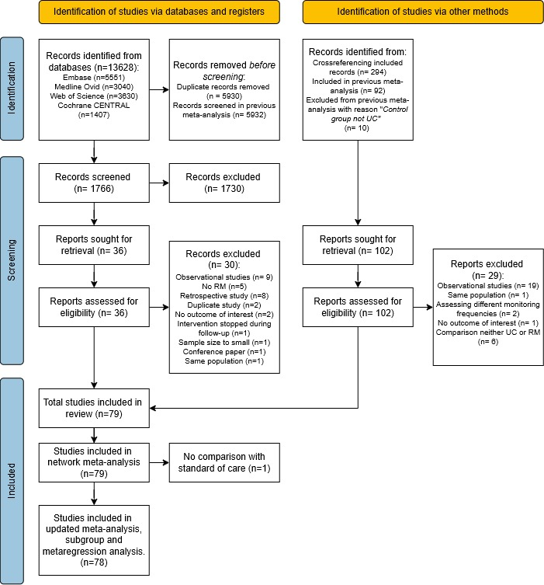

Supplementary Figure S2. Updated meta-analyses
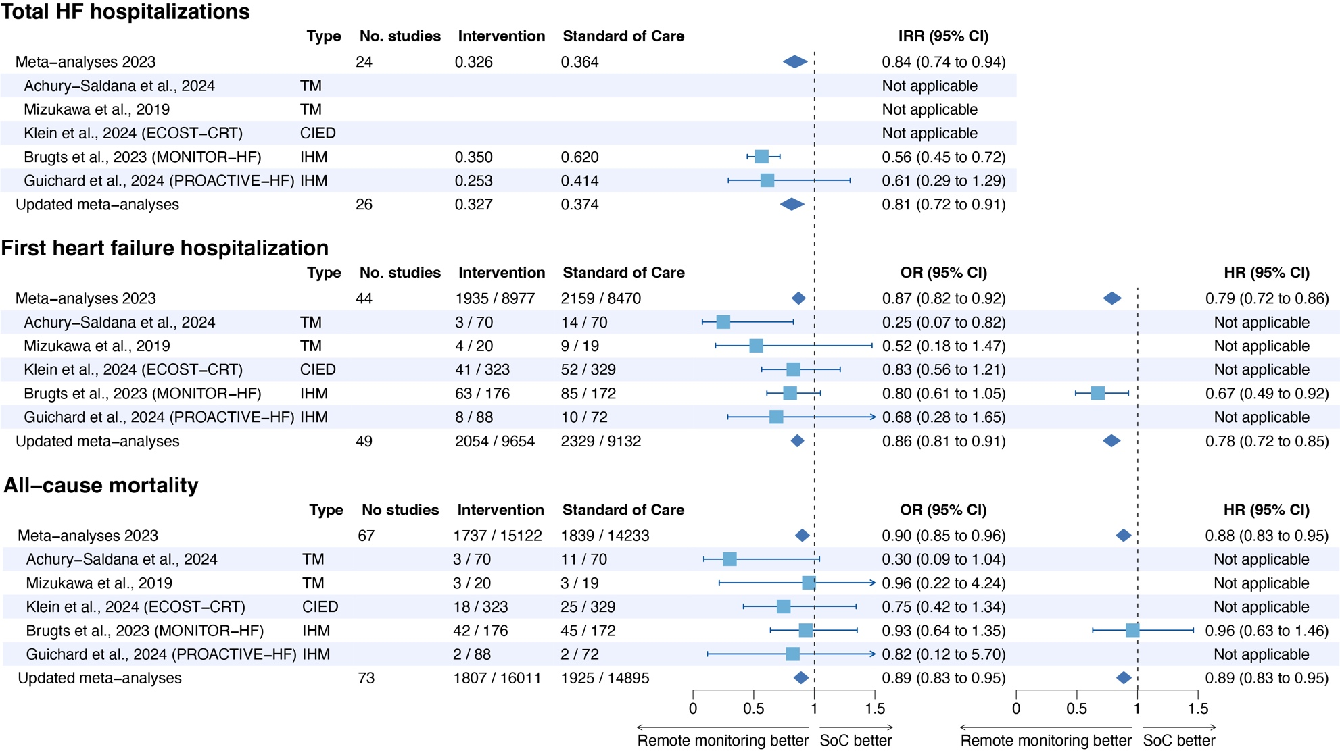

Supplementary Figure S3. Updated meta-analyses – total HF hospitalizations
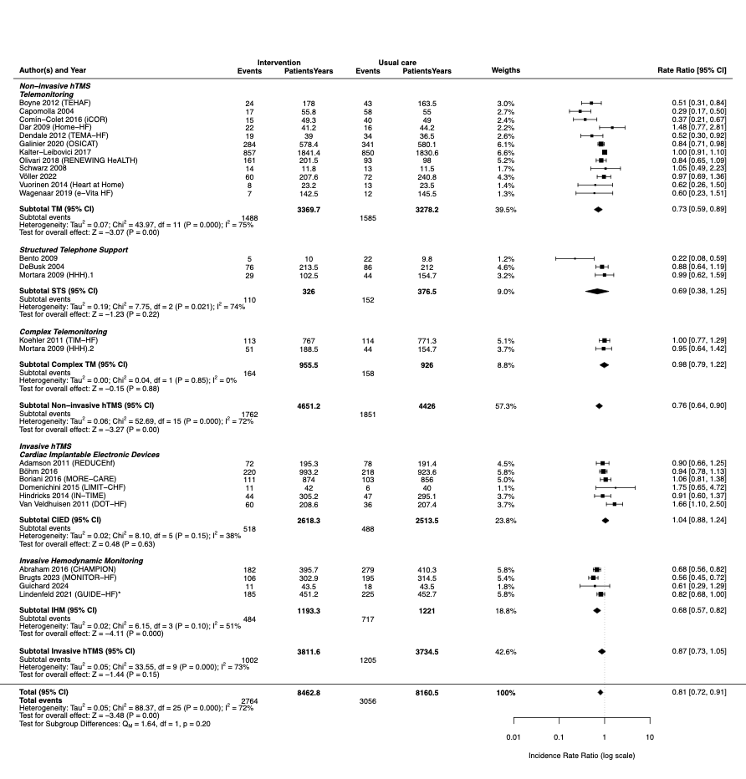

Supplementary Figure S4. Updated meta-analyses – first HF hospitalization

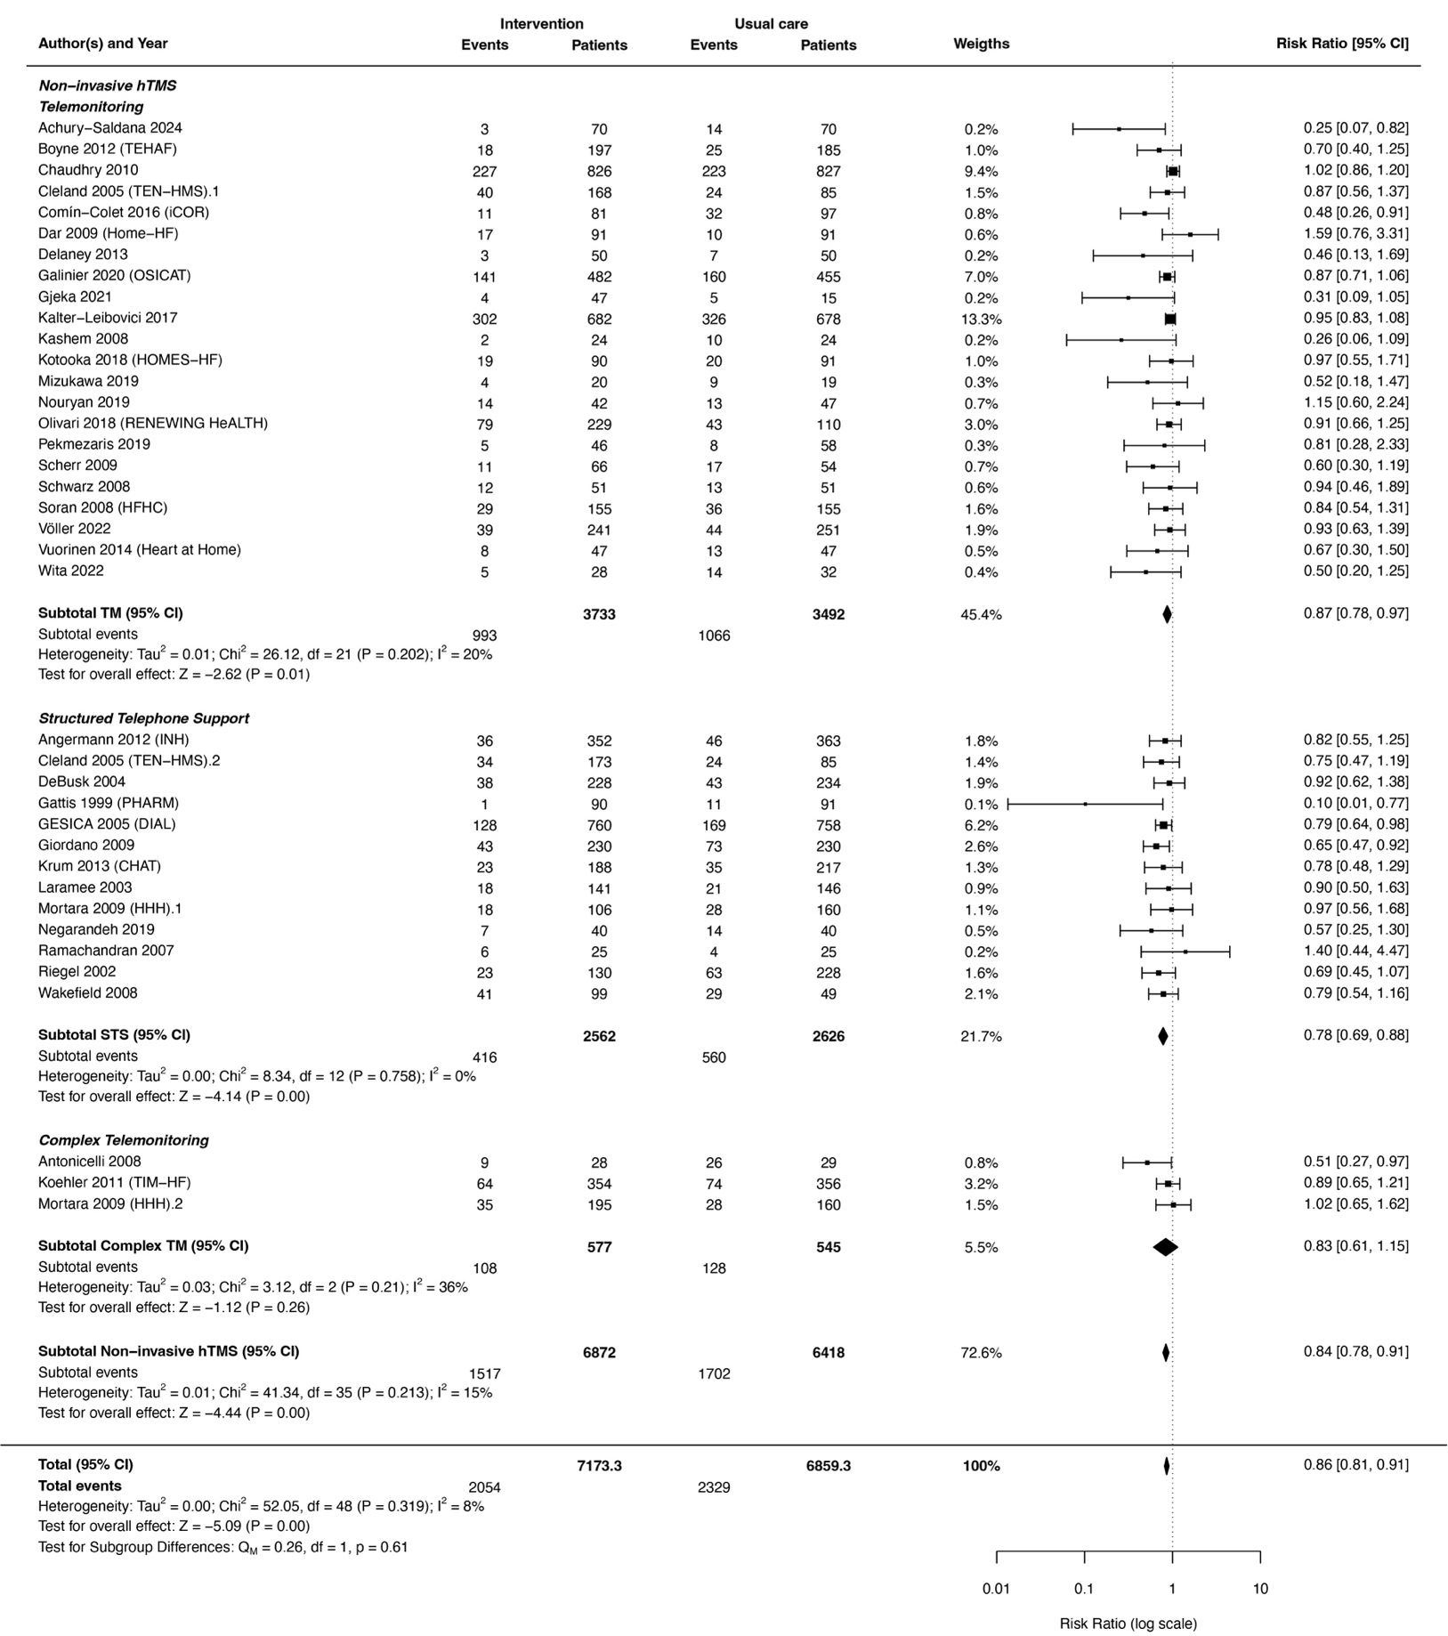

Supplementary Figure S4. Continued

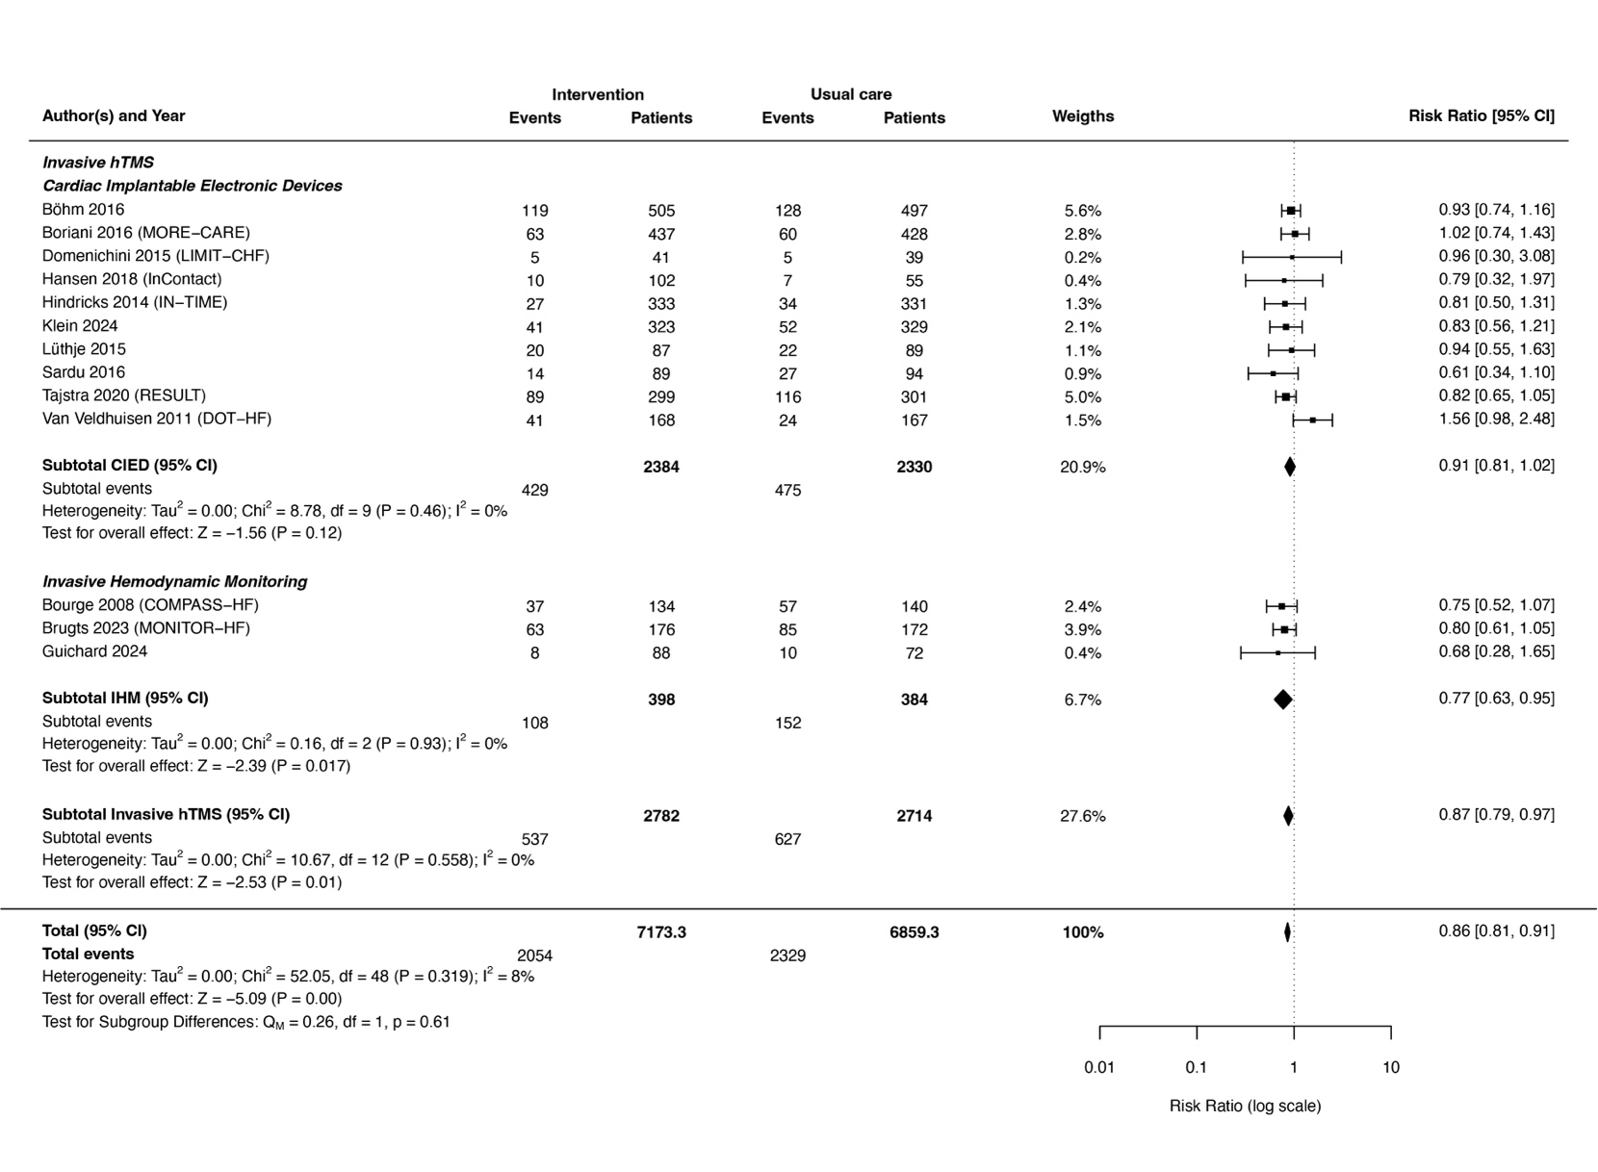

Supplementary Figure S5. Updated meta-analyses – all-cause mortality
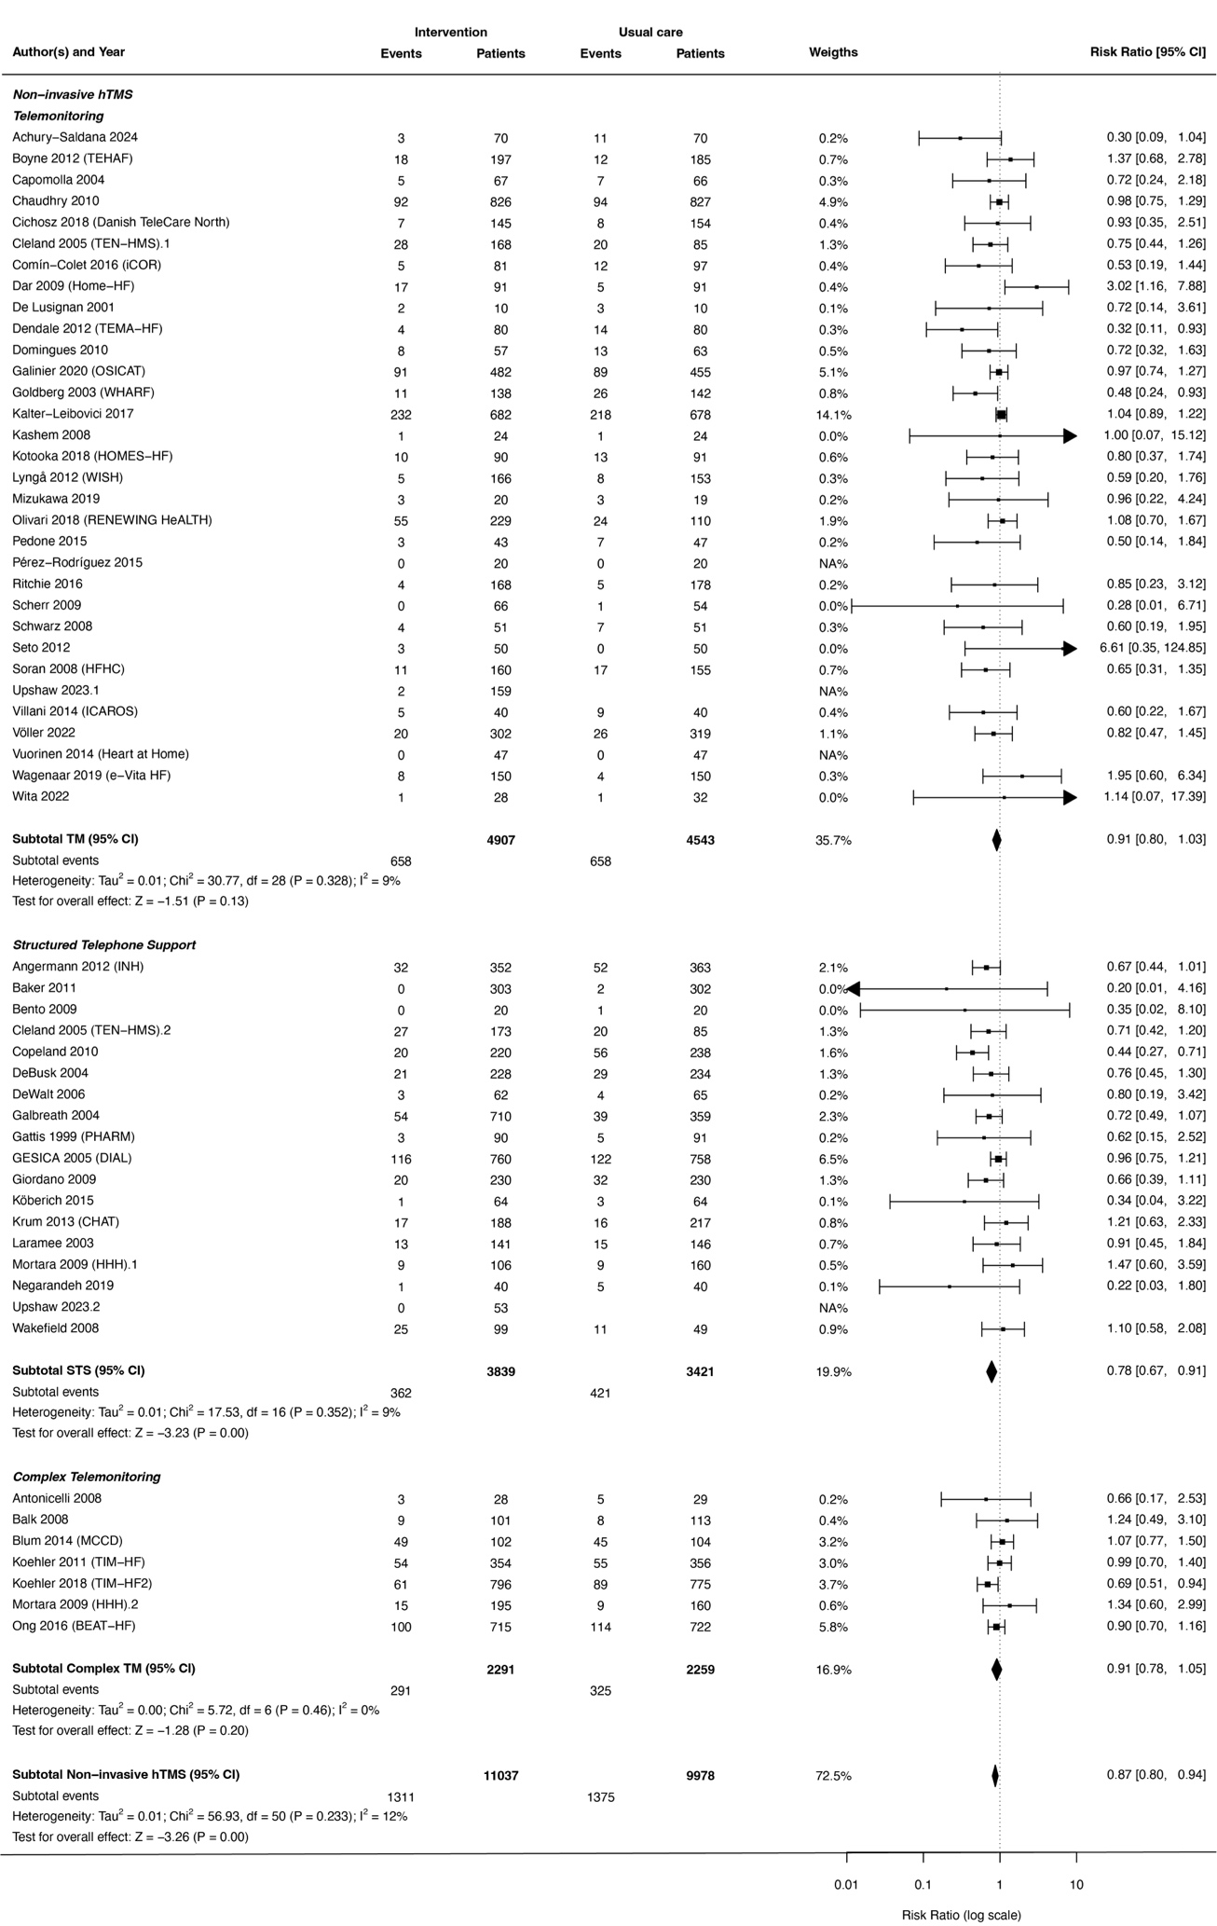
Supplementary Figure S5. Continued
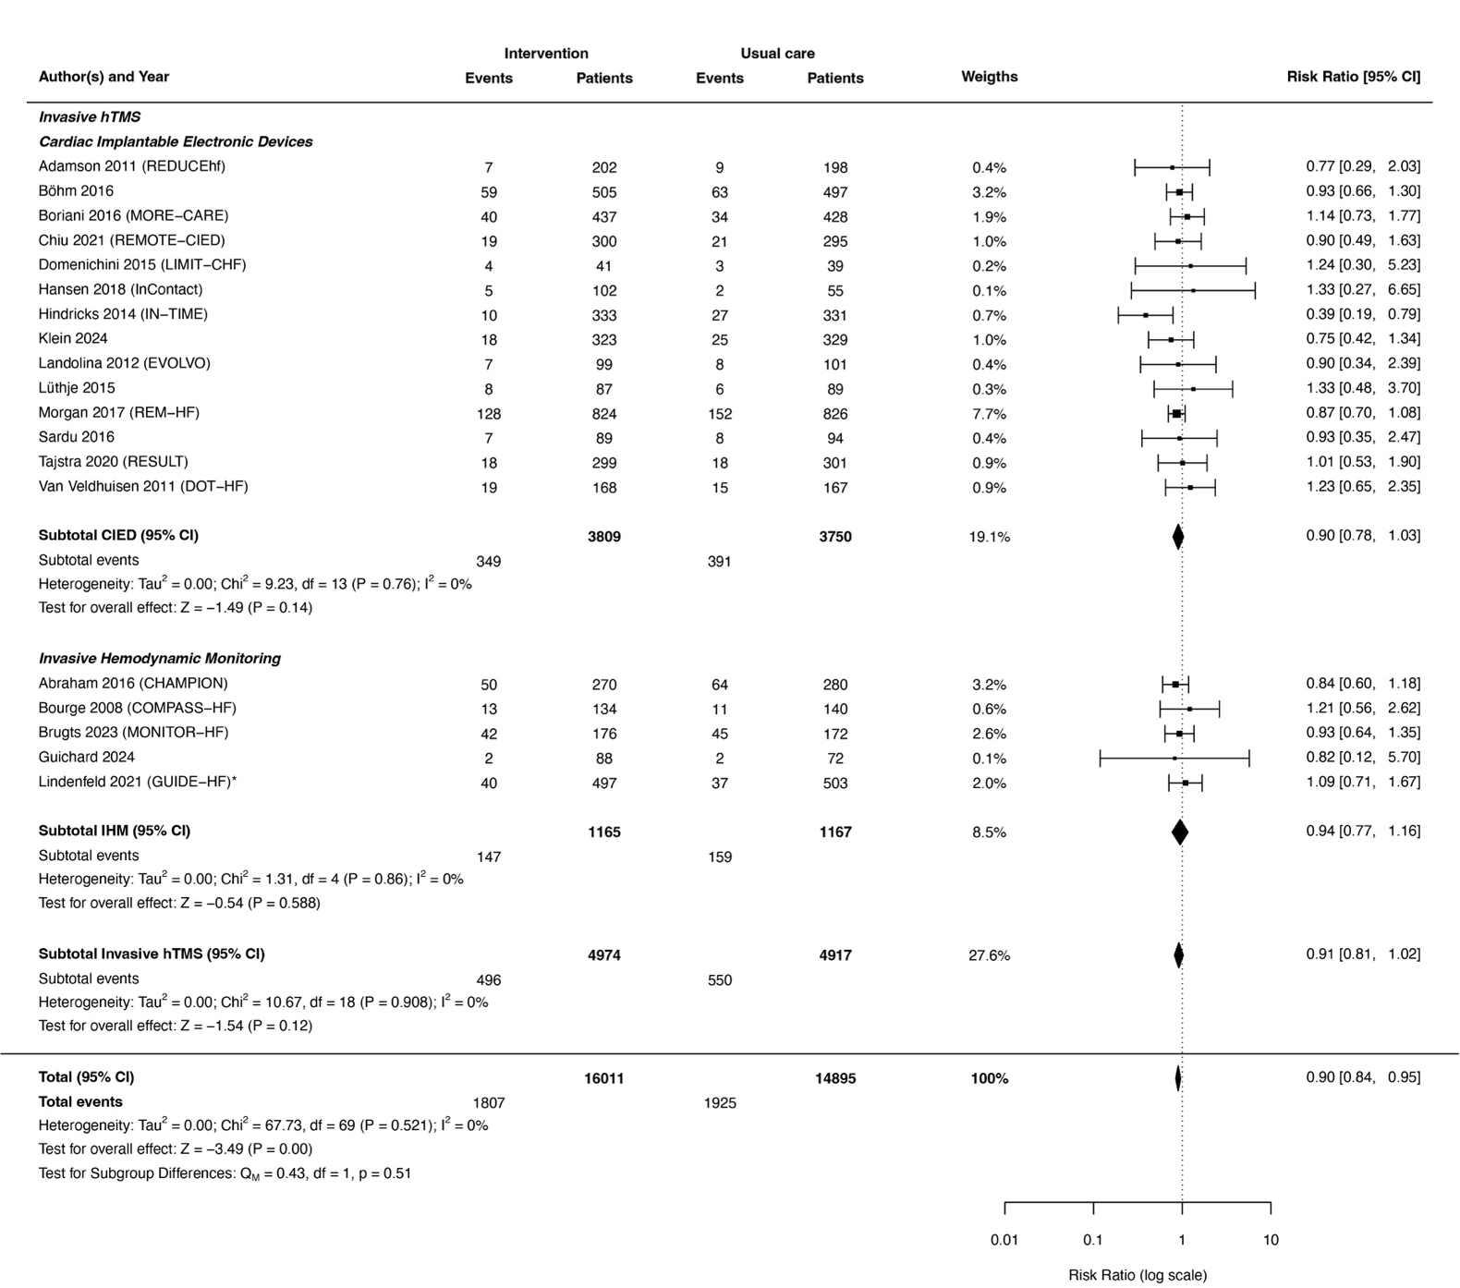

Supplementary Figure S6. Funnel plot updated meta-analysis – Total HF hospitalizations
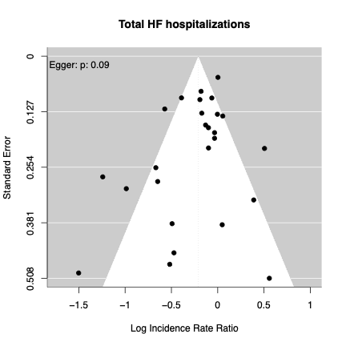

Supplementary Figure S7. Funnel plot updated meta-analysis – First HF hospitalization
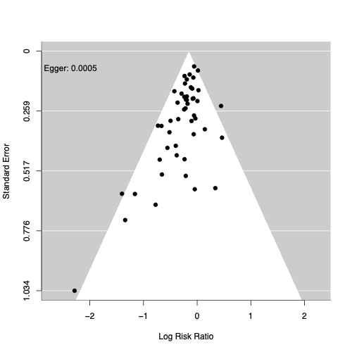

Supplementary Figure S8. Funnel plot updated meta-analysis – All-cause mortality
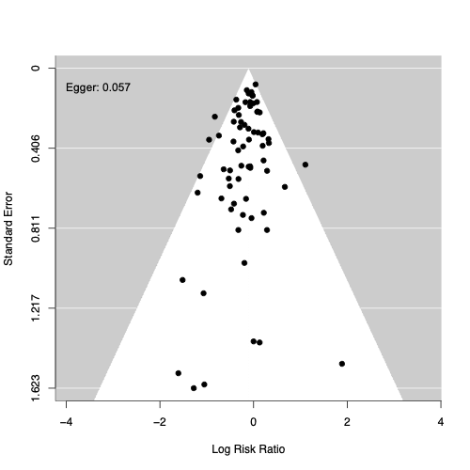

Supplementary Figure S9. Risk of bias (RoB 2) analysis
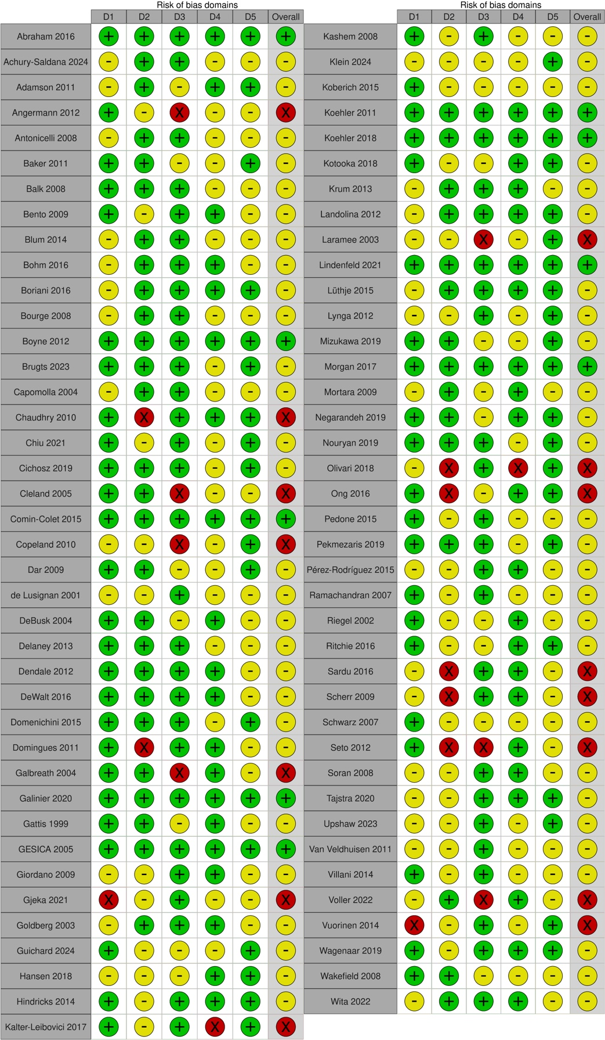

Supplementary Figure S10. Risk of bias (RoB 2) analysis – Summary table
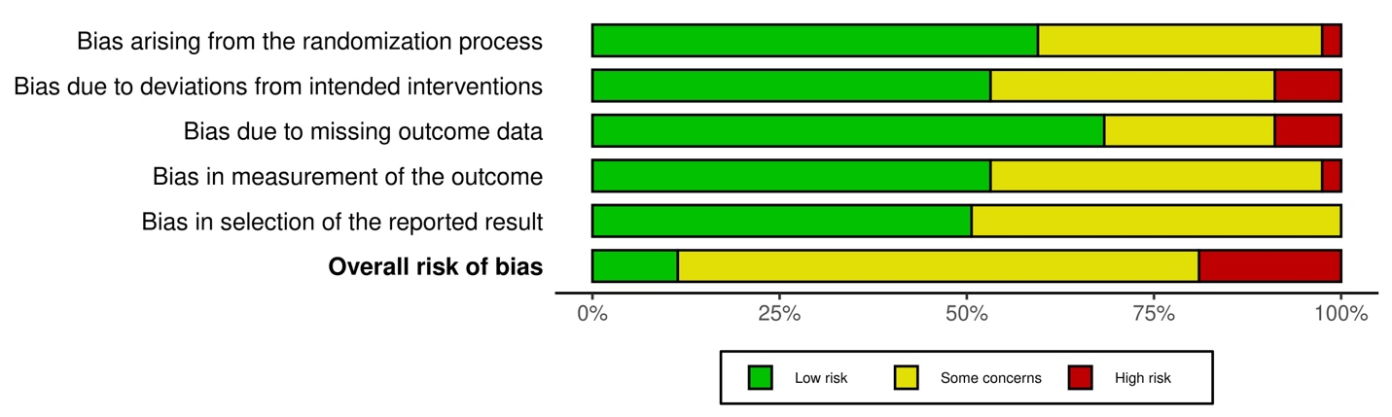

Supplementary Figure S11. Funnel plot network meta-analysis – Total HF hospitalizations
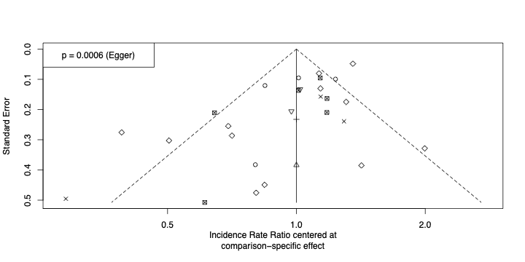

Supplementary Figure S12. Funnel plot network meta-analysis – First HF hospitalization
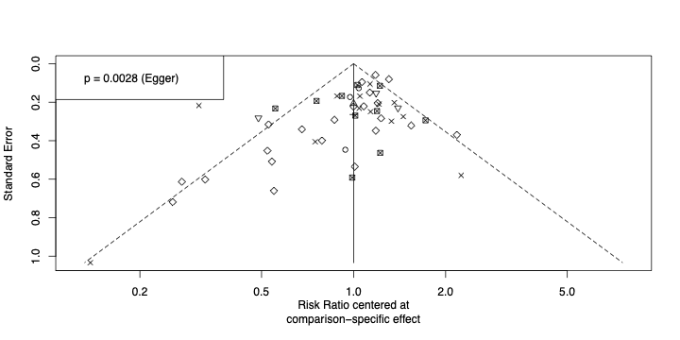

Supplementary Figure S13. Funnel plot network meta-analysis – All-cause mortality
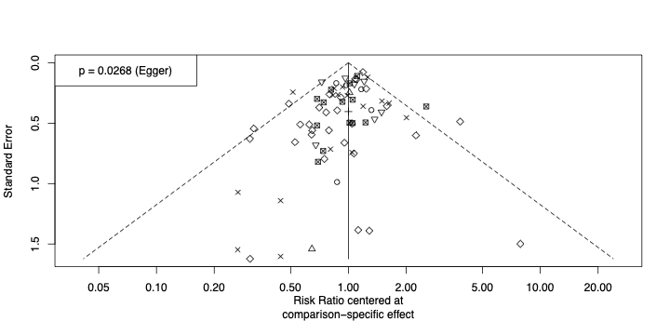

Supplementary Figure S14. Sensitivity analysis updated meta-analysis – excluding high risk of bias studies
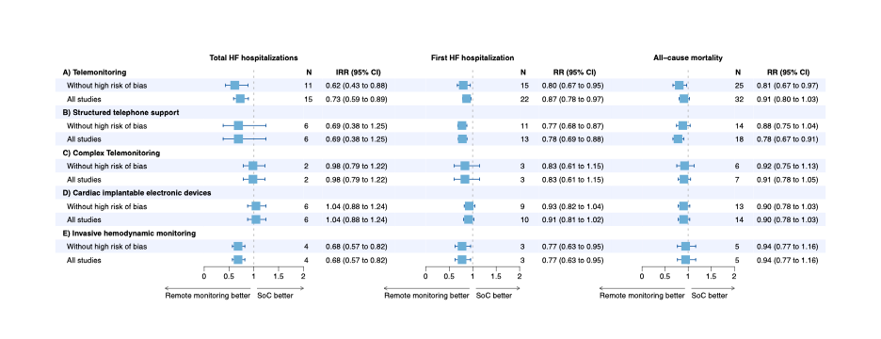

Supplementary Figure S15. Sensitivity analysis network meta-analysis – excluding high risk of bias studies
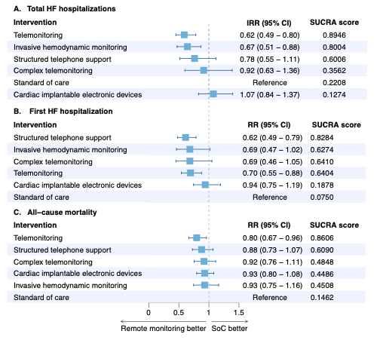

Supplementary Table S1. Inclusion and exclusion criteria
Inclusion criteria patients:
• Chronic HF patients (NYHA class I-IV)
• ≥18 years
Exclusion criteria patients:
• Specific subset of the HF population (e.g. patients with LVAD, AF only, specific combination with comorbid conditions)
Inclusion criteria studies:
• Invasive or non-invasive RM (including structured telephone support)
• RCT with a sample size of ≥ 20 patients with either standard of care or other RM modalities as control group
• Outcomes: (all-cause) mortality, (HF) hospitalization
• English language
• Full text available
• Published after 1996
Exclusion criteria studies:
• Design papers, conference papers, (systematic) reviews and meta-analyses
• HF is not mentioned separately
• Inpatient, rehabilitation clinic, nursing home setting
• Frequent face-to-face sessions either in-home or outpatient setting
• Closed-loop without input from a healthcare provider (automated solution)
• Self-education intervention only
• Lack of remote/wireless transmission of data
• Medication adherence/titration only
• Algorithms for model development
• Telerehabilitation studies
HF: Heart Failure; NYHA; New York Heart Association; LVAD: Left Ventricular Assist Device; AF: Atrial Fibrillation; RM: remote monitoring;

Supplementary Table S2. Patient and trial characteristics of non-invasive RM studies
Author, year (study) | Country | Design | Enrollment | N | Ageª, years  ± SD or (IQR) | Men, % | NYHA  III-IV, % | LVEF  cut-off | Ischemic  etiology, %
Achury−Saldaña et al., 2024 | CO | RCT | 2020 - 2021 | 140 | 66.8 ± 11.9 | 70 | 11 | Any | 60
Angermann et al., 2012 (INH) | DE | RCT | 2004–2007 | 715 | 68.6 ± 12.2 | 71 | 40 | ANY | 58
Antonicelli et al., 2008 | IT | RCT | NA | 57 | 78 ± 8.5 | 61 | 42 | ANY | 67
Baker et al., 2011 | US | RCT | 2007–2009 | 605 | 60.7 ± 13.1 | 52 | 31 | ANY | NA
Balk et al., 2008 | NL | RCT | 2005–2006 | 214 | 66 (33 – 87) | 70 | 52 | ANY | 57
Bento et al., 2009 | BR | RCT | NA | 40 | 57.5 ± 9.4 | 70 | 38 | ANY | 25
Blum et al., 2014 (MCCD) | US | RCT | 2001–2005 | 203 | 72.5 ± 9 | 71 | 86 | ANY | 65
Boyne et al., 2012 (TEHAF) | NL | RCT | 2007–2008 | 382 | 71.4 ± 11.2 | 59 | 43 | ANY | 50
Capomolla et al., 2004 | IT | RCT | 2000–2001 | 133 | 57 ± 10 | 88 | 33 | ANY | 41
Chaudhry et al., 2010 (Tele-HF) | US | RCT | NA | 1653 | 61 (51 – 73) | 58 | 57 | ANY | 51
Cichosz et al., 2018 (Danish telecare north) | DK | RCT | NA | 299 | 70.5 | 81 | NA | ANY | NA
Cleland et al., 2005 (TEN-HMS) | NL/UK/DE | RCT | 2000–2002 | 426 | 67.2 ± 11.6 | 77 | 34 | <40% | 78
Copeland et al., 2010 | US | RCT | 2005 | 458 | 70.0 ± 10.8 | 99 | 44 | ANY | 35
Comin-Colet et al., 2016 (iCOR) | ES | RCT | 2010–2012 | 178 | 74 ± 11 | 59 | 54 | ANY | 35
Dar et al., 2009 (Home HF) | UK | RCT | 2006–2007 | 182 | 71.0 ± 11.7 | 66 | NA | ANY | 55
De Lusignan et al., 2001 | UK | RCT | NA | 20 | 75.2 | NA | NA | ANY | NA
DeBusk et al., 2004 | US | RCT | 1998–2001 | 462 | 72 ± 11 | 51 | 50 | ANY | 51
Delaney et al., 2013 | US | RCT | 2011–2012 | 100 | NA | 32 | 100 | ANY | NA
Dendale et al., 2012 (TEMA-HF) | BE | RCT | 2008–2010 | 160 | 75.8 ± 9.7 | 65 | NA | ANY | NA
DeWalt et al., 2006 | US | RCT | 2001–2003 | 123 | 62.5 ± 10.1 | 49 | 50 | ANY | NA
Domingues et al., 2010 | BR | RCT | 2005–2008 | 111 | 63 ± 13 | 58 | NA | <45% | NA
Galbreath et al., 2004 | US | RCT | 1999–2003 | 1069 | 70.9 ± 10.3 | 71 | 24 | ANY | NA
Galinier et al., 2020 (OSICAT) | FR | RCT | 2013–2016 | 990 | 70 ± 12.4 | 72 | 49 | ANY | NA
Gattis et al., 1999 (PHARM) | US | RCT | 1996 -1997 | 181 | NA | 68 | 33 | <45% | NA
GESICA, Grancelli et al., 2005 (DIAL) | AR | RCT | 2000–2001 | 1518 | 65 ± 13.3 | 71 | 49 | ANY | NA
Giordano et al., 2009 | IT | RCT | 2002–2004 | 460 | 57 ± 10 | 85 | 40 | <40% | 53
Gjeka et al., 2021 | US | RCT | 2016–2018 | 62 | 68.6 | 49 | NA | NA | NA
Goldberg et al., 2003 (WHARF) | US | RCT | 1998–2000 | 280 | 59.1 ± 15.3 | 68 | 100 | ≤35% | 43
Kalter-Leibovici et al., 2017 | IL | RCT | 2007–2012 | 1360 | 70.7 ± 11.3 | 73 | 85 | ANY | NA
Kashem et al., 2008 | US | RCT | NA | 48 | 53.7 ± 10.5 | 74 | 58 | ANY | 41
Köberich et al., 2015 | DE | RCT | 2011–2013 | 110 | 61.7 ± 12.0 | 83 | 34 | ≤40% | 53
Koehler et al., 2011 (TIM-HF) | DE | RCT | 2008–2009 | 710 | 66.9 ± 10.6 | 81 | 50 | ≤35% | 56
Koehler et al., 2018 (TIM-HF2) | DE | RCT | 2013–2017 | 1538 | 70.0 ± 10.5 | 70 | 48 | ANY | 41

Supplementary Table S2. Continued
Author, year (study) | Country | Design | Enrollment | N | Ageª, years  ± SD or (IQR) | Men, % | NYHA  III-IV, % | LVEF  cut-off | Ischemic  etiology, %
Kotooka et al., 2018 (HOMES-HF) | JP | RCT | 2012–2013 | 181 | 66.2 ± 14.2 | 59 | 22 | ANY | 30
Krum et al., 2013 (CHAT) | AU | RCT | 2003–? | 405 | 73.0 ± 10.5 | 63 | 41 | <40% | NA
Laramee et al., 2003 | US | RCT | 1999–2001 | 287 | 70.7 ± 11.8 | 54 | 36 | <40% | 71
Lyngå et al., 2012 (WISH) | SE | RCT | NA | 319 | 73.6 ± 10.1 | 75 | 100 | <50% | 46
Mizukawa et al., 2019 | JP | RCT | 2013 - 2015 | 39 | 72.4 ± 12.7 | 51 | 44 | Any | 33
Mortara et al., 2009 (HHH) | UK/IT/PL | RCT | 2002–2004 | 461 | 60 ± 12 | 85 | 40 | ≤40% | 56
Negarandeh et al., 2019 | IR | RCT | 2016 | 68 | NA | 60 | NA | NA | NA
Nouryan et al., 2019 | US | RCT | NA | 89 | 83.2 | 32 | NA | NA | NA
Olivari et al., 2018 (RENEWING HEALTH) | EU | RCT | 2011–2014 | 339 | 80.0 ± 7.0 | 63 | 52 | ANY | 43
Ong et al., 2016 (BEAT-HF) | US | RCT | 2011–2013 | 1437 | 73 | 54 | 75 | ANY | NA
Pedone et al., 2015 | IT | RCT | NA | 96 | 80 ± 7 | 39 | 68 | ANY | NA
Pekmezaris et al., 2019 | US | RCT | 2014–2016 | 104 | 59.9 ± 15.1 | 57 | 70 | ANY | NA
Pérez-Rodríguez et al., 2015 | MX | RCT | 2011–2012 | 40 | 68.2 ± 7.5 | 65 | 100 | NA | NA
Ramachandran et al., 2007 | IN | RCT | 2005 | 50 | 44.6 ± 11.9 | 78 | 26 | <40% | 12
Riegel et al., 2002 | US | RCT | NA | 358 | 73.8 ± 12.4 | 51 | 97 | ANY | 49
Ritchie et al. 2016 | US | RCT | 2010–2011 | 346 | 63.3 ± 13.1 | 51 | NA | NA | NA
Scherr et al., 2009 | AU | RCT | 2003–2008 | 108 | NA | 73 | 87 | NA | NA
Schwarz et al., 2008 | US | RCT | NA | 102 | 78.1 ± 7.1 | 48 | 79 | ANY | NA
Seto et al., 2012 | CA | RCT | 2009–2010 | 100 | 53.7 ± 13.7 | 79 | 46 | <40% | 33
Soran et al., 2008 (HFHC trial) | US | RCT | 2002–2005 | 315 | 76 ± 7 | 35 | 42 | ≤40% | 55
Upshaw et al., 2023 | US | RCT | 2014 - 2019 | 212 | 65.7± 14.2 | 71 | 49 | Any | -
Villani et al., 2014 | IT | RCT | NA | 80 | 72 ± 3 | 74 | NA | <40% | NA
Völler, et al., 2022 | DE | RCT | 2010–2013 | 621 | 63.0 ± 11.5 | 88 | 31 | <40% | 59
Vuorinen et al., 2014 (Heart at Home) | FI | RCT | 2010–2012 | 94 | 58.1 ± 11.8 | 83 | 62 | ≤35% | NA
Wagenaar et al., 2019 (e-VITA HF) | NL | RCT | 2013–2014 | 450 | 66.8 ± 11.0 | 74 | 20 | NA | NA
Wakefield et al., 2008 | US | RCT | 2002–2005 | 148 | 69.3 ± 9.6 | 99 | 72 | NA | NA
Wita et al., 2022 | PL | RCT | 2014–2017 | 63 | 66.1 ± 10.5 | 87 | NA | NA | 29
Abbreviations: SD, standard deviation; IQR, interquartile range; NYHA, New York Heart Association classification; LVEF, left ventricular ejection fraction; DE, Germany; IT, Italy; US, United States; NL,The Netherlands; BR, Brazil; TW, Taiwan; DK, Denmark; UK, United Kingdom; ES, Spain; BE, Belgium; FR, France; AR, Argentina; IL, Israel; JP, Japan; AU. Australia; SE, Sweden; CN, China; PL, Poland; IR, Iran; PT, Portugal; EU, Europe; MX, Mexico; IN, India; CA, Canada; TH, Thailand; FI, Finland; RCT, randomized controlled trial; OBS, observational study; NRCT, non-randomized controlled trial; NA, not available. ª Mean ± SD or median (IQR).

Supplementary Table S3. Patient and trial characteristics of invasive RM studies
Author, year (study) | Country | Design | Enrollment | N | Ageª, years  ± SD or (IQR) | Men, % | NYHA  III-IV, % | LVEF  cut-off | Ischemic  etiology, %
Abraham et al., 2016 (CHAMPION) | US | RCT | 2007–2009 | 550 | 61.6 ± 12.8 | 73 | 100^{b} | ANY | 61
Adamson et al., 2011 (REDUCEhf) | US | RCT | NA | 400 | 55 ± 15 | 69 | 51 | ANY | 45
Böhm et al., 2016 | DE | RCT | 2008–2013 | 1002 | 66.3 ± 10.4 | 80 | 87 ^{b} | <35% | 54
Boriani et al., 2016 (MORE-CARE) | IT | RCT | 2009–2014 | 918 | 66 ± 10 | 76 | 62 | ANY | 44
Bourge et al., 2008 (COMPASS-HF) | US | RCT | NA | 274 | 58 ± 13.5 | 65 | 100 | <50% | 81
Brugts et al., 2023 (MONITOR-HF) | NL | RCT | 2019 - 2022 | 348 | 69.9 | 76 | 100 | Any | 50
Chiu et al., 2021 (REMOTE-CIED) | NL/DK | RCT | 2013–2016 | 595 | 65 (59 – 73) | 78 | 33 ^{b} | ANY | 55
Domenichini et al., 2015 (LIMIT-CHF) | UK | RCT | 2010–2013 | 80 | 67.9 ± 11.4 | 94 | NA | <50% | NA
Guichard et al., 2024 (PROACTIVE-HF) | US/IE/BE | RCT | 2019 - 2022 | 180 | 65.1 ± 11.4 | 61 | 100 | Any | 33
Hansen et al., 2018 (InContact) | DE | RCT | 2010–2014 | 210 | 63.8 ± 11.1 | 84 | 43 | ≤35% | 59
Hindricks et al., 2014 (IN-TIME) | AU/EU/IL | RCT | 2007–2010 | 664 | 65.5 ± 9.4 | 81 | 57 | ≤35% | NA
Klein et al., 2024 (ECOST-CRT) | FR | RCT | 2017 - 2022 | 652 | 70.4 | 73 | 43 | Any | 46
Landolina et al., 2012 (EVOLVO) | IT | RCT | 2008–2009 | 200 | NA | 79 | 88 | ≤35% | 46
Lindenfeld et al., 2021 (GUIDE-HF) | US | RCT | 2018–2019 | 1000 | NA | 63 | 70 | ANY | 40
Lüthje et al., 2015 | DE | RCT | 2007–2011 | 176 | 65.9 ± 12.0 | 77 | 43 | ANY | 51
Morgan et al., 2017 (REM-HF) | UK | RCT | 2011–2014 | 1650 | 69.5 ± 10.17 | 86 | 31 | ANY | NA
Sardu et al., 2016 | IT | RCT | 2010–2014 | 191 | 72.2 ± 7.2 | 76 | 55 | <35% | NA
Tajstra et al., 2020 (RESULT) | PL | RCT | 2015–2017 | 608 | NA | 81 | 22 | <35% | 64
Van Veldhuisen et al., 2011 (DOT-HF) | EU/AF/  ME/AS | RCT | NA | 335 | 64 ± 10 | 86 | 37 | ≤ 35% | 56
Abbreviations: SD, standard Deviation; IQR, interquartile range; NYHA, New York Heart Association classification; LVEF, Left Ventricular Ejection Fraction; US, United States; NL, The Netherlands; DE, Germany; IE, Ireland; IT, Italy; DK, Denmark; AU, Australia; EU, Europe; PL, Poland; UK, United Kingdom; BE, Belgium; AT, Austria; CH, Switzerland; AF, Africa; ME, Middle East; AS, Asia; RCT, randomized controlled trial; OBS, observational study; NRCT, non-randomized controlled trial; NA, not available. ª Mean ± SD or median (IQR). ^{b} Only NYHA III patients.

Supplementary Table S4. Remote monitoring solutions and study endpoints of non-invasive RM studies
Author, Year (Study) | System | Comparison | Monitoring Frequency | Parameters | FUP (months) | Endpoints
Achury−Saldaña et al., 2024 | TM | SoC | Daily | Weight, BP, HR, S&S | 6 | FHFH, ACM
Angermann et al., 2012 (INH) | STS | UC | W - M | S&S, HS-Q | 1.5 | ACM, ACH, CVH, HFH, SF-36
Antonicelli et al., 2008 | Complex TM | UC | W | BW, HR, BP, ECG, UO, S&S, HS-Q | 12 | ACM, ACH, SF-36
Baker et al., 2011 | STS | UC | w | S&S, HS-Q | 1 | ACM, HFSS (HFQOL)
Balk et al., 2008 | Complex TM | UC | D | BW, BP, HS-Q | Mean: 9.5 | ACM, ACH, SF-36, MLHFQ
Bento et al., 2009 | STS | UC | Bi-weekly | BW, BP | 6 | ACH
Blum et al., 2014 (MCCD) | Complex TM | UC | D | BW, HR, BP, HS-Q | Mean: 26.3 | ACM, ACH, SF-36, MLHFQ
Boyne et al., 2012 (TEHAF) | TM | UC | D | S&S | 12 | ACM, ACH, CVH, HFH
Capomolla et al., 2004 | TM | UC | D | BW, HR, BP, S&S | Mean: 12 | ACM, CVM, CVH, HFH
Chaudhry et al., 2010 (Tele-HF) | TM | UC | D | BW, S&S | 6 | ACM, ACH, HFH
Cichosz et al., 2018 (Danish telecare north) | TM | UC | D - W | BW, HR, BP | 12 | SF-36, KCCQ12
Cleland et al., 2005 (TEN-HMS) | TM vs. STS | UC | D | BW, HR, BP, ECG | 14.8 | ACM, ACH, CVH, HFH
Comin-Colet et al., 2016 (iCOR) | TM | UC | D | BW, HR, BP, S&S | 6 | ACM, HVM, ACH, HFH
Copeland, et al., 2010 | STS | UC | M | BW, HR, BP, S&S | 12 | ACM, ACH, HFH, SF-8
Dar et al., 2009 (Home HF) | TM | UC | D | BW, HR, BP, SpO2, S&S, HS-Q | 6 | ACM, ACH, HFH, EQ5D, MLHFQ
DeBusk et al., 2004 | TM | UC | W - M | BW, S&S | 12 | ACM, ACH, HFH
De Lusignan, et al., 2001 | TM | UC | D | BW, HR, BP, HS-Q | 12 | ACM, GHQ, CHFQ
Delaney et al., 2013 | TM | UC | D | BW, HR, BP, SpO2, S&S | 3 | MLHFQ
Dendale et al., 2012 (TEMA-HF) | TM | UC | D | BW, HR, BP | 6 | ACM, ACH, HFH
DeWalt et al., 2006 | TM | UC | W-M | BW, S&S, HS-Q | 12 | ACM, ACH, MLHFQ
Domingues et al., 2010 | TM | UC | W-Biweekly | S&S | 3 | ACM, ACH
Galbreath et al., 2004 | STS | UC | W - M | BW, BP, SpO2, S&S | 18 | ACM
Galinier et al., 2020 (OSICAT) | TM | UC | D | BW, S&S | 18 | ACM, CVM, ACH, HFH
Gattis et al., 1999 (PHARM) | STS | UC | Q | S&S | 6 | ACM
GESICA, Grancelli et al., 2005 (DIAL) | STS | UC | NA | BW, S&S, HS-Q | 16 | ACM, ACH, CVH, HFH, MLHFQ
Giordano et al., 2009 | STS | UC | W | BW, BP, ECG, S&S | 12 | ACM, CVM, CVH, HFH
Gjeka et al., 2021 | TM | UC | D | HR, BP, SpO2, S&S, HS-Q | 1,5 | ACH, HFH

Supplementary Table S4. Continued
Author, Year (Study) | System | Comparison | Monitoring Frequency | Parameters | FUP (months) | Endpoints
Goldberg et al., 2003 (WHARF) | TM | UC | D | BW, S&S | 6 | ACM, ACH, HFH, SF-12, MLFHQ
Kalter-Leibovici et al., 2017 | TM | UC | D | BW, HR, BP, S&S | 12 (median: 32.4) | ACM, ACH, HFH, SF-36
Kashem et al., 2008 | TM | UC | NA | BW, HR, BP, ACT, S&S | 12 | ACM, ACH, HFH
Köberich et al., 2015 | STS | UC | M | BW, HR, BP, S&S | 3 | KCCQ
Koehler et al., 2018 (TIM-HF2) | Complex TM | UC | D | BW, HR, BP, SpO2, ECG, S&S | 12 | ACM, CVM, CVH, HFH, MLHFQ
Koehler et al., 2011 (TIM-HF) | Complex TM | UC | D | BW, HR, BP, SpO2, ECG, S&S | 12-24 (median 26) | ACM, CVM, CVH, HFH, SF-36
Kotooka et al., 2018 (HOMES-HF) | TM | UC | D | BW, HR, BP, BC | 0 - 31 (mean 15) | ACM, CVM, ACH, CVH, HFH, MLHFQ
Krum et al., 2013 (CHAT) | STS | UC | M | BW, S&S | 12 | ACM, HFM, ACH, HFH, MLHFQ, EQ-5D
Laramee et al., 2003 | STS | UC | W | BW, PB, S&S | 3 | ACH, CVH, HFH
Lyngå et al., 2012 (WISH) | TM | UC | D | BW | 12 | ACM, ACH, CVH, SF-12
Mizukawa et al., 2019 | TM | SoC | Daily | Weight, BP, HR, | 12 | MLWHFQ, CD-SES, EHFScBS, FHFH, ACM
Mortara et al., 2009 (HHH) | STS vs. Complex TM 1 vs. Complex TM 2 | UC | W - M | BW, HR, BP, ECG, RM, S&S | 12 | ACM, CVM, ACH, HFH
Negarandeh et al., 2019 | STS | UC | W | S&S | 2 | HFH
Nouryan et al., 2019 | TM | UC | D - W | BW, HR, BP, SpO2, ST, S&S | 6 | ACH, MLHFQ
Olivari et al., 2018 (RENEWING HEALTH) | TM | UC | D | BW, HR, BP, SpO2, ECG, S&S | 12 | ACM, ACH, HFH, SF-36
Ong et al., 2016 (BEAT-HF) | Complex TM | UC | D - M | BW, HR, BP, S&S | 6 | ACM, ACH, MLHFQ
Pedone et al., 2015 | TM | UC | D | BW, HR, BP, SpO2 | 6 | ACM, ACH
Pekmezaris et al., 2019 | Complex TM | UC | D | BW, HR, BP, SpO2, S&S, stethoscope | 3 | ACH, HFH, MLHFQ
Pérez-Rodríguez et al., 2015 | TM | UC | D | BW, BP | 3 | ACM
Ramachandran et al., 2007 | STS | UC | W | S&S | 6 | HFH, KCCQ
Riegel et al., 2002 | STS | UC | D - W | S&S | 6 | HFH, ACH
Ritchie et al. 2016 | TM | UC | D - W | S&S | 1 | ACH, ACM
Scherr et al., 2009 | TM | UC | D | BW, HR, BP, MI | 6 | HFH, CVM
Schwarz et al., 2008 | TM | UC | D | BW, S&S, HS-Q | 3 | ACM, HFH, MLHFQ
Supplementary Table S4. Continued
Author, Year (Study) | System | Comparison | Monitoring Frequency | Parameters | FUP (months) | Endpoints
Seto et al., 2012 | TM | UC | D - W | BW, BP, ECG, S&S | 6 | ACM, ACH, MLHFQ
Soran et al., 2008 (HFHC trial) | TM | UC | D | BW, S&S | 6 | ACM, CVM, ACH, HFH, SF-12, KCCQ
Upshaw et al., 2023 | TM | STS | Daily | Weight, BP, HR, S&S | 3 | Days hospitalized for HF, THFH, ACM
Villani et al., 2014 | TM | UC | D - W | BW, HR, BP, ECG, HS-Q | 12 | CVM, HFH
Völler, et al., 2022 | TM | UC | D | BW, HR, BP, S&S | 12 | ACM, ACH, HFH, CVH, KCCQ, WHO-5, SF-36
Vuorinen et al., 2014 (Heart at Home) | TM | UC | W | BW, HR, BP, S&S | 6 | ACM, HFH
Wagenaar et al., 2019 (e-VITA HF) | TM | UC | D | BW, HR, BP | 12 | ACM, HFM, ACH, HFH, MLHFQ
Wakefield et al., 2008 | STS | UC | W | BW, BP, AC, S&S | 12 | ACM, ACH, HFH, MLHFQ
Wita et al., 2022 | TM | UC | D - W | BW, BP, ECG, S&S | 24 | ACM, HFH
FUP: Follow-up, hTMS: home Telemonitoring System, STS: Structured Telephone Support, TM: Telemonitoring, Complex TM: Complex forms of telemonitoring (e.g. combination of STS and TM), UC: Usual care, D: Dialy, W: Weekly, Q: Quarterly, M: Monthly, S&S: Signs and Symptoms, BW: Bodyweight, HR: Heart Rate, BP: Blood Pressure, HS-Q: Health Status Questionnaire, ECG: Electrocardiogram, UO: Urine Output, ACT: Activity, SpO2: Oxygen Saturation, BC: Body Composition, PB: Pill box, LS: Life Style, MI: Medication Intake, GLC: Glucose, AC: Ankle Circumference, ACM, All-cause Mortality, ACH, All-cause Hospitalization, HFH: Heart Failure Hospitalization, ERV: Emergency Room Visits, MLHFQ: Minessota Living with Heart Failure Questionnaire, Cardiovascular Mortality, Cardiovascular Hospitalization, EQ-5D: EuroQol 5D, SF: Short Form Health Survey, KCCQ: Kansas City Cardiomyopathy Questionnaire, GHQ: General Health Questionnaire, CHFQ: Chronic Heart Failure symptomatology Questionnaire, Borg: Borg rating of perceived exertion scale, VAS: Visual Analogue Scale

Supplementary Table S5. Remote monitoring solutions and study endpoints of invasive RM studies
Author, Year (Study) | System | Comparison | Monitoring Frequency | Parameters | FUP (months) | Endpoints
Abraham et al., 2016 (CHAMPION) | IHM | IHM (RM off) | D | HR, PAP, HS-Q | 6 | ACM, ACH, HFH, MLHFQ
Adamson et al., 2011 (REDUCEhf) | CIED + IHM | UC (RM off) | D | HR, RVP, ePAP, ACT | 12 | ACH, HFH
Böhm et al., 2016 | CIED | UC (RM off) | D | FI | 18 | ACM, CVM, CVH, HFH
Boriani et al., 2016 (MORE-CARE) | CIED | UC (RM off) | D | HR, FI | Median: 24 | ACM, CVH, MLHFQ
Bourge et al., 2008 (COMPASS-HF) | IHM | UC (RM off) | W | PAP, FI, S&S, HS-Q | 6 | HFH, MLHFQ
Brugts et al., 2023 (MONITOR-HF) | IHM | SoC | Daily | PAP | 12 | KCCQ, THFH, FHFH, ACM
Chiu et al., 2021 (REMOTE-CIED) | CIED | UC (RM off) | D | HR | 12 | ACM, CVH
Domenichini et al., 2015 (LIMIT-CHF) | CIED | UC (RM off) | D - M | HR, FI | 12 | ACH, HFH, ERV, MLFHQ
Guichard et al., 2024 (PROACTIVE-HF) | IHM | SoC | Daily | PAP | 6 | ACM, FHFH, THFH, KCCQ
Hansen et al., 2018 (InContact) | CIED | UC | Q | HR, ECG | 12 | ACM, HFH, MLFHQ
Hindricks et al., 2014 (IN-TIME) | CIED | UC (RM off) | D | HR, ECG | 12 | ACM, HFH
Klein et al., 2024 (ECOST-CRT) | CIED | SoC | Monthly | S&S, CIED data | 27 | ACM, FHFH
Landolina et al., 2012 (EVOLVO) | CIED | UC (RM off) | When indicated | ECG, FI, S&S | 16 | ACH, MLHFQ
Lindenfeld et al., 2021 (GUIDE-HF) | IHM | UC (RM off) | D | PAP | 12 | ACM, HFH, EQ-5D
Lüthje et al., 2015 | CIED | UC (RM off) | D | HR, ECG, FI | 15 | ACM, HFH
Morgan et al., 2017 (REM-HF) | CIED | UC (RM off) | W | HR, ECG, FI | 24 | ACM, CVM, CVH
Sardu et al., 2016 | CIED | UC | NA | HR, ECG | 12 | ACM, CVM, HFH,
Tajstra et al., 2020 (RESULT) | CIED | UC | D | HR | 12 | ACM, HFH, MLHFQ
Van Veldhuisen et al., 2011 (DOT-HF) | CIED | UC | D | FI | Median: 14.5 | ACM, CVM, HFH
FUP: Follow-up, hTMS: home Telemonitoring System, IHM: Invasive Hemodynamic Monitoring, CIED: Cardiac Implantable Electronic Device, UC: Usual Care, D: Dialy, W: Weekly, Q: Quarterly, M: Monthly, HR: Heart Rate, BP: Blood Pressure, (e)PAP: (Estimated) Pulmonary Artery Pressure, HS-Q: Health Status Questionnaire, RVP: Right Ventricular Pressure, ACT: Activity, FI: Fluid Index, S&S: Signs and Symptoms, ECG: Electrocardiogram, S1: first heart sound, S3: thirth heart sound, ACM, All-cause Mortality, ACH, All-cause Hospitalization, HFH: Heart Failure Hospitalization, MLHFQ: Minessota Living with Heart Failure Questionnaire, Cardiovascular Mortality, Cardiovascular Hospitalization, EQ-5D: EuroQol 5D

Supplementary Table S6. Background medical therapy of non-invasive RM studies
Author, Year (Study) | RAAS-inhibitors, % | Beta-blockers, % | Mineralocorticoid receptor antagonist, % | Duiretics, %
Achury−Saldaña et al., 2024 | NA | NA | NA | NA
Angermann et al., 2012 (INH) | 88 | 80 | 42 | 88
Antonicelli et al., 2008 | NA | NA | NA | NA
Baker et al., 2011 | 82 | 82 | 27 | NA
Balk et al., 2008 | 95 | 80 | 47 | 92
Bento et al., 2009 | 75 | 85 | 63 | 83
Blum et al., 2014 (MCCD) | 66 | 68 | NA | 83
Boyne et al., 2012 (TEHAF) | 89 | 82 | NA | 87
Capomolla et al., 2004 | 84 | NA | 21 | 89
Chaudhry et al., 2010 | 67 | 79 | 33 | 78
Cichosz et al, 2018 (Danish telecare north) | NA | NA | NA | NA
Cleland et al., 2005 (TEN-HMS) | 81 | 81 | 49 | NA
Copeland et al., 2010 | 74 | 81 | NA | 84
Comin-Colet et al., 2016 (iCOR) | 61 | 84 | 26 | 98
Dar et al., 2009 (Home HF) | 88 | 56 | 41 | 93
De Lusignan et al. (2001) | NA | NA | NA | NA
DeBusk et al., 2004 | NA | NA | NA | NA
Delaney et al., 2013 | NA | NA | NA | NA
Dendale et al., 2012 (TEMA-HF) | NA | NA | NA | NA
DeWalt et al., 2006 | 73 | 63 | NA | NA
Domingues et al., 2010 | NA | NA | NA | NA
Galbreath et al., 2004 | 73 | 47 | NA | 75
Galinier et al., 2020 (OSICAT) | NA | 80 | NA | 92
Gattis et al., 1999 (PHARM) | 78 | NA | NA | NA
GESICA, Grancelli et al., 2005 (DIAL) | NA | 62 | 32 | 83
Giordano et al., 2009 | 94 | 72 | 62 | 94
Gjeka et al., 2021 | NA | NA | NA | NA
Goldberg et al., 2003 (WHARF) | 90 | 38 | NA | 96
Kalter-Leibovici et al., 2017 | 84 | 84 | 38 | 91
Kashem et al., 2008 | NA | NA | NA | NA
Köberich et al., 2015 | 80 | 93 | NA | 94
Koehler et al., 2011 (TIM-HF) | 95 | 95 | 64 | 94
Koehler et al., 2018 (TIM-HF2) | 83 | 92 | 55 | 93
Kotooka et al., 2018 (HOMES-HF) | 90 | 90 | 61 | 86
Krum et al., 2013 (CHAT) | 83 | 61 | 26 | 80
Laramee et al., 2003 | 83 | 63 | NA | NA
Lyngå et al., 2012 (WISH) | 96 | 92 | 43 | NA
Mizukawa et al., 2019 | 74 | 82 | NA | 100
Mortara et al., 2009 (HHH) | 87 | 85 | NA | 87
Negarandeh et al., 2019 | NA | NA | NA | NA
Nouryan et al., 2019 | NA | NA | NA | NA
Olivari et al., 2018 (RENEWING HEALTH) | 70 | 66 | 53 | 97
Ong et al., 2016 (BEAT-HF) | 56 | 75 | 19 | 79
Pedone et al., 2015 | 58 | 54 | 32 | 91
Pekmezaris et al., 2019 | NA | NA | NA | NA
Pérez-Rodríguez et al., 2015 | NA | NA | NA | NA
Ramachandran et al., 2007 | 94 | 50 | 72 | 92
Riegel et al., 2002 | 54 | 17 | NA | 86
Ritchie et al. 2016 | NA | NA | NA | NA
Robinson et al., 2004 (TEN-HMS) | NA | NA | NA | NA
Scherr et al., 2009 | 100 | 82 | 41 | 86
Schwarz et al., 2008 | NA | NA | NA | NA
Seto et al., 2012 | 97 | 98 | 52 | 92
Soran et al., 2008 (HFHC trial) | 97 | 80 | NA | 94
Upshaw et al., 2023 | 86 | 69 | NA | 94
Villani et al., 2014 | NA | NA | NA | NA

Supplementary Table S6. Continued
Author, Year (Study) | RAAS-inhibitors, % | Beta-blockers, % | Mineralocorticoid receptor antagonist, % | Diuretics, %
Völler, et al. (2022) | 93 | 95 | 71 | 82
Vuorinen et al., 2014 (Heart at Home) | NA | NA | NA | NA
Wagenaar et al., 2019 (e-VITA HF) | 78 | 83 | 41 | 75
Wakefield et al., 2008 | NA | NA | NA | NA
Wita et al. 2022 | NA | 93 | 88 | 90
RAAS: Renin-Angiotensin-Aldosterone System

Supplementary Table S7. Background medical therapy invasive RM studies
Author, Year (Study) | RAAS-inhibitors, % | Beta-blockers, % | Mineralocorticoid receptor antagonist, % | Diuretics, %
Abraham et al., 2016 (CHAMPION) | 78 | 87 | 42 | 92
Adamson et al., 2011 (REDUCEhf) | 92 | 96 | NA | 95
Böhm et al., 2016 | 93 | 94 | 69 | 95
Boriani et al., 2016 (MORE-CARE) | 81 | 82 | 31 | 92
Bourge et al., 2008 (COMPASS) | 83 | 82 | NA | 96
Brugts et al., 2023 (MONITOR-HF) | 86 | 84 | 83 | 96
Chiu et al., 2021 (REMOTE-CIED) | 89 | 83 | 61 | 72
Domenichini et al., 2015 (LIMIT-CHF) | 96 | 90 | 56 | 83
Guichard et al., 2024 (PROACTIVE-HF) | 54 | 74 | 55 | 79
Hansen et al., 2018 (InContact) | 96 | NA | 55 | 84
Hindricks et al., 2014 (IN-TIME) | 89 | 92 | NA | 93
Klein et al., 2024 (ECOST-CRT) | 47 | 86 | 44 | 76
Landolina et al., 2012 (EVOLVO) | NA | 85 | NA | 91
Lindenfeld et al., 2021 GUIDE-HF | 64 | 89 | 45 | 95
Lüthje et al., 2015 | NA | NA | NA | NA
Morgan et al., 2017 (REM-HF) | 91 | 91 | 52 | 77
Sardu et al. 2016 | 80 | 95 | NA | 89
Tajstra et al., 2020 (RESULT) | 95 | 91 | 97 | 90
Van Veldhuisen et al. 2011 (DOT-HF) | 85 | 82 | NA | 90
RAAS: Renin-Angiotensin-Aldosterone System

Supplementary Table S8. League table
A. Total HF hospitalizations
CIED
1.15 (0.74; 1.77) | CTM
1.60 (1.12; 2.27) | 1.39 (0.89; 2.19) | IHM
1.07 (0.84; 1.35) | 0.93 (0.64; 1.35) | 0.67 (0.51; 0.87) | SoC
1.32 (0.88; 2.00) | 1.16 (0.74; 1.81) | 0.83 (0.54; 1.28) | 1.24 (0.88; 1.74) | STS
1.45 (1.08; 1.95) | 1.27 (0.84; 1.90) | 0.91 (0.66; 1.25) | 1.36 (1.14; 1.63) | 1.10 (0.76; 1.59) | TM
B. First HF hospitalization
CIED
1.33 (0.90; 1.97) | CTM
1.35 (0.90; 2.02) | 1.02 (0.63; 1.66) | IHM
0.94 (0.77; 1.15) | 0.71 (0.51; 1.00) | 0.70 (0.49; 0.99) | SoC
1.43 (1.09; 1.87) | 1.08 (0.74; 1.56) | 1.06 (0.71; 1.57) | 1.52 (1.27; 1.81) | STS
1.21 (0.94; 1.55) | 0.91 (0.63; 1.32) | 0.89 (0.61; 1.31) | 1.28 (1.10; 1.49) | 0.84 (0.67; 1.06) | TM
C. All-cause mortality
CIED
1.03 (0.81; 1.32) | CTM
1.00 (0.75; 1.34) | 0.97 (0.72; 1.30) | IHM
0.94 (0.79; 1.11) | 0.91 (0.76; 1.08) | 0.94 (0.74; 1.19) | SoC
1.24 (0.99; 1.55) | 1.20 (0.95; 1.51) | 1.24 (0.93; 1.65) | 1.32 (1.13; 1.54) | STS
1.05 (0.85; 1.30) | 1.02 (0.82; 1.27) | 1.05 (0.80; 1.38) | 1.12 (0.99; 1.28) | 0.85 (0.70; 1.04) | TM
Abbreviations: CIED: Cardiac Implantable Electronic Devices, CTM: Complex Telemonitoring, IHM: Invasive Hemodynamic Monitoring, SoC: Standard of Care, STS: Structured Telephone Support, TM: Telemonitoring

Supplementary Table S9. Certainty of evidence (CINeMA) – Total HF hospitalizations
Comparison | N studies | Within-study bias | Reporting bias | Indirectness | Imprecision | Heterogeneity | Incoherence | Confidence rating | Reason(s) for downgrading
CIED - SoC | 6 | No concerns | Some concerns | No concerns | Some concerns | No concerns | No concerns | Moderate | Reporting bias, Imprecision
CTM - SoC | 2 | No concerns | Some concerns | No concerns | Some concerns | No concerns | No concerns | Moderate | Reporting bias, Imprecision
IHM - SoC | 4 | Some concerns | Some concerns | No concerns | No concerns | No concerns | No concerns | Moderate | Within-study bias, Reporting bias
STS - SoC | 3 | No concerns | Some concerns | No concerns | Some concerns | No concerns | No concerns | Moderate | Reporting bias, Imprecision
TM - SoC | 12 | Some concerns | Some concerns | No concerns | No concerns | Some concerns | No concerns | Low | Within-study bias, Reporting bias, Heterogeneity
Abbreviations: CIED: Cardiac Implantable Electronic Devices, CTM: Complex Telemonitoring, IHM: Invasive Hemodynamic Monitoring, SoC: Standard of Care, STS: Structured Telephone Support, TM: Telemonitoring

Supplementary Table S10. Certainty of evidence (CINeMA) – First HF hospitalizations
Comparison | N studies | Within-study bias | Reporting bias | Indirectness | Imprecision | Heterogeneity | Incoherence | Confidence rating | Reason(s) for downgrading
CIED - SoC | 10 | No concerns | Some concerns | No concerns | No concerns | Major concerns | No concerns | Very low | Reporting bias, Heterogeneity
CTM - SoC | 3 | No concerns | Some concerns | No concerns | Some concerns | No concerns | No concerns | Moderate | Reporting bias, Imprecision
IHM - SoC | 3 | No concerns | Some concerns | No concerns | No concerns | Some concerns | No concerns | Moderate | Reporting bias, Heterogeneity
STS - SoC | 13 | No concerns | Some concerns | No concerns | No concerns | Some concerns | No concerns | Moderate | Reporting bias, Heterogeneity
TM - SoC | 22 | No concerns | Some concerns | No concerns | No concerns | Some concerns | No concerns | Moderate | Reporting bias, Heterogeneity
Abbreviations: CIED: Cardiac Implantable Electronic Devices, CTM: Complex Telemonitoring, IHM: Invasive Hemodynamic Monitoring, SoC: Standard of Care, STS: Structured Telephone Support, TM: Telemonitoring

Supplementary Table S11. Certainty of evidence (CINeMA) – All-cause mortality

Comparison | N studies | Within-study bias | Reporting bias | Indirectness | Imprecision | Heterogeneity | Incoherence | Confidence rating | Reason(s) for downgrading
CIED - SoC | 14 | No concerns | No concerns | No concerns | No concerns | Some concerns | No concerns | Moderate | Heterogeneity
CTM - SoC | 7 | No concerns | No concerns | No concerns | No concerns | Some concerns | Some concerns | Moderate | Heterogeneity, Incoherence
IHM - SoC | 5 | No concerns | No concerns | No concerns | No concerns | Some concerns | No concerns | High | Heterogeneity
STS - SoC | 17 | Some concerns | No concerns | No concerns | No concerns | Some concerns | No concerns | Moderate | Within-study bias, Heterogeneity
TM - SoC | 31 | Some concerns | No concerns | No concerns | No concerns | Some concerns | No concerns | Moderate | Within-study bias, Heterogeneity
Abbreviations: CIED: Cardiac Implantable Electronic Devices, CTM: Complex Telemonitoring, IHM: Invasive Hemodynamic Monitoring, SoC: Standard of Care, STS: Structured Telephone Support, TM: Telemonitoring

