Detail of Human Evaluation

Multi-dimensional Complex Medical Question Evaluation Framework
We developed and implemented a rigorous multi-dimensional assessment protocol to evaluate model performance across five clinically critical domains. This framework was designed to comprehensively assess the clinical reasoning capabilities and potential clinical utility of artificial intelligence systems in medical decision-making contexts. The assessment framework incorporates weighted evaluation metrics across the domains shown in Supplementary Table 1.
Supplementary Table 1: Clinical Performance Assessment Domains and Weighting Schema
Domain | Description | Scale | Weight
Overall Clinical Assessment | Evaluation of diagnostic accuracy, therapeutic appropriateness, and clinical reasoning quality | 0-10 | 1.5
Evidence-Based Guideline Adherence | Assessment of concordance with current clinical practice guidelines and standard-of-care protocols | 0-10 | 2.5
Clinical Relevance | Quantification of response precision and avoidance of non-indicated or potentially distracting information | 0-10 | 1.5
Iatrogenic Risk Assessment | Evaluation of potential adverse events, contraindications, and clinical risks associated with recommended interventions | 0-10 | 1.5
Therapeutic Value | Assessment of clinical utility, intervention appropriateness, and potential impact on patient outcomes | 0-10 | 3.0
For statistical analysis, domain-specific scores were multiplied by their respective weighting coefficients and summed to generate a composite score for each clinical vignette (maximum 100 points). The differential weighting methodology reflects the relative clinical importance of each domain in medical decision-making, with emphasis on evidence-based practice adherence (weight = 2.5) and therapeutic value (weight = 3.0) as primary determinants of clinical performance.

EMR based Question Answering Evaluation
Similar to the complex clinical question answering, we developed a standardized assessment framework to evaluate the quality of clinical documentation across five critical domains, shown in Supplementary Table 2. Each domain was scored on a 10-point Likert scale (0 = completely inadequate, 10 = exemplary) and assigned differential weighting to reflect its relative importance in clinical practice.
Supplementary Table 2: Medical Documentation Quality Assessment Framework
Assessment Domain | Evaluation Criteria | Scale | Weight
Comprehensiveness | Evaluation of whether documentation contains all essential clinical elements required for the specific case type | 0-10 | 2.0
Clinical Specificity | Assessment of whether diagnostic and therapeutic documentation is appropriately tailored to the specific clinical presentation | 0-10 | 2.0
Narrative Coherence | Measurement of logical flow, clarity, and linguistic appropriateness of the clinical documentation | 0-10 | 1.0
Clinical Utility | Evaluation of documentation’s suitability as a foundation for clinical decision-making and care planning | 0-10 | 2.5
Overall Quality | Holistic assessment of documentation quality, considering all clinical and technical aspects | 0-10 | 2.5
For each medical record evaluated, domain scores were multiplied by their respective weights and summed to generate a composite score (maximum 100 points). This methodology allows for standardized quantitative assessment of documentation quality while emphasizing domains of greatest clinical significance.

Benchmark Construction: Integrating EMR and Expert Knowledge for Comprehensive Medical Evaluation
To cover a more comprehensive range of results, we have categorized our benchmark, 301MedQA, into three types, Foundational Medical Queries, Advanced Clinical Queries, and Real-World Clinic Questions.
Foundational Medical Queries focuses on fundamental medical questions typically encountered in everyday clinical practice. It covers a wide range of topics, including common diseases, various types of surgery, and standard medical examinations. These questions are designed to reflect the foundational knowledge expected in general medical corpora, serving as a baseline for evaluating the model’s understanding of essential medical concepts.
Advanced Clinical Queries consists of intricate clinical questions formulated by experienced physicians. These questions are crafted to reflect the complexity and nuance of real-life clinical decision making. The process involves expanding initial queries through the clinical expertise of a doctor and filtering them through their in-depth medical knowledge. This category aims to test the model’s ability to handle sophisticated, scenario-based medical inquiries that go beyond basic medical knowledge.
Real-World Clinical Scenarios are derived from clinical data and electronic medical records, providing a foundation in real-case scenarios.
In the realm of medical research, Real-World Clinical Scenarios (RWCS) represent a paradigm shift towards integrating real-life complexities into the clinical research framework. Building on our ontology-based EMR processing pipeline, we structure and standardize various clinical records into a comprehensive knowledge framework. This ontological approach ensures semantic consistency and medical validity while maintaining the rich contextual information inherent in clinical practice. Our data set is derived from an extensive repository of clinical data and electronic medical records (EMRs), encompassing more than 224 common diseases and conditions. The ontological structure allows us to capture complex relationships between symptoms, diagnoses, treatments, and outcomes, while maintaining standardized medical terminology and hierarchical disease classifications. This structured approach facilitates both effective knowledge retrieval and accurate clinical reasoning, enabling our model to process and understand real-world medical scenarios in a manner that aligns with professional medical practice. The integrated ontological framework not only preserves the intricate details of patient care pathways but also enables systematic organization of medical knowledge, creating a robust foundation for advanced clinical decision support and analysis.
The clinical value of RWCS lies in its unparalleled representation of the multifaceted nature of healthcare delivery in real-world settings. Unlike traditional clinical trials, which are often constrained by rigid inclusion and exclusion criteria, RWCS encompass a broader spectrum of patient demographics, co-morbid conditions, and varied treatment modalities. This inclusivity ensures that the insights gleaned are not only reflective of the general population but also applicable to the nuanced and diverse patient scenarios encountered by clinicians daily.
A cornerstone of RWCS is the rigorous revision process undertaken by a panel of seasoned doctors and medical experts. This critical review ensures that the scenarios are not only medically accurate but also relevant and applicable to current clinical practice. Each scenario undergoes a thorough vetting process, in which real-world data are aligned with evidence-based medicine, thus improving the reliability and applicability of the research findings. This iterative process of refinement serves to bridge the gap between theoretical research and practical patient care at the bedside, facilitating the translation of research insights into tangible clinical benefits.
Moreover, RWCS offer a unique platform for testing the efficacy and safety of new treatments and interventions in a real-world context. By simulating a wide range of clinical situations, these scenarios provide invaluable insights into the performance of medical interventions across diverse patient populations. This, in turn, aids in the identification of potential treatment gaps, informs clinical guidelines, and drives the innovation of patient-centered care strategies.
These are then revised by doctors for testing purposes, which is described as Preliminary Diagnosis Discussion, Initial Course of Disease, Postoperative Initial Course of Disease, and Discharge Summary.
Preliminary Diagnosis Discussion as the Foundation of Admission Diagnosis: First, the preliminary diagnosis discussion forms the foundation of the admission diagnosis. Through detailed patient history inquiries, physical examinations, and necessary auxiliary tests, doctors preliminarily judge the probable diseases a patient might have, which constitutes the preliminary diagnosis. This process requires doctors to use their professional medical knowledge and clinical experience to comprehensively and deeply analyze and judge the patient’s condition.
Initial Course of Disease The initial course of disease record refers to the detailed description of the patient’s condition and the medical plan written by the attending physician or on-call doctor after the first encounter with the patient during hospitalization. This is completed in the early stages of the patient’s admission, usually on the day of admission or the following day by the doctor responsible for the patient. Input: Admission record; Output: Initial course of disease record.
Postoperative Initial Course of Disease The postoperative initial course of disease record is a detailed documentation of the patient’s postoperative condition, completed by the surgeon or the doctor responsible for postoperative care. This record is usually created shortly after the surgery, once the patient has recovered from anesthesia and is settled in the ward. Input: Surgical record + postoperative orders; Output: Postoperative initial course of disease record.
Discharge Summary The discharge summary is a concluding medical document compiled by the doctor in charge of the patient at the time of discharge. It provides a detailed account of the patient’s condition changes, treatment progress, test results, and the patient’s status at the time of discharge. The discharge summary is not only part of the patient’s medical record but also an important reference for subsequent treatment and rehabilitation. Input: Admission Record, Initial Course of Disease Record, Ward Round Records, Daily Course of Disease Records, Surgical Record, Postoperative Course of Disease Record, Transfer (In/Out) Records, Shift Handovers, Periodic Summaries, Rescue Records, Consultation Records + Discharge orders; Output: Discharge Summary.

EMR-Centric AI4docter
Electronic Medical Records (EMRs) exhibit three fundamental properties that make them uniquely valuable for medical Large Language Model development: temporal coherence through longitudinal patient trajectories, multi-dimensional task integration across clinical domains, and knowledge-rich representations of clinical practice. The temporal coherence manifests in the sequential documentation of patient encounters, providing inherent weak supervision signals through structured progression of clinical events. This temporal grid structure captures the evolution of medical decision-making, from initial presentation through diagnosis, treatment, and follow-up care. The multi-dimensional nature of EMRs encompasses diverse clinical tasks spanning multiple specialties, creating a natural framework for model development across three axes: departmental specialization, clinical task categorization, and temporal progression. This framework enables comprehensive coverage of medical practice while maintaining domain-specific precision. EMRs contain dense knowledge representations across multiple clinical domains. These include diagnostic reasoning patterns, treatment selection criteria, clinical outcome associations, and complex relationships between symptoms, diagnoses, and interventions. This knowledge richness extends beyond standard medical documentation to encompass clinical decision-making processes, therapeutic strategies, and outcome evaluations, representing the full spectrum of medical expertise in practice.
These distinctive characteristics of EMRs make them invaluable for developing medical LLMs that can truly understand and assist in clinical practice. Unlike traditional medical textbooks or guidelines, EMRs provide real-world examples of clinical reasoning, decision-making patterns, and treatment outcomes. This real-world clinical knowledge, combined with the structured progression of patient care, enables the development of models that can better understand the complex interplay of medical factors and support more nuanced clinical decision-making. Recognizing these advantages, we have incorporated extensive EMR data into our training framework, developing a comprehensive approach that leverages these unique properties to create a more clinically competent language model. The specific details of our training methodology are described below.
Electronic Medical Records (EMRs) exhibit three fundamental properties that make them uniquely valuable for medical Large Language Model development: temporal coherence through longitudinal patient trajectories, multi-dimensional task integration across clinical domains, and knowledge-rich representations of clinical practice. The temporal coherence manifests in the sequential documentation of patient encounters, providing inherent weak supervision signals through structured progression of clinical events. This temporal grid structure captures the evolution of medical decision-making, from initial presentation through diagnosis, treatment, and follow-up care. The multi-dimensional nature of EMRs encompasses diverse clinical tasks spanning multiple specialties, creating a natural framework for model development across three axes: departmental specialization, clinical task categorization, and temporal progression. This framework enables comprehensive coverage of medical practice while maintaining domain-specific precision. EMRs contain dense knowledge representations across multiple clinical domains. These include diagnostic reasoning patterns, treatment selection criteria, clinical outcome associations, and complex relationships between symptoms, diagnoses, and interventions. This knowledge richness extends beyond standard medical documentation to encompass clinical decision-making processes, therapeutic strategies, and outcome evaluations, representing the full spectrum of medical expertise in practice.
These distinctive characteristics of EMRs make them invaluable for developing medical LLMs that can truly understand and assist in clinical practice. Unlike traditional medical textbooks or guidelines, EMRs provide real-world examples of clinical reasoning, decision-making patterns, and treatment outcomes. This real-world clinical knowledge, combined with the structured progression of patient care, enables the development of models that can better understand the complex interplay of medical factors and support more nuanced clinical decision-making. Recognizing these advantages, we have incorporated extensive EMR data into our training framework, developing a comprehensive approach that leverages these unique properties to create a more clinically competent language model. The specific details of our training methodology are described below.

Medical Datasets for Continued Training
To mitigate catastrophic forgetting, additional corpora were incorporated. We curated a comprehensive dataset from diverse complementary sources. Our dataset composition (Supplementary Table 3) balances real-world clinical data with theoretical knowledge. EMRs (9.3% of training data) were processed by integrating related patient records, de-identifying sensitive information, and preserving clinically relevant outliers. Chinese medical textbooks (23.5%) underwent a 5-step processing regimen to convert unstructured content into training-suitable format. PubMed literature (33.5%) introduced academic perspectives and current research findings, while general Chinese data (23.4%) enhanced overall language comprehension with additional medical text selected through domain-specific filtering.
Supplementary Table 3: Static of Continue Training Datasets
Source | Docs | Chars | C/L
EMR | 123,877 | 187,148,748 | 1,511
Books | 4,583,625 | 1,631,248,058 | 356
Books-pdf | 3,545,221 | 1,179,375,607 | 333
Books-epub | 1,011,993 | 428,130,075 | 423
Books-txt | 26,411 | 23,742,376 | 899
PubMed | 35,080,759 | 2,922,060,929 | 833
General | 1,450,904 | 1,919,211,584 | 1,323
To perform continued training and enhance our model’s comprehension of medical data, we gathered a diverse array of data, prioritizing quality and clinical value. Our sources include private data like electronic medical records (EMRs) compiled by expert physicians over decades, as well as publicly available documents like medical books. Preparing this data for large language model (LLM) training necessitated considerable effort due to the need to respect patient confidentiality and the varying formats of the data.

Data De-identification
Protection of patient privacy in EMRs requires robust de-identification while preserving clinical value. We developed a comprehensive two-stage protocol comprising automated de-identification then expert verification through stratified sampling. This systematic approach addresses both the technical challenges of identifying protected health information (PHI) and the need to maintain clinical utility for model development.
We developed a multi-layered approach to identify and remove protected health information, focusing particularly on personal identifiers. The process integrates three complementary methods, Named Entity Recognition (NER): Implementation of a specialized medical NER model trained on annotated clinical texts ($F_{1}$-score = 0.83 for personal identifiers). Rule-based Pattern Matching: Application of heuristic rules derived from standardized documentation patterns, defined as:
$\begin{matrix}R=\{(p_{i},τ_{i})∣i∈[1,n]\}\end{matrix}$ (1)
where $p_{i}$ represents pattern templates and $τ_{i}$ denotes corresponding identifier types. Dictionary-based Screening: Utilization of comprehensive name registries including hospital staff directory, regional patient database, and common Chinese name patterns. Any text segment identified as potentially containing PHI by any of these three methods is removed, ensuring a conservative approach to privacy protection.
Following de-identification, we implemented a stratified sampling strategy accounting for four key dimensions:
- Medical Center Distribution: Weighted sampling across $n=9$ medical centers, with weights proportional to center size and case diversity.
- Temporal Coverage: Structured sampling across years (2008-2023) to ensure contemporary medical practice representation.
- Record Length Distribution: $L=\{\text{short}:<1000\text{ tokens},$ $\text{medium}:1000\text{-}3000$ $\text{ tokens},$ $\text{long}:>3000\text{ tokens}\}$ with proportional sampling to maintain natural length distribution.
- Department Distribution: Stratified sampling across 35 clinical departments, weighted by patient volume and specialty representation.
The final sampling weight for each record was calculated by combining these dimensional factors to ensure balanced representation while maintaining the natural distribution of clinical records. The resulting sampled dataset (n = 1,247) demonstrated a balanced representation across all stratification dimensions (Gini coefficient = 0.12) while preserving essential clinical information for model training.

EMR-Specific Corpus Construction
We developed a structured approach to construct pre-training corpus from Electronic Medical Records (EMRs), focusing on preserving temporal treatment patterns and medical knowledge representation. Our method consists of three key components:
Each hospitalization episode is modeled as an evolving graph sequence:
$\begin{aligned}T(p)&=\{G_{1},G_{2},...,G_{n}\} \\ G_{t}&=(V_{t},E_{t})\end{aligned}$ (2)
where $G_{t}$ represents the daily treatment graph. These trajectories are compared with standard clinical pathways to automatically identify both typical cases and clinically meaningful variations.
The extracted medical knowledge structure encompasses core medical concepts (diseases, diagnoses, symptoms, signs, medications, and interventions) and their clinical relationships, including manifestations, therapeutic interventions, and anatomical-temporal associations. This structured representation captures the rich semantic relationships within clinical narratives.
The corpus maintains a balanced representation across disease categories, treatment variations, departments, and temporal distributions, following the established sampling protocol from our de-identification process.
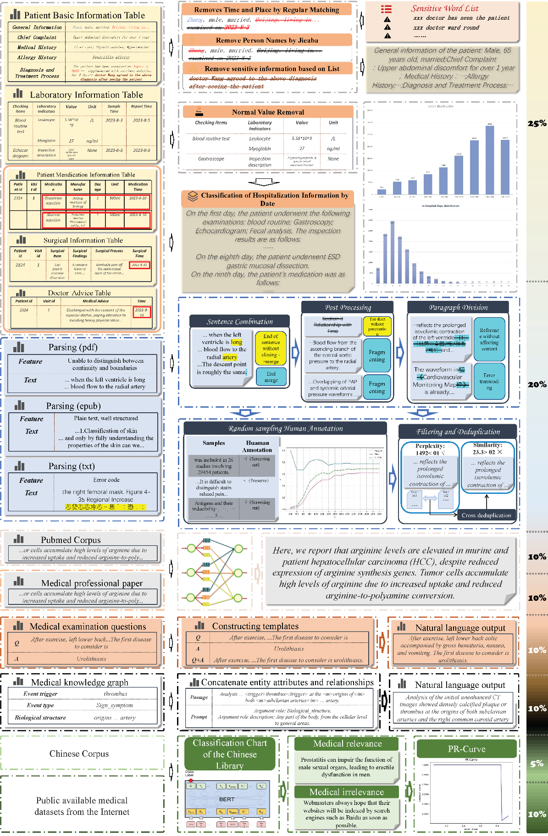
Supplementary Figure 1: Data Distribution and Processing Strategies for Continue Training
To perform continued training and enhance our model’s comprehension of medical data, we gathered a diverse array of data, prioritizing quality and clinical value. Our sources include private data like electronic medical records (EMRs) compiled by expert physicians over decades, as well as publicly available documents like medical books. Preparing this data for large language model (LLM) training necessitated considerable effort due to the need to respect patient confidentiality and the varying formats of the data.

Multisource Extraction of High-Quality Medical Data
The data preparation process (illustrated in Figure 6) involved curating a dataset from four sources: (1) Structured EMRs from real-world clinical applications, (2) Chinese medical books obtained through various channels, including hospital teaching resources and online materials, (3) A medical domain subset derived from the PubMed corpus, and (4) General Chinese data from public datasets commonly used for LLM training. The combination of these diverse sources means our model is comprehensive in its understanding, covering not only the clinical observations from EMRs but also the theoretical knowledge from medical books. This helps the model to provide well-rounded insights that could assist medical experts in their work.
Electronic Medical Records: Capturing Real-World Clinical Observations(9.3% of training). Electronic medical records (EMRs) are a cornerstone of our dataset due to their direct insights into real-world clinical practice. To make this structured data suitable for LLM training, we integrated related records from individual patient visits, creating a holistic view of each case. This involved connecting information from various EMR tables, removing sensitive details to respect privacy, retaining clinically relevant outliers in test reports, and organizing the data chronologically. This process ensures our model gains a firsthand understanding of real-world medical scenarios, enhancing its capacity to assist with diagnostics and patient management.
Chinese Medical Books: Imbuing the Model with Theoretical Knowledge (23.5% of training). Chinese medical books, while unstructured, are a comprehensive source of professional medical knowledge. However, their varied formats necessitated a meticulous 5-step processing regimen to convert the raw data into a format suitable for LLM training. This included parsing the documents into plaintext, segmenting and concatenating the text, performing post-hoc cleaning, filtering, and deduplicating. By training the model on these texts, it gains a broad understanding of medical theories and concepts, further complementing its clinical insights derived from EMRs.
PubMed Subset: Integrating Academic Medical Literature (33.5% of training). A subset of specialized articles from the PubMed corpus serves as another significant data source, introducing the model to cutting-edge research and academic perspectives in medicine. The processing of this data aligns with that of the medical books, ensuring uniformity across different data types. The inclusion of this academic literature enriches the model’s knowledge base, allowing it to stay informed about the latest medical research trends and findings.
General Chinese Data: Enhancing Comprehensive Understanding (23.4% of training). General Chinese data from diverse public datasets rounds out our data sources, providing the model with a broader language context. This data was supplemented with medical text selected by a model trained on Chinese book data, further enhancing the medical relevance. The integration of these varied general texts improves the model’s overall language comprehension, ensuring it can effectively understand and generate human-like responses.

Continual Pre-training Details
We conducted continual pre-training on Qwen-1.5-32B model using domain-specific medical data. The training data composition balanced EMR data with other medical resources to ensure comprehensive medical knowledge coverage (see Appendix A for detailed data ratios and sources). Based on the collected corpus and following the most popular next token prediction method. The training was implemented using DeepSpeed with ZeRO Stage 3 optimization across 8 nodes (64 GPUs in total). We trained the model for 2 epochs using AdamW optimizer with a learning rate of 5e-6. The sequence length was set to 8,192 tokens with a batch size of 1 per GPU. The system achieved a throughput of approximately 521K tokens per second. This domain adaptation process yielded a medical-domain-enhanced language model while maintaining the base model’s general capabilities.

Instruction Tuning Data Construction

Leveraging EMR for Advanced Multi-Task Model Optimization and Instruction Fine-Tuning

Expert-Guided Instruction Tuning Datasets
Building upon the foundational knowledge acquired during the initial phase of continued training, our focus shifts to the critical process of Instruction Tuning. This phase aims to optimize the model’s ability to answer domain-specific questions accurately, effectively translating the latent understanding gleaned from the first phase into practical problem-solving capabilities. Electronic Medical Records (EMRs) serve as a rich source of clinical knowledge for enhancing large language models through multi-task instruction tuning. This section presents our systematic approach to leveraging EMRs, which encompasses three key components: (1) a three-dimensional task cube formulation that organizes medical tasks across NLP capabilities, clinical specialties, and application domains; (2) a task-aware data selection strategy that ensures both diversity and quality in EMR-derived training instances; and (3) a collaborative medical question construction process that combines expert knowledge with data-driven filtering. Through this structured framework, we effectively transform raw EMR data into high-quality instruction tuning examples while maintaining comprehensive coverage of medical scenarios and preserving the natural interconnections within clinical practice. Implementation details are provided in Supplementary Appendix E.

EMR-Guided Medical Model Enhancement with Expert Supervision
The construction of high-quality preference data for medical language models integrates structured clinical evidence from EMRs with expert evaluation from professional doctors. EMRs provide implicit preferences embedded in real clinical decisions, capturing nuanced relationships between diagnoses, treatments, and outcomes. This natural supervision is enhanced through systematic evaluation by medical professionals who assess model outputs across multiple clinical dimensions. This dual-source approach ensures that the resulting preference data reflects both evidence-based medical practice and expert clinical judgment.
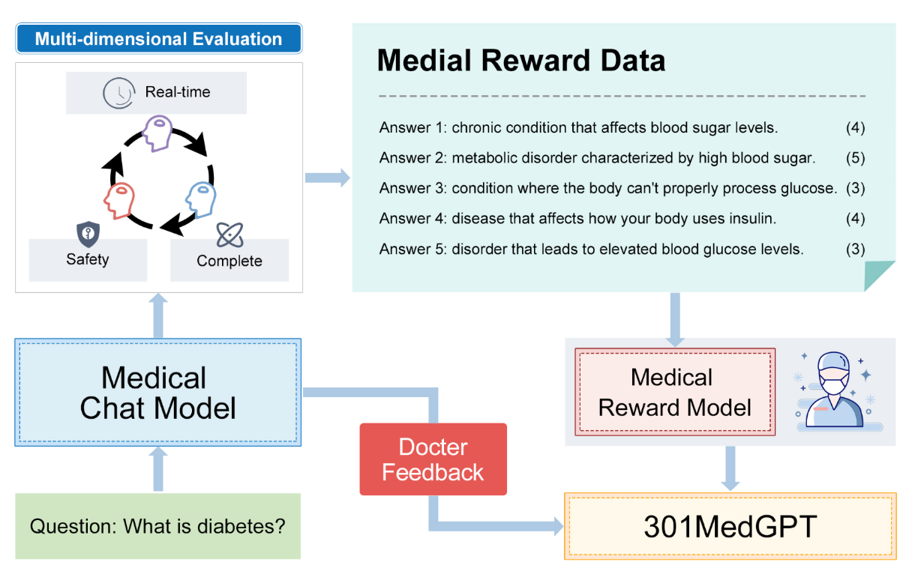
Supplementary Figure 2: Framework of Reinforcement Learning

EMR-Supervised Preference Data Construction
The inherent supervisory nature of electronic medical records (EMRs) provides robust implicit supervision signals that can be leveraged to establish preferential relationships between medical tasks. By utilizing the structured information within EMRs, we can automatically extract and model preferences across various medical scenarios without requiring explicit annotations. This framework enhances the model’s understanding and preference alignment across fine-grained medical attributes, including diagnoses, treatment plans, and laboratory results.

Doctor Feedback and Preference Construction
To generate diverse candidate responses for doctor evaluation, we employ a sophisticated multi-model sampling approach. The primary source comes from self-sampling of the current model with a temperature setting of 0.9 for general medical content generation. For sensitive EMR-related tasks, we utilize specialized deployed open-source models for sampling and content refinement. Additional candidates are sourced from clinical scenarios for general medical tasks, ensuring comprehensive coverage of medical domains. We streamlined the physician evaluation process by focusing on three critical dimensions: real-time performance, safety, and comprehensiveness. This simplified framework balances efficiency with meaningful assessment, enabling rapid expert evaluation while capturing essential aspects of clinical utility. The average scores are used to rank candidate responses, with high-scoring responses incorporated as preference data for subsequent model optimization. The statistical preference data is shown in Appendix F.
The training process is executed on a distributed system comprising two nodes, each equipped with eight NVIDIA A100 GPUs. We employ a learning rate of 5e-5 and conduct training for two complete epochs. The implementation leverages ZeRO Stage 3 optimization with a per-GPU batch size of one to maximize computational efficiency while maintaining training stability. This comprehensive framework enables systematic preference learning while maintaining clinical accuracy and safety standards. The multi-dimensional scoring mechanism ensures that the model’s outputs align with professional medical practices while satisfying real-time performance requirements.

Task Cube Formulation
To comprehensively capture the complexity of medical knowledge and ensure effective task representation, we construct a three-dimensional medical task cube. This structure enables systematic coverage of medical expertise while maintaining task diversity. Let $T$ denote the complete task space, defined as:
$\begin{matrix}T=N×S×A\end{matrix}$ (3)
where $N=\{t_{i}^{n}\}_{i=1}^{N_{1}}$ denotes NLP tasks, $S=\{t_{j}^{s}\}_{j=1}^{N_{2}}$ denotes Clinical specialties, and $A=\{t_{k}^{a}\}_{k=1}^{N_{3}}$ denotes Application domains.
Each task instance $τ∈T$ is represented as:
$\begin{matrix}τ=(t^{n},t^{s},t^{a}),\text{ where }t^{n}∈N,t^{s}∈S,t^{a}∈A\end{matrix}$ (4)
The NLP dimension $N$ encompasses fundamental clinical language tasks, including medical question answering, clinical summarization, and diagnostic reasoning. For example, given a patient’s symptoms, the model performs both entity extraction for key clinical findings and reasoning for potential diagnoses. The clinical specialty dimension $S$ captures domain-specific medical knowledge across different fields. For instance, in cardiology, tasks focus on ECG interpretation and cardiovascular risk assessment, while oncology tasks emphasize tumor staging and treatment response evaluation. The application domain dimension $A$ addresses practical clinical needs, ranging from risk stratification to treatment planning. This includes tasks such as mortality prediction in intensive care and medication regimen optimization based on patient-specific factors.
For each selected task configuration $τ$, we generate instruction instances $I_{τ}$ based on the template $P_{τ}$designed by clinical expert:
$\begin{matrix}I_{τ}=\{(x_{i},y_{i})∣ϕ(P_{τ},x_{i},y_{i})=τ,(x_{i},y_{i})∈D\}\end{matrix}$ (5)
where $ϕ(⋅)$ maps data instances to task configurations, and $D$ is the EMR dataset. This structured approach ensures comprehensive coverage of medical scenarios while maintaining the natural interconnections between different aspects of clinical practice.

Task-awareness EMR Data Selection
To effectively leverage EMRs while maintaining model capabilities, we develop a systematic method for instruction selection. The approach addresses the challenge of potential degradation from homogeneous content by ensuring diversity and quality in the training data.
Let $D=\{(x_{i},y_{i})\}_{i=1}^{N}$ denote the constructed datasets for specific $τ$. To ensure diversity in selected data, we first employ clustering-based selection:
$\begin{aligned}C&=\{c_{1},c_{2},…,c_{K}\}⊂D \\ S_{\text{cluster}}&=\underset{k=1}{\overset{K}{⋃}}\{{\text{argmin}}_{x_{i}∈D}d(y_{i},c_{k})\}\end{aligned}$ (6)
where $C$ represents K-means cluster centers, and $d(⋅,⋅)$ is the cosine distance in embedding space.
To capture task-specific characteristics that might be overlooked by clustering, we employ a complementary task-specific selection:
$\begin{matrix}S_{\text{task}}=\{(x_{i},y_{i})∈D∣L_{t}(f(x_{i}),y_{i})>θ_{t}\}\end{matrix}$ (7)
where $f(⋅)$ is a task-specific model (Qwen-7B), $L_{t}$ is the task-specific loss, and $θ_{t}$ is the 75th percentile threshold of validation loss. The final instruction tuning dataset combines both selection strategies:
$\begin{matrix}I=S_{\text{cluster}}∪S_{\text{task}}\end{matrix}$ (8)

Collaborative Medical Question Construction with Clinical Experts
To enhance the model’s ability to handle complex medical questions, we first used doctors’ knowledge to construct a large set of complex questions. Through a process of self-instruction and iterative refinement with doctors, we continuously optimized the overall collection of questions. After obtaining the medical questions, we initially used LLM (Language Model) to generate answers and then obtained a dataset of real complex question evaluations through revision by doctors. To encourage diversity, a new instruction is added to the task pool only when its ROUGE-L similarity with any existing instruction is less than 0.7. Actually, we use bm25 to filter the generated questions.
For data deduplication, we employ the MinHash algorithm with a similarity threshold of 0.5. The filtering process further enhances data quality, leveraging Qwen-70B with carefully designed prompts to evaluate data quality across multiple dimensions, including content richness, logical structure, absence of hallucinations, and non-redundancy.
We conduct the training over 2 epochs with a learning rate 5e-6, utilizing AdamW optimizer for parameter updates. The distributed training is executed across 8 NVIDIA A800 GPUs, with DeepSpeed’s native communication backend facilitating efficient inter-GPU communication. We employ ZeRO Stage 3 optimization for memory efficiency, maintaining a per-GPU batch size of 1 to maximize the utilization of available computational resources.

Expert-Integrated Preference Datasets
Frontline clinical experts are involved to align the differences between our model and the expertise of seasoned practitioners.
The dataset encompasses 316 clinical questions spanning diverse specialties, including Pulmonology, Dermatology, Cardiology, and others across internal medicine, surgical disciplines, and emergency departments. This comprehensive coverage ensures broad applicability across multiple clinical contexts and specialty areas. Besides, the complexity of these clinical questions closely mirrors the challenges encountered by experienced physicians in real-world settings.
Given the limited data that physicians can curate based on their expertise, owing to the intricacies of each specialty, we employed a multi-agent approach to set profiles. Using GPT-4, we augmented the model’s data further. Taking the expert-provided clinical questions for each department as seed questions, we generated 200 questions per department, encompassing critical illnesses, complications, inter-departmental issues, and other primary clinical concerns.
The generated questions were further annotated and filtered by physicians, selecting a meaningful subset of clinical questions. This ensures that the model’s hallucination issues do not proliferate in our training dataset. The final dataset consisted of 631.
To ensure model diversity, for each generated question, we utilized ChatGLM, AI4Docter, and HuatuoGPT-II for responses. These answers serve as training data for the reward model. We evaluated the responses based on safety, professionalism, and completeness. Scores were provided from these three perspectives, offering a holistic assessment of the model and contributing to the training data.
Furthermore, to safeguard the model’s accuracy and reliability, we supplemented the medical queries with safety-specific data. To mitigate any potential deterioration in model performance, 1,000 safety-related entries were added.
To maximize clinical diversity while maintaining representativeness, we implemented a cluster-based medical record selection strategy across departments. We applied unsupervised clustering algorithms within each specialty cohort, using a combination of ICD codes, procedure types, medication classes, and clinical narratives as feature vectors. This approach identified distinct clinical phenotypes and practice patterns within each department. From each identified cluster center, we selected representative medical records, ensuring coverage of diverse disease presentations, treatment approaches, and patient demographics. In constructing preference data pairs, original content from these medical records served as the superior response, while model-generated content was positioned as the inferior alternative. This approach leverages authentic clinical documentation as the gold standard, directly guiding the model to emulate the precision and clinical reasoning patterns of expert physicians. The selection process incorporated heuristic rule-based verification followed by LLM-assisted comparative analysis to identify inconsistencies between generated responses and original medical records. Through this rigorous filtering methodology, we obtained 1,500 high-quality preference data pairs with verified clinical accuracy and relevance across 28 clinical departments.

Retrieval Augment Answer Generation
The integration of historical EMR cases and expert knowledge bases significantly enhances the model’s ability to handle complex medical scenarios while reducing hallucination risks. Our approach combines parametric knowledge stored in model weights with non-parametric knowledge accessed through efficient retrieval mechanisms [39-42], enabling both memorization and dynamic reference of medical expertise. These details in EMR provide the foundation for constructing various medical tasks, such as diagnostic discussions, treatment plan recommendations, and admission diagnosis assessments.

Ontology-Enhanced EMR Knowledge Representation and Retrieval
For each EMR document $d$, we construct a dual representation combining dense vectors and structured medical concepts:
$\begin{matrix}R(d)=[v_{d};m_{d}]\end{matrix}$ (9)
where $v_{d}∈R^{h}$ is the dense embedding encoded by a medical-domain pretrained encoder, and $m_{d}∈\{0,1\}^{|V|}$ represents the sparse ontological features extracted from medical concepts and attributes. The ontological features $m_{d}$ are derived from structured EMR fields including chief complaints, medical history, examination results, medications, surgical records, and diagnostic discussions. These clinical elements are mapped to standardized medical ontologies and enriched with their corresponding attributes, creating a comprehensive scalar representation that captures the hierarchical relationships and semantic associations within medical concepts.
Given a query $q$, relevant documents are retrieved using a hybrid scoring function:
$\begin{aligned}score(q,d)&=λ⋅sim_{d}(q,d)+(1-λ)⋅sim_{s}(q,d) \\ \text{where }&sim_{d}(q,d)=cos(v_{q},v_{d}), \\ &sim_{s}(q,d)=f_{onto}(m_{q},m_{d})\end{aligned}$ (10)
where $f_{onto}$ measures the ontological similarity between medical concept sets, and $λ$ balances dense and sparse matching signals.

Multi-source Knowledge Integration
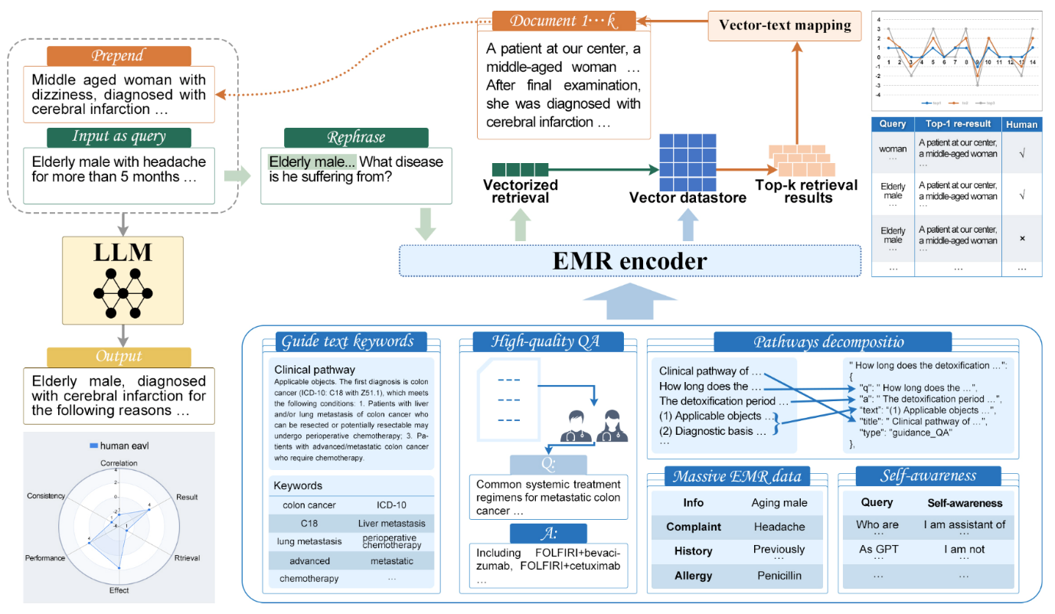 Supplementary Figure 3: Our pipeline can be decomposed into the following 4 stages. Blue: Encode data from multiple sources into a vector datastore. Green: Given a input question, rewrite it into a query with a retriever-preferred form. Orange: Use the query to retrieve the top-k documents from the vector datastore. Yellow: The retrieved results are prepended to the original question, fed into the LM to get an enhanced output.
The knowledge base integrates three primary information sources: EMR abstractions, medical guidelines, and expert dialogues, as shown in Figure 8. EMR abstractions systematically capture essential clinical information through structured core elements, including chief complaints for primary patient concerns, comprehensive medical history documenting previous conditions, detailed examination results encompassing lab tests and imaging studies, diagnostic assessments with supporting evidence, and prescribed treatment regimens with monitoring protocols.
The medical guideline component maintains version-controlled clinical protocols, with standardized frameworks like NCCN Guidelines serving as authoritative references. Each guideline $g∈G$ is represented as:
$\begin{matrix}g=\{(c_{i},r_{i},t_{i})\}_{i=1}^{n}\end{matrix}$ (11)
where $c_{i}$ represents specific clinical conditions and disease stages, $r_{i}$ details evidence-based therapeutic recommendations with role-specific guidance for different physician experience levels, and $t_{i}$ indicates the timestamp of the latest protocol update.
Expert dialogues $D$ are structured as question-answer pairs enriched with medical context:
$\begin{matrix}D=\{(q_{i},a_{i},m_{i})\}_{i=1}^{N}\end{matrix}$ (12)
where $m_{i}$ captures metadata including medical specialty, difficulty level, and expert verification status.
During inference, given an input query $x$, the model generates response $y$ by incorporating retrieved knowledge $K$:
$\begin{aligned}P(y|x)&=P(y|x,K), \\ &\text{ where }K=\text{Retrieve}(x,[E,G,D])\end{aligned}$ (13)
For each retrieved document $d_{i}$, we construct a context-enriched prompt template as shown in Figure 8. This unified framework enables the model to leverage both structured medical knowledge and practical clinical experience, significantly improving response accuracy and reducing hallucination in complex medical scenarios.

Supplementary Table 4: Generation Results With Different Models Under different Settings.
Model | R_L | ΔR_L | F1 | ΔF1 | EM | ΔEM | Hit | ΔHit
AI4Docter(7B) | 32.55 | 0.00 | 19.93 | 0.00 | 14.97 | 0.00 | 59.00 | 0.00
w/ Re-Aug-EMR | 33.55 | +1.00 | 19.49 | +4.66 | 14.72 | +1.10 | 62.00 | +3.00
w/ Re-Aug-MG | 41.26 | +8.71 | 19.93 | +10.92 | 14.97 | +4.49 | 59.00 | 0.00
Huatuo 7B | 18.38 | 0.00 | 40.72 | 0.00 | 36.78 | 0.00 | 9.00 | 0.00
w/ Re-Aug-EMR | 18.44 | +0.06 | 41.19 | +0.47 | 35.16 | -1.62 | 7.00 | -2.00
w/ Re-Aug-MG | 18.53 | +0.15 | 40.95 | +0.23 | 36.03 | -0.75 | 9.00 | 0.00
HuatuoII 13B | 18.07 | 0.00 | 40.55 | 0.00 | 25.73 | 0.00 | 1.00 | 0.00
w/ Re-Aug-EMR | 18.53 | +0.46 | 41.76 | +1.21 | 27.63 | +1.90 | 1.00 | 0.00
w/ Re-Aug-MG | 18.05 | -0.02 | 40.55 | 0.00 | 25.73 | 0.00 | 1.00 | 0.00
Yidu 13B | 16.90 | 0.00 | 33.80 | 0.00 | 32.36 | 0.00 | 5.00 | 0.00
w/ Re-Aug-EMR | 18.24 | +1.34 | 35.81 | +2.01 | 36.15 | +3.79 | 8.00 | +3.00
w/ Re-Aug-MG | 16.90 | 0.00 | 33.80 | 0.00 | 32.36 | 0.00 | 5.00 | 0.00
Qwen 32B | 18.46 | 0.00 | 40.97 | 0.00 | 32.10 | 0.00 | 2.00 | 0.00
w/ Re-Aug-EMR | 19.08 | +0.62 | 42.29 | +1.32 | 35.73 | +3.63 | 6.00 | +4.00
w/ Re-Aug-MG | 18.47 | +0.01 | 40.97 | 0.00 | 32.10 | 0.00 | 2.00 | 0.00

