Supplementary Information
Supplement to: Ji J, Zhang Y, Zhang XL, Liu JY, Xu JF. Digital Interventions for HIV-related Sexual Risk Behaviors: A Systematic Review and Network Meta-Analysis

Table of contents
1. PRISMA 2020 Checklist | 1
2. Search Strategy | 5
3. Study Characteristics | 12
4. Network Plots for Different Outcomes | 20
5. Risk of Bias Assessment Results | 23
6. League Table | 26
7. SUCRA and Cumulative Probability Plots | 30
8. Subgroup Analysis Results | 32
9. Regression Analysis Results | 46
10. Sensitivity Analysis Results | 48
11. Evaluation of Inconsistency and Heterogeneity | 51
12. Funnel Plots | 58
13. CINeMA Assessment | 61

1.PRISMA 2020 Checklist

Section and Topic | Item # | Checklist item | Location where item is reported
TITLE
Title | 1 | Identify the report as a systematic review. | Page 1
ABSTRACT
Abstract | 2 | See the PRISMA 2020 for Abstracts checklist. | Page 2
INTRODUCTION
Rationale | 3 | Describe the rationale for the review in the context of existing knowledge. | Page 2-4
Objectives | 4 | Provide an explicit statement of the objective(s) or question(s) the review addresses. | Page 4
METHODS
Eligibility criteria | 5 | Specify the inclusion and exclusion criteria for the review and how studies were grouped for the syntheses. | Page 13-14
Information sources | 6 | Specify all databases, registers, websites, organisations, reference lists and other sources searched or consulted to identify studies. Specify the date when each source was last searched or consulted. | Page 14
Search strategy | 7 | Present the full search strategies for all databases, registers and websites, including any filters and limits used. | Page 14
Selection process | 8 | Specify the methods used to decide whether a study met the inclusion criteria of the review, including how many reviewers screened each record and each report retrieved, whether they worked independently, and if applicable, details of automation tools used in the process. | Page 14
Data collection process | 9 | Specify the methods used to collect data from reports, including how many reviewers collected data from each report, whether they worked independently, any processes for obtaining or confirming data from study investigators, and if applicable, details of automation tools used in the process. | Page 14
Data items | 10a | List and define all outcomes for which data were sought. Specify whether all results that were compatible with each outcome domain in each study were sought (e.g. for all measures, time points, analyses), and if not, the methods used to decide which results to collect. | Page 15
Data items | 10b | List and define all other variables for which data were sought (e.g. participant and intervention characteristics, funding sources). Describe any assumptions made about any missing or unclear information. | Page 15-16
Study risk of bias assessment | 11 | Specify the methods used to assess risk of bias in the included studies, including details of the tool(s) used, how many reviewers assessed each study and whether they worked independently, and if applicable, details of automation tools used in the process. | Page 17
Effect measures | 12 | Specify for each outcome the effect measure(s) (e.g. risk ratio, mean difference) used in the synthesis or presentation of results. | Page 16
Synthesis methods | 13a | Describe the processes used to decide which studies were eligible for each synthesis (e.g. tabulating the study intervention characteristics and comparing against the planned groups for each synthesis (item #5)). | Page 14-15
Synthesis methods | 13b | Describe any methods required to prepare the data for presentation or synthesis, such as handling of missing summary statistics, or data conversions. | Page 15
Synthesis methods | 13c | Describe any methods used to tabulate or visually display results of individual studies and syntheses. | Page 16-17
Synthesis methods | 13d | Describe any methods used to synthesize results and provide a rationale for the choice(s). If meta-analysis was performed, describe the model(s), method(s) to identify the presence and extent of statistical heterogeneity, and software package(s) used. | Page 15-16
Synthesis methods | 13e | Describe any methods used to explore possible causes of heterogeneity among study results (e.g. subgroup analysis, meta-regression). | Page 16
Synthesis methods | 13f | Describe any sensitivity analyses conducted to assess robustness of the synthesized results. | Page 16
Reporting bias assessment | 14 | Describe any methods used to assess risk of bias due to missing results in a synthesis (arising from reporting biases). | Page 16
Certainty assessment | 15 | Describe any methods used to assess certainty (or confidence) in the body of evidence for an outcome. | Page 16
RESULTS
Study selection | 16a | Describe the results of the search and selection process, from the number of records identified in the search to the number of studies included in the review, ideally using a flow diagram. | Fig. 1
Study selection | 16b | Cite studies that might appear to meet the inclusion criteria, but which were excluded, and explain why they were excluded. | Fig. 1
Study characteristics | 17 | Cite each included study and present its characteristics. | Page4-5
Risk of bias in studies | 18 | Present assessments of risk of bias for each included study. | Page 5
Results of individual studies | 19 | For all outcomes, present, for each study: (a) summary statistics for each group (where appropriate) and (b) an effect estimate and its precision (e.g. confidence/credible interval), ideally using structured tables or plots. | Page 5-7
Results of syntheses | 20a | For each synthesis, briefly summarise the characteristics and risk of bias among contributing studies. | Page 8
Results of syntheses | 20b | Present results of all statistical syntheses conducted. If meta-analysis was done, present for each the summary estimate and its precision (e.g. confidence/credible interval) and measures of statistical heterogeneity. If comparing groups, describe the direction of the effect. | Page 5-8
Results of syntheses | 20c | Present results of all investigations of possible causes of heterogeneity among study results. | Page 8
Results of syntheses | 20d | Present results of all sensitivity analyses conducted to assess the robustness of the synthesized results. | Page 7-8
Reporting biases | 21 | Present assessments of risk of bias due to missing results (arising from reporting biases) for each synthesis assessed. | Page 8
Certainty of evidence | 22 | Present assessments of certainty (or confidence) in the body of evidence for each outcome assessed. | Page 8
DISCUSSION
Discussion | 23a | Provide a general interpretation of the results in the context of other evidence. | Page 8-9
Discussion | 23b | Discuss any limitations of the evidence included in the review. | Page 11-12
Discussion | 23c | Discuss any limitations of the review processes used. | Page 11-12
Discussion | 23d | Discuss implications of the results for practice, policy, and future research. | Page12-13
OTHER INFORMATION
Registration and protocol | 24a | Provide registration information for the review, including register name and registration number, or state that the review was not registered. | Page 13
Registration and protocol | 24b | Indicate where the review protocol can be accessed, or state that a protocol was not prepared. | Page 13
Registration and protocol | 24c | Describe and explain any amendments to information provided at registration or in the protocol. | Page 13
Support | 25 | Describe sources of financial or non-financial support for the review, and the role of the funders or sponsors in the review. | Page 17
Competing interests | 26 | Declare any competing interests of review authors. | Page 18
Availability of data, code and other materials | 27 | Report which of the following are publicly available and where they can be found: template data collection forms; data extracted from included studies; data used for all analyses; analytic code; any other materials used in the review. | Page 17
From: Page MJ, McKenzie JE, Bossuyt PM, Boutron I, Hoffmann TC, Mulrow CD, et al. The PRISMA 2020 statement: an updated guideline for reporting systematic reviews. BMJ 2021;372:n71. doi: 10.1136/bmj.n71. This work is licensed under CC BY 4.0. To view a copy of this license, visit https://creativecommons.org/licenses/by/4.0/
2. Search Strategy

Table S1 Search Strategy for the Cochrane Central Register of Controlled Trials (CENTRAL)
# | Searches
1 | MeSH descriptor: [Condom Use] explode all trees
2 | MeSH descriptor: [Anal Sex] explode all trees
3 | MeSH descriptor: [Chemsex] explode all trees
4 | MeSH descriptor: [Chemical Sex] explode all trees
5 | ("unprotected sex"):ti,ab,kw OR ("unprotected anal sex"):ti,ab,kw OR ("condomless sex"):ti,ab,kw OR ("condomless anal sex"):ti,ab,kw OR ("unsafe sex"):ti,ab,kw
6 | ("high-risk sex"):ti,ab,kw OR ("high risk sex"):ti,ab,kw OR ("high-risk sexual behavior"):ti,ab,kw OR ("sexual risk behavior"):ti,ab,kw OR ("unprotected intercourse"):ti,ab,kw
7 | ("number of sexual partners"):ti,ab,kw OR ("safer sexual agreements"):ti,ab,kw OR ("safer agreements"):ti,ab,kw OR ("polysexual partner"):ti,ab,kw OR ("commercial sex"):ti,ab,kw
8 | ("alcohol-facilitated sex"):ti,ab,kw OR ("concurrent sexual partnerships"):ti,ab,kw OR ("casual sex"):ti,ab,kw OR ("compulsive sexual behavior"):ti,ab,kw
9 | #1 OR #2 OR #3 OR #4 OR #5 OR #6 OR #7 OR #8
10 | MeSH descriptor: [Digital Health] explode all trees
11 | MeSH descriptor: [Digital Tools] explode all trees
12 | MeSH descriptor: [mHealth] explode all trees
13 | MeSH descriptor: [Telemedicine] explode all trees
14 | MeSH descriptor: [App] explode all trees
15 | MeSH descriptor: [Smartphone] explode all trees
16 | MeSH descriptor: [SMS] explode all trees
17 | MeSH descriptor: [Gamification] explode all trees
18 | MeSH descriptor: [Social Network-Based Strategies] explode all trees
19 | MeSH descriptor: [Big Data] explode all trees
20 | MeSH descriptor: [Digital Innovations] explode all trees
21 | MeSH descriptor: [Data Harnessing] explode all trees
22 | MeSH descriptor: [Virtual Reality] explode all trees
23 | ("digital"):ti,ab,kw OR ("digital interventions"):ti,ab,kw OR ("digital health interventions"):ti,ab,kw OR ("digital therapies"):ti,ab,kw OR ("digital technologies"):ti,ab,kw
24 | ("digital supports"):ti,ab,kw OR ("eHealth"):ti,ab,kw OR ("electronic health"):ti,ab,kw OR ("mobile health"):ti,ab,kw OR ("virtual medicine"):ti,ab,kw
25 | ("telehealth"):ti,ab,kw OR ("digital health technology"):ti,ab,kw OR ("digital health technologies"):ti,ab,kw OR ("health technologies"):ti,ab,kw OR ("mobile applications"):ti,ab,kw
26 | ("social media"):ti,ab,kw OR ("cellular phone"):ti,ab,kw OR ("mobile phone"):ti,ab,kw OR ("mobile device"):ti,ab,kw OR ("text message"):ti,ab,kw
27 | ("MMS"):ti,ab,kw OR ("online platform"):ti,ab,kw OR ("AI"):ti,ab,kw OR ("artificial intelligence"):ti,ab,kw OR ("machine learning"):ti,ab,kw
28 | ("mobile health apps"):ti,ab,kw OR ("personal digital assistant"):ti,ab,kw
29 | #10 OR #11 OR #12 OR #13 OR #14 OR #15 OR #16 OR #17 OR #18 OR #19 OR #20 OR #21 OR #22 OR #23 OR #24 OR #25 OR #26 OR #27 OR #28
30 | MeSH descriptor: [HIV] explode all trees
31 | MeSH descriptor: [Human Immunodeficiency Virus] explode all trees
32 | MeSH descriptor: [HIV Prevention] explode all trees
33 | MeSH descriptor: [HIV Preventive] explode all trees
34 | MeSH descriptor: [HIV Tertiary Prevention] explode all trees
35 | MeSH descriptor: [HIV Control] explode all trees
36 | MeSH descriptor: [HIV Treatment] explode all trees
37 | MeSH descriptor: [HIV Management] explode all trees
38 | MeSH descriptor: [HIV Pre-Exposure Prophylaxis] explode all trees
39 | MeSH descriptor: [HIV Post-Exposure Prophylaxis] explode all trees
40 | MeSH descriptor: [AIDS] explode all trees
41 | MeSH descriptor: [Acquired Immunodeficiency Syndrome] explode all trees
42 | ("HIV prevention and control"):ti,ab,kw OR ("HIV preventive measures"):ti,ab,kw OR ("HIV therapy prophylaxis"):ti,ab,kw OR ("HIV therapy"):ti,ab,kw OR ("HIV care"):ti,ab,kw
43 | #30 OR #31 OR #32 OR #33 OR #34 OR #35 OR #36 OR #37 OR #38 OR #39 OR #40 OR #41 OR #42

Table S2 Search Strategy for Embase
# | Searches
1 | 'unsafe sex'/exp
2 | 'condom'/exp
3 | 'sexual behavior'/exp
4 | 'sexual partner'/exp
5 | 'chemsex'/exp
6 | (((((((((((((((((((((((((('unprotected sex':ti,ab,kw) OR ('unprotected anal sex':ti,ab,kw)) OR ('condomless sex':ti,ab,kw)) OR ('condomless anal sex':ti,ab,kw)) OR ('unsafe sex':ti,ab,kw)) OR ('high-risk sex':ti,ab,kw)) OR ('high risk sex':ti,ab,kw)) OR ('high-risk sexual behavior':ti,ab,kw)) OR ('sexual risk behavior':ti,ab,kw)) OR ('unprotected intercourse':ti,ab,kw)) OR ('number of sexual partners':ti,ab,kw)) OR ('safer sexual agreements':ti,ab,kw)) OR ('safer agreements':ti,ab,kw)) OR ('polysexual partner':ti,ab,kw)) OR ('commercial sex':ti,ab,kw)) OR ('alcohol-facilitated sex':ti,ab,kw)) OR ('concurrent sexual partnerships':ti,ab,kw)) OR ('casual sex':ti,ab,kw)) OR ('compulsive sexual behavior':ti,ab,kw)) OR ('chemsex':ti,ab,kw)) OR ('chemical sex':ti,ab,kw)) OR ('anal sex':ti,ab,kw))
7 | 'telemedicine'/exp
8 | 'mobile health'/exp
9 | 'mobile application'/exp
10 | 'smartphone'/exp
11 | 'social media'/exp
12 | 'text messaging'/exp
13 | 'video game'/exp
14 | 'artificial intelligence'/exp
15 | 'virtual reality'/exp
16 | (((((((((((((((((((((((((((((((((((('digital':ti,ab,kw) OR ('digital health':ti,ab,kw)) OR ('digital interventions':ti,ab,kw)) OR ('digital health interventions':ti,ab,kw)) OR ('digital tools':ti,ab,kw)) OR ('digital therapies':ti,ab,kw)) OR ('digital technologies':ti,ab,kw)) OR ('digital supports':ti,ab,kw)) OR ('ehealth':ti,ab,kw)) OR ('electronic health':ti,ab,kw)) OR ('mhealth':ti,ab,kw)) OR ('mobile health':ti,ab,kw)) OR ('virtual medicine':ti,ab,kw)) OR ('telehealth':ti,ab,kw)) OR ('digital health technology':ti,ab,kw)) OR ('digital health technologies':ti,ab,kw)) OR ('health technologies':ti,ab,kw)) OR ('app':ti,ab,kw)) OR ('mobile applications':ti,ab,kw)) OR ('social media':ti,ab,kw)) OR ('cellular phone':ti,ab,kw)) OR ('smartphone':ti,ab,kw)) OR ('mobile phone':ti,ab,kw)) OR ('mobile device':ti,ab,kw)) OR ('gamification':ti,ab,kw)) OR ('text message':ti,ab,kw)) OR ('sms':ti,ab,kw)) OR ('mms':ti,ab,kw)) OR ('online platform':ti,ab,kw)) OR ('ai':ti,ab,kw)) OR ('artificial intelligence':ti,ab,kw)) OR ('social network-based strategies':ti,ab,kw)) OR ('big data':ti,ab,kw)) OR ('digital innovations':ti,ab,kw)) OR ('data harnessing':ti,ab,kw)) OR ('machine learning':ti,ab,kw)) OR ('mobile health apps':ti,ab,kw)) OR ('personal digital assistant':ti,ab,kw)) OR ('virtual reality':ti,ab,kw))
17 | 'human immunodeficiency virus'/exp
18 | 'human immunodeficiency virus infection'/exp
19 | 'acquired immune deficiency syndrome'/exp
20 | 'pre-exposure prophylaxis'/exp
21 | 'postexposure prophylaxis'/exp
22 | (((((((((((((('human immunodeficiency virus':ti,ab,kw) OR ('hiv prevention':ti,ab,kw)) OR ('hiv preventive':ti,ab,kw)) OR ('hiv control':ti,ab,kw)) OR ('hiv treatment':ti,ab,kw)) OR ('hiv prevention and control':ti,ab,kw)) OR ('hiv preventive measures':ti,ab,kw)) OR ('hiv therapy prophylaxis':ti,ab,kw)) OR ('hiv therapy':ti,ab,kw)) OR ('hiv care':ti,ab,kw)) OR ('hiv management':ti,ab,kw)) OR ('hiv pre-exposure prophylaxis':ti,ab,kw)) OR ('hiv post-exposure prophylaxis':ti,ab,kw)) OR ('aids':ti,ab,kw))
23 | #1 OR #2 OR #3 OR #4 OR #5 OR #6
24 | #7 OR #8 OR #9 OR #10 OR #11 OR #12 OR #13 OR #14 OR #15 OR #16
25 | #17 OR #18 OR #19 OR #20 OR #21 OR #22
26 | #23 AND #24 AND #25

Table S3 Search Strategy for Pubmed
# | Searches
1 | "Unsafe Sex"[Mesh]
2 | "Condoms"[Mesh]
3 | "Sexual Behavior"[Mesh]
4 | "Sexual Partners"[Mesh]
5 | (((((((((((((((((((((((((("unprotected sex"[Title/Abstract]) OR ("unprotected anal sex"[Title/Abstract])) OR ("condomless sex"[Title/Abstract])) OR ("condomless anal sex"[Title/Abstract])) OR ("unsafe sex"[Title/Abstract])) OR ("high-risk sex"[Title/Abstract])) OR ("high risk sex"[Title/Abstract])) OR ("high-risk sexual behavior"[Title/Abstract])) OR ("sexual risk behavior"[Title/Abstract])) OR ("unprotected intercourse"[Title/Abstract])) OR ("number of sexual partners"[Title/Abstract])) OR ("safer sexual agreements"[Title/Abstract])) OR ("safer agreements"[Title/Abstract])) OR ("polysexual partner"[Title/Abstract])) OR ("commercial sex"[Title/Abstract])) OR ("alcohol-facilitated sex"[Title/Abstract])) OR ("concurrent sexual partnerships"[Title/Abstract])) OR ("casual sex"[Title/Abstract])) OR ("compulsive sexual behavior"[Title/Abstract])) OR ("Chemsex"[Title/Abstract])) OR ("chemical sex"[Title/Abstract])) OR ("Anal Sex"[Title/Abstract]))
6 | "Telemedicine"[Mesh]
7 | "Mobile Health"[Mesh]
8 | "Mobile Applications"[Mesh]
9 | "Computers, Hand-Held"[Mesh]
10 | "Social Media"[Mesh]
11 | "Text Messaging"[Mesh]
12 | "Video Games"[Mesh]
13 | "Artificial Intelligence"[Mesh]
14 | "Virtual Reality"[Mesh]
15 | (((((((((((((((((((((((((((((((((("digital"[Title/Abstract]) OR ("digital health"[Title/Abstract])) OR ("digital interventions"[Title/Abstract])) OR ("digital health interventions"[Title/Abstract])) OR ("digital tools"[Title/Abstract])) OR ("digital therapies"[Title/Abstract])) OR ("digital technologies"[Title/Abstract])) OR ("digital supports"[Title/Abstract])) OR ("eHealth"[Title/Abstract])) OR ("electronic health"[Title/Abstract])) OR ("mHealth"[Title/Abstract])) OR ("mobile health"[Title/Abstract])) OR ("virtual medicine"[Title/Abstract])) OR ("telehealth"[Title/Abstract])) OR ("digital health technology"[Title/Abstract])) OR ("digital health technologies"[Title/Abstract])) OR ("health technologies"[Title/Abstract])) OR ("app"[Title/Abstract])) OR ("mobile applications"[Title/Abstract])) OR ("social media"[Title/Abstract])) OR ("cellular phone"[Title/Abstract])) OR ("smartphone"[Title/Abstract])) OR ("mobile phone"[Title/Abstract])) OR ("mobile device"[Title/Abstract])) OR ("gamification"[Title/Abstract])) OR ("text message"[Title/Abstract])) OR ("SMS"[Title/Abstract])) OR ("MMS"[Title/Abstract])) OR ("online platform"[Title/Abstract])) OR ("AI"[Title/Abstract])) OR ("artificial intelligence"[Title/Abstract])) OR ("social network-based strategies"[Title/Abstract])) OR ("big data"[Title/Abstract])) OR ("digital innovations"[Title/Abstract])) OR ("data harnessing"[Title/Abstract])) OR ("machine learning"[Title/Abstract])) OR ("mobile health apps"[Title/Abstract])) OR ("personal digital assistant"[Title/Abstract])) OR ("virtual reality"[Title/Abstract]))
16 | "HIV"[Mesh]
17 | "HIV Infections"[Mesh]
18 | "Acquired Immunodeficiency Syndrome"[Mesh]
19 | "Pre-Exposure Prophylaxis"[Mesh]
20 | "Post-Exposure Prophylaxis"[Mesh]
21 | (((((((((("human immunodeficiency virus"[Title/Abstract]) OR ("HIV prevention"[Title/Abstract])) OR ("HIV preventive"[Title/Abstract])) OR ("HIV control"[Title/Abstract])) OR ("HIV treatment"[Title/Abstract])) OR ("HIV prevention and control"[Title/Abstract])) OR ("HIV preventive measures"[Title/Abstract])) OR ("HIV therapy prophylaxis"[Title/Abstract])) OR ("HIV therapy"[Title/Abstract])) OR ("HIV care"[Title/Abstract])) OR ("HIV management"[Title/Abstract])) OR ("HIV pre-exposure prophylaxis"[Title/Abstract])) OR ("HIV post-exposure prophylaxis"[Title/Abstract])) OR ("AIDS"[Title/Abstract]))
22 | #1 OR #2 OR #3 OR #4 OR #5
23 | #6 OR #7 OR #8 OR #9 OR #10 OR #11 OR #12 OR #13 OR #14 OR #15
24 | #16 OR #17 OR #18 OR #19 OR #20 OR #21
25 | #22 AND #23 AND #24
26 | (((("Meta-Analysis"[Publication Type]) OR ("Meta-Analysis as Topic"[Mesh])) OR ("Systematic Review"[Publication Type])) OR ("Review"[Publication Type])) OR ("meta-analysis"[Title/Abstract]))
27 | #25 NOT #26
28 | (((((((((("randomized controlled trial"[Publication Type]) OR ("controlled clinical trial"[Publication Type])) OR ("randomized controlled trials as topic"[Mesh])) OR ("clinical trials as topic"[Mesh])) OR ("random allocation"[Mesh])) OR ("clinical trial"[Publication Type])) OR ("clinical trial"[Title/Abstract])) OR (random*[Title/Abstract])) OR (trial[Title/Abstract])) OR (groups[Title/Abstract]))
29 | #27 AND #28

Table S4 Search Strategy for Web of Science
# | Searches
1 | TS=("unprotected sex" OR "unprotected anal sex" OR "condomless sex" OR "condomless anal sex" OR "unsafe sex" OR "high-risk sex" OR "high risk sex" OR "high-risk sexual behavior" OR "sexual risk behavior" OR "unprotected intercourse" OR "number of sexual partners" OR "safer sexual agreements" OR "safer agreements" OR "polysexual partner" OR "commercial sex" OR "chemsex" OR "chemical sex" OR "alcohol-facilitated sex" OR "concurrent sexual partnerships" OR "casual sex" OR "compulsive sexual behavior")
2 | TS=("digital" OR "digital health" OR "digital interventions" OR "digital health interventions" OR "digital tools" OR "digital therapies" OR "digital technologies" OR "digital supports" OR "eHealth" OR "electronic health" OR "mHealth" OR "mobile health" OR "virtual medicine" OR "telehealth" OR "telemedicine" OR "digital health technology" OR "digital health technologies" OR "health technologies" OR "app" OR "mobile applications" OR "social media" OR "cellular phone" OR "smartphone" OR "mobile phone" OR "mobile device" OR "gamification" OR "text message" OR "SMS" OR "MMS" OR "online platform" OR "AI" OR "artificial intelligence" OR "social network-based strategies" OR "big data" OR "digital innovations" OR "data harnessing" OR "machine learning" OR "mobile health apps" OR "personal digital assistant" OR "virtual reality")
3 | TS=("HIV" OR "human immunodeficiency virus" OR "HIV prevention" OR "HIV preventive" OR "HIV control" OR "HIV treatment" OR "HIV prevention and control" OR "HIV preventive measures" OR "HIV therapy prophylaxis" OR "HIV therapy" OR "HIV care" OR "HIV management" OR "HIV pre-exposure prophylaxis" OR "HIV post-exposure prophylaxis" OR "AIDS" OR "acquired immunodeficiency syndrome")
4 | #1 AND #2 AND #3
5 | TS=("randomized controlled trial" OR "randomised controlled trial" OR "RCT" OR "controlled clinical trial" OR "clinical trial" OR "random allocation" OR "randomly" OR "randomized" OR "randomised" OR "placebo" OR "trial" OR "groups")
6 | TS=("meta-analysis" OR "meta analysis" OR "systematic review" OR "review" OR "literature review")
7 | #4 AND #5
8 | #7 NOT #6

Table S5 Search Strategy for SCOPUS
# | Searches
1 | TITLE-ABS-KEY ( "unprotected sex" OR "unprotected anal sex" OR "condomless sex" OR "condomless anal sex" OR "unsafe sex" OR "high-risk sex" OR "high risk sex" OR "high-risk sexual behavior" OR "sexual risk behavior" OR "unprotected intercourse" OR "number of sexual partners" OR "safer sexual agreements" OR "safer agreements" OR "polysexual partner" OR "commercial sex" OR "chemsex" OR "chemical sex" OR "alcohol-facilitated sex" OR "concurrent sexual partnerships" OR "casual sex" OR "compulsive sexual behavior" )
2 | INDEXTERMS ( "Unsafe Sex" ) OR INDEXTERMS ( "Condoms" ) OR INDEXTERMS ( "Sexual Behavior" ) OR INDEXTERMS ( "Sex Partners" )
3 | TITLE-ABS-KEY ( "digital" OR "digital health" OR "digital interventions" OR "digital health interventions" OR "digital tools" OR "digital therapies" OR "digital technologies" OR "digital supports" OR "eHealth" OR "electronic health" OR "mHealth" OR "mobile health" OR "virtual medicine" OR "telehealth" OR "telemedicine" OR "digital health technology" OR "digital health technologies" OR "health technologies" OR "app" OR "mobile applications" OR "social media" OR "cellular phone" OR "smartphone" OR "mobile phone" OR "mobile device" OR "gamification" OR "text message" OR "SMS" OR "MMS" OR "online platform" OR "AI" OR "artificial intelligence" OR "social network-based strategies" OR "big data" OR "digital innovations" OR "data harnessing" OR "machine learning" OR "mobile health apps" OR "personal digital assistant" OR "virtual reality" )
4 | INDEXTERMS ( "Telemedicine" ) OR INDEXTERMS ( "Mobile Applications" ) OR INDEXTERMS ( "Social Media" ) OR INDEXTERMS ( "Text Messaging" ) OR INDEXTERMS ( "Artificial Intelligence" ) OR INDEXTERMS ( "Virtual Reality" )
5 | TITLE-ABS-KEY ( "HIV" OR "human immunodeficiency virus" OR "HIV prevention" OR "HIV preventive" OR "HIV control" OR "HIV treatment" OR "HIV prevention and control" OR "HIV preventive measures" OR "HIV therapy prophylaxis" OR "HIV therapy" OR "HIV care" OR "HIV management" OR "HIV pre-exposure prophylaxis" OR "HIV post-exposure prophylaxis" OR "AIDS" OR "acquired immunodeficiency syndrome" )
6 | INDEXTERMS ( "Human Immunodeficiency Virus" ) OR INDEXTERMS ( "HIV Infections" ) OR INDEXTERMS ( "Acquired Immunodeficiency Syndrome" ) OR INDEXTERMS ( "Pre-Exposure Prophylaxis" )
7 | #1 OR #2
8 | #3 OR #4
9 | #5 OR #6
10 | #7 AND #8 AND #9
11 | TITLE-ABS-KEY ( "meta-analysis" OR "meta analysis" OR "systematic review" OR "review" ) OR DOCTYPE ( "re" )
12 | #10 AND NOT #11
13 | TITLE-ABS-KEY ( "randomized controlled trial" OR "randomised controlled trial" OR "RCT" OR "controlled clinical trial" OR "clinical trial" OR "random allocation" OR "randomly" OR "randomized" OR "randomised" OR "placebo" OR "trial" OR "groups" )
14 | #12 AND #13

- Study Characteristics

Table S6 Study Characteristics of the Prevalence of HIV-related Sexual Risk Behaviors
General Information
Author and year of publication | Participants | Nation | Mean Age (year) | Sample size  (n) | Interventions |  | Duration of follow-up | Outcome variable
 |  |  |  |  | T | C | Duration of follow-up | Outcome variable
Bauermeister, J. A. 2019 | YMSM | multiple nationalities | 21.5 | 155 | eHealth Online intervention  myDEx | ANC | 90D | UAI
Brody, C. 2018 | FEWs | Cambodia | 24.6 | 388 | SMS | ANC | 12M | ICU
Bull, Sheana S. 2012 | Youth | American | 19.9 | 1578 | eHealth Social networking sites Exposure to Just/Us | ANC | 6M | ICU
L. W. Chang 2021 | 15-49 year old Community residents | Uganda | 31.5 | 2148 | mHealth Health APP Scout | PC | 39M | ICU
E. P. H. Choi 2023 | MSM | China | 27.3 | 316 | SMS | ANC | 3M | ICU
D. Cordova 2020 | Youths | American | 18.8 | 50 | mHealth Multilevel Mobile Health App S4E | ANC | 30D | ICU
A. Desrosiers 2017 | WLH | American | 22 | 42 | SMS+Phone call | PC | 3M | UAI
C. Free 2016 | Youths with chlamydia infection | UK. | 20.5 | 200 | SMS | ANC | 12M | ICU
K. Govender 2019 | Truck drivers | South Africa | 36.5 | 1783 | SMS | ANC | 6M | ICU
R. Hémono 2024 | Adolescent | Rwanda | 16 | 7425 | mHealth APP Cyber Rwanda | ANC | 24M | ICU
D. Kerrigan 2019 | FSW | Tanzania | 27.8 | 496 | Combined intervention Community drop-in center and mobilization activities+Peer education+ Mobile counseling+SMS Shikamana Project | PC | 18M | ICU
M. S. C. Lim 2012 | Youngs | Australia | 19 | 994 | SMS | PC | 12M | ICU
Q. Luo 2023 | MSM | China | 34.5 | 9280 | mHealth Self-reported HIV risk assessment tool | ANC | 12M | UAI
S. L. Marhefka 2014 | WLH | American | 42.9 | 71 | eHealth Synchronous Telebehavioral Intervention VGs | PC | 6M | ICU
D. S. Maria 2021 | Youth experiencing homelessness | American | 21.2 | 97 | mHealth Just-in-Time Adaptive Intervention APP MY-RID | ANC | 6W | ICU
L. J. Mayo-Wilson 2020 | Young adults | American | 21 | 38 | SMS | ANC | 26W | ICU
X. Zhu 2019 | MSM | China | 26 | 100 | mHealth APP WeTest | PC | 6M | ICU
K. Yun, Z 2021 | HIV-negative MSM | China | 28.5 | 192 | eHealth Web-based comprehensive intervention  package | ANC | 12W | ICU  UAI
W. Tang 2018 | MSM | China | 25 | 1381 | Combined intervention Multi-media HIV testing campaign, online HIV testing service | ANC | 3M | ICU
P. S. Sullivan 2021 | HIV-negative MSM | American | 31.2 | 1220 | mHealth APP M-cubed | PC | 6M | UAI
L. Song 2016 | First-year college students | China | 20.3 | 360 | SMS | PC | 6M | ICU
E. Rice 2021 | Youth experiencing homelessness | American | 21.9 | 713 | AI AI select peer change agents PCAs | PC | 3M | UAI
W. N. Songtaweesin 2020 | YMSM and YTGW | Thailand | 17.5 | 200 | mHealth PrEP adherence App "Project Raincoat" | ANC | 6M | ICU
YMSM: young men who have sex with men; FEWs: female entertainment workers; MSM: men who have sex with men; YMSM: young men who have sex with men
BMSM: black men who have sex with men; FSW: female sex workers; WLH: women living with human immunodeficiency virus; myDEx: My Desires & Expectations; S4E: Storytelling 4 Empowerment; VGs: video conferencing groups; PCA: Peer Change Agent Model; D: day; W: week; M: month; UAI: unprotected anal intercourse; CAI: condomless anal intercourse; ICU: inconsistent condom use; NSP: number of sexual partners

Table S7 Study Characteristics of the Cumulative Exposure to HIV-related Sexual Risk Behaviors
General Information
Author and year of publication | Participants | Nation | Mean Age (year) | Sample size  (n) |  | Interventions |  | Duration of follow-up | Outcome variable
 |  |  |  |  |  | T | C | Duration of follow-up | Outcome variable
Bauermeister, J. A. 2019 | YMSM | Multiple nationalities | 21.5 | 155 |  | eHealth online intervention  myDEx | ANC | 90D | NSP
G. Chander 2015 | HIV-infected,  heavy drinking women | American | 45.6 | 148 |  | Phone call booster call | PC | 12M | ICU
R. J. DiClemente 2014 | African American female | American | 17.6 | 701 |  | Phone call Telephone counseling | ANC | 36M | ICU
R. Jones 2018 | Young urban African  American women | American | 22 | 238 |  | mHealth Soap opera video | PC | 12W | ICU
S. C. Kalichman 2018 | Sexually active men and women | American | 44.3 | 500 |  | Combined intervention in-person group workshop+mHealth cellphone-delivered coaching sessions | ANC | 12M | ICU
C. H. Klein 2017 | BMSM | American | 33 | 140 |  | eHealth Health education programs based on mobile phones and tablets Real Talk | PC | 6M | CAI
C. D. Llewellyn 2019 | MSM prescribed HIV post-exposure prophylaxis | UK. | 34.5 | 175 |  | mHealth Remote Behavioral Intervention | ANC | 12M | NSP  ICU
M. E. Newcomb 2023 | Young male couples | American | 28.3 | 400 |  | mHealth Remote video conference 2GETHER | ANC | 12M | NSP  CAI
M. J. Mimiaga 2017 | MSW | India | 27.7 | 140 |  | SMS and mobile phone counseling | PC | 6M | CAI
K. Yun, Z 2021 | HIV-negative MSM | China | 28.5 | 192 |  | eHealth web-based comprehensive intervention  package | ANC | 12W | NSP
R. G. Thompson 2020 | FSWs | Cameroon | 29.6 | 100 |  | mHealth OnTrack+BMI APP | ANC | 6W | ICU
R. Schnall 2022 | Adolescent males | American | 15.6 | 227 |  | mHealth APP MyPEEPS | PC | 9M | ICU
C. J. Reback 2019 | MSM | American | 42 | 286 |  | SMS (Interactive) TXT-PHE | PC | 8W | CAI
Mustanski, B. 2018 | YMSM | American | 23.5 | 901 |  | eHealth Online program Keep It Up! | ANC | 12M | CAI
YMSM: young men who have sex with men; BMSM: black men who have sex with men; MSW: male sex workers; FSWs: female sex workers; MSM: men who have sex with men; CAI: condomless anal intercourse; ICU: inconsistent condom use; NSP: number of sexual partners; D: day; W: week; M: month

Table S8 Abbreviations for Interventions and Outcome Indicators
Classifications | Full name | Abbreviations
All treatment modalities | Short message service or phone call based intervention | SMS or Phone call
All treatment modalities | Electronic health based intervention | eHealth
All treatment modalities | Mobile health based intervention | mHealth
All treatment modalities | Artificial intelligence based intervention | AI
All treatment modalities | Combined intervention | Combined
All treatment modalities | Passive control | PC
All treatment modalities | Active non-digital control | ANC
Outcome indicators | Unprotected anal intercourse | UAI
Outcome indicators | Inconsistent condom use | ICU
Outcome indicators | Condomless anal intercourse | CAI
Outcome indicators | Number of sexual partners | NSP

4. Network Plots for Different Outcomes

The meanings of all abbreviations can be seen in Table S6. Please click on the blue font link to access the information.

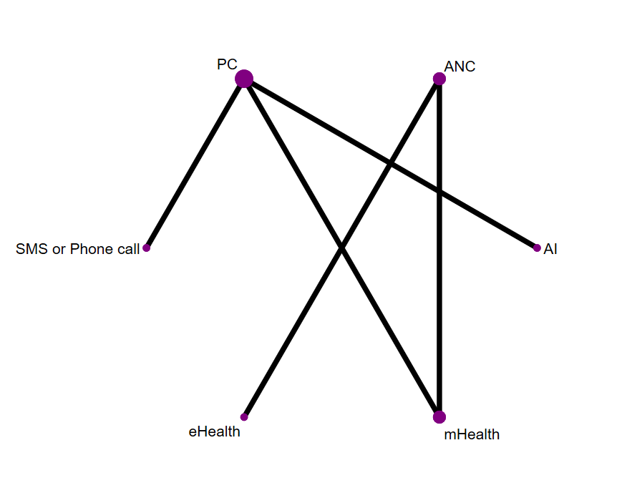
Fig S1 Network Plot of the Effect the Prevalence of UAI. The size of the nodes was proportional to the number of participants included in the trial, and the thickness of lines between the interventions relates to the number of studies for that comparison.

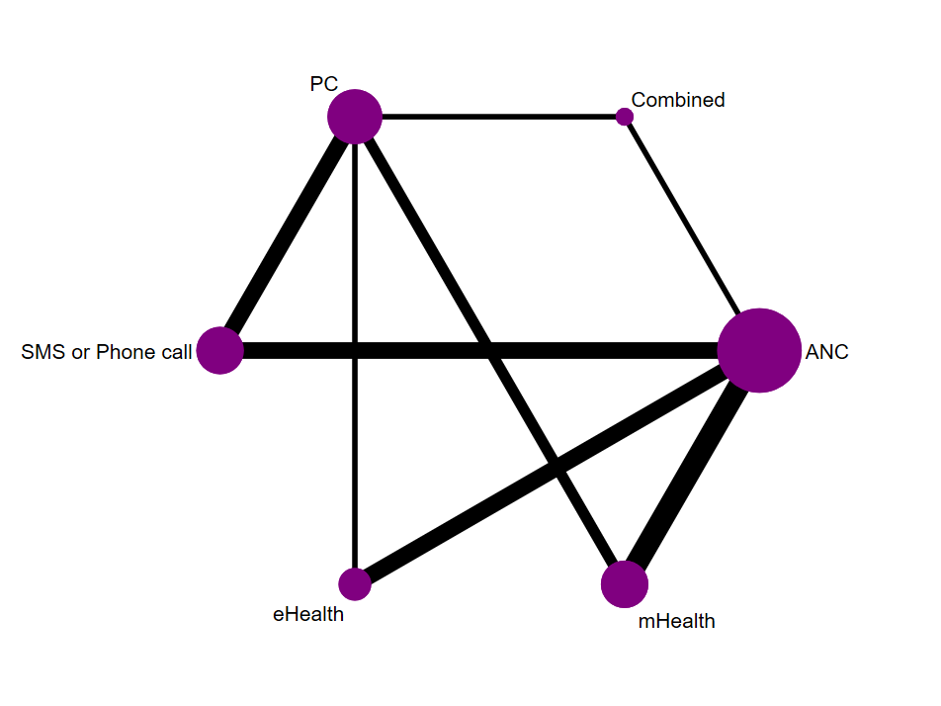
Fig S2 Network Plot of the Effect the Prevalence of ICU. The size of the nodes was proportional to the number of participants included in the trial, and the thickness of lines between the interventions relates to the number of studies for that comparison.

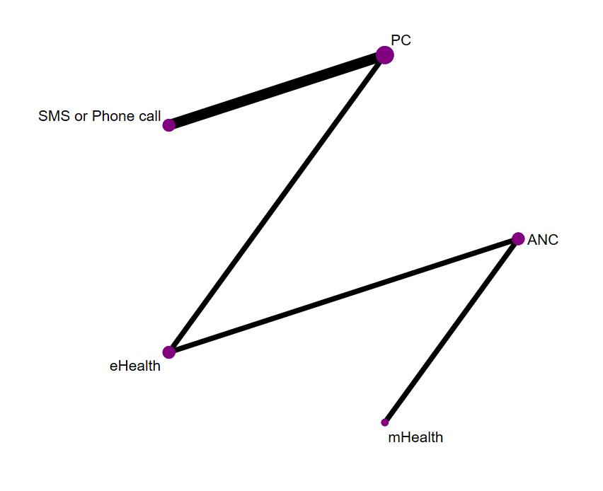
Fig S3 Network Plot of the Effect the CAI frequency. The size of the nodes was proportional to the number of participants included in the trial, and the thickness of lines between the interventions relates to the number of studies for that comparison.

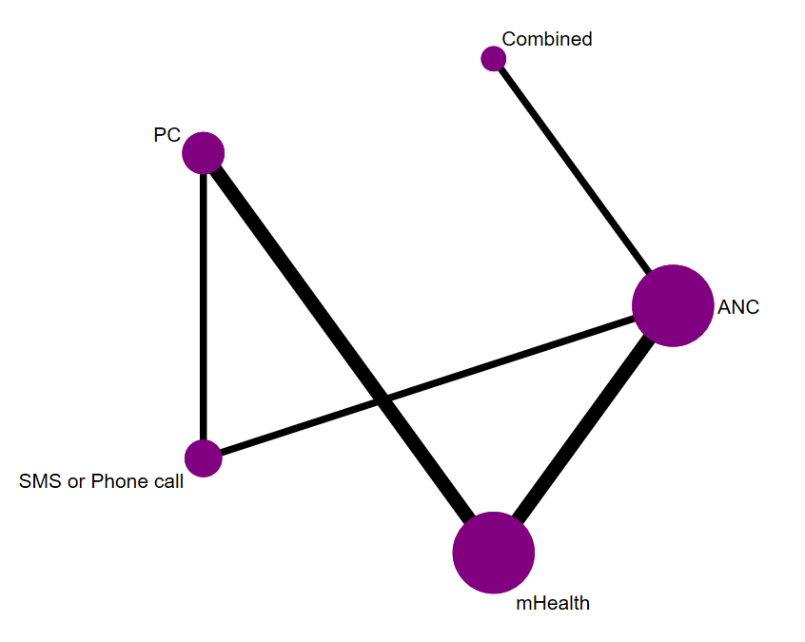
Fig S4 Network Plot of the Effect the ICU frequency. The size of the nodes was proportional to the number of participants included in the trial, and the thickness of lines between the interventions relates to the number of studies for that comparison.

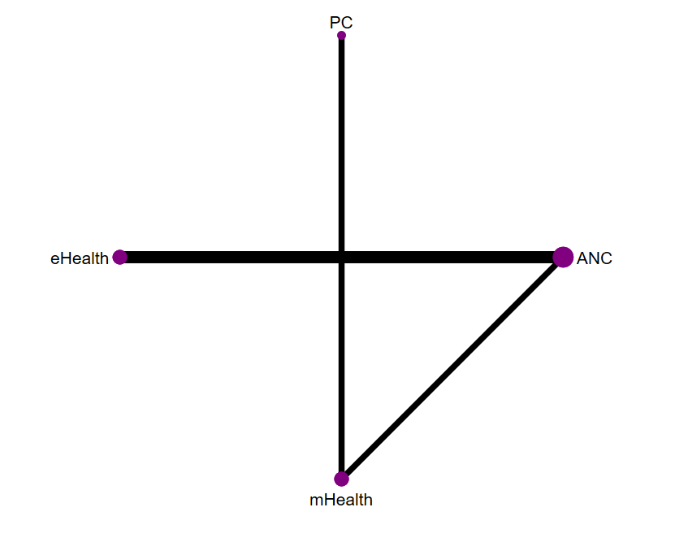
Fig S5 Network Plot of the Effect the NSP. The size of the nodes was proportional to the number of participants included in the trial, and the thickness of lines between the interventions relates to the number of studies for that comparison.

5. Risk of Bias Assessment Results
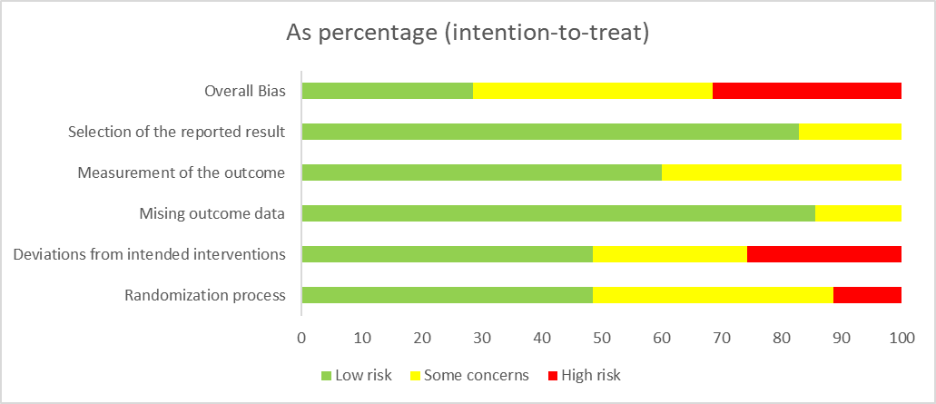
Fig S6 Overall Risk of Bias. This figure presents the overall risk of bias, expressed as the percentage for each bias item across all included studies. The assessment was conducted using the RoB 2.0 tool.

Table S9 Study-Level Risk of Bias Assessment. This table presents the study-level risk of bias assessment, conducted using the Cochrane Risk of Bias 2.0 tool to evaluate the risk of bias in RCTs.
Author | Risk bias
Author | Random sequence generation | Deviations | Missing outcome data | Measurement of outcome | Selection of reported result | Overall bias
Bauermeister, J. A. 2019 | Low risk | High risk | Low risk | Low risk | Low risk | High risk
Brody, C. 2018 | Low risk | High risk | Some concerns | Some concerns | Low risk | High risk
Bull, Sheana S. 2012 | High risk | High risk | Low risk | Low risk | Low risk | High risk
L. W. Chang 2021 | Low risk | Low risk | Low risk | Low risk | Low risk | Low risk
E. P. H. Choi 2023 | Low risk | Low risk | Low risk | Low risk | Low risk | Low risk
D. Cordova 2020 | Some concerns | Low risk | Low risk | Low risk | Some concerns | Some concerns
A. Desrosiers 2017 | Some concerns | Some concerns | Some concerns | Some concerns | Low risk | Some concerns
C. Free 2016 | Some concerns | High risk | Low risk | Low risk | Low risk | High risk
K. Govender 2019 | Low risk | Some concerns | Low risk | Some concerns | Low risk | Some concerns
R. Hémono 2024 | High risk | Some concerns | Low risk | Low risk | Some concerns | High risk
D. Kerrigan 2019 | Low risk | Low risk | Low risk | Low risk | Low risk | Low risk
M. S. C. Lim 2012 | Some concerns | Some concerns | Low risk | Some concerns | Low risk | Some concerns
Q. Luo 2023 | Low risk | Low risk | Some concerns | Low risk | Low risk | Some concerns
S. L. Marhefka 2014 | Low risk | Low risk | Low risk | Low risk | Low risk | Low risk
D. S. Maria 2021 | Low risk | Low risk | Low risk | Low risk | Low risk | Low risk
L. J. Mayo-Wilson 2020 | Some concerns | High risk | Low risk | Some concerns | Low risk | High risk
X. Zhu 2019 | Some concerns | Low risk | Low risk | Some concerns | Low risk | Some concerns
K. Yun, Z 2021 | Low risk | Low risk | Low risk | Low risk | Low risk | Low risk
W. Tang 2018 | Some concerns | Some concerns | Low risk | Some concerns | Low risk | Some concerns
P. S. Sullivan 2021 | Some concerns | High risk | Some concerns | Some concerns | Some concerns | High risk
L. Song 2016 | Some concerns | Some concerns | Low risk | Some concerns | Low risk | Some concerns
E. Rice 2021 | High risk | Low risk | Low risk | Low risk | Low risk | High risk
W. N. Songtaweesin 2020 | Low risk | Low risk | Low risk | Low risk | Low risk | Low risk
G. Chander 2015 | Low risk | High risk | Low risk | Low risk | Some concerns | High risk
R. J. DiClemente 2014 | Low risk | Low risk | Low risk | Low risk | Low risk | Low risk
R. Jones 2018 | Some concerns | High risk | Low risk | Some concerns | Low risk | High risk
S. C. Kalichman 2018 | Low risk | Some concerns | Low risk | Low risk | Low risk | Some concerns
C. H. Klein 2017 | High risk | High risk | Some concerns | Some concerns | Low risk | High risk
C. D. Llewellyn 2019 | Low risk | Some concerns | Low risk | Some concerns | Low risk | Some concerns
M. E. Newcomb 2023 | Some concerns | Low risk | Low risk | Low risk | Low risk | Some concerns
M. J. Mimiaga 2017 | Some concerns | Low risk | Low risk | Low risk | Low risk | Some concerns
R. G. Thompson 2020 | Low risk | Low risk | Low risk | Low risk | Low risk | Low risk
R. Schnall 2022 | Low risk | Some concerns | Low risk | Low risk | Low risk | Some concerns
C. J. Reback 2019 | Some concerns | Low risk | Low risk | Some concerns | Low risk | Some concerns
Mustanski, B. 2018 | Low risk | Low risk | Low risk | Low risk | Low risk | Low risk

6. League Table

The meanings of all abbreviations can be seen in Table S6. Please click on the blue font link to access the information. In the league table, bolding indicates that the comparison of intervention measures has statistical significance.

Table S10 League Table of the Prevalence of UAI.
SMS or Phone call
2.29 (0.56,9.25) | eHealth
1.00 (0.36,2.74) | 0.44 (0.08,2.45) | mHealth
0.92 (0.61,1.39) | 0.40 (0.09,1.73) | 0.93 (0.37,2.34) | AI
1.46 (0.83,2.55) | 0.64 (0.14,2.88) | 1.47 (0.46,4.65) | 1.58 (0.79,3.16) | PC
0.41 (0.25,0.68) | 0.18 (0.04,0.79) | 0.41 (0.17,0.99) | 0.44 (0.33,0.60) | 0.28 (0.13,0.60) | ANC

Table S11 League Table of the Prevalence of ICU.
SMS or Phone call
0.96  (0.67,1.39) | eHealth
1.26  (0.81,1.97) | 1.31  (0.75,2.28) | mHealth
1.07  (0.79,1.45) | 1.11  (0.74,1.67) | 0.85  (0.56,1.29) | Combined
1.26  (0.88,1.81) | 1.31  (0.81,2.12) | 1.00  (0.64,1.58) | 1.18  (0.82,1.70) | PC
1.13  (0.82,1.55) | 1.17  (0.80,1.71) | 0.90  (0.61,1.32) | 1.05  (0.84,1.32) | 0.89  (0.63,1.26) | ANC

Table S12 League Table of the CAI frequency.
SMS or Phone call
-1.19 (-6.02,3.64) | eHealth
-0.61  (-7.95,6.74) | 0.59  (-4.97,6.15) | mHealth
1.54  (-1.27,4.34) | 0.34  (-3.59,4.28) | 0.93  (-5.86,7.72) | PC
-1.34  (-7.55,4.88) | -0.14  (-4.07,3.78) | -0.73  (-4.67,3.21) | 0.20  (-5.34,5.74) | ANC

Table S13 League Table of the ICU frequency.
SMS or Phone call
-2.00 (-3.79,-0.21) | mHealth
-6.98  (-9.63,-4.33) | -4.98 (-7.43,-2.53) | Combined
0.94  (-0.74,2.62) | -1.06  (-2.39,0.27) | -6.04 (-8.70,-3.39) | PC
-3.49  (-5.17,-1.81) | -1.49 (-2.83,-0.15) | 3.49  (1.45,5.54) | -2.55 (-4.24,-0.86) | ANC

Table S14 League Table of the NSP.
eHealth
-0.94  (-1.26,-0.61) | mHealth
0.56  (-0.01,1.12) | -0.38  (-0.84,0.08) | PC
-0.28  (-0.52,-0.03) | 0.66  (0.44,0.87) | 0.28  (-0.23,0.79) | ANC

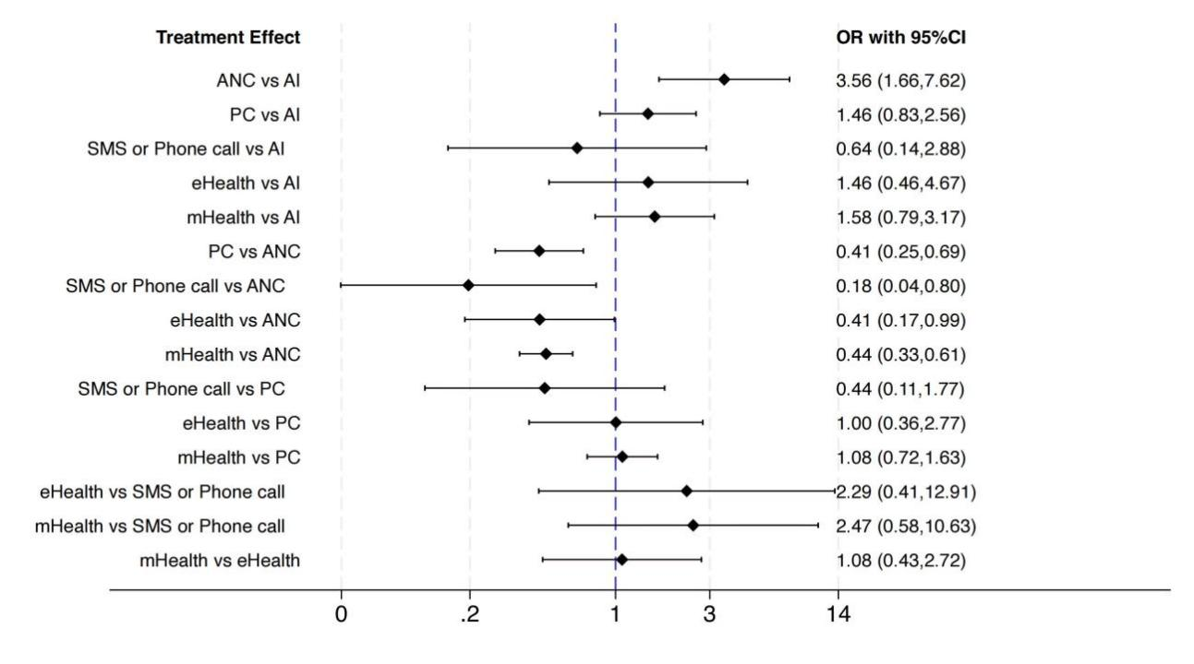
Figure S7 Forest Plot Comparing Different Interventions for the Prevalence of UAI.

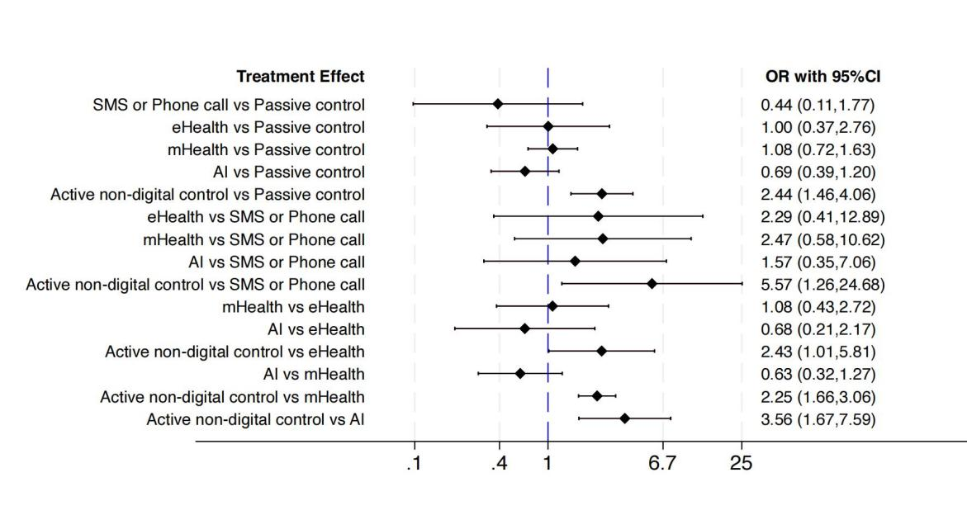
Figure S8 Forest Plot Comparing Different Interventions for the Prevalence of ICU.

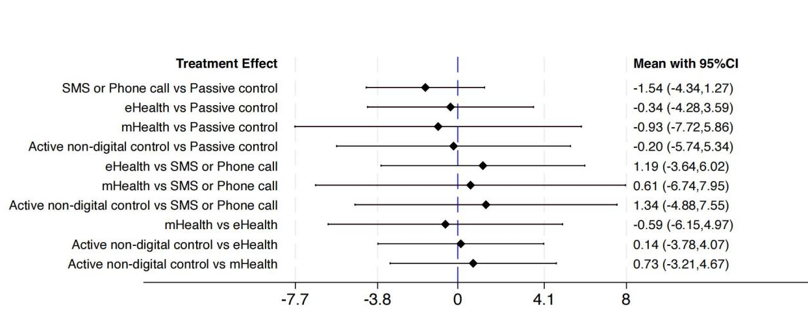
Figure S9 Forest Plot Comparing Different Interventions for CAI frequency.

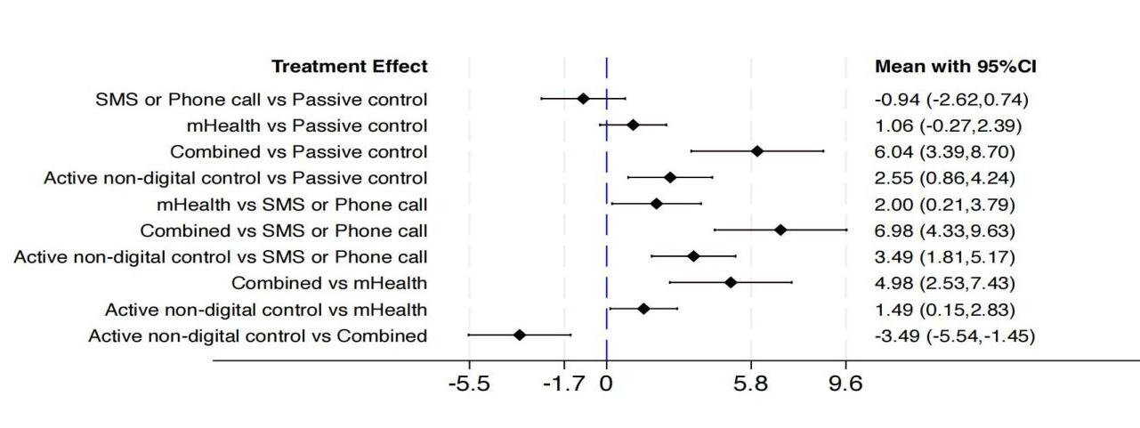
Figure S10 Forest Plot Comparing Different Interventions for ICU frequency.

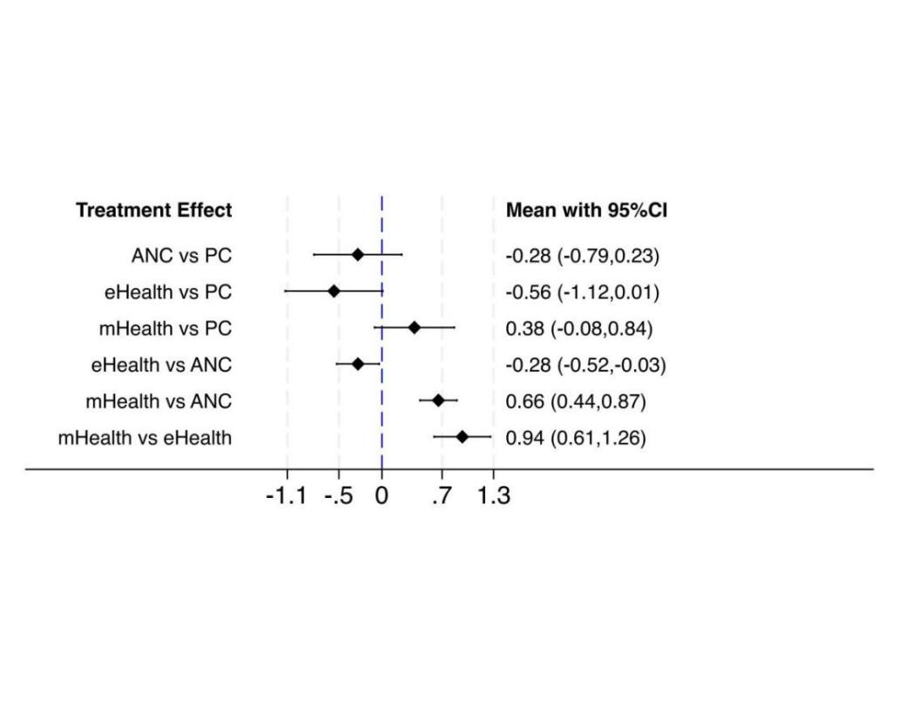
Figure S11 Forest Plot Comparing Different Interventions for NSP.

7. SUCRA and Cumulative Probability Plots

The meanings of all abbreviations can be seen in Table S6. Please click on the blue font link to access the information.

Table S15 SUCRA Values for Various Interventions of the Prevalence of UAI
Treatment | SUCRA | PrBest | MeanRank
PC | 47.5 | 0.5 | 3.6
AI | 77.5 | 23.3 | 2.1
ANC | 0.8 | 0.0 | 6.0
SMS or Phone call | 85.6 | 66.7 | 1.7
eHealth | 49.5 | 9.1 | 3.5
mHealth | 39.3 | 0.4 | 4.0

Table S16 SUCRA Values for Various Interventions of the Prevalence of ICU
Treatment | SUCRA | PrBest | MeanRank
PC | 27.7 | 1.6 | 4.6
ANC | 56.5 | 7.6 | 3.2
Combined | 76.3 | 40.7 | 2.2
SMS or Phone call | 25.2 | 5.6 | 4.7
eHealth | 72.2 | 40.6 | 2.4
mHealth | 42.2 | 3.8 | 3.9

Table S17 SUCRA Values for Various Interventions of CAI frequency
Treatment | SUCRA | PrBest | MeanRank
PC | 35.4 | 3.3 | 3.6
ANC | 42.6 | 9.2 | 3.3
SMS or Phone call | 68.6 | 43.0 | 2.3
eHealth | 46.4 | 10.5 | 3.1
mHealth | 57.0 | 34.1 | 2.7

Table S18 SUCRA Values for Various Interventions of ICU frequency
Treatment | SUCRA | PrBest | MeanRank
PC | 76.9 | 13.1 | 1.9
ANC | 25.5 | 0.0 | 4.0
Combined | 0.0 | 0.0 | 5.0
SMS or Phone call | 93.3 | 86.6 | 1.1
mHealth | 51.3 | 0.3 | 2.9

Table S19 SUCRA Values for Various Interventions of NSP
Treatment | SUCRA | PrBest | MeanRank
PC | 37.4 | 2.6 | 2.9
eHealth | 98.6 | 96.2 | 1.0
mHealth | 1.7 | 0.0 | 3.9
ANC | 62.3 | 1.2 | 2.1

8. Subgroup Analysis Results

The meanings of all abbreviations can be seen in Table S6. Please click on the blue font link to access the information. In the league table, bolding indicates that the comparison of intervention measures has statistical significance.

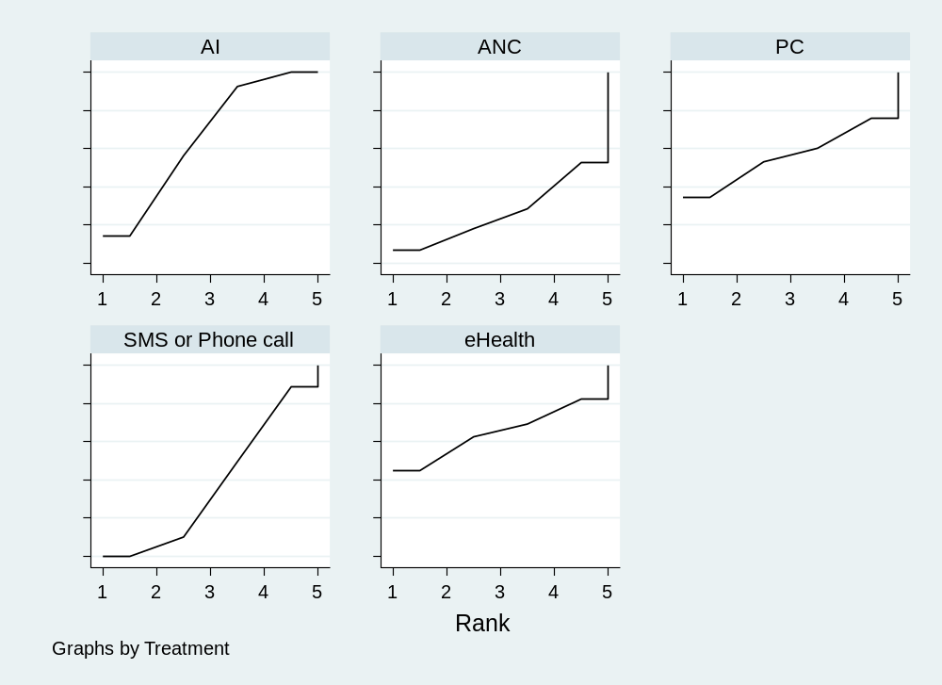
Fig S12 Cumulative Ranking Curve Plots of Interventions with Duration Less Than 6 Months in the Prevalence of UAI Outcome Events. A larger area under the curve reflects a higher probability of association with interventions less than 6 months in the Prevalence of UAI outcome events.

Table S20 SUCRA Values for Interventions with Duration Less Than 6 Months in the Prevalence of UAI Outcome Events.
Treatment | SUCRA | PrBest | MeanRank
SMS or Phone call | 37.1 | 0.0 | 3.5
eHealth | 64.7 | 14.7 | 2.4
AI | 65.7 | 44.0 | 2.4
PC | 56.0 | 34.6 | 2.8
ANC | 26.5 | 6.8 | 3.9

Table S21 League Table of Interventions with Duration Less Than 6 Months in the Prevalence of UAI Outcome Events.
eHealth
-0.83 (-4.53,2.88) | SMS or Phone call
-0.45 (-5.66,4.76) | 0.38 (-3.28,4.04) | PC
-1.49 (-5.81,2.83) | -0.66 (-2.89,1.56) | -1.04 (-5.32,3.24) | ANC
-0.60 (-4.31,3.10) | 0.22 (0.12,0.42) | -0.15 (-3.81,3.51) | 0.89 (-1.34,3.11) | AI

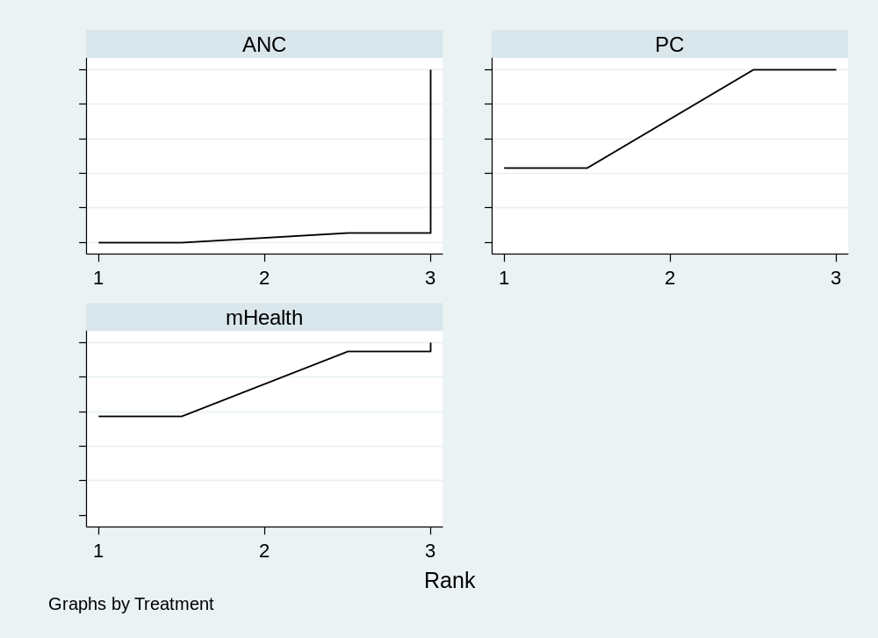
Fig S13 Cumulative Ranking Curve Plots of Interventions with Duration More Than or Equal to 6 Months in the Prevalence of UAI Outcome Events. A larger area under the curve reflects a higher probability of association with interventions more than or equal to 6 months in the Prevalence of UAI outcome events.

Table S22 SUCRA Values for Interventions with Duration More than or Equal to 6 Months in the Prevalence of UAI Outcome Events.
Treatment | SUCRA | PrBest | MeanRank
mHealth | 75.9 | 57.1 | 1.5
PC | 71.4 | 42.9 | 1.6
ANC | 2.7 | 0.0 | 2.9

Table S23 League Table of Interventions with Duration More than or equal to 6 Months in the Prevalence of UAI Outcome Events.
mHealth
0.88 (0.81,0.97) | PC
0.89 (-0.19,1.97) | 0.81 (0.46,1.16) | ANC

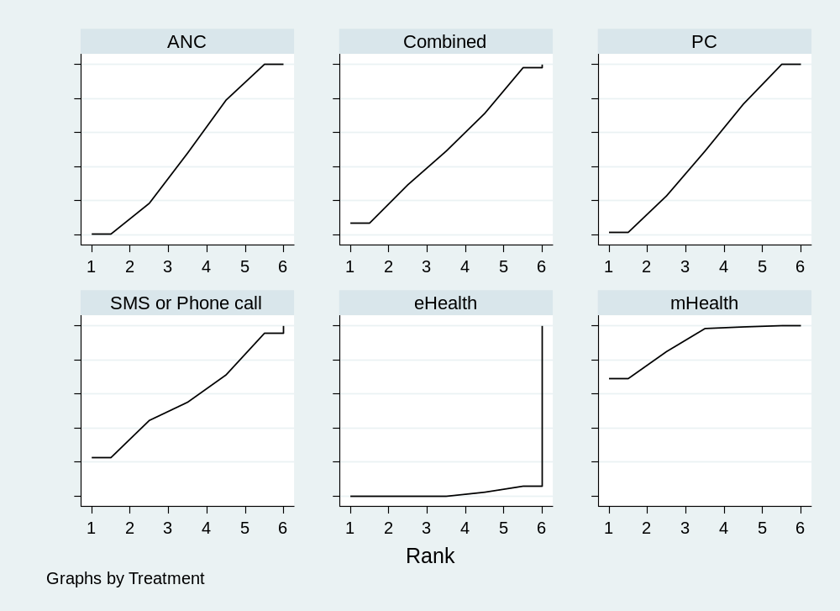
Fig S14 Cumulative Ranking Curve Plots of Interventions with Duration Less Than 6 Months in the Prevalence of ICU Outcome Events. A larger area under the curve reflects a higher probability of association with interventions of duration less than 6 months in the Prevalence of ICU outcome events.

Table S24 SUCRA Values for Interventions with Duration Less Than 6 Months in the Prevalence of ICU Outcome Events.
Treatment | SUCRA | PrBest | MeanRank
SMS or Phone call | 57.9 | 22.7 | 3.1
eHealth | 1.6 | 0.0 | 5.9
mHealth | 90.3 | 68.9 | 1.5
Combined | 51.0 | 6.9 | 3.4
PC | 50.0 | 1.2 | 3.5
ANC | 49.2 | 0.3 | 3.5

Table S25 League Table of Interventions with Duration Less Than 6 Months in the Prevalence of ICU Outcome Events.
SMS or Phone call
0.24 (0.04,1.24) | eHealth
1.63 (0.36,7.41) | 6.92 (2.45,19.59) | mHealth
0.91 (0.38,2.15) | 3.85 (0.93,15.84) | 0.56 (0.16,1.92) | Combined
0.91 (0.22,3.80) | 3.86 (1.55,9.64) | 0.56 (0.30,1.03) | 1.00 (0.32,3.13) | PC
0.91 (0.22,3.70) | 3.85 (1.60,9.26) | 0.56 (0.32,0.97) | 1.00 (0.33,3.03) | 1.00 (0.77,1.28) | ANC

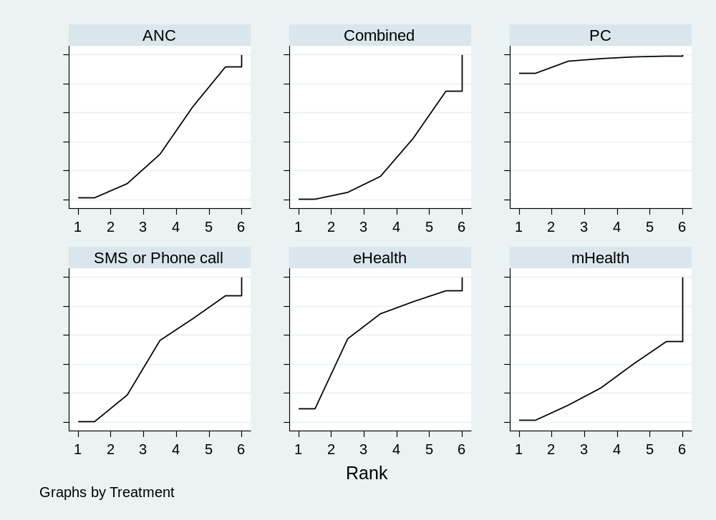
Fig S15 Cumulative Ranking Curve Plots of Interventions with Duration More Than or Equal to 6 Months in the Prevalence of ICU Outcome Events. A larger area under the curve reflects a higher probability of association with interventions more than or equal to 6 months in the Prevalence of ICU outcome events.

Table S26 SUCRA Values for Interventions with Duration More than or Equal to 6 Months in the Prevalence of ICU Outcome Events.
Treatment | SUCRA | PrBest | MeanRank
SMS or Phone call | 46.9 | 0.4 | 3.7
eHealth | 63.1 | 9.1 | 2.8
mHealth | 26.6 | 1.5 | 4.7
Combined | 27.8 | 0.5 | 4.6
PC | 95.7 | 87.2 | 1.2
ANC | 39.9 | 1.3 | 4.0

Table S27 League Table of Interventions with Duration More than or equal to 6 Months in the Prevalence of ICU Outcome Events.
SMS or Phone call
1.09 (0.80,1.48) | eHealth
0.90 (0.61,1.33) | 0.83 (0.53,1.31) | mHealth
0.92 (0.69,1.22) | 0.85 (0.59,1.23) | 1.02 (0.75,1.39) | Combined
1.52 (1.01,2.27) | 1.40 (0.84,2.32) | 1.68 (0.96,2.95) | 1.65 (1.01,2.69) | PC
0.95 (0.70,1.28) | 0.88 (0.60,1.27) | 1.05 (0.80,1.39) | 1.03 (0.90,1.19) | 0.63 (0.38,1.04) | ANC

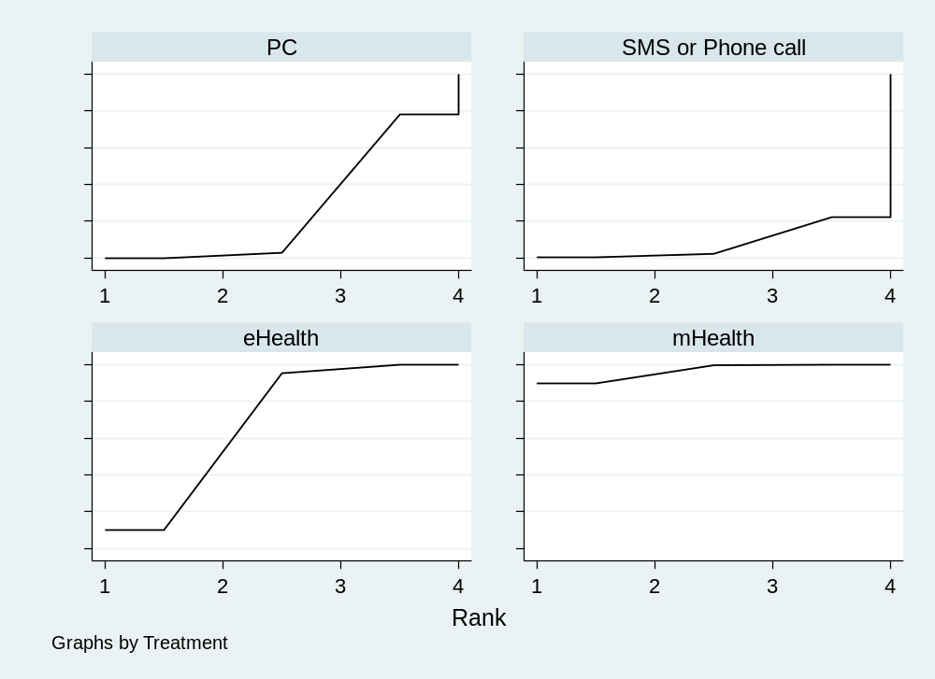
Fig S16 Cumulative Ranking Curve Plots of Interventions with Duration More Than or Equal to 6 Months in the CAI frequency Outcome Events. A larger area under the curve reflects a higher probability of association with interventions more than or equal to 6 months in the CAI frequency outcome events.

Table S28 SUCRA Values for Interventions with Duration More Than or Equal to 6 Months in the CAI frequency Outcome Events.
Treatment | SUCRA | PrBest | MeanRank
SMS or Phone call | 8.3 | 0.4 | 3.8
eHealth | 68.3 | 9.7 | 2.0
mHealth | 96.5 | 89.8 | 1.1
PC | 26.9 | 0.0 | 3.2

Table S29 League Table of Interventions with Duration More than or equal to 6 Months in the CAI frequency Outcome Events.
SMS or Phone call
-0.44  (-0.86,-0.02) | eHealth
-0.62 (-1.12,-0.12) | -0.18 (-0.46,0.10) | mHealth
-0.19 (-0.68,0.30) | 0.25 (0.00,0.50) | 0.43 (0.31,0.55) | PC

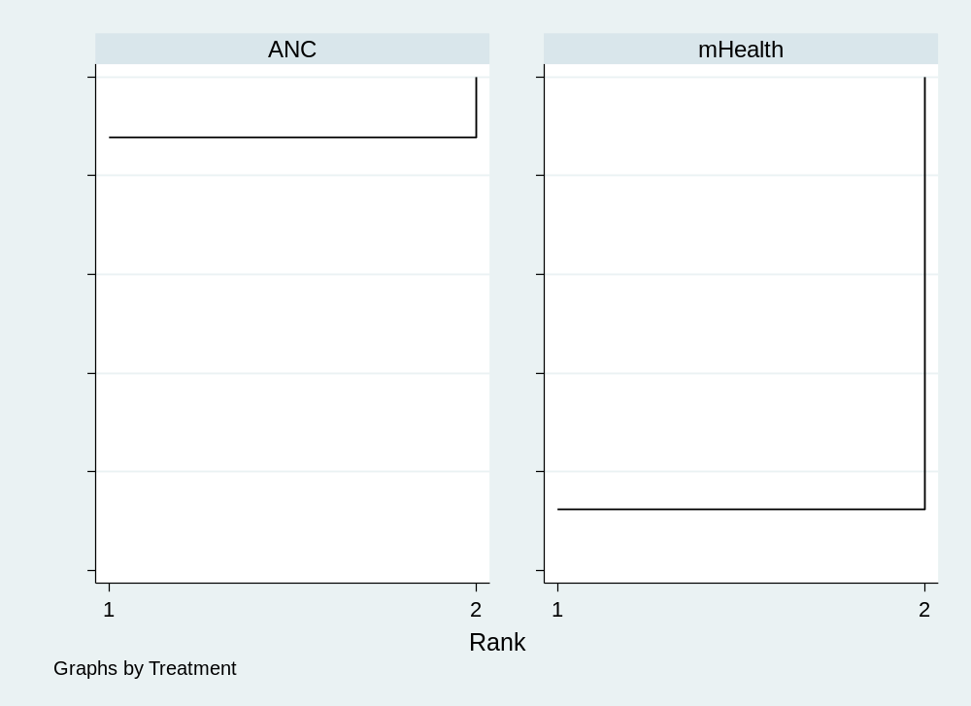
Fig S17 Cumulative Ranking Curve Plots of Interventions with Duration Less Than 6 Months in the ICU frequency Outcome Events. A larger area under the curve reflects a higher probability of association with interventions of duration less than 6 months in the ICU frequency outcome events.

Table S30 SUCRA Values for Interventions with Duration of Less Than 6 Months in the ICU frequency Outcome Events.
Treatment | SUCRA | PrBest | MeanRank
mHealth | 12.3 | 12.3 | 1.9
ANC | 87.7 | 87.7 | 1.1

Table S31 League Table of Interventions with Duration of Less Than 6 Months in the ICU frequency Outcome Events.
mHealth
6.06 (0.32,115.15) | ANC

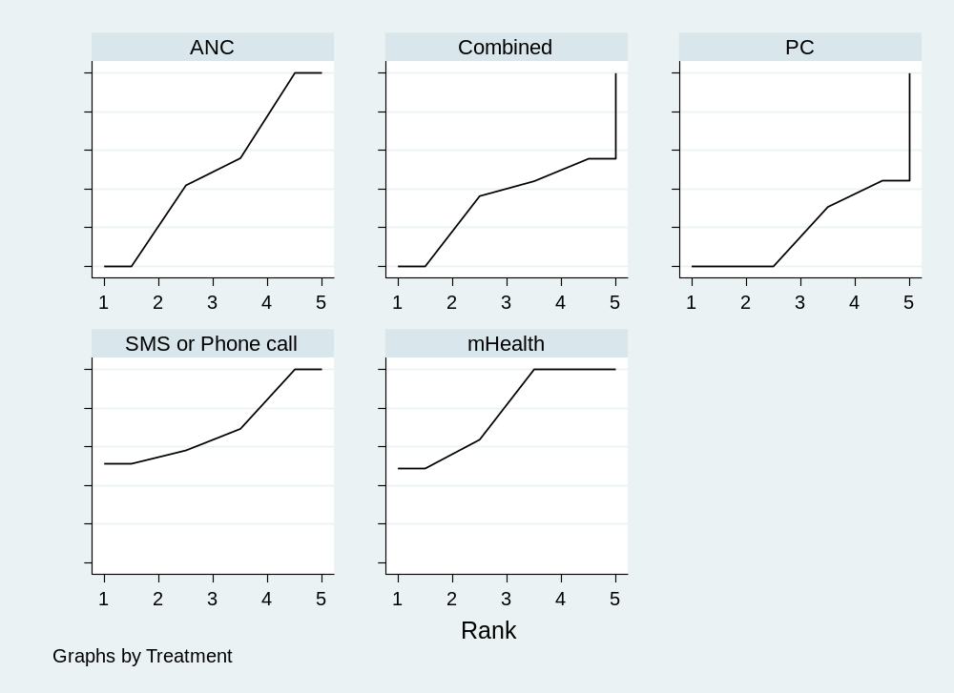
Fig S18 Cumulative Ranking Curve Plots of Interventions with Duration More Than or Equal to 6 Months in the ICU frequency Outcome Events. A larger area under the curve reflects a higher probability of association with interventions more than or equal to 6 months in the ICU frequency outcome events.

Table S32 SUCRA Values for Interventions with Duration More Than or Equal to 6 Months in the ICU frequency Outcome Events.
Treatment | SUCRA | PrBest | MeanRank
SMS or Phone call | 69.6 | 51.1 | 2.2
mHealth | 78.2 | 48.9 | 1.9
Combined | 34.0 | 0.0 | 3.6
PC | 18.8 | 0.0 | 4.2
ANC | 49.5 | 0.0 | 3.0

Table S33 League Table of Interventions with Duration More than or equal to 6 Months in the ICU frequency Outcome Events.
SMS or Phone call
0.01 (-0.93,0.94) | mHealth
0.17 (0.14,0.20) | 0.16 (-0.77,1.10) | Combined
0.24 (-0.70,1.17) | 0.23 (0.22,0.24) | 0.07 (-0.87,1.00) | PC
0.10 (-0.84,1.03) | 0.09 (0.09,0.09) | -0.07 (-1.01,0.86) | -0.14 (-0.15,-0.13) | ANC

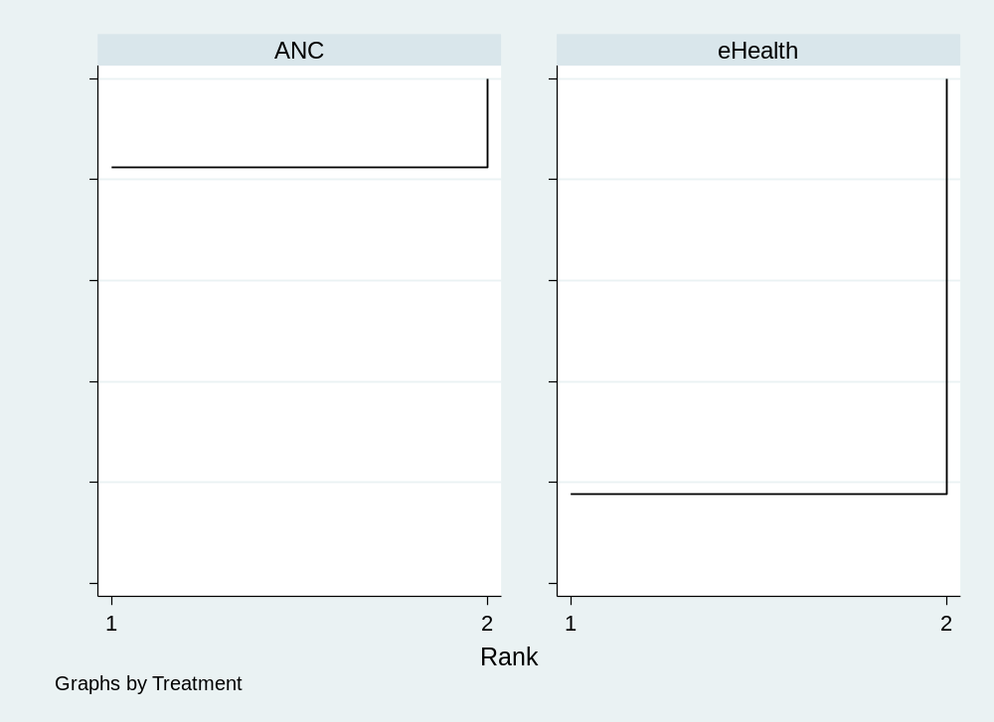
Fig S19 Cumulative Ranking Curve Plots of Interventions with Duration Less Than 6 Months in the NSP Outcome Events. A larger area under the curve reflects a higher probability of association with interventions less than 6 months in the NSP outcome events.

Table S34 SUCRA Values for Interventions with Duration Less Than 6 Months in the NSP Outcome Events.
Treatment | SUCRA | PrBest | MeanRank
eHealth | 17.6 | 17.6 | 1.8
ANC | 82.4 | 82.4 | 1.2

Table S35 League Table of Interventions with Duration Less than 6 Months in the NSP Outcome Events.
eHealth
-1.05  (-3.28,1.18) | ANC

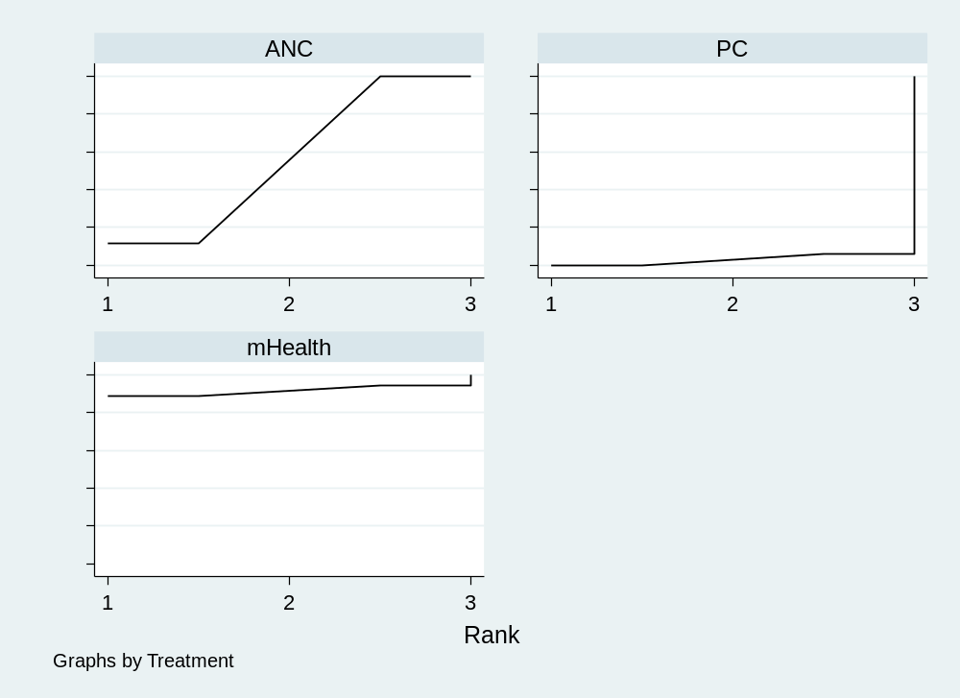
Fig S20 Cumulative Ranking Curve Plots of Interventions with Duration More Than or Equal to 6 Months in the NSP Outcome Events. A larger area under the curve reflects a higher probability of association with interventions more than or equal to 6 months in the NSP outcome events.

Table S36 SUCRA Values for Interventions with Duration More Than or Equal to 6 Months in the NSP Outcome Events.
Treatment | SUCRA | PrBest | MeanRank
mHealth | 91.4 | 88.5 | 1.2
PC | 2.8 | 0.0 | 2.9
ANC | 55.7 | 11.5 | 1.9

Table S37 League Table of Interventions with Duration More than or equal to 6 Months in the NSP Outcome Events.
mHealth
1.00 (-0.21,2.21) | PC
0.75 (-0.47,1.96) | -0.25 (-0.33,-0.17) | ANC

9. Regression Analysis Results

The meanings of all abbreviations can be seen in Table S6. Please click on the blue font link to access the information. In the league table, bolding indicates statistically significant moderator effects (p<0.05).

Table S38 Network Meta-Regression Analysis of the Effect of the Average Age, Country, Control Group Category, HIV Status, and Duration of Follow-up on the prevalence of UAI.
Moderator variable | Coefficient | Std. err. | z | P>|z| | 95% CI
Country | -0.019081 | 0.0406989 | -0.47 | 0.639 | (-0.0988495, 0.0606874)
Average age | -0.0022011 | 0.0074095 | -0.30 | 0.766 | (-0.0167233, 0.0123212)
Control group category | -0.6868692 | 0.2492439 | -2.76 | 0.006 | (-1.175378, -.1983601)
HIV status | -0.6243012 | 0.3214532 | -1.94 | 0.052 | (-1.254336, 0.005734)

Table S39 Network Meta-Regression Analysis of the Effect of the Average Age, Country, Control Group Category, HIV Status, and Duration of Follow-up on the prevalence of ICU.
Moderator variable | Coefficient | Std. err. | z | P>|z| | 95% CI
Country | -0.2163429 | 0.0765237 | -2.83 | 0.005 | (-0.3663265, -0.0663593)
Average age | 0.0186034 | 0.0279221 | 0.67 | 0.505 | (-0.0361229, 0.0733297)
Control group category | 0.1068152 | 0.2819022 | 0.38 | 0.705 | (-0.4457029,  0.6593333)
HIV status | -0.1563241 | 0.2984512 | -0.52 | 0.600 | (-0.7412885, 0.4286403)

Table S40 Network Meta-Regression Analysis of the Effect of the Average Age, Country, Control Group Category, HIV Status, and Duration of Follow-up on CAI frequency.
Moderator variable | Coefficient | Std. err. | z | P>|z| | 95% CI
Country | -0.37463 | 0.069217 | -5.41 | 0.000 | (-0.5102928, -0.2389673)
Average age | 0.0101812 | 0.0258641 | 0.39 | 0.694 | (-0.0405115, 0.0608739)
Control group category | 0.6900004 | 1.189522 | 0.58 | 0.562 | (-1.641419, 3.02142)
HIV status | -0.6254102 | 0.2151203 | -2.91 | 0.004 | (-1.047037, -0.203783)

Table S41 Network Meta-Regression Analysis of the Effect of the Average Age, Country, Control Group Category, HIV Status, and Duration of Follow-up on ICU frequency.
Moderator variable | Coefficient | Std. err. | z | P>|z| | 95% CI
Country | -0.1727776 | 1.207546 | -0.14 | 0.886 | ( -2.539523, 2.193968)
Average age | 0.1241132 | 0.0782038 | 1.59 | 0.113 | (-0.0291633, 0.2773898)
Control group category | -0.6348823 | 2.193172 | -0.29 | 0.772 | (-4.93342, 3.663656)
HIV status | -0.2854120 | 1.3421053 | -0.21 | 0.834 | (-2.915938, 2.345114)

Table S42 Network Meta-Regression Analysis of the Effect of the Average Age, Country, Control Group Category, HIV Status, and Duration of Follow-up on NSP.
Moderator variable | Coefficient | Std. err. | z | P>|z| | 95% CI
Country | -0.2904407 | 0.0559181 | -5.19 | 0.000 | (-0.400038, -0.1808433)
Average age | -0.0214784 | 0.0277839 | -0.77 | 0.439 | (-0.0759339, 0.0329771)
Control group category | -0.325145 | 0.6581783 | -0.49 | 0.621 | (-1.615151,  0.9648607)
HIV status | -0.5341208 | 0.2081345 | -2.57 | 0.010 | (-0.942064, -0.126177)

10. Sensitivity Analysis Results

The meanings of all abbreviations can be seen in Table S6. Please click on the blue font link to access the information. In the league table, bolding indicates that the comparison of intervention measures has statistical significance.

Table S43 Sensitivity Analysis: Comparison of NMA Results (Effect Sizes, SUCRA, P-Scores, and Ranks) Using the Original vs. Reclassified Digital Health Intervention Frameworks
Original intervention frameworks |  |  |  |  |  | Reclassified intervention frameworks
Outcomes | Treatment effect compared to control  (OR and 95%CI) |  | SUCRA | Prbest | Mean Rank | Treatment effect compared to control  (OR and 95%CI) |  |  | SUCRA | Prbest |  | Mean Rank
The Prevalence of UAI | Compared with PC |  |  |  |  | Compared with PC
The Prevalence of UAI | SMS or Phone call | 0.44 (0.11, 1.77) | 85.6 | 66.7 | 1.7 | SMS or Phone call |  | 1.45 (0.83, 2.56) | 86.3 |  | 70.4 | 1.5
The Prevalence of UAI | eHealth | 1.00 (0.37, 2.76) | 49.5 | 9.1 | 3.5 | mHealth |  | 0.64 (0.14, 2.86) | 46.3 |  | 0.8 | 3.1
The Prevalence of UAI | mHealth | 1.08 (0.72, 1.63) | 39.3 | 0.4 | 4.0 | AI |  | 1.59 (0.79, 3.13) | 39.1 |  | 1.7 | 3.4
The Prevalence of UAI | AI | 0.69 (0.39, 1.20) | 77.5 | 23.3 | 2.1
The Prevalence of UAI | Compared with ANC |  |  |  |  | Compared with ANC
The Prevalence of UAI | SMS or Phone call | 0.18 (0.04, 0.79) | 85.6 | 66.7 | 1.7 | SMS or Phone call |  | 0.41 (0.25, 0.67) | 86.3 |  | 70.4 | 1.5
The Prevalence of UAI | eHealth | 0.41 (0.17, 0.99) | 49.5 | 9.1 | 3.5 | mHealth |  | 0.18 (0.04, 0.79) | 46.5 |  | 0.8 | 3.1
The Prevalence of UAI | mHealth | 0.44 (0.33, 0.60) | 39.3 | 0.4 | 4.0 | AI |  | 0.44 (0.33, 0.59) | 39.1 |  | 1.7 | 3.4
The Prevalence of UAI | AI | 0.28 (0.13, 0.60) | 77.5 | 23.3 | 2.1
The Prevalence of ICU | Compared with PC |  |  |  |  | Compared with PC
The Prevalence of ICU | SMS or Phone call | 1.04 (0.72, 1.49) | 25.2 | 5.6 | 4.7 | SMS or Phone call | 1.23 (0.85, 1.79) |  | 34.1 | 3.2 |  | 4.3
The Prevalence of ICU | eHealth | 0.79 (0.51, 1.24) | 72.2 | 40.6 | 2.4 | eHealth | 1.30 (0.79, 2.17) |  | 26.8 | 7.3 |  | 4.7
The Prevalence of ICU | mHealth | 0.93 (0.69, 1.26) | 42.2 | 3.8 | 3.9 | mHealth | 1.18 (0.78, 1.79) |  | 44.0 | 9.3 |  | 3.8
The Prevalence of ICU | Combined | 0.79 (0.55, 1.13) | 76.3 | 40.7 | 2.2 | Combined | 1.09 (0.74, 1.61) |  | 63.3 | 21.7 |  | 2.8
The Prevalence of ICU | Compared with ANC |  |  |  |  | Compared with ANC
The Prevalence of ICU | SMS or Phone call | 1.18 (0.81, 1.69) | 25.2 | 5.6 | 4.7 | SMS or Phone call | 1.09 (0.77, 1.52) |  | 34.1 | 3.2 |  | 4.3
The Prevalence of ICU | eHealth | 0.90 (0.61, 1.32) | 72.2 | 40.6 | 2.4 | eHealth | 1.15 (0.78, 1.69) |  | 26.8 | 7.3 |  | 4.7
The Prevalence of ICU | mHealth | 1.05 (0.84, 1.32) | 42.2 | 3.8 | 3.9 | mHealth | 1.03 (0.78, 1.37) |  | 44.0 | 9.3 |  | 3.8
The Prevalence of ICU | Combined | 0.89 (0.63, 1.27) | 76.3 | 40.7 | 2.2 | Combined | 0.95 (0.70, 1.32) |  | 63.3 | 21.7 |  | 2.8
Outcomes | Treatment effect compared to control (MD and 95%CI) |  | SUCRA | Prbest | Mean Rank | Treatment effect compared to control  (MD and 95%CI) |  |  | SUCRA | Prbest |  | Mean Rank
The CAI frequency | Compared with PC |  |  |  |  | Compared with PC
The CAI frequency | SMS or Phone call | -1.54 (-4.34, 1.27) | 68.6 | 43.0 | 2.3 | SMS or Phone call | 0.44 (-0.02, 0.90) |  | 14.0 | 0.0 |  | 3.6
The CAI frequency | eHealth | -0.34 (-4.28, 3.59) | 46.4 | 10.5 | 3.1 | eHealth | -2.02 (-2.63, -1.41) |  | 100.0 | 100.0 |  | 1.0
The CAI frequency | mHealth | -0.93 (-7.72, 5.86) | 57.0 | 34.1 | 2.7
The CAI frequency | Compared with ANC |  |  |  |  | Compared with ANC
The CAI frequency | SMS or Phone call | -1.34 (-7.55, 4.88) | 68.6 | 43.0 | 2.3 | SMS or Phone call | 0.07 (-0.43, 0.57) |  | 14.0 | 0.0 |  | 3.6
The CAI frequency | eHealth | -0.14 (-4.07, 3.78) | 46.4 | 10.5 | 3.1 | eHealth | -2.39 (-3.05, -1.73) |  | 100.0 | 100.0 |  | 1.0
The CAI frequency | mHealth | -0.73 (-4.67, 3.21) | 57.0 | 34.1 | 2.7
The ICU frequency | Compared with PC |  |  |  |  | Compared with PC
The ICU frequency | SMS or Phone call | -0.94 (-2.62, 0.74) | 93.3 | 86.6 | 1.1 | SMS or Phone call | -2.06 (-2.46, -1.66) |  | 100.0 | 100.0 |  | 1.0
The ICU frequency | mHealth | 1.06 (-0.27, 2.39) | 51.3 | 0.3 | 2.9 | eHealth | -0.23 (-0.24, -0.22) |  | 40.0 | 0.0 |  | 4.0
The ICU frequency | Combined | 6.04 (3.39, 8.70) | 0.0 | 0.0 | 5.0 | mHealth | -1.22 (-1.43, -1.01) |  | 60.1 | 0.0 |  | 3.0
The ICU frequency |  |  |  |  |  | Combined | -1.89 (-2.29, -1.49) |  | 79.9 | 0.0 |  | 2.0
The ICU frequency | Compared with ANC |  |  |  |  | Compared with ANC
The ICU frequency | SMS or Phone call | -3.49 (-5.17, -1.81) | 93.3 | 86.6 | 1.1 | SMS or Phone call | -1.92 (-2.31, -1.52) |  | 100.0 | 100.0 |  | 1.0
The ICU frequency | mHealth | -1.49 (-2.83, -0.15) | 51.3 | 0.3 | 2.9 | eHealth | -0.09 (-0.09, -0.09) |  | 40.0 | 0.0 |  | 4.0
The ICU frequency | Combined | 3.49 (1.45, 5.54) | 0.0 | 0.0 | 5.0 | mHealth | -1.08 (-1.29, -0.87) |  | 60.1 | 0.0 |  | 3.0
The ICU frequency |  |  |  |  |  | Combined | -1.75 (-2.15, -1.35) |  | 79.9 | 0.0 |  | 2.0
The NSP | Compared with PC |  |  |  |  | Compared with PC
The NSP | eHealth | -0.56 (-1.12, 0.01) | 98.6 | 96.2 | 1.0 | eHealth | -1.00 (-3.57, 1.57) |  | 83.9 | 71.1 |  | 1.5
The NSP | mHealth | 0.38 (-0.08, 0.84) | 1.7 | 0.0 | 3.9 | mHealth | 1.30 (-1.88, 4.48) |  | 25.3 | 8.4 |  | 3.2
The NSP | Compared with ANC |  |  |  |  | Compared with ANC
The NSP | eHealth | -0.28 (-0.52, -0.03) | 98.6 | 96.2 | 1.0 | eHealth | -2.05 (-5.45, 1.35 ) |  | 83.9 | 71.1 |  | 1.5
The NSP | mHealth | 0.66 (0.44, 0.87) | 1.7 | 0.0 | 3.9 | mHealth | 0.25 (-2.02, 2.52) |  | 25.3 | 8.4 |  | 3.2

11. Evaluation of Inconsistency and Heterogeneity

The meanings of all abbreviations can be seen in Table S6. Please click on the blue font link to access the information.

Table S44 Global Inconsistency.
Outcome |  | Chi squar | P value
The prevalence of HIV-related SRBs | UAI | 0.45 | 0.7342
The prevalence of HIV-related SRBs | ICU | 1.68 | 0.6421
Cumulative exposure to HIV-related SRBs | CAI | 0.13 | 0.7224
Cumulative exposure to HIV-related SRBs | ICU | 0.27 | 0.6065
Cumulative exposure to HIV-related SRBs | NSP | 0.05 | 0.8210

Table S45 Side-Splitting of the prevalence of UAI. Inconsistency test between direct and indirect treatment comparisons in mixed treatment comparison
Comparison | Direct |  | Indirect |  | Difference |  |  | tau
Comparison | Coef. | Std.Err. | Coef. | Std.Err. | Coef. | Std.Err. | P>|z| | tau
eHealth vs ANC | 0.8865178 | 0.4448277 | 1.34368 | 0.4448277 | -0.457162 | 63.8354 | 0.967 | 4.77e-06
mHealth vs PC | -0.0794604 | 0.2078086 | 0.2825807 | 53.93939 | -0.3620411 | 53.93979 | 0.995 | 0.0000149
mHealth vs ANC | 0.8111852 | 0.1568119 | 0.4589716 | 142.9441 | 0.3522136 | 142.9607 | 0.998 | 0.0032468

Table S46 Side-Splitting of the prevalence of ICU. Inconsistency test between direct and indirect treatment comparisons in mixed treatment comparison
Comparison | Direct |  | Indirect |  | Difference |  |  | tau
Comparison | Coef. | Std.Err. | Coef. | Std.Err. | Coef. | Std.Err. | P>|z| | tau
SMS or Phone call vs PC | -0.1869257 | 0.3741714 | -0.4146397 | 0.5951336 | 0.227714 | .6928154 | 0.742 | 0.4049172
SMS or Phone call vs ANC | -0.3589283 | 0.4047675 | -0.1310126 | 0.5697212 | -0.2279157 | 0.6928233 | 0.742 | 0.4049212
eHealth vs PC | -0.2242128 | 0.6592199 | 0.0351383 | 0.552836 | -0.2593511 | 0.8603481 | 0.763 | 0.3903328
eHealth vs ANC | -0.0441329 | 0.4162518 | -0.3035149 | 0.7529377 | 0.259382 | 0.8603376 | 0.763 | 0.3903343
mHealth vs PC | -0.0299434 | 0.4559228 | 0.0341377 | 0.5411212 | -.0640811 | .7075859 | 0.928 | 0.425237
mHealth vs ANC | -0.0260877 | 0.2853839 | -0.0902203 | 0.6475024 | 0.0641326 | 0.7075864 | 0.928 | 0.4252359
AI vs PC | 0.4167627 | 0.2448967 | 0.031594 | .2611983 | .3851687 | 0.3851687 | 0.282 | 0.2971255

Table S47 Side-Splitting of CAI frequency. Inconsistency test between direct and indirect treatment comparisons in mixed treatment comparison
Comparison | Direct |  | Indirect |  | Difference |  |  | tau
Comparison | Coef. | Std.Err. | Coef. | Std.Err. | Coef. | Std.Err. | P>|z| | tau
eHealth vs PC | 0.44 | 1.23894 | 0.0437452 | 17.0935 | 0.3962548 | 17.13834 | 0.982 | 1.220429
eHealth vs ANC | 0.25 | 1.22739 | 0.6604297 | 17.72831 | -0.4104297 | 17.77075 | 0.982 | 1.220709
mHealth vs ANC | 0.43 | 1.221938 | -0.3795434 | 35.96583 | 0.8095434 | 35.98653 | 0.982 | 1.220341

Table S48 Side-Splitting of ICU frequency. Inconsistency test between direct and indirect treatment comparisons in mixed treatment comparison
Comparison | Direct |  | Indirect |  | Difference |  |  | tau
Comparison | Coef. | Std.Err. | Coef. | Std.Err. | Coef. | Std.Err. | P>|z| | tau
SMS or phone call vs PC | -0.57 | 1.544909 | -1.125944 | 0.0843294 | 0.5559444 | 1.547209 | 0.719 | 5.68e-06
SMS or phone call vs ANC | 0.0900006 | .0019332 | 1.761243 | 1.25794 | -1.671242 | 1.257951 | 0.184 | .0000865
mHealth vs PC | -0.1704153 | 0.0159096 | 0.9914775 | 0.6433569 | -1.161893 | 0.6435507 | 0.071 | 0.0000132
mHealth vs ANC | 1.088868 | 0.1072128 | -0.0730077 | 0.1072128 | 1.161876 | NA | NA | 2.83e-07
Combined vs ANC | -0.14 | 0.0035779 | 2.442164 | 3.392164 | -2.582164 | 3.392167 | 0.447 | 0.0000334

Table S49 Side-Splitting of NSP. Inconsistency test between direct and indirect treatment comparisons in mixed treatment comparison
Comparison | Direct |  | Indirect |  | Difference |  |  | tau
Comparison | Coef. | Std.Err. | Coef. | Std.Err. | Coef. | Std.Err. | P>|z| | tau
SMS or Phone call vs PC | 1.037355 | 1.121695 | 1.241992 | 84.00668 | -0.2046363 | 84.0153 | 0.998 | 1.126696
eHealth vs mHealth | -1 | 1.307743 | -0.1816719 | 11.4662 | -0.8183281 | 11.54053 | 0.943 | 1.154822
eHealth vs PC | -0.2500003 | 1.1529 | -1.599314 | 20.83053 | 1.349314 | 20.86243 | 0.948 | 1.152192

Table S50 Heterogeneity Test of the prevalence of UAI
Treatment 1 | Treatment 2 | I² (%) | P
SMS or phone call | PC | 0.0 | 0.815
SMS or phone call | ANC | 0.0 | 0.678
eHealth | PC | NA | NA
eHealth | ANC | 14.9 | 0.309
mHealth | PC | 0.0 | 0.985
mHealth | ANC | 0.0 | 0.974
Combined | PC | NA | NA
Combined | ANC | NA | NA

Table S51 Heterogeneity Test of the prevalence of ICU
Treatment 1 | Treatment 2 | I² (%) | P
SMS or phone call | PC | NA | NA
eHealth | ANC | NA | NA
mHealth | PC | NA | NA
mHealth | ANC | NA | NA
AI | PC | NA | NA

Table S52 Heterogeneity Test of CAI frequency
Treatment 1 | Treatment 2 | I² (%) | P
SMS or phone call | PC | 98.7 | 0.000
eHealth | PC | NA | NA
eHealth | ANC | NA | NA
mHealth | ANC | NA | NA
Table S53 Heterogeneity Test of ICU frequency
Treatment 1 | Treatment 2 | I² (%) | P
SMS or phone call | PC | NA | NA
SMS or phone call | ANC | NA | NA
mHealth | PC | 71.4 | 0.062
mHealth | ANC | 53.6 | 0.142
Combined | ANC | NA | NA

Table S54 Heterogeneity Test of NSP
Treatment 1 | Treatment 2 | I² (%) | P
eHealth | PC | 0.0 | 0.869
mHealth | PC | NA | NA
mHealth | ANC | NA | NA

12. Funnel Plots

The meanings of all abbreviations can be seen in Table S6. Please click on the blue font link to access the information.

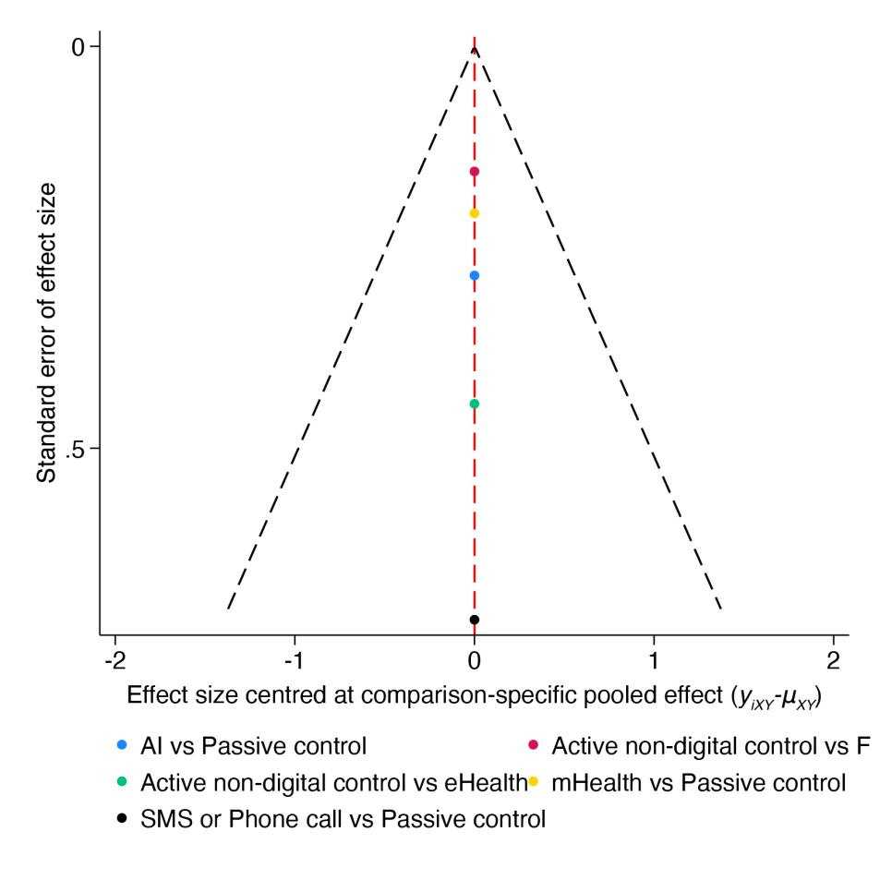
Fig S21 Funnel Plot for the prevalence of UAI.

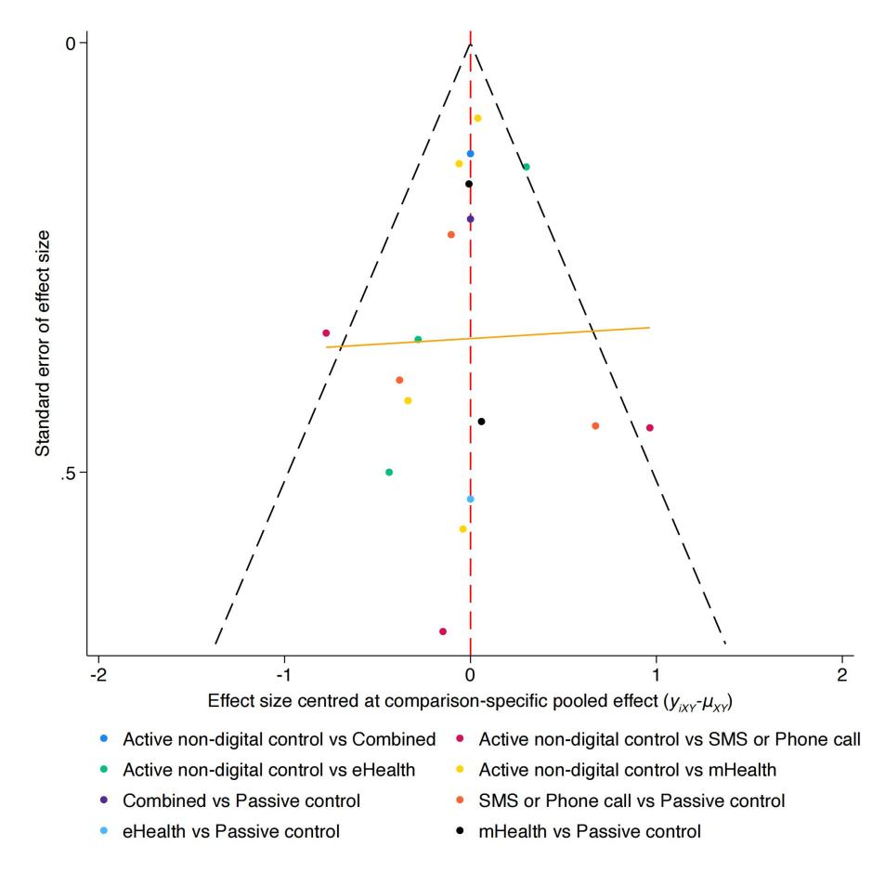
Fig S22 Funnel Plot for the prevalence of ICU.

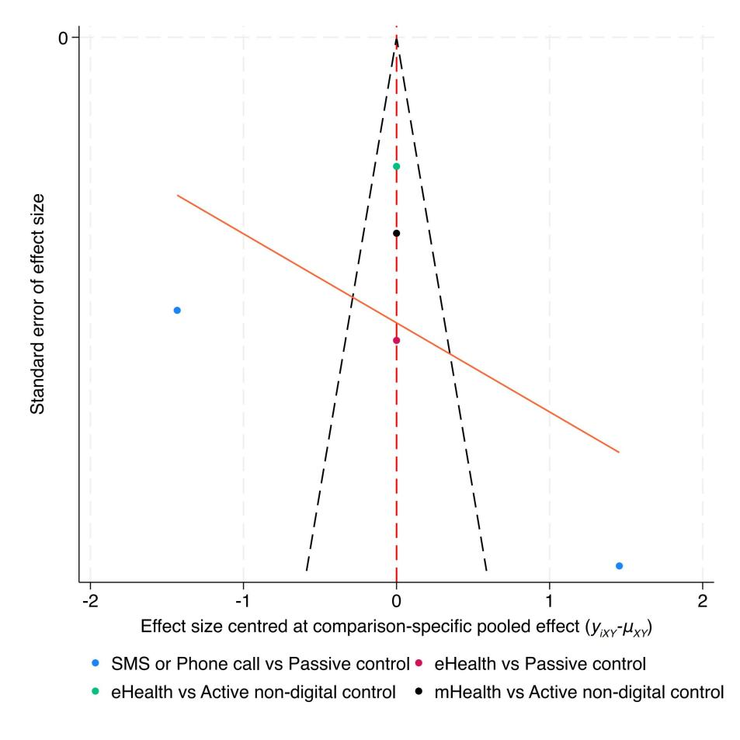
Fig S23 Funnel Plot for CAI frequency.

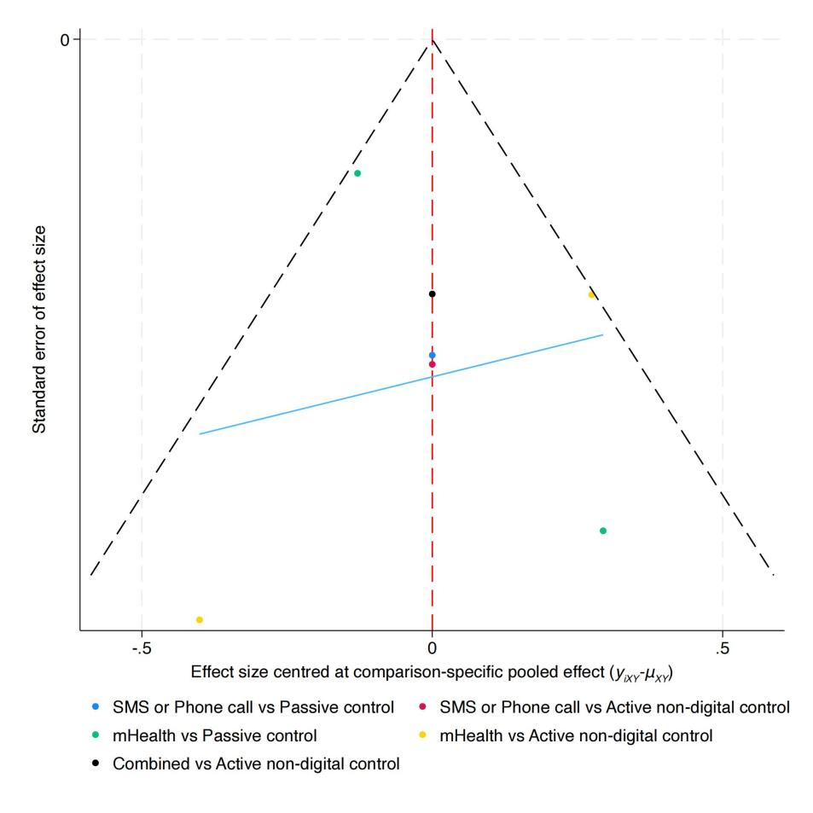
Fig S24 Funnel Plot for ICU frequency.

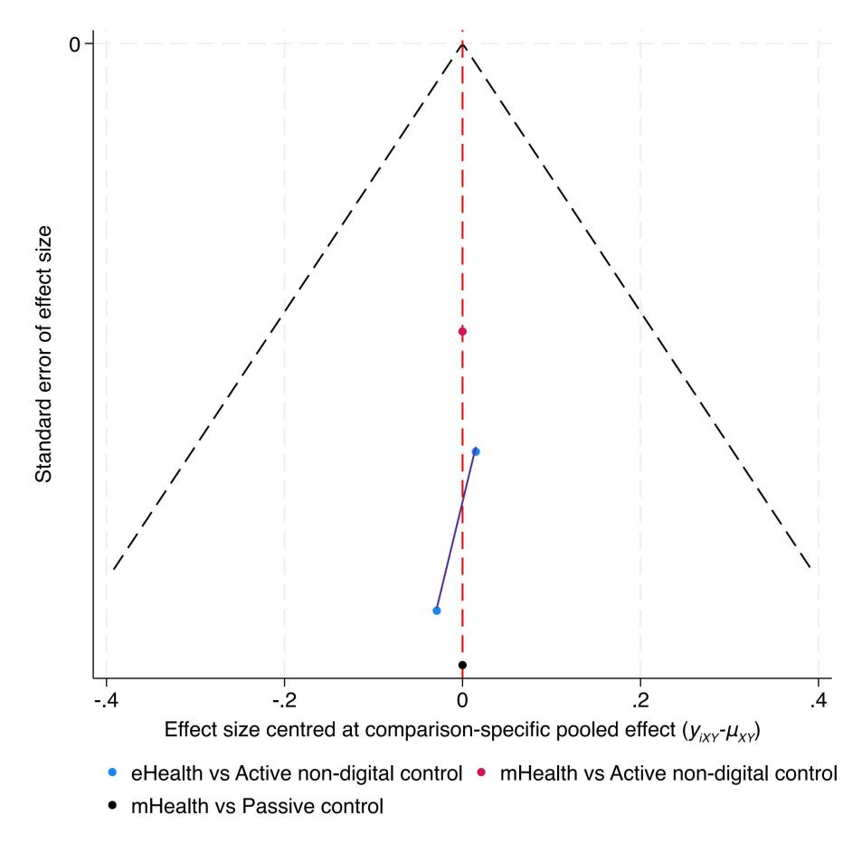
Fig S25 Funnel Plot for NSP.
13. CINeMA Assessment

The meanings of all abbreviations can be seen in Table S6. Please click on the blue font link to access the information. In the league table, bolding indicates that the comparison of intervention measures has statistical significance.

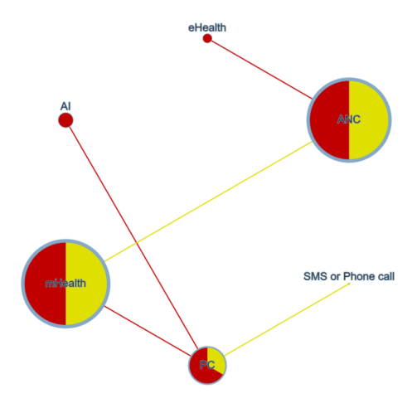
Fig S26 Risk of Bias Contribution by Intervention Group in the Prevalence of UAI. Node size is proportional to sample size, node color represents the risk of bias, edge width corresponds to the number of studies, and edge color reflects the average risk of bias.
Table S55 CINeMA Results for the Prevalence of UAI
Comparison | Number of studies | Within-study bias | Reporting bias | Indirectness | Imprecision | Heterogeneity | Incoherence | Confidence rating | Reason(s) for downgrading
Mixed evidence
AI:PC | 1 | Major concerns | Low risk | No concerns | No concerns | Major concerns | No concerns | Very low | ["Within-study bias","Heterogeneity"]
ANC:eHealth | 1 | Major concerns | Low risk | No concerns | No concerns | Major concerns | No concerns | Very low | ["Within-study bias","Heterogeneity"]
ANC:mHealth | 1 | Some concerns | Low risk | No concerns | No concerns | Major concerns | No concerns | Very low | ["Within-study bias","Heterogeneity"]
PC:SMS or Phone call | 1 | Some concerns | Low risk | No concerns | Some concerns | Some concerns | No concerns | Very low | ["Within-study bias","Imprecision", "Heterogeneity"]
PC:mHealth | 1 | Major concerns | Low risk | No concerns | No concerns | Major concerns | No concerns | Very low | ["Within-study bias","Heterogeneity"]
Indirect evidence
AI:ANC | 0 | Some concerns | Low risk | No concerns | No concerns | Major concerns | No concerns | Very low | ["Within-study bias","Heterogeneity"]
AI:SMS or Phone call | 0 | Some concerns | Low risk | No concerns | Major concerns | No concerns | No concerns | Very low | ["Within-study bias","Imprecision"]
AI:eHealth | 0 | Some concerns | Low risk | No concerns | Some concerns | Some concerns | No concerns | Very low | ["Within-study bias","Imprecision","Heterogeneity"]
AI:mHealth | 0 | Some concerns | Low risk | No concerns | Some concerns | Some concerns | No concerns | Very low | ["Within-study bias","Imprecision","Heterogeneity"]
ANC:PC | 0 | Some concerns | Low risk | No concerns | No concerns | Major concerns | No concerns | Very low | ["Within-study bias","Heterogeneity"]
ANC:SMS or Phone call | 0 | Some concerns | Low risk | No concerns | No concerns | Major concerns | No concerns | Very low | ["Within-study bias","Heterogeneity"]
PC:eHealth | 0 | Some concerns | Low risk | No concerns | No concerns | Major concerns | No concerns | Very low | ["Within-study bias","Heterogeneity"]
SMS or Phone call:eHealth | 0 | Some concerns | Low risk | No concerns | Some concerns | Some concerns | No concerns | Very low | ["Within-study bias","Imprecision","Heterogeneity"]
SMS or Phone call:mHealth | 0 | Some concerns | Low risk | No concerns | Some concerns | Some concerns | No concerns | Very low | ["Within-study bias","Imprecision","Heterogeneity"]
eHealth:mHealth | 0 | Some concerns | Low risk | No concerns | No concerns | Major concerns | No concerns | Very low | ["Within-study bias","Heterogeneity"]

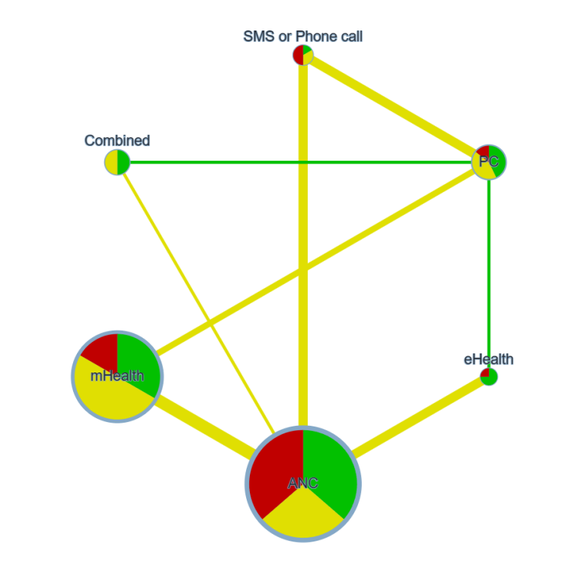
Fig S27 Risk of Bias Contribution by Intervention Group in the Prevalence of ICU. Node size is proportional to sample size, node color represents the risk of bias, edge width corresponds to the number of studies, and edge color reflects the average risk of bias.
Table S56 CINeMA Results for the Prevalence of ICU
Comparison | Number of studies | Within-study bias | Reporting bias | Indirectness | Imprecision | Heterogeneity | Incoherence | Confidence rating | Reason(s) for downgrading
Mixed evidence
ANC:Combined | 1 | Some concerns | Low risk | No concerns | Some concerns | Some concerns | No concerns | Very low | ["Within-study bias","Imprecision","Heterogeneity"]
ANC:SMS or Phone call | 3 | Some concerns | Low risk | No concerns | Some concerns | Some concerns | No concerns | Very low | ["Within-study bias","Imprecision","Heterogeneity"]
ANC:eHealth | 3 | Some concerns | Low risk | No concerns | Some concerns | Some concerns | No concerns | Very low | ["Within-study bias","Imprecision","Heterogeneity"]
ANC:mHealth | 4 | Some concerns | Low risk | No concerns | No concerns | Major concerns | No concerns | Very low | ["Within-study bias","Heterogeneity"]
Combined:PC | 1 | No concerns | Low risk | No concerns | Some concerns | No concerns | No concerns | Moderate | ["Imprecision"]
PC:SMS or Phone call | 3 | Some concerns | Low risk | No concerns | No concerns | Major concerns | No concerns | Very low | ["Within-study bias"]
eHealth:PC | 1 | Some concerns | Low risk | No concerns | Some concerns | Some concerns | No concerns | Very low | ["Within-study bias","Imprecision","Heterogeneity"]
mHealth:PC | 2 | Some concerns | Low risk | No concerns | No concerns | Major concerns | No concerns | Very low | ["Within-study bias","Heterogeneity"]
Indirect evidence
ANC:PC | 0 | Some concerns | Low risk | No concerns | Some concerns | Some concerns | No concerns | Very low | ["Within-study bias","Imprecision","Heterogeneity"]
Combined:SMS or Phone call | 0 | Some concerns | Low risk | No concerns | Some concerns | No concerns | No concerns | Low | ["Within-study bias","Imprecision"]
Combined:eHealth | 0 | Some concerns | Low risk | No concerns | Major concerns | No concerns | No concerns | Very low | ["Within-study bias","Imprecision"]
Combined:mHealth | 0 | Some concerns | Low risk | No concerns | Some concerns | Some concerns | No concerns | Very low | ["Within-study bias","Imprecision","Heterogeneity"]
eHealth:SMS or Phone call | 0 | Some concerns | Low risk | No concerns | Some concerns | No concerns | No concerns | Low | ["Within-study bias","Imprecision"]
mHealth:SMS or Phone call | 0 | Some concerns | Low risk | No concerns | Some concerns | Some concerns | No concerns | Very low | ["Within-study bias","Imprecision","Heterogeneity"]
eHealth:mHealth | 0 | Some concerns | Low risk | No concerns | Some concerns | Some concerns | No concerns | Very low | ["Within-study bias","Imprecision","Heterogeneity"]

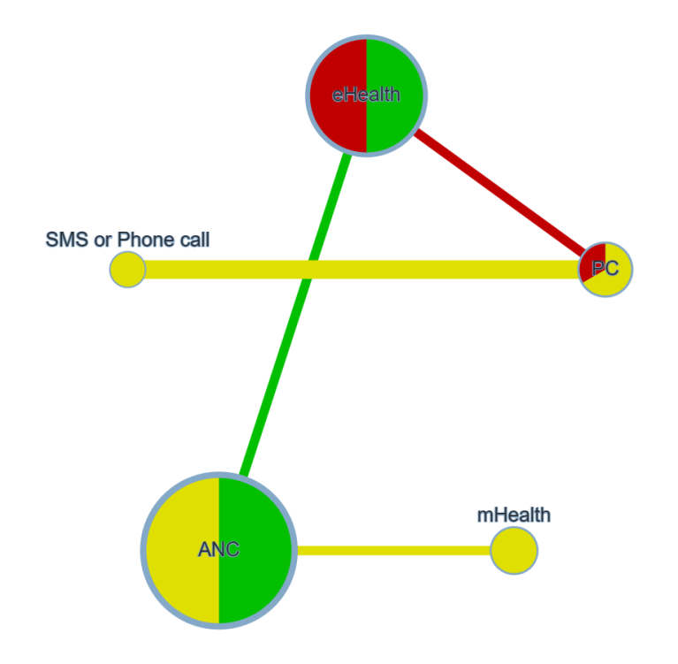
Fig S28 Risk of Bias Contribution by Intervention Group in the CAI frequency. Node size is proportional to sample size, node color represents the risk of bias, edge width corresponds to the number of studies, and edge color reflects the average risk of bias.

Table S57 CINeMA Results for the CAI frequency
Comparison | Number of studies | Within-study bias | Reporting bias | Indirectness | Imprecision | Heterogeneity | Incoherence | Confidence rating | Reason(s) for downgrading
Mixed evidence
ANC:eHealth | 1 | No concerns | High risk | No concerns | NA | NA | NA | Low | ["Reporting bias"]
ANC:mHealth | 1 | Some concerns | High risk | No concerns | NA | NA | NA | Very low | ["Within-study bias","Reporting bias"]
PC:SMS or Phone call | 2 | Some concerns | High risk | No concerns | NA | NA | NA | Very low | ["Within-study bias","Reporting bias"]
eHealth:PC | 1 | Major concerns | High risk | Major concerns | NA | NA | NA | Very low | ["Within-study bias","Reporting bias","Indirectness"]
Indirect evidence
ANC:PC | 0 | Some concerns | High risk | No concerns | NA | NA | NA | Very low | ["Within-study bias","Reporting bias"]
ANC:SMS or Phone call | 0 | Some concerns | High risk | No concerns | NA | NA | NA | Very low | ["Within-study bias","Reporting bias"]
mHealth:PC | 0 | Some concerns | High risk | Major concerns | NA | NA | NA | Very low | ["Within-study bias","Reporting bias","Indirectness"]
eHealth:SMS or Phone call | 0 | Major concerns | High risk | Major concerns | NA | NA | NA | Very low | ["Within-study bias","Reporting bias","Indirectness"]
mHealth:SMS or Phone call | 0 | Some concerns | High risk | Major concerns | NA | NA | NA | Very low | ["Within-study bias","Reporting bias","Indirectness"]

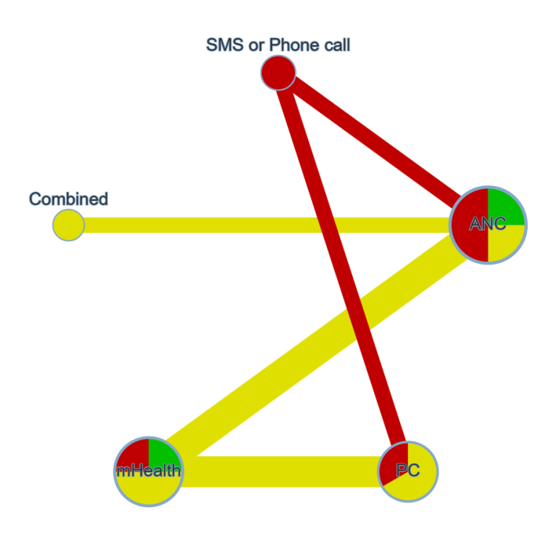

Fig S29 Risk of Bias Contribution by Intervention Group in the ICU frequency. Node size is proportional to sample size, node color represents the risk of bias, edge width corresponds to the number of studies, and edge color reflects the average risk of bias.

Table S58 CINeMA Results for the ICU frequency
Comparison | Number of studies | Within-study bias | Reporting bias | Indirectness | Imprecision | Heterogeneity | Incoherence | Confidence rating | Reason(s) for downgrading
Mixed evidence
ANC:Combined | 1 | Some concerns | Low risk | No concerns | No concerns | No concerns | No concerns | Moderate | ["Within-study bias"]
ANC:SMS or Phone call | 1 | Major concerns | Low risk | No concerns | No concerns | No concerns | No concerns | Low | ["Within-study bias"]
ANC:mHealth | 2 | Major concerns | Low risk | No concerns | No concerns | No concerns | No concerns | Low | ["Within-study bias"]
PC:SMS or Phone call | 1 | Major concerns | Low risk | No concerns | No concerns | No concerns | No concerns | Low | ["Within-study bias"]
mHealth:PC | 2 | Some concerns | Low risk | No concerns | No concerns | No concerns | No concerns | Moderate | ["Within-study bias"]
Indirect evidence
ANC:PC | 0 | Some concerns | Low risk | No concerns | No concerns | No concerns | No concerns | Moderate | ["Within-study bias"]
Combined:PC | 0 | Some concerns | Low risk | No concerns | No concerns | No concerns | No concerns | Moderate | ["Within-study bias"]
Combined:SMS or Phone call | 0 | Major concerns | Low risk | No concerns | No concerns | No concerns | No concerns | Low | ["Within-study bias"]
Combined:mHealth | 0 | Some concerns | Low risk | No concerns | No concerns | No concerns | No concerns | Moderate | ["Within-study bias"]
mHealth:SMS or Phone call | 0 | Major concerns | Low risk | No concerns | No concerns | No concerns | No concerns | Low | ["Within-study bias"]

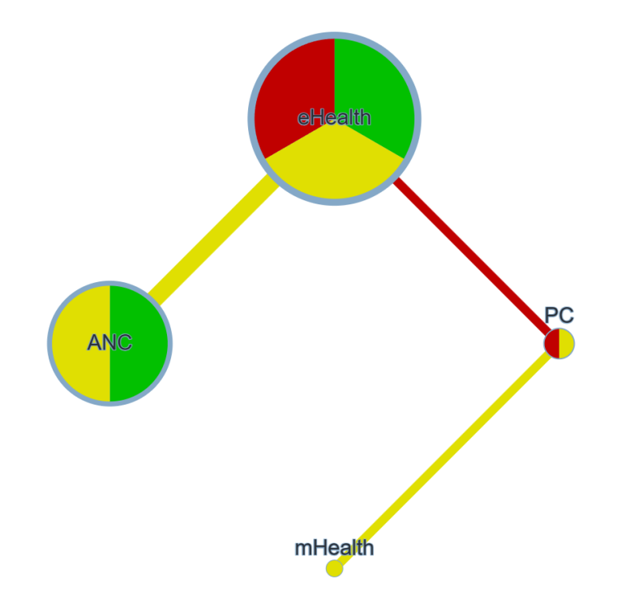
Fig S30 Risk of Bias Contribution by Intervention Group in the NSP. Node size is proportional to sample size, node color represents the risk of bias, edge width corresponds to the number of studies, and edge color reflects the average risk of bias.

Table S59 CINeMA Results for the NSP
Comparison | Number of studies | Within-study bias | Reporting bias | Indirectness | Imprecision | Heterogeneity | Incoherence | Confidence rating | Reason(s) for downgrading
Mixed evidence
ANC:eHealth | 2 | Some concerns | Low risk | No concerns | NA | NA | NA | Moderate | ["Within-study bias"]
eHealth:PC | 1 | Major concerns | Low risk | No concerns | NA | NA | NA | Low | ["Within-study bias"]
mHealth:PC | 1 | Some concerns | Low risk | No concerns | NA | NA | NA | Low | ["Within-study bias"]
Indirect evidence
ANC:PC | 0 | Major concerns | Low risk | No concerns | NA | NA | NA | Low | ["Within-study bias"]
mHealth:eHealth | 0 | Some concerns | Low risk | No concerns | NA | NA | NA | Moderate | ["Within-study bias"]

