SUPPLEMENTARY RESULTS

Correlation of EEG metrics with established AD biomarkers
To assess the robustness of the results about the relationship of digital biomarkers with established AD biomarkers, we also analyzed how EEG metrics (which include spectral and functional connectivity, see Methods) related to established AD biomarkers, performing the same correlational and odds ratio analyses.
Starting from the relationship of EEG metrics with cognitive status, our analysis revealed that alpha-band PSD presented significant correlation with MMSE similar to what is observed for digital biomarkers (r=-0.15, p=0.002). In the OR analysis, EEG metrics presented slightly lower significance than those presented by digital biomarkers (Supplementary Fig 1).
Subsequently, we quantified the correlation with CSF biomarkers and the Odds ratios for Abeta and Tau positivity associated with EEG metrics. Among EEG metrics, beta-band FC presented significant correlation with Abeta and Tau levels (respectively r=-0.13, p=0.012 and r=-0.17, p=0.0004). The OR analysis revealed that this metric also presented significant OR values (for Abeta: 0.75 [0.61, 0.91], p=0.003, for Tau: 0.75 [0.62, 0.91], p=0.004, see Supplementary Fig. 2), although OR values were slightly weaker when compared with digital biomarkers. It must be noted that despite the significance of these results, beta-band FC was not used in the model inversion routine to derive digital biomarkers as it presented small differences across groups (SCD and MCI participants). As such, digital biomarkers presented the ability to unify in a unique and interpretable framework the association of several EEG metrics with multimodal AD biomarkers.
The observed differences in digital biomarkers across AD biomarkers subgroups could not be explained by the differences in the EEG metrics used for their determination, which presented lower differences with limited statistical significance (Supplementary Table 1).

Digital biomarkers strongly distinguish participants in the early phases of AD neurodegeneration
The synaptic degeneration parameter is meant to model hyperexcitation driven by early-phase Abeta pathology, localized in the frontal and temporal regions¹ (see Methods). Since medial temporal lobe atrophy (MTA) measured with structural MRI quantifies atrophy in areas affected by the synaptic degeneration parameter, we analyzed again the synaptic degeneration parameter in relation to MTA values, this time stratifying participants according to (i) conversions at follow-up and (ii) Abeta positivity.
Our analysis revealed that lp was higher in participants negative for MTA (MTA-) that converted at follow-up compared to positive participants (MTA+, Mann-Whitney U=1264, p=0.001, d=0.8, Supplementary Fig. 3A-i), while this difference across MTA+ and MTA- participants was not observed in stable participants (Mann-Whitney U=408.5, p=0.47). Furthermore, differences between stable and converted MTA- participants were not observed in terms of the other digital biomarkers (connectivity degeneration: U=1712, p=0.52, neuroplasticity: U=1570, p=0.86, total degeneration: U=1836, p=0.12). These results were further corroborated by a two-way ANOVA, which revealed significant interaction between MTA positivity and later clinical conversion in determining the values of Synaptic degeneration (F=5.25, p=0.022).
By stratifying participants according to Abeta positivity, we found that in the MTA- subgroup, A+ participants exhibited significantly higher values of digital biomarkers when compared with A- participants. Specifically, we found higher values of synaptic degeneration parameter and connectivity degeneration parameter in MTA- A+ participants compared to MTA- A- participants (Supplementary Table 2, Supplementary Fig. 3A-ii), leading to remarkably higher total degeneration values (U=6222.5, p=3.2e-5, d=0.6). However, these differences were not present in MTA+ participants stratified according to Abeta positivity (Supplementary Table 2).
The interaction between MTA values and Abeta positivity in determining Total degeneration values was confirmed by a two-way ANOVA (F=4.70, p=0.034). Also in this case, EEG metrics presented less significant differences in the atrophy subgroups (Supplementary Table 3) and no interaction between MTA positivity and either clinical conversion or Abeta positivity.
These findings corroborate the role of DADD model parameters as digital biomarkers of early neurodegeneration mechanisms^{2–5}, as differences in digital biomarkers were relevant between A+ and A- subgroups, and between participants and converted at follow-up, only among those with intact temporal lobe (see Discussion). Overall, these results corroborate the hypothesis that digital biomarkers, particularly the connectivity degeneration parameter, capture not only clinical condition, but also the underlying neurodegeneration processes associated with it. The synaptic degeneration parameter, instead, meant to capture early pathological hyperexcitation mechanisms, emerged as a significant biomarker of disease severity in participants with no MTA, i.e. prior to the emergence of atrophy mechanisms.
The analysis of digital biomarkers in relation to MTA values in participants stratified according to Abeta positivity further supports their role in capturing early neurodegeneration. Significant differences were observed between A+ and A- participants within the subgroup with intact temporal lobes, suggesting that these biomarkers are particularly sensitive to early pathological changes. This aligns with the model's intended design, which simulates early-phase neurodegeneration processes, including Abeta-induced hyperexcitation⁴ and disconnection⁶. The absence of significant differences among participants with temporal lobe atrophy also reinforces this interpretation. At more advanced disease stages, where structural damage is widespread, digital biomarkers may converge across subgroups, reflecting the later-stage homogenization of neurodegeneration regardless of Abeta status. These findings highlight the potential of digital biomarkers to detect subtle yet clinically meaningful alterations in early disease phases, offering a computational window into neurodegeneration progression before overt structural damage becomes evident on MRI.

Importance of threshold values in Kaplan-Meier analysis
To test the robustness of the threshold choice in the Kaplan-Meier analysis (i.e., median values as thresholds), we also ran the analyses by stratifying groups with the standard cut-offs for Abeta and Tau positivity (see Supplementary Materials). Results in the subgroups identified by these thresholds presented no difference with respect to the subgroup identified by median values, with the only exception of Tau for the SCD A+ group, which presented significant differences using the usual threshold (p=0.012). However, the two subgroups identified by the usual Tau threshold were imbalanced (26 participants above and 33 below, with a threshold corresponding to the 56-percentile). Using a similar threshold for the synaptic degeneration parameter, we found that its significance also increased (p=0.013).

Discriminative analysis of participants with low levels of digital biomarkers who converted at follow-up
To further investigate the reasons for the discrepancy between digital biomarker values and clinical outcome, a targeted discriminative analysis focusing on participants who converted while exhibiting low values of the DADD-derived digital biomarkers was performed.
We hypothesized that the discrepancies were due to the fact that the model was originally developed to characterize early and prodromal stages of Alzheimer’s disease, where pathological alterations are expected to be subtle and primarily driven by synaptic dysfunction and network-level changes. Consequently, the model may not fully capture pathological processes associated with more advanced neurodegeneration.

To test this hypothesis, we first identified optimal thresholds for each digital biomarker based on their discriminative accuracy for conversion status. The resulting thresholds corresponded to the 30th percentile for connectivity degeneration, the 40th percentile for synaptic degeneration, the 30th percentile for neuroplasticity and the 45th percentile for total degeneration. Using these thresholds, subjects were stratified into low-biomarker subgroups. Within this restricted range, we compared converted and stable individuals with low digital biomarker values, thereby isolating clinical and biological differences not explained by the model parameters themselves.
Non-parametric statistical comparisons revealed marked and highly significant differences in established markers of neurodegeneration between the two groups. Converted subjects with low digital biomarker values exhibited substantially higher cerebrospinal fluid Tau concentrations compared to stable subjects with similarly low values (connectivity degeneration: $n_{conv}$=25, $n_{stable}$=117, U = 3225.5, p<0.00001, d=1.4; synaptic degeneration: $n_{conv}$=55, $n_{stable}$=146, U=5992, p<0.00001, d = 1.0; neuroplasticity: $n_{conv}$=57, $n_{stable}$=146, U=6288, p<0.00001, d=1.0; total degeneration: $n_{conv}$=47, $n_{stable}$=165, U=6004.5, p<0.00001, d = 1.2). A consistent pattern was also observed for medial temporal lobe atrophy, with converted individuals showing significantly higher MTA scores across all digital biomarkers (connectivity degeneration: U=1215.5, p=0.019, d=0.6; synaptic degeneration: U=4178.5, p<0.00001, d=0.8; neuroplasticity: U=3978.5, p=0.0063, d=0.5; total degeneration: U=3817.5, p<0.00001, d=0.8). Results are visualized in Supplementary Fig. 8.

These findings provide a mechanistic interpretation for the presence of converters with low digital biomarker values. These cases, despite being clinically labeled as SCD or MCI, are characterized by advanced neurodegenerative pathology that lies outside the intended domain of applicability of the model. In such individuals, substantial Tau pathology and structural atrophy likely dominate disease progression, overruling the early network-level mechanisms captured by the model and summarized in the digital biomarkers. We conclude that our model might have limited applicability to the rather atypical patients in which an advanced neural degeneration still did not manifest in overt behavioral symptoms. The DADD model combined with tools estimating structural neurodegeneration such as structural MRI could allow for a proper characterization of these atypical patients.

Comparative analysis with standard EEG biomarkers
To provide a direct methodological benchmark with conventional EEG-based approaches, all analyses performed using DADD-derived digital biomarkers were repeated using standard EEG biomarkers commonly employed in Alzheimer’s disease research. Specifically, conventional EEG features were extracted from the same recordings and included spectral power measures across canonical frequency bands, as well as established EEG-derived summary metrics routinely used in clinical and research settings.
These standard EEG biomarkers were then used to replicate the same analytical pipeline adopted for digital biomarkers, including: (i) discriminative analysis of participants stratified according to established AD biomarkers (CSF, MRI, APOE genotype) (ii) estimation of risk for cognitive impairment, Tau and Abeta positivity, (iii) correlation analyses with established AD biomarkers, (iv) classification tasks discriminating stable and converted participants, (v) Cox Proportional Hazard Ratio models, and (vi) conversion curves analysis. This approach ensured a direct and fair comparison under identical data, preprocessing, and statistical conditions, allowing standard EEG biomarkers to serve as a benchmark for evaluating the added value of DADD-derived digital biomarkers.
To compare the overall predictive value of the two classes of biomarkers across heterogeneous analyses, effect sizes were first standardized and subsequently compared across different tasks. This approach allowed us to aggregate evidence across multiple statistical paradigms while preserving the direction and magnitude of effects. After collecting effect sizes across multiple tasks, a binomial test was used to assess whether one class of biomarkers consistently outperformed the other beyond chance level, both within single task paradigms and cumulatively. Together, these complementary analyses provided convergent evidence for the superior overall performance of digital biomarkers over standard EEG biomarkers (Supplementary Table 9).

Standard EEG and Digital biomarkers are robust to different EEG settings
To address potential hardware-related systematic bias introduced by pooling data from EEG systems with different technical specifications, a hierarchical regression harmonization procedure was applied to all EEG-derived features. For each feature, a multivariate linear model was fitted with age and sex as biological covariates and the explicit hardware parameters of each recording system (sampling frequency, time constant, low-pass filter cutoff, ADC resolution) as fixed effects. Harmonized feature values were obtained as the residuals from this model. To assess the impact of harmonization on digital biomarkers, harmonized and non-harmonized values were compared using paired statistical testing. No significant differences were observed for any digital biomarker (Connectivity degeneration: mean absolute change MAC=0.030, p=0.50; Synaptic degeneration: MAC=0.015, p=0.14; Neuroplasticity: MAC=.026, p=0.099; Total degeneration: MAC=0.025, p=0.37) nor in the standard EEG biomarkers used for their derivation (Theta PSD: MAC=0.007, p=0.77, Alpha PSD: MAC=0.009, p=0.86, Alpha FC: MAC=0.002, p=0.46). This confirms the robustness of standard EEG metrics and digital biomarkers to the hardware variation present in this cohort.

Supplementary Table 1.

EEG metric | Theta PSD |  | Alpha PSD |  | Alpha FC
 | Test | p-val | Test | p-val | Test | p-val
SCD / MCI | 19726 | 0.013 | 29558.5 | 0.023 | 27160 | 0.076
APOE-4+ / APOE-4 - | 17595.5 | 0.095 | 23685.5 | 0.59 | 24055.5 | 0.017
A+ / A- | 18476.5 | 0.004 | 28664.5 | 0.015 | 24261.5 | 0.85
T+ / T- | 19558.5 | 0.025 | 29133.5 | 0.031 | 24989 | 0.65
Atrophy+/Atrophy- | 598.5 | 0.93 | 618.0 | 0.92 | 546.5 | 0.54
MTA+ / MTA- | 16693.5 | 0.96 | 19829 | 0.46 | 17728.5 | 0.64
Supplementary Table 1. Analysis of EEG metrics used in the derivation of digital biomarkers in participants’ subgroups. Groups are stratified according to clinical diagnosis and AD biomarkers profiling. Significant differences (after Bonferroni correction) are highlighted in bold. Only EEG metrics used in digital biomarkers determination are reported.

Supplementary Table 2.

 | MTA- |  | MTA+
 | Test | p-val | Test | p-val
Synaptic | 7645.5 | 0.023 | 1571.5 | 0.47
Connectivity | 6531 | 6.9e-5 | 1883.5 | 0.51
Neuroplasticity | 8503 | 0.32 | 1768 | 0.97
Total | 6222.5 | 3.2e-5 | 1762.5 | 0.74
Supplementary Table 2. Differences in digital biomarkers between A+ and A- participants, stratified according to MRI results (respectively absence or presence of medial temporal lobe atrophy). Significant differences (after Bonferroni correction) are highlighted in bold.
Supplementary Table 3.

 | MTA- |  | MTA+
 | Test | p-val | Test | p-val
Theta PSD | 6052 | 0.006 | 1342.5 | 0.51
Alpha PSD | 10112.5 | 0.028 | 1751 | 0.45
Alpha FC | 8812 | 0.41 | 1309.5 | 0.20
Supplementary Table 3. Differences in EEG metrics used to derive digital biomarkers between A+ and A- participants, stratified according to MRI results (respectively absence or presence of medial temporal lobe atrophy). Significant differences (after Bonferroni correction) are highlighted in bold. Results are reported separately for Theta PSD and Alpha PSD, which were used to compute the Theta/Alpha PSD ratio adopted for model inversion.
Supplementary Table 4.

Stable vs Converted
 | Test | p-val
Delta PSD | 19561 | 0.074
Theta PSD | 14363.5 | 0.0002
Alpha PSD | 24506.5 | 0.041
Beta PSD | 20517 | 0.30
Alpha FC | 22982 | 0.023
Beta FC | 24993 | 0.016
Supplementary Table 4. Differences in EEG metrics between stable and converted participants. Significant differences (after Bonferroni correction) are highlighted in bold.
Supplementary Table 5.

 | coef | exp(coef) | se(coef) | coef lower 95% | coef upper 95% | exp(coef) lower 95% | exp(coef) upper 95% | cmp to | z | p | -log2(p)
Delta PSD | 0.14 | 1.15 | 0.09 | -0.04 | 0.32 | 0.96 | 1.38 | 0.00 | 1.56 | 0.12 | 3.09
AGE_BL | 0.05 | 1.05 | 0.01 | 0.03 | 0.07 | 1.03 | 1.07 | 0.00 | 5.06 | <0.005 | 21.18
EEG_system | 0.18 | 1.20 | 0.15 | -0.12 | 0.48 | 0.89 | 1.61 | 0.00 | 1.18 | 0.24 | 2.07
SEX[T.m] | -0.16 | 0.85 | 0.18 | -0.51 | 0.19 | 0.60 | 1.20 | 0.00 | -0.91 | 0.36 | 1.46

 | coef | exp(coef) | se(coef) | coef lower 95% | coef upper 95% | exp(coef) lower 95% | exp(coef) upper 95% | cmp to | z | p | -log2(p)
Theta PSD | 0.05 | 1.05 | 0.08 | -0.10 | 0.20 | 0.90 | 1.22 | 0.00 | 0.63 | 0.53 | 0.93
AGE_BL | 0.05 | 1.05 | 0.01 | 0.03 | 0.07 | 1.03 | 1.07 | 0.00 | 4.82 | <0.005 | 19.44
EEG_system | 0.19 | 1.21 | 0.15 | -0.11 | 0.49 | 0.89 | 1.63 | 0.00 | 1.22 | 0.22 | 2.18
SEX[T.m] | -0.15 | 0.86 | 0.18 | -0.51 | 0.20 | 0.60 | 1.23 | 0.00 | -0.83 | 0.40 | 1.30

 | coef | exp(coef) | se(coef) | coef lower 95% | coef upper 95% | exp(coef) lower 95% | exp(coef) upper 95% | cmp to | z | p | -log2(p)
Alpha PSD | -0.18 | 0.84 | 0.09 | -0.36 | 0.01 | 0.70 | 1.01 | 0.00 | -1.90 | 0.06 | 4.13
AGE_BL | 0.05 | 1.05 | 0.01 | 0.03 | 0.07 | 1.03 | 1.07 | 0.00 | 4.86 | <0.005 | 19.73
EEG_system | 0.19 | 1.21 | 0.15 | -0.10 | 0.49 | 0.90 | 1.63 | 0.00 | 1.28 | 0.20 | 2.31
SEX[T.m] | -0.13 | 0.88 | 0.18 | -0.47 | 0.22 | 0.62 | 1.24 | 0.00 | -0.72 | 0.47 | 1.09

 | coef | exp(coef) | se(coef) | coef lower 95% | coef upper 95% | exp(coef) lower 95% | exp(coef) upper 95% | cmp to | z | p | -log2(p)
Beta PSD | 0.04 | 1.04 | 0.09 | -0.14 | 0.22 | 0.87 | 1.24 | 0.00 | 0.42 | 0.68 | 0.57
AGE_BL | 0.05 | 1.05 | 0.01 | 0.03 | 0.07 | 1.03 | 1.07 | 0.00 | 5.03 | <0.005 | 20.95
EEG_system | 0.22 | 1.24 | 0.16 | -0.09 | 0.52 | 0.92 | 1.68 | 0.00 | 1.39 | 0.16 | 2.60
SEX[T.m] | -0.09 | 0.91 | 0.19 | -0.46 | 0.28 | 0.63 | 1.32 | 0.00 | -0.49 | 0.62 | 0.69

 | coef | exp(coef) | se(coef) | coef lower 95% | coef upper 95% | exp(coef) lower 95% | exp(coef) upper 95% | cmp to | z | p | -log2(p)
Alpha FC | -0.18 | 0.83 | 0.09 | -0.37 | 0.00 | 0.69 | 1.00 | 0.00 | -1.95 | 0.05 | 4.30
AGE_BL | 0.05 | 1.05 | 0.01 | 0.03 | 0.07 | 1.03 | 1.07 | 0.00 | 5.10 | <0.005 | 21.50
EEG_system | 0.19 | 1.21 | 0.15 | -0.11 | 0.48 | 0.90 | 1.62 | 0.00 | 1.24 | 0.21 | 2.22
SEX[T.m] | -0.13 | 0.88 | 0.18 | -0.47 | 0.21 | 0.62 | 1.24 | 0.00 | -0.75 | 0.45 | 1.14

 | coef | exp(coef) | se(coef) | coef lower 95% | coef upper 95% | exp(coef) lower 95% | exp(coef) upper 95% | cmp to | z | p | -log2(p)
Beta FC | -0.16 | 0.86 | 0.09 | -0.33 | 0.02 | 0.72 | 1.02 | 0.00 | -1.72 | 0.08 | 3.56
AGE_BL | 0.05 | 1.05 | 0.01 | 0.03 | 0.07 | 1.03 | 1.07 | 0.00 | 4.75 | <0.005 | 18.90
EEG_system | 0.22 | 1.24 | 0.15 | -0.08 | 0.51 | 0.92 | 1.67 | 0.00 | 1.42 | 0.15 | 2.70
SEX[T.m] | -0.09 | 0.91 | 0.18 | -0.44 | 0.26 | 0.65 | 1.29 | 0.00 | -0.51 | 0.61 | 0.71

 | coef | exp(coef) | se(coef) | coef lower 95% | coef upper 95% | exp(coef) lower 95% | exp(coef) upper 95% | cmp to | z | p | -log2(p)
Connectivity | 0.43 | 1.53 | 0.10 | 0.23 | 0.62 | 1.26 | 1.86 | 0.00 | 4.35 | <0.005 | 16.14
AGE_BL | 0.05 | 1.05 | 0.01 | 0.03 | 0.07 | 1.03 | 1.07 | 0.00 | 4.83 | <0.005 | 19.45
EEG_system | 0.14 | 1.15 | 0.15 | -0.16 | 0.44 | 0.86 | 1.55 | 0.00 | 0.93 | 0.35 | 1.51
SEX[T.m] | -0.25 | 0.78 | 0.18 | -0.60 | 0.09 | 0.55 | 1.10 | 0.00 | -1.43 | 0.15 | 2.71

 | coef | exp(coef) | se(coef) | coef lower 95% | coef upper 95% | exp(coef) lower 95% | exp(coef) upper 95% | cmp to | z | p | -log2(p)
Synaptic | 0.07 | 1.07 | 0.09 | -0.11 | 0.25 | 0.89 | 1.28 | 0.00 | 0.74 | 0.46 | 1.12
AGE_BL | 0.05 | 1.05 | 0.01 | 0.03 | 0.07 | 1.03 | 1.07 | 0.00 | 4.89 | <0.005 | 19.89
EEG_system | 0.19 | 1.20 | 0.15 | -0.11 | 0.48 | 0.89 | 1.62 | 0.00 | 1.22 | 0.22 | 2.17
SEX[T.m] | -0.13 | 0.87 | 0.18 | -0.48 | 0.21 | 0.62 | 1.23 | 0.00 | -0.76 | 0.45 | 1.16

 | coef | exp(coef) | se(coef) | coef lower 95% | coef upper 95% | exp(coef) lower 95% | exp(coef) upper 95% | cmp to | z | p | -log2(p)
Neuroplasticity | 0.03 | 1.03 | 0.09 | -0.15 | 0.20 | 0.86 | 1.23 | 0.00 | 0.29 | 0.77 | 0.37
AGE_BL | 0.05 | 1.05 | 0.01 | 0.03 | 0.07 | 1.03 | 1.07 | 0.00 | 5.01 | <0.005 | 20.81
EEG_system | 0.19 | 1.21 | 0.15 | -0.11 | 0.49 | 0.89 | 1.64 | 0.00 | 1.23 | 0.22 | 2.21
SEX[T.m] | -0.13 | 0.88 | 0.18 | -0.47 | 0.22 | 0.62 | 1.24 | 0.00 | -0.72 | 0.47 | 1.09

 | coef | exp(coef) | se(coef) | coef lower 95% | coef upper 95% | exp(coef) lower 95% | exp(coef) upper 95% | cmp to | z | p | -log2(p)
Total | 0.34 | 1.41 | 0.09 | 0.16 | 0.52 | 1.18 | 1.68 | 0.00 | 3.75 | <0.005 | 12.44
AGE_BL | 0.05 | 1.05 | 0.01 | 0.03 | 0.07 | 1.03 | 1.07 | 0.00 | 4.60 | <0.005 | 17.83
EEG_system | 0.12 | 1.13 | 0.15 | -0.18 | 0.42 | 0.84 | 1.52 | 0.00 | 0.78 | 0.43 | 1.21
SEX[T.m] | -0.23 | 0.79 | 0.18 | -0.58 | 0.11 | 0.56 | 1.12 | 0.00 | -1.32 | 0.19 | 2.42

 | coef | exp(coef) | se(coef) | coef lower 95% | coef upper 95% | exp(coef) lower 95% | exp(coef) upper 95% | cmp to | z | p | -log2(p)
Tau | 0.50 | 1.66 | 0.06 | 0.39 | 0.62 | 1.47 | 1.86 | 0.00 | 8.48 | <0.005 | 55.27
AGE_BL | 0.03 | 1.03 | 0.01 | 0.01 | 0.05 | 1.01 | 1.05 | 0.00 | 2.88 | <0.005 | 7.97
EEG_system | 0.26 | 1.29 | 0.15 | -0.04 | 0.55 | 0.96 | 1.73 | 0.00 | 1.71 | 0.09 | 3.52
SEX[T.m] | 0.15 | 1.16 | 0.18 | -0.21 | 0.51 | 0.81 | 1.67 | 0.00 | 0.82 | 0.41 | 1.29

 | coef | exp(coef) | se(coef) | coef lower 95% | coef upper 95% | exp(coef) lower 95% | exp(coef) upper 95% | cmp to | z | p | -log2(p)
Abeta | -0.62 | 0.54 | 0.11 | -0.84 | -0.41 | 0.43 | 0.66 | 0.00 | -5.77 | <0.005 | 26.94
AGE_BL | 0.03 | 1.03 | 0.01 | 0.01 | 0.05 | 1.01 | 1.06 | 0.00 | 3.19 | <0.005 | 9.47
EEG_system | 0.13 | 1.14 | 0.15 | -0.17 | 0.43 | 0.84 | 1.53 | 0.00 | 0.85 | 0.40 | 1.33
SEX[T.m] | -0.08 | 0.92 | 0.18 | -0.43 | 0.26 | 0.65 | 1.30 | 0.00 | -0.47 | 0.64 | 0.65
Supplementary Table 5. Cox Proportional Hazard Model for digital biomarkers, EEG metrics and established AD biomarkers in all participants. The variable “AGE_BL” represents Age at baseline, while “EEG_system” is the categorical variable representing the EEG machine and “SEX[T.m]” represents biological sex. These variables were inserted as covariates. MRI and genotypic markers, used as covariates, are reported in the main text (only when significant).
Supplementary Table 6.

 | coef | exp(coef) | se(coef) | coef lower 95% | coef upper 95% | exp(coef) lower 95% | exp(coef) upper 95% | cmp to | z | p | -log2(p)
Delta PSD | 0.07 | 1.08 | 0.11 | -0.14 | 0.29 | 0.87 | 1.33 | 0.00 | 0.69 | 0.49 | 1.03
AGE_BL | 0.02 | 1.02 | 0.01 | -0.01 | 0.05 | 0.99 | 1.05 | 0.00 | 1.39 | 0.16 | 2.61
EEG_system | -0.17 | 0.85 | 0.21 | -0.57 | 0.24 | 0.56 | 1.27 | 0.00 | -0.80 | 0.43 | 1.23
SEX[T.m] | -0.31 | 0.74 | 0.21 | -0.72 | 0.11 | 0.49 | 1.11 | 0.00 | -1.46 | 0.15 | 2.78

 | coef | exp(coef) | se(coef) | coef lower 95% | coef upper 95% | exp(coef) lower 95% | exp(coef) upper 95% | cmp to | z | p | -log2(p)
Theta PSD | 0.10 | 1.10 | 0.09 | -0.08 | 0.28 | 0.92 | 1.32 | 0.00 | 1.07 | 0.29 | 1.81
AGE_BL | 0.02 | 1.02 | 0.01 | -0.01 | 0.04 | 0.99 | 1.04 | 0.00 | 1.18 | 0.24 | 2.07
EEG_system | -0.21 | 0.81 | 0.21 | -0.63 | 0.20 | 0.53 | 1.23 | 0.00 | -1.00 | 0.32 | 1.66
SEX[T.m] | -0.35 | 0.70 | 0.22 | -0.78 | 0.07 | 0.46 | 1.08 | 0.00 | -1.62 | 0.11 | 3.24

 | coef | exp(coef) | se(coef) | coef lower 95% | coef upper 95% | exp(coef) lower 95% | exp(coef) upper 95% | cmp to | z | p | -log2(p)
Alpha PSD | -0.08 | 0.92 | 0.11 | -0.29 | 0.13 | 0.75 | 1.14 | 0.00 | -0.77 | 0.44 | 1.18
AGE_BL | 0.02 | 1.02 | 0.01 | -0.01 | 0.04 | 0.99 | 1.05 | 0.00 | 1.24 | 0.22 | 2.21
EEG_system | -0.17 | 0.84 | 0.21 | -0.58 | 0.24 | 0.56 | 1.27 | 0.00 | -0.83 | 0.41 | 1.30
SEX[T.m] | -0.28 | 0.76 | 0.21 | -0.69 | 0.13 | 0.50 | 1.14 | 0.00 | -1.33 | 0.18 | 2.45

 | coef | exp(coef) | se(coef) | coef lower 95% | coef upper 95% | exp(coef) lower 95% | exp(coef) upper 95% | cmp to | z | p | -log2(p)
Beta PSD | -0.01 | 0.99 | 0.10 | -0.21 | 0.19 | 0.81 | 1.21 | 0.00 | -0.10 | 0.92 | 0.12
AGE_BL | 0.02 | 1.02 | 0.01 | -0.01 | 0.05 | 0.99 | 1.05 | 0.00 | 1.43 | 0.15 | 2.71
EEG_system | -0.16 | 0.86 | 0.21 | -0.56 | 0.25 | 0.57 | 1.29 | 0.00 | -0.75 | 0.46 | 1.13
SEX[T.m] | -0.30 | 0.74 | 0.22 | -0.73 | 0.14 | 0.48 | 1.15 | 0.00 | -1.33 | 0.18 | 2.45

 | coef | exp(coef) | se(coef) | coef lower 95% | coef upper 95% | exp(coef) lower 95% | exp(coef) upper 95% | cmp to | z | p | -log2(p)
Alpha FC | -0.19 | 0.83 | 0.11 | -0.40 | 0.03 | 0.67 | 1.03 | 0.00 | -1.70 | 0.09 | 3.49
AGE_BL | 0.02 | 1.02 | 0.01 | -0.01 | 0.05 | 0.99 | 1.05 | 0.00 | 1.43 | 0.15 | 2.72
EEG_system | -0.17 | 0.84 | 0.21 | -0.57 | 0.23 | 0.56 | 1.26 | 0.00 | -0.82 | 0.41 | 1.29
SEX[T.m] | -0.25 | 0.78 | 0.21 | -0.66 | 0.16 | 0.52 | 1.17 | 0.00 | -1.19 | 0.23 | 2.10

 | coef | exp(coef) | se(coef) | coef lower 95% | coef upper 95% | exp(coef) lower 95% | exp(coef) upper 95% | cmp to | z | p | -log2(p)
Beta FC | -0.07 | 0.94 | 0.11 | -0.27 | 0.14 | 0.76 | 1.15 | 0.00 | -0.63 | 0.53 | 0.93
AGE_BL | 0.02 | 1.02 | 0.01 | -0.01 | 0.05 | 0.99 | 1.05 | 0.00 | 1.37 | 0.17 | 2.55
EEG_system | -0.14 | 0.87 | 0.21 | -0.55 | 0.27 | 0.58 | 1.31 | 0.00 | -0.67 | 0.50 | 1.00
SEX[T.m] | -0.26 | 0.77 | 0.21 | -0.68 | 0.15 | 0.51 | 1.16 | 0.00 | -1.25 | 0.21 | 2.24

 | coef | exp(coef) | se(coef) | coef lower 95% | coef upper 95% | exp(coef) lower 95% | exp(coef) upper 95% | cmp to | z | p | -log2(p)
Connectivity | 0.39 | 1.47 | 0.12 | 0.15 | 0.62 | 1.16 | 1.86 | 0.00 | 3.24 | <0.005 | 9.73
AGE_BL | 0.02 | 1.02 | 0.01 | -0.00 | 0.05 | 1.00 | 1.05 | 0.00 | 1.66 | 0.10 | 3.38
EEG_system | -0.25 | 0.78 | 0.21 | -0.66 | 0.15 | 0.52 | 1.16 | 0.00 | -1.22 | 0.22 | 2.18
SEX[T.m] | -0.37 | 0.69 | 0.21 | -0.78 | 0.04 | 0.46 | 1.04 | 0.00 | -1.76 | 0.08 | 3.68

 | coef | exp(coef) | se(coef) | coef lower 95% | coef upper 95% | exp(coef) lower 95% | exp(coef) upper 95% | cmp to | z | p | -log2(p)
Synaptic | 0.21 | 1.23 | 0.11 | -0.01 | 0.43 | 0.99 | 1.54 | 0.00 | 1.86 | 0.06 | 3.98
AGE_BL | 0.01 | 1.01 | 0.01 | -0.01 | 0.04 | 0.99 | 1.04 | 0.00 | 1.07 | 0.29 | 1.80
EEG_system | -0.22 | 0.81 | 0.21 | -0.62 | 0.19 | 0.54 | 1.21 | 0.00 | -1.04 | 0.30 | 1.73
SEX[T.m] | -0.33 | 0.72 | 0.21 | -0.74 | 0.08 | 0.48 | 1.08 | 0.00 | -1.60 | 0.11 | 3.19

 | coef | exp(coef) | se(coef) | coef lower 95% | coef upper 95% | exp(coef) lower 95% | exp(coef) upper 95% | cmp to | z | p | -log2(p)
Neuroplasticity | 0.01 | 1.01 | 0.11 | -0.20 | 0.22 | 0.82 | 1.24 | 0.00 | 0.07 | 0.95 | 0.08
AGE_BL | 0.02 | 1.02 | 0.01 | -0.01 | 0.05 | 0.99 | 1.05 | 0.00 | 1.40 | 0.16 | 2.62
EEG_system | -0.16 | 0.85 | 0.22 | -0.58 | 0.27 | 0.56 | 1.31 | 0.00 | -0.73 | 0.47 | 1.10
SEX[T.m] | -0.29 | 0.75 | 0.21 | -0.70 | 0.12 | 0.50 | 1.13 | 0.00 | -1.39 | 0.16 | 2.60

 | coef | exp(coef) | se(coef) | coef lower 95% | coef upper 95% | exp(coef) lower 95% | exp(coef) upper 95% | cmp to | z | p | -log2(p)
Total | 0.40 | 1.49 | 0.11 | 0.18 | 0.62 | 1.19 | 1.85 | 0.00 | 3.55 | <0.005 | 11.37
AGE_BL | 0.02 | 1.02 | 0.01 | -0.01 | 0.04 | 0.99 | 1.04 | 0.00 | 1.20 | 0.23 | 2.11
EEG_system | -0.31 | 0.74 | 0.21 | -0.71 | 0.10 | 0.49 | 1.11 | 0.00 | -1.46 | 0.14 | 2.80
SEX[T.m] | -0.39 | 0.68 | 0.21 | -0.80 | 0.02 | 0.45 | 1.02 | 0.00 | -1.87 | 0.06 | 4.04

 | coef | exp(coef) | se(coef) | coef lower 95% | coef upper 95% | exp(coef) lower 95% | exp(coef) upper 95% | cmp to | z | p | -log2(p)
Tau | 0.41 | 1.51 | 0.09 | 0.24 | 0.59 | 1.27 | 1.80 | 0.00 | 4.69 | <0.005 | 18.46
AGE_BL | 0.01 | 1.01 | 0.01 | -0.02 | 0.04 | 0.98 | 1.04 | 0.00 | 0.62 | 0.53 | 0.91
EEG_system | -0.11 | 0.90 | 0.20 | -0.51 | 0.29 | 0.60 | 1.34 | 0.00 | -0.52 | 0.60 | 0.73
SEX[T.m] | -0.04 | 0.96 | 0.22 | -0.46 | 0.39 | 0.63 | 1.48 | 0.00 | -0.17 | 0.86 | 0.21

 | coef | exp(coef) | se(coef) | coef lower 95% | coef upper 95% | exp(coef) lower 95% | exp(coef) upper 95% | cmp to | z | p | -log2(p)
Abeta | -0.06 | 0.94 | 0.10 | -0.26 | 0.14 | 0.77 | 1.15 | 0.00 | -0.59 | 0.55 | 0.86
AGE_BL | 0.02 | 1.02 | 0.01 | -0.01 | 0.05 | 0.99 | 1.05 | 0.00 | 1.39 | 0.16 | 2.61
EEG_system | -0.16 | 0.86 | 0.21 | -0.56 | 0.25 | 0.57 | 1.28 | 0.00 | -0.76 | 0.45 | 1.15
SEX[T.m] | -0.29 | 0.75 | 0.21 | -0.70 | 0.12 | 0.50 | 1.12 | 0.00 | -1.40 | 0.16 | 2.64
Supplementary Table 6. Cox Proportional Hazard Model for digital biomarkers, EEG metrics and established AD biomarkers in A+ participants. The variable “AGE_BL” represents Age at baseline, while “EEG_system” is the categorical variable representing the EEG machine and “SEX[T.m]” represents biological sex. These variables were inserted as covariates. MRI and genotypic markers, used as covariates, are reported in the main text (only when significant).
Supplementary Table 7.

 | coef | exp(coef) | se(coef) | coef lower 95% | coef upper 95% | exp(coef) lower 95% | exp(coef) upper 95% | cmp to | z | p | -log2(p)
Delta PSD | 0.36 | 1.43 | 0.23 | -0.09 | 0.82 | 0.91 | 2.26 | 0.00 | 1.55 | 0.12 | 3.05
AGE_BL | 0.02 | 1.02 | 0.03 | -0.03 | 0.07 | 0.97 | 1.08 | 0.00 | 0.83 | 0.41 | 1.30
EEG_system | -0.54 | 0.58 | 0.42 | -1.36 | 0.29 | 0.26 | 1.33 | 0.00 | -1.28 | 0.20 | 2.32
SEX[T.m] | -0.29 | 0.75 | 0.42 | -1.11 | 0.53 | 0.33 | 1.70 | 0.00 | -0.69 | 0.49 | 1.03

 | coef | exp(coef) | se(coef) | coef lower 95% | coef upper 95% | exp(coef) lower 95% | exp(coef) upper 95% | cmp to | z | p | -log2(p)
Theta PSD | 0.39 | 1.48 | 0.20 | -0.00 | 0.79 | 1.00 | 2.20 | 0.00 | 1.94 | 0.05 | 4.25
AGE_BL | 0.01 | 1.01 | 0.03 | -0.04 | 0.06 | 0.96 | 1.07 | 0.00 | 0.46 | 0.64 | 0.64
EEG_system | -0.86 | 0.42 | 0.52 | -1.88 | 0.17 | 0.15 | 1.18 | 0.00 | -1.64 | 0.10 | 3.30
SEX[T.m] | -0.29 | 0.75 | 0.42 | -1.11 | 0.53 | 0.33 | 1.70 | 0.00 | -0.69 | 0.49 | 1.04

 | coef | exp(coef) | se(coef) | coef lower 95% | coef upper 95% | exp(coef) lower 95% | exp(coef) upper 95% | cmp to | z | p | -log2(p)
Alpha PSD | -0.37 | 0.69 | 0.26 | -0.88 | 0.14 | 0.42 | 1.15 | 0.00 | -1.43 | 0.15 | 2.70
AGE_BL | 0.01 | 1.01 | 0.03 | -0.05 | 0.06 | 0.96 | 1.06 | 0.00 | 0.30 | 0.76 | 0.39
EEG_system | -0.58 | 0.56 | 0.43 | -1.43 | 0.26 | 0.24 | 1.30 | 0.00 | -1.36 | 0.17 | 2.52
SEX[T.m] | -0.16 | 0.85 | 0.42 | -0.99 | 0.67 | 0.37 | 1.96 | 0.00 | -0.37 | 0.71 | 0.50

 | coef | exp(coef) | se(coef) | coef lower 95% | coef upper 95% | exp(coef) lower 95% | exp(coef) upper 95% | cmp to | z | p | -log2(p)
Beta PSD | -0.14 | 0.87 | 0.22 | -0.57 | 0.29 | 0.57 | 1.34 | 0.00 | -0.62 | 0.53 | 0.91
AGE_BL | 0.03 | 1.03 | 0.03 | -0.03 | 0.08 | 0.97 | 1.08 | 0.00 | 0.99 | 0.32 | 1.64
EEG_system | -0.40 | 0.67 | 0.41 | -1.21 | 0.40 | 0.30 | 1.49 | 0.00 | -0.99 | 0.32 | 1.62
SEX[T.m] | -0.32 | 0.73 | 0.43 | -1.16 | 0.52 | 0.31 | 1.69 | 0.00 | -0.74 | 0.46 | 1.13

 | coef | exp(coef) | se(coef) | coef lower 95% | coef upper 95% | exp(coef) lower 95% | exp(coef) upper 95% | cmp to | z | p | -log2(p)
Alpha FC | 0.01 | 1.01 | 0.20 | -0.37 | 0.40 | 0.69 | 1.49 | 0.00 | 0.07 | 0.94 | 0.09
AGE_BL | 0.02 | 1.02 | 0.03 | -0.03 | 0.07 | 0.97 | 1.07 | 0.00 | 0.83 | 0.41 | 1.29
EEG_system | -0.40 | 0.67 | 0.42 | -1.22 | 0.41 | 0.30 | 1.51 | 0.00 | -0.97 | 0.33 | 1.60
SEX[T.m] | -0.25 | 0.78 | 0.42 | -1.08 | 0.58 | 0.34 | 1.78 | 0.00 | -0.59 | 0.55 | 0.86

 | coef | exp(coef) | se(coef) | coef lower 95% | coef upper 95% | exp(coef) lower 95% | exp(coef) upper 95% | cmp to | z | p | -log2(p)
Beta FC | 0.16 | 1.17 | 0.25 | -0.33 | 0.65 | 0.72 | 1.91 | 0.00 | 0.64 | 0.52 | 0.93
AGE_BL | 0.02 | 1.03 | 0.03 | -0.03 | 0.08 | 0.97 | 1.08 | 0.00 | 0.93 | 0.35 | 1.51
EEG_system | -0.49 | 0.61 | 0.44 | -1.36 | 0.38 | 0.26 | 1.46 | 0.00 | -1.11 | 0.27 | 1.91
SEX[T.m] | -0.33 | 0.72 | 0.44 | -1.19 | 0.52 | 0.30 | 1.69 | 0.00 | -0.76 | 0.45 | 1.16

 | coef | exp(coef) | se(coef) | coef lower 95% | coef upper 95% | exp(coef) lower 95% | exp(coef) upper 95% | cmp to | z | p | -log2(p)
Connectivity | 0.37 | 1.45 | 0.24 | -0.10 | 0.85 | 0.90 | 2.34 | 0.00 | 1.54 | 0.12 | 3.03
AGE_BL | 0.02 | 1.02 | 0.03 | -0.03 | 0.07 | 0.97 | 1.07 | 0.00 | 0.69 | 0.49 | 1.03
EEG_system | -0.48 | 0.62 | 0.41 | -1.28 | 0.33 | 0.28 | 1.39 | 0.00 | -1.16 | 0.25 | 2.02
SEX[T.m] | -0.28 | 0.75 | 0.42 | -1.10 | 0.53 | 0.33 | 1.70 | 0.00 | -0.68 | 0.50 | 1.01

 | coef | exp(coef) | se(coef) | coef lower 95% | coef upper 95% | exp(coef) lower 95% | exp(coef) upper 95% | cmp to | z | p | -log2(p)
Synaptic | 0.61 | 1.84 | 0.27 | 0.07 | 1.15 | 1.07 | 3.15 | 0.00 | 2.22 | 0.03 | 5.23
AGE_BL | 0.02 | 1.02 | 0.03 | -0.03 | 0.07 | 0.97 | 1.07 | 0.00 | 0.81 | 0.42 | 1.26
EEG_system | -0.61 | 0.54 | 0.42 | -1.44 | 0.21 | 0.24 | 1.24 | 0.00 | -1.45 | 0.15 | 2.77
SEX[T.m] | -0.36 | 0.70 | 0.41 | -1.17 | 0.45 | 0.31 | 1.57 | 0.00 | -0.87 | 0.38 | 1.38

 | coef | exp(coef) | se(coef) | coef lower 95% | coef upper 95% | exp(coef) lower 95% | exp(coef) upper 95% | cmp to | z | p | -log2(p)
Neuroplasticity | 0.10 | 1.10 | 0.23 | -0.35 | 0.54 | 0.71 | 1.72 | 0.00 | 0.42 | 0.67 | 0.58
AGE_BL | 0.02 | 1.02 | 0.03 | -0.04 | 0.07 | 0.96 | 1.07 | 0.00 | 0.64 | 0.52 | 0.93
EEG_system | -0.47 | 0.63 | 0.44 | -1.33 | 0.39 | 0.27 | 1.48 | 0.00 | -1.07 | 0.28 | 1.82
SEX[T.m] | -0.25 | 0.78 | 0.41 | -1.06 | 0.56 | 0.35 | 1.75 | 0.00 | -0.61 | 0.54 | 0.88

 | coef | exp(coef) | se(coef) | coef lower 95% | coef upper 95% | exp(coef) lower 95% | exp(coef) upper 95% | cmp to | z | p | -log2(p)
Total | 0.66 | 1.94 | 0.23 | 0.20 | 1.12 | 1.22 | 3.07 | 0.00 | 2.82 | <0.005 | 7.70
AGE_BL | 0.01 | 1.01 | 0.03 | -0.04 | 0.06 | 0.96 | 1.06 | 0.00 | 0.50 | 0.62 | 0.69
EEG_system | -0.71 | 0.49 | 0.42 | -1.54 | 0.12 | 0.21 | 1.13 | 0.00 | -1.67 | 0.09 | 3.41
SEX[T.m] | -0.35 | 0.70 | 0.42 | -1.17 | 0.46 | 0.31 | 1.59 | 0.00 | -0.85 | 0.40 | 1.33

 | coef | exp(coef) | se(coef) | coef lower 95% | coef upper 95% | exp(coef) lower 95% | exp(coef) upper 95% | cmp to | z | p | -log2(p)
Tau | 0.33 | 1.40 | 0.13 | 0.07 | 0.59 | 1.08 | 1.81 | 0.00 | 2.53 | 0.01 | 6.44
AGE_BL | 0.01 | 1.01 | 0.03 | -0.04 | 0.06 | 0.96 | 1.07 | 0.00 | 0.37 | 0.71 | 0.49
EEG_system | -0.50 | 0.61 | 0.41 | -1.30 | 0.30 | 0.27 | 1.36 | 0.00 | -1.22 | 0.22 | 2.16
SEX[T.m] | 0.02 | 1.02 | 0.45 | -0.85 | 0.90 | 0.43 | 2.45 | 0.00 | 0.05 | 0.96 | 0.05

 | coef | exp(coef) | se(coef) | coef lower 95% | coef upper 95% | exp(coef) lower 95% | exp(coef) upper 95% | cmp to | z | p | -log2(p)
Abeta | -0.21 | 0.81 | 0.18 | -0.56 | 0.14 | 0.57 | 1.15 | 0.00 | -1.17 | 0.24 | 2.04
AGE_BL | 0.02 | 1.02 | 0.03 | -0.03 | 0.07 | 0.97 | 1.07 | 0.00 | 0.71 | 0.48 | 1.07
EEG_system | -0.45 | 0.64 | 0.41 | -1.25 | 0.35 | 0.29 | 1.42 | 0.00 | -1.10 | 0.27 | 1.88
SEX[T.m] | -0.29 | 0.74 | 0.42 | -1.12 | 0.53 | 0.33 | 1.69 | 0.00 | -0.70 | 0.48 | 1.05
Supplementary Table 7. Cox Proportional Hazard Model for digital biomarkers, EEG metrics and established AD biomarkers in SCD A+ participants. The variable “AGE_BL” represents Age at baseline, while “EEG_system” is the categorical variable representing the EEG machine and “SEX[T.m]” represents biological sex. These variables were inserted as covariates. MRI and genotypic markers, used as covariates, are reported in the main text (only when significant).
Supplementary Table 8.

 | coef | exp(coef) | se(coef) | coef lower 95% | coef upper 95% | exp(coef) lower 95% | exp(coef) upper 95% | cmp to | z | p | -log2(p)
Delta PSD | 0.03 | 1.03 | 0.13 | -0.22 | 0.28 | 0.80 | 1.32 | 0.00 | 0.23 | 0.82 | 0.29
AGE_BL | 0.01 | 1.01 | 0.02 | -0.02 | 0.04 | 0.98 | 1.05 | 0.00 | 0.63 | 0.53 | 0.91
EEG_system | 0.06 | 1.06 | 0.24 | -0.42 | 0.53 | 0.66 | 1.71 | 0.00 | 0.23 | 0.82 | 0.29
SEX[T.m] | -0.33 | 0.72 | 0.24 | -0.81 | 0.14 | 0.44 | 1.15 | 0.00 | -1.37 | 0.17 | 2.55

 | coef | exp(coef) | se(coef) | coef lower 95% | coef upper 95% | exp(coef) lower 95% | exp(coef) upper 95% | cmp to | z | p | -log2(p)
Theta PSD | 0.03 | 1.03 | 0.12 | -0.20 | 0.26 | 0.82 | 1.30 | 0.00 | 0.26 | 0.80 | 0.32
AGE_BL | 0.01 | 1.01 | 0.02 | -0.02 | 0.04 | 0.98 | 1.05 | 0.00 | 0.61 | 0.54 | 0.88
EEG_system | 0.03 | 1.03 | 0.26 | -0.47 | 0.54 | 0.62 | 1.71 | 0.00 | 0.12 | 0.90 | 0.15
SEX[T.m] | -0.35 | 0.71 | 0.25 | -0.85 | 0.15 | 0.43 | 1.17 | 0.00 | -1.35 | 0.18 | 2.51

 | coef | exp(coef) | se(coef) | coef lower 95% | coef upper 95% | exp(coef) lower 95% | exp(coef) upper 95% | cmp to | z | p | -log2(p)
Alpha PSD | -0.00 | 1.00 | 0.12 | -0.24 | 0.23 | 0.79 | 1.26 | 0.00 | -0.03 | 0.98 | 0.03
AGE_BL | 0.01 | 1.01 | 0.02 | -0.02 | 0.04 | 0.98 | 1.05 | 0.00 | 0.65 | 0.52 | 0.95
EEG_system | 0.05 | 1.06 | 0.24 | -0.42 | 0.53 | 0.65 | 1.70 | 0.00 | 0.22 | 0.83 | 0.28
SEX[T.m] | -0.32 | 0.72 | 0.24 | -0.79 | 0.15 | 0.45 | 1.16 | 0.00 | -1.35 | 0.18 | 2.49

 | coef | exp(coef) | se(coef) | coef lower 95% | coef upper 95% | exp(coef) lower 95% | exp(coef) upper 95% | cmp to | z | p | -log2(p)
Beta PSD | -0.01 | 0.99 | 0.12 | -0.26 | 0.23 | 0.77 | 1.26 | 0.00 | -0.12 | 0.90 | 0.15
AGE_BL | 0.01 | 1.01 | 0.02 | -0.02 | 0.04 | 0.98 | 1.05 | 0.00 | 0.64 | 0.52 | 0.94
EEG_system | 0.05 | 1.05 | 0.25 | -0.43 | 0.53 | 0.65 | 1.70 | 0.00 | 0.21 | 0.84 | 0.26
SEX[T.m] | -0.34 | 0.71 | 0.26 | -0.86 | 0.18 | 0.42 | 1.20 | 0.00 | -1.27 | 0.20 | 2.30

 | coef | exp(coef) | se(coef) | coef lower 95% | coef upper 95% | exp(coef) lower 95% | exp(coef) upper 95% | cmp to | z | p | -log2(p)
Alpha FC | -0.29 | 0.75 | 0.13 | -0.54 | -0.03 | 0.58 | 0.97 | 0.00 | -2.22 | 0.03 | 5.23
AGE_BL | 0.01 | 1.01 | 0.02 | -0.02 | 0.05 | 0.98 | 1.05 | 0.00 | 0.75 | 0.46 | 1.14
EEG_system | 0.02 | 1.02 | 0.24 | -0.46 | 0.49 | 0.63 | 1.64 | 0.00 | 0.07 | 0.95 | 0.08
SEX[T.m] | -0.29 | 0.75 | 0.24 | -0.76 | 0.18 | 0.47 | 1.20 | 0.00 | -1.21 | 0.23 | 2.14

 | coef | exp(coef) | se(coef) | coef lower 95% | coef upper 95% | exp(coef) lower 95% | exp(coef) upper 95% | cmp to | z | p | -log2(p)
Beta FC | -0.11 | 0.90 | 0.12 | -0.34 | 0.12 | 0.72 | 1.13 | 0.00 | -0.93 | 0.35 | 1.50
AGE_BL | 0.01 | 1.01 | 0.02 | -0.02 | 0.04 | 0.98 | 1.05 | 0.00 | 0.63 | 0.53 | 0.92
EEG_system | 0.04 | 1.04 | 0.24 | -0.44 | 0.52 | 0.65 | 1.68 | 0.00 | 0.17 | 0.87 | 0.21
SEX[T.m] | -0.29 | 0.75 | 0.24 | -0.76 | 0.19 | 0.47 | 1.21 | 0.00 | -1.19 | 0.24 | 2.08

 | coef | exp(coef) | se(coef) | coef lower 95% | coef upper 95% | exp(coef) lower 95% | exp(coef) upper 95% | cmp to | z | p | -log2(p)
Connectivity | 0.36 | 1.43 | 0.14 | 0.09 | 0.63 | 1.09 | 1.88 | 0.00 | 2.57 | 0.01 | 6.62
AGE_BL | 0.02 | 1.02 | 0.02 | -0.01 | 0.06 | 0.99 | 1.06 | 0.00 | 1.25 | 0.21 | 2.24
EEG_system | -0.11 | 0.90 | 0.25 | -0.60 | 0.38 | 0.55 | 1.46 | 0.00 | -0.44 | 0.66 | 0.61
SEX[T.m] | -0.40 | 0.67 | 0.24 | -0.88 | 0.07 | 0.42 | 1.08 | 0.00 | -1.65 | 0.10 | 3.35

 | coef | exp(coef) | se(coef) | coef lower 95% | coef upper 95% | exp(coef) lower 95% | exp(coef) upper 95% | cmp to | z | p | -log2(p)
Synaptic | 0.10 | 1.11 | 0.12 | -0.14 | 0.34 | 0.87 | 1.41 | 0.00 | 0.82 | 0.41 | 1.28
AGE_BL | 0.01 | 1.01 | 0.02 | -0.02 | 0.04 | 0.98 | 1.04 | 0.00 | 0.52 | 0.61 | 0.72
EEG_system | 0.02 | 1.02 | 0.25 | -0.47 | 0.50 | 0.63 | 1.65 | 0.00 | 0.07 | 0.95 | 0.08
SEX[T.m] | -0.35 | 0.71 | 0.24 | -0.82 | 0.13 | 0.44 | 1.13 | 0.00 | -1.44 | 0.15 | 2.73

 | coef | exp(coef) | se(coef) | coef lower 95% | coef upper 95% | exp(coef) lower 95% | exp(coef) upper 95% | cmp to | z | p | -log2(p)
Neuroplasticity | -0.04 | 0.96 | 0.13 | -0.29 | 0.21 | 0.75 | 1.23 | 0.00 | -0.33 | 0.74 | 0.43
AGE_BL | 0.01 | 1.01 | 0.02 | -0.02 | 0.04 | 0.98 | 1.05 | 0.00 | 0.65 | 0.51 | 0.96
EEG_system | 0.08 | 1.09 | 0.26 | -0.43 | 0.59 | 0.65 | 1.81 | 0.00 | 0.32 | 0.75 | 0.42
SEX[T.m] | -0.32 | 0.73 | 0.24 | -0.79 | 0.15 | 0.45 | 1.16 | 0.00 | -1.33 | 0.18 | 2.46

 | coef | exp(coef) | se(coef) | coef lower 95% | coef upper 95% | exp(coef) lower 95% | exp(coef) upper 95% | cmp to | z | p | -log2(p)
Total | 0.31 | 1.36 | 0.13 | 0.05 | 0.57 | 1.05 | 1.77 | 0.00 | 2.33 | 0.02 | 5.67
AGE_BL | 0.01 | 1.01 | 0.02 | -0.02 | 0.05 | 0.98 | 1.05 | 0.00 | 0.82 | 0.41 | 1.28
EEG_system | -0.11 | 0.89 | 0.25 | -0.60 | 0.38 | 0.55 | 1.46 | 0.00 | -0.45 | 0.65 | 0.61
SEX[T.m] | -0.41 | 0.66 | 0.24 | -0.89 | 0.07 | 0.41 | 1.07 | 0.00 | -1.68 | 0.09 | 3.44

 | coef | exp(coef) | se(coef) | coef lower 95% | coef upper 95% | exp(coef) lower 95% | exp(coef) upper 95% | cmp to | z | p | -log2(p)
Tau | 0.52 | 1.68 | 0.13 | 0.27 | 0.78 | 1.31 | 2.17 | 0.00 | 4.01 | <0.005 | 13.98
AGE_BL | 0.00 | 1.00 | 0.02 | -0.03 | 0.03 | 0.97 | 1.03 | 0.00 | 0.13 | 0.90 | 0.15
EEG_system | 0.19 | 1.21 | 0.24 | -0.29 | 0.66 | 0.75 | 1.94 | 0.00 | 0.78 | 0.44 | 1.19
SEX[T.m] | -0.02 | 0.98 | 0.26 | -0.52 | 0.49 | 0.60 | 1.62 | 0.00 | -0.06 | 0.95 | 0.07

 | coef | exp(coef) | se(coef) | coef lower 95% | coef upper 95% | exp(coef) lower 95% | exp(coef) upper 95% | cmp to | z | p | -log2(p)
Abeta | 0.02 | 1.02 | 0.12 | -0.22 | 0.27 | 0.80 | 1.30 | 0.00 | 0.19 | 0.85 | 0.24
AGE_BL | 0.01 | 1.01 | 0.02 | -0.02 | 0.04 | 0.98 | 1.05 | 0.00 | 0.65 | 0.52 | 0.96
EEG_system | 0.05 | 1.05 | 0.24 | -0.42 | 0.53 | 0.65 | 1.70 | 0.00 | 0.22 | 0.83 | 0.27
SEX[T.m] | -0.32 | 0.72 | 0.24 | -0.79 | 0.14 | 0.45 | 1.16 | 0.00 | -1.36 | 0.18 | 2.51
Supplementary Table 8. Cox Proportional Hazard Model for digital biomarkers, EEG metrics and established AD biomarkers in MCI A+ participants. The variable “AGE_BL” represents Age at baseline, while “EEG_system” is the categorical variable representing the EEG machine and “SEX[T.m]” represents biological sex. These variables were inserted as covariates. MRI and genotypic markers, used as covariates, are reported in the main text (only when significant).
Supplementary Table 9.

 | Digital > Standard | Standard > Digital | p-value
Discrimination tests | 6 | 0 | 0.017
Correlations | 2 | 1 | 0.50
Odds Ratios | 3 | 0 | 0.125
Classifications | 3 | 0 | 0.125
Cox Models | 4 | 0 | 0.065
Survival Curves | 4 | 0 | 0.065
Cumulative | 22 | 1 | <0.00001
Supplementary Table 9. Comparative analysis of digital and standard EEG biomarkers. Binomial tests were computed separately for each class of tasks in which digital and standard EEG biomarkers were tested. Cumulative results were computed by aggregating different tasks. The best class of biomarkers for each task is reported in bold.

Supplementary Table 10.

 | Nihon Kohden | BrainLab | BrainRT
Sampling frequency | 200 Hz | 500 Hz | 500 Hz
Time constant | 1 s | 1 s | 0.6 s
Low-pass filter | 70 Hz | 70 Hz | 100 Hz
Notch filter | Not applied | Not applied | Not applied
Analog-to-digital conversion | 12-bit | 12-bit | 20-bit
Electrode impedance | <5 kΩ | <5 kΩ | <5 kΩ

Supplementary Table 10. Technical specifications of different EEG machines employed in the study.
Supplementary Table 11.

 | Connectivity Degeneration |  | Synaptic Degeneration |  | Neuroplasticity |  | Total Degeneration
 | Index | p-val | Index | p-val | Index | p-val | Index | p-val
EEG Machine | 0.001 | 0.29 | 0.0009 | 0.30 | 0.003 | 0.17 | 0.00001 | 0.52
Sampling frequency | 0.004 | 0.15 | 0.002 | 0.36 | 0.005 | 0.11 | 0.003 | 0.26
Time constant | 0.003 | 0.21 | 0.001 | 0.47 | 0.0001 | 0.79 | 0.0005 | 0.61
Low-pass filter | 0.00002 | 0.92 | 0.005 | 0.13 | 0.005 | 0.12 | 0.0004 | 0.68
Analog-to-digital conversion | 0.00002 | 0.92 | 0.005 | 0.13 | 0.005 | 0.12 | 0.0004 | 0.68

Supplementary Table 11. Sensitivity analysis of different EEG machines employed in the study. Sensitivity indices were computed separately for each biomarker (columns) and different specifics of the EEG machines. Notch filter and electrode impedance were not included since all machines presented the same values. Analog-to-digital conversion and Low-pass filter present the same statistics since they presented the same relative values in different machines (see Supplementary Table 10).
Parameter Label | Description | Measure unit | Value
$$A$$ | Maximum Excitatory | mV | 3.25
 | post-synaptic potential
$$B$$ | Maximum Inhibitory | mV | 22.0
 | post-synaptic potential
$$τ_{e}$$ | Excitatory time constant | ms | (10-8)
$$τ_{i}$$ | Inhibitory time constant | ms | (20-40)
$$v_{0}$$ | Voltage threshold for which a | mV | 6.0
 | 50 % firing rate is achieved
$$υ_{max}$$ | Maximum firing rate of | s−1 | 0.0025
 | neural population
$$r$$ | Steepness of sigmoidal | mV−1 | 0.56
 | transfer function
$$C_{1}$$ | Average number of synaptic contacts in the feedback excitatory loop | pure number | 1.0
$$C_{2}$$ | Average number of synaptic contacts in the slow feedback excitatory loop | pure number | 0.8
$$C_{3}$$ | Average number of synaptic contacts in the feedback inhibitory loop | pure number | 0.25
$$C_{4}$$ | Average number of synaptic contacts in the slow feedback inhibitory loop | pure number | 0.25
$$σ$$ | Mean input noise | s−1 | 0.22
$$μ$$ | Mean input from other regions | s−1 | 0.22
C_{weight} | Connective weights with other nodes | 76x76 matrix, pure numbers | See Sanz-Leon et al.⁷
Supplementary Table 12.

Supplementary Table 12: Jansen-Rit model parameters and their modulation by digital biomarkers. Values altered by $cp$, $lp$ and $np$ parameters are reported in bold. Values affected by $lp$are reported in brackets, with their value for $lp=0$at the beginning and the value for $lp=1$ at the end. The values altered by $cp$ and $np$ are the connective weights of the structural connectivity matrix (see Equation 2). The reference for the adopted structural connectivity matrix is reported in the Table.
Supplementary Table 13.

 | ε = 0.05 |  | ε = 0.10 |  | ε = 0.20
 | Mean | Std | Mean | Std | Mean | Std
Robustness | 13767 | 2168 | - | - | - | -
Basin Volume | 0.0008 | 0.0001 | 0.0018 | 0.00008 | 0.0044 | 0.00003
Dispersion (steps) | 2.05 | 0.21 | 2.80 | 0.24 | 3.75 | 0.28
Supplementary Table 13. Convergence analysis of Digital Biomarkers. Convergence was assessed in the full three-dimensional parameter space by analyzing the geometry of the cost surface. Robustness was quantified by the global contrast between the minimum and the median cost (loss function value), while parameter precision was characterized by the Volume and Spatial Dispersion (in terms of grid units) of the basin of attraction below a fixed cost threshold (ε).
Supplementary Table 14.

 | Stable vs. Converted (All) |  | Stable vs. Converted (MCI) |  | Stable vs. Converted (SCD)
 | Digital | Standard | Digital | Standard | Digital | Standard
First | Connectivity (100%) | Theta PSD (93%) | Total (89%) | Beta FC (72%) | Connectivity (100%) | Theta PSD (90%)
Second | Total (100%) | Beta FC (76%) | Connectivity (78%) | Theta PSD (55%) | Total (99%) | Beta FC (64%)
Others | - | Alpha FC (24%), Alpha PSD (7%) | Synaptic (33%) | Alpha PSD (45%), Alpha FC (28%) | Neuroplasticity (1%) | Alpha FC (36%), Alpha PSD (10%)
Supplementary Table 14. Classifying features selected in the machine-learning pipeline. Observation frequencies are reported between brackets. Results are reported only for standard EEG and digital biomarkers, as for established biomarkers the values of CSF Tau and CSF Abeta were selected as optimal features across all iterations, and for all classifications based on the combination of established and digital biomarkers the connectivity degeneration parameter and the CSF Tau / CSF Abeta ratio were selected across all iterations.
Supplementary Fig. 1.

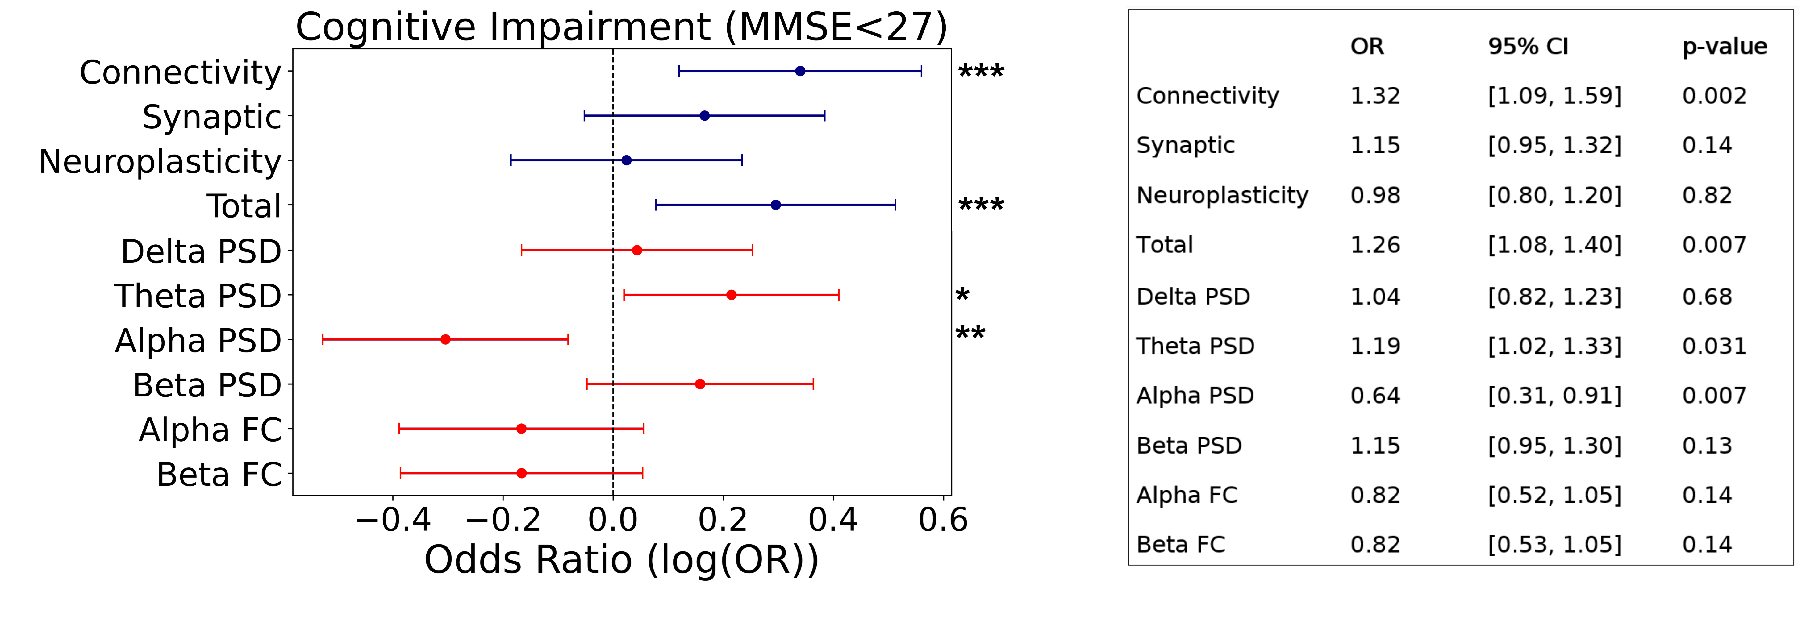
Supplementary Fig. 1. Association of digital biomarkers with cognitive impairment risk. (A): Odds ratio of having cognitive impairment (MMSE<27) for digital biomarkers and EEG metrics. Horizontal lines represent confidence intervals at 95%. Significance notation: * stands for p<0.05, ** stands for p<0.01, *** stands for p<0.005.

Supplementary Fig. 2.

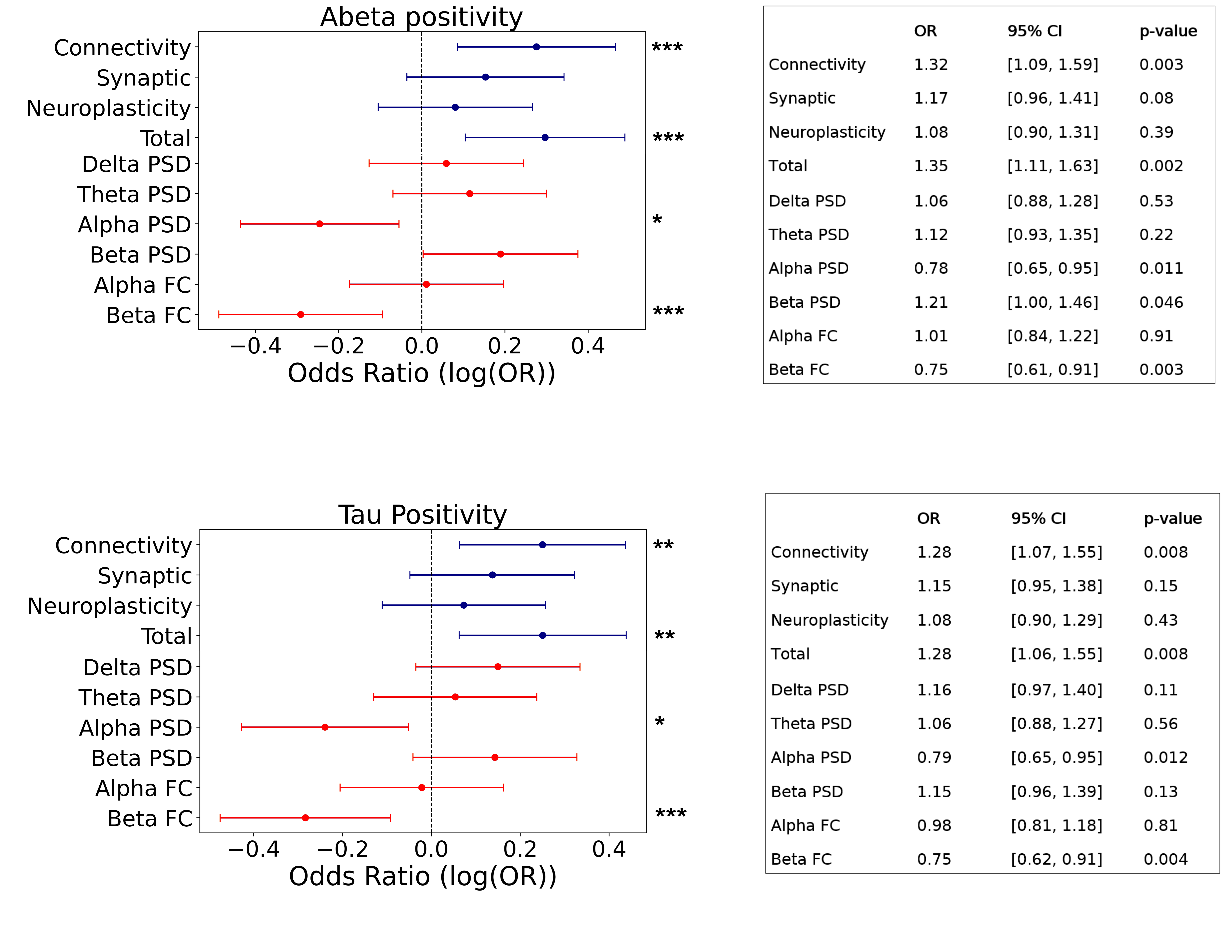
Supplementary Fig. 2. Association of digital biomarkers with Abeta and Tau positivity risk. (A): Odds ratio of being A+ for digital biomarkers and EEG metrics. Horizontal lines represent confidence intervals at 95%. (B): Odds ratio of being T+ for digital biomarkers and EEG metrics Notation is the same as in (A). Significance notation: * stands for p<0.05, ** stands for p<0.01, *** stands for p<0.005.
Supplementary Fig. 3.

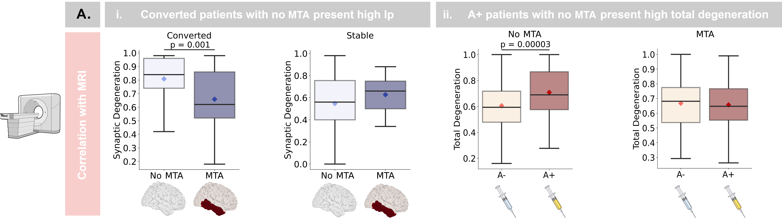
Supplementary Fig. 3. Digital biomarkers interaction with clinical conversion, Abeta positivity and medial temporal atrophy. (A-i): Participants with no temporal lobe atrophy that converted at follow-up presented higher levels of synaptic degeneration than participants with temporal lobe atrophy. These higher lp levels were not found in participants that remained stable. (A-ii): Among participants with no temporal lobe atrophy, A+ had significantly higher levels of total degeneration. Conversely, A+ and A- participants with temporal lobe atrophy presented comparable values of total degeneration. Whiskers represent interquartile ranges, black lines represent median values and diamonds represent mean values.
Supplementary Fig. 4.
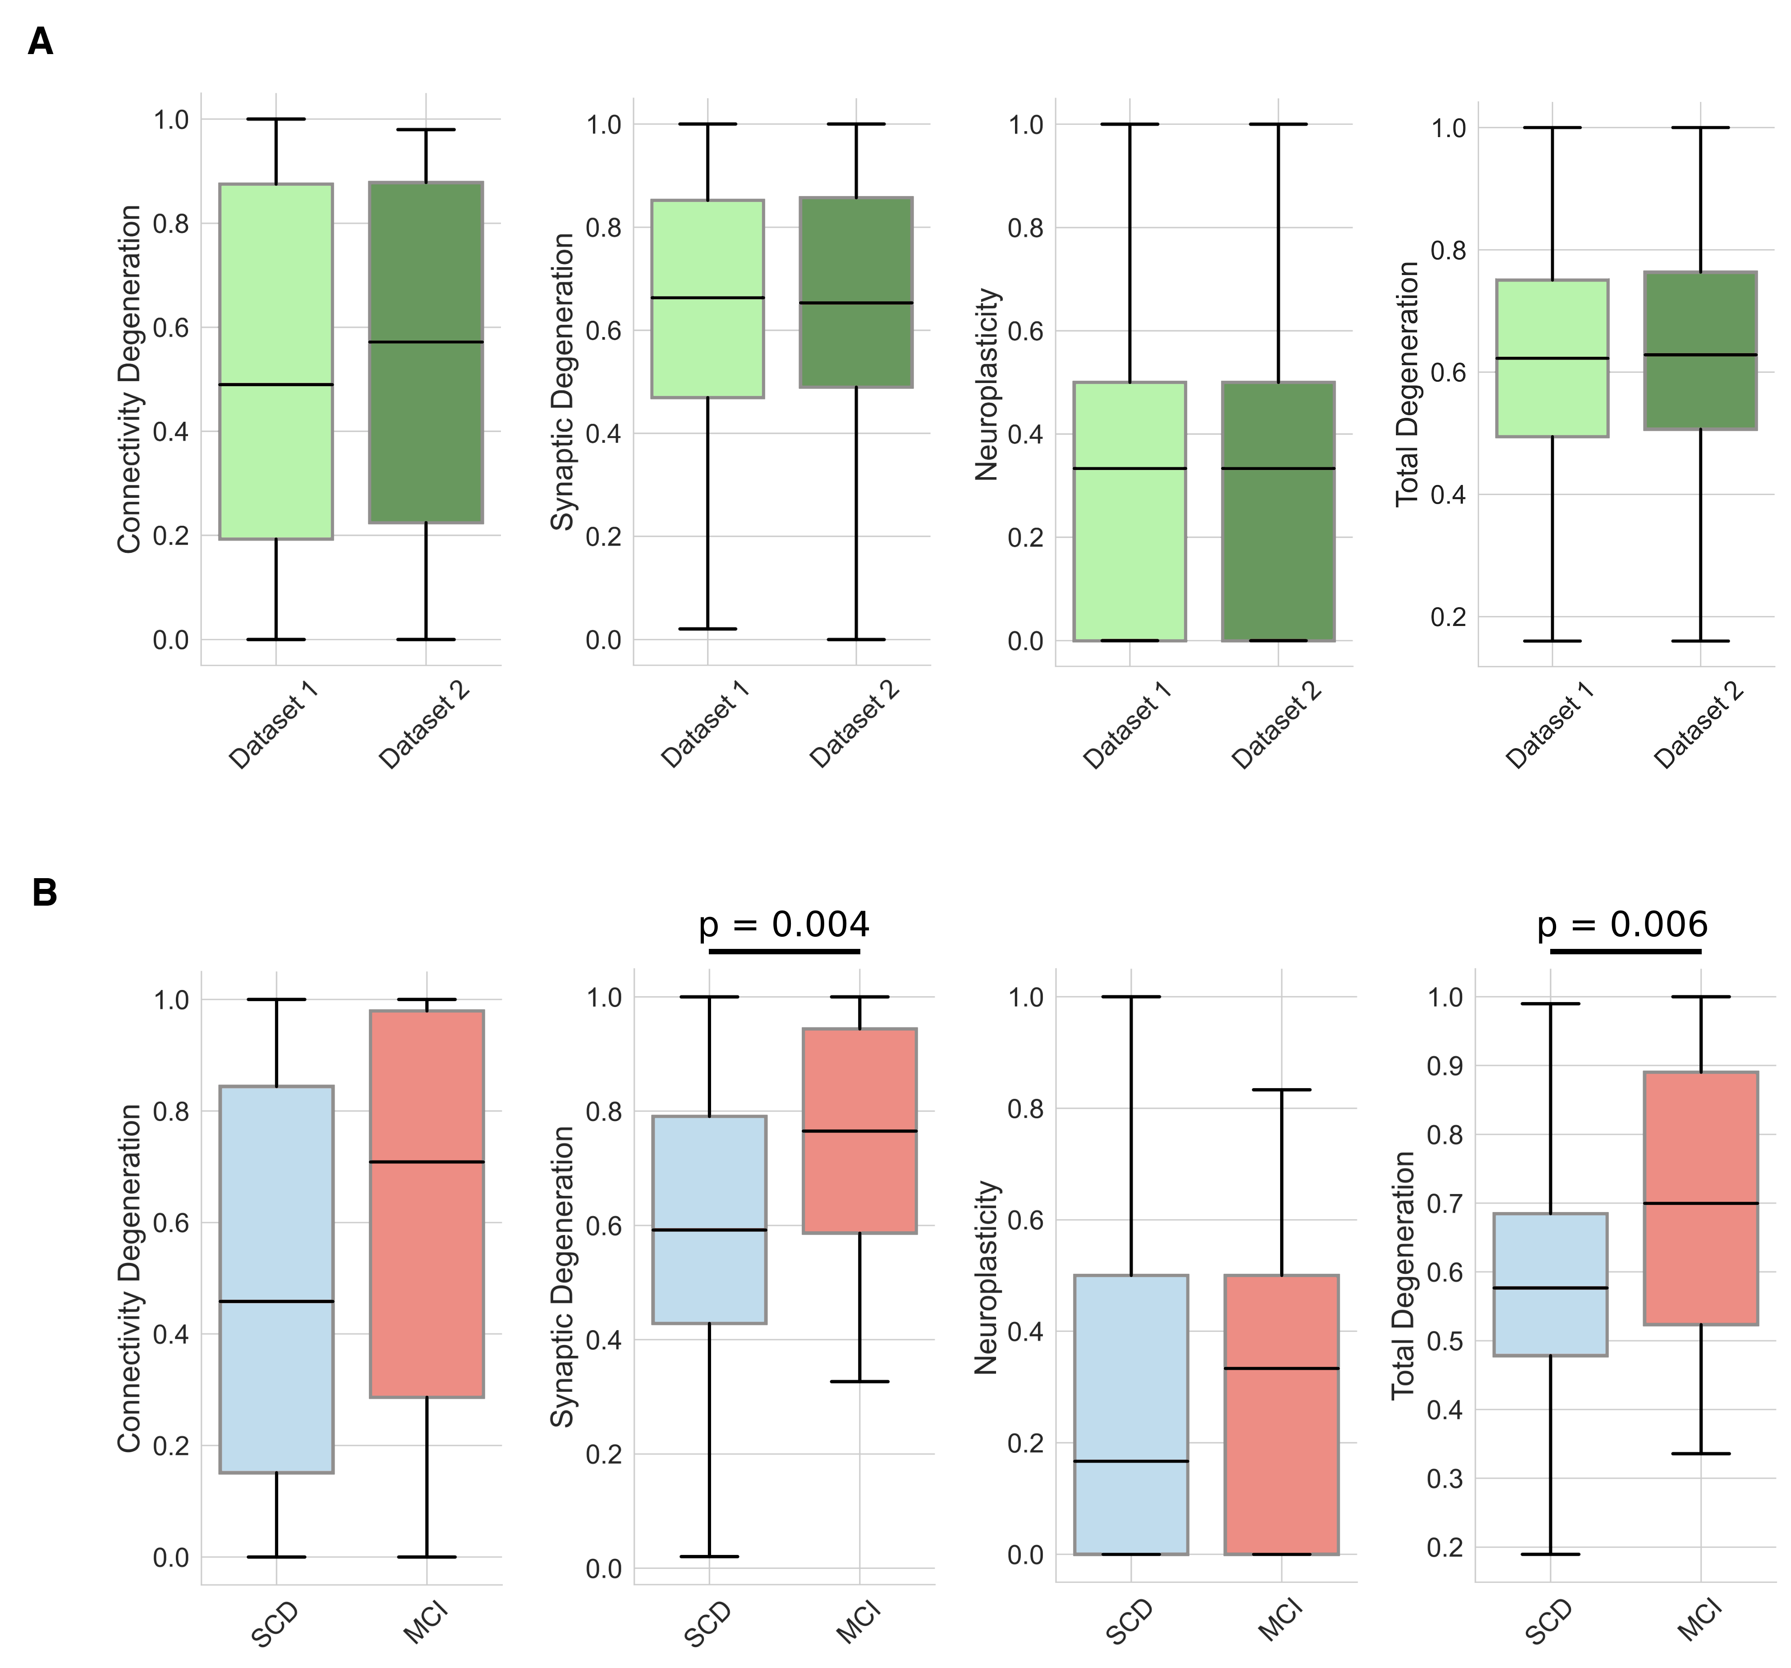
Supplementary Fig. 4. Generalizability analysis of Digital Biomarkers (A): Boxplot representing differences in terms of digital biomarkers across datasets. Whiskers represent interquartile ranges, black lines represent median values. (B): Boxplot representing differences in terms of digital biomarkers across diagnostic subgroups (SCD and MCI) in Dataset 2. Notation is the same as in A.
Supplementary Fig. 5.

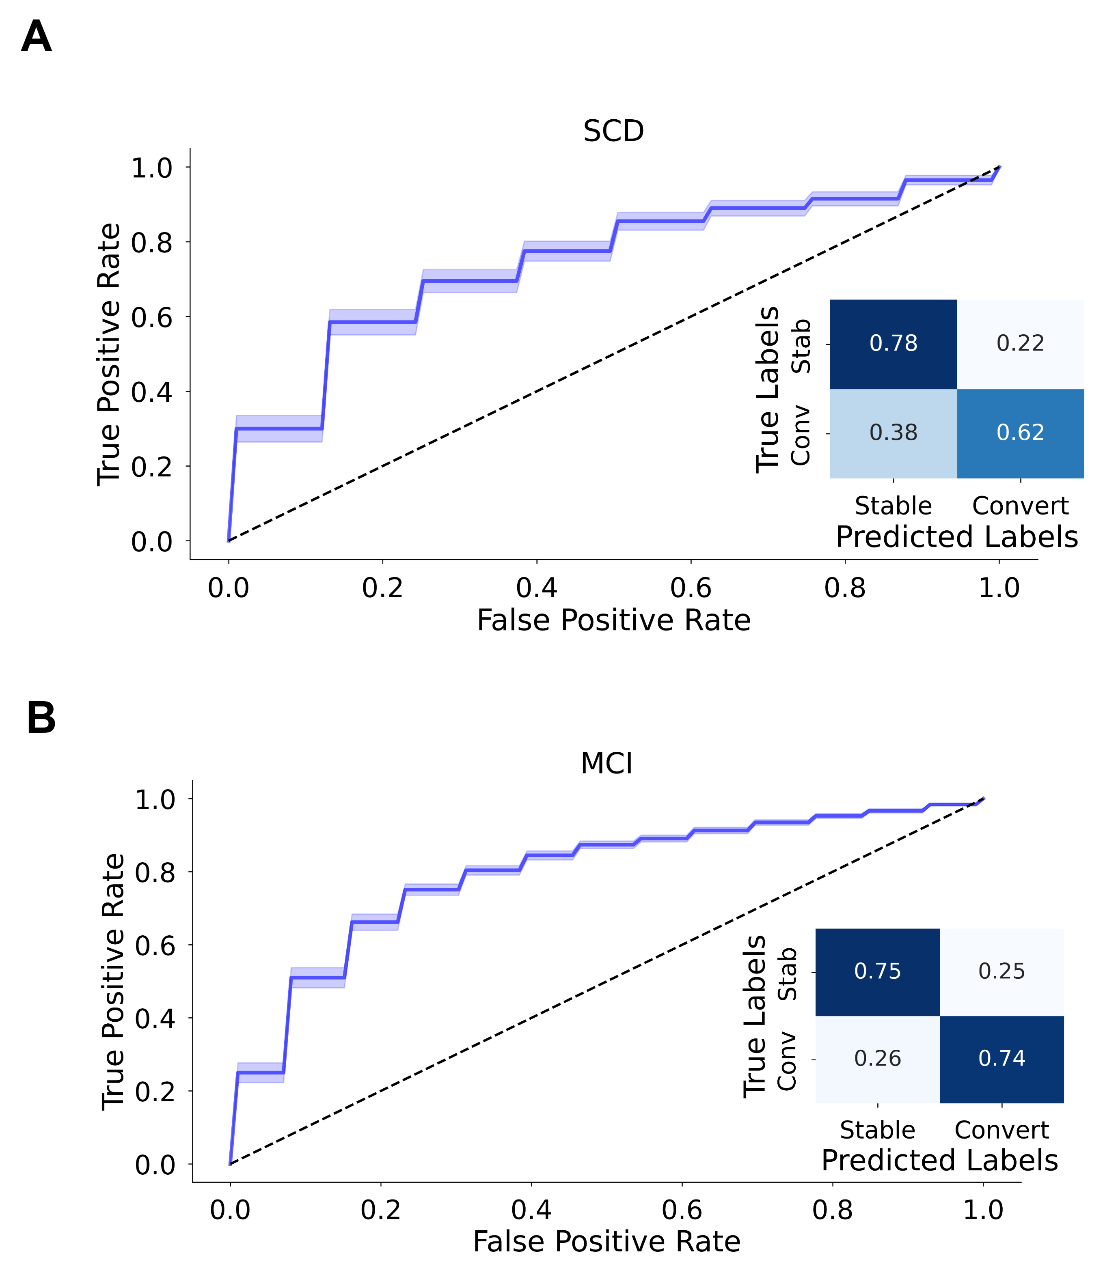

Supplementary Fig. 5. Combination of established AD biomarkers and digital biomarkers led to optimal prediction of conversions from SCD and from MCI (A): Prediction of conversions from SCD using CSF and digital biomarkers: mean ROC curve and confusion matrix. (B): Prediction of conversions from MCI using CSF and digital biomarkers: mean ROC curve and confusion matrix. Standard deviations are represented by shaded areas.
Supplementary Fig. 6.

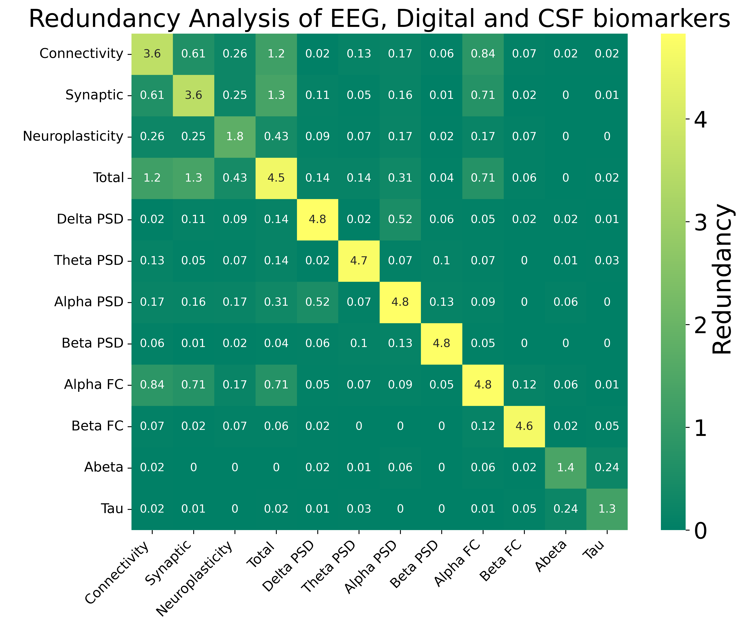
Supplementary Fig. 6. Redundancy matrix of classifying features, including digital biomarkers, EEG metrics and established AD biomarkers. High Redundancy ⁸ is denoted by yellow tones, while low Redundancy is denoted by dark green tones. Only CSF metrics are reported among established AD biomarkers, as they were consistently selected by the feature selection routine.
Supplementary Fig. 7.

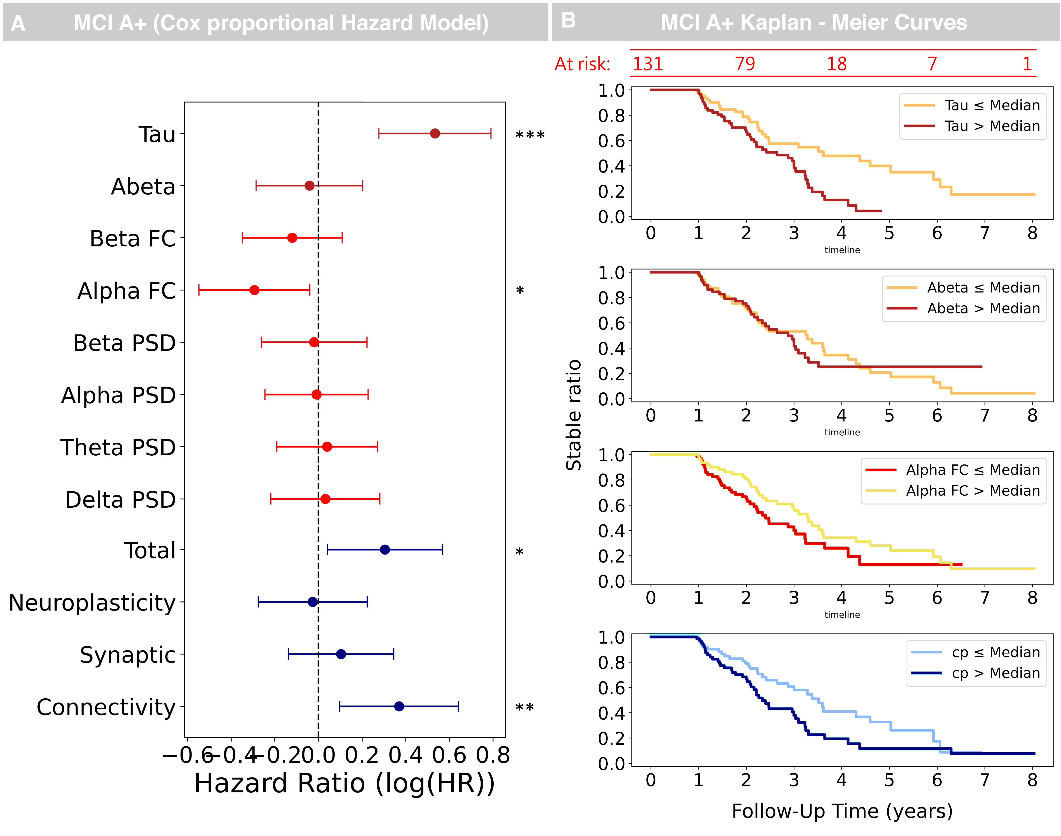
Supplementary Fig. 7. Cox Proportional Hazard Ratio and Kaplan-Meier curves for the MCI A+ subgroup. (A): Cox Proportional Hazard Model of MCI to AD conversions for established, EEG and digital biomarkers). Different families of biomarkers (established, EEG metrics and digital) are highlighted by different colors. Horizontal lines represent confidence intervals at 95%. (B): Kaplan-Meier curves for established AD biomarkers, EEG metrics, and Digital biomarkers (only best performing biomarkers shown). Also here, different colors were used to identify different families of biomarkers. Abeta values were inverted for better visualization (the plotted quantity refers to -Abeta). Significance notation: * stands for p<0.05, ** stands for p<0.01, *** stands for p<0.005.
Supplementary Fig. 8.
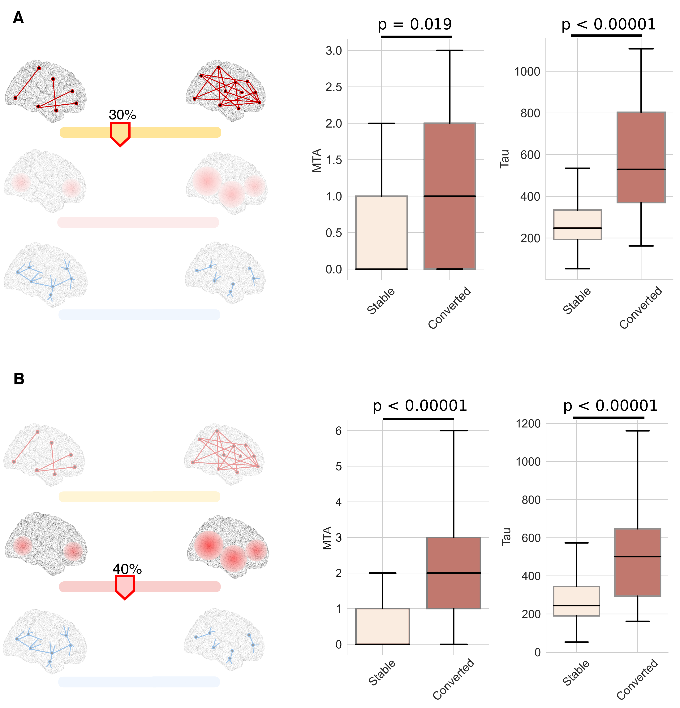
Supplementary Fig. 8. Discriminative analysis on participants with low levels of digital biomarkers who converted at follow-up. For each biomarker, an optimal threshold dividing converted vs stable participants was identified. Subsequently, participants below threshold were divided into converted and stable, to investigate differences in terms of neurodegeneration biomarkers. The analysis highlighted that converted participants presented significantly higher levels of Medial Temporal Lobe atrophy and Tau. Results are here reported for Connectivity Degeneration (A) and Synaptic Degeneration (B).

Supplementary Fig. 9.
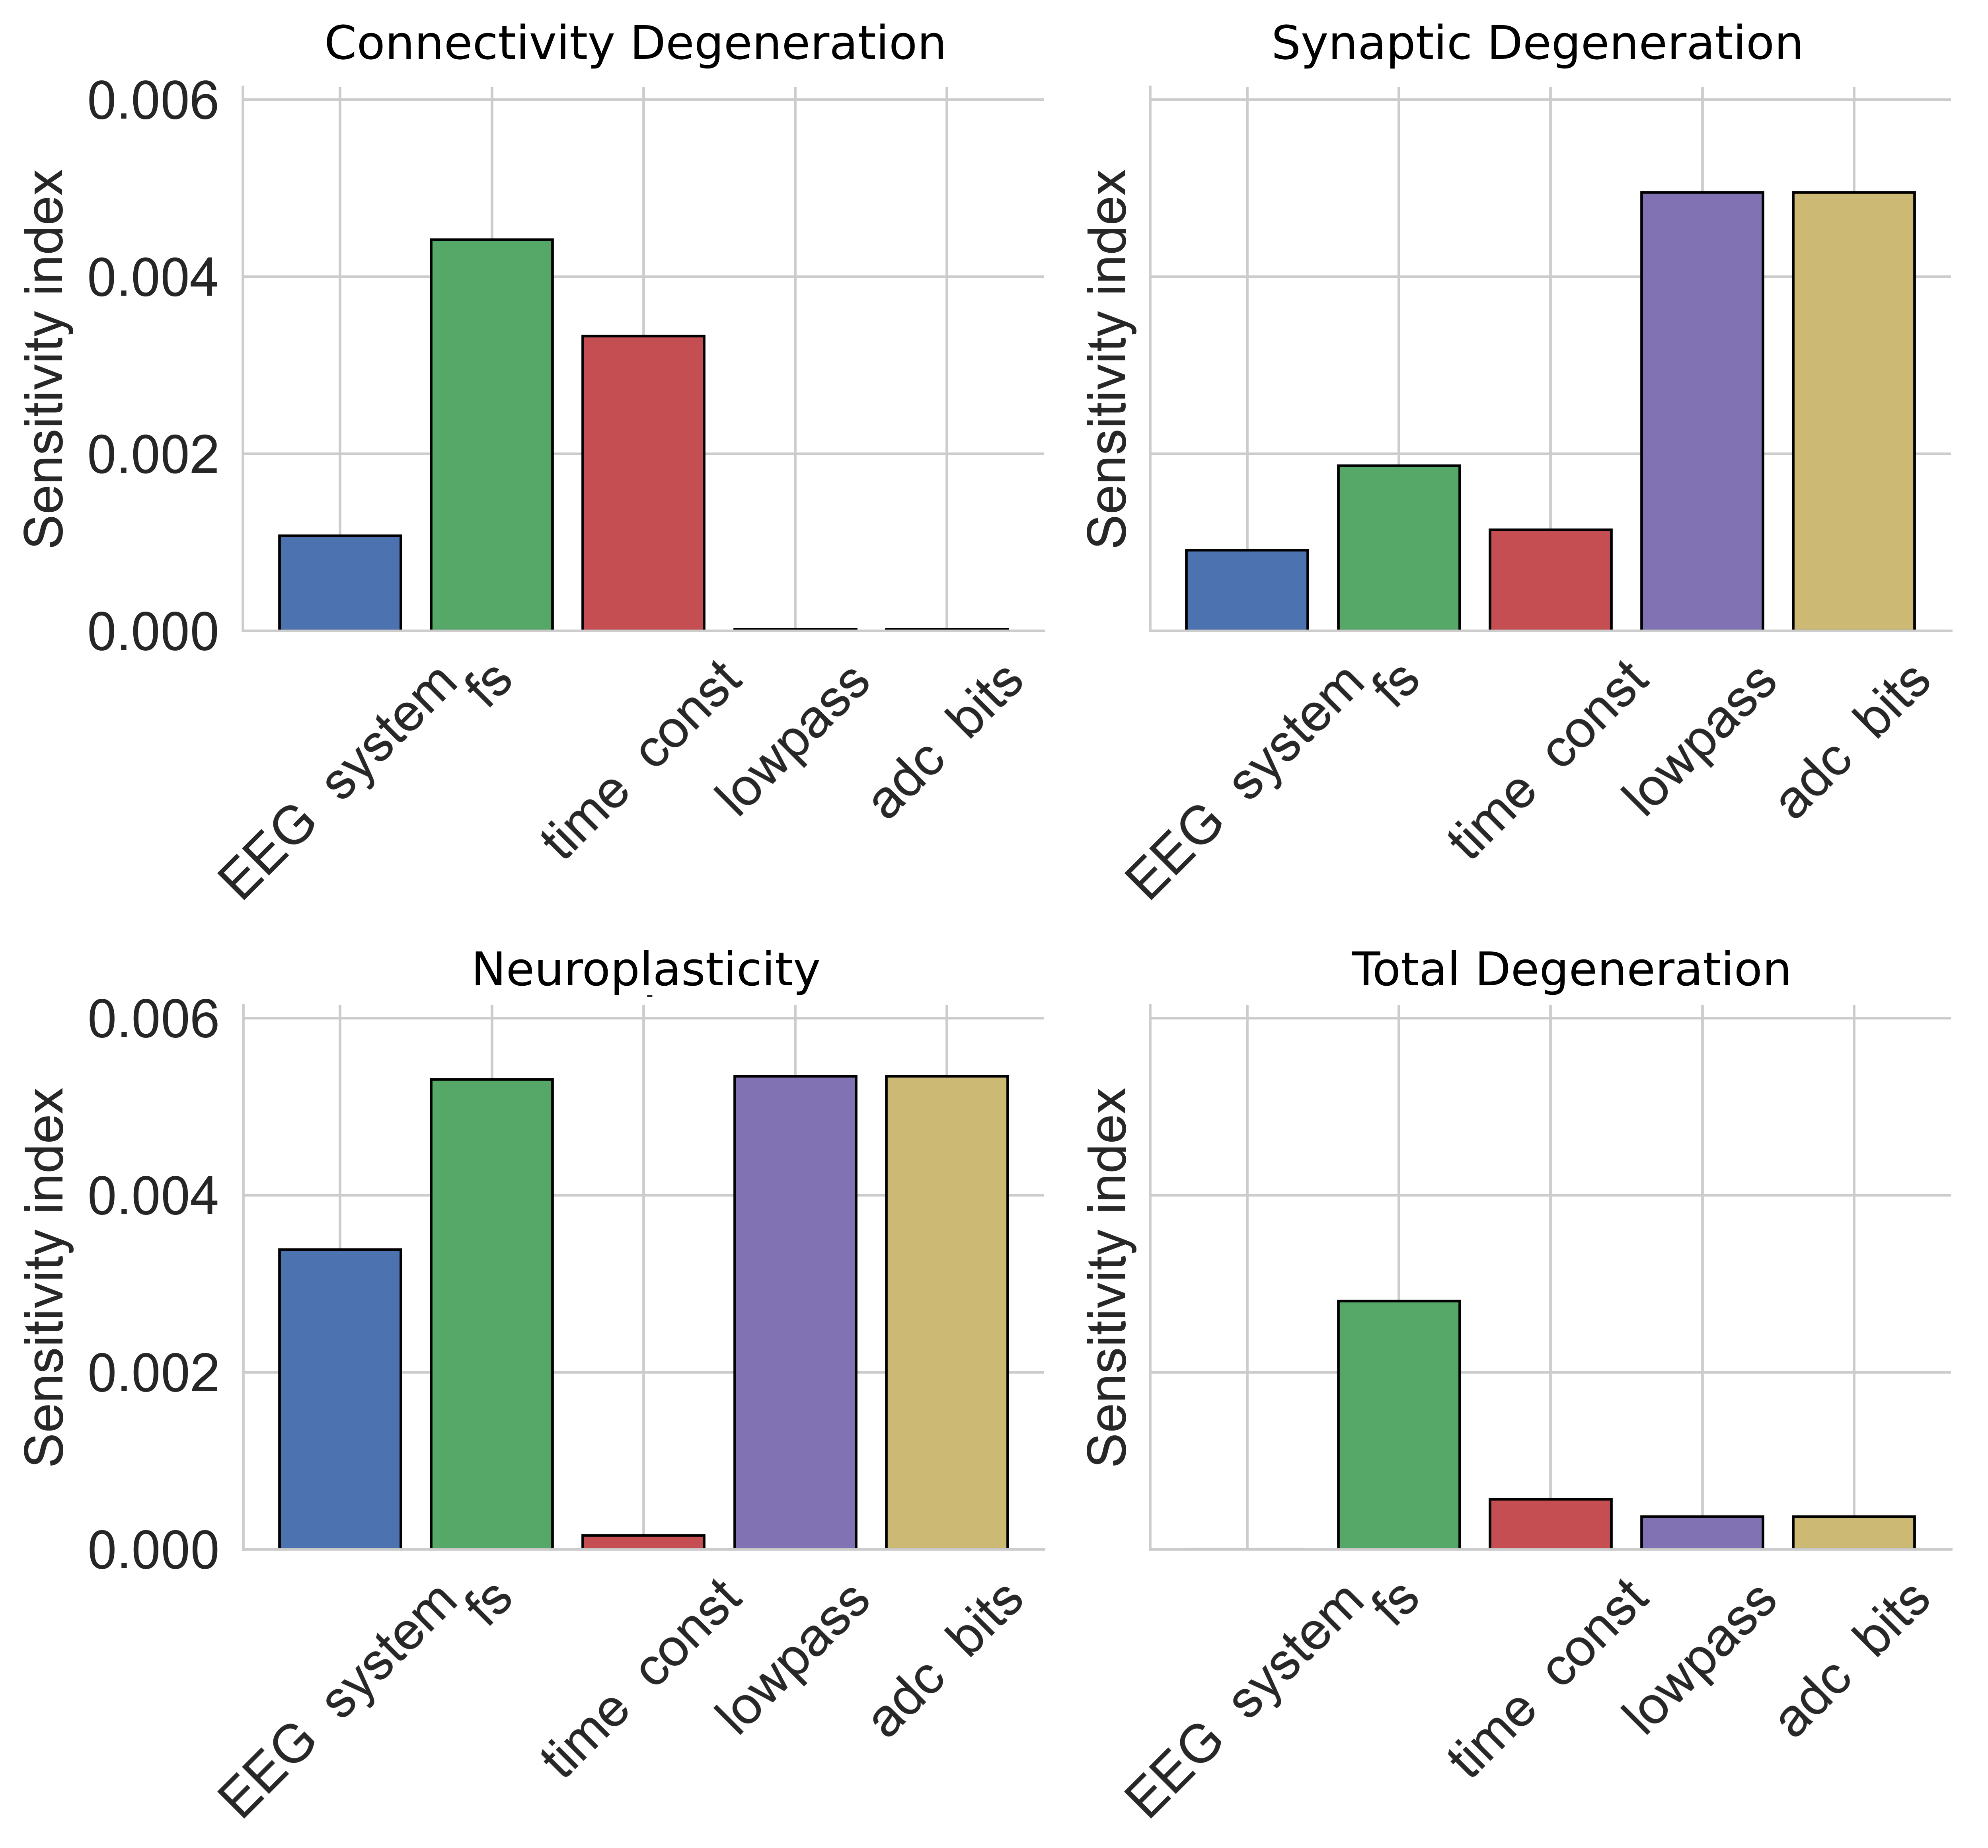
Supplementary Fig. 9. Sensitivity Analysis of EEG systems. Sensitivity indices are reported separately for each digital biomarker. The specifics of EEG systems included in the analysis are: sampling frequency (fs), time constant, cut frequency of low-pass filter (lowpass) and the bits of the Analog-to-digital conversion (adc bits).
Supplementary Fig. 10.
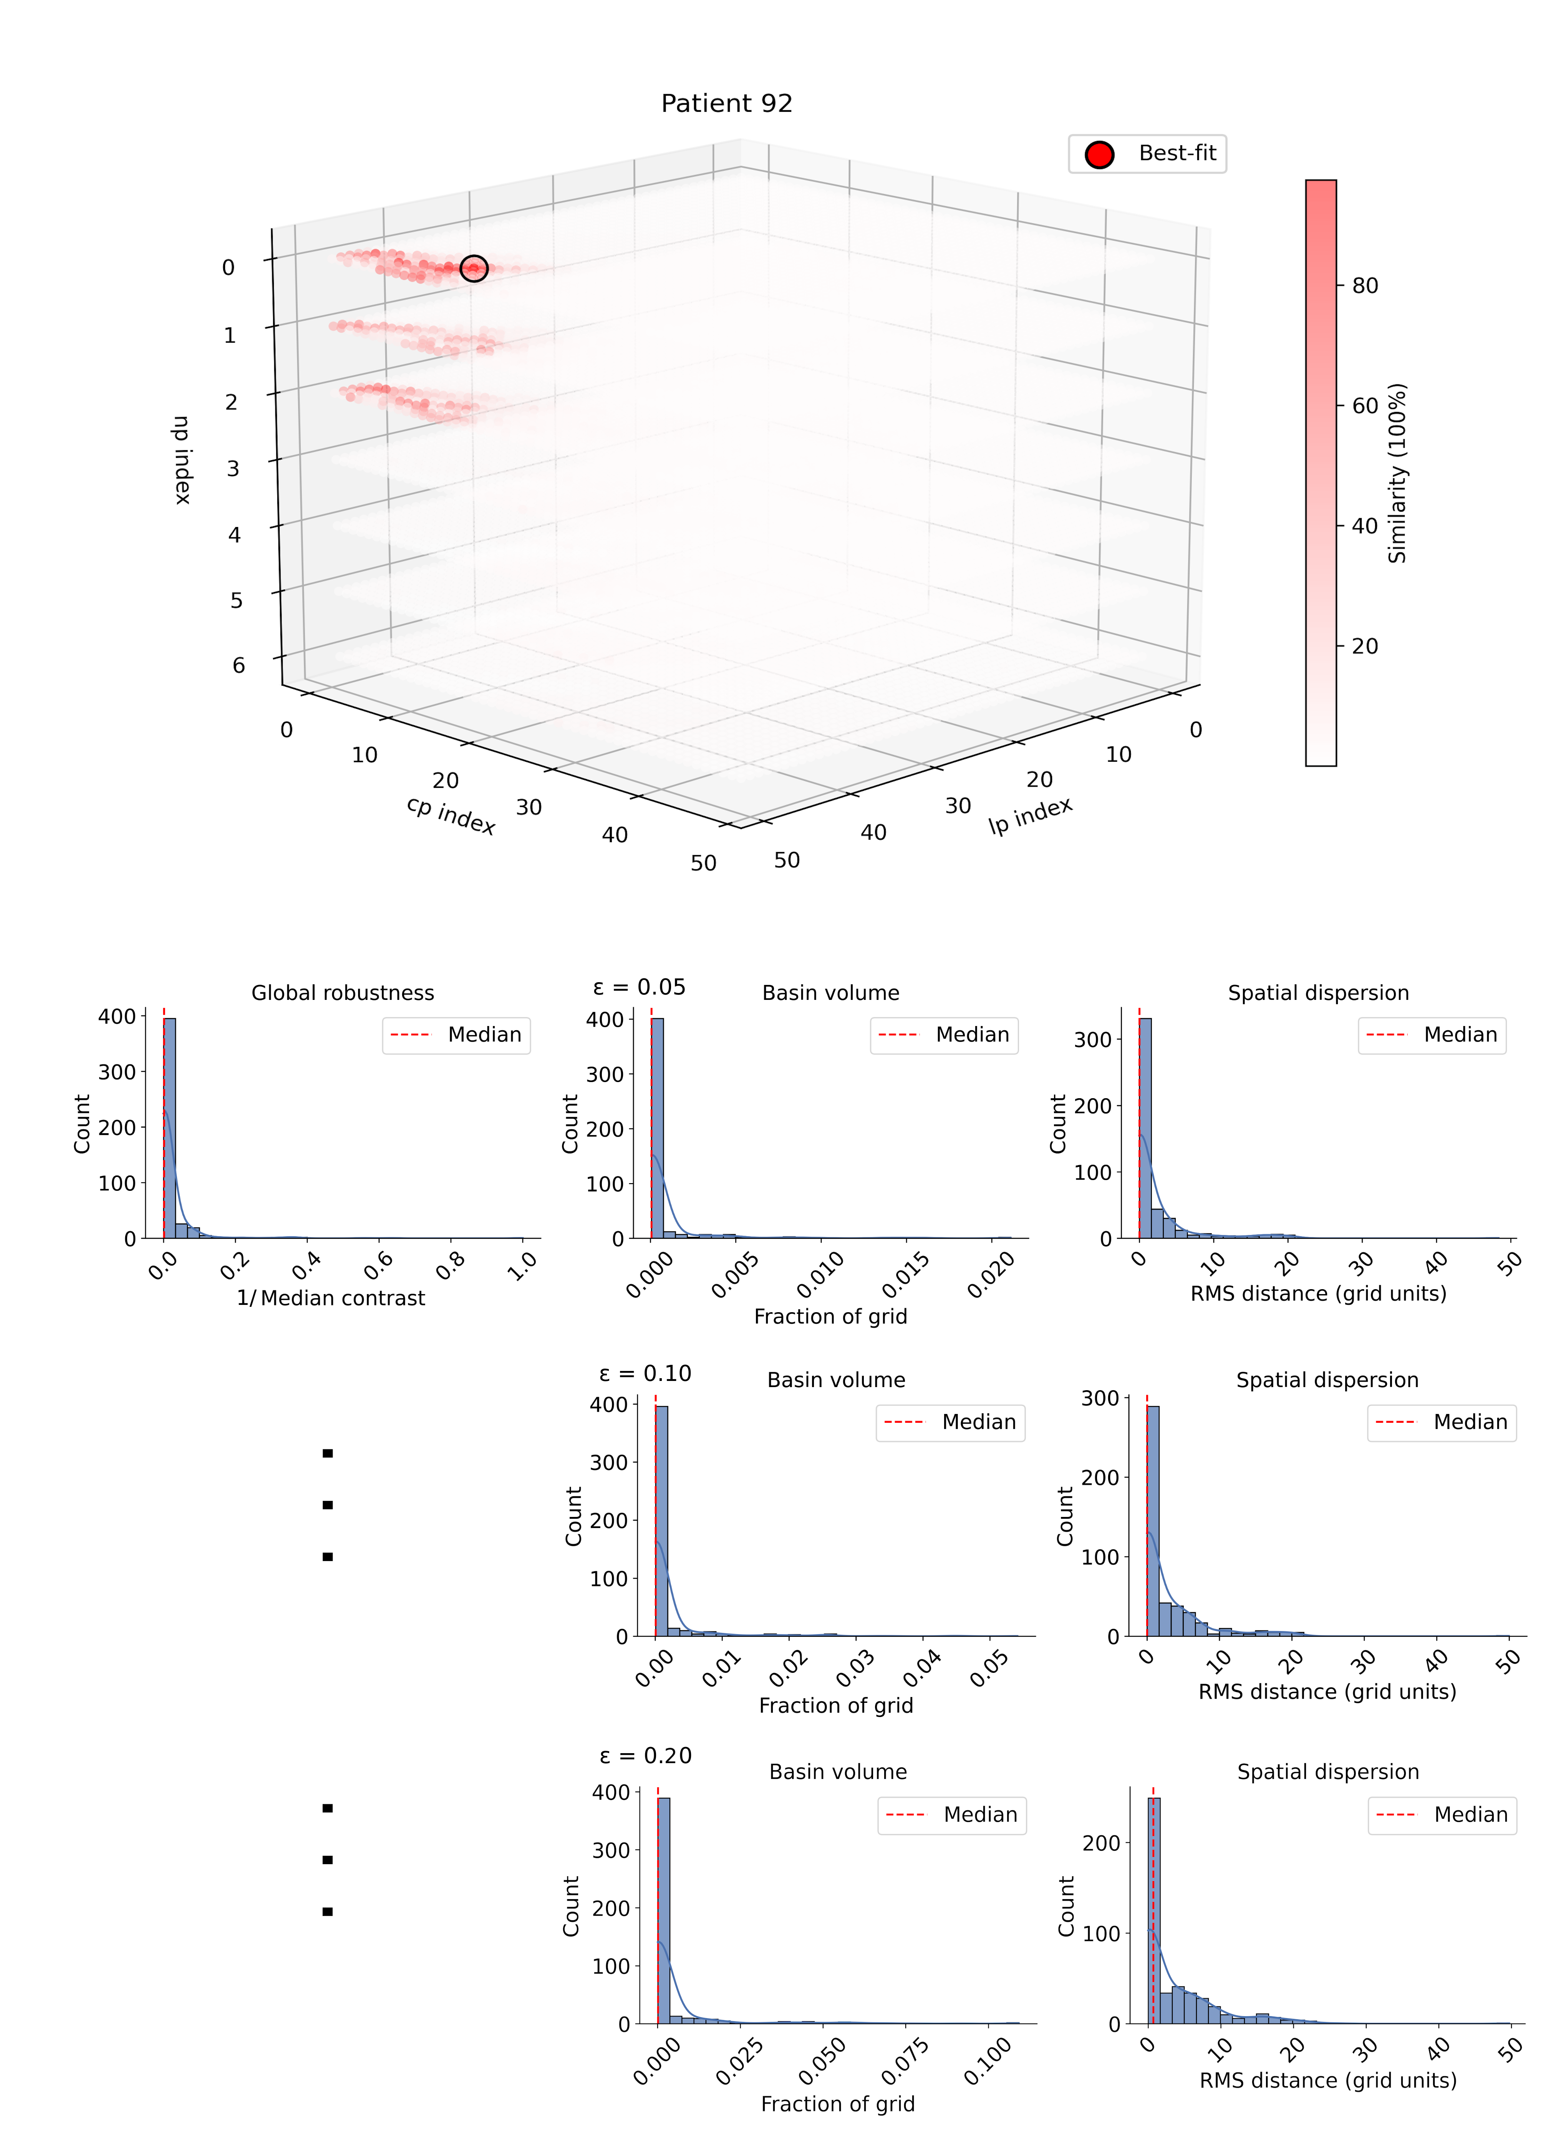
Supplementary Fig. 10. Convergence Analysis of Digital Biomarkers. (A): For each participant, an optimal combination of digital biomarkers is determined with a grid search that minimizes a loss function between simulated and empirical data. Red color represents similarity between simulated and empirical data. (B): Convergence analysis results for all participants, based on Robustness, Basin Volume and Spatial Dispersions. Robustness is quantified as the global contrast between the minimum and the median value of the loss function (here the inverse of the median contrast is plotted for visualization reasons), while volume and spatial dispersion of the basin of attraction are reported for different values of a fixed threshold, namely ε=0.05 (B-i), ε=0.10 (B-ii) and ε=0.20 (B-iii, see Main Text). Median values are highlighted by a vertical red line.

Supplementary References
1. Braak, H. & Braak, E. Neuropathological stageing of Alzheimer-related changes. Acta Neuropathol. (Berl.) 82, 239–259 (1991).
2. Stefanovski, L. et al. Linking Molecular Pathways and Large-Scale Computational Modeling to Assess Candidate Disease Mechanisms and Pharmacodynamics in Alzheimer’s Disease. Front. Comput. Neurosci. 13, 54 (2019).
3. Van Nifterick, A. M. et al. A multiscale brain network model links Alzheimer’s disease-mediated neuronal hyperactivity to large-scale oscillatory slowing. Alzheimers Res. Ther. 14, 101 (2022).
4. Ren, S.-Q. et al. Amyloid β causes excitation/inhibition imbalance through dopamine receptor 1-dependent disruption of fast-spiking GABAergic input in anterior cingulate cortex. Sci. Rep. 8, 302 (2018).
5. Maestú, F., de Haan, W., Busche, M. A. & DeFelipe, J. Neuronal excitation/inhibition imbalance: core element of a translational perspective on Alzheimer pathophysiology. Ageing Res. Rev. 69, 101372 (2021).
6. Pietroboni, A. M. et al. The Role of Amyloid-β in White Matter Damage: Possible Common Pathogenetic Mechanisms in Neurodegenerative and Demyelinating Diseases. J. Alzheimers Dis. 78, 13–22 (2020).
7. Sanz-Leon, P., Knock, S. A., Spiegler, A. & Jirsa, V. K. Mathematical framework for large-scale brain network modeling in The Virtual Brain. Neuroimage 111, 385–430 (2015).
8. MacKay, D. J. C. Information Theory, Inference & Learning Algorithms. (Cambridge University Press, USA, 2002).

