Deep learning from retinal images for prediction of biomarker-informed obesity subtypes associated with cardiometabolic risk

Supplementary Materials

Table of Contents
Supplementary Tables 1
Table S1: Baseline characteristics of study cohorts by data partition 1
Table S2: Classification performance of the ROSA model 2
Table S3: Baseline characteristics of the UKB-CHV set stratified by ROSA-predicted obesity subtype 3
Table S4: Association between ROSA-predicted obesity subtype and incident cardiometabolic outcomes in the UKB-CHV set 4
Table S5: Incremental predictive performance of ROSA probabilities beyond BMI-only and established clinical risk-score models for 10-year incident outcomes 5
Supplementary Figures 6
Figure S1: Participant inclusion and exclusion flowchart 6
Figure S2: Latent profile analysis model selection for subtype number 7
Figure S3: Biochemical residual profiles for alternative latent profile analysis solutions (G = 4, 5, and 6), stratified by sex 8
Figure S4: Replication of the three-profile latent profile structure across sex and datasets 9
Figure S5: Biomarker-only latent profile solutions across candidate profile numbers 10
Figure S6: Latent profile structures under left-eye-prioritised and right-eye-prioritised retinal feature selection 11
Figure S7: Latent profile solutions derived from retina-predicted biochemical residuals 12
Figure S8: Representative attention heatmaps for correctly and incorrectly classified ROSA predictions in UKB-CHV and BHMC-EV 13
Figure S9: Subgroup analyses of subtype–outcome associations 14
Figure S10: Decision-curve analysis for ROSA-predicted obesity subtypes and 10-year clinical outcomes 15
Figure S11: Multi-state transition probabilities by predicted subtype 16
Figure S12: Metabolomic associations of predicted subtypes 17
Figure S13: Proteomic associations of predicted subtypes 18
Figure S14: MWAS and PWAS after exclusion of LPA-defining biomarker overlaps and molecular proxies 19
Figure S15: Genome-wide association analysis of predicted subtypes 20
Figure S16: Gene-level association analysis of predicted obesity subtypes 21
Supplementary Data 22
Supplementary Data 1: Overall classification performance across models and datasets 22
Supplementary Data 2: Per-class classification performance across models and datasets 22
Supplementary Data 3: Sensitivity analysis of distillation temperature and soft-label weighting parameters 22
Supplementary Data 4: Ancestry-stratified classification performance of ROSA and comparator models in UKB-CHV 22
Supplementary Data 5: Stratified performance of ROSA across demographic, BMI and assessment-centre subgroups 23
Supplementary Data 6: Performance of a demographics- and centre-only baseline model for LPA subtype prediction 23
Supplementary Data 7: Quantitative performance of direct retina-to-biomarker and retina-to-residual prediction 23
Supplementary Data 8: Classification performance of retinal-image models for biomarker-only latent profile labels 24
Supplementary Data 9: Clinical risk patterns of three- and six-profile latent profile solutions 24
Supplementary Data 10: Full phenome-wide association results for predicted obesity subtypes 24
Supplementary Data 11: Full metabolome-wide association results for predicted obesity subtypes 24
Supplementary Data 12: Full proteome-wide association results for predicted obesity subtypes 24

Supplementary Tables

Table S1: Baseline characteristics of study cohorts by data partition
 | UKB-DT (N=13487) | UKB-DV (N=3246) | UKB-CHV (N=20404) | BHMC-EV (N=26556)
Age (mean (SD)) | 55.09 (8.35) | 55.08 (8.23) | 55.87 (8.18) | 40.84 (12.61)
Sex (%)
Female | 7544 (55.9) | 1809 (55.7) | 10879 (53.3) | 13695 ( 51.6)
Male | 5943 (44.1) | 1437 (44.3) | 9525 (46.7) | 12861 ( 48.4)
Ethnicity (%)
Non-white | 1636 (12.1) | 368 (11.3) | 767 ( 3.8) | 26556 (100.0)
White | 11851 (87.9) | 2878 (88.7) | 19637 (96.2) | 0 ( 0.0)
BMI (median [IQR]) | 26.06 [23.56, 29.08] | 26.11 [23.60, 29.15] | 26.98 [24.39, 30.01] | 23.85 [21.45, 26.45]
LDL-C (median [IQR]) | 3.47 [2.92, 4.03] | 3.46 [2.93, 4.04] | 3.55 [2.97, 4.15] | 2.92 [2.48, 3.40]
HDL-C (median [IQR]) | 1.46 [1.23, 1.74] | 1.47 [1.23, 1.75] | 1.41 [1.19, 1.68] | 1.29 [1.12, 1.49]
Triglycerides (median [IQR]) | 1.33 [0.96, 1.92] | 1.34 [0.96, 1.94] | 1.48 [1.05, 2.11] | 1.06 [0.78, 1.53]
ApoA (median [IQR]) | 1.55 [1.38, 1.74] | 1.55 [1.39, 1.74] | 1.52 [1.36, 1.71] | 1.36 [1.24, 1.51]
Glucose (median [IQR]) | 5.00 [4.71, 5.32] | 5.00 [4.71, 5.35] | 5.00 [4.71, 5.33] | 5.00 [4.73, 5.36]
CRP (median [IQR]) | 1.11 [0.56, 2.31] | 1.10 [0.56, 2.33] | 1.32 [0.66, 2.68] | 0.65 [0.33, 1.38]
ALT (median [IQR]) | 19.95 [15.19, 27.11] | 20.30 [15.44, 27.87] | 20.69 [15.83, 27.90] | 17.00 [12.00, 26.00]
GGT (median [IQR]) | 24.50 [17.50, 37.75] | 24.10 [17.20, 37.68] | 26.10 [18.50, 40.00] | 19.00 [15.00, 28.00]
Creatinine (median [IQR]) | 70.30 [61.50, 80.50] | 70.40 [61.60, 80.30] | 71.70 [62.50, 82.40] | 62.00 [53.00, 72.25]
Cystatin C (median [IQR]) | 0.86 [0.78, 0.96] | 0.86 [0.78, 0.95] | 0.88 [0.80, 0.97] | 0.64 [0.55, 0.72]
Notes: Data are presented as mean (s.d.), median [IQR] or n (%). UK Biobank (UKB) participants are shown by data split: UKB-DT, UKB-DV, and UKB-CHV sets. The BHMC-EV set served as an independent external validation. BMI, body-mass index; LDL-C, low-density lipoprotein cholesterol; HDL-C, high-density lipoprotein cholesterol; ApoA, apolipoprotein A; CRP, C-reactive protein; ALT, alanine aminotransferase; GGT, gamma-glutamyl transferase; UKB-DT, UK Biobank development train; UKB-DV, UK Biobank development validation; UKB-CHV, UK Biobank centre-held-out validation; BHMC-EV, Beijing Health Management Cohort external validation.

Table S2: Classification performance of the ROSA model
Metrics | UKB-CHV | BHMC-EV
Macro average
AUROC | 0.80 (0.79 - 0.82) | 0.66 (0.64 - 0.67)
Sensitivity | 0.59 (0.57 - 0.61) | 0.45 (0.45 - 0.47)
Specificity | 0.80 (0.80 - 0.81) | 0.76 (0.75 - 0.76)
PPV | 0.83 (0.81 - 0.84) | 0.65 (0.58 - 0.70)
NPV | 0.84 (0.83 - 0.85) | 0.75 (0.74 - 0.75)
Micro average
AUROC | 0.93 (0.93 - 0.94) | 0.89 (0.89 - 0.89)
Sensitivity | 0.81 (0.80 - 0.81) | 0.76 (0.75 - 0.77)
Specificity | 0.90 (0.90 - 0.91) | 0.88 (0.88 - 0.88)
PPV | 0.81 (0.80 - 0.81) | 0.76 (0.75 - 0.77)
NPV | 0.90 (0.90 - 0.91) | 0.88 (0.88 - 0.88)
Notes: Classification metrics for the ROSA model across the UKB-CHV (n = 20,404) and BHMC-EV (n = 26,556) cohorts. 95% confidence intervals were obtained by 2,000 bootstrap resamples. AUROC, area under the receiver operating characteristic curve; PPV, positive predictive value; NPV, negative predictive value; UKB-CHV, UK Biobank centre-held-out validation; BHMC-EV, Beijing Health Management Cohort external validation.

Table S3: Baseline characteristics of the UKB-CHV set stratified by ROSA-predicted obesity subtype
 | BC (N=15715) | DIS (N=3241) | DHG (N=148)
Age (mean (SD)) | 55.39 (8.20) | 56.00 (8.00) | 60.21 (7.07)
Sex (%)
Female | 8606 (54.8) | 1787 (55.1) | 53 (35.8)
Male | 7109 (45.2) | 1454 (44.9) | 95 (64.2)
Ethnicity (%)
Non-white | 657 ( 4.2) | 56 ( 1.7) | 10 ( 6.8)
White | 15058 (95.8) | 3185 (98.3) | 138 (93.2)
BMI (mean (SD)) | 27.34 (4.57) | 27.81 (4.65) | 30.82 (5.31)
Smoking Status (%)
Current | 1415 ( 9.0) | 277 ( 8.5) | 12 ( 8.1)
Never | 9263 (58.9) | 1895 (58.5) | 73 (49.3)
Previous | 5037 (32.1) | 1069 (33.0) | 63 (42.6)
Drinking status (%)
Current | 14605 (93.0) | 3015 (93.1) | 130 (87.8)
Never | 640 ( 4.1) | 120 ( 3.7) | 11 ( 7.4)
Previous | 458 ( 2.9) | 104 ( 3.2) | 7 ( 4.7)
Diet quality (mean (SD)) | 4.00 (1.26) | 3.96 (1.25) | 3.84 (1.20)
Sleep quality (mean (SD)) | 3.06 (0.99) | 3.05 (1.00) | 2.74 (1.04)
Physical activity (%)
No | 5375 (34.2) | 1171 (36.1) | 59 (39.9)
Yes | 10340 (65.8) | 2070 (63.9) | 89 (60.1)
Hypertension (%)
No | 3601 (22.9) | 646 (19.9) | 12 ( 8.1)
Yes | 12114 (77.1) | 2595 (80.1) | 136 (91.9)
Follow-up years (median [IQR]) | 13.33 [13.22, 13.48] | 13.34 [13.23, 13.48] | 13.31 [13.16, 13.46]
Notes: Data are presented as mean (s.d.), median [IQR] or n (%). Participants with prevalent cardiometabolic disease at baseline were excluded from the UKB-CHV set, leaving 19,104 participants for incident disease analyses; these participants were then classified by the ROSA model. BC, baseline concordant; DIS, discordant inflammatory state; DHG, discordant hyperglycaemic; BMI, body-mass index; IQR, interquartile range; UKB-CHV, UK Biobank centre-held-out validation.

Table S4: Association between ROSA-predicted obesity subtype and incident cardiometabolic outcomes in the UKB-CHV set
Outcome | Model 1 | Model 2 | Model 3
IHD
BC | Reference | Reference | Reference
DIS | 1.14 (1.00 - 1.30) | 1.13 (0.99 - 1.29) | 1.13 (0.99 - 1.29)
DHG | 1.17 (0.80 - 1.71) | 1.12 (0.76 - 1.63) | 1.11 (0.76 - 1.63)
Stroke
BC | Reference | Reference | Reference
DIS | 1.06 (0.83 - 1.35) | 1.06 (0.83 - 1.35) | 1.05 (0.82 - 1.34)
DHG | 0.67 (0.30 - 1.50) | 0.64 (0.28 - 1.44) | 0.64 (0.28 - 1.44)
T2DM
BC | Reference | Reference | Reference
DIS | 1.20 (1.03 - 1.39) | 1.19 (1.03 - 1.38) | 1.19 (1.02 - 1.38)
DHG | 5.05 (3.96 - 6.43) | 4.75 (3.72 - 6.06) | 4.72 (3.70 - 6.02)
CMD
BC | Reference | Reference | Reference
DIS | 1.16 (1.05 - 1.29) | 1.15 (1.04 - 1.28) | 1.15 (1.04 - 1.27)
DHG | 3.08 (2.44 - 3.91) | 2.89 (2.28 - 3.66) | 2.87 (2.26 - 3.63)
Notes: Hazard ratios (95% CI) from Cox proportional hazards models in the UKB-CHV set. Participants with prevalent cardiometabolic disease at baseline were excluded, leaving 19,104 participants for incident disease analyses. BC (reference group) denotes baseline concordant. Model 1: adjusted for age, sex, ethnicity and BMI. Model 2: Model 1 plus smoking status, alcohol intake, diet quality score, sleep quality score and physical activity. Model 3: Model 2 plus hypertension, eGFR, hyperlipidaemia, medication use. IHD, ischaemic heart disease; T2DM, type 2 diabetes mellitus; CMD, composite cardiometabolic disease; DIS, discordant inflammatory state; DHG, discordant hyperglycaemic; HR, hazard ratio; CI, confidence interval; UKB-CHV, UK Biobank centre-held-out validation.

Table S5: Incremental predictive performance of ROSA probabilities beyond BMI-only and established clinical risk-score models for 10-year incident outcomes
Endpoint | Model comparison | Base C-index | C-index with ROSA | Delta C-index (95% CI) | P value
IHD | BMI-only vs BMI-only + ROSA probabilities | 0.576 | 0.580 | 0.004 (-0.002 to 0.010) | 0.193
IHD | QRISK3 score vs QRISK3 score + ROSA probabilities | 0.709 | 0.708 | -0.001 (-0.003 to 0.001) | 0.347
IHD | Framingham score vs Framingham score + ROSA probabilities | 0.679 | 0.676 | -0.003 (-0.008 to 0.002) | 0.173
Stroke | BMI-only vs BMI-only + ROSA probabilities | 0.568 | 0.560 | -0.008 (-0.022 to 0.009) | 0.320
Stroke | QRISK3 score vs QRISK3 score + ROSA probabilities | 0.723 | 0.722 | -0.001 (-0.003 to 0.001) | 0.360
Stroke | Framingham score vs Framingham score + ROSA probabilities | 0.670 | 0.664 | -0.006 (-0.013 to 0.000) | 0.067
T2DM | BMI-only vs BMI-only + ROSA probabilities | 0.728 | 0.743 | 0.014 (0.009 to 0.021) | <0.001
T2DM | QRISK3 score vs QRISK3 score + ROSA probabilities | 0.703 | 0.711 | 0.008 (0.004 to 0.014) | <0.001
T2DM | Framingham score vs Framingham score + ROSA probabilities | 0.657 | 0.668 | 0.011 (0.003 to 0.019) | 0.007
CMD | BMI-only vs BMI-only + ROSA probabilities | 0.632 | 0.637 | 0.006 (0.001 to 0.010) | 0.007
CMD | QRISK3 score vs QRISK3 score + ROSA probabilities | 0.705 | 0.708 | 0.002 (0.000 to 0.005) | 0.047
CMD | Framingham score vs Framingham score + ROSA probabilities | 0.669 | 0.671 | 0.002 (-0.003 to 0.006) | 0.467
CVD | BMI-only vs BMI-only + ROSA probabilities | 0.576 | 0.578 | 0.002 (-0.004 to 0.007) | 0.513
CVD | QRISK3 score vs QRISK3 score + ROSA probabilities | 0.712 | 0.711 | -0.001 (-0.003 to 0.001) | 0.313
CVD | Framingham score vs Framingham score + ROSA probabilities | 0.680 | 0.676 | -0.004 (-0.008 to 0.000) | 0.087
Notes: Concordance indices were compared between base prediction models and corresponding models additionally incorporating ROSA-predicted subtype probabilities. Endpoints were 10-year incident ischaemic heart disease, stroke, type 2 diabetes mellitus, composite cardiometabolic disease and cardiovascular disease. Base models included a BMI-only model, a QRISK3 score model and a Framingham score model. For each endpoint and comparison, Δ C-index was calculated as the C-index of the model including ROSA probabilities minus the C-index of the corresponding base model. ROSA probabilities refer to the predicted probabilities for the three retina-derived obesity subtypes generated by the ROSA model. IHD, ischaemic heart disease; T2DM, type 2 diabetes mellitus; CMD, cardiometabolic disease; CVD, cardiovascular disease; BMI, body-mass index; ROSA, Retinal-based Obesity Subtyping Algorithm.

Supplementary Figures
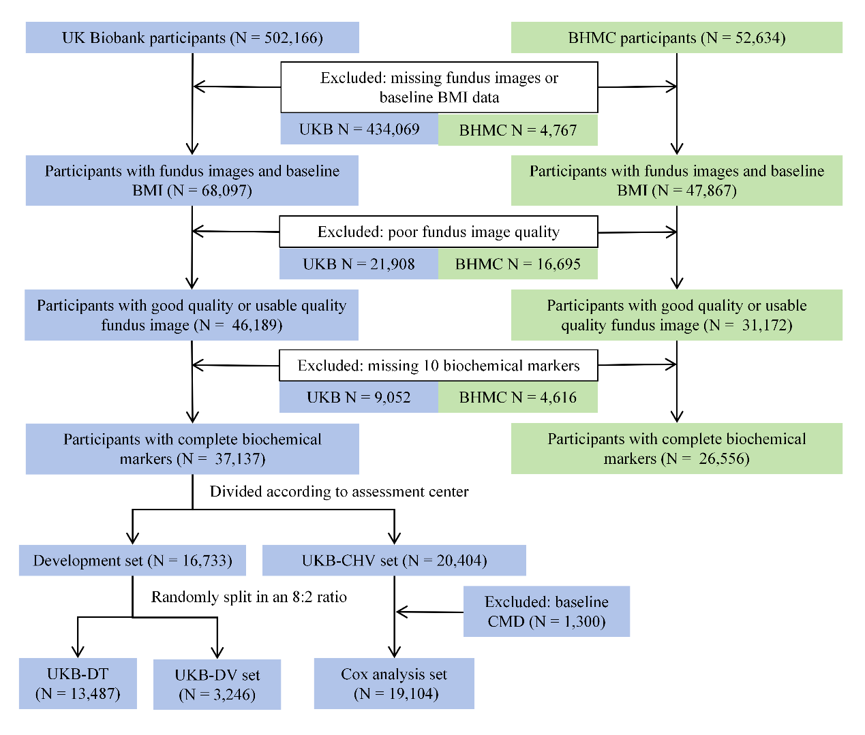

Figure S1: Participant inclusion and exclusion flowchart
Flow diagram showing the selection of participants from the UK Biobank (left) and Beijing Health Management Cohort (right). UK Biobank participants were included if they had at least one gradable fundus image and complete data for all ten biochemical markers. The final UK Biobank analytic sample comprised 37,137 participants allocated to UKB-DT (n = 13,487), UKB-DV (n = 3,246), and UKB-CHV (n = 20,404) sets by assessment centre. Participants with prevalent cardiometabolic disease at baseline were further excluded from the UKB-CHV set for incident outcome analyses, as described in the main text. The BHMC-EV set (n = 26,556) served as an independent cross-ethnic external validation set. UKB-DT, UK Biobank development train; UKB-DV, UK Biobank development validation; UKB-CHV, UK Biobank centre-held-out validation; BHMC-EV, Beijing Health Management Cohort external validation.
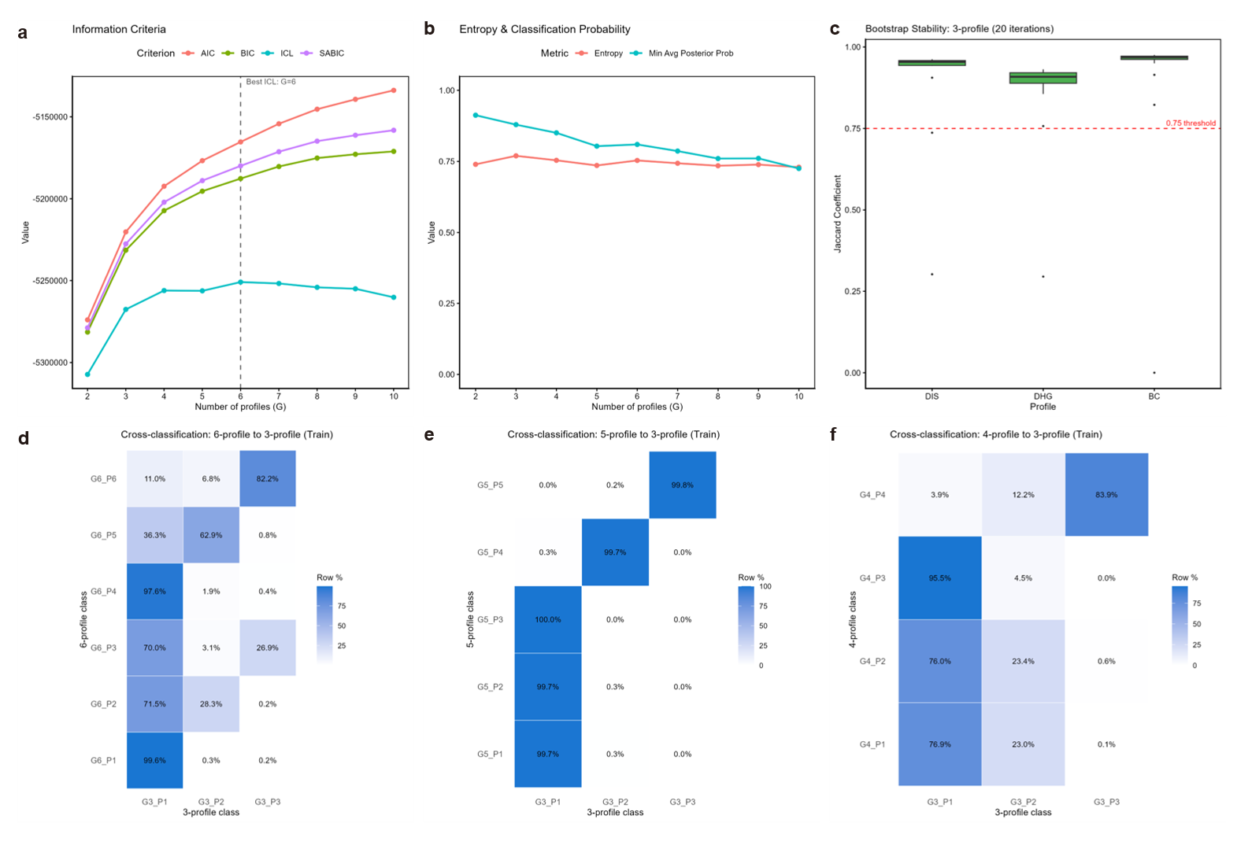

Figure S2: Latent profile analysis model selection for subtype number
a, Information criteria (AIC, BIC, ICL, SABIC) across 2–10 profile solutions fitted by Gaussian mixture models (mclust v6.1.2). The ICL criterion was minimised at G = 6 (dashed line); BIC and SABIC showed diminishing improvement beyond G = 3, consistent with an inflection point at the three-profile boundary. b, Classification entropy and minimum average posterior probability across profile solutions. Entropy remained stable (approximately 0.75) from G = 3 onwards; however, the minimum average posterior probability declined progressively beyond G = 5, indicating increasing classification uncertainty in higher-order solutions. c, Bootstrap stability of the three-profile solution (20 iterations). Jaccard coefficients exceeded the 0.75 stability threshold (red dashed line) for all three profiles: BC (median 0.95), DIS (median 0.92), and DHG (median 0.75), confirming acceptable-to-high resampling stability. d, Cross-classification of the six-profile solution onto the three-profile solution in the UKB-DT set (row percentages). Several six-profile classes showed mixed allocation across the three parent profiles (e.g., G6_P2: 71.5% to G3_P1 and 28.3% to G3_P2), indicating poor separability at G = 6. e, Cross-classification of the five-profile solution onto the three-profile solution. All five profiles mapped near-exclusively onto a single three-profile parent (≥99.7%), demonstrating that the additional profiles at G = 5 represent sub-divisions of the baseline concordant class rather than novel cardiometabolic phenotypes. f, Cross-classification of the four-profile solution onto the three-profile solution. Two of four profiles (G4_P1 and G4_P2) showed approximately 23% leakage into G3_P2 (DIS), suggesting incomplete separation of the inflammatory profile at G = 4. Together, these analyses support the three-profile solution as the most parsimonious, stable, and clinically interpretable partitioning of cardiometabolic heterogeneity within obesity. BC, baseline concordant; DIS, discordant inflammatory state; DHG, discordant hyperglycaemic; ICL, integrated completed likelihood; BIC, Bayesian information criterion; AIC, Akaike information criterion; SABIC, sample-size adjusted BIC; UKB-DT, UK Biobank development train.
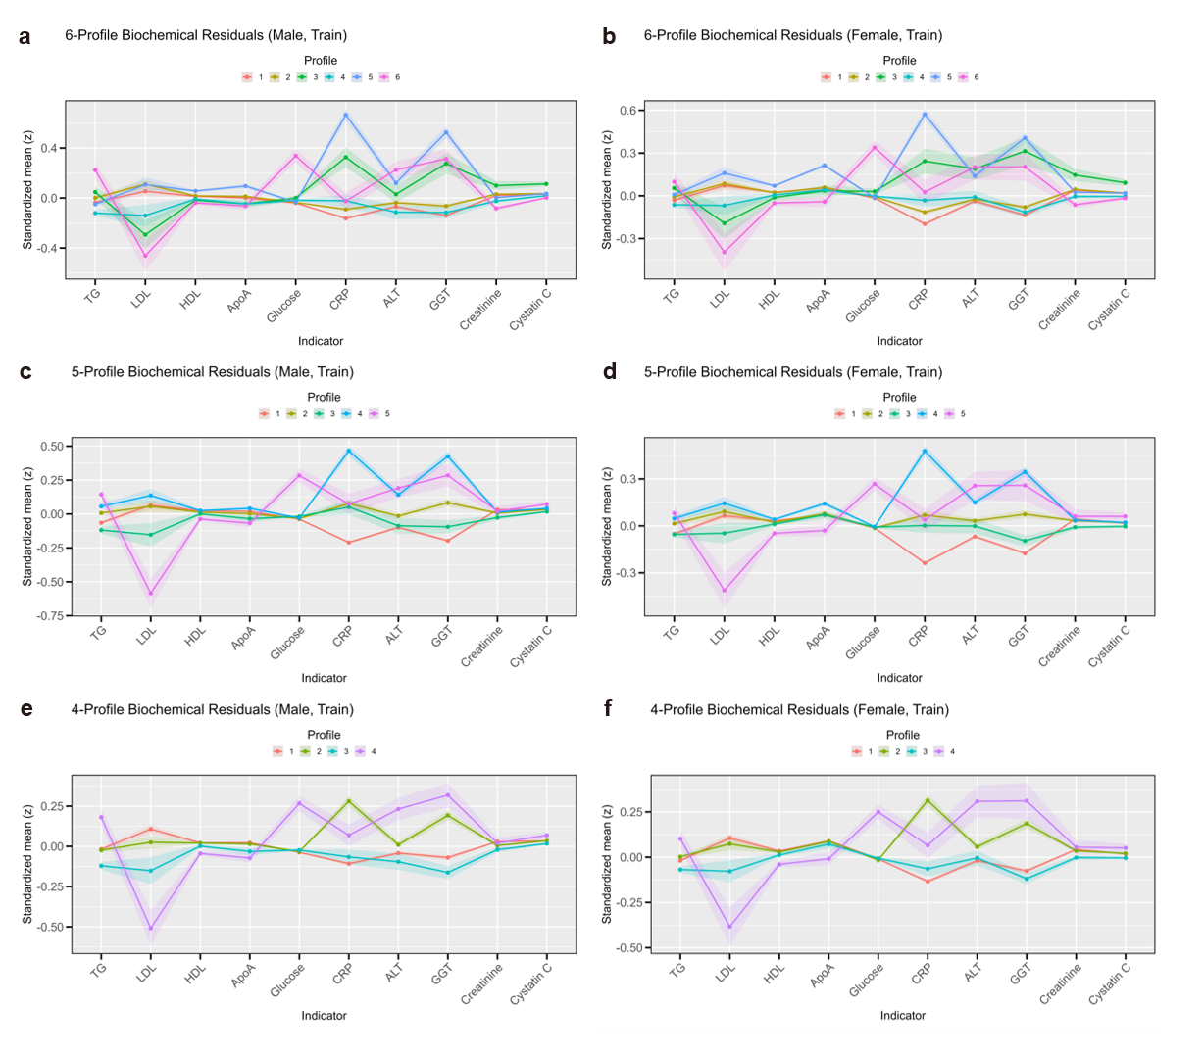

Figure S3: Biochemical residual profiles for alternative latent profile analysis solutions (G = 4, 5, and 6), stratified by sex
Standardised biochemical residual profiles (z-scores) for each latent profile across the 10 cardiometabolic indicators in the UKB-DT set. a, b, Six-profile solution in males (a) and females (b). Multiple profiles exhibit overlapping biochemical signatures—particularly profiles 1–4, which cluster near-zero residuals across most indicators—consistent with the high classification entropy observed at G = 6. c, d, Five-profile solution in males (c) and females (d). Three of five profiles (profiles 1–3) show near-identical biochemical patterns corresponding to the baseline concordant class, while profiles 4 (elevated CRP/ALT/GGT) and 5 (elevated glucose, reduced LDL-C) retain the distinctive signatures of DIS and DHG, respectively. This redundancy in the concordant class, together with the near-perfect cross-classification onto the three-profile solution (Figure S2e), confirms that the additional profiles at G = 5 do not capture novel cardiometabolic phenotypes. e, f, Four-profile solution in males (e) and females (f). A distinctive profile characterised by markedly reduced LDL-C with elevated glucose (purple line, profile 4) is consistent with DHG; however, the DIS signal (elevated CRP) is distributed across profiles 1 and 2 rather than consolidated, indicating incomplete resolution of the inflammatory phenotype at G = 4. Biochemical residuals were obtained after regression adjustment for age and smoking status within sex strata. BC, baseline concordant; DIS, discordant inflammatory state; DHG, discordant hyperglycaemic; TG, triglycerides; LDL, low-density lipoprotein cholesterol; HDL, high-density lipoprotein cholesterol; ApoA, apolipoprotein A; CRP, C-reactive protein; ALT, alanine aminotransferase; GGT, gamma-glutamyl transferase; UKB-DT, UK Biobank development train.
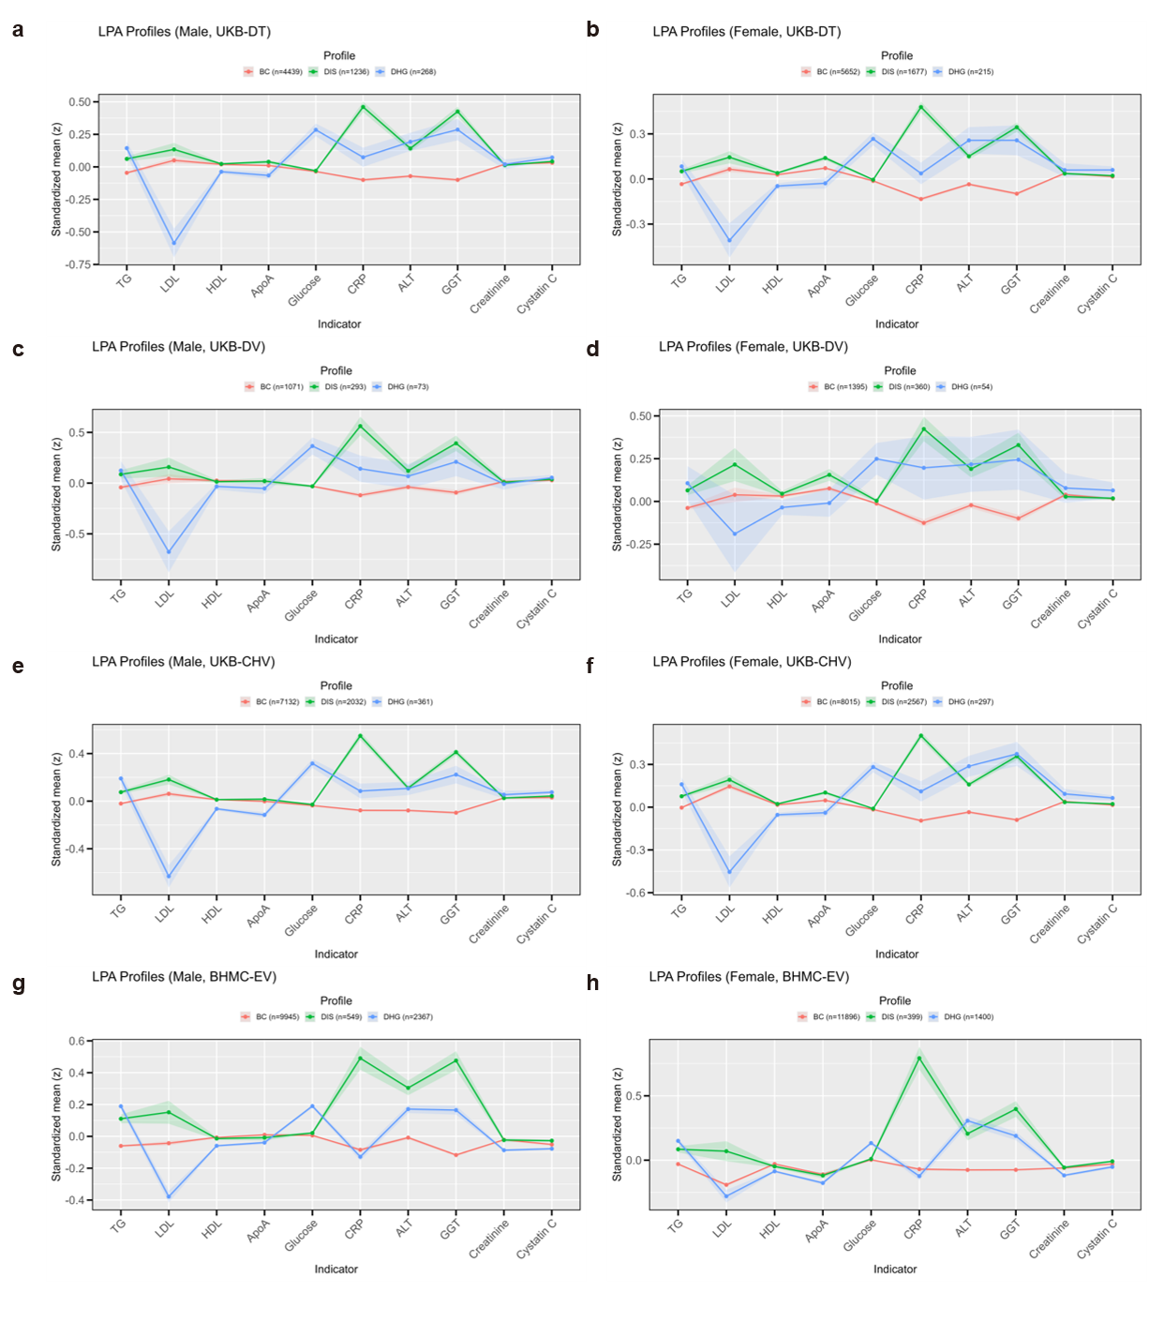

Figure S4: Replication of the three-profile latent profile structure across sex and datasets
Standardised biochemical residual profiles for the three latent profiles are shown separately by sex and dataset. a,b, Male and female participants in the UKB-DT set. c,d, Male and female participants in the UKB-DV set. e,f, Male and female participants in the UKB-CHV set. g,h, Male and female participants in the BHMC-EV cohort. Lines show the mean standardised residuals for each biochemical indicator within each subtype, with shaded bands indicating uncertainty around the mean. Biochemical residuals were derived after adjustment for age, smoking status and BMI within sex strata. BC, baseline concordant; DIS, discordant inflammatory state; DHG, discordant hyperglycaemic; UKB-DT, UK Biobank development train; UKB-DV, UK Biobank development validation; UKB-CHV, UK Biobank centre-held-out validation; BHMC-EV, Beijing Health Management Cohort external validation; TG, triglycerides; LDL, low-density lipoprotein cholesterol; HDL, high-density lipoprotein cholesterol; ApoA, apolipoprotein A; CRP, C-reactive protein; ALT, alanine aminotransferase; GGT, gamma-glutamyl transferase. 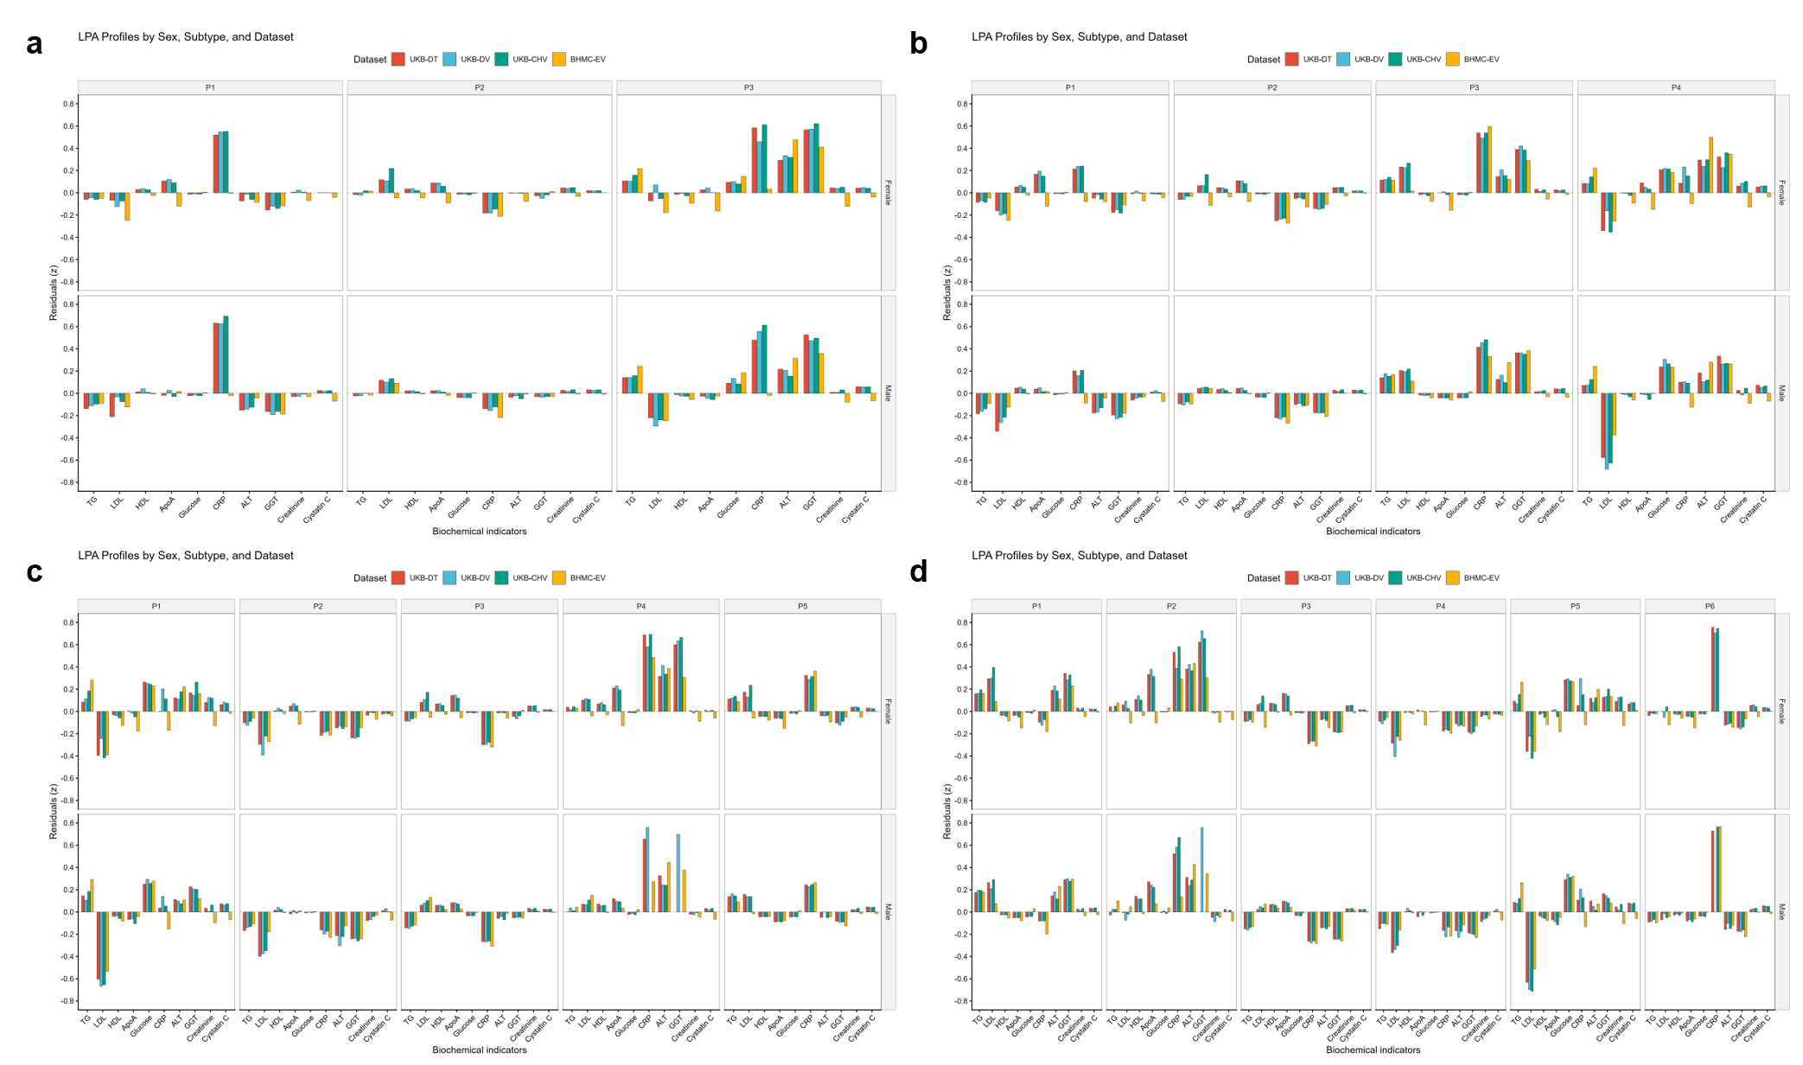

Figure S5: Biomarker-only latent profile solutions across candidate profile numbers
Biomarker-only latent profile analysis was performed using the ten observed biochemical residuals without inclusion of retinal features or RETFound-derived components. a–d, Three-, four-, five- and six-profile solutions, respectively. For each solution, standardised biochemical residual profiles are shown across the ten cardiometabolic indicators, stratified by sex and dataset. The analysis was used to assess whether the major cardiometabolic subtype structure identified in the multimodal framework could be recovered from biochemical information alone. Across candidate profile numbers, the biomarker-only solutions retained recurrent inflammatory and hyperglycaemic patterns, supporting the presence of stable biochemical subtype structure independent of retinal-feature input. Biochemical residuals were derived after adjustment for age, smoking status and BMI within sex strata. TG, triglycerides; LDL, low-density lipoprotein cholesterol; HDL, high-density lipoprotein cholesterol; ApoA, apolipoprotein A; CRP, C-reactive protein; ALT, alanine aminotransferase; GGT, gamma-glutamyl transferase; LPA, latent profile analysis; BC, baseline concordant; DIS, discordant inflammatory state; DHG, discordant hyperglycaemic; UKB-DT, UK Biobank development train; UKB-DV, UK Biobank development validation; UKB-CHV, UK Biobank centre-held-out validation; BHMC-EV, Beijing Health Management Cohort external validation.
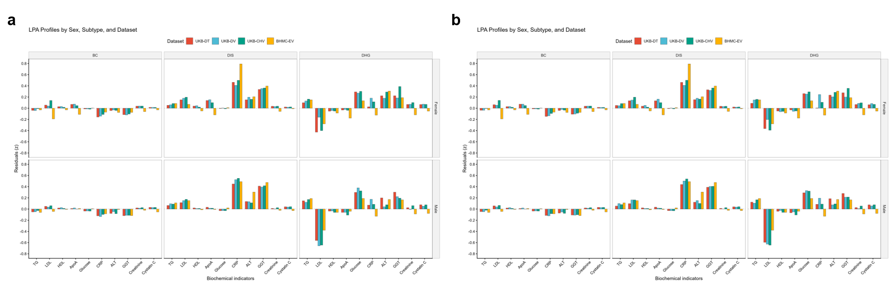

Figure S6: Latent profile structures under left-eye-prioritised and right-eye-prioritised retinal feature selection
Alternative eye-selection analyses were performed to assess the influence of bilateral-eye handling on latent profile analysis. a, Left-eye-prioritised analysis, in which the left-eye fundus image was used when available and the right-eye image was used only if the left-eye image was unavailable. b, Right-eye-prioritised analysis, in which the right-eye fundus image was used when available and the left-eye image was used only if the right-eye image was unavailable. For each strategy, RETFound-derived retinal features were extracted from the selected image, combined with the ten standardised biochemical residuals through partial least squares regression, and then used for latent profile analysis following the same pipeline as the primary analysis. Profiles are shown by sex and dataset across the ten biochemical indicators. Biochemical residuals were derived after adjustment for age, smoking status and BMI within sex strata. TG, triglycerides; LDL, low-density lipoprotein cholesterol; HDL, high-density lipoprotein cholesterol; ApoA, apolipoprotein A; CRP, C-reactive protein; ALT, alanine aminotransferase; GGT, gamma-glutamyl transferase; LPA, latent profile analysis; UKB-DT, UK Biobank development train; UKB-DV, UK Biobank development validation; UKB-CHV, UK Biobank centre-held-out validation; BHMC-EV, Beijing Health Management Cohort external validation.
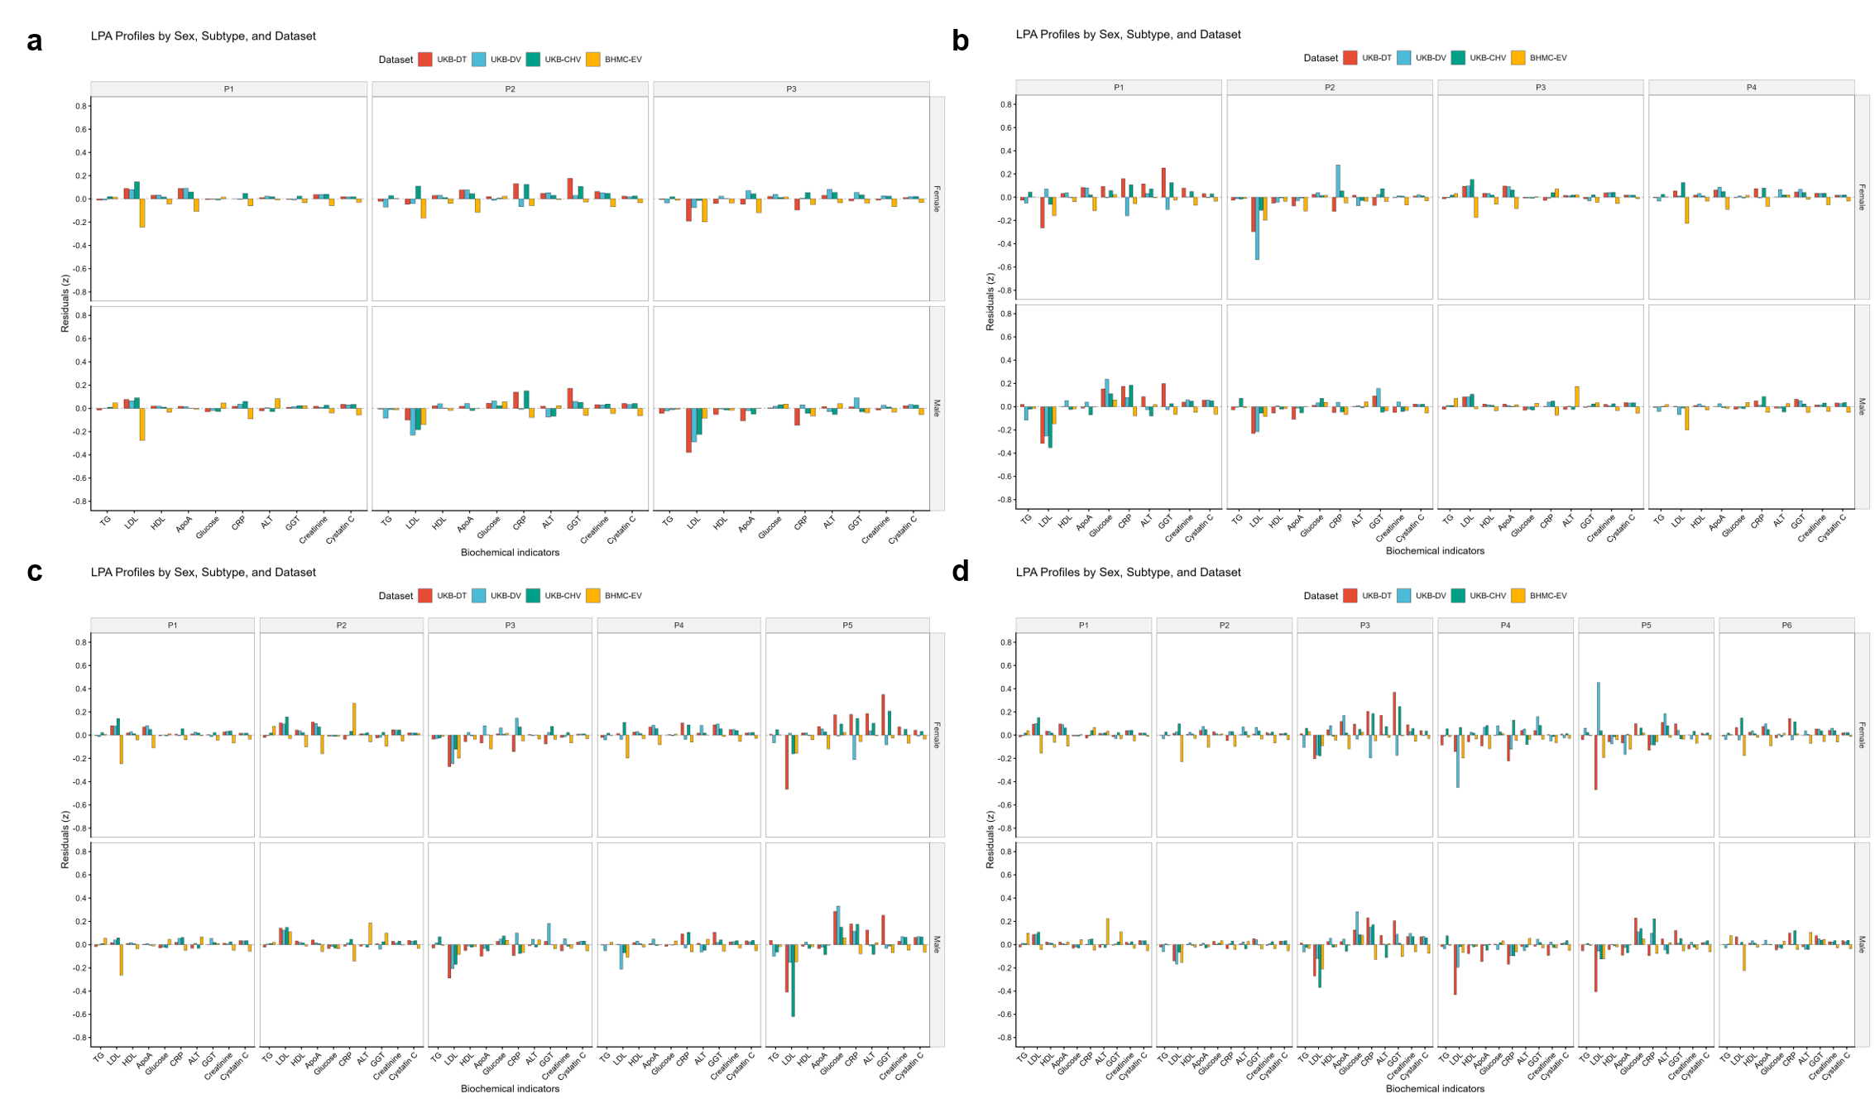

Figure S7: Latent profile solutions derived from retina-predicted biochemical residuals
Latent profile analysis was applied to the ten biochemical residuals predicted directly from retinal fundus images by the retina-to-residual regression baseline. a–d, Three-, four-, five- and six-profile solutions, respectively. Bars show the mean predicted residual z-score for each biochemical indicator, stratified by sex, latent profile and dataset. Across profile numbers, the predicted-residual solutions showed compressed residual amplitudes, inconsistent profile patterns across datasets and no reproducible inflammatory or hyperglycaemic signatures comparable to those identified using observed biochemical residuals in the multimodal LPA. UKB-DT, UK Biobank development train; UKB-DV, UK Biobank development validation; UKB-CHV, UK Biobank centre-held-out validation; BHMC-EV, Beijing Health Management Cohort external validation; LPA, latent profile analysis; TG, triglycerides; LDL, low-density lipoprotein cholesterol; HDL, high-density lipoprotein cholesterol; ApoA, apolipoprotein A; CRP, C-reactive protein; ALT, alanine aminotransferase; GGT, gamma-glutamyl transferase; BC, baseline concordant; DIS, discordant inflammatory state; DHG, discordant hyperglycaemic.
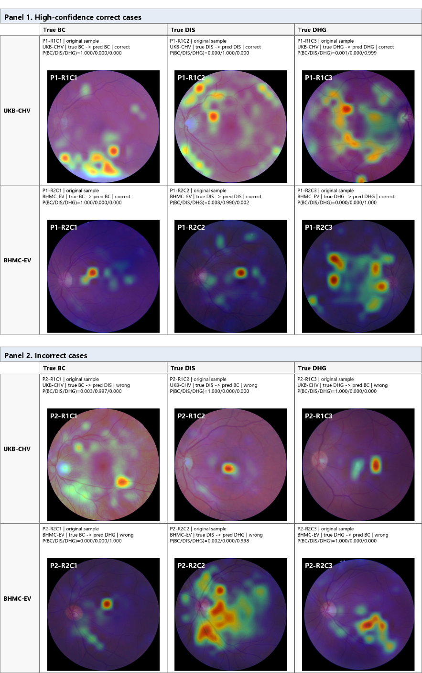

Figure S8: Representative attention heatmaps for correctly and incorrectly classified ROSA predictions in UKB-CHV and BHMC-EV
Representative examples of ROSA attention heatmaps from UKB-CHV and BHMC-EV are shown for both correctly and incorrectly classified cases. For each example, the original fundus image is displayed together with the overlaid last-layer CLS-to-patch attention map and the corresponding predicted subtype probabilities for BC, DIS and DHG. Cases were selected to illustrate both model strengths and limitations across internal centre-held-out and independent external validation settings. In correctly classified cases, attention was generally concentrated within anatomically plausible posterior-pole regions, including the optic disc/peripapillary area, macular-adjacent retina and major vascular arcades. In incorrectly classified cases, attention was more often diffuse or less focused on these central retinal structures. These visualisations are intended to illustrate model behaviour and do not constitute lesion-localisation maps or evidence of causal mechanisms. UKB-CHV, UK Biobank centre-held-out validation; BHMC-EV, Beijing Health Management Cohort external validation; BC, baseline concordant; DIS, discordant inflammatory state; DHG, discordant hyperglycaemic.
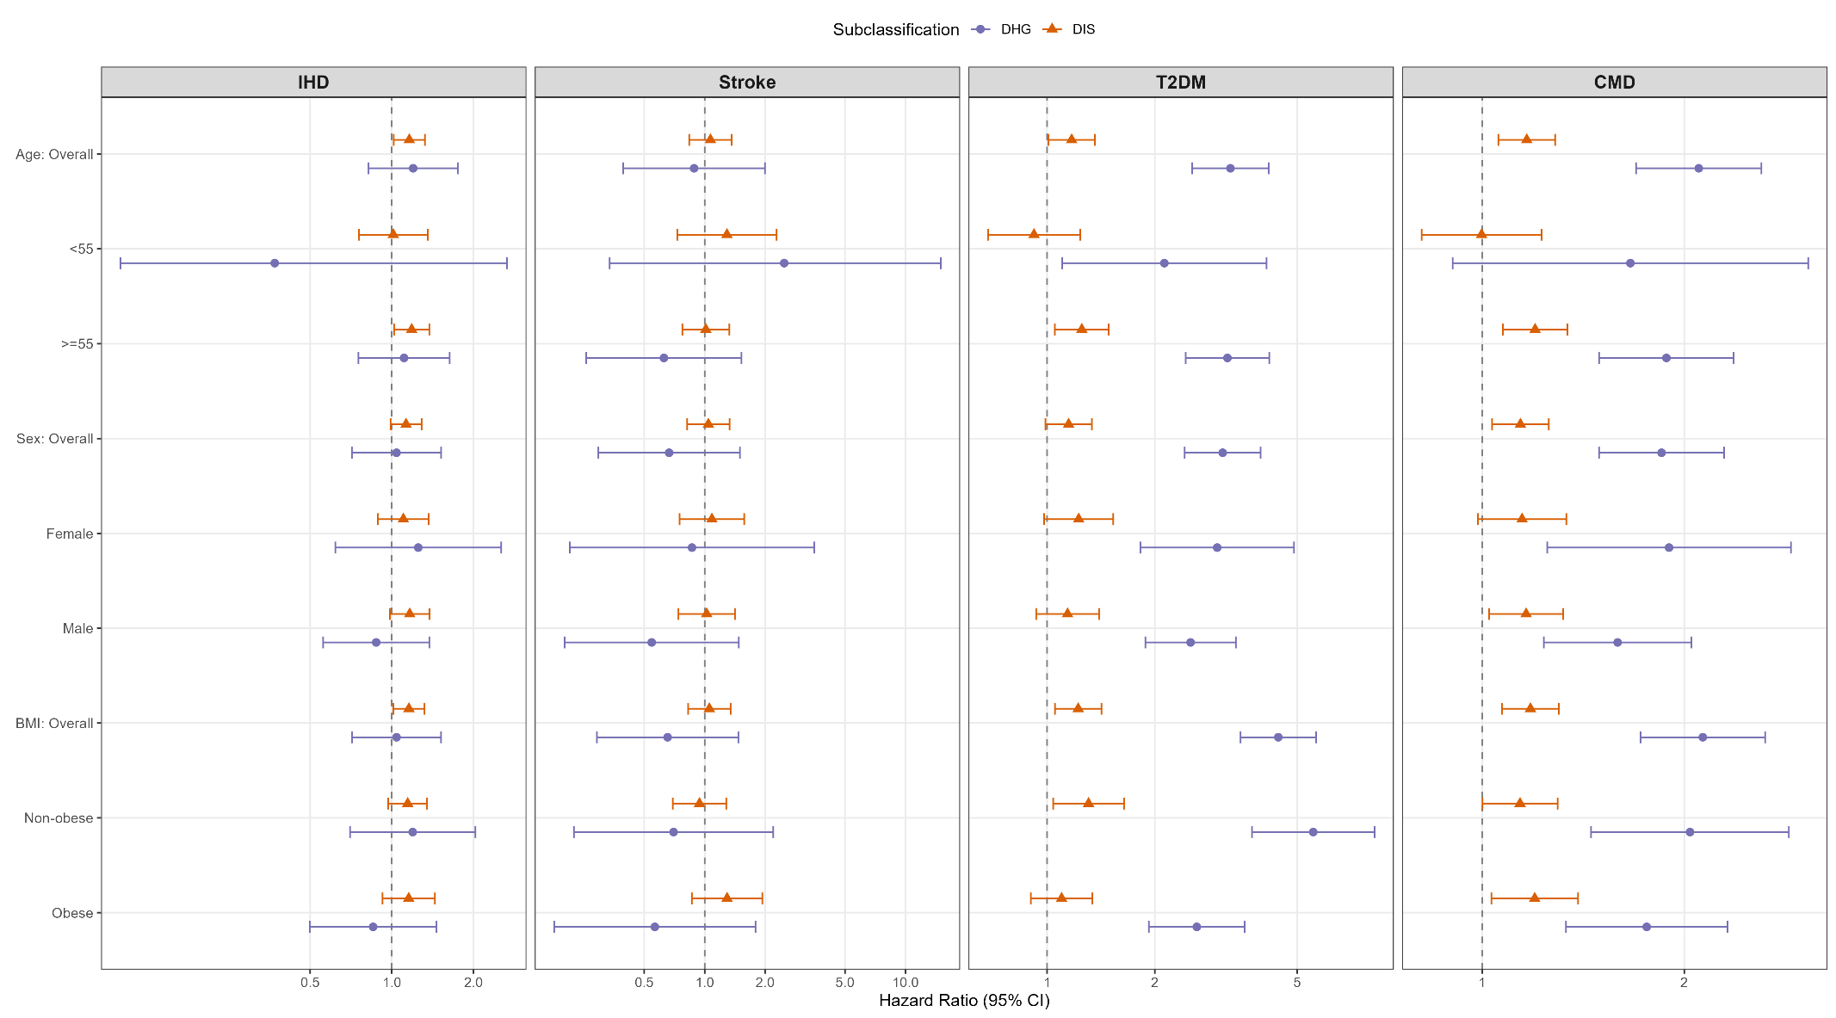

Figure S9: Subgroup analyses of subtype–outcome associations
Forest plots showing hazard ratios (95% CI) for associations between ROSA-predicted subtypes and incident outcomes across strata defined by age (<55 versus ≥55 years), sex, and BMI (<30 versus ≥30 kg/m²). Panels display the subgroup-specific estimates for DIS and DHG relative to BC. Models were adjusted according to Model 3 in Supplementary Table S4. P values for interaction were obtained using likelihood-ratio tests. DIS, discordant inflammatory state; DHG, discordant hyperglycaemic; BC, baseline concordant; HR, hazard ratio; CI, confidence interval; BMI, body-mass index.
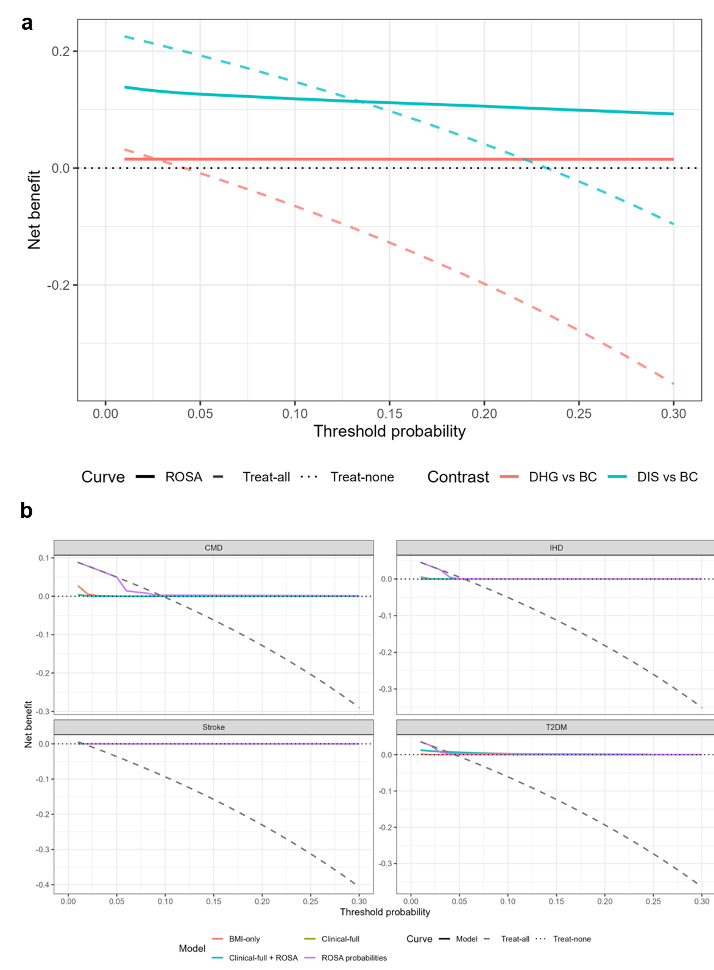

Figure S10: Decision-curve analysis for ROSA-predicted obesity subtypes and 10-year clinical outcomes
a, Decision-curve analysis for ROSA-predicted subtype probabilities in DIS versus BC and DHG versus BC contrasts. Net benefit was evaluated across threshold probabilities from 0.01 to 0.30 and compared with treat-all and treat-none strategies. b, Decision-curve analysis for 10-year incident CMD, IHD, stroke and T2DM. Models included BMI-only, clinical-full, clinical-full plus ROSA probabilities, and ROSA probabilities alone. Net benefit was calculated across the same threshold-probability range. BC, baseline concordant; DIS, discordant inflammatory state; DHG, discordant hyperglycaemic; CMD, cardiometabolic disease; IHD, ischaemic heart disease; T2DM, type 2 diabetes mellitus; ROSA, Retinal-based Obesity Subtyping Algorithm.
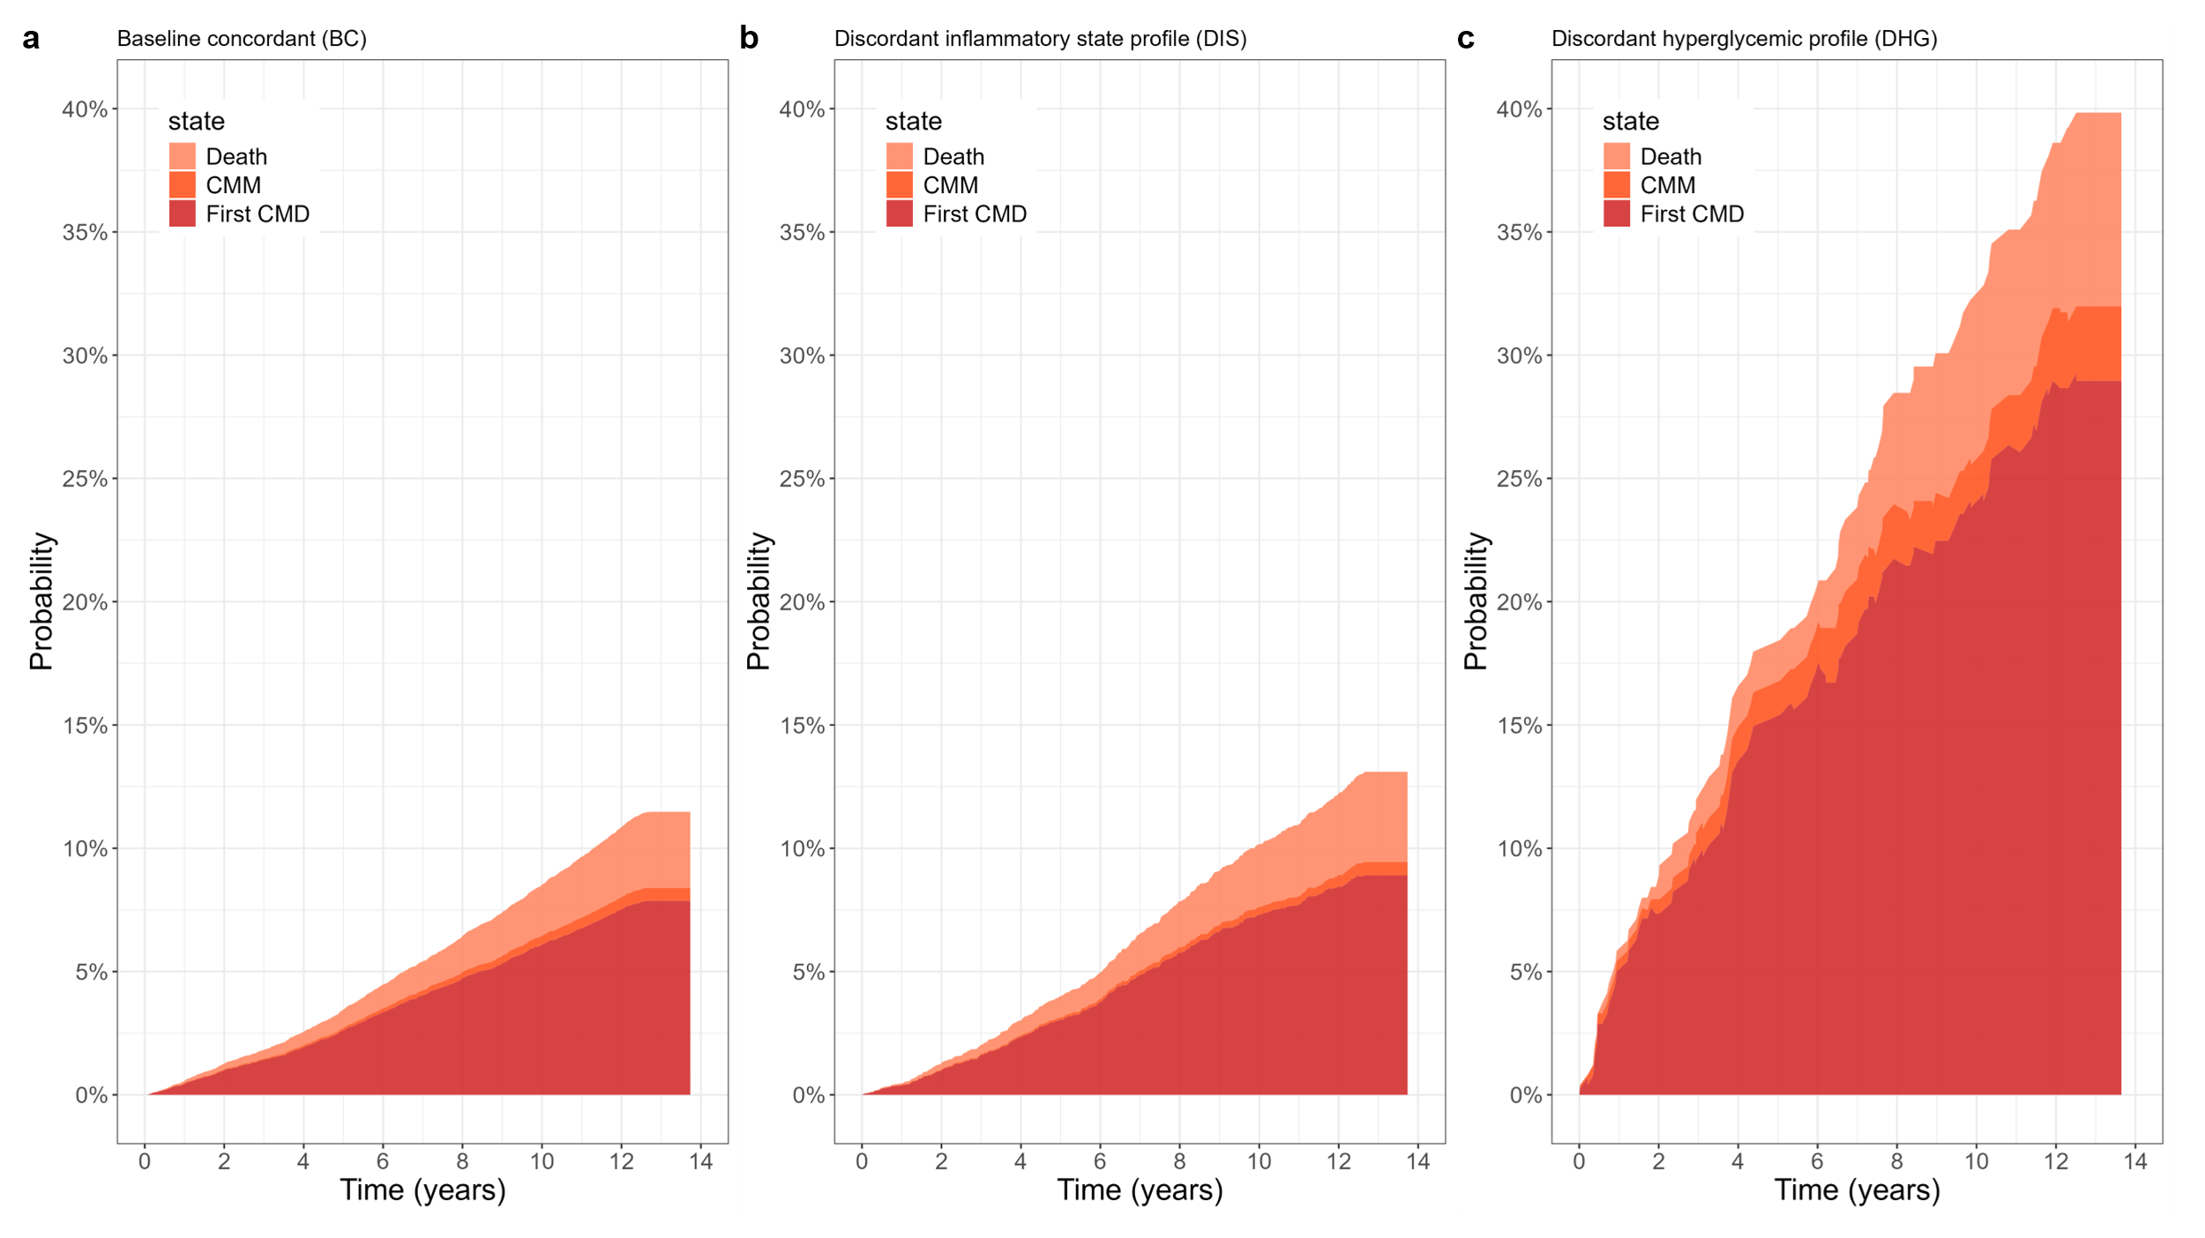

Figure S11: Multi-state transition probabilities by predicted subtype
a, BC. b, DIS. c, DHG. Aalen–Johansen cumulative transition probability curves across four clinical states: CMD-free, first CMD event, cardiometabolic multimorbidity, and death, stratified by ROSA-predicted subtype. Transition-specific hazard ratios from multistate models are provided in Table 1 (main text). CMD, composite cardiometabolic disease; BC, baseline concordant; DIS, discordant inflammatory state; DHG, discordant hyperglycaemic.
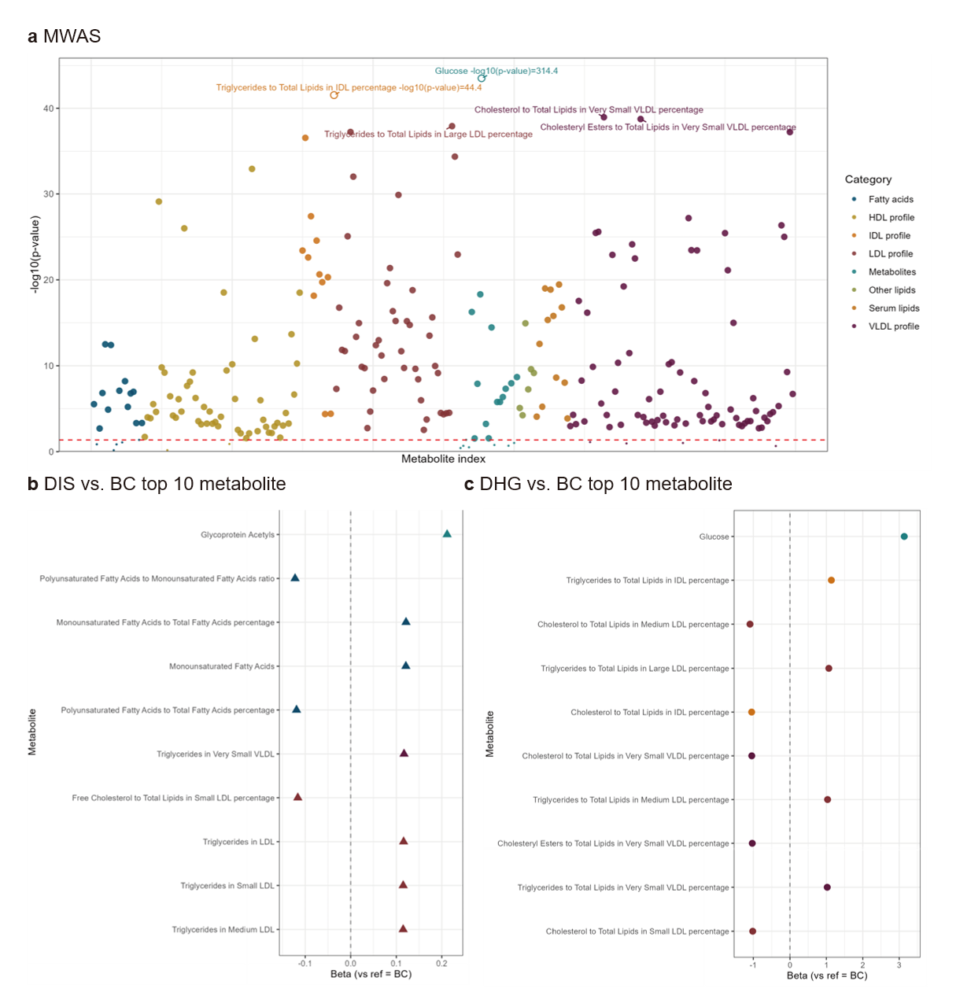

Figure S12: Metabolomic associations of predicted subtypes
a, Manhattan plot of associations between ROSA-predicted subtypes and 249 circulating metabolites quantified by NMR spectroscopy in the UKB-CHV set (n = 12,839). b, Top 10 metabolite associations for DIS versus BC, ranked by absolute standardised effect size. c, Top 10 metabolite associations for DHG versus BC. Linear regression models were adjusted for age, age-squared, sex, and BMI. Associations passing FDR < 0.05 are shown. Full results are provided in Supplementary Data 11. DIS, discordant inflammatory state; DHG, discordant hyperglycaemic; BC, baseline concordant; NMR, nuclear magnetic resonance; FDR, false discovery rate.

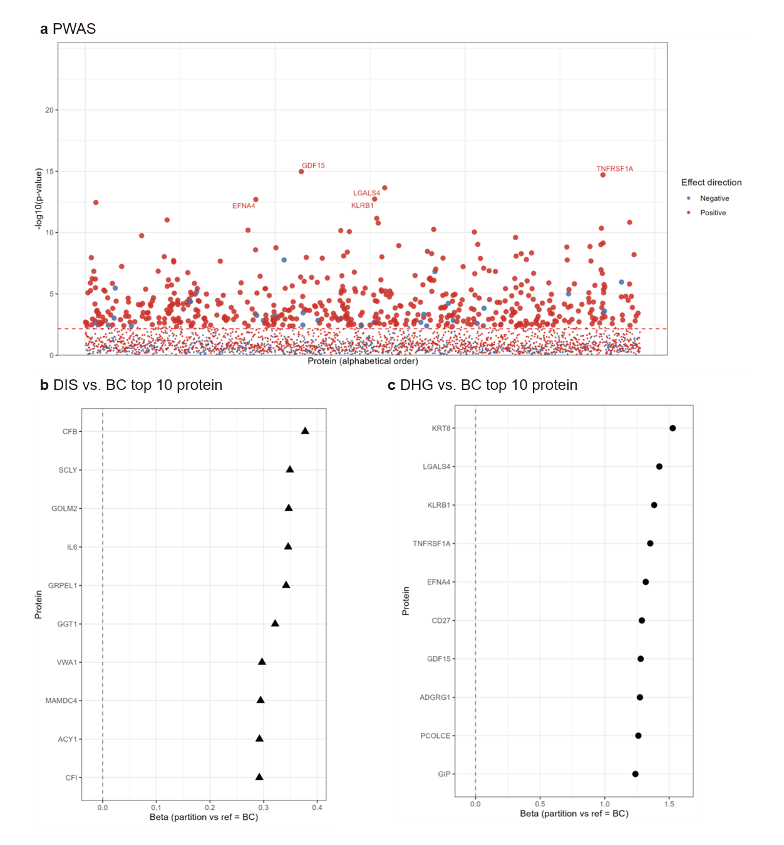

Figure S13: Proteomic associations of predicted subtypes
a, Manhattan plot of associations between ROSA-predicted subtypes and 2,919 circulating proteins quantified using the Olink Explore 3072 platform in the UKB-CHV set (n = 3,512). b, Top 10 protein associations for DIS versus BC. c, Top 10 protein associations for DHG versus BC. Linear regression models were adjusted for age, age-squared, sex, and BMI. Associations passing FDR < 0.05 are shown. Full results are provided in Supplementary Data 12. DIS, discordant inflammatory state; DHG, discordant hyperglycaemic; BC, baseline concordant; FDR, false discovery rate.
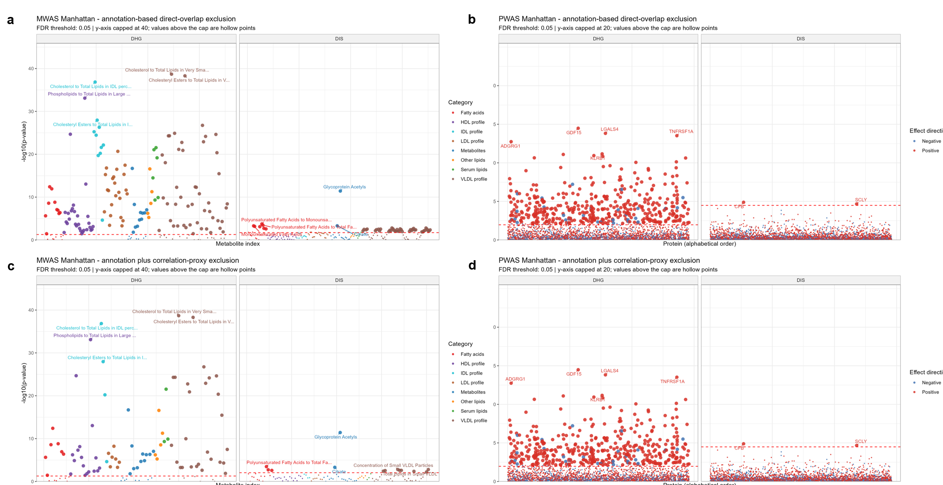

Figure S14: MWAS and PWAS after exclusion of LPA-defining biomarker overlaps and molecular proxies
Manhattan plots of metabolome-wide and proteome-wide association analyses after excluding omics variables overlapping with, or closely proxying, the ten biochemical markers used for latent profile analysis. a, MWAS after annotation-based direct-overlap exclusion using a prespecified marker dictionary covering triglycerides, LDL-C, HDL-C, apolipoprotein A, glucose, C-reactive protein, alanine aminotransferase, gamma-glutamyltransferase, creatinine and cystatin C. b, PWAS after the same annotation-based direct-overlap exclusion. c, MWAS after the more conservative exclusion strategy, in which variables with an absolute Spearman correlation ≥0.80 with any LPA-defining biochemical marker were additionally removed. d, PWAS after the corresponding annotation-plus-correlation exclusion. Associations were tested for ROSA-predicted DIS and DHG relative to BC using the same regression framework as the primary MWAS and PWAS. The dashed horizontal line indicates the FDR q < 0.05 threshold. The y-axis was capped for visualisation, and points exceeding the cap are shown as hollow points. BC, baseline concordant; DIS, discordant inflammatory state; DHG, discordant hyperglycaemic; MWAS, metabolome-wide association study; PWAS, proteome-wide association study; LPA, latent profile analysis; LDL-C, low-density lipoprotein cholesterol; HDL-C, high-density lipoprotein cholesterol; FDR, false discovery rate.
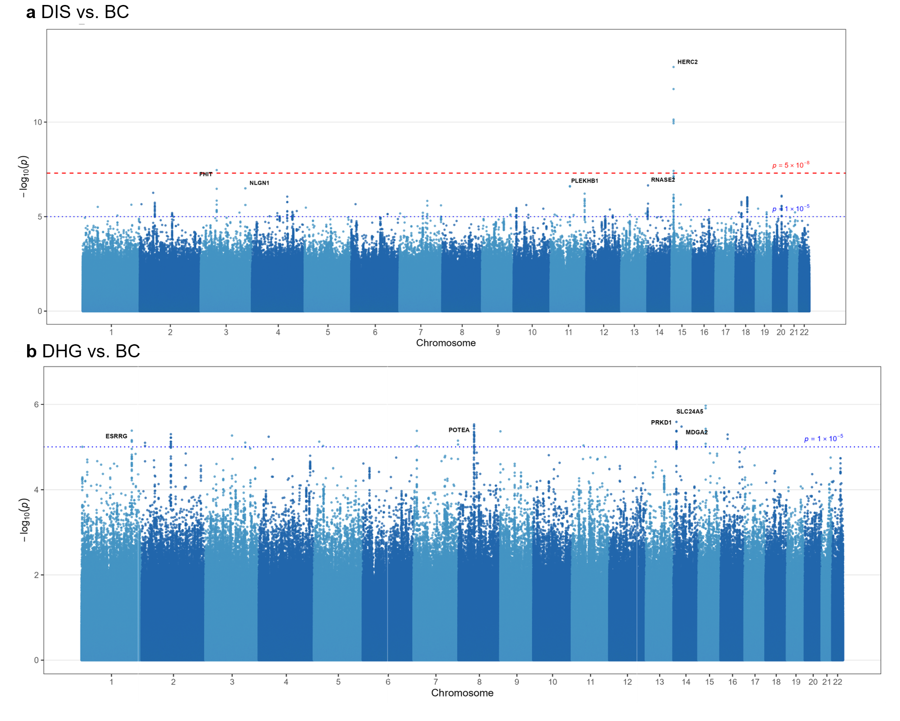

Figure S15: Genome-wide association analysis of predicted subtypes
a, Manhattan plot from the genome-wide association study of DIS versus BC. Dashed red and dotted blue horizontal lines indicate the genome-wide significance threshold (P = 5 × 10⁻⁸) and the suggestive significance threshold (P = 1 × 10⁻⁵), respectively. Genome-wide significant signals were observed for DIS, with the lead association mapping to the HERC2/OCA2 region. b, Manhattan plot from the genome-wide association study of DHG versus BC. No genome-wide significant association was identified for DHG. Lead loci were defined by distance-based clumping. DIS, discordant inflammatory state; DHG, discordant hyperglycaemic; BC, baseline concordant; SNP, single-nucleotide polymorphism.
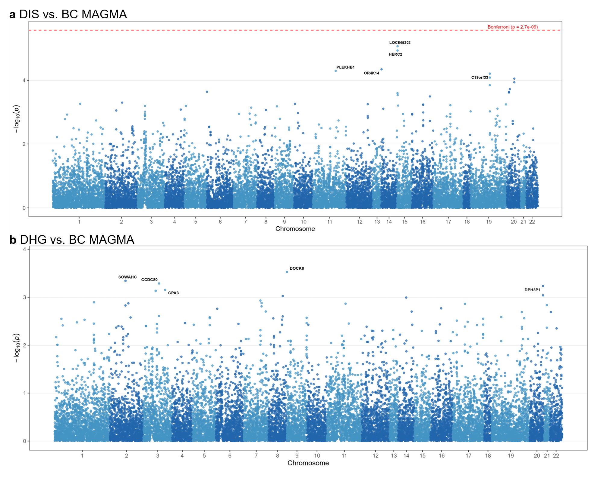

Figure S16: Gene-level association analysis of predicted obesity subtypes
a, Manhattan plot from the MAGMA gene-level association analysis of DIS versus BC. The dashed red horizontal line indicates the Bonferroni-corrected significance threshold (P = 2.7 × 10⁻⁶). Bonferroni-significant genes were observed for DIS, including signals in the HERC2/OCA2 region. b, Manhattan plot from the MAGMA gene-level association analysis of DHG versus BC. No Bonferroni-significant gene was identified for DHG. DIS, discordant inflammatory state; DHG, discordant hyperglycaemic; BC, baseline concordant; MAGMA, Multi-marker Analysis of GenoMic Annotation.

Supplementary Data

Supplementary Data 1: Overall classification performance across models and datasets
Overall model performance for ROSA and comparator retinal-image-based models across the UKB-DT, UKB-DV, UKB-CHV, and BHMC-EV sets. Separate worksheets report macro-averaged and micro-averaged results. Metrics include area under the receiver operating characteristic curve, area under the precision–recall curve, Brier score, sensitivity, specificity, positive predictive value, negative predictive value, and overall accuracy. Values are presented as point estimates with 95% confidence intervals. UKB-DT, UK Biobank development train; UKB-DV, UK Biobank development validation; UKB-CHV, UK Biobank centre-held-out validation; BHMC-EV, Beijing Health Management Cohort external validation.

Supplementary Data 2: Per-class classification performance across models and datasets
Per-class one-versus-rest classification performance for baseline concordant, discordant inflammatory state, and discordant hyperglycaemic subtypes across ROSA and comparator retinal-image-based models in the UKB-DT, UKB-DV, UKB-CHV, and BHMC-EV sets. The worksheet reports accuracy, sensitivity, specificity, positive predictive value, and negative predictive value for each class, with values presented as point estimates and 95% confidence intervals. UKB-DT, UK Biobank development train; UKB-DV, UK Biobank development validation; UKB-CHV, UK Biobank centre-held-out validation; BHMC-EV, Beijing Health Management Cohort external validation

Supplementary Data 3: Sensitivity analysis of distillation temperature and soft-label weighting parameters
Overall classification performance of ROSA across combinations of the soft-label weighting coefficient α and distillation temperature τ. The sensitivity grid evaluated α values of 0.3 and 0.7 and τ values of 1, 2, 5 and 10 using the same data partitions, model architecture and evaluation metrics as the primary analysis. Performance is reported for UKB-DV, UKB-CHV and BHMC-EV. Metrics include macro-averaged AUROC, AUPRC, Brier score, sensitivity, specificity, positive predictive value, negative predictive value and accuracy. UKB-DV, UK Biobank development validation; UKB-CHV, UK Biobank centre-held-out validation; BHMC-EV, Beijing Health Management Cohort external validation; ROSA, Retinal-based Obesity Subtyping Algorithm; AUROC, area under the receiver operating characteristic curve; AUPRC, area under the precision–recall curve; PPV, positive predictive value; NPV, negative predictive value.

Supplementary Data 4: Ancestry-stratified classification performance of ROSA and comparator models in UKB-CHV
Classification performance of ROSA and comparator retinal-image-based models stratified by ancestry-defined subgroups in the UKB-CHV set. The workbook reports performance separately for White and non-white participants using the same trained models and prediction rules as in the primary analysis. Models included ROSA, ResNet, VGG-16 and randomly initialised ViT-Large. Metrics include macro-averaged and micro-averaged AUROC, AUPRC, Brier score, sensitivity, specificity, positive predictive value, negative predictive value and accuracy. Estimates in the non-white subgroup should be interpreted cautiously because of the smaller sample size and class imbalance. UKB-CHV, UK Biobank centre-held-out validation; ROSA, Retinal-based Obesity Subtyping Algorithm; AUROC, area under the receiver operating characteristic curve; AUPRC, area under the precision–recall curve; PPV, positive predictive value; NPV, negative predictive value.

Supplementary Data 5: Stratified performance of ROSA across demographic, BMI and assessment-centre subgroups
Classification performance of ROSA stratified by age group, sex, ancestry/ethnicity group, BMI category and assessment centre. Metrics are reported for UKB-CHV and BHMC-EV where applicable using the same trained ROSA model and prediction rule as in the primary analysis. Reported metrics include macro-averaged and micro-averaged AUROC, AUPRC, Brier score, sensitivity, specificity, positive predictive value, negative predictive value and accuracy, together with per-class performance for BC, DIS and DHG. Smaller strata, including the non-white UKB-CHV subgroup and underweight BMI subgroup, should be interpreted cautiously because of limited sample size and class imbalance. UKB-CHV, UK Biobank centre-held-out validation; BHMC-EV, Beijing Health Management Cohort external validation; BC, baseline concordant; DIS, discordant inflammatory state; DHG, discordant hyperglycaemic; AUROC, area under the receiver operating characteristic curve; AUPRC, area under the precision–recall curve; PPV, positive predictive value; NPV, negative predictive value.

Supplementary Data 6: Performance of a demographics- and centre-only baseline model for LPA subtype prediction
Performance of a non-image baseline model trained to predict LPA-derived subtype labels using demographic variables and assessment-centre information. The model was evaluated across UKB-DT, UKB-DV, UKB-CHV and BHMC-EV using the same subtype labels as the primary ROSA analysis. Reported metrics include macro-averaged and micro-averaged AUROC, AUPRC, Brier score, sensitivity, specificity, positive predictive value, negative predictive value and accuracy, together with per-class performance for BC, DIS and DHG. This analysis was used to assess whether simple demographic or centre-level information could explain the LPA subtype labels. UKB-DT, UK Biobank development train; UKB-DV, UK Biobank development validation; UKB-CHV, UK Biobank centre-held-out validation; BHMC-EV, Beijing Health Management Cohort external validation; LPA, latent profile analysis; BC, baseline concordant; DIS, discordant inflammatory state; DHG, discordant hyperglycaemic; AUROC, area under the receiver operating characteristic curve; AUPRC, area under the precision–recall curve; PPV, positive predictive value; NPV, negative predictive value.

Supplementary Data 7: Quantitative performance of direct retina-to-biomarker and retina-to-residual prediction
Performance of the direct retinal-image regression baseline for predicting the ten biochemical markers and their corresponding biochemical residuals across the UKB-DT, UKB-DV, UKB-CHV and BHMC-EV datasets. For each target and dataset split, the number of participants, coefficient of determination (R²), root mean squared error (RMSE), mean absolute error (MAE) and Pearson correlation between predicted and observed values are reported. The biomarker targets included triglycerides, LDL-C, HDL-C, ApoA, glucose, CRP, ALT, GGT, creatinine and cystatin C. Residual targets refer to the corresponding standardised biochemical residuals used for latent profile analysis after covariate adjustment, as described in the Methods. Negative R² values indicate that retinal-image-based prediction performed worse than a split-specific mean-value prediction. UKB-DT, UK Biobank development train; UKB-DV, UK Biobank development validation; UKB-CHV, UK Biobank centre-held-out validation; BHMC-EV, Beijing Health Management Cohort external validation; LDL-C, low-density lipoprotein cholesterol; HDL-C, high-density lipoprotein cholesterol; ApoA, apolipoprotein A; CRP, C-reactive protein; ALT, alanine aminotransferase; GGT, gamma-glutamyl transferase.

Supplementary Data 8: Classification performance of retinal-image models for biomarker-only latent profile labels
Performance of the RETFound + LoRA retinal-image classifier trained to predict subtype labels derived from biomarker-only latent profile analysis. Model performance is reported across the UKB-DT, UKB-DV, UKB-CHV and BHMC-EV datasets for candidate latent profile solutions. Metrics include overall and class-specific discrimination and classification performance, including AUROC, AUPRC, sensitivity, specificity, positive predictive value, negative predictive value and accuracy, with 95% confidence. UKB-DT, UK Biobank development train; UKB-DV, UK Biobank development validation; UKB-CHV, UK Biobank centre-held-out validation; BHMC-EV, Beijing Health Management Cohort external validation; LoRA, low-rank adaptation; LPA, latent profile analysis; AUROC, area under the receiver operating characteristic curve; AUPRC, area under the precision–recall curve; PPV, positive predictive value; NPV, negative predictive value.

Supplementary Data 9: Clinical risk patterns of three- and six-profile latent profile solutions
Hazard ratios were estimated for incident CMD, IHD, stroke and T2DM using the same Cox regression framework as the primary outcome analysis. For each G = 6 class, similarity to the G = 3 DIS and DHG risk patterns was quantified using the vector of log hazard ratios across the four outcomes. Cosine similarity, mean absolute log-HR difference and same-direction fraction were used to assess whether G = 6 classes recapitulated the major non-BC risk patterns identified in the three-profile solution. G6 class 1 was used as the reference class and is not shown in the hazard-ratio rows. CMD, cardiometabolic disease; IHD, ischaemic heart disease; T2DM, type 2 diabetes mellitus; DIS, discordant inflammatory state; DHG, discordant hyperglycaemic.

Supplementary Data 10: Full phenome-wide association results for predicted obesity subtypes
Full phenome-wide association study results for ROSA-predicted discordant inflammatory state and discordant hyperglycaemic subtypes, analysed relative to the baseline concordant subtype. The workbook includes all tested phenotype-level results, the strongest subtype association for each phenotype, and ranked top associations used for display. Reported fields include phenotype code and description, disease category, case counts, effect estimates, standard errors, nominal and false-discovery-rate-adjusted P values, false discovery rate significance flags, −log10(P), and odds ratios.

Supplementary Data 11: Full metabolome-wide association results for predicted obesity subtypes
Full metabolome-wide association study results for ROSA-predicted discordant inflammatory state and discordant hyperglycaemic subtypes. The workbook includes all metabolite-level results, the strongest subtype association for each metabolite, and ranked top associations used for display. Reported fields include metabolite identifier, description, metabolite category, subtype comparison, total sample size, subtype-specific sample size, effect estimates, standard errors, nominal and false-discovery-rate-adjusted P values, false discovery rate significance flags, and −log10(P).

Supplementary Data 12: Full proteome-wide association results for predicted obesity subtypes
Full proteome-wide association study results for ROSA-predicted discordant inflammatory state and discordant hyperglycaemic subtypes. The workbook includes all protein-level results, the strongest subtype association for each protein, and ranked top associations used for display. Reported fields include protein identifier, protein abbreviation, protein label, subtype comparison, total sample size, subtype-specific sample size, effect estimates, standard errors, nominal and false-discovery-rate-adjusted P values, false discovery rate significance flags, −log10(P), and direction of association.

