Supplementary Information

Supplementary Tables
Table S1 | Additional baseline clinical characteristics not shown in Table 1.
Table S2 | Detailed process of feature selection.
Table S3 | Optimal XGBoost hyperparameters for each model, selected according to training-cohort performance.
Table S4 | Clinicopathological variables entered into Boruta feature selection.
Table S5 | Results of univariable and multivariable Cox proportional hazards regression analyses for clinical variables selected by Boruta.
Table S6 | Post hoc power analysis for the Cox regression analysis in the external validation cohort.
Table S7 | Multivariable Cox analysis incorporating ICI type.
Table S8 | Performance of the prognostic model in leave-one-center-out cross-validation.
Table S9 | Net reclassification improvement (NRI) of the NeoLung-JC model compared with traditional clinical indicators.
Table S10 | Availability of PET-CT, PD-L1, and TMB data across the four cohorts.
Table S11 | Parameters for non-contrast-enhanced and contrast-enhanced CT scans at four medical centers.
Table S12 | The extracted features are categorized into seven distinct groups.

Supplementary Figures
Figure S1 | Determination of cluster number K across different clustering methods. (A) Davies-Bouldin (DB) score for joint clustering of non-contrast–enhanced CT (nCECT) and contrast–enhanced CT (CECT); (B) Calinski-Harabasz (CH) score for joint clustering of CECT and nCECT; (C) DB score for independent clustering of nCECT; (D) CH score for independent clustering of nCECT; (E) DB score for independent clustering of CECT; (F) CH score for independent clustering of CECT.
Figure S2 | Distribution of intraclass correlation coefficients (ICCs) under the joint clustering strategy. (A) ICC distribution of radiomic features extracted from Core_nCE. Of 3,552 features, 3,024 (85.1%) had ICC ≥ 0.75 and were classified as robust, whereas 528 (14.9%) had ICC < 0.75 and were classified as non-robust. (B) ICC distribution of radiomic features extracted from Core_CE. Of 3,552 features, 3,024 (85.1%) were robust and 528 (14.9%) were non-robust. (C) ICC distribution of radiomic features extracted from Peri_nCE. Of 1,184 features, 1,023 (86.4%) were robust and 161 (13.6%) were non-robust. Features with ICC ≥ 0.75 were considered robust and retained for subsequent analyses, whereas those with ICC < 0.75 were excluded.
Figure S3 | Top five SHAP-ranked features in Core_CE and Core_nCE models. SHapley Additive exPlanations (SHAP) analysis depicting the top five most influential features in the Core_CE model (A) and Core_nCE model (B). CE contrast–enhanced, nCE non-contrast–enhanced.
Figure S4 | Distribution of intraclass correlation coefficients (ICCs) under the independent clustering strategy. (A) ICC distribution of radiomic features extracted from snCE. Of 2,368 features, 2,079 (87.8%) had ICC ≥ 0.75 and were classified as robust, whereas 289 (12.2%) had ICC < 0.75 and were classified as non-robust. (B) ICC distribution of radiomic features extracted from sCE. Of 5,920 features, 5,096 (86.1%) were robust and 824 (13.9%) were non-robust. Features with ICC ≥ 0.75 were considered robust and retained for subsequent analyses, whereas those with ICC < 0.75 were excluded.
Figure S5 | Boxplots of feature importance scores for clinical variables selected by the Boruta algorithm. LDH lactic dehydrogenase, cTNM clinical TNM stage, ypTNM post-neoadjuvant pathological TNM stage.
Figure S6 | Proportional hazards assumption tests for the clinicopathological model and the NeoLung-JC model. (A) Schoenfeld residual test results for each covariate in the clinicopathological model. (B) Schoenfeld residual test results for each covariate in the NeoLung-JC model. (C) Schoenfeld residual plot for the pCR variable in the clinicopathological model. (D) Schoenfeld residual plot for the pCR variable in the NeoLung-JC model. pCR pathological complete response.
Figure S7 | Subgroup analysis with interaction tests. Subgroup analysis with interaction tests was performed to evaluate the predictive value of the NeoLung-JC model for disease-free survival in an external validation cohort of non-small cell lung cancer patients receiving neoadjuvant immunochemotherapy.​ HR hazard ratio, CI confidence interval, cTNM clinical TNM stage, SD, stable disease, CR complete response, PR partial response, ypTNM post-neoadjuvant pathological TNM stage.
Figure S8 | Kaplan–Meier curves for subgroup analysis. In the external validation cohort, the DFS prognostic predictive ability of the high-, medium-, and low-risk groups stratified by NeoLung-JC model was validated in subgroups defined by different clinicopathological risk factors, including (A) under 60 years old, (B) over 60 years old, (C) central lung cancer, (D) peripheral lung cancer, (E) pre-NAIC clinical N0 stage, (F) pre-NAIC clinical N1 stage, (G) pre-NAIC clinical N2–3 stage, (H) pre-NAIC clinical T1–2 stage, (I) pre-NAIC clinical T3 stage, (J) pre-NAIC clinical T4 stage, (K) cTNM stage I–II, (L) cTNM stage III, (M) adenocarcinoma, (N) squamous carcinoma, (O) upper or middle lobe, (P) lower lobe, (Q) right lung, (R) left lung, (S) absence of pleural invasion, (T) presence of pleural invasion, (U) absence of residual nodal involvement, (V) presence of residual nodal involvement, (W) male, (X) female, (Y) treatment cycle = 2, (Z) treatment cycle = 3, (AA) treatment cycle = 4, (AB) stable disease, (AC) partial response, (AD) absence of vascular invasion, (AE) presence of vascular invasion. DFS disease-free survival, N node stage, T tumor stage, cTNM clinical TNM stage, NAIC neoadjuvant immunochemotherapy. Figure S9 | Kaplan–Meier curves of disease-free survival stratified by ICI type. Patients were grouped according to the ICI received. Differences in DFS among ICI categories were assessed using the log-rank test (P = 0.47). ICI, immune checkpoint inhibitor; DFS, disease-free survival.
Figure S10 | Subgroup analysis of the NeoLung-JC model by ICI type. Forest plot of hazard ratios and 95% confidence intervals for the association between NeoLung-JC-predicted risk and DFS across ICI subgroups. No significant interaction was observed between ICI type and predicted risk (P for interaction = 0.107). ICI, immune checkpoint inhibitor; HR, hazard ratio; CI, confidence interval; DFS, disease-free survival.
Figure S11 | Subgroup analysis of the NeoLung-JC model in Cohorts A and D.
Figure S12 | Kaplan–Meier curves for DFS in Cohorts A and D stratified by adjuvant therapy status and NeoLung-JC risk groups. (A) Patients receiving adjuvant therapy. (B) Patients without adjuvant therapy.
Figure S13 | Violin plots showing the distribution of four voxel-based features in the core region identified by the joint clustering method across four cohorts. From top to bottom, each row corresponds to one cohort; from left to right, each violin plot represents the Hounsfield unit (HU) value and gray-level co-occurrence matrix (GLCM) Joint Entropy for the Core_nCE region, followed by the HU value and GLCM Joint Entropy for the Core_CE region. In each plot, the central horizontal line denotes the median, and the width of the violin indicates the kernel density of the data distribution. Differences among the three habitats were assessed using the Kruskal-Wallis test, with all comparisons showing P < 2.2 × 10⁻¹⁶. Asterisks indicate pairs of habitats with statistically significant differences as determined by post hoc pairwise comparisons. Overall, a highly consistent pattern of feature distribution was observed across all four cohorts. nCE non-contrast–enhanced, CE contrast–enhanced.

Supplementary Tables
Table S1 | Additional baseline clinical characteristics not shown in Table 1.
Characteristics | Cohort A  (n=340) | Cohort B  (n=68) | Cohort C  (n=54) | Cohort D  (n=46) | P value
Anatomical classification, n (%) |  |  |  |  | < 0.001
Central type | 241 (70.9) | 29 (42.6) | 45 (83.3) | 22 (47.8)
Peripheral type | 99 (29.1) | 39 (57.4) | 9 (16.7) | 24 (52.2)
Lobar distribution, n (%) |  |  |  |  | 0.956
Upper or middle lobe | 208 (61.2) | 43 (63.2) | 32 (59.3) | 27 (58.7)
Lower lobe | 132 (38.8) | 25 (36.8) | 22 (40.7) | 19 (41.3)
Laterality, n (%) |  |  |  |  | 0.249
Right lung | 177 (52.1) | 43 (63.2) | 33 (61.1) | 27 (58.7)
Left lung | 163 (47.9) | 25 (36.8) | 21 (38.9) | 19 (41.3)
Treatment cycles, n (%) |  |  |  |  | < 0.001
2 | 251 (73.8) | 2 (2.9) | 43 (79.6) | 15 (32.6)
3 | 62 (18.2) | 60 (88.2) | 10 (18.5) | 11 (23.9)
4 | 27 (7.9) | 6 (8.8) | 1 (1.9) | 20 (43.5)
Tumor marker status, n (%) |  |  |  |  | < 0.001
Normal | 45 (13.2) | 23 (33.8) | 5 (9.3) | 3 (6.5)
Abnormal | 295 (86.8) | 45 (66.2) | 49 (90.7) | 18 (39.1)
Not available | 0 (0) | 0 (0) | 0 (0) | 25 (54.3)
Hypoalbuminemia, n (%) |  |  |  |  | < 0.001
No | 253 (74.4) | 44 (64.7) | 33 (61.1) | 31 (67.4)
Yes | 87 (25.6) | 24 (35.3) | 21 (38.9) | 7 (15.2)
Not available | 0 (0) | 0 (0) | 0 (0) | 8 (17.4)
Increased LDH, n (%) |  |  |  |  | < 0.001
No | 289 (85) | 62 (91.2) | 50 (92.6) | 28 (60.9)
Yes | 51 (15) | 6 (8.8) | 4 (7.4) | 4 (8.7)
Not available | 0 (0) | 0 (0) | 0 (0) | 14 (30.4)
Neutrophil  (×10⁹/L), median (IQR) | 4.60 (3.75–5.90) | 4.24 (3.42–5.73) | 4.40 (3.77–5.23) | 3.79 (2.46–5.15) | 0.002
Lymphocyte  (×10⁹/L), median (IQR) | 1.50 (1.20–1.90) | 1.71 (1.43–2.07) | 1.66 (1.37–2.04) | 1.92 (1.15–2.37) | 0.019
NLR, median (IQR) | 3.00 (2.29–4.09) | 2.43 (1.75–3.52) | 2.80 (1.93–3.74) | 1.91 (1.15–2.47) | < 0.001
PLR, median (IQR) | 153 (117–205) | 155 (130–187) | 142 (107–167) | 116 (85–158) | < 0.001
SII, median (IQR) | 676 (503–1049) | 654 (451–1009) | 570 (441–852) | 480 (260–632) | < 0.001
Hemoglobin  (g/L), median (IQR) | 139 (127–147) | 137 (124–146) | 145 (133–152) | 135 (107–146) | 0.012
Platelet  (×10⁹/L), median (IQR) | 237 (193–283) | 259 (225–343) | 225 (194–268) | 239 (170–299) | 0.017
IQR interquartile range, LDH lactic dehydrogenase, NLR neutrophil-to-lymphocyte ratio, PLR platelet-to-lymphocyte ratio, SII Systemic Immune-Inflammation Index.

Table S2 | Detailed process of feature selection.
Table S2a. Joint clustering process of feature selection.
Model | Univariable Cox regression | LASSO Cox | Step Cox
Peri_nCE model | 2 | 2 | 2
Core_nCE model | 35 | 10 | 10
Core_CE model | 79 | 24 | 9
nCE non-contrast-enhanced, CE contrast-enhanced, LASSO least absolute shrinkage and selection operator.

Table S2b. Independent clustering process of feature selection.
Model | Univariable Cox regression | LASSO Cox | Step Cox
snCE model | 17 | 6 | 6
sCE model | 136 | 33 | 16
snCE single non-contrast-enhanced, sCE single contrast-enhanced, LASSO least absolute shrinkage and selection operator.

Table S3 | Optimal XGBoost hyperparameters for each model, selected according to training-cohort performance.
Model | max_depth | N_estimators | colsample_bytree | min_child_weight | subsample | booster | lambda | gamma | alpha | eta
Core_nCE model | 9 | 6 | 0.4 | 1 | 0.6 | gbtree | 0.7 | 0.1 | 0.5 | 0.01
Core_CE model | 7 | 6 | 0.1 | 1 | 0.5 | gbtree | 0.3 | 1 | 0.1 | 0.06
Peri_nCE model | 1 | 4 | 0 | 1 | 0.3 | gbtree | 0.06 | 0.1 | 0 | 0.01
snCE model | 5 | 4 | 0 | 2 | 0.4 | gbtree | 1 | 0 | 0 | 0.01
sCE model | 4 | 6 | 0.5 | 1 | 0.2 | gbtree | 1 | 0 | 0 | 0.05
Clinical model | 3 | 7 | 0.5 | 1 | 0.1 | gbtree | 1 | 0 | 0 | 0.01
Joint Habitat model | 1 | 5 | 0.9 | 3 | 0.1 | gbtree | 1 | 0 | 0 | 0.1
Independent Habitat model | 3 | 2 | 0.2 | 3 | 0.2 | gbtree | 1 | 0 | 0 | 0.05
NeoLung-JC model | 2 | 3 | 0.3 | 3 | 0.5 | gbtree | 1 | 0 | 0 | 0.01
NeoLung-IC model | 3 | 7 | 0.3 | 1 | 0.4 | gbtree | 0.45 | 0.05 | 0.1 | 0.02
XGBoost eXtreme Gradient Boosting, nCE non-contrast-enhanced, CE contrast-enhanced, snCE single non-contrast–enhanced, sCE single contrast–enhanced.

Table S4 | Clinicopathological variables entered into Boruta feature selection.
Demographic data | Tumor location | Tumor stage | Laboratory parameters | Treatment-related records | Pathological variables
Age | Anatomical classification | Pre-NAIC clinical T stage | Tumor marker status | Treatment response after 2 cycles | Pathological type
Gender | Lobar distribution | Pre-NAIC clinical N stage | Hypoalbuminemia | Treatment cycles | Pathological response
 | Laterality | cTNM stage | Increased LDH |  | Residual nodal involvement
 |  | ypTNM stage | Neutrophil |  | Pleural invasion
 |  |  | Lymphocyte |  | lympho-vascular invasion
 |  |  | Neutrophil-to-lymphocyte ratio |  | Perineural invasion
 |  |  | Platelet-to-lymphocyte ratio
 |  |  | Systemic Immune-Inflammation Index
 |  |  | Hemoglobin
 |  |  | Platelet
LDH lactic dehydrogenase, cTNM clinical TNM stage, ypTNM post-neoadjuvant pathological TNM stage, NAIC neoadjuvant immunochemotherapy.

Table S5 | Results of univariable and multivariable Cox proportional hazards regression analyses for clinical variables selected by Boruta.
Characteristics | Univariable Cox analysis |  |  | Multivariable Cox analysis
Characteristics | HR (95% CI) |  | P value | HR (95% CI) | P value
Pathological response
Non-MPR | Ref. |  |  | Ref.
MPR | 0.66 (0.39–1.12) |  | 0.121 | 0.91 (0.61–1.98) | 0.761
pCR | 0.08 (0.03–0.23) |  | < 0.001 | 0.16 (0.05–0.48) | 0.001
lympho-vascular invasion
No | Ref. |  |  | Ref.
Yes | 2.83 (1.70–4.73) |  | < 0.001 | 1.80 (1.03–3.12) | 0.038
Perineural invasion
No | Ref. |  |  | Ref.
Yes | 3.79 (2.20–6.53) |  | < 0.001 | 1.81 (1.08–3.33) | 0.046
pre-NAIC clinical N stage
N0 | Ref. |  |  | Ref.
N1 | 2.30 (1.11–4.76) |  | 0.025 | 2.51 (1.16–5.42) | 0.019
N2 | 2.50 (1.27–4.94) |  | 0.008 | 2.00 (1.00–3.99) | 0.050
ypTNM stage
0 (T0N0M0) | Ref.
IA | 3.63 (1.54–8.54) |  | 0.003
IB | 5.58 (1.62–19.24) |  | 0.007
IIA | 7.73 (1.97–30.36) |  | 0.003
IIB | 4.25 (1.75–10.30) |  | 0.001
IIIA | 4.91 (2.04–11.80) |  | < 0.001
IIIB | 5.75 (1.46–22.59) |  | 0.012
Treatment response after 2 cycles
SD | Ref. |  |  | Ref.
PR | 0.29 (0.19–0.47) |  | < 0.001 | 0.57 (0.34–0.95) | 0.031
Ref. reference, MPR major pathological response, pCR pathological complete response, N node, ypTNM post-neoadjuvant pathological TNM stage, SD stable disease, PR partial response, HR hazard ratio, CI confidence interval, NAIC neoadjuvant immunochemotherapy.

Table S6 | Post hoc power analysis for the Cox regression analysis in the external validation cohort
Parameter | Value
Software | PASS 2026
Sample size | 168
Overall event rate | 0.327
Regression coefficient | 0.6124
Corresponding HR | Approximately 1.85
Predictor standard deviation | 0.974
Two-sided alpha level | 0.05
Estimated statistical power | 0.993
HR hazard ratio.

Table S7 | Multivariable Cox analysis incorporating ICI type
Characteristics | Multivariate Cox analysis  HR (95% CI, P)
Checkpoint inhibitors
Tislelizumab | Ref.
Camrelizumab | 0.88 (0.44–1.77, P = 0.719)
Pembrolizumab | 0.56 (0.28–1.14, P = 0.109)
Toripalimab | 1.09 (0.42–2.79, P = 0.862)
Sintilimab | 0.82 (0.33–2.02, P = 0.662)
Others | 0.61 (0.27–1.36, P = 0.225)
Treatment response after two cycles
SD | Ref.
PR | 0.55 (0.32–0.97, P = 0.037)
lympho-vascular invasion
No | Ref.
Yes | 2.08 (1.16–3.70, P = 0.013)
Perineural invasion
No | Ref.
Yes | 2.10 (1.15–3.82, P = 0.016)
cN stage
N0 | Ref.
N1 | 2.41 (1.11–5.23, P = 0.026)
N2 | 2.25 (1.11–4.58, P = 0.025)
Pathological response
Non-MPR | Ref.
MPR | 0.98 (0.52–1.84, P = 0.939)
pCR | 0.14 (0.05–0.44, P < 0.001)
ICI immune checkpoint inhibitor, HR hazard ratio, CI confidence interval, SD stable disease, PR partial response, cN clinical N stage, MPR major pathological response, pCR pathological complete response, Ref. reference.

Table S8 | Performance of the prognostic model in leave-one-center-out cross-validation.
Model | left-out center |  | Training cohort | Internal validation cohort | External validation cohort
Model |  |  | C-index (95% CI) | C-index (95% CI) | C-index (95% CI)
Model 1 |  | Cohort A | 0.772 (0.687–0.835) | 0.747 (0.595–0.863) | 0.756 (0.696–0.798)
Model 2 |  | Cohort B | 0.765 (0.712–0.807) | 0.742 (0.666–0.806) | 0.770 (0.633–0.856)
Model 3 |  | Cohort C | 0.772 (0.723–0.817) | 0.746 (0.657–0.817) | 0.745 (0.607–0.841)
Model 4 |  | Cohort D | 0.755 (0.700–0.796) | 0.744 (0.659–0.812) | 0.801 (0.620–0.918)
CI confidence interval, C-index concordance index.

Table S9 | Net reclassification improvement (NRI) of the NeoLung-JC model compared with traditional clinical indicators.
Model | Clinicopathological indicators  (Ref.) | Training cohort  NRI (95% CI) | Internal validation cohort  NRI (95% CI) | External validation cohort  NRI (95% CI)
NeoLung-JC model | cTNM stage | 0.266  (0.071, 0.511) | 0.441  (0.118, 0.782) | 0.151  (0.025, 0.270)
NeoLung-JC model | ypTNM stage | 0.247  (0.060, 0.464) | 0.386  (-0.123, 0.772) | 0.316  (-0.140, 0.586)
NeoLung-JC model | Pathological response | 0.217  (0.055, 0.481) | 0.441  (0.065, 0.771) | 0.109  (0.068, 0.310)
Ref. reference, CI confidence interval, cTNM clinical TNM stage, ypTNM post-neoadjuvant pathological TNM stage.

Table S10 | Availability of PET-CT, PD-L1, and TMB data across the four cohorts.
 | Cohort A  (N = 340) | Cohort B  (N = 68) | Cohort C  (N = 54) | Cohort D  (N = 46)
Baseline PET-CT | 100/340 (29.4%) | 67/68 (98.5%) | 15/54 (27.8%) | 21/46 (45.7%)
Postoperative PET-CT | 15/340 (4.4%) | 61/68 (89.7%) | 3/54 (5.6%) | 2/46 (4.3%)
Baseline PD-L1 | 48/340 (14.1%) | 48/68 (70.6%) | 7/54 (13.0%) | 0/46 (0.0%)
Postoperative PD-L1 | 66/340 (19.4%) | 49/68 (72.1%) | 2/54 (3.7%) | 0/46 (0.0%)
Baseline TMB | 5/340 (1.5%) | 8/68 (11.8%) | 0/54 (0.0%) | 2/46 (4.3%)
Postoperative TMB | 5/340 (1.5%) | 10/68 (14.7%) | 0/54 (0.0%) | 1/46 (2.2%)
Note: Data are presented as n/N (%), where n indicates the number of patients with available PET-CT, PD-L1, or TMB data, and N indicates the total number of patients in each cohort. Baseline refers to data obtained before neoadjuvant immunochemotherapy, whereas postoperative refers to data obtained after surgery. PET-CT positron emission tomography-computed tomography, PD-L1 programmed death-ligand 1, TMB tumor mutational burden.

Table S11 | Parameters for non-contrast-enhanced and contrast-enhanced CT scans at four medical centers.

 | Center A |  |  | Center B |  | Center C |  | Center D
Manufacturer | GE MEDICAL SYSTEMS | SIEMENS | Philips | SIEMENS | UIH | SIEMENS | UIH | GE MEDICAL SYSTEMS | SIEMENS
nCECT
Field of view | 35–47.5 cm | 33.6–47.5 cm | 32.3–49 cm | 33.4–42 cm | 33.3–45 cm | 36–44 cm | 30.4–44.9 cm | 40–50 cm | 35.8–45 cm
Image matrix | 512 × 512 | 512 × 512 | 512 × 512 | 512 × 512 | 512 × 512 | 512 × 512 | 512 × 512 | 512 × 512 | 512 × 512
Tube voltage | 120 kVp | 120 kVp | 120 kVp | 120 kVp | 120 kVp | 120 kVp | 120 kVp | 120 kVp | 120 kVp
Tube current | automatically | automatically | automatically | automatically | automatically | automatically | automatically | automatically | automatically
Pitch | 0.94–1.38 | 1–1.3 | 1 | 1 | 1.09 | 1 | 0.6–1.2 | 1 | 0.6–1.2
Collimation | 40 | 38.4 | 40 | 40 | 40 | 40 | 40 | 40 | 38.4
Reconstructed slice thickness | 1.25 | 1 | 1 | 1 | 1 | 1.25 | 1 | 1.25 | 1–1.5
CECT
Field of view | 35–47.5 cm | 33.6–47.5 cm | 32.3–49 cm | 33.4–42 cm | 33.3–45 cm | 36–44 cm | 30.4–44.9 cm | 40–50 cm | 35.8–45 cm
Image matrix | 512 × 512 | 512 × 512 | 512 × 512 | 512 × 512 | 512 × 512 | 512 × 512 | 512 × 512 | 512 × 512 | 512 × 512
Tube voltage | 120 kVp | 120 kVp | 120 kVp | 120 kVp | 120 kVp | 120 kVp | 120 kVp | 120 kVp | 120 kVp
Tube current | automatically | automatically | automatically | automatically | automatically | automatically | automatically | automatically | automatically
Pitch | 0.94–1.38 | 1–1.3 | 1 | 1 | 1.09 | 1 | 0.6–1.2 | 1 | 0.6–1.2
Collimation | 40 | 38.4 | 40 | 40 | 40 | 40 | 40 | 40 | 38.4
Reconstructed slice thickness | 5 | 5 | 5 | 1 | 1 | 1.25 | 1 | 1.25 | 1–1.5
Arterial phase CT | 38 s after injection | 38 s after injection | 38 s after injection | 38 s after injection | 38 s after injection | 38 s after injection | 38 s after injection | 38 s after injection | 38 s after injection

nCECT non-contrast-enhanced CT, CECT contrast-enhanced CT.
Table S12 | The extracted features are categorized into seven distinct groups.
Features | Number
Shape | n = 14
first-order statistics | n = 234
gray level co-occurrence matrix (GLCM) | n = 273
gray level size zone matrix (GLSZM) | n = 208
neighborhood gray-tone difference matrix (NGTDM) | n = 65
gray level run length matrix (GLRLM) | n = 208
gray level dependence matrix (GLDM) | n = 182

Supplementary Figures
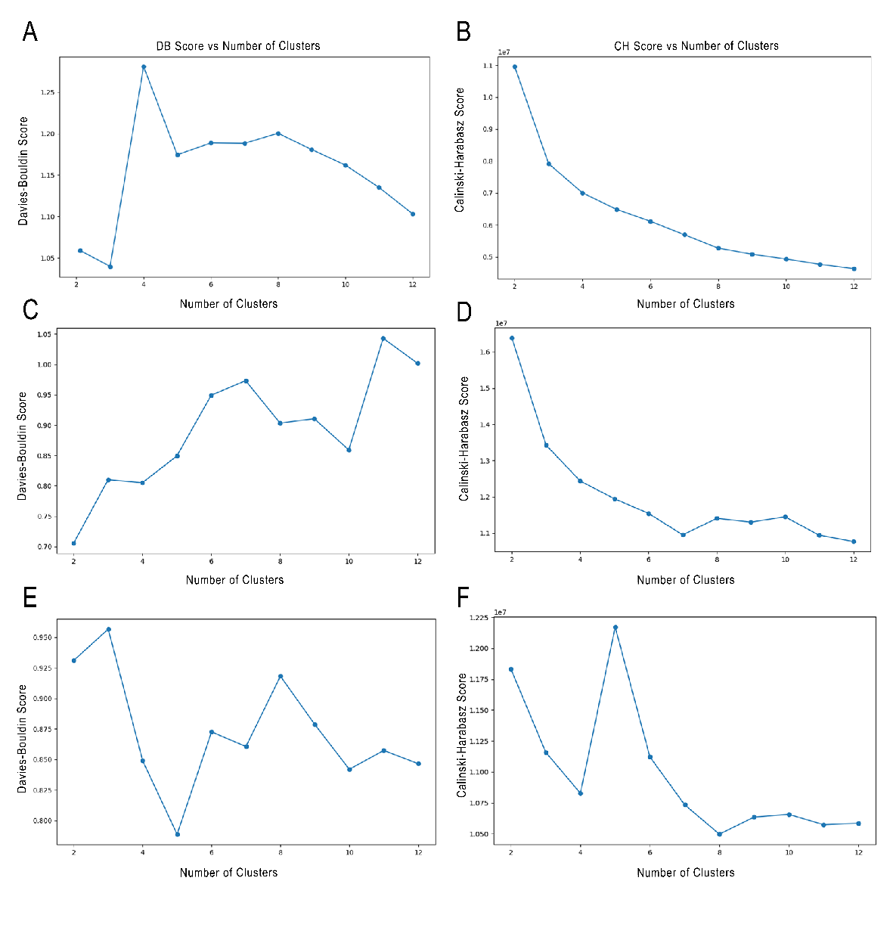
Figure S1 | Determination of cluster number K across different clustering methods. (A) Davies-Bouldin (DB) score for joint clustering of non-contrast–enhanced CT (nCECT) and contrast–enhanced CT (CECT); (B) Calinski-Harabasz (CH) score for joint clustering of CECT and nCECT; (C) DB score for independent clustering of nCECT; (D) CH score for independent clustering of nCECT; (E) DB score for independent clustering of CECT; (F) CH score for independent clustering of CECT.

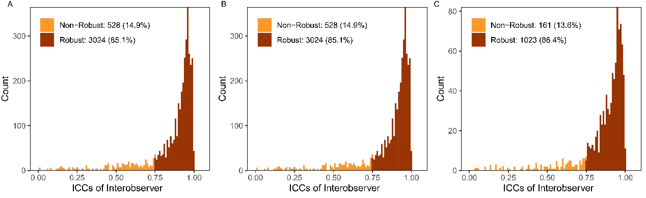
Figure S2 | Distribution of intraclass correlation coefficients (ICCs) under the joint clustering strategy. (A) ICC distribution of radiomic features extracted from Core_nCE. Of 3,552 features, 3,024 (85.1%) had ICC ≥ 0.75 and were classified as robust, whereas 528 (14.9%) had ICC < 0.75 and were classified as non-robust. (B) ICC distribution of radiomic features extracted from Core_CE. Of 3,552 features, 3,024 (85.1%) were robust and 528 (14.9%) were non-robust. (C) ICC distribution of radiomic features extracted from Peri_nCE. Of 1,184 features, 1,023 (86.4%) were robust and 161 (13.6%) were non-robust. Features with ICC ≥ 0.75 were considered robust and retained for subsequent analyses, whereas those with ICC < 0.75 were excluded.

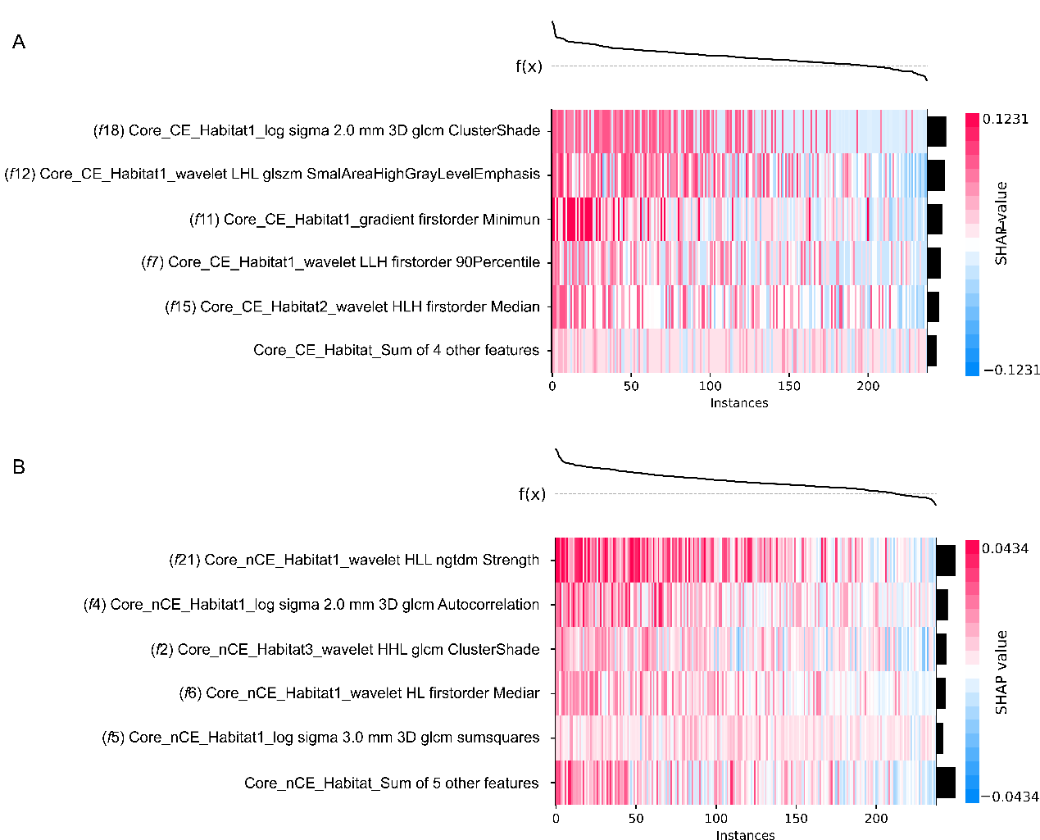
Figure S3 | Top five SHAP-ranked features in Core_CE and Core_nCE models. SHapley Additive exPlanations (SHAP) analysis depicting the top five most influential features in the Core_CE model (A) and Core_nCE model (B). CE contrast–enhanced, nCE non-contrast–enhanced.
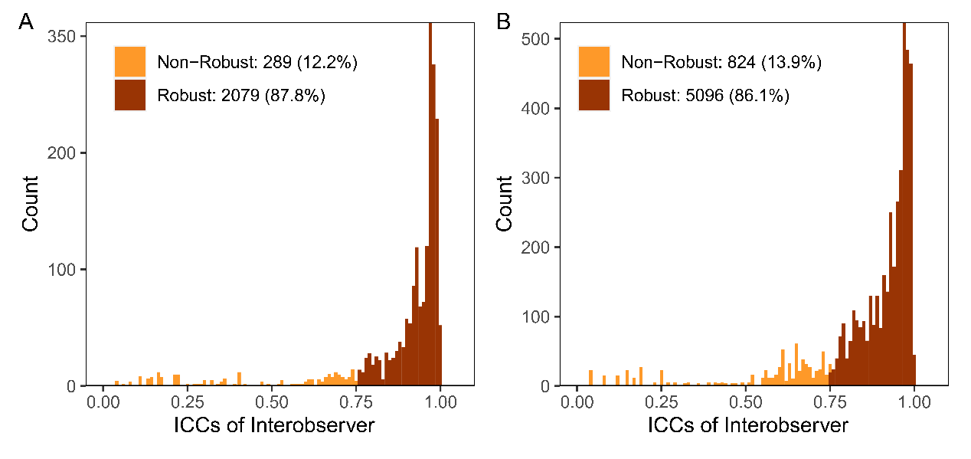
Figure S4 | Distribution of intraclass correlation coefficients (ICCs) under the independent clustering strategy. (A) ICC distribution of radiomic features extracted from snCE. Of 2,368 features, 2,079 (87.8%) had ICC ≥ 0.75 and were classified as robust, whereas 289 (12.2%) had ICC < 0.75 and were classified as non-robust. (B) ICC distribution of radiomic features extracted from sCE. Of 5,920 features, 5,096 (86.1%) were robust and 824 (13.9%) were non-robust. Features with ICC ≥ 0.75 were considered robust and retained for subsequent analyses, whereas those with ICC < 0.75 were excluded.

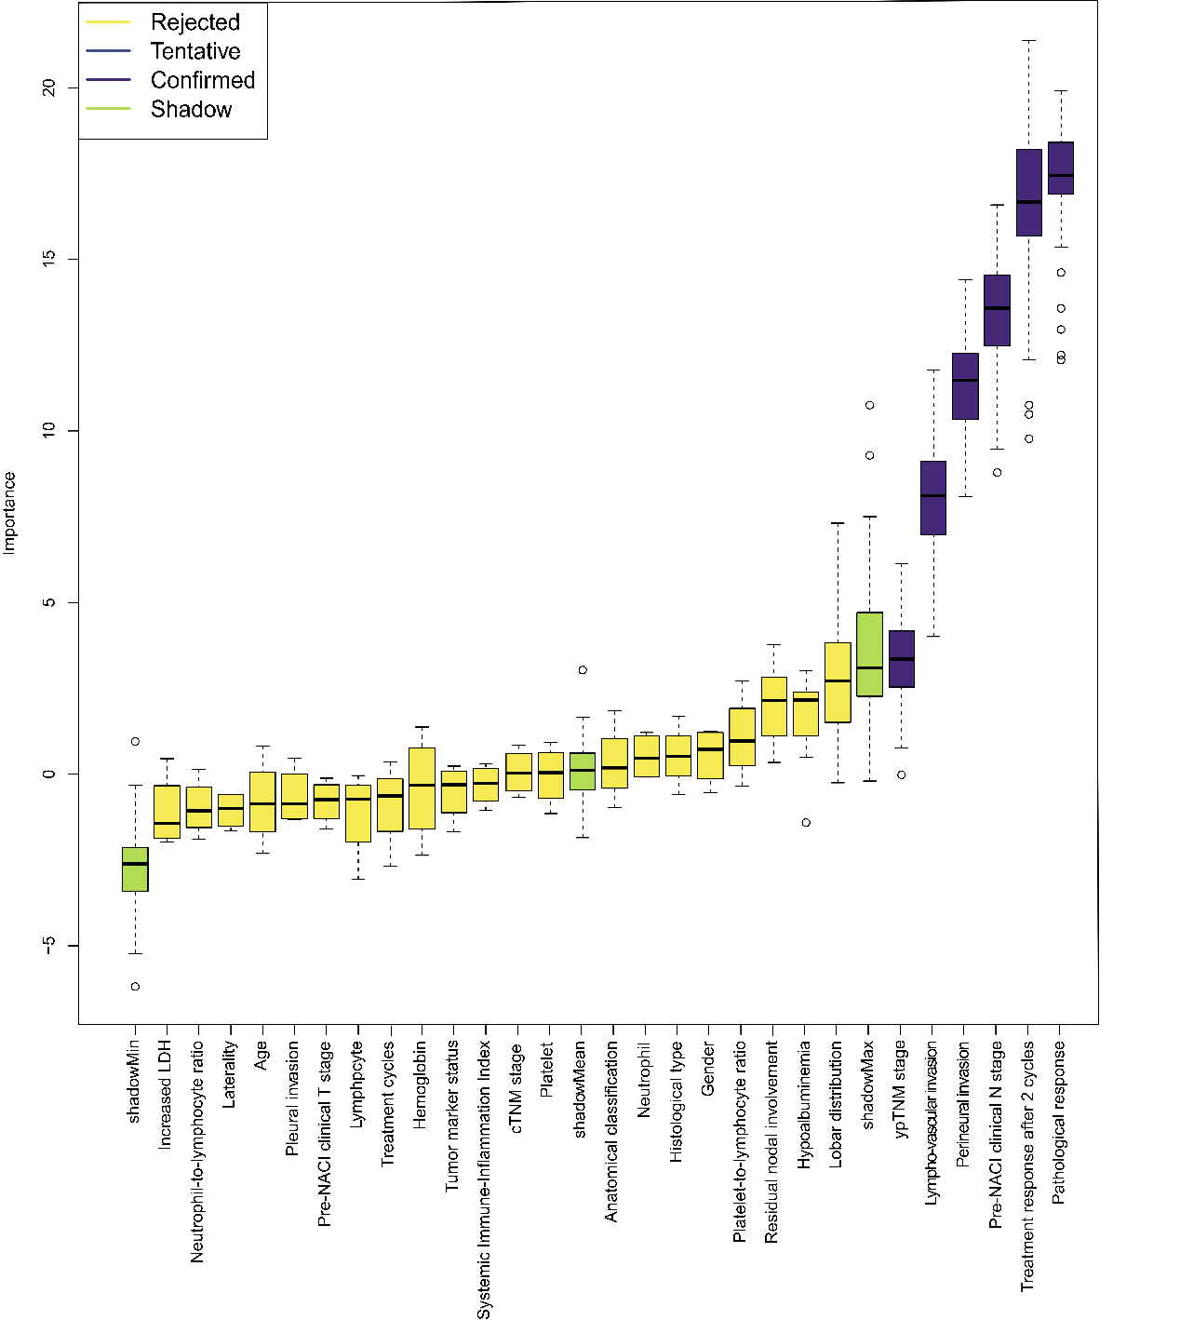Figure S5 | Boxplots of feature importance scores for clinical variables selected by the Boruta algorithm. LDH lactic dehydrogenase, cTNM clinical TNM stage, ypTNM post-neoadjuvant pathological TNM stage.

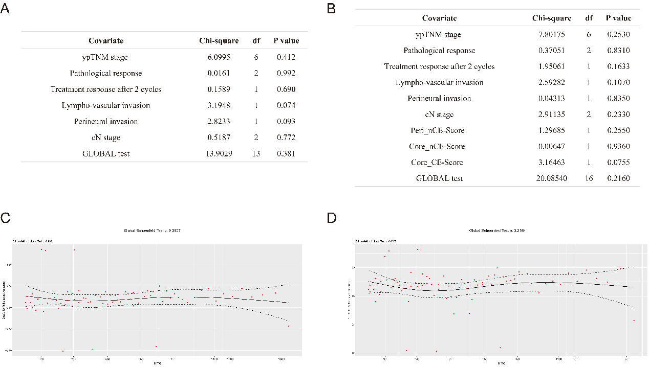
Figure S6 | Proportional hazards assumption tests for the clinicopathological model and the NeoLung-JC model. (A) Schoenfeld residual test results for each covariate in the clinicopathological model. (B) Schoenfeld residual test results for each covariate in the NeoLung-JC model. (C) Schoenfeld residual plot for the pCR variable in the clinicopathological model. (D) Schoenfeld residual plot for the pCR variable in the NeoLung-JC model. pCR pathological complete response.

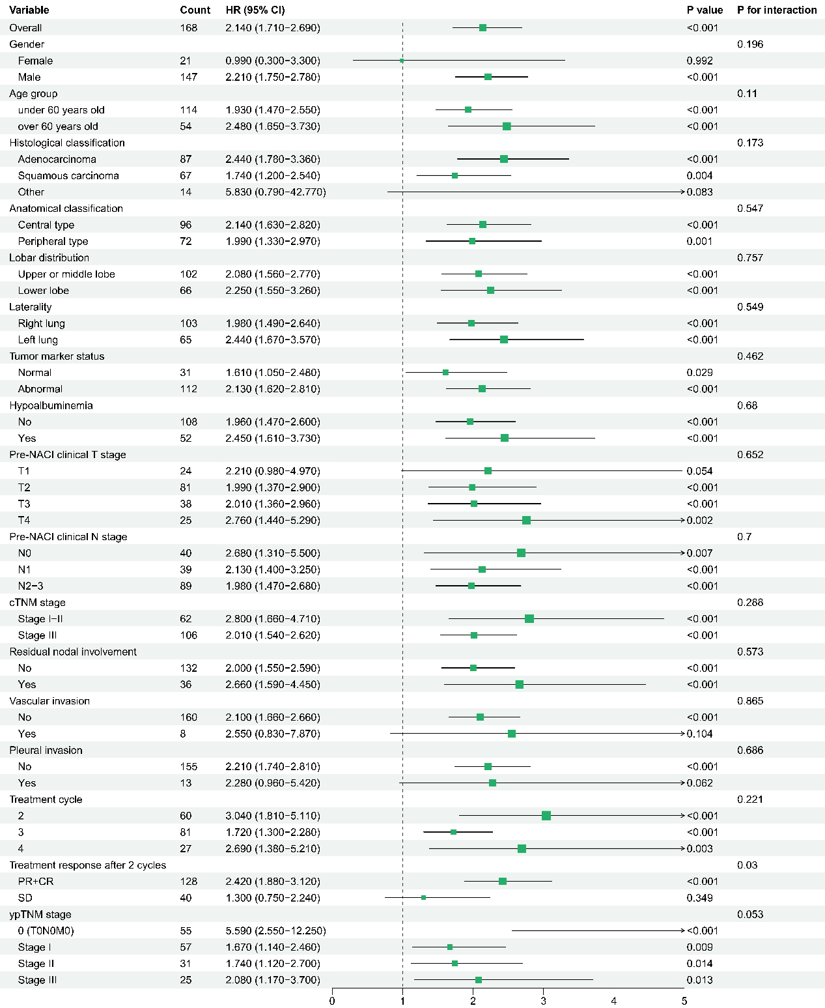
Figure S7 | Subgroup analysis with interaction tests. Subgroup analysis with interaction tests was performed to evaluate the predictive value of the NeoLung-JC model for disease-free survival in an external validation cohort of non-small cell lung cancer patients receiving neoadjuvant immunochemotherapy. HR hazard ratio, CI confidence interval, cTNM clinical TNM stage, SD, stable disease, CR complete response, PR partial response, ypTNM post-neoadjuvant pathological TNM stage.

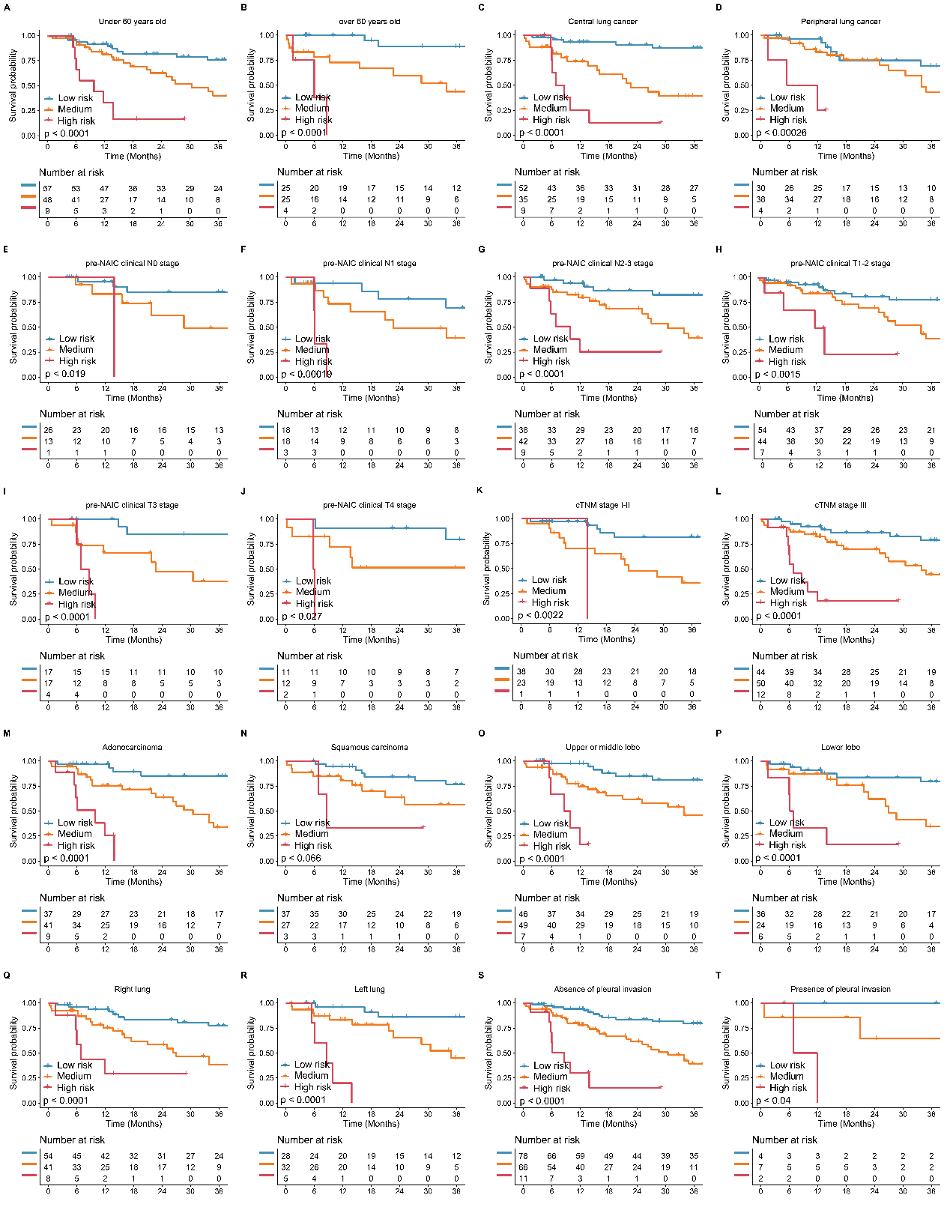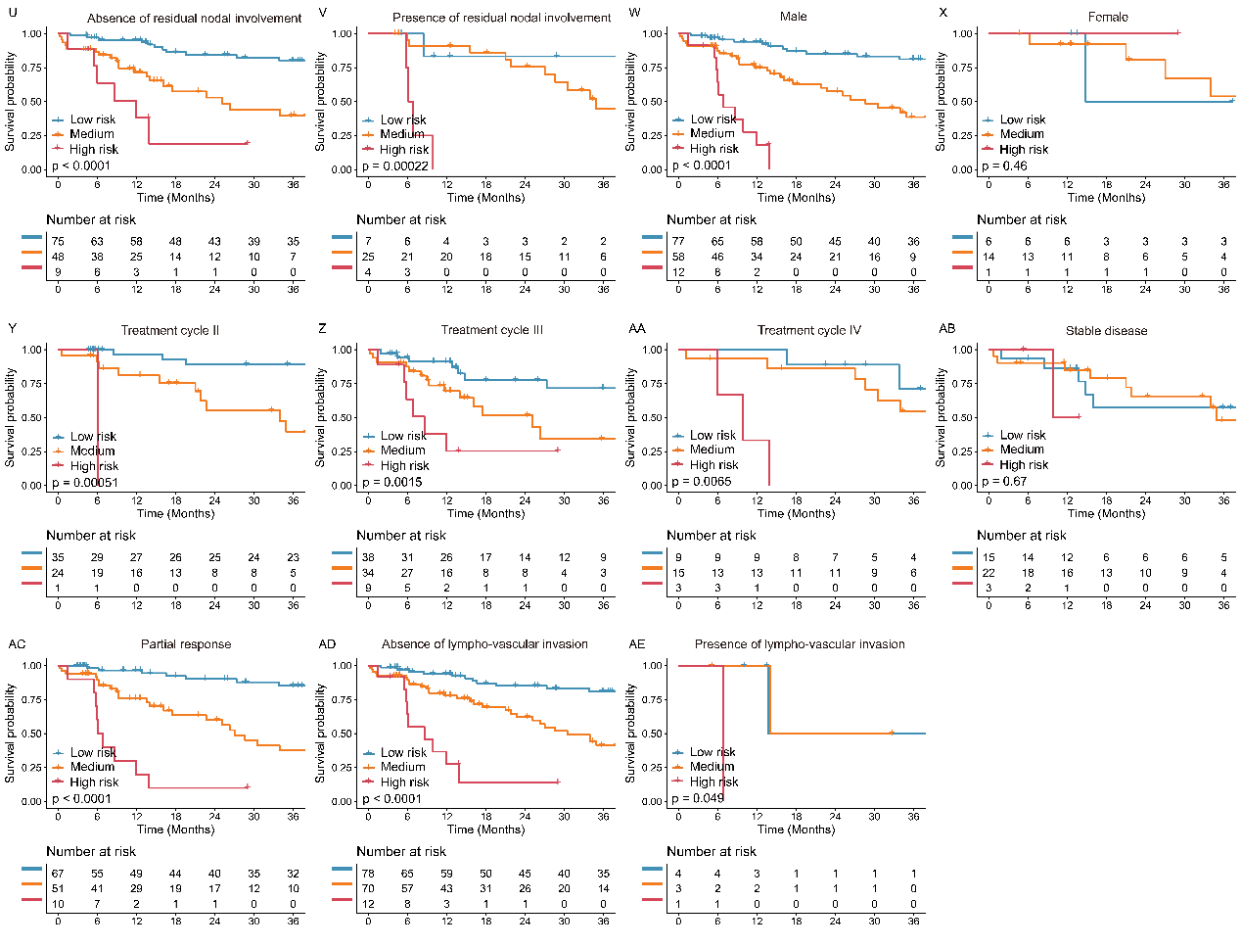
Figure S8 | Kaplan–Meier curves for subgroup analysis. In the external validation cohort, the DFS prognostic predictive ability of the high-, medium-, and low-risk groups stratified by NeoLung-JC model was validated in subgroups defined by different clinicopathological risk factors, including (A) under 60 years old, (B) over 60 years old, (C) central lung cancer, (D) peripheral lung cancer, (E) pre-NAIC clinical N0 stage, (F) pre-NAIC clinical N1 stage, (G) pre-NAIC clinical N2–3 stage, (H) pre-NAIC clinical T1–2 stage, (I) pre-NAIC clinical T3 stage, (J) pre-NAIC clinical T4 stage, (K) cTNM stage I–II, (L) cTNM stage III, (M) adenocarcinoma, (N) squamous carcinoma, (O) upper or middle lobe, (P) lower lobe, (Q) right lung, (R) left lung, (S) absence of pleural invasion, (T) presence of pleural invasion, (U) absence of residual nodal involvement, (V) presence of residual nodal involvement, (W) male, (X) female, (Y) treatment cycle = 2, (Z) treatment cycle = 3, (AA) treatment cycle = 4, (AB) stable disease, (AC) partial response, (AD) absence of lympho-vascular, (AE) presence of lympho-vascular. DFS disease-free survival, N node stage, T tumor stage, cTNM clinical TNM stage, NAIC neoadjuvant immunochemotherapy.
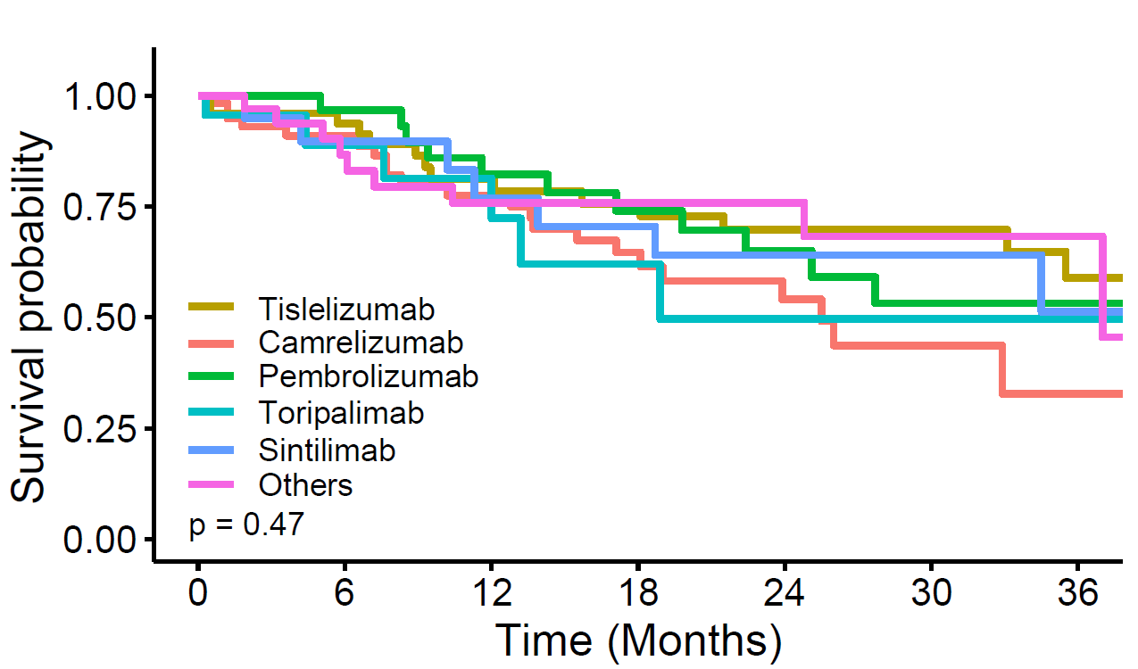
Figure S9 | Kaplan–Meier curves of disease-free survival stratified by ICI type. Patients were grouped according to the ICI received. Differences in DFS among ICI categories were assessed using the log-rank test (P = 0.47). ICI, immune checkpoint inhibitor; DFS, disease-free survival.

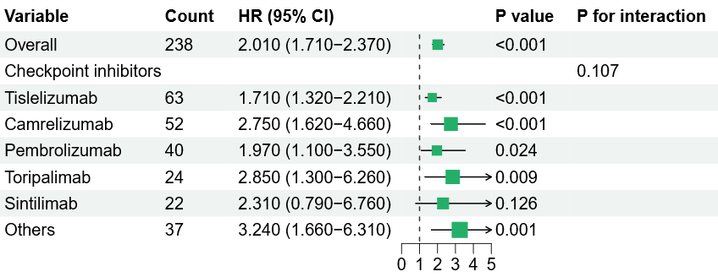
Figure S10 | Subgroup analysis of the NeoLung-JC model by ICI type. Forest plot of hazard ratios and 95% confidence intervals for the association between NeoLung-JC-predicted risk and DFS across ICI subgroups. No significant interaction was observed between ICI type and predicted risk (P for interaction = 0.107). ICI, immune checkpoint inhibitor; HR, hazard ratio; CI, confidence interval; DFS, disease-free survival.

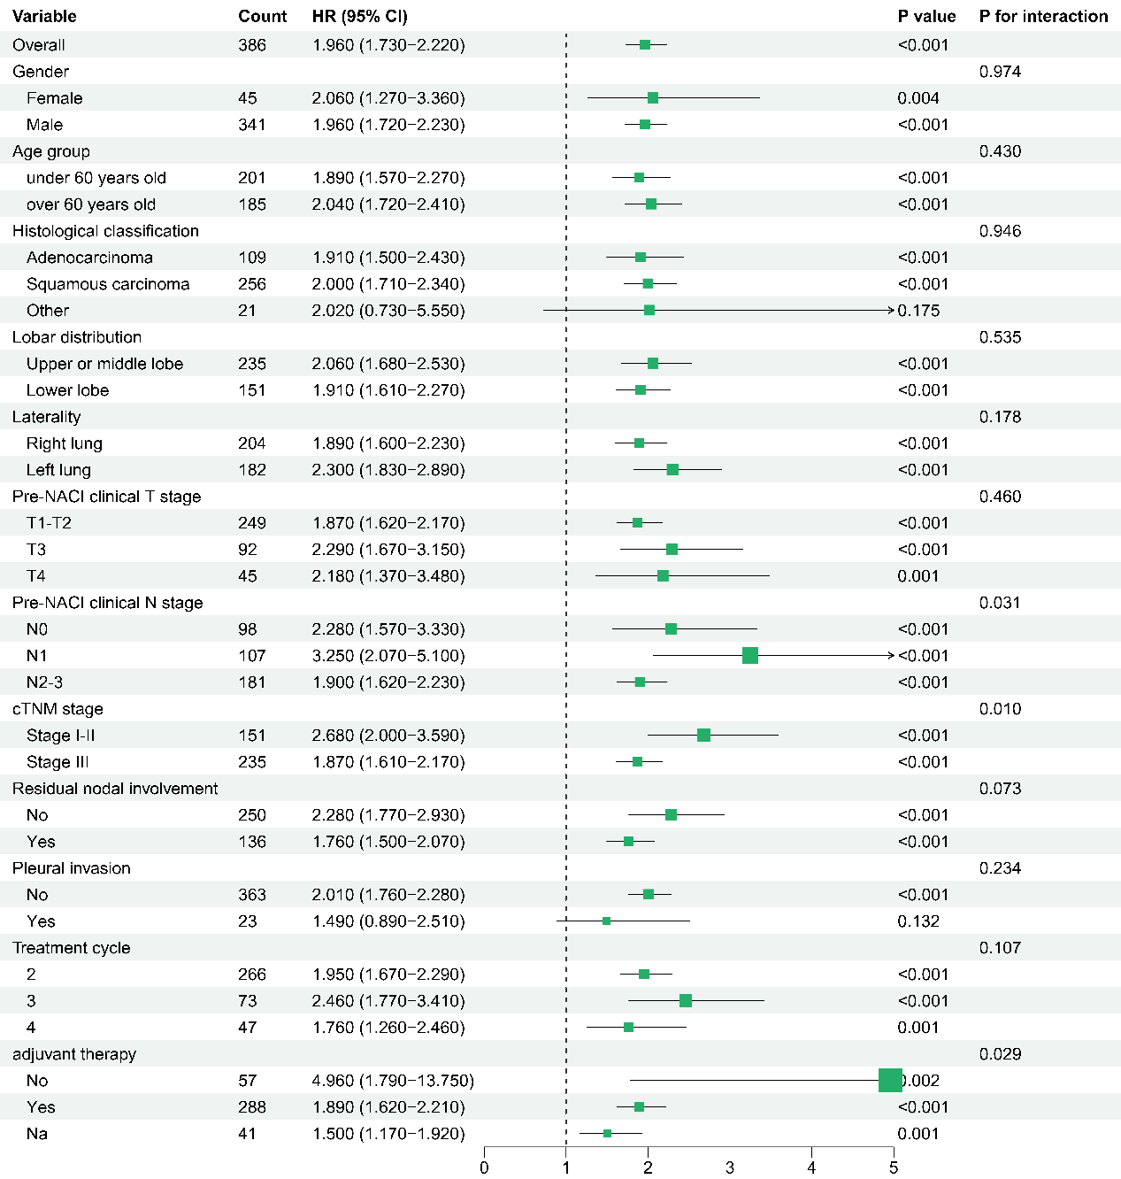
Figure S11 | Subgroup analysis of the NeoLung-JC model in Cohorts A and D.

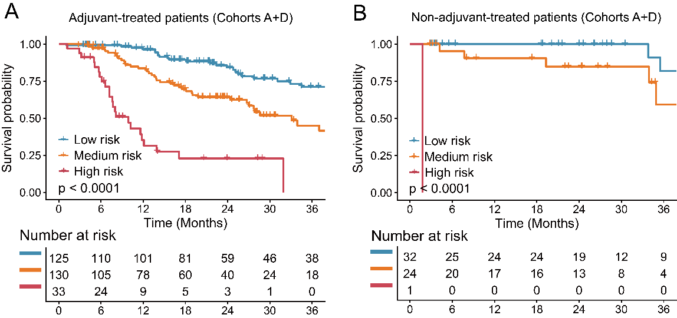
Figure S12 | Kaplan–Meier curves for DFS in Cohorts A and D stratified by adjuvant therapy status and NeoLung-JC risk groups. (A) Patients receiving adjuvant therapy. (B) Patients without adjuvant therapy.

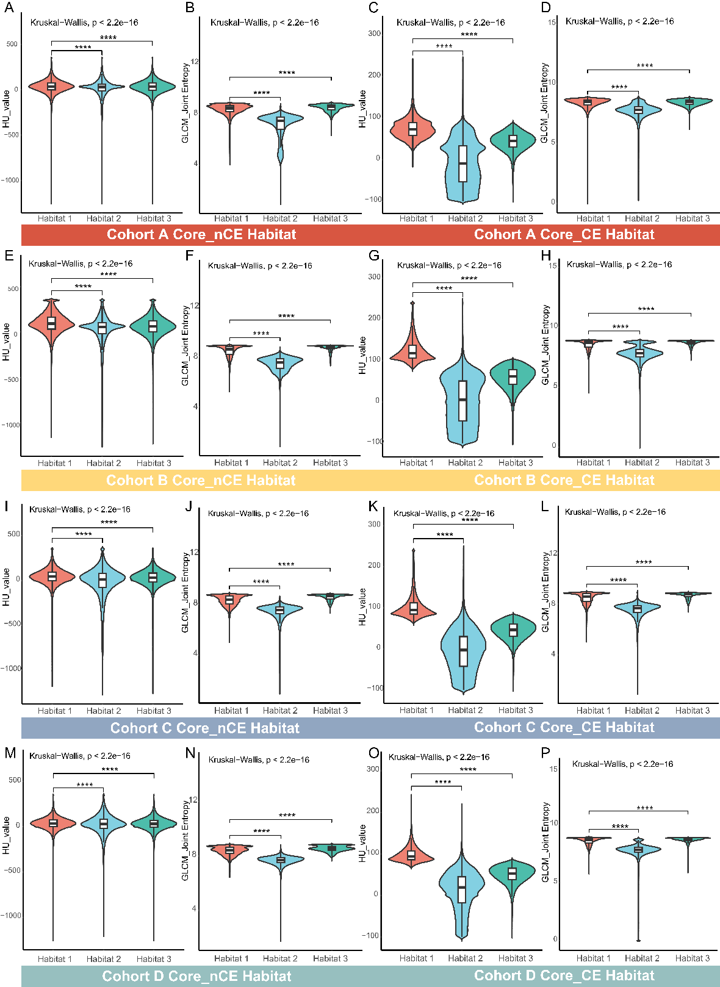
Figure S13 | Violin plots showing the distribution of four voxel-based features in the core region identified by the joint clustering method across four cohorts. From top to bottom, each row corresponds to one cohort; from left to right, each violin plot represents the Hounsfield unit (HU) value and gray-level co-occurrence matrix (GLCM) Joint Entropy for the Core_nCE region, followed by the HU value and GLCM Joint Entropy for the Core_CE region. In each plot, the central horizontal line denotes the median, and the width of the violin indicates the kernel density of the data distribution. Differences among the three habitats were assessed using the Kruskal-Wallis test, with all comparisons showing P < 2.2 × 10⁻¹⁶. Asterisks indicate pairs of habitats with statistically significant differences as determined by post hoc pairwise comparisons. Overall, a highly consistent pattern of feature distribution was observed across all four cohorts. nCE non-contrast–enhanced, CE contrast–enhanced.

