Supplementary Information
Supplementary Figures
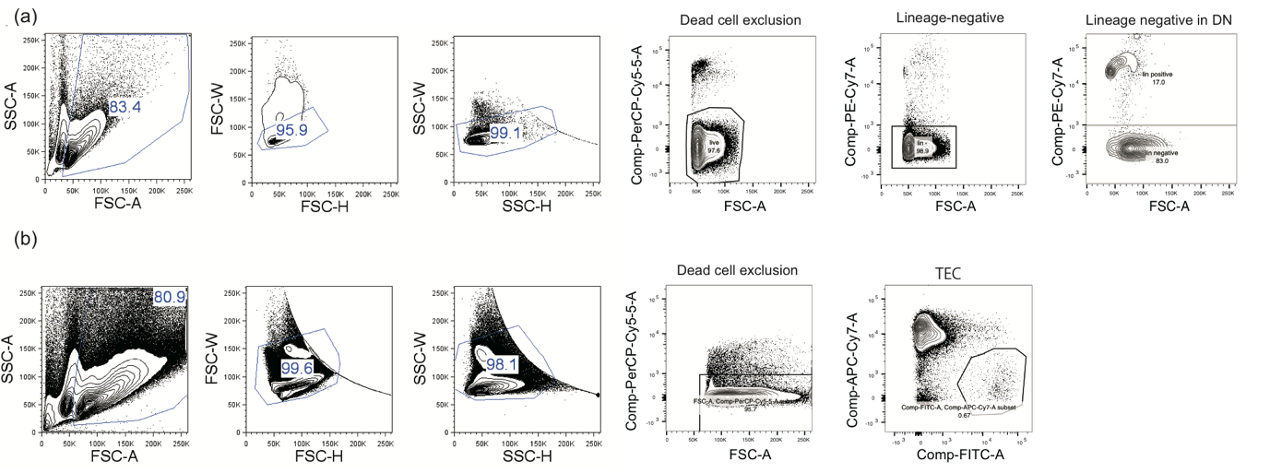
Supplementary Figure 1: (a) Gating strategy for thymocytes. (b) Gating strategy for TECs
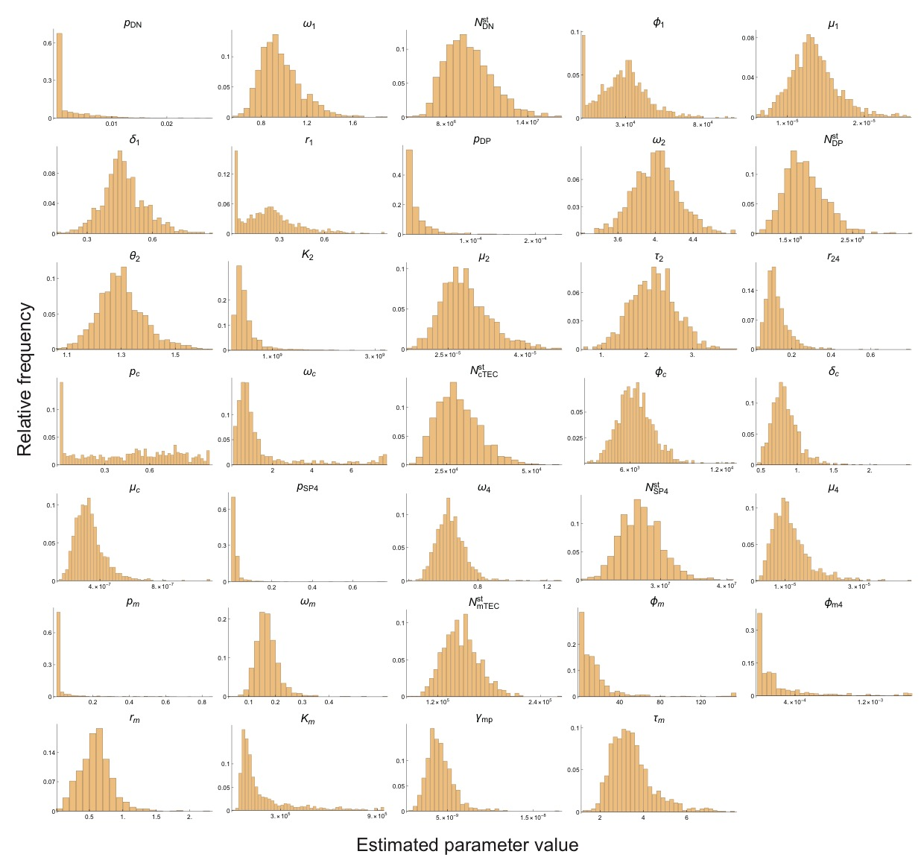Supplementary Figure 2: Histograms of the parameter values obtained by the bootstrap estimation.
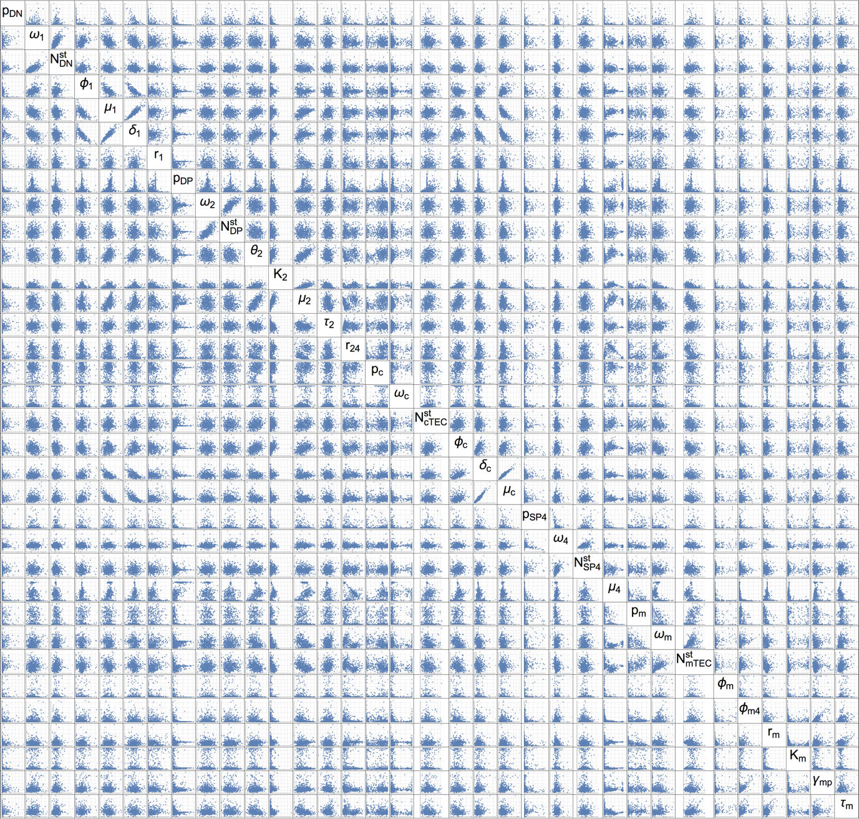
Supplementary Figure 3: Two-dimensional scatter plots of the parameter values obtained by the bootstrap estimation. The plot range of each parameter is set to be the same as that in Supplementary Fig. 2.
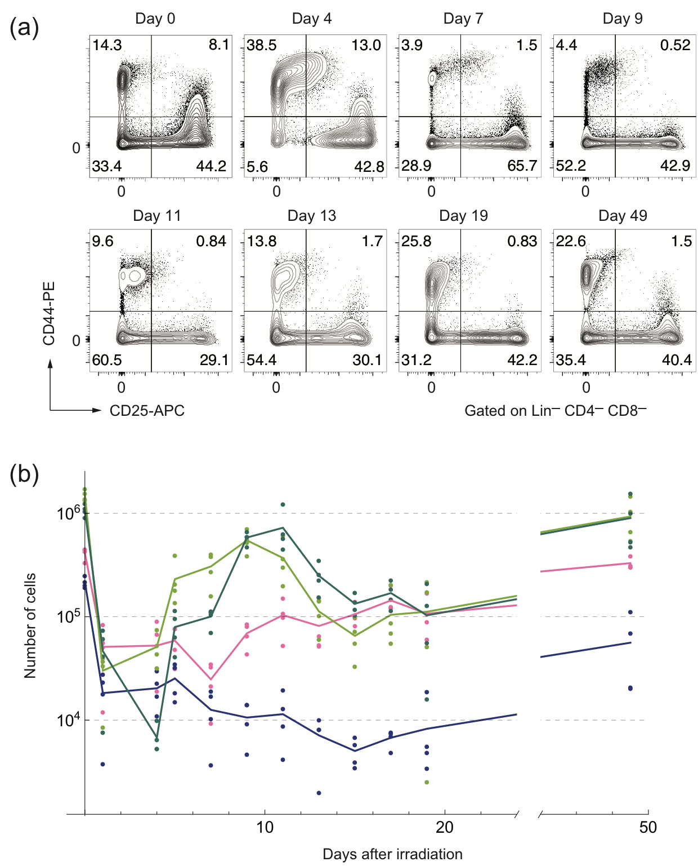
Supplementary Figure 4: (a) Typical flow cytometric profiles of DN thymocytes after the sub-lethal dose radiation. Lineage marker-negative, CD4-negative, CD8-negative thymocytes were analyzed by staining with anti-CD25 and anti-CD44. Percentage of each fraction is shown in the panels. (b) The trajectories of the counts of the DN1 (pink), DN2 (blue), DN3 (light green), DN4 (green) thymocytes after the irradiation. Points correspond to the experimental counts of the cells, and the solid curves are linear interpolations of the average counts at each time point. (n=4 at each time point)

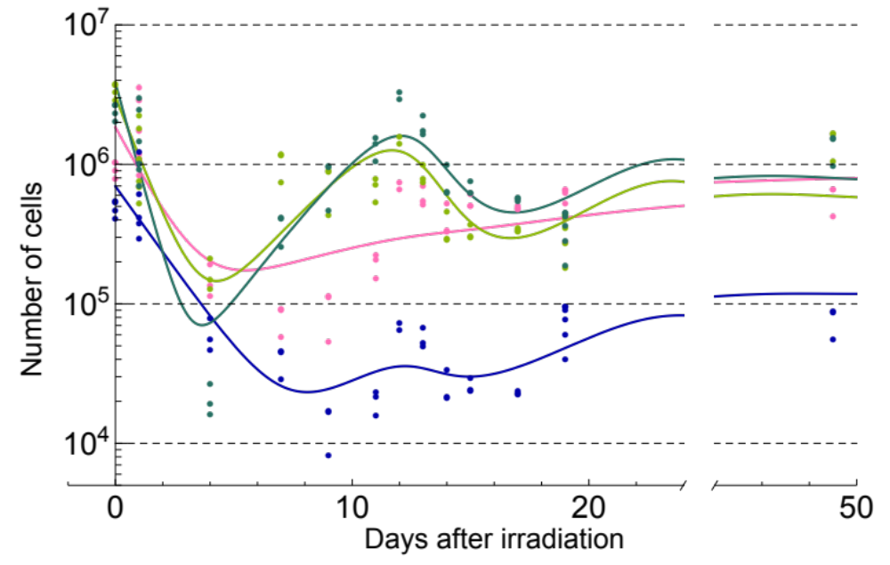
Supplementary Figure 5: Trajectories of the detailed model as a result of fitting to the experimentally obtained dynamics of DN subpopulations while keeping the values of the parameters common to the coarse-grained model fixed. DN1 : pink, DN2 : blue, DN3 : light green, DN4 : green.

Supplementary Tables
Supplementary Table 1. Estimated parameter values in the coarse-grained model. (CI : confidence interval). We should note that this is the first systematic estimate of the parameters related to the dynamics of TECs. These parameters should be verified by independent researches.

Symbol | Description | Value | CI
p_{DN} | Proportion of normal cells in the initial number of DN | 1.71 × 10⁻⁵ | [1.39 × 10⁻⁷, 1.18 × 10⁻²]
ω_{DN} | Death rate of irradiated DN | 9.24 × 10⁻¹ | [7.04 × 10⁻¹, 1.40 × 10⁰]
n_{DN}^{tot}(0) | Initial value for the number of DN | 9.29 × 10⁶ | [6.89 × 10⁶, 1.38 × 10⁷]
φ₁ | Inflow to DN | 3.34 × 10⁴ | [3.34 × 10³, 6.56 × 10⁴]
μ₁ | Negative regulation by cTEC to DN | 1.35 × 10⁻⁵ | [8.08 × 10⁻⁶, 2.11 × 10⁻⁵]
δ₁ | Intrinsic proliferation rate of DN | 4.69 × 10⁻¹ | [2.84 × 10⁻¹, 6.94 × 10⁻¹]
r₁ | Proportion of differentiation to DP in regulation by cTEC | 2.95 × 10⁻¹ | [1.57 × 10⁻⁵, 6.91 × 10⁻¹]
p_{DP} | Proportion of normal cells in the initial number of DP | 6.87 × 10⁻⁶ | [4.53 × 10⁻⁹, 8.39 × 10⁻⁵]
ω_{DP} | Death rate of irradiated DP | 4.00 × 10⁰ | [3.51 × 10⁰, 4.51 × 10⁰]
n_{DP}^{tot}(0) | Initial value for the number of DP | 1.70 × 10⁸ | [1.18 × 10⁸, 2.47 × 10⁸]
θ₂ | Proliferation rate of DP | 1.31 × 10⁰ | [1.14 × 10⁰, 1.51 × 10⁰]
K₂ | Carrying capacity of DP | 4.23 × 10⁸ | [2.42 × 10⁸, 1.39 × 10⁹]
μ₂ | Negative regulation rate by cTEC to DP | 2.85 × 10⁻⁵ | [2.06 × 10⁻⁵, 4.02 × 10⁻⁵]
τ₂ | Delay of cTEC regulating DP | 2.12 × 10⁰ | [1.17 × 10⁰, 3.12 × 10⁰]
r₂₄ | Proportion of differentiation to CD4+SP in regulation by cTEC | 1.03 × 10⁻¹ | [4.94 × 10⁻², 2.96 × 10⁻¹]
p_{cTEC} | Proportion of normal cells in the initial number of cTEC | 7.65 × 10⁻¹ | [1.10 × 10⁻⁴, 9.83 × 10⁻¹]
ω_{cTEC} | Death rate of irradiated cTEC | 7.67 × 10⁻¹ | [9.28 × 10⁻², 7.58 × 10⁰]
n_{cTEC}^{tot}(0) | Initial value for the number of cTEC | 2.71 × 10⁴ | [1.87 × 10⁴, 4.34 × 10⁴]
φ_{c} | Inflow to cTEC | 6.47 × 10³ | [4.26 × 10³, 8.75 × 10³]
δ_{c} | Death rate of cTEC | 7.94 × 10⁻¹ | [5.39 × 10⁻¹, 1.29 × 10⁰]
μ_{c} | Positive regulation by DN to cTEC | 3.13 × 10⁻⁷ | [1.96 × 10⁻⁷, 5.73 × 10⁻⁷]
p_{SP4} | Proportion of normal cells in the initial number of CD4+SP | 1.47 × 10⁻² | [8.22 × 10⁻⁴, 1.11 × 10⁻¹]
ω_{SP4} | Death rate of irradiated CD4+SP | 6.31 × 10⁻¹ | [5.04 × 10⁻¹, 8.28 × 10⁻¹]
n_{SP4}^{tot}(0) | Initial value for the number of CD4+SP | 2.66 × 10⁷ | [2.16 × 10⁷, 3.38 × 10⁷]
μ₄ | Negative regulation by mTEC to CD4+SP | 9.85 × 10⁻⁶ | [4.70 × 10⁻⁶, 2.47 × 10⁻⁵]
p_{mTEC} | Proportion of normal cells in the initial number of mTEC | 3.15 × 10⁻⁶ | [5.53 × 10⁻⁸, 4.39 × 10⁻¹]
ω_{mTEC} | Death rate of irradiated mTEC | 1.60 × 10⁻¹ | [9.97 × 10⁻², 2.79 × 10⁻¹]
n_{mTEC}^{tot}(0) | Initial value for the number of mTEC | 1.44 × 10⁵ | [1.10 × 10⁵, 1.93 × 10⁵]
φ_{m} | Constant inflow to mTEC | 1.52 × 10¹ | [1.52 × 10⁰, 1.18 × 10²]
φ_{m4} | Inflow to mTEC regulated by CD4+SP | 1.60 × 10⁻⁴ | [1.60 × 10⁻⁵, 1.53 × 10⁻³]
r_{m} | Proliferation rate of mTEC | 6.10 × 10⁻¹ | [1.67 × 10⁻¹, 1.16 × 10⁰]
K_{m} | Carrying capacity of mTEC | 9.22 × 10⁴ | [4.94 × 10⁴, 7.41 × 10⁵]
γ_{mp} | Negative regulation rate by DP to mTEC | 3.50 × 10⁻⁹ | [1.76 × 10⁻⁹, 8.18 × 10⁻⁹]
τ_{m} | Delay of DP regulating mTEC | 3.27 × 10⁰ | [2.09 × 10⁰, 6.19 × 10⁰]

Supplementary Table 2. Estimated parameter values in the detailed model.
Symbol | Description | Value
φ₁ | Inflow to DN | 5.65 × 10¹
δ_{DN1} | Intrinsic proliferation rate of DN1 | 5.42 × 10⁻¹
δ_{DN2} | Intrinsic proliferation rate of DN2 | 3.26 × 10⁻⁵
δ_{DN3} | Intrinsic proliferation rate of DN3 | 7.38 × 10⁻¹
δ_{DN4} | Intrinsic proliferation rate of DN4 | 4.14 × 10⁻¹
μ_{DN1} | Negative regulation by cTEC to DN1 | 1.32 × 10⁻⁵
μ_{DN2} | Negative regulation by cTEC to DN2 | 1.25 × 10⁻⁴
μ_{DN3} | Negative regulation by cTEC to DN3 | 3.30 × 10⁻⁵
μ_{DN4} | Negative regulation by cTEC to DN4 | 3.39 × 10⁻⁵
μ_{cTEC1} | Positive regulation by DN1 to cTEC | 2.59 × 10⁻⁷
μ_{cTEC2} | Positive regulation by DN2 to cTEC | 1.06 × 10⁻⁸
μ_{cTEC3} | Positive regulation by DN3 to cTEC | 2.80 × 10⁻⁹
μ_{cTEC4} | Positive regulation by DN4 to cTEC | 5.33 × 10⁻⁷
n_{DN1}^{tot}(0) | Initial value for the number of DN1 | 1.80 × 10⁶
n_{DN2}^{tot}(0) | Initial value for the number of DN2 | 7.09 × 10⁵
n_{DN3}^{tot}(0) | Initial value for the number of DN3 | 2.86 × 10⁶
n_{DN4}^{tot}(0) | Initial value for the number of DN4 | 3.84 × 10⁶
p_{DN1} | Proportion of normal cells in the initial number of DN1 | 2.30 × 10⁻³
p_{DN2} | Proportion of normal cells in the initial number of DN2 | 2.37 × 10⁻²
p_{DN3} | Proportion of normal cells in the initial number of DN3 | 4.08 × 10⁻⁴
p_{DN4} | Proportion of normal cells in the initial number of DN4 | 2.47 × 10⁻⁵
ω_{DN1} | Death rate of irradiated DN1 | 6.24 × 10⁻¹
ω_{DN2} | Death rate of irradiated DN2 | 5.14 × 10⁻¹
ω_{DN3} | Death rate of irradiated DN3 | 8.95 × 10⁻¹
ω_{DN4} | Death rate of irradiated DN4 | 1.44 × 10⁰
r_{DN4} | Proportion of differentiation from DN4 to DP in regulation by cTEC | 6.67 × 10⁻¹

