Supplementary Information

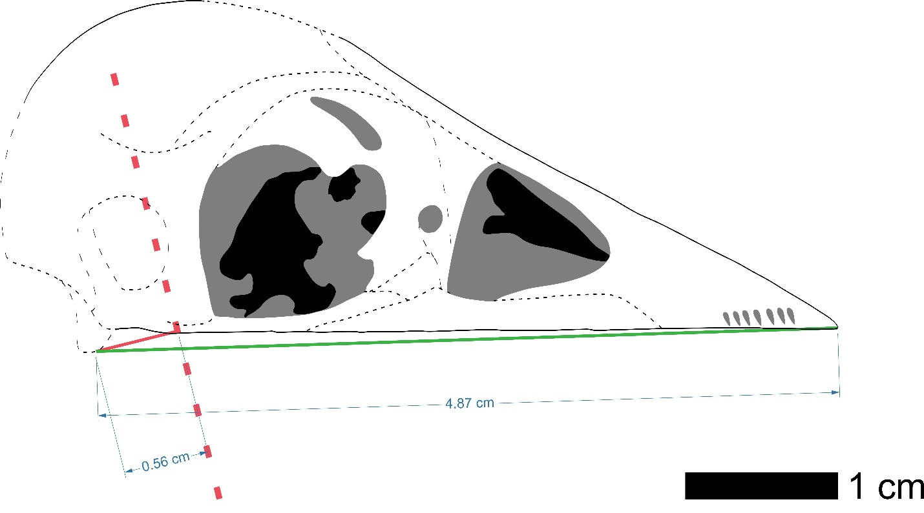
Supplementary Figure 1. Reconstruction of Confuciusornis sanctus STM 13-162. The maxilla as reconstructed in Figure 1C, with rhamphotheca removed. Mechanical inlever (red) and outlever (green) are labeled after¹, with lengths labeled.

Rhamphotheca Thickness | Max VM Stress (MPa) | Avg VM Stress (MPa)
0% | 5.609 | 2.19662
25% | 5.827 | 2.24624
50% | 5.695 | 2.25848
75% | 5.839 | 2.25643
100% | 5.891 | 2.28961
125% | 5.507 | 2.1151
150% | 5.864 | 2.24471
175% | 6.081 | 2.32951
200% | 6.102 | 2.30009
Supplementary Table 1. Sample Sensitivity Analysis of Rhamphotheca Thickness Effect on FEA. Example based on the model of Lonchura malacca (Fig. 2E) in which sensitivity was relatively high in order to present a conservative estimate. VM stress was worked with disregarding the upper 2% of values as singularities after². Rhamphotheca thickness is given relative to that used in Figure 2. Thickness was modulated by increasing or decreasing the amount of underlying bone, so as to not affect the overall lever length of the jaw. While there is a weak trend of increase (R² = 0.4) in the maximum VM stress experienced with increased thickness, likely due to compressing the tip of the mandible to smaller elements, the overall average VM stress resembles pure noise (R² = 0.1). The range of VM stress within a taxa (0.6 MPa) is also much less than the range between taxa (8.9 MPa).

Supplementary References

1. Navalón G, Bright JA, Marugán-Lobón J, Rayfield EJ. The evolutionary relationship among beak shape, mechanical advantage, and feeding ecology in modern birds. Evolution 73, 422-435 (2018).

2. Marcé-Nogué J, De Esteban-Trivigno S, Püschel TA, Fortuny J. The intervals method: a new approach to analyse finite element outputs using multivariate statistics. PeerJ 5, e3793 (2017).

