Supplementary Material

Multimodal Detection of Dopamine by Sniffer Cells Expressing Genetically Encoded Fluorescent Sensors

Carmen Klein Herenbrink^{#1}, Jonatan Fullerton Støier^{#1}, William Dalseg Reith¹, Abeer Dagra², Miguel Alejandro Cuadrado Gregorek¹, Reto B. Cola³, Tommaso Patriarchi ^{3,4}, Yulong Li^{5,6,7}, Lin Tian⁸, Ulrik Gether¹, Freja Herborg^{1†}

# Contributed equally

¹Molecular Neuropharmacology and Genetics Laboratory, Department of Neuroscience, Faculty of Health and Medical Sciences, University of Copenhagen, Copenhagen, Denmark.
²College of Medicine, University of Florida, Gainesville, FL 32611, USA.
³Institute of Pharmacology and Toxicology, University of Zurich, Zurich, Switzerland
⁴Neuroscience Center Zurich, University and ETH Zurich, Zurich, Switzerland
⁵State Key Laboratory of Membrane Biology, Peking University School of Life Sciences, 100871 Beijing, China
⁶PKU-IDG/McGovern Institute for Brain Research, 100871 Beijing, China
⁷Peking-Tsinghua Center for Life Sciences, 100871 Beijing, China.
⁸Departments of Biochemistry and Molecular Medicine, School of Medicine, University of California, Davis, Davis, CA, USA

†Address author correspondence to: Freja Herborg, Department of Neuroscience, Maersk Tower 7.5, University of Copenhagen, Blegdamsvej 3B, DK-2200 N, Copenhagen, Denmark. Phone +4553609699; E-mail: frejahh@sund.ku.dk

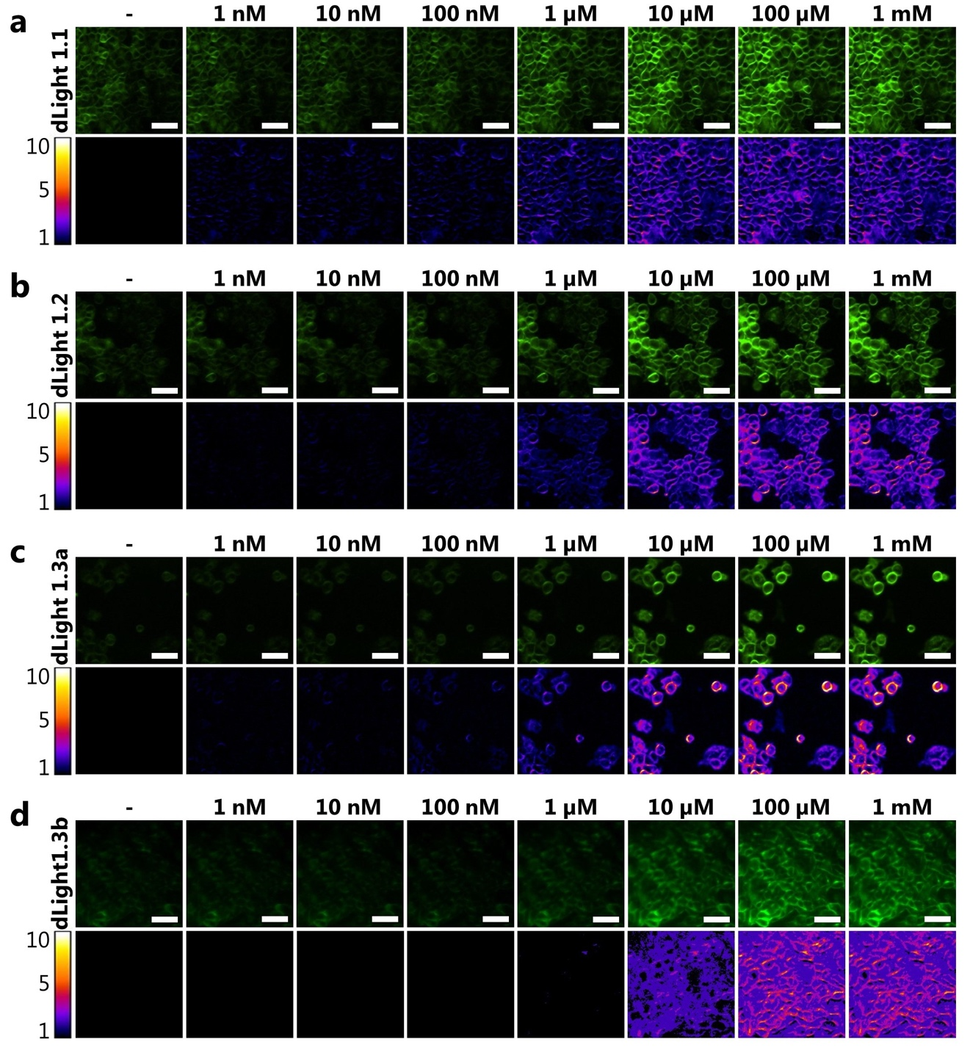
Supplementary Figure 1. Characterization of D1R-Based DA Sensor-Expressing Sniffer Cell Lines. The dose-dependent increase in fluorescence upon addition of increasing DA concentrations to cells expressing the dLight1.1 (a), dLight1.2 (b), dLight1.3a (c), and dLight1.3b (d) sensors as detected by an epifluorescence microscope. Bottom panels show the change in fluorescence (F/F₀) upon addition of DA. Images shown are representatives from three independent experiments. Scale bars are 50µM.
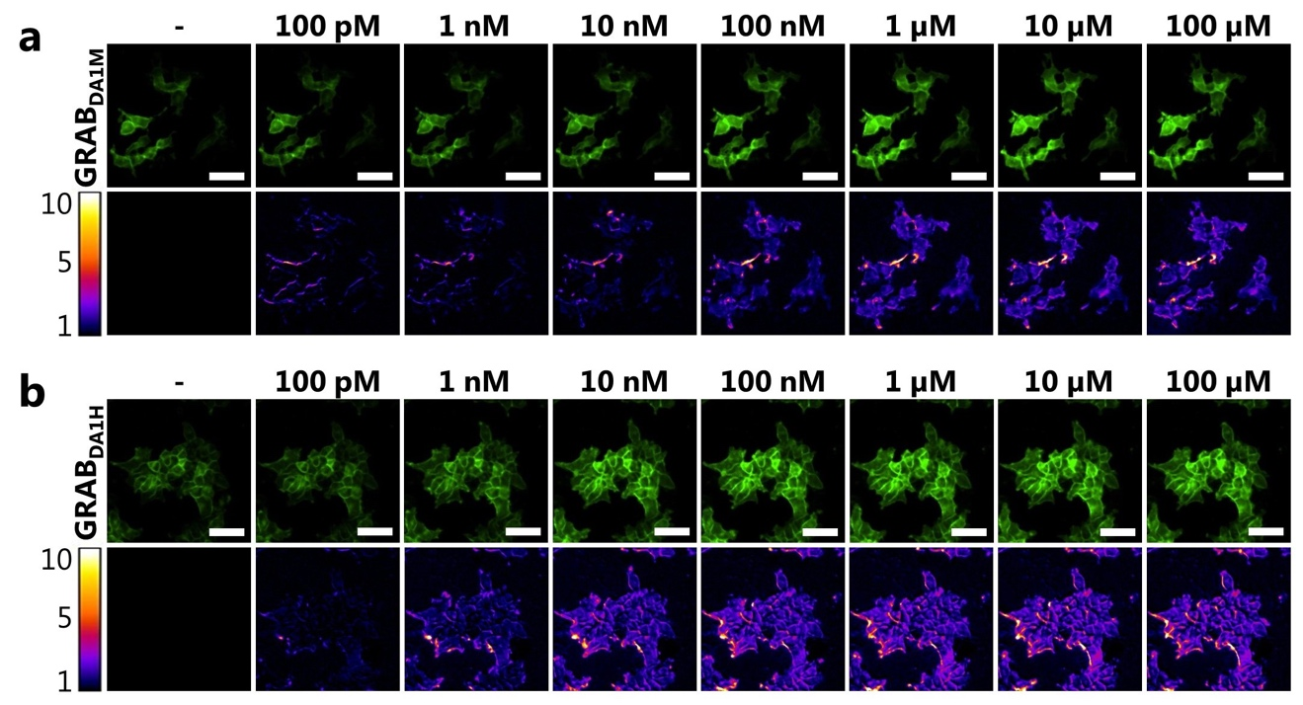
Supplementary Figure 2. Characterization of D2R-Based DA Sensor-Expressing Sniffer Cell Lines. The dose-dependent increase in fluorescence upon addition of increasing DA concentrations to cells expressing the GRAB_{DA1M} (a) and GRAB_{DA1H} (b) sensors as detected by an epifluorescence microscope. Bottom panels show the change in fluorescence (F/F₀) upon addition of DA. Images shown are representatives from three independent experiments. Scale bars are 50µM.

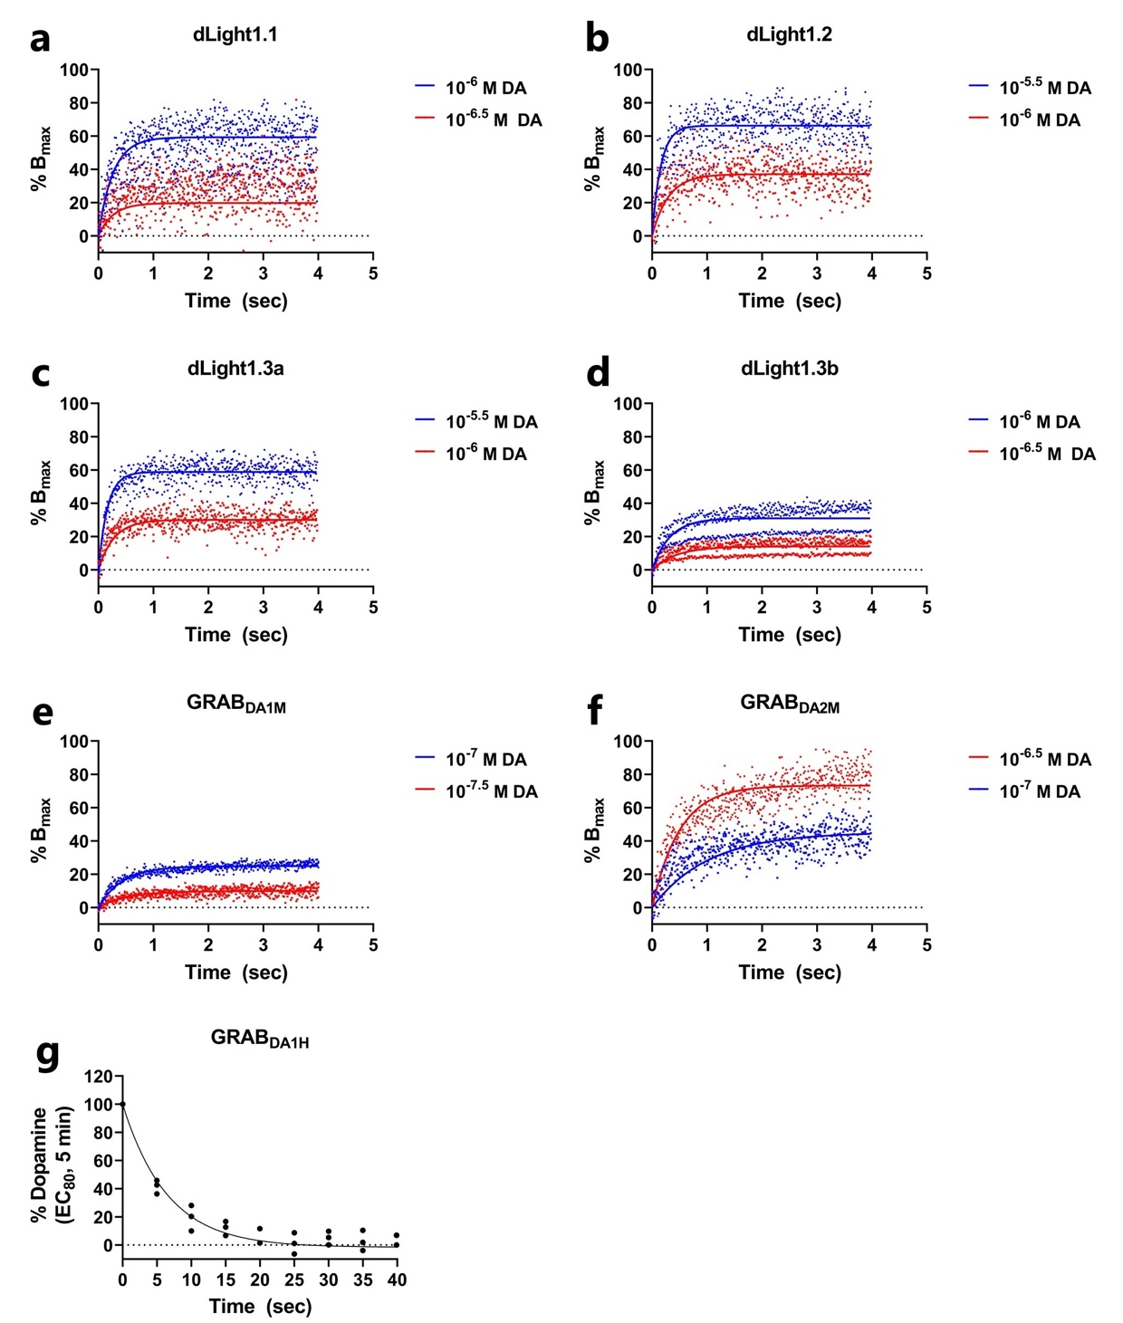
Supplementary Figure 3. Determination of Kinetic Parameters of DA Sensors. (a-f) Sniffer cells were stimulated with two concentrations of DA and the change in fluorescence was determined over time. The data was then fitted with Graphpad Prism (association kinetics (two ligands concentrations)) to allow the determination of the on (k_{on}) and off (k_{off}) activation rates. (g) GRAB_{DA1H}-expressing sniffer cells were stimulated for 5 minutes with an EC₈₀ concentration of DA followed by 10µM haloperidol (time-point 0) to determine the off-rate. The data was fitted with Graphpad Prism (Dissociation - One phase exponential decay). Data is shown as fitted curves in scatter plots of three-four independent experiments conducted on a fluorescence plate reader.

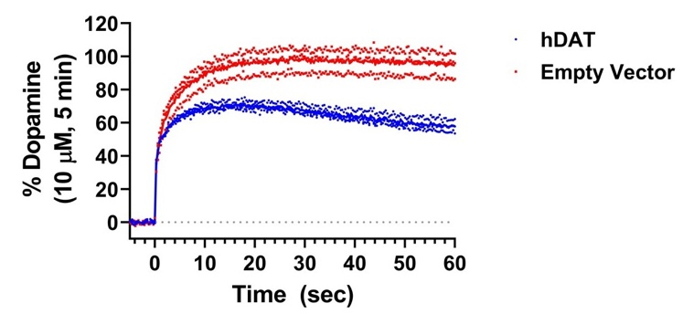
Supplementary Figure 4. Detection of DAT-Mediated DA Uptake Using Sniffer Cells. Measurement of DA uptake using DA sniffer cells. GRAB_{DA2M} sniffer cells, transfected with hDAT or an empty pcDNA3.1 expression vector, were stimulated with 1 µM DA for 1 min with fast sampling every 0.3s. The decreased fluorescence upon addition of DA to cells transfected with hDAT versus an empty vector is indicative of DAT-mediated DA uptake into the cells. To ensure that the measurements between hDAT- and empty vector-transfected cells were comparable (as expression of hDAT may alter the sensor expression) the data was normalized to a 5 min stimulation with a saturating concentration of DA (10 µM). The fast sampling rate shows that the hDAT-expressing cells exhibit a similar sensor response as the control cells in the first seconds after dopamine stimulation, but never reaches the response as cell without hDAT expression, consistent with a hDAT-mediated local dopamine depletion. Data is shown as connecting line of the mean in a scatter plot of three independent experiments conducted on a fluorescence plate reader.

Supplementary Video 1. The video shows the fluorescence change of GRAB_{DA1H} sniffer cells co-cultured with tdTomato-expressing mouse dopaminergic neurons upon stimulation with 90mM KCl.

