Supplementary Material

Altered Subgenomic RNA Abundance Provides Unique Insight into SARS-CoV-2 B.1.1.7 Infections

Contents
Supplementary Material 1
Contents 1
Supplementary Authors 3
Supplementary Data 18
Supplementary Tables 19
Supplementary Figures 22

Supplementary Authors

Funding acquisition, Leadership and supervision, Metadata curation, Project administration, Samples and logistics, Sequencing and analysis, Software and analysis tools, and Visualisation:
Samuel C Robson ^{13, 84}
Funding acquisition, Leadership and supervision, Metadata curation, Project administration, Samples and logistics, Sequencing and analysis, and Software and analysis tools:
Thomas R Connor ^{11, 74} and Nicholas J Loman ⁴³
Leadership and supervision, Metadata curation, Project administration, Samples and logistics, Sequencing and analysis, Software and analysis tools, and Visualisation:
Tanya Golubchik ⁵
Funding acquisition, Leadership and supervision, Metadata curation, Samples and logistics, Sequencing and analysis, and Visualisation:
Rocio T Martinez Nunez ⁴⁶
Funding acquisition, Leadership and supervision, Project administration, Samples and logistics, Sequencing and analysis, and Software and analysis tools:
David Bonsall ⁵
Funding acquisition, Leadership and supervision, Project administration, Sequencing and analysis, Software and analysis tools, and Visualisation:
Andrew Rambaut ¹⁰⁴
Funding acquisition, Metadata curation, Project administration, Samples and logistics, Sequencing and analysis, and Software and analysis tools:
Luke B Snell ¹²
Leadership and supervision, Metadata curation, Project administration, Samples and logistics, Software and analysis tools, and Visualisation:
Rich Livett ¹¹⁶
Funding acquisition, Leadership and supervision, Metadata curation, Project administration, and Samples and logistics:
Catherine Ludden ^{20, 70}
Funding acquisition, Leadership and supervision, Metadata curation, Samples and logistics, and Sequencing and analysis:
Sally Corden ⁷⁴ and Eleni Nastouli ^{96, 95, 30}
Funding acquisition, Leadership and supervision, Metadata curation, Sequencing and analysis, and Software and analysis tools:
Gaia Nebbia ¹²
Funding acquisition, Leadership and supervision, Project administration, Samples and logistics, and Sequencing and analysis:
Ian Johnston ¹¹⁶
Leadership and supervision, Metadata curation, Project administration, Samples and logistics, and Sequencing and analysis:
Katrina Lythgoe ⁵, M. Estee Torok ^{19, 20} and Ian G Goodfellow ²⁴
Leadership and supervision, Metadata curation, Project administration, Samples and logistics, and Visualisation:
Jacqui A Prieto ^{97, 82} and Kordo Saeed ^{97, 83}
Leadership and supervision, Metadata curation, Project administration, Sequencing and analysis, and Software and analysis tools:
David K Jackson ¹¹⁶
Leadership and supervision, Metadata curation, Samples and logistics, Sequencing and analysis, and Visualisation:
Catherine Houlihan ^{96, 94}
Leadership and supervision, Metadata curation, Sequencing and analysis, Software and analysis tools, and Visualisation:
Dan Frampton ^{94, 95}
Metadata curation, Project administration, Samples and logistics, Sequencing and analysis, and Software and analysis tools:
William L Hamilton ¹⁹ and Adam A Witney ⁴¹
Funding acquisition, Samples and logistics, Sequencing and analysis, and Visualisation:
Giselda Bucca ¹⁰¹
Funding acquisition, Leadership and supervision, Metadata curation, and Project administration:
Cassie F Pope ^{40, 41}
Funding acquisition, Leadership and supervision, Metadata curation, and Samples and logistics:
Catherine Moore ⁷⁴
Funding acquisition, Leadership and supervision, Metadata curation, and Sequencing and analysis:
Emma C Thomson ⁵³
Funding acquisition, Leadership and supervision, Project administration, and Samples and logistics:
Ewan M Harrison ^{116, 102}
Funding acquisition, Leadership and supervision, Sequencing and analysis, and Visualisation:
Colin P Smith ¹⁰¹
Leadership and supervision, Metadata curation, Project administration, and Sequencing and analysis:
Fiona Rogan ⁷⁷
Leadership and supervision, Metadata curation, Project administration, and Samples and logistics:
Shaun M Beckwith ⁶, Abigail Murray ⁶, Dawn Singleton ⁶, Kirstine Eastick ³⁷, Liz A Sheridan ⁹⁸, Paul Randell ⁹⁹, Leigh M Jackson ¹⁰⁵, Cristina V Ariani ¹¹⁶ and Sónia Gonçalves ¹¹⁶
Leadership and supervision, Metadata curation, Samples and logistics, and Sequencing and analysis:
Derek J Fairley ^{3, 77}, Matthew W Loose ¹⁸ and Joanne Watkins ⁷⁴
Leadership and supervision, Metadata curation, Samples and logistics, and Visualisation:
Samuel Moses ^{25, 106}
Leadership and supervision, Metadata curation, Sequencing and analysis, and Software and analysis tools:
Sam Nicholls ⁴³, Matthew Bull ⁷⁴ and Roberto Amato ¹¹⁶
Leadership and supervision, Project administration, Samples and logistics, and Sequencing and analysis:
Darren L Smith ^{36, 65, 66}
Leadership and supervision, Sequencing and analysis, Software and analysis tools, and Visualisation:
David M Aanensen ^{14, 116} and Jeffrey C Barrett ¹¹⁶
Metadata curation, Project administration, Samples and logistics, and Sequencing and analysis:
Dinesh Aggarwal ^{20, 116, 70}, James G Shepherd ⁵³, Martin D Curran ⁷¹ and Surendra Parmar ⁷¹
Metadata curation, Project administration, Sequencing and analysis, and Software and analysis tools:
Matthew D Parker ¹⁰⁹
Metadata curation, Samples and logistics, Sequencing and analysis, and Software and analysis tools:
Catryn Williams ⁷⁴
Metadata curation, Samples and logistics, Sequencing and analysis, and Visualisation:
Sharon Glaysher ⁶⁸
Metadata curation, Sequencing and analysis, Software and analysis tools, and Visualisation:
Anthony P Underwood ^{14, 116}, Matthew Bashton ^{36, 65}, Nicole Pacchiarini ⁷⁴, Katie F Loveson ⁸⁴ and Matthew Byott ^{95, 96}
Project administration, Sequencing and analysis, Software and analysis tools, and Visualisation:
Alessandro M Carabelli ²⁰
Funding acquisition, Leadership and supervision, and Metadata curation:
Kate E Templeton ^{56, 104}
Funding acquisition, Leadership and supervision, and Project administration:
Thushan I de Silva ¹⁰⁹, Dennis Wang ¹⁰⁹, Cordelia F Langford ¹¹⁶ and John Sillitoe ¹¹⁶
Funding acquisition, Leadership and supervision, and Samples and logistics:
Rory N Gunson ⁵⁵
Funding acquisition, Leadership and supervision, and Sequencing and analysis:
Simon Cottrell ⁷⁴, Justin O’Grady ^{75, 103} and Dominic Kwiatkowski ^{116, 108}
Leadership and supervision, Metadata curation, and Project administration:
Patrick J Lillie ³⁷
Leadership and supervision, Metadata curation, and Samples and logistics:
Nicholas Cortes ³³, Nathan Moore ³³, Claire Thomas ³³, Phillipa J Burns ³⁷, Tabitha W Mahungu ⁸⁰ and Steven Liggett ⁸⁶
Leadership and supervision, Metadata curation, and Sequencing and analysis:
Angela H Beckett ^{13, 81} and Matthew TG Holden ⁷³
Leadership and supervision, Project administration, and Samples and logistics:
Lisa J Levett ³⁴, Husam Osman ^{70, 35} and Mohammed O Hassan-Ibrahim ⁹⁹
Leadership and supervision, Project administration, and Sequencing and analysis:
David A Simpson ⁷⁷
Leadership and supervision, Samples and logistics, and Sequencing and analysis:
Meera Chand ⁷², Ravi K Gupta ¹⁰², Alistair C Darby ¹⁰⁷ and Steve Paterson ¹⁰⁷
Leadership and supervision, Sequencing and analysis, and Software and analysis tools:
Oliver G Pybus ²³, Erik M Volz ³⁹, Daniela de Angelis ⁵², David L Robertson ⁵³, Andrew J Page ⁷⁵ and Inigo Martincorena ¹¹⁶
Leadership and supervision, Sequencing and analysis, and Visualisation:
Louise Aigrain ¹¹⁶ and Andrew R Bassett ¹¹⁶
Metadata curation, Project administration, and Samples and logistics:
Nick Wong ⁵⁰, Yusri Taha ⁸⁹, Michelle J Erkiert ⁹⁹ and Michael H Spencer Chapman ^{116, 102}
Metadata curation, Project administration, and Sequencing and analysis:
Rebecca Dewar ⁵⁶ and Martin P McHugh ^{56, 111}
Metadata curation, Project administration, and Software and analysis tools:
Siddharth Mookerjee ^{38, 57}
Metadata curation, Project administration, and Visualisation:
Stephen Aplin ⁹⁷, Matthew Harvey ⁹⁷, Thea Sass ⁹⁷, Helen Umpleby ⁹⁷ and Helen Wheeler ⁹⁷
Metadata curation, Samples and logistics, and Sequencing and analysis:
James P McKenna ³, Ben Warne ⁹, Joshua F Taylor ²², Yasmin Chaudhry ²⁴, Rhys Izuagbe ²⁴, Aminu S Jahun ²⁴, Gregory R Young ^{36, 65}, Claire McMurray ⁴³, Clare M McCann ^{65, 66}, Andrew Nelson ^{65, 66} and Scott Elliott ⁶⁸
Metadata curation, Samples and logistics, and Visualisation:
Hannah Lowe ²⁵
Metadata curation, Sequencing and analysis, and Software and analysis tools:
Anna Price ¹¹, Matthew R Crown ⁶⁵, Sara Rey ⁷⁴, Sunando Roy ⁹⁶ and Ben Temperton ¹⁰⁵
Metadata curation, Sequencing and analysis, and Visualisation:
Sharif Shaaban ⁷³ and Andrew R Hesketh ¹⁰¹
Project administration, Samples and logistics, and Sequencing and analysis:
Kenneth G Laing ⁴¹, Irene M Monahan ⁴¹ and Judith Heaney ^{95, 96, 34}
Project administration, Samples and logistics, and Visualisation:
Emanuela Pelosi ⁹⁷, Siona Silviera ⁹⁷ and Eleri Wilson-Davies ⁹⁷
Samples and logistics, Software and analysis tools, and Visualisation:
Helen Fryer ⁵
Sequencing and analysis, Software and analysis tools, and Visualization:
Helen Adams ⁴, Louis du Plessis ²³, Rob Johnson ³⁹, William T Harvey ^{53, 42}, Joseph Hughes ⁵³, Richard J Orton ⁵³, Lewis G Spurgin ⁵⁹, Yann Bourgeois ⁸¹, Chris Ruis ¹⁰², Áine O'Toole ¹⁰⁴, Marina Gourtovaia ¹¹⁶ and Theo Sanderson ¹¹⁶
Funding acquisition, and Leadership and supervision:
Christophe Fraser ⁵, Jonathan Edgeworth ¹², Judith Breuer ^{96, 29}, Stephen L Michell ¹⁰⁵ and John A Todd ¹¹⁵
Funding acquisition, and Project administration:
Michaela John ¹⁰ and David Buck ¹¹⁵
Leadership and supervision, and Metadata curation:
Kavitha Gajee ³⁷ and Gemma L Kay ⁷⁵
Leadership and supervision, and Project administration:
Sharon J Peacock ^{20, 70} and David Heyburn ⁷⁴
Leadership and supervision, and Samples and logistics:
Katie Kitchman ³⁷, Alan McNally ^{43, 93}, David T Pritchard ⁵⁰, Samir Dervisevic ⁵⁸, Peter Muir ⁷⁰, Esther Robinson ^{70, 35}, Barry B Vipond ⁷⁰, Newara A Ramadan ⁷⁸, Christopher Jeanes ⁹⁰, Danni Weldon ¹¹⁶, Jana Catalan ¹¹⁸ and Neil Jones ¹¹⁸
Leadership and supervision, and Sequencing and analysis:
Ana da Silva Filipe ⁵³, Chris Williams ⁷⁴, Marc Fuchs ⁷⁷, Julia Miskelly ⁷⁷, Aaron R Jeffries ¹⁰⁵, Karen Oliver ¹¹⁶and Naomi R Park ¹¹⁶
Metadata curation, and Samples and logistics:
Amy Ash ¹, Cherian Koshy ¹, Magdalena Barrow ⁷, Sarah L Buchan ⁷, Anna Mantzouratou ⁷, Gemma Clark ¹⁵, Christopher W Holmes ¹⁶, Sharon Campbell ¹⁷, Thomas Davis ²¹, Ngee Keong Tan ²², Julianne R Brown ²⁹, Kathryn A Harris ^{29, 2}, Stephen P Kidd ³³, Paul R Grant ³⁴, Li Xu-McCrae ³⁵, Alison Cox ^{38, 63}, Pinglawathee Madona ^{38, 63}, Marcus Pond ^{38, 63}, Paul A Randell ^{38, 63}, Karen T Withell ⁴⁸, Cheryl Williams ⁵¹, Clive Graham ⁶⁰, Rebecca Denton-Smith ⁶², Emma Swindells ⁶², Robyn Turnbull ⁶², Tim J Sloan ⁶⁷, Andrew Bosworth ^{70, 35}, Stephanie Hutchings ⁷⁰, Hannah M Pymont ⁷⁰, Anna Casey ⁷⁶, Liz Ratcliffe ⁷⁶, Christopher R Jones ^{79, 105}, Bridget A Knight ^{79, 105}, Tanzina Haque ⁸⁰, Jennifer Hart ⁸⁰, Dianne Irish-Tavares ⁸⁰, Eric Witele ⁸⁰, Craig Mower ⁸⁶, Louisa K Watson ⁸⁶, Jennifer Collins ⁸⁹, Gary Eltringham ⁸⁹, Dorian Crudgington ⁹⁸, Ben Macklin ⁹⁸, Miren Iturriza-Gomara ¹⁰⁷, Anita O Lucaci ¹⁰⁷ and Patrick C McClure ¹¹³
Metadata curation, and Sequencing and analysis:
Matthew Carlile ¹⁸, Nadine Holmes ¹⁸, Christopher Moore ¹⁸, Nathaniel Storey ²⁹, Stefan Rooke ⁷³, Gonzalo Yebra ⁷³, Noel Craine ⁷⁴, Malorie Perry ⁷⁴, Nabil-Fareed Alikhan ⁷⁵, Stephen Bridgett ⁷⁷, Kate F Cook ⁸⁴, Christopher Fearn ⁸⁴, Salman Goudarzi ⁸⁴, Ronan A Lyons ⁸⁸, Thomas Williams ¹⁰⁴, Sam T Haldenby ¹⁰⁷, Jillian Durham ¹¹⁶and Steven Leonard ¹¹⁶
Metadata curation, and Software and analysis tools:
Robert M Davies ¹¹⁶
Project administration, and Samples and logistics:
Rahul Batra ¹², Beth Blane ²⁰, Moira J Spyer ^{30, 95, 96}, Perminder Smith ^{32, 112}, Mehmet Yavus ^{85, 109}, Rachel J Williams ⁹⁶, Adhyana IK Mahanama ⁹⁷, Buddhini Samaraweera ⁹⁷, Sophia T Girgis ¹⁰², Samantha E Hansford ¹⁰⁹, Angie Green ¹¹⁵, Charlotte Beaver ¹¹⁶, Katherine L Bellis ^{116, 102}, Matthew J Dorman ¹¹⁶, Sally Kay ¹¹⁶, Liam Prestwood ¹¹⁶ and Shavanthi Rajatileka ¹¹⁶
Project administration, and Sequencing and analysis:
Joshua Quick ⁴³
Project administration, and Software and analysis tools:
Radoslaw Poplawski ⁴³
Samples and logistics, and Sequencing and analysis:
Nicola Reynolds ⁸, Andrew Mack ¹¹, Arthur Morriss ¹¹, Thomas Whalley ¹¹, Bindi Patel ¹², Iliana Georgana ²⁴, Myra Hosmillo ²⁴, Malte L Pinckert ²⁴, Joanne Stockton ⁴³, John H Henderson ⁶⁵, Amy Hollis ⁶⁵, William Stanley ⁶⁵, Wen C Yew ⁶⁵, Richard Myers ⁷², Alicia Thornton ⁷², Alexander Adams ⁷⁴, Tara Annett ⁷⁴, Hibo Asad ⁷⁴, Alec Birchley ⁷⁴, Jason Coombes ⁷⁴, Johnathan M Evans ⁷⁴, Laia Fina ⁷⁴, Bree Gatica-Wilcox ⁷⁴, Lauren Gilbert ⁷⁴, Lee Graham ⁷⁴, Jessica Hey ⁷⁴, Ember Hilvers ⁷⁴, Sophie Jones ⁷⁴, Hannah Jones ⁷⁴, Sara Kumziene-Summerhayes ⁷⁴, Caoimhe McKerr ⁷⁴, Jessica Powell ⁷⁴, Georgia Pugh ⁷⁴, Sarah Taylor ⁷⁴, Alexander J Trotter ⁷⁵, Charlotte A Williams ⁹⁶, Leanne M Kermack ¹⁰², Benjamin H Foulkes ¹⁰⁹, Marta Gallis ¹⁰⁹, Hailey R Hornsby ¹⁰⁹, Stavroula F Louka ¹⁰⁹, Manoj Pohare ¹⁰⁹, Paige Wolverson ¹⁰⁹, Peijun Zhang ¹⁰⁹, George MacIntyre-Cockett ¹¹⁵, Amy Trebes ¹¹⁵, Robin J Moll ¹¹⁶, Lynne Ferguson ¹¹⁷, Emily J Goldstein ¹¹⁷, Alasdair Maclean ¹¹⁷ and Rachael Tomb ¹¹⁷
Samples and logistics, and Software and analysis tools:
Igor Starinskij ⁵³
Sequencing and analysis, and Software and analysis tools:
Laura Thomson ⁵, Joel Southgate ^{11, 74}, Moritz UG Kraemer ²³, Jayna Raghwani ²³, Alex E Zarebski ²³, Olivia Boyd ³⁹, Lily Geidelberg ³⁹, Chris J Illingworth ⁵², Chris Jackson ⁵², David Pascall ⁵², Sreenu Vattipally ⁵³, Timothy M Freeman ¹⁰⁹, Sharon N Hsu ¹⁰⁹, Benjamin B Lindsey ¹⁰⁹, Keith James ¹¹⁶, Kevin Lewis ¹¹⁶, Gerry Tonkin-Hill ¹¹⁶and Jaime M Tovar-Corona ¹¹⁶
Sequencing and analysis, and Visualisation:
MacGregor Cox ²⁰
Software and analysis tools, and Visualisation:
Khalil Abudahab ^{14, 116}, Mirko Menegazzo ¹⁴, Ben EW Taylor MEng ^{14, 116}, Corin A Yeats ¹⁴, Afrida Mukaddas ⁵³, Derek W Wright ⁵³, Leonardo de Oliveira Martins ⁷⁵, Rachel Colquhoun ¹⁰⁴, Verity Hill ¹⁰⁴, Ben Jackson ¹⁰⁴, JT McCrone ¹⁰⁴, Nathan Medd ¹⁰⁴, Emily Scher ¹⁰⁴ and Jon-Paul Keatley ¹¹⁶
Leadership and supervision:
Tanya Curran ³, Sian Morgan ¹⁰, Patrick Maxwell ²⁰, Ken Smith ²⁰, Sahar Eldirdiri ²¹, Anita Kenyon ²¹, Alison H Holmes ^{38, 57}, James R Price ^{38, 57}, Tim Wyatt ⁶⁹, Alison E Mather ⁷⁵, Timofey Skvortsov ⁷⁷ and John A Hartley ⁹⁶
Metadata curation:
Martyn Guest ¹¹, Christine Kitchen ¹¹, Ian Merrick ¹¹, Robert Munn ¹¹, Beatrice Bertolusso ³³, Jessica Lynch ³³, Gabrielle Vernet ³³, Stuart Kirk ³⁴, Elizabeth Wastnedge ⁵⁶, Rachael Stanley ⁵⁸, Giles Idle ⁶⁴, Declan T Bradley ^{69, 77}, Jennifer Poyner ⁷⁹ and Matilde Mori ¹¹⁰
Project administration:
Owen Jones ¹¹, Victoria Wright ¹⁸, Ellena Brooks ²⁰, Carol M Churcher ²⁰, Mireille Fragakis ²⁰, Katerina Galai ^{20, 70}, Andrew Jermy ²⁰, Sarah Judges ²⁰, Georgina M McManus ²⁰, Kim S Smith ²⁰, Elaine Westwick ²⁰, Stephen W Attwood ²³, Frances Bolt ^{38, 57}, Alisha Davies ⁷⁴, Elen De Lacy ⁷⁴, Fatima Downing ⁷⁴, Sue Edwards ⁷⁴, Lizzie Meadows ⁷⁵, Sarah Jeremiah ⁹⁷, Nikki Smith ¹⁰⁹ and Luke Foulser ¹¹⁶
Samples and logistics:
Themoula Charalampous ^{12, 46}, Amita Patel ¹², Louise Berry ¹⁵, Tim Boswell ¹⁵, Vicki M Fleming ¹⁵, Hannah C Howson-Wells ¹⁵, Amelia Joseph ¹⁵, Manjinder Khakh ¹⁵, Michelle M Lister ¹⁵, Paul W Bird ¹⁶, Karlie Fallon ¹⁶, Thomas Helmer ¹⁶, Claire L McMurray ¹⁶, Mina Odedra ¹⁶, Jessica Shaw ¹⁶, Julian W Tang ¹⁶, Nicholas J Willford ¹⁶, Victoria Blakey ¹⁷, Veena Raviprakash ¹⁷, Nicola Sheriff ¹⁷, Lesley-Anne Williams ¹⁷, Theresa Feltwell ²⁰, Luke Bedford ²⁶, James S Cargill ²⁷, Warwick Hughes ²⁷, Jonathan Moore ²⁸, Susanne Stonehouse ²⁸, Laura Atkinson ²⁹, Jack CD Lee ²⁹, Dr Divya Shah ²⁹, Adela Alcolea-Medina ^{32, 112}, Natasha Ohemeng-Kumi ^{32, 112}, John Ramble ^{32, 112}, Jasveen Sehmi ^{32, 112}, Rebecca Williams ³³, Wendy Chatterton ³⁴, Monika Pusok ³⁴, William Everson ³⁷, Anibolina Castigador ⁴⁴, Emily Macnaughton ⁴⁴, Kate El Bouzidi ⁴⁵, Temi Lampejo ⁴⁵, Malur Sudhanva ⁴⁵, Cassie Breen ⁴⁷, Graciela Sluga ⁴⁸, Shazaad SY Ahmad ^{49, 70}, Ryan P George ⁴⁹, Nicholas W Machin ^{49, 70}, Debbie Binns ⁵⁰, Victoria James ⁵⁰, Rachel Blacow ⁵⁵, Lindsay Coupland ⁵⁸, Louise Smith ⁵⁹, Edward Barton ⁶⁰, Debra Padgett ⁶⁰, Garren Scott ⁶⁰, Aidan Cross ⁶¹, Mariyam Mirfenderesky ⁶¹, Jane Greenaway ⁶², Kevin Cole ⁶⁴, Phillip Clarke ⁶⁷, Nichola Duckworth ⁶⁷, Sarah Walsh ⁶⁷, Kelly Bicknell ⁶⁸, Robert Impey ⁶⁸, Sarah Wyllie ⁶⁸, Richard Hopes ⁷⁰, Chloe Bishop ⁷², Vicki Chalker ⁷², Ian Harrison ⁷², Laura Gifford ⁷⁴, Zoltan Molnar ⁷⁷, Cressida Auckland ⁷⁹, Cariad Evans ^{85, 109}, Kate Johnson ^{85, 109}, David G Partridge ^{85, 109}, Mohammad Raza ^{85, 109}, Paul Baker ⁸⁶, Stephen Bonner ⁸⁶, Sarah Essex ⁸⁶, Leanne J Murray ⁸⁶, Andrew I Lawton ⁸⁷, Shirelle Burton-Fanning ⁸⁹, Brendan AI Payne ⁸⁹, Sheila Waugh ⁸⁹, Andrea N Gomes ⁹¹, Maimuna Kimuli ⁹¹, Darren R Murray ⁹¹, Paula Ashfield ⁹², Donald Dobie ⁹², Fiona Ashford ⁹³, Angus Best ⁹³, Liam Crawford ⁹³, Nicola Cumley ⁹³, Megan Mayhew ⁹³, Oliver Megram ⁹³, Jeremy Mirza ⁹³, Emma Moles-Garcia ⁹³, Benita Percival ⁹³, Megan Driscoll ⁹⁶, Leah Ensell ⁹⁶, Helen L Lowe ⁹⁶, Laurentiu Maftei ⁹⁶, Matteo Mondani ⁹⁶, Nicola J Chaloner ⁹⁹, Benjamin J Cogger ⁹⁹, Lisa J Easton ⁹⁹, Hannah Huckson ⁹⁹, Jonathan Lewis ⁹⁹, Sarah Lowdon ⁹⁹, Cassandra S Malone ⁹⁹, Florence Munemo ⁹⁹, Manasa Mutingwende ⁹⁹, Roberto Nicodemi ⁹⁹, Olga Podplomyk ⁹⁹, Thomas Somassa ⁹⁹, Andrew Beggs ¹⁰⁰, Alex Richter ¹⁰⁰, Claire Cormie ¹⁰², Joana Dias ¹⁰², Sally Forrest ¹⁰², Ellen E Higginson ¹⁰², Mailis Maes ¹⁰², Jamie Young ¹⁰², Rose K Davidson ¹⁰³, Kathryn A Jackson ¹⁰⁷, Lance Turtle ¹⁰⁷, Alexander J Keeley ¹⁰⁹, Jonathan Ball ¹¹³, Timothy Byaruhanga ¹¹³, Joseph G Chappell ¹¹³, Jayasree Dey ¹¹³, Jack D Hill ¹¹³, Emily J Park ¹¹³, Arezou Fanaie ¹¹⁴, Rachel A Hilson ¹¹⁴, Geraldine Yaze ¹¹⁴ and Stephanie Lo ¹¹⁶
Sequencing and analysis:
Safiah Afifi ¹⁰, Robert Beer ¹⁰, Joshua Maksimovic ¹⁰, Kathryn McCluggage ¹⁰, Karla Spellman ¹⁰, Catherine Bresner ¹¹, William Fuller ¹¹, Angela Marchbank ¹¹, Trudy Workman ¹¹, Ekaterina Shelest ^{13, 81}, Johnny Debebe ¹⁸, Fei Sang ¹⁸, Marina Escalera Zamudio ²³, Sarah Francois ²³, Bernardo Gutierrez ²³, Tetyana I Vasylyeva ²³, Flavia Flaviani ³¹, Manon Ragonnet-Cronin ³⁹, Katherine L Smollett ⁴², Alice Broos ⁵³, Daniel Mair ⁵³, Jenna Nichols ⁵³, Kyriaki Nomikou ⁵³, Lily Tong ⁵³, Ioulia Tsatsani ⁵³, Sarah O'Brien ⁵⁴, Steven Rushton ⁵⁴, Roy Sanderson ⁵⁴, Jon Perkins ⁵⁵, Seb Cotton ⁵⁶, Abbie Gallagher ⁵⁶, Elias Allara ^{70, 102}, Clare Pearson ^{70, 102}, David Bibby ⁷², Gavin Dabrera ⁷², Nicholas Ellaby ⁷², Eileen Gallagher ⁷², Jonathan Hubb ⁷², Angie Lackenby ⁷², David Lee ⁷², Nikos Manesis ⁷², Tamyo Mbisa ⁷², Steven Platt ⁷², Katherine A Twohig ⁷², Mari Morgan ⁷⁴, Alp Aydin ⁷⁵, David J Baker ⁷⁵, Ebenezer Foster-Nyarko ⁷⁵, Sophie J Prosolek ⁷⁵, Steven Rudder ⁷⁵, Chris Baxter ⁷⁷, Sílvia F Carvalho ⁷⁷, Deborah Lavin ⁷⁷, Arun Mariappan ⁷⁷, Clara Radulescu ⁷⁷, Aditi Singh ⁷⁷, Miao Tang ⁷⁷, Helen Morcrette ⁷⁹, Nadua Bayzid ⁹⁶, Marius Cotic ⁹⁶, Carlos E Balcazar ¹⁰⁴, Michael D Gallagher ¹⁰⁴, Daniel Maloney ¹⁰⁴, Thomas D Stanton ¹⁰⁴, Kathleen A Williamson ¹⁰⁴, Robin Manley ¹⁰⁵, Michelle L Michelsen ¹⁰⁵, Christine M Sambles ¹⁰⁵, David J Studholme ¹⁰⁵, Joanna Warwick-Dugdale ¹⁰⁵, Richard Eccles ¹⁰⁷, Matthew Gemmell ¹⁰⁷, Richard Gregory ¹⁰⁷, Margaret Hughes ¹⁰⁷, Charlotte Nelson ¹⁰⁷, Lucille Rainbow ¹⁰⁷, Edith E Vamos ¹⁰⁷, Hermione J Webster ¹⁰⁷, Mark Whitehead ¹⁰⁷, Claudia Wierzbicki ¹⁰⁷, Adrienn Angyal ¹⁰⁹, Luke R Green ¹⁰⁹, Max Whiteley ¹⁰⁹, Emma Betteridge ¹¹⁶, Iraad F Bronner ¹¹⁶, Ben W Farr ¹¹⁶, Scott Goodwin ¹¹⁶, Stefanie V Lensing ¹¹⁶, Shane A McCarthy ^{116, 102}, Michael A Quail ¹¹⁶, Diana Rajan ¹¹⁶, Nicholas M Redshaw ¹¹⁶, Carol Scott ¹¹⁶, Lesley Shirley ¹¹⁶ and Scott AJ Thurston ¹¹⁶
Software and analysis tools:
Will Rowe ⁴³, Amy Gaskin ⁷⁴, Thanh Le-Viet ⁷⁵, James Bonfield ¹¹⁶, Jennifier Liddle ¹¹⁶ and Andrew Whitwham ¹¹⁶
1 Barking, Havering and Redbridge University Hospitals NHS Trust, 2 Barts Health NHS Trust, 3 Belfast Health & Social Care Trust, 4 Betsi Cadwaladr University Health Board, 5 Big Data Institute, Nuffield Department of Medicine, University of Oxford, 6 Blackpool Teaching Hospitals NHS Foundation Trust, 7 Bournemouth University, 8 Cambridge Stem Cell Institute, University of Cambridge, 9 Cambridge University Hospitals NHS Foundation Trust, 10 Cardiff and Vale University Health Board, 11 Cardiff University, 12 Centre for Clinical Infection and Diagnostics Research, Department of Infectious Diseases, Guy's and St Thomas' NHS Foundation Trust, 13 Centre for Enzyme Innovation, University of Portsmouth, 14 Centre for Genomic Pathogen Surveillance, University of Oxford, 15 Clinical Microbiology Department, Queens Medical Centre, Nottingham University Hospitals NHS Trust, 16 Clinical Microbiology, University Hospitals of Leicester NHS Trust, 17 County Durham and Darlington NHS Foundation Trust, 18 Deep Seq, School of Life Sciences, Queens Medical Centre, University of Nottingham, 19Department of Infectious Diseases and Microbiology, Cambridge University Hospitals NHS Foundation Trust, 20Department of Medicine, University of Cambridge, 21 Department of Microbiology, Kettering General Hospital, 22Department of Microbiology, South West London Pathology, 23 Department of Zoology, University of Oxford, 24Division of Virology, Department of Pathology, University of Cambridge, 25 East Kent Hospitals University NHS Foundation Trust, 26 East Suffolk and North Essex NHS Foundation Trust, 27 East Sussex Healthcare NHS Trust, 28Gateshead Health NHS Foundation Trust, 29 Great Ormond Street Hospital for Children NHS Foundation Trust, 30Great Ormond Street Institute of Child Health (GOS ICH), University College London (UCL), 31 Guy's and St. Thomas’ Biomedical Research Centre, 32 Guy's and St. Thomas’ NHS Foundation Trust, 33 Hampshire Hospitals NHS Foundation Trust, 34 Health Services Laboratories, 35 Heartlands Hospital, Birmingham, 36 Hub for Biotechnology in the Built Environment, Northumbria University, 37 Hull University Teaching Hospitals NHS Trust, 38 Imperial College Healthcare NHS Trust, 39 Imperial College London, 40 Infection Care Group, St George’s University Hospitals NHS Foundation Trust, 41 Institute for Infection and Immunity, St George’s University of London, 42 Institute of Biodiversity, Animal Health & Comparative Medicine, 43 Institute of Microbiology and Infection, University of Birmingham, 44 Isle of Wight NHS Trust, 45 King's College Hospital NHS Foundation Trust, 46 King's College London, 47 Liverpool Clinical Laboratories, 48 Maidstone and Tunbridge Wells NHS Trust, 49 Manchester University NHS Foundation Trust, 50 Microbiology Department, Buckinghamshire Healthcare NHS Trust, 51 Microbiology, Royal Oldham Hospital, 52 MRC Biostatistics Unit, University of Cambridge, 53 MRC-University of Glasgow Centre for Virus Research, 54 Newcastle University, 55 NHS Greater Glasgow and Clyde, 56NHS Lothian, 57 NIHR Health Protection Research Unit in HCAI and AMR, Imperial College London, 58 Norfolk and Norwich University Hospitals NHS Foundation Trust, 59 Norfolk County Council, 60 North Cumbria Integrated Care NHS Foundation Trust, 61 North Middlesex University Hospital NHS Trust, 62 North Tees and Hartlepool NHS Foundation Trust, 63 North West London Pathology, 64 Northumbria Healthcare NHS Foundation Trust, 65Northumbria University, 66 NU-OMICS, Northumbria University, 67 Path Links, Northern Lincolnshire and Goole NHS Foundation Trust, 68 Portsmouth Hospitals University NHS Trust, 69 Public Health Agency, Northern Ireland, 70 Public Health England, 71 Public Health England, Cambridge, 72 Public Health England, Colindale, 73 Public Health Scotland, 74 Public Health Wales, 75 Quadram Institute Bioscience, 76 Queen Elizabeth Hospital, Birmingham, 77 Queen's University Belfast, 78 Royal Brompton and Harefield Hospitals, 79 Royal Devon and Exeter NHS Foundation Trust, 80 Royal Free London NHS Foundation Trust, 81 School of Biological Sciences, University of Portsmouth, 82 School of Health Sciences, University of Southampton, 83 School of Medicine, University of Southampton, 84 School of Pharmacy & Biomedical Sciences, University of Portsmouth, 85 Sheffield Teaching Hospitals NHS Foundation Trust, 86 South Tees Hospitals NHS Foundation Trust, 87 Southwest Pathology Services, 88 Swansea University, 89 The Newcastle upon Tyne Hospitals NHS Foundation Trust, 90 The Queen Elizabeth Hospital King's Lynn NHS Foundation Trust, 91 The Royal Marsden NHS Foundation Trust, 92 The Royal Wolverhampton NHS Trust, 93 Turnkey Laboratory, University of Birmingham, 94 University College London Division of Infection and Immunity, 95 University College London Hospital Advanced Pathogen Diagnostics Unit, 96 University College London Hospitals NHS Foundation Trust, 97 University Hospital Southampton NHS Foundation Trust, 98 University Hospitals Dorset NHS Foundation Trust, 99 University Hospitals Sussex NHS Foundation Trust, 100 University of Birmingham, 101 University of Brighton, 102 University of Cambridge, 103University of East Anglia, 104 University of Edinburgh, 105 University of Exeter, 106 University of Kent, 107University of Liverpool, 108 University of Oxford, 109 University of Sheffield, 110 University of Southampton, 111University of St Andrews, 112 Viapath, Guy's and St Thomas' NHS Foundation Trust, and King's College Hospital NHS Foundation Trust, 113 Virology, School of Life Sciences, Queens Medical Centre, University of Nottingham, 114 Watford General Hospital, 115 Wellcome Centre for Human Genetics, Nuffield Department of Medicine, University of Oxford, 116 Wellcome Sanger Institute, 117 West of Scotland Specialist Virology Centre, NHS Greater Glasgow and Clyde, 118 Whittington Health NHS Trust

Supplementary Data

Supplementary Data 1
Pillar 1 genome metadata

Supplementary Data 2
Pillar 2 genome metadata

Supplementary Data 3
Periscope canonical sgRNA counts for Pillar 1 samples

Supplementary Data 4
Periscope canonical sgRNA counts for Pillar 2 samples

Supplementary Data 5
LC-MS/MS protein abundance data

Supplementary Data 6
Pillar 1 sample days since symptom onset

Supplementary Data 7
Periscope noncanonical sgRNA counts for Pillar 1 samples. Note: some samples do not have any predicted noncanonical sgRNA and so will not appear in this file.

Supplementary Data 8
ARTIC Network SARS-CoV-2 V3 primer sequences

Supplementary Data 9
R code to recreate figures and analyses

Supplementary Tables
PANGOLineage | Public Health England nomenclature | NextStrain | Defining amino acid substitutions/deletions
B.1.177 | NA | 20A.EU1 | S: A222V
B.1.177 | NA | 20A.EU1 | N: A220V
B.1.1.7 | VOC-202012/01 | 20I/501Y.V1 | ORF1ab: T1001I, A1708D, I2230T, del3675–3677 SGF
B.1.1.7 | VOC-202012/01 | 20I/501Y.V1 | S: del69–70 HV, del144 Y, N501Y, A570D, D614G, P681H, T761I, S982A, D1118H
B.1.1.7 | VOC-202012/01 | 20I/501Y.V1 | ORF8: Q27stop, R52I, Y73C
B.1.1.7 | VOC-202012/01 | 20I/501Y.V1 | N: D3L, S235F

Supplementary Table 1 - Defining amino acid substitutions and deletions present in SARS-CoV-2 lineages B.1.177 and B.1.1.7

Pillar | >90% Consensus Coverage | > 50k Mapped Reads | Lineage |  | ECT | RLU | Days Since Symptom Onset
1 | 4376 | 3856 | B.1.177 | 764 | 257 | 626 | <0 | 7
 |  |  |  |  |  |  | 0 | 144
 |  |  |  |  |  |  | 1 | 65
 |  |  |  |  |  |  | 2 | 39
 |  |  |  |  |  |  | 3 | 37
 |  |  |  |  |  |  | 4 | 22
 |  |  |  |  |  |  | 5 | 13
 |  |  |  |  |  |  | 6 | 6
 |  |  |  |  |  |  | 7 | 29
 |  |  |  |  |  |  | >7 | 36
1 | 4376 | 3856 | B.1.1.7 | 729 | 185 | 626 | <0 | 4
 |  |  |  |  |  |  | 0 | 108
 |  |  |  |  |  |  | 1 | 113
 |  |  |  |  |  |  | 2 | 51
 |  |  |  |  |  |  | 3 | 14
 |  |  |  |  |  |  | 4 | 20
 |  |  |  |  |  |  | 5 | 2
 |  |  |  |  |  |  | 6 | 4
 |  |  |  |  |  |  | 7 | 4
 |  |  |  |  |  |  | >7 | 14
2 | 718 | 584 | B.1.177 | 179 | NA | NA | NA | NA
2 | 718 | 584 | B.1.1.7 | 150 | NA | NA | NA | NA
Total | 5094 | 4440 | NA | 1822 | 442 | 1252 | NA | 732
Supplementary Table 2 - Dataset Summary
Dataset used in the analysis of B.1.177 and B.1.1.7 lineage SARS-CoV-2. Only those genomes with a consensus coverage >90% and those with >50,000 total mapped reads were chosen for analysis.

 | S | E | M | N | ORF6
(Intercept) | 69.20 * | 8.13 *** | 83.05 | 78.69 | 76.60 *
 | (32.67) | (1.53) | (45.98) | (42.41) | (30.04)
Lineage B.1.1 | -4.52 | -0.19 | 36.09 | 40.01 | 37.92
 | (37.88) | (1.77) | (53.31) | (49.10) | (34.83)
Lineage B.1.1.7 | 298.02 *** | 9.54 *** | 586.67 *** | 416.73 *** | -7.11
 | (37.58) | (1.76) | (52.89) | (48.73) | (34.55)
Lineage B.1.177 | 52.48 | 4.34 * | 585.87 *** | 149.91 ** | -8.46
 | (36.29) | (1.70) | (51.07) | (47.05) | (33.36)
Days Since Symptom Onset | 5.88 | 0.57 *** | 6.26 | 2.02 | 9.81 **
 | (3.60) | (0.17) | (5.07) | (4.65) | (3.31)
N | 935 | 935 | 935 | 934 | 935
R2 | 0.11 | 0.06 | 0.24 | 0.11 | 0.02
*** p < 0.001; ** p < 0.01; * p < 0.05.

Supplementary Table 3 - Linear regression model exploring impact of lineage (B.1, B.1.1, B.1.1.7 and B.1.177) and Days since symptom onset at sampling on sgRNA levels for S, E, M, N and ORF6. No significant interactions between lineage and Days since symptom onset was observed. Reference lineage used B.1. Standard error of the estimate in brackets.

 | N* | ORF10 | ORF3a | ORF7a | ORF8
(Intercept) | -0.09 | 0.01 | 1.95 | 3.15 | 0.84
 | (0.56) | (0.02) | (3.44) | (14.32) | (0.43)
Lineage B.1.1 | 2.24 *** | 0.00 | 6.85 | 1.65 | -0.79
 | (0.65) | (0.02) | (3.99) | (16.60) | (0.50)
Lineage B.1.1.7 | 3.94 *** | 0.03 | -0.12 | 16.58 | -0.33
 | (0.65) | (0.02) | (3.96) | (16.47) | (0.50)
Lineage B.1.177 | 0.05 | 0.01 | 0.56 | -0.20 | -0.43
 | (0.62) | (0.02) | (3.82) | (15.91) | (0.48)
Days Since Symptom Onset | 0.03 | -0.00 | -0.29 | 0.39 | 0.03
 | (0.06) | (0.00) | (0.38) | (1.58) | (0.05)
N | 935 | 935 | 935 | 935 | 935
R2 | 0.07 | 0.00 | 0.01 | 0.00 | 0.00
*** p < 0.001; ** p < 0.01; * p < 0.05.

Supplementary Table 4 - Linear regression model exploring impact of lineage (B.1, B.1.1, B.1.1.7 and B.1.177) and Days since symptom onset at sampling on sgRNA levels for ORF3a, ORF7a, ORF8 and ORF10. N* refers to novel non-canonical sgRNA due to N R203K/G204R substitutions and present in all lineages containing these mutations ¹⁵. No significant interactions between lineage and Days since symptom onset was observed. Reference lineage used B.1. Standard error of the estimate in brackets.

Supplementary Figures

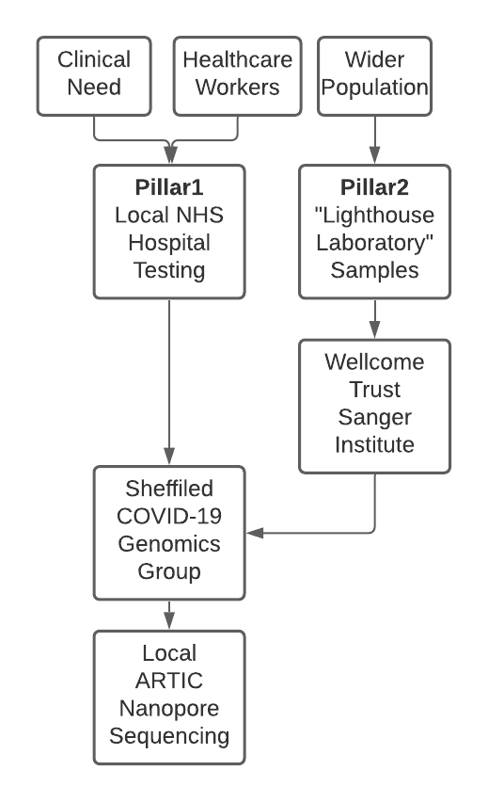
Supplementary Figure 1 - UK Diagnostic Pillar Testing Strategy
Pillar 1: Diagnostic samples tested at Sheffield Teaching Hospitals NHS Foundation Trust, including patients and healthcare workers. Pillar 2: SARS-CoV-2 positive samples from the general public, tested at the UK’s SARS-CoV-2 lighthouse laboratories which are picked, and extracted at the Wellcome Trust Sanger Institute and sent to Sheffield COVID-19 Genomics Group for PCR, library preparation and sequencing.

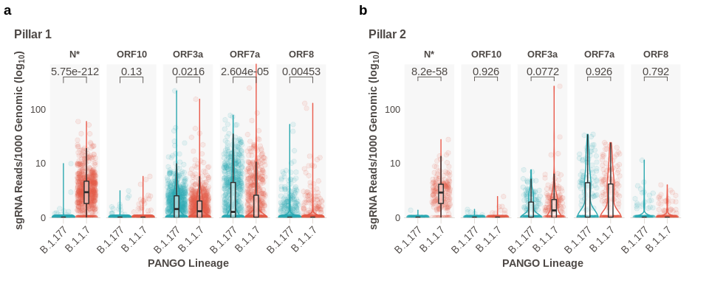
Supplementary Figure 2. Normalized sgRNA for ORF3a, ORF7a, ORF8 and ORF10
a. Comparison of normalized sub-genomic RNA abundance in B.1.177 and B.1.1.7 not plotted in main figures for Pillar 1 samples. b. Comparison of normalized abundance of sub-genomic RNA in B.1.177 and B.1.1.7 not plotted in main figures for Pillar 2 samples. N* refers to novel non-canonical sgRNA due to N R203K/G204R substitutions and present in all lineages containing these mutations ¹⁵. All p-values calculated using an unpaired Wilcoxon signed rank test, and adjusted for multiple testing with Holm (ns or blank = not significant). All boxplots depict the 25th, 50th (median), and 75th percentiles, whiskers represent the most extreme datapoint which is no more than 1.5x the interquartile range.

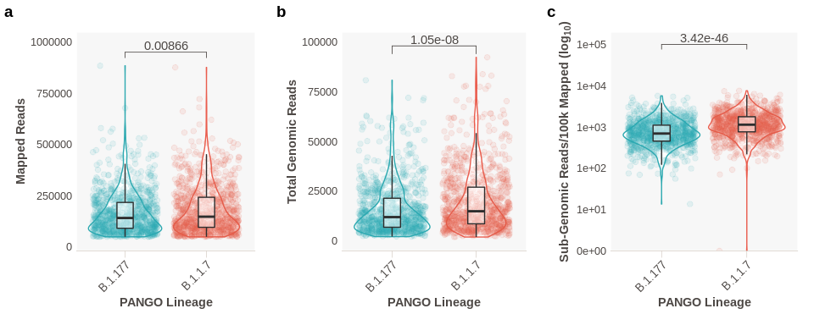
Supplementary Figure 3. Comparison of Mapped Reads and Genomic RNA (i.e. non-sgRNA) reads between B.1.177 and B.1.1.7 infections.
a. Mapped reads between B.1.177 and B.1.1.7 (Wilcoxon effect size: 0.0810) b. Total genomic reads between B.1.177 and B.1.1.7 (Wilcoxon effect size: 0.154) c. Total sgRNA reads per 100,000 mapped reads (Wilcoxon effect size: 0.285) as an alternate normalization method to sgRNA normalization to genomic amplicon reads used in main figures. All p-values calculated using an unpaired Wilcoxon signed rank test, and adjusted for multiple testing with Holm (ns or blank = not significant). All boxplots depict the 25th, 50th (median), and 75th percentiles, whiskers represent the most extreme datapoint which is no more than 1.5x the interquartile range.
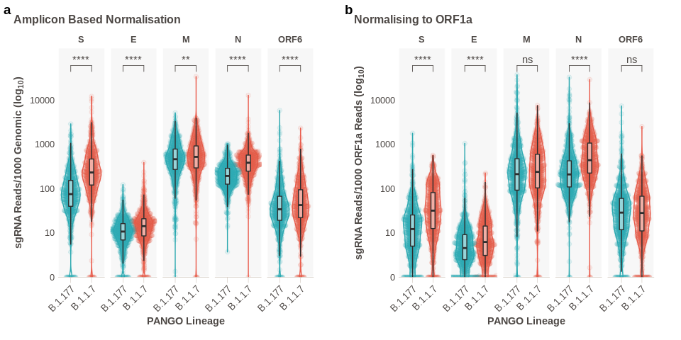
Supplementary Figure 4. Normalisation of sgRNA Abundance using ORF1a
a. Normalisation method presented in Figure 1C reproduced for comparison. b. Normalisation to reads from the amplicon covering the leader/ORF1a junction. All p-values calculated using an unpaired Wilcoxon signed rank test, and adjusted for multiple testing with Holm (**** < 0.0001, *** < 0.001, ** < 0.01, * < 0.05, ns or blank = not significant). All boxplots depict the 25th, 50th (median), and 75th percentiles, whiskers represent the most extreme datapoint which is no more than 1.5x the interquartile range.

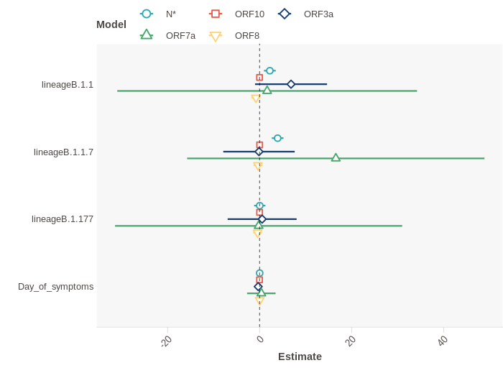
Supplementary Figure 5 - Linear regression model output evaluating impact of lineage and Days since symptom onset at sampling on ORF3a, ORF7a, ORF8 and ORF10.
Effect size plot on the lower expressed ORFs in our dataset. Days since symptom onset has no effect. Reference lineage of B.1. Error bars represent standard error of the estimate.

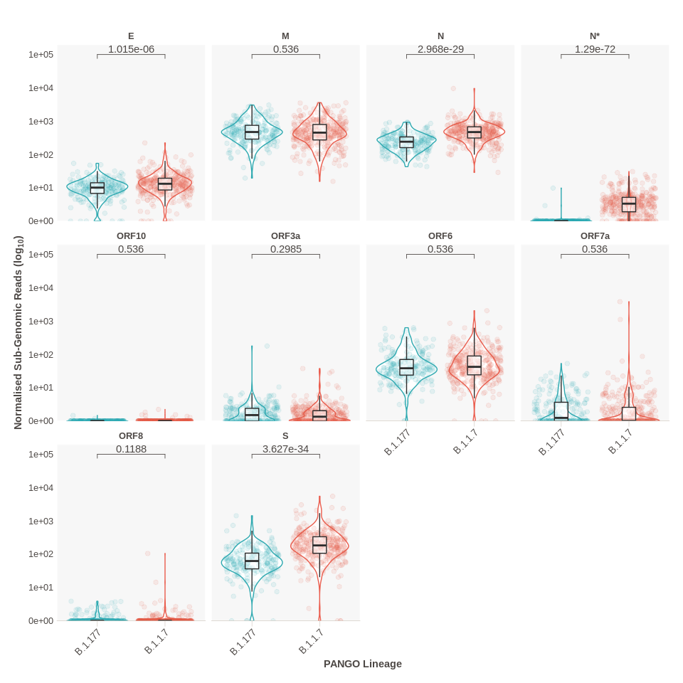
Supplementary Figure 6. Normalized sgRNA Abundance in Healthcare Workers infected with B.1.177 and B.1.1.7 Lineages.
Normalised sub-genomic abundance stratified by lineage in only samples identified as originating from healthcare workers. All p-values calculated using an unpaired Wilcoxon signed rank test, and adjusted for multiple testing with Holm (ns or blank = not significant). All boxplots depict the 25th, 50th (median), and 75th percentiles, whiskers represent the most extreme datapoint which is no more than 1.5x the interquartile range.

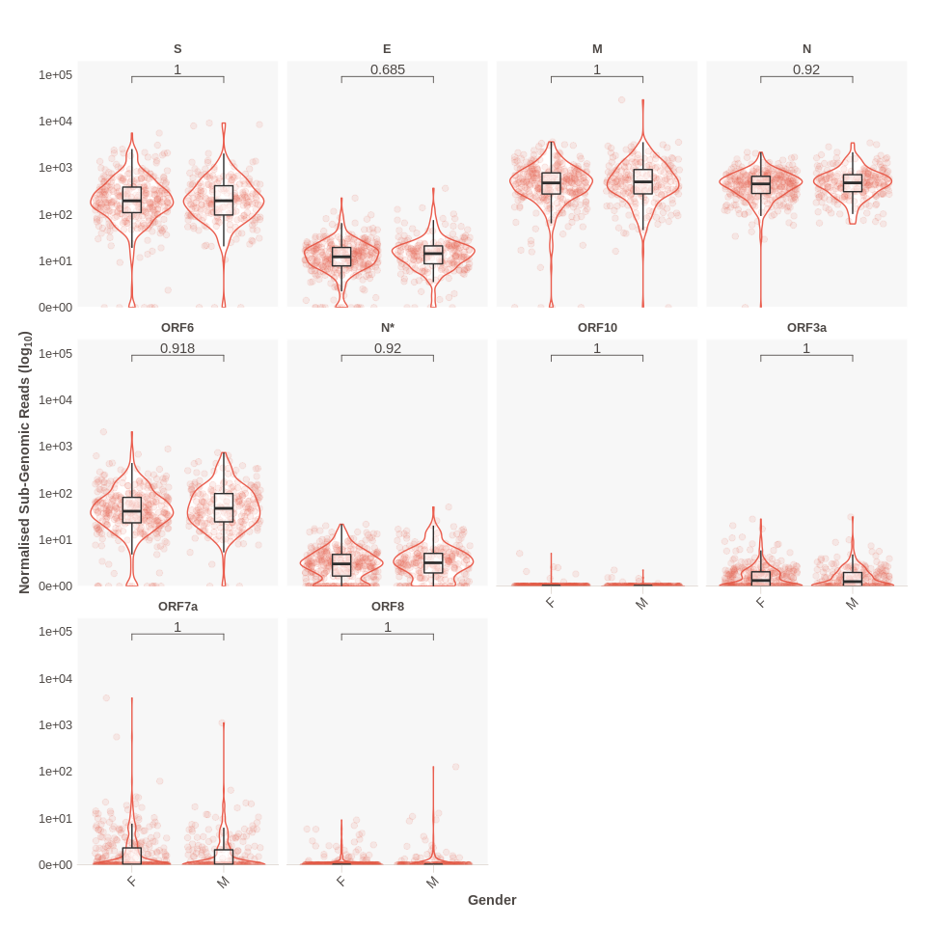
Supplementary Figure 7. Normalized sgRNA Abundance in B.1.1.7 Stratified by Sex
Normalized sub-genomic abundance for samples of the B1.1.7 lineage by ORF and sex. No differences seen between infections in males and females. P values from a Wilcoxon unpaired test, adjusted for multiple testing with Holm. N* refers to novel non-canonical sgRNA due to N R203K/G204R substitutions and present in all lineages containing these mutations ¹⁵. All p-values calculated using an unpaired Wilcoxon signed rank test, and adjusted for multiple testing with Holm (ns or blank = not significant). All boxplots depict the 25th, 50th (median), and 75th percentiles, whiskers represent the most extreme datapoint which is no more than 1.5x the interquartile range.

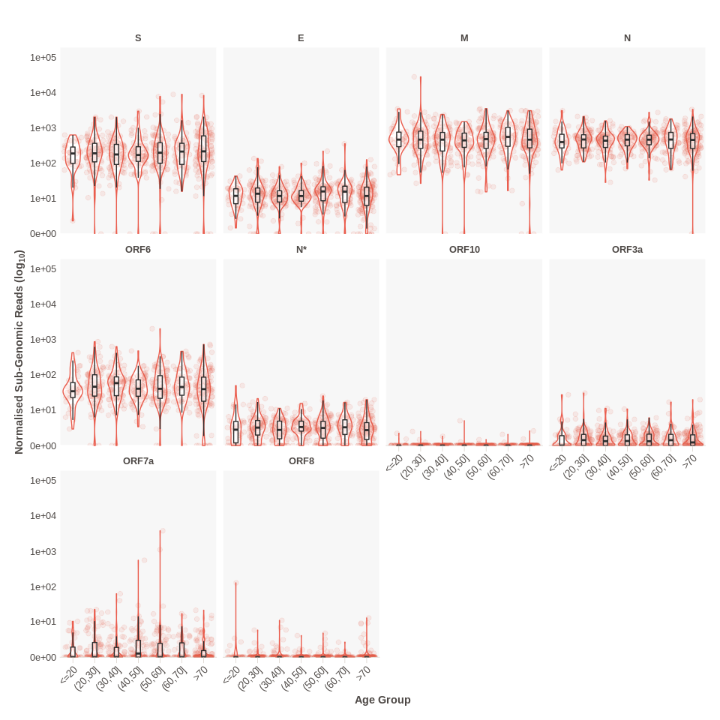
Supplementary Figure 8. Normalized sgRNA Abundance in B.1.1.7 Stratified by Age
Normalized sub-genomic abundance in samples of the B.1.1.7 lineage by ORF and age group. X-axis notation is as follows; (a,b] means ">a and <=b". N* refers to novel non-canonical sgRNA due to N R203K/G204R substitutions and present in all lineages containing these mutations ¹⁵. All boxplots depict the 25th, 50th (median), and 75th percentiles, whiskers represent the most extreme datapoint which is no more than 1.5x the interquartile range.

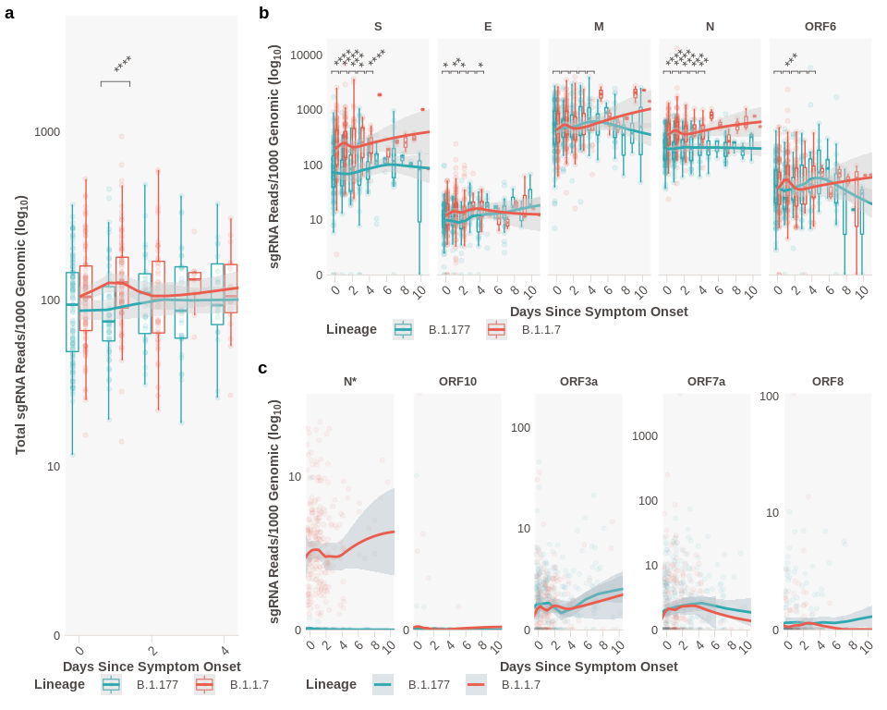
Supplementary Figure 9. Normalized sgRNA abundance stratified by days since symptom onset.
A. Normalized abundance of total subgenomic RNA comparing B.1.1.7 and B.1.177 stratified by the reported days since symptom onset, loess model. B. Normalized abundance of subgenomic RNA for each of the most abundant canonical sgRNAs stratified by the reported days since symptom onset, loess model. Note: differing y-axis scales, plot restricted to 10 days. (0 Days; B.1.177_{n} = 115, B.1.1.7_{n}= 93. 1 Day; B.1.177_{n} = 53, B.1.1.7_{n}= 93. 2 Days; B.1.177_{n} = 31, B.1.1.7_{n}= 47. 3 Days; B.1.177_{n} = 31, B.1.1.7_{n}= 12. 4 Days; B.1.177_{n} = 19, B.1.1.7_{n}= 18.). All p-values calculated using an unpaired Wilcoxon signed rank test, and adjusted for multiple testing with Holm (**** < 0.0001, *** < 0.001, ** < 0.01, * < 0.05, ns or blank = not significant). C. Other ORFS; N* refers to novel non-canonical sgRNA due to N R203K/G204R substitutions and present in all lineages containing these mutations¹⁵. All boxplots depict the 25th, 50th (median), and 75th percentiles, whiskers represent the most extreme datapoint which is no more than 1.5x the interquartile range.
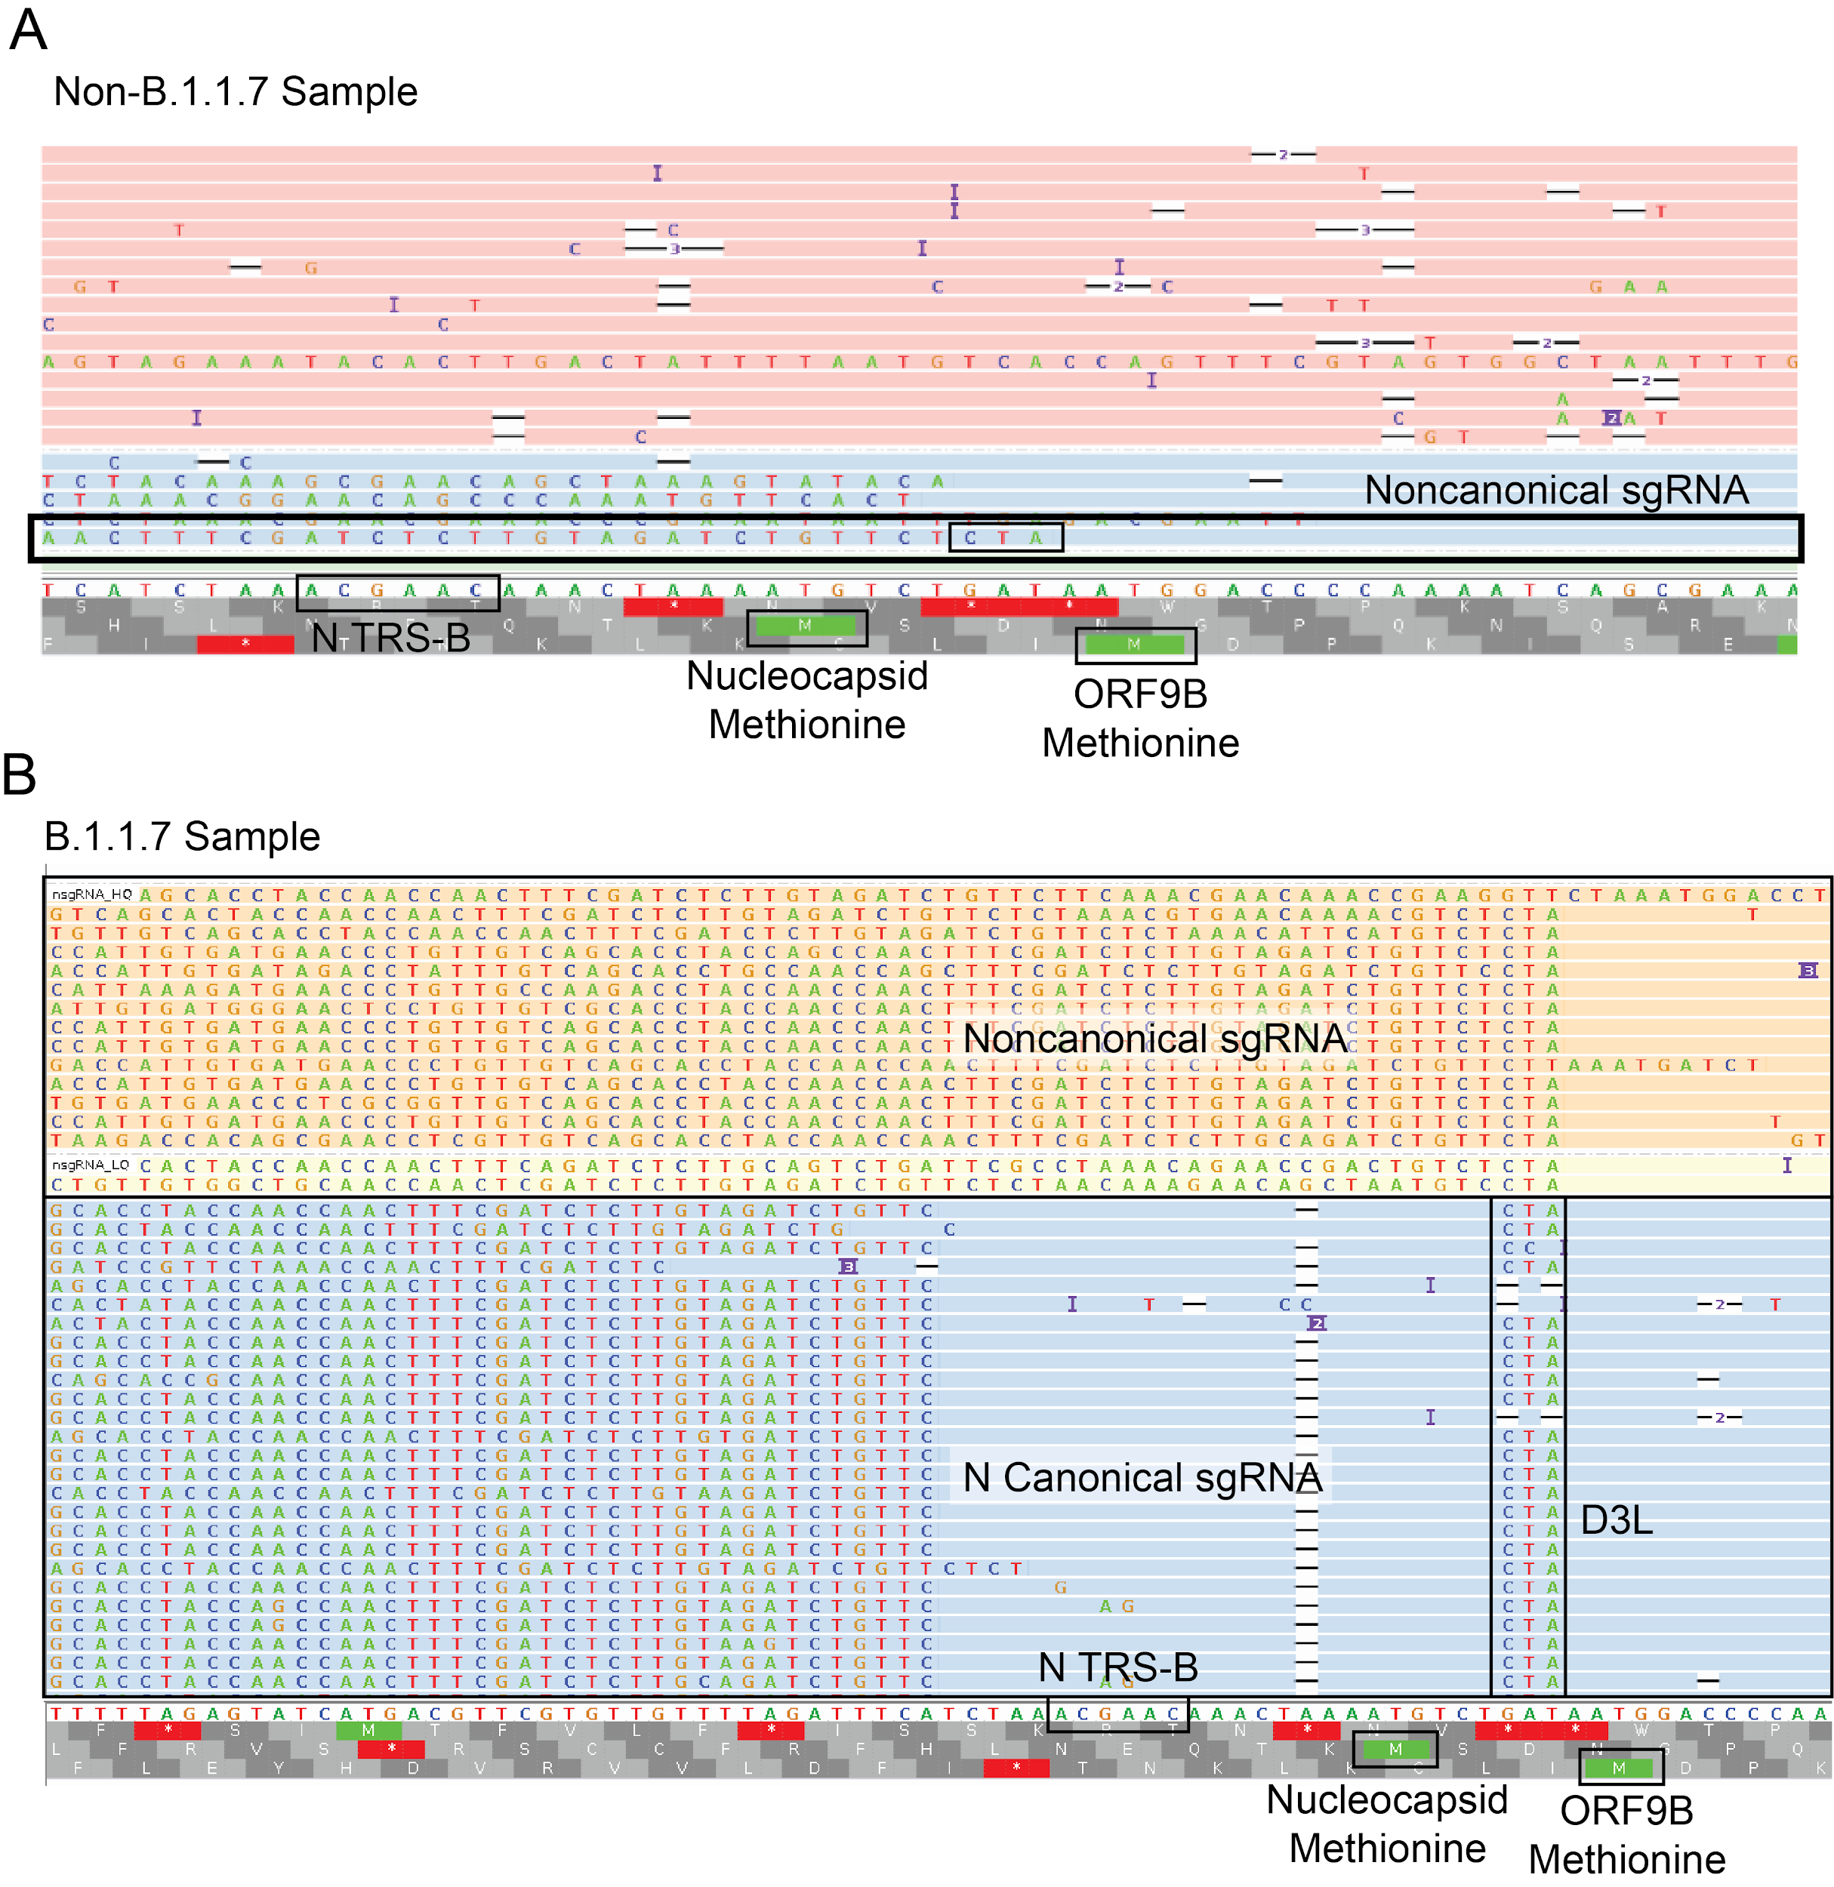
Supplementary Figure 10. Noncanonical sgRNA at nucleotide position 28282
a. IGV plot showing reads around the canonical N TRS site in a non-B.1.1.7 sample. A Read is present that supports a 28282 noncanonical sgRNA that contains the CTA adjacent to the leader (red box). b. IGV plot showing reads around the canonical N TRS site in B.1.1.7 (navy bar bottom). Blue shaded reads are canonical ORF N sgRNA supporting reads, with the leader on the left. Peach reads are a noncanonical sgRNA produced from a new TRS like site complementary to a region 3’ of the leader sequence at the 5’ end of the genome as a result of the GAT->CTA mutation in this region.

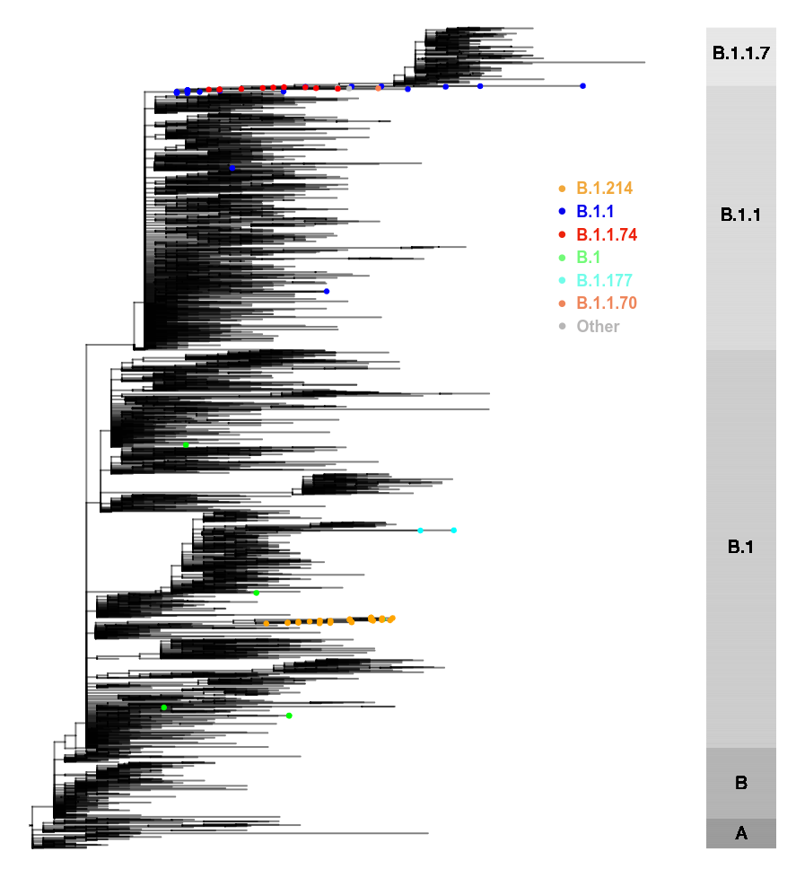
Supplementary Figure 11 - A representative phylogenetic tree of global SARS-CoV-2 genomes depicting non-B.1.1.7 viruses containing the nucleocapsid D3L mutation
The nucleocapsid D3L mutation is found in 77 non-B.1.1.7 sequences indicated with dots at the ends of tips (see legend). Non-D3L sequences were subsampled for visualisation purposes. Bar on right depicts ancestral lineages alone. The grapevine pipeline (https://github.com/COG-UK/grapevine) was used for generating the phylogeny based on all data available on GISAID and COG-UK up until 16th February 2021. Of note, in some cases (e.g. B.1.1.74), several other B.1.1.7 defining mutations were also noted in sequences, raising the possibility of contamination, which could not be excluded.

