Supplementary Information for:

Chronological age-related metabolome responses in the dinoflagellate Karenia mikimotoi, can predict future bloom demise

Takeshi Hano*, Yuji Tomaru

Environment Conservation Division, Fisheries Technology Institute, National Research and Development Agency, Japan Fisheries Research and Education Agency,
2-17-5 Maruishi, Hatsukaichi, Hiroshima 739-0452, Japan

*Corresponding author
National Research Institute of Fisheries and Environment of Inland Sea, Fisheries Research and Education Agency, 2-17-5, Maruishi, Hatsukaichi, Hiroshima Japan, 739-0452
Tel: +81-829-55-0666; Fax: +81-829-54-1216; E-mail address: hano_takeshi74@fra.go.jp

In this document, 3 tables and 5 figures.

Supplementary Table 1. Sensitivity, specificity, accuracy, and AUC (95% CI) of metabolites.
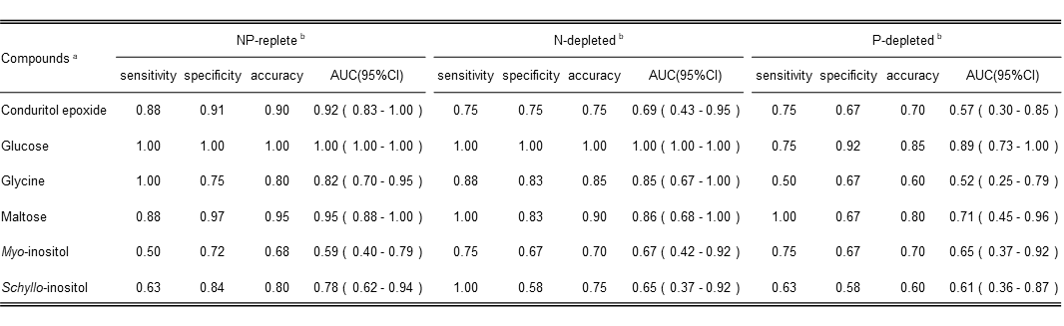
ª: Of the 46 metabolites tested, only those that were mean signal-to-noise ratio (S/N ratio) being higher than 20 per 1 × 10⁶ cells per milliliter for any treatment group and sampling date were included in the table.
^{b}: AUC, area under the curve; CI, credible interval.

Supplementary Table 2. Sensitivity, specificity, accuracy, and AUC (95% CI) of the ratio of glucose to the other five metabolites.
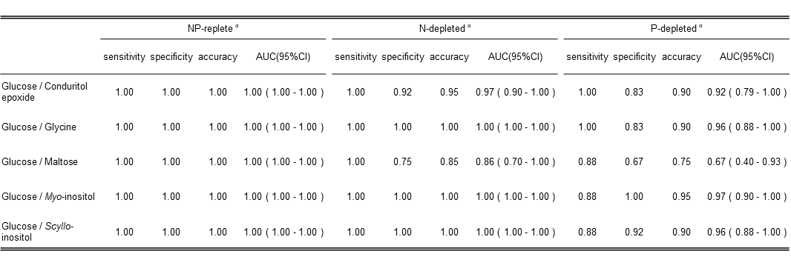
ª: AUC, area under the curve. CI, credible interval.

Supplementary Table 3. List of chemicals used for modified SWM-3

 | Stock solution | Final concentrations in 1000 mL
 | Stock solution | NP replete | N depleted | P depleted
NaNO₃  NaH₂PO₄ 2H₂O  Na₂SiO₃ 9H₂O  Na₂₋EDTA  Fe-EDTA  Na₂SeO₃  Tris  P-1 Metal solution ª  S3 Vitamin Sol. ^{b}  Sea water  pH 7.7−7.8 | 21.25 g/250 mL  1.95 g/250 mL  7.105 g/250 mL  1.40 g/250 mL  0.105 g/250 mL  0.346 mg/L | 2.0 mM  0.1 mM  0.2 mM  30 µM  2 µM  2 nM  500 mg  10 mL  2 mL  Up to 1000 mL | 0.2 mM  0.1 mM  0.2 mM  30 µM  2 µM  2 nM  500 mg  10 mL  2 mL  Up to 1000 mL | 2.0 mM  0.003 mM  0.2 mM  30 µM  2 µM  2 nM  500 mg  10 mL  2 mL  Up to 1000 mL

ª
P-1 Metal solution | in 1000 mL
H₃BO₃  MnCl₂ 4H₂O  ZnCl₂  CoCl₂ 6H₂O | 6.183 g  692.5 mg  54.5 mg  2.38 mg

^{b}
S3 Vitamin solution | in 1000 mL
Thiamine HCl  Nicotinic acid  Ca pantothenate  p-aminobenzoic acid  Biotin  Inositol  Folic acid  Thymine  B12 | 0.25 g  0.05 g  0.05 g  5 mg  0.5 mg  2.5 g  1 mg  1.5 g  1 mg

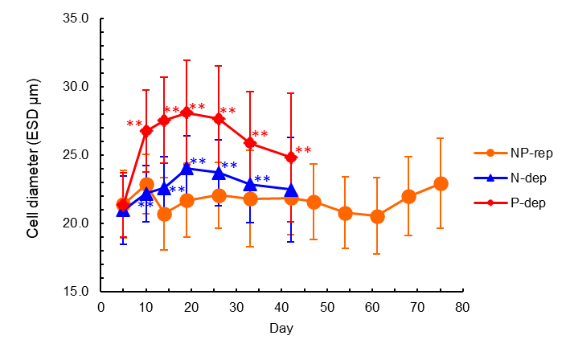
a

b
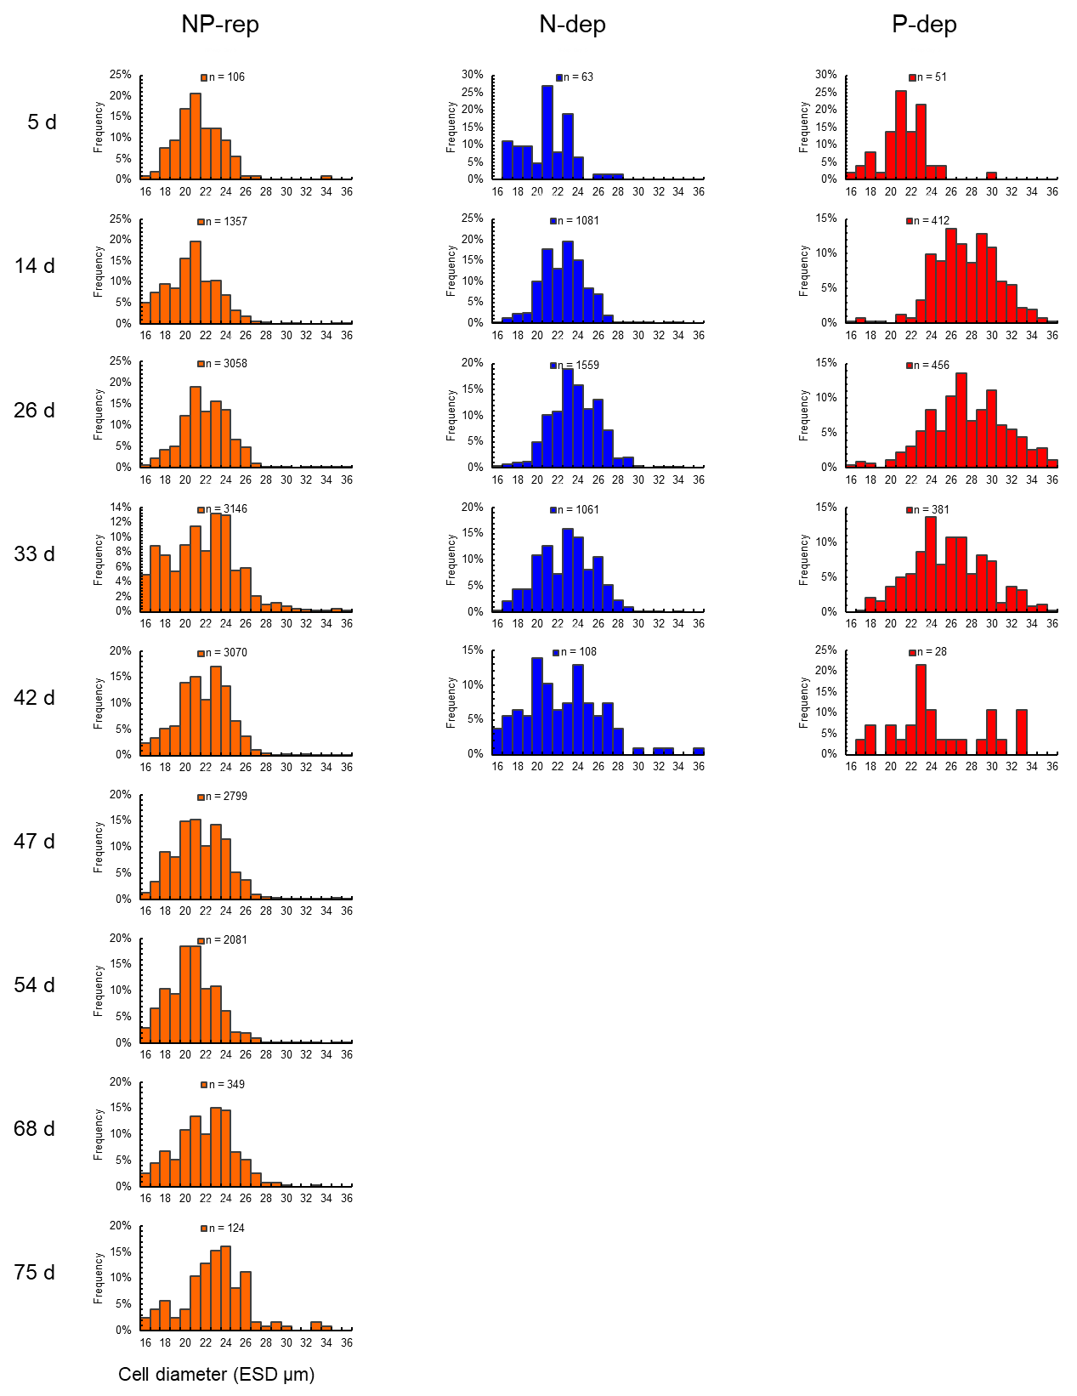
Supplementary Fig. 1 Diameter (µm/cell) of K. mikimotoi cells. a) Mean fold changes and b) histograms of cell size during the experimental period. The dinoflagellate cells were cultured for 47 or 82 days in the SWM-3 medium with different concentrations of nitrogen (NaNO₃) and phosphate (NaH₂PO₄) and initial N and P concentrations were 2 and 0.1 mM for NP-replete (NP-rep), 0.2 and 0.1 mM for N-depleted (N-dep), and 2 and 0.0033 mM for P-depleted (P-dep) treatment groups. In (a), data are expressed as the mean ± standard deviation (n = 4). **, p < 0.01 versus the NP-replete on the same sampling date (two sample t-tests for parametric data and Welch’s t-tests for non-parametric data). Rep., replete; dep., depleted.
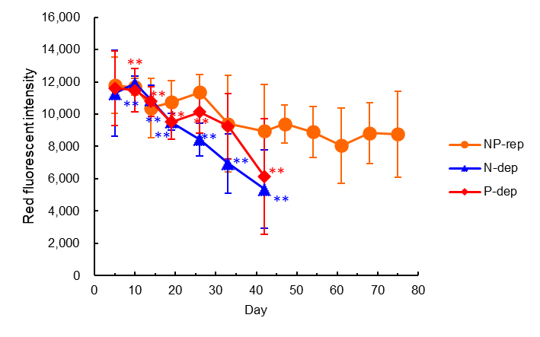
a

b
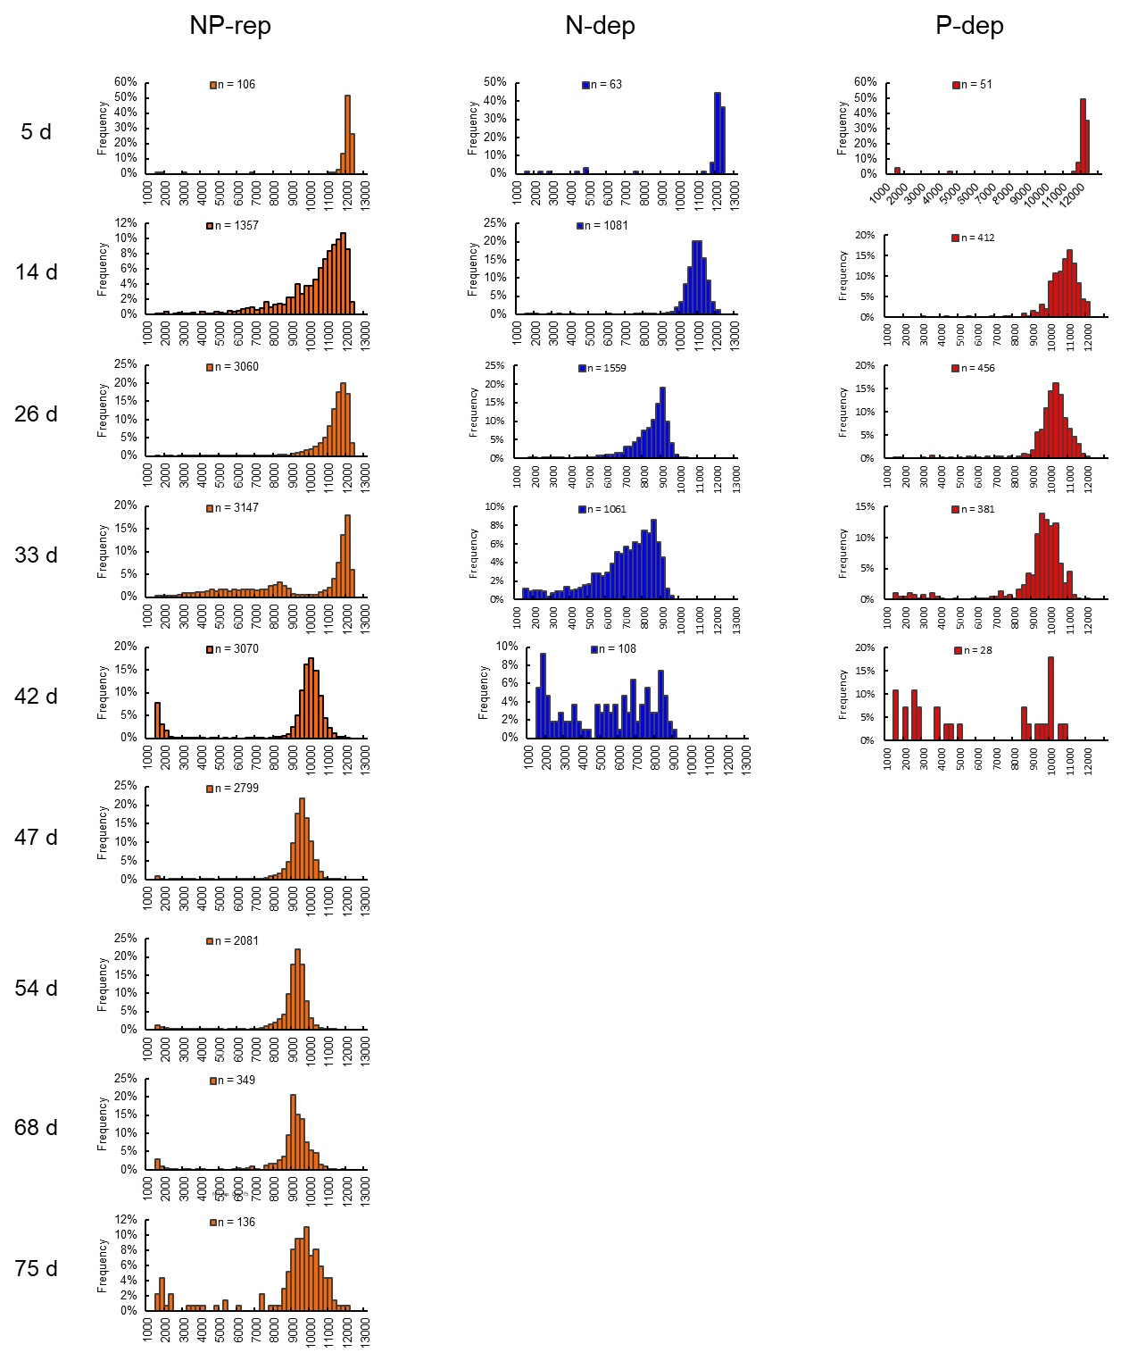
Supplementary Fig. 2 Unicellular chlorophyll red fluorescence intensity of K. mikimotoi cells. a) Mean fold changes and b) histograms of red fluorescence intensity during the experimental period. The dinoflagellate cells were cultured for 47 or 82 days in the SWM-3 medium with different concentrations of nitrogen (NaNO₃) and phosphate (NaH₂PO₄) and initial N and P concentrations were 2 and 0.1 mM for NP-replete (NP-rep), 0.2 and 0.1 mM for N-depleted (N-dep), and 2 and 0.0033 mM for P-depleted (P-dep) treatment groups. In (a), data are expressed as the mean ± standard deviation (n = 4). **, p < 0.01 versus the NP-replete on the same sampling date (two sample t-tests for parametric data and Welch’s t-tests for non-parametric data). Rep., replete; dep., depleted.

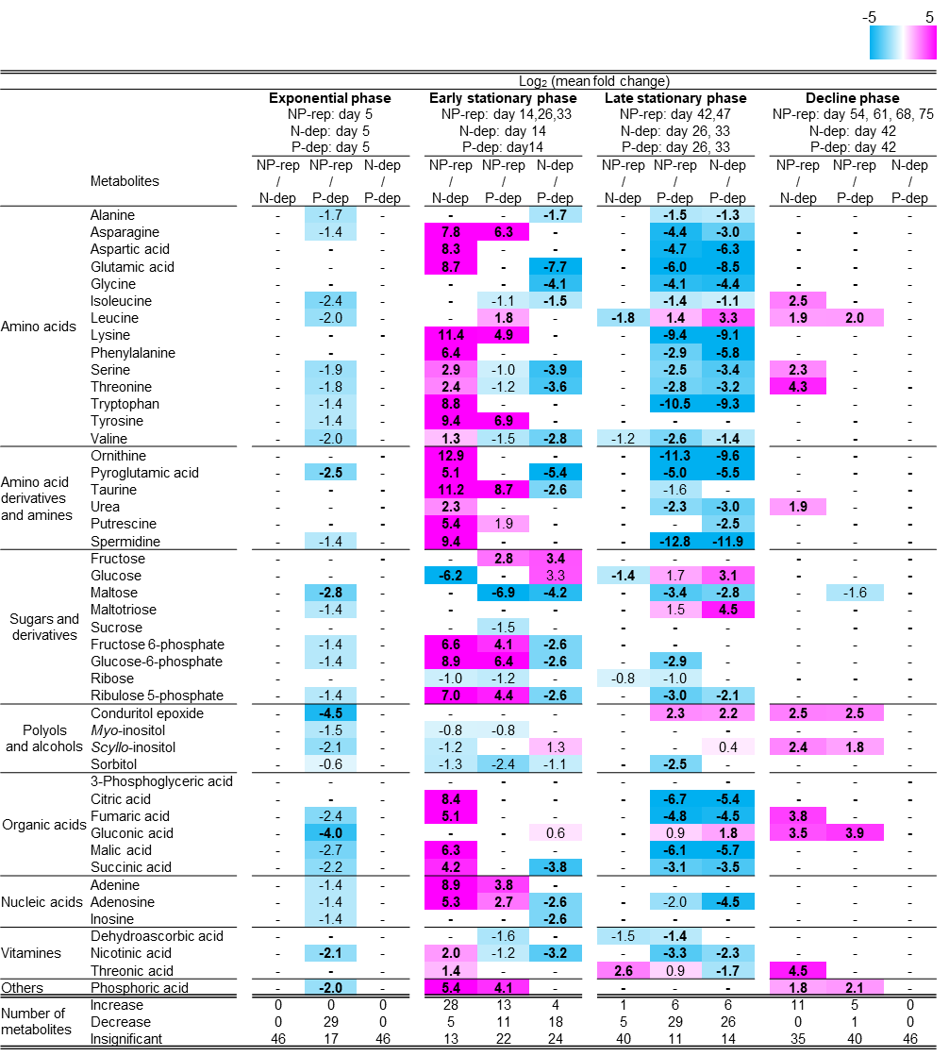
Supplementary Fig. 3 Heatmap of growth phase-, nutrient- related metabolic changes in the K. mikimotoi. Log₂-transformed mean fold changes in metabolites among various nutrient media at the specified growth phase. The dinoflagellate cells were cultured for 47 or 82 days in the SWM-3 medium with different concentrations of nitrogen (NaNO₃) and phosphate (NaH₂PO₄) and initial N and P concentrations were 2 and 0.1 mM for NP-replete (NP-rep), 0.2 and 0.1 mM for N-depleted (N-dep), and 2 and 0.0033 mM for P-depleted (P-dep) treatment groups. Plain and bold numbers indicate significant fold changes based on t-tests for parametric data and Welch’s t-tests for non-parametric data, respectively, after FDR adjustment at a significance threshold of 0.05 (q < 0.05). Fold changes are color-coded; pink and sky blue indicate significant increase and decrease and “-“denote insignificant changes. Rep., replete; dep., depleted.
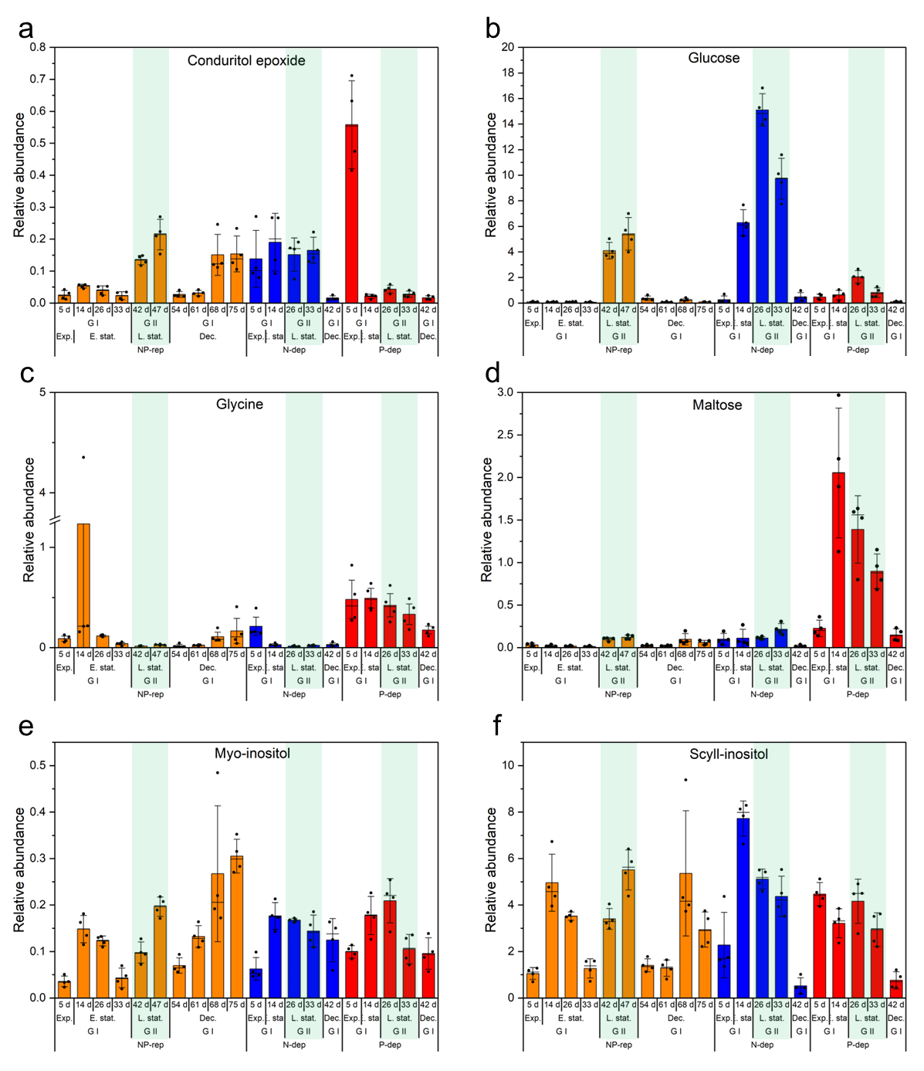
Supplementary Fig. 4 Chronological alterations of metabolites and criterion in the K. mikimotoi. Of the 46 metabolites tested, each graph represents relative abundance (abundance of metabolite normalized by cell number (1.0 × 10³ cells) and internal standard) of six metabolites (a-f) whose mean signal-to-noise ratio (S/N ratio) being higher than 20 per 1.0 × 10⁶ cells per milliliter for any treatment group and sampling date. The dinoflagellate cells were cultured for 47 or 82 days in the SWM-3 medium with different concentrations of nitrogen (NaNO₃) and phosphate (NaH₂PO₄) and initial N and P concentrations were 2 and 0.1 mM for NP-replete (NP-rep), 0.2 and 0.1 mM for N-depleted (N-dep), and 2 and 0.0033 mM for P-depleted (P-dep) treatment groups. Data indicate mean ± standard deviation (SD; n = 4). Exp., Exponential; E. stat, Early stationary; L. stat, Late stationary; Dec, Decline; G I, Group I; G II, Group II; Rep, replete; dep, depleted. Light green shades in each graph show late stationary phase (Group II).
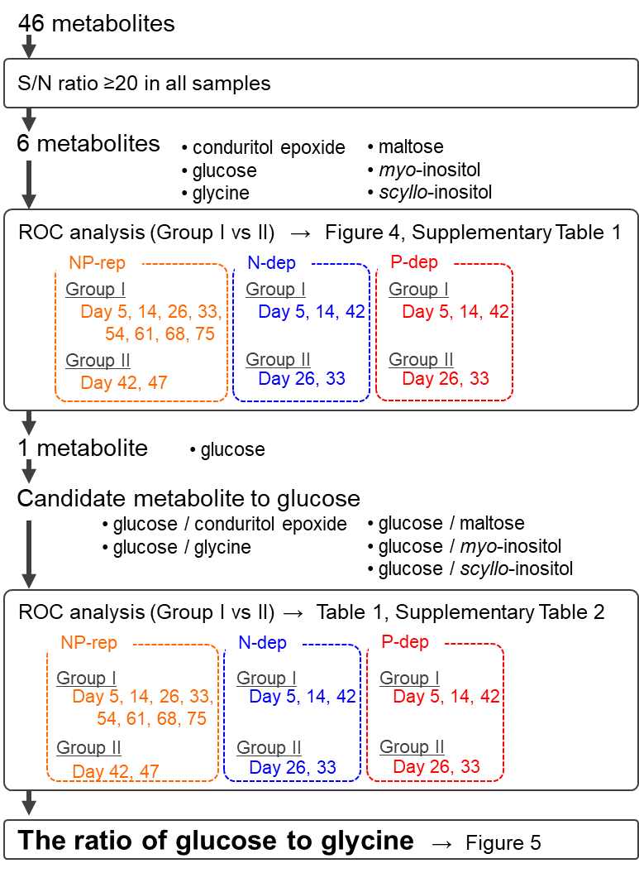

Supplementary Fig. 5 Experimental flow showing the criterion for metabolite determination. ROC., Receiver operating characteristic; Rep., replete; dep., depleted.

