SUPPLEMENTARY INFORMATION
Supplementary information for the paper: Targeted and whole-genome sequencing reveal a north-south divide in P. falciparum drug resistance markers and genetic structure in Mozambique

Supplementary Table 1. Sampling source of P. falciparum positive samples successfully genotyped for at least one molecular marker of resistance, whole genome sequences available, and samples with microhaplotype coverage higher than 50%.

Supplementary Table 2. Districts and Provinces in Mozambique where P. falciparum isolates successfully genotyped were collected.

Supplementary Table 3. Number of P. falciparum samples from which molecular markers of antimalarial resistance were obtained.

Supplementary Table 4. Molecular markers of P. falciparum antimalarial resistance observed at frequencies below 5% in 2015 and 2018 in 7 provinces from Mozambique.

wt, wild-type; mut, mutants; mix; mixed genotypes
Supplementary Table 5. Frequency of P. falciparum isolates carrying mixed genotypes in molecular markers of antimalarial resistance.

Supplementary Table 6. Frequency of P. falciparum isolates carrying mutations in in pfdhfr, pfdhps and pfmdr1 by province.

Samples with a mixed genotype in codons 51, 59, 108 of pfdhfr and 437 or 540 in pfdhps were excluded. pfdhfr and pfdhps haplotypes were built as a combination of mutations at these codons. pfdhfr double mutants were defined as any combination of two mutations out of the three possible. pfdhps single mutants were defined as the presence of either pfdhps-437 or -540. P values indicate the statistical significance of the difference in frequencies between provinces.

wt, wild-type; mut, mutant
Supplementary Table 7. Frequency of P. falciparum isolates carrying mutations in pfdhfr, pfdhps and pfmdr1 by year.

Samples with a mixed genotype in codons pfdhfr-51, -59 or -108, and pfdhps-437 or -540 were excluded. pfdhfr and pfdhps haplotypes were built as a combination of mutations at these codons. pfdhfr double mutants were defined as any combination of two mutations out of the three possible. pfdhps single mutants were defined as the presence of either pfdhps-437 or -540. P values indicates the statistical significance of the difference in frequencies between years.

wt, wild-type; mut, mutant
Supplementary Table 8. Multivariable logistic regression model, with presence or absence of a mutation as response and temporal and spatial predictors.
 | Region |  |  |  |  | Period
 |  | OR | (95%CI) | p |  |  | OR | (95%CI) | p
Monoclonal (n=1090)
 | North | 1 |  | 0.013 |  | 2015 | 1 |  | 0.464
 | Central | 1.29 | (0.87; 1.90) | 0.013 |  | 2018 | 0.88 | (0.63; 1.23) | 0.464
 | South | 1.62 | (1.16; 2.26) | 0.013
dhfr 51 (n=1638)
 | North | 1 |  | 0.033 |  | 2015 | 1 |  | 0.009
 | Central | 1.37 | (0.63; 2.98) | 0.033 |  | 2018 | 2.29 | (1.23; 4.29) | 0.009
 | South | 2.67 | (1.25; 5.69) | 0.033
dhfr 59 (n=1625)
 | North | 1 |  | <0.001 |  | 2015 | 1 |  | 0.002
 | Central | 3.38 | (1.35; 8.45) | <0.001 |  | 2018 | 3.4 | (1.59; 7.29) | 0.002
 | South | 7.66 | (2.93;20.04) | <0.001
dhfr 108 (n=1649)
 | North | 1 |  | 0.005 |  | 2015 | 1 |  | 0.004
 | Central | 3.1 | (0.92;10.48) | 0.005 |  | 2018 | 5.06 | (1.67;15.34) | 0.004
 | South | 11.38 | (2.39;54.25) | 0.005
dhfr pure (n=1600)
 | North | 1 |  | 0.006 |  | 2015 | 1 |  | 0.002
 | Central | 1.53 | (0.76; 3.06) | 0.006 |  | 2018 | 2.46 | (1.40; 4.33) | 0.002
 | South | 2.98 | (1.51; 5.89) | 0.006
dhps 436 (n=1539)
 | North | 1 |  | <0.001 |  | 2015 | 1 |  | 0.683
 | Central | 0.09 | (0.04; 0.19) | <0.001 |  | 2018 | 0.87 | (0.44; 1.71) | 0.683
 | South | 0.01 | (0.00; 0.04) | <0.001
dhps 437 (n=1439)
 | North | 1 |  | <0.001 |  | 2015 | 1 |  | 0.004
 | Central | 3.28 | (2.18; 4.95) | <0.001 |  | 2018 | 1.78 | (1.20; 2.63) | 0.004
 | South | 17.55 | (10.73;28.72) | <0.001
dhps 540 (n=1404)
 | North | 1 |  | <0.001 |  | 2015 | 1 |  | 0.003
 | Central | 2.94 | (1.96; 4.41) | <0.001 |  | 2018 | 1.75 | (1.20; 2.55) | 0.003
 | South | 12.92 | (8.22;20.32) | <0.001
dhps pure (n=1377)
 | North | 1 |  | <0.001 |  | 2015 | 1 |  | 0.009
 | Central | 3.22 | (2.12; 4.89) | <0.001 |  | 2018 | 1.69 | (1.14; 2.50) | 0.009
 | South | 15.03 | (9.32;24.24) | <0.001
quintuple pure (n=1330)
 | North | 1 |  | <0.001 |  | 2015 | 1 |  | 0.007
 | Central | 2.77 | (1.85; 4.14) | <0.001 |  | 2018 | 1.67 | (1.15; 2.42) | 0.007
 | South | 11.27 | (7.33;17.33) | <0.001
mdr1 184 (n=1171)
 | North | 1 |  | 0.291 |  | 2015 | 1 |  | 0.354
 | Central | 0.78 | (0.54; 1.11) | 0.291 |  | 2018 | 1.14 | (0.87; 1.50) | 0.354
 | South | 0.93 | (0.68; 1.29) | 0.291
Supplementary Table 9. Frequency of P. falciparum isolates carrying mutations in codon 436 of dhps, in combination with other mutations in pfdhfr and pfdhps.

Samples with a mix genotype in any of the codons 51, 59, 108 of pfdhfr and 437 or 540 in pfdhps were excluded. P values indicates the statistical significance of the difference in frequencies.

Supplementary Table 10. Confusion Matrix for Random Forest classification at the regional (North-Central-South) level.

Microhaplotypes at loci with expected heterozygosity in the top 25% percentile were considered as predictors of the classification model. Random Forest was run with ntree = 2500 and the OOB error rate = 24.89%.

 | North | Central | South | Classification error
North | 98 | 66 | 34 | 0.5051
Central | 49 | 12 | 57 | 0.4690
South | 10 | 55 | 600 | 0.0977

Supplementary Table 11. Estimated genetic complexity of infection by region and year.

Supplementary Table 12. Expected heterozygosity (H_{e}) values at 16 microhaplotype loci within a 50kb region around pfdhps in P. falciparum isolates from Cabo Delgado.

Haplotypes were constructed after excluding mixed genotypes in pfdhps codons 436/437/540. Sub-populations WT/WT/WT + MUT/WT/WT were merged for the analysis. The statistical significance of the difference of the H_{e} values between the groups was calculated using a permutation test, by randomly shuffling the sub-population labels of the samples 1000 times and obtaining a null distribution for the difference of the H_{e}.

Microhaplotype | Gene | WT/WT/WT & MUT/WT/WT  N=51 | WT/MUT/MUT  N=92 | p value
Pf3D7_08_v3-522797-522858 | pfabc1 | 0.246 | 0.221 | 0.737
Pf3D7_08_v3-527371-527432 | pfppm5 | 0.410 | 0.412 | 0.962
Pf3D7_08_v3-532468-532604 | pf0810400 | 0.355 | 0.178 | 0.052
Pf3D7_08_v3-534632-534693 | pfppm7 | 0.150 | 0.087 | 0.344
Pf3D7_08_v3-536195-536274 | pfppm7 | 0.340 | 0.288 | 0.498
Pf3D7_08_v3-542446-542571 | pfdbp1 | 0.682 | 0.533 | 0.006
Pf3D7_08_v3-543445-543506 | pfdbp1 | 0.212 | 0.084 | 0.102
Pf3D7_08_v3-548133-548222 | pfdhps | 0.482 | 0.022 | <0.001
Pf3D7_08_v3-548770-548831 | pfdhps | 0.511 | 0.104 | <0.001
Pf3D7_08_v3-549650-549715 | pfdhps | 0.703 | 0 | <0.001
Pf3D7_08_v3-549962-550023 | pfdhps | 0.079 | 0 | 0.304
Pf3D7_08_v3-556150-556203 | pfcul1 | 0.393 | 0.166 | 0.005
Pf3D7_08_v3-557281-557382 | pfcul1 | 0.292 | 0.257 | 0.649
Pf3D7_08_v3-559505-559566 | pfemc1 | 0.402 | 0.044 | <0.001
Pf3D7_08_v3-562482-562647 | Intergenic | 0.156 | 0.516 | <0.001
Pf3D7_08_v3-565050-565130 | pfcaf1 | 0.289 | 0.099 | 0.038

Supplementary Figure 1. Frequency of P. falciparum isolates carrying mutations in codon 184 of pfmdr1.

The error bars represent a 95% Confidence Interval (CI) for the population proportion.

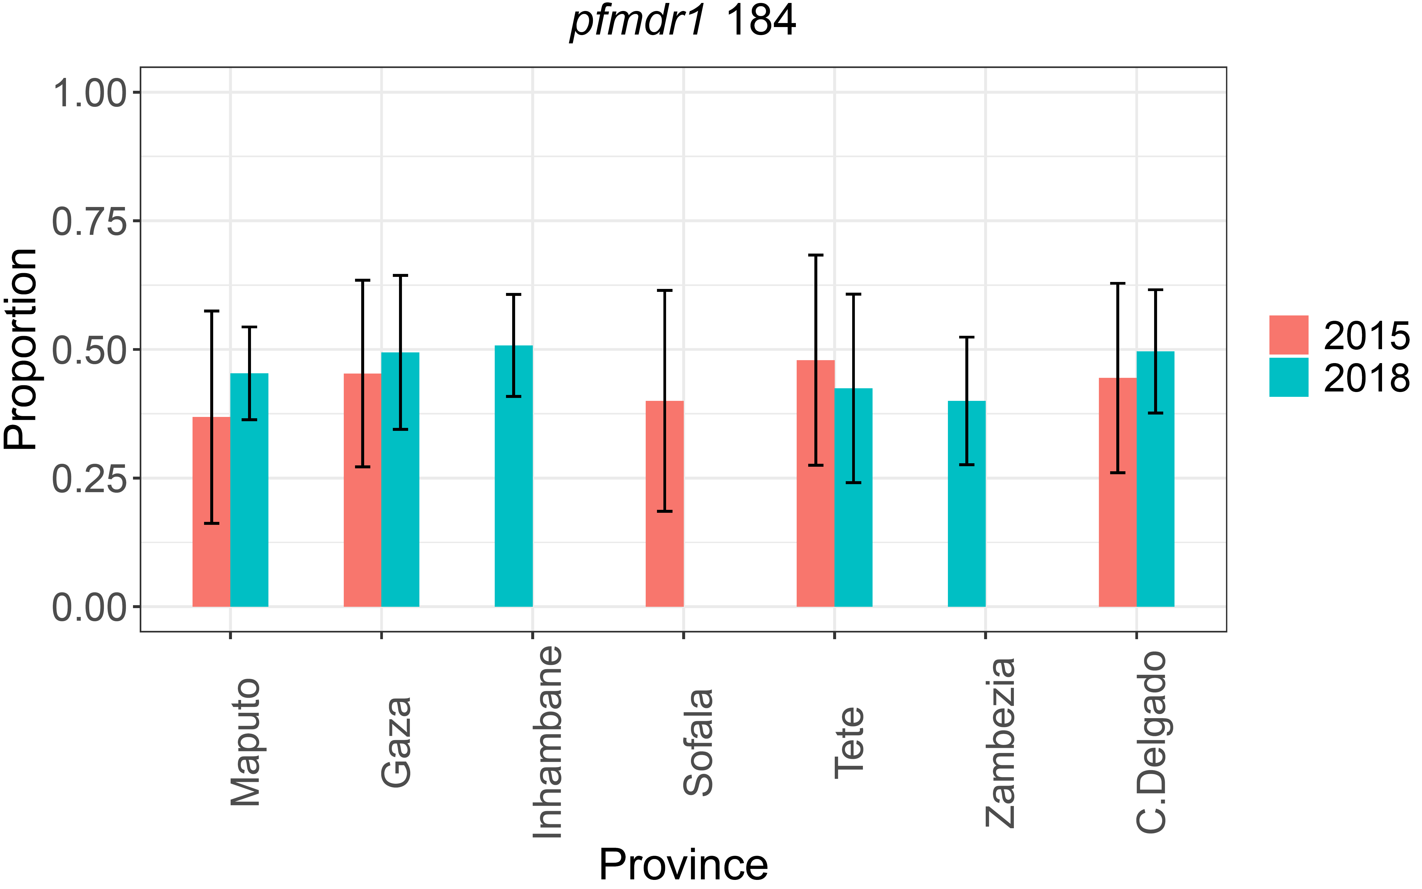
Supplementary Figure 2. Frequency of P. falciparum isolates carrying mutations in pfdhfr (codons 51,59,108) and pfdhps (codons 436, 437, 540) in 2015 and 2018 in 7 provinces from Mozambique.

Frequencies were calculated after excluding mixed genotypes. Data from Sofala was only available for 2015, and from Inhambane and Zambezia for 2018. The error bars represent a 95% Confidence Interval (CI) for the population proportion.

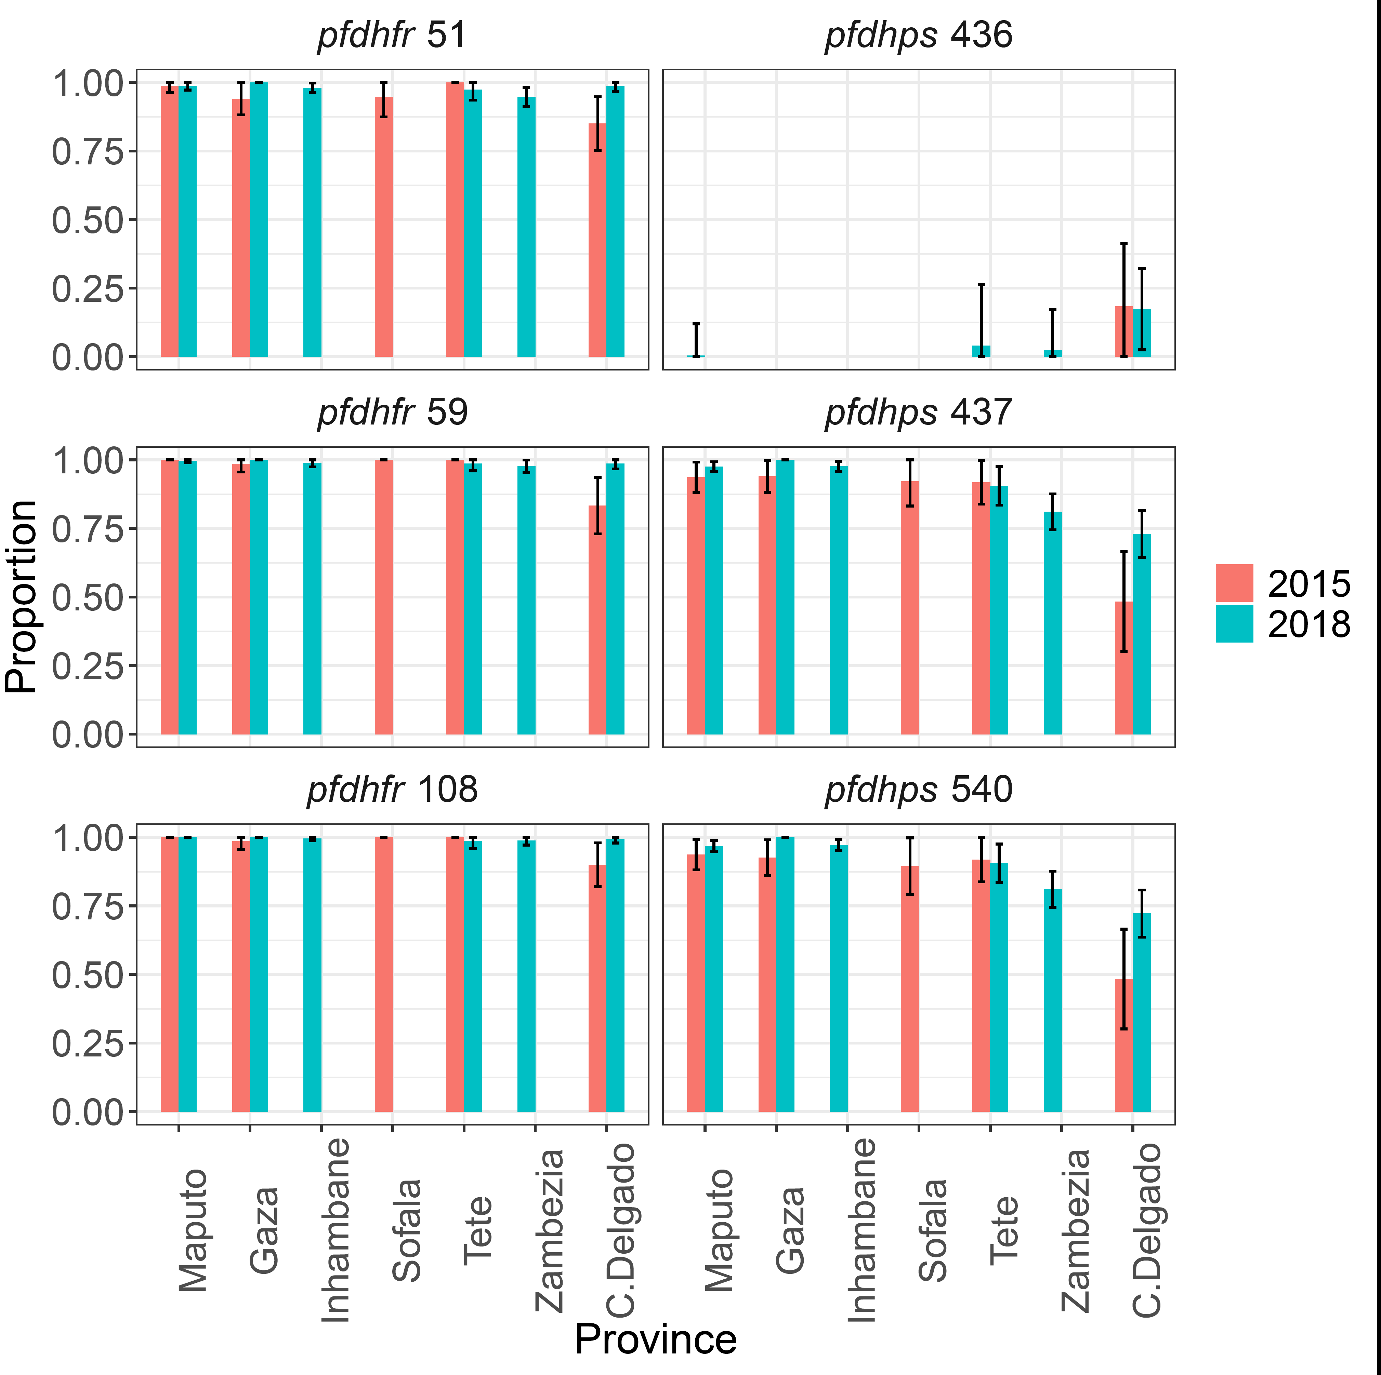

Supplementary Figure 3. Microhaplotypes in P. falciparum samples included in the study.

A) Percentage of microhaplotype loci (N=8722) present for samples from 2015 and 2018 (N=1438). Samples which had greater than 50% of the microhaplotype loci missing (N=349) were excluded from subsequent analyses. B) Microhaplotypes, sorted by importance, which contribute to the geographic (North-Central-South) classification model. 155 microhaplotypes had a mean decrease in accuracy greater than the inflection point (3.1; red dashed line) of the distribution of mean decrease in accuracy.

Supplementary Figure 4. Population structure by geography.
Principal coordinates analysis (PCoA) of the raw data, considering microhaplotypes at loci with expected heterozygosity in the top 25% percentile (left figure in each panel), and considering the top microhaplotypes important for each Random Forest classification (right figure in each panel). Microhaplotypes at loci with expected heterozygosity in the top 25% percentile were considered as predictors of the classification model. Random Forest was run with ntree = 2500. Sample size (2015 and 2018 together): C. Delgado: 198, Zambezia: 131, Sofala: 6, Tete: 89, Gaza: 166, Inhambane: 230, and Maputo: 269 (total: 1089). For the province level classification, samples from Tete and Sofala were combined together to reduce sample imbalance. Regional assignment of samples: North: C.Delgado; Central: Sofala, Tete and Zambezia; South: Gaza, Inhambane and Maputo. A) Random Forest classification at the province level. OOB error rate = 50.51%. B) Random Forest classification at the regional (North-South) level. OOB error rate = 8%. C) Random Forest classification at the regional (Central-South) level. OOB error rate = 15.26%. D) Random Forest classification at the regional (North-Central) level. OOB error rate = 36.79%
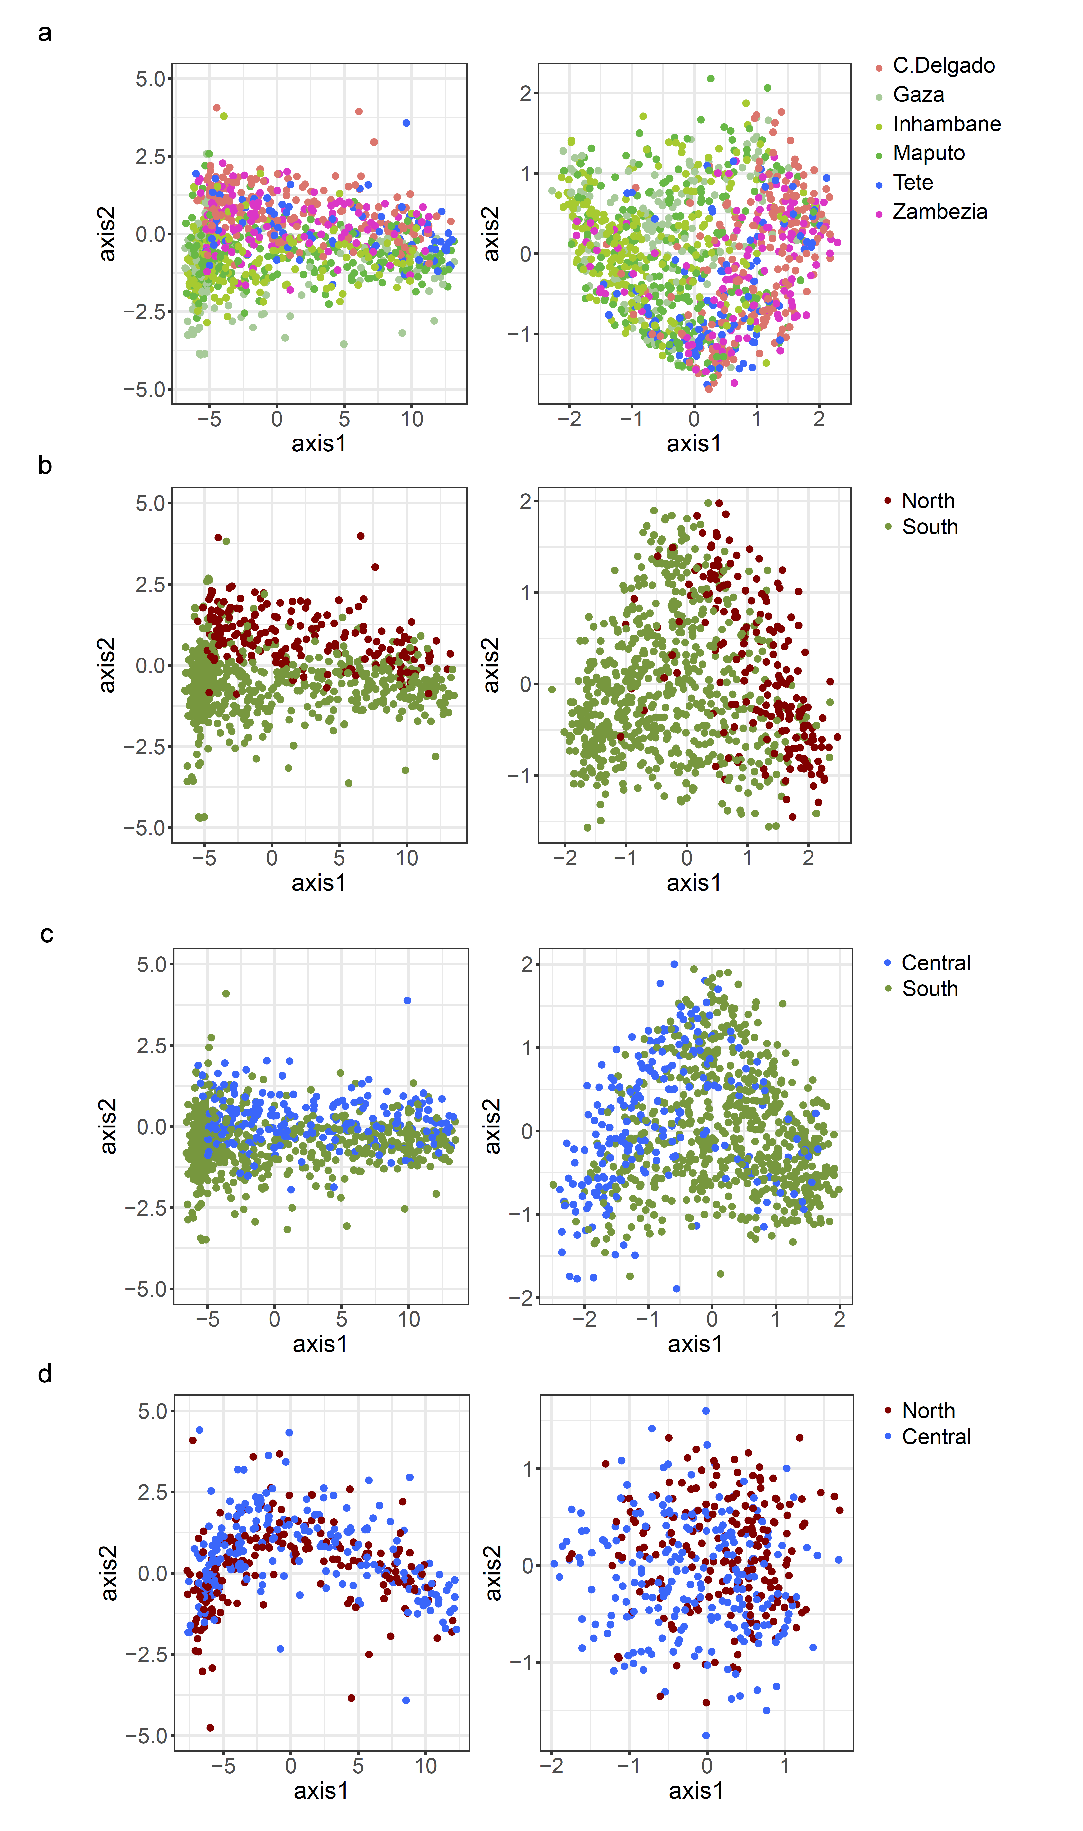

Supplementary Figure 5. Genetic diversity around pfdhps locus.
The expected heterozygosity at microhaplotypes within the 50kb region around pfdhps of parasite isolates from Cabo Delgado collected in 2015 and 2018. Wild-type in 436, 437 and 540 (WT/WT/WT; n=20) and mutant in 436, and wild-type in 437 and 540 (MUT/WT/WT; n=31) were combined and compared to wild-type in 436, and mutant in 437 and 540 (WT/MUT/MUT; n=92) population. The error bars indicate ± standard error (SE).
For loci falling within the gene pfdhps (chr 8: 547896-551057), this difference was particularly pronounced, with three of the four microhaplotype loci having significant differences in H_{e} values between the two groups. These four loci are: Pf3D7_08_v3-548133-548222 (pfdhps codons 1-7, 5 microhaplotypes), Pf3D7_08_v3-548770-548831 (pfdhps codons 133-152, 3 microhaplotypes), Pf3D7_08_v3-549650-549715 (pfdhps codons 426-446, 6 microhaplotypes) and Pf3D7_08_v3-549962-550023 (pfdhps codons 530-549, 3 microhaplotypes). The error bars indicate the standard error.

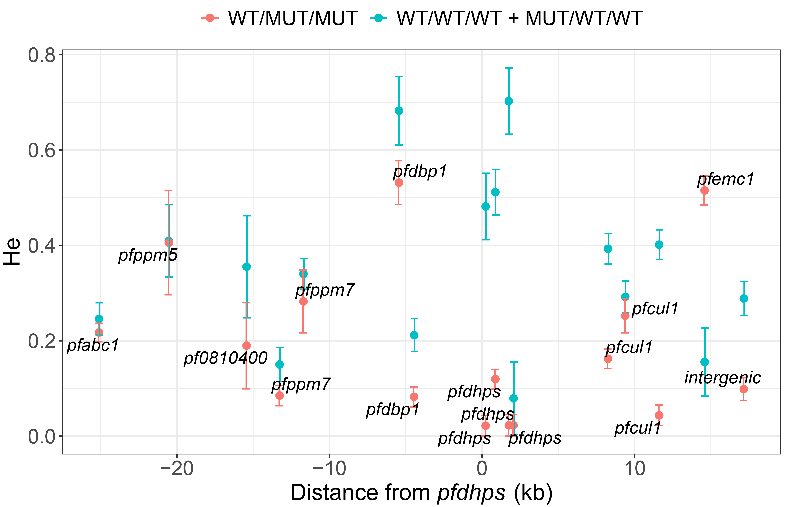

Supplementary Figure 6. Violin plots of inter-sub-population IBS values in Cabo Delgado (2015 and 2018).

Microhaplotypes in a 50 kb region around pfdhps were used to calculate the pairwise IBS between sub-populations: wild-type in codons 436, 437 and 540 (WT/WT/WT; n=20): median IBS=0.68, IQR=(0.62-0.74); mutant in codon 436, and wild-type in codons 437 and 540 (MUT/WT/WT; n=31): median IBS=0.73, IQR=(0.65-0.79); wild-type in codon 436, and mutant in codons 437 and 540 (WT/MUT/MUT; n=92): median IBS=0.88, IQR=[0.81-0.91]). Comparisons between groups were done using Kruskal-Wallis Test (p<0.001). The lower, middle and upper hinges of the rectangle correspond to the 25% quantile , median and 75% quantile of the distribution

