Supplementary information

Fluorescence Lifetime Multiplexing for
Simultaneous High Dimensional Spatial Biology
in 3D
Wonsang Hwang1, Tucker Raymond2,3, Tyler McPartland1,2,
Sinyoung Jeong2, Conor L. Evans1*
1*Wellman Center for Photomedicine, Harvard Medical School,
Massachusetts General Hospital, CNY149, 13th St, Charlestown, 02129,
MA, USA.
2Intek Scientific, Street, City, 10587, State, Country.
*Corresponding author(s). E-mail(s): evans.conor@mgh.harvard.edu;
Contributing authors: whwang6@mgh.harvard.edu;
tpraymond@mgh.harvard.edu; tmcpartland@mgh.harvard.edu;
sjeong@intekscientific.com;

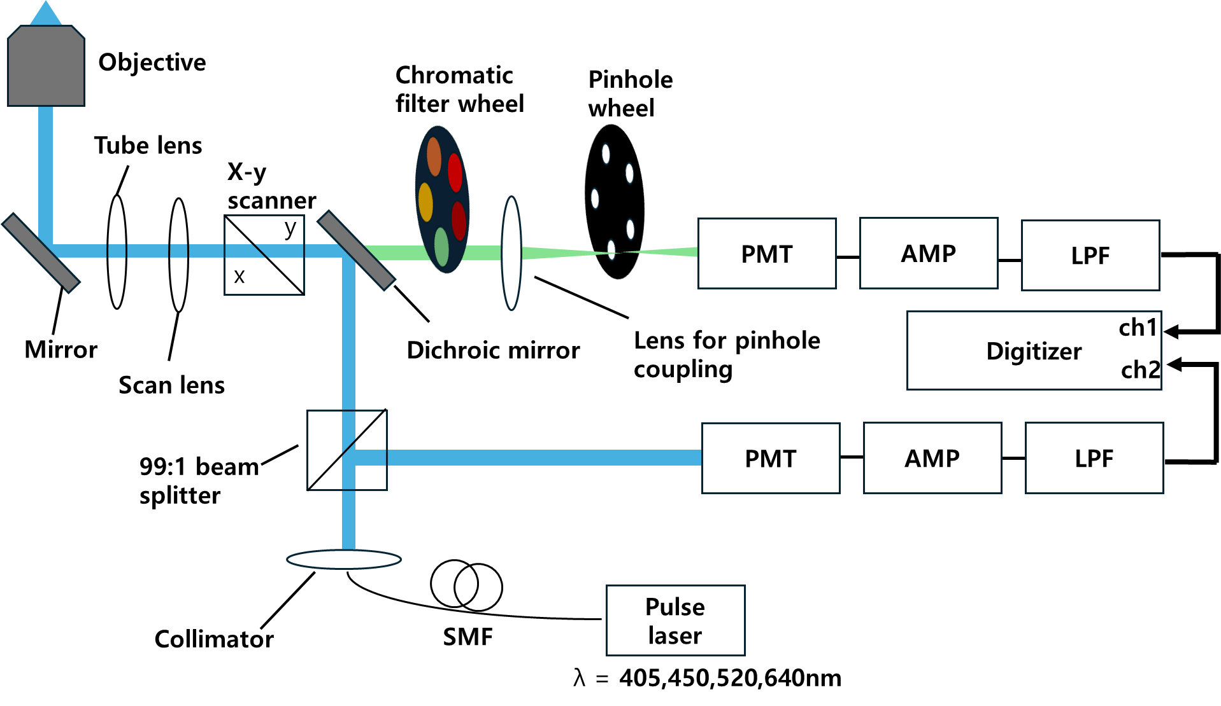
Supplemental Figure.1 Schematic diagram of the real-time FLIM system.

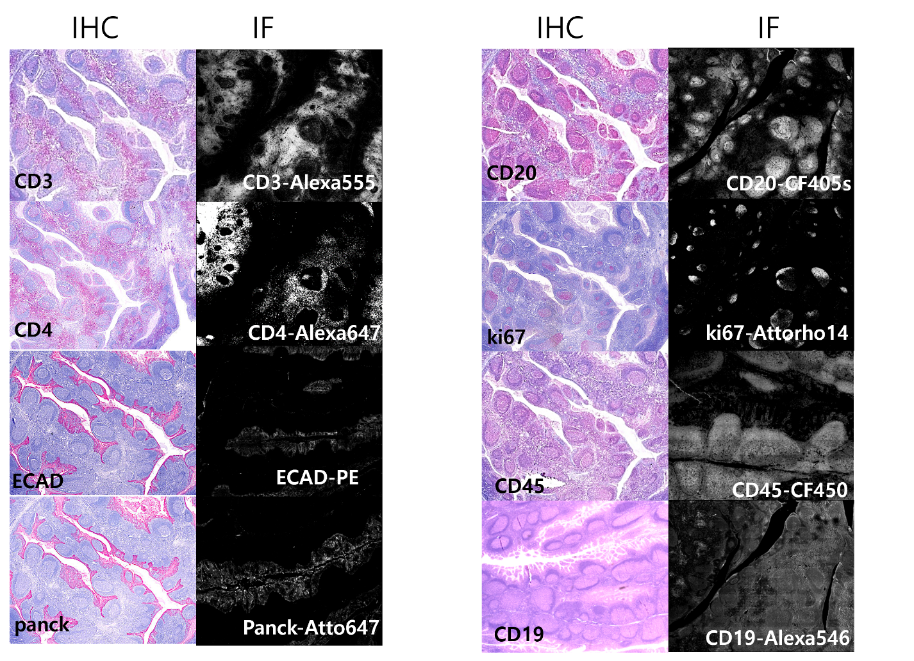
Supplemental Figure.2 IHC and IF results of 8 antibodies

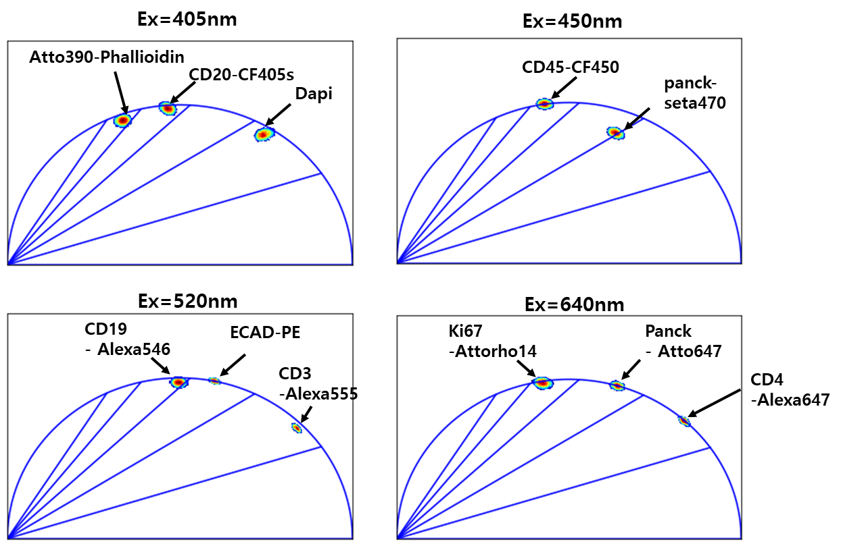
Supplemental Figure.3 Phasors of antibody-dye solutions in PBS solvent at a concentration of 10 μg/ml.

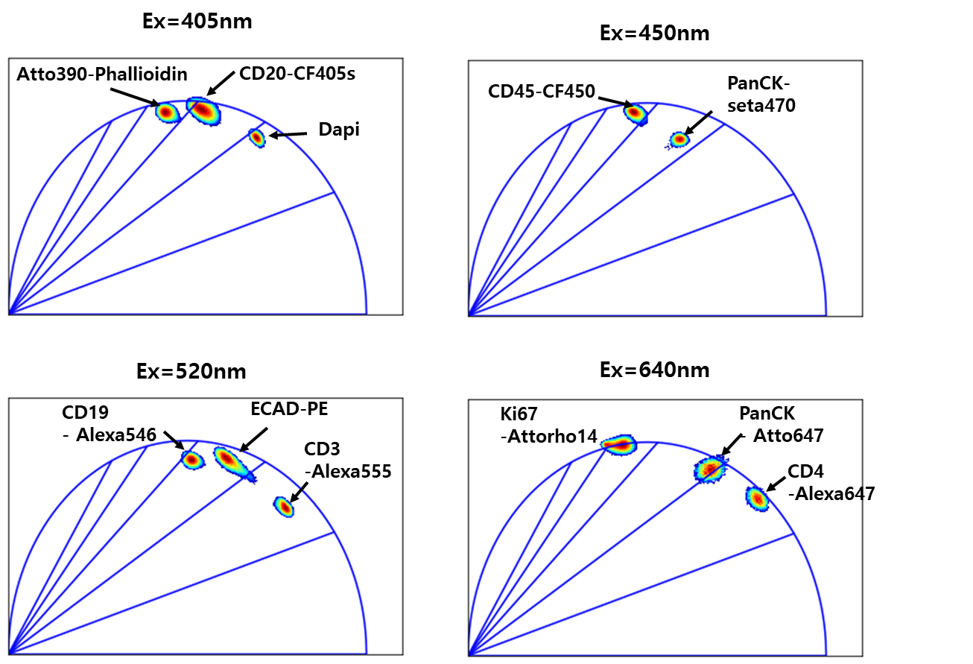
Supplemental Figure.4 Phasors of the single labelled FFPE tonsil tissue

Spectral crosstalk elimination

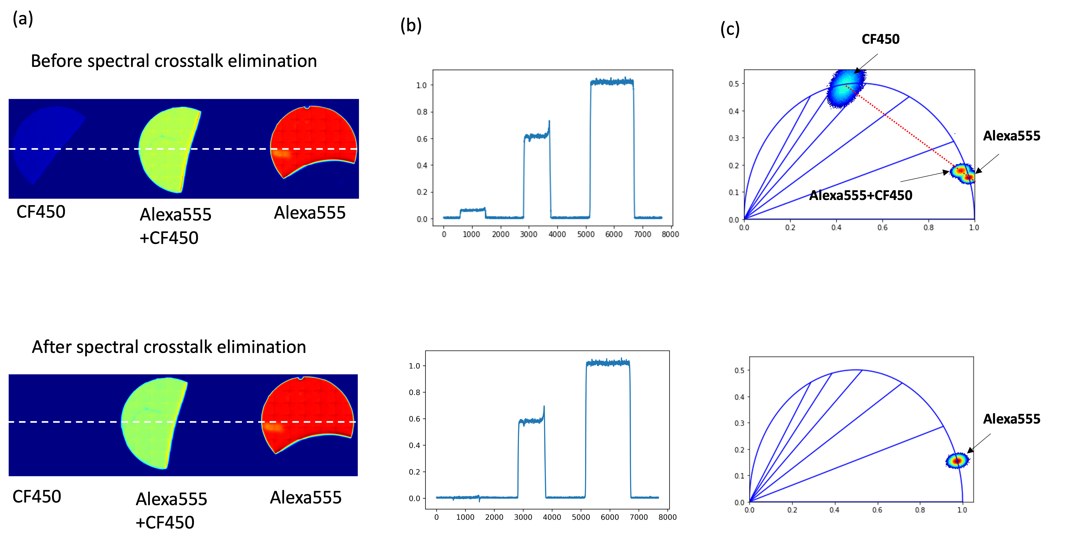
Supplemental Figure.5 (a) Fluorescence Intensity Images Before (top) and After (bottom) the Application of Spectral Crosstalk Elimination in 520nm channel. (b) Cross-Sectional Graph Aligned with the White Dot Lines in Panel (a) and Phasor Histograms Corresponding to the Images in Panel (a). PBS was used as the solvent for each solution, with a concentration set at 10 μg/ml.
Spectral crosstalk elimination algorithm

In the event of crosstalk occurring within the 450-520 nm channel range, the following equation provides a means of its elimination. Specifically, when dyes originally designated for the 450 nm channel (referred to as dye1, dye2, and dye3) are detected within the 520 nm channel, it can be regarded as crosstalk. The equation is defined with the relevant variables as specified below

$C_{1}:$concentration of dye1
$C_{2}:$concentration of dye2
$C_{3}:$concentration of dye3

$ε_{dye1}$=Extinction coefficient of dye1
$ε_{dye2}$=Extinction coefficient of dye2
$ε_{dye3}$=Extinction coefficient of dye3

$E_{1}$: Emission spectrum of dye1
$E_{2}$: Emission spectrum of dye2
$E_{3}$: Emission spectrum of dye3

${QY}_{1}:$ Quantum yield of dye1
${QY}_{2}:$ Quantum yield of dye2
${QY}_{3}:$ Quantum yield of dye3

$Ρ_{1}$: power of 450nm laser line
$Ρ_{2}$: power of 520nm laser line
$G_{450-1}$: phasor of dye1 with 450nm excitation
$G_{520-1}$: phasor of dye1 with 520nm excitation
$G_{450-2}$: phasor of dye2 with 450nm excitation
$G_{520-2}$: phasor of dye2 with 520nm excitation

$G_{450-3}$: phasor of dye3 with 450nm excitation
$G_{520-3}$: phasor of dye3 with 520nm excitation

$S_{450-1}$: phasor of dye1 with 450nm excitation
$S_{520-1}$: phasor of dye1 with 520nm excitation
$S_{450-2}$: phasor of dye2 with 450nm excitation
$S_{520-2}$: phasor of dye2 with 520nm excitation

$S_{450-3}$: phasor of dye3 with 450nm excitation
$S_{520-3}$: phasor of dye3 with 520nm excitation

$N_{450}$: the number of photons of a pixel with 450nm laser

First, the fluorescence intensity from each dye can be defined as below.

$F_{dye1-488nm}=C_{1}∙ε_{dye1}(450)∙\int_{500}^{555}{E_{1}dλ}∙{QY}_{1}∙Ρ_{1}$ , $F_{dye1-520nm}=C_{1}∙ε_{dye1}(520)∙\int_{550}^{614}{E_{1}dλ}∙{QY}_{1}∙Ρ_{2}$
$F_{dye2-488nm}=C_{2}∙ε_{dye2}(488)∙\int_{500}^{555}{E_{2}dλ}∙{QY}_{2}∙Ρ_{1}$, $F_{dye2-520nm}=C_{2}∙ε_{dye2}(520)∙\int_{550}^{614}{E_{2}dλ}∙{QY}_{2}∙Ρ_{2}$
$F_{dye3-488nm}=C_{3}∙ε_{dye3}(488)∙\int_{500}^{555}{E_{3}dλ}∙{QY}_{3}∙Ρ_{1}$, ${ F}_{dye3-520nm}=C_{3}∙ε_{dye3}(520)∙\int_{550}^{614}{E_{3}dλ}∙{QY}_{3}∙Ρ_{2}$

The observed fluorescence intensity in each channel is correlated as follows.

$\frac{F_{dye1-450nm}}{ε_{dye1}\left(450\right)∙\int_{500}^{555}{E_{1}dλ}∙Ρ_{1}}$= $C_{1}{QY}_{1}=\frac{F_{dye1-520nm}}{ε_{dye1}\left(520\right)∙\int_{550}^{614}{E_{1}dλ}∙Ρ_{2}}$

$$→$$

$$F_{dye1-520nm}=\frac{ε_{dye1}(520)∙\int_{550}^{614}{E_{1}dλ}∙Ρ_{2}}{ε_{dye1}(488)∙\int_{500}^{555}{E_{1}dλ}∙Ρ_{1}}F_{dye1-450nm}$$

$F_{dye2-520nm}=\frac{ε_{dye2}(520)∙\int_{550}^{614}{E_{2}dλ}∙Ρ_{2}}{ε_{dye2}(488)∙\int_{500}^{555}{E_{2}dλ}∙Ρ_{1}}F_{dye2-450nm}$.

$F_{dye3-520nm}=\frac{ε_{dye3}(520)∙\int_{550}^{614}{E_{3}dλ}∙Ρ_{2}}{ε_{dye3}(488)∙\int_{500}^{555}{E_{3}dλ}∙Ρ_{1}}F_{dye3-450nm} ⋯⋯$ (1)

The values of G, S, and N, obtainable at 450 nm, can be represented as the linear sum of individual contributions from each dye as follows.

$f_{1}G_{450-1}+f_{2}G_{450-2}+f_{3}G_{450-3}=G_{450}$ $, f_{1}S_{450-1}+f_{2}S_{450-2}+f_{3}S_{450-3}=S_{450}$ $⋯⋯$ (2)

$f_{1}+f_{2}+f_{3}=$1

$→ F_{dye1-450nm}={f_{1}N}_{450}$ , $F_{dye2-450nm}={f_{2}N}_{450} ,F_{dye3-450nm}={f_{3}N}_{450}$ $⋯⋯$ (3)

By combining equations (1), (2), and (3), we can determine the G, S, and N components of the crosstalk signal as below.

$$\frac{\frac{ε_{dye1}(520)∙\int_{550}^{614}{E_{1}dλ}∙Ρ_{2}}{ε_{dye1}(450)∙\int_{500}^{550}{E_{1}dλ}∙Ρ_{1}}{f_{1}N}_{450}G_{520-1}+\frac{ε_{dye2}(520)∙\int_{550}^{614}{E_{2}dλ}∙Ρ_{2}}{ε_{dye2}(450)∙\int_{500}^{550}{E_{2}dλ}∙Ρ_{1}} {f_{2}N}_{450}G_{520-2}+ \frac{ε_{dye3}(520)∙\int_{550}^{614}{E_{3}dλ}∙Ρ_{2}}{ε_{dye3}(450)∙\int_{500}^{550}{E_{3}dλ}∙Ρ_{1}} {f_{3}N}_{450}G_{520-3}}{\frac{ε_{dye1}(520)∙\int_{550}^{614}{E_{1}dλ}∙Ρ_{2}}{ε_{dye1}(450)∙\int_{500}^{550}{E_{1}dλ}∙Ρ_{1}}{f_{1}N}_{450}+\frac{ε_{dye2}(520)∙\int_{550}^{614}{E_{2}dλ}∙Ρ_{2}}{ε_{dye2}(450)∙\int_{500}^{550}{E_{2}dλ}∙Ρ_{1}} {f_{2}N}_{450}+ \frac{ε_{dye3}(520)∙\int_{550}^{614}{E_{3}dλ}∙Ρ_{2}}{ε_{dye3}(450)∙\int_{500}^{550}{E_{3}dλ}∙Ρ_{1}} {f_{3}N}_{450}}=G_{crosstalk}$$

$$\frac{\frac{ε_{dye1}(520)∙\int_{550}^{614}{E_{1}dλ}∙Ρ_{2}}{ε_{dye1}(450)∙\int_{500}^{550}{E_{1}dλ}∙Ρ_{1}}{f_{1}N}_{450}S_{520-1}+\frac{ε_{dye2}(520)∙\int_{550}^{614}{E_{2}dλ}∙Ρ_{2}}{ε_{dye2}(450)∙\int_{500}^{550}{E_{2}dλ}∙Ρ_{1}} {f_{2}N}_{450}S_{520-2}+ \frac{ε_{dye3}(520)∙\int_{550}^{614}{E_{3}dλ}∙Ρ_{2}}{ε_{dye3}(450)∙\int_{500}^{550}{E_{3}dλ}∙Ρ_{1}} {f_{3}N}_{450}S_{520-3}}{\frac{ε_{dye1}(520)∙\int_{550}^{614}{E_{1}dλ}∙Ρ_{2}}{ε_{dye1}(450)∙\int_{500}^{550}{E_{1}dλ}∙Ρ_{1}}{f_{1}N}_{450}+\frac{ε_{dye2}(520)∙\int_{550}^{614}{E_{2}dλ}∙Ρ_{2}}{ε_{dye2}(450)∙\int_{500}^{550}{E_{2}dλ}∙Ρ_{1}} {f_{2}N}_{450}+ \frac{ε_{dye3}(520)∙\int_{550}^{614}{E_{3}dλ}∙Ρ_{2}}{ε_{dye3}(450)∙\int_{500}^{550}{E_{3}dλ}∙Ρ_{1}} {f_{3}N}_{450}}=S_{crosstalk}$$

$\frac{ε_{dye1}(520)∙\int_{550}^{614}{E_{1}dλ}∙Ρ_{2}}{ε_{dye1}(450)∙\int_{500}^{550}{E_{1}dλ}∙Ρ_{1}}{f_{1}N}_{450}+\frac{ε_{dye2}(520)∙\int_{550}^{614}{E_{2}dλ}∙Ρ_{2}}{ε_{dye2}(450)∙\int_{500}^{550}{E_{2}dλ}∙Ρ_{1}} {f_{2}N}_{450}+ \frac{ε_{dye3}(520)∙\int_{550}^{614}{E_{3}dλ}∙Ρ_{2}}{ε_{dye3}(450)∙\int_{500}^{550}{E_{3}dλ}∙Ρ_{1}} {f_{3}N}_{450}$ $=N_{crosstalk}$

Where $z_{520}=G_{520}+S_{520}i$ and $z_{crosstalk}=G_{crosstalk}+S_{crosstalk}i$,

the crosstalk free phasor can be defined as follow,

$z_{free}$=$\frac{z_{520} N_{520}\text{- }N_{crosstalk}z_{crosstalk}}{(N_{520}-N_{crosstalk})}$

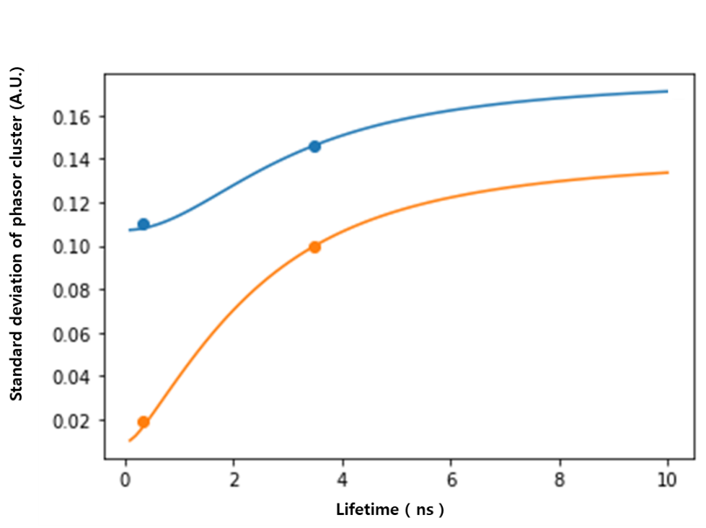
Supplemental Figure.6 precision comparison between nanosecond and picosecond laser. The blue and orange line represents the theoretical estimate reflected their pulse width, and the dots represent experimental data. The equation for the theoretical estimate can be found in reference to [6].

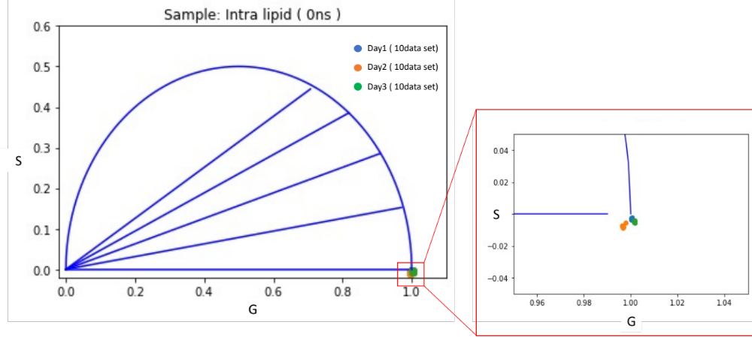
Supplemental Figure.7 Phasor stability test over 3 days, showing centroid positions of intra-lipid (0 ns). Each day (blue, orange, green) comprises 10 data points. Total centroid position standard deviation ~ 0.003, equivalent to a 13 ps fluorescence lifetime.

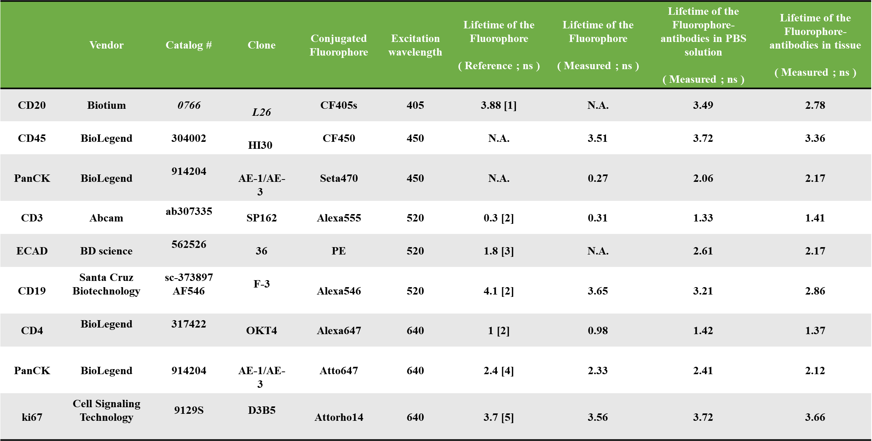
Supplemental table.1 List of antibodies and fluorophores used for FLEX in this paper. The concentration of the fluorescence solutions for lifetime measurements were set to 10ug/ml and PBS was used as solvent.

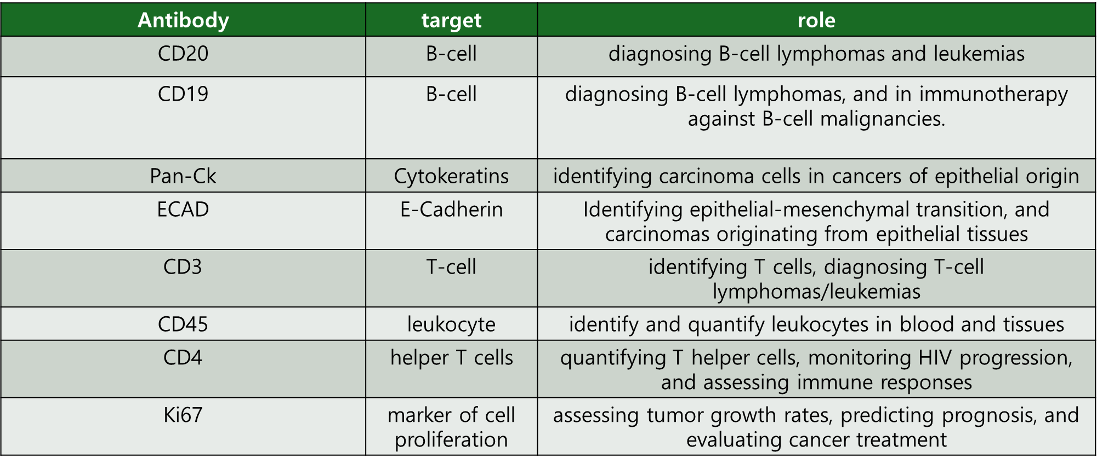
Supplemental table.2 the specific role of antibodies used in this paper.

Reference for supplementary figures.

[1] https://biotium.com/technology/cf-dyes/cf405s-dye/
[2] https://www.thermofisher.com/us/en/home/references/molecular-probes-the-handbook/tables/fluorescence-quantum-yields-and-lifetimes-for-alexa-fluor-dyes.html
[3] Maksimov, E. G., et al. "Anomalous temperature dependence of the fluorescence lifetime of phycobiliproteins." Laser Physics Letters 10.5 (2013): 055602.
[4] https://www.atto-tec.com/ATTO-647.html?language=en
[5] https://www.atto-tec.com/ATTO-Rho14.html?language=en
[6] Kim, D., Moon, S., Hwang, W., & Kim, D. Y. (2022). Use of nanosecond excitation pulses in fluorescence lifetime measurement via phasor analysis. Optics Express, 30(9), 14677-14685.

