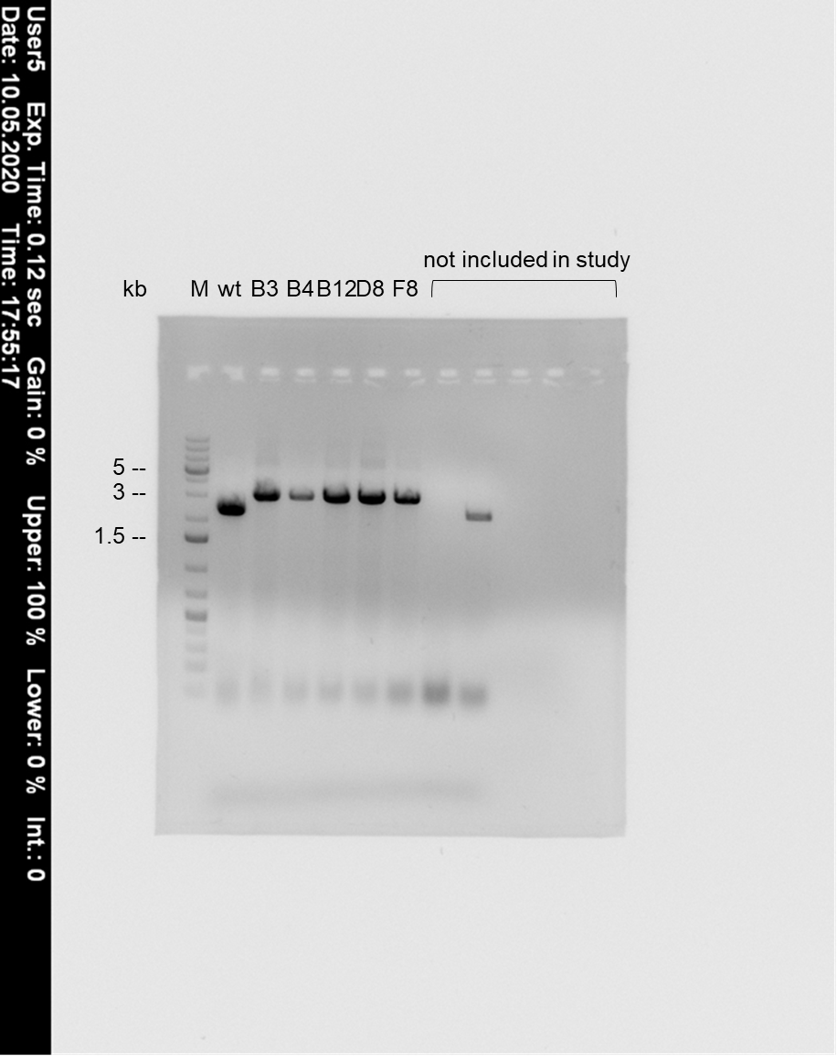
Supplementary Figure 1. Uncropped image of Figure 4B. Marker: Thermo Scientific generuler 1 kb Plus DNA ladder.

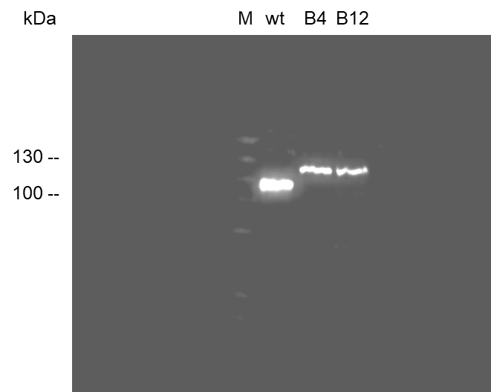
Supplementary Figure 2. Uncropped image of Figure 4C. Marker: Thermo Scientific PageRuler Plus prestained, 10-250 kDa,.

