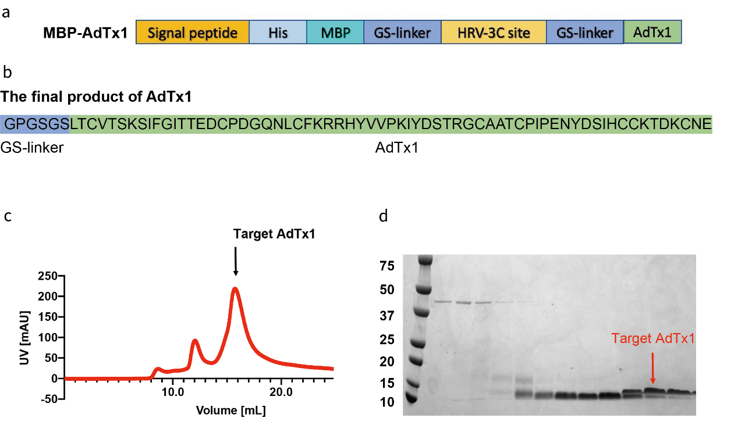
Fig. S1. AdTx1 Construct design and purification.
a, Construct design of MBP-AdTx1.
b, The protein sequence of final product of AdTx1.
c, Size exclusion chromatography (SEC) of AdTx1.
d, Coomassie brilliant blue stained SDS-PAGE gel of AdTx1 after SEC purification.

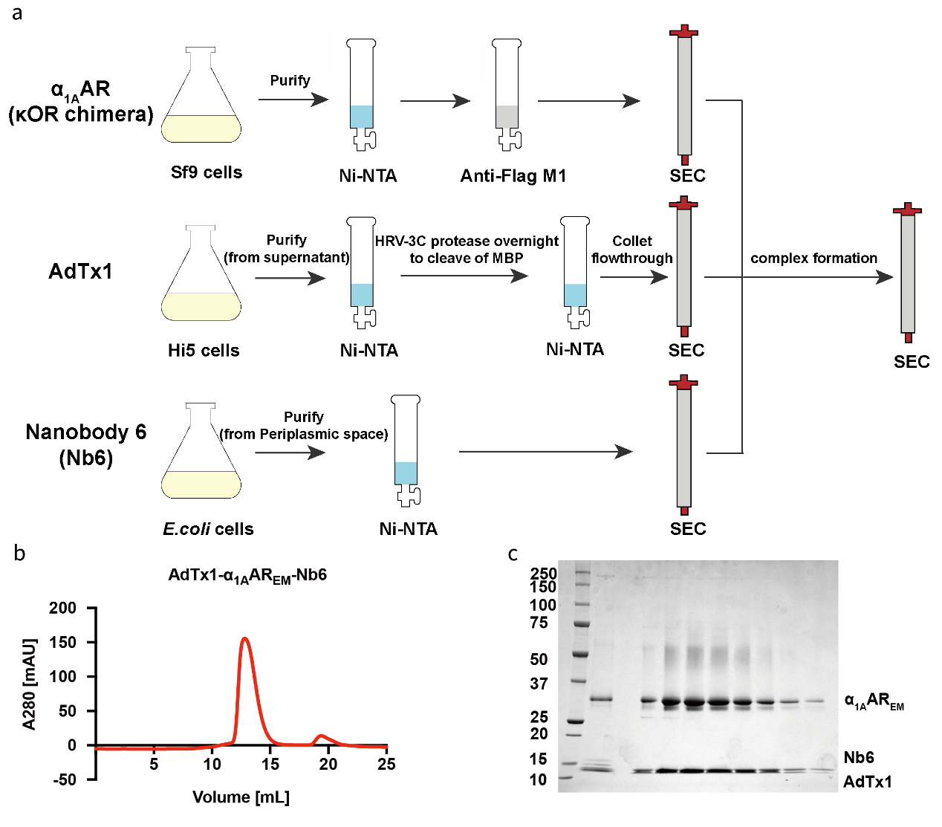
Fig. S2. Protein purification and complex formation of the AdTx1-α_{1A}AR-Nb6.
a, Flowchart of AdTx1-α_{1A}AR-Nb6 complex preparation.
b, Size exclusion chromatography (SEC) of AdTx1-α_{1A}AR-Nb6 complex.
c, Coomassie brilliant blue stained SDS-PAGE gel of AdTx1-α_{1A}AR-Nb6 complex after SEC purification.

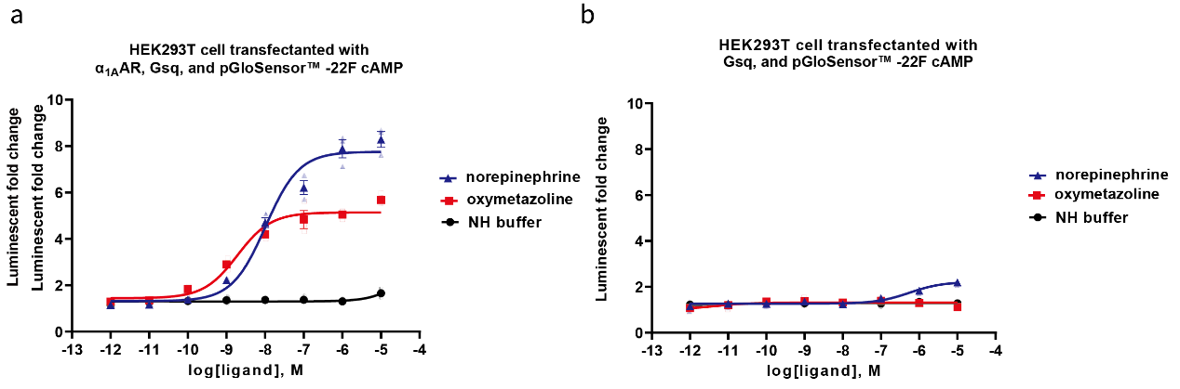
Fig. S3. Oxymetazoline induces receptor-specific cAMP accumulation in HEK293T cells co-expressing pGloSensor™-22F, α_{1A}AR and Gsq protein.
a, Both oxymetazoline and norepinephrine induce cAMP accumulation in HEK293T cells co-expressing pGloSensor™-22F, α_{1A}AR and Gsq. NH buffer (20 mM HEPES pH=7.5, 100 mM NaCl) was used as negative control. Data represent means ± SEM. (n≥ 3 measurements).
b, Oxymetazoline does not induce cAMP accumulation in HEK293T cells co-expressing only pGloSensor™-22F and Gsq, while norepinephrine induces weak cAMP accumulation in HEK293T cells co-expressing only pGloSensor™-22F and Gsq. Data represent means ± SEM. (n ≥ 3 measurements).

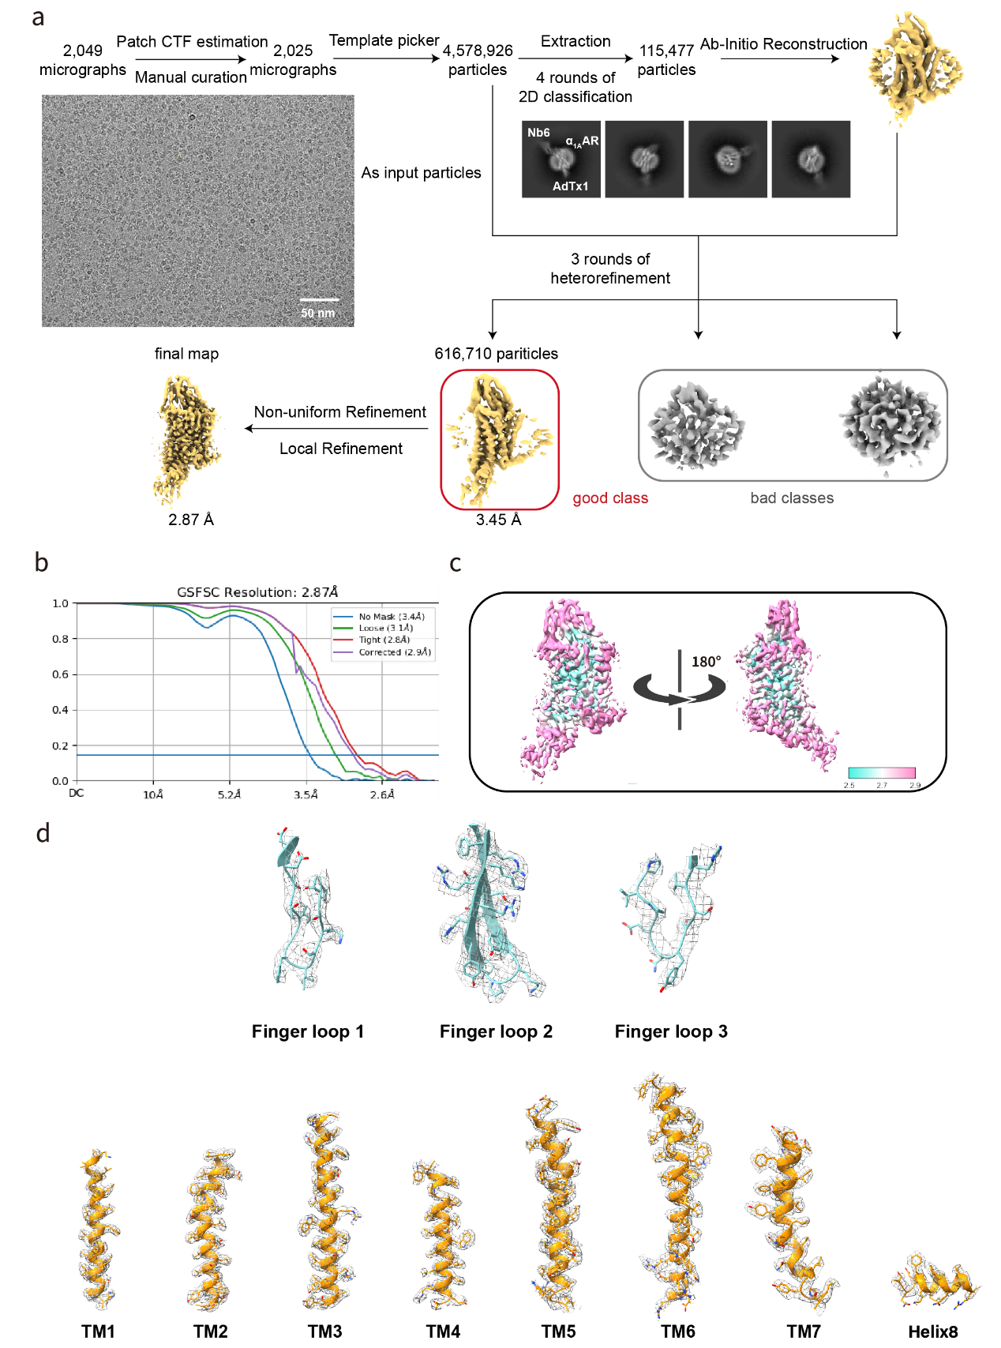
Fig. S4. Cryo-EM data processing of AdTx1-α_{1A}AR-Nb6 complex.
a, Workflow for AdTx1-α_{1A}AR-Nb6 complex cryo-EM data processing.
b, The gold standard FSC curve represents the overall nominal resolution.
c, Local resolution maps of the AdTx1-α_{1A}AR-Nb6 complex structure.
d, Cryo-EM density maps of representative sections of the AdTx1-α_{1A}AR-Nb6 model including the finger loops of AdTx1, and all transmembrane helices and helix 8 of α_{1A}AR.

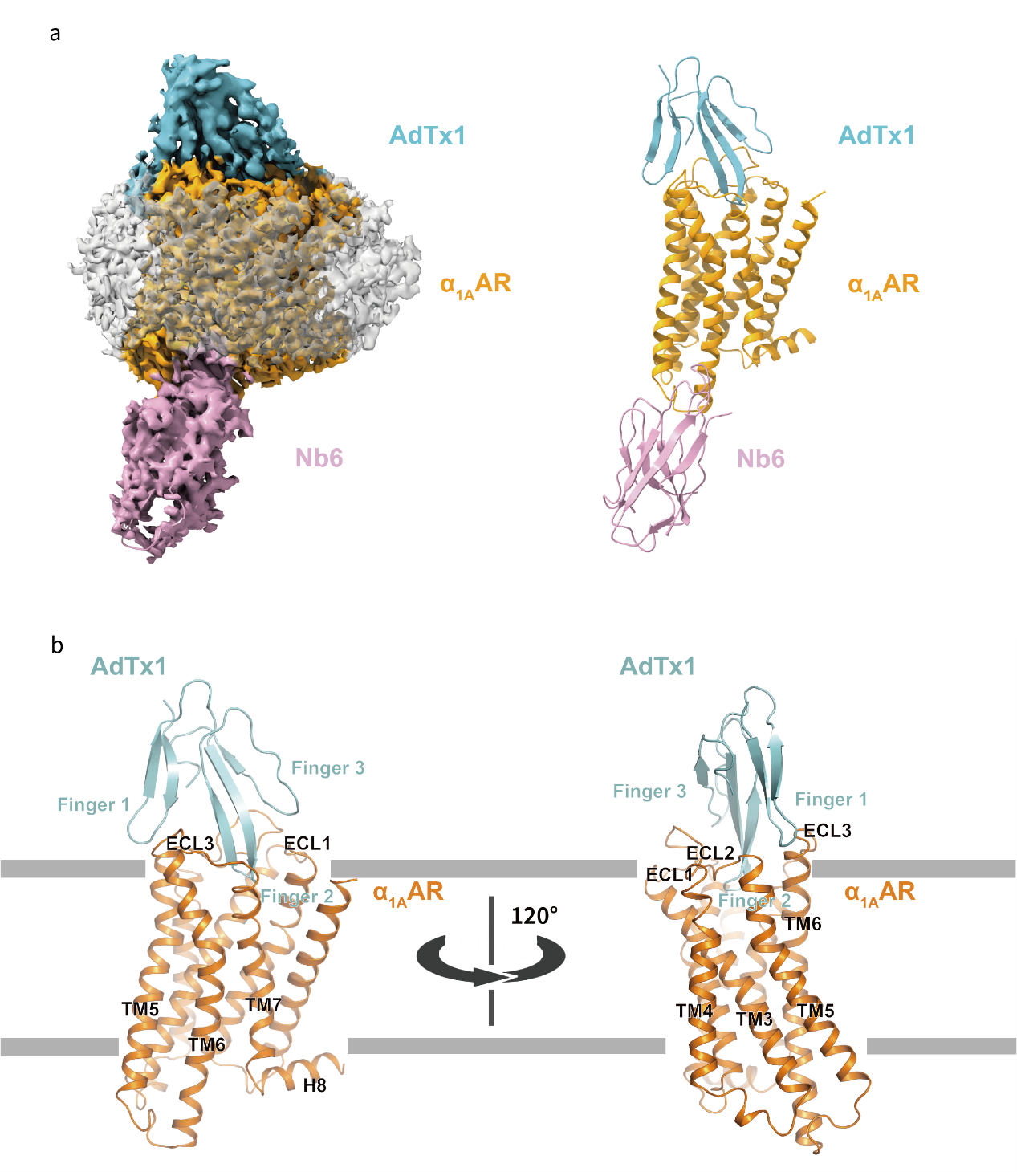
Fig. S5. Cryo-EM structure of AdTx1-α_{1A}AR-Nb6 complex.
a, The cryo-EM density map (left) and model (right) of AdTx1-α_{1A}AR-Nb6 complex. Grey surface indicates detergent micelle.
b, Side view of the overall structure of AdTx1-α_{1A}AR (Nb6 was removed for clarity). AdTx1 and α_{1A}AR are colored cyan and orange, respectively. Transmembrane positions predicted by the Orientations of Proteins in Membranes (OPM) database (http://opm.phar.umich.edu).

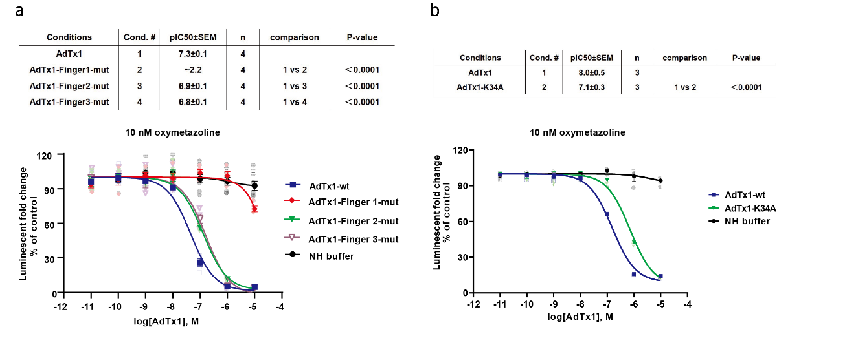
Fig. S6. Functional studies of AdTx1 mutants using Gsq based cAMP accumulation assay.
a, AdTx1-Finger 1 mut, AdTx1-Finger 2 mut, AdTx1-Finger 3 mut show reduced antagonist activity compared to the WT AdTx1 to different extent.
b, K34A mutation impairs the antagonist activity of AdTx1.

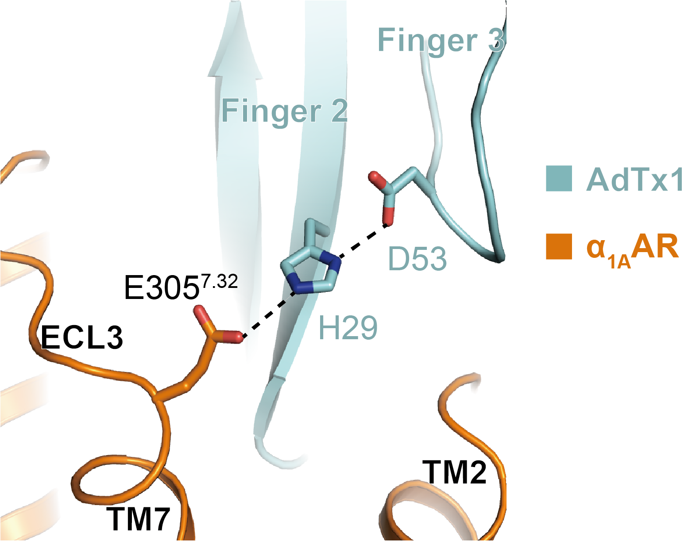
Fig. S7. Structure display of the hydrogen bond network between Finger loop 2/3 of AdTx1 and TM7 of α_{1A}AR.

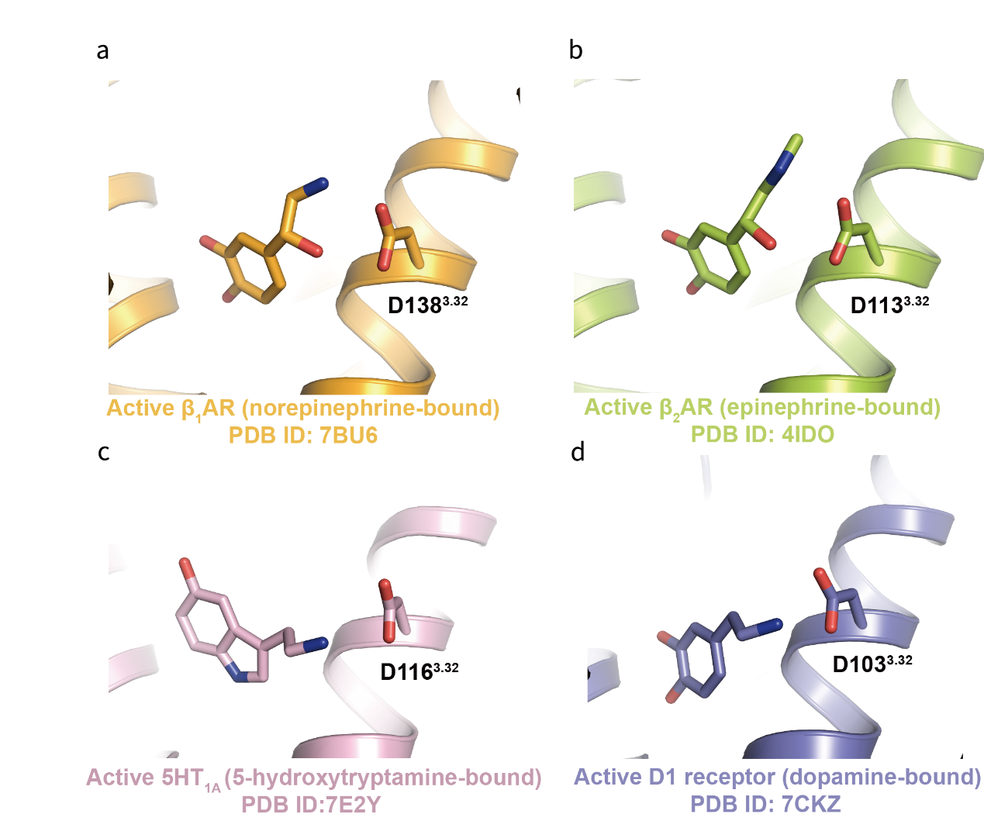
Fig. S8. Similar polar interactions between D^{3.32} and orthosteric ligands in β₁AR, β₂AR, 5HT_{1A} and D1 receptor.
Similar to the α_{1A}AR, polar interactions are also observed between D138^{3.32} and norepinephrine in β₁AR (PDB code: 7BU6) a, between D113^{3.32} and epinephrine in the β₂AR (PDB code: 4IDO) b, between D116^{3.32} and 5-hydroxytryptamine in the 5HT_{1A} (PDB code: 7E2Y) c, as well as between D103^{3.32} and dopamine in the D1 receptor (PDB code: 7CKZ) d.

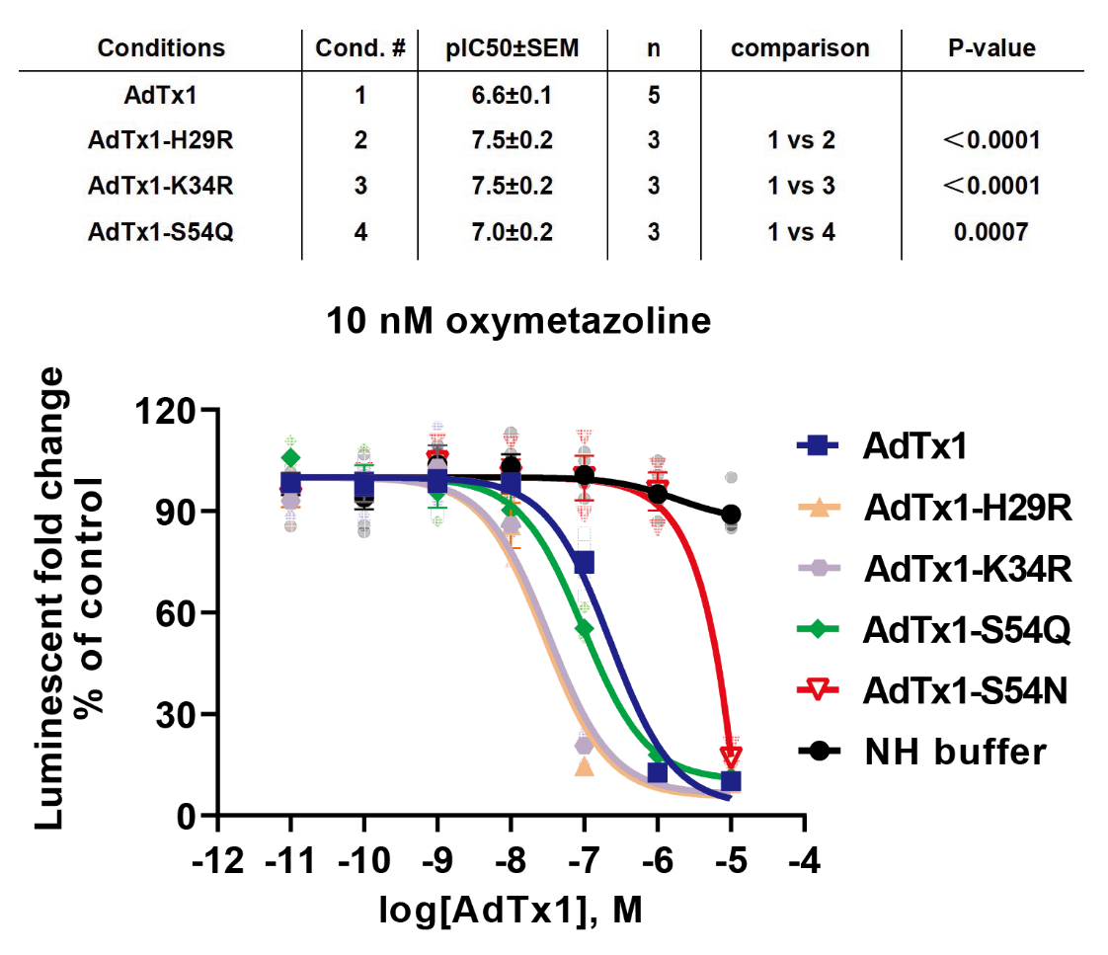
Fig. S9. The H29R, K34R and S54Q single-site mutants enhance the inhibitory effect of AdTx1, while S54N mutant shows impaired function. Data are given as means ± SEM of 3 independent samples.

Fig. S10. Comparison of the AdTx1-α_{1A}AR structure and the MT7-M₁AChR structure.
Side view of the AdTx1-α_{1A}AR structure (left) and MT7-M₁AChR structure (right). The binding modes between the toxins and receptors are different in these two complexes.

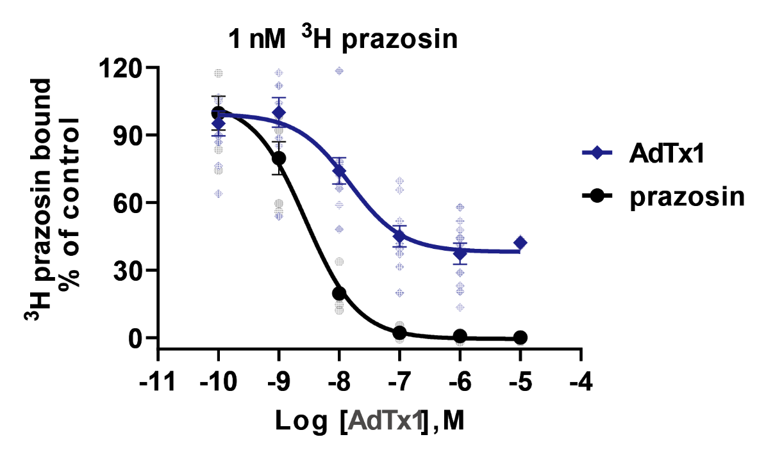
Fig. S11. The competition curve between AdTx1 and ³H prazosin. ³H-prazosin could not be completely displaced by AdTx1, and the competition curve becomes flat, with about 30% of ³H-prazosin still bound when AdTx1 levels go above 1 μM.

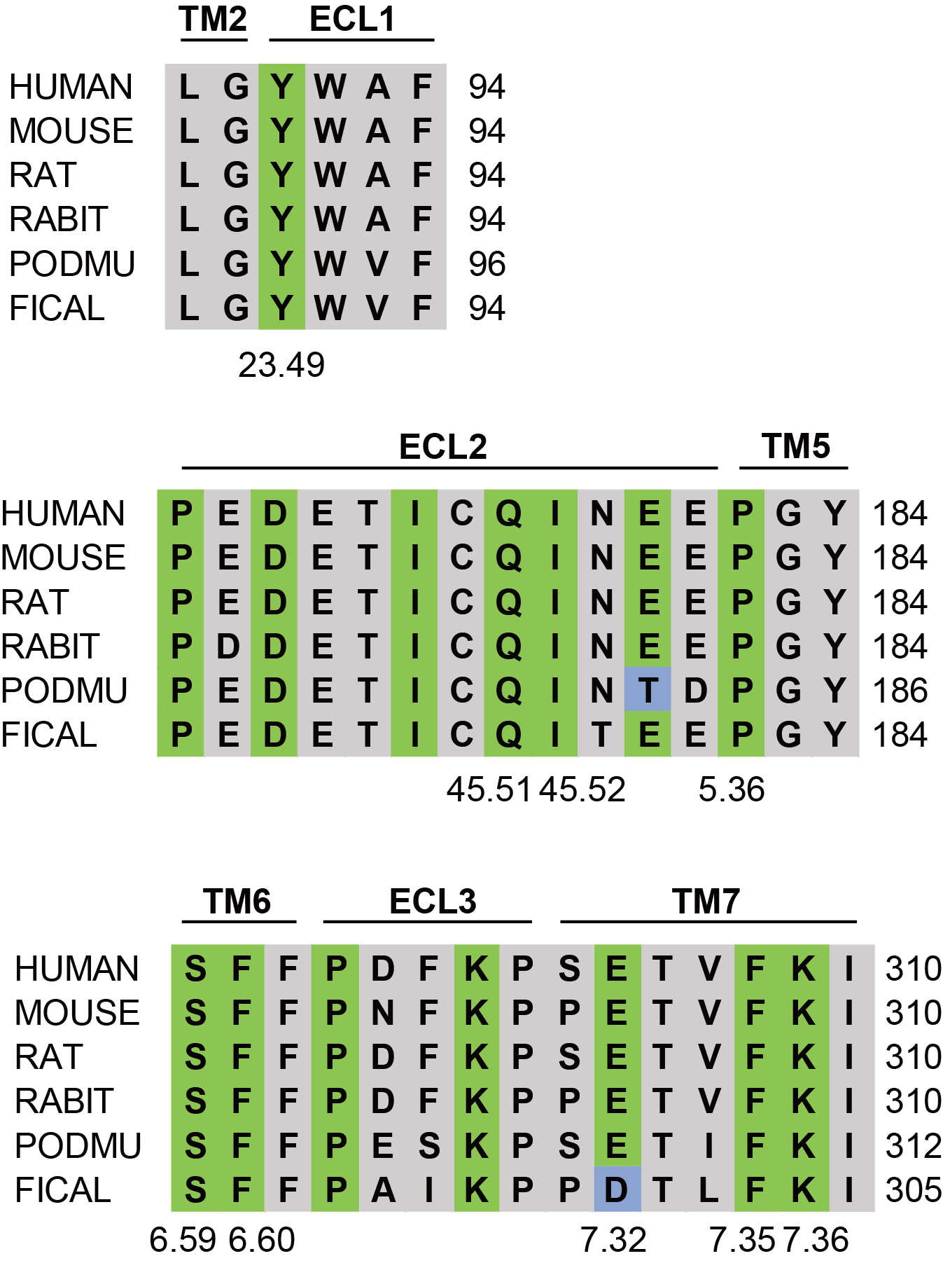
Fig. S12. Sequence alignments of AdTx1 binding sites in α_{1A}AR homologs.
The sequences of AdTx1 binding sites in α_{1A}AR from human, mouse, rat, rabbit, Podarcis muralis (common wall lizard), and Ficedula albicollis (collared flycatcher) were aligned using UniProt (https://www.uniprot.org/align) and manually adjusted. The α_{1A}AR residues that interact with AdTx1 are colored in green, while non-conserved residues are colored in blue.

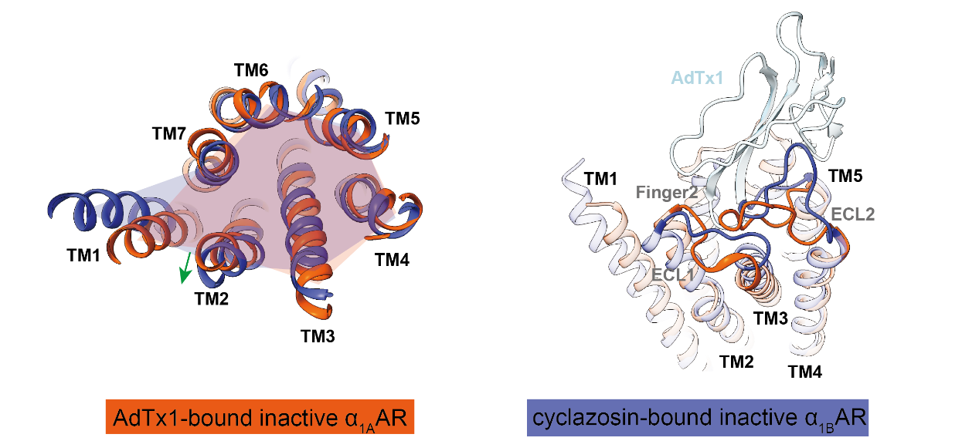
Fig. S13. Comparison of the AdTx1-α_{1A}AR structure and the cyclazosin-α_{1B}AR structure.
Structural overlay of AdTx1-bound inactive α_{1A}AR (orange) and cyclazosin-bound inactive α_{1B}AR (slate blue). The top view of the α_{1A}AR and α_{1B}AR structures shows the outward movement of TM2 (left). A structural comparison of α_{1A}AR and α_{1B}AR highlights differences in ECL1 and ECL2 (right).

