Supplementary information
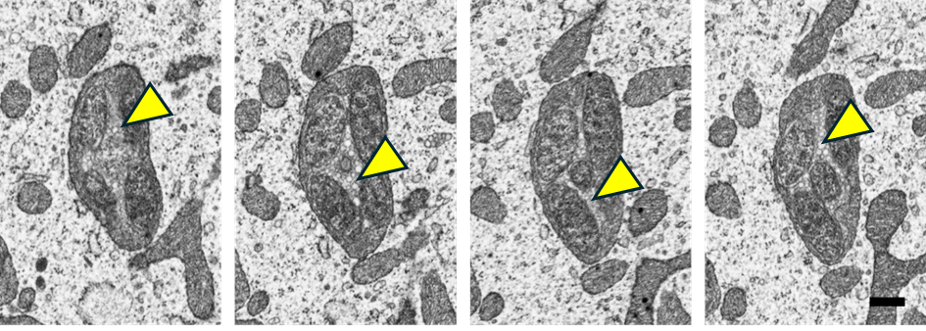
Supplementary Figure S1: AT images of densely packed Midichloria-containing mitochondria. The images are taken from subsequent sections of the same region, highlighting the presence of the outer membrane vesicles (OMV)-like structures (indicated by yellow arrowheads).

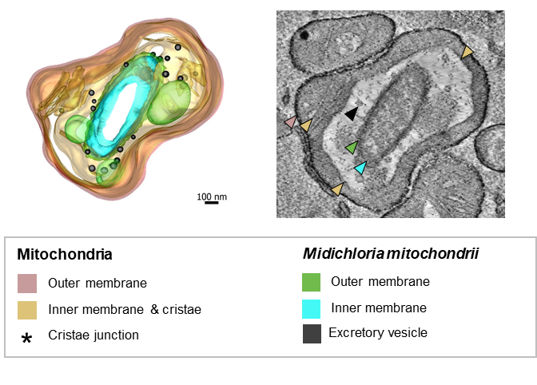
Supplementary Figure S2: sET (thickness ~140 nm, pixel size 0.66 nm) showing intra-mitochondrial stages, with multiple symbionts occupying the intracristal space. Note the width of cristae exceeding 1 µm.

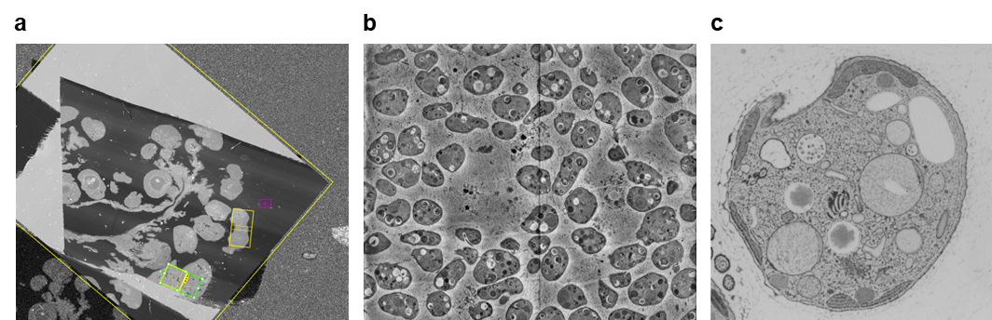
Supplementary Figure S3: Comparison of different EM imaging methods used to examine mitobiosis. a) Overview of AT section containing multiple oocytes; Horizontal Field of View (HFW) = 0.5 mm, best candidate ROIs are indicated in green and yellow. b) Section from the SBF-SEM diplonemid dataset illustrating how many cells can be imaged together; HFW = 70 µm. c) Example of the FIB-SEM dataset showing cross-section through one of the three cells imaged; HFW = 6 µm.

Supplementary Video SV1: Part of the AT dataset and a 3D model of vitellogenic I. ricinus oocyte showing the spatial distribution of M. mitochondrii and host mitochondria. The mitochondria are shown in beige, and intra-mitochondrial M. mitochondria cells are shown in colours.

Supplementary Video SV2: Part of the SBF-SEM dataset and a 3D model of a D. japonicum cell. The reticulated mitochondrion is shown in beige, and endosymbionts are colour-coded according to five interaction categories with the mitochondrion: red, outside mt; violet, touching mt; yellow, half-engulfed; blue, mostly-engulfed; green, fully-engulfed.

Supplementary Video SV3: Part of the SBF-SEM dataset showing serial sections through a sessile Diplonema japonicum cell.

Supplementary Video SV4: Part of the SBF-SEM dataset showing serial sections through a trophic Diplonema japonicum cell.
Supplementary Video SV5: Representative FIB-SEM dataset showing a Diplonema japonicum cell.
Supplementary Data File. Raw data underlying all graphs shown in the figures. The Excel file contains the raw data used to generate all graphs presented in the main figures. Each graph is provided in a separate worksheet.

