Supplementary Methods

Preparation of holey graphene oxide. Graphene oxide was prepared by a modified Hummers method. Graphite powder was added to 40 mL of concentrated H₂SO₄. Subsequently, 3 g of K₂S₂O₈ followed by 3 g of P₂O₅ were added slowly to the mixture under stirring. The suspension was stirred at 80 ºC for 5 h, after which the solid was collected, repeatedly washed with water until neutral pH and dried at 70 °C. This solid was then mixed with 90 ml of concentrated H₂SO₄ and stirred in an ice bath. 2 g of NaNO₃ was added slowly under stirring. Subsequently, 12 g of KMnO₄ was added very slowly under vigorous stirring, not allowing the temperature to rise above 10 °C. The suspension was stirred for 1 h in the ice bath followed by 5 days at room temperature. 250 mL of water was added slowly under vigorous stirring and the mixture was heated at 98 °C for 1 h. After heating for 1 h, 20 mL of H₂O₂ (30 wt%) were added slowly to the hot mixture. The warm suspension was filtered and washed with a 2 M HCl solution. The solid was then thoroughly washed with DI water until the pH increased to 6-7, and dried at 70 °C. 100 mg of graphene oxide was dispersed in 50 mL of DI water, and 5 mL of 30 % H₂O₂ was added. The suspension was heated at 100 °C for 3 h, thoroughly washed with water and dried.

Supplementary Figure 1. ¹H-NMR spectrum of the reaction solution. a) Zoom in aromatic region shows the signals of two different aromatic compounds and of an allylic proton. b) Expanded view of the aliphatic region indicates two different compounds with a methylene group in a 1:10 ratio. c) Full spectrum of the reaction mixture. Acetophenone: ¹H-NMR (500 MHz, CDCl₃) δ = 7.98 – 7.96 (m, 2H_{arom.}), 7.57 – 7.54 (m, 1H_{arom.}), 7.47 – 7.43 (m, 2H_{arom.}), 2.59 (s, 3H_{methyl}) ppm. Dypnone: ¹H-NMR (500 MHz, CDCl₃) δ = 8.06 – 8.02 (m, 2H_{arom.}), 7.62 – 7.59 (m, 2H_{arom.}), 7.51 – 7.48 (m, 2H_{arom.}), 7.43 – 7.37 (m, 3H_{arom.}), 7.22 (q, J = 1.3 Hz, 1H_{allylic}), 2.63 (d, J = 1.3 Hz, 3H_{methyl}) ppm.⁴

Supplementary Figure 2. ¹³C-NMR spectrum of the reaction mixture shows the characteristic peaks of acetophenone and dypnone. Acetophenone: ¹³C-NMR (126 MHz, CDCl₃) δ = 197.9, 137.0, 133.0, 128.5, 128.2, 26.4 ppm. Dypnone: ¹³C-NMR (126 MHz, CDCl₃) δ = 191.5, 154. 9, 142.5, 139.3, 132.5, 129.1, 128.6, 128.5, 128.2, 126.4, 121.9, 18.7 ppm.⁴

a)

b)

Supplementary Figure 3. a) Overall reaction of the formation of niobium oxide from niobium pentachloride in acetophenone; b) proposed reaction mechanism of the formation of hydroxylated niobium species and 1,3-diphenyl-2-buten-1-one (dypnone) via aldol condensation of the acetophenone solvent, catalyzed by the niobium pentachloride precursor (Lewis acid). The hydroxylated niobium species are the primary species (monomers) of the niobium oxide nanoparticles formation.

Supplementary Note 1
To get insights into the mechanism of the reaction leading to the oxide, the composition of the organic solution was analyzed by ¹H and ¹³C NMR spectroscopy (Supplementary Fig. 1-2). The main organic side-product of the reaction of NbCl₅ with acetophenone is 1,3-diphenyl-2-buten-1-one (dypnone), which is the product of the aldol condensation of acetophenone, indicating that the formation of the oxide proceeds through an aldol condensation mechanism.¹ The NbCl₅ metal oxide precursor, which is a Lewis acid, acts as the reaction catalyst. It is worth mentioning that no reaction between the acetophenone molecules occurs in the absence of NbCl₅. The proposed mechanism is shown in Supplementary Fig. 3 and can be summarized as follows: first, an acetophenone molecule coordinates to the niobium ion of the NbCl₅ molecule, leading to the formation of an enolate and HCl. Subsequently, the enolate nucleophilically attacks a second acetophenone molecule, resulting in the formation of 1,3-diphenyl-2-buten-1-one and hydroxylated niobium species (NbCl₄OH). The latter further reacts with acetophenone or with other niobium species present in solution to form the Nb-O-Nb bonds that generate the oxide.
The small size, defective nature and structural distortions of the oxide nanoparticles formed in acetophenone are consequence of the reaction mechanism, which involves coordination of the ketone to the niobium centers during the nucleation and growth of the particles. The spatial constrains caused by the bulky ketone restrict the free condensation of the niobium hydroxide species in solution and limit the particle growth, as Niederberger and coworkers found that larger TiO₂ nanoparticles were synthesized in smaller ketones.² Coordination of the organic molecules during nucleation and growth can lead also to unsaturated metal coordinations. In the absence of niobium species for further reaction, the metal coordination may remain incomplete or may be counterbalanced by local structural rearrangements, such as a change in the linkage of the NbO₆ octahedra from corner- to edge-shared, which can generate distortions in the structure. Changes in the linkage of NbO₆ octahedra to compensate for the presence of oxygen vacancies and maintain the hexacoordination of the metal are known to occur relatively easily in niobium oxides.³ For very large oxygen deficiencies, these rearrangements lead to crystallographic shear planes and new phases of the material. The nucleation and growth of the nanoparticles at the surface of the carbon support favors the formation of a structure closer to that of the pure orthorhombic Nb₂O₅, likely as a result of interactions or formation of bonds between the metal and the highly oxidized carbon.
The effect of the Co²⁺ ions in promoting the formation of the spheres is not completely clear and requires a more detailed study, which is out of the scope of this manuscript. A possible explanation for the formation of the spheres is that the adsorption of Co²⁺ ions at the surface of the nanoparticles during their growth increases the charge of their surface. Because the reaction takes place in an organic solvent, the assembly of the nanoparticles into spherical structures is favored, as it decreases the total surface energy of the oxide.

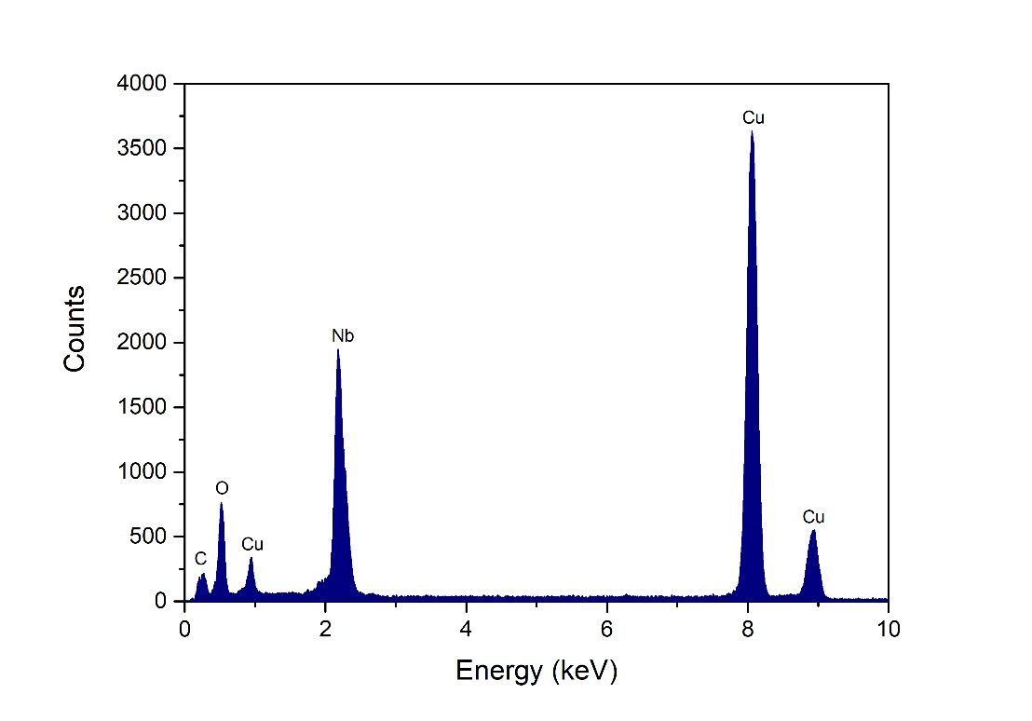
Supplementary Figure 4. Energy dispersive X-ray spectrum of Nb₂O₅-NS, showing the absence of cobalt.

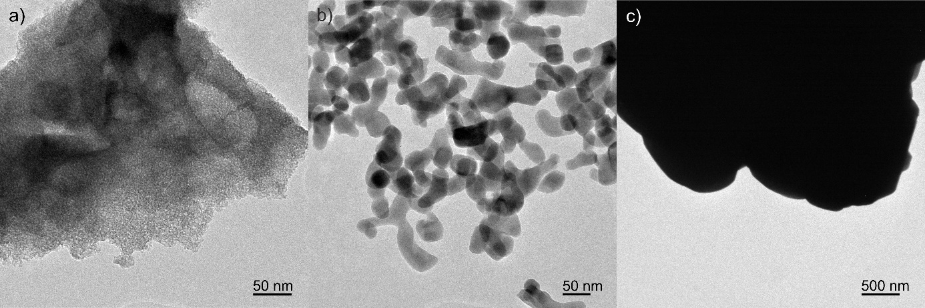

Supplementary Figure 5. TEM images of a) Nb₂O₅·nH₂O, b) T-Nb₂O₅ and c) com-Nb₂O₅.

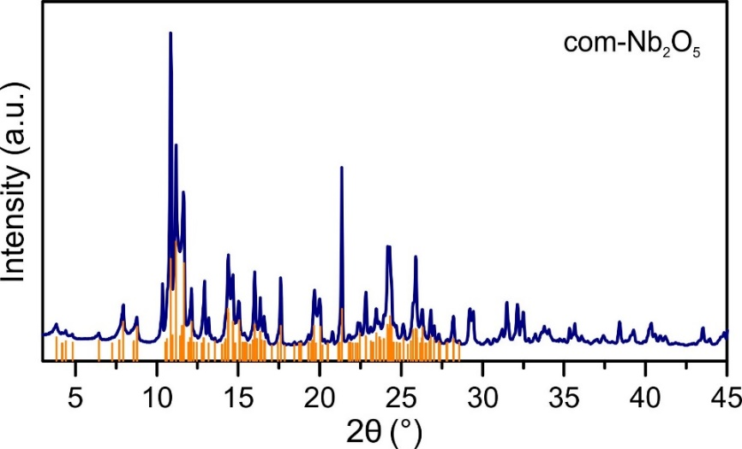
Supplementary Figure 6. X-ray diffraction pattern of the commercial Nb₂O₅ (vertical bars represent the monoclinic H-Nb₂O₅ reference pattern - ICDD file no. 037-1468).

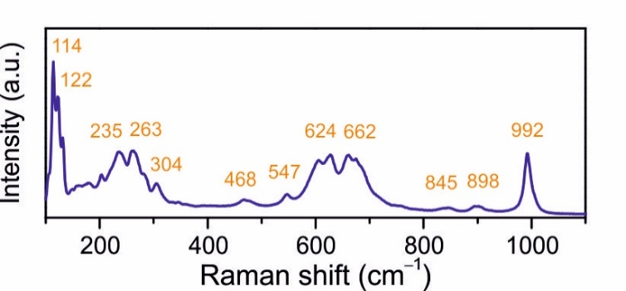

Supplementary Figure 7. Raman spectrum of the commercial Nb₂O₅.

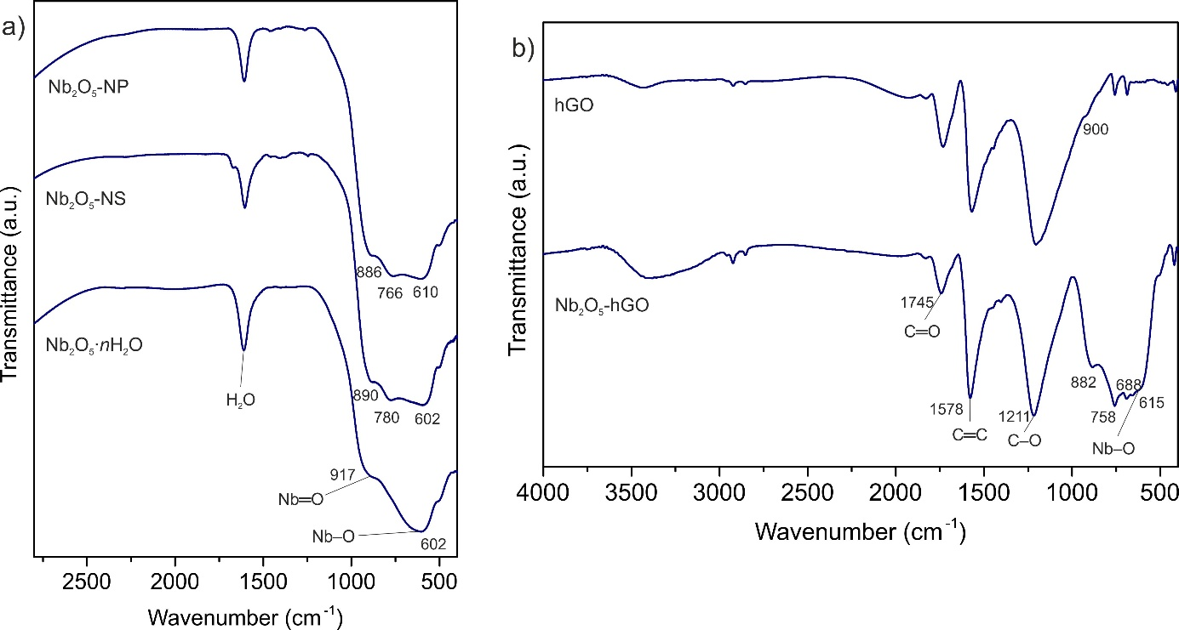
Supplementary Figure 8. FT-IR spectra of a) Nb₂O₅-NP, Nb₂O₅-NS, Nb₂O₅·nH₂O, and b) hGO, Nb₂O₅-hGO.

Supplementary Note 2
The FT-IR spectrum of amorphous Nb₂O₅·nH₂O (Supplementary Figure 8a) shows a broad band at 602 cm⁻¹ and a shoulder at 917 cm⁻¹. The band at 602 cm⁻¹ is assigned to the vibrations of Nb−O bonds of the polyhedra in the structure, whereas the band at 917 cm⁻¹ has been assigned in the literature to the vibration of Nb=O bonds.^{5,6} The spectra of Nb₂O₅-NP and Nb₂O₅-NS (Supplementary Figure 8a) exhibits two bands between 500 and 800 cm⁻¹, in addition to the shoulder at ca. 890 cm⁻¹. The clearly defined bands at 766 and 780 cm⁻¹ in the spectra of Nb₂O₅-NP and Nb₂O₅-NS, respectively, are not typically found on the spectra of niobium pentoxides produced by heating of amorphous Nb₂O₅,⁶ and indicate the presence of an additional type of Nb-O bond in Nb₂O₅-NP and Nb₂O₅-NS that exists in less amounts in Nb₂O₅·nH₂O. These results are consistent with the Raman spectra of the materials.
The spectrum of Nb₂O₅-hGO (Supplementary Figure 8b) displays intense bands from the highly functionalized carbon support. The band at 1745 cm⁻¹ is attributed to carbonyl groups in carboxylic acids and the band at 1578 cm⁻¹ to the vibration of C=C bonds of the graphene oxide. The broad and intense band between 1400 and 980 cm⁻¹ is assigned to the vibration of C−O bonds belonging to different functional groups (carboxylic acid, epoxy, hydroxyl or ketone groups).⁷ This band is centered at ca. 1211 cm⁻¹, which is characteristic of epoxy groups. The spectrum is typical of graphene oxides and, according to the structural models of GO, indicates that the support contains mainly epoxy groups and hydroxyls on the basal planes, whereas carboxylic acid groups are present at the edges and holes.⁸ In the low wavenumber region, the spectrum displays bands at 882, 758, 688 and 615 cm⁻¹, which are bands from the oxide (615 cm⁻¹) overlapped with those of the support (758 and 688 cm⁻¹). The band at 882 cm⁻¹ is at a similar position as those assigned to Nb=O bonds in the spectra of Nb₂O₅-NP and Nb₂O₅-NS. However, there is no match for this band in the Raman spectrum and the FT-IR spectrum of the pristine hGO support also exhibits intensity between ca. 910 and 810 cm⁻¹. Therefore, the band at 882 cm⁻¹ is most likely from the hGO support.

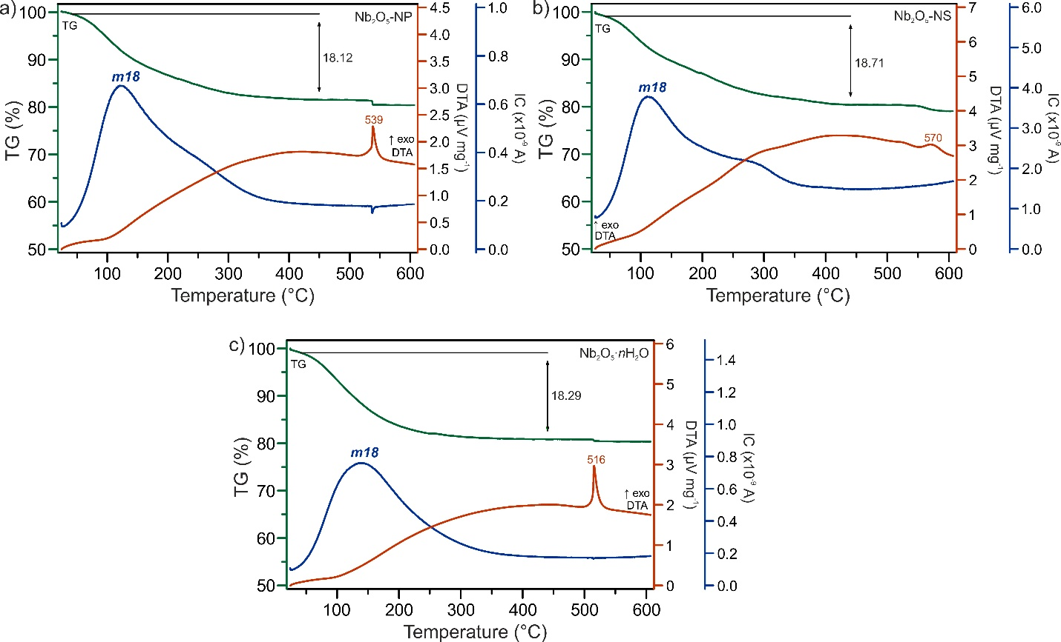
Supplementary Figure 9. Thermogravimetric analysis coupled with mass spectrometry (TG-MS) of (a) Nb₂O₅-NP, (b) Nb₂O₅-NS, and (c) Nb₂O₅·nH₂O under argon flow, with the ion current curves for the mass number m/z = 18 (H₂O⁺).

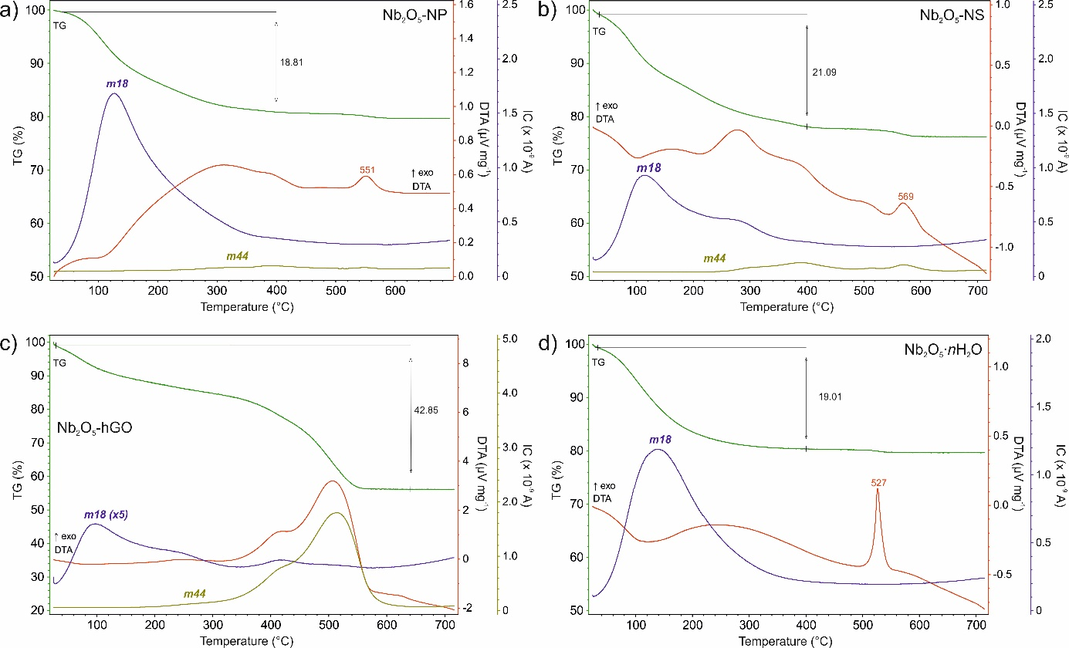

Supplementary Figure 10. TG-MS curves of a) Nb₂O₅-NP, b) Nb₂O₅-NS, c) Nb₂O₅·hGO and d) Nb₂O₅·nH₂O under air flow, with the ion current curves for the mass numbers m/z = 18 (H₂O⁺) and 44 (CO₂⁺).

Supplementary Note 3
TG-MS was used for determining the water/hydroxyl content of the oxides (Supplementary Figure 9-10). For Nb₂O₅-NP, Nb₂O₅-NS and Nb₂O₅·nH₂O, the measurements performed under argon (Supplementary Figure 9) gave qualitatively similar results to those performed under synthetic air (Supplementary Figure 10). The main species formed during heating was water. Small amounts of CO₂ were detected during heating of Nb₂O₅-NP and Nb₂O₅-NS under air, resulting from the decomposition of residual organic molecules adsorbed on the solids (Supplementary Figure 10). The TG curves of Nb₂O₅-NP, Nb₂O₅-NS and Nb₂O₅·nH₂O under argon show mass losses of around 18-19 % in the temperature range 25-450 °C. The water results from desorption of water molecules (dehydration), which generally takes place at temperatures around 100-120 °C, and from the condensation of hydroxyl groups (dehydroxylation), which occurs at higher temperatures, depending on the number of OH groups, distance between them and extent of hydrogen bonding.⁹ It is interesting to note that the three samples release a similar amount of water during heating. However, most of the water (ca. 90 %) evolves until 300 °C for Nb₂O₅·nH₂O (or 200 °C under air), whereas for Nb₂O₅-NP and Nb₂O₅-NS this occurs only at temperatures close to 400 °C (or 300 °C under synthetic air). Thus, Nb₂O₅·nH₂O appears to contain a higher amount of physically adsorbed water and OH groups requiring lower dehydroxylation temperatures. According to the literature, the water molecules incorporated in Nb₂O₅·nH₂O supply oxygen atoms to the coordination sphere of the niobium,¹⁰ and hydroxyls in Nb₂O₅·nH₂O are thus generated through dissociative adsorption of water, which require less energy to be removed from the structure compared to an hydroxyl in which the Nb−O bond has a higher covalent character. Nb₂O₅-NP and Nb₂O₅-NS have a higher proportion of OH groups that require dehydroxylation temperatures higher than 200 °C, possibly including isolated OH groups only eliminated by condensation of the oxide particles. Above 500 °C, an exothermic peak in the DTA curves indicates a crystallization process, determined by XRD to correspond to the formation of highly crystalline orthorhombic Nb₂O₅. The water formed during the heating of Nb₂O₅-hGO results from the dehydration and dehydroxylation of the metal oxide in combination with the elimination of oxygen-containing groups of the support, and is not possible to distinguish the two processes.

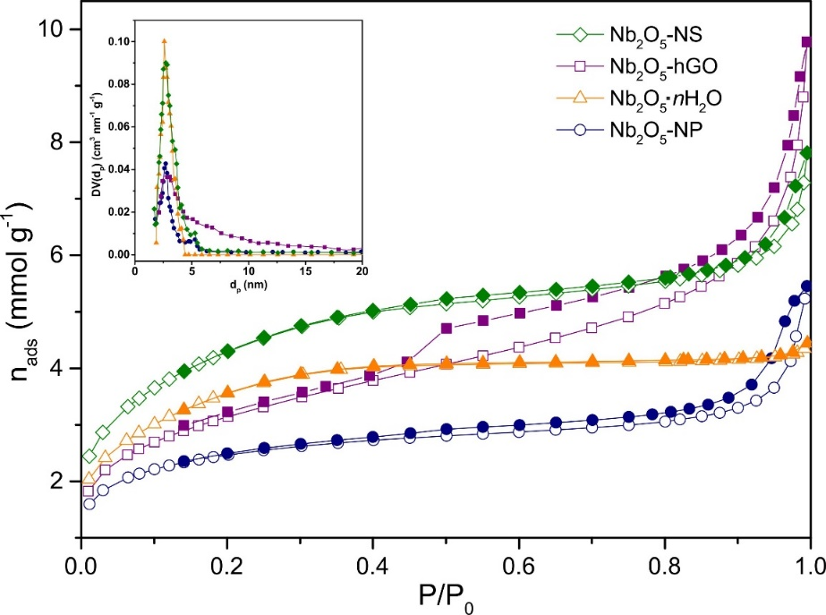
Supplementary Figure 11. Nitrogen adsorption-desorption isotherms at -196 °C of the niobium oxides; inset shows the DFT mesopore size distribution.

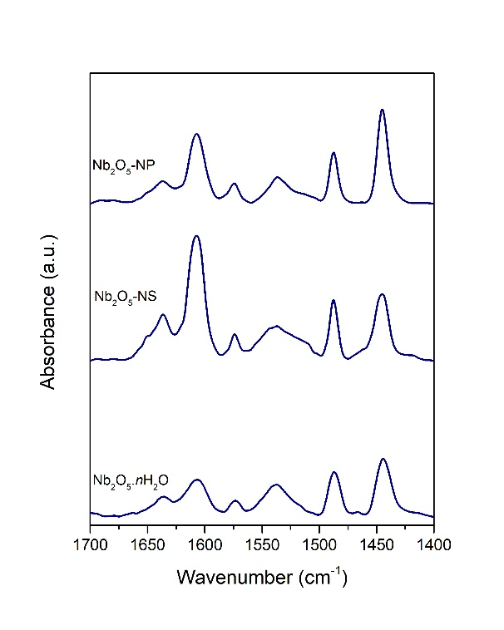
Supplementary Figure 12. Differential FT-IR spectra of adsorbed pyridine on Nb₂O₅-NP, Nb₂O₅-NS, and Nb₂O₅·nH₂O (bands at 1445 cm⁻¹ and 1540 cm⁻¹ are indicative of Lewis and Brønsted acid sites, respectively).

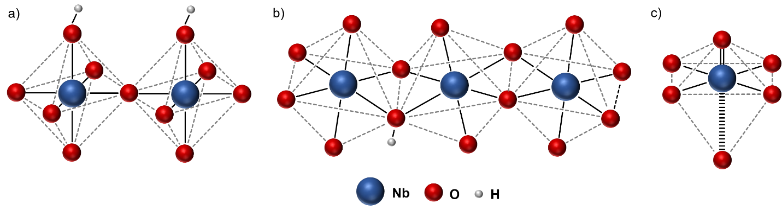
Supplementary Figure 13. Examples of a) terminal and b) bridging hydroxyl groups; c) highly distorted octahedra.

Supplementary Note 4
The structures of the niobium pentoxides synthesized in acetophenone can be considered as orthorhombic containing distortions and unsaturated niobium coordinations to different extents. The structure of Nb₂O₅-hGO is the most similar to the pristine orthorhombic and the less distorted. It consists of corner- and edge-shared NbO₆ octahedra, with a higher proportion of corner-shared octahedra. This structure contains mostly medium-weak Brønsted acid sites, corresponding to terminal OH groups. Strong Brønsted acid sites, corresponding to bridging hydroxyls, correlate with the presence of distorted regions in the orthorhombic structure containing protonated oxygen atoms (indicated by the Raman bands between 700 and 800 cm⁻¹ in the spectra of Nb₂O₅-NP and Nb₂O₅-NS). Furthermore, the higher content of strong Brønsted acid sites in Nb₂O₅-NP is consistent with the higher relative intensity of the Raman band at 700-800 cm⁻¹ for this sample. The exact strength of the acid sites depends on the local structure, particularly the extent of edge-sharing of the octahedra. Similarities between the structures of the oxides synthesized in acetophenone and Nb₂O₅·nH₂O, inferred from the Raman data, are in agreement with reports stating that amorphous Nb₂O₅·nH₂O has structural motifs in common with the low temperature phases of Nb₂O₅ (e.g. T-Nb₂O₅),¹¹ and suggest a common origin for the acidity. The disordered structure of Nb₂O₅·nH₂O generates overall stronger acid sites than those of the more ordered Nb₂O₅-hGO, likely because distortions are easier to occur in the disordered structure. Lewis acidity correlates with the existence of slightly reduced Nb atoms in the materials, i.e., with unsaturated Nb coordinations. Niobium is in the most reduced state in Nb₂O₅·nH₂O, which has the highest relative amount of Lewis acid sites based on C_{D3}CN experiments, whereas Nb₂O₅-hGO does not exhibit Lewis acidity and its XPS Nb 3d spectra indicates the absence of coordinatively unsaturated Nb centers in the structure. In addition, only the samples containing Nb=O bonds exhibit Lewis acidity, as reported before by other authors,^{12,13} indicating a correlation between the niobium oxidation state, Nb=O bonds and Lewis acid sites. Lewis acid sites in niobium pentoxides have been attributed to NbO₄ tetrahedra ^{14,15} or highly distorted NbO₆ octahedra.^{12,13} Tetrahedral NbO₄ species with Nb=O double bonds originate Raman bands at ca. 840-880 cm⁻¹, similarly to NbO₄ tetrahedra in the structures of YNbO₄ and YbNbO₄ (830-850 cm⁻¹).^{16,17} The NbO₄ tetrahedron is difficult to stabilize in niobium compounds because of the large size of the niobium cation, and occurs only in a limited number of structures.¹⁶ However, tetrahedral species with Nb=O bonds can be stabilized as monomeric species at low loadings and highly dispersed state at the surface of oxides such as SiO₂ or TiO₂.^{17,18} In polymerized surface species or bulk Nb₂O₅, the Nb=O Raman band appears at ca. 980 cm⁻¹,^{10,16,19} and corresponds to a structure described as square-pyramidal or highly distorted octahedral (illustrated in Supplementary Fig. 13c).^{13,18} The Raman spectra of our oxides do not show bands assignable to NbO₄ tetrahedra, but show bands around 980 cm⁻¹ instead. Thus, the structure of the Lewis acid sites of the niobium pentoxides is of the type shown in Supplementary Fig. 13c.

Supplementary Table 1. Applications of the bioproducts EL, pseEL and LA.
Bioproducts | Application sector | Ref.
EL | Fuel additives | ¹⁹⁻³²
EL | Solvents | ^{20,21,30,33}
EL | Plasticizers | ^{21,24,27,28,34}
EL | Flavors | ^{21,24,27,28,31,34}
pseEL | Solvents (e.g. varnishes and paint removers) | ³⁵
pseEL | Restorers of surface metals bright | ³⁵
LA | Synthetic rubbers, plastics | ^{36,37}
 | Solvents | ³⁸
 | Anti-freezing agents | ³⁸
 | Pharmaceuticals | ³⁸
 | Polymers | ^{36,39}
 | Pesticide, insecticide | ⁴⁰
 | Batteries | ^{36,37,41}
 | Inks | ⁴¹
 | Coatings | ^{36,37,41}
 | Flavors | ^{36,37}
 | Fragrances | ^{36,37}
 | Additive consumer products | ^{36,37}
 | Lubricants | ⁴¹
 | Adsorbents | ⁴¹
 | Photography | ⁴¹
 | Resins | ³⁸
 | Antifoulants | ⁴²
 | Textile printing | ³³
 | Intermediate of transportation fuels | ^{25,37,38,44-4748}
2EMF | Pharmaceutical | ^{49,50}
 | Food additives | ⁴⁹
 | Transportation fuels | ^{49,51} ⁵² ⁵³
 | Flavors (food, beer, wines) | ⁵⁴⁻⁵⁶ ⁵⁰

Supplementary Figure 14. Dependency of (A, C) the yield of total useful bioproducts formed from FA, i.e. EL and 2EMF (Y_{tot}), and of (B, D) EL yield (Y_{EL}) on FA conversion (X_{FA}), in the presence of the different niobium-based catalysts, at 110 ºC (A, B) or 140 ºC (C, D); Nb₂O₅-NP (∆),Nb₂O₅-NS (o), Nb₂O₅-hGO (□), com-Nb₂O₅ (-), Nb₂O₅·nH₂O (×). Reaction conditions: 0.33 M FA in EtOH, catalyst load equivalent to 5.8 g_{Nb2O5} L⁻¹.

Supplementary Table 2. Conversion of furfuryl alcohol with ethanol, in the presence of the niobium oxide catalysts, and comparison to literature data for different catalysts tested for the same reaction.
Catalyst | Reaction conditionsª |  |  |  | X_{FA} (%)^{b} | Y_{EL} ^{c} (%) | Y_{tot} (%)^{d} | Ref.
Catalyst | T (ºC) | t (h) | [FA]₀  (M) | Cat Load  (g_{cat}L⁻¹)
Nb₂O₅-NP ^{e} | 110 | 1 | 0.33 | 6.8 | 73 | 28 | 53 | tw ^{f}
Nb₂O₅-NP ^{e} | 110 | 3 | 0.33 | 6.8 | 84 | 36 | 68 | tw
Nb₂O₅-NP ^{e} | 140 | 1 | 0.33 | 6.8 | 98 | 60 | 93 | tw
Nb₂O₅-NP ^{e} | 140 | 3 | 0.33 | 6.8 | 100 | 73 | 96 | tw
Nb₂O₅-NS ^{e} | 110 | 1 | 0.33 | 6.8 | 60 | 25 | 48 | tw
Nb₂O₅-NS ^{e} | 110 | 3 | 0.33 | 6.8 | 95 | 52 | 88 | tw
Nb₂O₅-NS ^{e} | 140 | 1 | 0.33 | 6.8 | 93 | 47 | 80 | tw
Nb₂O₅-NS ^{e} | 140 | 3 | 0.33 | 6.8 | 100 | 69 | 90 | tw
Nb₂O₅-hGO ^{e} | 110 | 1 | 0.33 | 9.7 | 77 | 32 | 62 | tw
Nb₂O₅-hGO ^{e} | 110 | 3 | 0.33 | 9.7 | 98 | 55 | 86 | tw
Nb₂O₅-hGO ^{e} | 140 | 1 | 0.33 | 9.7 | 99 | 74 | 93 | tw
Nb₂O₅-hGO ^{e} | 140 | 3 | 0.33 | 9.7 | 100 | 74 | 92 | tw
Nb₂O₅·nH₂O | 110 | 1 | 0.33 | 9.7 | 46 | 6 | 19 | tw
 | 110 | 3 | 0.33 | 9.7 | 64 | 23 | 46 | tw
 | 140 | 1 | 0.33 | 9.7 | 83 | 23 | 53 | tw
 | 140 | 3 | 0.33 | 9.7 | 95 | 44 | 83 | tw
com-Nb₂O₅ | 110 | 1 | 0.33 | 9.7 | 1.9 | 0.2 | 0.5 | tw
 | 110 | 3 | 0.33 | 9.7 | 2.4 | 0.2 | 0.4 | tw
 | 140 | 1 | 0.33 | 9.7 | 1.8 | 0.2 | 1 | tw
 | 140 | 3 | 0.33 | 9.7 | 2.6 | 0.2 | 2 | tw
ITQ-2 | 140 | 24 | 0.33 | 10 | 100 | 60 | nm ^{g} | ⁶²
H-MCM-22 | 140 | 24 | 0.33 | 10 | 100 | 47 | nm ^{g} | ⁶²
Beta/TUD-1 | 140 | 24 | 0.33 | 10 | 100 | 63 | nm ^{g} | ⁶²
Al-TUD-1(21) | 110 | 24 | 0.33 | 10 | 100 | 65 | nm ^{g} | ⁶²
 | 140 | 0.5 | 0.33 | 10 | 100 | 13 | 57 | ⁶²
 | 140 | 6 | 0.33 | 10 | 100 | 65 | nm ^{g} | ⁶²
 | 140 | 24 | 0.33 | 10 | 100 | 80 | 80 | ⁶²
Al-TUD-1(4) | 140 | 24 | 0.33 | 10 | 100 | 51 | 55 | ⁵⁷
CST-1^{h} | 110 | 1 | 0.33 | 10 | 100 | 35 | 64 | ⁶⁵
CST-1^{h} | 110 | 16 | 0.33 | 10 | 100 | 82 | 82 | ⁶⁵
CST-1^{h} | 140 | 6 | 0.33 | 10 | 100 | 78 | 79 | ⁶⁵
C-SBA(45)i | 110 | 1 | 0.33 | 10 | 100 | 46 | 64 | ⁵⁸
C-SBA(45)i | 110 | 4 | 0.33 | 10 | 100 | 68 | 70 | ⁵⁸
C-MCF(63) ^{j} | 110 | 1 | 0.33 | 10 | 100 | 51 | 70 | ⁵⁸
C-MCF(63) ^{j} | 110 | 4 | 0.33 | 10 | 100 | 77 | 78 | ⁵⁸
12.1PW₁₂/ZrO₂-Si(Et)Si-NTs1.0^{k} | 120 | 0.5 | 0.28 | 12 | nm ^{g} | 32 | nm ^{g} | ⁶⁶
 | 120 | 3 | 0.28 | 12 | nm ^{g} | 70 | nm ^{g} | ⁶⁶
HPW/ZrO₂ | 120 | 6 | 0.33 | 8 | 100 | 48 | 88 | ⁶⁴
WO₃/ZrO₂ | 120 | 6 | 0.33 | 8 | 100 | 16 | 90 | ⁶⁴
MoO₃/ZrO₂ | 120 | 6 | 0.33 | 8 | 100 | 13 | 72 | ⁶⁴
Graphene oxide | 120 | 6 | 0.33 | 8 | 100 | 96 | 96 | ⁶⁴
 | 100 | 6 | 0.33 | 4 | 100 | 65 | 87 | ⁶⁴
GO-HT^{l} | 120 | 6 | 0.33 | 8 | 100 | 40 | 79 | ⁶⁴
SO₃H/AC | 120 | 6 | 0.33 | 8 | 100 | 90 | 97 | ⁶⁴
1M-SZF^{m} | 120 | 2 | 1.04 | 7.5 | 100 | 96 | nm ^{g} | ⁶⁷
Pr/SO₃H-Et/HNS9.0^{n} | 120 | 2 | 0.28 | 12 | nm ^{g} | 79 | nm ^{g} | ⁶⁸
Amberlyst-15 | 110 | 4 | 0.3 | 5 | 98 | 80 | 85 | ⁶⁹
SO₄²⁻/TiO₂ | 200 | 2.5 | 0.55 | 23.8 | nm ^{g} | 68 | nm ^{g} | ⁶¹
SO₄²⁻/ZrO₂ | 200 | 2.5 | 0.55 | 23.8 | nm ^{g} | 64 | nm ^{g} | ⁶¹
SO₄²⁻/SnO₂ | 200 | 2.5 | 0.55 | 23.8 | nm ^{g} | 65 | nm ^{g} | ⁶¹
SO₄²⁻/Al₂O₃ | 200 | 2.5 | 0.55 | 23.8 | nm ^{g} | 65 | nm ^{g} | ⁶¹
Al₂O₃/SBA-15 | 110 | 6 | 0.16 | 65.7 | 95 | 32 | nm ^{g} | ⁷⁰
H-Y | 200 | 2.5 | 0.55 | 23.8 | nm ^{g} | 25 | nm ^{g} | ⁶¹
H-Mordenite | 200 | 2.5 | 0.55 | 23.8 | nm ^{g} | 18 | nm ^{g} | ⁶¹
H-Mordenite (20)º | 125 | ^{p} | 9.2 |  | 90 | 3 | 3 | ⁶³
H-Beta | 140 | 24 | 0.33 | 10 | 100 | 60 | nm ^{g} | ⁶²
H-Beta | 120 | 6 | 0.33 | 8 | 100 | 83 | 91 | ⁶⁴
H-Betaº | 125 | ^{p} | 9.2 | 130 | 98 | 8 | 8 | ⁶³
ZSM-5 | 200 | 2.5 | 0.55 | 23.8 | nm ^{g} | 49 | nm ^{g} | ⁶¹
ZSM-5 | 120 | 6 | 0.33 | 8 | 100 | 86 | 94 | ⁶⁴
ZSM-5(25) | 70 | 18 | 0.94 | 73.5 | 98 | 53 | 77 | ⁷¹
HZSM-5(30)^{q} | 40 | 2 | 0.89 | 35.4 | 92 | 73 | 73 | ⁷²
HZSM-5(30)º | 125 | ^{p} | 9.2 | 7^{r} | 99 | 65 | 65 | ⁶³
HZSM-48 | 120 | 6 | 0.33 | 8 | 100 | 19 | 74 | ⁶⁴
HZSM5(50)º | 170 | ^{p} | 1.6 | 14.3 | 100 | 59 | 60 | ⁷⁹
HZSM5(80)º | 125 | ^{p} | 9.2 | 7^{r} | 82 | 32 | 32 | ⁶³
HZSM12(80)º | 125 | ^{p} | 9.2 | 7^{r} | 100 | 15 | 15 | ⁶³
Hie-ZSM-5 | 100 | 2 | 1.82 | 17.8 | nm ^{g} | 19 | 31 | ⁷³
Hie-ZSM-5 | 140 | 4 | 2.27 | 66.8 | nm ^{g} | 73 | 99 | ⁷³
ZrAlW-mp^{s} | 140 | 24 | 0.33 | 10 | 100 | 58 | 64 | ⁷⁴
ZrAl-mp^{s} | 140 | 24 | 0.33 | 10 | 100 | 80 | 84 | ⁷⁴
ZrW^{s} | 140 | 24 | 0.33 | 10 | 98 | 8 | 60 | ⁷⁴
ZrAlW^{s} | 140 | 24 | 0.33 | 10 | 97 | 8 | 56 | ⁷⁴
ZrAl^{s} | 140 | 24 | 0.33 | 10 | 24 | 0 | <1 | ⁷⁴
PVDB- IL^{t} | 130 | 12 | 0.58 | 85.5 | 100 | 47 | nm ^{g} | ⁷⁵
PVDB-IL/DMSO ^{t} | 150 | 12 | 0.15 | 22.2 | 100 | 75 | nm ^{g} | ⁷⁵
[(HSO₃-p)₂im] [HSO₄]^{u} | 110 | 2 | 0.48 | 5.9 | 100 | 92 | nm ^{g} | ⁷⁶
[BMIm-SH][HSO₄]^{v} | 130 | 2 | 0.39 | 3.1 | 100 | 95 | nm ^{g} | ⁷⁷
ª Initial concentration of FA and catalyst load. ^{b} Conversion of FA. ^{c} Yield EL. ^{d} Total yield of 2EMF plus EL. ^{e} The catalyst load equivalent to 5.8 g_{Nb2O5} L⁻¹. ^{f} tw = this work. ^{g} nm=not mentioned, ^{h}Non-porous silica-sulfonated carbon composite, ^{i}Mesoporous silica SBA-15/sulfonated carbon composites, ^{j} Mesoporous (silica) cellular foam/sulfonated carbon composites, ^{k} Heteropoly acid and ZrO₂ bifunctionalized organosilica nanotubes,^{l} GO-HT - graphene oxide, hydrothermally treated, ^{m} Sulfated zirconia, ^{n} Organosulfonic acid functionalized alkyl-bridged organosilica hollow nanospheres, º Continuous flow operation, ^{p} Time on stream, ^{q} Addition of triethylorthoformate as sacrificial reagent, ^{r} value of weight hourly space velocity (WHSV) expressed in g_{FA} g_{cat}⁻¹ h⁻¹, ^{s} MZM = mesostructured zirconium-based mixed oxides. ^{t} Crosslinked polymer of divinylbenzene with acid ionic liquid. ^{u} 3-bis(3-sulfopropryl)-1H-imidazol-3-ium hydrogensulfate. ^{v} Butyl sulfonic acid 3 methyl imidazoliumhydrogensulfate.

Supplementary Note 5
Furfuryl alcohol (FA) is a bio-based compound derived from hemicelluloses (sources of pentoses) that can be converted to levulinate esters and 2-(alkoxymethyl)furans in alcohol media, in the presence of acid catalysts. In particular, 2-(ethoxymethyl)furan (2EMF) and ethyl levulinate (EL) are formed in ethanol. 2EMF is an intermediate of the conversion of FA to EL,^{57,58} which may occur through various pathways, including the etherification of FA to 2EMF followed by 2EMF ring-opening to EL.²⁸
The niobium oxides synthesized via aldol condensation were effective catalysts for the conversion of FA in ethanol (Supplementary Fig. 14 and Supplementary Table 2), leading to the formation of 2EMF and EL at 110 and 140 °C. The increase of the reaction temperature results in high EL yields (Y_{EL}) of 69-74 % within 3 h at 140 °C.
All three catalysts are more active than Nb₂O₅·nH₂O and com-Nb₂O₅, with the initial reaction rates following the order Nb₂O₅-hGO ~ Nb₂O₅-NP > Nb₂O₅-NS > Nb₂O₅·nH₂O >> com-Nb₂O₅. The carbon support alone was considerably less active than Nb₂O₅-hGO, leading only to 41 % of Y_{tot} at 140 °C for 3 h. Nb₂O₅-NP and Nb₂O₅-hGO exhibit the best catalytic performance, leading to the highest EL and total yields. According to the results available in the literature for different types of acid catalysts, the etherification of FA to 2-(alkoxymethyl)furans may be promoted by Lewis or Brønsted acids, whereas the conversion of FA to levulinate esters is achieved with Brønsted acids.⁵⁷⁻⁶⁰ In addition, formation of levulinate esters is favored with increasing acid strength, although very strong Brønsted acids may lead to competitive undesirable FA polymerization.⁶¹ In addition, Nguyen et al.⁶⁰ recently investigated the catalytic activity of metal chloride catalysts in the etherification of FA. They developed a kinetic model for evaluating the intrinsic catalytic activity of metal chlorides (MCl₃) solutions and determine the role of Lewis acid metal species and their induced Brønsted acid (HCl) on FA etherification. Comparison of the rate constants revealed that the Brønsted acid was substantially more effective for FA etherification than Lewis acid metal species. The authors concluded that FA etherification is primarily governed by the induced Brønsted acidity instead of the Lewis acidity.
Supplementary Table 2 compares the catalytic results for the niobium oxide catalysts to those reported in the literature for different catalysts tested in the FA/EtOH reaction ^{57,58,61-77}. Lower EL yields (47-63% yield) were reported for zeolites such as H-Beta, H-MCM-22 and ITQ-2 ⁶², and mesostructured mixed oxides of Zr, Al and W, at 140 ºC ⁶⁴. With ZSM-5 at 200 ºC, the EL yield was 49 % ⁶⁴. Several ZSM-5 zeolites tested under continuous operation mode led to EL yields of up to 65 % with a WHSV of 7 g_{FA} g_{cat}⁻¹ h⁻¹) ⁶³. Zeolites H-MOR and H-Y led to lower EL yields (18-24%) at higher temperature (200 ºC), in batch mode ⁶¹. FA conversion in continuous operation mode, over H-MOR, was 90 % at 125 ºC, albeit EL yield did not exceed 3 % ⁶³. Mesoporous aluminosilicate Al-TUD-1(21) led to 80 % EL yield at 140 ºC, but only after 24 h ⁶²; at 6 h, EL yield was 65 %, which is lower than that for Nb₂O₅-hGO (74 % at 1 h/140 ºC). Likewise, mesostructured mixed oxides of Zr and Al led to 80 % EL at 140 ºC/24 h and 58 % EL at 140 ºC/24 h ⁷⁴. Relatively low EL yields where reported for supported heteropolyacids (32-48 %) ^{64,66}, and mixed oxides (e.g. WO₃/ZrO₂, MoO₃/ZrO₂; <18%) ⁶⁴. Sulfated metal oxides led to 64-68 % EL yield (SO₄²⁻/TiO₂, SO₄²⁻/ZrO₂, SO₄²⁻/SnO₂, SO₄²⁻/Al₂O₃) ⁶¹ at relatively high temperature (200 ºC); similar EL yields (73 %) were reported for Fe₂O₃ ⁷⁸ and a hierarchical ZSM-5 ⁷³ at higher temperature (250 ºC) or using a higher catalyst amount (66 g L⁻¹), respectively. A crosslinked polymer of divinylbenzene with acid ionic liquid led to 74 % EL yield when adding dimethyl sulfoxide (DMSO) to the reaction medium; without DMSO, the EL yield was 47% ⁷⁵. The FA/EtOH reaction over ZSM-5 zeolite with Si/Al=30 led to 73 % EL yield at 40 ºC/2 h, using triethylorthoformate as sacrificial reagent (otherwise EL yield was 7 %) ⁷². A comparative study of the EL yields at 1 h/110 ºC for Nb₂O₅-hGO and silica-carbon based composites, showed that Nb₂O₅-hGO led to intermediate results (32 % EL yield for Nb₂O₅-hGO, compared to 46-51 % for the composites ^{58,65}). Few sulfonic acid functionalized catalysts (SO₃H/Activated carbon) ⁶⁴, sulfonic acid functionalized organosilica hollow nanospheres ⁶⁸, Amberlyst-15 ⁶⁹) performed superiorly (79-96 % EL yields at 110/120 ºC, and 2-6 h).

Supplementary Figure 15. Dependency of (A) the yield of total useful bioproducts formed from HMF, i.e. 5EMF, 5EMFda and EL (Y_{tot}), and (B) total yield of 5EMF+5EMFda (Y_{totEMFs}) on HMF conversion (X_{HMF}), in the presence of the different niobium-based catalysts, at 140 ºC; Nb₂O₅-NP (∆),Nb₂O₅-NS (o), Nb₂O₅-hGO (□), com-Nb₂O₅ (-), Nb₂O₅·nH₂O (×). Reaction conditions: 0.33 M HMF in EtOH, catalyst load equivalent to 5.8 g_{NbOx} L⁻¹.
Supplementary Table 3. Conversion of 5-(hydroxymethyl)furfural with ethanol, in the presence of the niobium oxide catalysts, and comparison to literature data for different heterogeneous catalysts tested in the same reaction.
Catalyst | Reaction conditions |  |  |  | X_{HMF}ª  (%) | Y_{EL}^{b} (%) | Y_{totEMFs}^{c} (%) | Y_{tot}^{d}  (%) | Ref.
Catalyst | T (ºC) | t (h) | [Hmf]₀  (M) | Cat. Load  (g_{cat}L⁻¹)
Nb₂O₅-NP ^{e} | 140 | 1 | 0.33 | 6.8 | 74 | 8 | 60 | 68 | tw ^{f}
Nb₂O₅-NP ^{e} | 140 | 3 | 0.33 | 6.8 | 86 | 10 | 75 | 85 | tw
Nb₂O₅-NS ^{e} | 140 | 1 | 0.33 | 6.8 | 76 | 8 | 62 | 70 | tw
Nb₂O₅-NS ^{e} | 140 | 3 | 0.33 | 6.8 | 86 | 9 | 68 | 77 | tw
Nb₂O₅-hGO ^{e} | 140 | 1 | 0.33 | 9.7 | 72 | 7 | 60 | 67 | tw
Nb₂O₅-hGO ^{e} | 140 | 3 | 0.33 | 9.7 | 86 | 10 | 69 | 79 | tw
Nb₂O₅·nH₂O | 140 | 1 | 0.33 | 6.8 | 44 | 4 | 38 | 42 | tw
Nb₂O₅·nH₂O | 140 | 3 | 0.33 | 6.8 | 68 | 8 | 50 | 58 | tw
com-Nb₂O₅ | 140 | 1 | 0.33 | 6.8 | 18 | 0 | 0 | 0 | tw
com-Nb₂O₅ | 140 | 3 | 0.33 | 6.8 | 29 | 0.3 | 4 | 4 | tw
Al-TUD-1(21) | 140 | 1 | 0.33 | 10 | 56 | 2 | 41 | 43 | ⁵⁷
Al-TUD-1(21) | 140 | 4 | 0.33 | 10 | 79 | 4 | 61 | 65 | ⁵⁷
Al-TUD-1(4) | 140 | 1 | 0.33 | 10 | 47 | 2 | 34 | 36 | ⁵⁷
Al-TUD-1(4) | 140 | 4 | 0.33 | 10 | 63 | 3 | 52 | 55 | ⁵⁷
H-Beta | 160 | 0.08 | 0.10 | 6.6 | 20 | 0 | nm^{g} |  | ⁸⁶
 | 110 | 6 | 0.33 | 10 | 78 | 1 | 75 | 76 | ⁵⁸
H-ZSM-5(3) | 160 | 0.08 | 0.10 | 6.6 | 32 | 0 | nm^{g} |  | ⁸⁶
ZSM-5(11.5) | 140 | 24 | 0.12 | 15.6 | 99 | 3 | 83 | 86 | ⁸⁴
H-MOR | 140 | 24 | 0.12 | 15.6 | 99 | 3 | 78 | 81 | ⁸⁴
H-Y | 100 | 10 | 0.20 | 5.9 | 10 | nm^{g} | 9 |  | ⁸⁷
NH₄-BEA | 140 | 5 | 0.69 | nm^{g} | 100 | 0.44^{h} | 3.52^{h} |  | ⁸⁸
NH₄-MFI | 140 | 5 | 0.69 | nm^{g} | 60 | 0.44^{h} | 1.29^{h} |  | ⁸⁸
NH₄-Silicate-1 | 140 | 5 | 0.69 | nm^{g} | 55 | 0.15^{h} | 0.92^{h} |  | ⁸⁸
SBA-15 | 140 | 5 | 0.69 | nm^{g} | 75 | 0 | 0 | 0 | ⁸³
Z-SBA-15^{i} | 140 | 5 | 0.69 | nm^{g} | 100 | 23 | 76 | 99 | ⁸³
SZ-SBA-15^{j} | 140 | 5 | 0.69 | nm^{g} | 100 | 35 | 62 | 97 | ⁸³
Al-MCM-41(25) | 140 | 5 | 0.69 | nm^{g} | 100 | 47 | 37 | 84 | ⁸³
S-CNT | 140 | 1 | 0.33 | 10 | 32 | 1 | 17 | 18 | ⁸²
S-CNT | 140 | 4 | 0.33 | 10 | 65 | 4 | 50 | 54 | ⁸²
S-CB | 140 | 1 | 0.33 | 10 | 33 | 1 | 22 | 23 | ⁸²
S-CB | 140 | 4 | 0.33 | 10 | 72 | 8 | 61 | 69 | ⁸²
S-RGO | 140 | 1 | 0.33 | 10 | 99 | 9 | 83 | 92 | ⁸²
S-RGO | 140 | 4 | 0.33 | 10 | 99 | 22 | 74 | 96 | ⁸²
GO | 100 | 12 | 0.48 | 19.1 | 96 | nm^{g} | 92 |  | ⁸⁹
Fe₃O₄-RGO^{k} | 70 | 0.1 | 0.5 | ^{l} | 100 | 0 | 99 | 99 | ⁹⁰
CST-0.1 | 110 | 1 | 0.33 | 10 | 47 | 2 | 28 | 30 | ⁶⁵
CST-0.1 | 110 | 4 | 0.33 | 10 | 83 | 7 | 61 | 68 | ⁶⁵
CST-0.4 | 110 | 1 | 0.33 | 10 | 68 | 4 | 54 | 58 | ⁶⁵
CST-0.4 | 110 | 2 | 0.33 | 10 | 83 | 5 | 64 | 69 | ⁶⁵
CST-1 | 110 | 1 | 0.33 | 10 | 87 | 6 | 65 | 71 | ⁶⁵
CST-1 | 140 | 1 | 0.33 | 10 | 99 | 9 | 77 | 86 | ⁶⁵
CST-1 | 140 | 4 | 0.33 | 10 | 100 | 20 | 76 | 96 | ⁶⁵
C-SBA(45) | 110 | 1 | 0.33 | 10 | 93 | 8 | 71 | 79 | ⁵⁸
C-MCF(63) | 110 | 1 | 0.33 | 10 | 98 | 11 | 76 | 87 | ⁵⁸
C-MCF(63) | 110 | 4 | 0.33 | 10 | 100 | 19 | 80 | 99 | ⁵⁸
SO₃H-SBA-15 | 140 | 24 | 0.12 | 15.6 | 99 | 75 | 7 | 82 | ⁸⁴
Cellulose-SO₃H | 100 | 10 | 0.20 | 10 | 98 | nm^{g} | 84 |  | ⁹¹
 | 120 | 10 | 0.20 | 10 | 100 | nm^{g} | 67 |  | ⁹¹
Glu-Fe₃O₄-SO₃H^{m} | 80 | 12 | 0.16 | 2 | 90 | 0 | 28 | 28 | ⁹²
 | 80 | 2 | 0.16 | 5.9 | 100 | 0 | 92 | 92 | ⁹²
Silica-SO₃H | 100 | 10 | 0.20 | 40 | 97 | nm^{g} | 84 |  | ⁹³
 | 100 | 12 | 0.20 | 40 | 99 | 15 | 81 | 96 | ⁹³
 | 120 | 10 | 0.20 | 40 | 98 | nm^{g} | 62 |  | ⁹³
 | 75 | 24 | 0.38 | 3 | 100 | 7 | 61 | 68 | ⁸¹
Fe₃O₄@C-SO₃H | 100 | 10 | 0.20 | 5.9 | 97 | nm^{g} | 86 |  | ⁸⁷
 | 100 | 12 | 0.20 | 19.6 | 95 | 0 | 88 | 88 | ⁹⁴
 | 120 | 12 | 0.20 | 19.6 | 98 | 14 | 80 | 94 | ⁹⁴
Fe₃O₄@SiO₂-SO₃H | 100 | 10 | 0.20 | 19.6 | 99 | nm^{g} | 89 |  | ⁹⁵
 | 120 | 10 | 0.20 | 19.6 | 100 | 24 | 67 | 91 | ⁹⁵
Fe₃O₄@SiO₂-SH-Im-HSO₄^{n} | 100 | 12 | 0.20 | 19.6 | 89 | 4 | 83 | 87 | ⁹⁶
 | 120 | 12 | 0.20 | 19.6 | 98 | 14 | 82 | 96 | ⁹⁶
LS-SO₃H | 80 | 11 | 0.28 | 6.5 | 100 | nm^{g} | 86 |  | ⁹⁷
 | 110 | 15 | 0.28 | 6.5 | 100 | 22 | 75 | 97 | ⁹⁷
Ar-CMSs–SO₃Hº | 100 | 12 | 0.02 | 2 | 83 | nm^{g} | 62 |  | ⁹⁸
AC-SO₃H | 100 | 12 | 0.02 | 2 | 28 | nm^{g} | 10 |  | ⁹⁸
MWCNTs-SO₃H | 100 | 12 | 0.02 | 2 | 3 | 0 | 0 | 0 | ⁹⁸
Cs₂STA | 120 | 2.5 | 0.38 | 11.4 | 98 | 5 | 91 | 96 | ⁹⁹
NKG-9-resin | 100 | 10 | 0.20 | 5.9 | 100 | nm^{g} | 83 |  | ⁸⁷
 | 90 | 11 | 0.20 | 20 | 93 | nm^{g} | 79 |  | ¹⁰⁰
 | 70 | 24 | 0.20 | nm^{g} | 100 | nm^{g} | 83 |  | ¹⁰¹
Dowex50wx8 | 75 | 24 | 0.38 | 3 | 100 | 9 | 73 | 82 | ⁸¹
DowexDH2030 | 75 | 24 | 0.38 | 3 | 100 | 8 | 90 | 98 | ⁸¹
Amberlyst-15 | 75 | 24 | 0.38 | 3 | 100 | 8 | 86 | 94 | ⁸¹
 | 100 | 12 | 0.48 | 9.5 | 99 | nm^{g} | 59 |  | ⁸⁹
 | 110 | 4 | 0.33 | 10 | 99 | 12 | 73 | 85 | ⁶⁵
 | 140 | 5 | 0.69 | nm^{g} | 100 | 10 | 68 | 78 | ⁸³
Amberlyst-15 ^{k} | 100 | 12 | 0.23 | 5.8 | 99 | 8 | 82 | 90 | ¹⁰²
Amberlyst-732 ^{k} | 100 | 12 | 0.23 | 5.8 | 94 | nm^{g} | 55 |  | ¹⁰²
Amberlyst-77 ^{k} | 100 | 12 | 0.23 | 5.8 | 89 | nm^{g} | 52 |  | ¹⁰²
Amberlyst-IR20 | 75 | 24 | 0.38 | 3 | 100 | 7 | 67 | 74 | ⁸¹
Ag₁H₂PW | 120 | 6 | 0.20 | 4.9 | 93 | nm^{g} | 87 |  | ¹⁰³
 | 100 | 6 | 0.20 | 19.6 | 96 | nm^{g} | 87 |  | ¹⁰³
 | 100 | 10 | 0.20 | 4.8 | 94 | nm^{g} | 89 |  | ¹⁰³
40-MCM-41-HPW | 120 | 12 | 0.20 | 19.6 | 98 | 29 | 65 | 94 | ¹⁰⁴
40H₄SiW₁₂O₄₀/MNs | 90 | 2 | 1.43 | 9.6 | 80 | 4 | 69 | 73 | ¹⁰⁵
Fe₃O₄@SiO₂-HPW | 100 | 11 | 0.20 | 20 | 90 | nm^{g} | 77 |  | ¹⁰⁰
35Ta-TPA/SnO₂ | 120 | 0.75 | 0.38 | 30.7 | 100 | 15 | 82 | 97 | ¹⁰⁶
Al-K10-Clay | 100 | 8 | 0.20 | 19.6 | 79 | nm^{g} | 73 |  | ¹⁰⁷
Cu-K10-Clay | 100 | 8 | 0.20 | 19.6 | 4.6 | nm^{g} | 1.5 |  | ¹⁰⁷
30K10-Clay-HPW | 100 | 6 | 0.20 | 19.6 | 85 | nm^{g} | 78 |  | ¹⁰⁸
30K10-Clay-HPW | 100 | 10 | 0.20 | 31.4 | 97 | nm^{g} | 92 |  | ¹⁰⁸
30K10-Clay-HPW | 120 | 10 | 0.20 | 31.4 | 97 | nm^{g} | 76 |  | ¹⁰⁸
[Cu–BTC][HPM] (NENU-5)^{p} | 100 | 12 | 0.12 | 10 | 100 | 8 | 44 | 52 | ¹⁰⁹
HPM | 100 | 12 | 0.12 | 2 | 100 | 9 | 45 | 54 | ¹⁰⁹
ª Conversion of HMF. ^{b} EL Yield. ^{c} Total yield of 5EMF plus 5EMFda. ^{d} Total yield of 5EMF plus 5EMFda plus EL. ^{e} The catalyst load equivalent to 5.8 g_{Nb2O5} L⁻¹. ^{f} tw = this work. ^{g} nm= not mentioned, ^{h} Space time yields given in mmol h⁻¹g_{cat}⁻¹, i- zirconia supported in SBA-15, j- sulfated zirconia supported in SBA-15, ^{k} Operation under continuous mode in which it is used a HMF solution resultant from a first step from fructose. ^{l} The amount of catalyst was 1 g. No reference is made to the total volume. ^{m} DMSO plus ethanol. ^{n} magnetic material grafted cross-linked imidazolium based polyionic liquids. ºAr-CMSs-SO₃H = sulfonic acid groups functionalized aromatic carbon microspheres, ^{p} [Cu–BTC][HPM] (NENU-5) = MOF based polyoxometalate.

Supplementary Note 6
5-(hydroxymethyl)furfural (HMF) is a platform chemical derived from carbohydrate sources of hexoses such as cellulose. The reaction of HMF in alcohol media in the presence of acid catalysts somewhat parallels that of FA, and can lead to the formation of 5-(alkoxymethyl)furfural and levulinate esters.^{80,81} The reaction process involves the etherification of HMF to 5-(alkoxymethyl)furfural, followed by ring opening to the ester; other pathways may be involved, depending on the reaction conditions and catalyst acid properties.⁸¹
The niobium oxide materials were investigated as catalysts for the conversion of HMF in ethanol at 140 °C (Supplementary Fig. 15 and Supplementary Table 3). The initial reaction rates of Nb₂O₅-NP, Nb₂O₅-NS and Nb₂O₅-hGO were similar and significantly higher than those of Nb₂O₅·nH₂O, and com-Nb₂O₅, which was essentially inactive. The main reaction products were 5-(ethoxymethyl)furfural (5EMF), formed via etherification of HMF, and 5-(ethoxymethyl)furfural diethyl acetal (5EMFda). The latter compound is formed through acetalization of 5EMF and reportedly interconverts with 5EMF to an extent that depends on the reaction conditions such as temperature and water content.^{81,82} Nb₂O₅-NP, Nb₂O₅-NS and Nb₂O₅-hGO converted 86 % of HMF within 3 h and led to total yields of 5EMF plus 5EMFda (Y_{totEMFs}) of 75, 68 and 69 %, respectively, while the EL yields were low (Supplementary Table 3). The hGO support led to sluggish HMF reaction, specifically 35 % HMF conversion at 3 h, which is similar to that of com-Nb₂O₅. Under these reaction conditions the catalysts are thus much more selective for the etherification reaction than for the formation of EL, as opposed to what happens with FA.
Similarly to FA, the etherification of HMF to 5EMF can occur over Lewis or Brønsted acid sites, while the conversion of HMF to the levulinate esters requires Brønsted acidity.⁸⁰⁻⁸³ Barbera et al.⁸⁰ found that conversion of HMF to 5EMF was catalyzed by the Lewis acid sites of zirconia supported on SBA-15 but the production of EL only occurred when Brønsted sites were present in the sulfated samples, leading the authors to propose that 5EMF formation occurs over Lewis acid sites and EL formation over Brønsted acid sites. The formation of the ethers also takes place over catalysts containing strong Brønsted acid sites such as materials functionalized with sulfonic acid groups.^{82,84} Very mild Brønsted acidity was found to be sufficient to promote the etherification of HMF in low yields but not the formation of significant EL amounts. Increasingly stronger Brønsted acidity promoted not only EL but also 5EMF formation.⁸² Schwartz et al.⁸⁵ investigated the etherification of HMF over several catalysts and found that catalysts possessing either basic sites or Lewis acid sites were an order of magnitude less active and less selective than those possessing Brønsted acid sites. As observed for the FA conversion, Nb₂O₅-NP and Nb₂O₅-hGO exhibit better performance, leading to higher total yields at 3 h, 140 ºC.
Supplementary Table 3 compares the catalytic results for the prepared catalysts to the literature data for different type of catalysts tested for HMF reaction to 5EMF and/or EL ^{57,58,65,81-84,86-109}. The results for Nb₂O₅-NP, Nb₂O₅-NS and Nb₂O₅-hGO surpassed those reported in the literature for mesoporous aluminosilicates of the type TUD-1, which led to a maximum of 65 % total yield of 5EMF+5EMFda+EL (Y_{tot}), at 4 h/140 ºC ⁵⁷, compared to 77-85 % for the niobium oxide catalysts, at 3 h/140 ºC. Zeolites (ZSM-5, H-MOR) ⁸⁴, sulfonated mesoporous SBA-15 ⁸⁴, and the sulfonic acid resin Amberlyst-15 ⁸³ led to roughly comparable Y_{tot} of 78-85 % at 140 ºC, albeit longer reaction times were required (24 h for the zeolites and SBA15 type catalysts and 5 h for Amberlyst-15, compared to 3 h for the niobium oxide catalysts. Comparable Y_{tot} were reported for a mesoporous aluminosilicate of the type MCM-41 (84 % yield at 5 h/140 ºC) ⁸³. Sulfonated carbon catalysts led to Y_{tot} of 54-96 % at 4 h/140 ºC ⁷². Y_{tot} of 62-89 % were reported for different sulfonated or sulfated catalysts ^{65,87,91,95,96,98}, supported heteropolyacids ¹⁰⁰, or a silver-containing solid heteropolyacid ¹⁰³ at lower reaction temperature (100-110 ºC) and considerably longer reaction times (10-12 h); a MOF led to 52 % Y_{tot} ¹⁰⁹. Sulfonated carbon-silica composites ^{58,65} led to superior results (86 % bioproducts yield) at 140 ºC/1 h, and at 110 ºC/1 h (51-87 % bioproducts yield) ^{58,65} compared to 67-70 % Y_{tot} at 140 ºC/1 h for the niobium oxide catalysts, which may be partly due to the stronger (Brønsted) acidity of the former ⁵⁸. Zirconia and sulphated zirconia impregnated on SBA-15 ⁸³ led to similar 5EMF yields at 140 ºC/5 h (62-76 %) to the niobium oxide catalysts at 140 ºC/3 h (68-75%); the former led to higher EL yields albeit at longer times ⁸³. In terms of total selectivity to bioproducts at high X_{HMF}, the niobium oxide catalysts compare favorably to most sulfonated carbon silica composites reported in the literature; 82-86 % total selectivity at ca. 85-93 % X_{HMF} ^{58,65}, compared to 98 % total selectivity for Nb₂O₅-NP, 90 % for Nb₂O₅-NS and 92 % for Nb₂O₅-hGO, at ca. 86 % X_{HMF} and 3 h/140 ºC.

Supplementary Figure 16. AnL conversion to bioproducts: (A, C) yield of total bioproducts (Y_{tot}), i.e. EL, pseEL and LA, and (B, D) yield of EL plus pseEL (Y_{totELs}) as a function of AnL conversion (X_{AnL}), for the niobium-based catalysts, at 110 ºC (A, B) or 140 ºC (C, D); Nb₂O₅-NP (∆),Nb₂O₅-NS (o), Nb₂O₅-hGO (□), com-Nb₂O₅ (-), Nb₂O₅·nH₂O (×). Reaction conditions: 0.33 M AnL in EtOH, catalyst load equivalent to 5.8 g_{Nb2O5} L⁻¹.

Supplementary Table 4. Conversion of α-angelica lactone with ethanol, in the presence of the niobium oxide materials and comparison to literature data for different heterogeneous catalysts tested in the same reaction.
Catalyst | Reaction conditions |  |  |  | X_{AnL} ª (%) | Y_{totELs} (Y_{EL}) ^{b} (%) | Y_{tot} ^{c} (%) | ^{Ref.}
Catalyst | T (ºC) | t (h) | [AnL]₀  (M) | Cat Load (g_{cat}L⁻¹)
Nb₂O₅-NP | 110 | 1 | 0.33 | 6.8 | 100 | 79 (76) | 93 | tw ^{d}
Nb₂O₅-NP | 110 | 3 | 0.33 | 6.8 | 100 | 100 (99) | 100 | tw
Nb₂O₅-NP | 140 | 1 | 0.33 | 6.8 | 100 | 87 (81) | 99 | tw
Nb₂O₅-NP | 140 | 3 | 0.33 | 6.8 | 100 | 99 (99) | 99 | tw
Nb₂O₅-NP | 75 | 3 | 5.3 | 26.2 | 97 | 80 (53) | 92 | tw
Nb₂O₅-NS | 110 | 1 | 0.33 | 6.8 | 100 | 78 (72) | 89 | tw
Nb₂O₅-NS | 110 | 3 | 0.33 | 6.8 | 100 | 80 (76) | 90 | tw
Nb₂O₅-NS | 140 | 1 | 0.33 | 6.8 | 100 | 76 (72) | 91 | tw
Nb₂O₅-NS | 140 | 3 | 0.33 | 6.8 | 100 | 90 (87) | 93 | tw
Nb₂O₅-NS | 75 | 3 | 5.3 | 26.2 | 94 | 69 (42) | 85 | tw
Nb₂O₅-hGO | 110 | 1 | 0.33 | 9.7 | 100 | 86 (83) | 97 | tw
Nb₂O₅-hGO | 110 | 3 | 0.33 | 9.7 | 100 | 88 (88) | 88 | tw
Nb₂O₅-hGO | 140 | 1 | 0.33 | 9.7 | 100 | 84 (84) | 99 | tw
Nb₂O₅-hGO | 140 | 3 | 0.33 | 9.7 | 100 | 93 (93) | 96 | tw
Nb₂O₅-hGO | 75 | 1 | 0.33 | 9.7 | 62 | 45 (39) | 48 | tw
Nb₂O₅-hGO | 75 | 3 | 0.33 | 9.7 | 87 | 69 (59) | 73 | tw
Nb₂O₅-hGO | 75 | 3 | 5.3 | 26.2 | 100 | 75 (44) | 92 | tw
Nb₂O₅·nH₂O | 110 | 1 | 0.33 | 6.8 | 72 | 41 (38) | 50 | tw
Nb₂O₅·nH₂O | 110 | 3 | 0.33 | 6.8 | 98 | 56 (55) | 65 | tw
Nb₂O₅·nH₂O | 140 | 1 | 0.33 | 6.8 | 97 | 47 (40) | 67 | tw
Nb₂O₅·nH₂O | 140 | 3 | 0.33 | 6.8 | 100 | 58 (53) | 71 | tw
com-Nb₂O₅ | 110 | 1 | 0.33 | 6.8 | 10 | 3 (3) | 3 | tw
com-Nb₂O₅ | 110 | 3 | 0.33 | 6.8 | 20 | 4 (4) | 5 | tw
com-Nb₂O₅ | 140 | 1 | 0.33 | 6.8 | 12 | 5 (5) | 8 | tw
com-Nb₂O₅ | 140 | 3 | 0.33 | 6.8 | 34 | 19 (19) | 25 | tw
H-Beta | 110 | 1.5 | 0.25 | 10 | 95 | 10 | 32 | ¹¹²
H-ZSM-5 | 100 | 1 | 2.6 | 61.5 | 95 | 37 | nm^{e} | ¹¹³
LiOAc/SiO₂ | 100 | 1 | 2.6 | 61.5 | 97 | 70 | nm | ¹¹⁴
KOAc/SiO₂ | 100 | 1 | 2.6 | 61.5 | 97 | 60 | nm | ¹¹⁴
CsOAc/SiO₂ | 100 | 1 | 2.6 | 61.5 | 89 | 59 | nm | ¹¹⁴
MgOAc/SiO₂ | 100 | 1 | 2.6 | 61.5 | 96 | 70 | nm | ¹¹⁴
CaOAc/SiO₂ | 100 | 1 | 2.6 | 61.5 | 95 | 50 | nm | ¹¹⁴
SrOAc/SiO₂ | 100 | 1 | 2.6 | 61.5 | 68 | 54 | nm | ¹¹⁴
BaOAc/SiO₂ | 100 | 1 | 2.6 | 61.5 | 69 | 36 | nm | ¹¹⁴
Amberlyst-36 | 75 | 3 | 5.5 | 27 | 99 | 91 | 99 | ¹¹⁰
Amberlyst-15 | 100 | 1 | 2.6 | 61.5 | 99 | 95 (95) | nm | ¹¹³
Nafion based | 100 | 1 | 2.6 | 61.5 | 99 | 89 | nm | ¹¹³
ª Conversion of AnL. ^{b} Yield of pseEL plus EL (EL yield in parentheses). ^{c} Total yield of pseEL, EL and LA. ^{d} tw = this work. ^{e} nm= not mentioned.

Supplementary Note 7
Nb₂O₅-NP, Nb₂O₅-NS, and Nb₂O₅-hGO were very effective catalysts for the reaction of AnL with ethanol, leading to 100 % conversion of AnL (X_{AnL}) within 1 h at 110 °C or 140 °C (corresponding to an initial reaction rate of at least 57 mmol g_{Nb2O5}⁻¹ h⁻¹), and to high yields of EL (Supplementary Table 4). Additional products formed were pseudo ethyl levulinate (pseEL) and levulinic acid (LA). The presence of pseEL in the products is consistent with a reaction pathway proposed by Polkovits and coworkers for the conversion of AnL to levulinate esters over solid acids via the formation of a pseudo levulinate ester intermediate.^{110,111} These authors also reported that the formation of the pseudo levulinate ester intermediates has low activation energy and thus weak acid sites should be sufficient to catalyze this transformation, whereas the conversion of the intermediate to the levulinate ester requires strong acid sites.¹¹⁰ LA can be formed by the reaction of EL, pseEL or AnL with water present in the system. For the Nb₂O₅-NP, Nb₂O₅-NS and Nb₂O₅-hGO catalysts the molar ratio pseEL/EL was always less than 0.08 at 110 °C or 140 °C, and LA was formed in up to 14 % yield for Nb₂O₅-NP for 1 h at 110 °C. Furthermore, the selectivity towards EL could be generally increased by increasing the reaction time at 110 °C from 1 to 3 h or by increasing the temperature from 110 to 140 °C (Supplementary Table 4 and Supplementary Fig. 16). Accordingly, Nb₂O₅-NP led to an excellent EL yield of 99 % within 1 h at 140 ºC or 3h at 110 ºC. Nb₂O₅-NS and Nb₂O₅-hGO also led to high EL yields, although slightly inferior to that of Nb₂O₅-NP. Nb₂O₅·nH₂O performs considerably worse and the commercial Nb₂O₅ (com-Nb₂O₅) led to very sluggish AnL reaction (Supplementary Table 4), similar to the results obtained without a catalyst. The hGO support only led to 45 % AnL conversion within 3 h at 110 °C and to an EL yield of 16 %.
Supplementary Table 4 compares the catalytic results for the niobium oxide catalysts to literature data for different materials tested as catalysts in the AnL reaction ^{110,112-114}. For example, zeolite H-Beta led to poorer catalytic results than Nb₂O₅-NP ¹¹². Under identical AnL reaction conditions, Nb₂O₅-NP led to similar X_{AnL} to the ion-exchange Amberlyst-36 (97 and 99 %, respectively, at 3 h/75 ºC), albeit lower Y_{totEL} of ca. 80 % (EL:pseEL = 0.5), which may be at least partly due to stronger acidity of the (Brønsted acid) resin ¹¹⁰.

Supplementary Figure 17. Catalytic results for Nb₂O₅-NP (A), Nb₂O₅-NS (B), Nb₂O₅-hGO (C) and Nb₂O₅·nH₂O (D), tested for three consecutive 1 hour-batch runs of the reaction AnL/EtOH at 110 ºC, and solvothermal stability test (SolvoT) for the catalysts; X_{AnL} (dots), Y_{totELs} (waves) and Y_{tot} (diagonal lines). Reaction conditions: 0.33 M AnL, 110 ºC, 1 h, catalyst load equivalent to 5.8 g_{Nb2O5} L⁻¹.

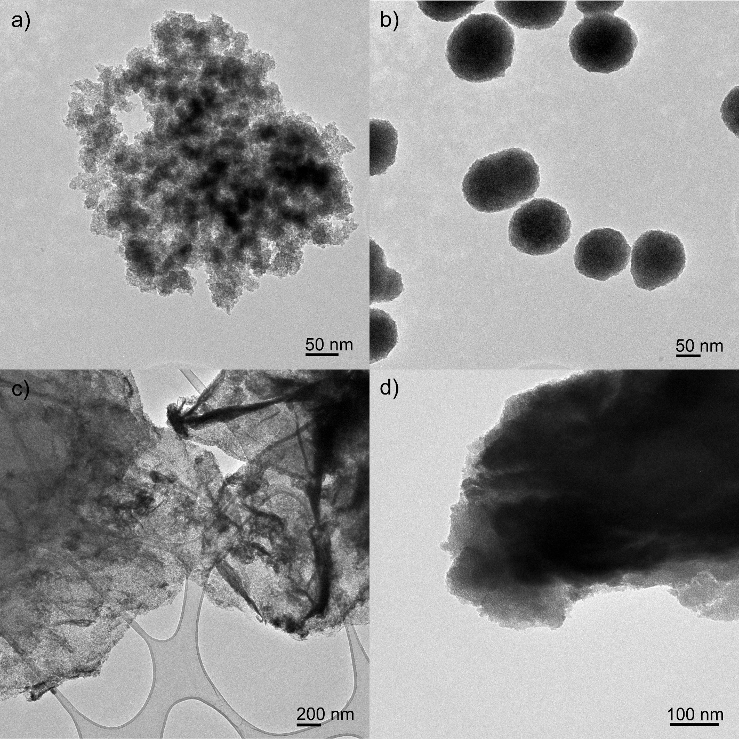

Supplementary Figure 18. TEM images of the solid acids after catalytic reaction: a) Nb₂O₅-NP, b) Nb₂O₅-NS, c) Nb₂O₅-hGO and d) Nb₂O₅·nH₂O.

Supplementary Note 8
The solvothermal stability of the catalysts was evaluated by stirring the materials with ethanol at 110 °C for 24 h, without substrate, and subsequently testing them on the AnL reaction at 110 °C (Supplementary Fig. 17). For Nb₂O₅-NP, Nb₂O₅-NS and Nb₂O₅-hGO the AnL conversion and total yield dropped slightly, which was accompanied by a slight increase of the carbon content of the materials. This indicates that the ethanol molecules adsorb strongly on the surface of the catalysts. However, the performance of the Nb₂O₅·nH₂O catalyst, in particular the products yields, decreased more drastically, indicating a stronger effect of the ethanol adsorption for this material. Ethanol molecules may establish strong physical bonds such as hydrogen bonds with the hydroxyl and oxygen atoms at the surface. In addition, ethanol molecules can coordinate to the coordinately unsaturated niobium ions that function as Lewis acid sites and possibly form niobium ethoxide surface species. Because Nb₂O₅·nH₂O has a higher proportion of Lewis acid sites compared to the other materials, this type of interaction could explain the higher loss of performance.
The Nb₂O₅-NP, Nb₂O₅-NS, Nb₂O₅-hGO and Nb₂O₅·nH₂O catalysts were used for three consecutive batch runs on the AnL reaction at 110 ºC; the solids were solely washed and dried at room temperature between runs (Supplementary Fig. 17). The performance of Nb₂O₅-NP and Nb₂O₅-NS dropped slightly after three runs, whereas a more significant drop of the AnL conversion and products yield occurred for Nb₂O₅-hGO. The conversion of AnL over Nb₂O₅·nH₂O, as well as the Ytot, decreased considerably in consecutive batch runs. This was expected considering the effect of ethanol on the performance. Characterization of all the materials recovered after the catalytic runs showed that the structural and morphological features (Supplementary Fig. 18) were preserved but the carbon content increased by ca. 3-4 wt. %, suggesting that the loss of catalytic performance is due to passivation of the surface of the catalysts by adsorbed organic compounds. Some loss of performance comes already from the interaction with the ethanol molecules. The higher loss of performance by Nb₂O₅-hGO compared to Nb₂O₅-NP and Nb₂O₅-NS due to surface adsorbed organics is consistent with a stronger adsorption of the organic compounds involved in the reaction on the former catalyst.

Supplementary Figure 19. Relationships between initial activity of the bulk niobium oxide catalysts for FA conversion, expressed (A) per amount of loaded catalyst (mmol g_{cat}⁻¹ h⁻¹) or (B) per amount of niobium oxide active phase (mmol g_{Nb2O5}⁻¹ h⁻¹), as a function of the density of total acid sites measured using different methods (total amount (AS) via solid-liquid phase titration (×), or via solid-gas phase (+) titration where B+L stands for Brønsted plus Lewis (B+L) acid sites).

Supplementary Figure 20. Relationships between initial activity of the bulk niobium oxide catalysts for HMF conversion, expressed (A) per amount of loaded catalyst (mmol g_{cat}⁻¹ h⁻¹) or (B) per amount of niobium oxide active phase (mmol g_{Nb2O5}⁻¹ h⁻¹), as a function of the amount of acid sites measured using different methods (total amount (AS) via solid-liquid phase titration (×), or amount of Brønsted (-) or Lewis (*) acid sites (B or L) via solid-gas phase titration).

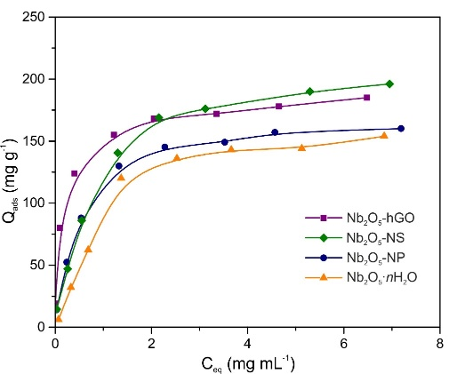
Supplementary Figure 21. Adsorption isotherms of 5-(hydroxymethyl)furfural on the niobium oxides.

Supplementary Table 5. Results from the fitting of the Langmuir and Freundlich equations to the 5-(hydroxymethyl)furfural adsorption isotherms on the niobium oxides.
Sample | Q_{mL} (mg g⁻¹)ª | K_{L} (mL mg⁻¹)^{b} | K_{F}^{c} | n_{F}^{d}
Nb₂O₅-NP | 158 | 4.2 | 112.5 | 4.5
Nb₂O₅-NS | 191 | 3.3 | 118.0 | 3.3
Nb₂O₅-hGO | 168 | 6.2 | 144.1 | 7.0
Nb₂O₅·nH₂O | 147 | 3.0 | 87.0 | 2.8
ª Langmuir monolayer capacity. ^{b} Langmuir constant. ^{c} Freundlich constant. ^{d} Freundlich exponent.

Supplementary Note 9
The adsorption of a substrate on the surface of a catalyst is the first step in a heterogeneous catalytic process. Electronic changes in the substrate molecules or stabilization of reaction intermediates, the extent of which depends on the adsorption energy, can facilitate the conversion of the substrate. We investigated the adsorption properties of the niobium oxides using HMF as a representative adsorptive molecule. Adsorption isotherms were determined at 20 °C and analyzed using the Langmuir (eq.1) and Freundlich (eq.2) equations (Supplementary Fig. 21 and Supplementary Table 5). The values of the Langmuir constant and Freundlich exponent (Table S5), which provide a measure of the adsorption affinities,¹¹⁵ suggest that the strength of the adsorption decreases in the following order Nb₂O₅-hGO > Nb₂O₅-NP ≈ Nb₂O₅-NS > Nb₂O₅·nH₂O. The lower affinity of Nb₂O₅·nH₂O toward the polar HMF molecules is likely due to the lower density of acid sites, that constitute polar centers for adsorption. In contrast, Nb₂O₅-hGO has the highest affinity for the HMF molecules in solution, as a result of the oxygen-containing functional groups from the support (C-O-C, OH, C=O, COOH) that lead to a high surface density of polar centers for adsorption. The strong adsorption of the substrate molecules near the acid sites can facilitate their conversion and contribute to the observed catalytic activity of Nb₂O₅-hGO.

Langmuir equation
$Q_{ads}= \frac{Q_{mL} C_{eq} K_{L}}{1+ C_{eq} K_{L}}$ (Eq. 1)

Freundlich equation

$Q_{ads}= K_{F} {{(C}_{eq})}^{1/n_{F}}$ (Eq. 2)

Supplementary References
1. Deshmukh, R. & Niederberger, M. Mechanistic Aspects in the Formation, Growth and Surface Functionalization of Metal Oxide Nanoparticles in Organic Solvents. Chem. Eur. J. 23, 8542-8570 (2017).
2. Garnweitner, G. et al. Nonaqueous synthesis of crystalline anatase nanoparticles in simple ketones and aldehydes as oxygen-supplying agents. Chem. Commun. 397-399 (2005).
3. Nico, C., Monteiro, T. & Graça, M. P. F. Niobium oxides and niobates physical properties: Review and prospects. Prog. Mater Sci. 80, 1-37 (2016).
4. Deng, K. et al. Rearrangement of Dypnones to 1,3,5-Triarylbenzenes. Org. Lett. 17, 1473-1476 (2015).
5. Burke, P. A. & Ko, E. I. Acidic properties of oxides containing niobia on silica and niobia in silica. J. Catal. 129, 38-46 (1991).
6. Ristić, M., Popović, S. & Musić, S. Sol–gel synthesis and characterization of Nb₂O₅ powders. Mater. Lett. 58, 2658-2663 (2004).
7. Chen, W., Yan, L. & Bangal, P. R. Preparation of graphene by the rapid and mild thermal reduction of graphene oxide induced by microwaves. Carbon 48, 1146-1152 (2010).
8. Dreyer, D. R. et al. The chemistry of graphene oxide. Chem. Soc. Rev. 39, 228-240 (2010).
9. Zhuravlev, L. T. The surface chemistry of amorphous silica. Zhuravlev model. Colloid Surf. A. 173, 1-38 (2000).
10. Kreissl, H. T. et al. Structural Studies of Bulk to Nanosize Niobium Oxides with Correlation to Their Acidity. J. Am. Chem. Soc. 139, 12670-12680 (2017).
11. Pittman, R. M. & Bell, A. T. Raman studies of the structure of niobium oxide/titanium oxide (Nb₂O₅.TiO₂). J. Phys. Chem. 97, 12178-12185 (1993).
12. Kreissl, H. T. et al. Niobium oxides: Correlation of acidity with structure and catalytic performance in sucrose conversion to 5-hydroxymethylfurfural. J. Catal. 338, 329-339 (2016).
13. Jehng, J.-M. & Wachs, I. E. The molecular structures and reactivity of supported niobium oxide catalysts. Catal. Today 8, 37-55 (1990).
14. Nakajima, K. et al. Nb₂O₅·nH₂O as a Heterogeneous Catalyst with Water-Tolerant Lewis Acid Sites. J. Am. Chem. Soc. 133, 4224-4227 (2011).
15. Nakajima, K. et al. Facile Formation of Lactic Acid from a Triose Sugar in Water over Niobium Oxide with a Deformed Orthorhombic Phase. ACS Catal. 8, 283-290 (2018).
16. Jehng, J. M. & Wachs, I. E. Structural chemistry and Raman spectra of niobium oxides. Chem. Mater. 3, 100-107 (1991).
17. Nishimura, M., Asakura, K. & Iwasawa, Y. New SiO₂-supported niobium monomer catalysts for dehydrogenation of ethanol. J. Chem. Soc., Chem. Commun. 1660-1661 (1986).
18. Yoshida, S. et al. The local structures and photo-catalytic activity of supported niobium oxide catalysts. Catal. Today 8, 67-75 (1990).
19. Joshi, H. et al. Ethyl levulinate: A potential bio-based diluent for biodiesel which improves cold flow properties. Biomass Bioenerg. 35, 3262-3266 (2011).
20. Olson, E. S. Subtask 4.1- Conversion of lignocellulosic material to chemicals and fuels, Energy & Environmental Research Center, University of North Dakota (2001).
21. Manzer, L. E. Preparation of levulinic acid esters from alpha-angelica lactone and alcohols. WO Patent 2005097724 A1 (2005).
22. Windom, B. C. et al. Advanced Distillation Curve Analysis on Ethyl Levulinate as a Diesel Fuel Oxygenate and a Hybrid Biodiesel Fuel. Energy Fuels 25, 1878-1890 (2011).
23. Christensen, E. et al. Properties and Performance of Levulinate Esters as Diesel Blend Components. Energy Fuels 25, 5422-5428 (2011).
24. Mao, R. L. V. et al. New Process for the Acid-Catalyzed Conversion of Cellulosic Biomass (AC3B) into Alkyl Levulinates and Other Esters Using a Unique One-Pot System of Reaction and Product ExtractionCatal. Lett. 141, 271-276 (2011).
25. Climent, M. J., Corma, A. & Iborra, S. Conversion of biomass platform molecules into fuel additives and liquid hydrocarbon fuels. Green Chem. 16, 516-547 (2014).
26. Addepally, U. & Thulluri, C. Recent progress in production of fuel range liquid hydrocarbons from biomass-derived furanics via strategic catalytic routes. Fuel 159, 935-942 (2015).
27. Chang, C., Xu, G. & Jiang, X. Production of ethyl levulinate by direct conversion of wheat straw in ethanol media. Bioresour. Technol. 121, 93-99 (2012).
28. González Maldonado, G. M. et al. Acid-catalyzed conversion of furfuryl alcohol to ethyl levulinate in liquid ethanol. Energy Environ. Sci. 5, 8990-8997 (2012).
29. Hayes, D. J. An examination of biorefining processes, catalysts and challenges. Catal. Today 145, 138-151 (2009).
30. Démolis, A., Essayem, N. & Rataboul, F. Synthesis and Applications of Alkyl Levulinates. ACS Sustainable Chem. Eng. 2, 1338-1352 (2014).
31. Zhang, J. et al. Advances in the Catalytic Production of Valuable Levulinic Acid Derivatives. ChemCatChem 4, 1230-1237 (2012).
32. Groves, A. P. et al. US 2005/0144835 A1 (2005).
33. Lomba, L. et al. Physicochemical properties of green solvents derived from biomass. Green Chem. 13, 2062-2070 (2011).
34. Leonard, R. H. Levulinic acid as a basic chemical raw material. Ind. Eng. Chem. 48, 1330-1341 (1956).
35. Langlois, D. P. & Wolff, H. US 2493676 (1950).
36. Zanghellini, A. L. EP 2611764A1 (2010).
37. Zanghellini, A. L. US 2017/0275657 A1 (2017).
38. Rackemann, D. W. & Doherty, W. O. The conversion of lignocellulosics to levulinic acid. Biofuels, Bioprod. Bioref. 5, 198-214 (2011).
39. van Aert, H. A. M. et al. Modified Poly(2,6-dimethyl-1,4-phenylene ether)s Prepared by Redistribution Macromolecules 30, 6056-6066 (1997).
40. Yom-Tov, B. EP 1833790 B1 (2007).
41. Bozell, J. J. et al. Production of levulinic acid and use as a platform chemical for derived products. Resour. Conserv. Recy. 28, 227-239 (2000).
42. Bush, J. H. US 5851377 (1998).
43. Bart, H. J. et al. Kinetics of esterification of levulinic acid with n-butanol by homogeneous catalysis. Ind. Eng. Chem. Res. 33, 21-25 (1994).
44. Bohre, A. et al. Upgrading Furfurals to Drop-in Biofuels: An Overview. ACS Sustainable Chem. Eng. 3, 1263-1277 (2015).
45. Serrano-Ruiz, J. C. et al. Catalytic Conversion of Renewable Biomass Resources to Fuels and Chemicals. Annu. Rev. Chem. Biomol. Eng. 1, 79-100 (2010).
46. Bond, J. Q. et al. Integrated Catalytic Conversion of γ-Valerolactone to Liquid Alkenes for Transportation Fuels. Science 327, 1110-1114 (2010).
47. Gürbüz, E. I. et al. Conversion of Hemicellulose to Furfural and Levulinic Acid using Biphasic Reactors with Alkylphenol Solvents. ChemSusChem 5, 383-387 (2012).
48. Lange, J.-P. et al. Valeric Biofuels: A Platform of Cellulosic Transportation Fuels. Angew. Chem. Int. Ed. 49, 4479-4483 (2010).
49. R J. Haan & Lange, J. P. US 8372164 B2 (2013).
50. Haan, R. J. & Lange, J.-P. WO2009077606A2 (2009).
51. Lange, J.-P. et al. Furfural—A Promising Platform for Lignocellulosic Biofuels. ChemSusChem 5, 150-166 (2011).
52. Eerhart, A. J. J. E. et al. Fuels and plastics from lignocellulosic biomass via the furan pathway; a technical analysis. RSC Adv. 4, 3536-3549 (2014).
53. de Jong, E. et al. Promising results with YXY Diesel components in an ESC test cycle using a PACCAR Diesel engine. Biomass Bioener. 36, 151-159 (2012).
54. Vanderhaegen, B. et al. Furfuryl Ethyl Ether: Important Aging Flavor and a New Marker for the Storage Conditions of Beer. J. Agric. Food Chem. 52, 1661-1668 (2004).
55. Vanderhaegen, B. et al. Evolution of Chemical and Sensory Properties during Aging of Top-Fermented Beer. J. Agric. Food Chem. 51, 6782-6790 (2003).
56. Aroxa https://www.aroxa.com/discovery/discovery-standard/2-furfuryl-ethyl-ether, August 15th 2018.
57. Neves, P. et al. Production of biomass-derived furanic ethers and levulinate esters using heterogeneous acid catalysts. Green Chem. 15, 3367-3376 (2013).
58. Russo, P. A. et al. Mesoporous carbon–silica solid acid catalysts for producing useful bio-products within the sugar-platform of biorefineries. Green Chem. 16, 4292-4305 (2014).
59. Antunes, M. M. et al. One-pot conversion of furfural to useful bio-products in the presence of a Sn,Al-containing zeolite beta catalyst prepared via post-synthesis routes. J. Catal. 329, 522-537 (2015).
60. Nguyen, H. et al. Role of Lewis and Brønsted Acidity in Metal Chloride Catalysis in Organic Media: Reductive Etherification of Furanics. ACS Catal. 7, 7363-7370 (2017).
61. Zhao, G. et al. Conversion of Biomass-Derived Furfuryl Alcohol into Ethyl Levulinate Catalyzed by Solid Acid in Ethanol. Bioresources 9, 2634-2644 (2014).
62. Neves, P. et al. Conversion of furfuryl alcohol to ethyl levulinate using porous aluminosilicate acid catalysts. Catal. Today 218-219, 76-84 (2013).
63. Lange, J.-P. et al. Conversion of Furfuryl Alcohol into Ethyl Levulinate using Solid Acid Catalysts. ChemSusChem 2, 437-441 (2009).
64. Zhu, S. et al. Graphene Oxide: An Efficient Acid Catalyst for Alcoholysis and Esterification Reactions. ChemCatChem 6, 3080-3083 (2014).
65. Russo, P. A. et al. Solid acids with SO₃H groups and tunable surface properties: versatile catalysts for biomass conversion. J. Mater. Chem. A 2, 11813-11824 (2014).
66. Song, D. et al. Efficient conversion of levulinic acid or furfuryl alcohol into alkyl levulinates catalyzed by heteropoly acid and ZrO2 bifunctionalized organosilica nanotubes. J. Catal. 333, 184-199 (2016).
67. Tiwari, M. S. et al. Magnetically separable sulfated zirconia as highly active acidic catalysts for selective synthesis of ethyl levulinate from furfuryl alcohol. Green Chem. 19, 963-976 (2017).
68. Lu, B. et al. Design of organosulfonic acid functionalized organosilica hollow nanospheres for efficient conversion of furfural alcohol to ethyl levulinate. Green Chem. 17, 1767-1778 (2015).
69. Gao, X. et al. Formation of humin and alkyl levulinate in the acid-catalyzed conversion of biomass-derived furfuryl alcohol. Bioresources 10, 6548-6564 (2015).
70. Enumula, S. S. et al. Conversion of furfuryl alcohol to alkyl levulinate fuel additives over Al₂O₃/SBA-15 catalyst. Sustainable Energy Fuels 1, 644-651 (2017).
71. Cao, Q. et al. Solid acid-catalyzed conversion of furfuryl alcohol to alkyl tetrahydrofurfuryl ether. Catal. Commun. 58, 76-79 (2015).
72. Chaffey, D. R. et al. Etherification Reactions of Furfuryl Alcohol in the Presence of Orthoesters and Ketals: Application to the Synthesis of Furfuryl Ether Biofuels. ACS Sustainable Chem. Eng. 6, 4996-5002 (2018).
73. Nandiwale, K. Y. et al. One step synthesis of ethyl levulinate biofuel by ethanolysis of renewable furfuryl alcohol over hierarchical zeolite catalyst. RSC Adv. 5, 79224-79231 (2015).
74. Neves, P. et al. Mesoporous zirconia-based mixed oxides as versatile acid catalysts for producing bio-additives from furfuryl alcohol and glycerol. Appl. Catal. A 487, 148-157 (2014).
75. Zhou, H. et al. One-pot conversion of carbohydrates into gamma-valerolactone catalyzed by highly cross-linked ionic liquid polymer and Co/TiO₂. RSC Adv. 5, 15267-15273 (2015).
76. Wang, G. et al. Efficient and selective alcoholysis of furfuryl alcohol to alkyl levulinates catalyzed by double SO3H-functionalized ionic liquids. Green Chem. 16, 1436-1443 (2014).
77. Hengne, A. M. et al. Single pot conversion of furfuryl alcohol to levulinic esters and γ-valerolactone in the presence of sulfonic acid functionalized ILs and metal catalysts. Green Chem. 15, 2540-2547 (2013).
78. Ren, D. et al. Efficient conversion of biomass-derived furfuryl alcohol to levulinate esters over commercial α-Fe2O3. RSC Adv. 6, 22174-22178 (2016).
79. Zhao, D. et al. Continuous Flow Alcoholysis of Furfuryl Alcohol to Alkyl Levulinates Using Zeolites. ACS Sustainable Chem. Eng. 6, 6901-6909 (2018).
80. Barbera, K. et al. The role of oxide location in HMF etherification with ethanol over sulfated ZrO₂ supported on SBA-15. J. Catal. 323, 19-32 (2015).
81. Balakrishnan, M. et al. Etherification and reductive etherification of 5-(hydroxymethyl)furfural: 5-(alkoxymethyl)furfurals and 2,5-bis(alkoxymethyl)furans as potential bio-diesel candidates. Green Chem. 14, 1626-1634 (2012).
82. Antunes, M. M. et al. Sulfonated Graphene Oxide as Effective Catalyst for Conversion of 5‐(Hydroxymethyl)‐2‐furfural into Biofuels. ChemSusChem 7, 804-812 (2014).
83. Lanzafame, P. et al. Etherification of 5-hydroxymethyl-2-furfural (HMF) with ethanol to biodiesel components using mesoporous solid acidic catalysts. Catal. Today 175, 435-441 (2011).
84. Saravanamurugan, S. & Riisager, A. Solid acid catalysed formation of ethyl levulinate and ethyl glucopyranoside from mono- and disaccharides. Catal. Commun. 17, 71-75 (2012).
85. Schwartz, T. J., Allen, M. & Gramlich, W. M. Functionalization of 5-Hydroxymethylfurfural By Selective Etherification. Proceeding 2017 AIChE Annual Meeting (2017).
86. Quereshi, S. et al. Insights into the metal salt catalyzed ethyl levulinate synthesis from biorenewable feedstocks. Catal. Today 291, 187-194 (2017).
87. Yao, Y. et al. Magnetically-recoverable carbonaceous material: An efficient catalyst for the synthesis of 5-hydroxymethylfurfural and 5-ethoxymethylfurfural from carbohydrates. Russ. J. Gen. Chem. 86, 1698-1704 (2016).
88. Barbera, K. et al. HMF etherification using NH4-exchanged zeolites. New J. Chem. 40, 4300-4306 (2016).
89. Wang, H. et al. Graphene oxide as a facile acid catalyst for the one-pot conversion of carbohydrates into 5-ethoxymethylfurfural. Green Chem. 15, 2379-2383 (2013).
90. Jeong, G.-Y. et al. One-flow syntheses of diverse heterocyclic furan chemicals directly from fructose via tandem transformation platform. Npg Asia Materials 7, e173 (2015).
91. Liu, B., Zhang, Z. & Huang, K. Cellulose sulfuric acid as a bio-supported and recyclable solid acid catalyst for the synthesis of 5-hydroxymethylfurfural and 5-ethoxymethylfurfural from fructose. Cellulose 20, 2081-2089 (2013).
92. Thombal, R. S. & Jadhav, V. H. Application of glucose derived magnetic solid acid for etherification of 5-HMF to 5-EMF, dehydration of sorbitol to isosorbide, and esterification of fatty acids. Tetrahedron Lett. 57, 4398-4400 (2016).
93. Liu, B. & Zhang, Z. One-pot conversion of carbohydrates into 5-ethoxymethylfurfural and ethyl D-glucopyranoside in ethanol catalyzed by a silica supported sulfonic acid catalyst. RSC Adv. 3, 12313-12319 (2013).
94. Yuan, Z. et al. Efficient synthesis of promising liquid fuels 5-ethoxymethylfurfural from carbohydrates. Fuel 150, 236-242 (2015).
95. Zhang, Z. et al. Synthesis of 5‐Ethoxymethylfurfural from Fructose and Inulin Catalyzed by a Magnetically Recoverable Acid Catalyst. ChemPlusChem 79, 233-240 (2014).
96. Yin, S. et al. Magnetic material grafted cross-linked imidazolium based polyionic liquids: an efficient acid catalyst for the synthesis of promising liquid fuel 5- ethoxymethylfurfural from carbohydrates. J. Mater. Chem. A 3, 4992-4999 (2015).
97. Yu, X. et al. One-step fabrication of carbonaceous solid acid derived from lignosulfonate for the synthesis of biobased furan derivatives. RSC Adv. 8, 15762- 15772 (2018).
98. Zhao, K. et al. Fabrication of −SO₃H functionalized aromatic carbon microspheres directly from waste Camellia oleifera shells and their application on heterogeneous acid catalysis. Molecular Catal. 433, 193-201 (2007).
99. Raveendra, G. et al. Selective etherification of hydroxymethylfurfural to biofuel additives over Cs containing silicotungstic acid catalysts. Appl. Catal. A 520, 105-113 (2016).
100. Wang, S. et al. Silica coated magnetic Fe₃O₄ nanoparticles supported phosphotungstic acid: a novel environmentally friendly catalyst for the synthesis of 5- ethoxymethylfurfural from 5-hydroxymethylfurfural and fructose. Catal. Sci. Technol. 3, 2104-2112 (2013).
101. Bing, L. et al. Efficient One-Pot Synthesis of 5-(Ethoxymethyl)furfural from Fructose Catalyzed by a Novel Solid Catalyst. Ind. Eng. Chem. Res. 51, 15331-15336 (2012).
102. Zuo, M. et al. An effective pathway for converting carbohydrates to biofuel 5- ethoxymethylfurfural via 5-hydroxymethylfurfural with deep eutectic solvents (DESs). Ind. Crops Prod. 112, 18-23 (2018).
103. Ren, Y. et al. Silver-exchanged heteropolyacid catalyst (Ag1H2PW): An efficient heterogeneous catalyst for the synthesis of 5-ethoxymethylfurfural from 5- hydroxymethylfurfural and fructose. J. Ind. Eng. Chem. 21, 1127-1131 (2015).
104. Liu, A. et al. Synthesis of 5-ethoxymethylfurfural from 5-hydroxymethylfurfural and fructose in ethanol catalyzed by MCM-41 supported phosphotungstic acid. J. Ind. Eng. Chem. 20, 1977-1984 (2014).
105. Che, P. et al. Catalytic selective etherification of hydroxyl groups in 5- hydroxymethylfurfural over H4SiW12O40/MCM-41 nanospheres for liquid fuel production. Bioresource Technol. 119, 433-436 (2012).
106. Kumari, P. K. et al. Lewis acidity induced heteropoly tungustate catalysts for the synthesis of 5-ethoxymethyl furfural from fructose and 5-hydroxymethylfurfural. Molecular Catal. 448, 108-115 (2018).
107. Liu, B. et al. Synthesis of furan compounds from HMF and fructose catalyzed by aluminum-exchanged K-10 clay. J. Ind. Eng. Chem. 21, 338-339 (2015).
108. Liu, A. et al. Efficient one-pot synthesis of 5-ethoxymethylfurfural from fructose catalyzed by heteropolyacid supported on K-10 clay. Fuel 117, 68-73 (2014).
109. Wang, Z. & Chen, Q. Conversion of 5-hydroxymethylfurfural into 5- ethoxymethylfurfural and ethyl levulinate catalyzed by MOF-based heteropolyacid materials. Green Chem. 18, 5884-5889 (2016).
110. Al-Shaal, M. G. et al. Catalytic upgrading of α-angelica lactone to levulinic acid esters under mild conditions over heterogeneous catalysts. Catal. Sci. Technol. 5, 5168-5173 (2015).
111. Yi, X. et al. Synthesis of Butyl Levulinate Based on α-Angelica Lactone in the Presence of Easily Separable Heteropoly Acid Catalysts. ChemSusChem 10, 1494- 1500 (2017).
112. Paniagua, M. et al. Catalytic upgrading of furfuryl alcohol to bio-products: Catalysts screening and kinetic analysis. Appl. Catal. A 537, 74-82 (2017).
113. Manzer, L. E. US 2006/0063948 A1 (2006).
114. Manzer, L. E. US 2005/0210738 A1 (2005).
115. Mourão, P. A. M. et al. Application of different equations to adsorption isotherms of phenolic compounds on activated carbons prepared from cork. Carbon 44, 2422-2429 (2006).

