Supporting Information for
Advances and Challenges of Aluminum-Sulfur Batteries
Matthias Klimpel,^{1,2} Maksym V. Kovalenko,^{*,1,2} Kostiantyn V. Kravchyk^{*,1,2}

¹ Laboratory of Inorganic Chemistry, Department of Chemistry and Applied Biosciences, ETH Zürich, Vladimir-Prelog-Weg 1, CH-8093 Zürich, Switzerland
² Laboratory for Thin Films and Photovoltaics, Empa – Swiss Federal Laboratories for Materials Science and Technology, Überlandstrasse 129, CH-8600 Dübendorf, Switzerland

Corresponding Author
*E-mail: mvkovalenko@ethz.ch and kravchyk@inorg.chem.ethz.ch
Keywords: Al-S battery, sulfur, aluminum, stationary energy storage.
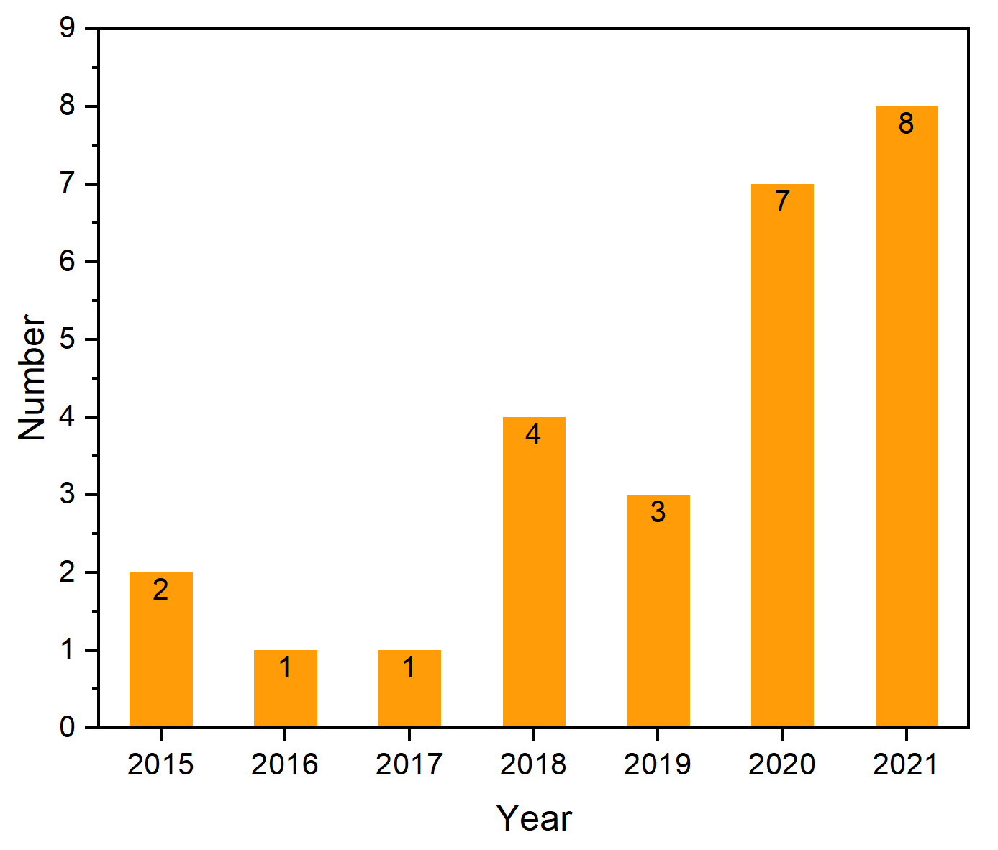
Supplementary Figure S1. Numbers of publications on the research topic of aluminum sulfur batteries.

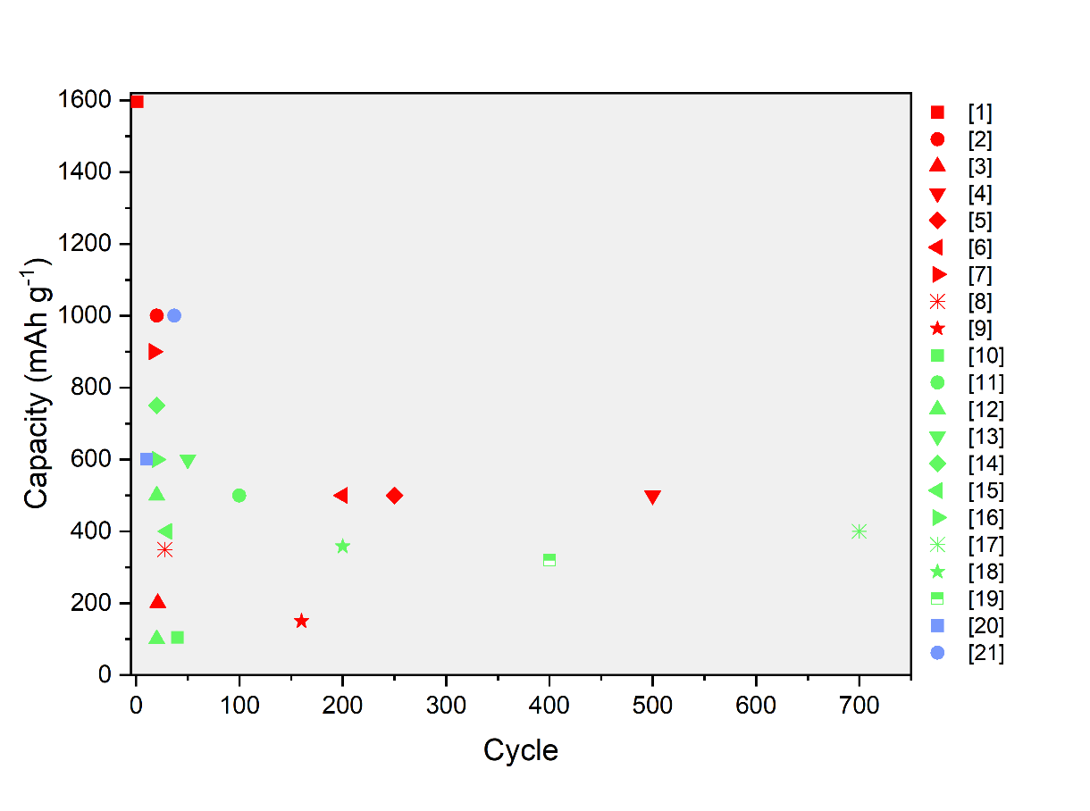
Supplementary Figure S2. Performances of aluminum sulfur batteries with the maximum number of cycles and the highest capacity is given.¹⁻²¹ Red dots relate to changes in the carbon host material, green dots correspond to different electrolyte compositions, blue dots show works where the separator was coated.

Supplementary References
1. Cohn, G., Ma, L. & Archer, L. A. A novel non-aqueous aluminum sulfur battery. J. Power Sources 283, 416-422 (2015).
2. Gao, T. et al. A Rechargeable Al/S Battery with an Ionic-Liquid Electrolyte. Angew. Chem. Int. Ed. 55, 9898-9901 (2016).
3. Wang, W. et al. Recognizing the Mechanism of Sulfurized Polyacrylonitrile Cathode Materials for Li–S Batteries and beyond in Al–S Batteries. ACS Energy Lett. 3, 2899-2907 (2018).
4. Guo, Y. et al. Carbonized-MOF as a Sulfur Host for Aluminum–Sulfur Batteries with Enhanced Capacity and Cycling Life. Adv. Funct. Mater. 29, 1807676 (2019).
5. Zhang, K. et al. Two-dimensional boron nitride as a sulfur fixer for high performance rechargeable aluminum-sulfur batteries. Sci. Rep. 9, 13573 (2019).
6. Guo, Y. et al. Rechargeable Aluminium–Sulfur Battery with Improved Electrochemical Performance by Cobalt-Containing Electrocatalyst. Angew. Chem. Int. Ed. 59, 22963-22967 (2020).
7. Smajic, J. et al. Capacity Retention Analysis in Aluminum-Sulfur Batteries. ACS Appl. Energy Mater. 3, 6805-6814 (2020).
8. Zhang, Y. et al. The host hollow carbon nanospheres as cathode material for nonaqueous room-temperature Al–S batteries. Int. J. Hydrogen Energy 46, 4936-4946 (2021).
9. Xiao, X., Tu, J., Huang, Z. & Jiao, S. A cobalt-based metal–organic framework and its derived material as sulfur hosts for aluminum–sulfur batteries with the chemical anchoring effect. Phys. Chem. Chem. Phys. 23, 10326-10334 (2021).
10. Xia, S., Zhang, X.-M., Huang, K., Chen, Y.-L. & Wu, Y.-T. Ionic liquid electrolytes for aluminium secondary battery: Influence of organic solvents. J. Electroanal. Chem. 757, 167-175 (2015).
11. Bian, Y. et al. Using an AlCl₃/Urea Ionic Liquid Analog Electrolyte for Improving the Lifetime of Aluminum-Sulfur Batteries. ChemElectroChem 5, 3607-3611 (2018).
12. Yang, H. et al. An Aluminum–Sulfur Battery with a Fast Kinetic Response. Angew. Chem. Int. Ed. 57, 1898-1902 (2018).
13. Yu, X., Boyer, M. J., Hwang, G. S. & Manthiram, A. Room-Temperature Aluminum-Sulfur Batteries with a Lithium-Ion-Mediated Ionic Liquid Electrolyte. Chem 4, 586-598 (2018).
14. Chu, W. et al. A low-cost deep eutectic solvent electrolyte for rechargeable aluminum-sulfur battery. Energy Storage Mater. 22, 418-423 (2019).
15. Hu, Z., Guo, Y., Jin, H., Ji, H. & Wan, L.-J. A rechargeable aqueous aluminum–sulfur battery through acid activation in water-in-salt electrolyte. Chem. Commun. 56, 2023-2026 (2020).
16. Wang, J., Xu, J., Huang, Z. & Fan, G. Preparation of nitrogen-doped three-dimensional hierarchical porous carbon/sulfur composite cathodes for high-performance aluminum-sulfur batteries. Fuller. Nanotub. Carbon Nanostructures 29, 39-45 (2021).
17. Zhang, D. et al. Highly reversible aluminium–sulfur batteries obtained through effective sulfur confinement with hierarchical porous carbon. J. Mater. Chem. A 9, 8966-8974 (2021).
18. Jiang, W., Bian, Y., Zhang, Y. & Lin, M. A New Strategy to Improve the Performance of Aluminum-Sulfur Battery. IOP Conf. Ser. Earth Environ. Sci. 692, 032070 (2021).
19. Bian, Y. et al. Understanding the Oxidation and Reduction Reactions of Sulfur in Rechargeable Aluminum-Sulfur Batteries with Deep Eutectic Solvent and Ionic Liquid Electrolytes. ChemSusChem n/a (2021).
20. Ren, Y., Liu, T., Shen, Y., Lin, Y. & Nan, C.-W. Garnet-Type Oxide Electrolyte with Novel Porous-Dense Bilayer Configuration for Rechargeable All-Solid-State Lithium Batteries. Ionics 23, 2521-2527 (2017).
21. Zheng, X. et al. Design of a composite cathode and a graphene coated separator for a stable room-temperature aluminum–sulfur battery. Sustain. Energy Fuels 4, 1630-1641 (2020).

