Supplementary data
Table SI: Significant Raman peaks observed in the PC loadings contributing to the separation of SARS-CoV-2 or MeV-infected and non-infected cells.
*Raman peaks in cm⁻¹
Cytoplasm region | Golgi-mitochondria | Nucleus
465: glycogen | 790: phosphodiester bands in DNA O-P-O stretching DNA | 1006 : Phenylalanine
782 : DNA, Thymine, cytosine, uracil, RNA, U, T, C (ring breathing modes in the DNA/RNA bases) | 1099: n(C-N) | 1240: RNA
1001: Phenylalanine | 1253: A, T (ring breathing modes of the DNA/RNA bases ,lipid | 1304 : adenine, cytosine
1442: Cholesterol, fatty acid band  d(CH2) (lipids) | 1294: CH2 deformation (lipid) | 1457 :Deoxyribose  d(CH2)
1457: Deoxyribose  d(CH2) | 1304: CH2 deformation lipid , | 1572: Ring breathing modes in the DNA bases  G, A (ring breathing modes of the DNA/RNA bases)
1651 Lipid (C=C stretch) | 1457 :Deoxyribose  d(CH2) | 1651: (C=C) Amide I  Protein
2885: v3 CH3, lipids, fatty acids | 1584: C=C bending mode of phenylalanine | 2872 :CH₂ asymmetric stretch and CH stretch of lipids and proteins
2929: CH₂ asymmetric stretch | 1646: Amide I | 2881 :CH2 asymmetric stretch of proteins
 | 1656: Amide I | 2927 :Symmetric CH3 stretch  Due primarily to protein
 | 2849 :CH₂ asymmetric stretch of lipids and proteins | 2941: C-H vibrations in proteins
 | 2862: CH₂ symmetric stretch of lipids
 | 2906: C-H stretch of lipids and proteins
 | 2949: lipids, fatty acids
* Classification of the infection signature (either SARS-CoV-2 or MeV) compared to non-infected cells.

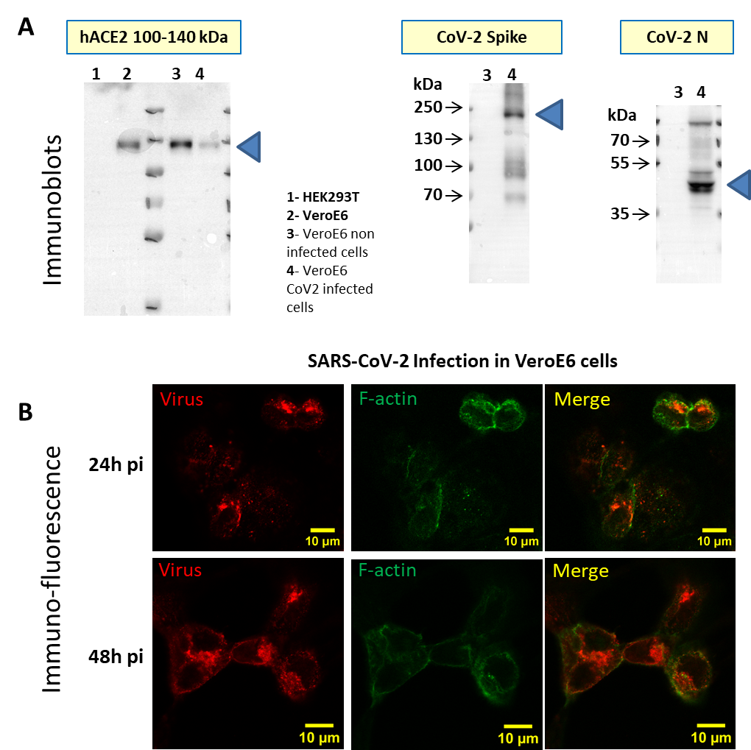
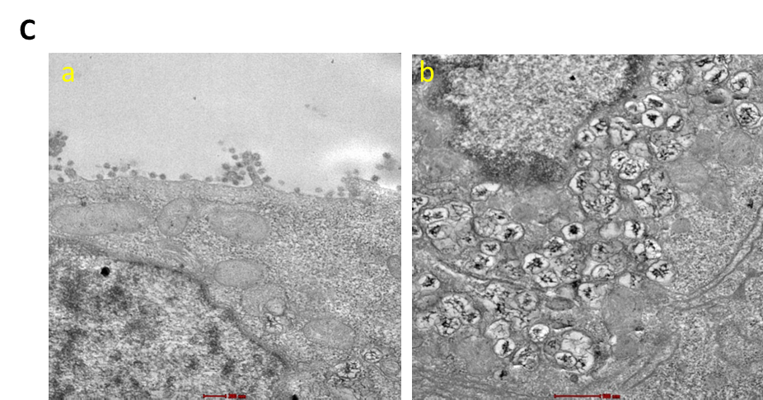
B

Figure S1: Characterization of SARS-CoV-2 infected VeroE6 cells.
- Cellular human ACE2 and viral gene expression analysis of SARS-CoV-2 infected VeroE6 cells using immunoblots. Western-blot analysis for human ACE2 expression in HEK293T (lane 1) and in VeroE6 (lane 2) cell lysates, and in infected (lane 4) versus non-infected (lane 3) VeroE6 cells. Western blots of the SARS-CoV-2 Spike and Nucleocapsid N proteins in control (lane 3) and infected (lane 4) VeroE6 cells 48h post-infection with SARS-CoV-2 (Wuhan) at MOI= 0.1.
- Immuno-fluorescence images of infected VeroE6 cells 24h or 48h post-infection with SARS-CoV-2 (Wuhan) using confocal fluorescence microscopy. For imaging the virus, rabbit anti-M primary antibody and then secondary antibody anti-rabbit Alexa568 (red) were used. For imaging the cells, F-actin labelling with Phalloidin-Alexa 488 (green) was used on fixed cells. The merged image is shown revealing all infected cells, in conditions similar to the confocal Raman spectroscopy experiment.
- Transmission electron microscopy images of thin sections of SARS-CoV-2 infected VeroE6 cells producing SARS-CoV-2 showing (a) SARS-CoV-2 particles at the cell surface and (b) multiple intracellular replicative virus-filled organelles inside the cell cytoplasm that are absent in non-infected cells. Scale bars are 200-500 nm as indicated.

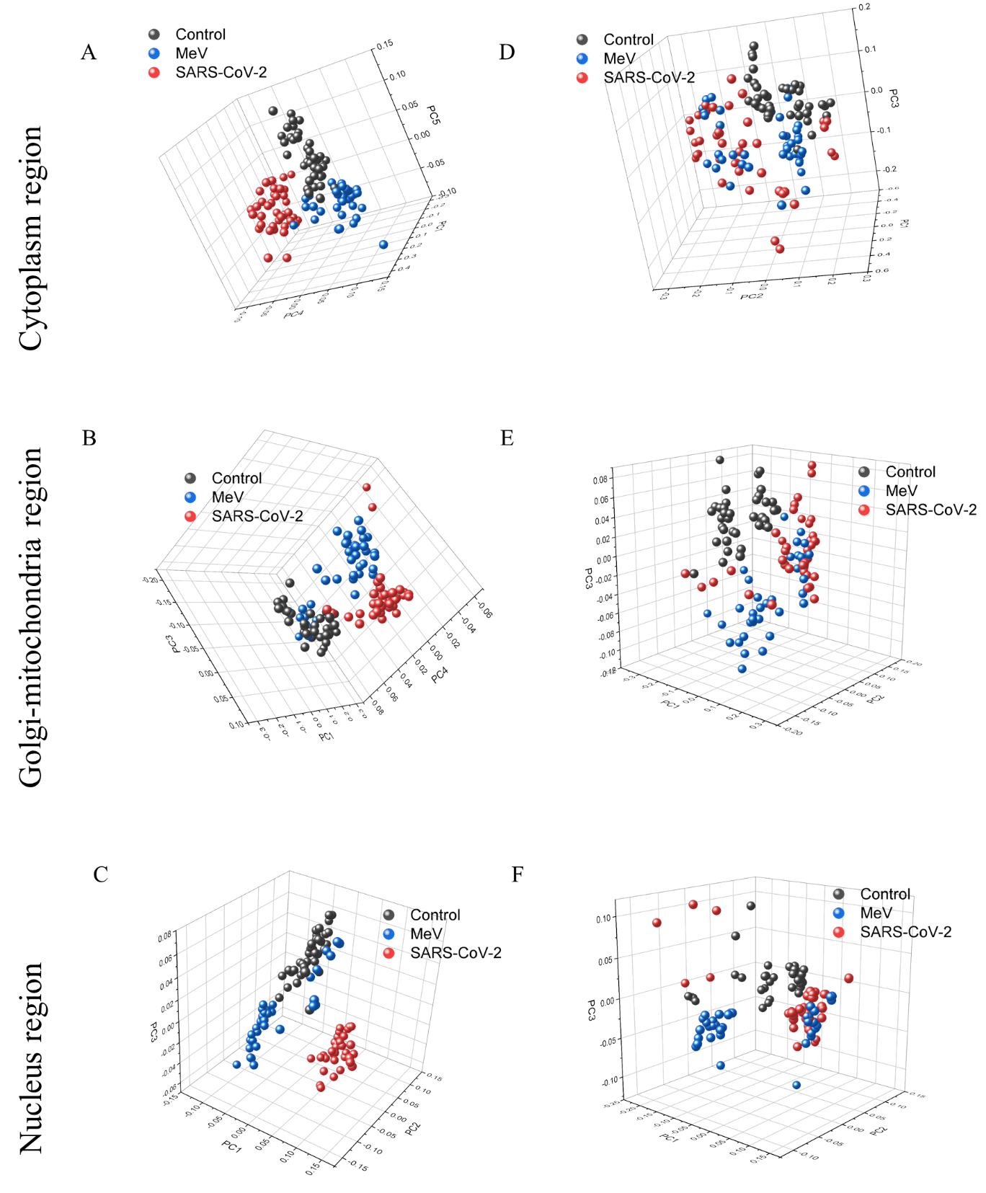
Figure S2: The score plot obtained using Principal component analysis for experimental batch 2 (A to C) and experimental batch 3 (D to F).
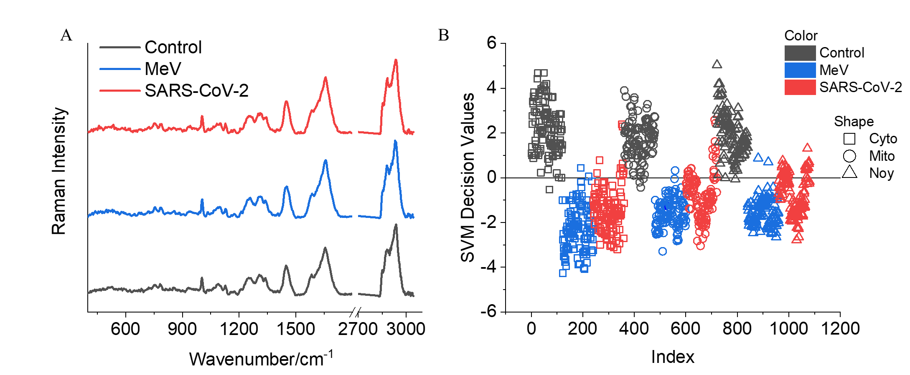
Figure S3: Raman model generated using support vector machine (SVM) algorithm to differentiate non-infected (Control, black) from SARS-CoV-2 (red) and measles virus (MeV, blue) infected Vero E6 cells. The model was generated using Raman spectra extracted from intracellular components: cytoplasm (Cyto, square), Golgi-mitochondria bodies (Mito, circle), and nucleus (Noy, triangle) of the Vero E6 cells. (Total classification accuracy 95%, 10-fold cross-validation)

