Supplementary Data 2
(X-ray crystal structure)

Formal [4+2] combined ionic and radical approach of vinylogous enaminonitriles to access highly substituted sulfonyl pyridazines

Chanhyun Jung,^{†[a]} Kwanghee Lee,^{†[a]} Shanmugam Rajasekar, ^{[a]} Ji-Youn Yim, ^{[a]} Jaeuk Sim, ^{[a][b]} Young Hee Lee, ^{[a][b]} Jae-Hwan Kwak,^{[a]} Soonsil Hyun,^{[a]} Young Kee Kang,*^{[c]} Mayavan Viji,*^{[a][d]} Jae-Kyung Jung*^{[a]}

[a] Mr. Chanhyun Jung, Mr. Kwanghee Lee, Dr Shanmugam Rajasekar, Ms. Ji-Youn Yim, Dr. Jaeuk Sim, Dr. Young Hee Lee, Prof. Jae-Hwan Kwak, Prof. Soonsil Hyun, Prof. Mayavan Viji, Prof. Jae-Kyung Jung
College of Pharmacy and Medicinal Research Center (MRC)
Chungbuk National University, Cheongju 28160, Republic of Korea
Tel: +82-43-261-2635, fax: +82-43-268-2732, E-mail: orgjkjung@chungbuk.ac.kr (J.-K. Jung)
[b] Dr. Jaeuk Sim, Dr. Young Hee Lee
Samjin Central Research Institute, Samjin Pharma Co., LTD, Cheongju 28158, Republic of Korea
[c] Prof. em. Young Kee Kang
Department of Chemistry, Chungbuk National University
Cheongju 28644, Republic of Korea, E-mail: ykkang@chungbuk.ac.kr
[d] Prof. Mayavan Viji,
Department of Chemistry, School of Physical and Chemical Sciences, Central University of Kashmir
Ganderbal. J&K-191201, India, E-mail: mviji@cukashmir.ac.in

- X-ray crystal structure

< Instrument Information >

1.1 Instrument

Instrument and model | Bruker SMART APEX-II
Source | Mo Kα (λ= 0.71073Å)
Operation voltage / current | No exp file
Monochromator | None
Detector | Charge-Coupled Device (CCD)
Exposure time | No exp file
Operating temperature | Room Temperature 296(1) K
Theta range for data collection | 1.999 to 27.873
Total data collection time | 15hr

1.2 Software

Data collection | None
Cell refinement | SAINT V8.40A (Bruker Nano, Inc., 2019)
Data reduction | SAINT V8.40A (Bruker Nano, Inc., 2019)
Absorption correction | SADABS-2016/2
Solve structure | SHELXT 2014/5 (Sheldrick, 2014)
Refine structure | SHELXL-2018/3 (Sheldrick, 2018)
Molecular graphics | XP

<CCDC number : 2094834>

2 X-ray Crystallographic Results

2.1 X-ray Crystallographic Data

2.1.1 Crystal data and structure refinement for PYRIDAZINE (3a).
Identification code 20200715
Empirical formula C18 H12 Cl N3 O2 S
Formula weight 369.82
Temperature 296(1) K
Wavelength 0.71073 Å
Crystal system Triclinic
Space group P-1
Unit cell dimensions a = 9.0476(5) Å α= 111.781(2)°
b = 9.2759(5) Å β= 112.14°
c = 12.0056(6) Å γ = 90°
Volume 855.14(8) Å³
Z 2
Density (calculated) 1.436 Mg/m³
Absorption coefficient 0.362 mm⁻¹
F(000) 380
Crystal size 0.180 x 0.160 x 0.160 mm³
Theta range for data collection 1.999 to 27.873°
Index ranges -11<=h<=11, -12<=k<=12, -15<=l<=15
Reflections collected 9694
Independent reflections 2856 [R(int) = 0.0310]
Completeness to theta = 25.242° 63.7 %
Absorption correction Multi-scan
Refinement method Full-matrix least-squares on F²
Data / restraints / parameters 2856 / 0 / 227
Goodness-of-fit on F² 0.878
Final R indices [I>2sigma(I)] R1 = 0.0447, wR2 = 0.1116
R indices (all data) R1 = 0.0668, wR2 = 0.1192
Extinction coefficient n/a
Largest diff. peak and hole 0.194 and -0.226 e.Å⁻³
_____________________________________________________________________________
2.1.2 Atomic coordinates (x 10⁴) and equivalent isotropic displacement parameters (Å²x 10³) for PYRIDAZINE (3a).
U(eq) is defined as one third of the trace of the orthogonalized Uⁱʲ tensor
_____________________________________________________________________________
x y z U(eq)
_____________________________________________________________________________
Cl(1) 3910(1) 8400(1) 8589(1) 90(1)
S(1) 166(1) 1123(1) 3711(1) 64(1)
O(1) -949(2) -306(2) 2807(2) 87(1)
O(2) -270(2) 2311(2) 4646(2) 81(1)
N(1) 3220(3) -1794(2) 4634(2) 68(1)
N(2) 4353(3) -917(2) 5804(2) 66(1)
N(3) 6678(4) 2098(3) 8607(3) 100(1)
C(1) 3657(3) 6380(2) 7770(2) 63(1)
C(2) 3992(3) 5760(3) 6678(2) 67(1)
C(3) 3799(3) 4148(3) 6027(2) 63(1)
C(4) 3278(3) 3159(2) 6481(2) 54(1)
C(5) 2952(3) 3797(3) 7583(2) 66(1)
C(6) 3144(4) 5406(3) 8240(2) 71(1)
C(7) 3118(3) 1421(2) 5794(2) 53(1)
C(8) 1935(3) 475(2) 4600(2) 56(1)
C(9) 2028(3) -1119(3) 4070(2) 65(1)
C(10) 4295(3) 614(2) 6367(2) 58(1)
C(11) 5606(4) 1446(3) 7631(3) 72(1)
C(12) 785(3) 1951(2) 2831(2) 57(1)
C(13) 780(4) 3543(3) 3097(3) 75(1)
C(14) 1217(4) 4129(3) 2332(3) 85(1)
C(15) 1637(3) 3184(3) 1337(3) 77(1)
C(16) 1667(3) 1616(3) 1123(3) 77(1)
C(17) 1226(3) 992(3) 1861(2) 67(1)
C(18) 2077(5) 3826(5) 484(4) 115(1)
_____________________________________________________________________________
2.1.3 Bond lengths [Å] and angles [°] for PYRIDAZINE (3a).
_____________________________________________________________________________
Cl(1)-C(1) 1.730(2)
S(1)-O(2) 1.430(2)
S(1)-O(1) 1.4350(19)
S(1)-C(12) 1.751(2)
S(1)-C(8) 1.803(2)
N(1)-N(2) 1.324(3)
N(1)-C(9) 1.334(3)
N(2)-C(10) 1.338(3)
N(3)-C(11) 1.139(4)
C(1)-C(2) 1.371(3)
C(1)-C(6) 1.387(3)
C(2)-C(3) 1.381(3)
C(2)-H(2) 0.9300
C(3)-C(4) 1.387(3)
C(3)-H(3) 0.9300
C(4)-C(5) 1.379(3)
C(4)-C(7) 1.491(3)
C(5)-C(6) 1.380(3)
C(5)-H(5) 0.9300
C(6)-H(6) 0.9300
C(7)-C(8) 1.371(3)
C(7)-C(10) 1.413(3)
C(8)-C(9) 1.393(3)
C(9)-H(9) 0.9300
C(10)-C(11) 1.442(4)
C(12)-C(17) 1.374(3)
C(12)-C(13) 1.392(3)
C(13)-C(14) 1.392(4)
C(13)-H(13) 0.9300
C(14)-C(15) 1.380(4)
C(14)-H(14) 0.9300
C(15)-C(16) 1.383(4)
C(15)-C(18) 1.524(4)
C(16)-C(17) 1.387(3)
C(16)-H(16) 0.9300
C(17)-H(17) 0.9300
C(18)-H(18A) 0.9600
C(18)-H(18B) 0.9600
C(18)-H(18C) 0.9600

O(2)-S(1)-O(1) 119.77(12)
O(2)-S(1)-C(12) 109.64(10)
O(1)-S(1)-C(12) 109.02(11)
O(2)-S(1)-C(8) 108.07(11)
O(1)-S(1)-C(8) 104.18(10)
C(12)-S(1)-C(8) 105.09(9)
N(2)-N(1)-C(9) 118.27(19)
N(1)-N(2)-C(10) 119.57(19)
C(2)-C(1)-C(6) 120.8(2)
C(2)-C(1)-Cl(1) 119.68(17)
C(6)-C(1)-Cl(1) 119.51(18)
C(1)-C(2)-C(3) 119.73(19)
C(1)-C(2)-H(2) 120.1
C(3)-C(2)-H(2) 120.1
C(2)-C(3)-C(4) 120.1(2)
C(2)-C(3)-H(3) 119.9
C(4)-C(3)-H(3) 119.9
C(5)-C(4)-C(3) 119.54(19)
C(5)-C(4)-C(7) 120.69(16)
C(3)-C(4)-C(7) 119.74(17)
C(4)-C(5)-C(6) 120.68(19)
C(4)-C(5)-H(5) 119.7
C(6)-C(5)-H(5) 119.7
C(5)-C(6)-C(1) 119.1(2)
C(5)-C(6)-H(6) 120.5
C(1)-C(6)-H(6) 120.5
C(8)-C(7)-C(10) 114.07(19)
C(8)-C(7)-C(4) 126.44(19)
C(10)-C(7)-C(4) 119.5(2)
C(7)-C(8)-C(9) 118.6(2)
C(7)-C(8)-S(1) 124.31(16)
C(9)-C(8)-S(1) 116.92(18)
N(1)-C(9)-C(8) 124.3(2)
N(1)-C(9)-H(9) 117.8
C(8)-C(9)-H(9) 117.8
N(2)-C(10)-C(7) 125.1(2)
N(2)-C(10)-C(11) 114.3(2)
C(7)-C(10)-C(11) 120.6(2)
N(3)-C(11)-C(10) 177.6(3)
C(17)-C(12)-C(13) 121.3(2)
C(17)-C(12)-S(1) 118.79(15)
C(13)-C(12)-S(1) 119.90(18)
C(12)-C(13)-C(14) 117.6(3)
C(12)-C(13)-H(13) 121.2
C(14)-C(13)-H(13) 121.2
C(15)-C(14)-C(13) 122.1(2)
C(15)-C(14)-H(14) 118.9
C(13)-C(14)-H(14) 118.9
C(14)-C(15)-C(16) 118.6(2)
C(14)-C(15)-C(18) 121.9(3)
C(16)-C(15)-C(18) 119.5(3)
C(15)-C(16)-C(17) 120.7(2)
C(15)-C(16)-H(16) 119.7
C(17)-C(16)-H(16) 119.7
C(12)-C(17)-C(16) 119.6(2)
C(12)-C(17)-H(17) 120.2
C(16)-C(17)-H(17) 120.2
C(15)-C(18)-H(18A) 109.5
C(15)-C(18)-H(18B) 109.5
H(18A)-C(18)-H(18B) 109.5
C(15)-C(18)-H(18C) 109.5
H(18A)-C(18)-H(18C) 109.5
H(18B)-C(18)-H(18C) 109.5
_____________________________________________________________________________
Symmetry transformations used to generate equivalent atoms:
2.1.4 Anisotropic displacement parameters (Å²x 10³) for PYRIDAZINE (3a).
The anisotropic displacement factor exponent takes the form: -2π²[h²a*²U¹¹ + ... + 2hka*b*U¹²]
_____________________________________________________________________________
U¹¹ U²² U³³ U²³ U¹³ U¹²
_____________________________________________________________________________
Cl(1) 116(1) 43(1) 98(1) 14(1) 44(1) 10(1)
S(1) 65(1) 59(1) 81(1) 34(1) 37(1) 8(1)
O(1) 73(1) 75(1) 114(2) 46(1) 31(1) -7(1)
O(2) 86(1) 90(1) 100(1) 49(1) 60(1) 34(1)
N(1) 91(1) 45(1) 79(1) 24(1) 47(1) 15(1)
N(2) 92(1) 54(1) 76(1) 34(1) 51(1) 26(1)
N(3) 121(2) 85(2) 72(1) 23(1) 26(2) 33(2)
C(1) 68(1) 43(1) 72(1) 19(1) 27(1) 11(1)
C(2) 87(2) 49(1) 76(1) 32(1) 38(1) 11(1)
C(3) 88(2) 49(1) 68(1) 28(1) 45(1) 14(1)
C(4) 67(1) 45(1) 61(1) 24(1) 35(1) 13(1)
C(5) 95(2) 50(1) 72(1) 24(1) 54(1) 12(1)
C(6) 90(2) 57(1) 70(1) 15(1) 45(1) 10(1)
C(7) 74(1) 44(1) 62(1) 27(1) 44(1) 15(1)
C(8) 71(1) 46(1) 67(1) 27(1) 39(1) 10(1)
C(9) 80(2) 47(1) 75(1) 22(1) 40(1) 7(1)
C(10) 80(1) 50(1) 63(1) 28(1) 44(1) 20(1)
C(11) 98(2) 62(1) 65(1) 29(1) 40(2) 30(1)
C(12) 58(1) 51(1) 64(1) 26(1) 24(1) 4(1)
C(13) 99(2) 51(1) 81(2) 25(1) 42(2) 11(1)
C(14) 107(2) 54(1) 96(2) 39(1) 33(2) 1(1)
C(15) 69(2) 90(2) 75(2) 45(1) 21(1) -4(1)
C(16) 80(2) 86(2) 72(2) 33(1) 38(2) 12(1)
C(17) 81(2) 53(1) 73(1) 26(1) 35(1) 14(1)
C(18) 116(3) 145(3) 120(3) 92(3) 46(2) 6(2)
_____________________________________________________________________________
2.1.5 Hydrogen coordinates (x 10⁴) and isotropic displacement parameters Å²x 10³ for PYRIDAZINE (3a).
_____________________________________________________________________________
x y z U(eq)
_____________________________________________________________________________
H(2) 4349 6423 6377 80
H(3) 4018 3724 5283 75
H(5) 2599 3136 7887 80
H(6) 2932 5833 8987 86
H(9) 1205 -1753 3270 78
H(13) 494 4193 3761 90
H(14) 1226 5192 2498 102
H(16) 1986 972 479 92
H(17) 1228 -69 1700 81
H(18A) 2954 3354 310 173
H(18B) 2399 4946 934 173
H(18C) 1157 3581 -329 173
_____________________________________________________________________________

2.1.6 Torsion angles [°] for PYRIDAZINE (3a).
_____________________________________________________________________________
C(9)-N(1)-N(2)-C(10) -1.6(3)
C(6)-C(1)-C(2)-C(3) 0.8(4)
Cl(1)-C(1)-C(2)-C(3) 179.7(2)
C(1)-C(2)-C(3)-C(4) -0.5(4)
C(2)-C(3)-C(4)-C(5) 0.2(4)
C(2)-C(3)-C(4)-C(7) -178.3(2)
C(3)-C(4)-C(5)-C(6) -0.3(4)
C(7)-C(4)-C(5)-C(6) 178.2(2)
C(4)-C(5)-C(6)-C(1) 0.6(4)
C(2)-C(1)-C(6)-C(5) -0.8(4)
Cl(1)-C(1)-C(6)-C(5) -179.8(2)
C(5)-C(4)-C(7)-C(8) 108.1(3)
C(3)-C(4)-C(7)-C(8) -73.5(3)
C(5)-C(4)-C(7)-C(10) -73.9(3)
C(3)-C(4)-C(7)-C(10) 104.5(2)
C(10)-C(7)-C(8)-C(9) -1.8(3)
C(4)-C(7)-C(8)-C(9) 176.30(18)
C(10)-C(7)-C(8)-S(1) 173.41(14)
C(4)-C(7)-C(8)-S(1) -8.5(3)
O(2)-S(1)-C(8)-C(7) -32.13(19)
O(1)-S(1)-C(8)-C(7) -160.52(17)
C(12)-S(1)-C(8)-C(7) 84.88(18)
O(2)-S(1)-C(8)-C(9) 143.17(16)
O(1)-S(1)-C(8)-C(9) 14.77(18)
C(12)-S(1)-C(8)-C(9) -99.83(16)
N(2)-N(1)-C(9)-C(8) 3.3(3)
C(7)-C(8)-C(9)-N(1) -1.5(3)
S(1)-C(8)-C(9)-N(1) -177.06(17)
N(1)-N(2)-C(10)-C(7) -1.9(3)
N(1)-N(2)-C(10)-C(11) -179.3(2)
C(8)-C(7)-C(10)-N(2) 3.6(3)
C(4)-C(7)-C(10)-N(2) -174.68(18)
C(8)-C(7)-C(10)-C(11) -179.21(19)
C(4)-C(7)-C(10)-C(11) 2.5(3)
O(2)-S(1)-C(12)-C(17) -178.70(18)
O(1)-S(1)-C(12)-C(17) -45.8(2)
C(8)-S(1)-C(12)-C(17) 65.4(2)
O(2)-S(1)-C(12)-C(13) -0.5(2)
O(1)-S(1)-C(12)-C(13) 132.4(2)
C(8)-S(1)-C(12)-C(13) -116.4(2)
C(17)-C(12)-C(13)-C(14) 0.8(4)
S(1)-C(12)-C(13)-C(14) -177.3(2)
C(12)-C(13)-C(14)-C(15) 0.3(4)
C(13)-C(14)-C(15)-C(16) -1.9(4)
C(13)-C(14)-C(15)-C(18) 178.6(3)
C(14)-C(15)-C(16)-C(17) 2.4(4)
C(18)-C(15)-C(16)-C(17) -178.1(3)
C(13)-C(12)-C(17)-C(16) -0.4(4)
S(1)-C(12)-C(17)-C(16) 177.83(18)
C(15)-C(16)-C(17)-C(12) -1.3(4)
_____________________________________________________________________________
Symmetry transformations used to generate equivalent atoms:

2.2 X-ray Crystallographic Structure.

2.2.1 Crystal structure.
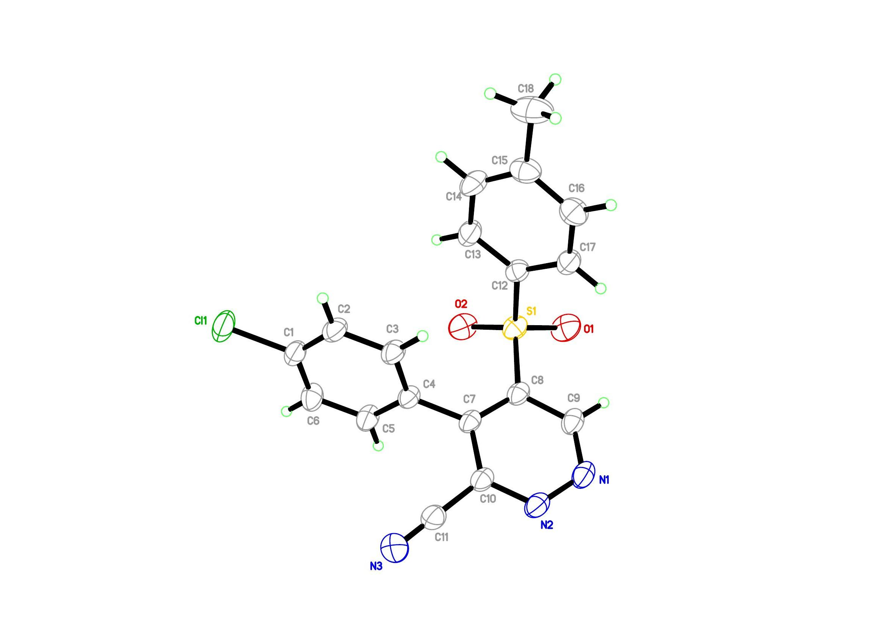
Figure S1. Crystal structure of PYRIDAZINE (3a). Thermal ellipsoids for non-H atoms are shown at the 25% probability level.

<CCDC number : 2216818>

3. X-ray Crystallographic Results

3.1 X-ray Crystallographic Data

3.1.1 Crystal data and structure refinement for 'JCH-BrBrBr’.
_____________________________________________________________________________
Identification code 20221008LT
Empirical formula C23 H16 Br3 N3 O4 S2
Formula weight 702.24
Temperature 100(1) K
Wavelength 0.71073 Å
Crystal system Monoclinic
Space group P21/c
Unit cell dimensions a = 15.0683(10) Å α= 90°
b = 14.2976(9) Å β= 94.759(4)°
c = 11.5410(7) Å γ = 90°
Volume 2477.8(3) Å³
Z 4
Density (calculated) 1.882 Mg/m³
Absorption coefficient 5.090 mm⁻¹
F(000) 1376
Crystal size 0.100 x 0.100 x 0.080 mm³
Theta range for data collection 1.356 to 25.447°
Index ranges -16<=h<=18, -17<=k<=17, -13<=l<=13
Reflections collected 21529
Independent reflections 4301 [R(int) = 0.0518]
Completeness to theta = 25.242° 94.3 %
Absorption correction Semi-empirical from equivalents
Max. and min. transmission 0.69 and 0.57
Refinement method Full-matrix least-squares on F²
Data / restraints / parameters 4301 / 0 / 316
Goodness-of-fit on F² 1.014
Final R indices [I>2sigma(I)] R1 = 0.0506, wR2 = 0.1087
R indices (all data) R1 = 0.0784, wR2 = 0.1192
Extinction coefficient n/a
Largest diff. peak and hole 1.456 and -0.503 e.Å⁻³
_____________________________________________________________________________
3.1.2 Atomic coordinates (x 10⁴) and equivalent isotropic displacement parameters (Å²x 10³) for 'JCH-BrBrBr'.
U(eq) is defined as one third of the trace of the orthogonalized Uⁱʲ tensor
_____________________________________________________________________________
x y z U(eq)
_____________________________________________________________________________
Br(1) 7832(1) 2462(1) 627(1) 25(1)
Br(2) 3961(1) 7849(1) 7390(1) 42(1)
Br(3) 6694(1) 5493(1) 11113(1) 35(1)
S(1) 10035(1) 5900(1) 3016(1) 17(1)
S(2) 6641(1) 5203(1) 4898(1) 20(1)
O(1) 6674(2) 4313(2) 5470(3) 25(1)
O(2) 6447(2) 5238(3) 3659(3) 26(1)
O(3) 10528(2) 6311(2) 2119(3) 18(1)
O(4) 10522(2) 5551(2) 4050(3) 20(1)
N(1) 8887(3) 6473(3) 4291(3) 18(1)
N(2) 9311(3) 6689(3) 3269(3) 15(1)
N(3) 9875(3) 7474(3) 5281(4) 20(1)
C(1) 8115(3) 5990(3) 4229(4) 18(1)
C(2) 7676(3) 5797(3) 5188(4) 17(1)
C(3) 8031(3) 6156(3) 6280(4) 19(1)
C(4) 8764(3) 6716(3) 6304(4) 16(1)
C(5) 9201(3) 6915(4) 5301(4) 17(1)
C(6) 9457(3) 4932(3) 2366(4) 16(1)
C(7) 9311(3) 4884(4) 1162(4) 21(1)
C(8) 8844(3) 4142(3) 647(4) 19(1)
C(9) 8503(3) 3466(4) 1341(4) 21(1)
C(10) 8624(3) 3513(4) 2533(4) 22(1)
C(11) 9109(3) 4231(3) 3055(4) 18(1)
C(12) 5861(3) 5911(4) 5560(4) 18(1)
C(13) 5567(4) 5638(4) 6607(5) 24(1)
C(14) 4993(3) 6234(4) 7146(5) 26(1)
C(15) 4729(4) 7063(4) 6614(5) 26(1)
C(16) 4999(4) 7317(4) 5555(5) 28(2)
C(17) 5581(3) 6742(4) 5022(4) 22(1)
C(18) 7658(3) 5969(4) 7422(4) 19(1)
C(19) 7509(3) 5073(4) 7822(4) 22(1)
C(20) 7217(3) 4934(4) 8908(4) 22(1)
C(21) 7067(4) 5683(4) 9614(5) 27(1)
C(22) 7209(3) 6594(4) 9219(4) 25(1)
C(23) 7499(4) 6729(4) 8142(4) 22(1)
_____________________________________________________________________________
3.1.3 Bond lengths [Å] and angles [°] for 'JCH-BrBrBr'.
_____________________________________________________________________________
Br(1)-C(9) 1.904(5)
Br(2)-C(15) 1.891(5)
Br(3)-C(21) 1.883(5)
S(1)-O(4) 1.438(4)
S(1)-O(3) 1.447(3)
S(1)-N(2) 1.612(4)
S(1)-C(6) 1.770(5)
S(2)-O(1) 1.432(3)
S(2)-O(2) 1.437(4)
S(2)-C(12) 1.771(5)
S(2)-C(2) 1.783(5)
N(1)-C(1) 1.350(6)
N(1)-C(5) 1.375(6)
N(1)-N(2) 1.421(5)
N(3)-C(5) 1.294(6)
N(3)-H(3A) 0.8800
N(3)-H(3B) 0.8800
C(1)-C(2) 1.364(6)
C(1)-H(1) 0.9500
C(2)-C(3) 1.423(7)
C(3)-C(4) 1.363(7)
C(3)-C(18) 1.499(7)
C(4)-C(5) 1.408(6)
C(4)-H(4) 0.9500
C(6)-C(7) 1.391(7)
C(6)-C(11) 1.407(6)
C(7)-C(8) 1.380(7)
C(7)-H(7) 0.9500
C(8)-C(9) 1.381(7)
C(8)-H(8) 0.9500
C(9)-C(10) 1.374(7)
C(10)-C(11) 1.371(7)
C(10)-H(10) 0.9500
C(11)-H(11) 0.9500
C(12)-C(13) 1.377(7)
C(12)-C(17) 1.390(7)
C(13)-C(14) 1.397(7)
C(13)-H(13) 0.9500
C(14)-C(15) 1.377(7)
C(14)-H(14) 0.9500
C(15)-C(16) 1.370(7)
C(16)-C(17) 1.383(7)
C(16)-H(16) 0.9500
C(17)-H(17) 0.9500
C(18)-C(19) 1.387(7)
C(18)-C(23) 1.401(7)
C(19)-C(20) 1.377(7)
C(19)-H(19) 0.9500
C(20)-C(21) 1.375(7)
C(20)-H(20) 0.9500
C(21)-C(22) 1.403(7)
C(22)-C(23) 1.365(6)
C(22)-H(22) 0.9500
C(23)-H(23) 0.9500

O(4)-S(1)-O(3) 118.6(2)
O(4)-S(1)-N(2) 113.5(2)
O(3)-S(1)-N(2) 103.9(2)
O(4)-S(1)-C(6) 106.2(2)
O(3)-S(1)-C(6) 106.2(2)
N(2)-S(1)-C(6) 107.9(2)
O(1)-S(2)-O(2) 119.1(2)
O(1)-S(2)-C(12) 107.9(2)
O(2)-S(2)-C(12) 108.8(2)
O(1)-S(2)-C(2) 109.9(2)
O(2)-S(2)-C(2) 105.8(2)
C(12)-S(2)-C(2) 104.4(2)
C(1)-N(1)-C(5) 121.0(4)
C(1)-N(1)-N(2) 120.8(4)
C(5)-N(1)-N(2) 117.2(4)
N(1)-N(2)-S(1) 110.9(3)
C(5)-N(3)-H(3A) 120.0
C(5)-N(3)-H(3B) 120.0
H(3A)-N(3)-H(3B) 120.0
N(1)-C(1)-C(2) 122.3(5)
N(1)-C(1)-H(1) 118.9
C(2)-C(1)-H(1) 118.9
C(1)-C(2)-C(3) 118.3(5)
C(1)-C(2)-S(2) 114.8(4)
C(3)-C(2)-S(2) 126.6(4)
C(4)-C(3)-C(2) 118.3(5)
C(4)-C(3)-C(18) 116.7(5)
C(2)-C(3)-C(18) 125.0(5)
C(3)-C(4)-C(5) 122.4(5)
C(3)-C(4)-H(4) 118.8
C(5)-C(4)-H(4) 118.8
N(3)-C(5)-N(1) 118.9(4)
N(3)-C(5)-C(4) 124.1(5)
N(1)-C(5)-C(4) 116.9(5)
C(7)-C(6)-C(11) 119.6(5)
C(7)-C(6)-S(1) 119.5(4)
C(11)-C(6)-S(1) 120.8(4)
C(8)-C(7)-C(6) 120.1(5)
C(8)-C(7)-H(7) 120.0
C(6)-C(7)-H(7) 120.0
C(7)-C(8)-C(9) 119.3(5)
C(7)-C(8)-H(8) 120.4
C(9)-C(8)-H(8) 120.4
C(10)-C(9)-C(8) 121.5(5)
C(10)-C(9)-Br(1) 119.4(4)
C(8)-C(9)-Br(1) 119.1(4)
C(11)-C(10)-C(9) 119.9(5)
C(11)-C(10)-H(10) 120.1
C(9)-C(10)-H(10) 120.1
C(10)-C(11)-C(6) 119.6(5)
C(10)-C(11)-H(11) 120.2
C(6)-C(11)-H(11) 120.2
C(13)-C(12)-C(17) 121.7(5)
C(13)-C(12)-S(2) 119.4(4)
C(17)-C(12)-S(2) 118.9(4)
C(12)-C(13)-C(14) 118.3(5)
C(12)-C(13)-H(13) 120.8
C(14)-C(13)-H(13) 120.8
C(15)-C(14)-C(13) 119.5(5)
C(15)-C(14)-H(14) 120.2
C(13)-C(14)-H(14) 120.2
C(16)-C(15)-C(14) 122.0(5)
C(16)-C(15)-Br(2) 120.3(4)
C(14)-C(15)-Br(2) 117.8(4)
C(15)-C(16)-C(17) 119.0(5)
C(15)-C(16)-H(16) 120.5
C(17)-C(16)-H(16) 120.5
C(16)-C(17)-C(12) 119.4(5)
C(16)-C(17)-H(17) 120.3
C(12)-C(17)-H(17) 120.3
C(19)-C(18)-C(23) 118.6(5)
C(19)-C(18)-C(3) 122.7(4)
C(23)-C(18)-C(3) 118.6(5)
C(20)-C(19)-C(18) 120.6(5)
C(20)-C(19)-H(19) 119.7
C(18)-C(19)-H(19) 119.7
C(21)-C(20)-C(19) 120.5(5)
C(21)-C(20)-H(20) 119.8
C(19)-C(20)-H(20) 119.8
C(20)-C(21)-C(22) 119.6(5)
C(20)-C(21)-Br(3) 120.5(4)
C(22)-C(21)-Br(3) 119.8(4)
C(23)-C(22)-C(21) 119.7(5)
C(23)-C(22)-H(22) 120.1
C(21)-C(22)-H(22) 120.1
C(22)-C(23)-C(18) 120.9(5)
C(22)-C(23)-H(23) 119.5
C(18)-C(23)-H(23) 119.5
_____________________________________________________________________________
Symmetry transformations used to generate equivalent atoms:

3.1.4 Anisotropic displacement parameters (Å²x 10³) for 'JCH-BrBrBr'.
The anisotropic displacement factor exponent takes the form: -2π²[h²a*²U¹¹ + ... + 2hka*b*U¹²]
_____________________________________________________________________________
U¹¹ U²² U³³ U²³ U¹³ U¹²
_____________________________________________________________________________
Br(1) 28(1) 22(1) 24(1) -5(1) 0(1) -4(1)
Br(2) 37(1) 52(1) 37(1) -9(1) 3(1) 16(1)
Br(3) 39(1) 46(1) 20(1) 4(1) 8(1) 0(1)
S(1) 19(1) 17(1) 15(1) 1(1) 0(1) 1(1)
S(2) 19(1) 22(1) 18(1) -3(1) 0(1) -3(1)
O(1) 28(2) 17(2) 30(2) -1(2) 2(2) -4(2)
O(2) 26(2) 34(2) 16(2) -5(2) 2(2) -7(2)
O(3) 19(2) 21(2) 14(2) 2(2) 0(2) -4(2)
O(4) 23(2) 22(2) 13(2) 3(2) -2(2) 3(2)
N(1) 21(3) 20(3) 12(2) 2(2) -5(2) 1(2)
N(2) 15(3) 17(2) 11(2) -1(2) 1(2) 2(2)
N(3) 27(3) 19(2) 15(3) -3(2) 2(2) -11(2)
C(1) 21(3) 14(3) 19(3) -3(2) -5(3) 4(3)
C(2) 16(3) 16(3) 17(3) 0(2) 1(3) 0(2)
C(3) 24(3) 17(3) 17(3) 3(2) 1(3) 2(3)
C(4) 19(3) 14(3) 14(3) -6(2) -1(2) -1(2)
C(5) 16(3) 15(3) 21(3) 2(2) -1(3) 5(2)
C(6) 11(3) 17(3) 21(3) -1(2) 0(2) 3(2)
C(7) 23(3) 20(3) 19(3) 5(2) 4(3) 1(3)
C(8) 24(3) 17(3) 14(3) -3(2) 0(3) -2(3)
C(9) 19(3) 29(3) 16(3) -6(2) -3(3) 4(3)
C(10) 26(3) 24(3) 16(3) 5(2) 4(3) -3(3)
C(11) 23(3) 17(3) 12(3) 3(2) -3(3) 0(2)
C(12) 11(3) 25(3) 18(3) -5(2) -2(2) -8(2)
C(13) 20(3) 26(3) 24(3) 5(3) -2(3) -4(3)
C(14) 19(3) 36(4) 22(3) -3(3) 0(3) -6(3)
C(15) 20(3) 30(4) 25(3) -3(3) -2(3) 3(3)
C(16) 29(4) 28(4) 27(4) 4(3) -7(3) 7(3)
C(17) 22(3) 25(3) 18(3) 1(3) -2(3) 3(3)
C(18) 22(3) 22(3) 14(3) -1(2) 2(3) -1(3)
C(19) 19(3) 24(3) 21(3) -3(3) -3(3) 1(3)
C(20) 24(3) 20(3) 21(3) 3(3) 2(3) -3(3)
C(21) 24(4) 35(4) 21(3) 1(3) -1(3) -1(3)
C(22) 31(4) 26(3) 17(3) -8(3) 4(3) 0(3)
C(23) 27(3) 22(3) 16(3) -4(2) 1(3) -1(3)
_____________________________________________________________________________
3.1.5 Hydrogen coordinates (x 10⁴) and isotropic displacement parameters Å²x 10³ for 'JCH-BrBrBr'.
_____________________________________________________________________________
x y z U(eq)
_____________________________________________________________________________
H(3A) 10124 7566 4628 24
H(3B) 10083 7761 5921 24
H(1) 7869 5776 3491 22
H(4) 8988 6981 7024 19
H(7) 9532 5363 694 25
H(8) 8759 4096 -176 22
H(10) 8371 3049 2994 26
H(11) 9210 4255 3878 21
H(13) 5750 5059 6953 28
H(14) 4786 6070 7874 31
H(16) 4790 7880 5191 34
H(17) 5788 6913 4296 26
H(19) 7609 4550 7342 26
H(20) 7118 4316 9172 26
H(22) 7102 7115 9699 30
H(23) 7595 7347 7877 26
_____________________________________________________________________________
3.1.6 Torsion angles [°] for 'JCH-BrBrBr'.
_____________________________________________________________________________
C(1)-N(1)-N(2)-S(1) -93.1(4)
C(5)-N(1)-N(2)-S(1) 98.4(4)
O(4)-S(1)-N(2)-N(1) -38.2(4)
O(3)-S(1)-N(2)-N(1) -168.4(3)
C(6)-S(1)-N(2)-N(1) 79.2(4)
C(5)-N(1)-C(1)-C(2) -9.8(7)
N(2)-N(1)-C(1)-C(2) -177.8(4)
N(1)-C(1)-C(2)-C(3) 2.7(7)
N(1)-C(1)-C(2)-S(2) 176.9(4)
O(1)-S(2)-C(2)-C(1) 118.6(4)
O(2)-S(2)-C(2)-C(1) -11.1(4)
C(12)-S(2)-C(2)-C(1) -125.8(4)
O(1)-S(2)-C(2)-C(3) -67.7(5)
O(2)-S(2)-C(2)-C(3) 162.5(4)
C(12)-S(2)-C(2)-C(3) 47.8(5)
C(1)-C(2)-C(3)-C(4) 3.5(7)
S(2)-C(2)-C(3)-C(4) -170.0(4)
C(1)-C(2)-C(3)-C(18) -176.7(5)
S(2)-C(2)-C(3)-C(18) 9.9(8)
C(2)-C(3)-C(4)-C(5) -2.9(7)
C(18)-C(3)-C(4)-C(5) 177.3(4)
C(1)-N(1)-C(5)-N(3) -170.6(5)
N(2)-N(1)-C(5)-N(3) -2.2(7)
C(1)-N(1)-C(5)-C(4) 10.0(7)
N(2)-N(1)-C(5)-C(4) 178.4(4)
C(3)-C(4)-C(5)-N(3) 176.9(5)
C(3)-C(4)-C(5)-N(1) -3.7(7)
O(4)-S(1)-C(6)-C(7) -147.3(4)
O(3)-S(1)-C(6)-C(7) -20.2(5)
N(2)-S(1)-C(6)-C(7) 90.7(4)
O(4)-S(1)-C(6)-C(11) 35.6(5)
O(3)-S(1)-C(6)-C(11) 162.6(4)
N(2)-S(1)-C(6)-C(11) -86.4(4)
C(11)-C(6)-C(7)-C(8) -1.5(7)
S(1)-C(6)-C(7)-C(8) -178.7(4)
C(6)-C(7)-C(8)-C(9) 2.0(8)
C(7)-C(8)-C(9)-C(10) -0.5(8)
C(7)-C(8)-C(9)-Br(1) 178.2(4)
C(8)-C(9)-C(10)-C(11) -1.6(8)
Br(1)-C(9)-C(10)-C(11) 179.7(4)
C(9)-C(10)-C(11)-C(6) 2.0(8)
C(7)-C(6)-C(11)-C(10) -0.5(8)
S(1)-C(6)-C(11)-C(10) 176.6(4)
O(1)-S(2)-C(12)-C(13) 14.0(5)
O(2)-S(2)-C(12)-C(13) 144.5(4)
C(2)-S(2)-C(12)-C(13) -102.9(4)
O(1)-S(2)-C(12)-C(17) -167.8(4)
O(2)-S(2)-C(12)-C(17) -37.3(5)
C(2)-S(2)-C(12)-C(17) 75.3(5)
C(17)-C(12)-C(13)-C(14) -1.9(8)
S(2)-C(12)-C(13)-C(14) 176.3(4)
C(12)-C(13)-C(14)-C(15) 1.0(8)
C(13)-C(14)-C(15)-C(16) 1.2(9)
C(13)-C(14)-C(15)-Br(2) -179.4(4)
C(14)-C(15)-C(16)-C(17) -2.4(9)
Br(2)-C(15)-C(16)-C(17) 178.2(4)
C(15)-C(16)-C(17)-C(12) 1.5(8)
C(13)-C(12)-C(17)-C(16) 0.7(8)
S(2)-C(12)-C(17)-C(16) -177.5(4)
C(4)-C(3)-C(18)-C(19) -126.4(6)
C(2)-C(3)-C(18)-C(19) 53.7(8)
C(4)-C(3)-C(18)-C(23) 50.0(7)
C(2)-C(3)-C(18)-C(23) -129.8(6)
C(23)-C(18)-C(19)-C(20) -0.5(8)
C(3)-C(18)-C(19)-C(20) 176.0(5)
C(18)-C(19)-C(20)-C(21) 0.1(8)
C(19)-C(20)-C(21)-C(22) 0.4(8)
C(19)-C(20)-C(21)-Br(3) -178.6(4)
C(20)-C(21)-C(22)-C(23) -0.5(8)
Br(3)-C(21)-C(22)-C(23) 178.5(4)
C(21)-C(22)-C(23)-C(18) 0.1(8)
C(19)-C(18)-C(23)-C(22) 0.4(8)
C(3)-C(18)-C(23)-C(22) -176.2(5)
_____________________________________________________________________________
Symmetry transformations used to generate equivalent atoms:
3.1.7 Hydrogen bonds [Å and °] for 'JCH-BrBrBr'.
_____________________________________________________________________________
D-H...Å d(D-H) d(H...Å) d(D...Å) <(DHÅ)
_____________________________________________________________________________
N(3)-H(3A)...Br(1)#1 0.88 3.12 3.694(4) 124.7
N(3)-H(3A)...S(1) 0.88 3.02 3.472(4) 114.2
N(3)-H(3B)...O(3)#2 0.88 1.99 2.854(5) 165.9
C(4)-H(4)...N(2)#2 0.95 2.41 3.273(6) 151.3
C(8)-H(8)...O(3)#3 0.95 2.63 3.465(6) 146.7
C(11)-H(11)...O(4)#4 0.95 2.41 3.355(6) 175.4
C(20)-H(20)...Br(2)#5 0.95 3.13 3.720(5) 121.7
_____________________________________________________________________________
Symmetry transformations used to generate equivalent atoms:
#1 -x+2,y+1/2,-z+1/2 #2 x,-y+3/2,z+1/2 #3 -x+2,-y+1,-z
#4 -x+2,-y+1,-z+1 #5 -x+1,y-1/2,-z+3/2
3.2 X-ray Crystallographic Structure.

3.2.1 Crystal structure.
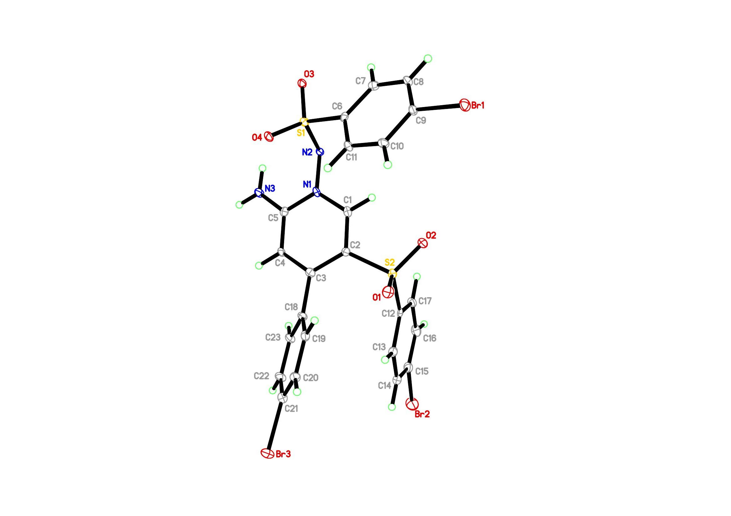
Figure S2. Crystal structure of 'JCH-BrBrBr'. Thermal ellipsoids for non-H atoms are shown at the 25% probability level.

