Charge, Spin, and Optimized Atomic Cartesian Coordinates for 1-E
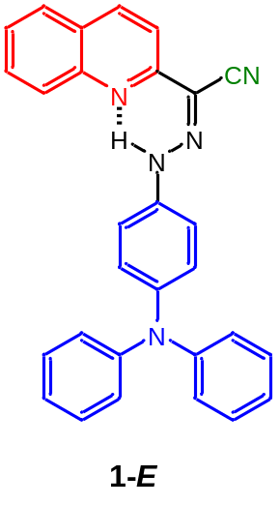0 1 Coordinates (Angstroms)
Atomic No. X Y Z
C1 -6.56728879 0.69039072 0.32945030
C2 -5.18735277 1.00044860 0.42578813
N3 -4.22007309 0.10706609 0.07681912
C4 -4.57384563 -1.08611979 -0.36563642
C5 -5.93839200 -1.48249691 -0.49573316
C6 -6.91583525 -0.59846242 -0.15004775
C7 -3.49950818 -2.02430451 -0.73006607
N8 -2.20780467 -1.84122609 -0.67222770
N9 -1.70159307 -0.71922645 -0.25455111
C10 -0.31137120 -0.53909443 -0.19816945
C11 0.17072511 0.68831419 0.25736092
C12 1.53576274 0.91289105 0.33960636
C13 2.44141276 -0.07754967 -0.04984226
C14 1.94600740 -1.30070202 -0.51285302
C15 0.58251644 -1.53940289 -0.58027584
N16 3.83681556 0.15315710 0.02231746
C17 4.69322205 -0.86558520 0.50634574
C18 4.36648739 1.39790618 -0.39478621
C19 -7.52618506 1.66038491 0.70836705
C20 -7.12400135 2.88889168 1.16446106
C21 -5.74636750 3.19763618 1.25984828
C22 -4.79689436 2.27751452 0.89973354
C23 4.29778394 -1.66849804 1.58087323
C24 5.13443556 -2.67580901 2.04542907
C25 6.37933165 -2.88852556 1.46044073
C26 6.77631814 -2.08495971 0.39526792
C27 5.94027021 -1.08576559 -0.08726692
C28 5.41961632 1.99284866 0.30764811
C29 5.93600621 3.21319784 -0.10971584
C30 5.40418979 3.86671005 -1.21787722
C31 4.35073876 3.27911956 -1.91236504
C32 3.83792919 2.05123086 -1.51296321
C33 -3.87465295 -3.32409004 -1.21530704
N34 -4.21261444 -4.35529478 -1.59955182
H35 -6.18178274 -2.47099873 -0.86373859
H36 -7.96305686 -0.86848055 -0.23671768
H37 -2.34302681 0.02806039 0.03150928
H38 -0.52687532 1.46184932 0.56120897
H39 1.90627421 1.86408454 0.70341075
H40 2.64112562 -2.07349636 -0.82010016
H41 0.20707704 -2.48813374 -0.94040856
H42 -8.57944580 1.41293124 0.63105616
H43 -7.85915042 3.62984916 1.45453939
H44 -5.44302278 4.17293570 1.62202345
H45 -3.73826669 2.49990276 0.96757969
H46 3.33341685 -1.50071821 2.04627449
H47 4.81305708 -3.29001663 2.87879435
H48 7.03132157 -3.67125456 1.82883597
H49 7.73957367 -2.24362315 -0.07598532
H50 6.24851622 -0.47051712 -0.92463487
H51 5.83027522 1.49376954 1.17764669
H52 6.75251199 3.66096732 0.44518852
H53 5.80591587 4.82098788 -1.53638298
H54 3.93055327 3.77174803 -2.78178266
H55 3.02554504 1.59210671 -2.06424838

Charge, Spin, and Optimized Atomic Cartesian Coordinates for 1-Z
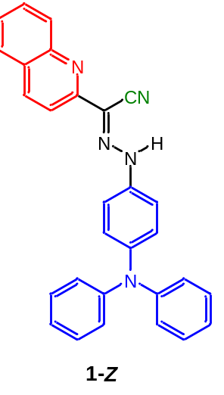0 1 Coordinates (Angstroms)
Atomic No. X Y Z
C1 6.66588806 1.23384549 0.73149913
C2 6.78282491 -0.02625542 0.08927642
N3 5.69457745 -0.74880979 -0.29360925
C4 4.50274555 -0.25624832 -0.05787890
C5 4.27495101 0.99621547 0.57988078
C6 5.35634402 1.72885917 0.96835225
C7 3.36703679 -1.08551318 -0.49719950
N8 2.14873659 -0.68645006 -0.32162491
N9 1.13619822 -1.41773687 -0.71040073
C10 -0.18831171 -0.99614732 -0.52028754
C11 -1.21581020 -1.83383622 -0.95452220
C12 -2.53850133 -1.45337115 -0.79315041
C13 -2.85928649 -0.24032353 -0.17805819
C14 -1.82089518 0.58642062 0.26009101
C15 -0.49462310 0.22231640 0.08441691
N16 -4.21103329 0.14294731 -0.00029335
C17 -4.59984779 1.48310155 -0.24033610
C18 -5.16353762 -0.81325951 0.42787141
C19 7.83770636 1.93513537 1.10397809
C20 9.07418256 1.40125680 0.84660832
C21 9.18992262 0.14450530 0.20638899
C22 8.07229683 -0.55645203 -0.16529438
C23 -5.52606254 2.11335652 0.59700616
C24 -5.90611473 3.42725955 0.35382447
C25 -5.36010028 4.13753078 -0.71168139
C26 -4.43118545 3.51378208 -1.53967859
C27 -4.05663454 2.19483422 -1.31464966
C28 -6.45737402 -0.81116316 -0.10353125
C29 -7.38918858 -1.74890315 0.32343740
C30 -7.04497535 -2.71054099 1.26944029
C31 -5.75493250 -2.71868675 1.79199366
C32 -4.82041762 -1.77489450 1.38371992
C33 3.63415292 -2.35230191 -1.12849716
N34 3.69279445 -3.38008351 -1.64350518
H35 3.26178008 1.33844668 0.74198700
H36 5.23121176 2.68891049 1.45827620
H37 1.29366132 -2.31908476 -1.15960718
H38 -0.97815403 -2.77877860 -1.43226580
H39 -3.33237305 -2.10365581 -1.14148533
H40 -2.05770936 1.52837827 0.74116287
H41 0.30101867 0.87011331 0.42715696
H42 7.73860887 2.89767193 1.59454828
H43 9.96971609 1.93999736 1.13274984
H44 10.17433867 -0.26417355 0.01030197
H45 8.13715549 -1.52009659 -0.65666291
H46 -5.94546308 1.56811156 1.43455090
H47 -6.62519248 3.90162217 1.01182647
H48 -5.65445613 5.16392466 -0.89425942
H49 -4.00163811 4.05158723 -2.37712841
H50 -3.34133004 1.70968416 -1.96868775
H51 -6.72687658 -0.07143443 -0.84838810
H52 -8.38791322 -1.73390957 -0.09773253
H53 -7.77259147 -3.44402461 1.59499111
H54 -5.47349905 -3.45701766 2.53406633
H55 -3.82072361 -1.77847496 1.80251395

Charge, Spin, and Optimized Atomic Cartesian Coordinates for 1-H⁺-E
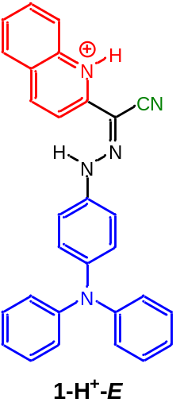1 1 Coordinates (Angstroms)
Atomic No. X Y Z
C1 6.44566544 1.34609536 -0.19110679
C2 6.62109992 0.02766489 0.28414210
N3 5.55117634 -0.83069555 0.22687709
C4 4.34265310 -0.51659408 -0.26095961
C5 4.15323421 0.78846818 -0.76775049
C6 5.18424953 1.69033158 -0.73335730
C7 3.33856655 -1.57272691 -0.31861871
N8 2.02878375 -1.45575679 -0.30676059
N9 1.42542810 -0.34655877 -0.08902647
C10 0.01681184 -0.25069255 -0.07925062
C11 -0.55613494 0.88207388 0.49383235
C12 -1.93191016 1.01586422 0.53346830
C13 -2.76308599 0.02194653 -0.00817783
C14 -2.16165083 -1.10819355 -0.59271867
C15 -0.78676311 -1.24669595 -0.62960022
N16 -4.15197724 0.15537103 0.02832903
C17 -4.99641067 -0.99165476 0.06553119
C18 -4.75917069 1.44389747 0.05739130
C19 7.54141277 2.23817544 -0.13589718
C20 8.74138510 1.81770441 0.37671834
C21 8.89368850 0.49472617 0.84871046
C22 7.85283305 -0.40047650 0.80627776
C23 -6.12215124 -1.04983953 -0.75712208
C24 -6.96087807 -2.15691071 -0.70728280
C25 -6.67894085 -3.21677820 0.14955986
C26 -5.55438760 -3.15745047 0.96783867
C27 -4.71926052 -2.04699528 0.93641128
C28 -4.34660851 2.43765753 -0.83255131
C29 -4.94685266 3.69033905 -0.80143591
C30 -5.97254071 3.95768671 0.10130261
C31 -6.39146023 2.96158496 0.97813725
C32 -5.78585269 1.71034780 0.96418237
C33 3.82836663 -2.91724128 -0.38086616
N34 4.31112291 -3.96228070 -0.39509037
H35 5.70410137 -1.77978974 0.56991944
H36 3.22443449 1.04491304 -1.25808206
H37 5.04780257 2.68197664 -1.15150538
H38 1.93697055 0.48340307 0.20794069
H39 0.07098197 1.64780259 0.93839992
H40 -2.36970245 1.88900995 0.99957539
H41 -2.78306483 -1.87685787 -1.03439293
H42 -0.33514653 -2.11304954 -1.09638273
H43 7.41448701 3.24774375 -0.50836040
H44 9.58248249 2.49817444 0.41965617
H45 9.84933642 0.17950013 1.24917527
H46 7.96323874 -1.41704463 1.16617760
H47 -6.33794475 -0.22493183 -1.42657838
H48 -7.83401381 -2.19276269 -1.34820971
H49 -7.33232039 -4.08025362 0.18233305
H50 -5.33209426 -3.97216800 1.64706873
H51 -3.85231702 -1.99284974 1.58540484
H52 -3.55846710 2.22226632 -1.54529881
H53 -4.62245103 4.45473315 -1.49786857
H54 -6.44492343 4.93238543 0.11699991
H55 -7.18954689 3.15903615 1.68419186
H56 -6.10902383 0.93432168 1.64868626

Charge, Spin, and Optimized Atomic Cartesian Coordinates for 1-H⁺-Z
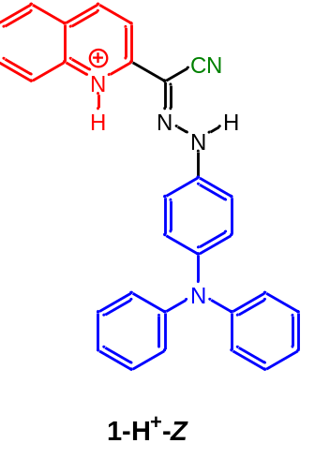1 1 Coordinates (Angstroms)
Atomic No. X Y Z
C1 6.83765031 0.58946287 0.20338045
C2 5.51425956 1.07959480 0.22852036
N3 4.48815137 0.18203342 0.05895338
C4 4.65567923 -1.13116996 -0.12632472
C5 5.96840583 -1.64940056 -0.16222792
C6 7.02905844 -0.80300191 0.00153915
C7 3.47989003 -1.95643623 -0.27741815
N8 2.30253240 -1.37287670 -0.19371442
N9 1.21442294 -2.03173019 -0.32495573
C10 -0.05676514 -1.43406763 -0.22616053
C11 -1.16802370 -2.21725816 -0.53163874
C12 -2.43788730 -1.67585446 -0.46234968
C13 -2.62608975 -0.33804557 -0.07673866
C14 -1.49057881 0.43128438 0.24102447
C15 -0.22052983 -0.10612768 0.16517795
N16 -3.90364761 0.21360414 -0.00231949
C17 -4.11062706 1.60996439 -0.19337788
C18 -5.04070322 -0.60994230 0.24830468
C19 7.90120573 1.50300466 0.37801211
C20 7.63880223 2.83663670 0.56559257
C21 6.30752541 3.30478883 0.58612929
C22 5.24808218 2.44465885 0.41969510
C23 -4.95050543 2.31148647 0.67250443
C24 -5.17156026 3.66943225 0.47529711
C25 -4.55088875 4.33971715 -0.57463598
C26 -3.71310937 3.63797917 -1.43711112
C27 -3.49861310 2.27692216 -1.25662632
C28 -6.18256174 -0.47481934 -0.54143412
C29 -7.29963936 -1.26106305 -0.28387753
C30 -7.28201659 -2.19253716 0.74988927
C31 -6.14025873 -2.32675813 1.53520722
C32 -5.02485043 -1.53376578 1.29449785
C33 3.61341888 -3.35939365 -0.51155425
N34 3.63773693 -4.49409155 -0.70611281
H35 3.53131174 0.53205887 0.07106030
H36 6.10902203 -2.71128074 -0.31680875
H37 8.04092524 -1.19298546 -0.02196372
H38 1.23878267 -3.03792129 -0.51343889
H39 -1.03892560 -3.24820422 -0.84455608
H40 -3.29257295 -2.28823345 -0.71865026
H41 -1.61533245 1.45704830 0.56353101
H42 0.63887015 0.49526775 0.43168306
H43 8.91849570 1.12967400 0.35991852
H44 8.45203537 3.53862130 0.69972459
H45 6.11653688 4.36048685 0.73641804
H46 4.22470648 2.80176134 0.43605617
H47 -5.43172569 1.78747381 1.49041569
H48 -5.82766352 4.20557578 1.15095267
H49 -4.72416720 5.39855167 -0.72415789
H50 -3.23667670 4.14746721 -2.26666188
H51 -2.86129936 1.72528827 -1.93869384
H52 -6.19082580 0.24944561 -1.34809194
H53 -8.18385909 -1.14936391 -0.90021927
H54 -8.15296476 -2.80607472 0.94602362
H55 -6.12174128 -3.04083305 2.35022243
H56 -4.13991978 -1.62414452 1.91450152

Charge, Spin, and Optimized Atomic Cartesian Coordinates for 2-E
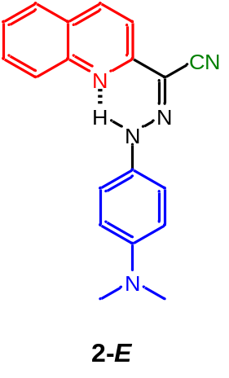0 1 Coordinates (Angstroms)
Atomic No. X Y Z
C1 -4.53604966 -0.56771655 0.02273220
C2 -3.18548106 -0.99683565 0.00106651
N3 -2.14593607 -0.11592849 -0.00592030
C4 -2.39874778 1.18137797 0.00764817
C5 -3.72904122 1.70116566 0.02943971
C6 -4.77661160 0.83121461 0.03682568
C7 -1.25272911 2.10067839 -0.00027405
N8 0.02393839 1.80598088 -0.01802951
N9 0.43337812 0.57760626 -0.03179303
C10 1.80684533 0.27445367 -0.05051928
C11 2.18742602 -1.06457219 -0.05956188
C12 3.52682033 -1.42015609 -0.07479266
C13 4.53904810 -0.44030670 -0.09289450
C14 4.12924659 0.90903954 -0.06588286
C15 2.78967877 1.26104393 -0.05005304
N16 5.87875907 -0.78610938 -0.14423358
C17 6.86716999 0.23440222 0.15299290
C18 6.24584928 -2.16290909 0.12842469
C19 -5.57247917 -1.53137948 0.02920218
C20 -5.27355952 -2.86947964 0.01456938
C21 -3.92536007 -3.29718838 -0.00716236
C22 -2.90220055 -2.38502633 -0.01375221
C23 -1.51531933 3.51190254 0.01256504
N24 -1.76241257 4.63677560 0.02393256
H25 -3.89129019 2.77137770 0.03996216
H26 -5.79854914 1.19509290 0.05347408
H27 -0.26993483 -0.16904412 -0.02967676
H28 1.42806735 -1.84006967 -0.04835894
H29 3.77862811 -2.47137286 -0.07366077
H30 4.86284928 1.70304391 -0.05806523
H31 2.50299476 2.30469220 -0.03181542
H32 6.81678692 1.04778921 -0.57394553
H33 6.74310788 0.65801515 1.15931728
H34 7.85979835 -0.20658418 0.08142383
H35 7.32792632 -2.25915047 0.05849230
H36 5.92888470 -2.49204318 1.12808384
H37 5.80837876 -2.83563749 -0.61261293
H38 -6.60232546 -1.19114254 0.04586774
H39 -6.06850489 -3.60554084 0.01949102
H40 -3.70323826 -4.35785742 -0.01869523
H41 -1.86470023 -2.69809300 -0.03041608

Charge, Spin, and Optimized Atomic Cartesian Coordinates for 2-Z
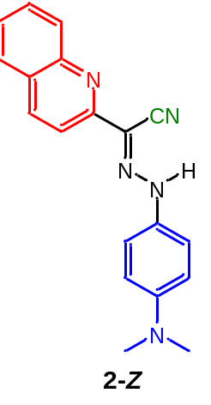0 1 Coordinates (Angstroms)
Atomic No. X Y Z
C1 -4.56427865 -1.31429845 -0.00907697
C2 -4.57481473 0.10430850 0.01937119
N3 -3.42892357 0.83921676 0.01945810
C4 -2.27976424 0.20783279 -0.00771344
C5 -2.15881774 -1.21161635 -0.03797193
C6 -3.29858103 -1.95781555 -0.03821144
C7 -1.07712778 1.05628600 -0.00559118
N8 0.10650799 0.52599864 -0.02769216
N9 1.18052595 1.26370389 -0.02728815
C10 2.46765846 0.69403900 -0.04599464
C11 3.57070818 1.54288203 -0.04607650
C12 4.85840096 1.03065212 -0.06234586
C13 5.09008649 -0.35844857 -0.09064953
C14 3.95794491 -1.19754130 -0.07008409
C15 2.67090252 -0.68268384 -0.05347213
N16 6.37418783 -0.87736640 -0.14677278
C17 6.55926572 -2.28668744 0.14631031
C18 7.48520303 0.00855728 0.14719934
C19 -5.79171883 -2.01914688 -0.00735632
C20 -6.98109545 -1.33691721 0.02127007
C21 -6.99112145 0.07775766 0.04968380
C22 -5.81725010 0.78568710 0.04887492
C23 -1.23377298 2.48595422 0.02167296
N24 -1.20801426 3.63702276 0.04202164
H25 -1.17676029 -1.66427464 -0.06001074
H26 -3.25452357 -3.04186140 -0.06071471
H27 1.10925683 2.28073345 -0.01100265
H28 3.42329905 2.61811294 -0.02764394
H29 5.68506845 1.72693324 -0.05429788
H30 4.07429226 -2.27224929 -0.06795461
H31 1.82147309 -1.35311838 -0.04057166
H32 6.03471909 -2.90734247 -0.58339389
H33 7.61904080 -2.52517272 0.07478757
H34 6.20658978 -2.55670728 1.15168980
H35 7.42247277 0.44116964 1.15575533
H36 8.41440140 -0.55284174 0.06742642
H37 7.53286153 0.82423068 -0.57736641
H38 -5.77343052 -3.10376639 -0.02894189
H39 -7.91936476 -1.87886592 0.02245209
H40 -7.93878154 0.60312233 0.07237171
H41 -5.80156534 1.86906170 0.07029757

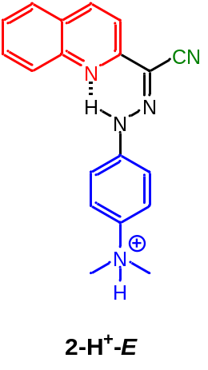Charge, Spin, and Optimized Atomic Cartesian Coordinates for 2-H⁺-E
1 1 Coordinates (Angstroms)
Atomic No. X Y Z
C1 4.54424130 -0.61507119 0.03236057
C2 3.18851139 -1.03074074 -0.01607522
N3 2.16191717 -0.13707157 -0.02598396
C4 2.43603645 1.15394382 0.00596351
C5 3.76397684 1.66189524 0.05488987
C6 4.80251131 0.77680032 0.06927022
C7 1.29208969 2.09083586 -0.01081794
N8 0.02421201 1.82627928 -0.03795713
N9 -0.41153406 0.58509762 -0.05146223
C10 -1.77902629 0.34334469 -0.05268289
C11 -2.21934249 -0.98470185 0.01407080
C12 -3.57389859 -1.26896999 0.03657769
C13 -4.48178963 -0.21977570 -0.01348780
C14 -4.06143428 1.09802851 -0.09320458
C15 -2.70654311 1.38736528 -0.11193134
N16 -5.93109539 -0.49889221 0.03351882
C17 -6.41218577 -1.25264079 -1.16793164
C18 -6.34022386 -1.17738985 1.30419250
C19 5.57102112 -1.59108164 0.03991853
C20 5.25633837 -2.92335241 -0.00136898
C21 3.90282512 -3.33710046 -0.05090449
C22 2.88969795 -2.41581821 -0.05747990
C23 1.57589445 3.50426620 0.01201878
N24 1.82770278 4.62593783 0.03306547
H25 3.94006593 2.72963237 0.08125270
H26 5.82804400 1.12798521 0.10782229
H27 0.27877414 -0.17353700 -0.03933089
H28 -1.49565464 -1.79028632 0.05903601
H29 -3.90996007 -2.29819436 0.09857225
H30 -4.78267995 1.90793774 -0.13673857
H31 -2.36304288 2.41089096 -0.16680215
H32 -6.39799499 0.41292743 0.02296043
H33 -7.49399822 -1.35362894 -1.10122740
H34 -6.12683864 -0.69783580 -2.05903861
H35 -5.93846582 -2.23193089 -1.16604886
H36 -7.42605541 -1.24887962 1.32146279
H37 -5.97550649 -0.58845552 2.14241099
H38 -5.89533820 -2.17012560 1.31626454
H39 6.60367348 -1.26219755 0.07742954
H40 6.04231310 -3.66878089 0.00303092
H41 3.67223762 -4.39538660 -0.08389805
H42 1.84980923 -2.71861395 -0.09569083

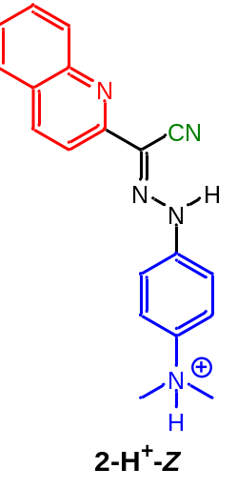Charge, Spin, and Optimized Atomic Cartesian Coordinates for 2-H⁺-Z
1 1 Coordinates (Angstroms)
Atomic No. X Y Z
C1 4.64536349 -1.28496474 -0.03947035
C2 4.61125901 0.13221448 0.04549595
N3 3.44192396 0.82746744 0.03143422
C4 2.31977445 0.15785341 -0.06146511
C5 2.24093008 -1.25741877 -0.15669448
C6 3.40597150 -1.96694109 -0.14397823
C7 1.09380137 0.98180022 -0.06281811
N8 -0.07199637 0.43802872 -0.06609648
N9 -1.16438249 1.18712746 -0.06953220
C10 -2.42159958 0.60263675 -0.03962413
C11 -3.54245723 1.44223430 -0.07109395
C12 -4.81639664 0.90540079 -0.03689913
C13 -4.96561220 -0.47432161 0.02970478
C14 -3.86602480 -1.31732474 0.06001447
C15 -2.58682613 -0.78334359 0.02360051
N16 -6.31969649 -1.06338848 0.07707108
C17 -7.07699374 -0.65869309 1.30509834
C18 -7.11154860 -0.79700014 -1.16648686
C19 5.89465577 -1.95116536 -0.01918571
C20 7.05722247 -1.23241168 0.08152226
C21 7.02157836 0.18043346 0.16618814
C22 5.82771469 0.85216711 0.14891723
C23 1.23730657 2.41964474 -0.05180881
N24 1.19831251 3.56890120 -0.04642996
H25 1.27619918 -1.73913232 -0.24107480
H26 3.40012291 -3.04950875 -0.21520598
H27 -1.09945955 2.20386509 -0.08159375
H28 -3.40859312 2.51671646 -0.12185382
H29 -5.67720213 1.56458481 -0.06517698
H30 -3.99408540 -2.39409924 0.11451517
H31 -1.72128527 -1.43021454 0.05012782
H32 -6.19404505 -2.07838085 0.13237454
H33 -8.02426198 -1.19532801 1.31474483
H34 -6.47692177 -0.91179272 2.17659860
H35 -7.25061050 0.41451090 1.26345330
H36 -8.05253962 -1.33993842 -1.09588092
H37 -6.53077392 -1.13312034 -2.02284637
H38 -7.29751503 0.27328891 -1.23033348
H39 5.91331493 -3.03370163 -0.08436754
H40 8.01232152 -1.74358499 0.09684738
H41 7.95118493 0.73154409 0.24553605
H42 5.77630898 1.93253446 0.21290849

Charge, Spin, and Optimized Atomic Cartesian Coordinates for 2-2H⁺-E
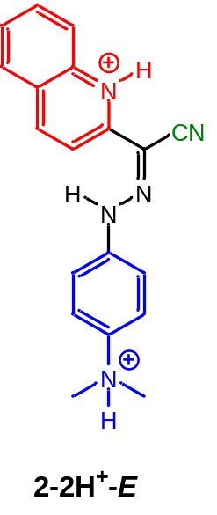2 1 Coordinates (Angstroms)
Atomic No. X Y Z
C1 -4.36746222 -1.26288633 -0.30261260
C2 -4.42527860 0.01498413 0.30630983
N3 -3.29813323 0.79093895 0.28043611
C4 -2.14287940 0.43272512 -0.29033880
C5 -2.06269755 -0.81669616 -0.91977202
C6 -3.16243070 -1.64571337 -0.92489238
C7 -1.05129745 1.42619002 -0.28028123
N8 0.22850154 1.23595769 -0.26668162
N9 0.81547913 0.07937860 -0.18112932
C10 2.22110567 0.02634538 -0.10167666
C11 2.81216326 -1.18484220 0.25626794
C12 4.19143885 -1.27629273 0.34762634
C13 4.95927644 -0.15087806 0.08366044
C14 4.37928374 1.05432844 -0.28050289
C15 2.99872158 1.14915124 -0.37647023
N16 6.42987326 -0.22842783 0.18157275
C17 6.90610024 -0.58275674 1.55910151
C18 7.01809229 -1.13671486 -0.85596531
C19 -5.52899074 -2.07412474 -0.28562929
C20 -6.67011190 -1.61571764 0.31521557
C21 -6.70283527 -0.33483224 0.91866249
C22 -5.60051122 0.48136664 0.92101505
C23 -1.45888930 2.80674743 -0.26462406
N24 -1.87572451 3.87690938 -0.21171924
H25 -3.36330917 1.71420357 0.71259120
H26 -1.16844968 -1.08230127 -1.46604520
H27 -3.11742715 -2.60236040 -1.43404652
H28 0.30238665 -0.78231784 -0.00739606
H29 2.19726037 -2.05054110 0.47576972
H30 4.64924946 -2.21721925 0.63176740
H31 4.99556484 1.92326383 -0.49119920
H32 2.53196142 2.08341953 -0.65724133
H33 6.78312865 0.71210283 -0.01731858
H34 7.99348122 -0.52961959 1.56493042
H35 6.47845565 0.12628045 2.26463165
H36 6.58220831 -1.59525994 1.78942773
H37 8.10257423 -1.07781849 -0.78763420
H38 6.67197143 -0.80798339 -1.83335551
H39 6.67940287 -2.15056884 -0.65356468
H40 -5.49593950 -3.04919035 -0.75676067
H41 -7.56226050 -2.22903760 0.32883042
H42 -7.61777188 0.00662710 1.38737133
H43 -5.61924663 1.46272308 1.38132921

Charge, Spin, and Optimized Atomic Cartesian Coordinates for 2-2H⁺-Z
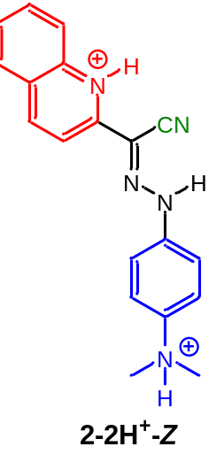2 1 Coordinates (Angstroms)
Atomic No. X Y Z
C1 -4.62159088 -1.30632211 -0.04389063
C2 -4.64661935 0.10312943 0.03959874
N3 -3.44737025 0.77343965 0.01175990
C4 -2.25540924 0.18073441 -0.09144422
C5 -2.19814642 -1.22072895 -0.18917738
C6 -3.36245278 -1.94269859 -0.16411373
C7 -1.06320879 1.02550919 -0.08392835
N8 0.10577639 0.45880090 -0.06779615
N9 1.18854969 1.16874498 -0.03417193
C10 2.46081300 0.57384873 -0.02283829
C11 3.56441445 1.42687312 0.00733560
C12 4.84334185 0.89858456 0.02946857
C13 5.00253611 -0.48041340 0.00879034
C14 3.91003642 -1.33421129 -0.02220676
C15 2.62559562 -0.80858976 -0.03810530
N16 6.36074043 -1.06000587 0.04143933
C17 7.20020097 -0.66307224 -1.13732403
C18 7.07087810 -0.77189639 1.33180312
C19 -5.85000432 -2.00623583 -0.00748276
C20 -7.02805617 -1.31497446 0.10906016
C21 -7.02745550 0.09603140 0.19047230
C22 -5.85460245 0.80961302 0.15821448
C23 -1.21985385 2.45228753 -0.07313227
N24 -1.32803931 3.59767212 -0.05674703
H25 -3.49699917 1.78967713 0.08413472
H26 -1.23193089 -1.69370582 -0.28936821
H27 -3.32887347 -3.02433607 -0.23584000
H28 1.14817547 2.18999996 -0.01566022
H29 3.42101268 2.50138117 0.01841302
H30 5.69751666 1.56572687 0.06147986
H31 4.04904613 -2.41019181 -0.03330110
H32 1.76508535 -1.46375851 -0.05908924
H33 6.24947012 -2.07707583 -0.01560112
H34 8.12479153 -1.23633596 -1.09956299
H35 6.64470520 -0.88504080 -2.04608790
H36 7.42174267 0.40040961 -1.07168665
H37 8.01778755 -1.30916676 1.32465602
H38 6.43883958 -1.10445765 2.15257880
H39 7.24379756 0.30140870 1.38927470
H40 -5.83803751 -3.08819444 -0.06794368
H41 -7.97010455 -1.84776267 0.13743411
H42 -7.96896984 0.62339107 0.28232739
H43 -5.84715428 1.89265918 0.21585610

