Fig. S1. Boxplots of canopy by grade for all cities, significance tests omitted for visual clarity. 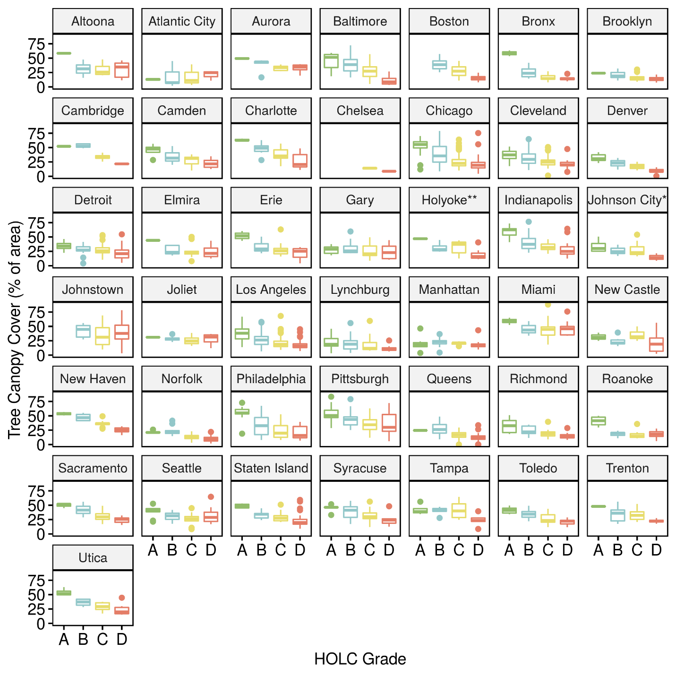*Johnson City / Birmingham, NY
**Holyoke / Chicopee, MA
Note that NYC is each of the five boroughs and that Boston is distinct from both Chelsea and Cambridge.

Table S1. Robustness check regression models
Table S1. Robustness check regression models.
 | Model 4: Mixed Effects, largest metros removed |  |  | Model 5: Mixed Effects, metros with partially missing land cover entirely omitted |  |  | Model 6: Mixed Effects, NYC as separate boroughs, Boston distinct from Cambridge & Chelsea |  |  | Model 7: Mixed Effects, Only data from The SAL
Fixed Effects | Estimates | 95% CI | p | Estimates | 95% CI | p | Estimates | 95% CI | p | Estimates | 95% CI | p
(Intercept) HOLC Grade A: "Best" ($γ_{00}$) | 42.93 | 38.92 to 46.95 | <0.001 | 44.70 | 41.71 to 47.70 | <0.001 | 42.63 | 40.06 to 45.21 | <0.001 | 42.99 | 40.31 to 45.66 | <0.001
HOLC Grade B: "Still Desirable" ($γ_{10}$) | -10.06 | -12.99 to -7.12 | <0.001 | -9.64 | -11.29 to -7.98 | <0.001 | -9.06 | -10.49 to -7.63 | <0.001 | -9.22 | -10.75 to -7.69 | <0.001
HOLC Grade C: "Definitely Declining" ($γ_{20}$) | -13.90 | -16.70 to -11.10 | <0.001 | -17.48 | -19.06 to -15.89 | <0.001 | -16.65 | -18.01 to -15.28 | <0.001 | -17.12 | -18.58 to -15.66 | <0.001
HOLC Grade D: "Hazardous" ($γ_{30}$) | -18.08 | -21.07 to -15.09 | <0.001 | -21.68 | -23.40 to -19.97 | <0.001 | -20.72 | -22.18 to -19.26 | <0.001 | -20.86 | -22.42 to -19.30 | <0.001
Random Effects
σ² | 117.59 |  |  | 126.97 |  |  | 113.45 |  |  | 118.74
τ₀₀ | 55.91 _{city_recode} |  |  | 54.63 _{city_recode} |  |  | 55.72 _{city} |  |  | 42.49 _{city_recode}
ICC | 0.32 _{city_recode} |  |  | 0.30 _{city_recode} |  |  | 0.33 _{city} |  |  | 0.26 _{city_recode}
Observations | 745 |  |  | 2438 |  |  | 3188 |  |  | 2939
Marginal R² / Conditional R² | 0.127 / 0.408 |  |  | 0.191 / 0.434 |  |  | 0.183 / 0.452 |  |  | 0.194 / 0.406

Table S2. Data sources, indicating representativeness

City | State | Population |  | Year Redlined | Land cover represents year | Source
City | State | Year 1930 | Year 1940 | Year Redlined | Land cover represents year | Source
Los Angeles | CA | 1,238,048 | 1,504,277 | 1939 | 2016 | LARIAC‡ / The SAL
Sacramento | CA | 93,750 | 105,958 | 1938 | 2009 | CLUE§
Denver | CO | 287,861 | 322,412 | 1938 | 2006 | NCDC Imaging, Colorado Springs¶
New Haven | CT | 162,655 | 160,605 | 1937 | 2008 | The SAL
Miami | FL | 110,637 | 172,172 | 1937 |  | Hochmair et al 2016
Tampa | FL | 101,161 | 108,391 | 1936 | 2016 | Shawn Landry, The Water Institute#
Aurora | IL | 46,589 | 47,170 | 1938 | 2010 | The SAL
Chicago | IL | 3,376,438 | 3,396,808 | 1940 | 2010 | The SAL
Joliet | IL | 42,993 | 42,365 | 1937 | 2010 | The SAL
Gary | IN | 100,426 | 111,719 | 1937 | 2010 | The SAL
Indianapolis | IN | 364,161 | 386,972 | 1937 | 2013 | The SAL
Boston | MA | 781,188 | 770,816 | 1938 | 2016 | The SAL
Cambridge | MA |  |  | 1938 | 2016 | The SAL
Chelsea | MA |  |  | 1938 | 2008 | The SAL
Holyoke* | MA | 56,537 | 58,750 | 1937 | 2015 | EarthDefine
Baltimore | MD | 804,874 | 859,100 | 1937 | 2016 | Chesapeake Conservancy /The SAL||
Detroit | MI | 1,568,662 | 623,452 | 1939 | 2016 | The SAL
Charlotte | NC | 82,675 | 100,899 | 1935 | 2012 | The SAL
Atlantic City | NJ | 66,198 | 64,094 | 1940 | 2013 | The SAL
Camden | NJ | 118,700 | 117,536 | 1937 | 2013 | The SAL
Trenton | NJ | 123,356 | 124,697 | 1937 | 2013 | The SAL
Elmira | NY | 47,397 | 45,106 | 1938 | 2016 | The SAL
Johnson City† | NY | 76,662 | 78,309 | 1937 | 2016 | Chesapeake Conservancy /The SAL||
New York | NY | 6,930,446 | 7,454,995 |  | 2010 | The SAL
Brooklyn | NY | 2,560,401 | 2,698,285 | 1938 | 2010 | The SAL
Manhattan | NY | 1,867,312 | 1,889,924 | 1938 | 2010 | The SAL
Queens | NY | 1,079,129 | 1,297,634 | 1938 | 2010 | The SAL
Staten Island | NY | 158,346 | 174,441 | 1938 | 2010 | The SAL
The Bronx | NY | 1,265,258 | 1,394,711 | 1938 | 2010 | The SAL
Syracuse | NY | 209,326 | 205,967 | 1937 | 2016 | Chesapeake Conservancy /The SAL||
Utica | NY | 101,740 | 100,518 | 1936 | 2016 | Chesapeake Conservancy /The SAL||
Cleveland | OH | 900,429 | 878,336 | 1940 | 2011 | The SAL
Toledo | OH | 290,718 | 282,349 | 1938 | 2006 | Xi Li, the Toledo PhD student.**
Altoona | PA | 82,054 | 80,214 | 1937 | 2006 / 2008 | The SAL
Erie | PA | 115,967 | 116,955 | 1937 | 2006 / 2008 | The SAL
Johnstown | PA | 66,993 | 66,668 | 1937 | 2006 / 2008 | The SAL
New Castle | PA | 48,674 | 47,638 | 1937 | 2006 / 2008 | The SAL
Philadelphia | PA | 1,950,961 | 1,931,334 | 1937 | 2006 / 2008 | The SAL
Pittsburgh | PA | 669,817 | 671,659 | 1937 | 2006 / 2008 | The SAL
Lynchburg | VA | 40,661 | 44,451 | 1937 | 2016 | Chesapeake Conservancy /The SAL||
Norfolk | VA | 129,710 | 144,332 | 1940 | 2016 | Chesapeake Conservancy /The SAL||
Richmond | VA | 182,929 | 193,042 | 1937 | 2016 | Chesapeake Conservancy /The SAL||
Roanoke | VA | 69,206 | 69,287 | 1937 | 2016 | Chesapeake Conservancy /The SAL||
Seattle | WA | 365,583 | 368,302 | 1936 | 2012 | RSGAL ††
Total: |  | 28,736,628 | 29,312,650
* Holyoke / Chicopee, MA
† Johnson City / Birmingham, NY
‡ Los Angeles Region Imagery Acquisition Consortium
§ Cadenasso Landscape and Urban Ecology
¶ https://www.denvergov.org/opendata/dataset/city-and-county-of-denver-tree-canopy
# https://data-waterinstitute.opendata.arcgis.com/datasets/tampa-tree-canopy-2016?geometry=-83.102%2C27.771%2C-81.712%2C28.195
|| https://chesapeakeconservancy.org/conservation-innovation-center/high-resolution-data/land-cover-data-project/
** http://rave.ohiolink.edu/etdc/view?acc_num=toledo1493417634359152
†† Land Use/Land Cover, Seattle, WA. (2009). Raster dataset. Moskal’s remote sensing and geospatial applications laboratory (RSGAL) precision forestry cooperative. Seattle, WA: School of Forest Resources, University of Washington.
Hochmair, H. H., Gann, D., Benjamin, A., and Fu, Z. J. Miami-Dade County Urban Tree Canopy Assessment, Funded by American Forests and Miami-Dade County. Available from http://digitalcommons.fiu.edu/gis/65/, 2016.

