Supplementary Information for manuscript “Surface Urban Heat Island Effects Intensify More Rapidly in Lower Income Countries”
Yuan Yuan^{abc}, Mattheos Santamouris^{d}, Dong Xu^{e}, Xiaolei Geng^{f}, Chengwei Li^{g}, Wanqing Cheng^{ac}, Ling Su^{ac}, Peng Xiong^{ac}, Zhengqiu Fan^{b}, Xiangrong Wang^{b}*, Chuan Liao^{h}*
ª Jiangxi Academy of Eco-Environmental Sciences and Planning, Nanchang 330039, China
^{b} Department of Environmental Science & Engineering, Fudan University, Shanghai, 200438, China
^{c} Jiangxi Provincial Key Laboratory of Environmental Pollution Control, Nanchang 330039, China
^{d} School of Built Environment, University New South Wales, Sydney, 2052, Australia
^{e} Department of Geography, National University of Singapore, Singapore, 119077, Singapore
^{f} School of Environment and Safety Engineering, Jiangsu university, Jiangsu, 2120 13, China
^{g} Shanghai Key Laboratory of Urban Design and Urban Science, NYU Shanghai, 200124, China
^{h} Department of Global Development, Cornell university, Ithaca, NY, 14853, USA

* Xiangrong Wang, Chuan Liao
Emails: xrxrwang@fudan.edu.cn (Xiangrong Wang); cl824@cornell.edu (Chuan Liao)

Contents
Fig. S1. Global SUHII changes from 2003 to 2018. 2
Fig. S2. Significant Global SUHII change rates over 2003 - 2018. …………………………. 3
Fig. S3. The intra-climate-zone SUHII trends of increasing, decreasing and their differences over 2003 - 2018. 3
Fig. S4. World map of five Köppen climate zones and four economic levels. 4
Table S1. The maximal variation rates of SUHII (℃/yr) during 2003-2018 in different countries at different times and income levels. 5
Table S2. The top 5 countries with the largest number of urban grids (National urban grids / Global urban grids * 100%) and the most experiencing increasing trends at multiple time intervals (National increasing urban grids / Global urban grids * 100%). 5
Table S3. Cities selected from The Oxford Economics Global Cities Index. 6
Table S4. The description of the used multivariate mixture cluster models. 7

Fig. S1. Global SUHII changes from 2003 to 2018. Sen's slope values within 95% confidence interval (p < 0.05) were calculated as changing rates (℃ / yr), with darker red indicating a stronger increasing trend in SUHII, and darker green indicating a stronger decreasing trend: a summer daytime (SD), b summer nighttime (SN), c winter daytime (WD), d winter nighttime (WN), e yearly daytime (YD) and f yearly nighttime (YN).
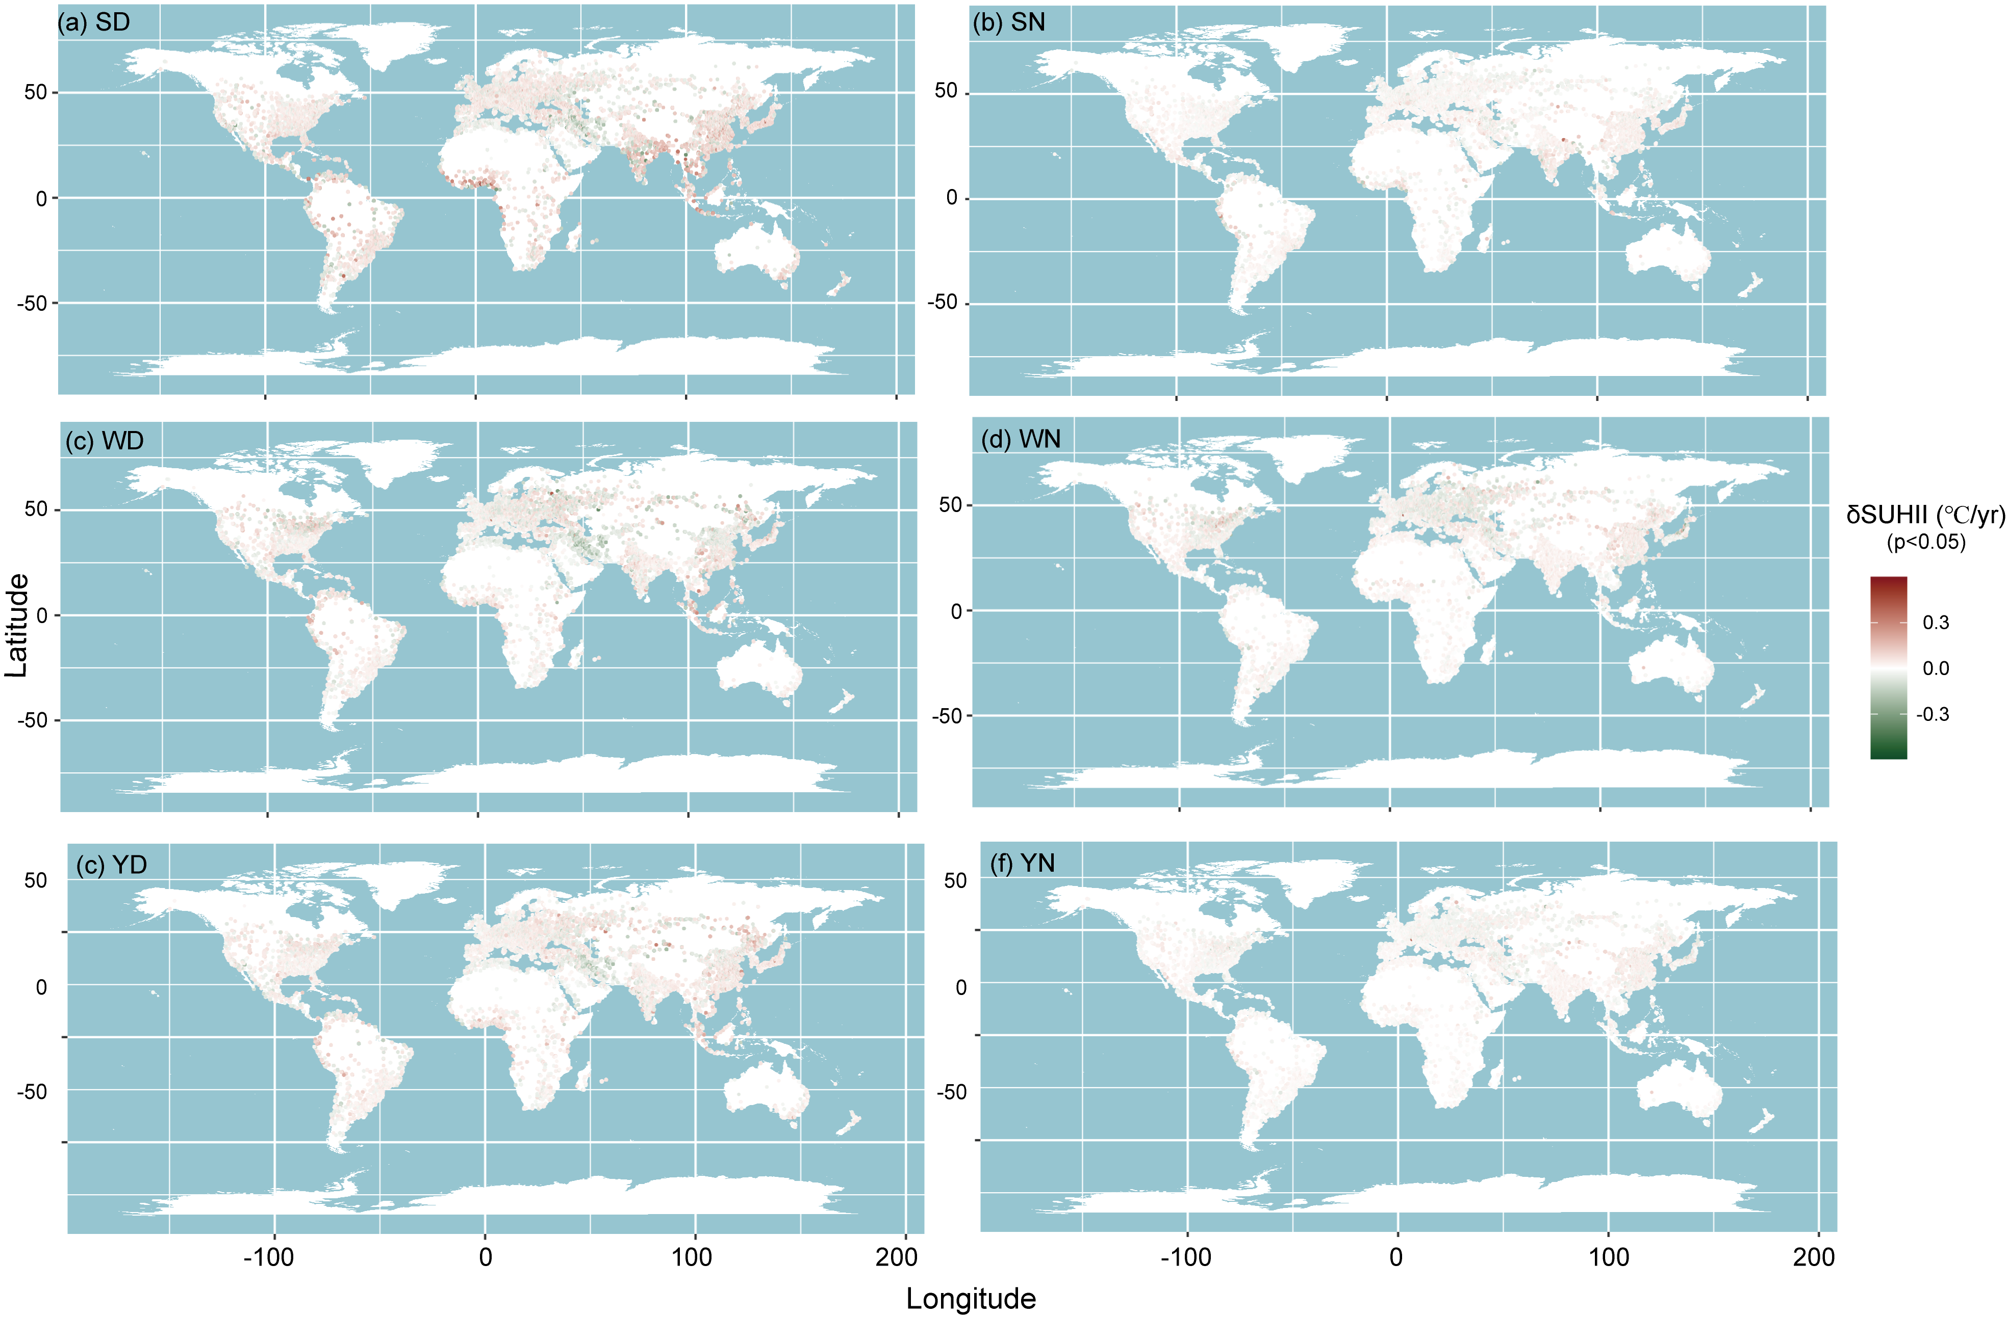

Fig. S2. Significant Global SUHII change rates over 2003 - 2018. The changing rates δSUHII over 0.1℃ per year within 95% confidence interval (p < 0.05) are selected as the extreme changing rates at: a summer daytime (SD), b summer nighttime (SN), c winter daytime (WD), d winter nighttime (WN). The violin plot in the lower left corner displays the distribution of rates for total decreasing and increasing trends. The red box highlights the large area where SUHII shows an upward trend, while the green box highlights the large area where SUHII shows a downward trend.
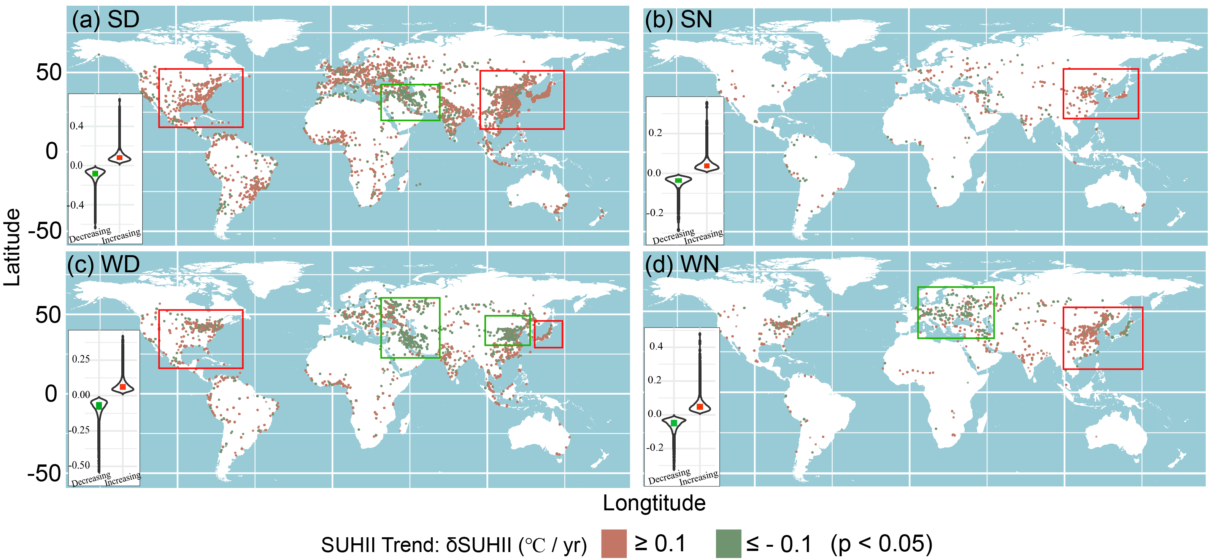

Fig. S3. The intra-climate-zone SUHII trends of increasing, decreasing and their differences over 2003 - 2018.
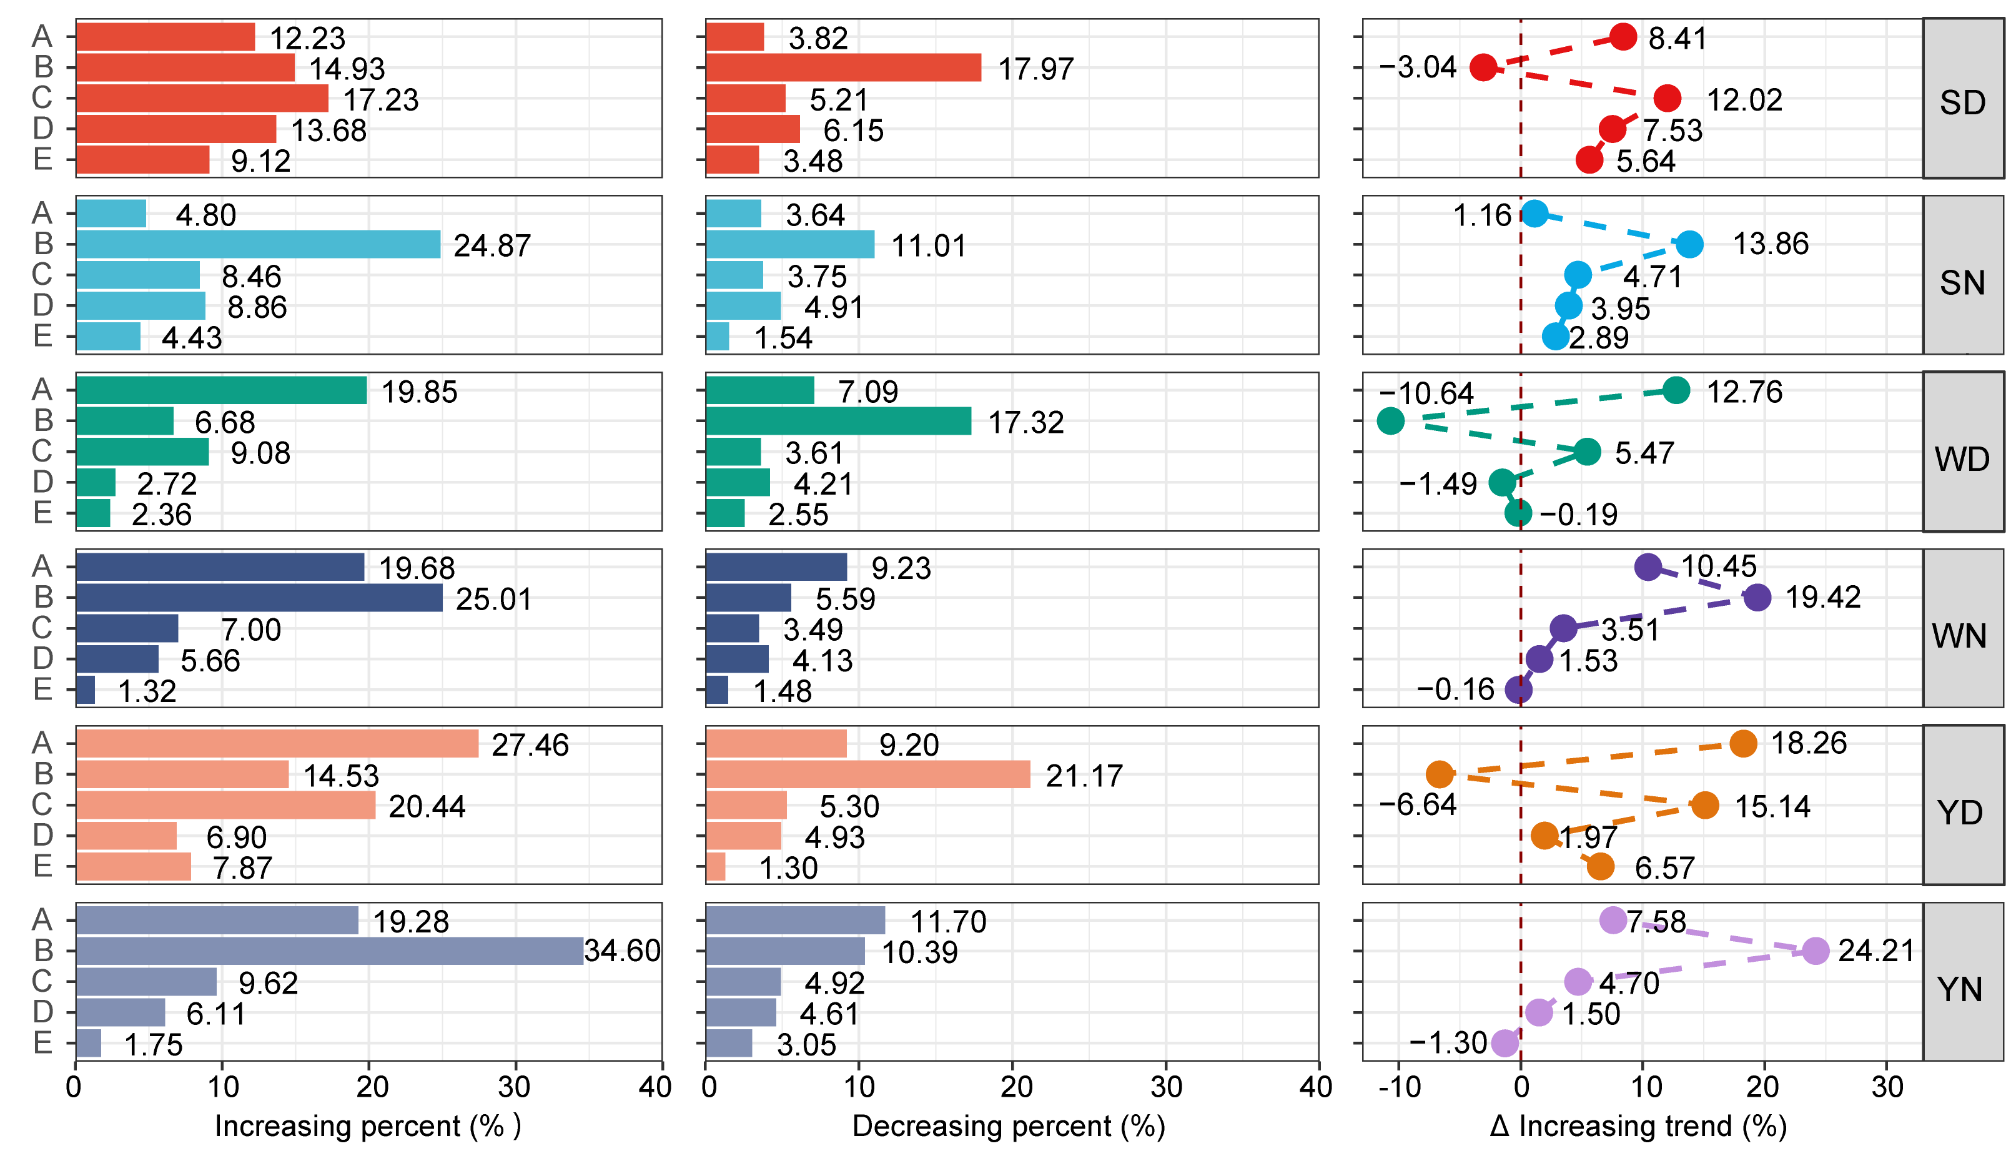

Fig. S4. World map of five Köppen climate zones and four economic levels. a The Köppen climate classification divides global climates into five main climate groups, with each group being divided based on seasonal precipitation and temperature patterns. The five main groups are A (tropical), B (arid), C (temperate), D (continental), and E (polar). b The map data are classified using the World Bank Atlas method estimates of 2021 gross national income (GNI) per capita (current US dollars). The World Bank classifies all 189 World Bank member countries, plus 28 other economies with populations of more than 30,000, as low-income (less than $1,085), lower-middle-income ($1,086–$4,255), upper-middle-income ($4,256– $13,205) or high-income (more than $13,205) as per GNI per capita in 2021.
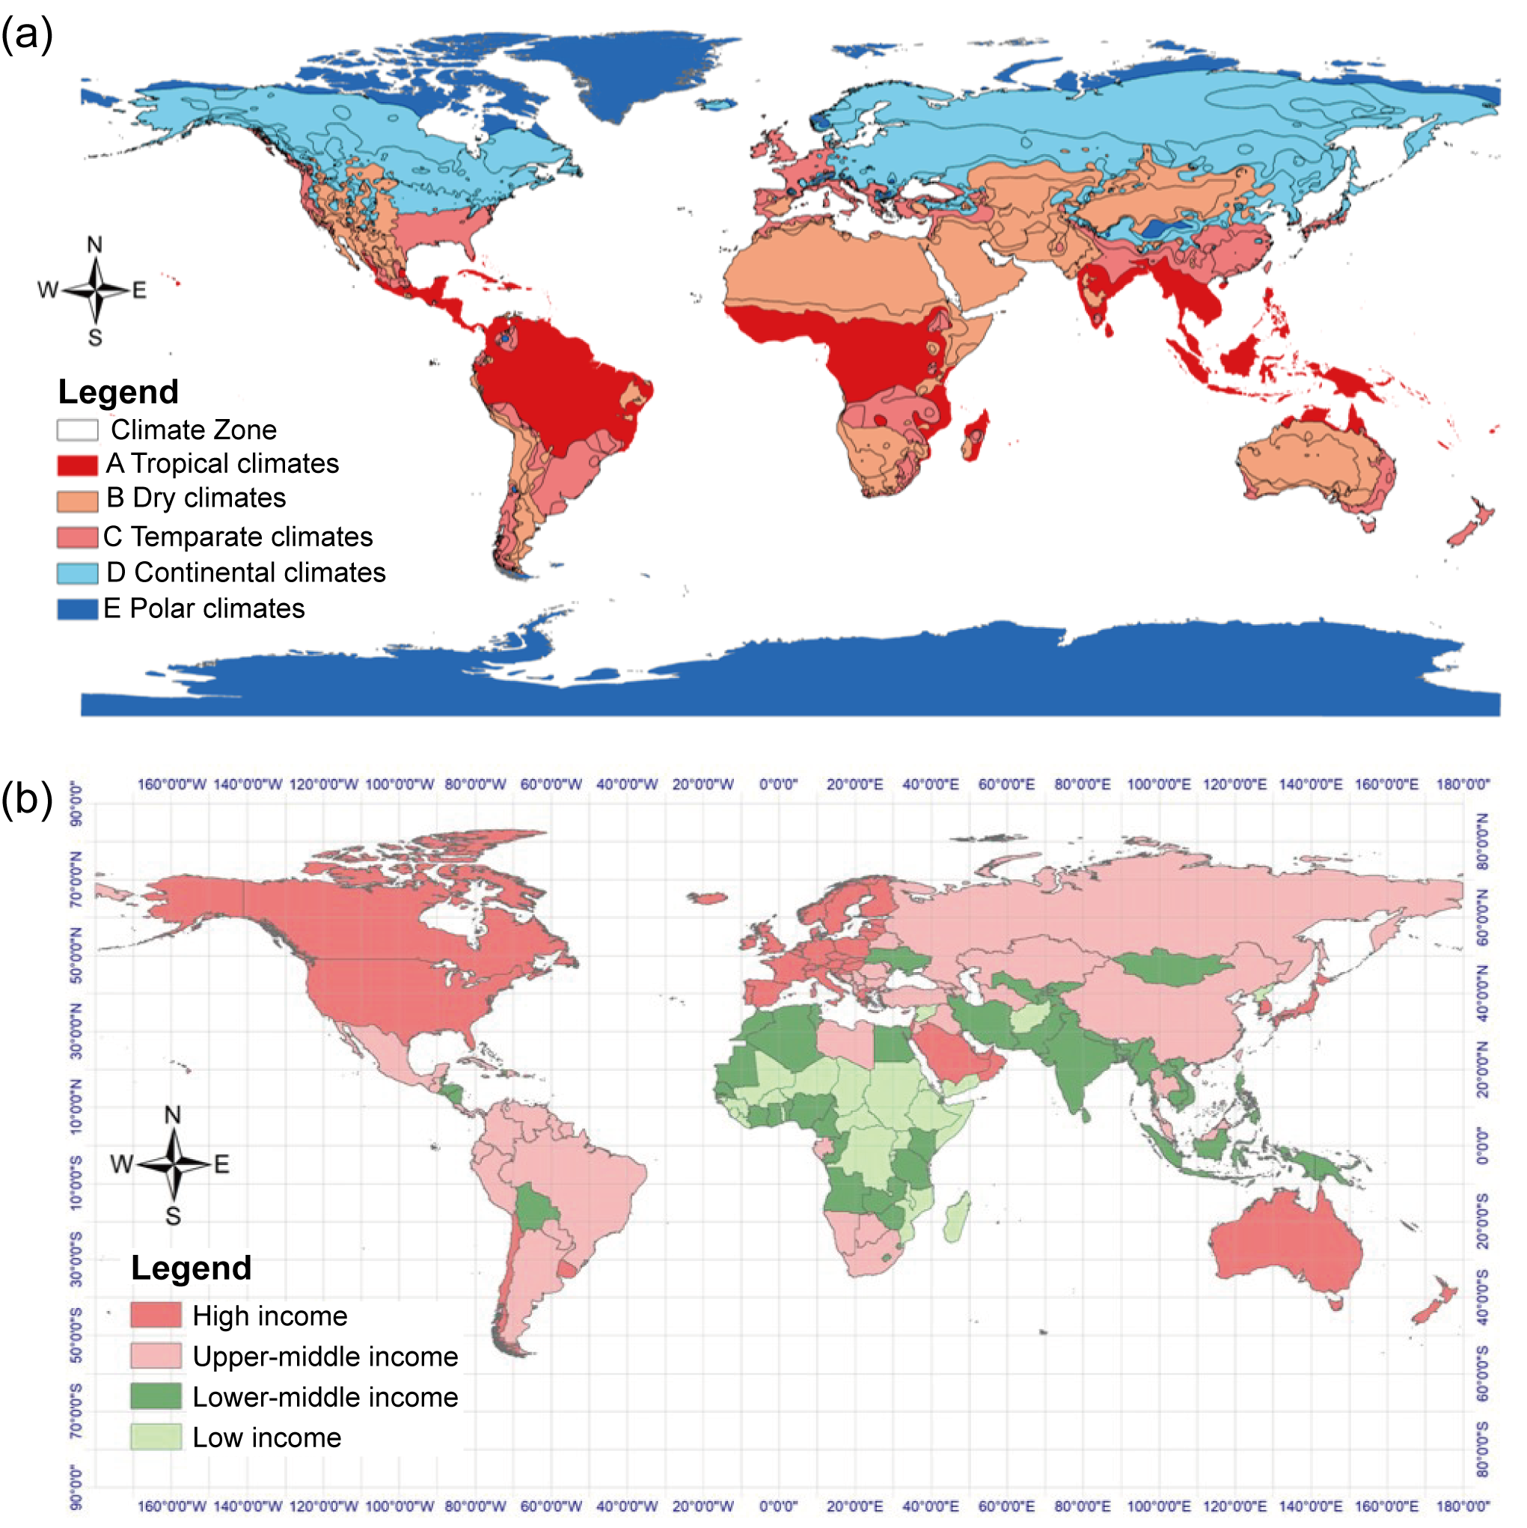

Table S1. The maximal variation rates of SUHII (℃/yr) during 2003-2018 in different countries at different times and income levels.
 | Maximum decrease rate | Country  (Income group) | Maximum increase rate | Country  (Income group)
YD | -0.451 | Iran  (Upper-middle income) | 0.484 | China  (Upper-middle income)
YN | -0.393 | China  (Upper-middle income) | 0.427 | France  (High income)
SD | -0.631 | Germany  (High income) | 0.668 | Brazil  (Upper-middle income)
SN | -0.317 | Russia  (Upper-middle income) | 0.432 | Nepal  (Low income)
WD | -0.533 | Iran  (Upper-middle income) | 0.415 | Russia  (Upper-middle income)
WN | -0.320 | Japan  (High income) | 0.477 | France  (High income)

Table S2. The top 5 countries with the largest number of urban grids (National urban grids / Global urban grids * 100%) and the most experiencing increasing trends at multiple time intervals (National increasing urban grids / Global urban grids * 100%).
Top 5 countries with the most urban grids |  | Top 5 fastest-increasing countries
 |  | YD |  | YN |  | SD |  | SN |  | WD |  | WN
America | (24.20%) | America | (24.20%) | China | (20.90%) | America | (27.20%) | America | (24.20%) | America | (18.90%) | China | (28.90%)
China | (10.70%) | Japan | (16.20%) | America | (18.30%) | Japan | (14.70%) | China | (20.30%) | Japan | (14.10%) | America | (15.80%)
Russia | (6.53%) | China | (10.90%) | India | (13.40%) | China | (14.20%) | Russia | (8.67%) | China | (11.10%) | India | (11.10%)
Germany | (4.76%) | Brazil | (5.39%) | Brazil | (3.36%) | Russia | (5.72%) | Ukraine | (4.18%) | India | (6.90%) | Brazil | (3.33%)
Japan | (4.26%) | India | (3.90%) | Russia | (2.83%) | Turkey | (3.49%) | Japan | (3.34%) | Brazil | (6.62%) | Mexico | (2.67%)
Total | (50.45%) | Total | (60.59%) | Total | (58.79%) | Total | (65.31%) | Total | (60.69%) | Total | (57.62%) | Total | (61.80%)

Table S3. Cities selected from The Oxford Economics Global Cities Index, a comprehensive urban assessment framework developed by Oxford Economics, including 25 cities ranked in the top 250 and 17 cities ranked in the bottom 100. The index contains five categories: Economics, Human Capital, Quality of Life, Environment, and Governance, which are aggregated to create a overall score for each city.
Rank | City | Country | Economics | Human Capital | Quality of Life | Environment | Governance
1 | New York | United States | 1 | 4 | 278 | 353 | 184
4 | Tokyo | Japan | 10 | 2 | 218 | 277 | 277
5 | Paris | France | 9 | 6 | 65 | 409 | 161
12 | Dublin | Ireland | 33 | 16 | 67 | 17 | 51
14 | Stockholm | Sweden | 28 | 15 | 85 | 88 | 10
19 | Oslo | Norway | 48 | 53 | 31 | 72 | 8
21 | Geneva | Switzerland | 36 | 60 | 14 | 335 | 13
22 | Luxembourg | Luxembourg | 38 | 66 | 6 | 440 | 70
30 | Tel Aviv | Israel | 21 | 44 | 70 | 290 | 350
40 | Bern | Switzerland | 80 | 142 | 3 | 396 | 13
41 | Seoul | South Korea | 67 | 5 | 272 | 615 | 148
43 | Berlin | Germany | 47 | 50 | 114 | 463 | 107
49 | Vienna | Austria | 42 | 47 | 82 | 395 | 107
56 | Hamburg | Germany | 39 | 78 | 162 | 413 | 107
59 | Auckland | New Zealand | 112 | 109 | 206 | 10 | 1
64 | Prague | Czech Republic | 65 | 104 | 83 | 486 | 144
65 | Taipei | Taiwan | 243 | 25 | 106 | 262 | 98
69 | Wellington | New Zealand | 189 | 165 | 66 | 9 | 1
73 | Barcelona | Spain | 115 | 71 | 130 | 201 | 278
75 | Manchester | United Kingdom | 83 | 92 | 246 | 248 | 72
82 | Edinburgh | United Kingdom | 213 | 65 | 133 | 50 | 72
83 | Bristol | United Kingdom | 168 | 113 | 95 | 133 | 72
94 | Antwerp | Belgium | 97 | 253 | 11 | 460 | 136
201 | Beijing | China | 142 | 24 | 367 | 769 | 637
203 | Shanghai | China | 90 | 85 | 405 | 883 | 637
909 | Niamey | Niger | 849 | 807 | 862 | 602 | 846
922 | Asyut | Egypt | 910 | 493 | 920 | 835 | 848
925 | Brazzaville | Congo | 866 | 504 | 971 | 420 | 924
934 | Sohag | Egypt | 900 | 692 | 924 | 655 | 848
937 | Astrakhan | Russia | 983 | 827 | 647 | 670 | 946
947 | Lipetsk | Russia | 956 | 849 | 668 | 870 | 830
952 | Harare | Zimbabwe | 960 | 207 | 998 | 298 | 922
958 | Jilin | China | 906 | 606 | 455 | 964 | 637
962 | Pointe-Noire | Congo | 994 | 595 | 921 | 105 | 924
963 | Kinshasa | Democratic Republic of Congo | 858 | 459 | 990 | 370 | 984
964 | Khartoum | Sudan | 817 | 622 | 956 | 746 | 997
971 | Bulawayo | Zimbabwe | 979 | 389 | 991 | 266 | 922
972 | Dodoma | Tanzania | 945 | 877 | 981 | 43 | 833
979 | Kabul | Afghanistan | 567 | 687 | 977 | 333 | 1000
988 | Huambo | Angola | 972 | 808 | 985 | 94 | 917
991 | N'Djamena | Chad | 976 | 639 | 972 | 689 | 980
992 | Bangui | Central African Republic | 970 | 526 | 989 | 513 | 998

Table S4. The description of the used multivariate mixture cluster models. Parameterisations of the within-group covariance matrix Σ_{k} for multidimensional data available in the mclust package, and the corresponding geometric characteristics.
Model | ∑_{k} | Distribution | Volume | Shape | Orientation
EII | λΙ | Spherical | Equal | Equal | —
VII | λ_{k}Ι | Spherical | Variable | Equal | —
EEI | λA | Diagonal | Equal | Equal | Coordinate axes
VEI | λ_{k}A | Diagonal | Variable | Equal | Coordinate axes
EVI | λA_{k} | Diagonal | Equal | Variable | Coordinate axes
VVI | λ_{k}A_{k} | Diagonal | Variable | Variable | Coordinate axes
EEE | λDAD^{Τ} | Ellipsoidal | Equal | Equal | Equal
EVE | λDA_{k}D^{Τ} | Ellipsoidal | Equal | Variable | Equal
VEE | λ_{k}DAD^{Τ} | Ellipsoidal | Variable | Equal | Equal
VVE | λ_{k}DA_{k}D^{Τ} | Ellipsoidal | Variable | Variable | Equal
EEV | λDA_{k}D_{k}^{Τ} | Ellipsoidal | Equal | Equal | Variable
VEV | λ_{k}D_{k}AD_{k}^{Τ} | Ellipsoidal | Variable | Equal | Variable
EVV | λD_{k}A_{k}D_{k}^{Τ} | Ellipsoidal | Equal | Variable | Variable
VVV | λ_{k}D_{k}A_{k}D_{k}^{Τ} | Ellipsoidal | Variable | Variable | Variable

