Supplementary Information for

Title: Mitigating the ripple effects of urbanization on farmland productivity and ecological security through inclusive urbanization strategies
Guohua Hu¹, Xia Li^{1*}, Xiaoping Liu^{2*}, Shaojian Wang^{3*}, Xiaoling Zhang^{4,5,6*}, Xun Shi⁷, Xuemei Bai⁸, Klaus Hubacek⁹
¹ Key Lab of Geographic Information Science (Ministry of Education), School of Geographic Sciences, East China Normal University, Shanghai, China.
² School of Geography and Planning, Sun Yat-sen University, Guangzhou, China.
³ School of Urban Design, School of Resource and Environmental Sciences, Wuhan University, Wuhan, China
⁴ Department of Real Estate & Construction, The University of Hong Kong, Hong Kong, China
⁵ Sustainability X-Lab, The University of Hong Kong, Hong Kong, China
⁶ Institute for Climate and Carbon Neutrality, The University of Hong Kong, Hong Kong, China
⁷ Department of Geography, Dartmouth College, Hanover, NH, USA
⁸ Fenner School of Environment & Society, Australian National University, Canberra ACT, Australia
⁹ Center for Energy and Environmental Sciences (IVEM), Energy and Sustainability Research Institute Groningen (ESRIG), University of Groningen, Groningen, the Netherlands
This Supplementary Information includes 9 pages, 4 figures and 4 tables are included.
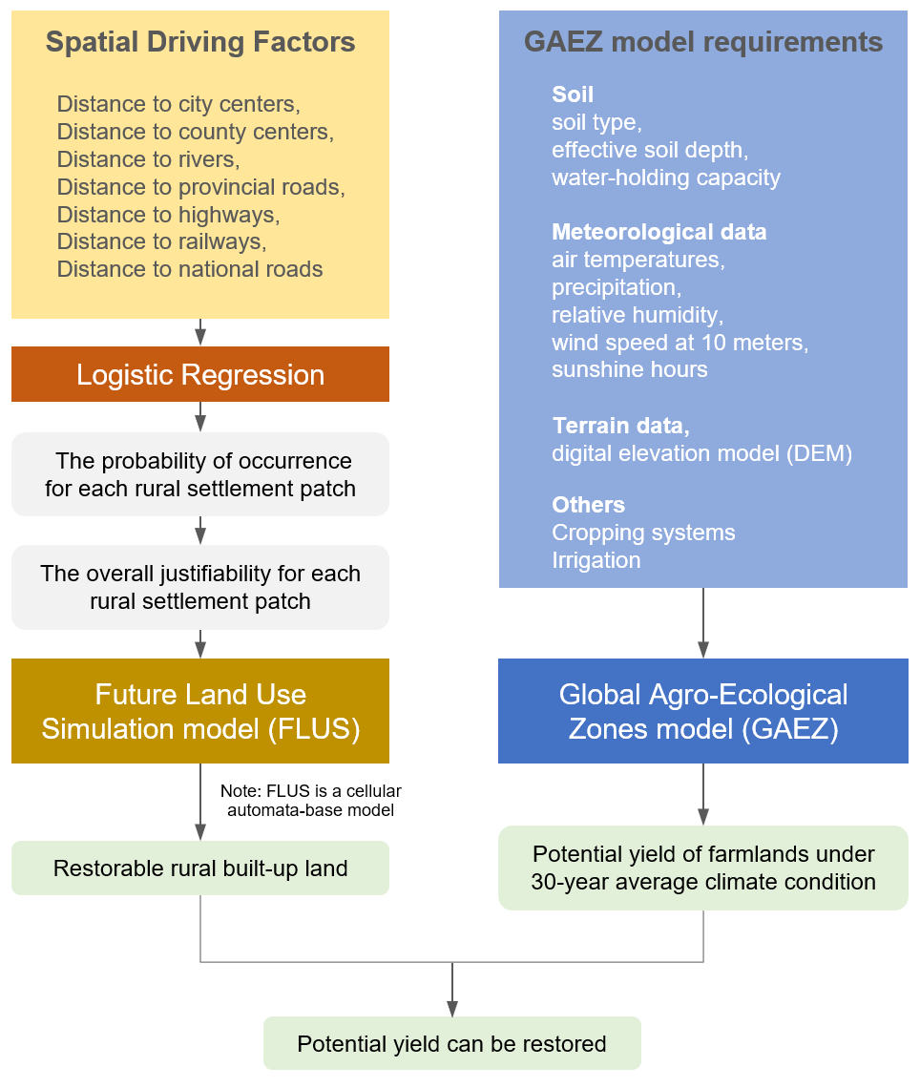

Supplementary Figure 1. Framework for Evaluating Farmland Productivity Restoration. The left side of the figure illustrates the spatial change simulation of rural built-up land recovery using logistic regression and the FLUS model. The right side depicts the estimation of future agricultural productivity using the GAEZ model. The results from both models are combined to estimate the total potential food production that can be generated from the restoration of rural built-up land back to farmland.
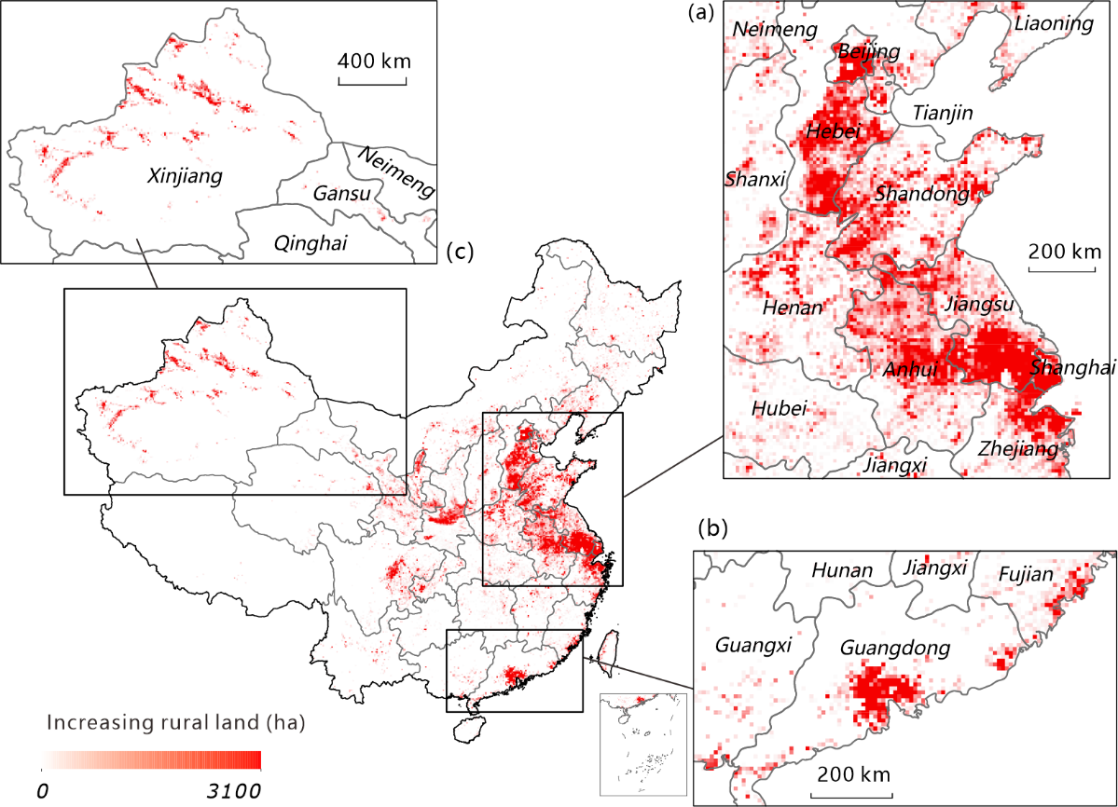

Supplementary Figure 2. Rural built-up land increased during 1990–2010. Three typical regions of rural built-up land increased in China: (a) Underdeveloped areas in remote western China such as Xinjiang province; (b) Well-developed areas in the south, such as Guangdong province; (c) Relatively developed areas in the North Plain of China such as Jiangsu, Zhejiang. The figure shows that an increase in rural built-up land was a very common phenomenon all around the country during the 20-year period.

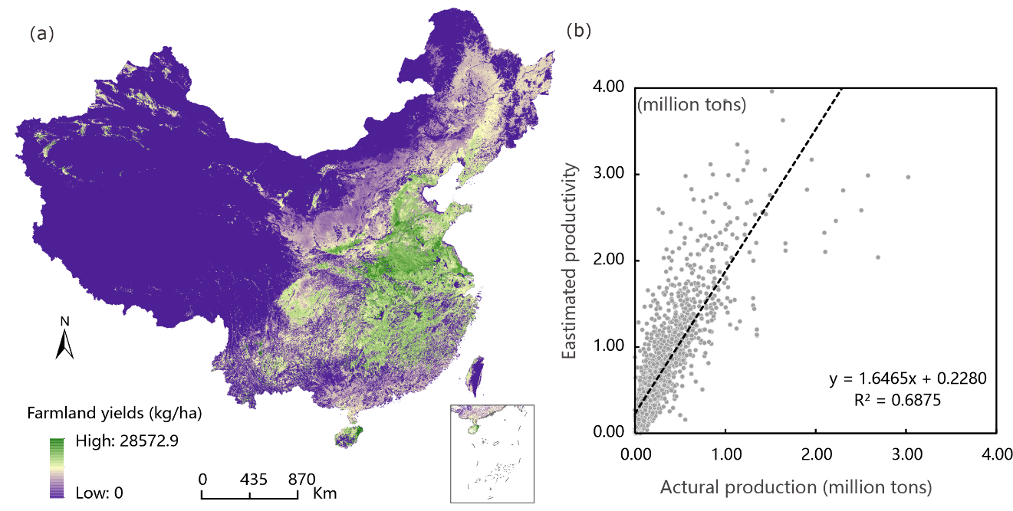

Supplementary Figure 3. Validation of 2010 farmland potential yield of China. (a) Farmland potential yield of China estimated using the GAEZ model based on the average over 30 years of climate conditions. (b) Scatter plot for validating the farmland potential yield for 1,924 counties with actual crop yield in 2010 from the China Statistical Yearbook (National Bureau of Statistics). The figure shows the high correlation between the estimated and actual yield.

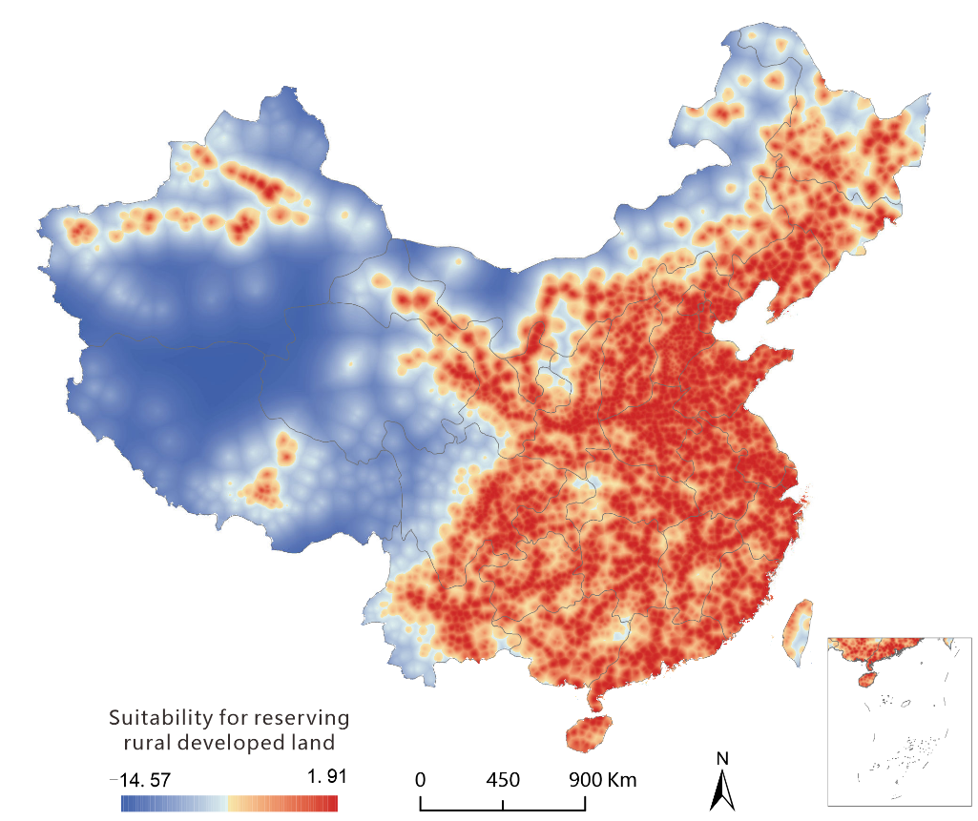

Supplementary Figure 4. Probability-of-occurrence of restorable farmland in rural China. A logistic regression analysis was carried out to quantify the probability-of-occurrence of restorable farmland according to a series of spatial-driver factors such as distance to the nearest administrative centres, distance to the nearest river, and distance to the nearest roads. In total, 2,000 random points were selected nationwide to train the logistic regression model. Then 2,000 additional random points were selected to validate the accuracy of the model. The figure shows that the suggested rural built-up land for keeping as residential land is mainly concentrated in the areas with good traffic conditions. The rest of the rural built-up land can be gradually restored back to farmland in the future.

Supplementary Table 1. Land use/cover classification system in NLUD-C.
First-level | Second-level | Code | Descriptions
Cultivated land | Paddy | 11 | Cropland that has sufficient water supply and irrigation facilities for planting paddy rice, lotus, etc., including land that is rotated for paddy field rice and dry-farming crops
Cultivated land | Dry land | 12 | Cropland for cultivation without water supply and irrigation facilities; cropland that has water supply and irrigation facilities and planting dry farming crops; cropland planting vegetables; fallow land
Forests | Forest | 21 | Natural or planted forests with greater than 30% canopy cover
Forests | Shrub | 22 | Land covered by trees less than 2 m in height, with greater than 40% canopy cover
Forests | Sparse woods | 23 | Land covered by trees with 10–30% canopy cover
Forests | Other woods | 24 | Land such as tea gardens, orchards, groves, and nurseries
Grassland | Dense grass | 31 | Grassland with greater than 50% canopy cover
Grassland | Moderate grass | 32 | Grassland with 20% and 50% canopy cover
Grassland | Sparse grass | 33 | Grassland with 5% and 20% canopy cover
Water bodies | River and canal  Lake | 41  42 | Land covered by rivers, including canals  Land covered by lakes
Water bodies | Reservoir and pond | 43 | Constructed facilities for water reservation
Water bodies | Ice and snow | 44 | Land covered by perennial snowfields and glaciers
Water bodies | Tidal flat | 45 | Land between high-tide level and low-tide level
Water bodies | Bottomland | 46 | Land between normal water level and flood level
Built-up land | Urban  Rural settlement | 51  52 | Land used for urban settlements  Land used for village settlements
Built-up land | Other built-up land | 53 | Land used for factories, quarries, mining, and oil-field slattern outside cities and land for special uses, such as transportation and airports
Unused land | Sandy land  Gobi | 61  62 | Sandy land covered with less than 5% vegetation cover  Gravel-covered land with less than 5% vegetation cover
Unused land | Saline-alkali land | 63 | Land with saline and alkali accumulation and sparse vegetation
Unused land | Swampland | 64 | Land with a permanent mixture of water and herbaceous or woody vegetation that covers extensive areas
Unused land | Bare soil | 65 | Bare exposed soil with less than 5% vegetation cover
Unused land | Bare rock | 66 | Bare exposed rock with less than 5% vegetation cover
Unused land | Other | 67 | Other land types such as alpine desert and tundra

Supplementary Table 2. Input data of the GAEZ model.
Data types | Data | Resolution | Description and sources
Terrain Data | STRM | 90m | The terrain elevation dataset derived from the Shuttle Radar Topography Mission C-band data, which was also used to calculate slope. (http://srtm.csi.cgiar.org/selection/inputcoord.asp)
Soil Data | Soil type | 1:1000,000 | Soil data were used to calculate the soil-water balance, and it can be used to determine the length of plants growing period. (Data Center for Resources and Environmental Science, Chinese Academy of Sciences.)
Soil Data | Soil effective depth | 1:1000,000
Soil Data | Water Holding Capacity | 1:1000,000
Meteorological data | Monthly maximum air temperature | 10km | Meteorological data include six key factors limiting plant growth, which were interpolated to 10 km resolution using the ANUSPLIN software, based on the digital terrain model of China. (http://cdc.cma.gov.cn)
Meteorological data | Monthly minimum air temperature | 10km
Meteorological data | Precipitation | 10km
Meteorological data | Relative humidity | 10km
Meteorological data | Wind speed at 10 m height | 10km
Meteorological data | Hours of sunshine | 10km

Supplementary Table 3. Estimated rural built-up lands that can be consolidated in 2010.
Region | PU1990 | PU2010 | PR1990 | PR2010 | Ratio | EPR2010 | ER2010 | ERC2010
China | 114 | 101 | 133 | 183 | 0.86 | 118 | 79,250 | 32,241
Beijing | 78 | 101 | 280 | 395 | 0.28 | 361 | 994 | (−188)
Tianjin | 178 | 135 | 209 | 327 | 0.85 | 159 | 422 | 392
Hebei | 275 | 150 | 163 | 244 | 1.69 | 89 | 3,535 | 5,052
Shanxi | 130 | 111 | 124 | 146 | 1.05 | 106 | 1,966 | 594
Inner Mongolia | 189 | 142 | 649 | 841 | 0.29 | 487 | 5,352 | 3,615
Liaoning | 138 | 109 | 247 | 353 | 0.56 | 196 | 3,244 | 2,433
Jilin | 99 | 89 | 328 | 392 | 0.30 | 294 | 3,767 | 1,205
Heilongjiang | 87 | 80 | 361 | 396 | 0.24 | 332 | 5,644 | 1,005
Shanghai | 68 | 65 | 95 | 352 | 0.72 | 90 | 222 | 192
Jiangsu | 221 | 123 | 157 | 348 | 1.40 | 88 | 2,728 | 5,630
Zhejiang | 148 | 111 | 46 | 108 | 3.25 | 34 | 715 | 874
Anhui | 90 | 72 | 186 | 291 | 0.48 | 149 | 5,055 | 3,627
Fujian | 185 | 146 | 44 | 73 | 4.25 | 34 | 545 | 558
Jiangxi | 80 | 61 | 60 | 82 | 1.33 | 46 | 1,149 | 702
Shandong | 268 | 173 | 193 | 291 | 1.39 | 124 | 6,001 | 7,346
Henan | 118 | 102 | 184 | 237 | 0.64 | 159 | 9,188 | 4,238
Hubei | 73 | 72 | 84 | 117 | 0.87 | 82 | 2,362 | 896
Hunan | 87 | 61 | 29 | 41 | 3.03 | 20 | 754 | 703
Guangdong | 158 | 97 | 88 | 130 | 1.78 | 55 | 1,932 | 2,355
Guangxi | 117 | 73 | 85 | 112 | 1.36 | 53 | 1,479 | 1,604
Hainan | 157 | 96 | 78 | 94 | 2.00 | 48 | 209 | 218
Chongqing | 63 | 70 | 6 | 16 | 10.17 | 7 | 119 | 34
Sichuan | 66 | 52 | 22 | 41 | 3.05 | 17 | 820 | 650
Guizhou | 76 | 36 | 7 | 10 | 10.17 | 4 | 81 | 133
Yunnan | 92 | 56 | 39 | 45 | 2.37 | 23 | 705 | 561
Tibet | 147 | 152 | 28 | 23 | 5.20 | 29 | 68 | (−15)
Shaanxi | 79 | 52 | 71 | 125 | 1.12 | 46 | 934 | 970
Gansu | 115 | 83 | 136 | 172 | 0.85 | 98 | 1,601 | 786
Qinghai | 231 | 313 | 157 | 178 | 1.47 | 213 | 663 | (−200)
Ningxia | 142 | 146 | 176 | 252 | 0.81 | 181 | 596 | 33
Xinjiang | 246 | 215 | 259 | 232 | 0.95 | 226 | 2,819 | (−180)
PU1990: Per-capita urban built-up lands in 1990 (m²/capita). PU2010: Per-capita urban built-up lands in 2010 (m²/capita). PR1990: Per-capita rural built-up lands in 1990 (m²/capita). PR2010: Per-capita rural built-up lands in 2010 (m²/capita). Ratio: PU1990/PR1990. EPR2010: Estimated per-capita rural built-up lands in 2010 (m²/capita). ER2010: Estimated rural built-up land in 2010 (km²). ERC2010: Estimated rural built-up lands that can be consolidated in 2010 (km²)

Supplementary Table 4. Coefficients of logistic regression for evaluating probability-of-occurrence of rural built-up patches.
Variable | B | S.E. | Wald | Significance | Exp(B)
x1 | -2.139 | .363 | 34.731 | .000 | .118
x2 | -7.337 | .507 | 209.506 | .000 | .001
x3 | -.746 | .175 | 18.260 | .000 | .474
x4 | -1.183 | .513 | 5.320 | .021 | .306
x5 | -.597 | .156 | 14.626 | .000 | .550
x6 | -4.377 | .298 | 215.933 | .000 | .013
x7 | -1.328 | .379 | 12.300 | .000 | .265
constant | 1.931 | .054 | 1294.259 | .000 | 6.895
x1: distance to city centers, x2: Distance to County Center, x3: distance to rivers, x4: distance to provincial road, x5: distance to highway, x6: distance to railway, x7: distance to national road.

