Supplementary Information for
Chemical Functionalities Govern Polyamide–Alumina Adhesion through Local Conformational Dynamics
Toyoshi Yoshida*, Koki Teramoto, and Takuya Kuwahara*

Department of Mechanical Engineering, Osaka Metropolitan University, 1-1 Gakuen-cho, Naka-ku, 599-8531 Sakai, Japan

*Corresponding authors: h23106y@omu.ac.jp (T.Y.), kuwa@omu.ac.jp (T.K.)

Table of contents
1. Tensile tests of PA/Al₂O₃ bonded specimens 3
2. Effects of polymerization degree on the bonding strength between PA and Al₂O₃ 4
3. Effect of quenching rate during model preparation 6
4. Density profile evolutions along the z axis with different tensile displacement rates 7
5. C=O bond local orientational order parameter 8
6. DFT calculations of model PA molecules on Al₂O₃ surfaces 10
7. Evolution of atomic stress of train, loop, and tail 13
8. Local radius of gyration as a function of the normalized segment length 14
9. Evolution of the local radius of gyration tensor components 15
10. Spatial variation in the local radius of gyration of a single chain 18
11. Evaluation of the relaxation state of the amorphous structure 20
12. AA-MD simulation models 23
13. Effect of tensile displacement rate 24
14. Effect of the difference between glass transition temperatures and MD simulation temperature 25

- Tensile tests of PA/Al₂O₃ bonded specimens
Supplementary Note 1. We performed tensile tests of PA6/Al₂O₃ and PAMXD6/Al₂O₃ specimens to compare the simulation results with the experimental data. The specimens had a cylindrical shape, as shown in Supplementary Fig. 1. The use of cylindrical specimens was intended to eliminate factors such as injection pressure and resin flow speed during injection molding, allowing for measurement of the pure bonding strength between the metal and the resin. A6061-T6 was anodized using phosphoric acid with a concentration of 80 ml L⁻¹ under the following conditions: a temperature of 18.5 $℃$, voltage of 15 V, slow start of 15 s, and treatment time of 7.5 min. The specimens were prepared by melt-joining PA pellets heated above their melting points. The PA thickness at the $ϕ=6$ mm joint was approximately 0.05 mm, and the joining pressure was 13.5 kPa. Tensile tests were performed using a Minebea TG-100kN machine at a tensile speed of 0.5 mm min⁻¹ and an ambient temperature of 25 $℃$. Three specimens were tested for each PA. Supplementary Figure 1b shows the tensile strength for each PA. The average tensile strength of PAMXD6 was 52.6 MPa, while that of PA6 was 29.2 MPa. The fracture morphology exhibited cohesive failure for both PA6 and PAMXD6. These experimental results qualitatively support our AA-MD findings, where PAMXD6 exhibits higher interfacial strength than PA6. The quantitative discrepancies in interfacial strength between the simulations and experiments can be attributed to various multiscale factors not captured in our simulations, e.g. surface morphology, impurities, and processing conditions.

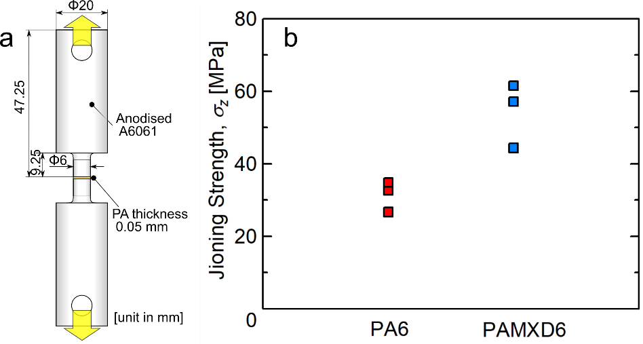
Supplementary Figure 1. Tensile tests of PA6 and PAMXD6 joined with an anodized aluminum alloy (A6061-T6): a) Tensile specimen geometry and b) joining strength of PA6 (red) and PAMXD6 (blue).

- Effects of polymerization degree on the bonding strength between PA and Al₂O₃
Supplementary Note 2. Supplementary Figure 2 shows the S−S curves of PA6 and PAMXD6 with higher degrees of polymerization of 80 and 56, respectively. The bulk PA6 and PAMXD6 samples consist of 128 and 84 molecular chains, respectively. The maximum tensile stress $σ_{z}^{max}$ is larger for PAMXD6 than for PA6, regardless of surface termination. For both PA6 and PAMXD6, $σ_{z}^{max}$ is larger on the non-terminated surface than on the OH-terminated one. For PA6 joined to the OH- and non-terminated surface, $σ_{z}^{max}$ is 206.5 and 233.0 MPa, respectively. For PAMXD6 joined to the OH- and non-terminated surface, $σ_{z}^{max}$ is 238.7 and 261.9 MPa, respectively. The variations in $σ_{z}^{max}$ between different degrees of polymerization for each system are relatively small. The trends observed in the strain-softening regime after yielding ($ε_{z}≳0.1$) are also consistent with those shown in Fig. 3. The right panels of Supplementary Fig. 2 visualize Green-Lagrange strain using corrected smoothed particle hydrodynamics (SPH) $E_{\text{zz}}^{\text{SPH}}$, following the same method as in Fig. 3. At $ε_{z}=0.05$, deformation is distributed uniformly throughout the PA layers. At $ε_{z}≳0.15$, nanovoids form near the interface for both PA6/ and PAMXD6/OH-terminated Al₂O₃, due to desorption of molecular chains from the surface. In contrast, for both PA6/ and PAMXD6/non-terminated Al₂O₃, the growth of red-colored regions indicating severe strain localization is suppressed, as the adsorbed chains remain stacked even under large tensile strains. These results confirm that the S−S behaviors, including molecular desorption and void formation, in PA6 and PAMXD6 are not significantly affected by the degree of polymerization.
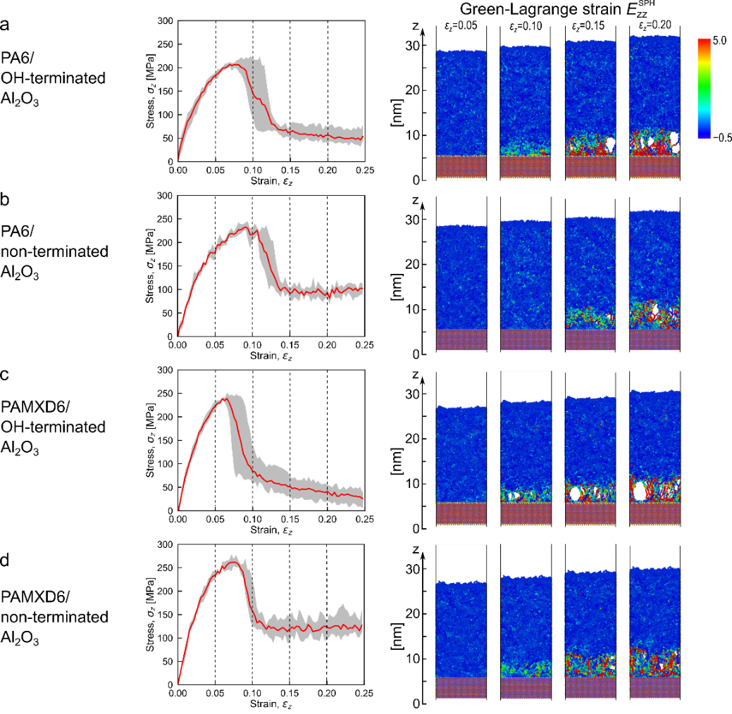
Supplementary Figure 2. Averaged S−S curves (left) and Green-Lagrange strain using corrected SPH $E_{\text{zz}}^{\text{SPH}}$ (right): a) PA6/OH-terminated Al₂O₃, b) PA6/non-terminated Al₂O₃, c) PAMXD6/OH-terminated Al₂O₃, and d) PAMXD6/non-terminated Al₂O₃ joining interface. Dashed vertical lines in the plots indicate the strain values at which the corresponding snapshots were taken. Gray-shaded regions represent the standard deviations over five independent MD simulations. Each was performed with different amorphous configurations of PA samples.

- Effect of quenching rate during model preparation
Supplementary Note 3. To evaluate the effect of the quenching rate, a PA6 sample was prepared with a quench rate of 0.1 K ps⁻¹, lower than the 1 K ps⁻¹ used in Fig. 3b. Supplementary Figure 3 shows the stress-strain curve and Green-Lagrange strain using corrected SPH $E_{\text{zz}}^{\text{SPH}}$. The resulting stress-strain curves are essentially unchanged. Both the maximum tensile stress and interfacial responses, including local inhomogeneous displacements after yielding, remain nearly identical. Within the computationally feasible range, the quench rate does not significantly affect the interfacial structure or mechanical behavior.

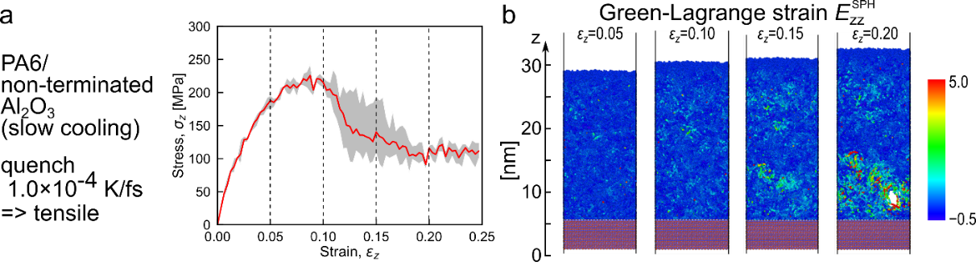
Supplementary Figure 3. Stress-strain curve and snapshots of Green-Lagrange strain using corrected SPH $E_{\text{zz}}^{\text{SPH}}$ for slow cooling $1.0×{10}^{-4}$ K fs⁻¹: a) Stress-strain curve for PA6/non-terminated model b) Green-Lagrange strain $E_{\text{zz}}^{\text{SPH}}$ for each strain level.

- Density profile evolutions along the z axis with different tensile displacement rates
Supplementary Note 4. We analyzed how tensile deformation and strain rate affect the interfacial density profile in the PA6/non-terminated Al₂O₃ system. Supplementary Figure 4 shows the evolutions in the density profiles at three strain rates of $2.5×{10}^{-6}$, $5.0×{10}^{-6}$ (used in the main text), and $1.0×{10}^{-5}$ nm fs⁻¹. The results show that the thickness of the first adsorption layer is not affected by both tensile strain and strain rate. However, the valley between the first and second density peaks (around $z=6.5 \text{nm}$) becomes more pronounced with increasing strain and at lower strain rates. This may be due to insufficient relaxation time of polymer chains in the adsorption layer at higher strain rates. Moreover, large strains enhance density decreases in the second adsorption layer at lower strain rates (Supplementary Fig. 4a), consistent with greater non-affine deformation. In contrast, at the higher strain rate of $1.0×{10}^{-5}$ nm fs⁻¹ (Supplementary Fig. 4c), such decreases are suppressed.

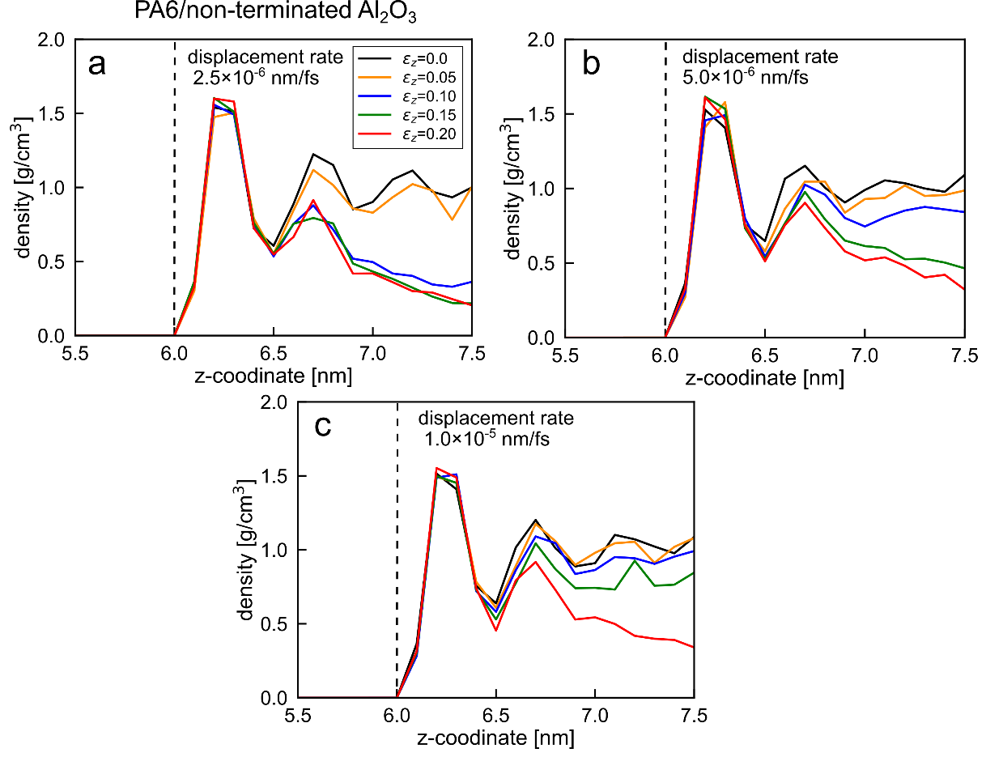
Supplementary Figure 4. Evolution of the density profiles of the PA6/non-terminated Al₂O₃ system along the z axis at different tensile displacement rates: a) displacement rate of $2.5×{10}^{-6}$, b) $5.0×{10}^{-6}$, and c) $1.0×{10}^{-5}$ nm fs⁻¹.

- C=O bond local orientational order parameter
Supplementary Note 5. We verified that the molecular chain is adsorbed to the substrate with the O atom of the amide group in the PA molecular chain facing the substrate, using the local orientational order parameter P₂ of the z axis (tensile) direction of the C=O bond. The local orientational order parameter P₂ is expressed by $P_{2}=〈\frac{3{\text{cos}}^{2}θ-1}{2}〉$ ¹, where the brackets indicate averaging over all C=O bonds within a bin width of 0.5 nm. A value of P₂ = 1 corresponds to full alignment along the z axis, whereas $P_{2}=-0.5$ indicates perfect perpendicular alignment. $P_{2}=0$ denotes random orientation. Supplementary Figure 5 shows the depth profiles of P₂ for PA6 and PAMXD6 under tensile deformation. On the OH-terminated surface (Supplementary Fig. 5a and c), both PA6 and PAMXD6 exhibit strong interfacial alignment ($P_{2}≈0.6$), indicating that C=O bonds are oriented along the z axis. As deformation proceeds, $P_{2}$ decreases rapidly and approaches 0.0, reflecting disorder in the orientation of C=O bonds. After yielding, $P_{2}$ at the interface remains relatively constant, while $P_{2}$ in the region ~4 nm from the interface $P_{2}$ decreases to about −0.3. This suggests that the C=O bonds reorient perpendicular to the z axis in regions where chain stretching and nanovoid formation occur (Fig. 3). Similar trends are observed on the non-terminated surface (Supplementary Fig. 5b and d), although the initial interfacial alignment is weaker ($P_{2}≈0.3$). These analyses confirm that oxygen atoms in amide groups preferentially orient toward the surface.

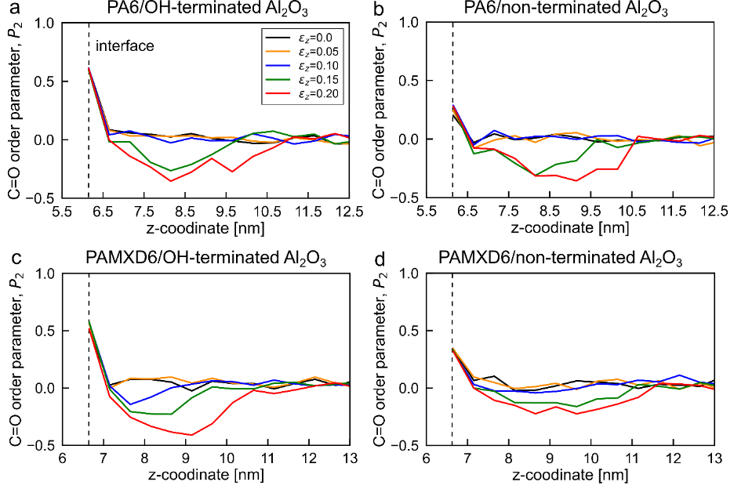
Supplementary Figure 5. C=O bond orientation analysis using local order parameter P₂: a) PA6/OH-terminated Al₂O₃, b) PA6/non-terminated Al₂O₃, c) PAMXD6/OH-terminated Al₂O₃, and d) PAMXD6/non-terminated Al₂O₃.

- DFT calculations of model PA molecules on Al₂O₃ surfaces
Supplementary Note 6. We performed first-principles DFT calculations of individual functional groups (i.e. a linear alkyl chain, amide group, and benzene) and PA monomers adsorbed on an Al₂O₃ surface. Adsorption energies of optimized configurations were evaluated using the Quantum-ESPRESSO software package, in which the Perdew-Burke-Ernzerhof exchange-correlation functional, Grimme’s D3 dispersion correction, and projector augmented wave method were employed. The cutoff values for the kinetic energy of the plane waves and the charge density were set to 30 and 240 Ry, respectively. The Brillouin zone was sampled using a 2×1×1 Γ-centered k-point grid. Spin polarization was taken into account, and a Gaussian smearing of 0.02 Ry was applied for electronic states near the Fermi level. An $α$-Al₂O₃(0001) slab with dimensions of 8.23×19.02×50.00 Å³ was used as the unit cell. Structural optimization was performed until all force components were less than 0.01 eV Å⁻¹. The adsorption energy was defined as $E_{ad}=E_{{mol}/{{Al}_{2}O_{3}}}-E_{mol}-E_{{Al}_{2}O_{3}}$, where $E_{{mol}/{{Al}_{2}O_{3}}}$ is the total energy of the system consisting of the model molecule and Al₂O₃ surface, $E_{mol}$ is the total energy of the isolated model molecule in gas phase, and $E_{{Al}_{2}O_{3}}$ is the total energy of the clean Al₂O₃ surface.
Supplementary Figure 6 shows the adsorption energies of model molecules on both non- and OH-terminated Al₂O₃ surfaces, averaged over 10 different adsorption configurations. The same optimization protocol as in the DFT calculations was used to estimate FF adsorption energies. Since these model molecules are significantly smaller than real polymer chains, general characteristics of PAs are not fully captured; for example, adsorption geometries could be constrained by entanglements and interactions with neighboring chains. Nevertheless, our DFT results are consistent with the trends observed in the AA-MD simulations. The adsorption energies of all model molecules are higher on the non-terminated surface than on the OH-terminated one. The adsorption energy of benzene ($E_{ad}=0.9$ eV) is larger than that of propane ($E_{ad}=0.6$ eV) on the non-terminated surface. In contrast, on the OH-terminated surface, the amide group exhibits higher adsorption energy than those of benzene and propane. Notably, we observe chemisorption of the amide group on the non-terminated Al₂O₃ surface. Physisorption configurations of the formamide molecule were not found on the non-terminated surface; instead, chemisorption via Al−O−C bond formation frequently occurs, consistent with previous experimental observations². A further study considering the chemical reactivity of polymer functional groups toward the surface would be valuable for understanding how chemical anchoring affects the bonding strength at PA/Al₂O₃ interfaces.
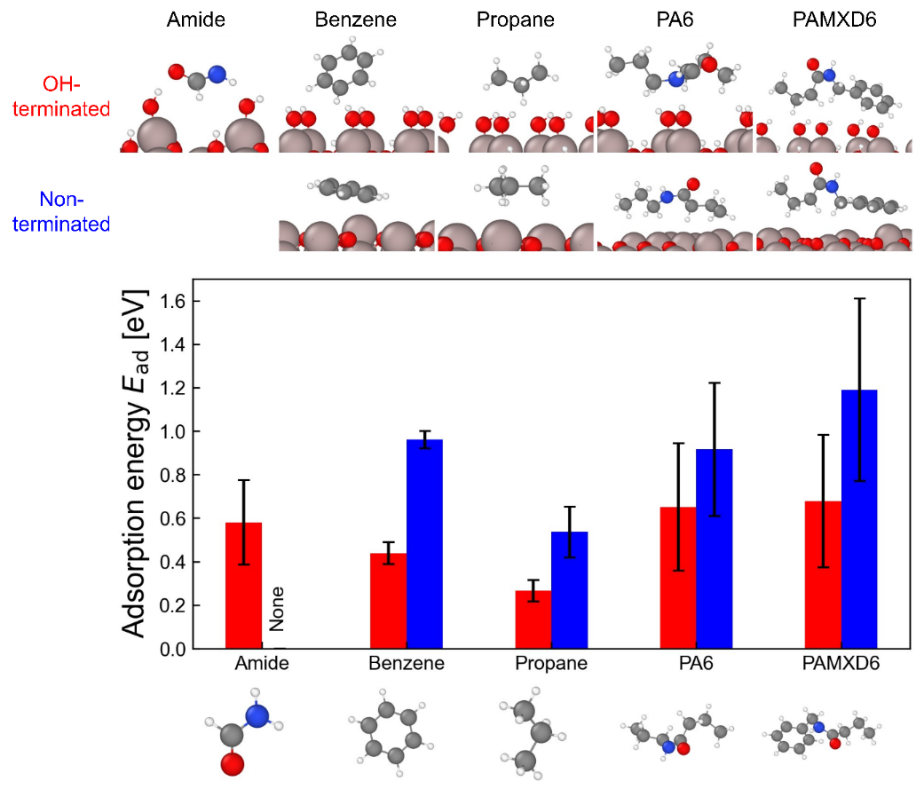
Supplementary Figure 6. Adsorption geometries and energies of model molecules on the non- and OH-terminated Al₂O₃ surface using DFT calculations. To investigate the contribution of individual functional groups to the surface adsorption, we use a formamide, benzene, and propane molecules for the amide group, aromatic ring, and linear hydrocarbon unit, respectively. The top panels show representative configurations of the model molecules adsorbed on the surfaces. The values and error bars represent the averages and standard deviations over 10 different configurations. No physisorption configurations are found for formamide.

Moreover, to evaluate the accuracy of the classical FF used in this study, we compared the adsorption energies obtained from FFs with those from DFT calculations. Supplementary Figure 7 shows the adsorption configurations and energies of PA6 and PAMXD6 monomers on both OH- and non-terminated Al₂O₃ surfaces. The deviations from GGA-PBE-D3 results are about 0.1−0.2 eV for PA6 and 0.2−0.3 eV for PAMXD6. Importantly, almost all FF adsorption energies fall within the error bars of the DFT calculations. Considering that, for organic molecules, typical errors in bond formation and adsorption energies on metal surfaces relative to experimental data are ~0.3 eV³ depending on the functional used, the FF results are in good quantitative and qualitative agreement with the DFT results. Specifically, both PA6 and PAMXD6 exhibit stronger adsorption on the non-terminated surface than on the OH-terminated surface. PAMXD6 shows stronger adsorption than PA6 on both surfaces. Therefore, these comparisons confirm that the FF used in this study reasonably captures the interfacial dynamics, supporting the reliability of our atomistic model.

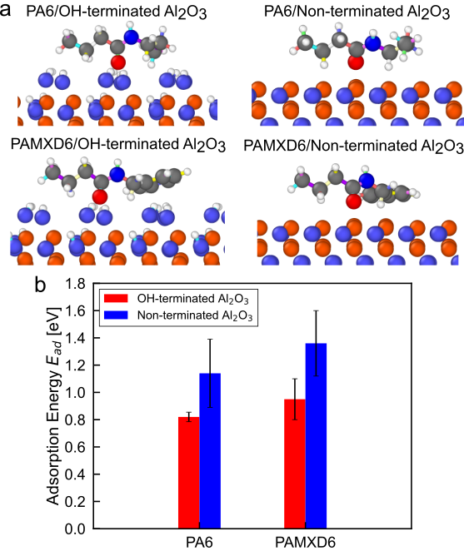
Supplementary Figure 7. Adsorption geometries and energies of PA monomers on the OH- and non-terminated Al₂O₃ surface using MD calculations. a) Adsorption morphologies of PA6 and PAMXD6 monomers on the OH-/non-terminated surface. b) Averaged adsorption energies of PA6 and PMXD6 monomers with 5 different initial configurations.

- Evolution of atomic stress of train, loop, and tail
Supplementary Note 7. We investigated spatially heterogeneous mechanical responses near the interface by analyzing atomic stresses in the adsorbed polymer chains during tensile deformation. We computed the von Mises atomic stress using the per-atom stress tensor and Voronoi tessellation methods implemented in LAMMPS. Supplementary Figure 8 shows the evolution of the average change in von Mises stress $〈∆σ_{m}〉$ for atoms classified as tail, train, and loop segments for all four systems. Here, $〈∆σ_{m}〉$ is defined as the difference in $〈σ_{m}〉$ at a given tensile strain $ε_{z}$ relative to that at $ε_{z}=0$. Interestingly, on the OH-terminated surface, $〈∆σ_{m}〉$ for train segments decreases sharply at higher strains (after yielding), indicating stress release due to chain desorption and subsequent local structural relaxation. In contrast, on the non-terminated surface, $〈∆σ_{m}〉$ remains relatively constant, suggesting that adsorbed chains maintain entanglement and resist desorption. This analysis underscores the spatially heterogeneous stress evolution within the adsorption layer and supports the desorption-driven stress relaxation mechanism.

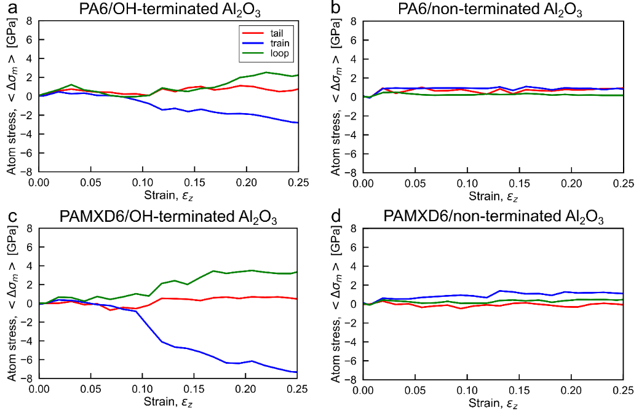
Supplementary Figure 8. Evolution of atomic stress (average von Mises stress) of train, loop, and tail from the initial stage of deformation: a) PA6/OH-terminated Al₂O₃, b) PA6/non-terminated Al₂O₃, c) PAMXD6/OH-terminated Al₂O₃, and d) PAMXD6/non-terminated Al₂O₃.

- Local radius of gyration as a function of the normalized segment length
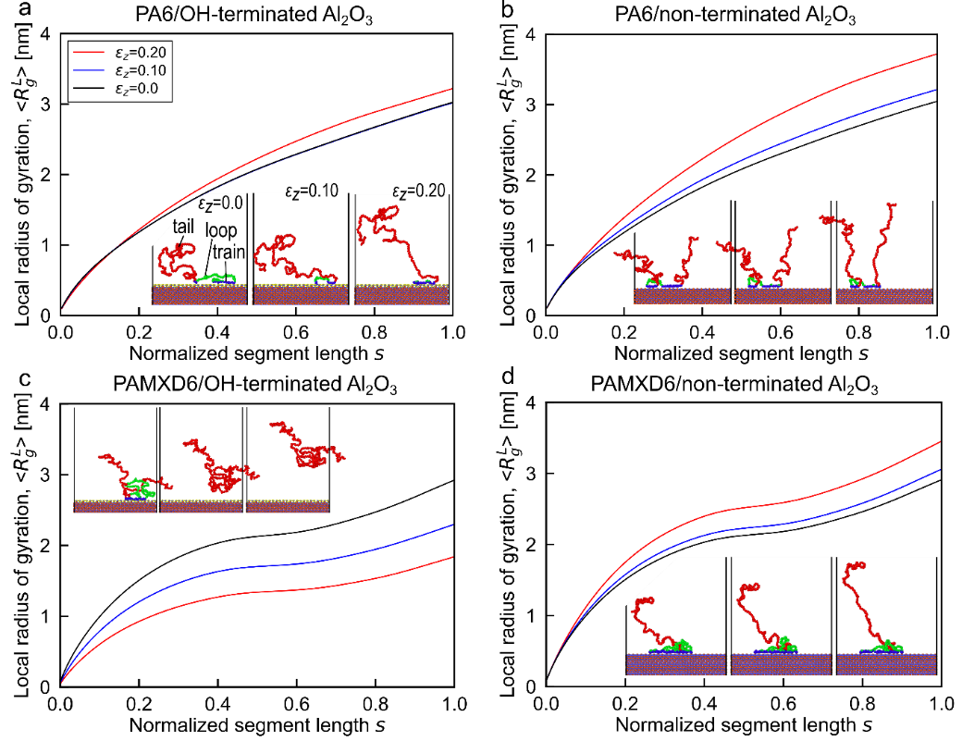
Supplementary Figure 9. Local radius of gyration $〈R_{g}^{L}\left(s\right)〉$ as a function of the normalized segment length $s/{s_{max}}$, where $s_{max}$ denotes the full segment length of each polymer chain: a) PA6/OH-terminated Al₂O₃, b) PA6/non-terminated Al₂O₃, c) PAMXD6/OH-terminated Al₂O₃, and d) PAMXD6/non-terminated Al₂O₃.

- Evolution of the local radius of gyration tensor components
Supplementary Note 8. We calculated the diagonal components of the local radius of gyration tensor $R_{g}^{L}$ and plotted the results as in Fig. 7g to analyze the anisotropy of polymer conformations. As shown in Supplementary Fig. 10, conformational changes are pronounced in the zz component, particularly in regions where loop-to-trail transitions occur, while variations in the xx and yy components remain relatively small. This trend is further highlighted in Supplementary Fig. 11, which shows the differences in the diagonal components of $R_{g}^{L}$ between $ε_{z}=0.0$ and $0.2$. Notably, large anisotropic changes are observed around $s≈180$ and $270$, corresponding to boundaries between trains and tails (as shown in Fig. 7g). Due to partial desorption of trains, structural relaxation also occurs in the x axis especially around $s≈270$. Supplementary Figure 12 shows the cumulative histograms of $R_{g}^{L} (s=30)$ for molecular chains located within 6.5 nm of the Al₂O₃ surface, obtained from five independent trajectories for the four PA/Al₂O₃ systems. As $ε_{z}=0.0$, the distributions of all three components are similar and centered near $R_{g}^{L}≈0.2-0.3$ nm. Upon increasing the strain to $ε_{z}=0.2$, as indicated by red line, the distributions of $R_{g,z}^{L}$ broaden significantly, with higher probability densities within the range $0.6-1.1$ nm, whereas the distributions of $R_{g,x}^{L}$ and $R_{g,y}^{L}$ remain almost unchanged in tail ends. This results in an increase of about 0.4–0.6 nm in the median $R_{g}^{L}$, quantitatively reflecting the local anisotropic extension of chain segments near the interface. These additional statistical results indicate that the strain-induced increase in the local radius of gyration $R_{g,z}^{L}$ occurs robustly across all four systems.

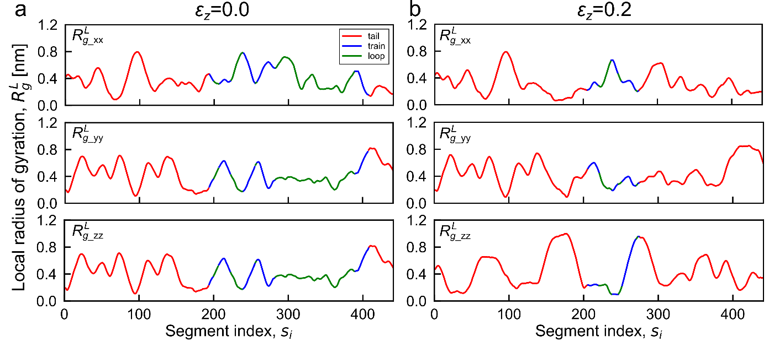
Supplementary Figure 10. Evolution of the local radius of gyration tensor components $R_{g}^{L}\left(I,s=30\right)$. a) $ε_{z}=0.0$ and b) $ε_{z}=0.2$ for a representative PAMXD6 chain adsorbed on the OH-terminated surface during tensile deformation.

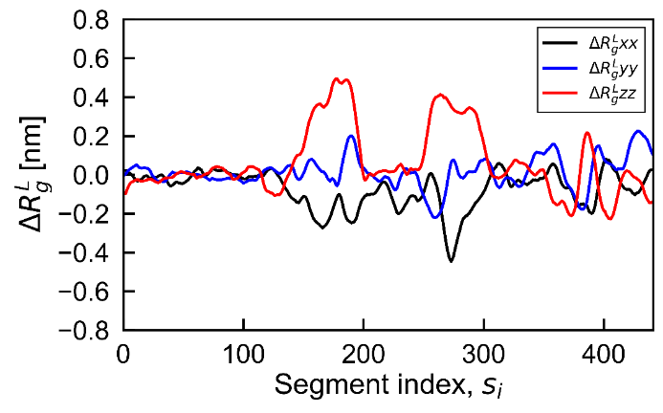
Supplementary Figure 11. Changes $∆R_{g}^{L}\left(I,s=30\right)$ in the local radius of gyration tensor components. $∆R_{g}^{L}\left(I,s=30\right)$ indicate the changes between $ε_{z}=0.0$ and $0.2$, calculated from the results in Supplementary Fig. 10.

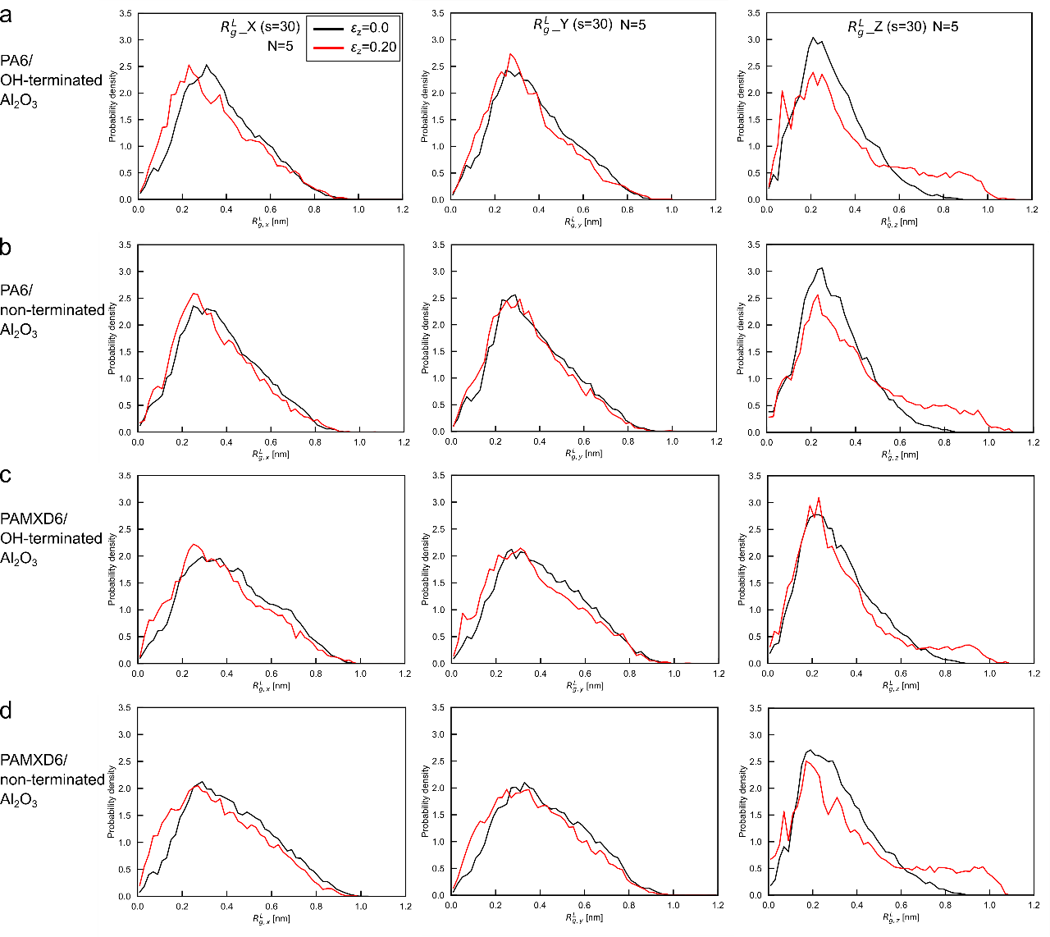
Supplementary Figure 12. Probability distributions of the local radius of gyration$R_{g,x}^{L} (s=30)$ (left), $R_{g,y}^{L} \left(s=30\right)$ (middle), and $R_{g,z}^{L} (s=30)$ (right) components for chains located within 6.5 nm of the substrate interface of four systems with five different initial configurations: a) PA6/OH-terminated model, b) PA6/non-terminated model, c) PAMXD6/OH-terminated model, d) PAMXD6/non-terminated model.

- Spatial variation in the local radius of gyration of a single chain
Supplementary Note 9. Supplementary Figure 12 illustrates the spatial variation of the local radius of gyration $R_{g}^{L}\left(s\right)$ along a single molecular chain at different $ε_{z}$ for PAMXD6/OH-terminated Al₂O₃. We here focus on the conformational response of a PAMXD6 chain undergoing a loop-to-tail transition (Mode 2) and demonstrate how the choice of segment length $s$ affects the description of local conformational changes under mechanical strain. For $s=10$ (Supplementary Fig. 12b), which is shorter than the length of a PAMXD6 monomer, monomer-scale fluctuations are captured, but the spatial evolution along the chain is highly noisy, making characteristic behaviors difficult to discern. In contrast, the $R_{g}^{L}\left(s\right)$ curve for $s=30$ (Supplementary Fig. 12c) clearly reveals localized variations in regions undergoing loop-to-tail transitions and at loop-train boundaries. Further increases in $s$ (Supplementary Fig. 12d and e) show that these localized conformational changes propagate to affect the larger-scale structure of the chain.

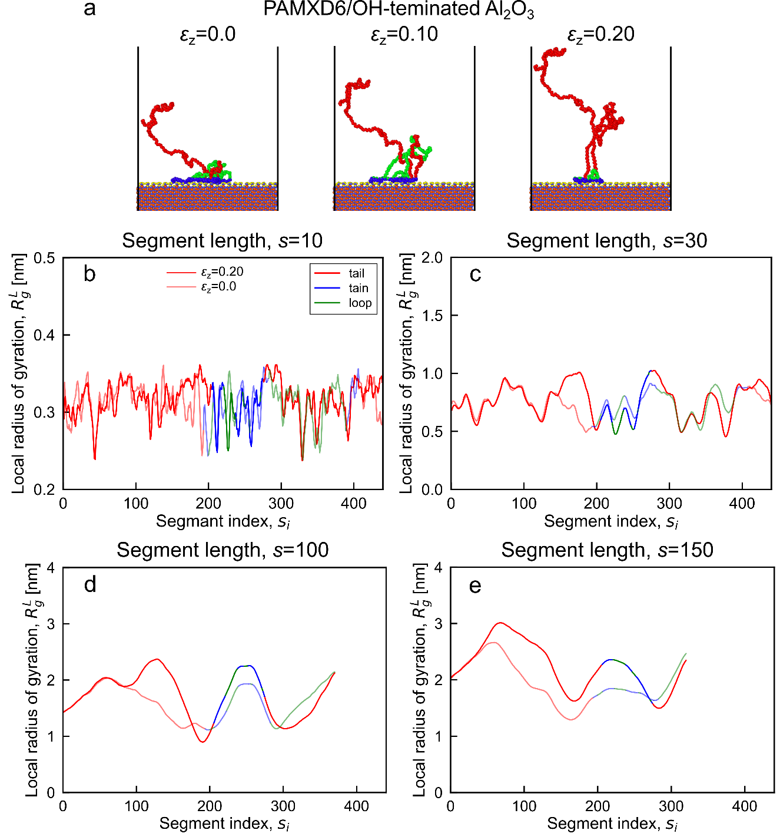
Supplementary Figure 13. Spatial variation of the local radius of gyration $R_{g}^{L}$ of a single PAMXD6 chain adsorbed on the OH-terminated Al₂O₃ surface. a) Atomic configurations of a molecular chain at different $ε_{z}$. $R_{g}^{L}$ at $s=b) 10, c) 30, d) 100, and e) 150$.

- Evaluation of the relaxation state of the amorphous structure
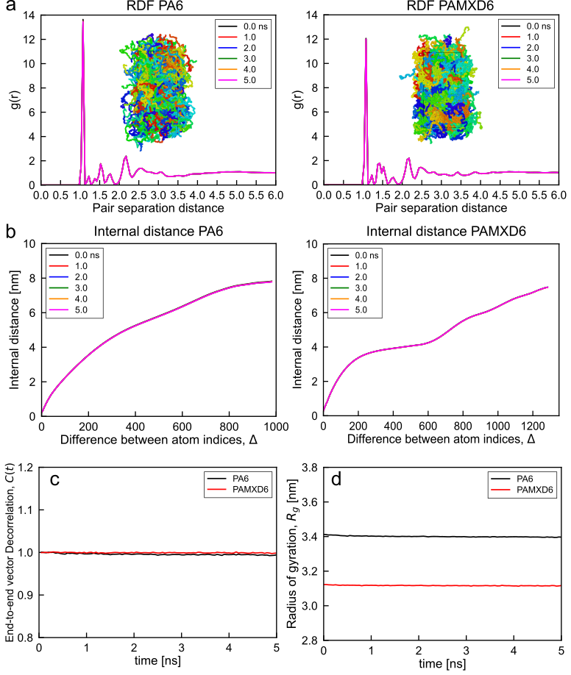
Supplementary Figure 14. Structural analysis of amorphous PA6 and PAMXD6. a) Radial Distribution Function (RDF). b) Internal distance. c) End-to-end vector decorrelation. d) Radius of gyration.

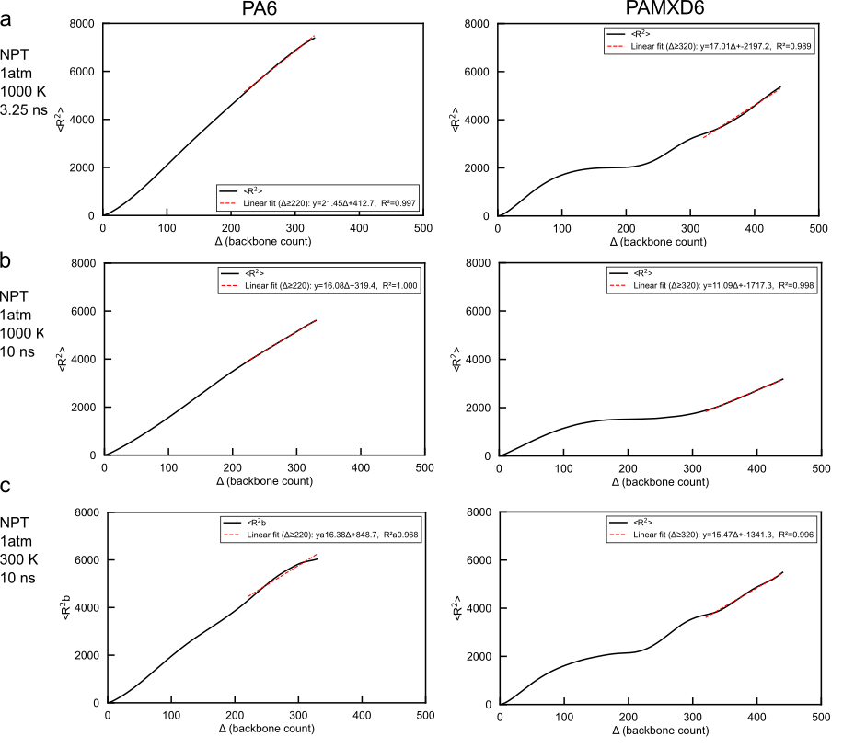
Supplementary Figure 15. Relaxation behavior and chain statistics of amorphous PA6 (left) and PAMXD6 (right). Mean-squared internal distances ⟨R²⟩ as a function of backbone count Δ at 1000 K after a) 3.25 and b) 10 ns. Linear fits for large $∆$ ($∆≥220$ for PA6 and $320$ for PAMXD6) demonstrate that chain conformations approach Gaussian statistics in the melt. PAMXD6 does not show perfect $〈R^{2}〉-∆$ linearity at small Δ since the aromatic rings impose local stiffness and conformational constraints. c) $〈R^{2}〉-∆$ relations at 300 K after 10 ns. The formation of intermolecular hydrogen-bond networks between amide groups perturbs the random-coil statistics at large Δ.

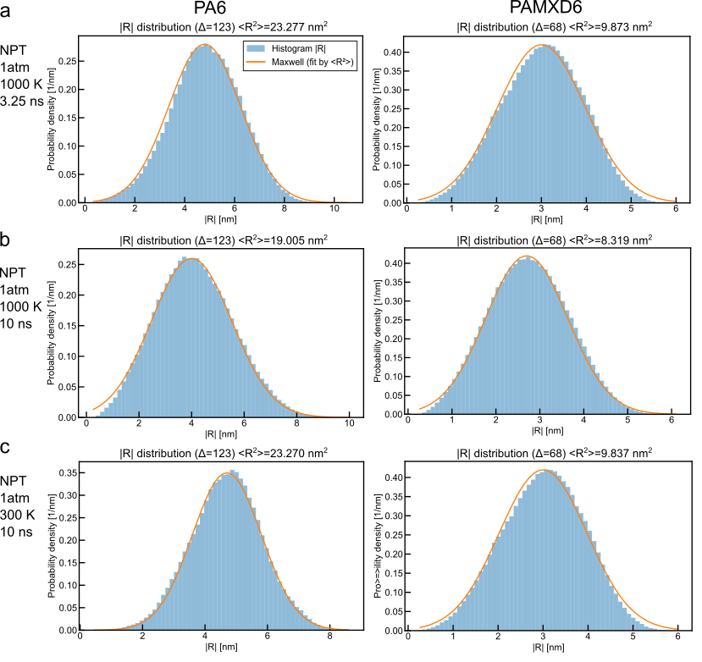
Supplementary Figure 16. Probability distributions of the internal distance |R| for amorphous PA6 (Δ = 123, left) and PAMXD6 (Δ = 68, right): a) after NPT equilibration at 1000 K (3.25 ns), b) after NPT equilibration at 1000 K (10 ns), and c) after NPT equilibration at 300 K (10 ns). At 1000 K, the distributions are well described by Gaussian statistics and remain unchanged between 3.25 and 10 ns, indicating equilibration of segmental conformations.

- AA-MD simulation models
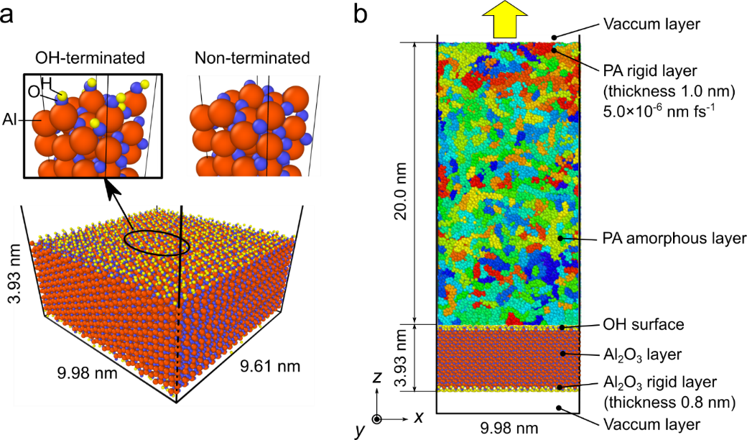
Supplementary Figure 17. AA-MD simulation models. a) Non-terminated and fully OH-terminated α-Al₂O₃ (0001) surfaces. b) Initial atomic configuration of the PA/Al₂O₃ joining interface used in uniaxial tensile simulations. The upper rigid layer of the PA slab is displaced at a constant velocity of $5.0×{10}^{-6}$ nm fs⁻¹ in the positive z direction, as indicated by the yellow arrow.

- Effect of tensile displacement rate
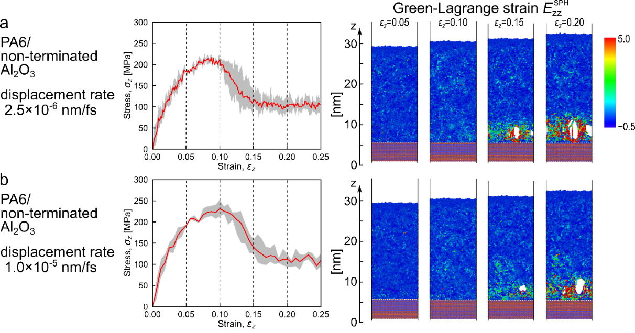
Supplementary Figure 18. Stress-strain curves and spatial distributions of Green-Lagrange strain using corrected SPH $E_{\text{zz}}^{\text{SPH}}$ of the PA6/non-terminated Al₂O₃ system at three different tensile displacement rates: a) $2.5×{10}^{-6}$, and b) $1.0×{10}^{-5}$ nm fs⁻¹.

- Effect of the difference between glass transition temperatures and MD simulation temperature
Supplementary Note 10. We experimentally determined the glass transition temperatures of PA6 and PAMXD6 using differential scanning calorimetry (DSC Q2000, TA Instruments Inc.). DSC measurements were performed by heating the samples from 25 $℃$ to 260 $℃$ at 10 $℃$min⁻¹ and cooling back to 25 $℃$ at a rate of 10 $℃$ min⁻¹. To eliminate the effects of absorbed moisture, $T_{g}$ was taken from the second heating/cooling cycle. The resulting $T_{g}$ values were equal to 55.0 $℃$ (328.0 K) for PA6 and 87.3 $℃$ (360.3 K) for PAMXD6 (Supplementary Fig. 19a and b). This confirms that the simulation temperature of 300 K lies well below $T_{g}$ of both PA6 and PAMXD6 ($∆T=-28.2 ℃$ for PA6 and $-60.5 ℃$ for PAMXD6). Next, to verify that the simulations were performed in the glassy regime, we computed the mean squared displacements (MSDs) at 300 K and 1 atm over 10 ns (Supplementary Fig. 19c). The MSDs of both PA6 and PAMXD6 remain very small (< 0.07 nm²), indicating that both PA6 and PAMXD6 are well below their $T_{g}$ and exhibit minimal chain mobility. We calculated the $T_{g}$ of amorphous PA6 and PAMXD6 by analyzing the density–temperature relationships under NPT conditions (1 atm, controlled cooling/heating runs) for three independent samples. The low-temperature (glassy) and high-temperature (rubbery) regimes were fitted by linear regression, and the intersection was taken as $T_{g}$ (Supplementary Fig. 20). The results indicate that $T_{g}$ is 327.7 ± 0.7 K for PA6 and 358.8 ± 0.8 K for PAMXD6, which are in close agreement with the experimental values obtained from DSC measurements (328.0 K for PA6 and 360.3 K for PAMXD6). These analyses demonstrate that both PA6 and PAMXD6 are in the glassy state under the present simulation conditions.

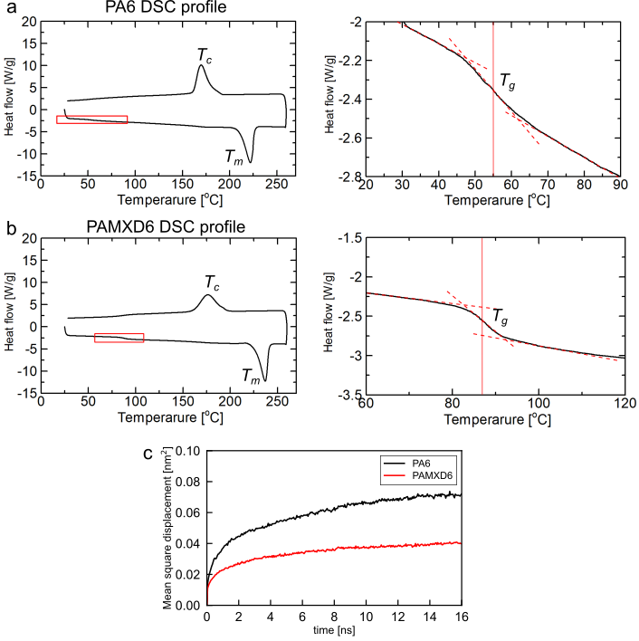
Supplementary Figure 19. Differential scanning calorimetry measurements of a) PA6 and b) PAMXD6. c) Evolution of mean squared displacements of PA6 and PAMXD6 computed from 16-ns MD simulations at 300 K and 1 atm.

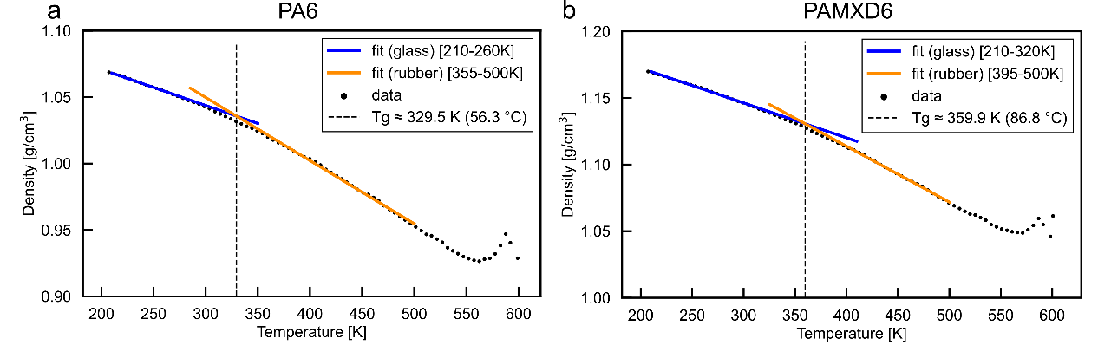
Supplementary Figure 20. Temperature dependence of density for amorphous polyamide models. The glass transition temperatures T_{g} of a) PA6 and b) PAMXD6 were determined by fitting the low-temperature (glassy) and high-temperature (rubbery) regions with linear regressions and defining the intersection as T_{g}. The T_{g} values are estimated as $358.8±0.8$ K for PA6 and $327.7±0.7$ K for PAMXD6. The simulations were carried out under NPT ensemble (1 atm, cooling/heating processes).

Supplementary References
1. Fujiwara, S. & Sato, T. Molecular dynamics study of structure formation of a single polymer chain by cooling. Comput. Phys. Commun. 142, 123–126 (2001).
2. Hirchenhahn, P. et al. Highlighting Chemical Bonding between Nylon-6.6 and the Native Oxide from an Aluminum Sheet Assembled by Laser Welding. ACS Appl. Polym. Mater. 2, 2517–2527 (2020).
3. Nørskov, J. K., Abild-Pedersen, F., Studt, F. & Bligaard, T. Density functional theory in surface chemistry and catalysis. Proc. Natl. Acad. Sci. U.S.A. 108, 937–943 (2011).

