Additively Manufacturing Printed Circuit Boards with Low Waste Footprint by Transferring Electroplated Zinc Tracks – Supplementary Information

Contents
Additional Data on the production and analysis of Zn-Based biodegradable PCBs. This consists of 5 sections:
- SI1:Further Production Details
- SI2:Further Sample Metrics
- SI3: Adhesion, Flexibility, and Degradation Stability Tests
- SI4:Further Life Cycle Analysis Data
- SI5:Literature Comparissons

SI1: Further Production Details

Seed Layer Deposition
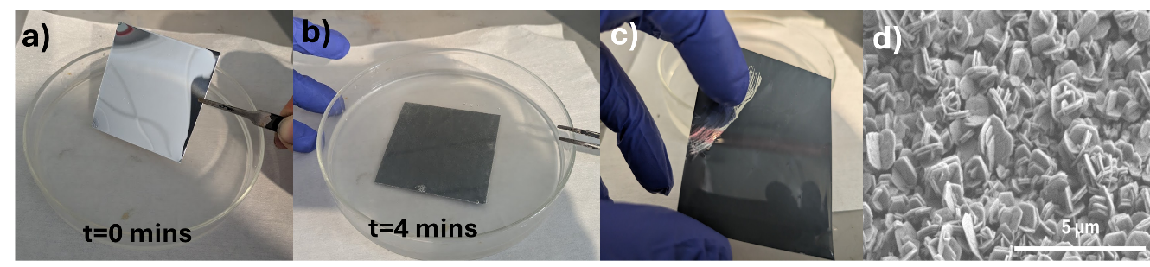
Supplementary Figure 1 – Applying a seed layer to a blank Al Sheet – a) A sample is immersed in the seed solution. b) After ~4 minutes the sample goes dark grey, coupled with bubbling. c) The grey layer is easily wiped off with a finger, demonstrating its low adhesion. d) An SEM image of the resulting film

Scalability
Through the use of a spray-coated photoresist, the process can be easily scaled up to large areas, with the key limiting factors being the illumination area of the UV light source. Supplementary Figure 2 shows a demonstration of this with a large area pattern of ~15 x 30 cm being peeled separated from the carrier substrate.
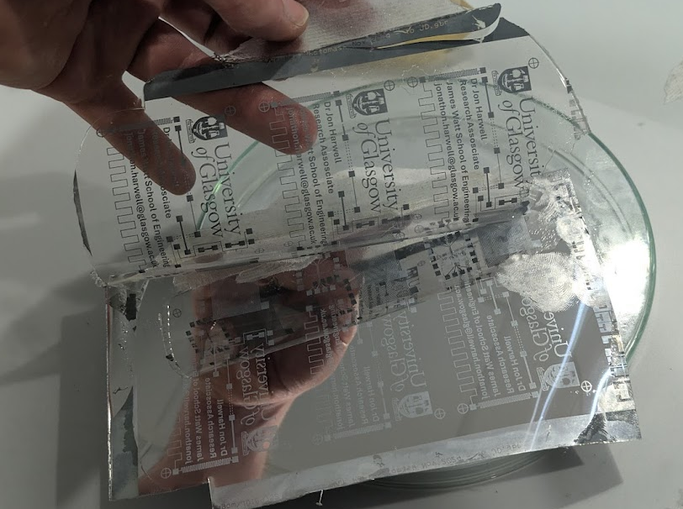
Supplementary Figure 2 – a large area (15 x 30 cm) pattern – sample consists of features down to 50 um on a UV resin substrate being separated from its carrier sheet.

3D Printer Exposure Setup
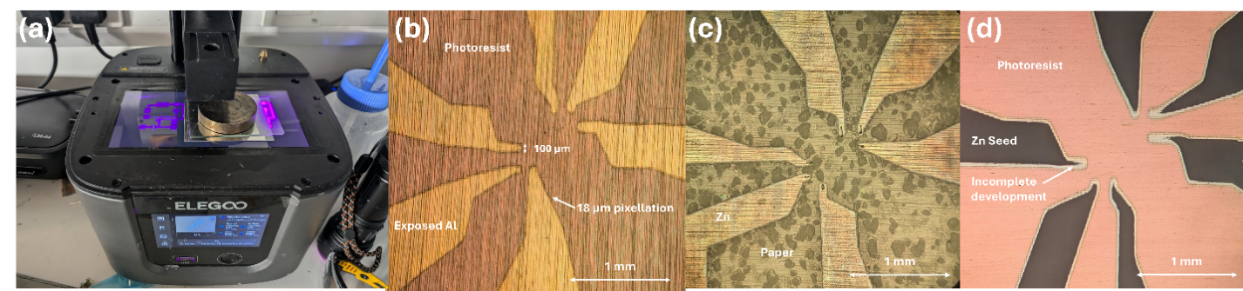
Supplementary Figure 3 – Exposure using a 3D Printer - (a) The Exposure setup when using a 3D printer for the pattern – the desired projected pattern was modelled as a 3D object and fed into the printer, while the sample to be exposed (the aluminium sheet) is held flat and face down on the bed of the printer. (b) shows an image of a sample with 60 s exposure and 60 s development time, with design features down to a minimum width of 100 um. Pixelation corresponding to the 18 um pixel size of the projector can be clearly seen. (c) Shows a microscope image of the final resulting sample after a further 5 minutes developing, followed by electroplating and then transfer to a paper substrate. (d) Shows an underexposed sample (only 30 s exposure) after 5 minutes developing. Note that the resist is not fully removed in the finer areas, leading to incomplete seed layer growth.

Overmoulding Process
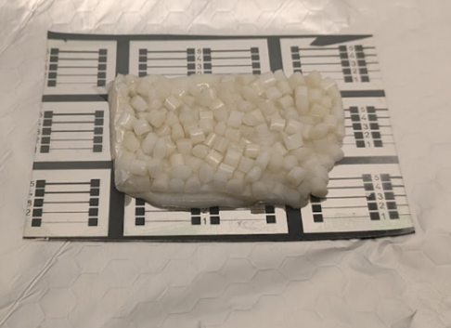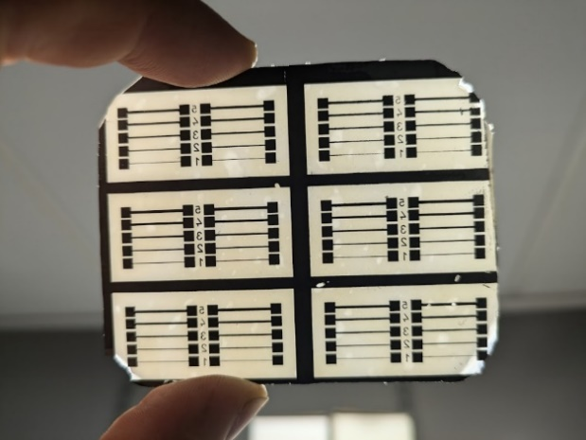

Supplementary Figure 4 – The Overmoulding Process - (left) Overmoulding PHBV pellets onto a series of zinc test lines of width between 100 and 500 µm– prior to applying pressure to flatten it. (right) the resulting sample after transfer.

Process Notes

Dark Erosion of Photoresist
Due to the strongly alkaline nature of the seed layer, dark erosion or delamination of the resist is a significant problem. The dark erosion can be mitigated by increasing the baking temperature, but temperatures above ~130 ºC will make the photoresist become insoluble in acetone, and hence it will be difficult to remove. Excessive pre-baking can also slow down the development rate to unacceptable levels, and so if this becomes a problem then two steps may be needed – do a standard pre-bake at 90 degrees C and then develop the pattern according to the resist manufacturer’s instructions. After development, rinse and dry the sample, and then do a hard bake at 120 ºC to harden the resist. This should allow the resist to be immersed in the seed layer solution for long times without eroding.

Seed Layer Solution
The seed layer must specifically use potassium hydroxide as opposed to sodium hydroxide or other bases. Switching the potassium for a different ion results in a discontinuous seed layer, or one which is too strongly adhered to the aluminium foil.
When immersing the Al in the seed solution, nothing will happen for several minutes until the oxide layer is broken through, at which point bubbling and colour changes will be observed. The breakthrough time will vary strongly depending on the substrate used and the temperature of the solution. Breakthrough can be accelerated by increasing the concentration of the seed solution or by increasing the temperature, but care must be taken not to increase these too far or dark erosion of the resist will occur.

Choice of Aluminium Substrate
As stated in the experimental, polished aluminium sheets works best, but it can be done with consumer grade foil as long as the surface is relatively flat. Thicker foils are easier to handle in this case as thin foils will tend to crinkle and break while handling. It should be noted that the overmoulding process will also create a negative of the surface profile of the carrier substrate, so mirror-polished aluminium is preferred for getting a clean surface with low haze (see Supplementary Figure 4). The breakthrough time for commercial Al foil (sigma Aldrich) seems to be longer than for polished aluminium, and so a higher concentration of developer solution may be needed to accelerate the breakthrough.
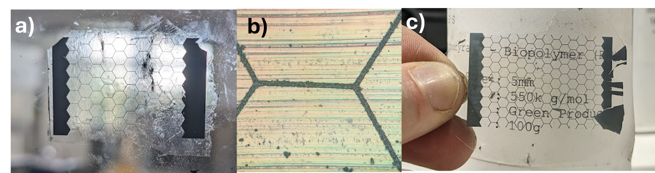Supplementary Figure 5 – Impact of Al Substrate Roughness - Images of conducting honeycomb grids made on a UV resin substrate using a) household Al foil and c) mirror-polished Al sheets. b) shows a microscope image of sample a). Note that the polishing marks from the foil can be clearly seen, meaning that sample c) has a much lower haze.

Spray-On Photoresist
Spin coating is not practical on foils, and so instead a spray-on photoresist should be used (Kontakt-Chemie 82009-AH Positiv 20 Photo Resist) – approx. cost £30 for 200 ml. The thickness is hard to control with this material, and we found it requires a slightly higher pre-bake temperature of 110 ºC and roughly 2x the UV exposure dose to get good results, but otherwise works similarly to AZ1518.
Dry film photoresist did not work well with this method due to excessive delamination of the resist during development, and due to residual adhesive causing problems in the transfer step

Other Metals
This method should in principle work with any metal that can be electroplated. We have tested it with silver and copper (spa plating solutions) and found that it works well. However it will not work if the plating bath is strongly acidic, as it will dissolve the zinc seed layer.

Troubleshooting

Incomplete Transfer
Incomplete transfer of the zinc tracks to the new substrate are usually due to poor quality of the seed layer. If this occurs, leaving the sample in the seed solution for longer duration usually helps, or increasing the temperature of the solution slightly to increase the reaction rate. Always do an adhesion test of an unpatterned seed layer prior to doing any more complex experiments – if it can’t be wiped off as in Supplementary Figure1(c) then it won’t work. Plating should be done as soon as possible after seed layer deposition without allowing it to dry out. Thicker zinc films will usually transfer more reliably, and it is easiest with materials that strongly adhere to the zinc (see table 2). It is also easier to get good transfers from mirror-polished Al substrates than rough foils.

Improving Electrodeposition Quality
Commercial electroplating solutions (e.g. Gateros inc) use additives such as Zylite to improve the plating quality by suppressing dendrite formation. This gives a much smoother film (see Supplementary Figure5), but this can also result in an incomplete transfer of the Zn from the carrier substrate due to reduced surface area for grip to the new substrate. For reliable results, it is best to omit any additives, although it is sometimes possible to get a good transfer by doing a brief plating in an additive-free bath at the start and end of the process, with the additive-containing bath being used for the bulk of the deposition.
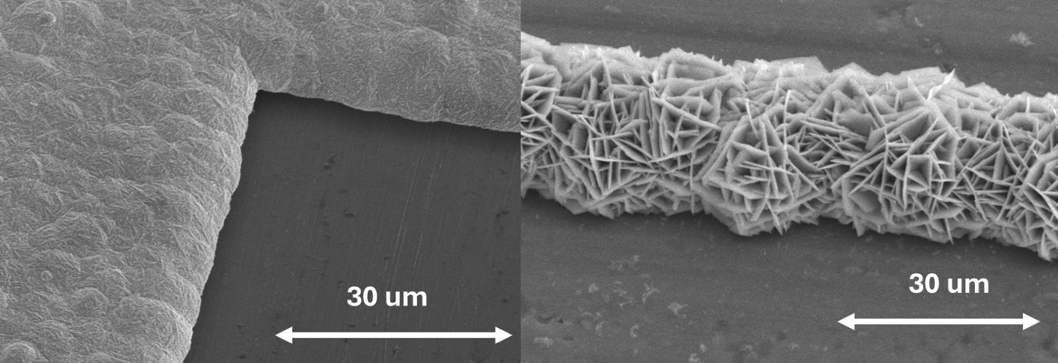
Supplementary Figure 6– Impact of Zylite Additive - SEM images of zinc electrodeposited on aluminium in a plating solution (left) with, and (right) without the zylite additive

Cost of a full setup
This process requires no expensive (by scientific standards) pieces of kit, and can be done even in a low resource environment as long as appropriate safety precautions are made. Below is a rough breakdown of the items needed to replicate this work (assuming spray coating is used instead of spin coating).
Item Name | Rough Cost
Elgoo Mars 4 3D Printer | £180 (Amazon)
3 A Power Supply | £40 (Amazon)
Crocodile Clips and Cables | £30 (Amazon)
Gateros Zinc Plating Kit | £70 (gateros Plating)
Polished Aluminium Sheet | £5 for 30x30cm (ebay)
Potassium Hydroxide | £15 per kg (APC Pure)
Zinc Oxide | £20 per Kg (APC Pure)
Spray-On Photoresist | £30 (RS Components/ebay)
UV Resin | £40 (Amazon)
UV Torch | £40 (Amazon)
Chrome Photomask (optional) | £200 (JD Photodata)
Acetone | £6/litre (APC Pure)
Hotplate | ~£100 (Amazon)
Glassware | ~£100 (Amazon)
Total | £876

SI2: Further Sample Metrics

Adhesion of Seed Layer and Grown Zn
The crucial parameter that enables our transfer process is that the adhesion of the Zn layer to its Al carrier after electroplating is much weaker than its adhesion to its new substrate. To quantify this, we measured the adhesion of the Zn to its substrate at 3 distinct phases. First, the Zn seed crystals after a 5 minute immersion in the seed solution, with a subsequent drying by compressed air. Second, adhesion of the grown Zn layer to the Al carrier after 5 minutes electroplating at 0.4 V. Third, the adhesion of a Zn layer grown under the same conditions to its final carrier substrate of UV resin or PHBV. Supplementary Figure 6 shows our setup for measuring the adhesion strength. (a)The substrate is held onto a rigid copper holder with a small area (usually 1x1 cm) piece of double-sided adhesive tape. A large-area of adhesive is applied to the back side of the substrate, from which varying weights are suspended until the zinc breaks off as shown in (b). (c) shows the situation where the adhesive tape fails before the zinc does. This occurs when a 5 kg load is suspended on a 1 cm2 area, corresponding to 500 kPa of tension. (d) shows a photo of the situation in (a), where a 1 kg weight is applied to a sample of Zn embedded in a PHBV substrate with a 1 cm2 contact area, corresponding to 100 kPa of tension. (e) shows the aftermath of situation (b), where a 2.5 x 2.5 cm area of adhesive was applied to the Zn seed layer without any subsequent plating – complete delamination occurred after only 40 g was suspended, corresponding to an adhesion of less than 1 kPa. c) shows the aftermath of a Zn on PHBV sample having a 5 kg weight (500 kPa of tension) applied to it – the break occurs in the tape, rather than Zn, meaning that the adhesion of the Zn to the PHBV is at least as strong as 500 kPa, but likely substantially more.

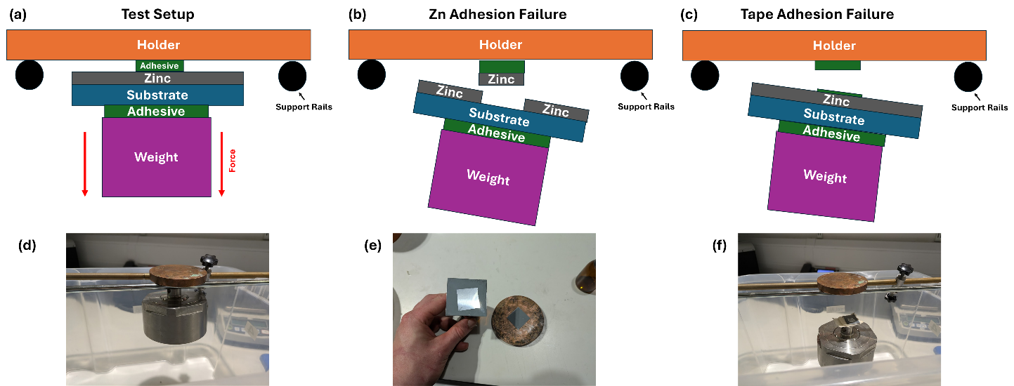
Supplementary Figure 7 – Setup for measuring the adhesion strength of the zinc layer. (a)The substrate is held onto a rigid copper holder with a piece of double-sided adhesive tape with clearly defined area. A larger piece of adhesive is applied to the back side of the substrate, from which varying weights are suspended until the zinc breaks off as shown in (b). (c) shows the situation where the adhesive tape fails before the zinc does. (d)-(f) show photos of test samples in each of the situations.
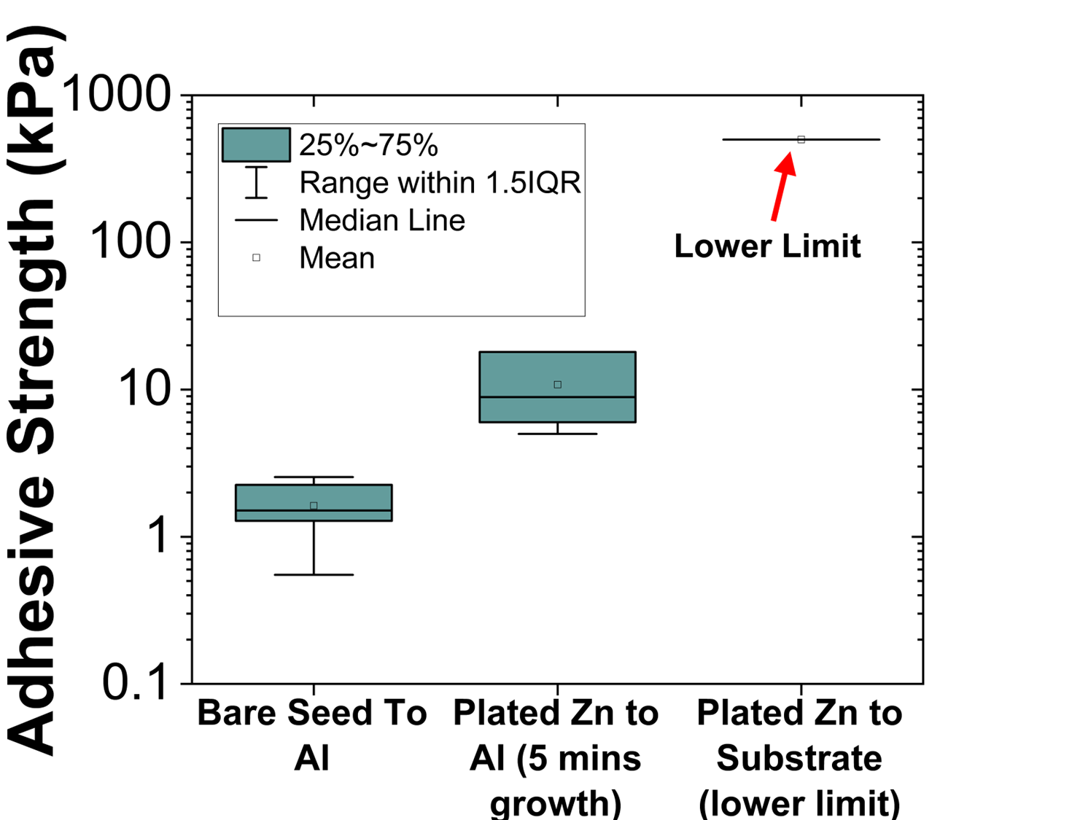
Supplementary Figure 8 – Adhesive strength of the Zn Layer to its substrate at different stages of the fabrication – n=5 Samples were measured with 1x1cm area, with the exception of the bare seed layer which needed a larger area to give quantifiable data. The plated Zn to the new substrate is a lower limit to the adhesion value as this is the maximum value our setup could measure.

Minimum Linewidth Test
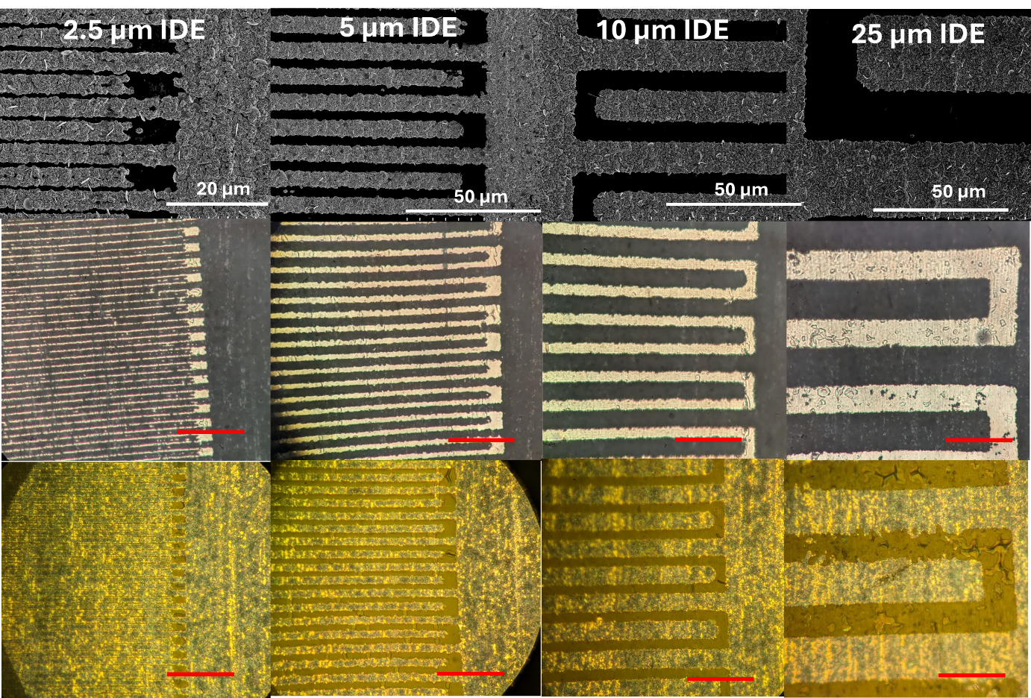
Supplementary Figure 9 – Resolution Test of Projection through a UV mask, showing (left to right) 2.5 µm, 5 µm, 10 µm, 25 µm linewidth IDEs. The top row shows SEM images of the Zn patterns on Al prior to transfer, while the middle and bottom rows show optical micrograph images of the IDE electrodes after transfer to a UV resin substrate. Middle row is in transmission mode, while bottom row is reflection. As can be seen, the 2.5 µm lines do not develop cleanly. The red scale bar corresponds to 50 µm.

Thickness of Grown Tracks
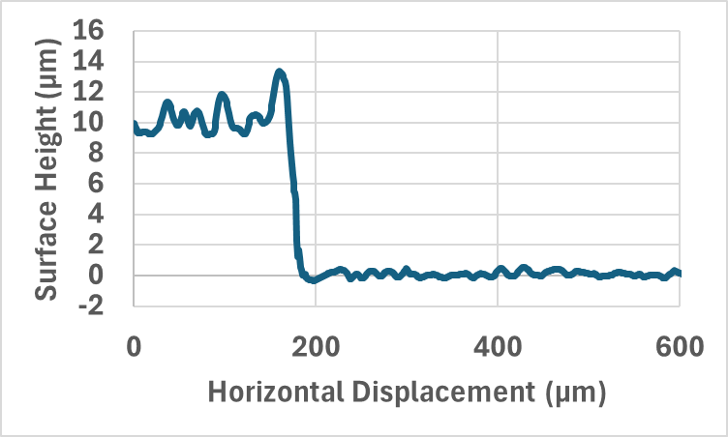
Supplementary Figure 10– Zn Thickness- Representative Optical Profilometry of a step in Zn grown at a current density of 20 mA/cm² for 30 minutes on an Al carrier (prior to transferring to new substrate). An average thickness of 10.0 ± 0.2 µm was calculated from the average step height over n=7 samples.

Proof that Embedded Tracks have Negligible Protrusion

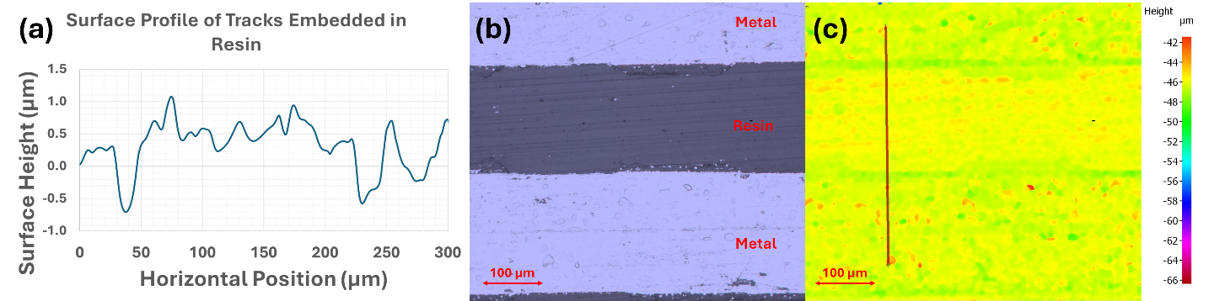
Supplementary Figure 11 – Surface profile of embedded Zn - (a) Surface profile of 200 µm wide metal tracks embedded in UV resin taken with an Alicona surface scanner. (b) An image of the scanned field, (c) A surface height heat map of the same area, with the scan line from (a) shown as a red line. Note that the boundary between the resin and the metal is hard to discern, with a height difference of less than 1 µm.

HF Sheet Resistance - uncertainty
Regarding the measurement uncertainty, the S11 amplitude for a “short” with under 20 mOhm resistance would be around -1 mdB, which reaches the uncertainty limit for the VNA. As such, all measurements are comparative and only serve to show the agreement with the bulk metal numerical model.

SI3: Adhesion, Flexibility, and Degradation Stability Tests

ISO4624:2016 Adhesion Tests
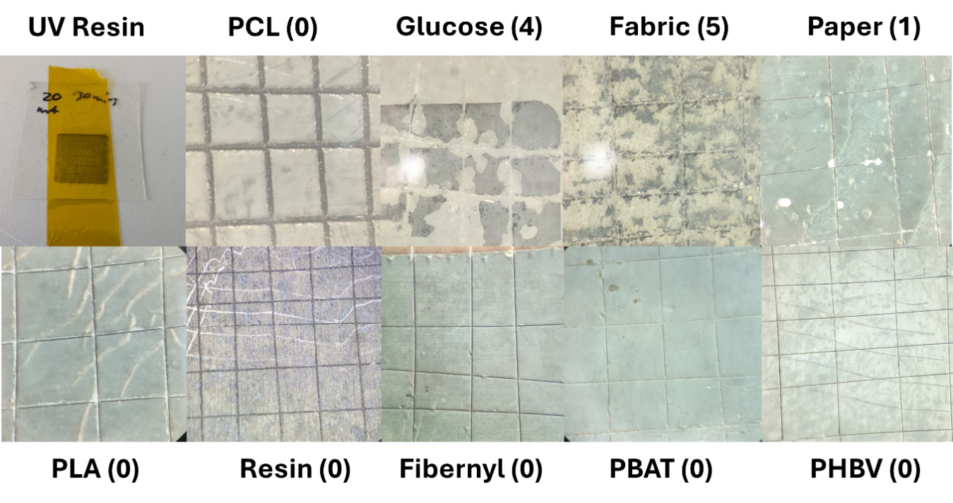
Supplementary Figure 12 – Images of the ISO4624:2016 test on different substrate materials. a) shows a zoomed out photo of the UV resin test, where a pattern is scored in a hatch pattern and then Kapton tape is applied and rapidly peeled off. b-j) shows zoom-in microscope images of the hatch patterns after peeling.

Flexibility
A clear benefit of our approach is that thin and flexible substrates can be used, leading to dematerialization and a lower environmental footprint. In this case, we found that the key determinator on the flexibility of our devices was in the choice of substrate material. To quantitatively prove their flexibility, we produced standard test pattern of a 5 mm wide track with a length of 5 cm, and printed it onto flexible substrates made of PBAT, fabric, and paper. The samples were then tested by measuring their line resistance as they were bent around objects of different radii (5 bending cycles each). As can be seen in figure 3, the paper sample can be bent around a 0.75 mm radius test structure with a with no increase in resistance, while the PBAT sample was observed to show a slow increase in resistance even at a relatively large bending radius of 27 mm. The fabric sample could survive a bending radius of approximately 3 mm before the Zn started to delaminate from the substrate, thus causing a rapid increase in resistance. The poor results for the PBAT sample are likely due to the relatively large thickness of the substrate (~1 mm). This thickness means that bending causes a large strain on the outer surface with the Zn on it, meaning that the Zn film will progressively crack and increase in resistance. Overall, these results show that thin substrates with strong adhesion are key to making highly flexible devices.
These test conditions confirms that our approach complies with the IEC 62899-202:2020 testing standard for dynamic bend testing. Further testing could be done to test at extremes to gain a better understanding of failure modes.”
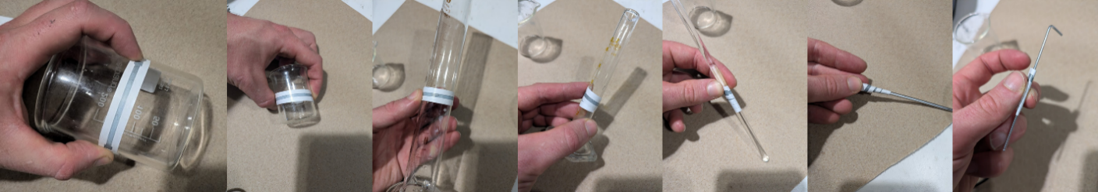
Supplementary Figure 13 –Simple Bending tests – A 50 x 5 mm zinc track on a paper substrate on different bending radii
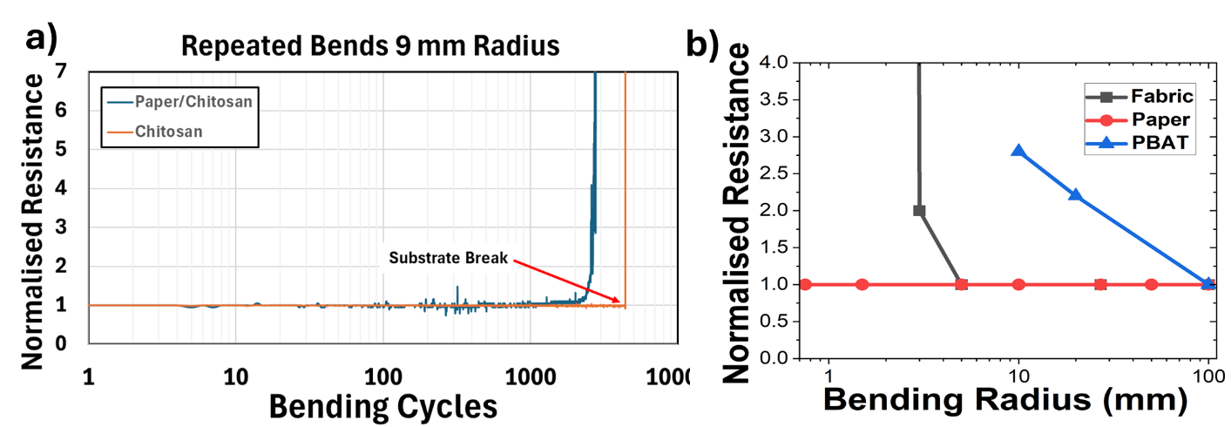
Supplementary Figure 14 – Repeated Bending Tests (a)The normalised resistance of 1 mm wide zn tracks on different substrates for repeated bending round a 9 mm bending radius. (b)The normalised resistance of a 5 mm x 50 mm track on different substrates after 5 bending cycles at different radii.

Water Stability
Samples of Zn on paper are found to completely degrade over 24 hours if immersed in PH6 buffer solution, but this degradation can be prevented simply by painting a layer of cellulose acetate over the surface. If a controlled degradation is required, for instance in bioresorbable applications, then chitosan can act as a suitable encapsulant due to its ability to slowly dissolve in acidic conditions. In Supplementary Figure 7 we show that encapsulation with a thin layer of chitosan can increase the degradation time of a Zn pattern in PH5 buffer solution can be increased from a few hours when unencapsulated to 7 days before the acid breaks through to the Zn layer.. As shown on Supplementary Figure 8, the rate of degradation is strongly dependent on the PH of the buffer solution, with strongly acidic or alkaline solutions causing rapid degradation while PH7 shows comparatively slow dissolution.
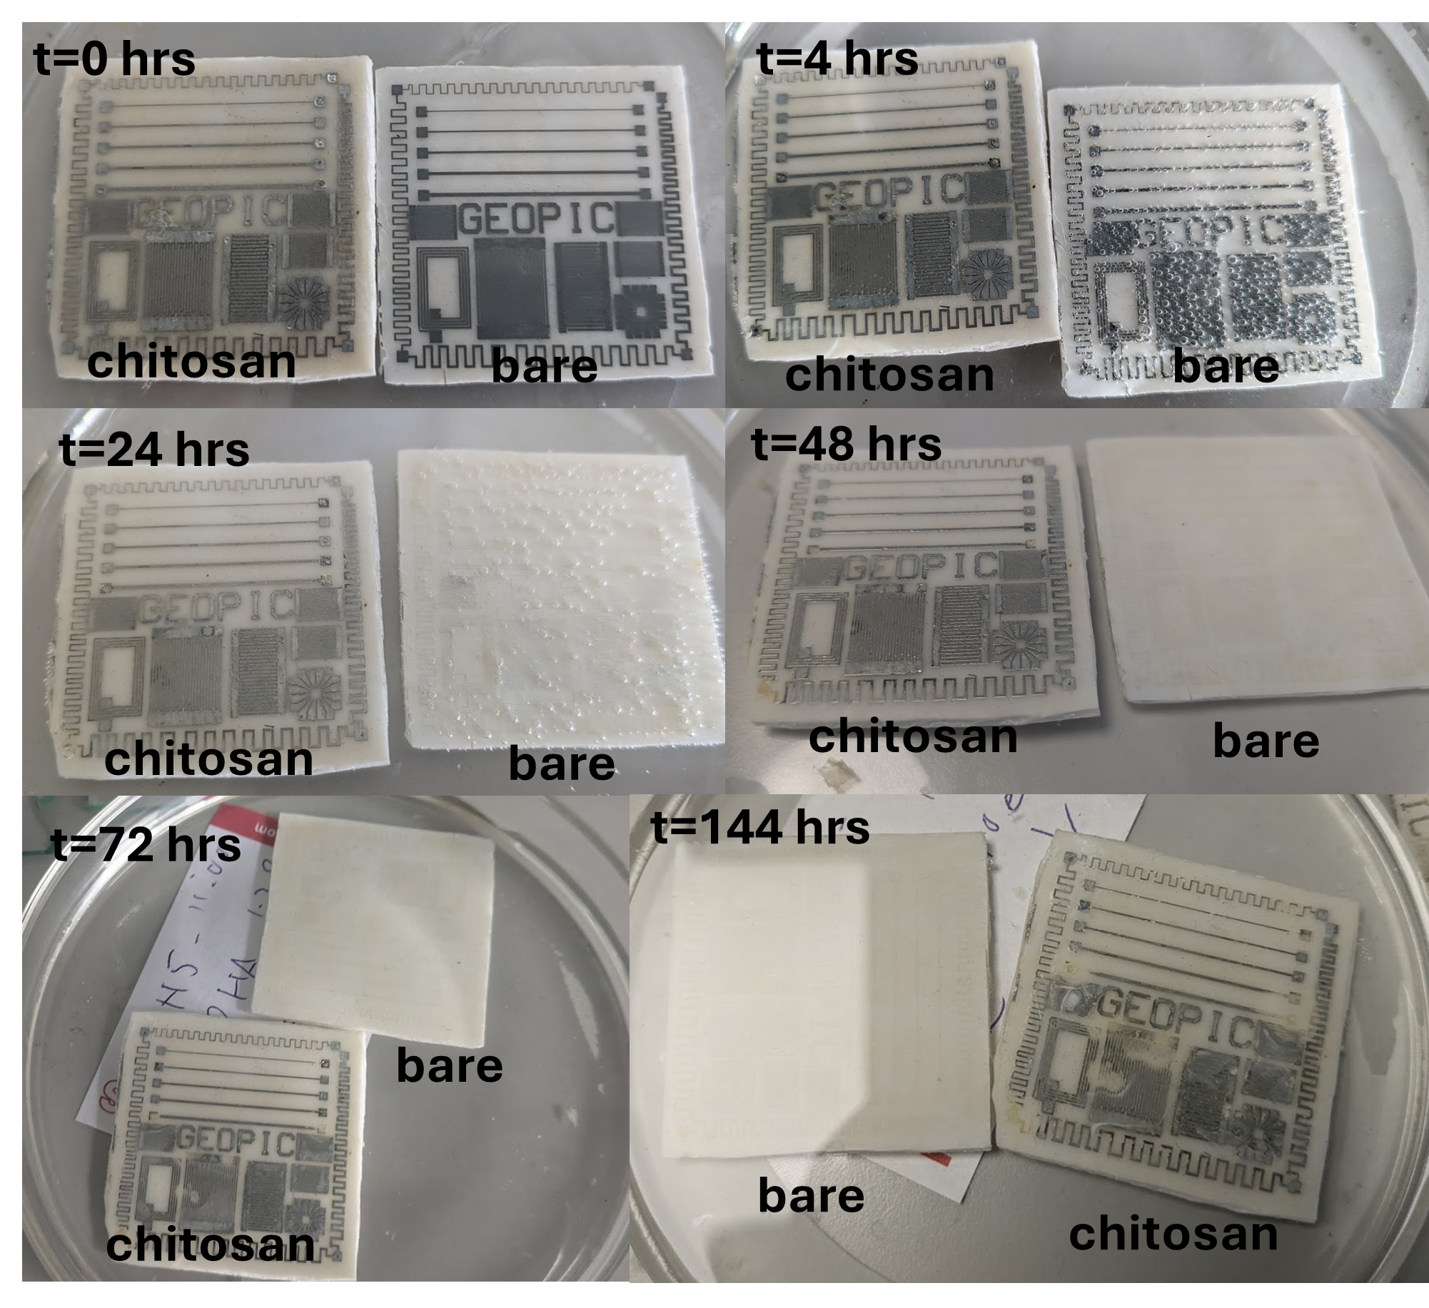
Supplementary Figure 15 – Erosion in Buffer Solution - Comparison of zinc samples on PHBV substrates immersed in a PH5 buffer solution. After 24 hours the unencapsulated sample is completely clean while the chitosan sample remains pristine. After 48 hours some pinholes become noticeable at probing points on the sample. After 72 hours these defect points begin to expand, and after 144 hours there is substantial degradation.

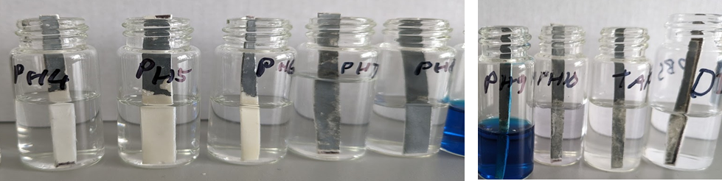
Supplementary Figure 16 – Dissolution vs PH - Strips of a 20 mΩ/sq film of zinc on PHBV after being immersed for 24 hours in different buffer solutions from PH4 (left) to PH10, tap water, and deionised water (right)

SI4: Further LCA Data
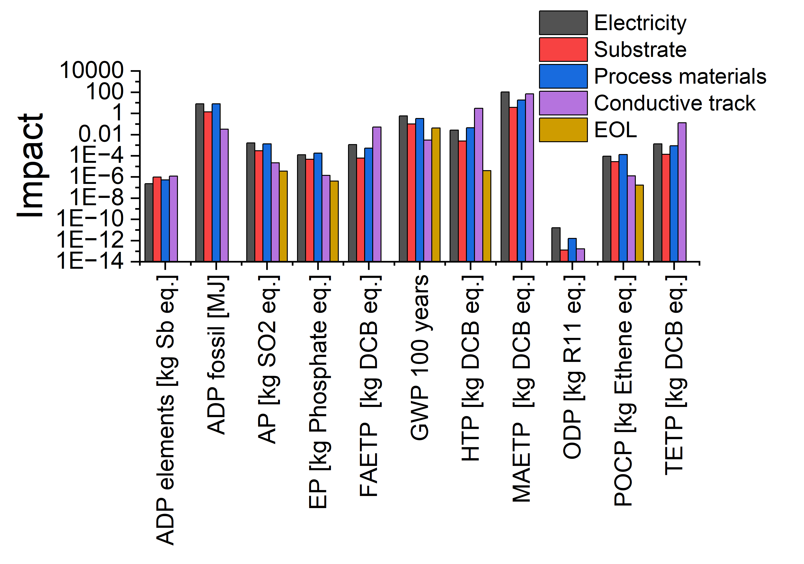

Supplementary Figure 17:- FR4 LCA - the breakdown by process including EoL for an incinerated FR4-Cu PCB
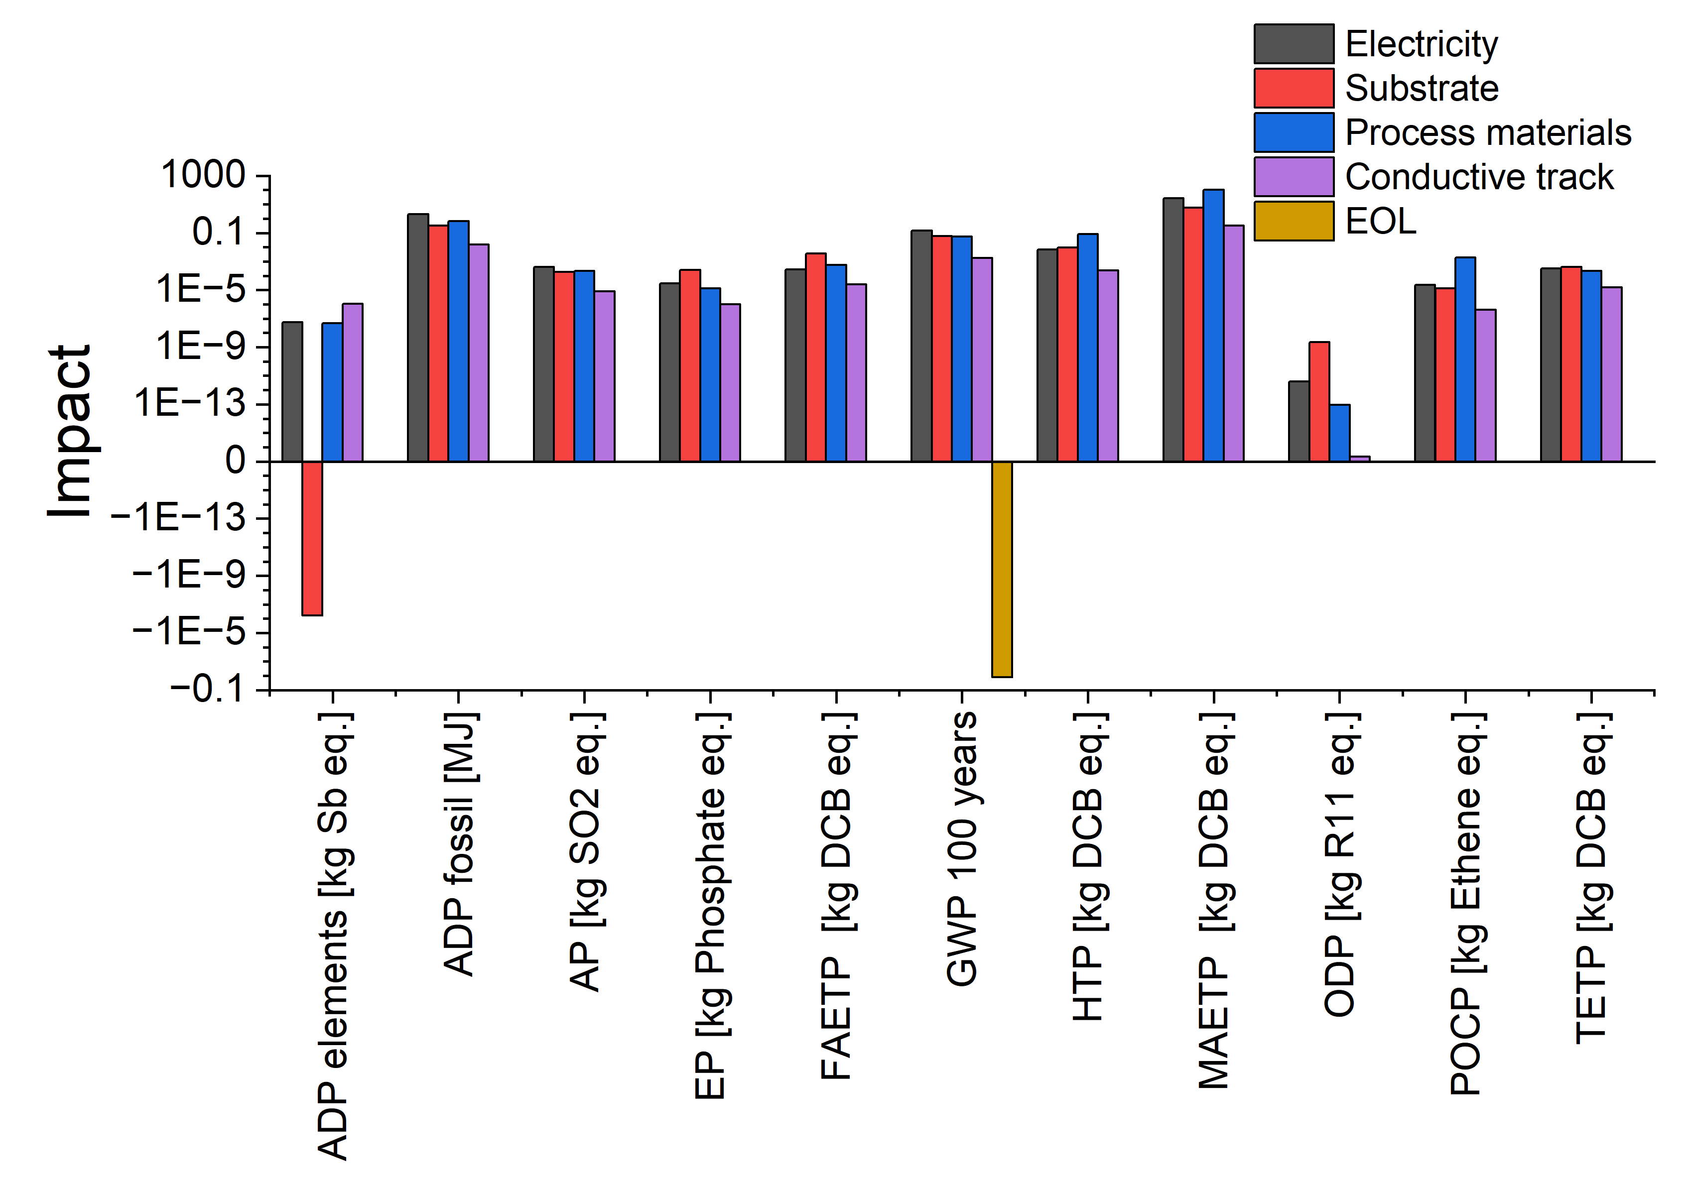
Supplementary Figure 18:- Zn LCA - The detailed breakdown for the Zn-based PCB that is put into landfill that includes the EoL.
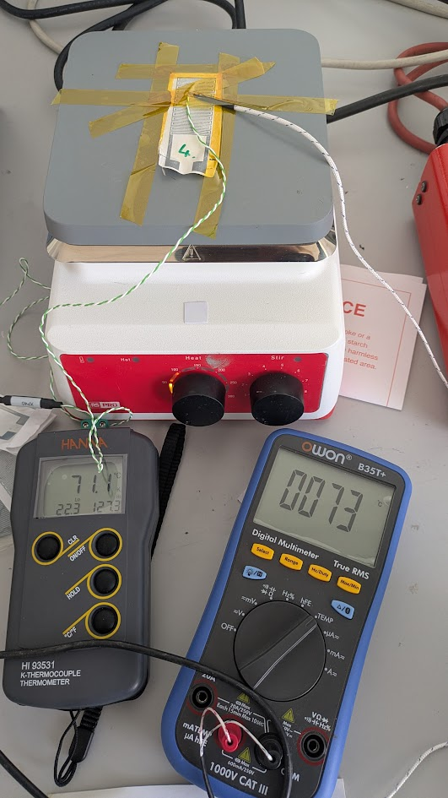
Supplementary Figure 19 – Temperature Measuring Setup - The setup for measuring the TCR of the heaters/temperature sensors. The sample is fixed to the hotplate using double sided Al tape within the serpentine region in order to assist in thermal contact.
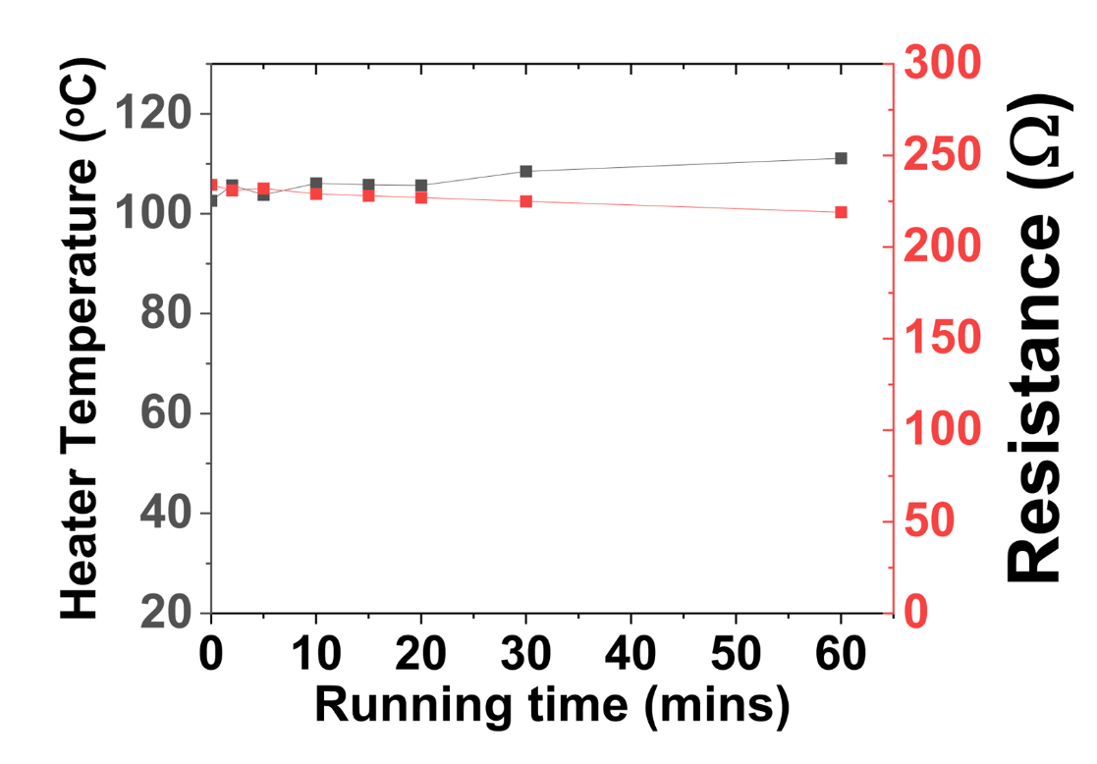
Supplementary Figure 20 – Another Stability measurement - Resistance and temperature measurements of a heater circuit running at 18 V (above 100 C) for 60 minutes

Thermal cycle tests have been conducted in accordance with JESD22-A104 testign standards, and the performance remained within the limits of the tests.
This work does not report an exhaustive reliability test program; this would need to be conducted at an independent and accredited test house.
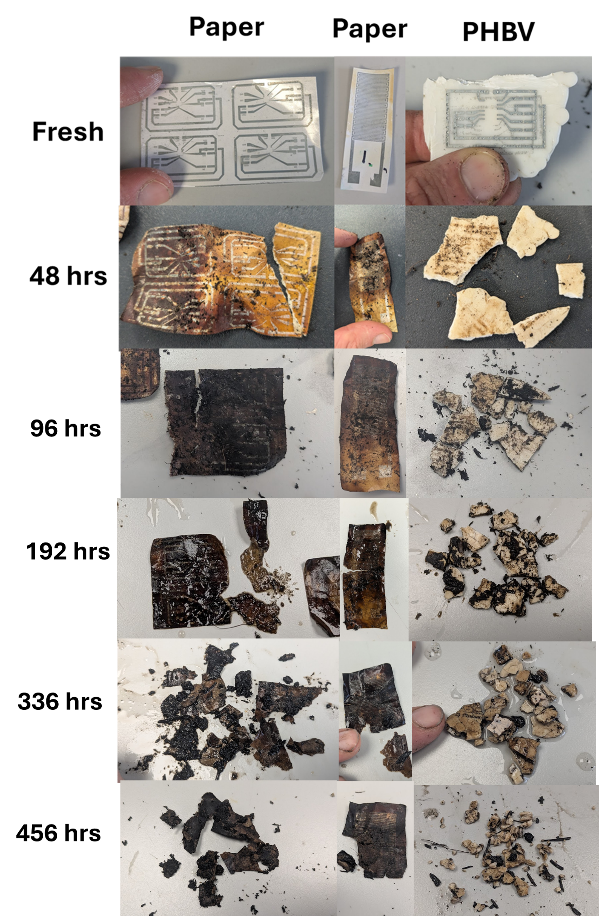
Supplementary Figure 21 – Degradation in Composting Conditions - Degradation images of circuit samples based on either paper or PHBV substrates before and after being buried under soil at industrial composting conditions (70 ºC, 85 % humidity)
Supplementary Figure 22 – Stability Carrying Current – Line resistance of n=5 Zn devices, consisting of 60 mm length lines with 2 mm width on a paper substrates, as they are stressed by constantly carrying a current of 150 mA while held at elevated temperature (80 ºC) under atmospheric conditions (~50 % RH). 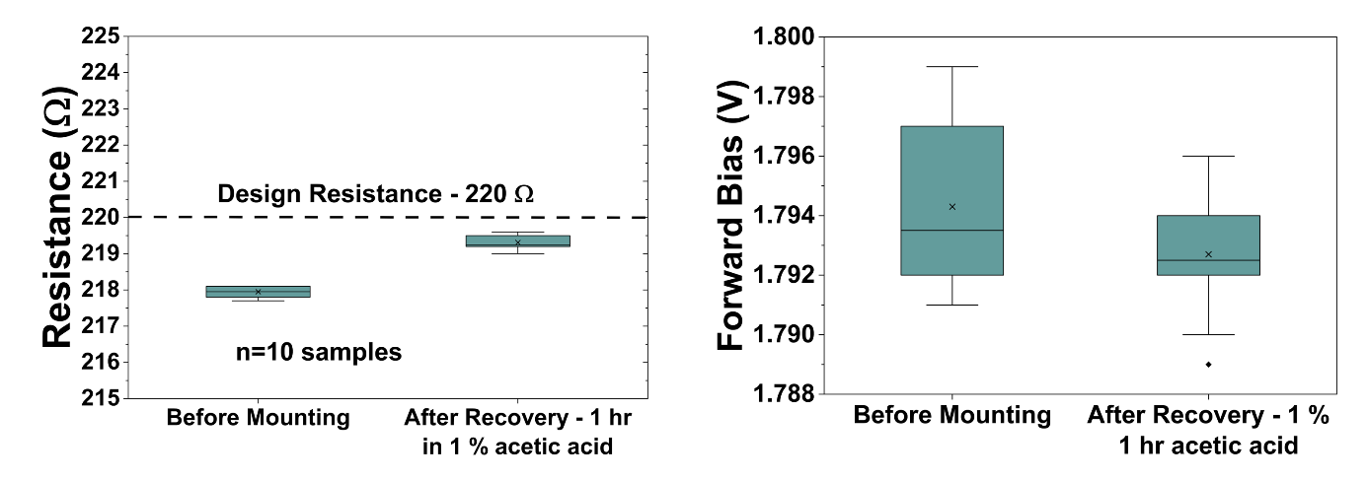
Supplementary Figure 23 – Recovery Efficiency - Performance metrics of resistors and LEDs before and after being put through the recycling process described in section 4.4. As can be seen, there is a negligible change in forward bias for the LEDs, and the change in resistance is well within the 5 % design tolerance of the 220 Ω resistors.
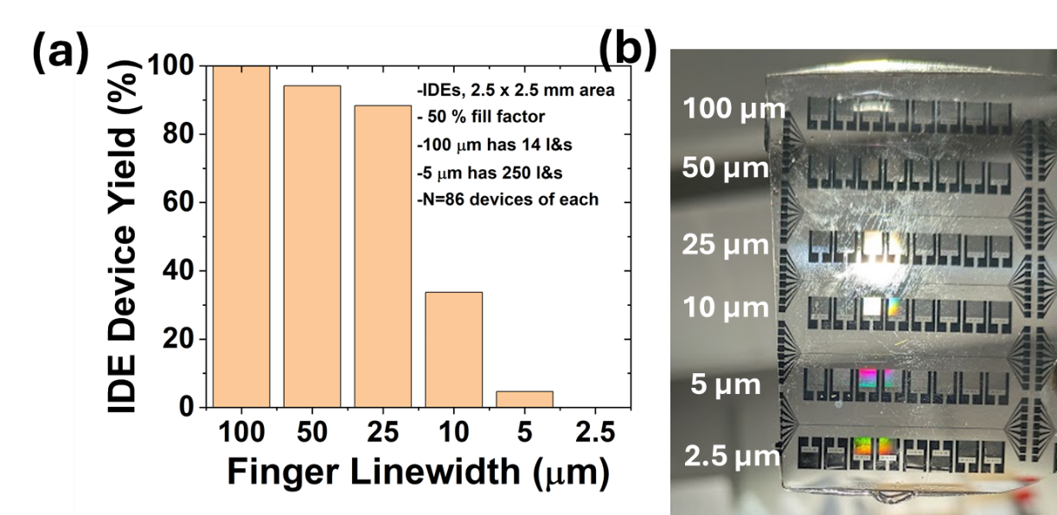
Supplementary Figure 24 – Device Yield - Yield tests performed using interdigitated electrode patterns with different linewidths on UV resin substrates. The devices have a 2.5x2.5 mm active area, consisting of line and space patterns with 50 % fill factor, and were fabricated in batches as shown in (b). Note the diffraction patterns occurring on the finer linewidth samples. These were fabricated outside of a cleanroom, meaning the yield drops rapidly at linewidths below 25 µm, but further optimisation could improve this.

SI5: Literature Comparisons

Supplementary Table 1- Biodegradable materials for transient electronics and manufacturing techniques¹⁻³. ‡Abundant materials; *materials in moderate amount;(according to Goldschmidt classification)⁴.
Functionality | Biodegradable and Natural Materials | Manufacturing techniques
Dielectric materials | Inorganics: MgO‡, SiO₂‡, Si₃N₄‡; Synthetic polymers: Polylactic Acid‡, Polyvinyl alcohol‡; Naturally derived polymers: glucose‡, cellulose‡, silk*, shellac‡, gelatin‡, amino acids‡, peptides‡ | Wet deposition techniques, Printing, Electrospinning
Semiconductor materials | Inorganics: ZnO*, Si‡, SiGe*; Synthetic polymers: Polythiophenes‡, Polypyroles‡, Naturally derived molecules: Indigo‡, melanin‡, β-carotene‡ | Conventional methods,  Wet deposition techniques, Printing
Electrode materials | Metals: Mg‡, Zn*, W*, Fe‡, Mo*, Cu*; Inorganic: Aluminium Zinc Oxide*, Carbon Nanotubes‡, Graphene‡, Graphite‡, Carbon black‡; Polymer-based: PEDOT:PSS‡, Polyaniline‡. | Metal deposition, Printing
Substrates/ Encapsulants | Naturally derived polymers: silk*, cellulose acetate‡, chitosan‡, collagen‡, starch‡,  Synthetic polymers: Polyhydroxyalkanoates‡, Polylactic acid‡, Ecoflex‡, Fibernyl‡, Polyvinyl alcohol‡ | Spin coating, drop casting, electrospinning

Supplementary Table 2– A review of different degradeable conductors and their best reported properties. Our work is shown in green, and non-degradeable alternatives are shown in red for comparisson.
Material | Reported Conductivity (S/m) | Best Sheet Resistance (mΩ/sq) | Deposition Method | Minimum Linewidth
PEDOT^{5,6} | 1x10⁴ | 5,000 | Inkjet Printing/Spin Coating | 300 µm
Polyaniline^{7,8} | 1x10² | 30,000 | Drop Casting | Drop Cast (~ 1 mm)
Aluminium Zinc Oxide^{9,10} | 1x10⁵ | 10,000 | Inkjet Printing/Spin Coating | 35 µm
Carbon^{11,12} | 2x10⁵ | 22,000 | Screen Printing | 300 µm
Molybdenum Paste¹³ | 1x10³ | 1,000 | Extrusion | ~1 mm
Magnesium¹⁴ | 2x10⁷ | 250 | Evaporation | Shadow Mask (~100 µm)
Zinc Nanoparticles¹⁵⁻¹⁷ | 5x10⁶ | 130 | Print and chemical sinter | 250
Laser Patterned Zinc¹⁸ | 1.7x10⁷ | 1 | Laser Cutting Zn Foils | 1000 μm
Printed Silver¹⁹ | 3x10⁷ | ~3 (For 10 µm thickness) | Inkjet printing²⁰ /Screen printing²¹ / extrusion²² | ~100 µm/~20 µm / 1µm
Copper PCB²³ | 6x10⁷ | ~1.5 (For 10 µm thickness) | Lamination then Photolithography | ~2x copper thickness
Our Work | 1.7 x10⁷ (within margin of error) | 3 | Electrodeposition/ Overmoulding | 5 µm

Supplementary Table 3– Comparisson of Substrate Materials - Various materials can be used as a substrate material, and the resultant properties which could be achieved using the same Electrodeposition properties (Plating conditions of 20 mA/cm² for 5 minutes). Adhesion tests were done according to the ISO 4624:2016 standard test with a semi-quantitative scale of 0-5, with 0 being the best. Melting points and biodegradability data is collected from the literature.
Material | Melting Point (ºC) | R_{sheet} (mΩ/sq) | ISO 4624 Adhesion Score (0= best, 5=worst) | Biodegradability | Transparency (>80% @ 550nm)
UV Resin | ~200 (degrades) | 22 | 0 | None | Yes
Fibernyl^{TM 24} | 150 | 61 | 0 | Compostable (EN1352) | No
Texwipe (polyester fabric) | 205 | 50 | 5 | No | No
PCL ²⁵ | 60 | 50 | 0 | Yes | No
PHBV ²⁶ | 150 | 20 | 0 | Compostable (EN1352) | No
Paper ²⁷ | ~200 (degrades) | 19 | 1 | Yes | No
Chitosan ²⁸ | ~200(degrades) | 21 | N/A | Yes | Yes
Cellulose Acetate²⁹ | 260 | 23 | N/A | Yes | Yes
PLA ³⁰⁻³² | 150 | 34 | 0 | Compostable (EN1352) | Yes
PBAT ^{30,33} | 120 | 61 | 0 | Yes | No
Glucose | 150 | 75 | 4 | Edible | Yes
Chocolate | 40 | 19 | 0 | Edible | No

Supplementary Table 4– A comparison of literature key performance indicators for PCBs made from conventional materials and from biodegradable materials in our method.
PCB Material | Maximum Operating Temperature (oC) | Minimum Routing Pitch (μm) | Dielectric Loss Tangent | Dielectric Constant
FR4³⁴ | ~150 oC | 100 (commercial)  50 (HDI/LDI) | 0.026 (2 GHz) | 4.4 (2 GHz)
Polyimide³⁵ | >260 oC | 100 (commercial)  25 (fine flex) | 0.015 (1 GHz) | 3.24 (1 GHz)
Paper³⁶ | ~120 oC | 10 (our work) | 0.09 (5 GHz) | 3.2 (5 GHz)
PHBV³⁶ | ~80 oC | 10 (our work) | 0.008 (5 GHz) | 2.9 (5 GHz)
Chitosan^{37,38} | ~120 oC | 10 (our work) | 0.32 (1 MHz) | 3.0 (1 MHz)

Note: HF integrity has not been included in analysis and is needed if circuit frequencies exceed 10MHz.

SI6: References
1 Tan, M. J. et al. Biodegradable electronics: cornerstone for sustainable electronics and transient applications. Journal of Materials Chemistry C 4, 5531-5558 (2016). https://doi.org/10.1039/C6TC00678G
2 Han, W. B., Lee, J. H., Shin, J.-W. & Hwang, S.-W. Advanced Materials and Systems for Biodegradable, Transient Electronics. Advanced Materials 32, 2002211 (2020). https://doi.org/https://doi.org/10.1002/adma.202002211
3 Palmieri, E. et al. Toward Sustainable Electronics: Exploiting the Potential of a Biodegradable Cellulose Blend for Photolithographic Processes and Eco-Friendly Devices. Advanced Materials Technologies 9, 2301282 (2024). https://doi.org/https://doi.org/10.1002/admt.202301282
4 Goldschmidt, V. M. Geochemistry. (Oxford:Clarendon Press, 1954).
5 Teo, M. A.-O., Lim, K., Aw, K. C., Kee, S. & Stringer, J. Towards biodegradable conducting polymers by incorporating seaweed cellulose for decomposable wearable heaters.
6 Lee, S., Hong, Y. & Shim, B. S. Biodegradable PEDOT:PSS/Clay Composites for Multifunctional Green-Electronic Materials. Advanced Sustainable Systems 6, 2100056 (2022). https://doi.org/https://doi.org/10.1002/adsu.202100056
7 Khan, T., Vadivel, G., Ramasamy, B., Murugesan, G. & Sebaey, T. A. Biodegradable Conducting Polymer-Based Composites for Biomedical Applications—A Review. Polymers 16 (2024).
8 Zare, E. N. et al. Progress in Conductive Polyaniline-Based Nanocomposites for Biomedical Applications: A Review. Journal of Medicinal Chemistry 63, 1-22 (2020). https://doi.org/10.1021/acs.jmedchem.9b00803
9 Zareei, A. et al. A Biodegradable Hybrid Micro/Nano Conductive Zinc Paste for Paper-Based Flexible Bioelectronics. Advanced Materials Technologies 7, 2101722 (2022). https://doi.org/https://doi.org/10.1002/admt.202101722
10 Hsiao, W.-T., Tseng, S.-F., Huang, K.-C. & Chiang, D. Electrode patterning and annealing processes of aluminum-doped zinc oxide thin films using a UV laser system. Optics and Lasers in Engineering 51, 15-22 (2013). https://doi.org/https://doi.org/10.1016/j.optlaseng.2012.08.003
11 Shadabfar, M., Ehsani, M., Khonakdar, H. A., Abdouss, M. & Ameri, T. Waterborne conductive carbon paste with an eco-friendly binder. Cellulose 30, 1759-1772 (2023). https://doi.org/10.1007/s10570-022-04998-5
12 Liu, L., Shen, Z., Zhang, X. & Ma, H. Highly conductive graphene/carbon black screen printing inks for flexible electronics. Journal of Colloid and Interface Science 582, 12-21 (2021). https://doi.org/https://doi.org/10.1016/j.jcis.2020.07.106
13 Kim, K.-S. et al. Biodegradable Molybdenum/Polybutylene Adipate Terephthalate Conductive Paste for Flexible and Stretchable Transient Electronics. Advanced Materials Technologies 7, 2001297 (2022). https://doi.org/https://doi.org/10.1002/admt.202001297
14 LLC, M. MatWeb: Online Materials Information Resource, <http://www.matweb.com> (2024).
15 Fumeaux, N. & Briand, D. Zinc hybrid sintering for printed transient sensors and wireless electronics. npj Flexible Electronics 7, 14 (2023). https://doi.org/10.1038/s41528-023-00249-0
16 Majee, S. et al. Low temperature chemical sintering of inkjet-printed Zn nanoparticles for highly conductive flexible electronic components. npj Flexible Electronics 5, 14 (2021). https://doi.org/10.1038/s41528-021-00111-1
17 Baumbauer, C. L., Gopalakrishnan, A., Atreya, M., Whiting, G. L. & Arias, A. C. Polycaprolactone-Based Zinc Ink for High Conductivity Transient Printed Electronics and Antennas. Advanced Electronic Materials 10, 2300658 (2024). https://doi.org/https://doi.org/10.1002/aelm.202300658
18 Gopalakrishnan, S. et al. A biodegradable chipless sensor for wireless subsoil health monitoring. Scientific Reports 12, 8011 (2022). https://doi.org/10.1038/s41598-022-12162-z
19 Fernandes, I. J. et al. Silver nanoparticle conductive inks: synthesis, characterization, and fabrication of inkjet-printed flexible electrodes. Scientific Reports 10, 8878 (2020). https://doi.org/10.1038/s41598-020-65698-3
20 Kuusisto, E. et al. Inkjet-printed flexible silver electrodes on thiol-enes. Sensors and Actuators B: Chemical 336, 129727 (2021). https://doi.org/https://doi.org/10.1016/j.snb.2021.129727
21 Hyun, W. J. et al. Screen Printing of Highly Loaded Silver Inks on Plastic Substrates Using Silicon Stencils. ACS Applied Materials & Interfaces 7, 12619-12624 (2015). https://doi.org/10.1021/acsami.5b02487
22 Losi, T. et al. High Frequency Solution-Processed Organic Field-Effect Transistors with High-Resolution Printed Short Channels. Advanced Functional Materials 33, 2302656 (2023). https://doi.org/https://doi.org/10.1002/adfm.202302656
23 PCBPrime. How Thick Is 1oz Copper?, <https://pcbprime.com/pcb-tips/how-thick-is-1oz-copper/> (2024).
24 Bioplasticsshop. Fibernyl, <https://bioplasticshop.com/product-categorie/fibernyl-en/> (2024).
25 Aoyama, T. et al. Development of a new poly-ε-caprolactone with low melting point for creating a thermoset mask used in radiation therapy. Scientific Reports 11, 20409 (2021). https://doi.org/10.1038/s41598-021-00005-2
26 Nevoralová, M. et al. Structure Characterization and Biodegradation Rate of Poly(ε-caprolactone)/Starch Blends. Frontiers in Materials 7 (2020). https://doi.org/10.3389/fmats.2020.00141
27 Alvarez, J. V. L., Larrucea, M. A., Bermúdez, P. A. & Chicote, B. L. Biodegradation of paper waste under controlled composting conditions. Waste Management 29, 1514-1519 (2009). https://doi.org/https://doi.org/10.1016/j.wasman.2008.11.025
28 Wrońska, N., Katir, N., Nowak-Lange, M., El Kadib, A. & Lisowska, K. Biodegradable Chitosan-Based Films as an Alternative to Plastic Packaging. Foods 12 (2023). https://doi.org/10.3390/foods12183519
29 Yadav, N. & Hakkarainen, M. Degradable or not? Cellulose acetate as a model for complicated interplay between structure, environment and degradation. Chemosphere 265, 128731 (2021). https://doi.org/https://doi.org/10.1016/j.chemosphere.2020.128731
30 Jiang, L., Wolcott, M. P. & Zhang, J. Study of Biodegradable Polylactide/Poly(butylene adipate-co-terephthalate) Blends. Biomacromolecules 7, 199-207 (2006). https://doi.org/10.1021/bm050581q
31 Kalita, N. K. et al. Biodegradation and characterization study of compostable PLA bioplastic containing algae biomass as potential degradation accelerator. Environmental Challenges 3, 100067 (2021). https://doi.org/https://doi.org/10.1016/j.envc.2021.100067
32 Hernández-García, E., Vargas, M., Chiralt, A. & González-Martínez, C. Biodegradation of PLA-PHBV Blend Films as Affected by the Incorporation of Different Phenolic Acids. Foods 11 (2022). https://doi.org/10.3390/foods11020243
33 Fu, Y., Wu, G., Bian, X., Zeng, J. & Weng, Y. Biodegradation Behavior of Poly(Butylene Adipate-Co-Terephthalate) (PBAT), Poly(Lactic Acid) (PLA), and Their Blend in Freshwater with Sediment. Molecules 25 (2020). https://doi.org/10.3390/molecules25173946
34 Cai, L. & Zeng, Y. in 2020 IEEE MTT-S International Wireless Symposium (IWS). 1-3.
35 Takahashi, R. et al. Development of Polyimides with Low Dielectric Loss Tangent by Incorporating Polysiloxanes with Phenyl Side Groups. Macromolecular Rapid Communications 46, 2500115 (2025). https://doi.org/https://doi.org/10.1002/marc.202500115
36 Bittolo Bon, S. et al. Self-adhesive plasticized regenerated silk on poly(3-hydroxybutyrate-co-3-hydroxyvalerate) for bio-piezoelectric force sensor and microwave circuit design. Journal of Applied Polymer Science 138, 49726 (2021). https://doi.org/https://doi.org/10.1002/app.49726
37 Prashanth, S. et al. Structural, electrical and dielectric properties of chitosan/polyaniline/vanadium-pentoxide hybrid nanocomposites. Journal of Molecular Structure 1267, 133600 (2022). https://doi.org/https://doi.org/10.1016/j.molstruc.2022.133600
38 Fang, Z. et al. Modulating crystallinity and dielectric constant of chitosan film for triboelectric polarity shift and performance enhancement in triboelectric nanogenerators. Nano Energy 117, 108923 (2023). https://doi.org/https://doi.org/10.1016/j.nanoen.2023.108923

