Supplementary Materials
Wearable bioelectronic system with conductive hydrogel for wound management through sensing and electrical stimulation
Huijuan Fu^{123#}, Kangbin Bai^{4#}, Xueqin Shuang^{235#}, Rongtai Wan^{6#}, Enling Hu⁷, Wei Zhang⁸, Chen Xiong¹²³, Feng Qin¹²³, Ye Tang¹²³, Jiahua Zhou¹²³, Zhifu Yin^{4*}, Ming Li^{235*}, Yanhua Wang^{123*}, Dianying Zhang^{123*}
¹ Department of Trauma and Orthopedics, Peking University People's Hospital, Beijing, 100044, China
² Key Laboratory of Trauma and Neural Regeneration, Ministry of Education, Peking University, Beijing, 100044, China
³ National Center for Trauma Medicine, Beijing, 100044, China
⁴ School of Mechanical and Aerospace Engineering, Jilin University, Changchun 130025, China
⁵ Trauma Medicine Center, Peking University People's Hospital, Beijing, 100044, China
⁶ Department of Engineering Mechanics, Zhejiang University, Hangzhou 310027, China
⁷ State Key Laboratory of Resource Insects, College of Sericulture, Textile and Biomass Sciences, Southwest University, Chongqing, 400715, China
⁸ Zhengzhou advanced research institute for new materials, Peking University, Zhengzhou, 450003, China
# These authors contributed equally to this work.
*Corresponding authors: 1) Zhifu Yin, Email: yinzf@jlu.edu.cn, Address: No. 5988 Renmin Street, Nanguan District, Changchun City, Jilin Province, China; 2) Ming Li, Email: liming_ort@bjmu.edu.cn, Address: No. 11 Xizhimen South Street, Beijing, China; 3) Yanhua Wang, Email: 94719599@qq.com, Address: No. 11 Xizhimen South Street, Beijing, China.; 4) Dianying Zhang, Email: zdy8016@163.com, Address: No. 11 Xizhimen South Street, Beijing, China.

Supplementary Material
Contents
Figure S1. Free radical polymerization process.
Figure S2. The fracture stress, fracture strain, Young’ modulus and toughness of poly (AM-DAMA) hydrogels with different MBAA concentrations.
Figure S3. Young’ modulus and toughness of poly (AM-DAMA) hydrogel with/out 20 mg mL⁻¹ PEDOT:PSS.
Figure S4. The energy dissipation of the hydrogel with 20 mg mL⁻¹ PEDOT:PSS during cyclic stretching at 400% strain.
Figure S5. Schematic presentation of the lap shear test.
Figure S6. The adhesion mechanism of the hydrogel to different substrates.
Figure S7. Photos of the hydrogel under bending.
Figure S8. The biocompatibility of the conductive and adhesive hydrogel interfaces.
Figure S9. Cryo-electron microscopy images of poly (AM-DAMA)-PEDOT:PSS hydrogel at a size of 2 μm (1000x magnification).
Figure S10. Dynamic oscillatory frequency sweeps (γ=1%) and time sweeps (γ=1%, ω=1 rad s⁻¹) of the hydrogel at 25 °C.
Figure S11. Impedance sensing function remains stable with and without stimulation, displaying consistent readout.
Figure S12. Photographs of the front and back sides of the smart dressing.
Figure S13. a, Photographs showing flexibility and thin layout of the FPCB. b, Photographs showing the application of smart dressing on multiple body parts.
Figure S14. Temperature sensed over time of the Smart Dressing and control group.
Figure S15. Assessment of Ⅰ/Ⅲ collagen, neovascularization, inflammation and immunomodulation in regenerated wound tissue between two groups.
Figure S16. Heat maps illustrating up-regulated genes after being treated with smart dressing on day 7, compared with control group.
Figure S17. Relative expression of the DEGs related to Schwann cell secreting trophic factors and neural regeneration.
Figure S18. Assessment of nervous system development in regenerated wound tissue on day 7 between two groups.
Figure S19. Schematic diagram of the preparation process of poly (AM-DAMA)-PEDOT:PSS hydrogel.
Movie S1. The rat wearing the smart dressing can move freely.
Figure S1. Free radical polymerization process. The initiation system of ascorbic acid and H₂O₂ initiates the free radical polymerization of double bonds (C=C) in AM and DAMA monomers, forming covalent single bonds (C-C) between monomer units to construct the linear polymer backbone.
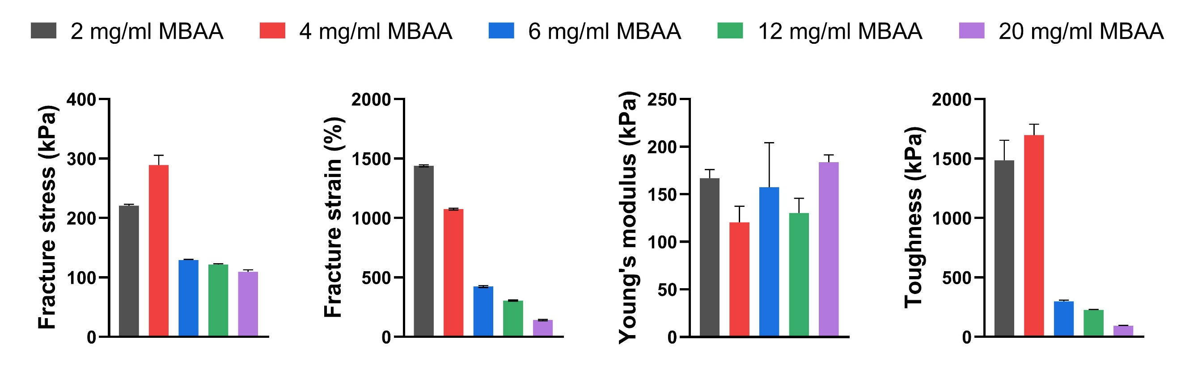
Figure S2. The fracture stress, fracture strain, Young’ modulus and toughness of poly (AM-DAMA) hydrogels with different MBAA concentrations (representing different crosslinking densities).
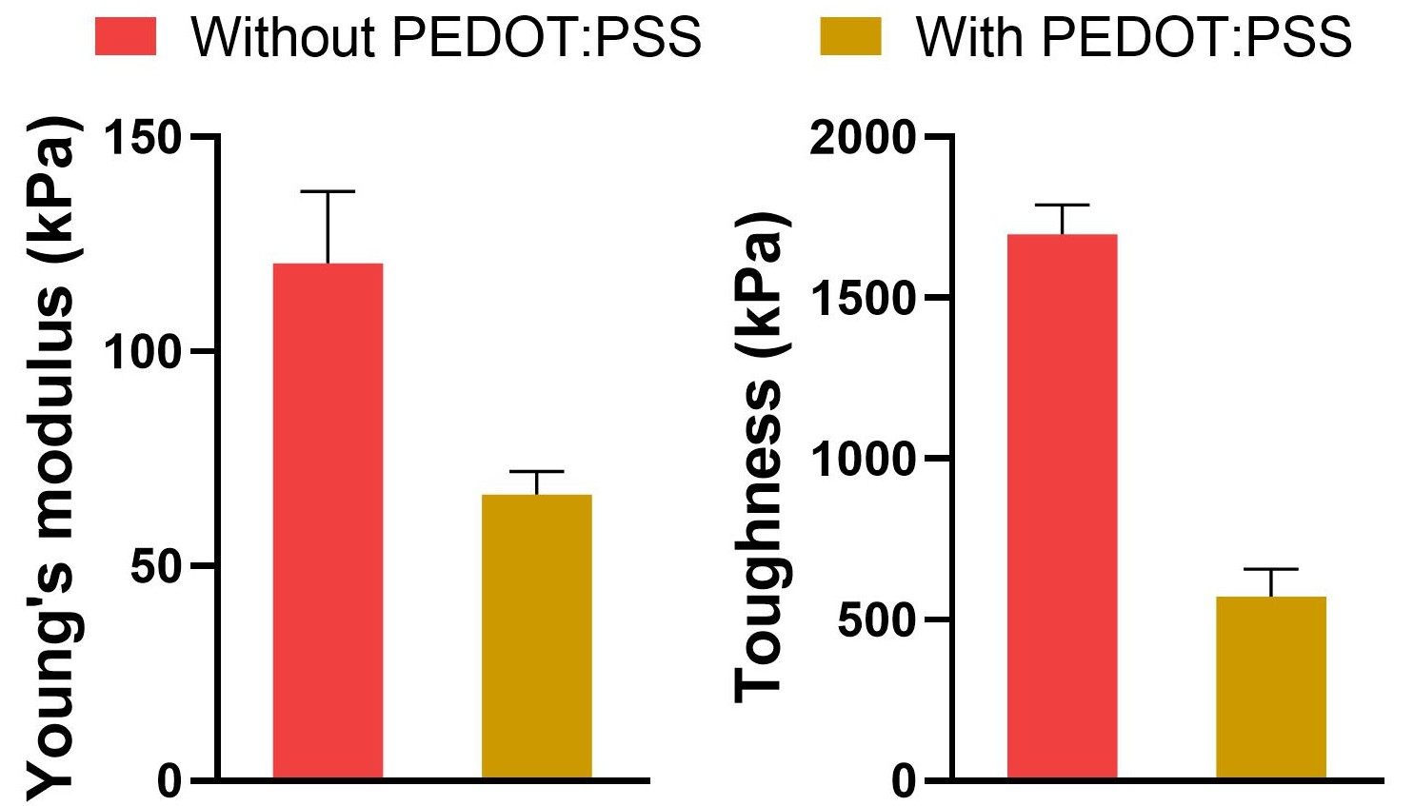
Figure S3. Young’ modulus and toughness of poly (AM-DAMA) hydrogel with/out 20 mg mL⁻¹ PEDOT:PSS
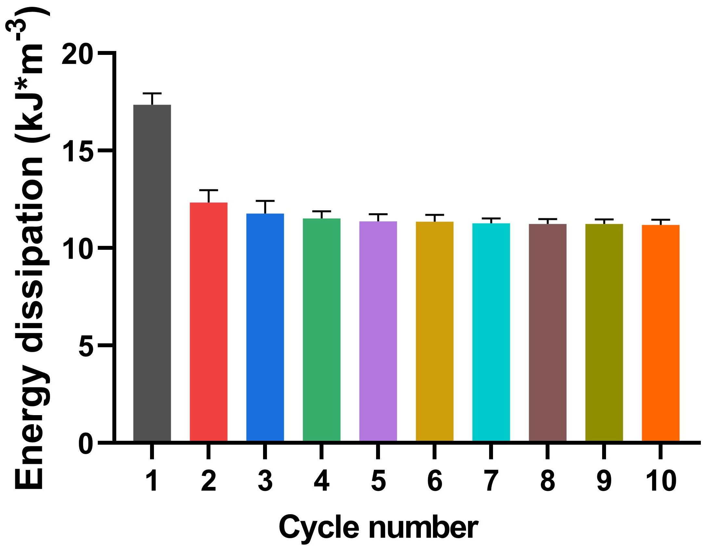
Figure S4. The energy dissipation of the hydrogel with 20 mg mL⁻¹ PEDOT:PSS during cyclic stretching at 400% strain.
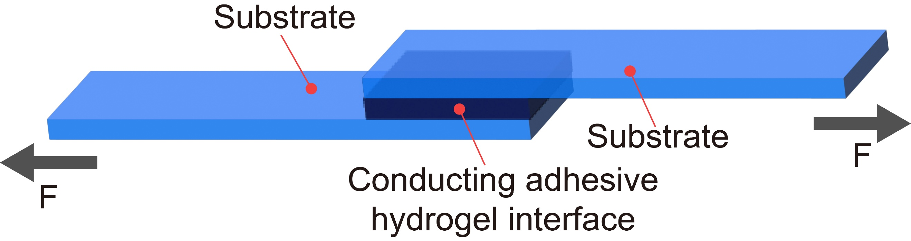
Figure S5. Schematic presentation of the lap shear test.
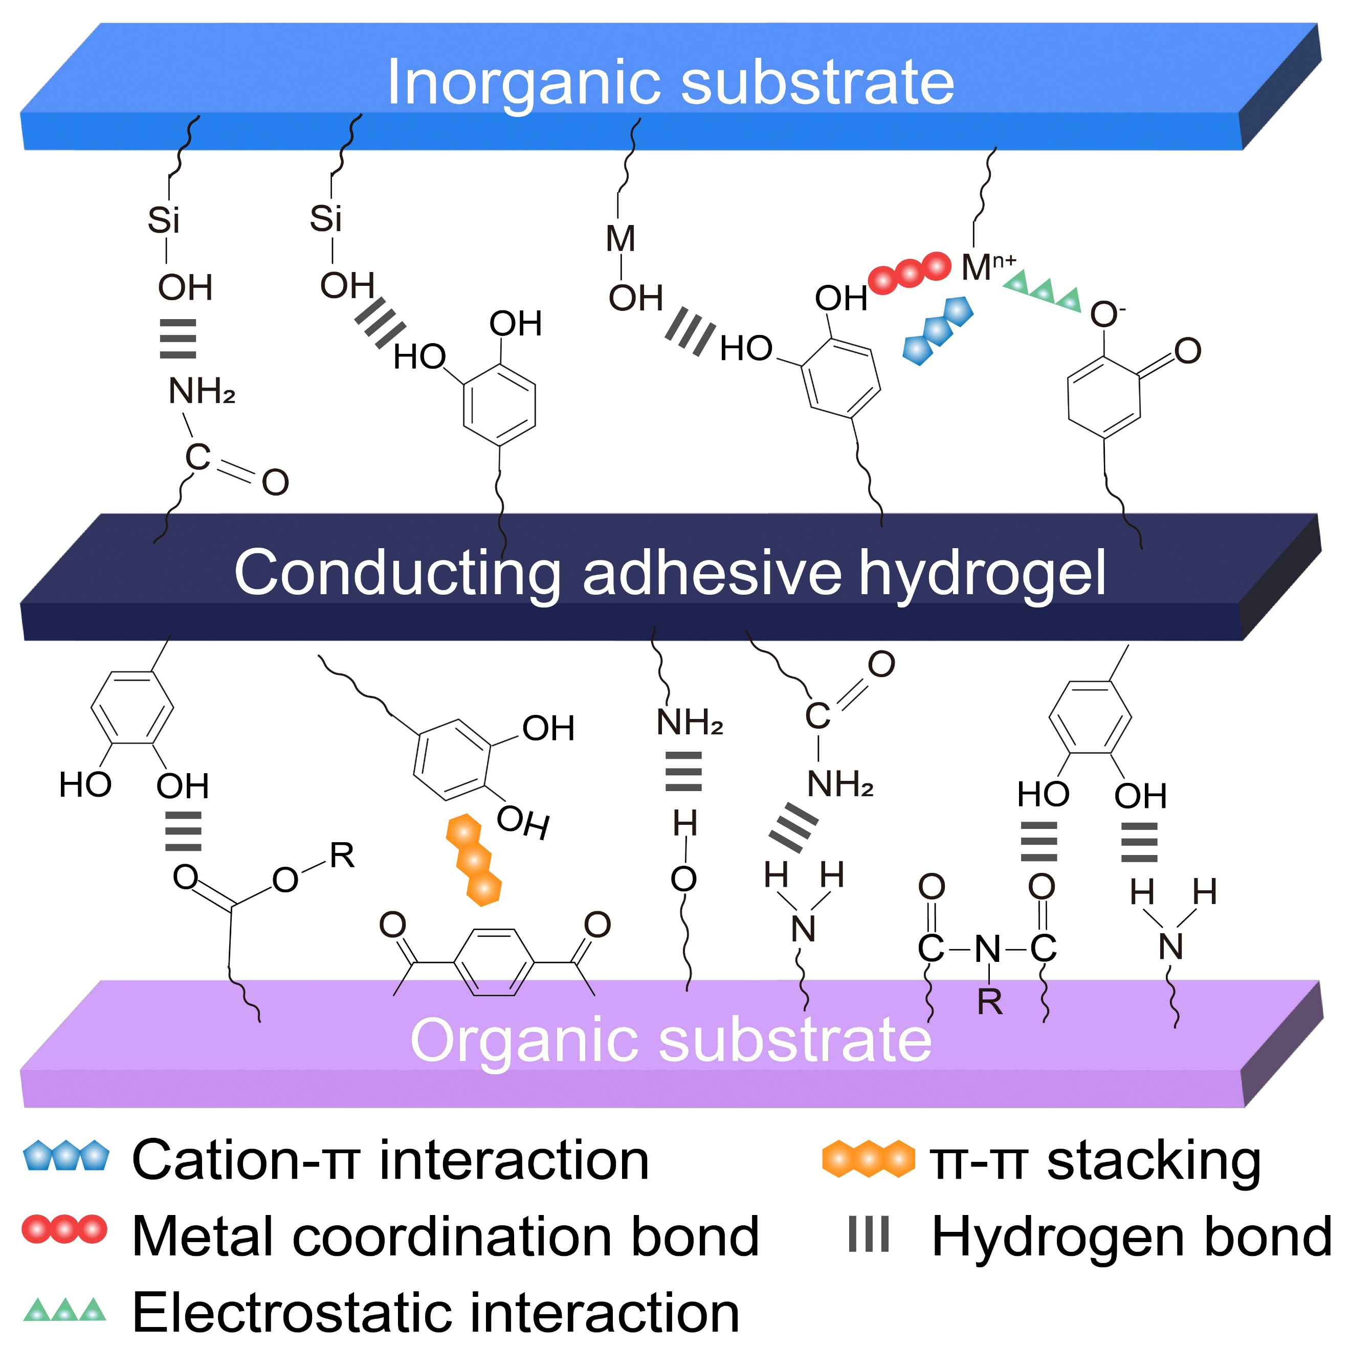
Figure S6. The adhesion mechanism of the hydrogel to different substrates.
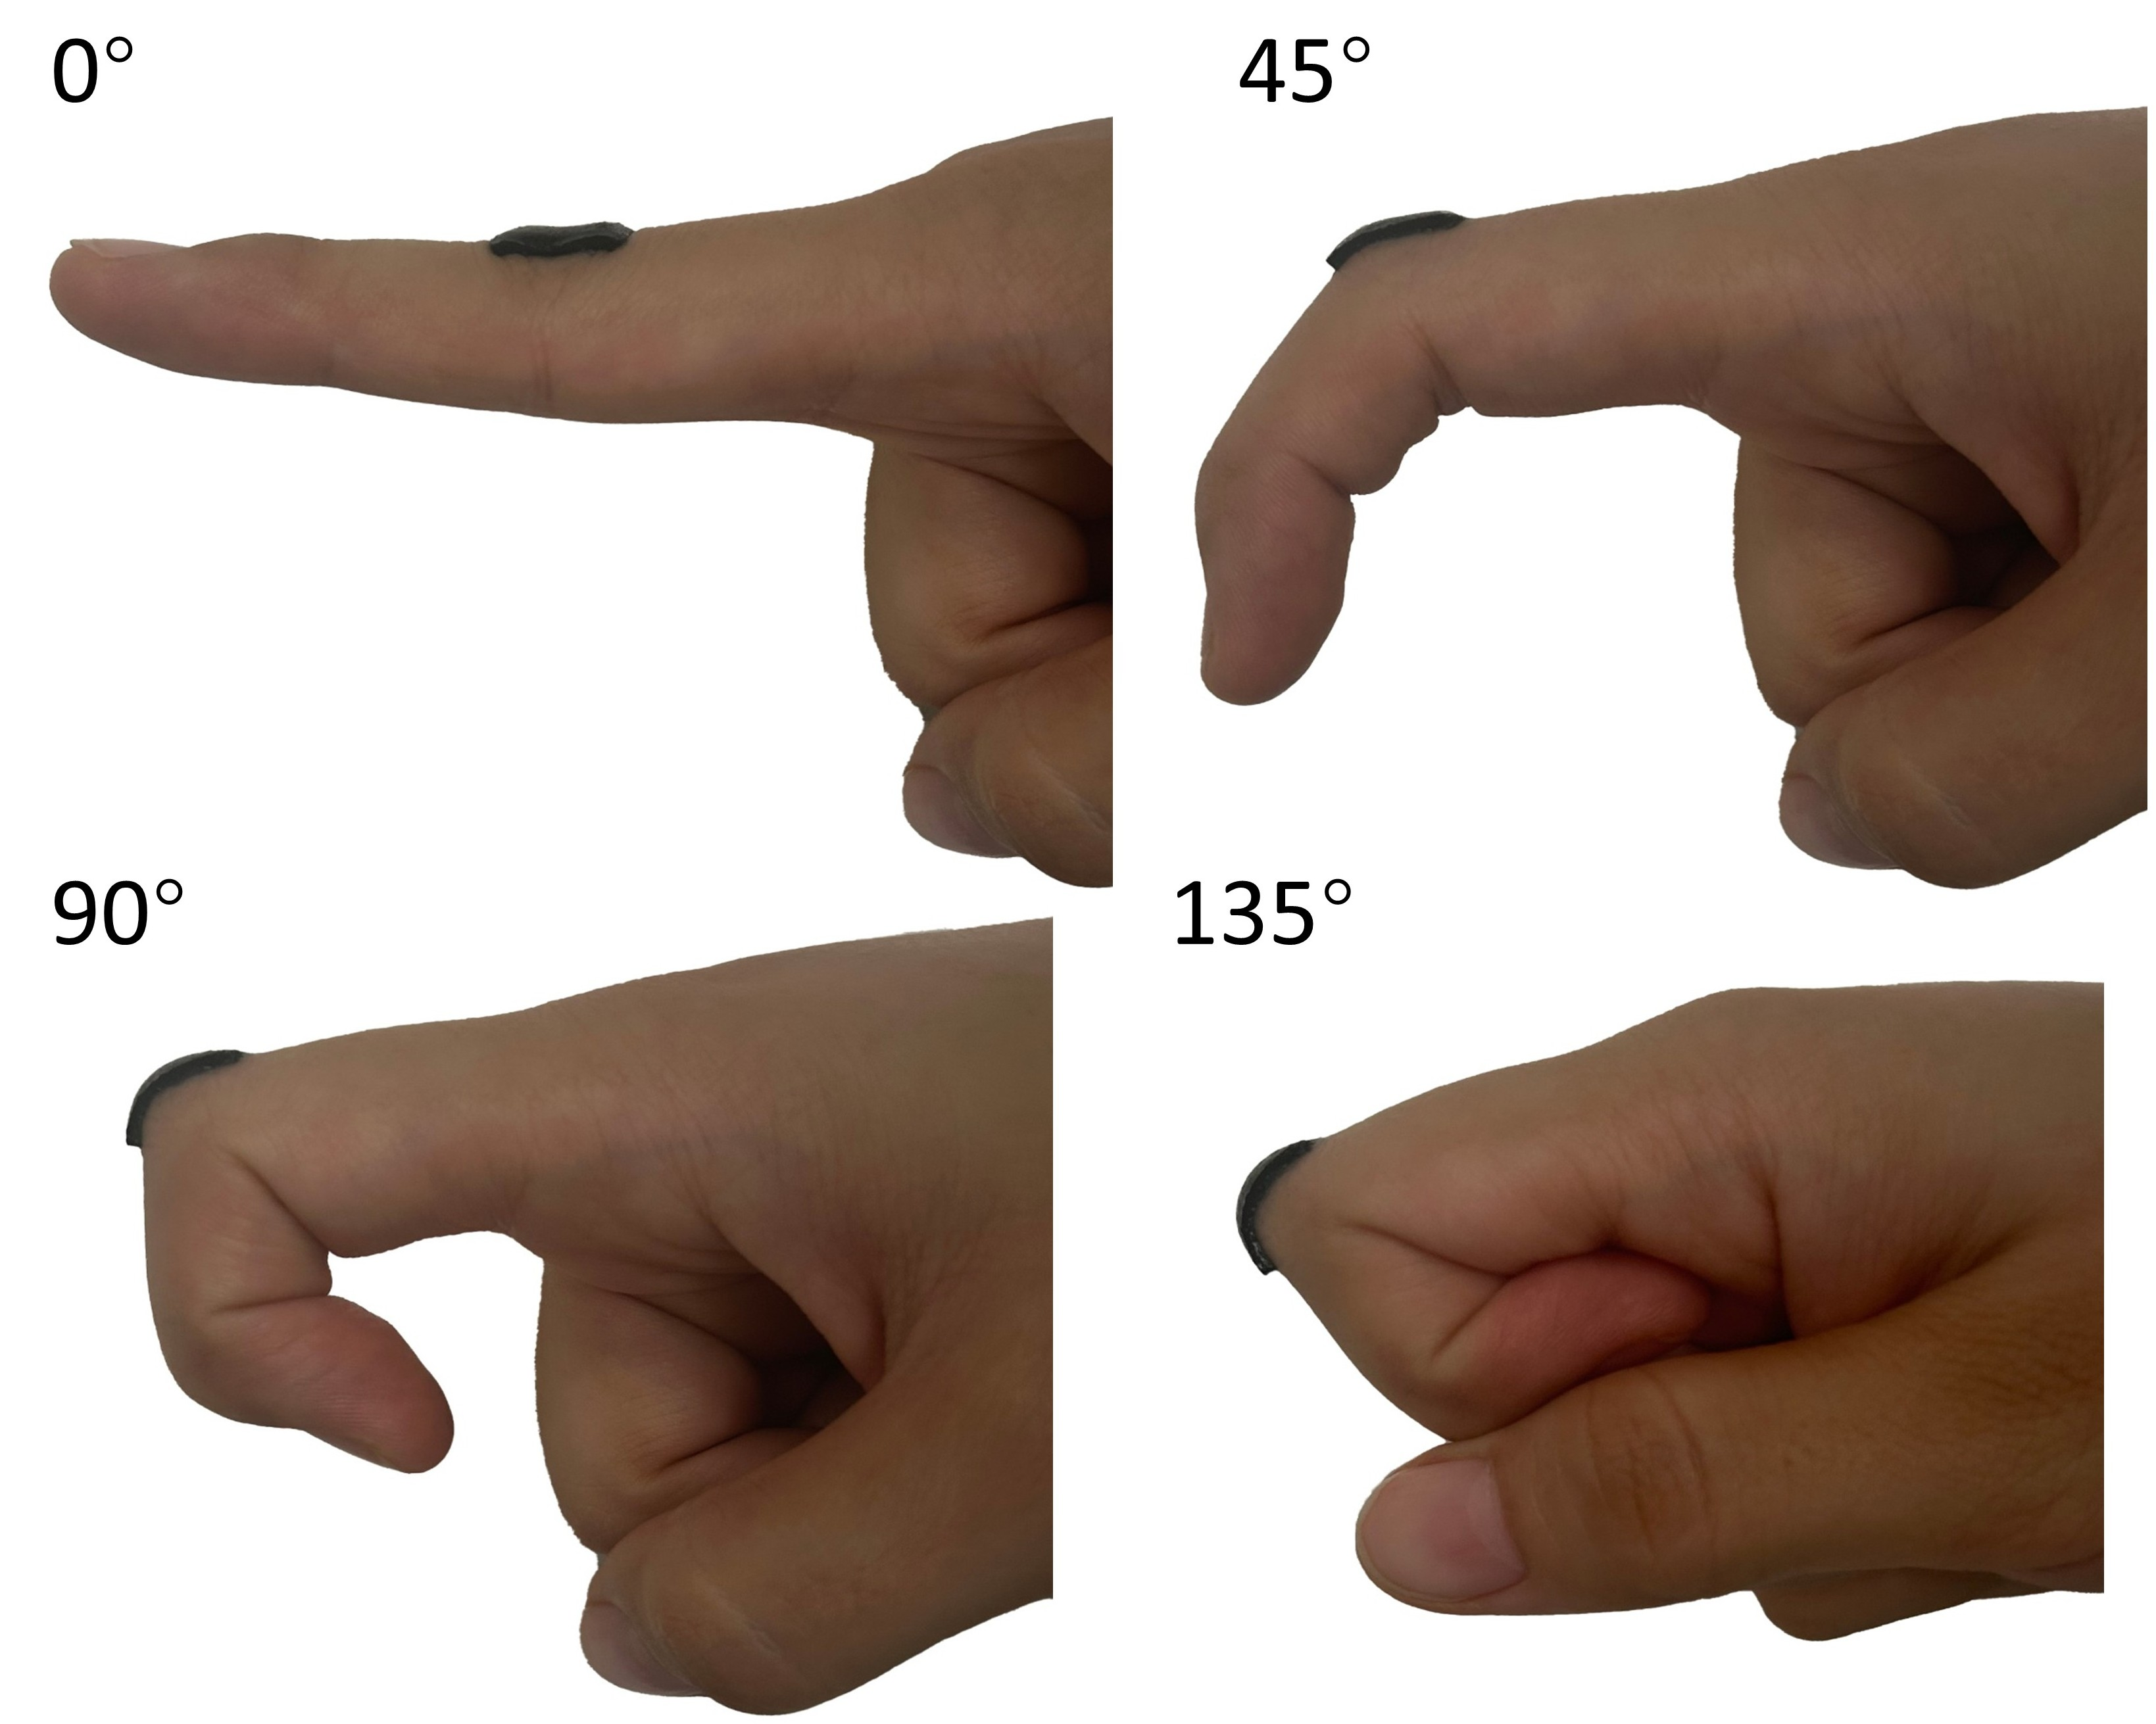
Figure S7. Photos of the hydrogel under bending. The hydrogel can form a firm adhesion with the skin under different angles.
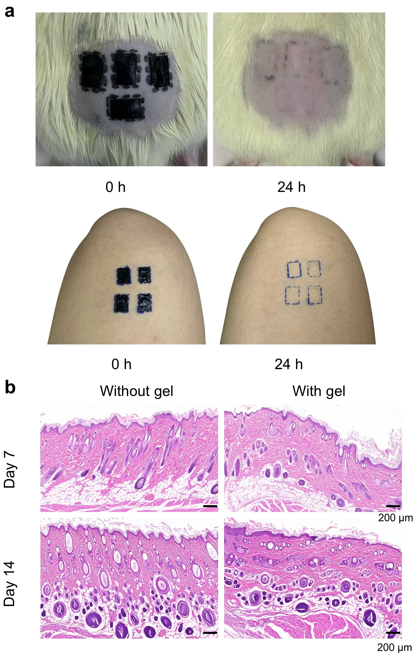
Figure S8. The biocompatibility of the conductive and adhesive hydrogel interfaces. a, Hypersensitivity tests of skin. No signs of adverse reactions were found. b, H&E staining was performed on skin tissues of rats exposed to and unexposed to the hydrogel during a two-week period. No obvious inflammatory cell infiltration (including polymorpho-nuclear cells, lymphocytes, plasma cells, macrophages, multinucleated giant cells), cell necrosis, fibrosis, or fatty infiltration was observed.
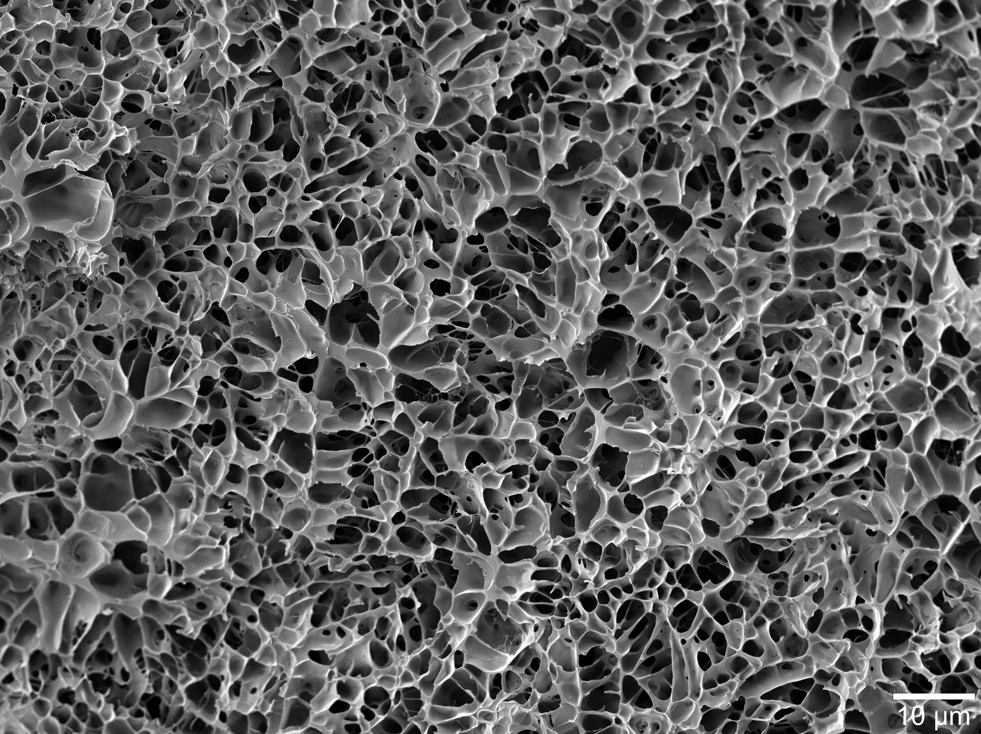
Figure S9. Cryo-electron microscopy images of poly (AM-DAMA)-PEDOT:PSS hydrogel at a size of 2 μm (1000x magnification) (scale bar: 10 µm).
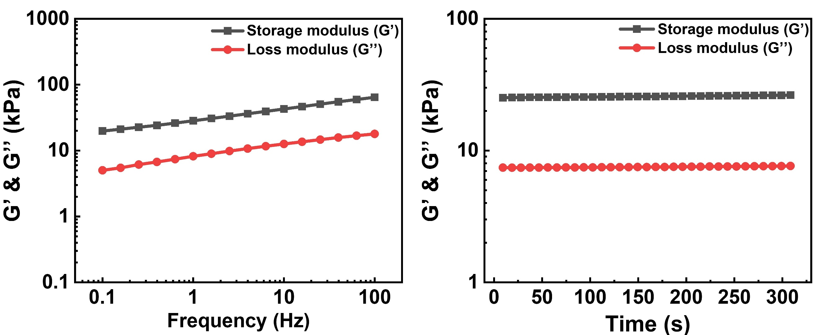
Figure S10. Dynamic oscillatory frequency sweeps (γ=1%) (left) and time sweeps (γ=1%, ω=1 rad s⁻¹) (Right) of the hydrogel at 25 °C.
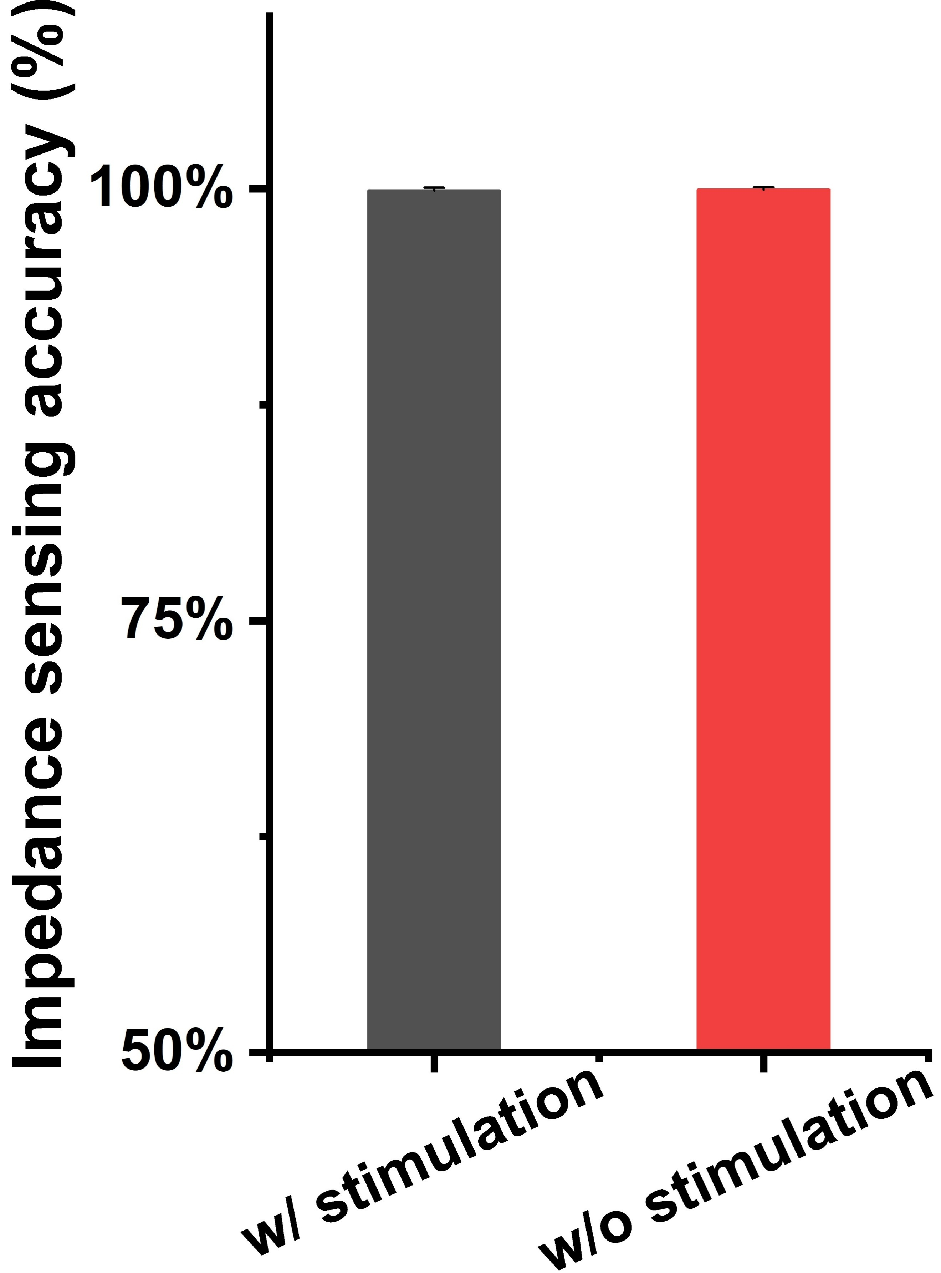
Figure S11. Impedance sensing function remains stable with and without stimulation, displaying consistent readout.
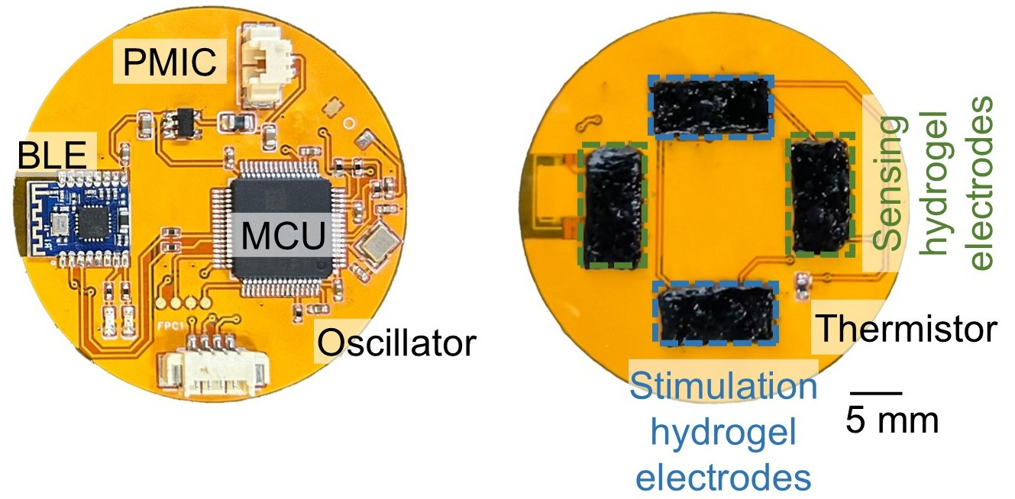
Figure S12. Photographs of the front (left) and back (right) sides of the smart dressing, showing the MCU, crystal oscillator, BLE module, PMIC, thermistor, stimulation and sensing electrodes (scale bar: 5 mm). MCU, commercial microcontroller unit. BLE, bluetooth. PMIC, power management integrated circuit.
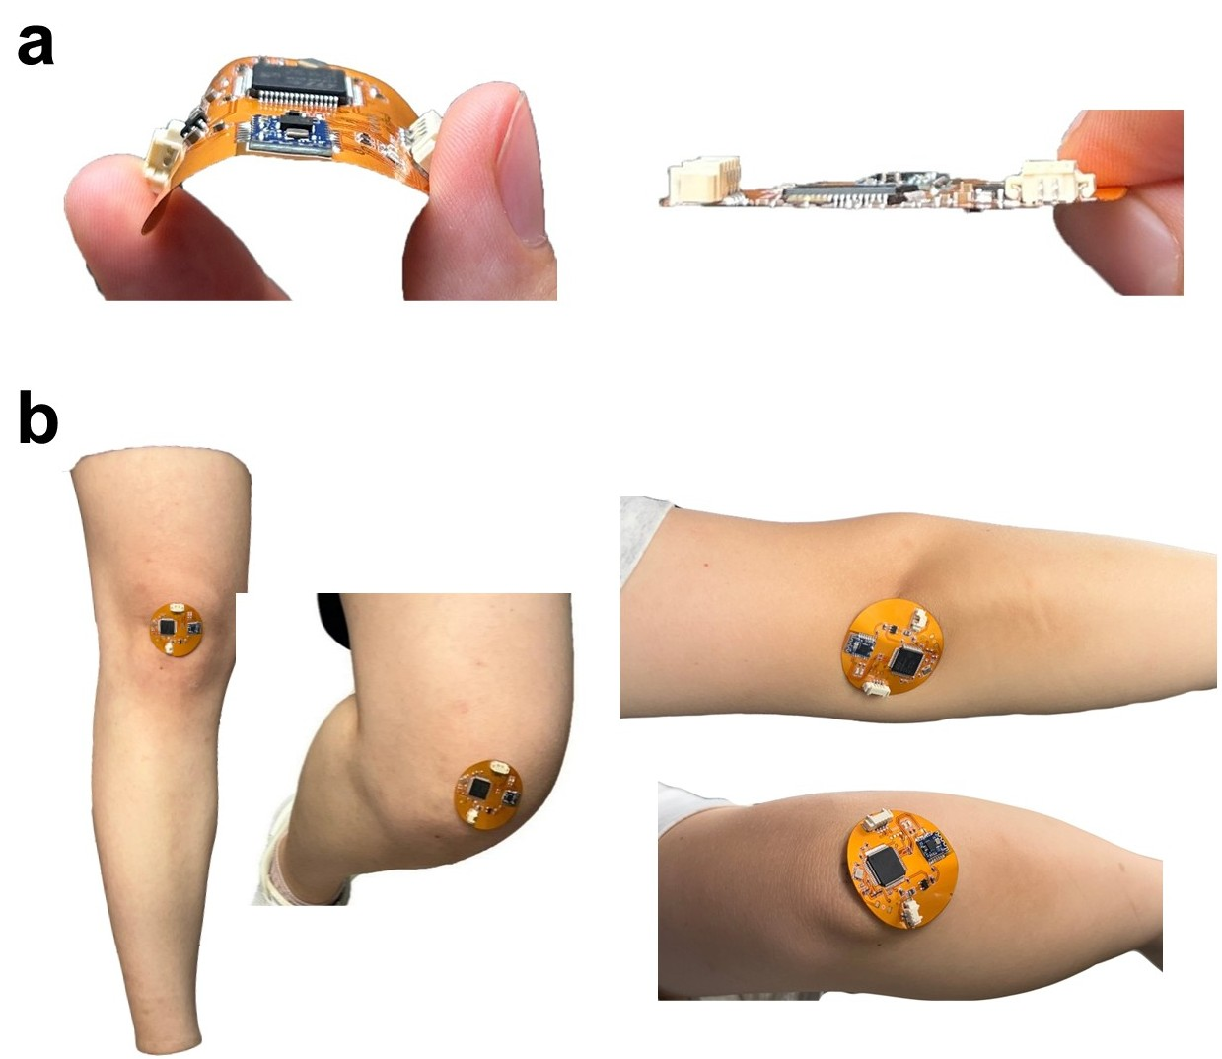
Figure S13. a, Photographs showing flexibility and thin layout of the FPCB. b, Photographs showing the application of smart dressing on multiple body parts.
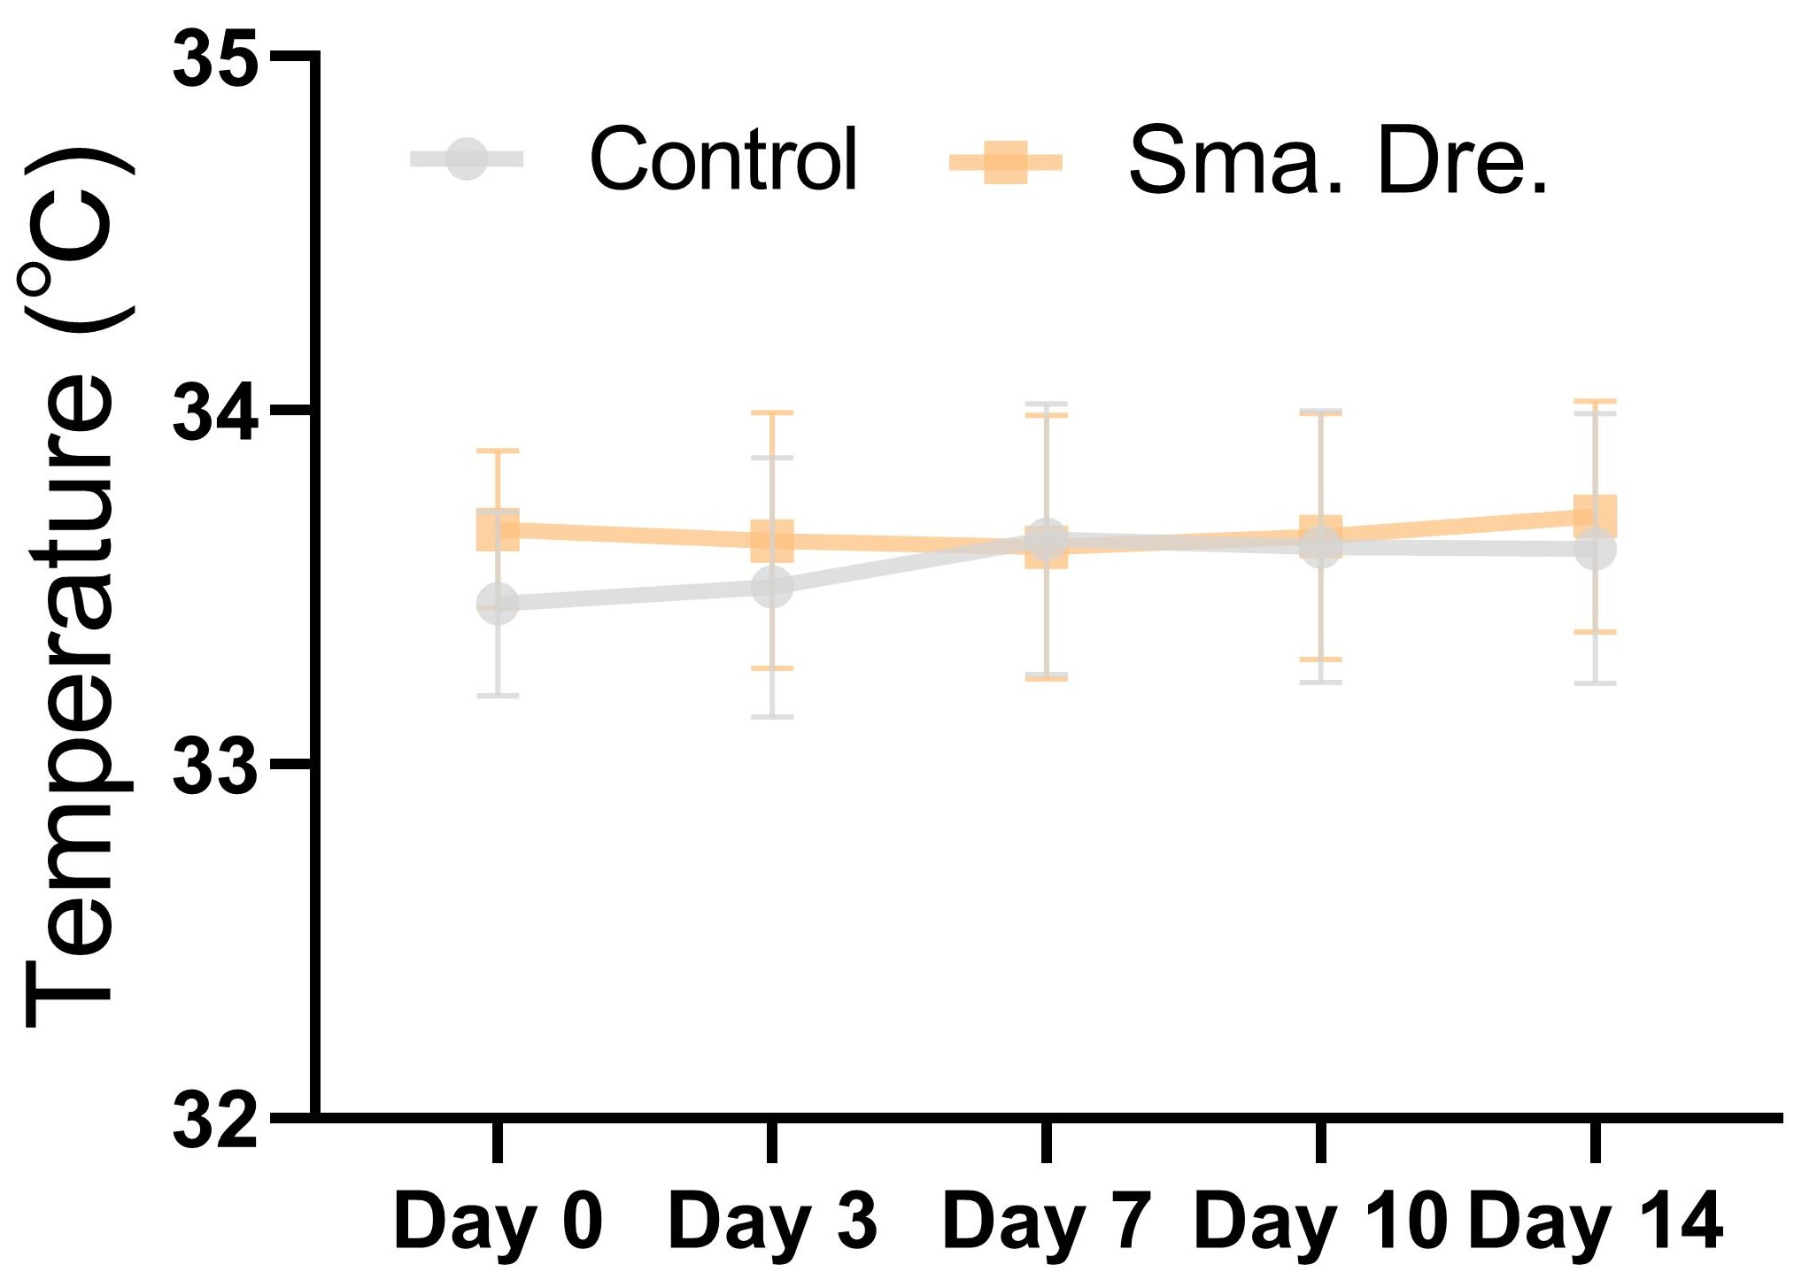
Figure S14. Temperature sensed over time of the Smart Dressing and control group.
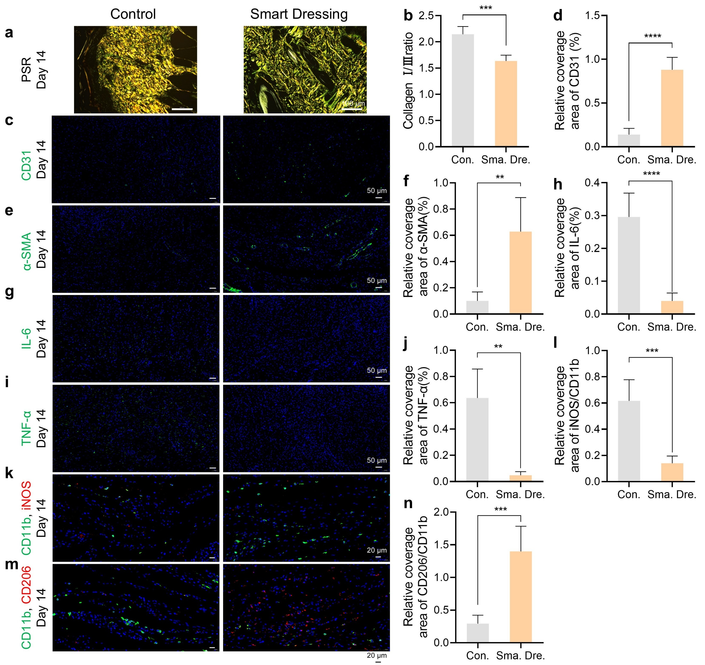
Figure S15. Assessment of Ⅰ/Ⅲ collagen, neovascularization, inflammation and immunomodulation in regenerated wound tissue between two groups.
a, PSR staining images (a) (scale bar: 100 μm) on day 14 and their quantitative analysis (b) (P=0.003). Collagen Ⅰ/Ⅲ fibers appeared orange-red/green, respectively. c-n, Immunofluorescence staining images and quantitative analysis of CD31 (c, d) (P=6.36×10⁻⁶), α-SMA (e, f) (P=0.0086), IL-6 (g, h) (P=7.12×10⁻⁵), TNF-α (i, j) (P= 0.0079), M1 (k, l) (P=0.0003) and M2 (m, n) (P=0.0003) macrophages in wound on day 14 (scale bar: 50 μm for CD31, α-SMA, IL-6 and TNF-α; 20 μm for M1/2 macrophages). If data passed normality test, two-sided unpaired t test was used for equal variances, or two-sided Welch’s t test for unequal variances. If not, Mann-Whitney test was used. Data were presented as mean ± SD (n=5). *P<0.05, **P<0.01, ***P<0.001, ****P<0.0001.
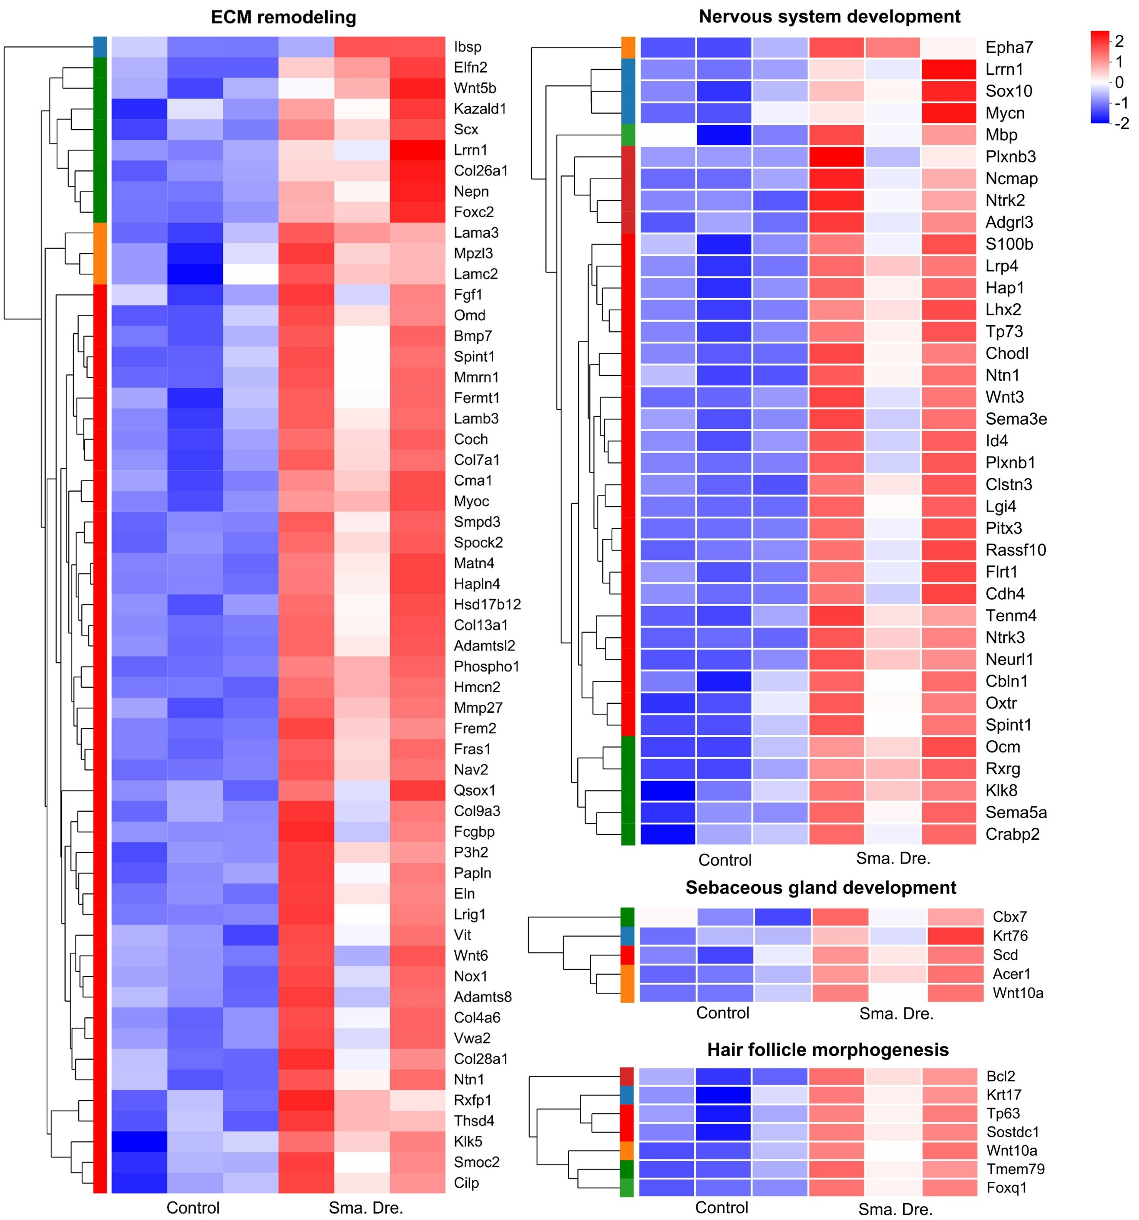
Figure S16. Heat maps illustrating up-regulated genes after being treated with smart dressing on day 7, compared with control group. It can be seen that up-regulated genes are implicated in ECM remodeling, nervous system, and skin appendage development.
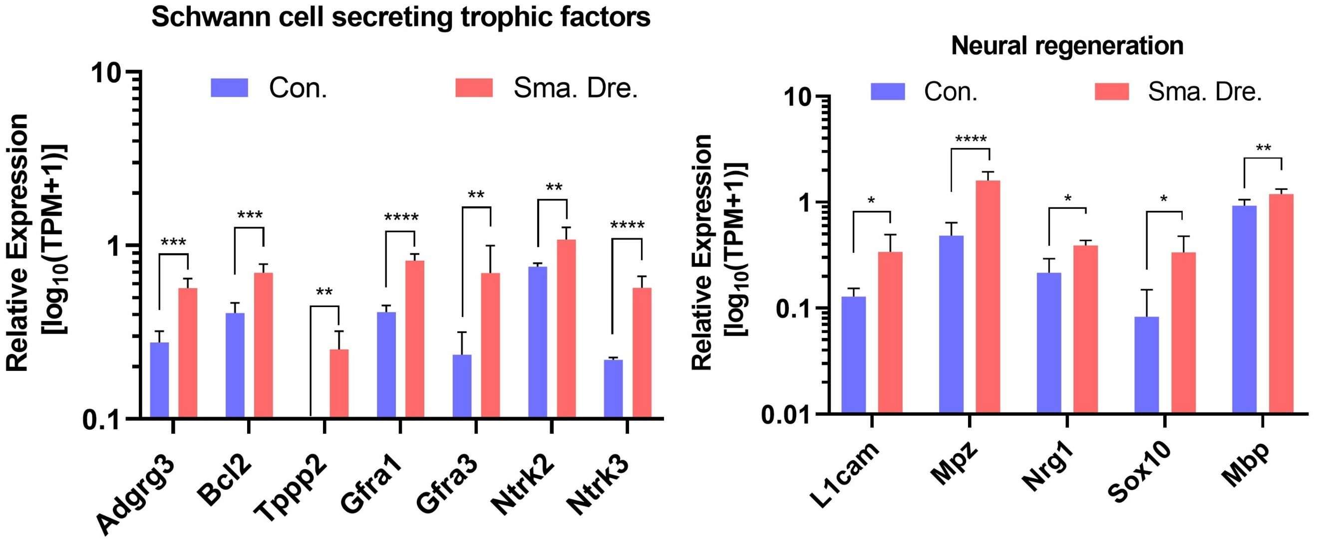
Figure S17. Relative expression of the DEGs related to Schwann cell secreting trophic factors (left) and neural regeneration (right). Adgrg3 P=0.0006, Bcl2 P=0.0004, Tppp2 P=0.0033, Gfra1 P=5.30×10⁻⁶, Gfra3 P=0.0017, Ntrk2 P=0.0055, Ntrk3 P=8.52×10⁻⁵, L1cam P=0.0136, Mpz P=2.25×10⁻¹⁰, Nrg1 P=0.0398, Sox10 P=0.0214, Mbp P=0.0031. Differential expression analysis was performed using the DESeq2. BH was applied to adjust P values for multiple testing. Data were presented as mean ± SD (n=5). *P < 0.05, **P < 0.01, ***P < 0.001, ****P < 0.0001.
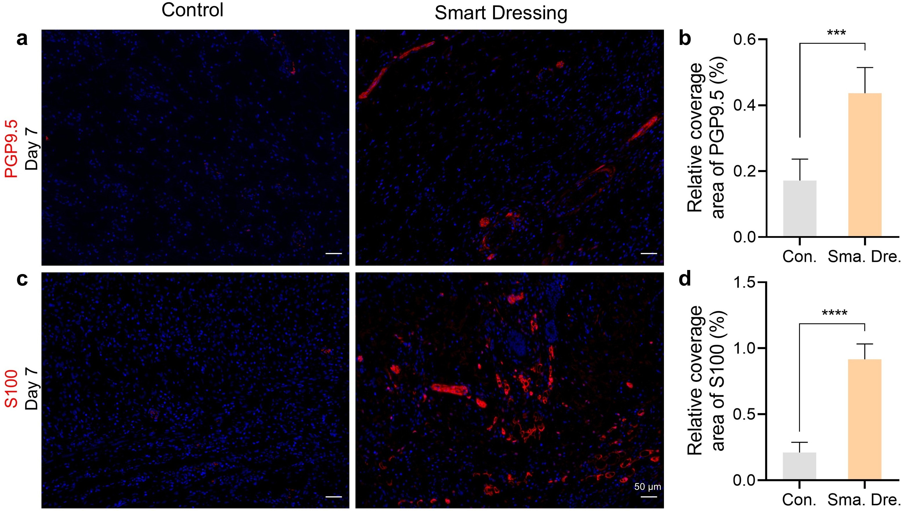
Figure S18. Assessment of nervous system development in regenerated wound tissue on day 7 between two groups. Immunofluorescence staining images (scale bar: 50 μm) and quantitative analysis of PGP9.5 (a, b) (P=0.0004) and S100 (c, d) (P=3.58×10⁻⁶). Two-sided unpaired t test was used for data analysis. Data was presented as mean ± SD (n=5). ***P<0.001, ****P<0.0001.
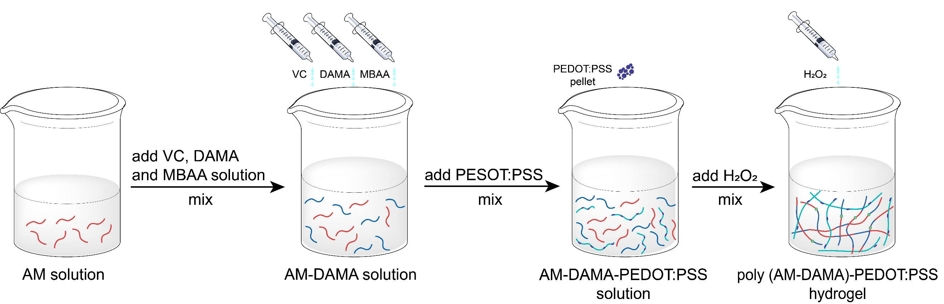
Figure S19. Schematic diagram of the preparation process of poly (AM-DAMA)-PEDOT:PSS hydrogel.

