Supplementary Information for “Distinct response of gross primary productivity in five terrestrial biomes to precipitation variability”
François Ritter, Max Berkelhammer and Cynthia Garcia-Eidell

Biomes | T  (°C) | P  (mm d⁻¹) | GPP SATFLUX  (gC m⁻² yr⁻¹) | GPP FLUXCOM  (gC m⁻² yr⁻¹) | GPP VPM  (gC m⁻² yr⁻¹) | UGi | f_{dry} | α  (mm event⁻¹) | CV | % of IGBP land cover type  (showing only ≥ 5%)
Cold  Grasslands  (347) | 5  ±5 | 1.4  ±0.5 | 420  ±300 | 400  ±130 | 480  ±200 | 0.18  ±0.05 | 0.70  ±0.12 | 5.0  ±1.5 | 0.21  ±0.06 | 69% Grasslands  12% Savannas  7% Open Shrublands  6% Woody Savannas
Warm-dry  Grasslands  (232) | 19  ±4 | 0.9  ±0.3 | 290  ±200 | 400  ±140 | 380  ±300 | 0.26  ±0.08 | 0.86  ±0.04 | 7.3  ±2.9 | 0.40  ±0.12 | 47% Grasslands  41% Open Shrublands  5% Savannas
Warm-wet  Grasslands  (147) | 19  ±4 | 2.2  ±0.5 | 920  ±510 | 910  ±290 | 1280  ±410 | 0.24  ±0.12 | 0.79  ±0.07 | 11.4  ±2.6 | 0.29  ±0.07 | 65% Grasslands  17% Savannas  8% Open Shrublands
Cold Forests  (392) | 4  ±3 | 2.0  ±0.6 | 1120  ±390 | 850  ±280 | 850  ±380 | 0.14  ±0.04 | 0.54  ±0.08 | 4.5  ±1.6 | 0.17  ±0.04 | 41% Woody Savannas  22% Evergreen Needleleaf  12% Mixed  10% Deciduous Broadleaf
Warm Forests  (310) | 14  ±4 | 3.4  ±0.6 | 2000  ±390 | 1570  ±210 | 1770  ±300 | 0.13  ±0.06 | 0.64  ±0.08 | 9.9  ±3.0 | 0.20  ±0.05 | 29% Deciduous Broadleaf  29% Woody Savannas  10% Evergreen Needleleaf  10% Evergreen Broadleaf  6% Mixed

Supplementary Table 1: Long-term temperature (T), Precipitation (P), Gross Primary Productivity (GPP) from SATFLUX, FLUXCOM RS+METEO and VPM, Unranked-Gini Index (UGi), Fraction of dry days (f_{dry}), Rain intensity (α), Coefficient of Variation (CV) of the five biomes. Percent coverage per land cover classification on each biome as defined by the International Geosphere-Biosphere Program (IGBP). Mean values are within +/- 1 standard deviation of the measurements derived from all the grid cells per biome (values in parenthesis in the first column).

Supplementary Figures
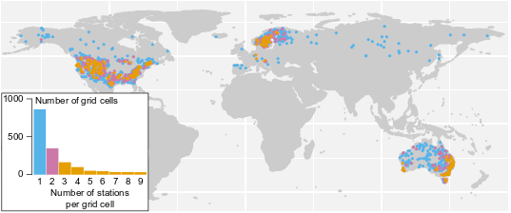
Supplementary Figure 1: Map of weather station locations and their density per grid cell in North America, Europe, Asia, and Australia. The weather stations have at least 15 years of daily data (2001 to 2018). Data considered are from grid cells that contain at least 50% forests or 50% grasslands, with less than 5% croplands.

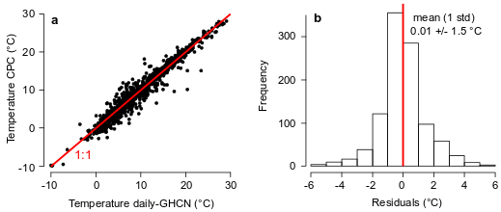
Supplementary Figure 2: Comparison between GHCN-daily and CPC-monthly averaged temperatures from 2001 to 2018 for each 0.5° × 0.5° grid cells. a, Long-term mean temperature of CPC versus daily-GHCN products. b, histogram of the residuals from a, with a mean of 0.01°C and a standard deviation of 1.5°C. Due to a lack of data in GHCN-daily temperature for certain grid cells, only long-term averages of CPC temperature are used in this study. The standard deviation of 1.5°C from the residuals defines the maximum absolute difference in temperature between two paired grid cells (Supplementary Methods 1).

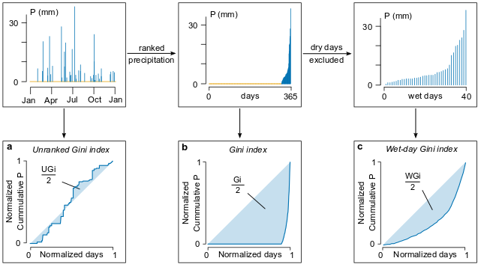
Supplementary Figure 3: Gini-based metrics. The Unranked-Gini index (UGi in a) is a novel metric similar to the Gini index (Gi in b), except that the precipitation is not ranked. The Wet-day Gini index (WGi in c) is similar to Gi except that it excludes dry days. All three indices are adimensional and normalized.

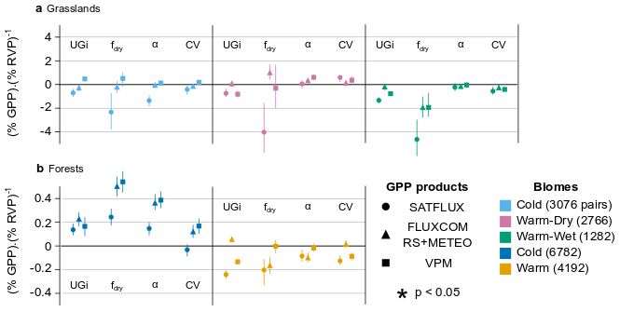
Supplementary Figure 4: Spatial slopes of change in GPP from each Rainfall Variability Parameters (RVP) for the grasslands (a) and the forests (b). The slopes are calculated from two populations: Control and Experiment (see Supplementary Methods 1 and 4). The uncertainties on the slopes are calculated with a bootstrapping technic (N=10000), and R-squared values are irrelevant as the slopes are calculated on two points only.

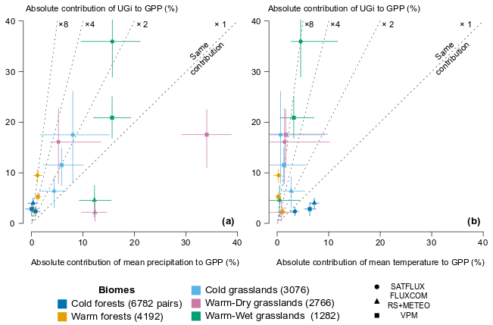
Supplementary Figure 5: Comparison of the performances of UGi with mean precipitation and temperature using the pairing method. The absolute contribution of UGi to GPP is compared to the absolute contribution of mean precipitation (a) and temperature (b) to GPP to make sure that the pairing method accurately reduces their influence on productivity. Error bars are calculated with a bootstrapping technique (N=10000) described in Supplementary Methods 1.

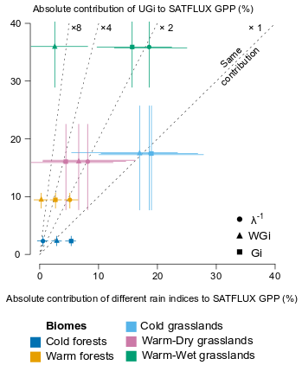
Supplementary Figure 6: Comparison of the performances of UGi with other parameters using the pairing method. The absolute contribution of UGi to GPP is compared to the absolute contribution of the mean interval between rainfall events (λ⁻¹) and other rain frequency metrics described in Supplementary Fig.3. Error bars are calculated with a bootstrapping technique (N=10000) described in Supplementary Methods 1.

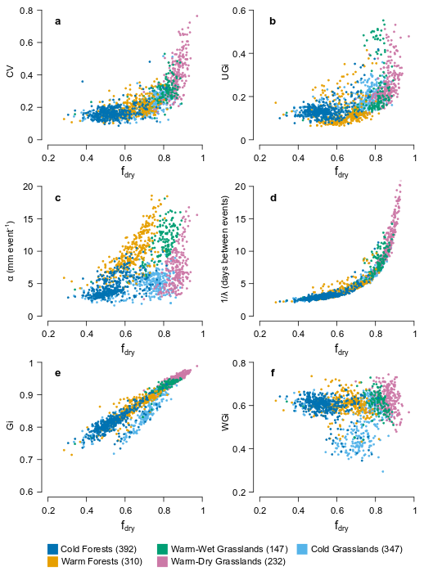
Supplementary Figure 7: Relationships between the various Rainfall Variability Parameters (RVPs) and the fraction of dry days. The following RVPs are plotted versus f_{dry}: CV (a), UGi (b), α (c), λ⁻¹ (d), Gi (e) and WGi (f). All parameters have been temporally averaged within each grid cell. λ⁻¹ or Gi are closely related to f_{dry}, therefore they are not providing additional information. WGi has been detrended from f_{dry} by excluding the dry days (see Supplementary Fig. 3).

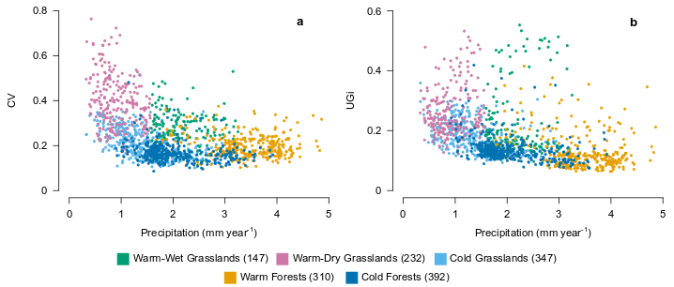
Supplementary Figure 8: Relationship between rainfall variability and long-term mean precipitation. Results are shown on the inter-annual scale with the coefficient or variation (a), and on the intra-annual scale with the Unranked Gini index (b).

Supplementary Methods
Supplementary Methods 1: Detailed pairing method.
Conditions for pairing. Two grid cells (e.g. grid cells A and B) with long-term mean precipitation $(\overline{P}$_{A} $, \overline{P}$_{B}) and long-term mean temperature ($\overline{T}$_{A} $,\overline{T}$_{B}) that share the same biome type are paired if $\overline{P}$_{A} $= \overline{P}$_{B} (t-test, p > 0.05) and | $\overline{T}$_{A} $- \overline{T}$_{B} | < 1.5°C.
The t-test is performed on the populations of mean annual precipitations (MAPs) associated with the two grid cells. For example, if A contains 3 weather stations with 18 years of data and B contains only 1 weather station with 16 years of data, then the t-test if performed between two populations of 54 MAPs and 16 MAPs.
For the temperature, we used a threshold T_{lim} because a t-test was too restrictive. Knowing that there are discrepancies between GHCN-daily and CPC-monthly (supplementary Fig. 2), we considered the standard deviation of the residuals between these two datasets as the threshold value (T_{lim} = 1.5 °C). Supplementary Fig. 5b shows that the influence of temperature on productivity is considerably reduced compared to UGi due to this constrain.
Step 1, set of all pairs for a biome. Based on the pairing condition, we create a dataset that includes all pairs per each biome from all possible grid cells combinations. One grid cell can be paired multiple times with different grid cells but without redundancy, for example A-B and A-C are possible but not A-B and B-A. Additionally, a grid cell with $\overline{P}$ & $\overline{T}$ values at the boundary between two biomes can be paired with any of its neighbors. For example, a cold grassland grid cell adjacent to warm-dry grassland grid cells (on a $\overline{P}$ vs $\overline{T}$ plot, see Fig.1b) can be paired as long as the pairing condition is fulfilled. This produces a slight overlap between sets of grassland pairs (or forest pairs) but also saves data because grid cells without paired neighbor would have been discarded from the analysis. The 232 grid cells of warm-dry grasslands produce for example 2766 pairs due to non-redundant combinations and non-restrictive boundary conditions.
Step 2, difference in productivity. Once we have the dataset of pairs associated with a biome, we calculate the percentage of difference in productivity within each pair. For example, for two grid cells A and B of the same pair i with long-term productivity (GPP_{A}, GPP_{B}) and long-term parameter (x_{A}, x_{B}) with x = {α, UGi, f_{dry}, CV} in our main study, the percentage of difference in productivity within the pair i is given by:
With x_{A} $≤$ x_{B ,} $d_{i}^{x}= \frac{{GPP}_{B}-{GPP}_{A}}{mean⁡({GPP}_{A},{GPP}_{B})} ×100 (\%)$
If $d_{i}^{x}$ is positive , there is an increase of GPP with an increase in x, and otherwise there is a decrease of GPP with an increase in x. We also calculate the percentage of difference in x for this pair:
$$g_{i}^{x}= \frac{x_{B}-x_{A}}{mean⁡(x_{A},x_{B})} ×100 (\%)$$
Each pair i is now associated with ($d_{i}^{x}, g_{i}^{x}$).

Step 3, contribution of a parameter to the productivity. For a given biome and a given x = {α, UGi, f_{dry}, CV,$\overline{T}$,$\overline{P}$,Gi,WGi,λ⁻¹}, we rank the set of all pairs in an increasing order with respect to g^{x}, and then we equally divide the set of all pairs into two populations: Control (first half, similar x within each pair) and Experiment (second half, different x within each pair).
We finally test the influence of x on the productivity by comparing the medians (M) of$d^{x}$ from the Experiment and Control populations:

$$D^{x}=M\left(d_{EXPERIMENT}^{x}\right) - M(d_{CONTROL}^{x}) (\%)$$

And we also calculate the spatial slopes of change:

$$S^{x}= \frac{M\left(d_{EXPERIMENT}^{x}\right) - M(d_{CONTROL}^{x})}{M\left(g_{EXPERIMENT}^{x}\right) - M(g_{CONTROL}^{x})} (\% \%^{-1})$$

For the five biomes and the four rainfall variability parameters (x = {α, UGi, f_{dry}, CV}), values of $D^{x}$ are shown in Fig. 3, and values of the $S^{x}$ are shown in Supplementary Fig. 4.
Step 4, Bootstrapping technic. The bootstrapping technic is performed by repeating step 2 and 3 with a resampled population of all pairs from the original population (N=10000), storing values of $D_{k}^{x} and S_{k}^{x}$ for each iteration with k$∈$[1,N] and then finally calculating the 2.5-97.5% quantiles of the $D^{x} and S^{x}$ populations to produce a 95% Confidence Interval. The resampling is performed with replacement, i.e. each pair is randomly replaced by another pair from the same original population.

Supplementary Methods 2: Reduction of the influence of Precipitation and Temperature on Productivity due to the pairing method
As detailed in the Supplementary Methods 1, the pairing method can be adapted to precipitation and temperature to estimate their contribution to productivity within each pair. We compare their absolute contribution with the absolute contribution of UGi (Supplementary Fig. 5) and observe that their influence is still significant (especially for the precipitation) but with contributions usually 2 to 8 times lower than UGi. Grid cells receiving more regular rainfall also receive slightly higher precipitations amounts (within the t-test power), and this correlation explains the significant contribution of mean precipitation to productivity.

Supplementary Methods 3: Comparison of the performances of UGi with other common rain frequency metrics
We describe in this section the different metrics of rain frequency calculated on a daily time scale, and the comparison of their impact on productivity. Popular rain frequency metrics are the mean interval between rainfall events¹ (λ⁻¹), the Gini index² (Gi), the Wet-day Gini index³ (WGi) and the Concentration Index⁴ (CI). The mean interval between rainfall events is the mean value of dry day spells (population of droughts within a year). The Gini index describes the inequality between contributions of different event sizes to the rainwater budget, with a value from 0 (all the event sizes contribute equally to the water budget) to 1 (one event size contributes dominantly to the water budget). The Wet-day Gini index is simply the Gini index with the dry days being excluded from the time-series because they represent a large part of the signal (see Supplementary Fig. 3b and 7e). The Concentration Index is equivalent to the Wet-day Gini Index, except that the empirical curve shown in Supplementary Fig. 3c is fit with an exponential relationship of type $y=axe^{bx}$, with a and b constants⁴. Differences between CI and WGi are almost negligible⁵, and we only use WGi in our comparison.
Supplementary Fig. 6 shows that UGi has a much higher contribution to productivity than the other metrics included in this study. An exception to this is the cold grasslands where all rain frequency metrics share similar contributions (lighter events benefit more the productivity). A mechanistic explanation to the good performances of UGi is that this index conserves the ecological information related to the temporality of rain. This is not the case for the other indices, which are ranked-based (Gi, WGi and CI). Additionally, UGi considers the succession of rain events and droughts relative to the total rainwater budget, which unlike the mean interval between rainfall events (λ⁻¹) is insensitive to the size of the events before and after a drought. The UGi should therefore become a standardized tool to perform ecological studies on the relationship between rain and productivity.

Supplementary Methods 4: Spatial slopes of change
The pairing method quantifies the overall contribution of rainfall variability parameter to primary productivity; however, Fig. 3 does not particularly provide the percentage of change in productivity as a function of change in rainfall variability. To estimate this, we use a simple linear approximation based on two points (medians of Control and Experiment) as described in Supplementary Methods 1 (parameter $S^{x}$) and illustrated in Supplementary Fig. 4. Productivity is shown to be notably sensitive to a change in fraction of dry days. For example, if a cold forest has a ~10% higher fraction of dry days (~ 20 more days without rain) compared to another cold forest that shares similar long-term precipitation and temperature, then its productivity will be on average ~5% higher. This estimate is not based on a temporal change of dry days at a single site, but on spatial differences in long-term f_{dry} for multiple sites. For this reason, it is difficult to extend this result to an analysis of the impact of global warming on productivity due to a change in rainfall variability. The linear model is also only valid for small changes, as ecosystems resilience or collapse are known to present non-linear patterns in the rainfall-productivity relationship.

References
1. Guan, K. et al. Continental-scale impacts of intra-seasonal rainfall variability on simulated ecosystem responses in Africa. Biogeosciences 11, 6939–6954 (2014).
2. Sangüesa, C. et al. Spatial and temporal analysis of rainfall concentration using the Gini Index and PCI. Water (Switzerland) 10, (2018).
3. Rajah, K. et al. Changes to the temporal distribution of daily precipitation. Geophys. Res. Lett. 41, 8887–8894 (2014).
4. Martin-Vide, J. Spatial distribution of a daily precipitation concentration index in peninsular Spain. Int. J. Climatol. 24, 959–971 (2004).
5. Monjo, R. & Martin-Vide, J. Daily precipitation concentration around the world according to several indices. Int. J. Climatol. 36, 3828–3838 (2016).

