Supplementary Notes 1: Samples and methods
Samples: Previously published low-temperature thermochronological data of 55 samples from western and central Dronning Maud Land (DML)^{1,2} are re-evaluated in this study. The samples are mainly derived from the basement within the Archean Grunehogna Craton, the Mesoproterozoic Maud Belt and the Tonian Oceanic Arc Super Terrane (TOAST) at elevations between sea-level and c. 3000 masl (Fig. Supplementary Figure 1). Two of the samples from the southwestern Maud Belt (Heimefrontfjella) are granitic dropstones from the lowermost part of the Beacon sediments, obtained few meters above the Late Paleozoic paleosurface in Heimefrontfjella (c. 2100 masl).
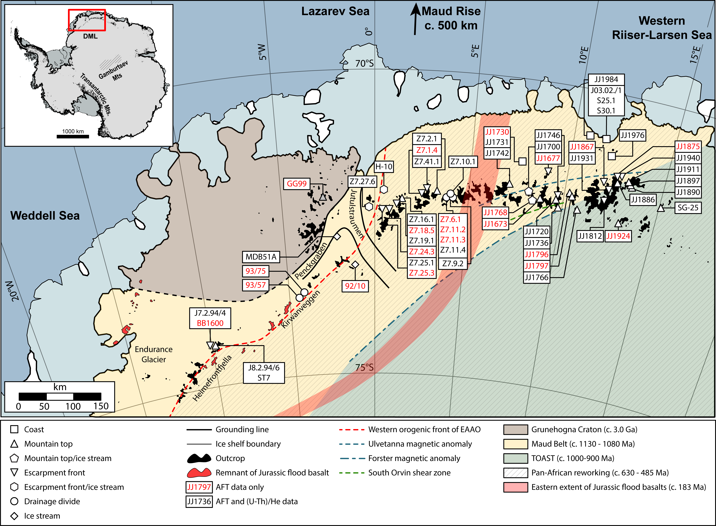
Supplementary Figure 1 – Sample locations. Location of samples from western¹ and central² Dronning Maud Land used in this study. The boundary between central DML and western DML is placed at 5 °E. Base map and inset were obtained from the Quantarctica package³. EAAO – East African-Antarctic Orogen; TOAST – Tonian Oceanic Arc Super Terrane.
Thermal history modeling: Thermal history modeling of the 55 samples was done in HeFTy (v. 1.9.1⁴). For thermal history modeling of apatite fission-track data, confined track lengths were c-axis projected⁵, and the annealing model of Ketcham et al.⁶ was applied. Track lengths were calibrated against the Durango standard ⁷, using a calibrated track length reduction factor of 0.998.
The resulting models (Supplementary Notes 6) show good (goodness-of-fits ≥ 0.5) and acceptable (goodness-of-fits ≥ 0.05) t – T paths. The goodness-of-fit is calculated in HeFTy, using Kuiper’s statistics⁴. The ending condition for all thermal history models was set to 1000 acceptable paths found. Pre-existing thermochronological and geological data were included in the thermal history models as external t – T constraints (Supplementary Figure 2):
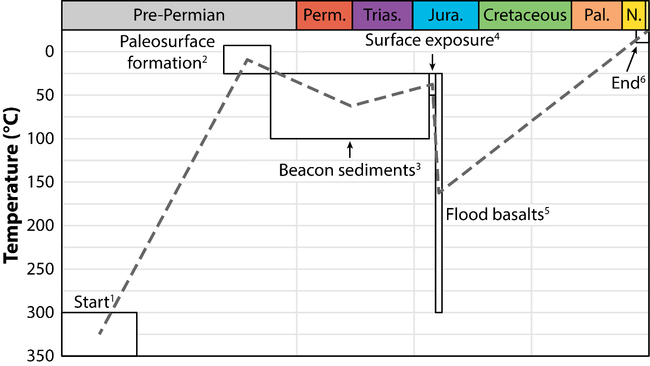
Supplementary Figure 2 – External constraints. External constraints used for thermal history modeling in this study. Note that constraint 4 and 5 have only been applied in western DML. See explanation below.
- Start: In southwestern DML, biotite and muscovite K – Ar data record temperatures of 300 – 350 °C at c. 500 Ma for the parts that experienced Pan-African overprint, and c. 975 Ma for the remaining areas⁸. For the remaining wDML, titanite fission-track ages indicate temperatures of c. 265 – 310 °C ⁹ at c. 345 Ma and c. 515 Ma in the western and eastern parts, respectively¹⁰. In central DML, we apply biotite ⁴⁰Ar – ³⁹Ar ages of c. 450 Ma¹¹ as a starting point.
- Paleosurface formation: Late Paleozoic sediments (including dropstone-bearing siltstones) unconformably overlying the Mesoproterozoic basement in Heimefrontfjella and Kirwanveggen (southwestern DML), indicating Late Paleozoic surface exposure at sea-level^{8,12}. The presence of a similar paleosurface is reported from Gjelsvikfjella in the eastern parts of wDML¹³. However, these surfaces are not presently overlain by Permo-Carboniferous sedimentary rocks, and the age of these may therefore be ambiguous. In cDML, the mountain peaks define a gently southward-dipping enveloping surface, interpreted to represent the remnants of the paleosurface². The temperature range for all following constraints, except the end-constraint, have been adjusted according to the distance of the sample at or below the assumed paleosurface, using a geothermal gradient of 25 °C/km.
- Beacon sedimentation: Up to c. 160 m of Late Carboniferous – Early Permian Beacon sediments are present in southwestern DML^{14–17}. Correspondingly, up to c. 3 km of Devonian – Triassic Beacon sediments are present in the Transantarctic Mountains ¹⁸ and up to c. 12 km of the equivalent Karoo Supergroup sediments are widespread on the conjugate margin in southeastern Africa¹⁹. Triassic surface temperatures of c. 25 °C have been used²⁰. The same surface temperatures were assumed for Jurassic constraints.
- Early Jurassic surface exposure: In outcrops in southwestern DML, the Mesoproterozoic basement is unconformably overlain by few meters of Beacon sediments, which again are covered by Jurassic continental flood basalts^{17,21}. This documents significant pre-Jurassic erosion of Beacon sediments, and that the peneplain once again was located close to the surface during Early Jurassic times. This constraint has only been applied for wDML samples, as there is no comparable evidence of pre-Jurassic erosion for cDML. The models from cDML have therefore been given more freedom with respect to post-Permian cooling.
- Jurassic continental flood basalts: Jurassic continental flood basalts are exposed in thicknesses of c. 400 – >1000 m in Vestfjella, wDML^{22,23}, and up to c. 5 km of the equivalent Sabie River Basalt Formation is preserved in the Lebombo Monocline in southern Africa²⁴. In DML, the eastern boundary of the basalts was probably located between 4 °E and 7 °C² (Supplementary Figure 1). Thus, we only allow for reheating for samples located to the west of this boundary. As published titanite fission-track and mica K – Ar ages predate the Jurassic continental flood basalts, temperature did not exceed 300 °C during the Jurassic. The maximum temperature has therefore been limited to 300 °C.
- End: A surface temperature of – 25 °C is applied for all samples.
The main focus of thermochronological modeling in this study was to extract paleotemperatures at 34 Ma. t – T paths were exported from HeFTy as txt-files constraining variably spaced t – T points. An in-house-developed Python script was then used to interpolate between these points, and to extract the temperature at 34 Ma for all individual modeling paths. Furthermore, the unweighted mean temperature was calculated based on all good (goodness-of-fit ≥ 0.5) and acceptable (goodness-of-fit ≥ 0.05) paths. The temperatures for all individual modeled cooling path are plotted as kernel density distributions in Supplementary Notes 4 and Supplementary Notes 5. Each sample has been modeled twice in order to evaluate a potential bias on the temperature distribution that might have been introduced by the external constraints that were used: One unconstrained model allowing for monotonic cooling (with only start and end temperature ranges given), and one constrained model using the previously published constraints from western¹ and central² DML (Supplementary Notes 5, Supplementary Figure 3a and 3b). Temperatures at 34 Ma generally reproduce well for the unconstrained and constrained model runs (Supplementary Notes 5), although some samples show a slight shift in the temperature distribution (e.g., sample JJ1890). For most samples, no significant bias was observed, and we prefer the models with additional external constraints, since these take into account known geological events and are considered to be more realistic.
In order to test the effect of helium diffusion models for samples including (U – Th)/He data, three different helium diffusion models were tested for the constrained models: the Farley²⁵ model, the Helium Trapping Model (HETM²⁶) and the Radiation Damage Accumulation and Annealing Model (RDAAM²⁷). A comparison of the temperature distribution at 34 Ma for the three diffusion models is shown in Supplementary Notes 4. For most samples, the temperature distributions are very similar for all three diffusion models. However, the RDAAM²⁷ was the only model to produce results for all samples and has been used for the final modeling of all samples.
The obtained temperature distributions at 34 Ma show some variation with respect to skewness and kurtosis, reflecting the scatter of t-T paths at 34 Ma. The precision of the temperature estimates therefore varies, with one standard deviation (1σ) of modeled temperatures ranging from c. 2.5 °C to c. 18 °C. The samples with the lowest mean temperatures at 34 Ma generally have the highest standard deviations (Supplementary Figure 3b). This correlation was expected, since the sensitivity of the methods decreases at temperatures below the PAZ and PRZ, resulting in more poorly constrained models at lower temperatures.
Supplementary Figure 3 – Modeled paleotemperatures. a) Comparison of unweighted mean temperatures between unconstrained and constrained thermal history models. All obtained mean temperatures from the constrained thermal history models overlap within 1σ with the corresponding mean temperatures from the unconstrained thermal history models. Error bars on the figure are 1σ. b) 1σ standard deviation of temperature distribution from constrained models. The uncertainty generally decreases with increasing mean temperature.
Calculation of pre-glacial overburden: Pre-glacial overburden thicknesses are calculated from the unweighted mean temperatures, based on interpolations from all individual paths (good and acceptable fits) at c. 34 Ma. Temperature distributions from good and acceptable paths for each sample are reported in Supplementary Notes 5. Different geothermal gradients have been applied for the different areas, depending on the type of overburden expected (i.e., basement, sediment or basalt). For continental flood basalts, a geothermal gradient of 50 °C/km is applied, based on the range of calculated geothermal gradients for the Deccan continental flood basalts (c. 35 – 80 °C/km²⁸). For the basement and sedimentary rocks, we apply a geothermal gradient of 25 °C/km, based on previously calculated and applied geothermal gradients for Mesoproterozoic basement in DML (c. 23 – 28 °C/km²⁹), Pan-African overprinted basement in Madagascar (c. 18 – 24 °C/km²⁹) and Beacon sediments in the Victoria Basin in the Transantarctic Mountains (25 °C/km³⁰). The paleosurface is used as a reference surface, assuming that the maximum thickness of additional basement rock (compared to today) corresponds to the vertical distance between the samples and the observed (western DML) and inferred (central DML) paleosurface. Overburden thicknesses exceeding the maximum thickness of basement rocks are attributed to continental flood basalts (western DML) or Beacon sediments (central DML). In order to test the calculations, the estimated overburden thicknesses to the sample elevations in two vertical profiles in Heimefrontfjella (wDML) and Gruberfjella (cDML). In both profiles, the total elevation of the pre-glacial surface reproduces within 200 m (no isostatic relaxation).

Supplementary Notes 2: Apatite fission-track data
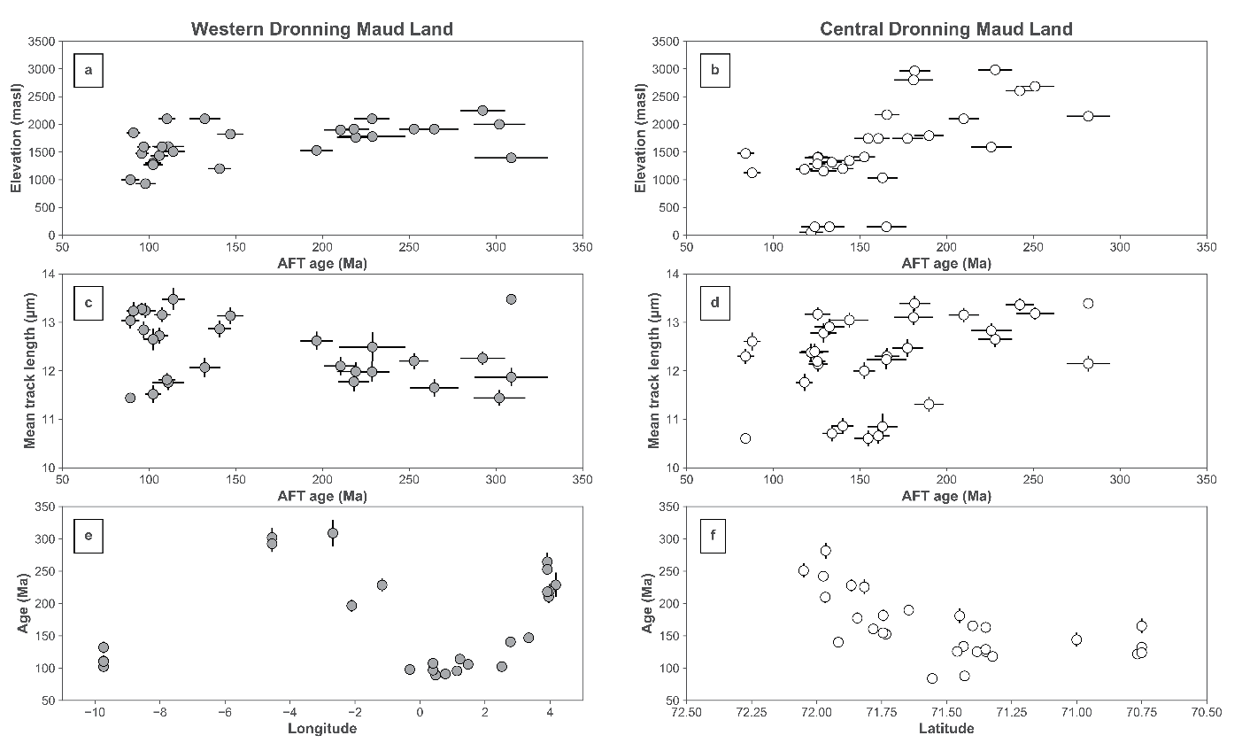
Supplementary Figure 4 – Apatite fission-track data. AFT ages from the 55 samples used in this study. Error bars on ages are 1σ, while error bars on mean track lengths (MTL) are 1SE. a) Most of the samples pre-dating the Jurassic continental flood basalts are from elevation ≥ 1400 masl. The younger ages show a steep age-elevation relationship, indicative of rapid exhumation. b) AFT ages up to c. 165 Ma are found at elevations ≤ 1500 masl, while the older ages are found at higher elevations. Apart from the samples from Schirmacheroasen (elevations of 50 – 150 masl), they show a moderate age-elevation relationship. c) The age – MTL resembles the left end of a boomerang plot³¹, indicating partial annealing of fission-tracks for samples that pre-date the Jurassic continental flood basalts. d) MTL below 11.3 µm are recorded in ages between c. 135 and 190 Ma. Longer track lengths are measured in the entire age range. e) AFT ages of wDML show an eastward increase, possibly related to diminishing thermal influence from the Jurassic continental flood basalts. f) The AFT ages of cDML show an age signature that is typical for retreating escarpments, with the oldest ages towards the highest elevation of the escarpment³².

Supplementary Notes 3: Apatite (U – Th)/He data
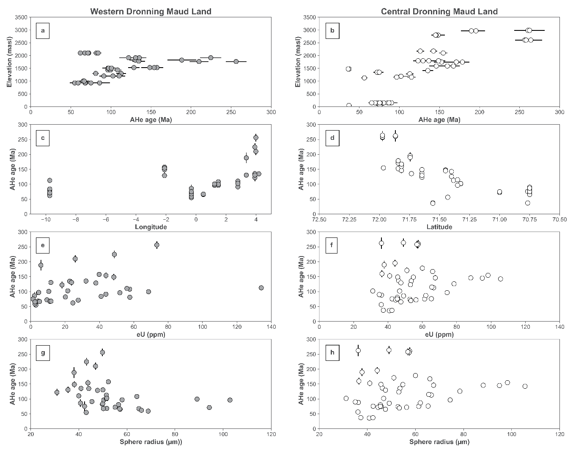
Supplementary Figure 5 – Apatite (U – Th)/He data. AHe data for the 34 samples used for modeling. Error bars are 1σ. a) AHe single-grain ages in wDML range from the late Ordovician to the Eocene. A strong age-elevation relationship, with a break-in-slope at c. 1800 masl is recorded. b) AHe single-grain ages from cDML range from the middle Permian to the Eocene. These ages show a good correlation between AHe age and elevation. c) The AHe ages of wDML show a similar correlation to longitude as the AFT ages. The oldest ages are generally found in the easternmost part of wDML. d) Similar to the AFT data of cDML, the AHe single-grain ages increase from the coast and towards the inland. e and f) In both regions, effective uranium (eU) concentrations range from c. 1 to c. 130 ppm. There is no overall systematic relationship between age and eU concentrations. g and h) Grain sizes (sphere radii) range from c. 30 to c. 105 µm for both regions. No systematic relationship between age and grain size is recorded.

Supplementary Notes 4: Temperature distributions – different diffusion models
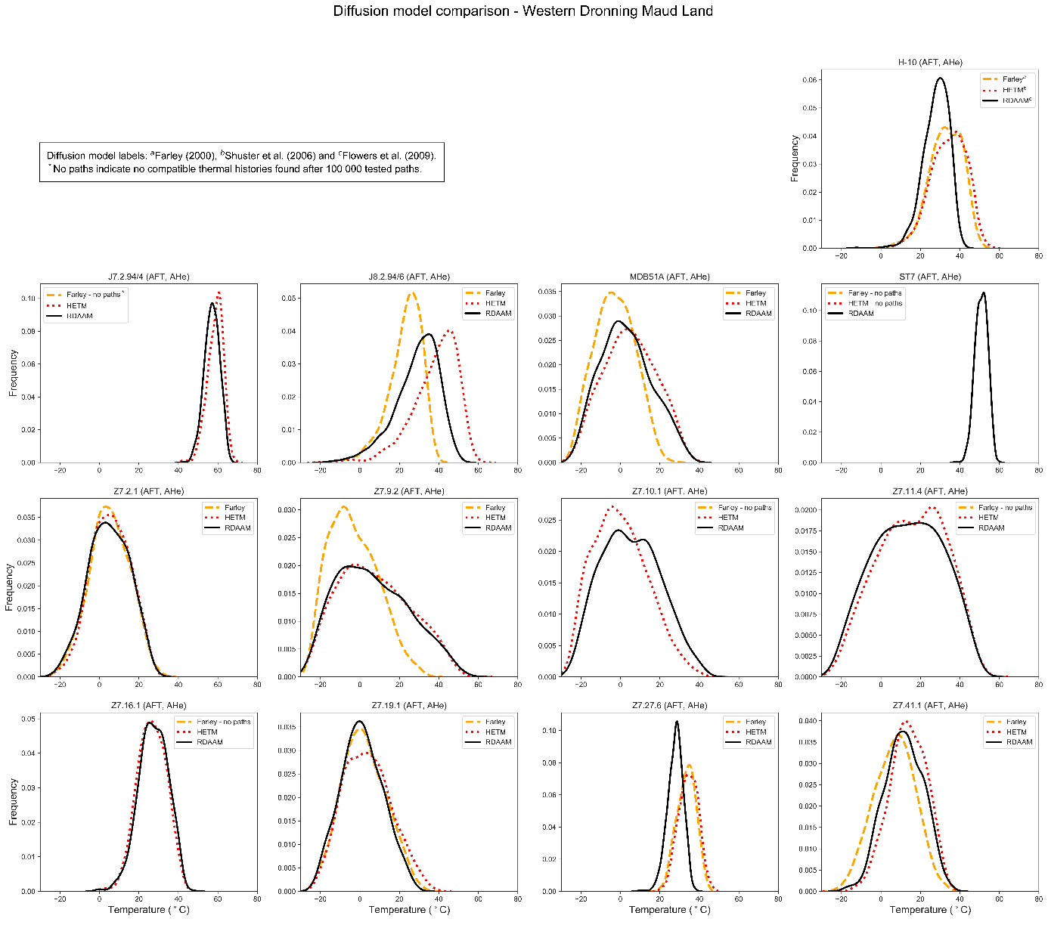
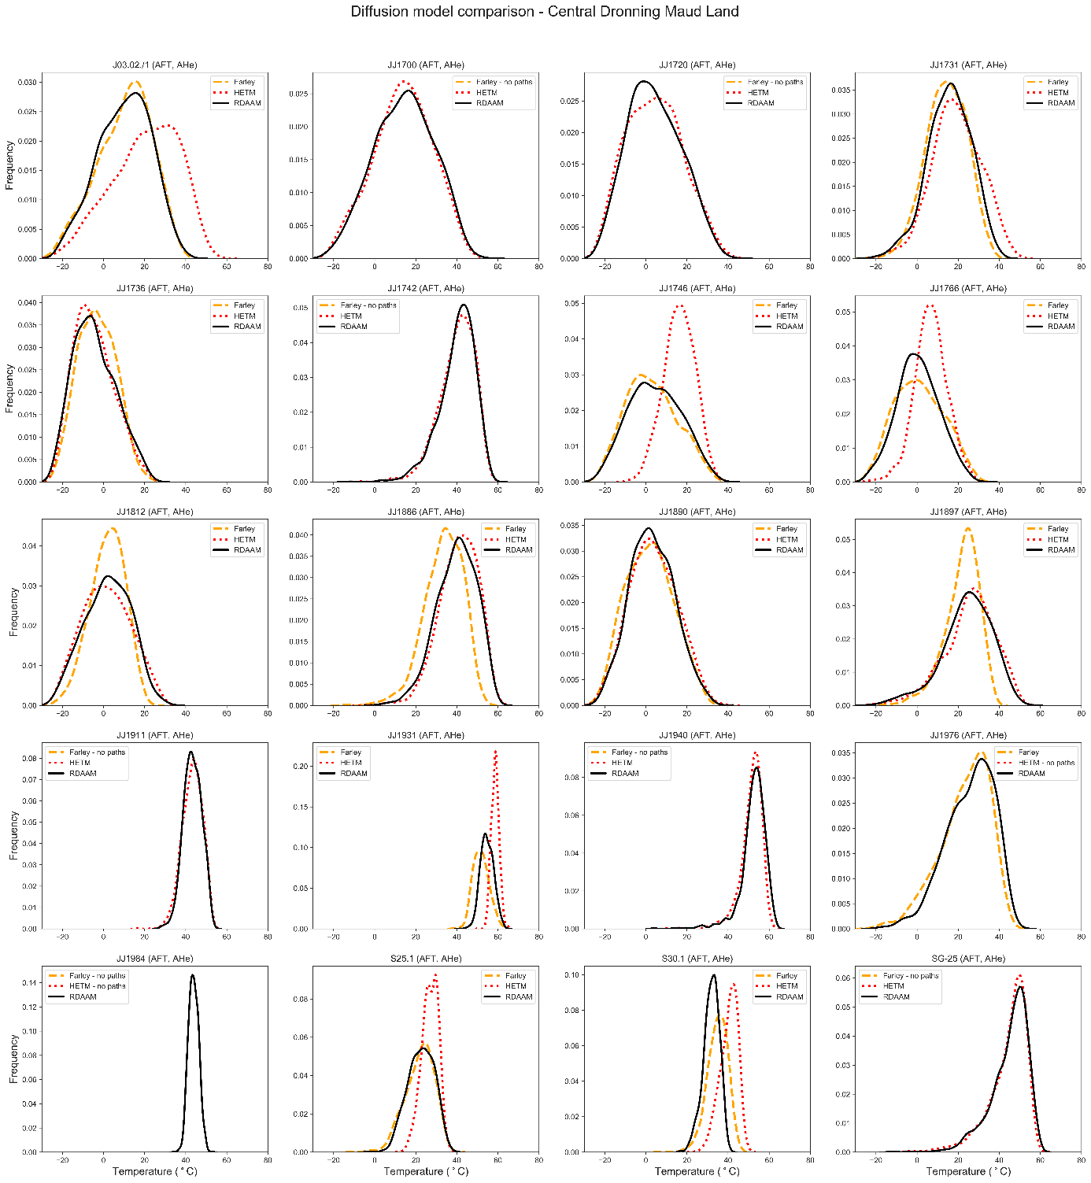
Supplementary Figure 6 – Modeled temperature distributions with different diffusion models. The plots show temperature distributions of individual modeled t-T paths at 34 Ma, comparing the different He diffusion models tested^{25–27}.

Supplementary Notes 5: Temperature distributions – different constraints
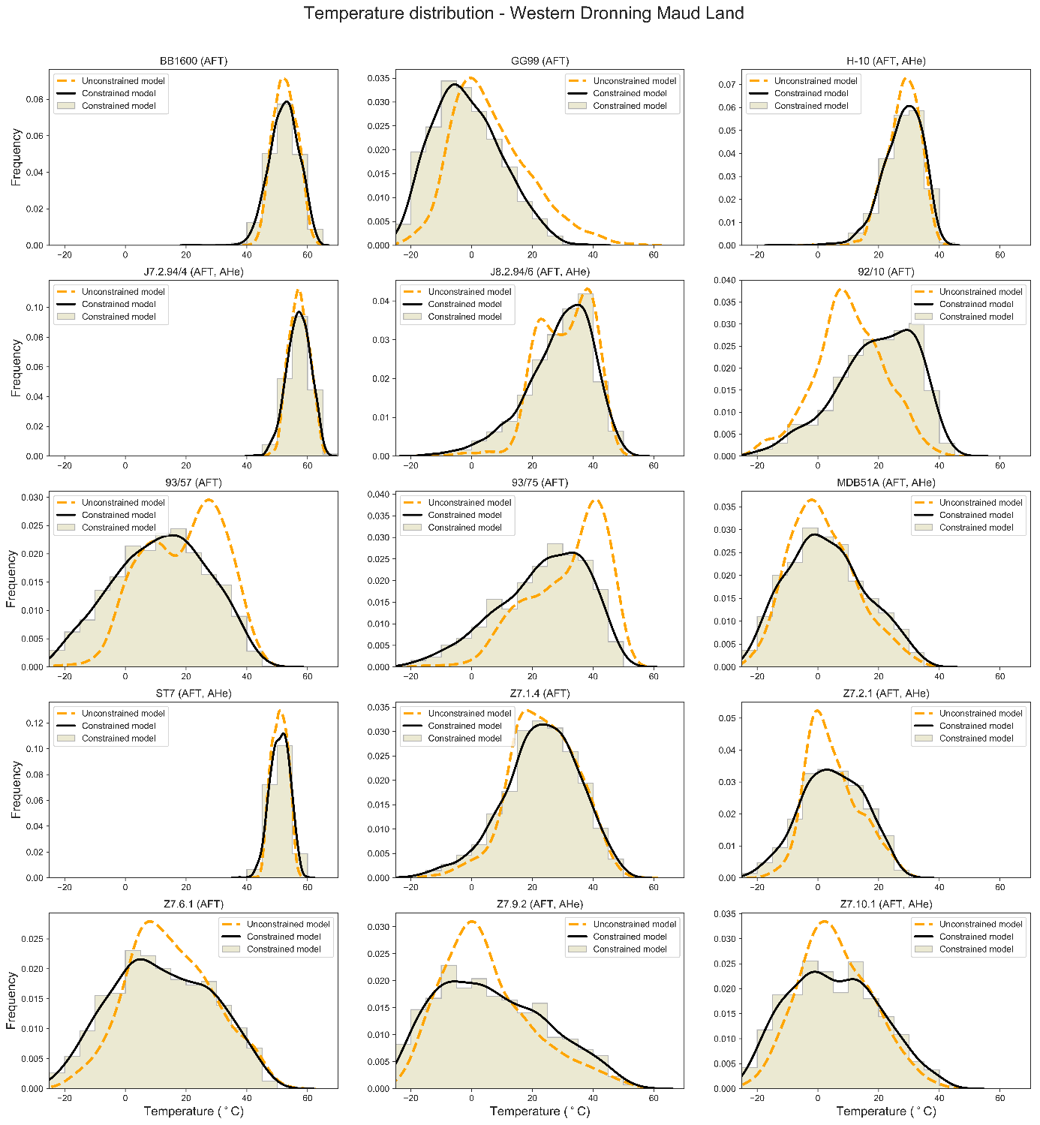
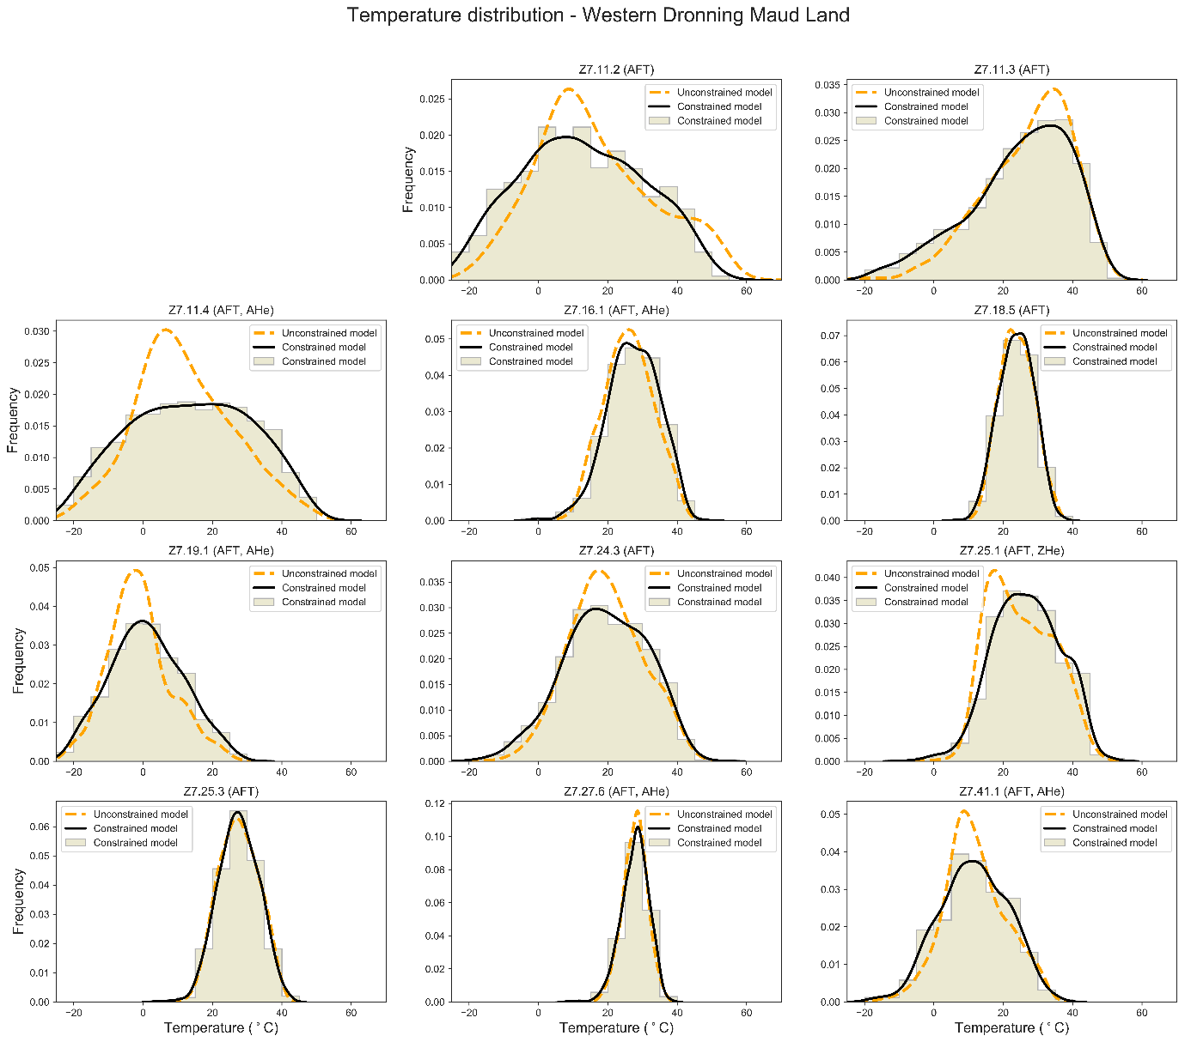
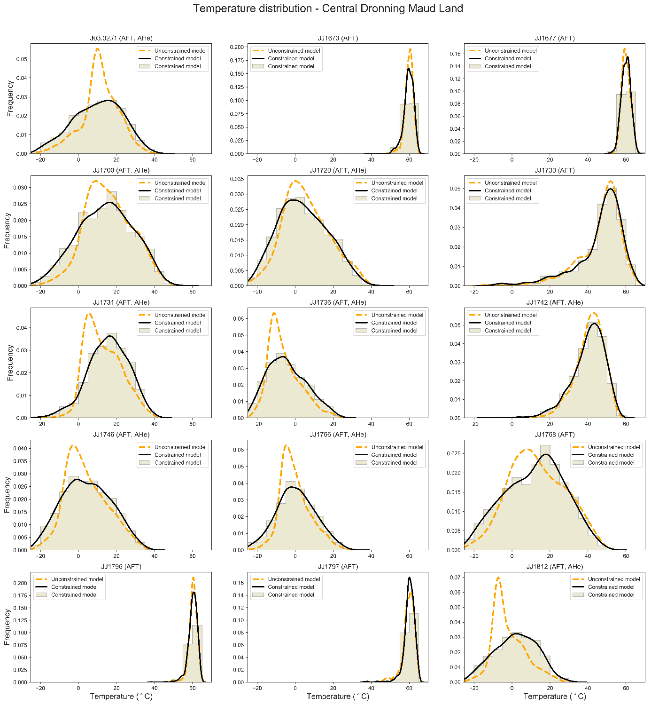
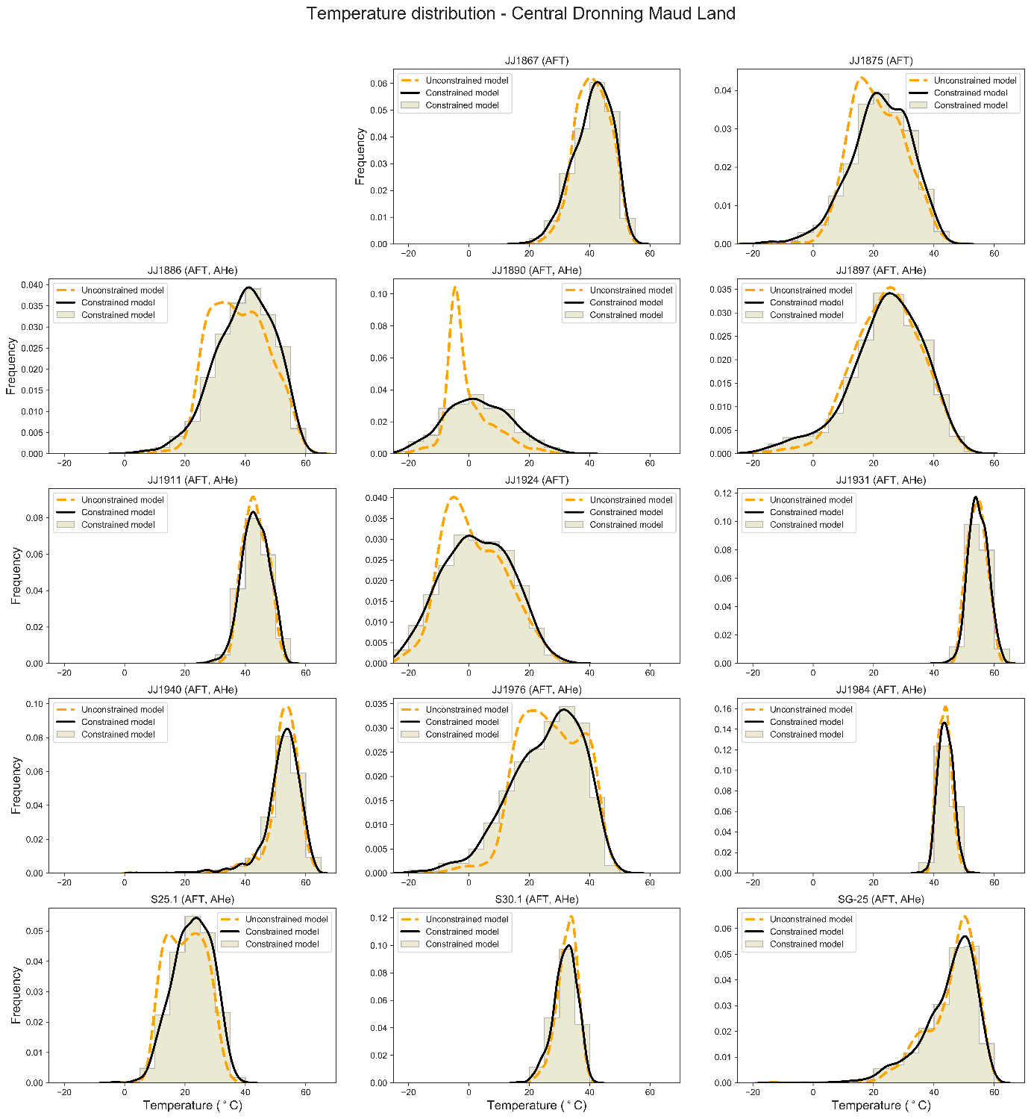
Supplementary Figure 7 – Modeled temperature distributions with different external constraints. The plots show the distribution of interpolated temperatures at 34 Ma. The dashed lines correspond to the unconstrained model, while the histograms and the solid lines represent the temperature distributions of the preferred, constrained models.

Supplementary Notes 6: Thermal history models
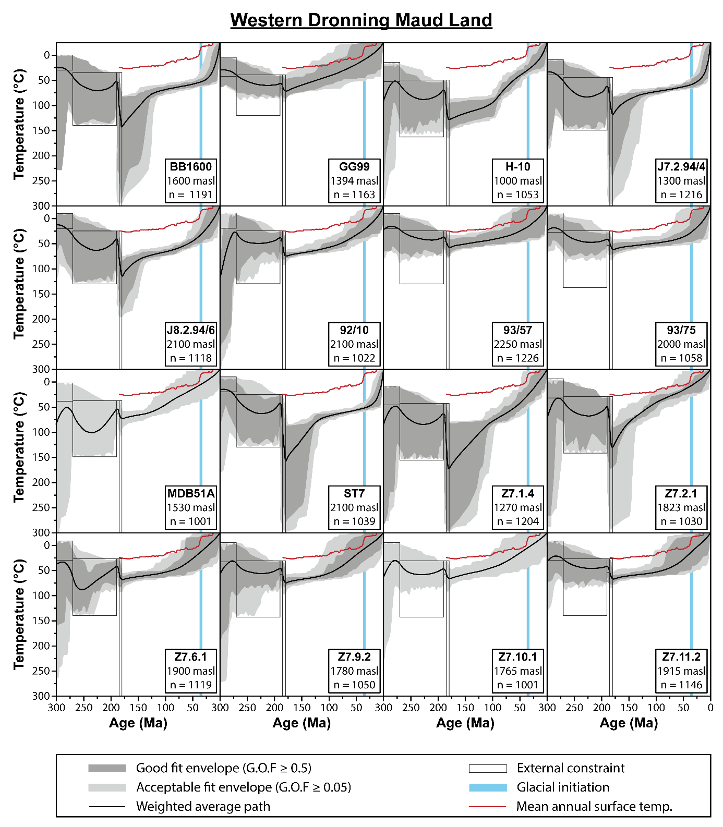
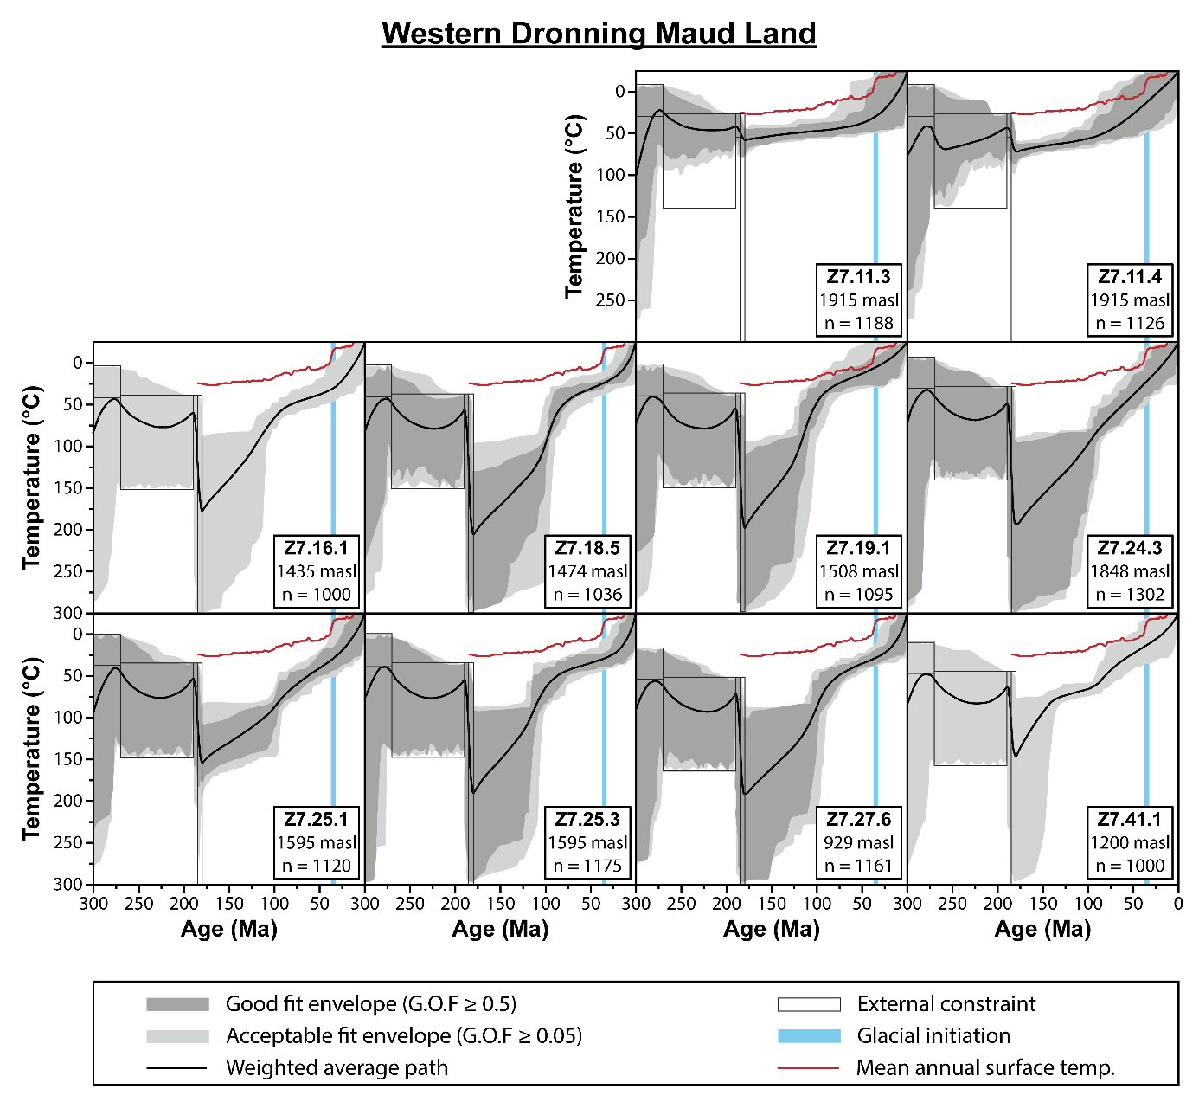

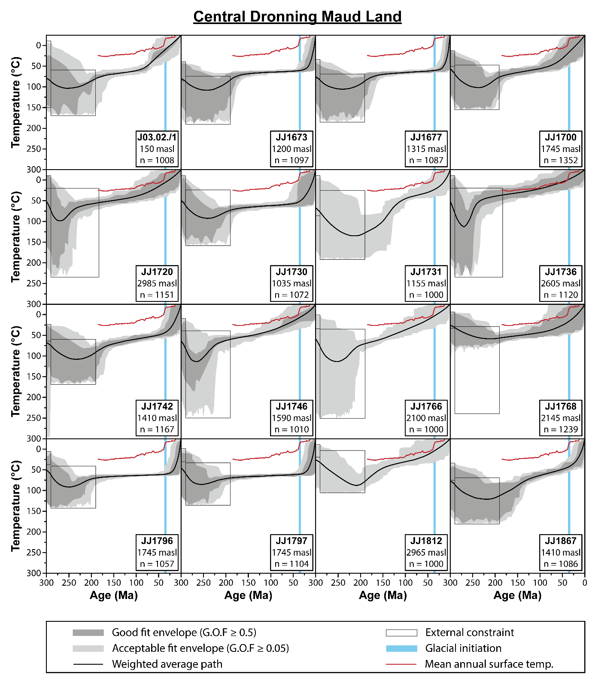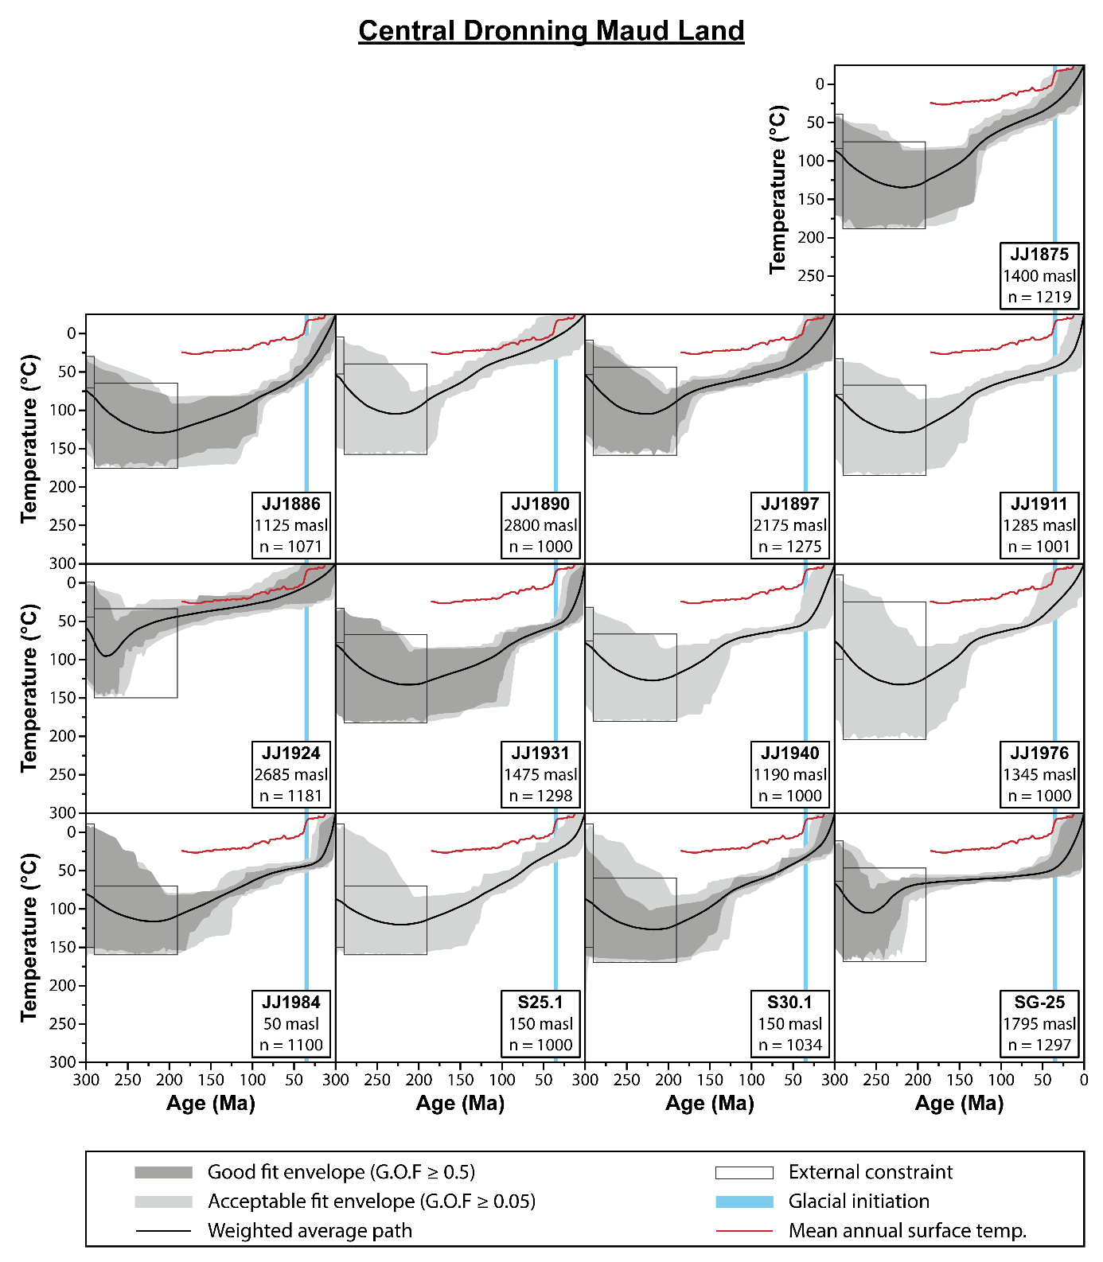
Supplementary Figure 8 – Thermal history models. The constrained thermal history models for all samples used in this study. See Supplementary Figure 2 for specification of the external constraints. n-values of 1000 include only acceptable-fit paths, while n-values > 1000 also include good-fit paths.

Supplementary References:
1. Sirevaag, H., Jacobs, J., Ksienzyk, A. K., Dunkl, I. & Marschall, H. R. Extent, thickness and erosion of the Jurassic continental flood basalts of Dronning Maud Land, East Antarctica: A low-T thermochronological approach. Gondwana Res. 61, 222–243 (2018).
2. Sirevaag, H., Ksienzyk, A. K., Jacobs, J., Dunkl, I. & Läufer, A. Tectono-thermal evolution and morphodynamics of the Central Dronning Maud Land Mountains, East Antarctica, based on new thermochronological data. Geosciences 8, 390 (2018).
3. Matsuoka, K., Skoglund, A. & Roth, G. Quantarctica [Data Set]. (2018). doi:10.21334/npolar.2018.8516e961
4. Ketcham, R. A. HeFTy v. 1.9.1. (2016).
5. Ketcham, R. A., Carter, A., Donelick, R. A., Barbarand, J. & Hurford, A. J. Improved measurement of fission-track annealing in apatite using c-axis projection. Am. Mineral. 92, 789–798 (2007).
6. Ketcham, R. A., Carter, A., Donelick, R. A., Barbarand, J. & Hurford, A. J. Improved modeling of fission-track annealing in apatite. Am. Mineral. 92, 799–810 (2007).
7. Ketcham, R. A., Carter, A. & Hurford, A. J. Inter-laboratory comparison of fission track confined length and etch figure measurements in apatite. Am. Mineral. 100, 1452–1468 (2015).
8. Jacobs, J., Ahrendt, H., Kreutzer, H. & Weber, K. K-Ar, 40Ar-39Ar and apatite fission-track evidence for Neoproterozoic and Mesozoic basement rejuvenation events in the Heimefrontfjella and Mannefallknausane (East Antarctica). Precambrian Res. 75, 251–262 (1995).
9. Coyle, D. A. & Wagner, G. A. Positioning the titanite fission-track partial annealing zone. Chem. Geol. 149, 117–125 (1998).
10. Emmel, B., Jacobs, J. & Daszinnies, M. C. Combined titanite and apatite fission-track data from Gjelsvikfjella, east antarctica - Another piece of a concealed intracontinental Permo-Triassic Gondwana rift basin? Geol. Soc. Spec. Publ. 324, 317–330 (2009).
11. Hendriks, B. W. H., Engvik, A. K. & Elvevold, S. 40Ar/39Ar record of late Pan-African exhumation of a granulite facies terrain, central Dronning Maud Land, East Antarctica. Mineral. Petrol. 107, 665–677 (2013).
12. Jacobs, J. & Lisker, F. Post Permian tectono-thermal evolution of western Dronning Maud Land, East Antarctica: an apatite fission-track approach. Antarct. Sci. 11, 451–460 (1999).
13. Näslund, J. O. Landscape development in western and central Dronning Maud Land, East Antarctica. Antarct. Sci. 13, 302–311 (2001).
14. Plumstead, E. P. A new assemblage of plant fossils from Milorgfjella, Dronning Maud Land. Br. Antarct. Surv. Sci. Reports 83, 1–61 (1975).
15. Olaussen, S. Sedimentological research in northwestern part of Dronning Maud Land. Rep. Nor. Antarct. Reasearch Exped. 1984/85 22, 75–88 (1985).
16. Lindstrom, S. Early Permian palynostratigraphy of the northern Heimefrontfjella mountain-range, Dronning Maud Land, Antarctica. Rev. Palaeobot. Palynol. 89, 359–415 (1995).
17. Bauer, W. Permian Sedimentary Cover , Heimefrontfjella , Western Dronning Maud Land (East Antarctica). Polarforschung 79, 39–42 (2009).
18. Isbell, J. L. The Kukri Erosion Surface; a reassessment of its relationship to rocks of the Beacon Supergroup in the central Transantarctic Mountains, Antarctica. Antarct. Sci. 11, 228–238 (1999).
19. Johnson, M. R. Stratigraphy and sedimentology of the Cape and Karoo sequences in the eastern Capr province. (1976).
20. Wilson, K. M., Pollard, D., Hay, W. W., Thompson, S. L. & Wold, C. N. General circulation model simulations of Triassic climates: preliminary results. in Pangea: Paleoclimate, tectonics, and sedimentation during accretion, zenith, and breakup of a supercontinent (ed. Klein, G. O.) (Geological Society of America, 1994). doi:https://doi.org/10.1130/SPE288
21. Juckes, L. M. The geology of north-eastern Heimefrontfjella, Dronning Maud Land. Br. Antarct. Surv. Sci. Reports 65, 1–66 (1972).
22. Luttinen, A. V. & Furnes, H. Flood basalts of Vestfjella: Jurassic magmatism across an Archaean-Proterozoic lithospheric boundary in Dronning Maud Land, Antarctica. J. Petrol. 41, 1271–1305 (2000).
23. Luttinen, A. V. et al. Depleted mantle-sourced CFB magmatism in the Jurassic Africa-Antarctica rift: Petrology and ⁴⁰Ar/³⁹Ar and U/Pb chronology of the Vestfjella dyke swarm, Dronning Maud Land, Antarctica. J. Petrol. 56, 919–952 (2015).
24. Cleverly, R. W. & Bristow, J. W. Revised volcanic stratigraphy of the Lebombo Monocline. Trans.geol.Soc.S.Afr. 82, 227–230 (1979).
25. Farley, K. A. Helium diffusion from apatite: General behavior as illustrated by Durango fluorapatite. J. Geophys. Res. Solid Earth 105, 2903–2914 (2000).
26. Shuster, D. L., Flowers, R. M. & Farley, K. A. The influence of natural radiation damage on helium diffusion kinetics in apatite. Earth Planet. Sci. Lett. 249, 148–161 (2006).
27. Flowers, R. M., Ketcham, R. A., Shuster, D. L. & Farley, K. A. Apatite (U-Th)/He thermochronometry using a radiation damage accumulation and annealing model. Geochim. Cosmochim. Acta 73, 2347–2365 (2009).
28. Negi, J. G., Agrawal, P. K., Pandey, O. P. & Singh, A. P. A possible K-T boundary bolide impact site offshore near Bombay and triggering of rapid Deccan volcanism. Phys. Earth Planet. Inter. 76, 189–197 (1993).
29. Nicoli, G., Moyen, J. F. & Stevens, G. Diversity of burial rates in convergent settings decreased as Earth aged. Sci. Rep. 6, 1–10 (2016).
30. Lisker, F. & Läufer, A. L. The Mesozoic Victoria Basin: Vanished link between Antarctica and Australia. Geology 41, 1043–1046 (2013).
31. Green, P. F. On the thermo-tectonic evolution of Northern England: Evidence from fission track analysis. Geol. Mag. 123, 493–506 (1986).
32. Gallagher, K. & Brown, R. Denudation and uplift at passive margins: The record on the Atlantic Margin of southern Africa. Philos. Trans. R. Soc. A Math. Phys. Eng. Sci. 357, 835–859 (1999).

