Supplementary information

Supplementary Figures 1-9
Supplementary Table 1-10

1. Sample locations and descriptions
The olivine grains are separated from eleven hand samples, which are from the Pioneer Igneous Complex (PIC) and the Sam Mill Complex (SMC). These two adjacent ultramafic complexes are located in the western part of the Weltevreden Formation. The 8 km long by 1 km thick PIC consists of several distinct successions of massive komatiitic flows, layered komatiitic flows, and tuffs, that have a nearly vertical dip and young to the south. A composite section was measured through the least structurally complex areas and includes at least 11 komatiitic units (Fig. 2 in ref.¹). Units 1-4 include 25-100 m thick massive and layered komatiites. Thicknesses vary laterally and flow lengths are at least 500 m. Individual komatiitic flows are separated by 10-60 m thick sections of komatiitic tuff. Unit 5 overlies a zone of carbonate-fuchsite alteration. Units 6-11 are each 10-60 m thick and are predominately spinifex-textured komatiitic basalts. These rocks are separated by thin (<10 m thick), discontinuous tuff layers. Unit 12 is a 180 m thick homogenous komatiitic flow or flow set. 6 Samples from 3 massive komatiite units (sample SA957-1 is from Units 1; sample MC4-3 and MC4-4 are from Units 4; sample SA719-1, SA719-32, and SA970-3 are from Units 12; Supplementary Figure 1). They are gray to brown on weathered surfaces and consist entirely of olivine cumulates. It is in fault contact with the Fig Tree Group sedimentary rocks at the top of the section¹.
The SMC, mapped over a 4 km² area, is a 1275 m thick sequence generally striking east-northeast and facing north-northwest. The stratigraphy has been tilted to near vertical orientation. The identifiable lithologic include pyroxenitic komatiites, peridotitic komatiites, dunitic komatiites, komatiitic basalts, and tuffs. The SMC can be divided into three distinct stratigraphic sequences. 1) From the base to 250 m, the stratigraphy is entirely composed of interbedded pyroxenitic komatiites and tuffs; 2) Emplacement shifts to a more dunitic komatiitic composition, still interbedded with tuffs, from 250 m to 700 m; 3) From 700 m to the top, this part is dominated by peridotitic komatiitic flows, again interbedded with tuffs. This general division of flows does not strictly follow the deposition of flows, as there are pyroxenitic and dunitic komatiites high in the sequence associated with layered flows, and there are komatiitic basalts interspersed in the stratigraphy of the SMC. However, peridotitic komatiites are only found above 780 m in the stratigraphic sequence, suggesting that the SMC is not a structurally repeated sequence of flows. Individual flows vary from as little as 40 m thick to as much as 100 m thick. The Fig Tree Group sediments lie conformably above the komatiites of the SMC². 5 Samples from 3 flows (sample 564-3 and SA902-2 are from #1 Gary’s Flows; sample SA903-3 and SA 501-9 are from #1 Keena’s Flow; sample SA904-2 is from #2 Keena’s Flows; Supplementary Figure 1).
All samples are massive peridotitic komatiite, commonly only partially serpentinized, with a mineral assemblage of fresh olivine, pyroxene, spinel, and chromite. Olivine is the most common primary phase in the komatiites. Euhedral olivine ranges in size (longest apparent dimension) from about 200 μm to about 1mm, with most approximately 400-500 μm. Olivine is a cumulate phase in the komatiites. Augite crystals are often observed growing in the interstitial space between olivine grains. Pigeonites grow as acicular crystals in the space between olivines, similar to small-scale spinifex texture, or as overgrowths of orthopyroxene. Generally, the chemical variation of flows is almost entirely controlled by olivine accumulation and separation. Geochemically, they have superchondritic Al/Ti (Al₂O₃/TiO₂ = 21-33, often referred to as Gorgona-type or AEK-type³). They are depleted in light rare earth elements (LREE) and enriched in heavy rare earth elements (HREE) with maximum liquid compositions of approximately 33% MgO, and olivines up to Fo95⁴. The oxygen isotopic composition of olivine from three samples was studied by ref.⁵. Detailed field information and the sample locations are shown in Supplementary Figure 1. Samples with low δ¹⁸O values are exposed in both regions, and samples from the same flow show homogenous δ¹⁸O values. Specific sample positions are listed in Supplementary Table 1.

2. Olivine chemistry systematics
Most major-minor-trace elements of the olivine grains in this study resemble those of other Weltevreden komatiites that have been reported (Supplementary Data 9), they are characterized by Ca and Ti depletion and have higher Sc contents than worldwide olivine from other localities. The tight correlation between Mn and Fo suggests that they have not undergone crustal contamination during upwelling⁶. Ca contents of the worldwide komatiitic olivine grains show different trends in the Fo content versus Ca diagram (Supplementary Figure 2 and Supplementary Figure 3). The Ca content increased in the order of ~3.3 Ga Weltevreden komatiites, ~2.7 Ga komatiites, and ~3.5 Ga Al-depleted komatiites. 3.5 Ga Al-depleted komatiites show a negative correlation with Fo content; ~2.7 Ga komatiites and 3.3 Ga Weltevreden komatiites show horizontal trends with the Fo, which may reflect the evolution of the mantle thermal state.
Fo content displays negative correlations with most of the first-row transition elements (FRTE) except for Ni and Li concentrations, implying their incompatible behavior. The high Cr contents indicate high temperatures with a high degree of partial melting. In general, two groups of olivine display different evolutionary trends in diagrams of Fo versus some element and element ratios. The two groups of olivine show comparable Ca, Al, Ti, Na, and P contents and no correlations between Fo content and Ca, Al, V, and Ti contents. Fo is positively correlated with Ni content in the low-δ¹⁸O olivines but with a horizontal trend in the normal-δ¹⁸O olivines (Supplementary Figure 2). They show nearly-parallel arrays when plotted in Fo versus Co/Fe, Co, and Zn, which means at equivalent Fo content, the low-δ¹⁸O olivines are higher in Co/Fe and Co, lower in Zn than the normal-δ¹⁸O olivine. The occurrence of inflection points in the Fo versus Zn/Co, and Zn/Fe diagrams indicates variable evolutionary trends between the two groups. Likewise, different trends can be observed in Fo versus Na, Mn/Zn, and Ca/Fe. In the normal-δ¹⁸O olivines, Fo shows a negative correlation with Na, which is opposite to that to the low-δ¹⁸O olivines; Fo shows a negative correlation with Mn/Zn in the low-δ¹⁸O olivines but displays no correlation in the normal-δ¹⁸O olivines; Fo shows a negative correlation with Ca/Fe, but displays no correlation in the low-δ¹⁸O olivines. These differences cannot be explained by single magmatic differentiation processes, indicative of the variable mantle source compositions of the two clusters of olivine grains.

3. Effect of alteration on olivine
According to the BSE images (Fig. 1), we can observe the structure of olivine. Some olivine is almost unaffected by alteration and shows only very thin alteration rims, and some grains show complex alteration structures. In some cases, olivine may first undergo alteration to form serpentine, and then form olivine again due to dehydration during high-grade metamorphism^{7,8}. The metamorphic grade of Weltevreden komatiites is mainly low-grade greenschist facies, and olivine, in this case, inherits the compositional characteristics of serpentine, especially with extremely high Fo values (96-98)⁸. From the mineral composition, we also analyzed different domains of the same grains by EPMA and LA-ICP-MS for comparison, the results show significant compositional differences between olivine and serpentine. Serpentine domains show a wide range of compositional variations (Supplementary Data 10). Generally, serpentine is characterized by higher Fo value (96.3-98.2), SiO₂ (47.3-49.7 wt.%), Al (1079-8548 ppm), Ca (94-5346 ppm), Ti (63-273 ppm), and Na (61-247 ppm), and lower FeO (1.61-3.22 wt.%), MgO, and Co (77-106 ppm) contents than olivine, which reflects the alteration reworking. Moreover, the composition of olivines in our samples is comparable to those of fresh olivines in other typical komatiites (Supplementary Figure 3-4). Therefore, we confirm that its oxygen isotopes represent the primary characteristics.

4. Comparison with previous results of the olivine δ¹⁸O values
The AOC is the main reservoir with variable δ¹⁸O values due to exchange with seawater at different temperatures^{9,10}. The low-T (<200℃) altered upper basalts and overlying sediments exhibit heavy δ¹⁸O (7-15‰) and the high-T hydrothermal alteration (>250℃) of the lower gabbros and peridotites causes ¹⁸O depletion (δ¹⁸O = 2-5 ‰). Deep recycling of the high-temperature hydrothermally altered oceanic crust (AOC) may provide substantial ¹⁸O-depleted domains in the deep mantle. Ref.¹⁸ rejected this possibility mainly based on the unrealistic high proportion of recycled material required (~50-80 %). They obtained δ¹⁸O values (as low as 2.9-4.1 ‰) of olivine by the LF method(). Though fresh olivine cores have been preserved intact without alteration, they intertwined with alteration fringes and penetrating veinlets of magnetite intergrown with serpentine (Fig. 1), these curvilinear and conjugate alteration minerals cannot be completely separated from olivine. Therefore, the bulk olivine δ¹⁸O values may represent the mixing of fresh olivine core and alteration domains with lower δ¹⁸O values, supported by that the average δ¹⁸O value measured by in-situ SIMS is higher than those obtained by LF for each same sample and a 0.8 ‰ difference from the same sample in duplicate LF analysis⁵. Olivines that have altered to serpentine, show lower δ¹⁸O values. In three samples analyzed in both laboratories, the results in our LF analysis are consistent with ref.⁵. Some samples show lower δ¹⁸O values by LF but mantle-like δ¹⁸O values by SIMS, reflecting the interference of alteration minerals during the LF method (Supplementary Figure 9). It is likely that ref.⁵ overestimates the degree of δ¹⁸O depletion in Weltevreden olivine, but more importantly, our SIMS data confirmed that a subgroup of olivine grains indeed possess light δ¹⁸O values.

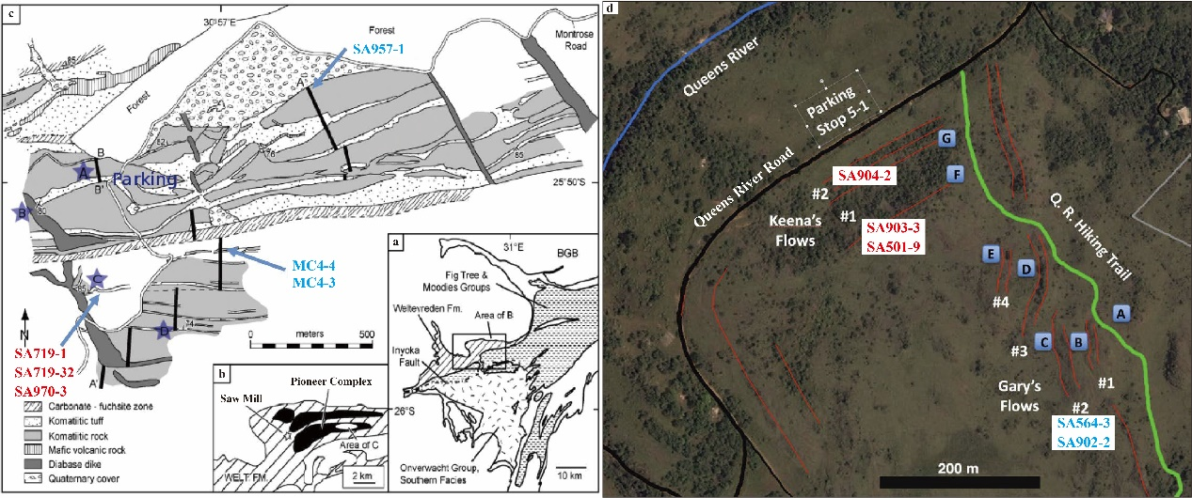
Supplementary Figure 1 Geologic map of the Pioneer Igneous Complex and the Saw Mill area of the Weltevreden Formation (modified by ref.²). Red sample numbers represent locations of normal δ¹⁸O samples, and blue sample numbers represent locations of low δ¹⁸O samples. c The parking area is 4.6 km on Montrose Farm Road west of the Agnes Mine Road intersection and approximately 12.9 km from Barberton Town Square. All strikes and dips are measured in komatiitic tuffs. d The area is 23.8 km from Barberton Town Square along the Queens River Road (black) and the new Queens River Hiking Trail. Sample localities for Keena’s Flows (#1 and #2) are directly across from the parking area. The sampling locality for Gary’s Flows is at “B”.

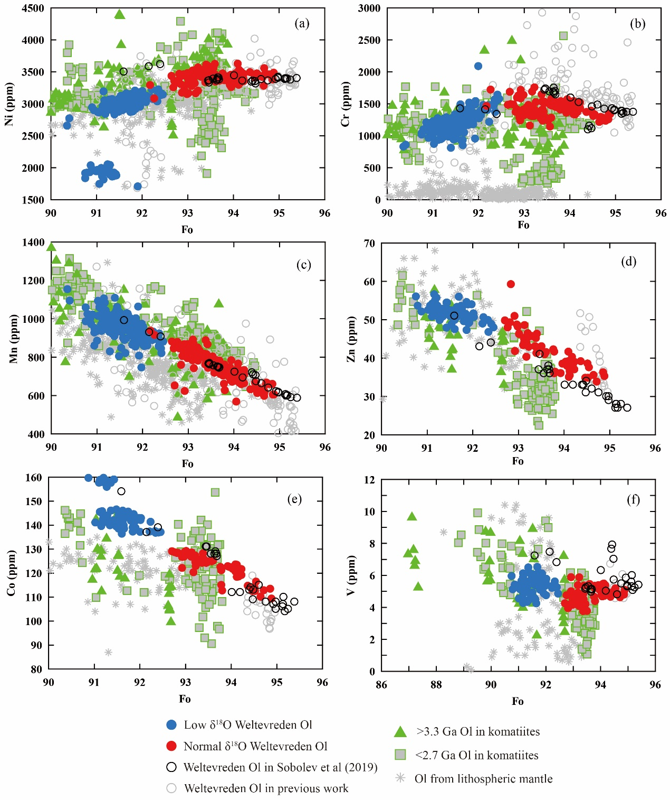
Supplementary Figure 2 Forsterite (Fo) content versus first-row transition elements (FRTE) for olivine grains. Covariation diagrams of Fo versus a Ni, b Cr, c Mn, d Zn, e Co, and f V content. Elements are shown in ppm. Olivine grains from komatiites worldwide^{1,11-15} and the lithospheric mantle samples, high-temperature peridotite xenoliths from kimberlite^{16,17} are plotted for comparison (data and source listed in Supplementary Data 9).

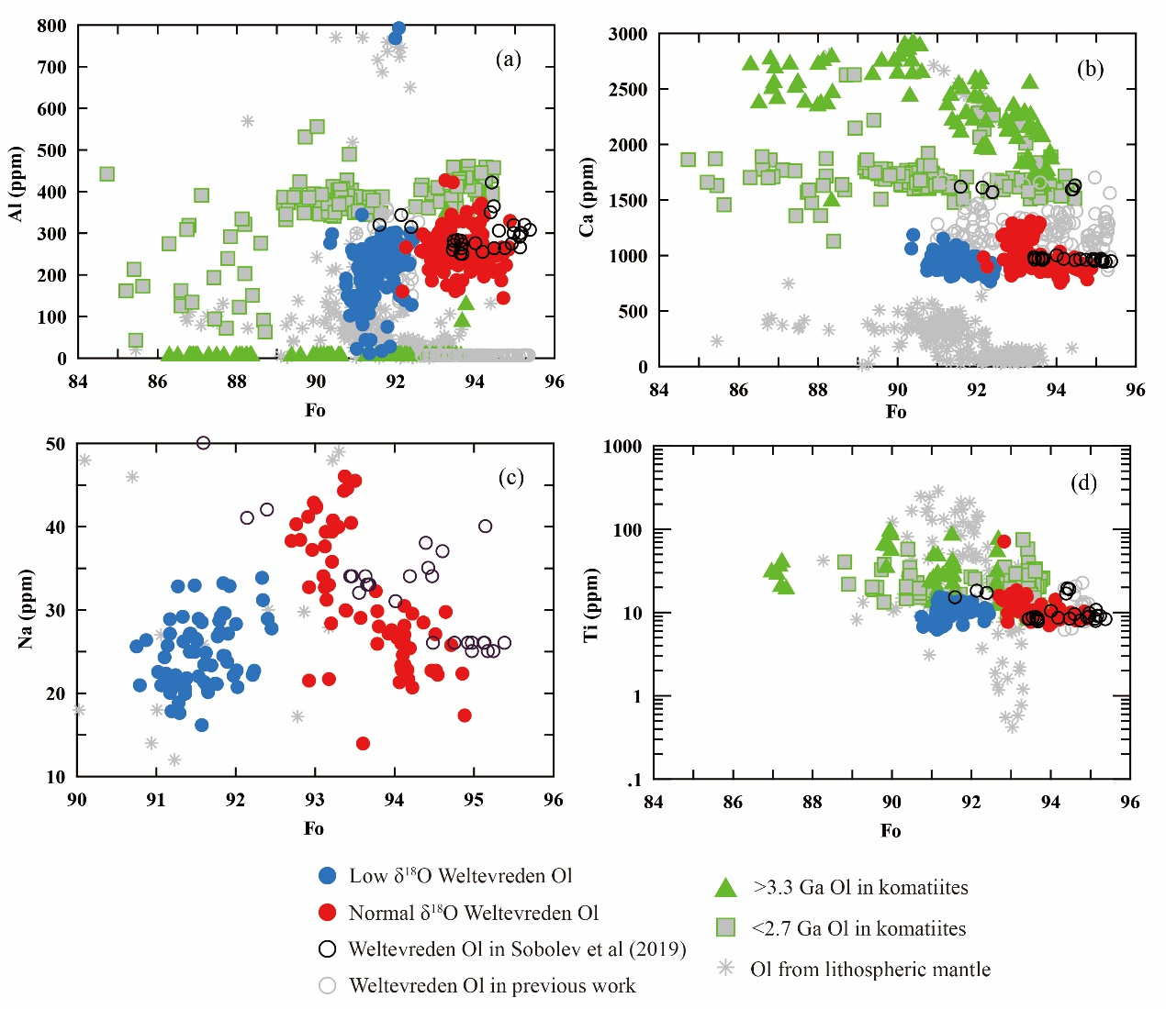
Supplementary Figure 3 Fo content versus some lithophile elements and Ti for olivine grains. Covariation diagrams of Fo versus a Al; b Ca; c Al and d Ti. Elements are shown in ppm. All symbols are as in Supplementary Figure 2.

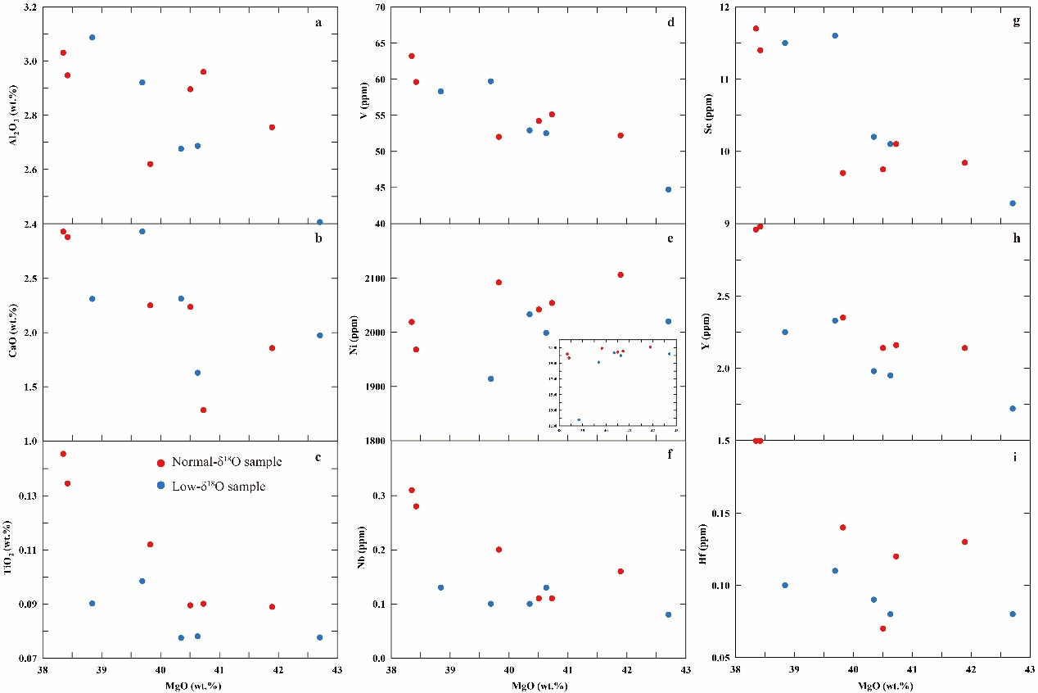
Supplementary Figure 4 Whole-rock MgO content versus representative elements for Weltevreden komatiite samples. Covariation diagrams of MgO versus a Al₂O₃; b CaO; c TiO₂; d V; e Ni; f Nb; g Sc; h Y; i Hf content. Blue symbols represent low δ¹⁸O olivines from five samples; red symbols represent normal δ¹⁸O olivine from the other six samples.

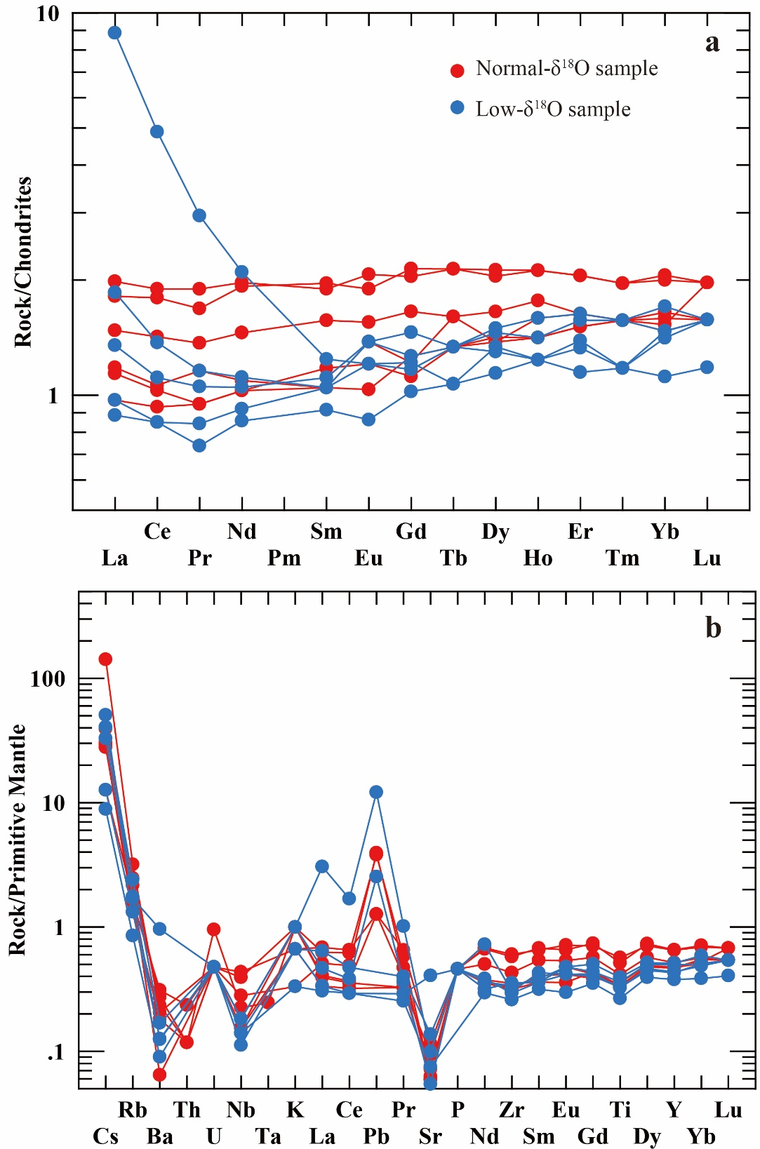
Supplementary Figure 5 Trace elements of the Weltevreden komatiites. a Chondrite-normalized REE distribution pattern and b Primitive mantle-normalized trace element spider diagram of the komatiites of the Weltevreden Formation. Normalized values are from ref.¹⁸.

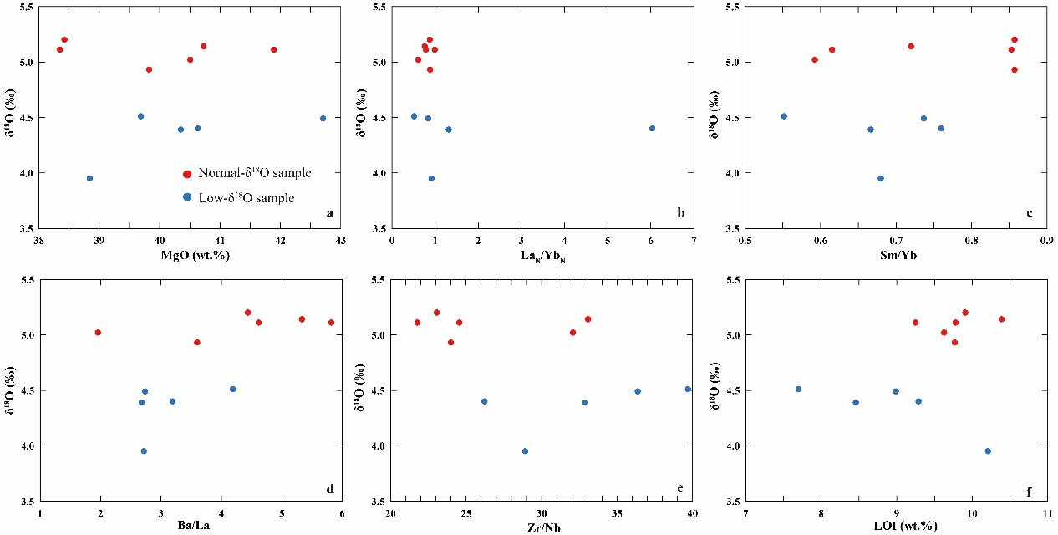
Supplementary Figure 6 Average forsterite content (Fo) for olivine grains in each sample versus whole-rock compositions. Covariation diagrams of Fo versus a MgO; b (La/Yb)_{N}; c Sm/Yb; d Ba/La; e Zr/Nb, and f loss on ignition (LOI). Elements are shown wt.% in a and f.

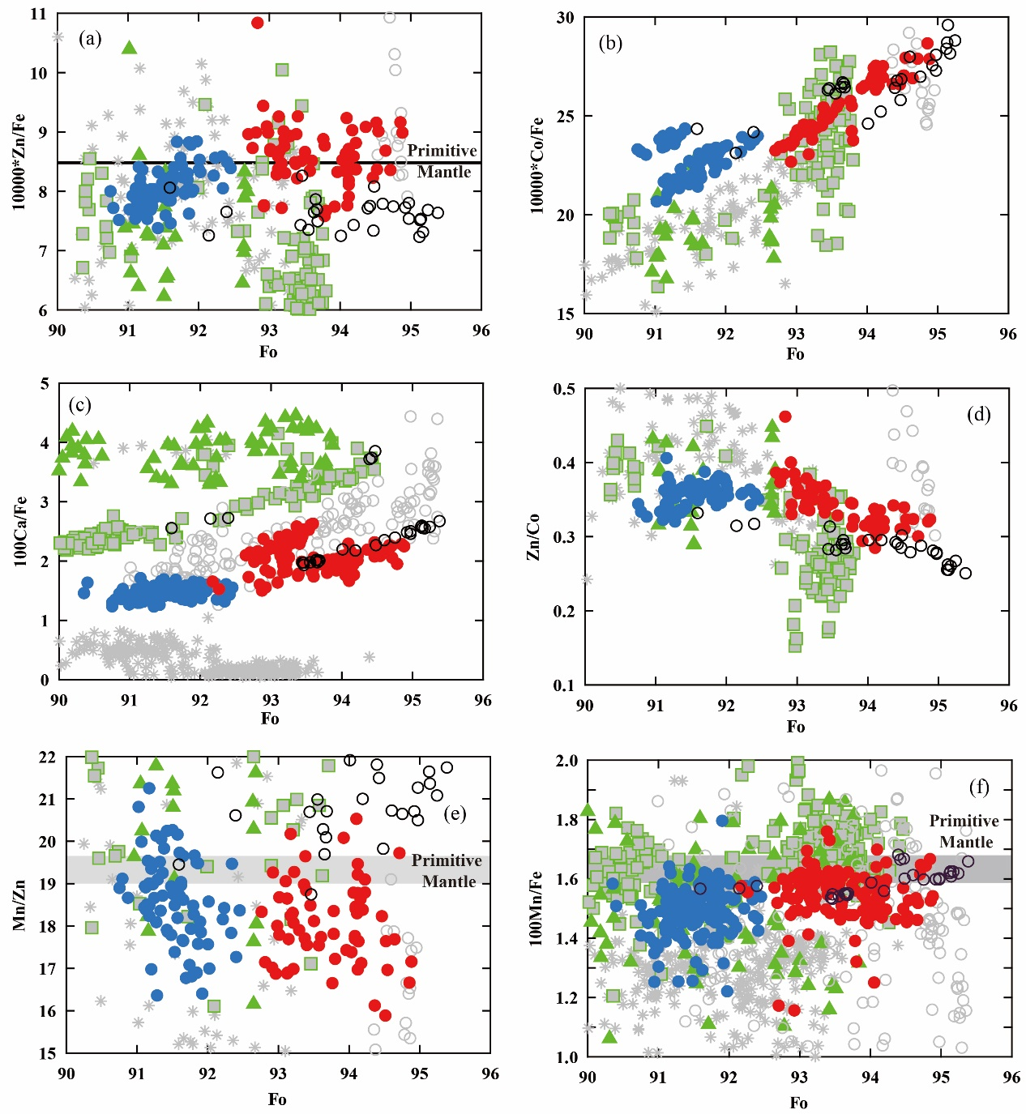

Supplementary Figure 7 A compilation of olivine compositions. Covariation diagrams of Fo values versus pyroxenite contribution-sensitive proxies for olivine grains. Fo versus a Zn/Fe; b Co/Fe; c Ca/Fe; d Zn/Co; e Mn/Zn and f Mn/Fe. The two groups of olivine display different trends, which cannot be explained by partial melting of a single mantle source previously affected by magmatic differentiation. The similarities of Mn/Zn and Mn/Fe between the two groups indicate either the decoupling or invalidation of these proxies in extreme scenarios. Some pyroxenite vestiges may be diluted or even erased, leading to the overwhelming control of compatible trace element contents in olivine by olivine-bearing lithologies. All symbols are as in Supplementary Figure 2.

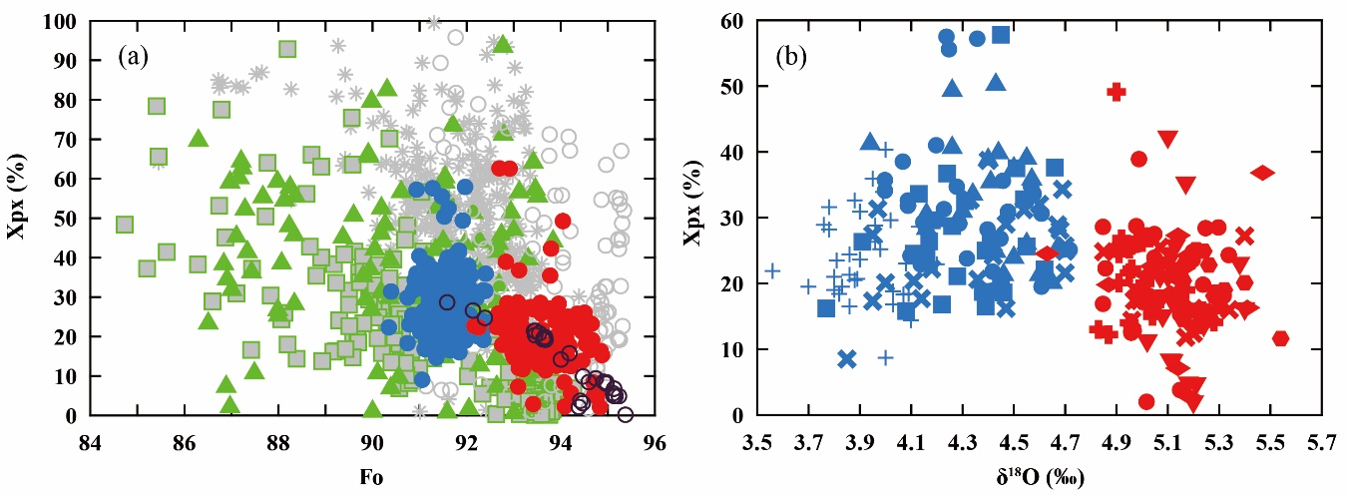
Supplementary Figure 8 Relationship between Xpx and a Fo content and b δ¹⁸O value of olivine grains from Weltevreden komatiite samples and olivine from worldwide komatiite. The equation¹⁹ used is: Xpx=6.705E-04×(Ni×FeO/MgO)-1.332E-02×Mn/FeO+1.5215.
where Xpx=weight fraction of pyroxenite-derived melt in the source; Ni and Mn are element concentrations given in ppm, FeO and MgO are given in wt.%. This calculation method is based on the parameterization of ref.³ utilizing normalized Ni and Mn contents in olivine phenocrysts to obtain relative Xpx. Here, the absolute value of the Xpx is probably meaningless and does not reflect the true proportion of pyroxenite rocks in the source. However, the low δ¹⁸O olivines show a discernible higher average Xpx proportion than the normal-δ¹⁸O olivine. The relative difference shown by the two groups of olivines is critical. All symbols in a) are as in Supplementary Figure 2, and in b) are as in Fig. 3.

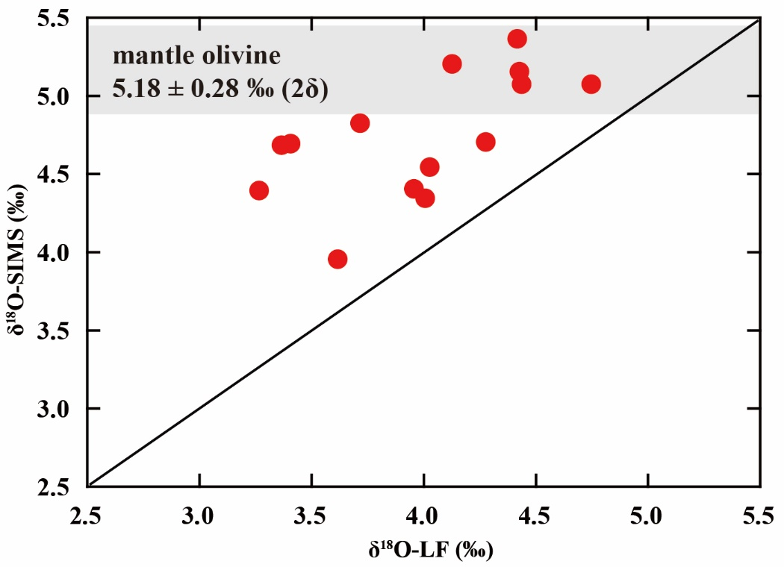
Supplementary Figure 9 Comparison of olivine δ¹⁸O values obtained by in situ SIMS and bulk-grain LF methods (Supplementary Data 9). The average δ¹⁸O values measured by SIMS are higher than those obtained by LF for the same sample. The bulk olivine δ¹⁸O values by LF represent the mixing of fresh relic core and alteration minerals with lower δ¹⁸O values.

Supplementary References
1. Thompson Stiegler, M., Cooper, M., Byerly, G. R. & Lowe, D. R. Geochemistry and petrology of komatiites of the Pioneer Ultramafic Complex of the 3.3Ga Weltevreden Formation, Barberton greenstone belt, South Africa. Precambrian Research 212-213, 1-12 (2012).
2. Huber, M. S. & Byerly, G. R. Volcanological and petrogenetic characteristics of komatiites of the 3.3 Ga Saw Mill Complex, Weltevreden Formation, Barberton Greenstone Belt, South Africa. South African Journal of Geology 121, (2018).
3. Arndt, N. in Komatiite (eds C. Michael Lesher, Nicholas Arndt, & Steve J. Barnes) 233-234 (Cambridge University Press, 2008).
4. Connolly, B. D. et al. Highly siderophile element systematics of the 3.3Ga Weltevreden komatiites, South Africa: Implications for early Earth history. Earth and Planetary Science Letters 311, 253-263 (2011).
5. Byerly, B. L., Kareem, K., Bao, H. & Byerly, G. R. Early Earth mantle heterogeneity revealed by light oxygen isotopes of Archaean komatiites. Nature Geoscience 10, 871-875 (2017).
6. Su, B. et al. Minor elements in olivine inspect the petrogenesis of orogenic peridotites. Lithos 344-345, 207-216 (2019).
7. Peters, S. T. M. et al. >2.7 Ga metamorphic peridotites from southeast Greenland record the oxygen isotope composition of Archean seawater. Earth and Planetary Science Letters 544, (2020).
8. Nutman, A. P., Scicchitano, M. R., Friend, C. R. L., Bennett, V. C. & Chivas, A. R. Isua (Greenland) ~3700 Ma meta-serpentinite olivine Mg# and δ18O signatures show connection between the early mantle and hydrosphere: Geodynamic implications. Precambrian Research 361, (2021).
9. Gregory, R. T. & Taylor, H. P. An oxygen isotope profile in a section of Cretaceous oceanic crust, Samail Ophiolite, Oman: Evidence for δ18O buffering of the oceans by deep (>5 km) seawater-hydrothermal circulation at mid-ocean ridges. Journal of Geophysical Research: Solid Earth 86 (1981).
10. Muehlenbachs, K. Alteration of the oceanic crust and the 18 O history of seawater. Reviews in Mineralogy and Geochemistry 16, 425-444 (1986).
11. Locmelis, M., Arevalo, R. D., Puchtel, I. S., Fiorentini, M. L. & Nisbet, E. G. Transition metals in komatiitic olivine: Proxies for mantle composition, redox conditions, and sulfide mineralization potential. American Mineralogist 104 (2019).
12. Nicklas, R. W., Puchtel, I. S. & Ash, R. D. Redox state of the Archean mantle: Evidence from V partitioning in 3.5–2.4 Ga komatiites. Geochimica et Cosmochimica Acta 222, 447-466 (2018).
13. Nicklas, R. W. et al. Secular mantle oxidation across the Archean-Proterozoic boundary: Evidence from V partitioning in komatiites and picrites. Geochimica et Cosmochimica Acta 250 (2019).
14. Puchtel, I. S. et al. Insights into early Earth from Barberton komatiites: Evidence from lithophile isotope and trace element systematics. Geochimica et Cosmochimica Acta 108, 63-90 (2013).
15. Sobolev, A. V. et al. Deep hydrous mantle reservoir provides evidence for crustal recycling before 3.3 billion years ago. Nature 571, 555-559 (2019).
16. De Hoog, J. C. M., Gall, L. & Cornell, D. H. Trace-element geochemistry of mantle olivine and application to mantle petrogenesis and geothermobarometry. Chemical Geology 270, 196-215 (2010).
17. Sobolev, N. V. et al. Petrogenetic significance of minor elements in olivines from diamonds and peridotite xenoliths from kimberlites of Yakutia. Lithos 112, 701-713 (2009).
18. Sun, S. s. & McDonough, W. F. Chemical and isotopic systematics of oceanic basalts: implications for mantle composition and processes. Geological Society, London, Special Publications 42, 313-345 (1989).
19. Gurenko, A. A., Sobolev, A. V., Hoernle, K. A., Hauff, F. & Schmincke, H.-U. Enriched, HIMU-type peridotite and depleted recycled pyroxenite in the Canary plume: A mixed-up mantle. Earth and Planetary Science Letters 277, 514-524 (2009).

