Supplemental Material for
Rainfall variability increased with warming in northern Queensland, Australia over the past 280 years
Kelsey A. Dyez, Julia Cole, Janice Lough

This supplement includes supporting figures: SEM images, coral growth rate, validation dataset and supporting tables of statistical values.

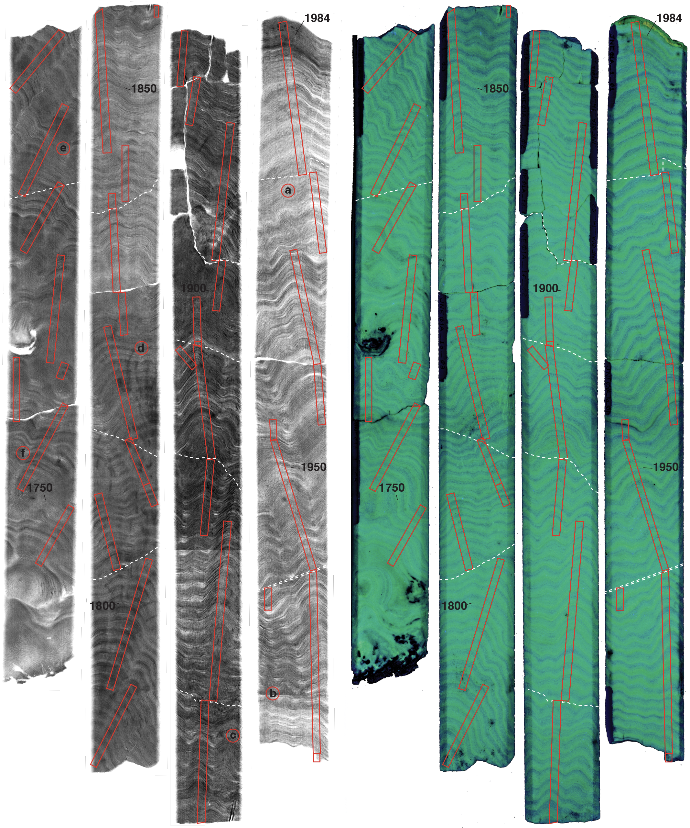
Supplemental Fig. 1. Coral density banding (left image) and luminescence banding (right image) with sample transects. Circled letters represent locations where SEM image samples were taken from the coral surface; SEM images show no signs of secondary precipitation or dissolution (Supplemental Fig. 2).
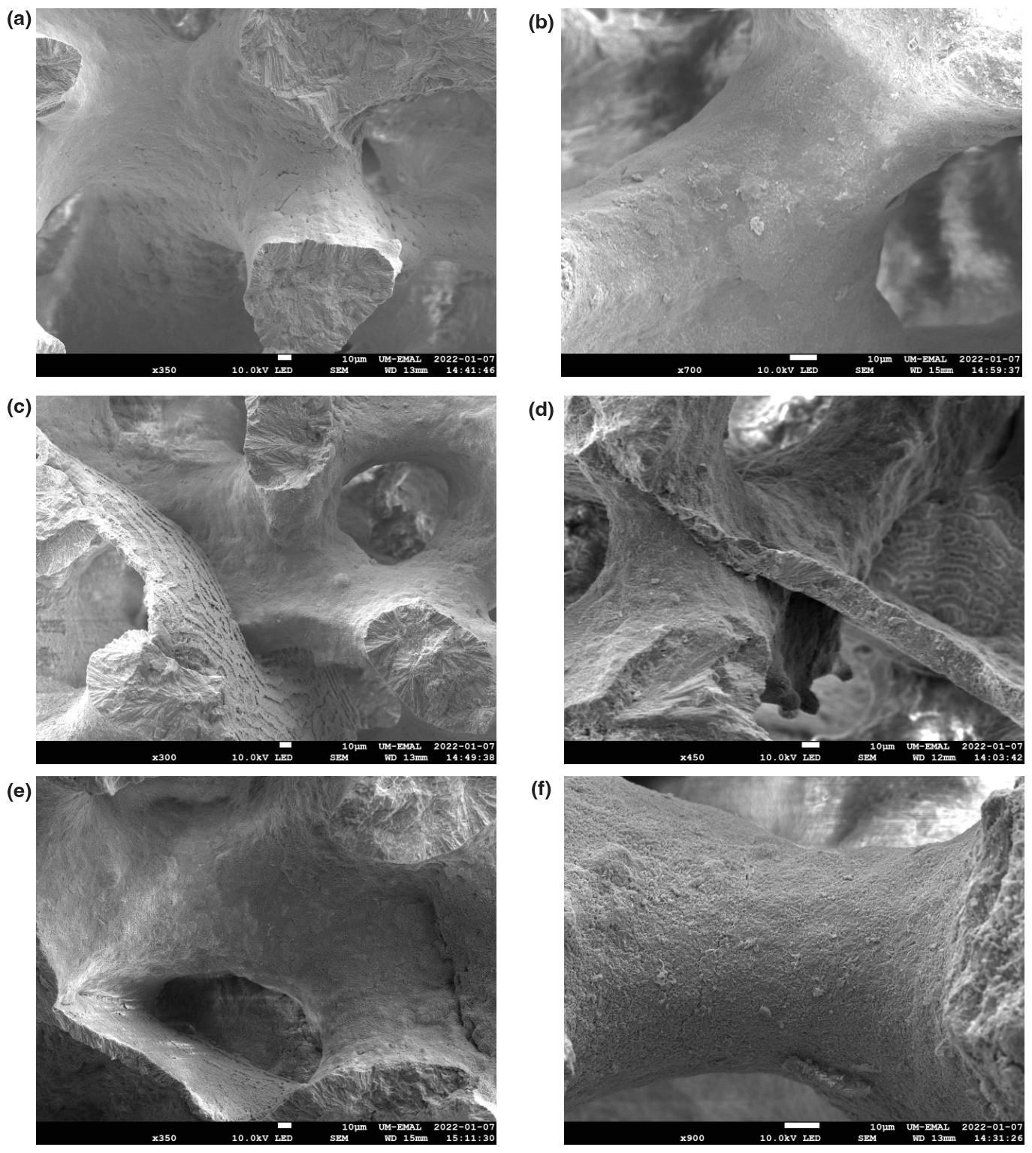

Supplemental Fig. 2. Example scanning electron microscope images of Jeannie River coral surface at 350-900x magnification. We observed no evidence of secondary aragonite on the surface of this coral. Locations of each SEM image are throughout the core and indicated by the circled letters in Supplemental Fig. 1.

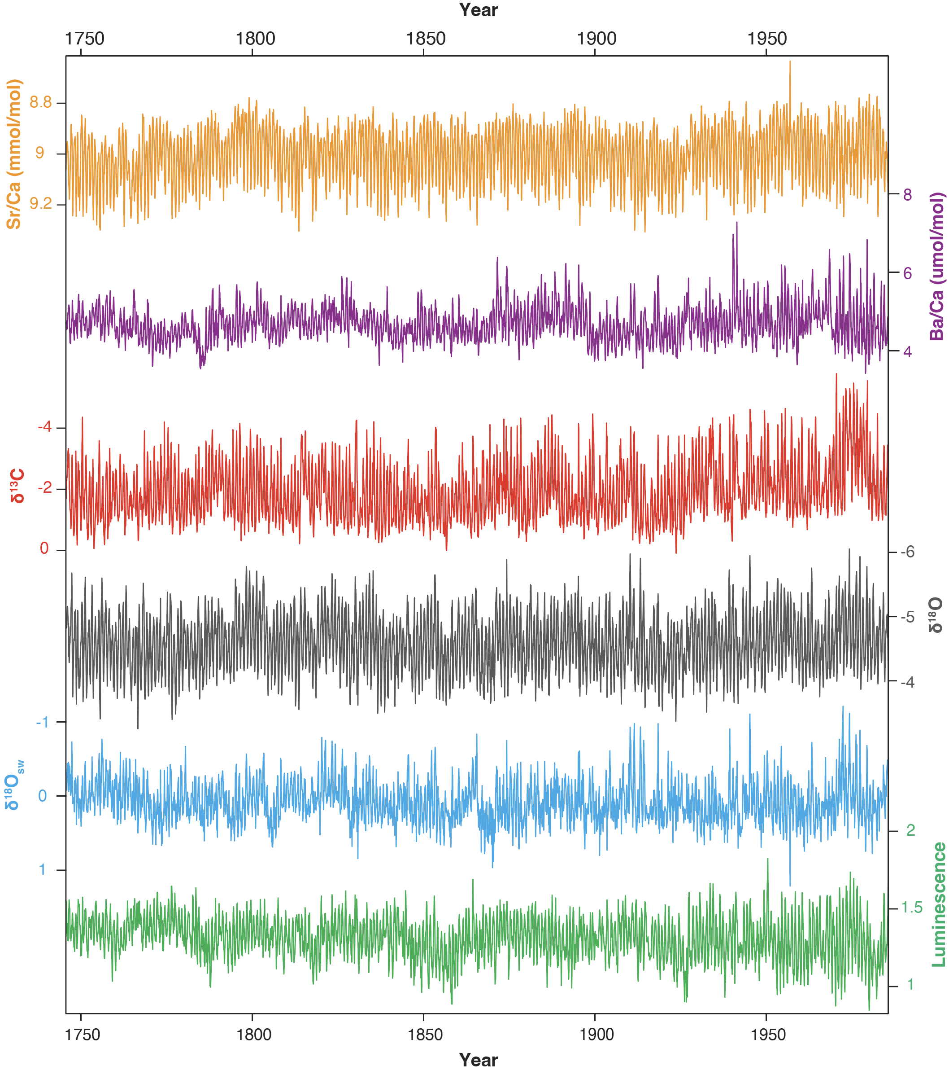

Supplemental Fig. 3. All sub-annual geochemical and physical data for Jeannie River coral composite section (average 13 samples/year). Note that Sr/Ca, δ¹³C, δ¹⁸O, and δ¹⁸O_{sw} are plotted with an inverted y-axis.

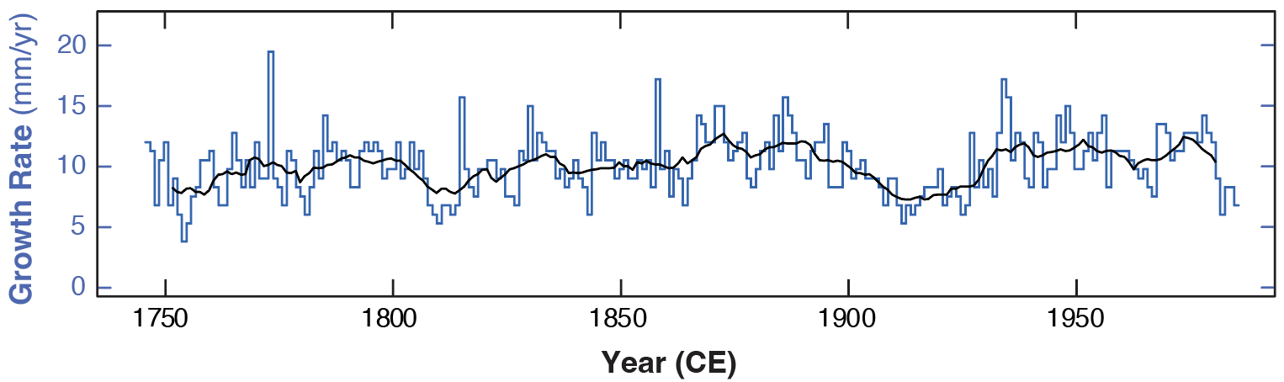

Supplemental Fig. 4. The growth rate (annual extension rate) is calculated based on Sr/Ca-defined years (August 15 defined as maximum annual Sr/Ca). The blue line is the annual extension rate and the black line is a running 10-yr average. Mean growth rate for the entire record is 10±2 mm per year and the sample resolution is 13±3 samples per year.

Supplemental Fig. 5. (a) Locations and site information for instrumental hydrological indices. The red outlines are major catchment boundaries. Meteorologic stations are green squares. (b) Detailed core location, ~1.3 km from mouth of Jeannie River.

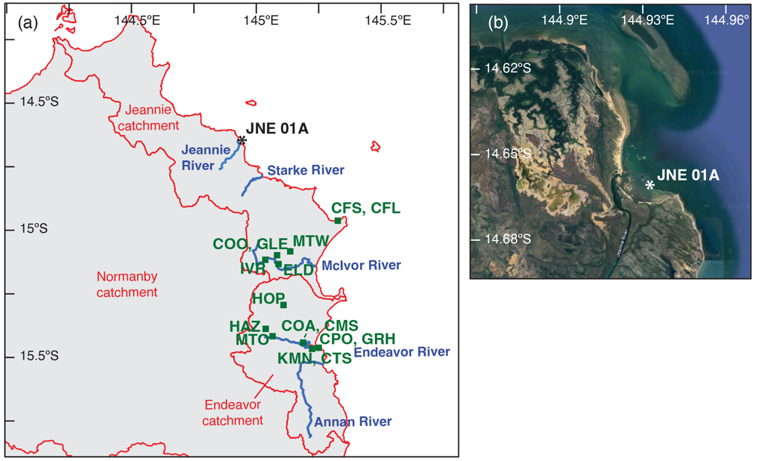

Map (b) is courtesy of Google Earth (10/22/2022) with data attributed to Airbus, Maxar Technologies, SIO, NOAA, US Navy, NGA, GEBCO, CNES / Airbus, TerraMetrics.

INSTRUMENTAL RAINFALL RECORDS:

Station: | ID | ID# | Lat. (ºS) | Long. (ºE) | Elev. (m) | Years
Jeannie River catchment
Cape Flattery Light* | CFL | 31213 | 14.97 | 145.31 | 18.5 | 2003-2019
Cape Flattery Silica | CFS | 31155 | 14.96 | 145.33 | 9 | 1975-2002
‘Cooktown’ | COO | 31072 | 15.1 | 145.08 | NA | 1954-1972
Ivor Park | IVR | 31143 | 15.12 | 145.03 | NA | 1974-1985
Elderslie | ELD | 31133 | 15.14 | 145.08 | 70 | 1972-1995
Glen Rock | GLE | 31101 | 15.1 | 145.08 | 85.3 | 1916-1932
Mt Webb | MTW | 31073 | 15.08 | 145.13 | NA | 1952-1956
Endeavor River catchment
Hope Vale | HOP | 31030 | 15.29 | 145.11 | 60 | 1951-2010
Hazelmere | HAZ | 31129 | 15.39 | 145.04 | 50 | 1972-2021
Mt Olive | MTO | 31107 | 15.42 | 145.06 | 23 | 1947-2021
Cooktown Airport* | COA | 31209 | 15.45 | 145.19 | 4.8 | 2000-2021
Cooktown Mission Strip | CMS | 31017 | 15.45 | 145.19 | 14 | 1874-1987
Cooktown Post Office | CPO | 31016 | 15.46 | 145.25 | 6 | 1874-1987
Grassy Hill Radio | GRH | 31094 | 15.47 | 145.25 | NA | 1896-1949
Kemenagi | KMN | 31137 | 15.47 | 145.22 | 60 | 1973-1978
Cooktown Town Strip | CTS | 31179 | 15.47 | 145.23 | NA | 1938-1941

RIVER DISCHARGE RECORDS:

Station: | ID | Lat. (ºS) | Long. (ºE) | Years
Jeannie River at Wakooka | 106002A | 14.76 | 144.86 | 1970-1988
Starcke River at Causeway | 106003A | 14.82 | 144.97 | 1970-1988
McIvor River at Elderslie | 106001A | 15.13 | 145.09 | 1969-1988
Endeavor River at Flaggy | 107001B | 15.42 | 145.07 | 1967-2020
Annan River at Mt Simon | 107002A | 15.64 | 145.19 | 1969-1991
Bloomfield River at China Camp | 108003A | 15.99 | 145.29 | 1970-2020

*Stations CFL and COA are used only for the modern record of rainfall.

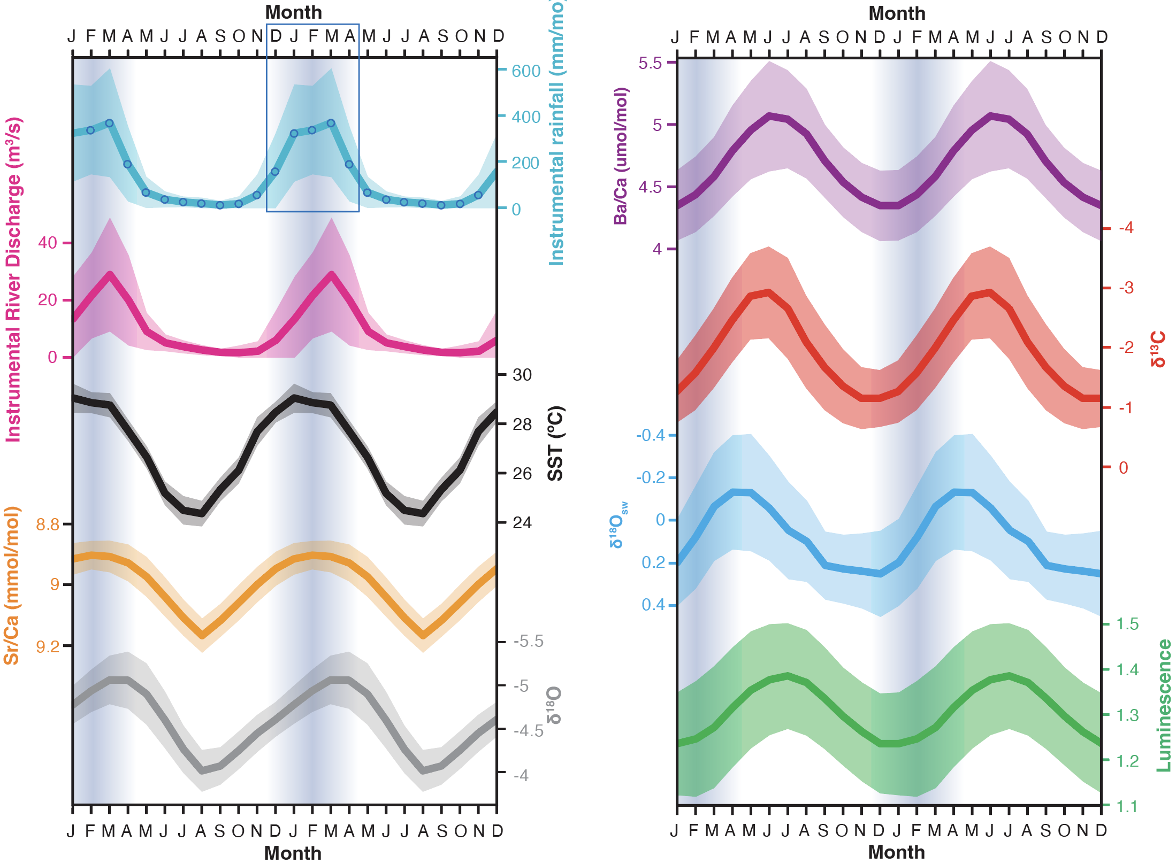

Supplemental Fig. 6. Summary of monthly averages for selected datasets, shown over 24 months. Left panel: Average monthly instrumental precipitation (1913-2020) and river discharge (1968-2020) for the region near Jeannie River compared with monthly HadISST (144-145ºE, 14-15ºS, 1980-2020) and Jeannie River coral Sr/Ca and δ¹⁸O values (1745-1984). Right panel: Monthly average values of Jeannie River coral Ba/Ca, δ¹³C, δ¹⁸O_{sw}, and luminescence. Uncertainty in all cases is one standard deviation of monthly values. Months Dec-April (vertical blue bars, blue box) are the wettest months AND the most variable months in this region.

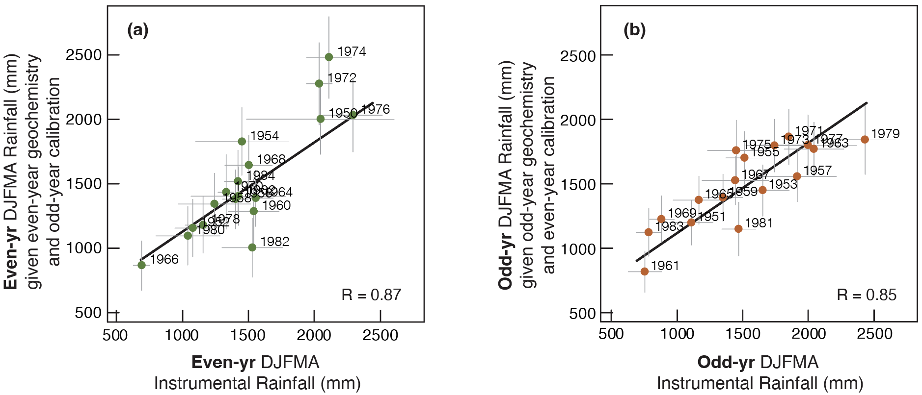

Supplemental Fig. 7. Calibration and validation tests for the calibration period 1950-1984. In the first version of the validation exercise (a), the even-year rainfall is predicted using a calibration developed using only odd-yr geochemistry and rainfall. In the second version (b), the odd-year rainfall is predicted using a calibration developed using only the even-yr geochemistry and rainfall. Both versions of the exercise result in validation regressions that are significant (p<0.001). Validation statistics for these two exercises are listed in Supplemental Table 1. Regression line (black) from Figure 2a of the main text is shown for comparison.

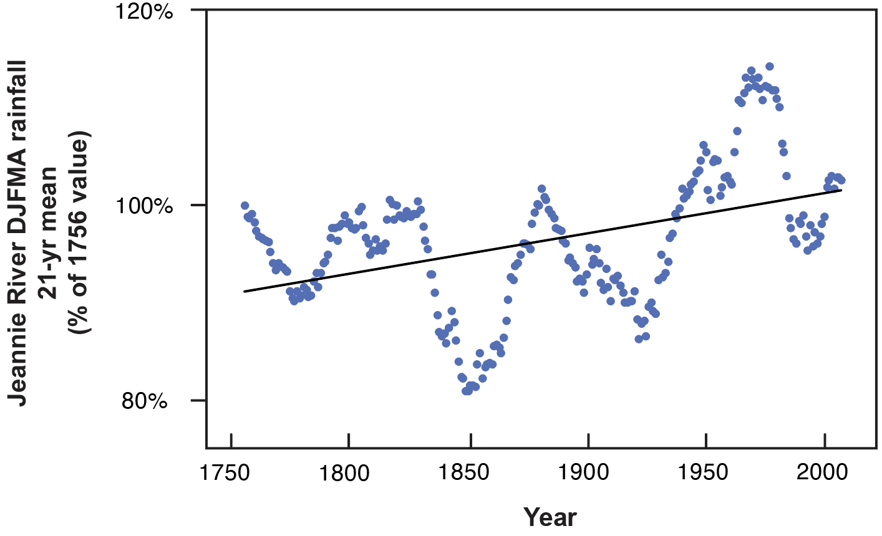

Supplemental Fig. 8. Percent change in mean rainfall since 1746. Each value is the percent change in DJFMA total rainfall for 21-yr windows centered on years 1756-2007 CE. Wet-season rainfall has increased on average by ~10% in this period.
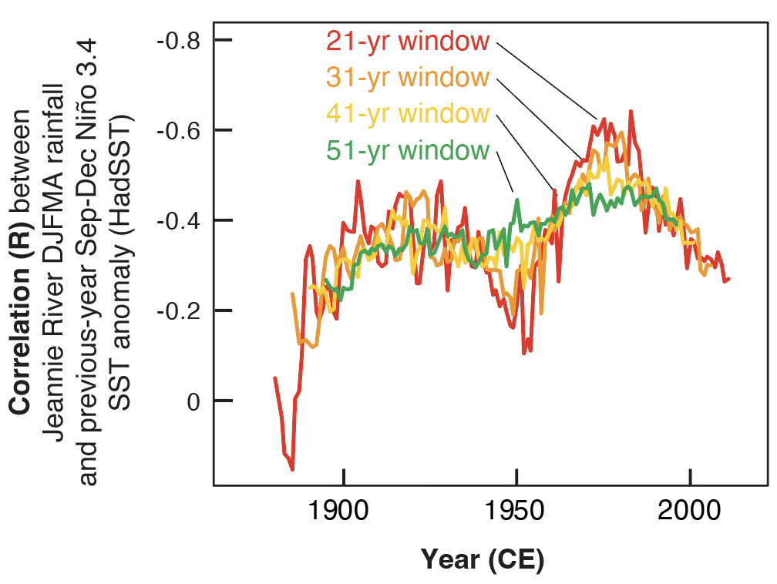

Supplemental Fig. 9. The link between the Pacific ENSO cycle and tropical Queensland rainfall has strengthened since the late 1800’s. This figure shows the running correlation between Jeannie River wet-season rainfall and the SST anomaly (HadISST1) in the Niño3.4 region of the central equatorial Pacific in time windows ranging from 21-51 years (https://psl.noaa.gov/gcos_wgsp/Timeseries/Nino34/).

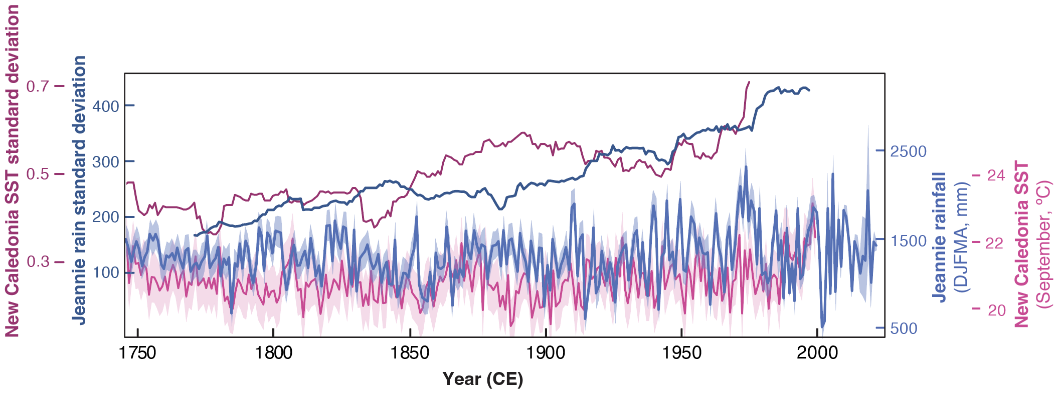

Supplemental Fig. 10. New Caledonia SST variability (pink lines) increased alongside Jeannie River summer rainfall (blue lines) from the mid-18th century to the late 20th century. New Caledonia SST is based on coral Sr/Ca¹; variability is shown in both cases as 51-yr standard deviations; SST uncertainty is shown as 0.75ºC.

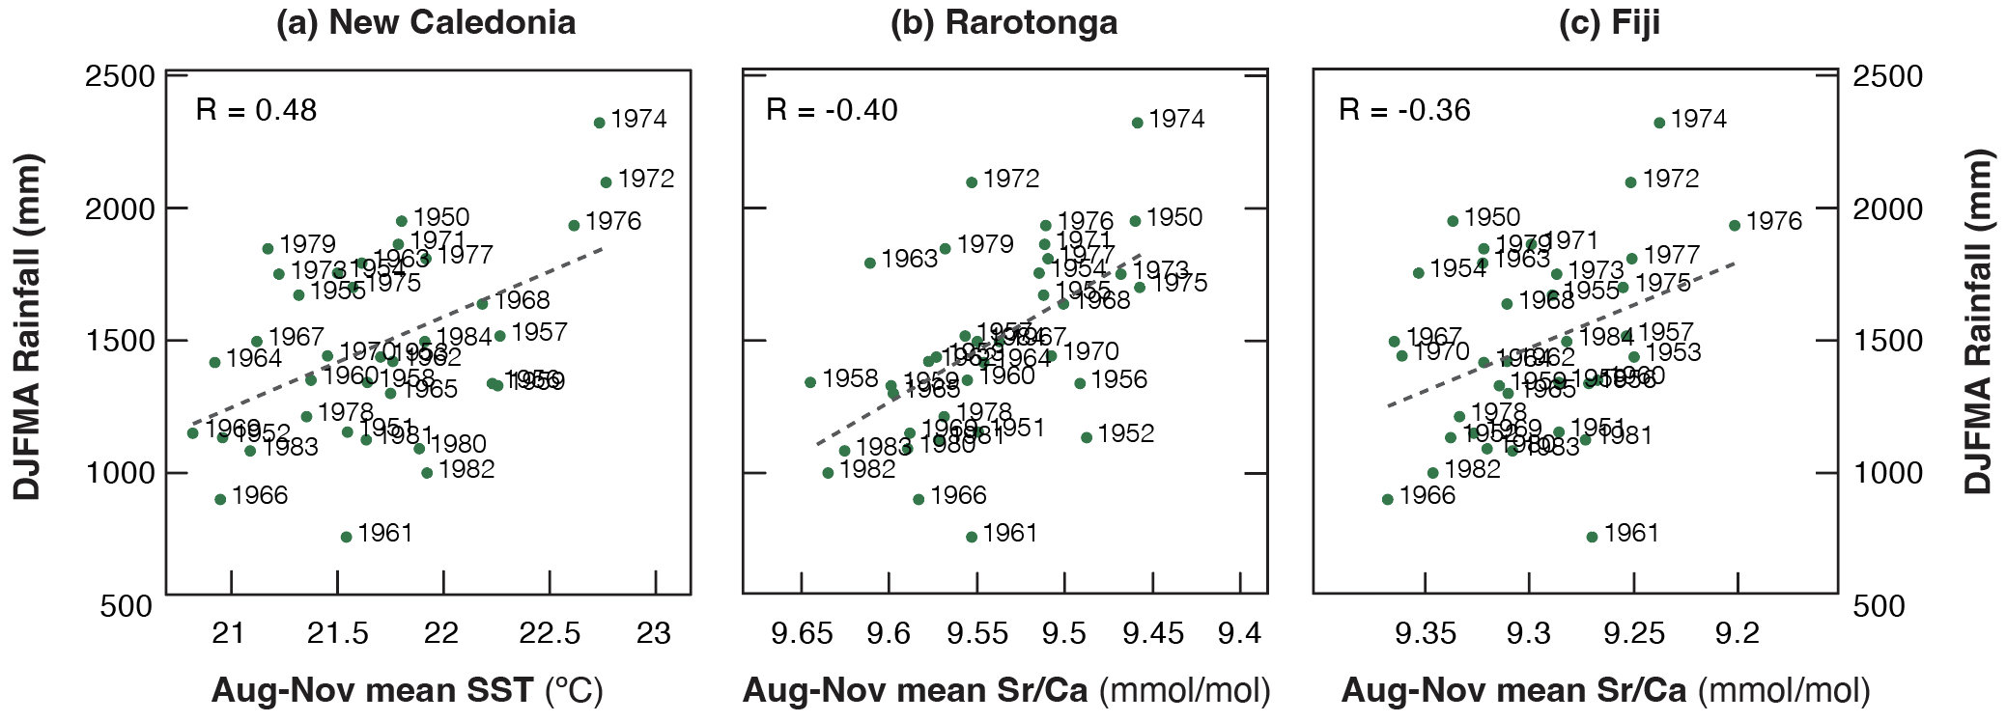

Supplemental Fig. 11. Correlations between the multi-proxy summer rainfall (DJFMA) this study) and the preceding austral spring (ASON) SST at (a) New Caledonia¹, and plotted here as coral Sr/Ca at (b) Rarotonga², and (c) Fiji² for the period 1950-1984. All three correlations are low, but significant (p<0.05). Sr/Ca correlations are negative due to inverse relationship with SST.

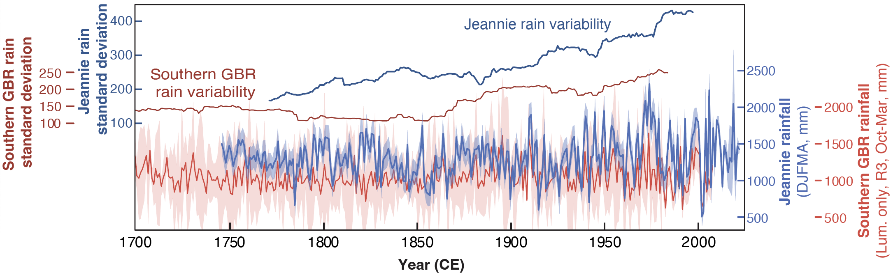

Supplemental Fig. 12. Rainfall variability (51-yr running standard deviation) increased from the mid-18th century to late 20th century, dark red and dark blue lines. Red line is summer rainfall estimated using luminescent banding of southern GBR corals (Humpy, Hook, Havannah Is; 18.8-23.2ºS)³; rainfall after 1981 is instrumental. Blue line is the Jeannie River (14.7ºS) four-proxy rainfall reconstruction from a single location; rainfall after 1984 is instrumental. The correlation between rainfall estimates is R = 0.38 (1746-1981 CE).

Supplemental Table 1. Test statistics for two validation exercises performed for the calibration period 1950-1984. Explained variance is the calibration correlation coefficient; Reduction of Error (RE) is the validation correlation coefficient; in a robust model √RE is only slightly less than calibration explained variance. Standard error of the estimate (SEE) is the “uncertainty” in the calibration set and root mean square error (RMSE) is the uncertainty in the validation set; in a robust model, RMSE is only slightly greater than SEE.

Even-year proxy data Odd-year proxy data

Statistic | Calibration (even-yr geochemistry, even-yr calibrations) | Validation (even-yr geochemistry, odd-yr calibrations) |  | Statistic | Calibration (odd-yr geochemistry, odd-yr calibrations) | Validation (odd-yr geochemistry, even-yr calibrations)
Explained variance (r) | 0.88 |  |  | Explained variance  (r) | 0.89
Reduction of Error √(RE) |  | 0.87 |  | Reduction of Error √(RE) |  | 0.85
Standard Error of the Estimate (SEE) | 197 mm |  |  | Standard Error of the Estimate (SEE) | 220 mm
Root Mean Square Error (RMSE) |  | 219 mm |  | Root Mean Square Error (RMSE) |  | 261 mm

Supplemental Table 2. Regression coefficients and significance for interannual peaks in 4 proxies vs. DJFMA observed rainfall (1950-1984).

Proxy: | Ba/Ca | δ¹³C | δ¹⁸O_{sw} | Luminescence
Correlation w/ DJFMA rainfall (r) | 0.54 | -0.74 | -0.79 | 0.63
p-value | <0.001 | <0.001 | <0.001 | <0.001
Slope | 0.00096±0.00013 | -0.0020±0.0001 | -0.00055±0.00008 | 0.00023±0.00002
Intercept | 4.00±0.20 | -0.15±0.20 | 0.56±0.12 | 1.132±0.031

Supplemental Table 3. Correlation (r) and p-values among the four proxy datasets (1746-1984).

Proxy: | δ¹³C | δ¹⁸O_{sw} | Luminescence
Ba/Ca | -0.32, <0.001 | -0.38, <0.001 | 0.24, <0.001
δ¹³C |  | 0.41, <0.001 | -0.46, <0.001
δ¹⁸O_{sw} |  |  | -0.44, <0.001

Supplemental Table 4. Correlation coefficients (r) for selected climate indices with the multi-proxy summer rainfall estimate from Jeannie River in 3 different time periods: 1950-1984, 1900-1984, and 1746-1984, except when noted that a timeseries is shorter than the given period. The lower section is designed to examine decadal-scale variability (ENSO variability filtered out of both rainfall and climate index). Correlations are significant (p<0.05) unless greyed out and marked with asterisk. Significance of low-pass filtered timeseries correlation is assessed via Ebisuzaki method to account for autocorrelation ⁴.

Observation-based Indices
 | TPI (1) | Niño3.4 (2) | Niño4 (3) | SOI (4) | IPO (5) | PDO (6)
1950-1984 | -0.55 | -0.48 | -0.45 | 0.61 | -0.56 | -0.41
1900-1984 | -0.33 | -0.38 | -0.41 | 0.46 | -0.48 | -0.26
1746-1984 | -0.20 | -0.29 | -0.34 | 0.35 | -0.38 | -0.13*
Low-pass filtered for >8 yr
1950-1984 | -0.77 | -0.85 | -0.71 | 0.82 | -0.82 | -0.50*
1900-1984 | -0.41* | -0.56 | -0.52 | 0.38* | -0.67 | -0.30*
1746-1984 | -0.22* | -0.37* | -0.35* | 0.40* | -0.55 | -0.13*
*not significant (p>0.05)

- IPO Tripole Index (TPI) unfiltered ERSSTv5 average of Jan.-Mar. ⁵, earliest year is 1854
- Niño3.4 Index using HadlSST1^{6,7} average of Jan.-Mar., earliest year is 1870
- Niño4 Index using HadlSST1^{6,7} average of Jan.-Mar., earliest year is 1870
- Southern Oscillation Index^{7,8} average of Jan.-Mar., earliest year is 1866
- Interdecadal Pacific Oscillation (IPO) HadlSST1 (annual)^{7,9}, earliest year is 1873
- Pacific Decadal Oscillation, Feb. ¹⁰, earliest year is 1854

Supplemental Table 5. Correlation coefficients (r) for selected proxies and indices with the multi-proxy summer rainfall estimate from Jeannie River in 3 different time periods: 1950-1984, 1900-1984, and 1746-1984, except when noted that a timeseries is shorter than the given period. The lower section is designed to examine decadal-scale variability (ENSO variability filtered out of both rainfall and coral proxy). Correlations significant (p<0.05) unless greyed out and marked with asterisk. Significance of low-pass filtered timeseries correlation is assessed via the Ebisuzaki method to account for autocorrelation⁴.

Coral Proxies
 | Paleo-ENSO  (1) | Paleo-ENSO  (2) | New Caledonia (3) | FTR  SST  (4) | GBR17 Lumin.  (5) | GBR3 Lumin.  (6) | Havannah Ba/Ca  (7)
1950-1984 | -0.49 | -0.45 | 0.48 | 0.46 | 0.76 | 0.66 | 0.40
1900-1984 | -0.32 | -0.38 | 0.40 | 0.44 | 0.69 | 0.56 | 0.43
1746-1984 | -0.15 | -0.29 | 0.19 | 0.26 | 0.64 | 0.34 | 0.34
Low-pass filtered for >8 yr
1950-1984 | -0.72 | -0.74 | 0.68* | 0.83 | 0.67* | 0.42* | 0.37*
1900-1984 | -0.23 | -0.39 | 0.49 | 0.59 | 0.59 | 0.44* | 0.36*
1746-1984 | -0.06* | -0.30 | 0.26* | 0.42 | 0.51 | 0.20* | 0.38*
*not significant (p>0.05)

- Paleo El Niño-Southern Oscillation compilation from network of proxy DJF averages, target of the proxy reconstruction is Niño3.4 from ERSSTv3¹¹.
- Paleo El Niño-Southern Oscillation compilation from network of proxy records (CPS), target of the proxy reconstruction is extended-MEI, annual average is from previous April to concurrent March¹², latest year is 1981
- New Caledonia SST, derived from coral Sr/Ca¹. Here we use the previous Aug-Nov average; these are the 3 individual months most correlated with Queensland DJFMA rainfall.
- Fiji-Tonga-Rarotonga, annual average SST is previous Aug to concurrent year July¹³, earliest year is 1791
- Queensland summer rainfall from luminescence, 17 cores, 15.1-23.2ºS³ spans 1891-1981
- Queensland summer rainfall from luminescence, 3 longest cores, 18.9-23.2ºS³, latest year is 1981
- Havannah Reef Ba/Ca annual peaks, 18.9ºS¹⁴, earliest year is 1758

Supplementary References:

1 DeLong, K. L., Quinn, T. M., Taylor, F. W., Lin, K. & Shen, C.-C. Sea surface temperature variability in the southwest tropical Pacific since AD 1649. Nature Climate Change 2, 799-804 (2012). https://doi.org:10.1038/nclimate1583
2 Linsley, B. K. et al. Tracking the extent of the South Pacific Convergence Zone since the early 1600s. Geochemistry, Geophysics, Geosystems 7 (2006). https://doi.org:10.1029/2005gc001115
3 Lough, J. M. Great Barrier Reef coral luminescence reveals rainfall variability over northeastern Australia since the 17th century. Paleoceanography 26 (2011). https://doi.org:10.1029/2010pa002050
4 Ebisuzaki, W. A method to estimate the statistical significance of a correlation when the data are serially correlated Journal of Climate (1997). https://doi.org:10.1175/1520-0442(1997)010<2147:AMTETS>2.0.CO;2
5 Henley, B. J. et al. A Tripole Index for the Interdecadal Pacific Oscillation. Climate Dynamics 45, 3077-3090 (2015). https://doi.org:10.1007/s00382-015-2525-1
6 Huang, B. et al. Extended Reconstructed Sea Surface Temperature, Version 5 (ERSSTv5): Upgrades, Validations, and Intercomparisons. Journal of Climate 30, 8179-8205 (2017). https://doi.org:10.1175/jcli-d-16-0836.1
7 Climate Explorer. KNMI Climate Explorer, <https://climexp.knmi.nl/> (2022).
8 Ropelewski, C. F. & Jones, P. D. An extension of the Tahiti-Darwin Southern Oscillation Index. Monthly Weather Review 115, 2161-2165 (1987). https://doi.org:10.1175/1520-0493(1987)115<2161:AEOTTS>2.0.CO;2
9 Salinger, M. J., Renwick, J. A. & Mullan, A. B. Interdecadal Pacific Oscillation and South Pacific climate. International Journal of Climatology 21, 1705-1721 (2001). https://doi.org:10.1002/joc.691
10 Mantua, N. J., Hare, S. R., Zhang, Y., Wallace, J. M. & Francis, R. C. A Pacific Interdecal Climate Oscillation with impacts on salmon production. Bulletin of the American Meteorological Society 78 (1997). https://doi.org:10.1175/1520-0477(1997)078<1069:APICOW>2.0.CO;2
11 Emile-Geay, J., Cobb, K. M., Mann, M. E. & Wittenberg, A. T. Estimating Central Equatorial Pacific SST Variability over the Past Millennium. Part II: Reconstructions and Implications. Journal of Climate 26, 2329-2352 (2013). https://doi.org:10.1175/jcli-d-11-00511.1
12 Loope, G., Thompson, D., Cole, J. & Overpeck, J. Is there a low-frequency bias in multiproxy reconstructions of tropical Pacific SST variability? Quaternary Science Reviews 246 (2020). https://doi.org:10.1016/j.quascirev.2020.106530
13 Linsley, B. K., Wu, H. C., Dassié, E. P. & Schrag, D. P. Decadal changes in South Pacific sea surface temperatures and the relationship to the Pacific decadal oscillation and upper ocean heat content. Geophysical Research Letters 42, 2358-2366 (2015). https://doi.org:10.1002/2015gl063045
14 McCulloch, M. T. et al. Coral record of increased sediment flux to the inner Great Barrier Reef since European settlement. Nature 421 (2003). https://doi.org:10

